Contents

1. WAAAVW0001 6

2. WAAAVW0002 8

3. WAAAVW0003 10

4. WAAAVW0004 12

5. WAAAVW0005 14

6. WAAAVW0006 16

7. WAAAVW0007 18

8. WAACAR0001 20

9. WAACAR0002 22

10. WAACAR0003 24

11. WAACAR0004 26

12. WAACEK0001 28

13. WAACEK0002 30

14. WAACEK0003 32

15. WAACOO0001 34

16. WAACOO0003 36

17. WAACOO0004 38

18. WAACOO0005 40

19. WAACOO0006 42

20. WAACOO0007 44

21. WAACOO0008 46

22. WAACOO0009 48

23. WAACOO0010 50

24. WAACOO0011 52

25. WAACOO0012 54

26. WAACOO0016 56

27. WAACOO0017 58

28. WAACOO0018 60

29. WAACOO0019 62

30. WAACOO0020 64

31. WAACOO0021 66

32. WAACOO0022 68

33. WAACOO0023 70

34. WAACOO0024 72

35. WAACOO0025 74

36. WAACOO0026 76

37. WAACOO0027 78

38. WAACOO0028 80

39. WAACOO0029 82

40. WAACOO0030 84

41. WAACOO0031 86

42. WAACOO0032 88

43. WAADAL0001 90

44. WAADAL0002 92

45. WAADAL0003 94

46. WAADAL0004 96

47. WAADAL0005 98

48. WAAESP0001 100

49. WAAGAS0001 102

50. WAAGAS0002 104

51. WAAGES0001 106

52. WAAGES0002 108

53. WAAGES0003 110

54. WAAGES0004 112

55. WAAGES0005 114

56. WAAGSD0001 116

57. WAAGVD0001 118

58. WAAHAM0001 120

59. WAAHAM0002 122

60. WAAHAM0003 124

61. WAAHAM0004 126

62. WAAHAM0005 128

63. WAAHAM0006 130

64. WAAJAF0001 132

65. WAAJAF0002 134

66. WAAJAF0003 136

67. WAALSD0001 138

68. WAALSD0002 140

69. WAALSD0003 142

70. WAAMAL0001 144

71. WAAMAL0002 146

72. WAAMAL0003 148

73. WAAMUR0001 150

74. WAAMUR0002 152

75. WAAMUR0003 154

76. WAAMUR0004 156

77. WAAMUR0005 158

78. WAAMUR0006 160

79. WAAMUR0007 162

80. WAAMUR0008 164

81. WAAMUR0028 166

82. WAAMUR0029 168

83. WAAMUR0030 170

84. WAAMUR0031 172

85. WAANOK0001 174

86. WAANOK0002 176

87. WAANOK0003 178

88. WAANOK0004 180

89. WAANOK0005 182

90. WAANOK0006 184

91. WAANOK0007 186

92. WAANOK0008 188

93. WAANUL0001 190

94. WAANUL0002 192

95. WAANUL0003 194

96. WAANUL0004 196

97. WAANUL0005 198

98. WAANUL0006 200

99. WAANUL0007 202

100. WAANUL0008 204

101. WAANUL0009 206

102. WAAPIL0001 208

103. WAAPIL0002 210

104. WAAPIL0003 212

105. WAAPIL0004 214

106. WAAPIL0005 216

107. WAAPIL0006 218

108. WAAPIL0007 220

109. WAAPIL0008 222

110. WAAPIL0009 224

111. WAAPIL0010 226

112. WAAPIL0011 228

113. WAAPIL0012 230

114. WAAPIL0013 232

115. WAAPIL0014 234

116. WAAPIL0015 236

117. WAAPIL0016 238

118. WAAPIL0017 240

119. WAAPIL0018 242

120. WAAPIL0019 244

121. WAAPIL0020 246

122. WAAPIL0021 248

123. WAAPIL0022 250

124. WAAPIL0023 252

125. WAAPIL0024 254

126. WAAPIL0025 256

127. WAAPIL0026 258

128. WAAPIL0027 260

129. WAAPIL0028 262

130. WAAPIL0029 264

131. WAAPIL0030 266

132. WAAPIL0031 268

133. WAAPIL0032 270

134. WAAPIL0033 272

135. WAAPIL0034 274

136. WAAPIL0035 276

137. WAASWA0001 278

138. WAASWA0002 280

139. WAASWA0003 282

140. WAASWA0004 284

141. WAAVIB0001 286

142. WAAVIB0002 288

143. WAAVIB0003 290

144. WAAVIB0004 292

145. WAAYAL0002 294

146. WAAYAL0004 296

147. WAAYAL0005 298

148. WAAYAL0006 300

149. WAAYAL0007 302

150. WAAYAL0008 304

151. WAGCOO0001 306

152. WAGCOO0002 308

153. WAGCOO0004 310

# WAAAVW0001

| Min. | 1st Qu. | Median | Mean | 3rd Qu. | Max. |
| --- | --- | --- | --- | --- | --- |
| 8.224785 | 16.61408 | 20.01241 | 20.48465 | 23.96685 | 36.22957 |

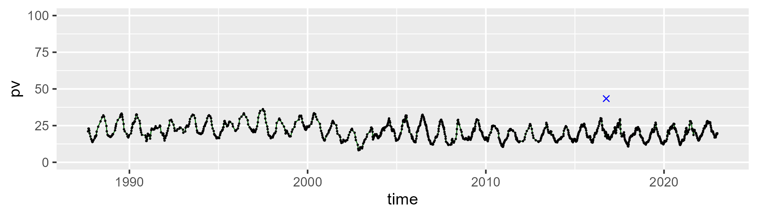

| Min. | 1st Qu. | Median | Mean | 3rd Qu. | Max. |
| --- | --- | --- | --- | --- | --- |
| 41.94276 | 61.16178 | 65.92367 | 65.06506 | 69.51751 | 82.12621 |

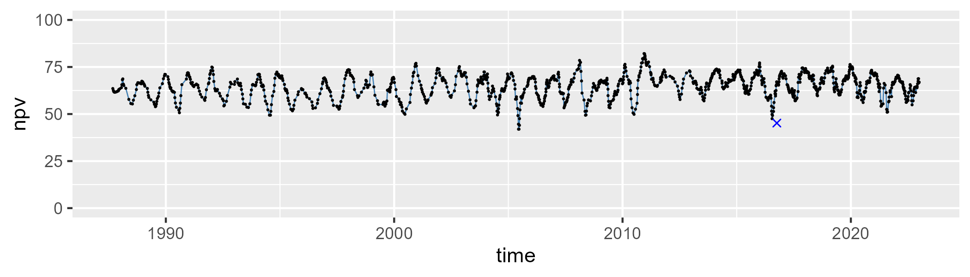

| Min. | 1st Qu. | Median | Mean | 3rd Qu. | Max. |
| --- | --- | --- | --- | --- | --- |
| 4.585295 | 10.96897 | 12.90709 | 13.31854 | 15.08148 | 29.51412 |

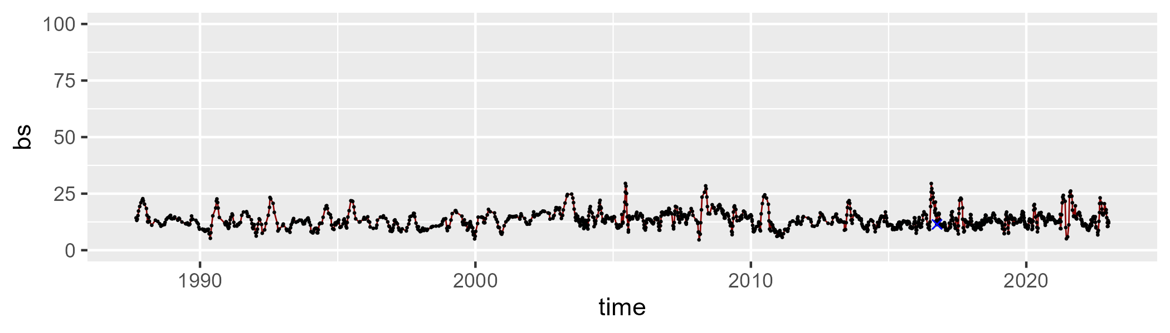

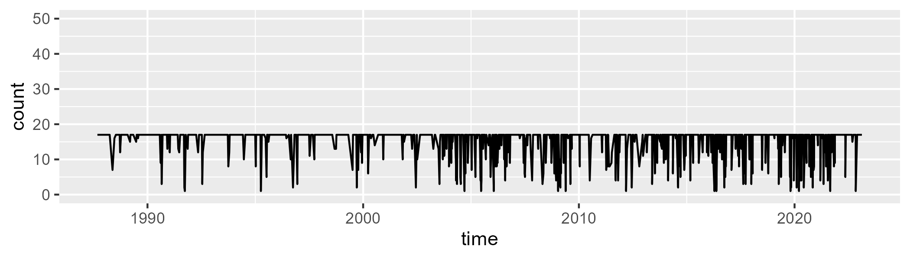

Min. : 1.00 1st Qu.:17.00 Median :17.00 Mean :15.39 3rd Qu.:17.00 Max. :17.00

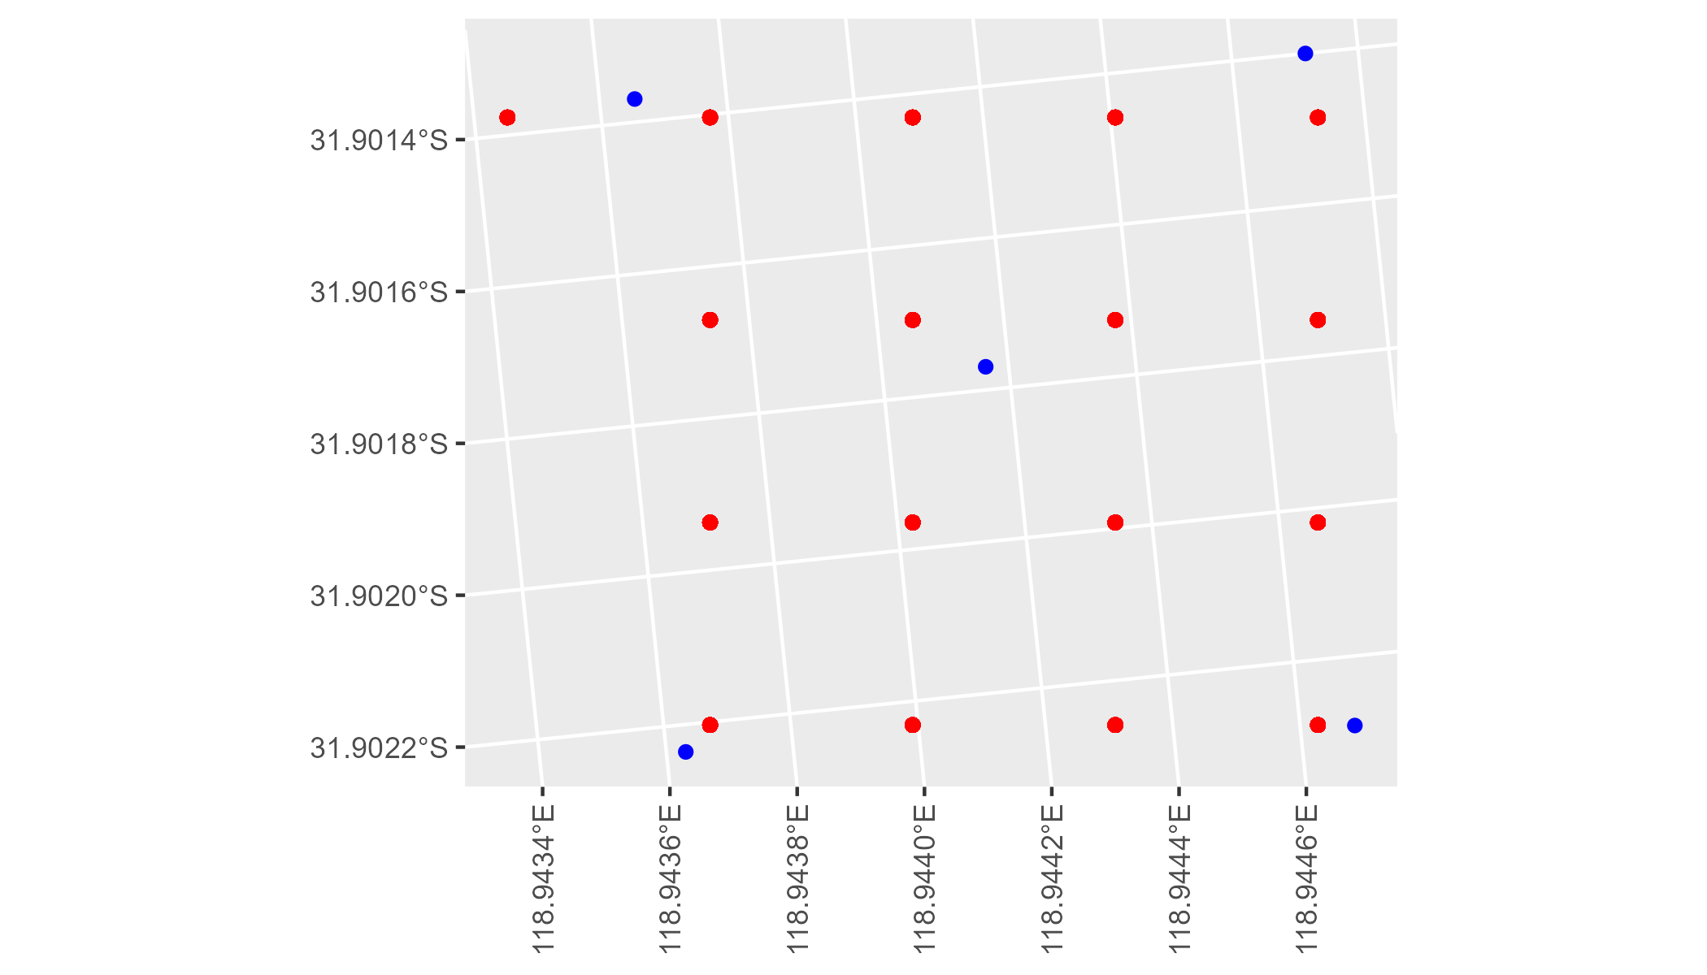

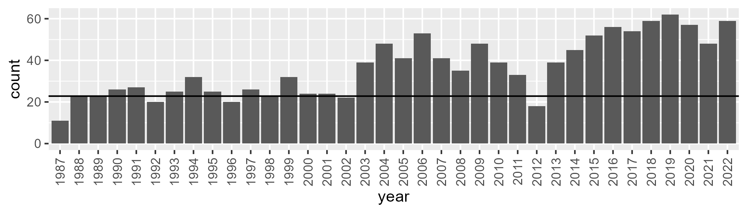

Number of samples: 1309

# WAAAVW0002

| Min. | 1st Qu. | Median | Mean | 3rd Qu. | Max. |
| --- | --- | --- | --- | --- | --- |
| 10.28171 | 19.02468 | 23.05107 | 23.5439 | 27.96769 | 39.9037 |

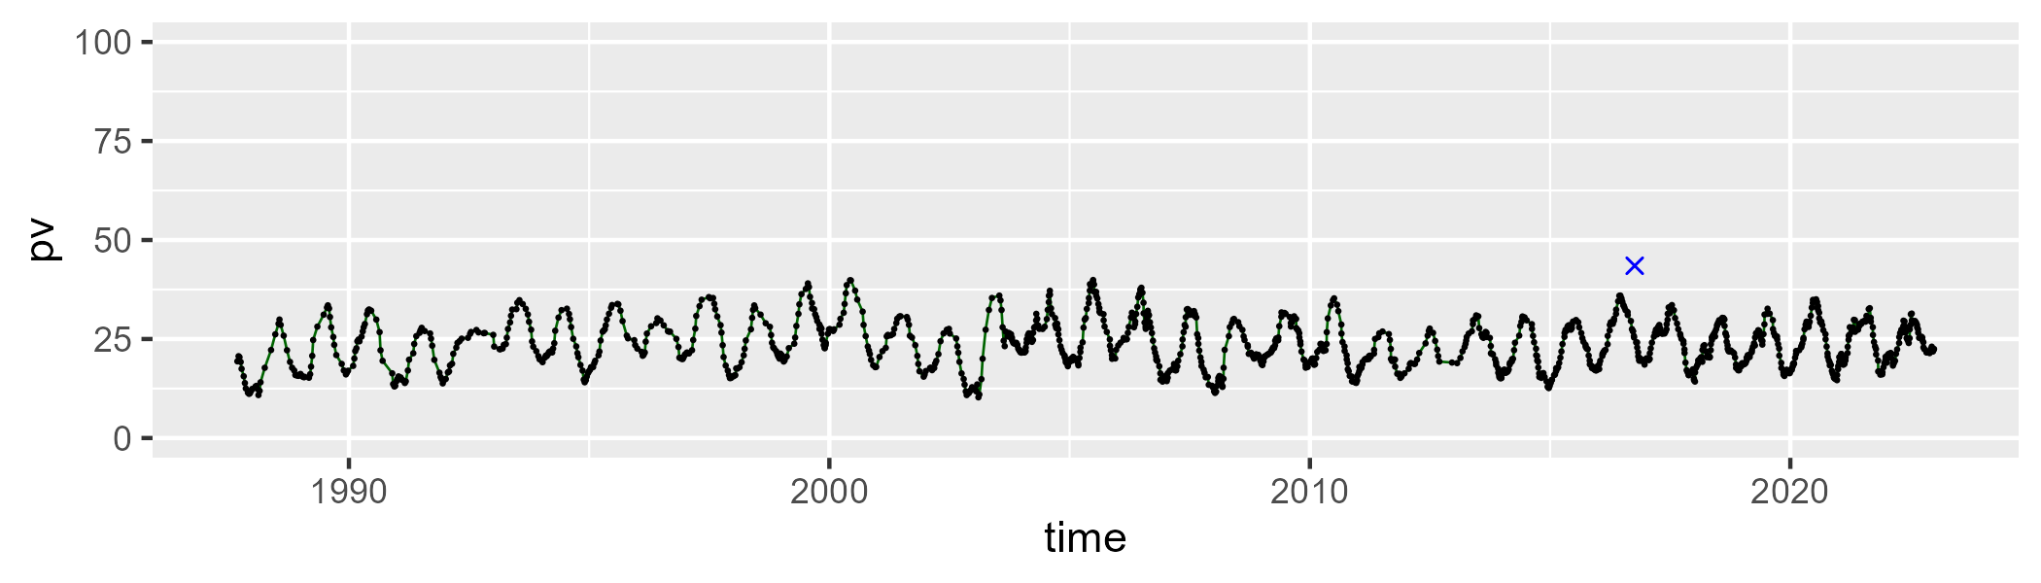

| Min. | 1st Qu. | Median | Mean | 3rd Qu. | Max. |
| --- | --- | --- | --- | --- | --- |
| 41.80959 | 59.32657 | 65.1268 | 64.59562 | 70.69221 | 83.98381 |

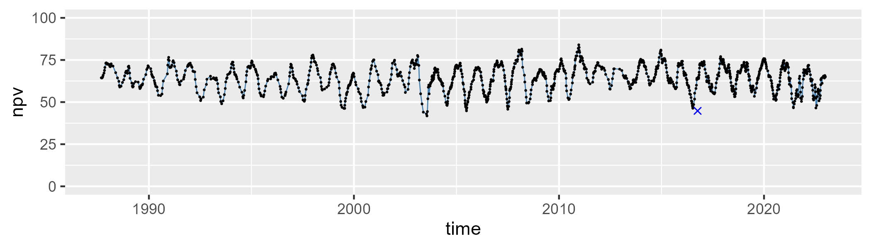

| Min. | 1st Qu. | Median | Mean | 3rd Qu. | Max. |
| --- | --- | --- | --- | --- | --- |
| 1.233632 | 8.416251 | 10.23081 | 10.74197 | 12.33675 | 30.22082 |

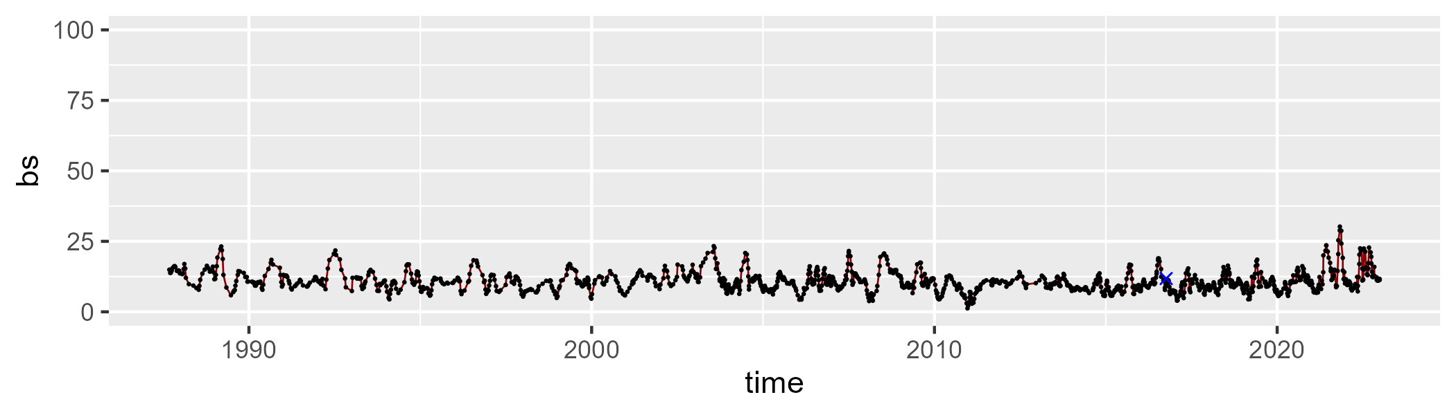

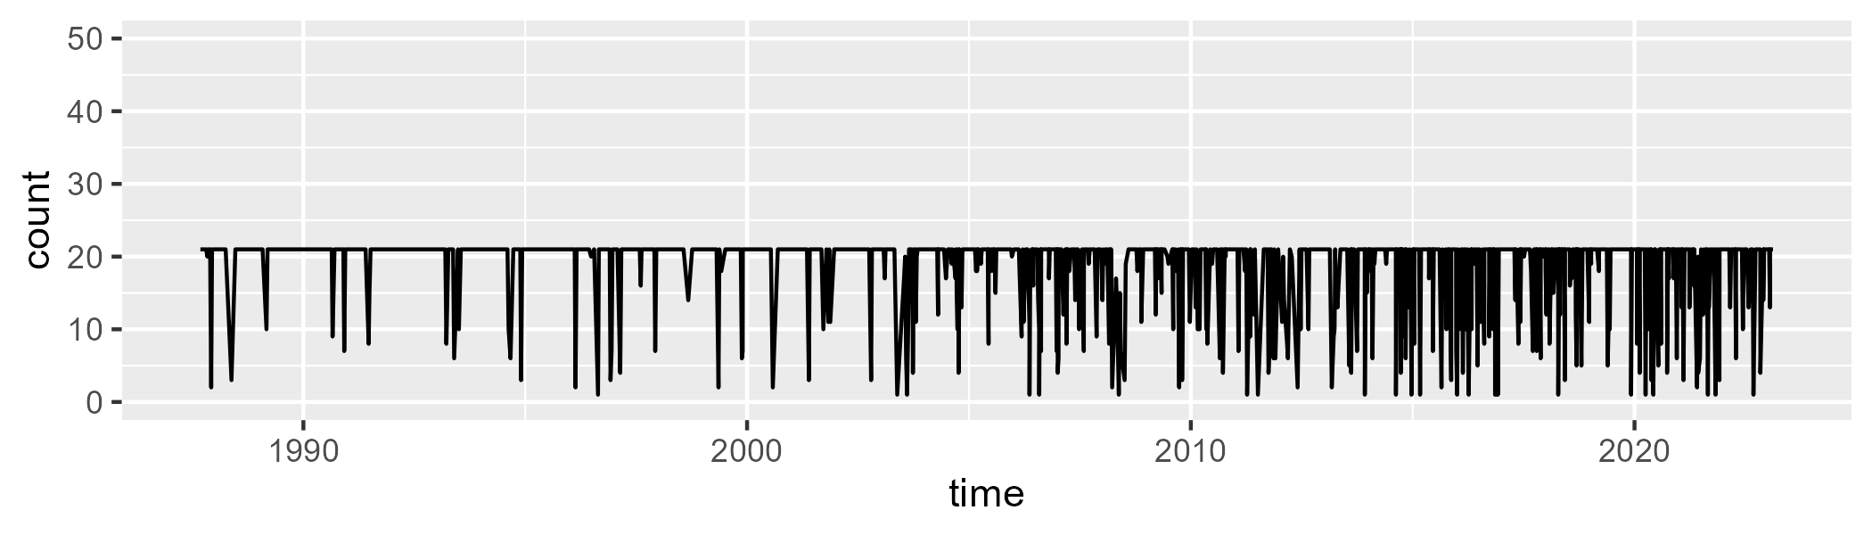

Min. : 1.00 1st Qu.:21.00 Median :21.00 Mean :18.88 3rd Qu.:21.00 Max. :21.00

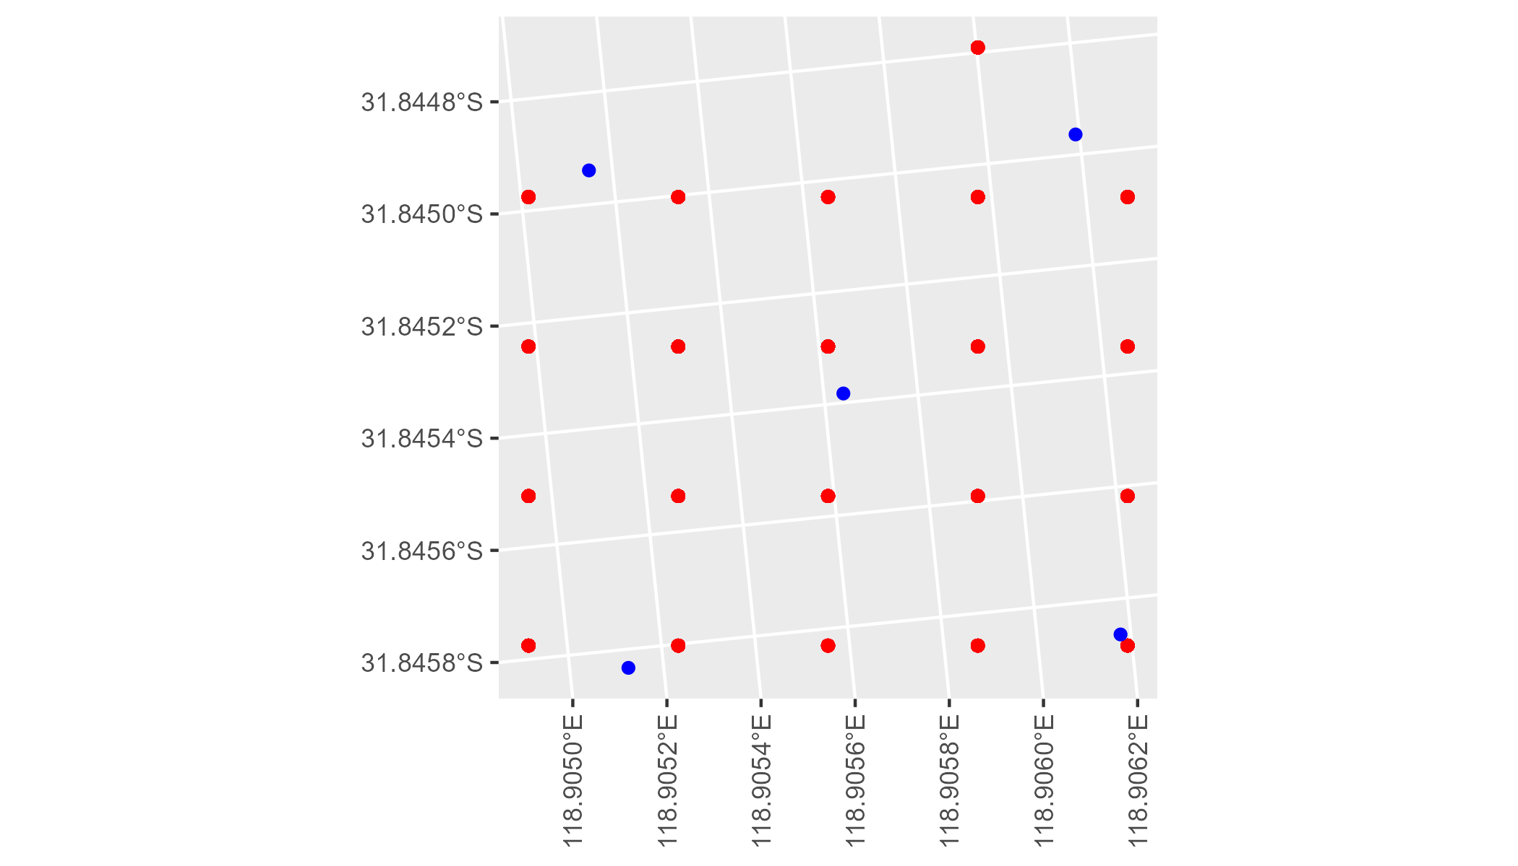

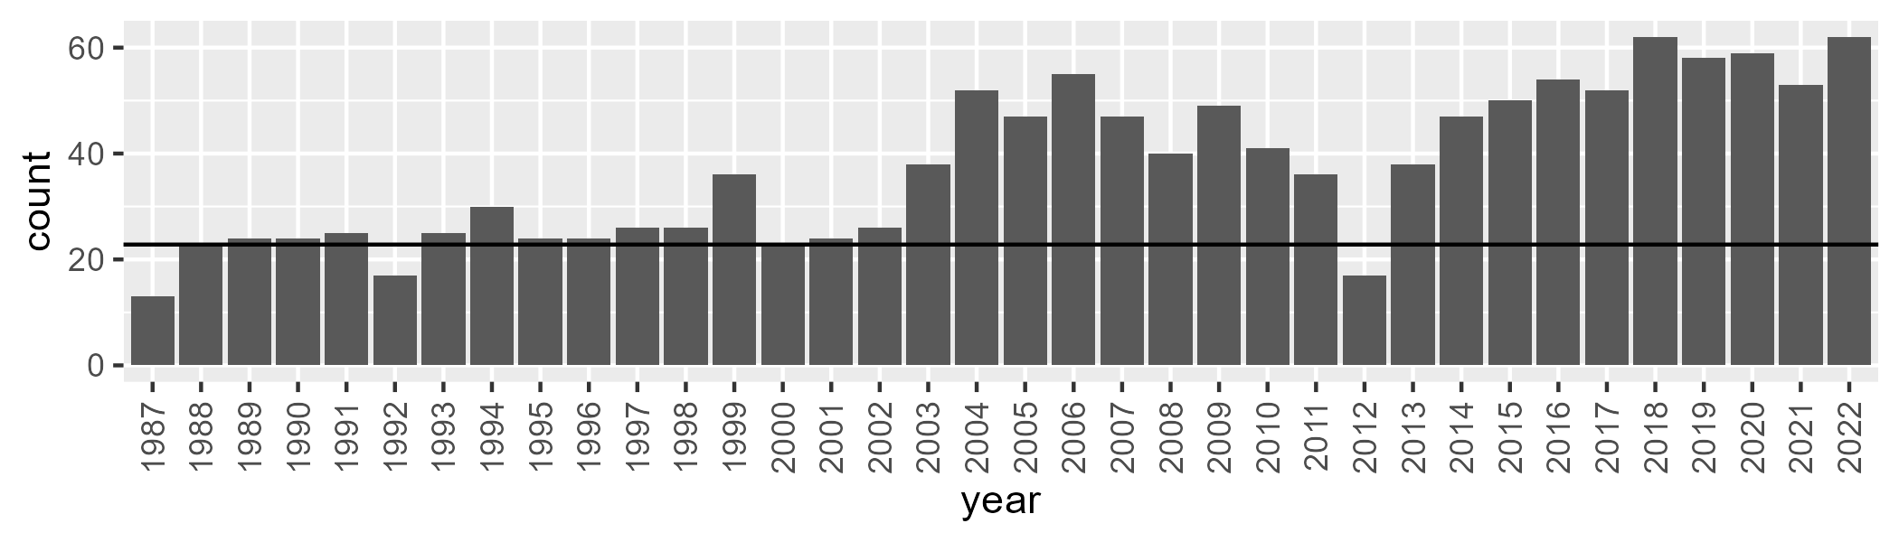

Number of samples: 1347

# WAAAVW0003

| Min. | 1st Qu. | Median | Mean | 3rd Qu. | Max. |
| --- | --- | --- | --- | --- | --- |
| 22.89115 | 35.34033 | 39.96267 | 40.18004 | 44.76212 | 59.33247 |

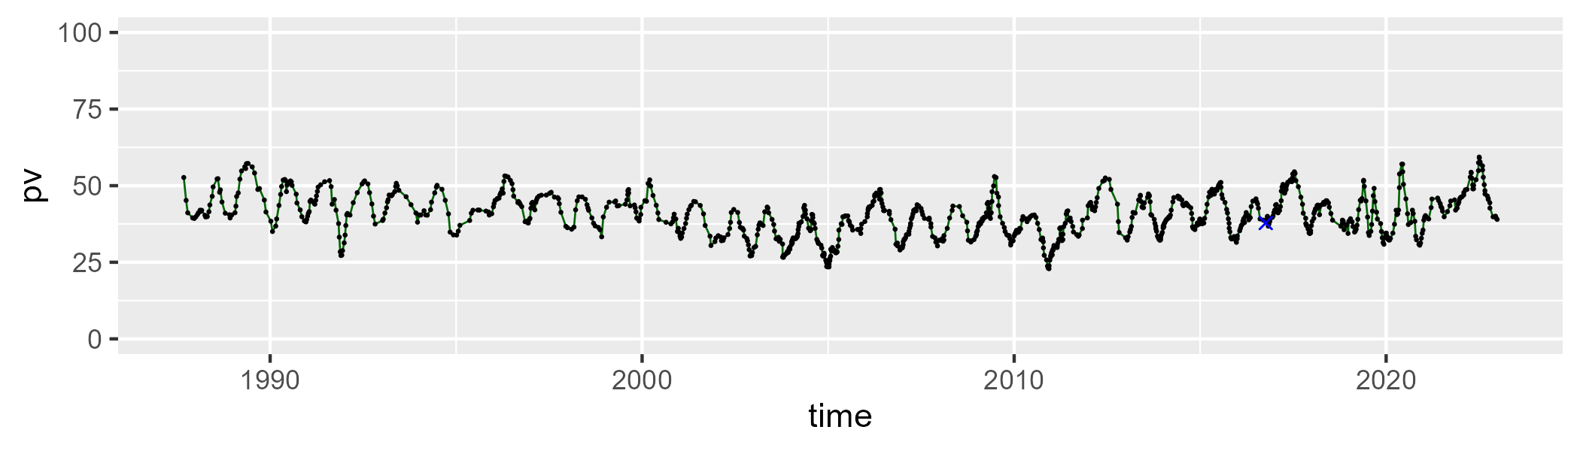

| Min. | 1st Qu. | Median | Mean | 3rd Qu. | Max. |
| --- | --- | --- | --- | --- | --- |
| 26.27323 | 41.9864 | 48.01391 | 47.65125 | 53.66863 | 68.1028 |

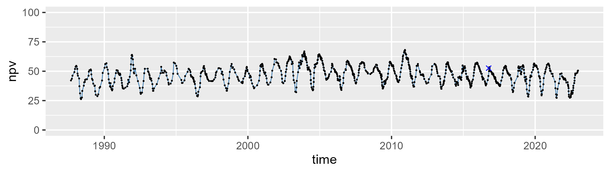

| Min. | 1st Qu. | Median | Mean | 3rd Qu. | Max. |
| --- | --- | --- | --- | --- | --- |
| 1.584239 | 8.124452 | 9.847706 | 10.95491 | 12.44545 | 35.55696 |

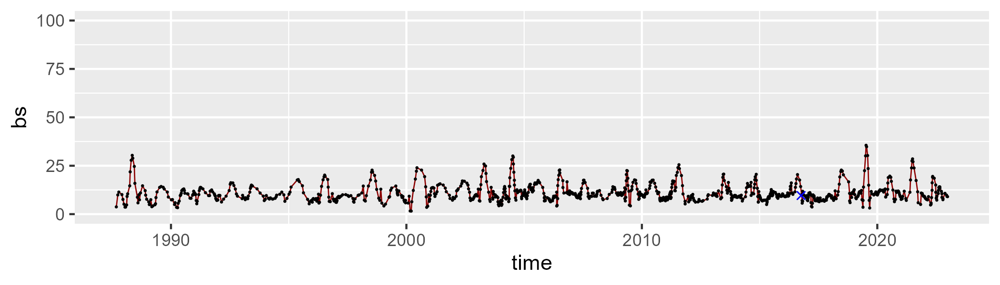

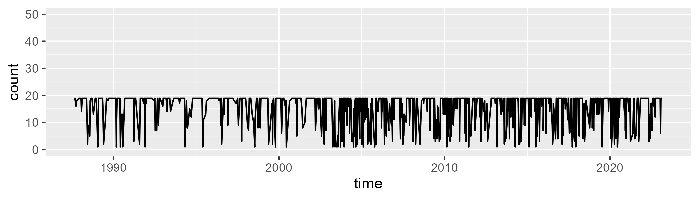

Min. : 1.00 1st Qu.:14.00 Median :19.00 Mean :15.71 3rd Qu.:19.00 Max. :19.00

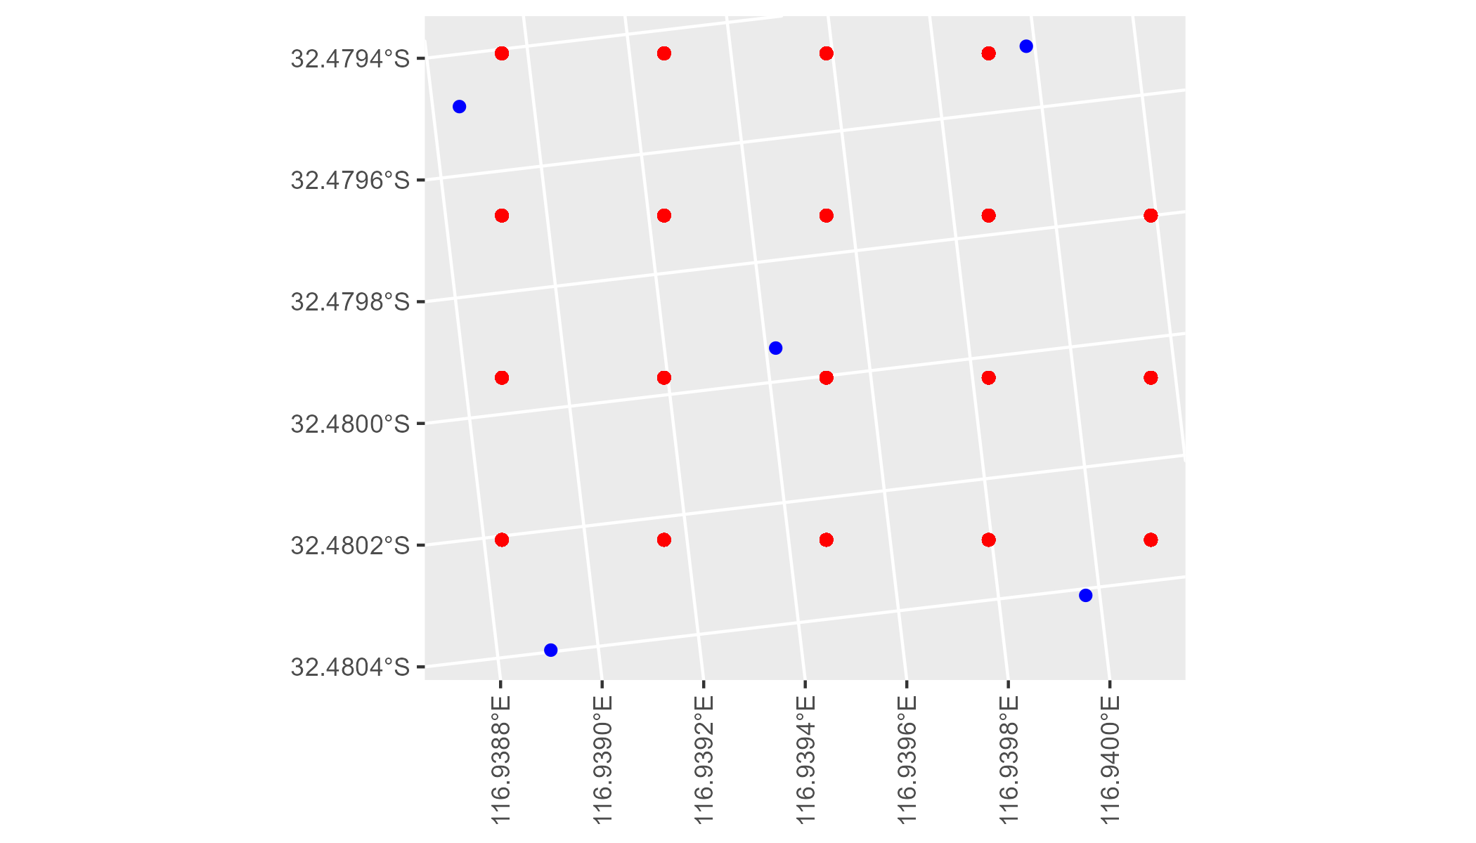

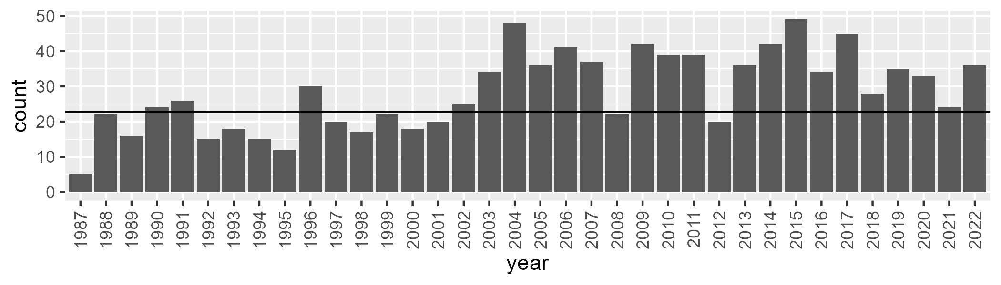

Number of samples: 1025

# WAAAVW0004

| Min. | 1st Qu. | Median | Mean | 3rd Qu. | Max. |
| --- | --- | --- | --- | --- | --- |
| 22.54653 | 33.98563 | 38.6888 | 38.67176 | 43.56187 | 55.31627 |

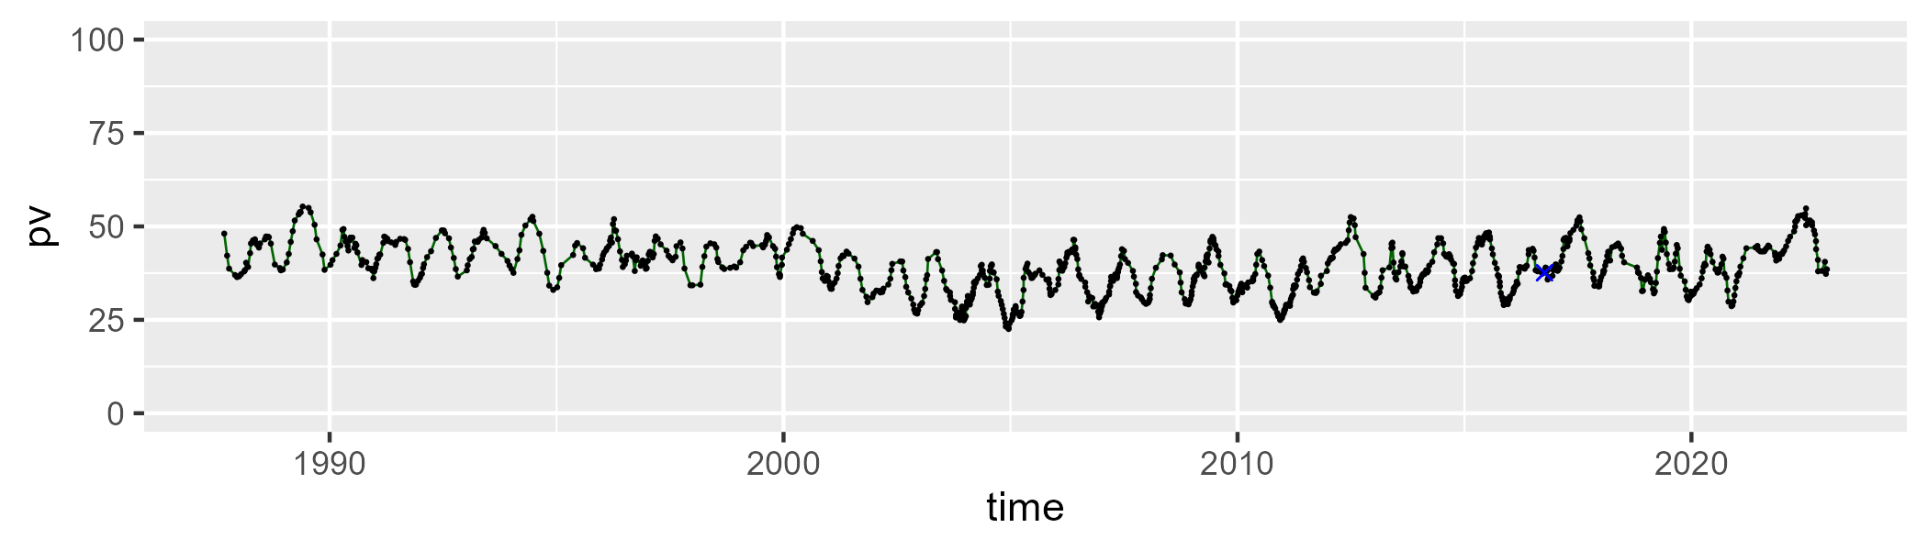

| Min. | 1st Qu. | Median | Mean | 3rd Qu. | Max. |
| --- | --- | --- | --- | --- | --- |
| 24.74408 | 42.92624 | 48.40351 | 48.12044 | 53.7803 | 67.7188 |

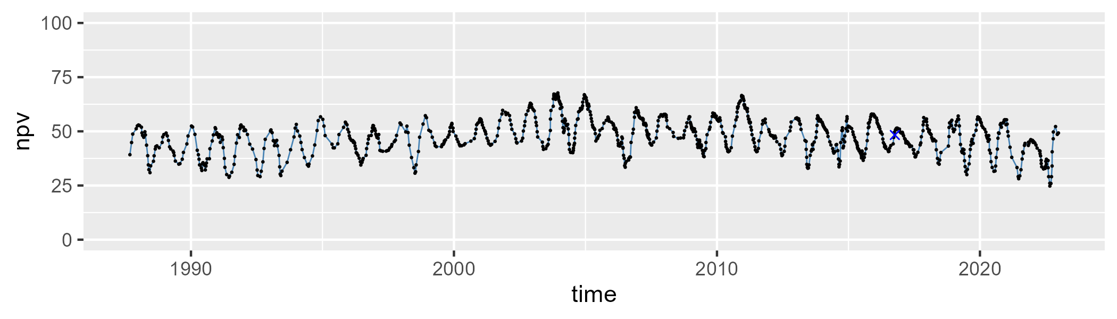

| Min. | 1st Qu. | Median | Mean | 3rd Qu. | Max. |
| --- | --- | --- | --- | --- | --- |
| 2.277058 | 9.143034 | 11.03239 | 11.98814 | 13.22259 | 31.04748 |

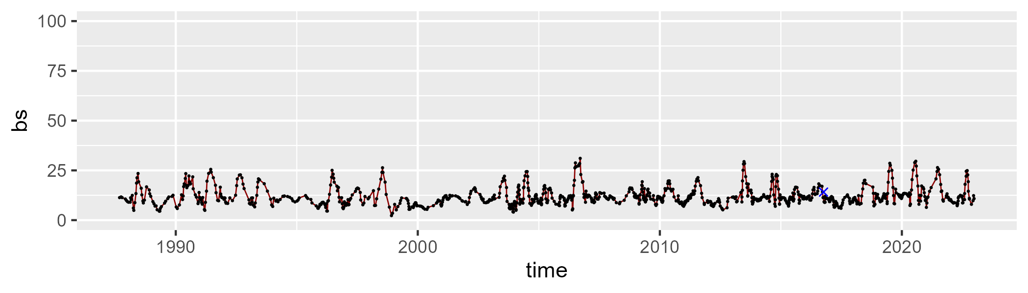

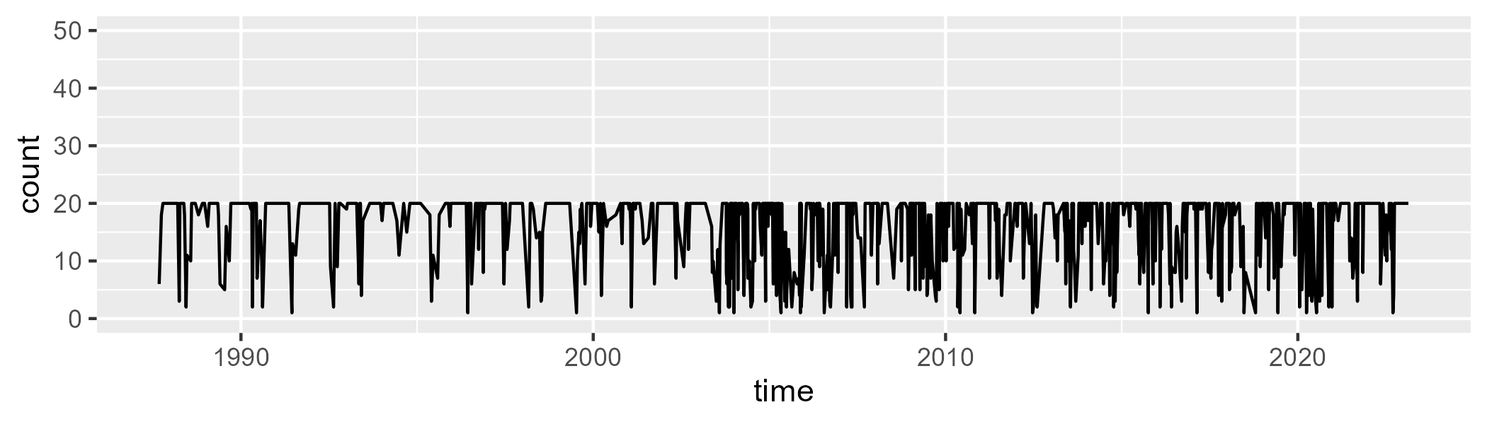

Min. : 1.00 1st Qu.:14.00 Median :20.00 Mean :16.56 3rd Qu.:20.00 Max. :20.00

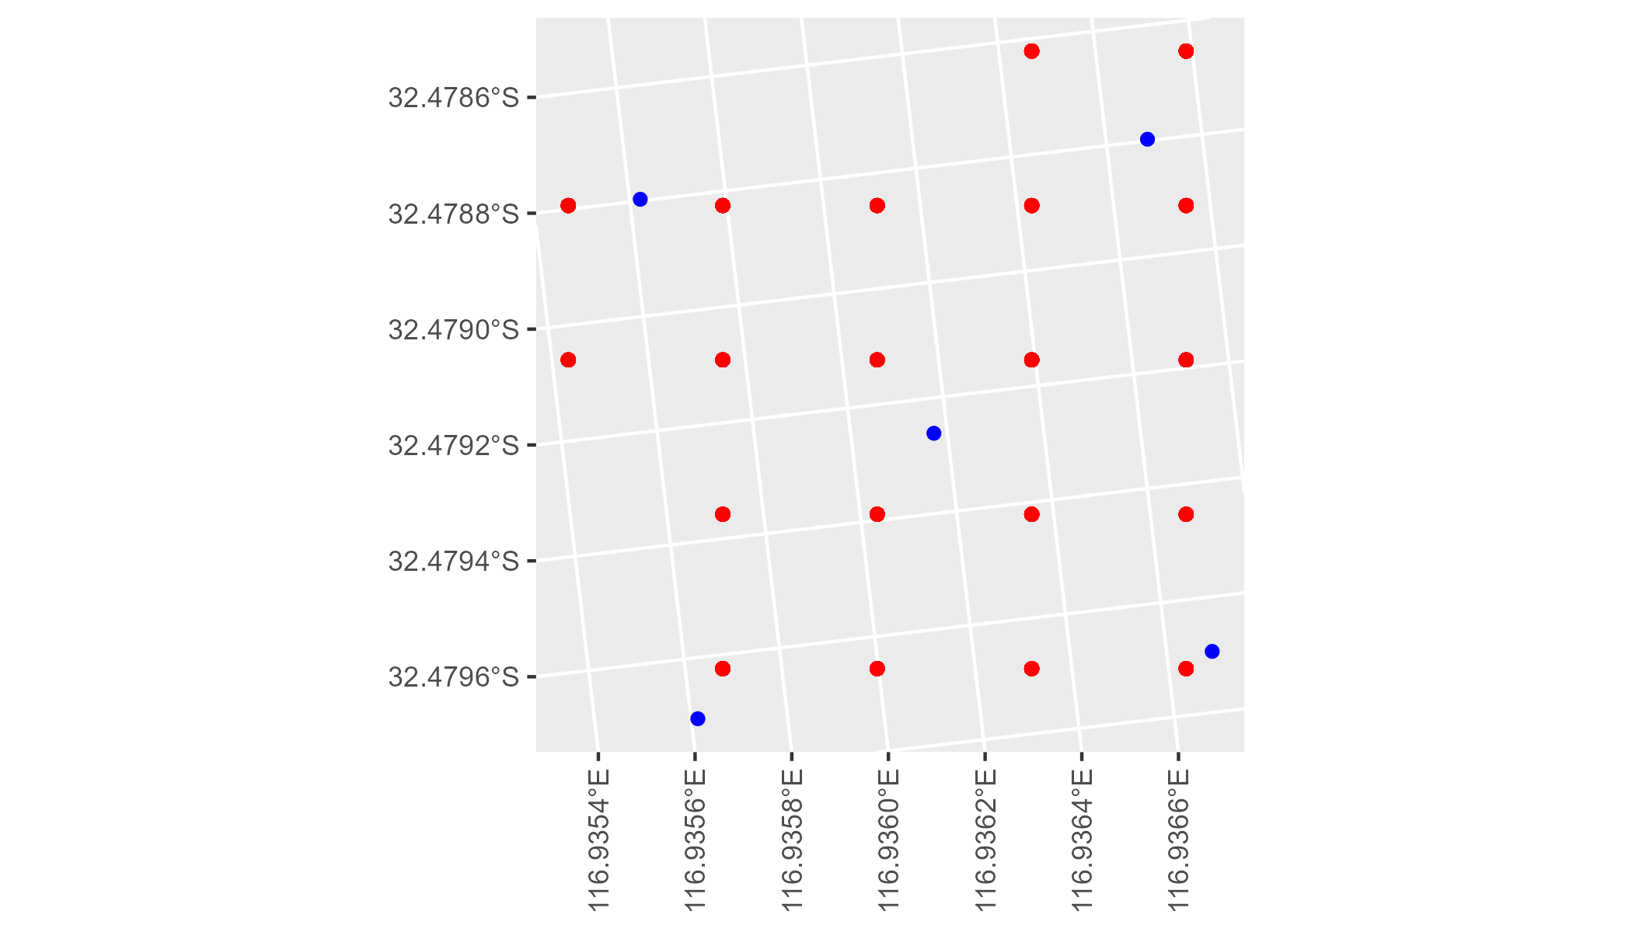

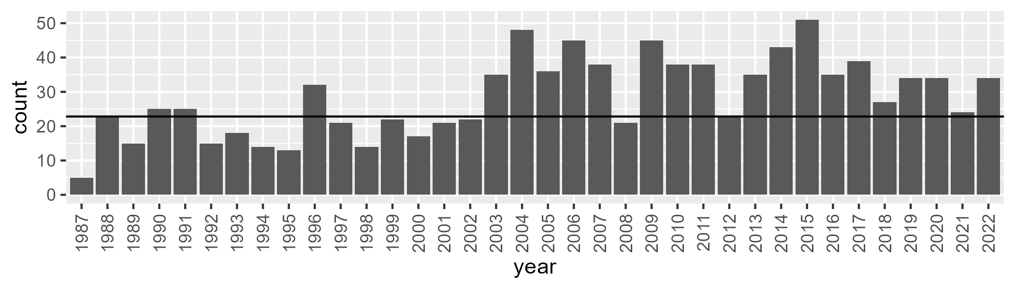

Number of samples: 1025

# WAAAVW0005

| Min. | 1st Qu. | Median | Mean | 3rd Qu. | Max. |
| --- | --- | --- | --- | --- | --- |
| 13.1078 | 19.73555 | 23.25874 | 24.11831 | 27.58269 | 43.4373 |

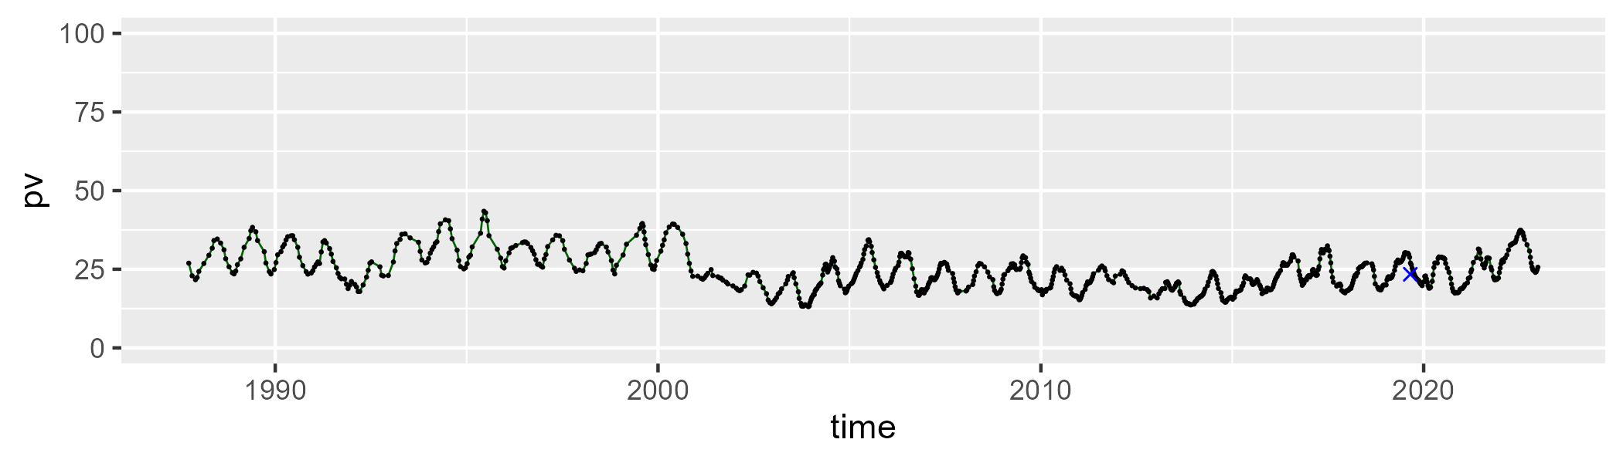

| Min. | 1st Qu. | Median | Mean | 3rd Qu. | Max. |
| --- | --- | --- | --- | --- | --- |
| 34.39713 | 46.93941 | 48.65605 | 48.56192 | 50.41594 | 59.52944 |

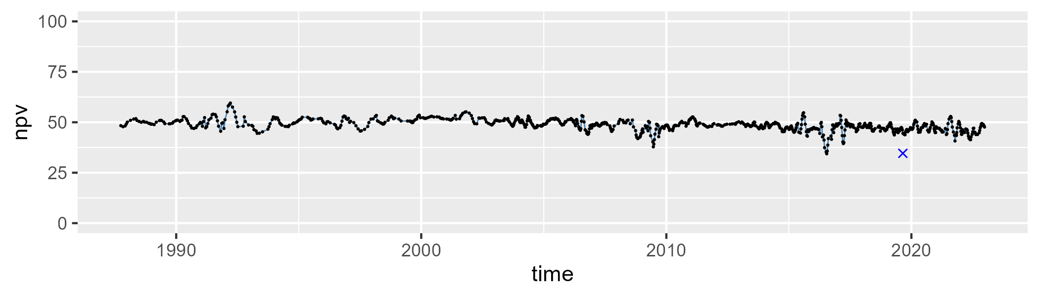

| Min. | 1st Qu. | Median | Mean | 3rd Qu. | Max. |
| --- | --- | --- | --- | --- | --- |
| 3.797074 | 21.78162 | 26.7228 | 26.04854 | 31.19545 | 39.42163 |

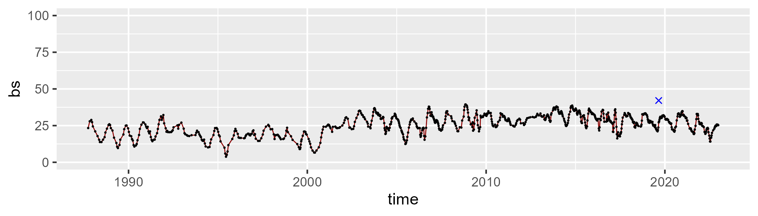

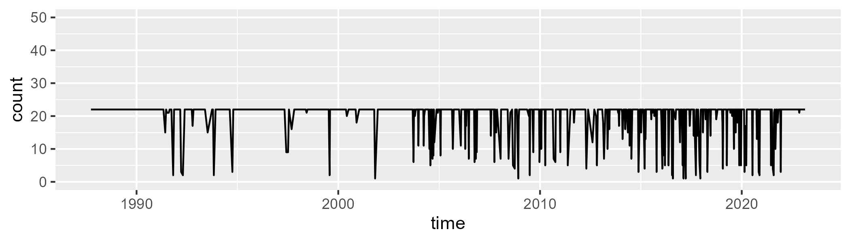

Min. : 1.0 1st Qu.:22.0 Median :22.0 Mean :20.2 3rd Qu.:22.0 Max. :22.0

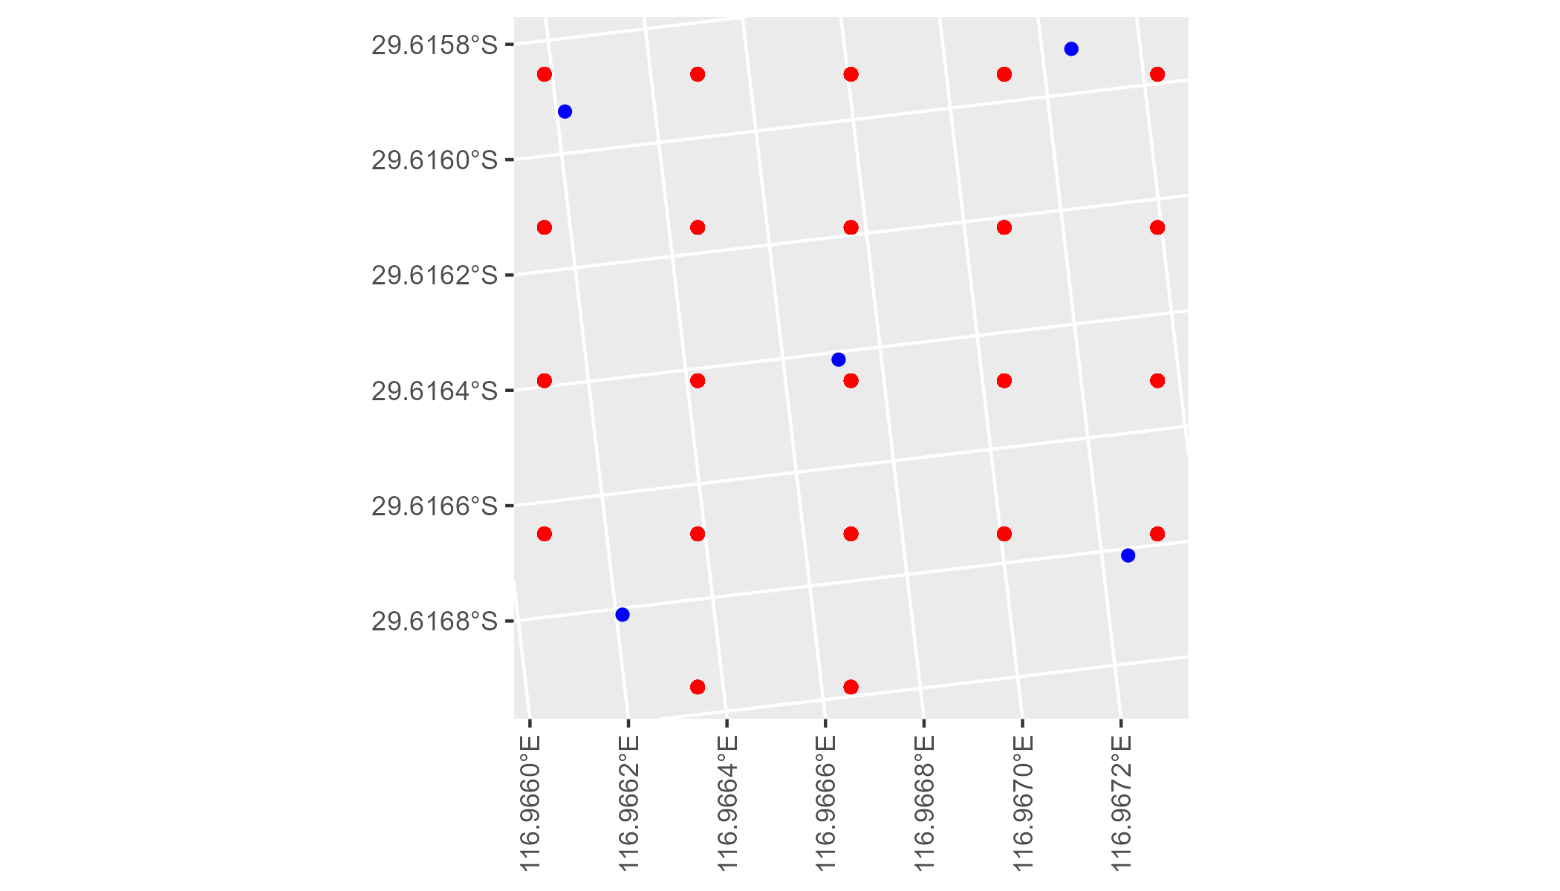

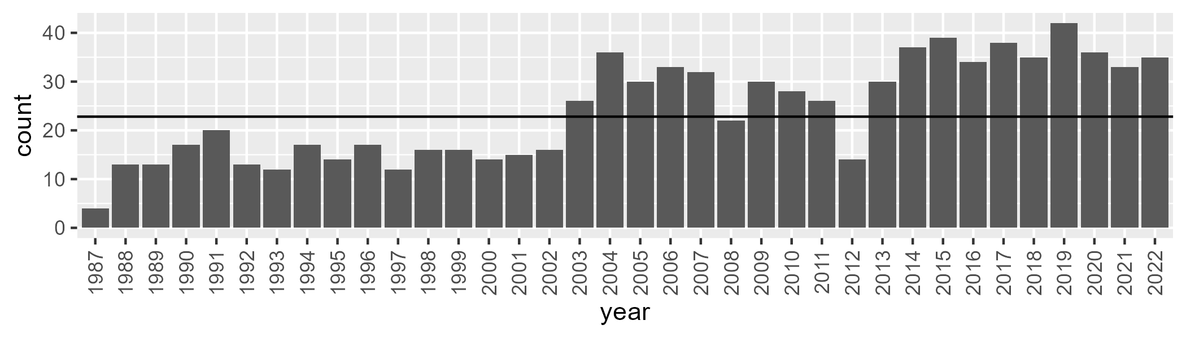

Number of samples: 865

# WAAAVW0006

| Min. | 1st Qu. | Median | Mean | 3rd Qu. | Max. |
| --- | --- | --- | --- | --- | --- |
| 3.788738 | 10.98563 | 15.73452 | 18.1664 | 23.72826 | 46.0352 |

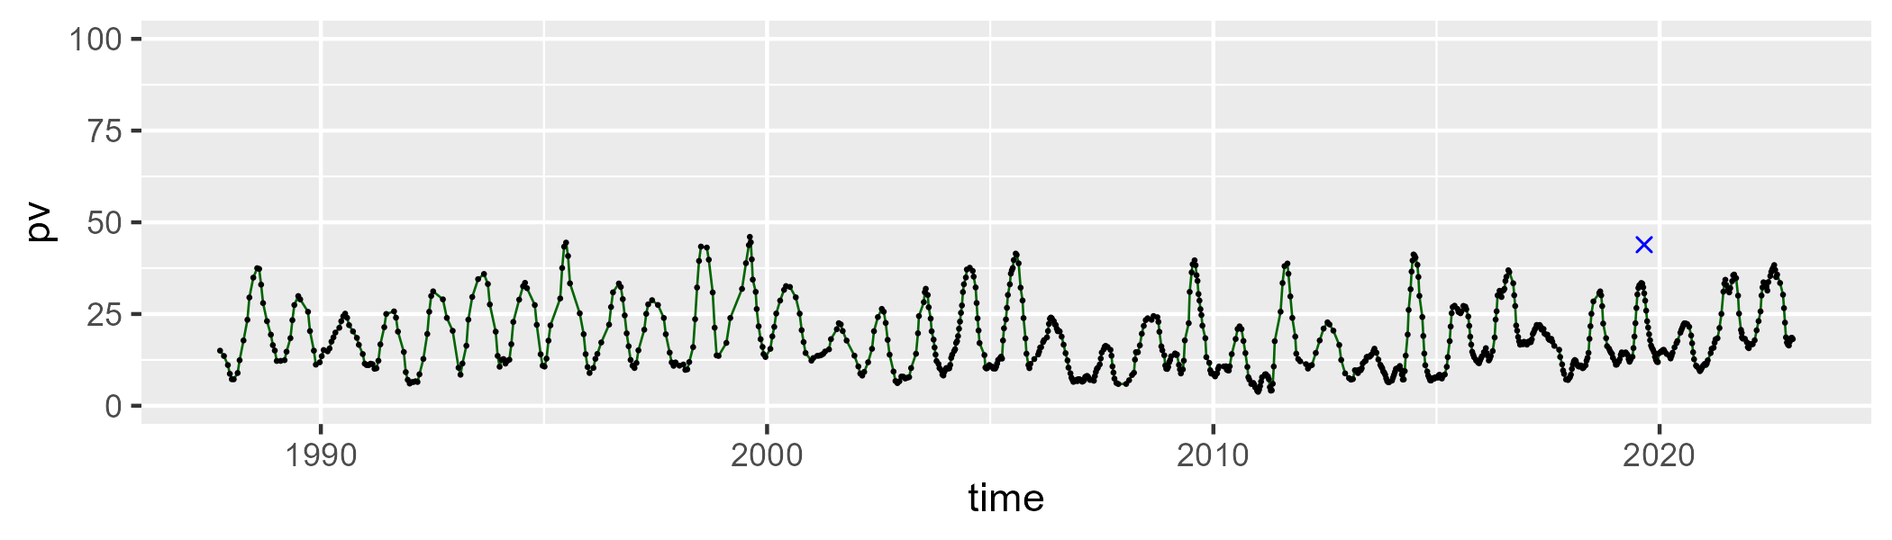

| Min. | 1st Qu. | Median | Mean | 3rd Qu. | Max. |
| --- | --- | --- | --- | --- | --- |
| 39.05821 | 54.73613 | 58.84235 | 57.9681 | 61.90032 | 70.02984 |

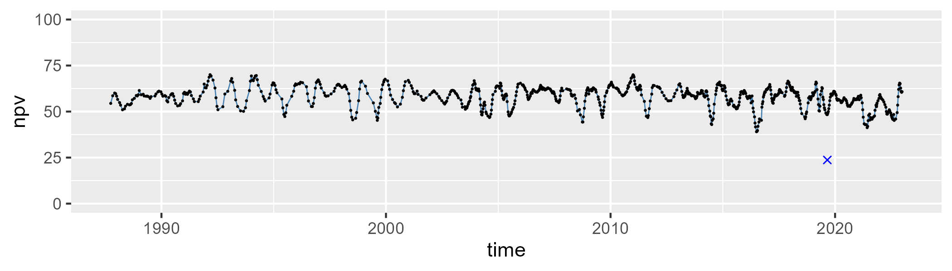

| Min. | 1st Qu. | Median | Mean | 3rd Qu. | Max. |
| --- | --- | --- | --- | --- | --- |
| 6.896169 | 18.63092 | 23.59349 | 22.63969 | 26.97391 | 36.9152 |

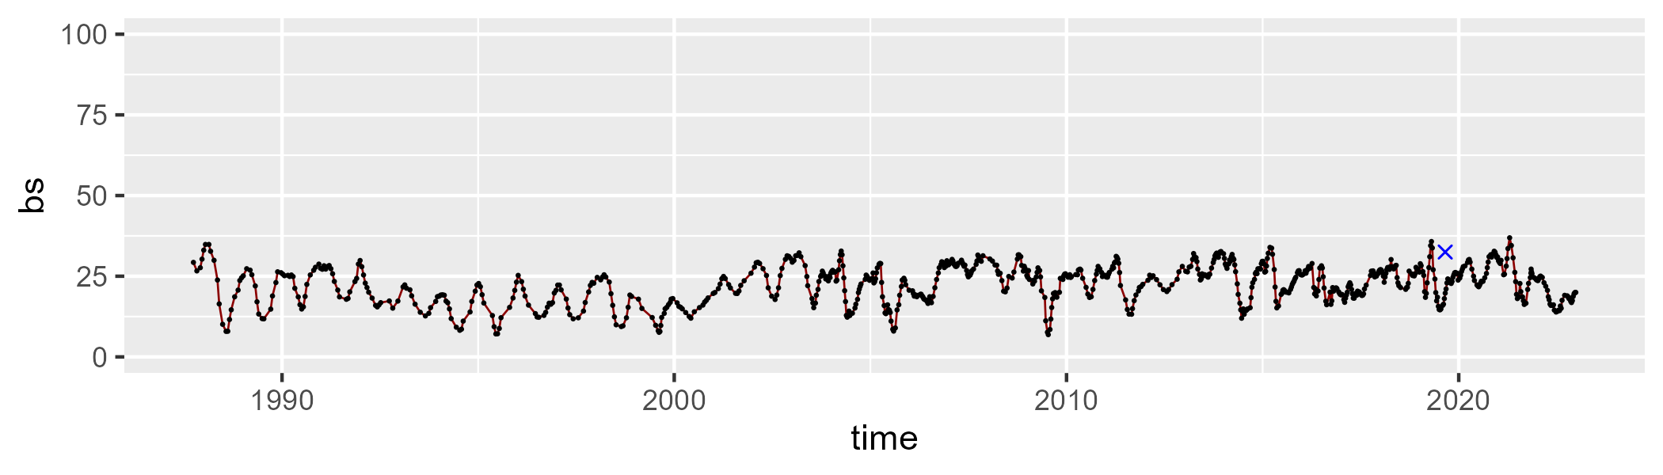

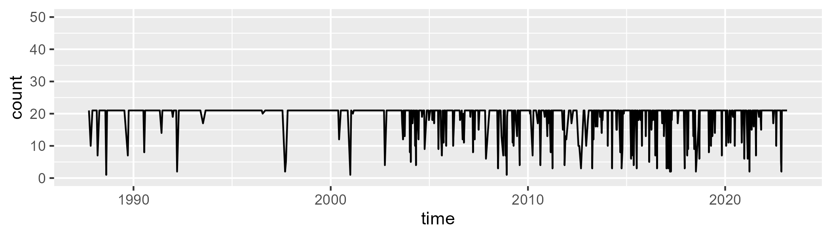

Min. : 1.00 1st Qu.:21.00 Median :21.00 Mean :19.29 3rd Qu.:21.00 Max. :21.00

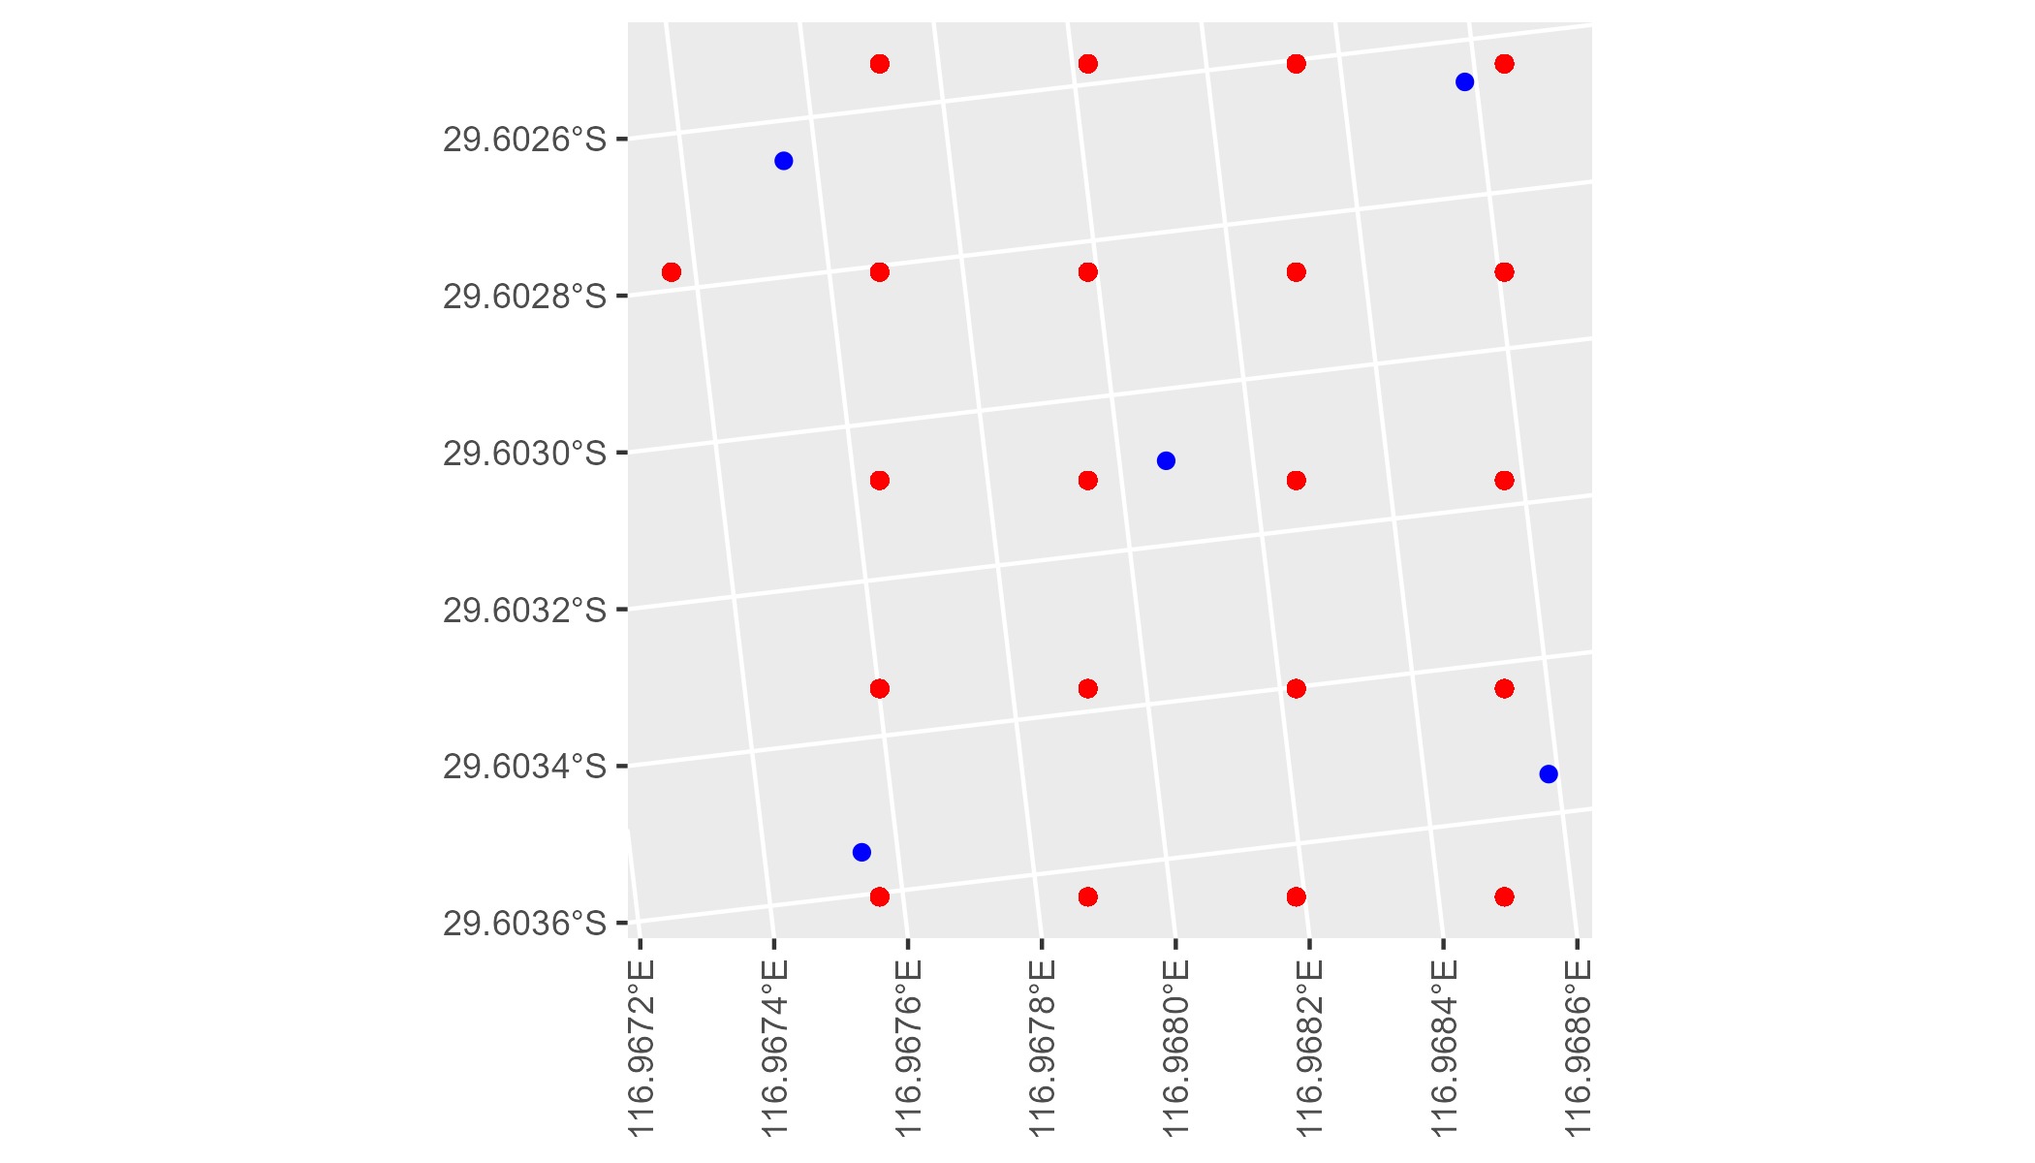

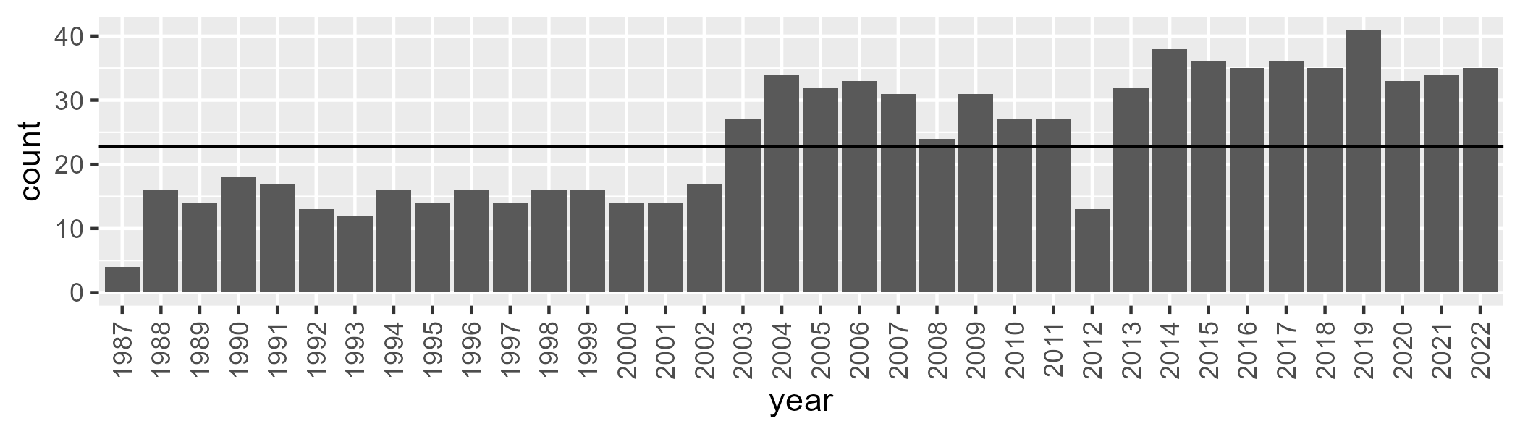

Number of samples: 865

# WAAAVW0007

| Min. | 1st Qu. | Median | Mean | 3rd Qu. | Max. |
| --- | --- | --- | --- | --- | --- |
| 0 | 9.651886 | 15.18782 | 16.40053 | 21.6998 | 49.89992 |

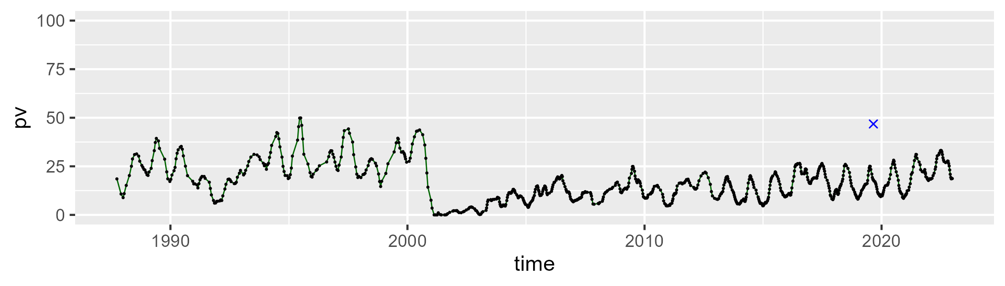

| Min. | 1st Qu. | Median | Mean | 3rd Qu. | Max. |
| --- | --- | --- | --- | --- | --- |
| 26.17315 | 48.6162 | 54.94372 | 54.13462 | 60.53689 | 75.06261 |

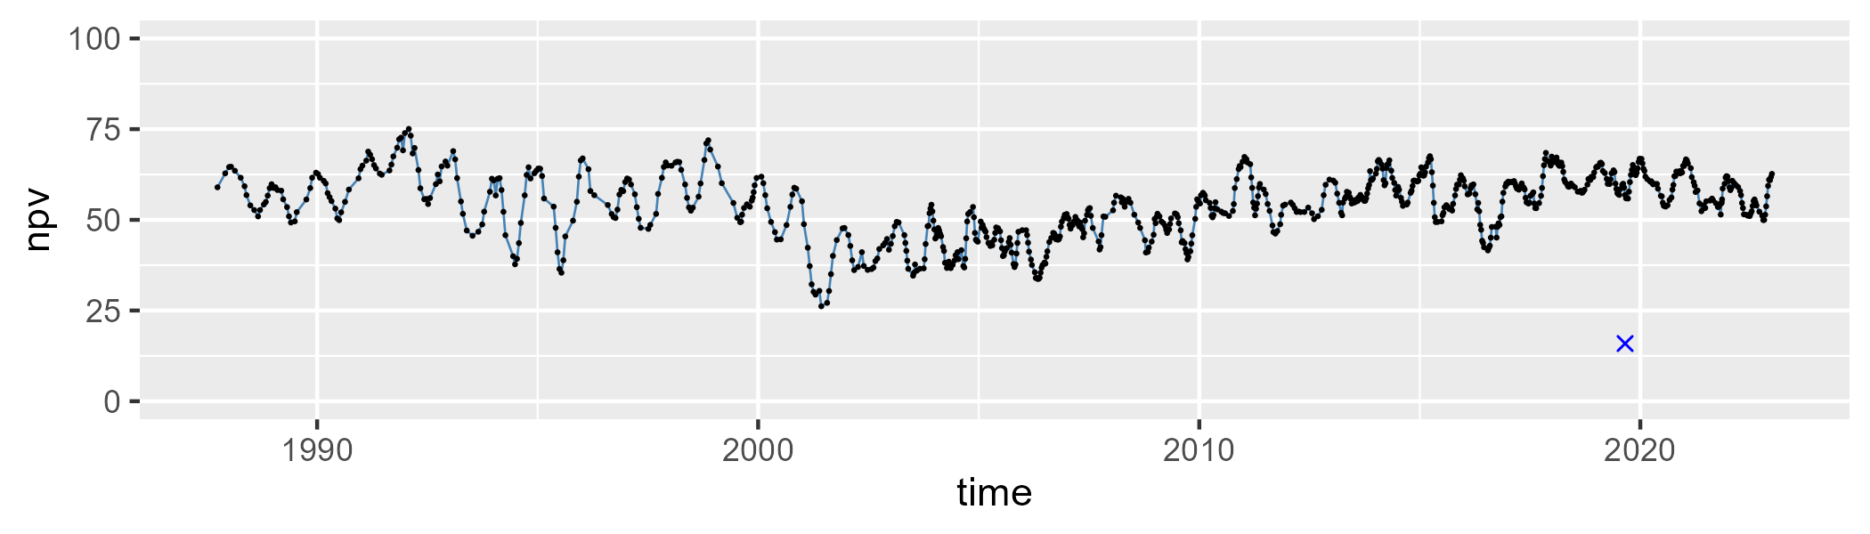

| Min. | 1st Qu. | Median | Mean | 3rd Qu. | Max. |
| --- | --- | --- | --- | --- | --- |
| 5.689012 | 18.69814 | 25.37884 | 28.15942 | 36.14211 | 73.12973 |

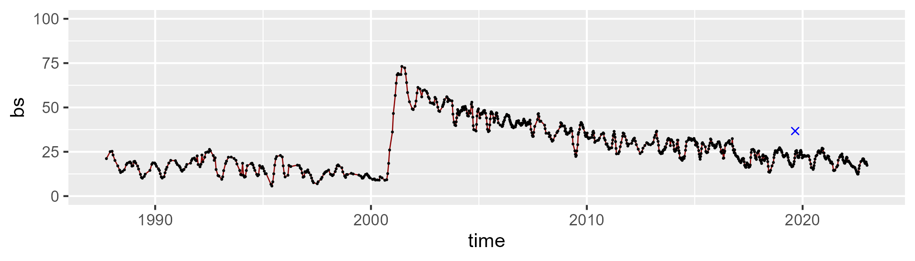

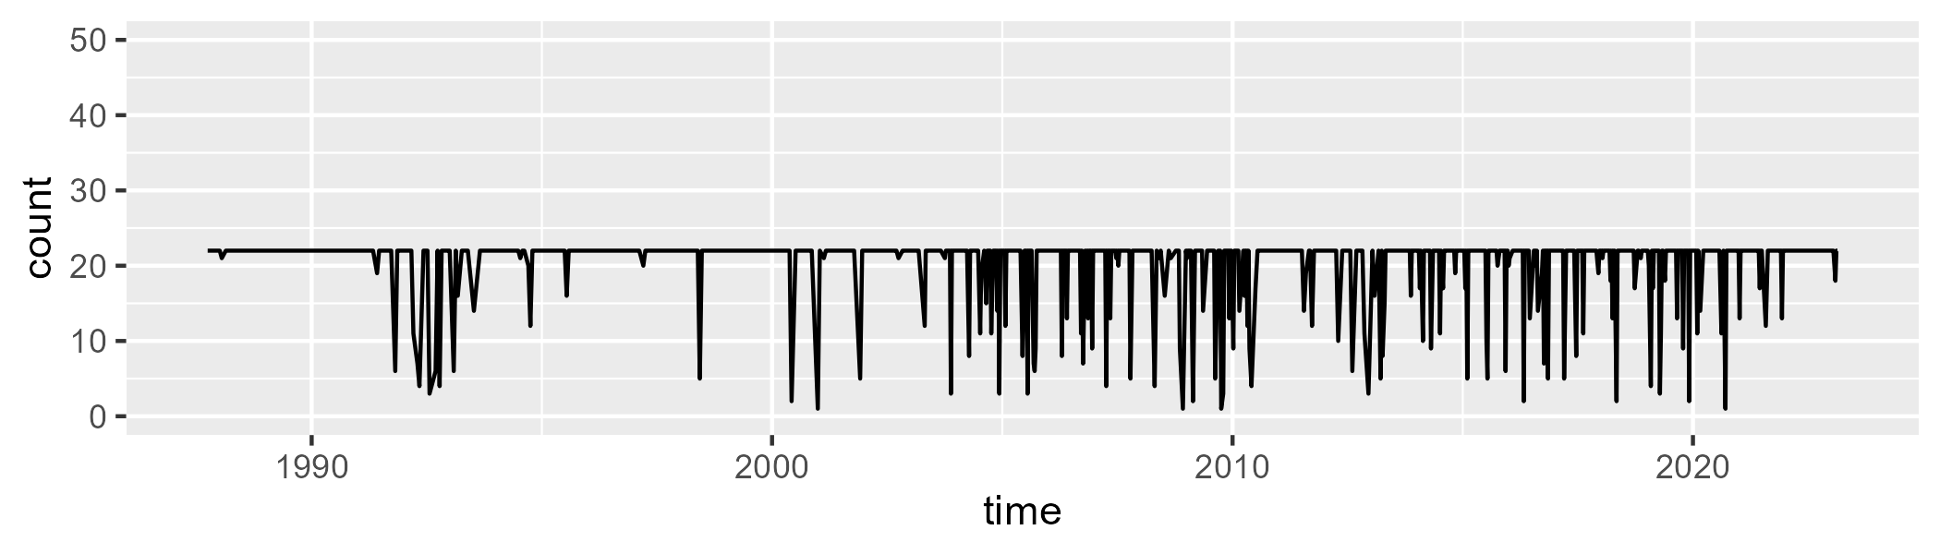

Min. : 1.00 1st Qu.:22.00 Median :22.00 Mean :20.36 3rd Qu.:22.00 Max. :22.00

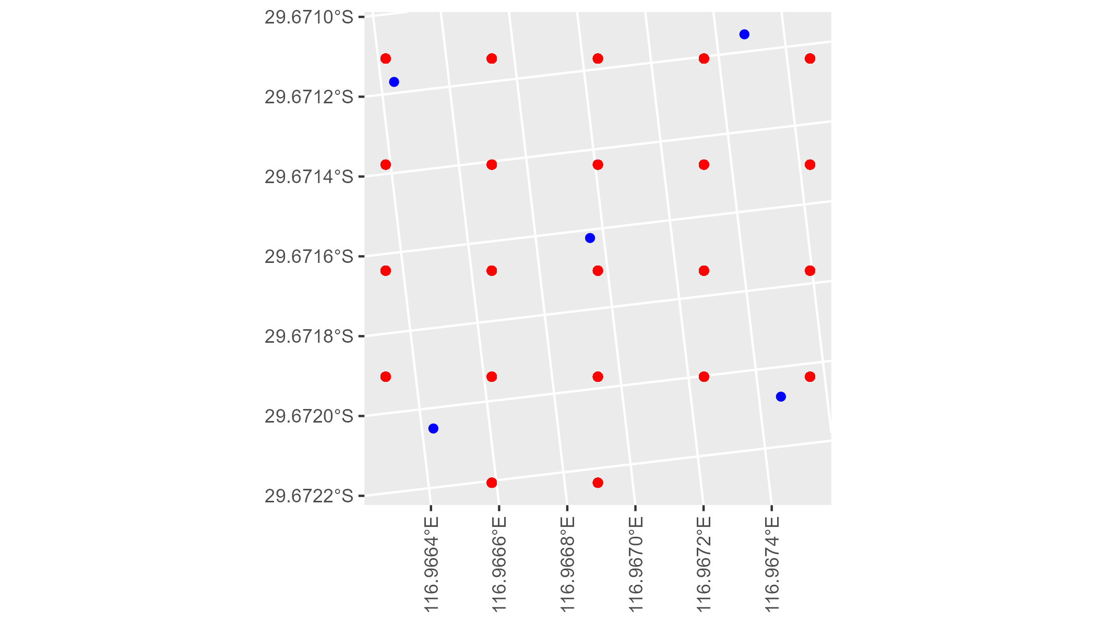

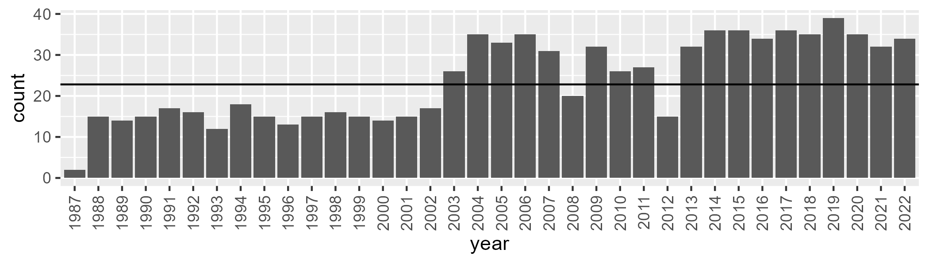

Number of samples: 858

# WAACAR0001

| Min. | 1st Qu. | Median | Mean | 3rd Qu. | Max. |
| --- | --- | --- | --- | --- | --- |
| 3.070526 | 9.572101 | 11.29158 | 12.48622 | 13.69737 | 36.94996 |

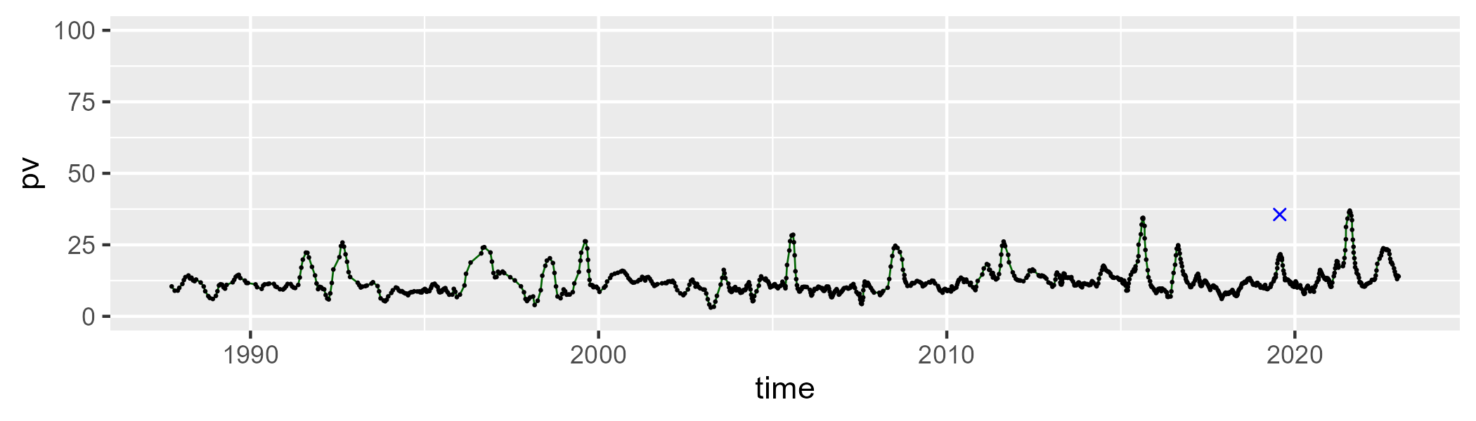

| Min. | 1st Qu. | Median | Mean | 3rd Qu. | Max. |
| --- | --- | --- | --- | --- | --- |
| 17.19182 | 29.14997 | 32.71019 | 33.2719 | 37.16739 | 57.5909 |

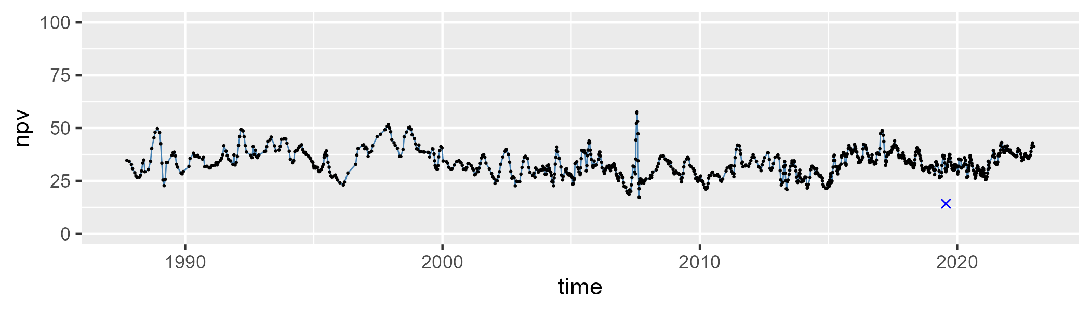

| Min. | 1st Qu. | Median | Mean | 3rd Qu. | Max. |
| --- | --- | --- | --- | --- | --- |
| 25.27962 | 48.14548 | 54.23483 | 52.76087 | 58.15458 | 69.55718 |

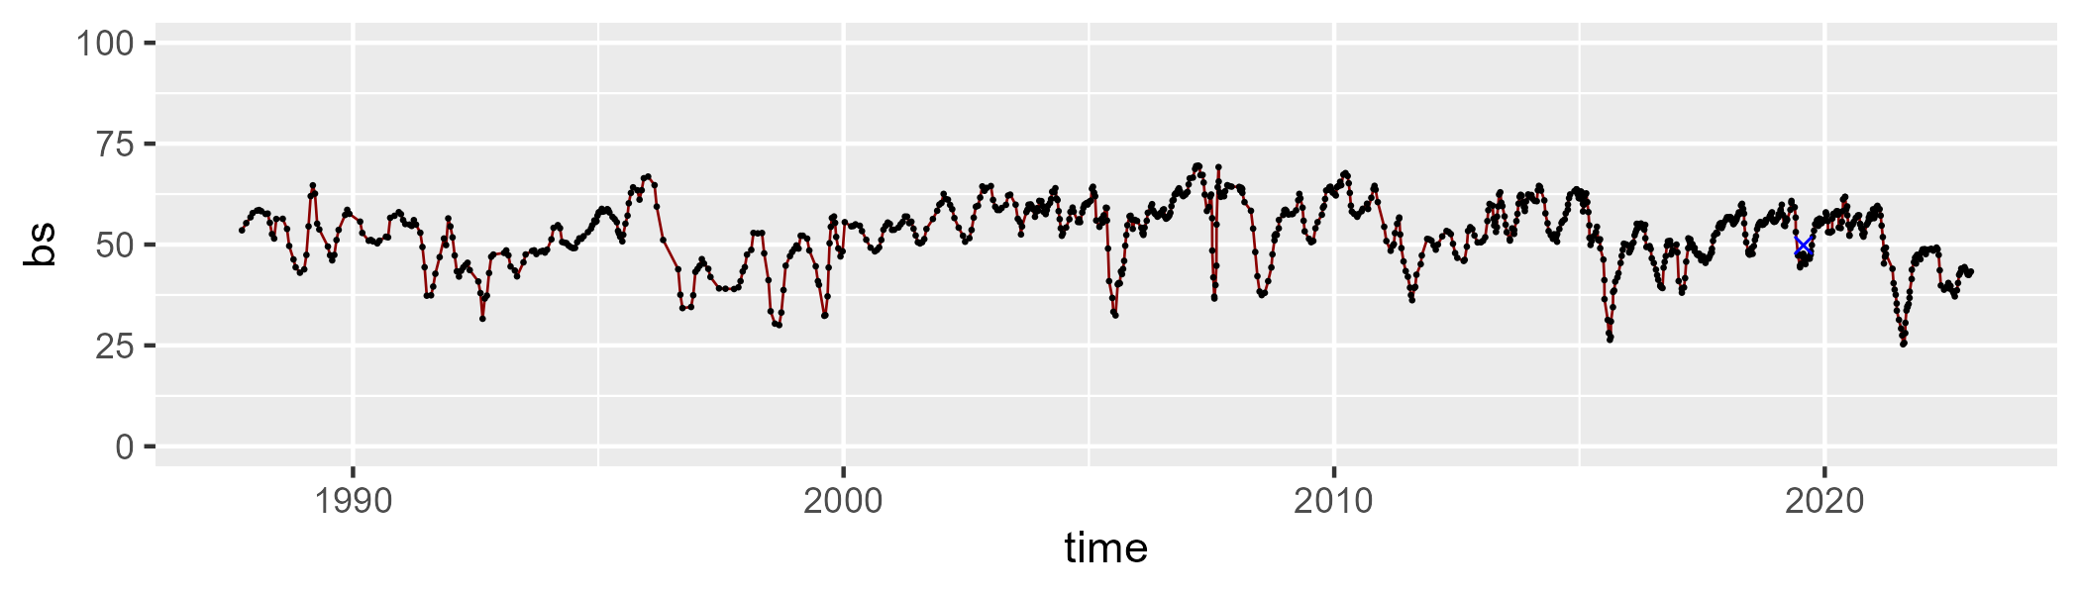

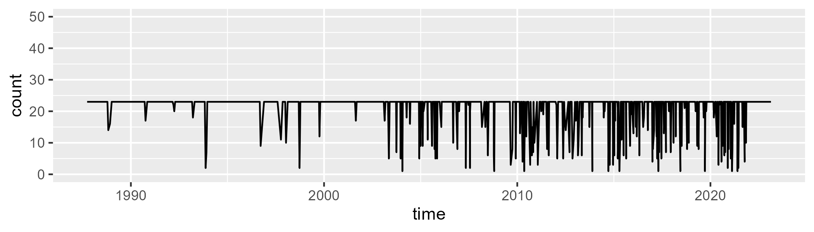

Min. : 1.00 1st Qu.:23.00 Median :23.00 Mean :21.05 3rd Qu.:23.00 Max. :23.00

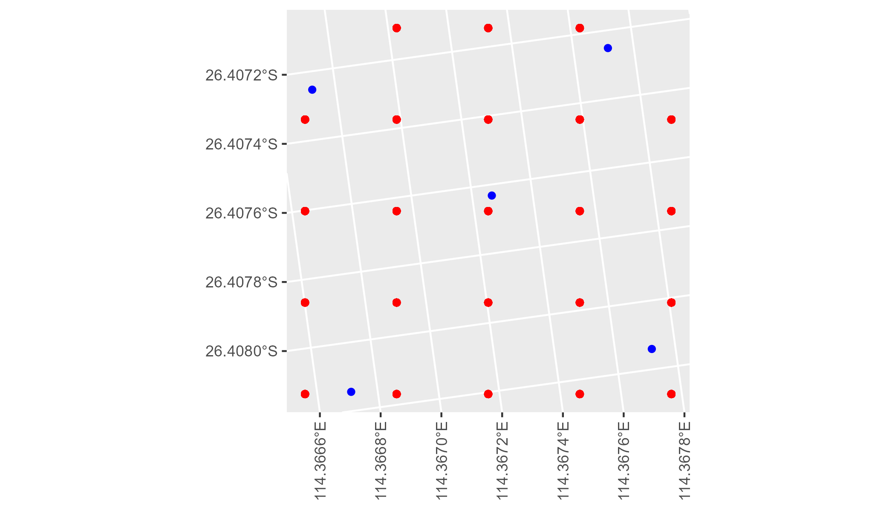

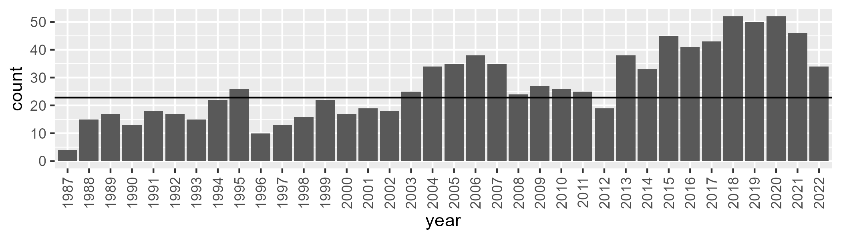

Number of samples: 984

# WAACAR0002

| Min. | 1st Qu. | Median | Mean | 3rd Qu. | Max. |
| --- | --- | --- | --- | --- | --- |
| 8.088208 | 13.69791 | 16.26922 | 16.98644 | 19.66078 | 33.9443 |

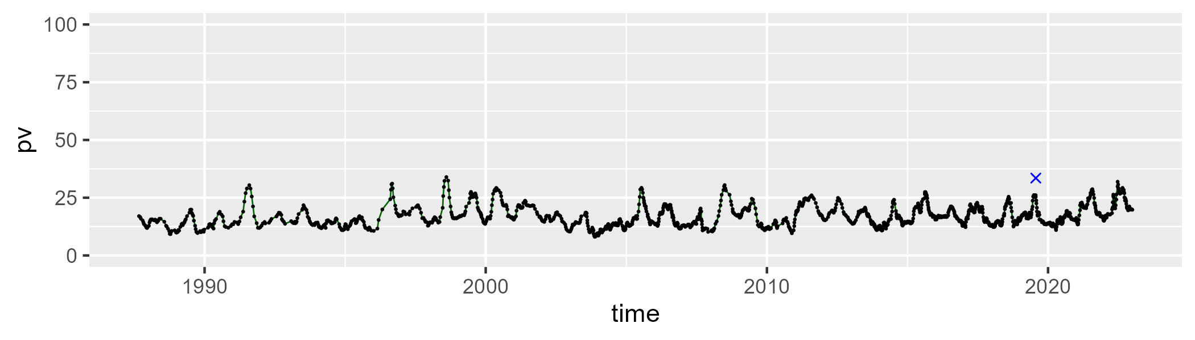

| Min. | 1st Qu. | Median | Mean | 3rd Qu. | Max. |
| --- | --- | --- | --- | --- | --- |
| 25.25879 | 34.54399 | 37.70075 | 38.00152 | 41.37891 | 53.60756 |

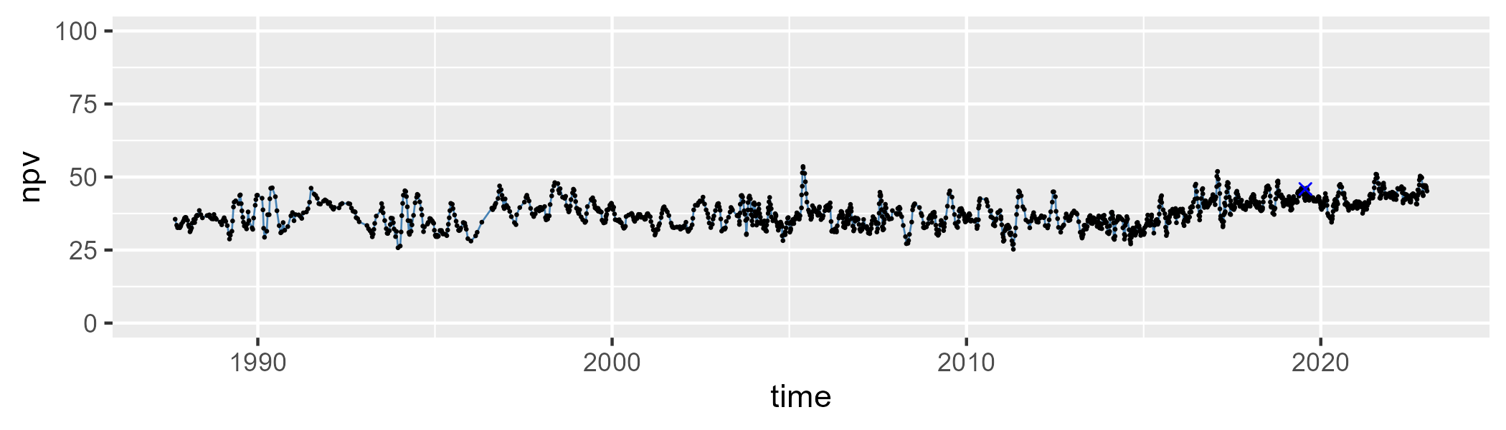

| Min. | 1st Qu. | Median | Mean | 3rd Qu. | Max. |
| --- | --- | --- | --- | --- | --- |
| 19.23232 | 39.31791 | 44.22987 | 43.55347 | 49.02842 | 59.81605 |

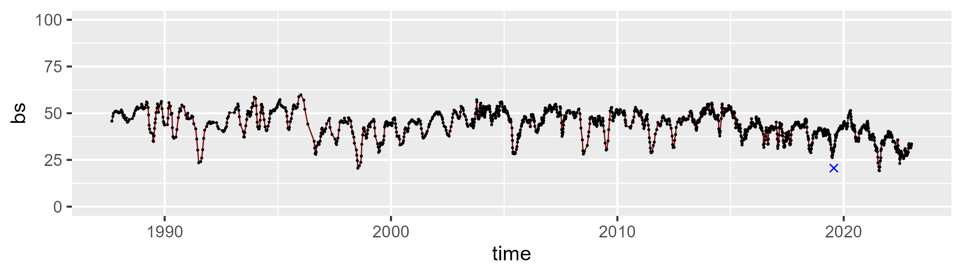

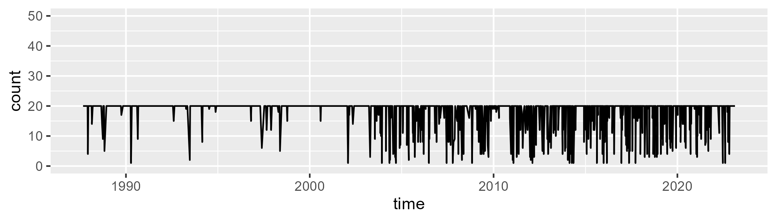

Min. : 1.00 1st Qu.:20.00 Median :20.00 Mean :18.21 3rd Qu.:20.00 Max. :20.00

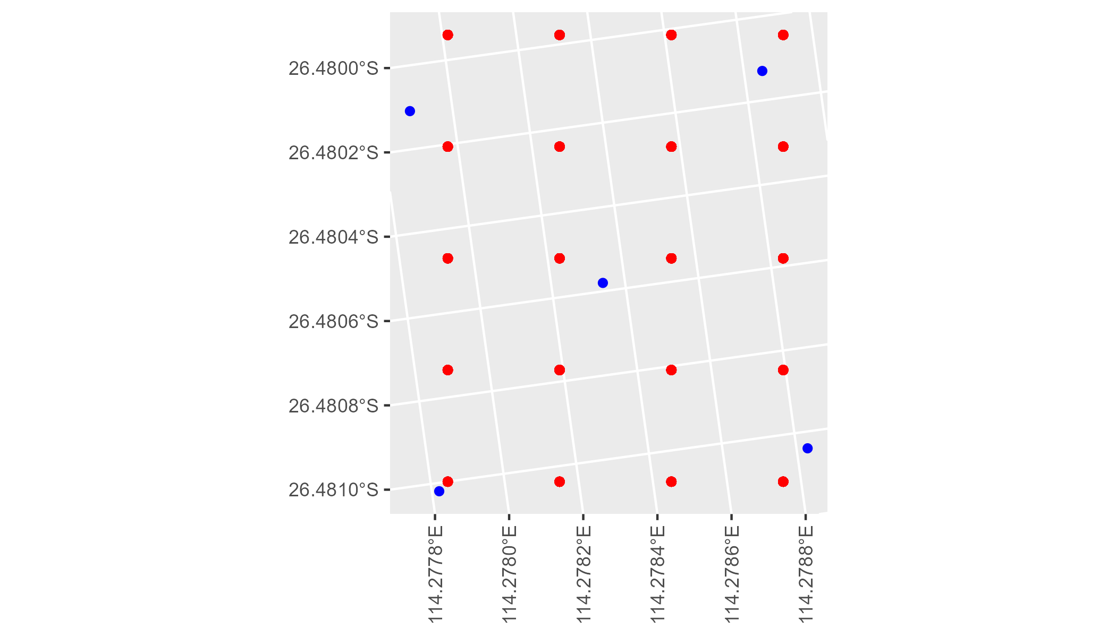

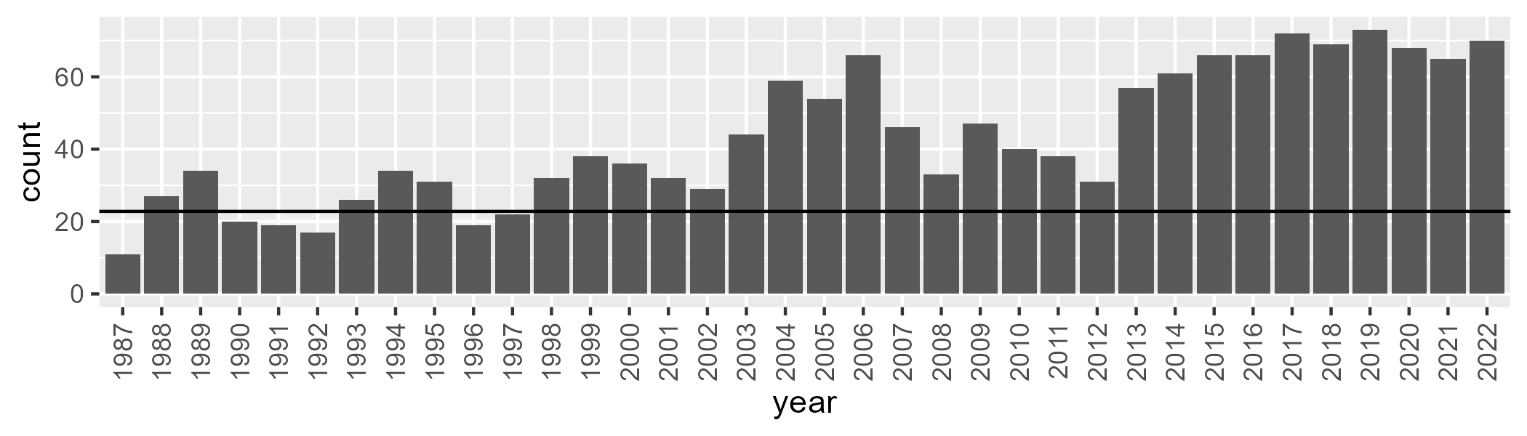

Number of samples: 1552

# WAACAR0003

| Min. | 1st Qu. | Median | Mean | 3rd Qu. | Max. |
| --- | --- | --- | --- | --- | --- |
| 7.966325 | 13.96337 | 16.72287 | 17.88701 | 20.73743 | 38.69765 |

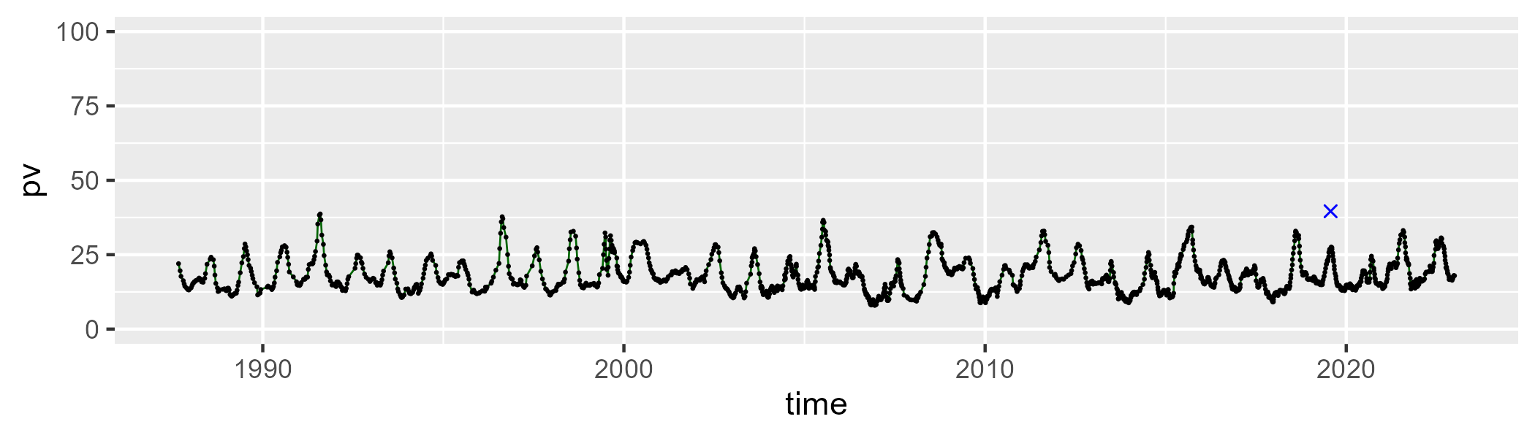

| Min. | 1st Qu. | Median | Mean | 3rd Qu. | Max. |
| --- | --- | --- | --- | --- | --- |
| 35.31869 | 46.74784 | 48.8074 | 48.96434 | 50.90681 | 66.4208 |

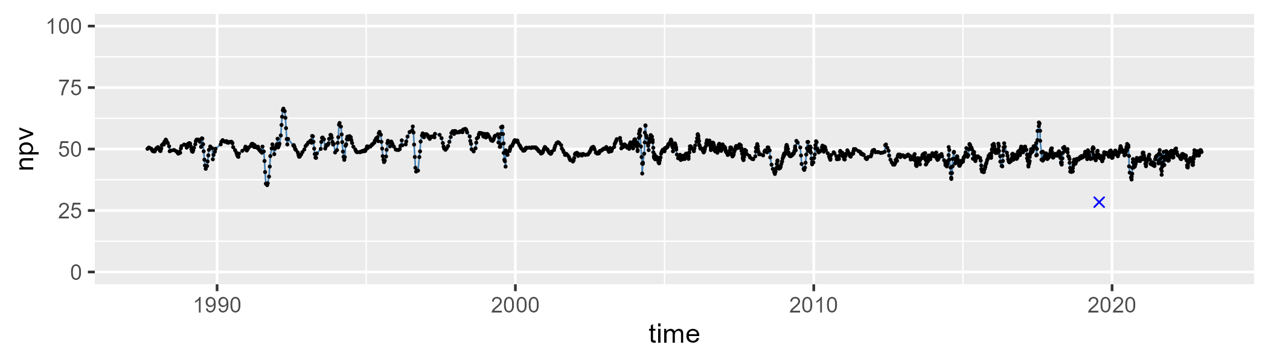

| Min. | 1st Qu. | Median | Mean | 3rd Qu. | Max. |
| --- | --- | --- | --- | --- | --- |
| 9.659905 | 28.58156 | 32.45652 | 31.88385 | 35.97358 | 44.6698 |

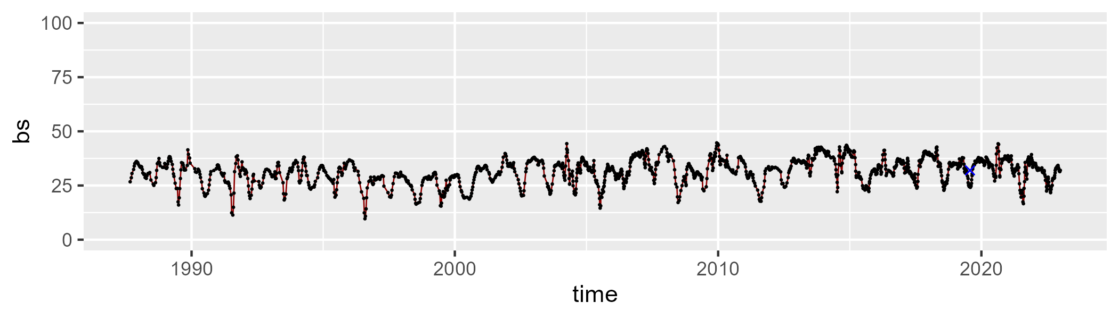

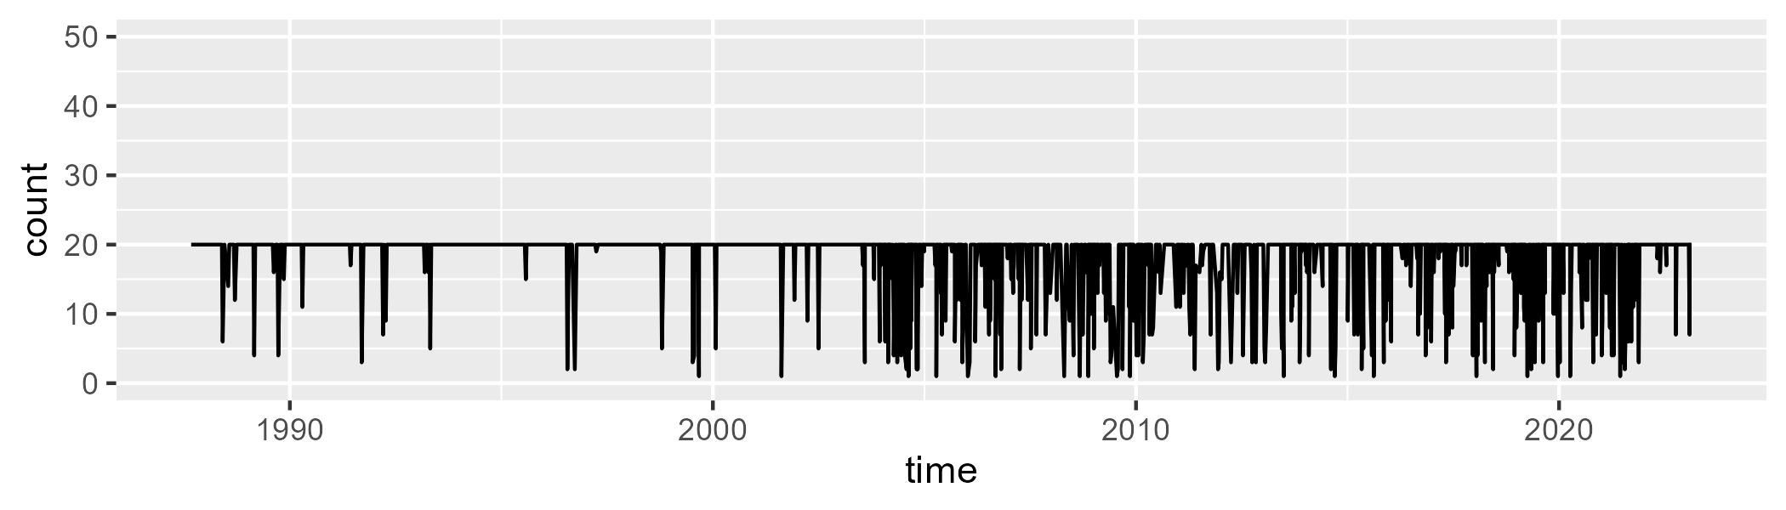

Min. : 1.00 1st Qu.:20.00 Median :20.00 Mean :18.17 3rd Qu.:20.00 Max. :20.00

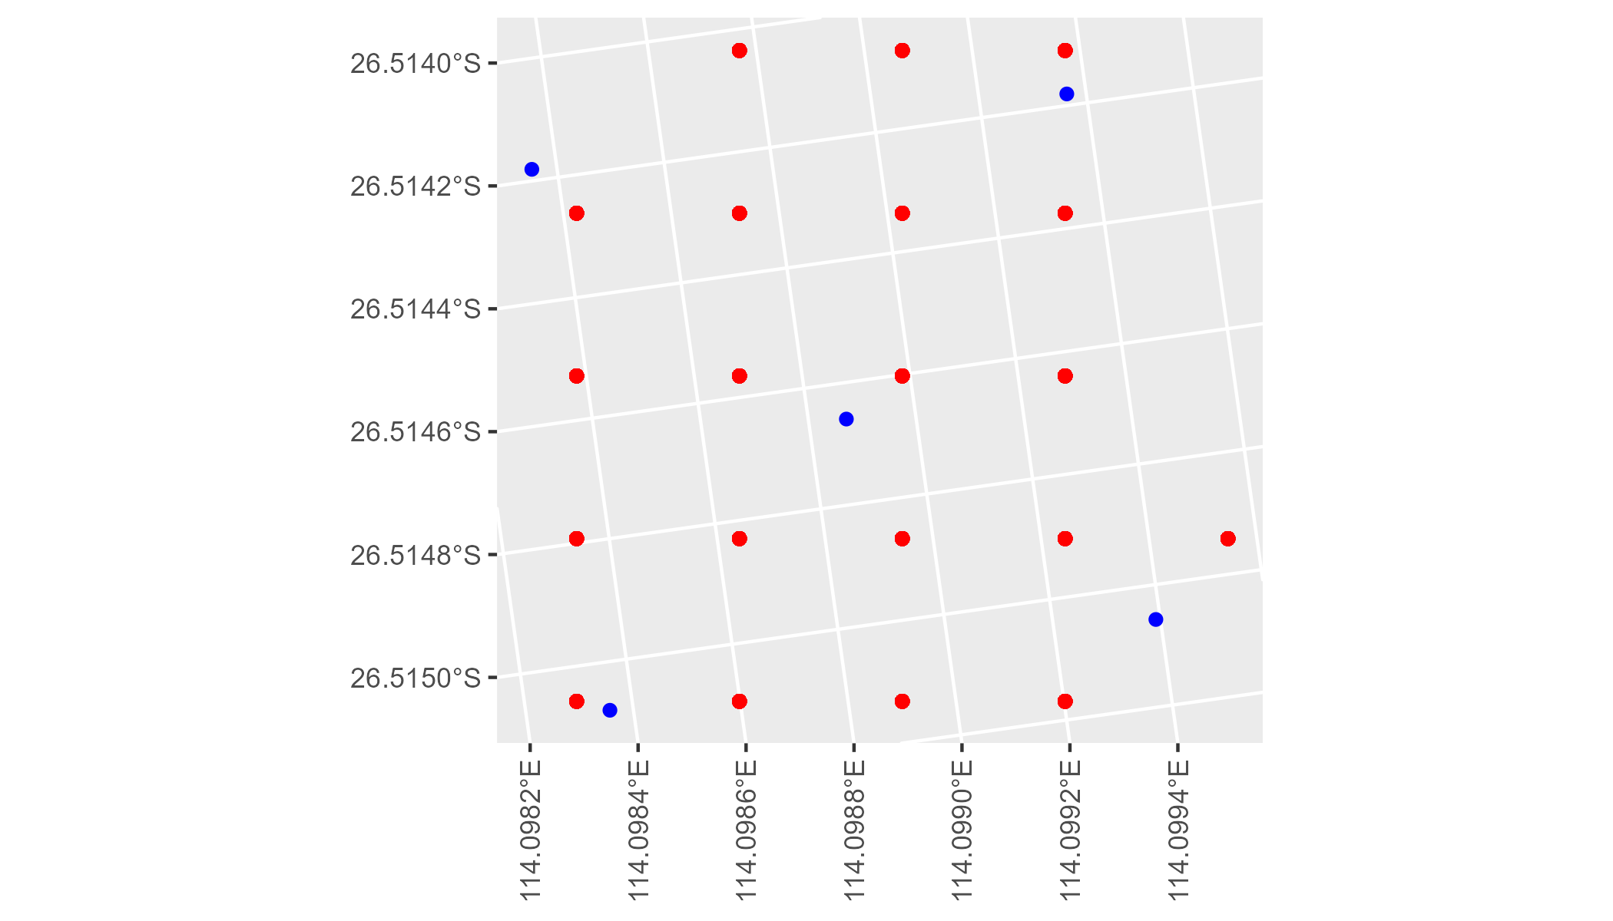

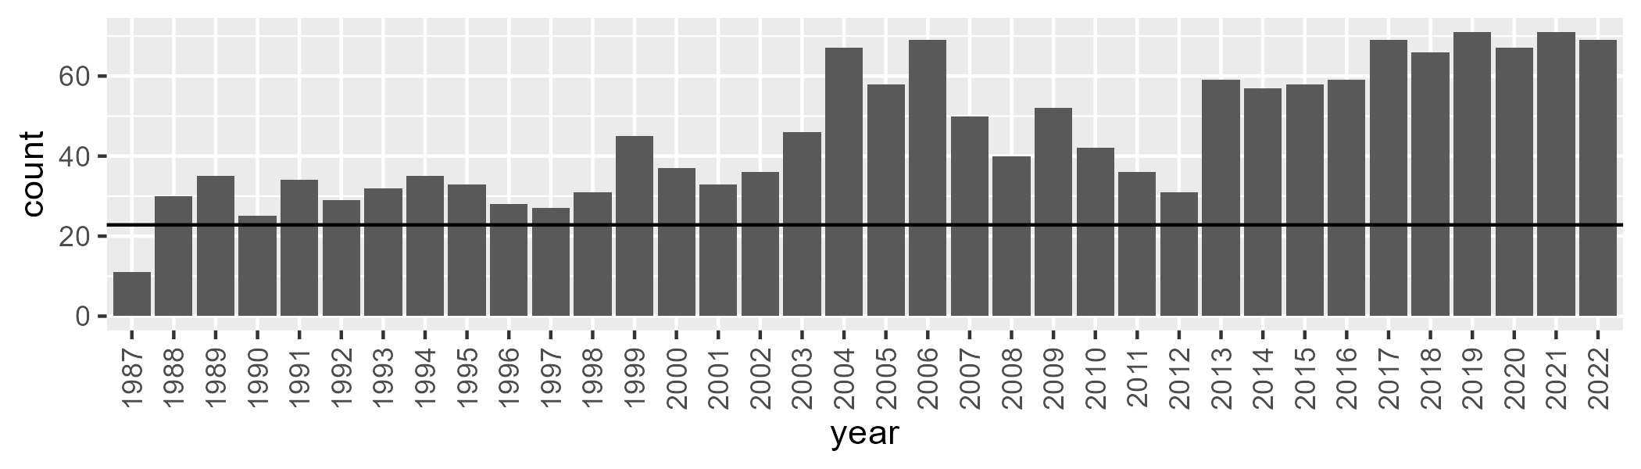

Number of samples: 1638

# WAACAR0004

| Min. | 1st Qu. | Median | Mean | 3rd Qu. | Max. |
| --- | --- | --- | --- | --- | --- |
| 0 | 3.882779 | 6.858324 | 9.690155 | 12.58787 | 54.55024 |

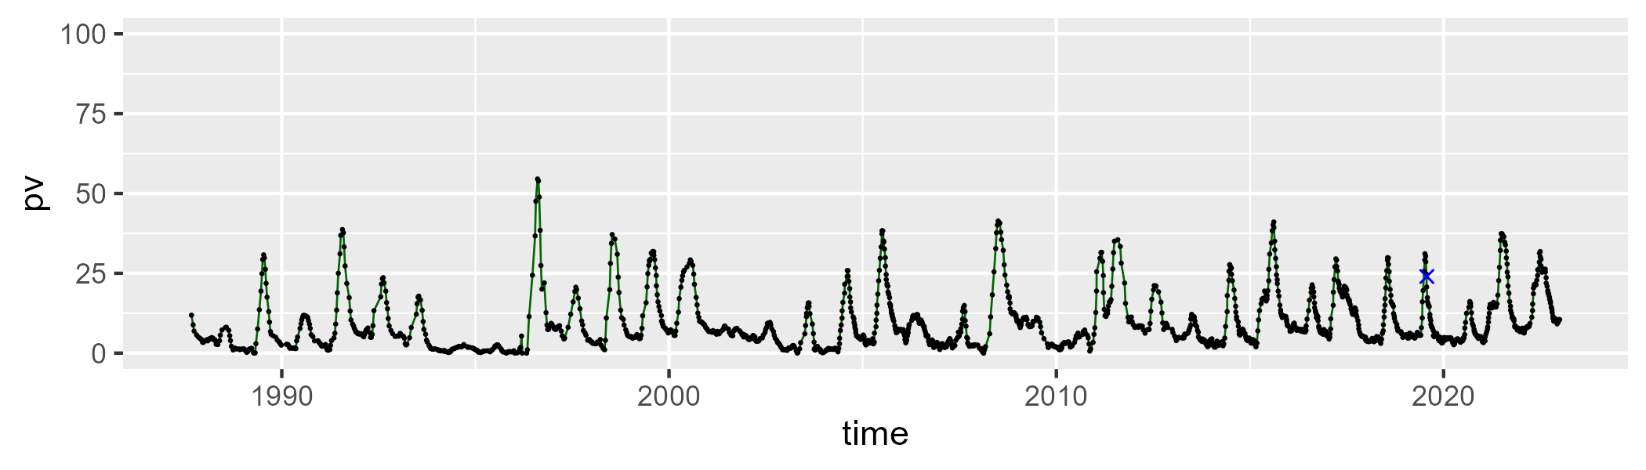

| Min. | 1st Qu. | Median | Mean | 3rd Qu. | Max. |
| --- | --- | --- | --- | --- | --- |
| 28.92518 | 45.465 | 49.25294 | 49.62946 | 53.91642 | 70.51764 |

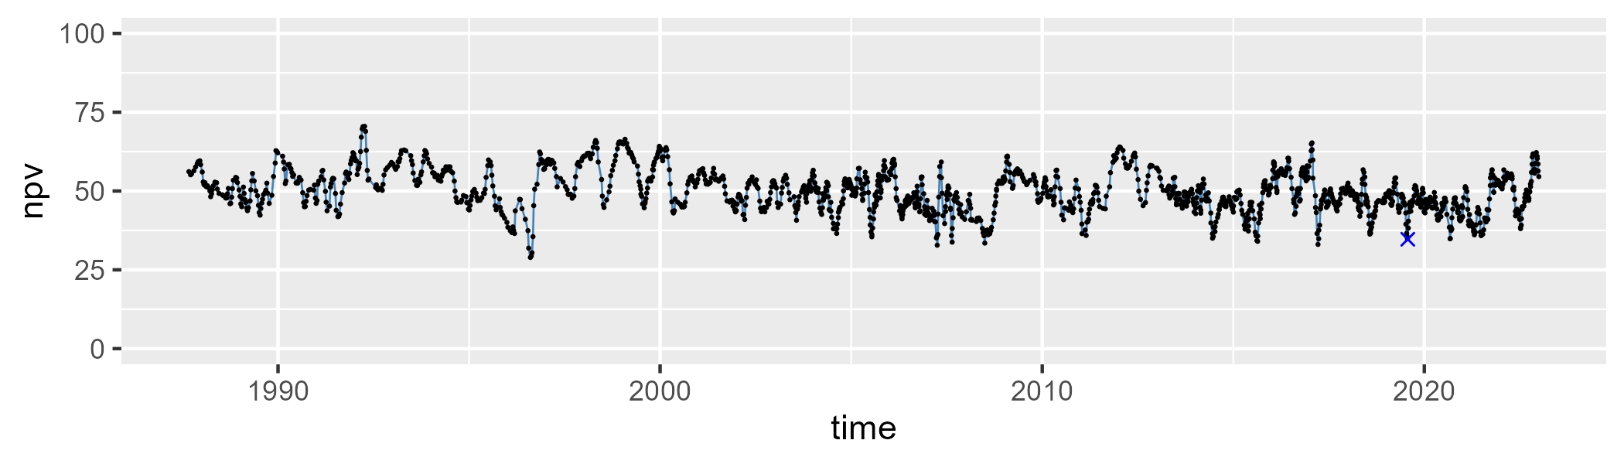

| Min. | 1st Qu. | Median | Mean | 3rd Qu. | Max. |
| --- | --- | --- | --- | --- | --- |
| 15.7399 | 33.31222 | 39.8793 | 39.29652 | 45.81773 | 61.6307 |

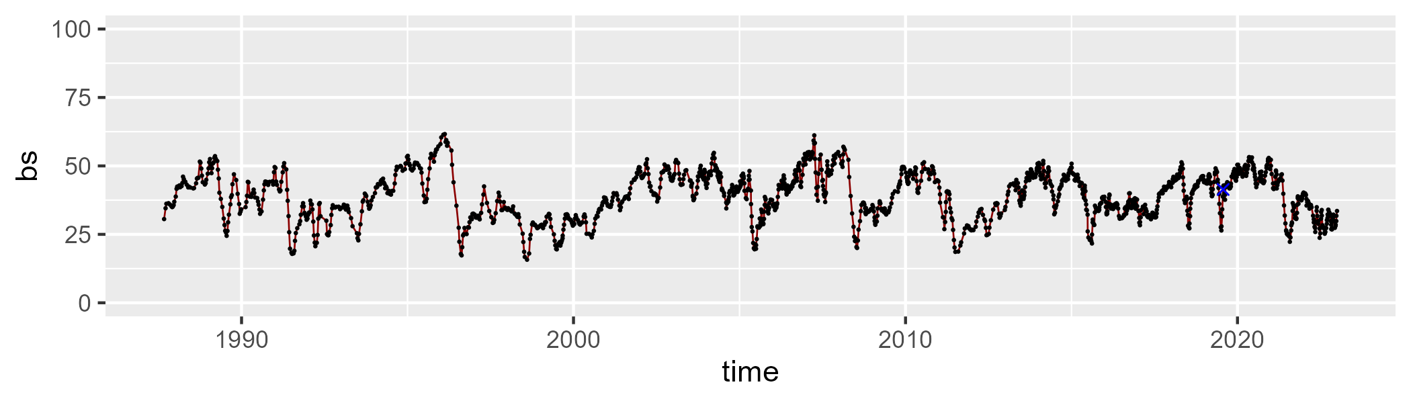

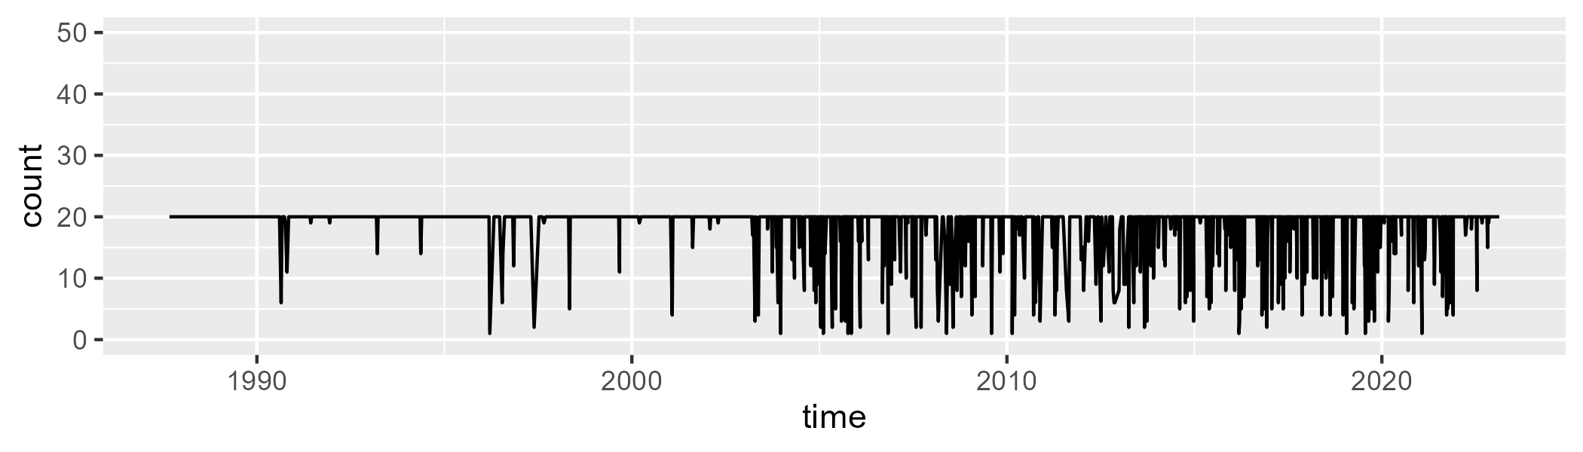

Min. : 1.00 1st Qu.:20.00 Median :20.00 Mean :18.49 3rd Qu.:20.00 Max. :20.00

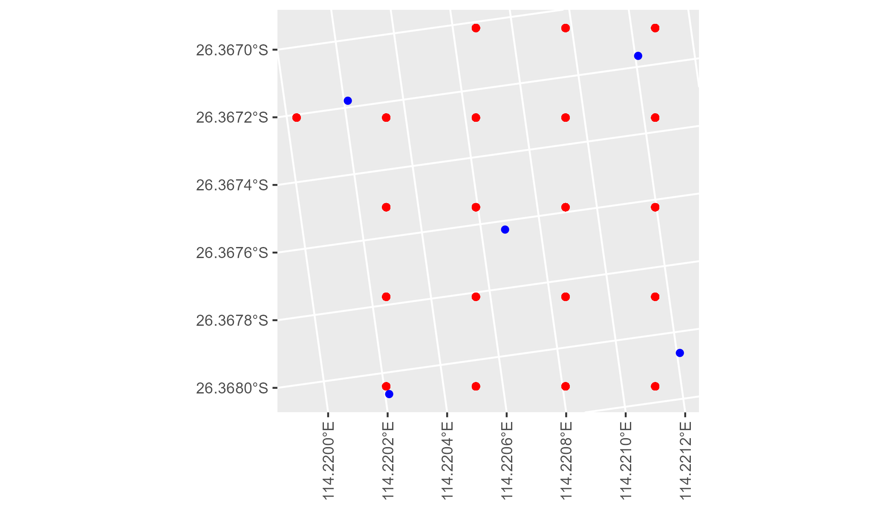

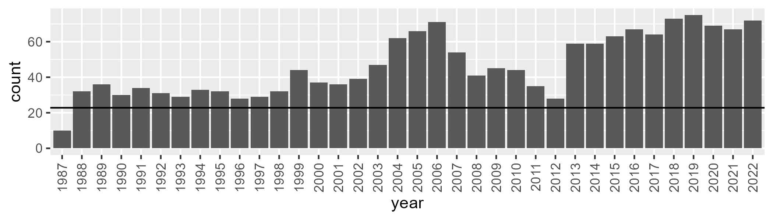

Number of samples: 1673

# WAACEK0001

| Min. | 1st Qu. | Median | Mean | 3rd Qu. | Max. |
| --- | --- | --- | --- | --- | --- |
| 13.09571 | 24.95112 | 29.42079 | 31.38701 | 37.09608 | 54.24413 |

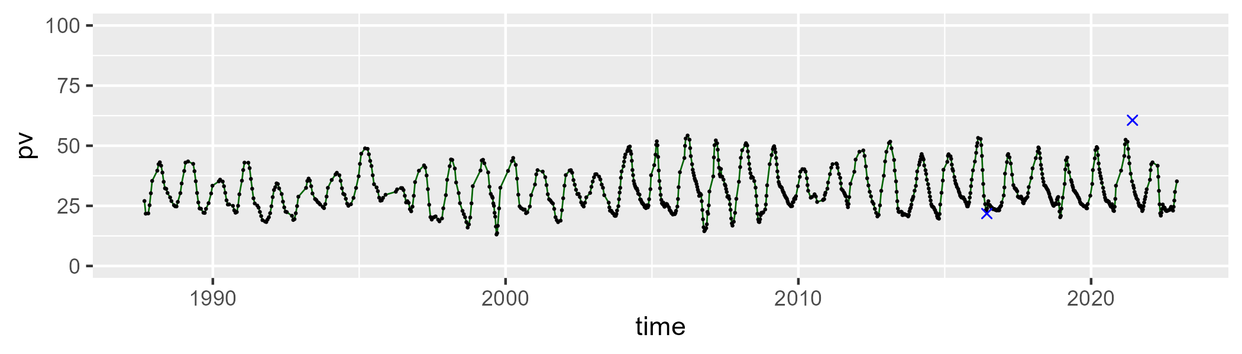

| Min. | 1st Qu. | Median | Mean | 3rd Qu. | Max. |
| --- | --- | --- | --- | --- | --- |
| 28.87803 | 43.64818 | 47.99033 | 48.07047 | 52.52013 | 65.50888 |

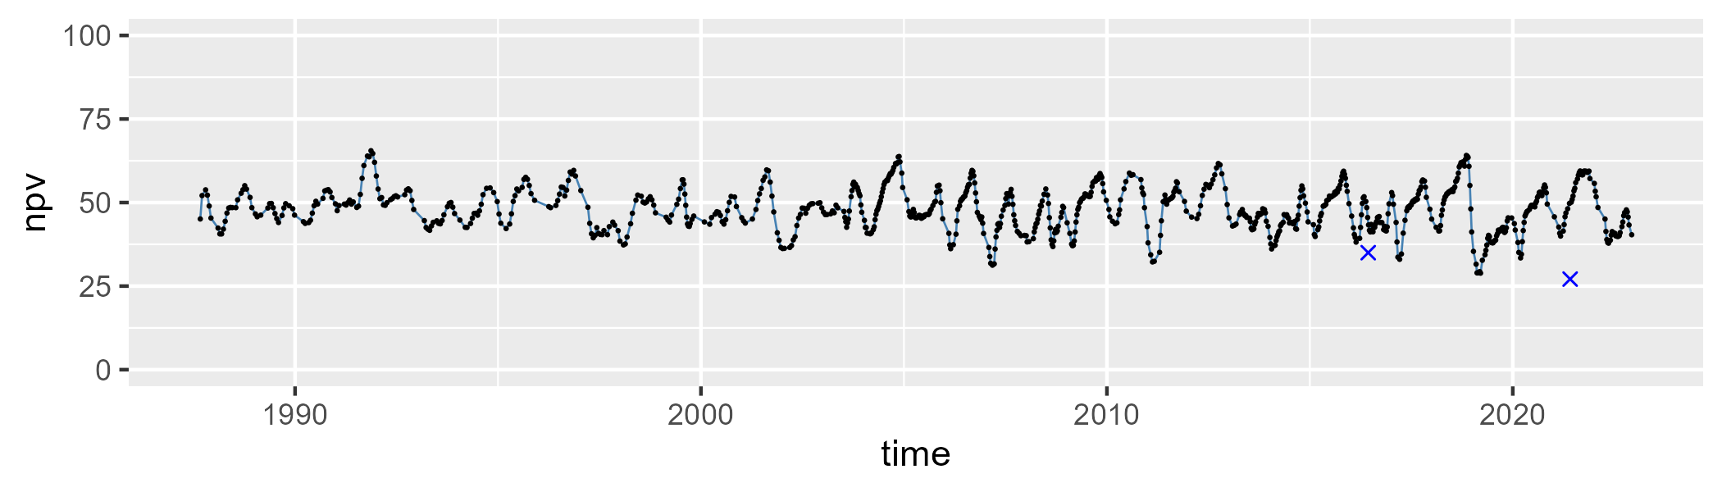

| Min. | 1st Qu. | Median | Mean | 3rd Qu. | Max. |
| --- | --- | --- | --- | --- | --- |
| 1.229696 | 13.35375 | 17.63178 | 19.26613 | 25.31676 | 43.46408 |

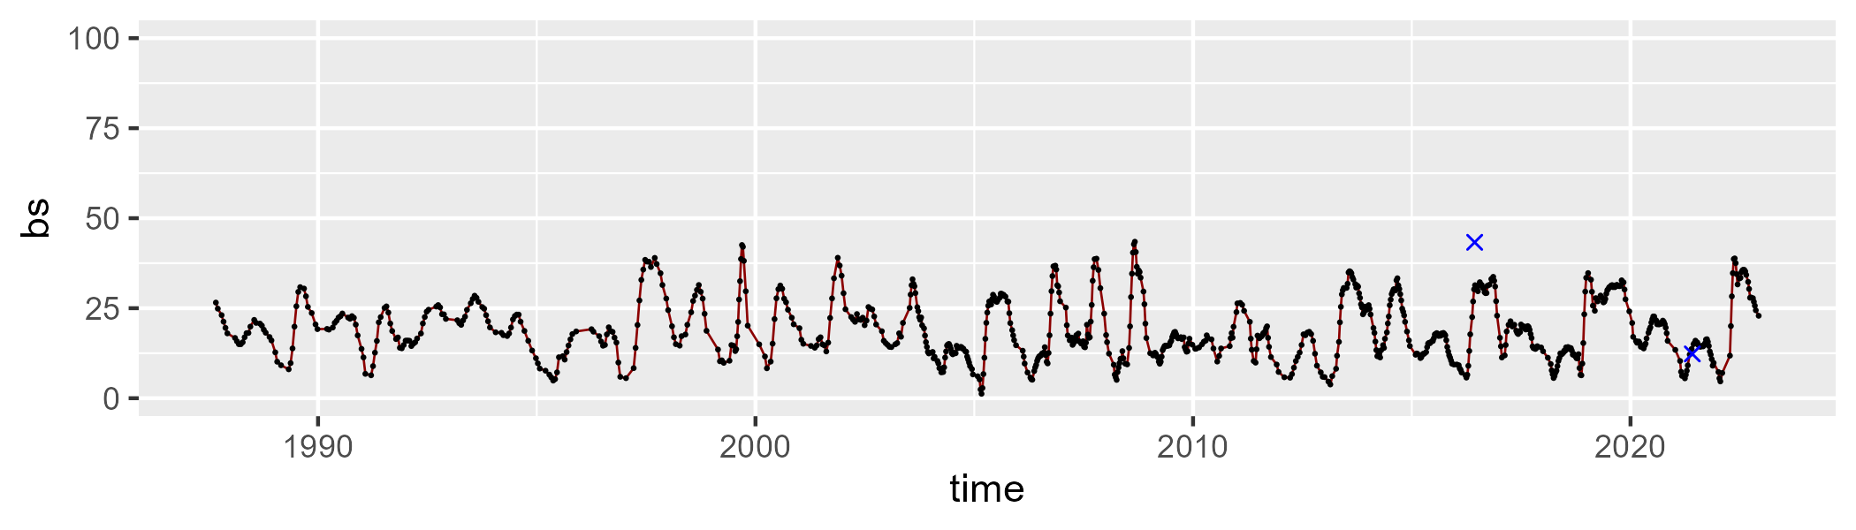

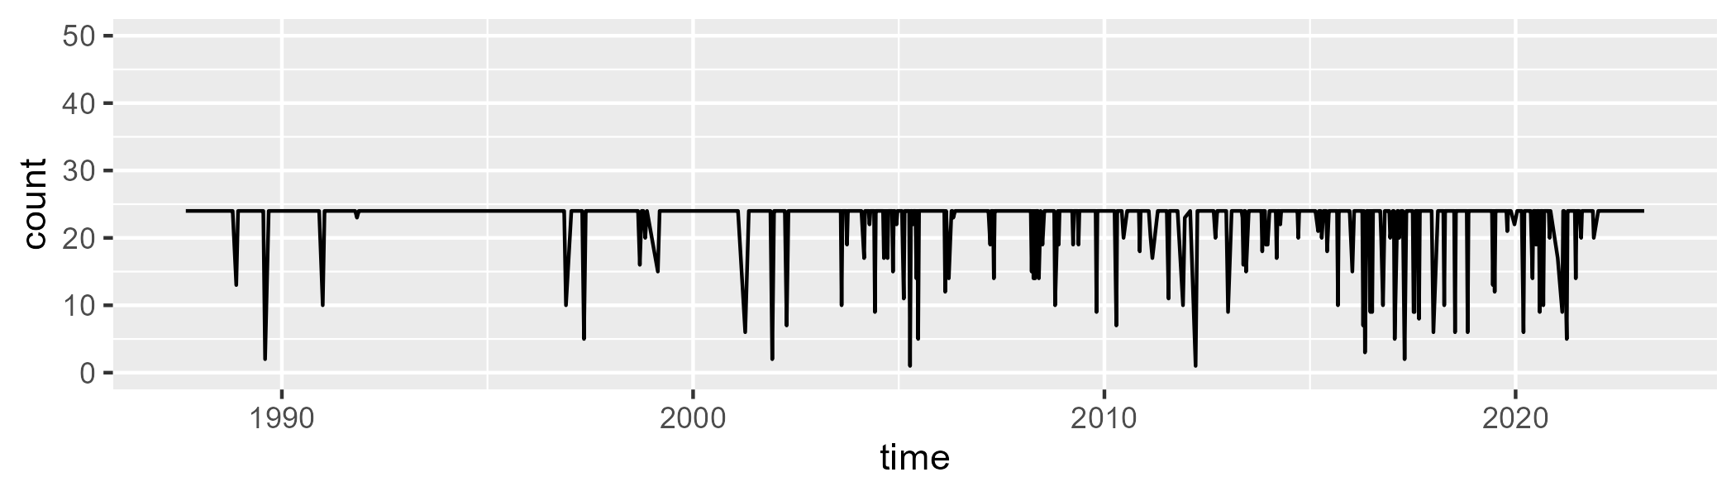

Min. : 1.00 1st Qu.:24.00 Median :24.00 Mean :22.87 3rd Qu.:24.00 Max. :24.00

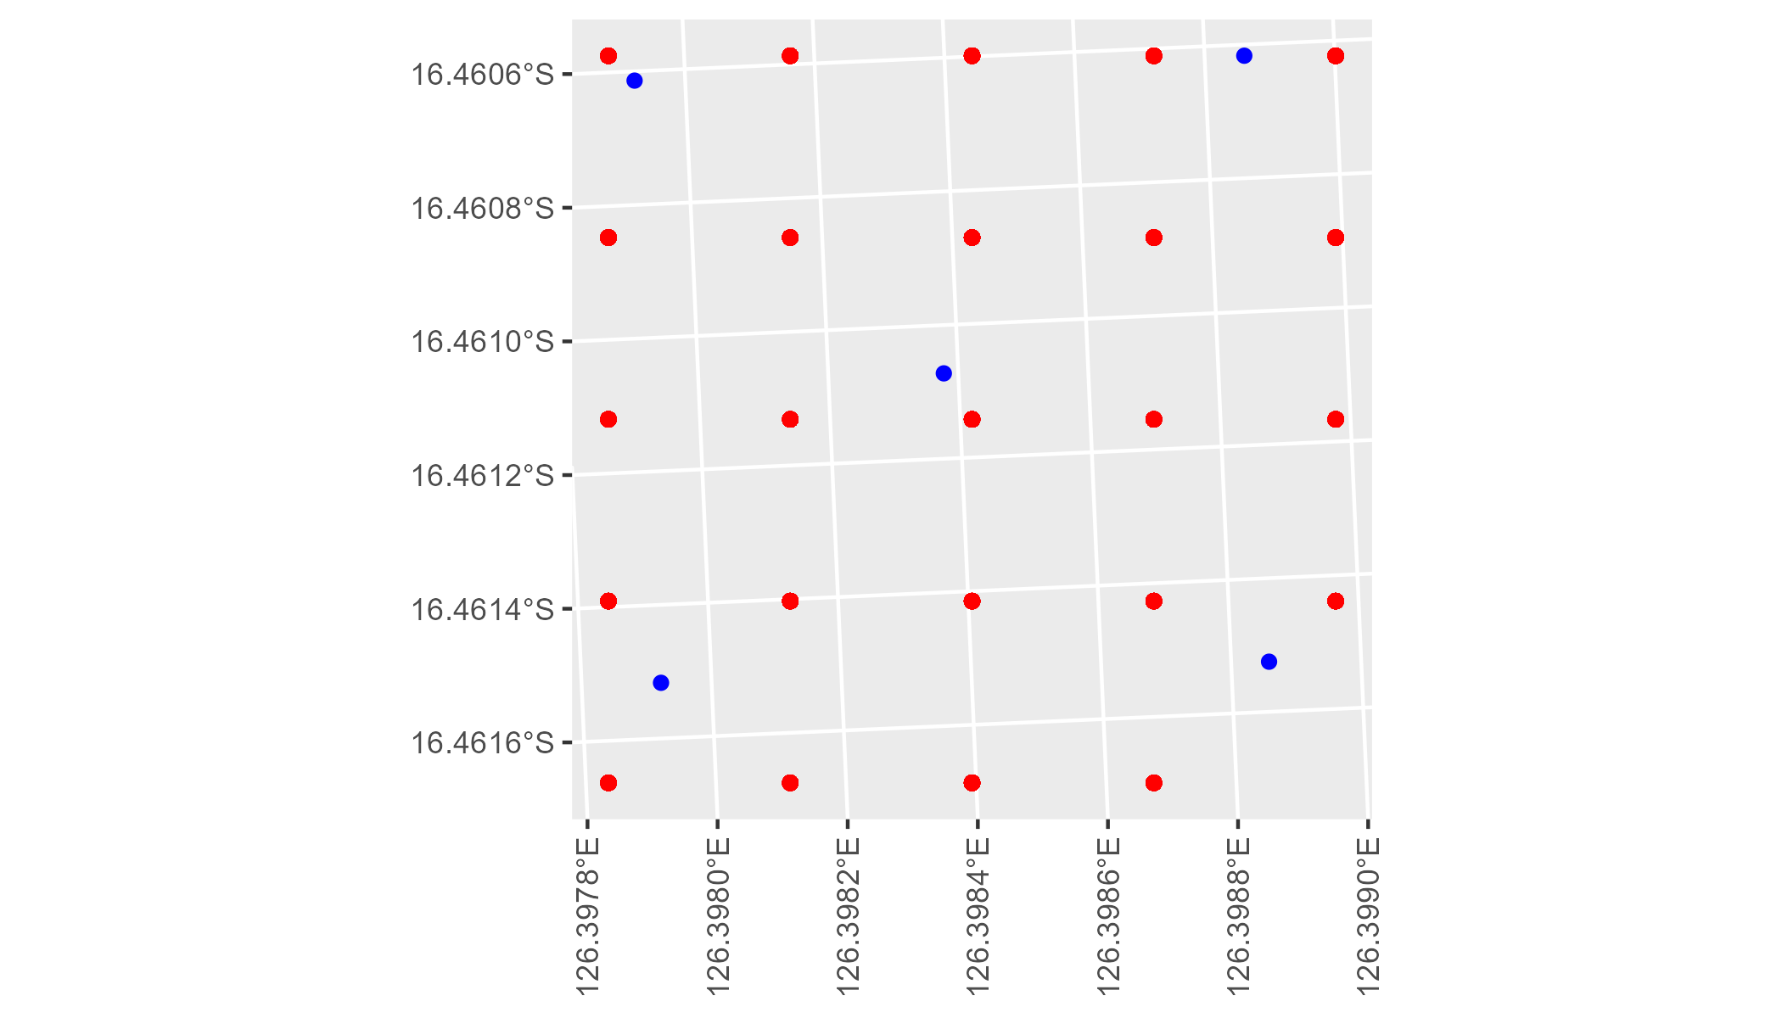

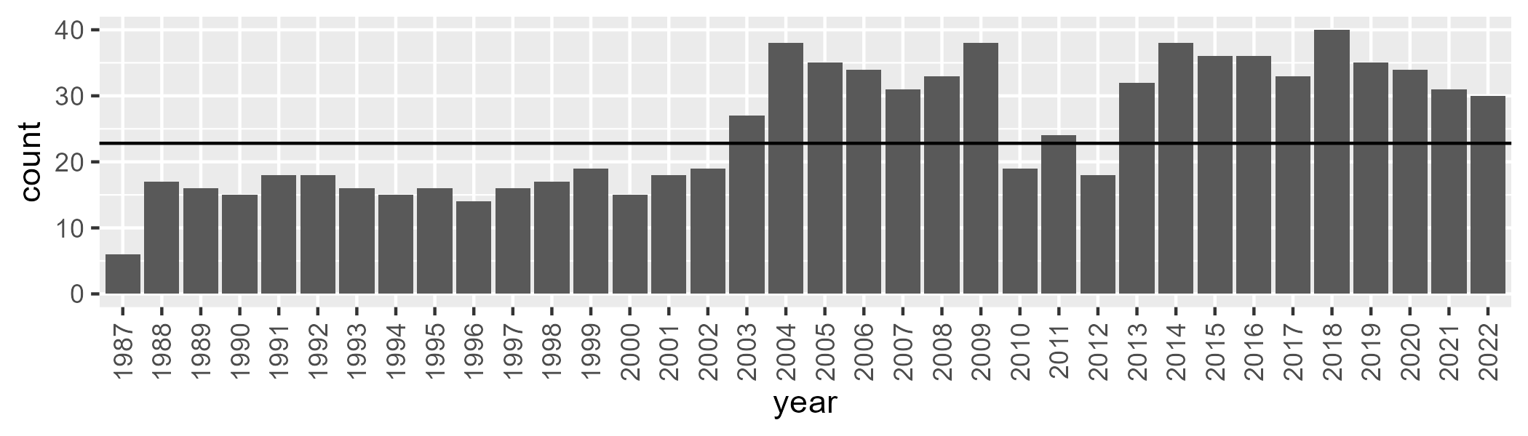

Number of samples: 897

# WAACEK0002

| Min. | 1st Qu. | Median | Mean | 3rd Qu. | Max. |
| --- | --- | --- | --- | --- | --- |
| 0 | 14.16883 | 21.49046 | 26.51035 | 38.35178 | 65.79805 |

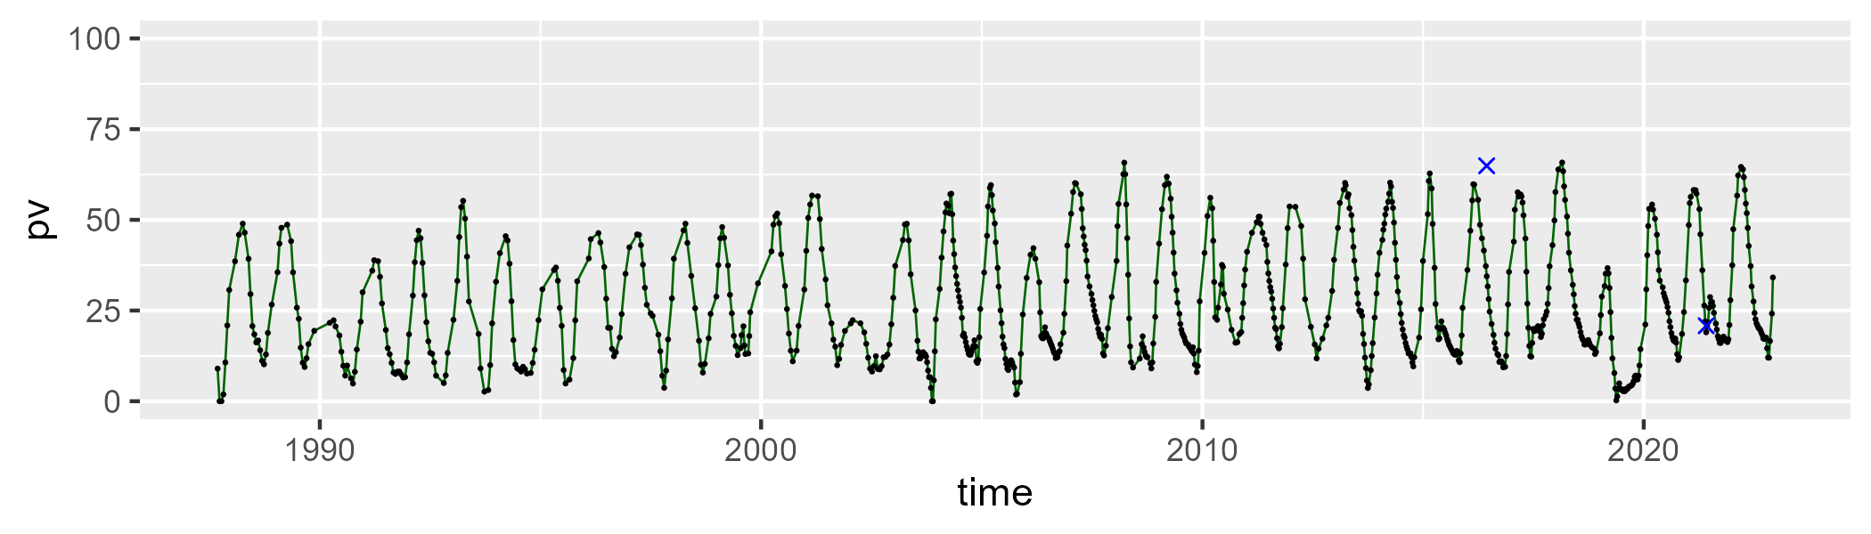

| Min. | 1st Qu. | Median | Mean | 3rd Qu. | Max. |
| --- | --- | --- | --- | --- | --- |
| 28.26831 | 45.26616 | 54.46114 | 56.31808 | 66.77262 | 93.08752 |

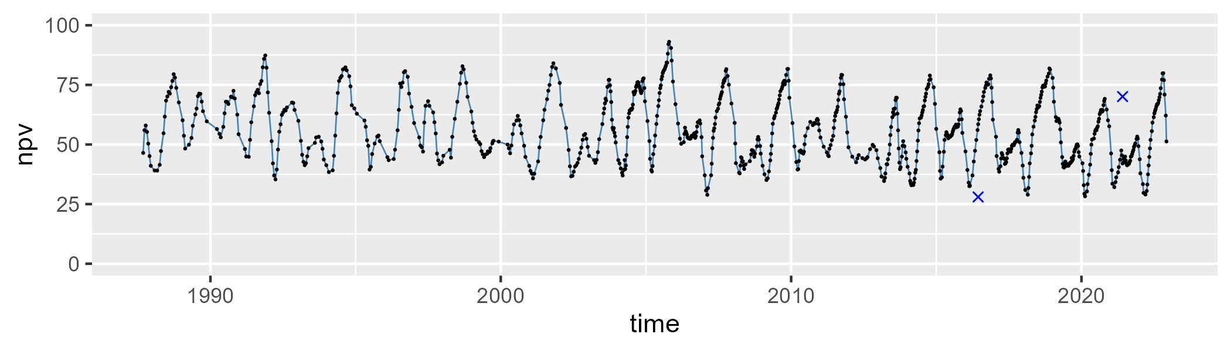

| Min. | 1st Qu. | Median | Mean | 3rd Qu. | Max. |
| --- | --- | --- | --- | --- | --- |
| 0 | 5.528548 | 11.52731 | 16.03315 | 24.61792 | 57.54016 |

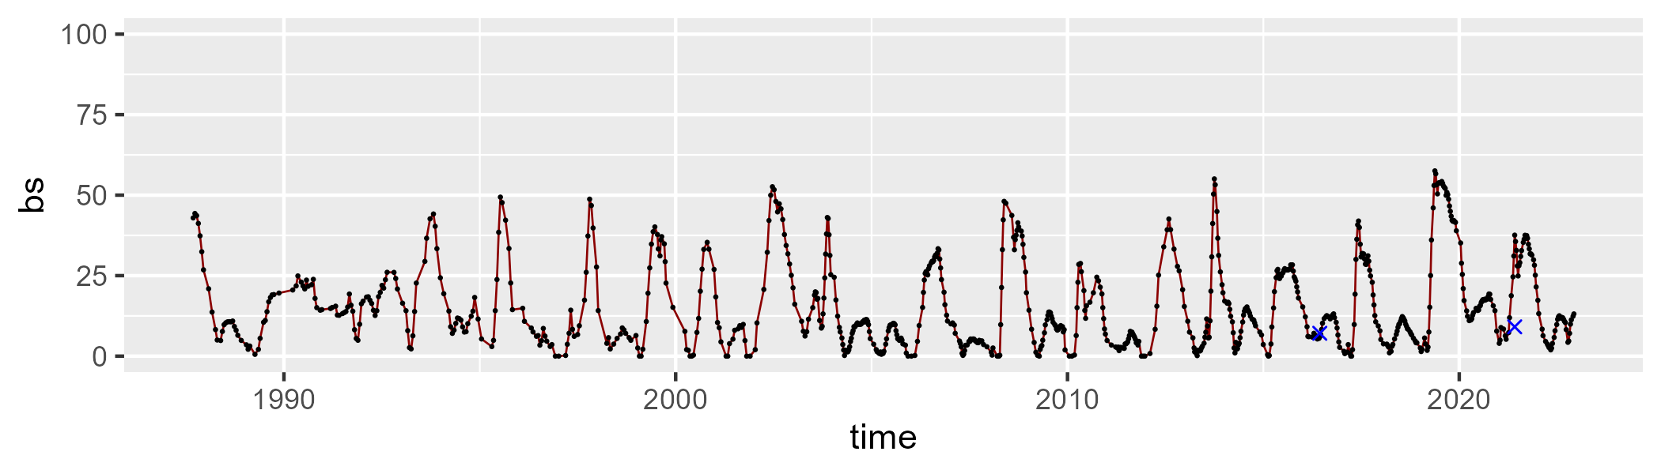

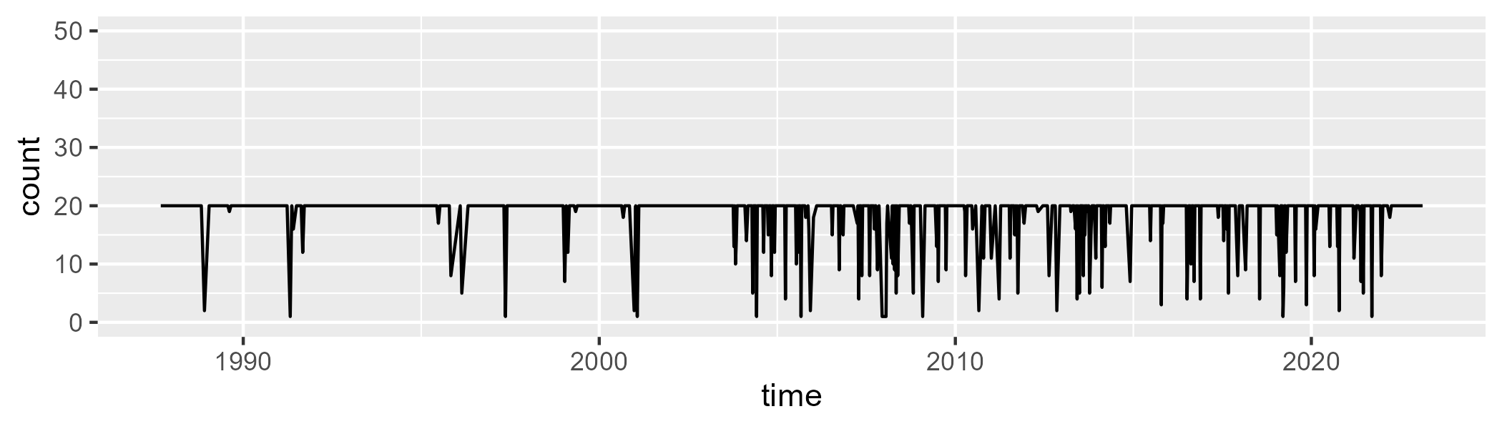

Min. : 1.00 1st Qu.:20.00 Median :20.00 Mean :18.61 3rd Qu.:20.00 Max. :20.00

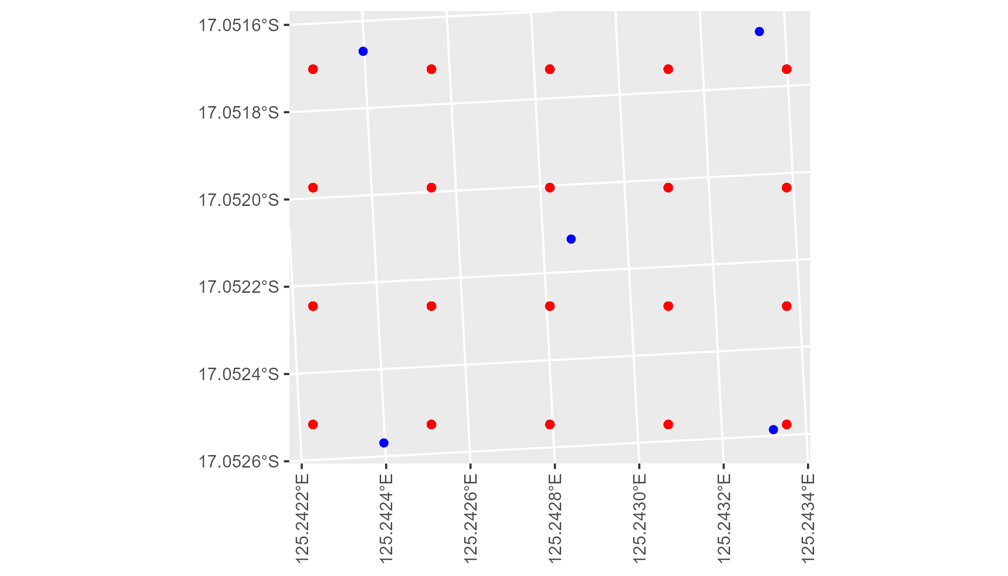

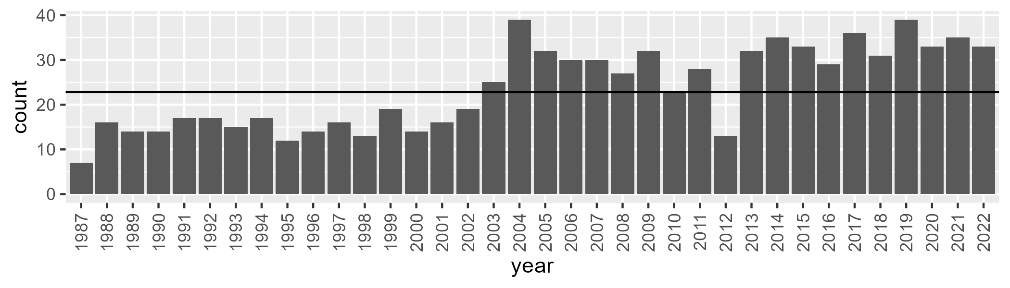

Number of samples: 855

# WAACEK0003

| Min. | 1st Qu. | Median | Mean | 3rd Qu. | Max. |
| --- | --- | --- | --- | --- | --- |
| 1.671583 | 12.07662 | 16.82739 | 20.08396 | 26.98166 | 47.80996 |

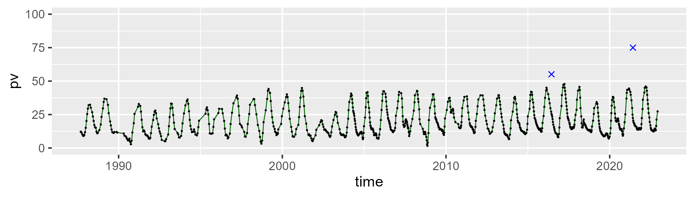

| Min. | 1st Qu. | Median | Mean | 3rd Qu. | Max. |
| --- | --- | --- | --- | --- | --- |
| 38.9802 | 52.88132 | 57.9704 | 57.72371 | 62.24733 | 79.40412 |

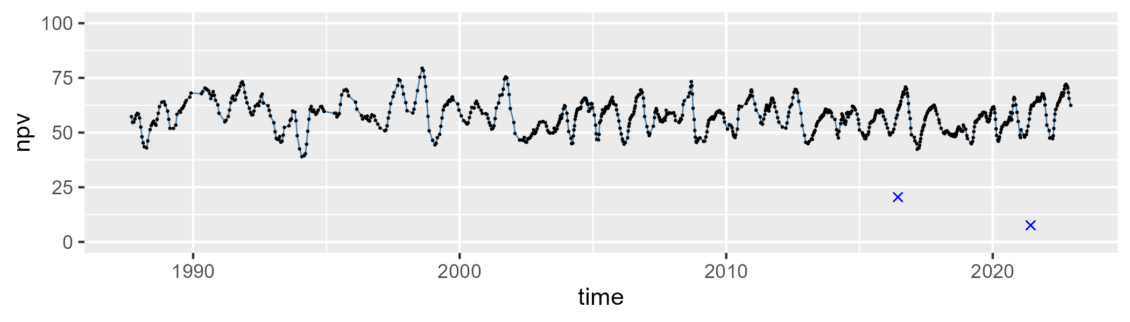

| Min. | 1st Qu. | Median | Mean | 3rd Qu. | Max. |
| --- | --- | --- | --- | --- | --- |
| 0.7385611 | 15.06577 | 21.27291 | 20.96632 | 26.37804 | 51.14749 |

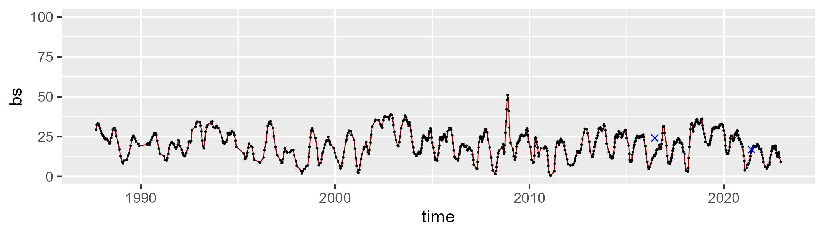

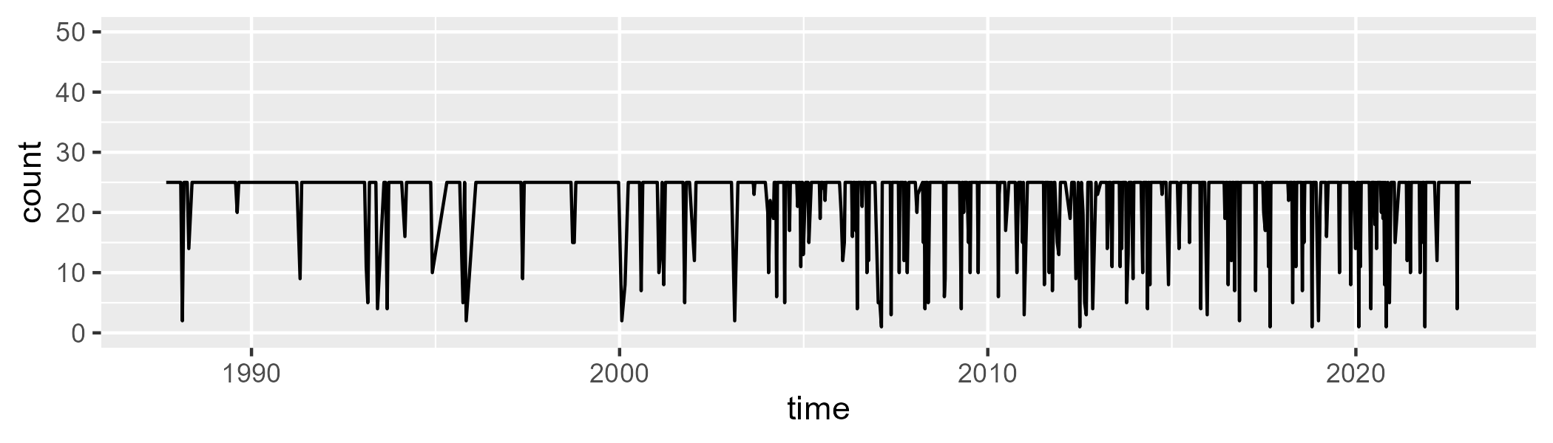

Min. : 1.00 1st Qu.:25.00 Median :25.00 Mean :22.69 3rd Qu.:25.00 Max. :25.00

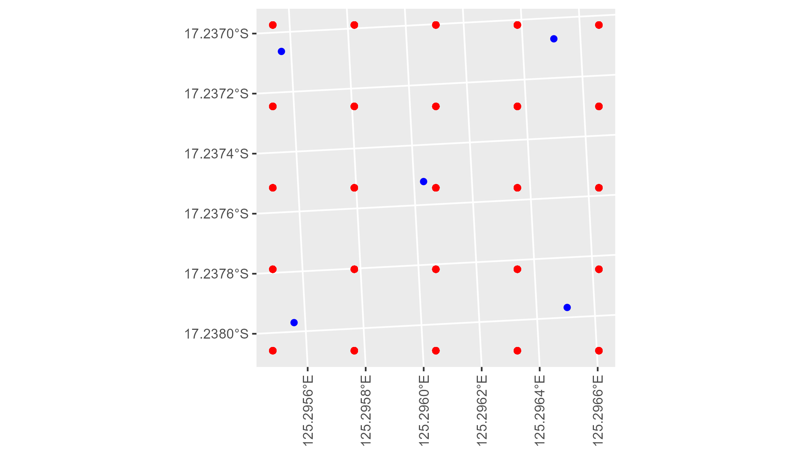

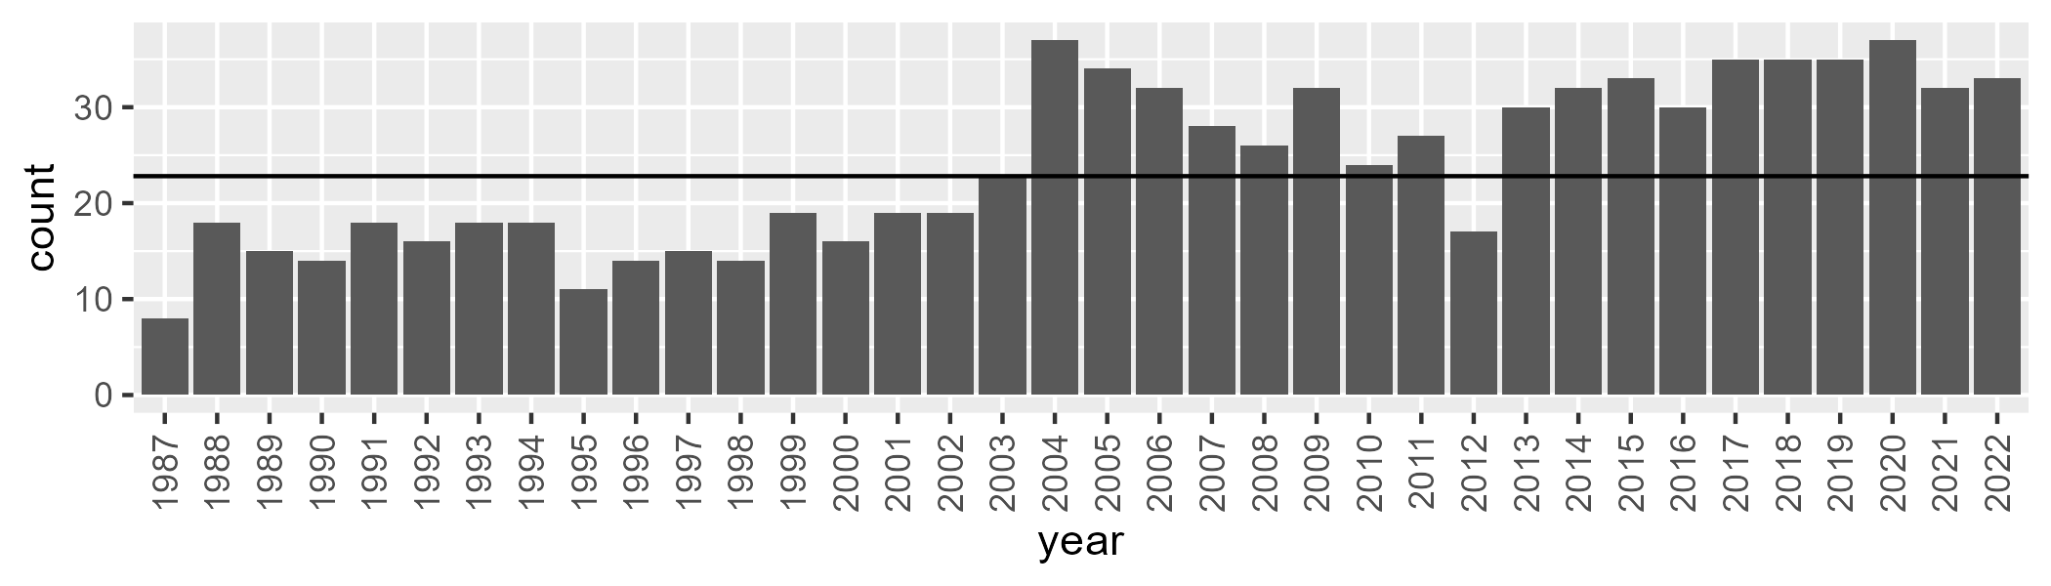

Number of samples: 864

# WAACOO0001

| Min. | 1st Qu. | Median | Mean | 3rd Qu. | Max. |
| --- | --- | --- | --- | --- | --- |
| 10.0816 | 18.60801 | 22.20034 | 22.77437 | 27.00273 | 37.5732 |

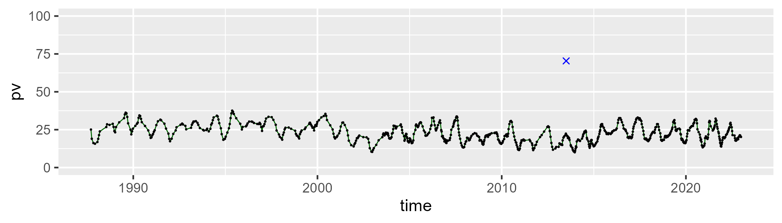

| Min. | 1st Qu. | Median | Mean | 3rd Qu. | Max. |
| --- | --- | --- | --- | --- | --- |
| 35.58102 | 57.48017 | 62.37737 | 61.62998 | 65.79701 | 76.03043 |

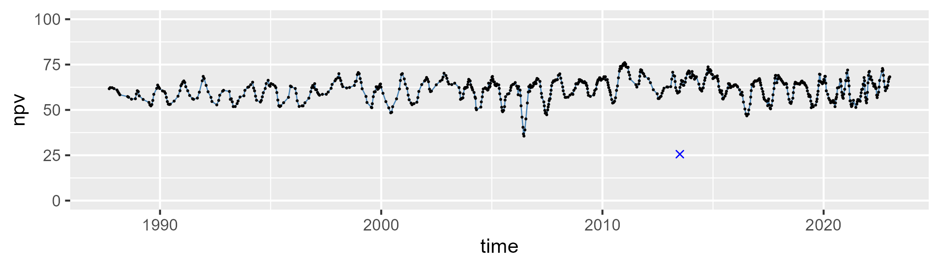

| Min. | 1st Qu. | Median | Mean | 3rd Qu. | Max. |
| --- | --- | --- | --- | --- | --- |
| 3.136027 | 11.65679 | 14.0172 | 14.53326 | 16.71637 | 38.59431 |

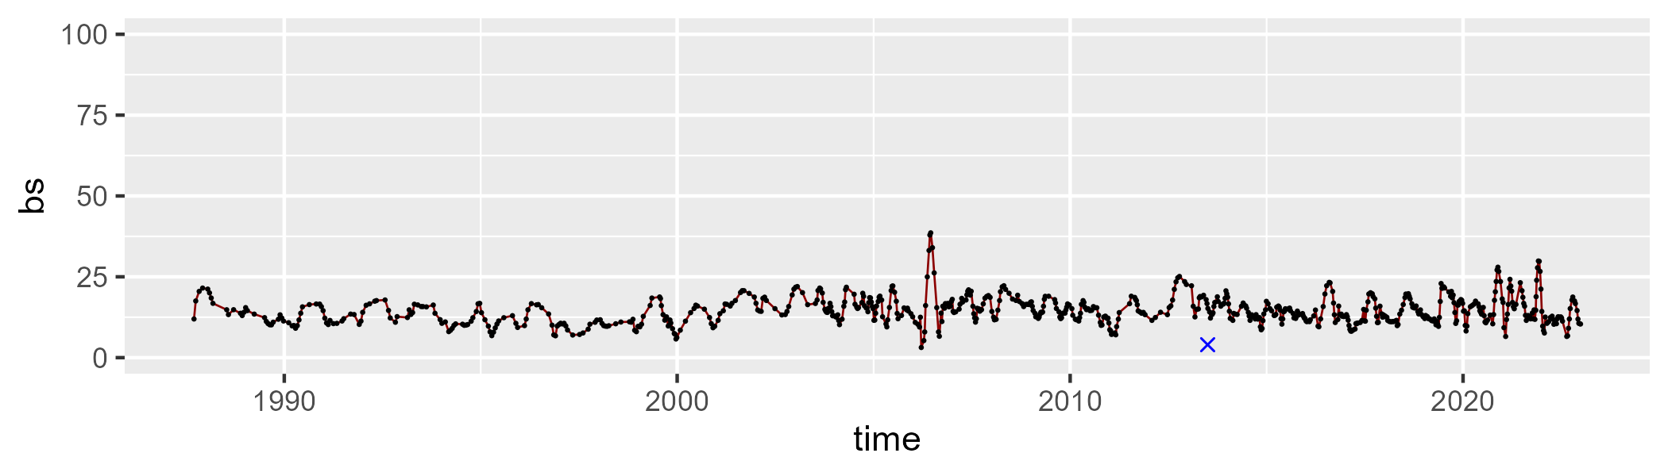

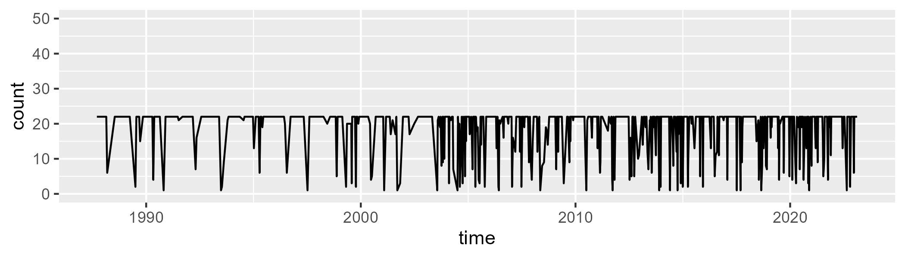

Min. : 1 1st Qu.:21 Median :22 Mean :19 3rd Qu.:22 Max. :22

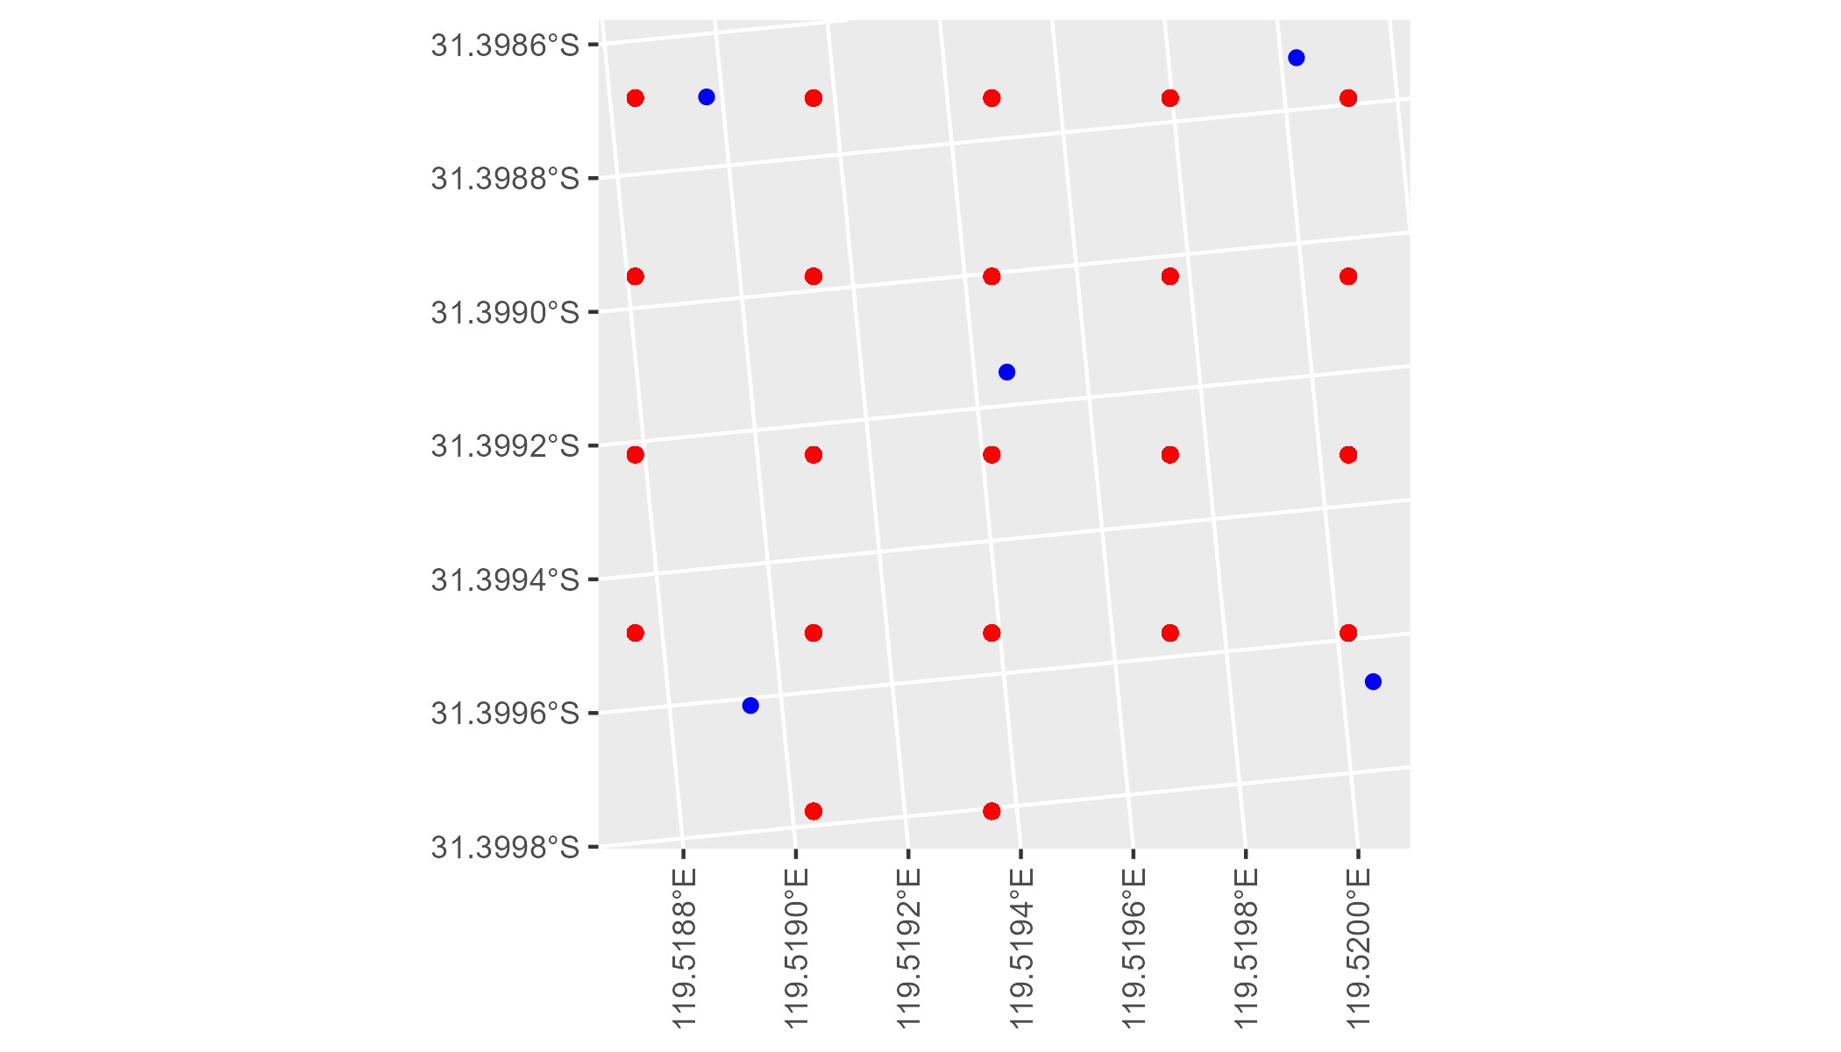

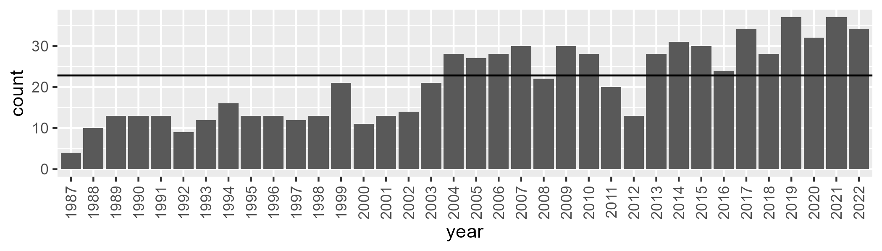

Number of samples: 762

# WAACOO0003

| Min. | 1st Qu. | Median | Mean | 3rd Qu. | Max. |
| --- | --- | --- | --- | --- | --- |
| 7.986898 | 16.2177 | 19.68047 | 20.41511 | 23.8964 | 35.72489 |

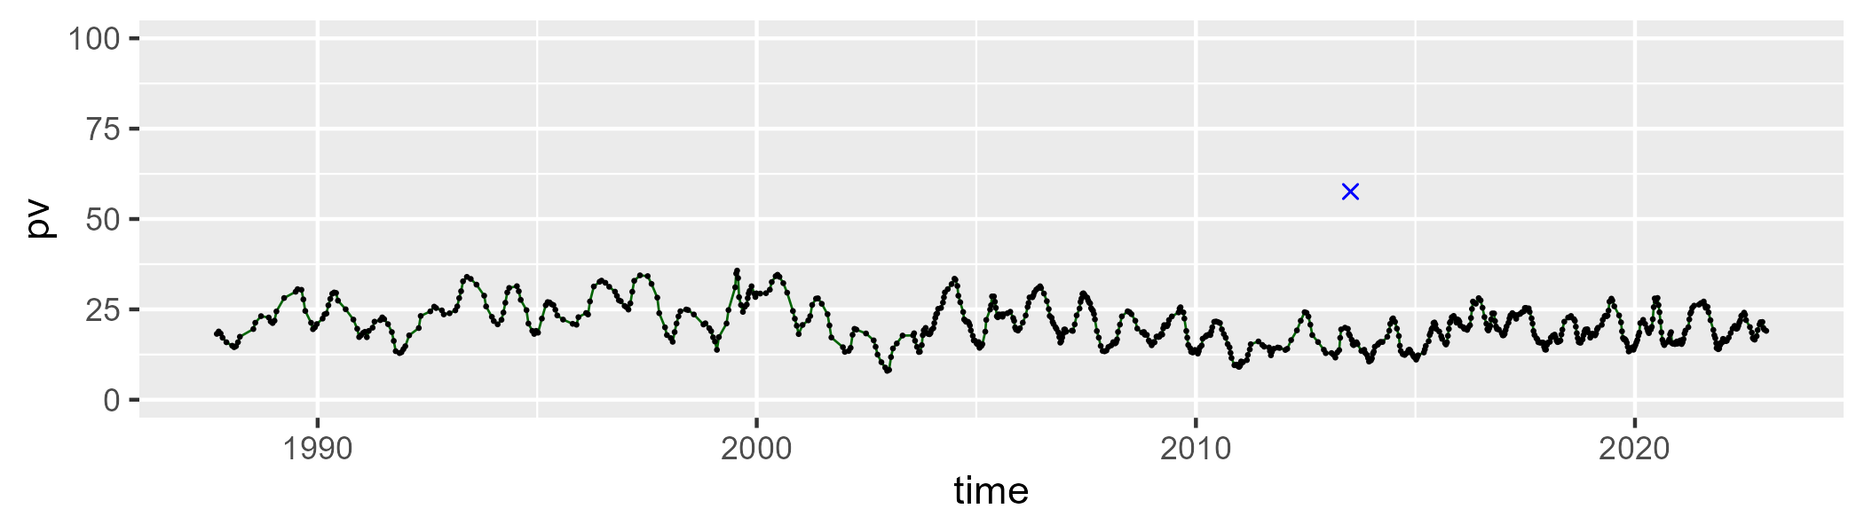

| Min. | 1st Qu. | Median | Mean | 3rd Qu. | Max. |
| --- | --- | --- | --- | --- | --- |
| 45.63131 | 58.53299 | 61.75747 | 61.53753 | 64.96713 | 77.21108 |

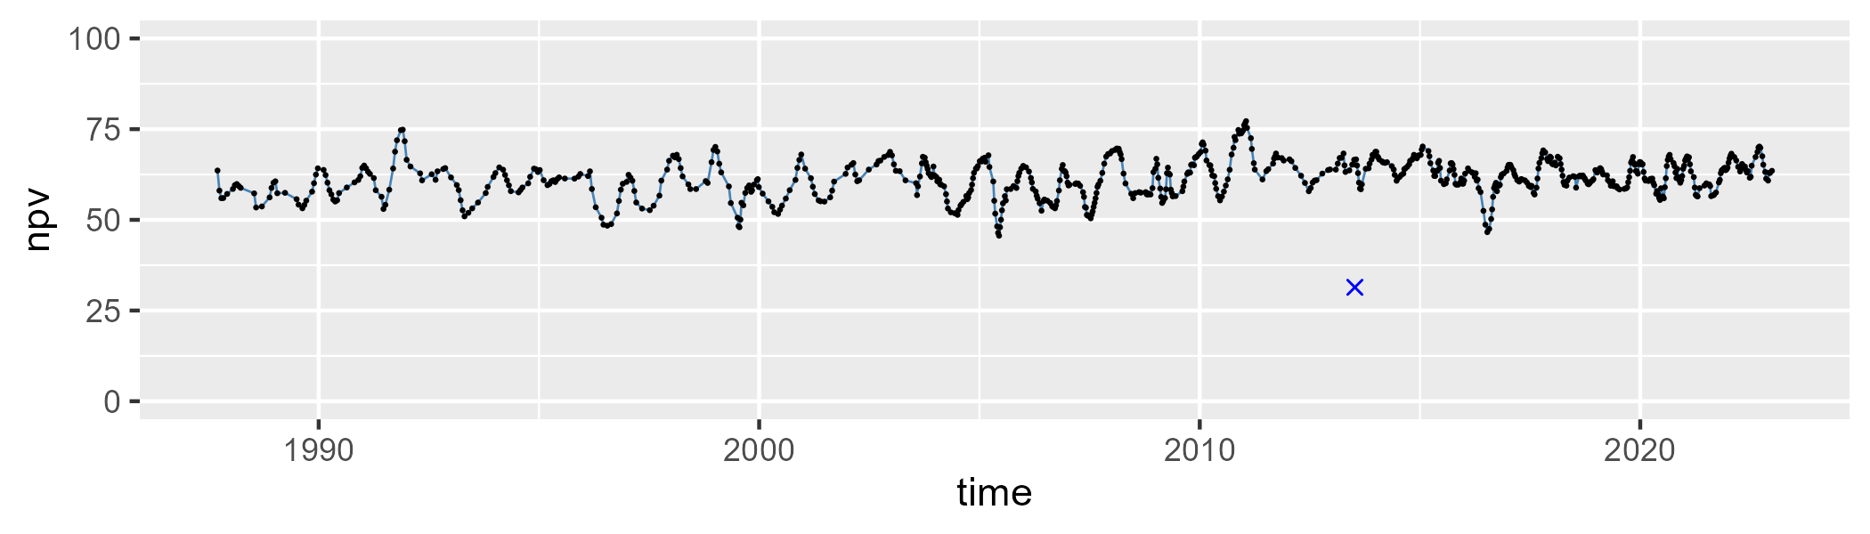

| Min. | 1st Qu. | Median | Mean | 3rd Qu. | Max. |
| --- | --- | --- | --- | --- | --- |
| 7.756754 | 14.50031 | 16.65941 | 16.91665 | 18.98632 | 28.27214 |

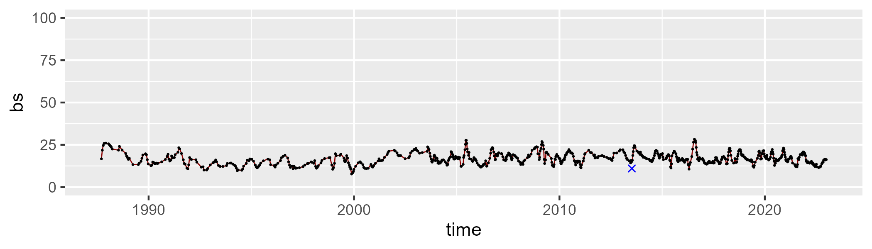

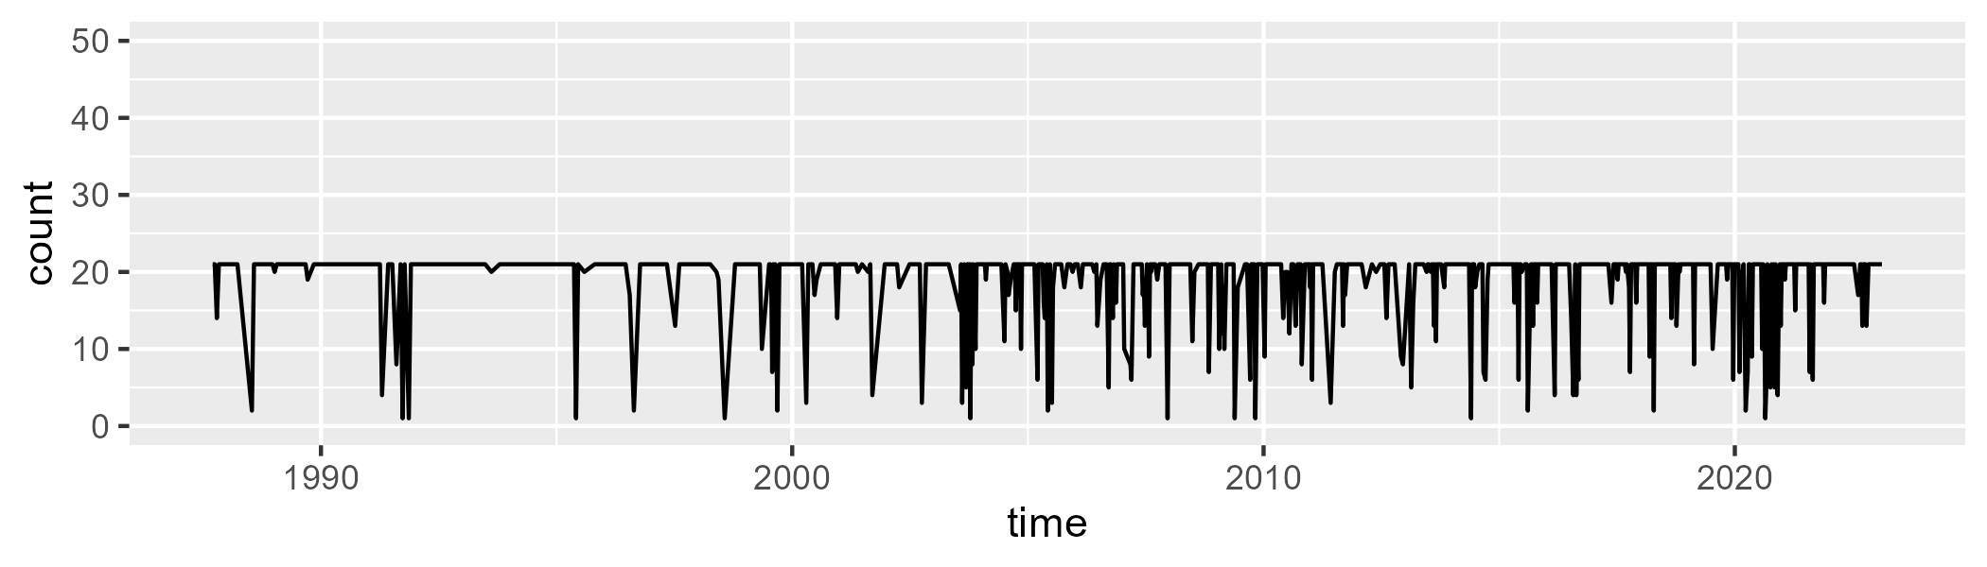

Min. : 1.00 1st Qu.:21.00 Median :21.00 Mean :19.07 3rd Qu.:21.00 Max. :21.00

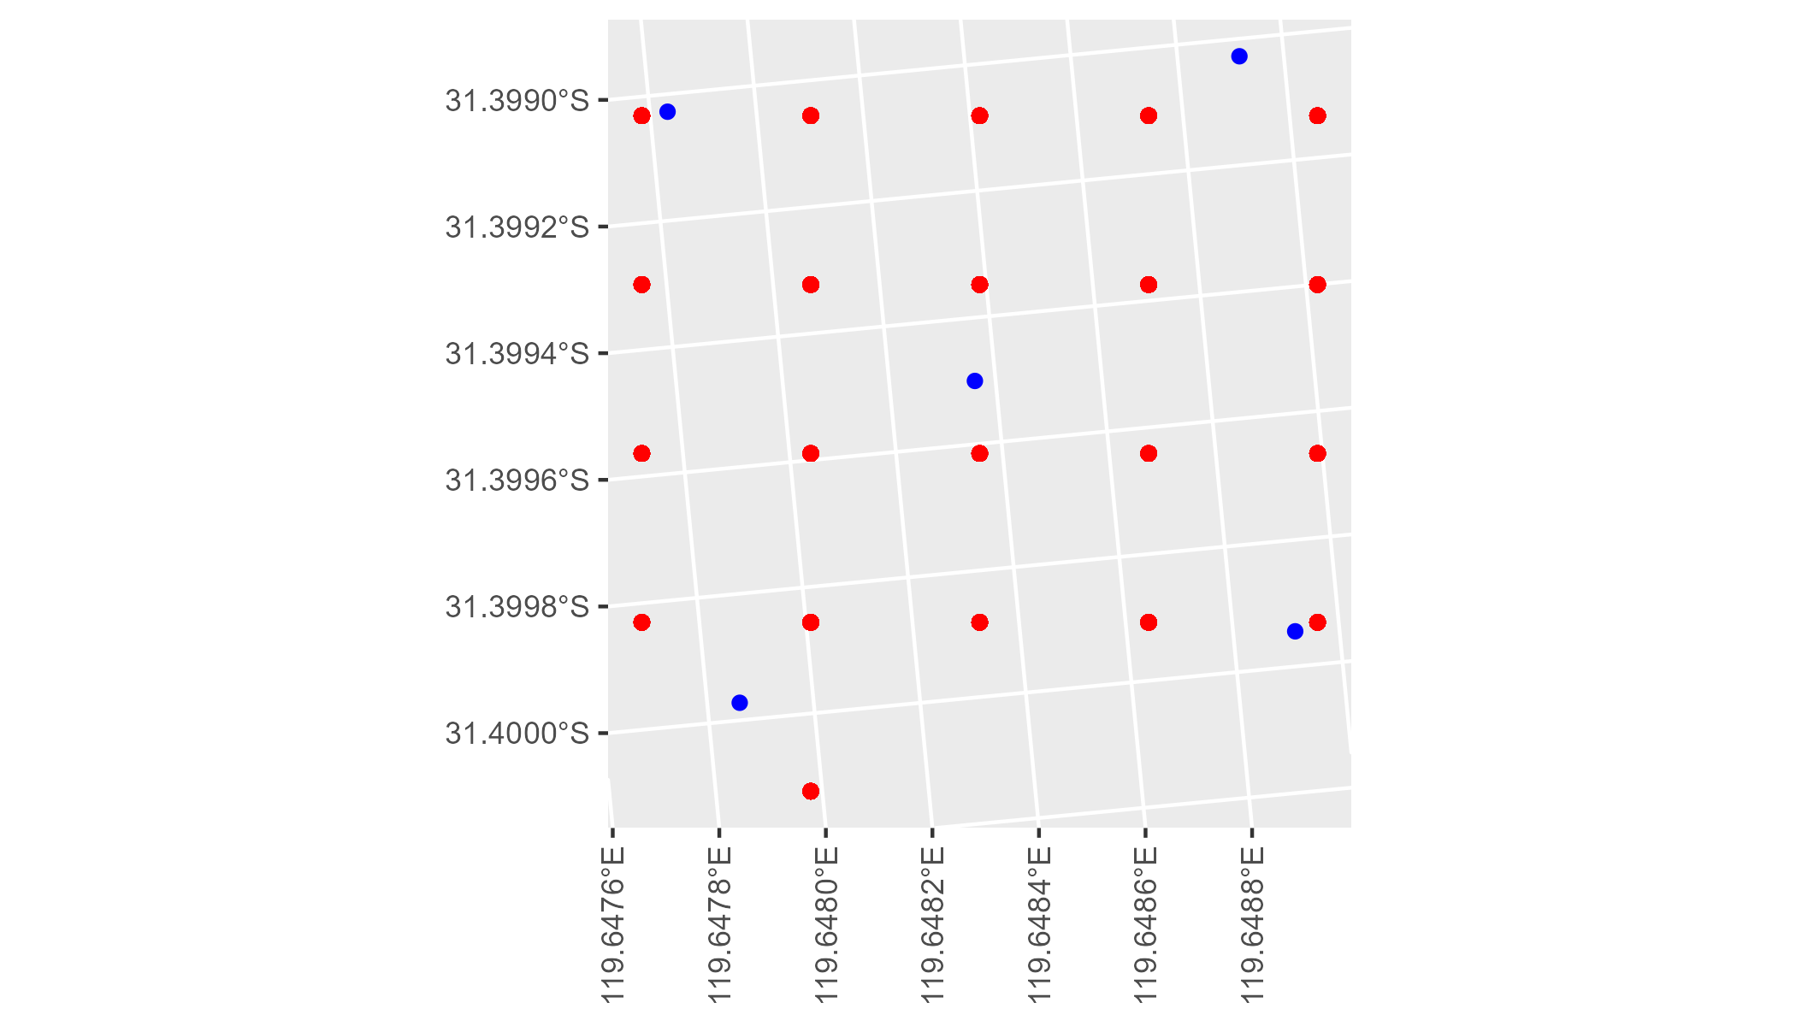

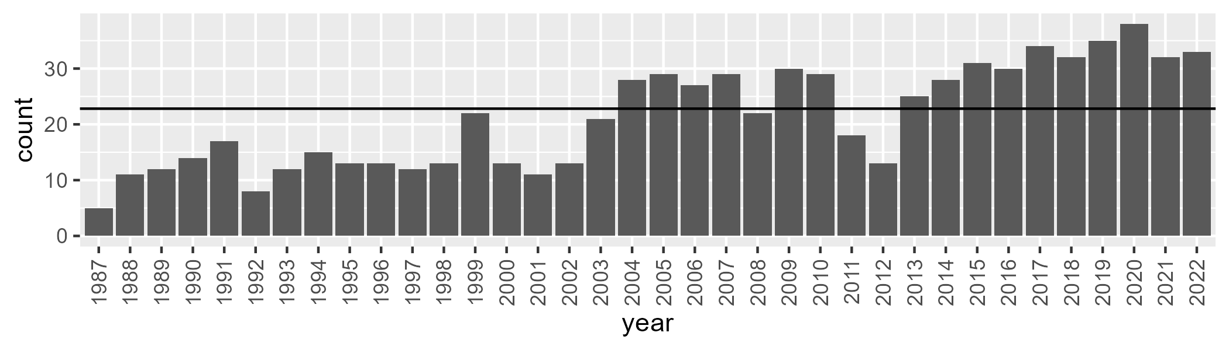

Number of samples: 768

# WAACOO0004

| Min. | 1st Qu. | Median | Mean | 3rd Qu. | Max. |
| --- | --- | --- | --- | --- | --- |
| 14.30514 | 22.42865 | 26.0556 | 26.62886 | 30.79768 | 41.24492 |

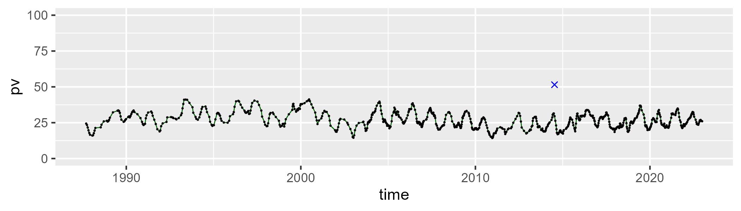

| Min. | 1st Qu. | Median | Mean | 3rd Qu. | Max. |
| --- | --- | --- | --- | --- | --- |
| 39.93983 | 52.36868 | 55.03821 | 54.79506 | 57.51795 | 68.56547 |

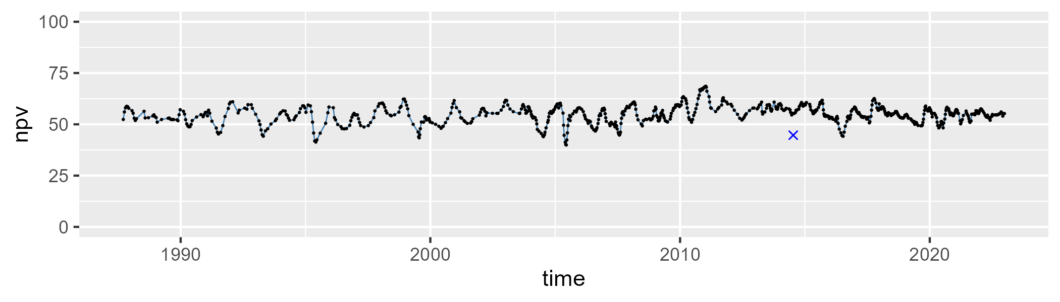

| Min. | 1st Qu. | Median | Mean | 3rd Qu. | Max. |
| --- | --- | --- | --- | --- | --- |
| 8.603635 | 14.87225 | 17.4605 | 17.43516 | 19.83825 | 30.19406 |

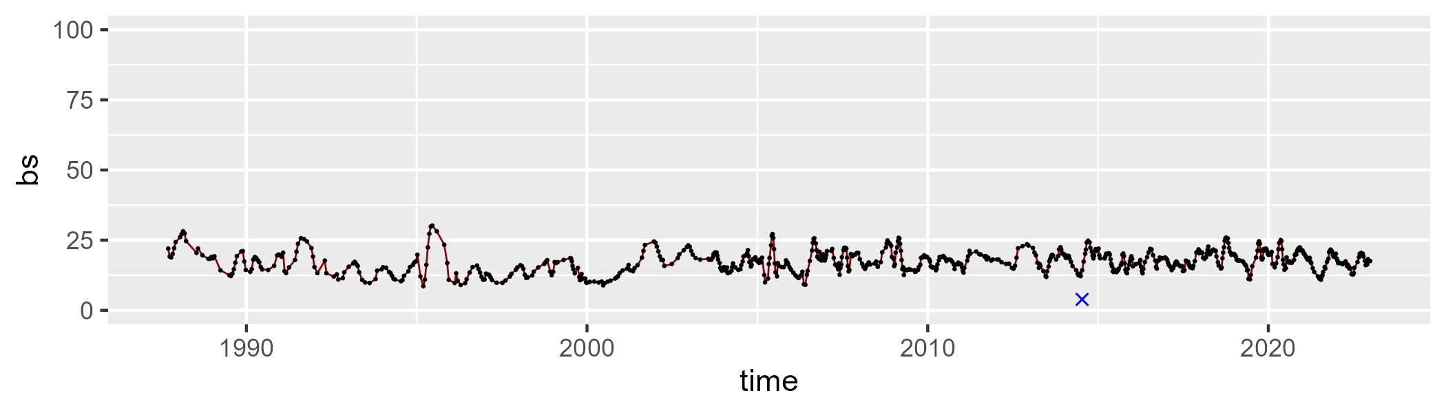

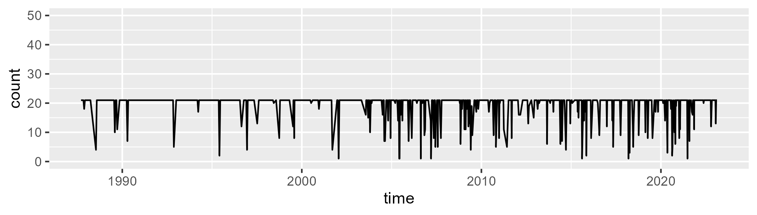

Min. : 1.00 1st Qu.:21.00 Median :21.00 Mean :19.32 3rd Qu.:21.00 Max. :21.00

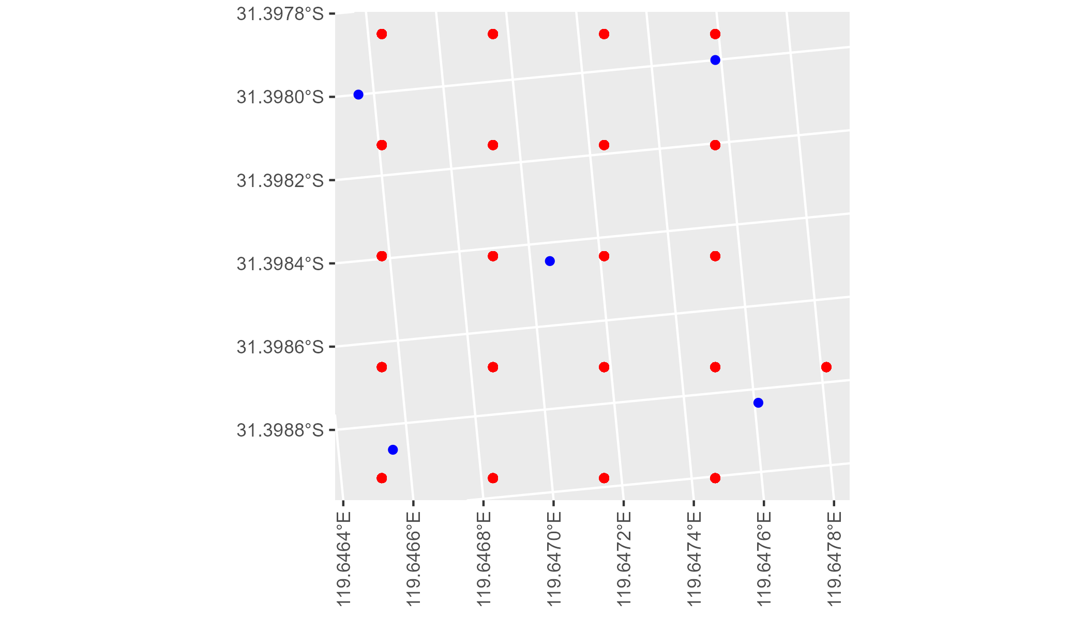

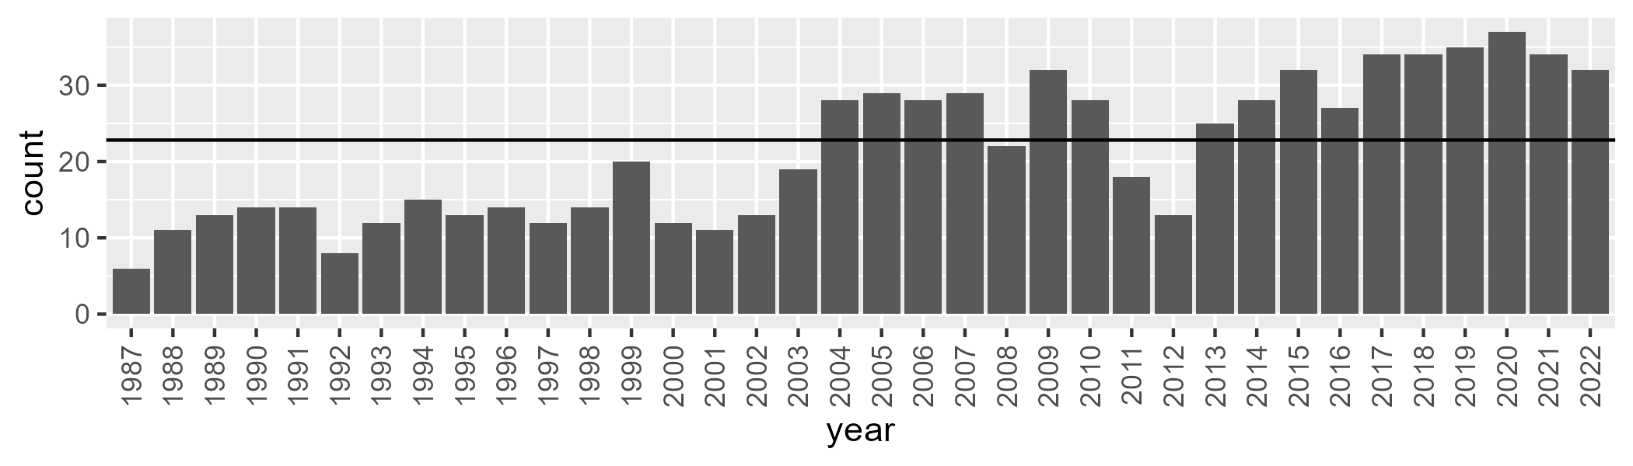

Number of samples: 766

# WAACOO0005

| Min. | 1st Qu. | Median | Mean | 3rd Qu. | Max. |
| --- | --- | --- | --- | --- | --- |
| 2.785893 | 10.24951 | 14.03614 | 15.13426 | 19.38962 | 38.69938 |

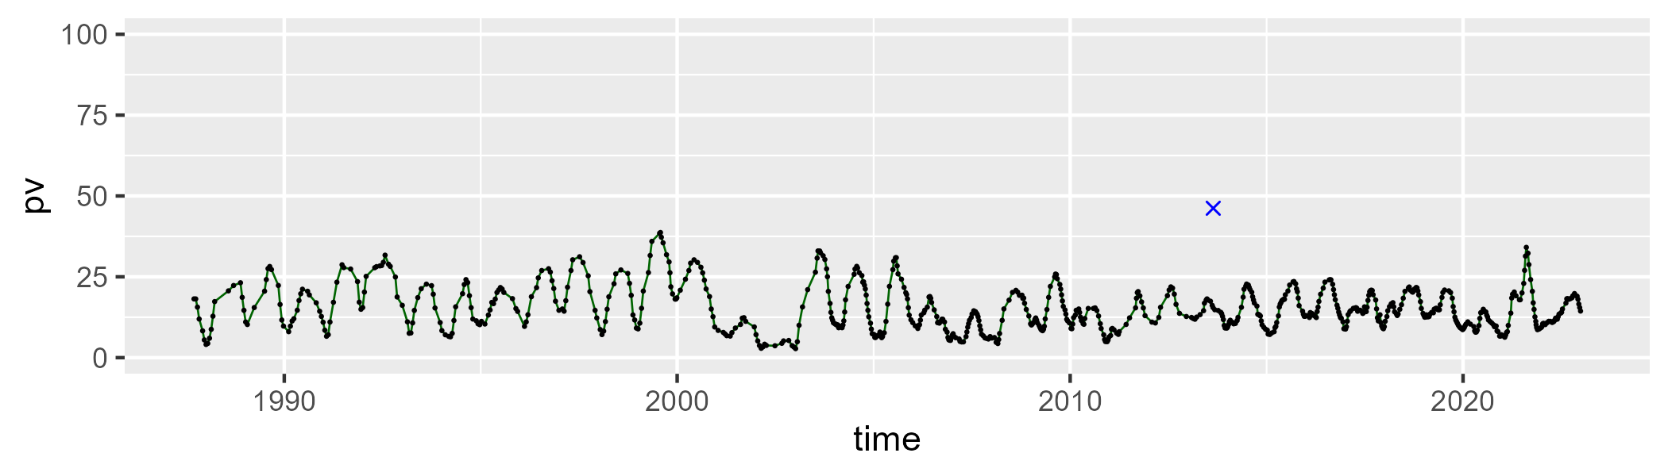

| Min. | 1st Qu. | Median | Mean | 3rd Qu. | Max. |
| --- | --- | --- | --- | --- | --- |
| 39.1112 | 50.40808 | 54.01777 | 54.47246 | 57.41173 | 74.91157 |

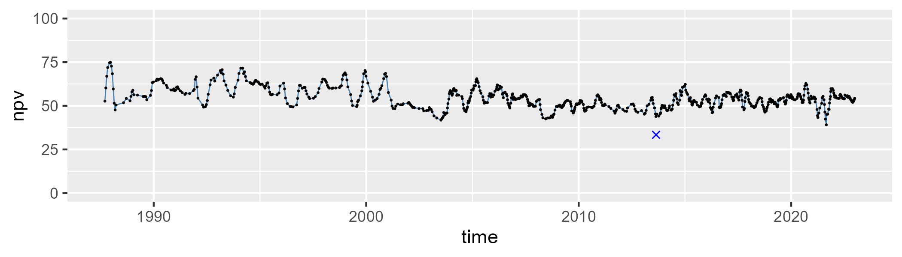

| Min. | 1st Qu. | Median | Mean | 3rd Qu. | Max. |
| --- | --- | --- | --- | --- | --- |
| 5.888994 | 23.67145 | 29.96627 | 29.10274 | 34.79332 | 47.64331 |

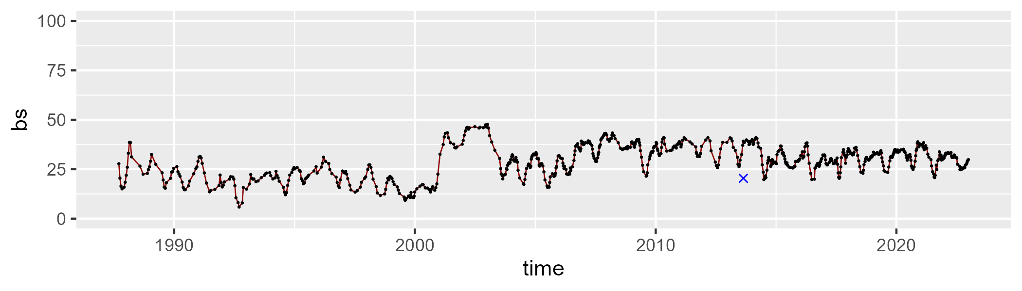

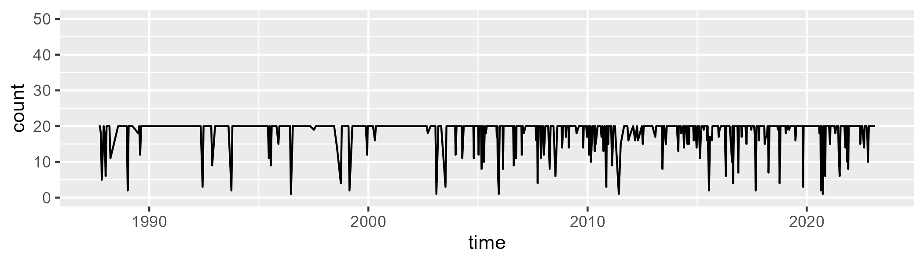

Min. : 1.00 1st Qu.:20.00 Median :20.00 Mean :18.66 3rd Qu.:20.00 Max. :20.00

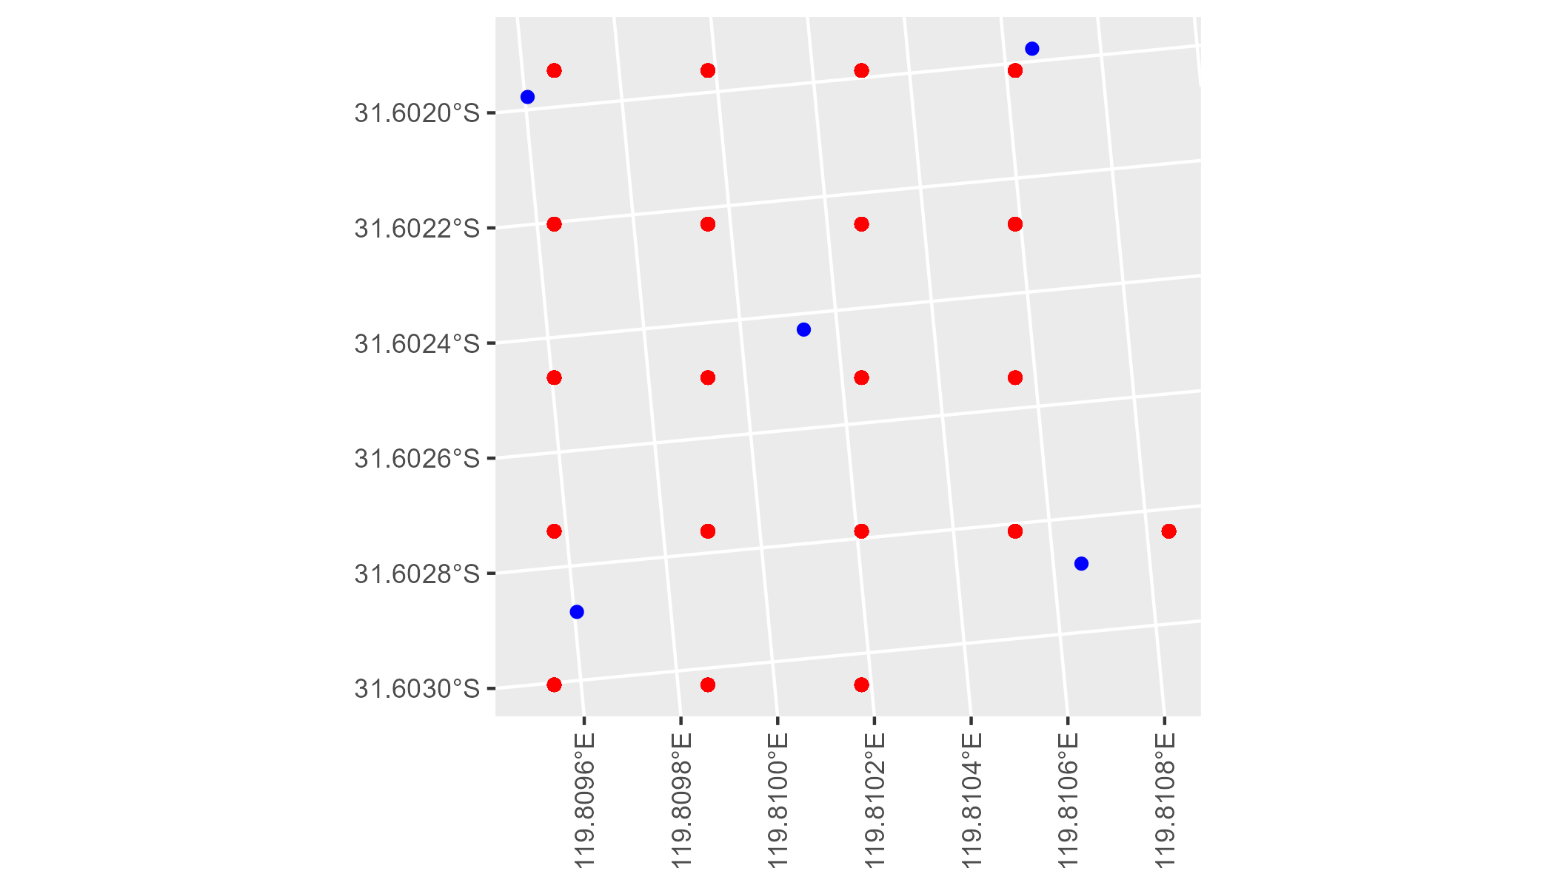

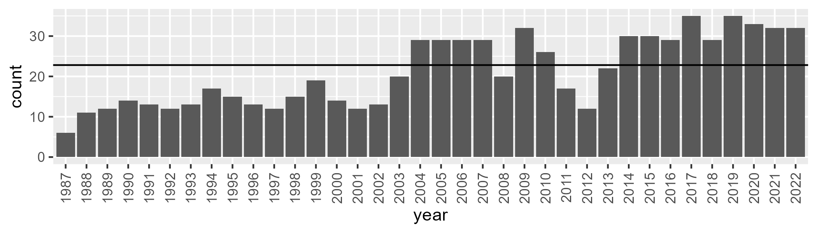

Number of samples: 761

# WAACOO0006

| Min. | 1st Qu. | Median | Mean | 3rd Qu. | Max. |
| --- | --- | --- | --- | --- | --- |
| 16.55844 | 24.58492 | 27.15408 | 27.67601 | 30.42619 | 39.9128 |

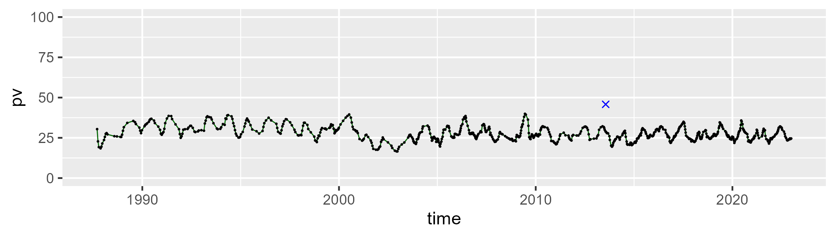

| Min. | 1st Qu. | Median | Mean | 3rd Qu. | Max. |
| --- | --- | --- | --- | --- | --- |
| 38.92966 | 49.50957 | 51.33806 | 51.43243 | 53.5261 | 66.45907 |

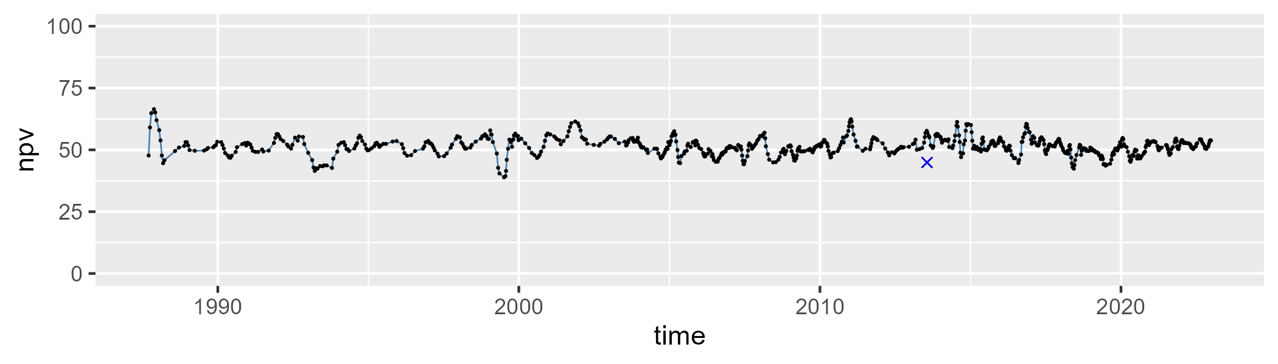

| Min. | 1st Qu. | Median | Mean | 3rd Qu. | Max. |
| --- | --- | --- | --- | --- | --- |
| 9.531254 | 16.90655 | 19.9664 | 19.65716 | 22.47706 | 31.72441 |

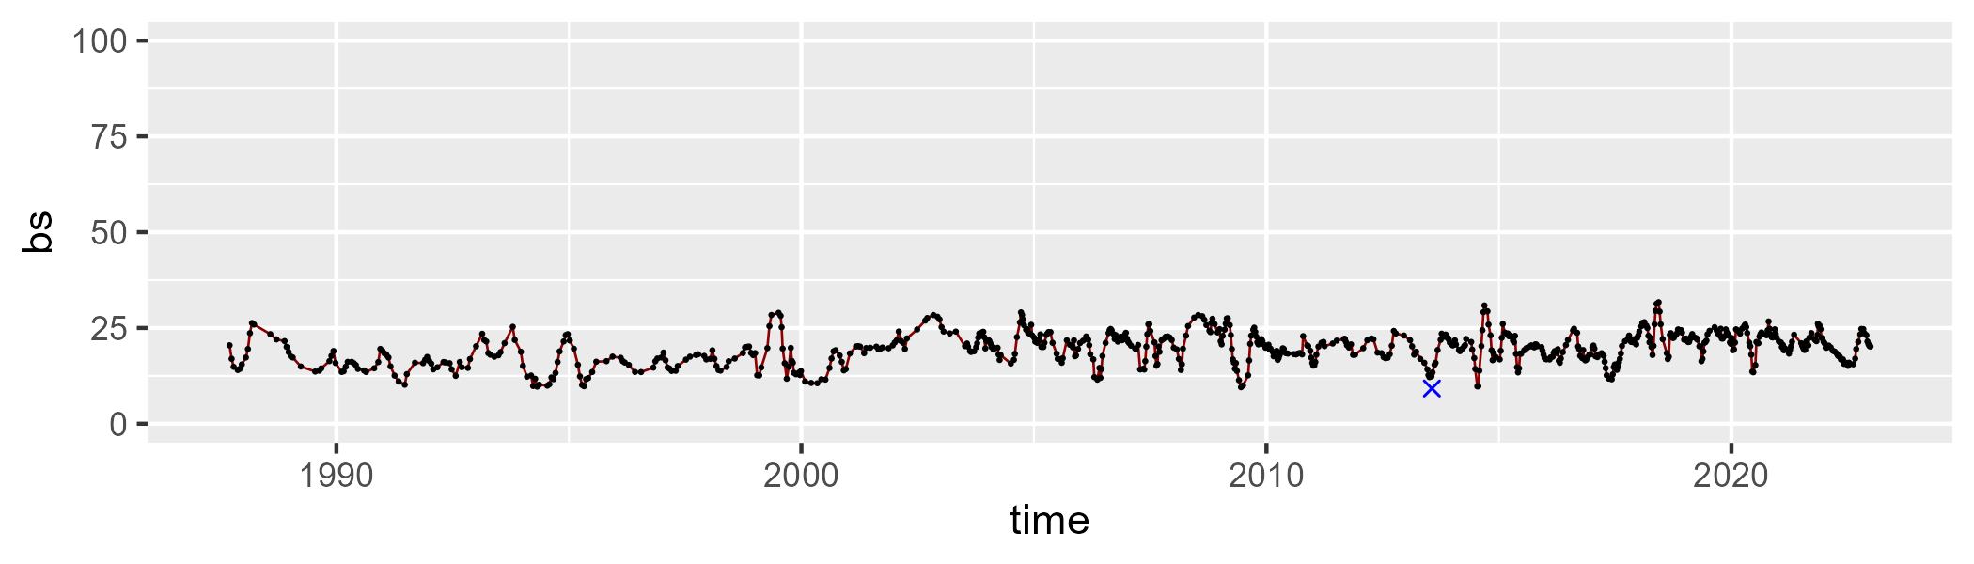

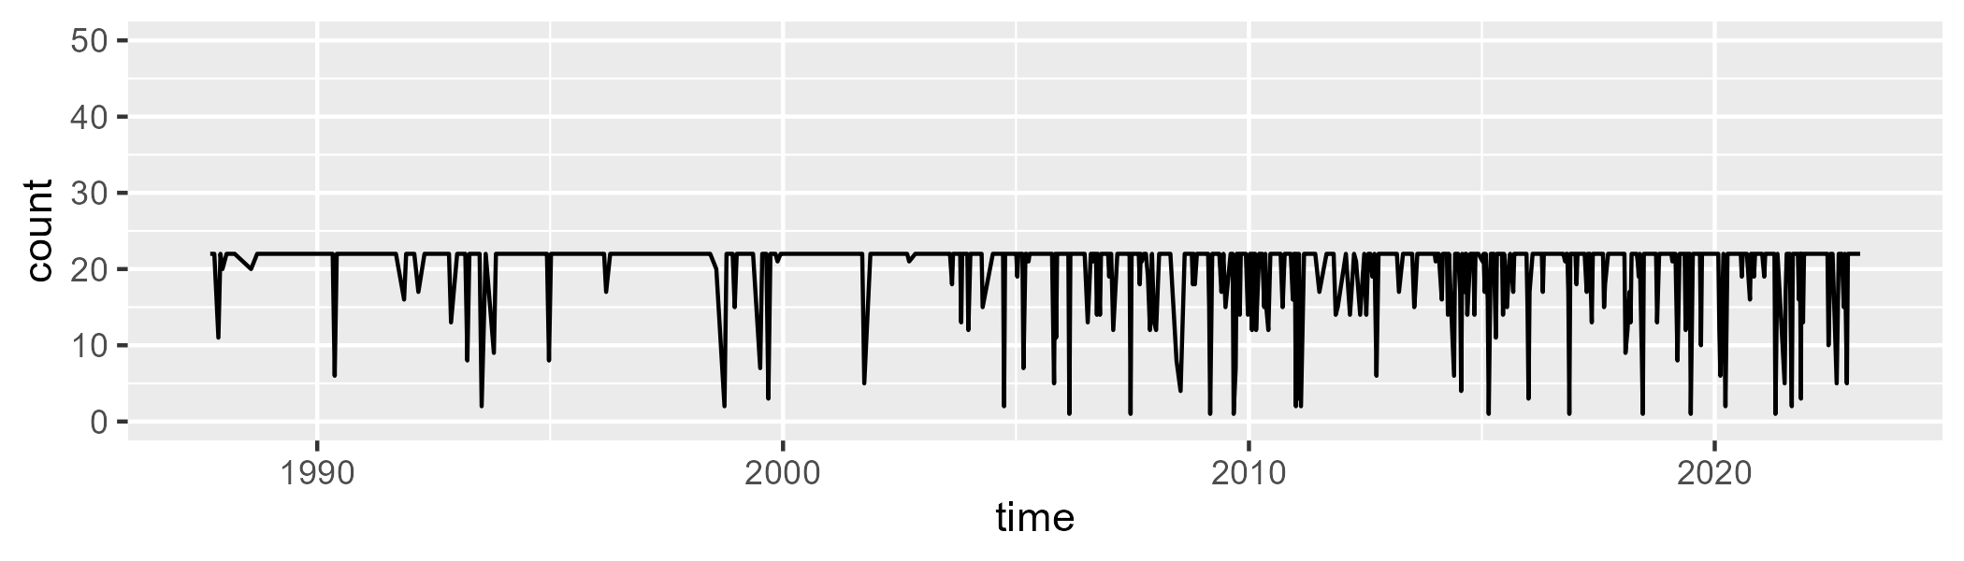

Min. : 1.00 1st Qu.:22.00 Median :22.00 Mean :20.27 3rd Qu.:22.00 Max. :22.00

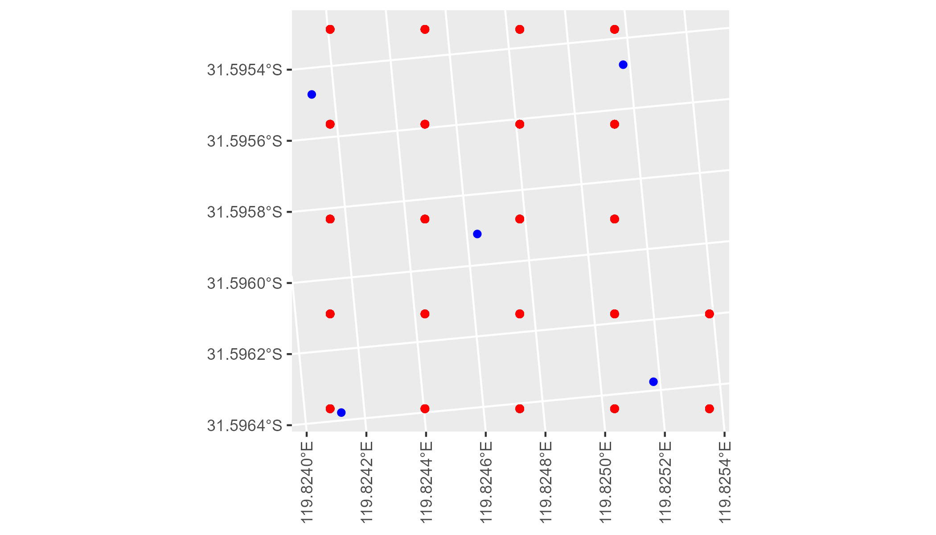

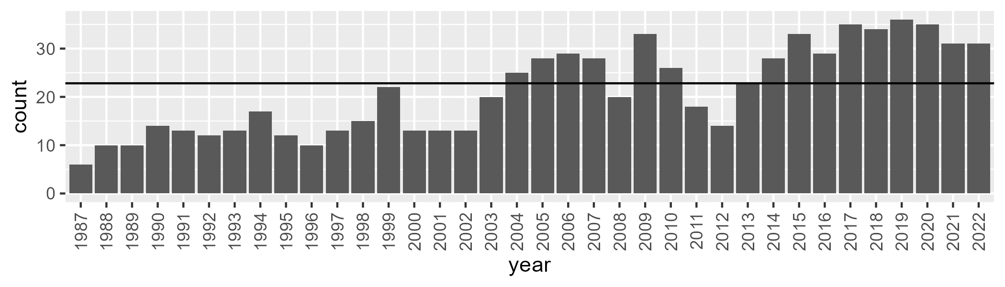

Number of samples: 762

# WAACOO0007

| Min. | 1st Qu. | Median | Mean | 3rd Qu. | Max. |
| --- | --- | --- | --- | --- | --- |
| 4.026765 | 30.06439 | 34.06931 | 33.3406 | 38.12098 | 47.14614 |

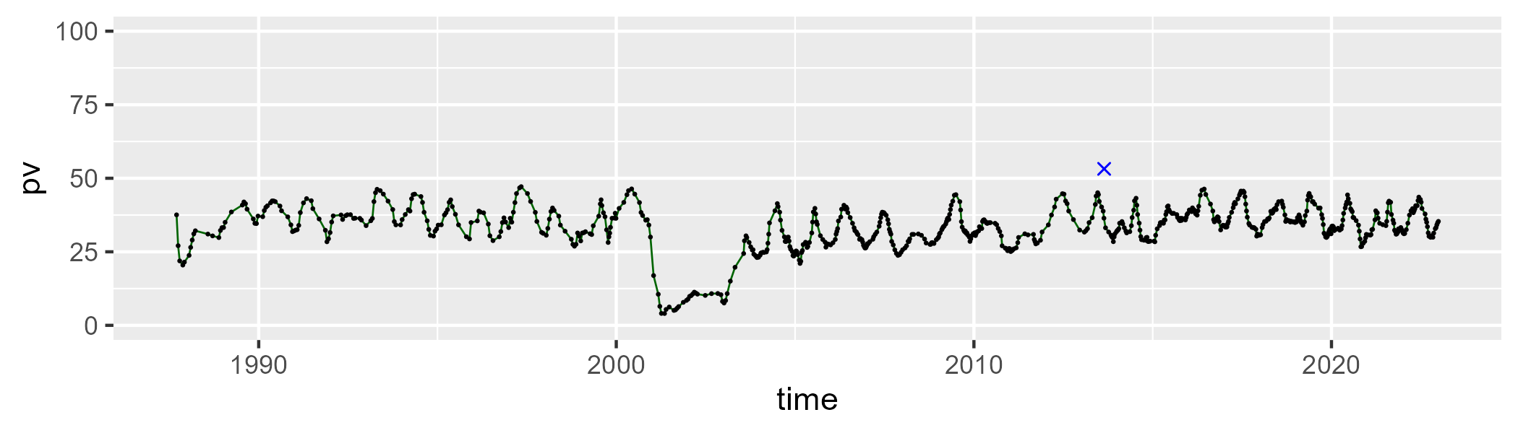

| Min. | 1st Qu. | Median | Mean | 3rd Qu. | Max. |
| --- | --- | --- | --- | --- | --- |
| 36.58811 | 46.68855 | 49.25722 | 48.99095 | 51.23514 | 66.14329 |

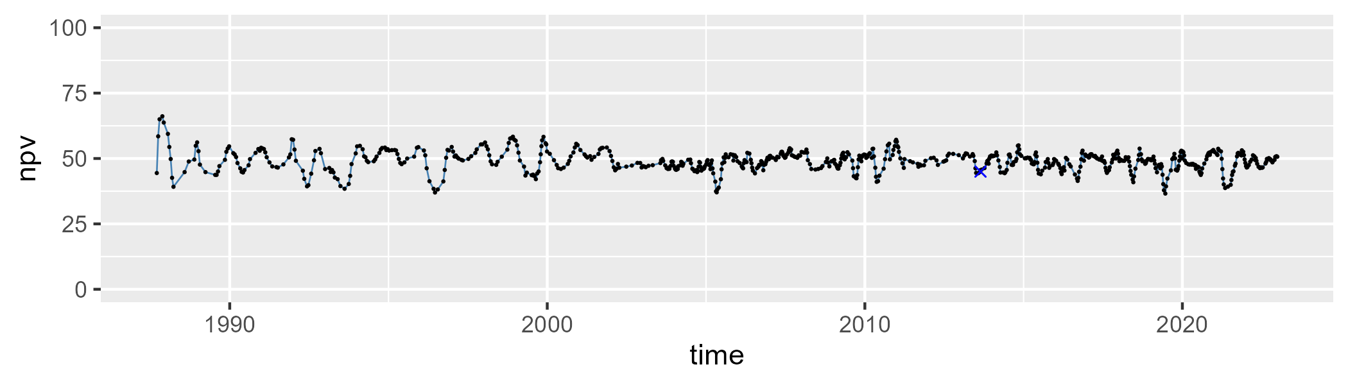

| Min. | 1st Qu. | Median | Mean | 3rd Qu. | Max. |
| --- | --- | --- | --- | --- | --- |
| 2.186317 | 11.46482 | 15.30219 | 16.48468 | 20.02296 | 44.23431 |

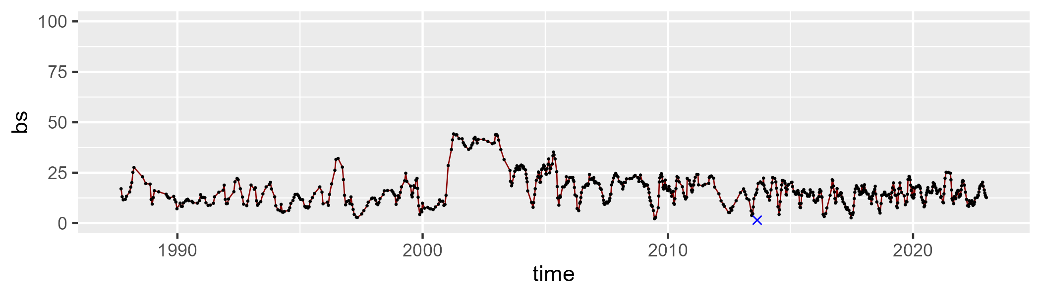

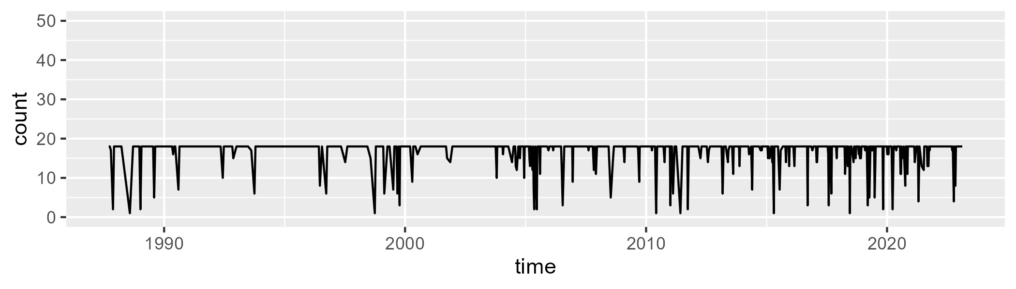

Min. : 1.00 1st Qu.:18.00 Median :18.00 Mean :16.87 3rd Qu.:18.00 Max. :18.00

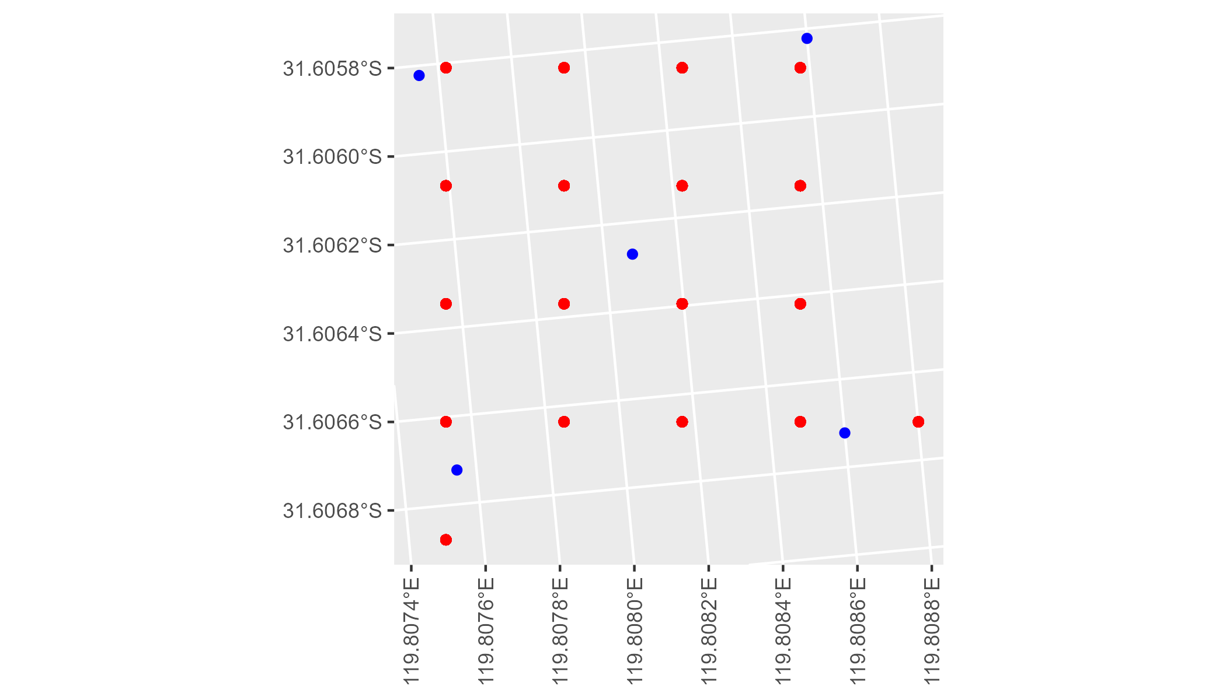

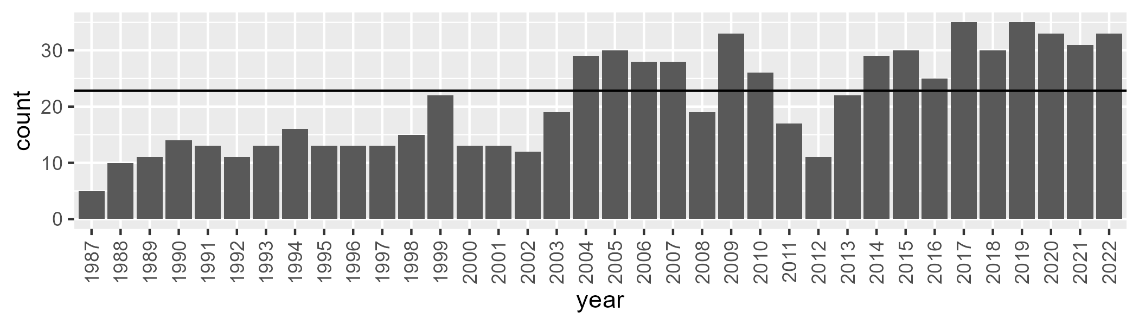

Number of samples: 750

# WAACOO0008

| Min. | 1st Qu. | Median | Mean | 3rd Qu. | Max. |
| --- | --- | --- | --- | --- | --- |
| 20.55572 | 28.98908 | 32.17707 | 32.88699 | 36.4878 | 46.60063 |

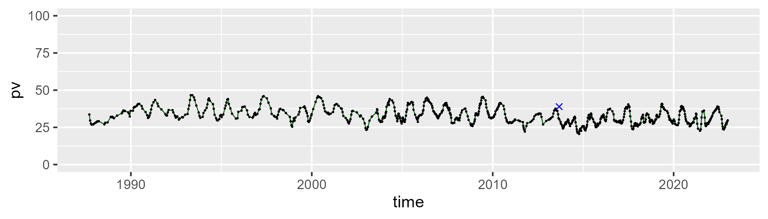

| Min. | 1st Qu. | Median | Mean | 3rd Qu. | Max. |
| --- | --- | --- | --- | --- | --- |
| 35.17375 | 48.78229 | 50.94015 | 50.41132 | 52.56258 | 62.37304 |

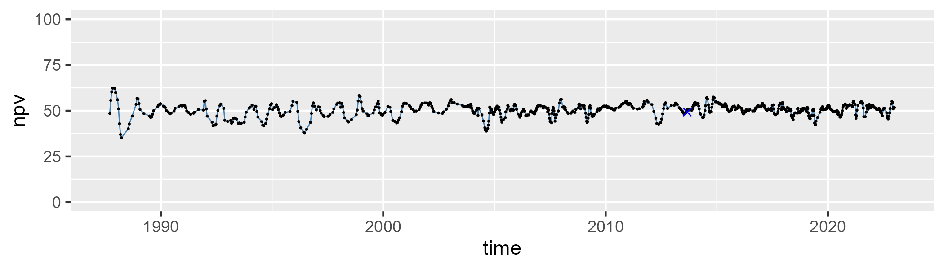

| Min. | 1st Qu. | Median | Mean | 3rd Qu. | Max. |
| --- | --- | --- | --- | --- | --- |
| 2.144784 | 12.10084 | 15.82229 | 15.58097 | 18.67568 | 34.55258 |

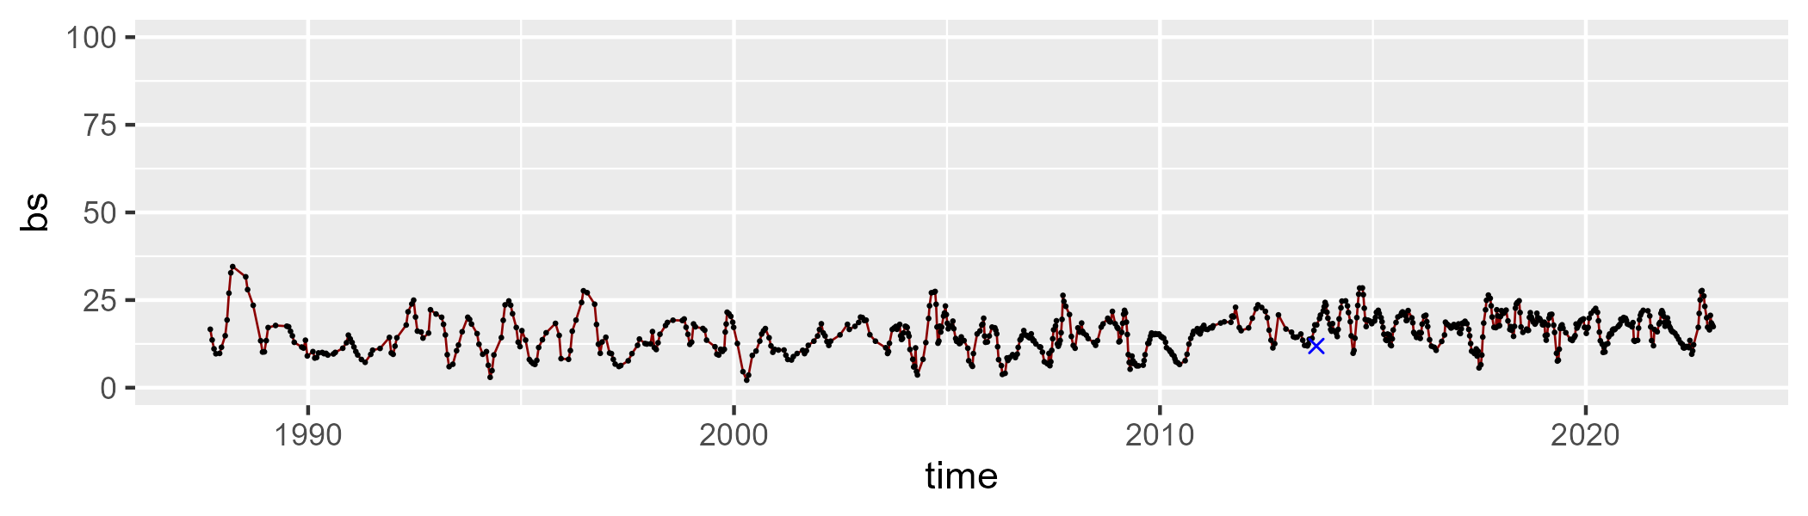

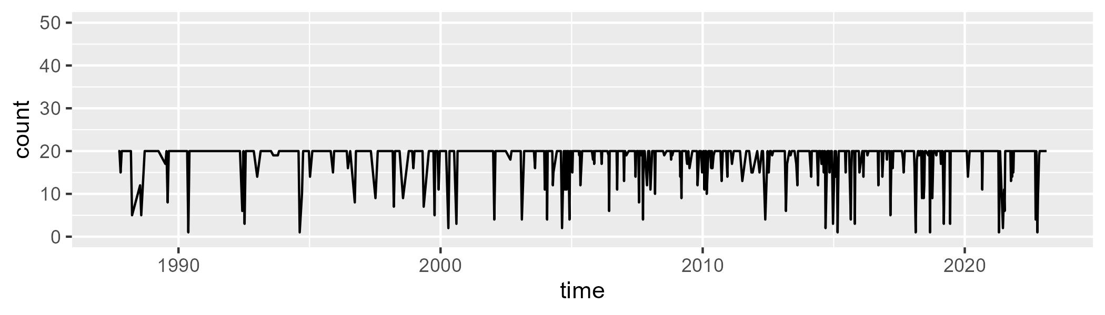

Min. : 1.00 1st Qu.:20.00 Median :20.00 Mean :18.48 3rd Qu.:20.00 Max. :20.00

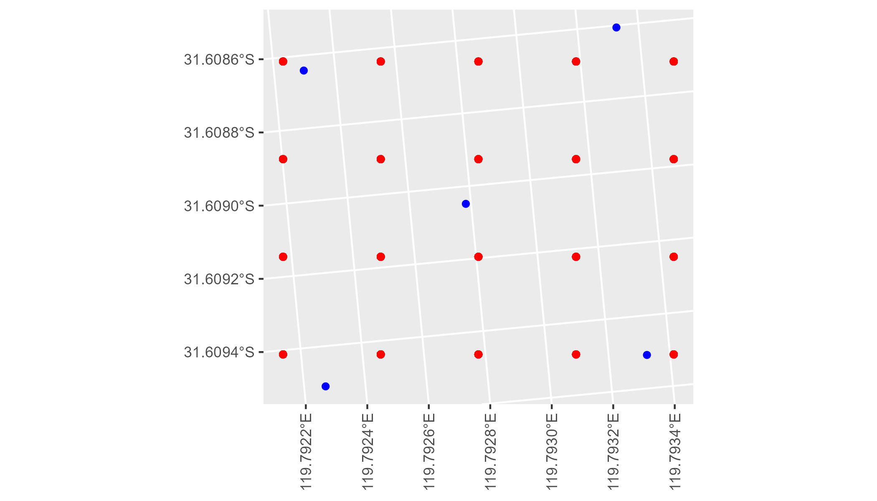

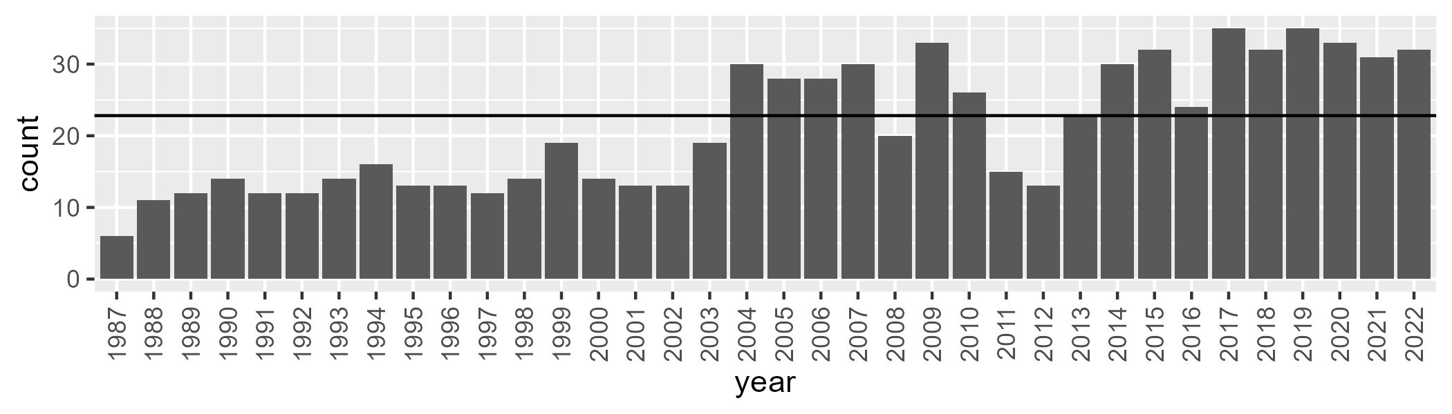

Number of samples: 757

# WAACOO0009

| Min. | 1st Qu. | Median | Mean | 3rd Qu. | Max. |
| --- | --- | --- | --- | --- | --- |
| 3.427159 | 11.53838 | 13.68576 | 14.92351 | 17.9746 | 37.39204 |

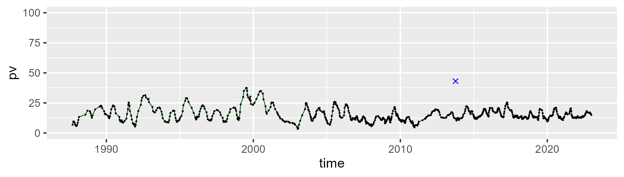

| Min. | 1st Qu. | Median | Mean | 3rd Qu. | Max. |
| --- | --- | --- | --- | --- | --- |
| 37.97921 | 47.3488 | 50.10042 | 50.1832 | 53.00175 | 60.93808 |

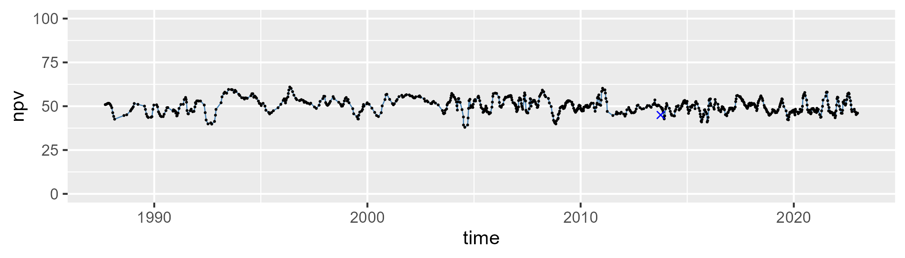

| Min. | 1st Qu. | Median | Mean | 3rd Qu. | Max. |
| --- | --- | --- | --- | --- | --- |
| 18.14283 | 29.75532 | 34.34805 | 33.50151 | 37.64946 | 46.47015 |

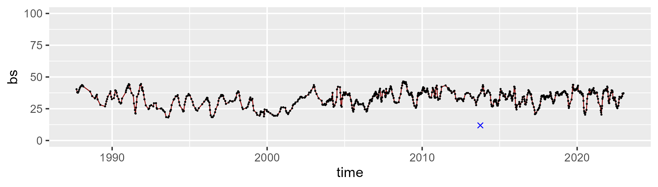

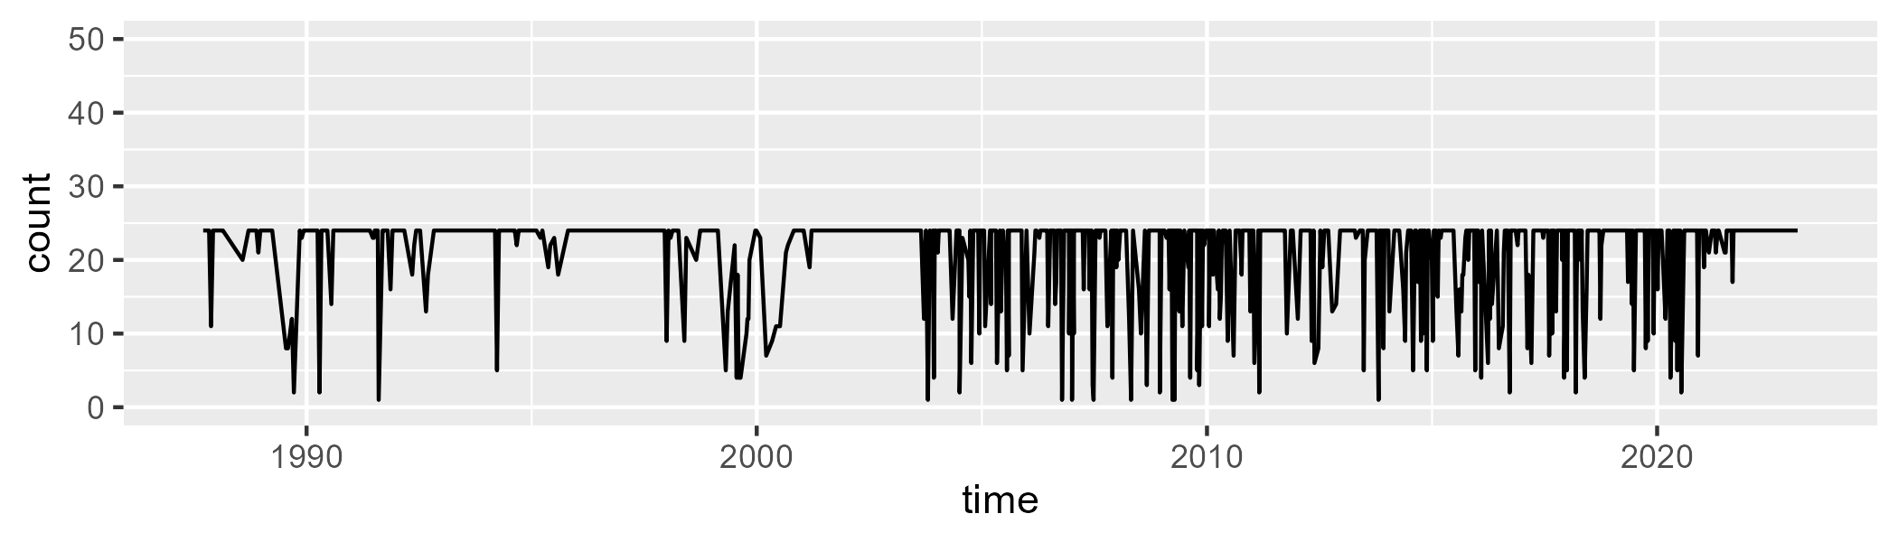

Min. : 1.00 1st Qu.:23.00 Median :24.00 Mean :21.08 3rd Qu.:24.00 Max. :24.00

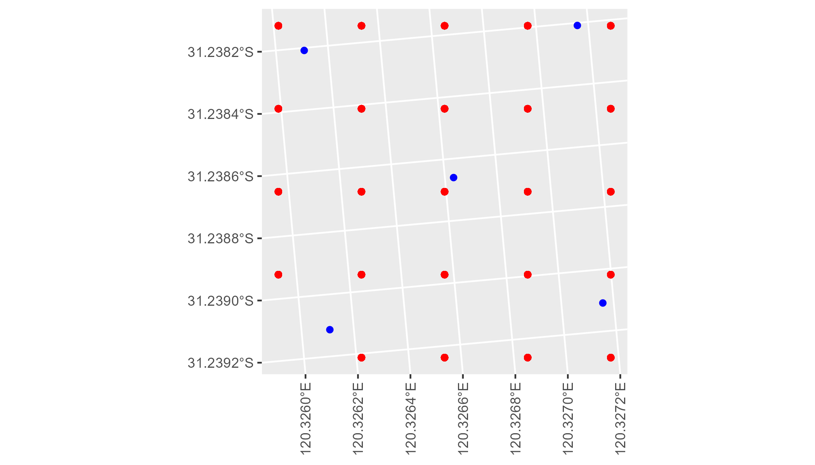

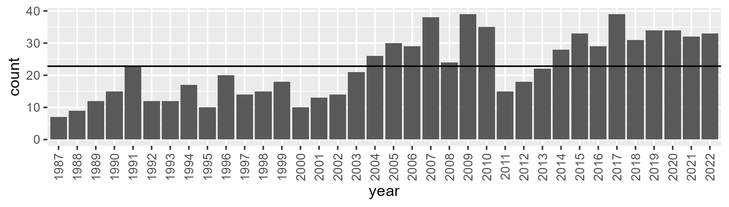

Number of samples: 811

# WAACOO0010

| Min. | 1st Qu. | Median | Mean | 3rd Qu. | Max. |
| --- | --- | --- | --- | --- | --- |
| 4.194218 | 8.867331 | 10.64433 | 10.8436 | 12.58511 | 27.70473 |

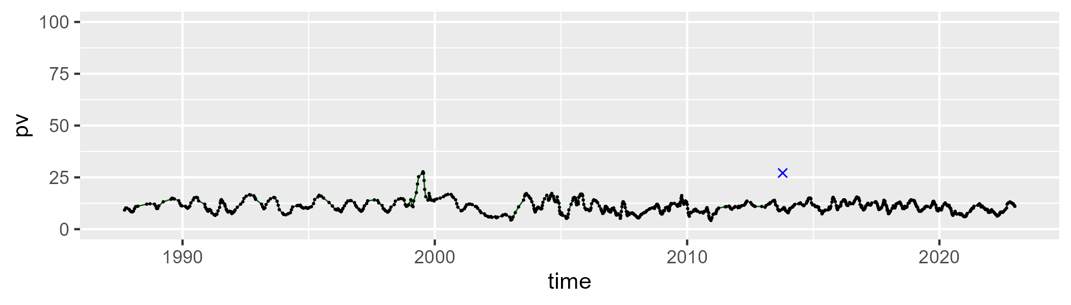

| Min. | 1st Qu. | Median | Mean | 3rd Qu. | Max. |
| --- | --- | --- | --- | --- | --- |
| 28.77365 | 37.96189 | 40.67204 | 40.61956 | 43.12668 | 54.30606 |

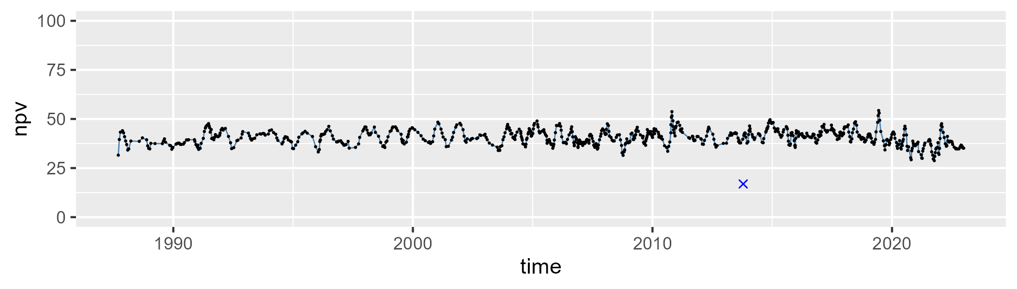

| Min. | 1st Qu. | Median | Mean | 3rd Qu. | Max. |
| --- | --- | --- | --- | --- | --- |
| 31.19482 | 44.01333 | 47.06413 | 47.14043 | 50.33238 | 61.51678 |

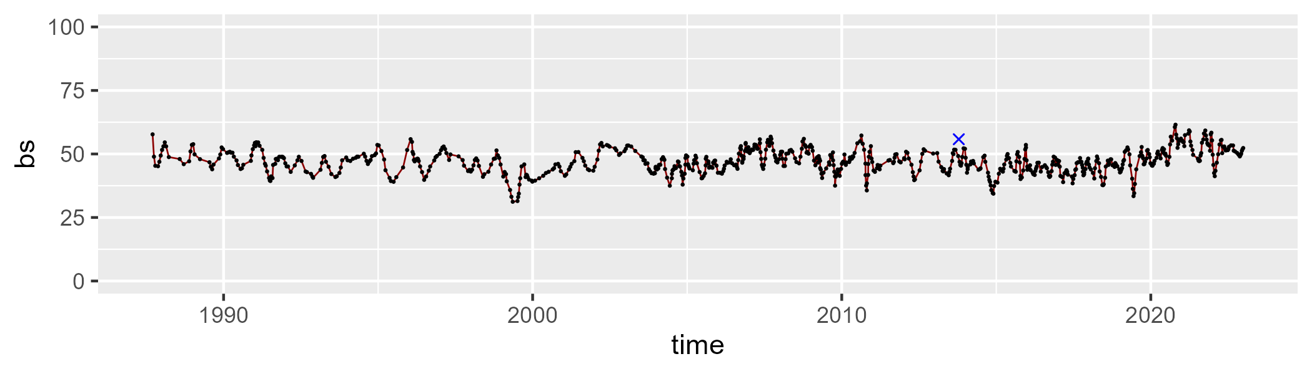

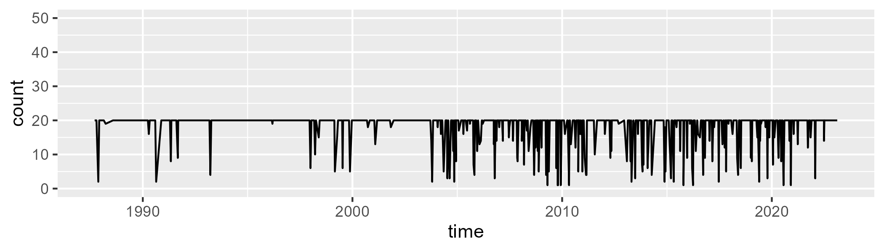

Min. : 1.00 1st Qu.:20.00 Median :20.00 Mean :18.12 3rd Qu.:20.00 Max. :20.00

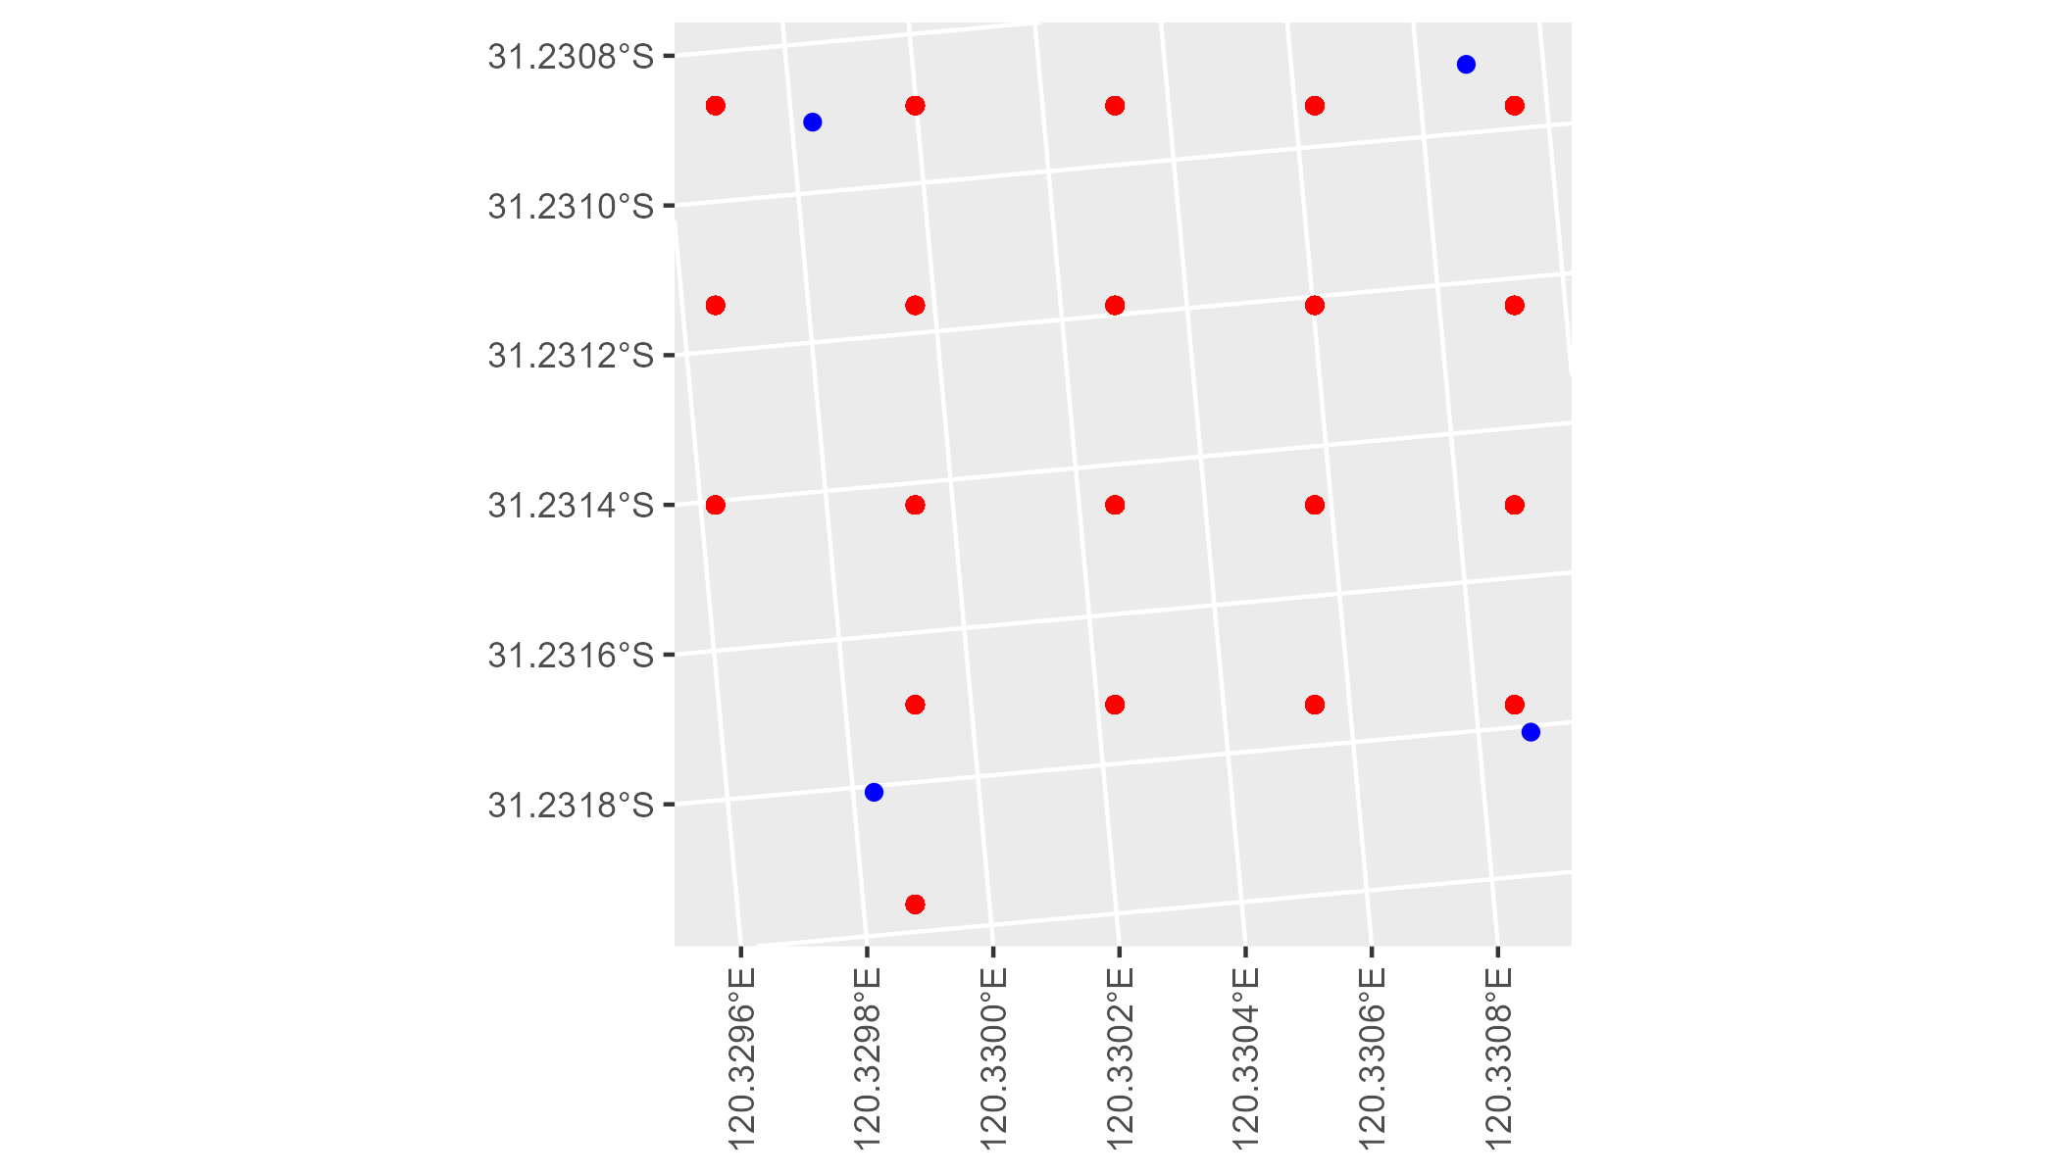

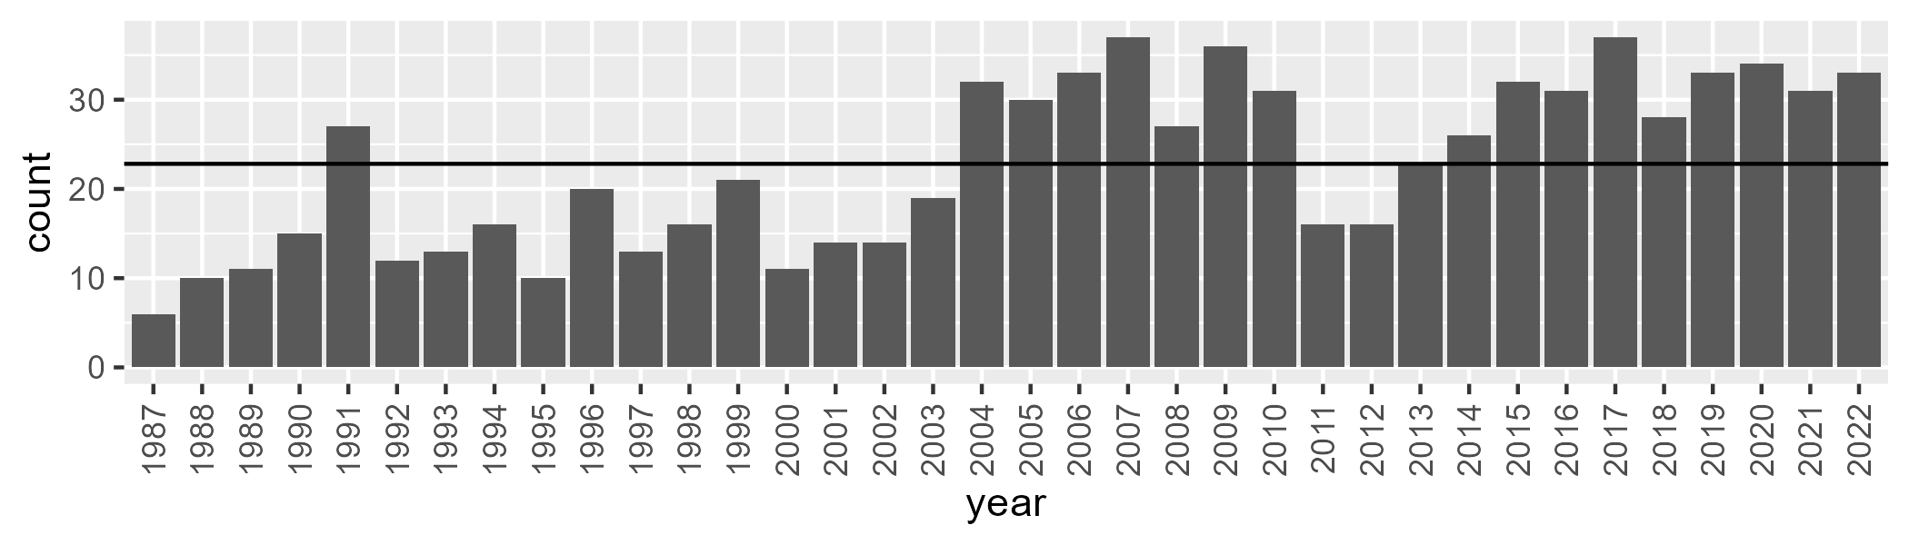

Number of samples: 814

# WAACOO0011

| Min. | 1st Qu. | Median | Mean | 3rd Qu. | Max. |
| --- | --- | --- | --- | --- | --- |
| 0 | 4.254358 | 5.882032 | 6.319735 | 7.538344 | 20.74182 |

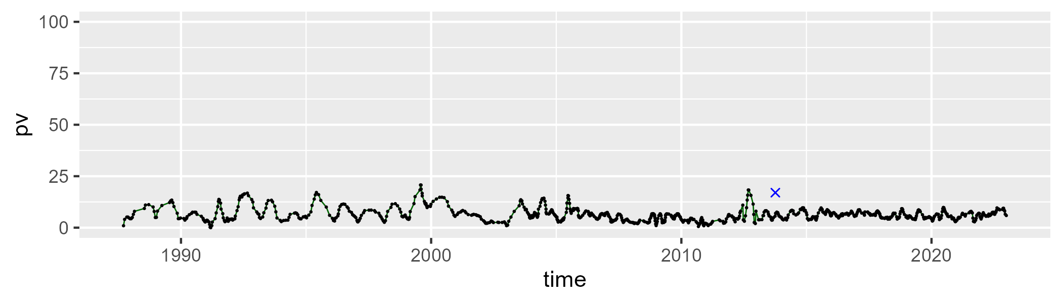

| Min. | 1st Qu. | Median | Mean | 3rd Qu. | Max. |
| --- | --- | --- | --- | --- | --- |
| 66.10108 | 75.56081 | 78.723 | 78.85553 | 82.39042 | 89.77522 |

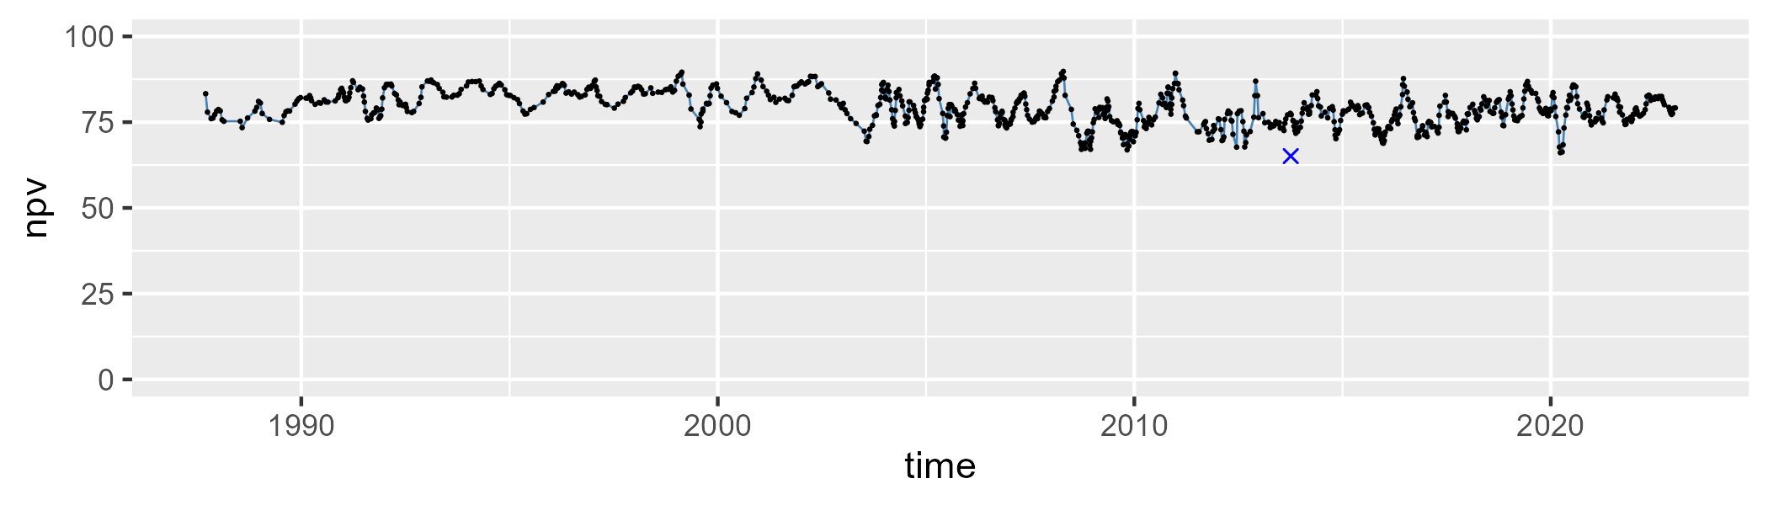

| Min. | 1st Qu. | Median | Mean | 3rd Qu. | Max. |
| --- | --- | --- | --- | --- | --- |
| 2.555531 | 9.70082 | 14.01386 | 13.64126 | 17.32193 | 28.7997 |

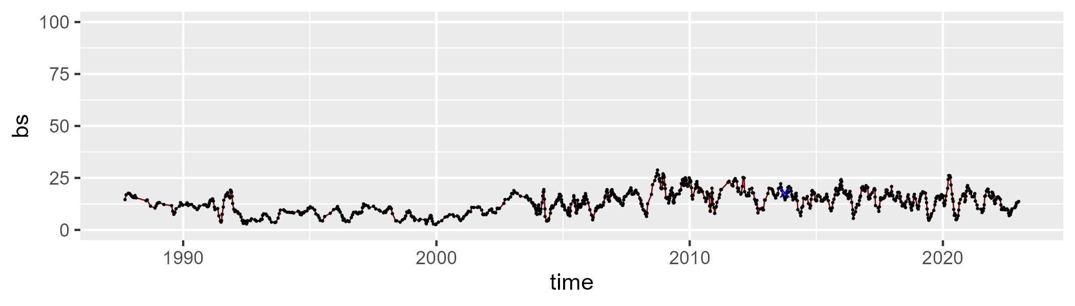

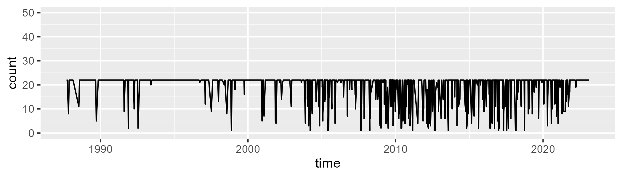

Min. : 1.00 1st Qu.:22.00 Median :22.00 Mean :19.35 3rd Qu.:22.00 Max. :22.00

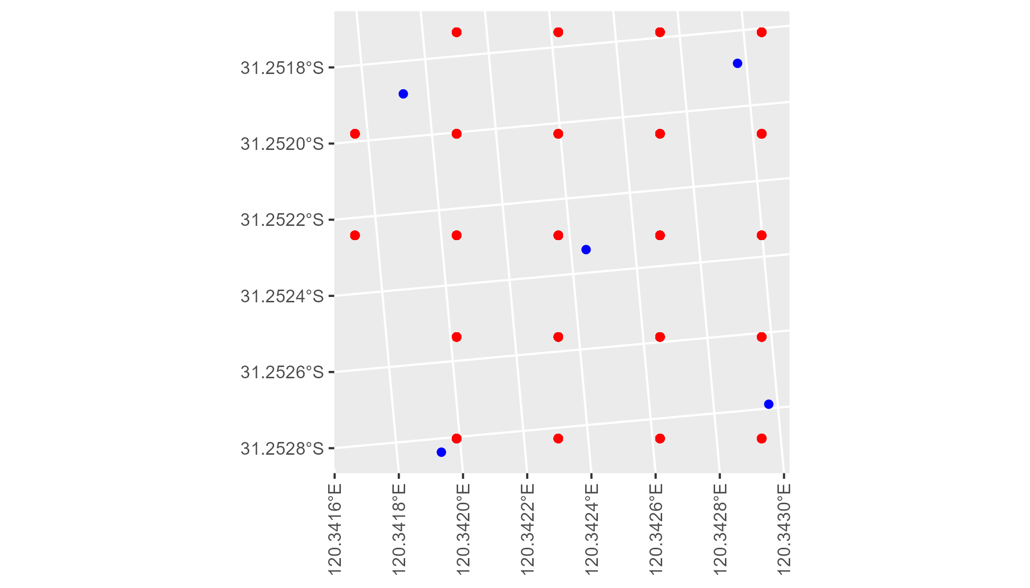

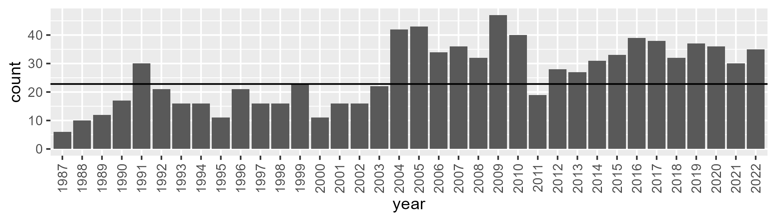

Number of samples: 939

# WAACOO0012

| Min. | 1st Qu. | Median | Mean | 3rd Qu. | Max. |
| --- | --- | --- | --- | --- | --- |
| 16.59968 | 24.8594 | 27.09595 | 27.64555 | 30.34212 | 43.58282 |

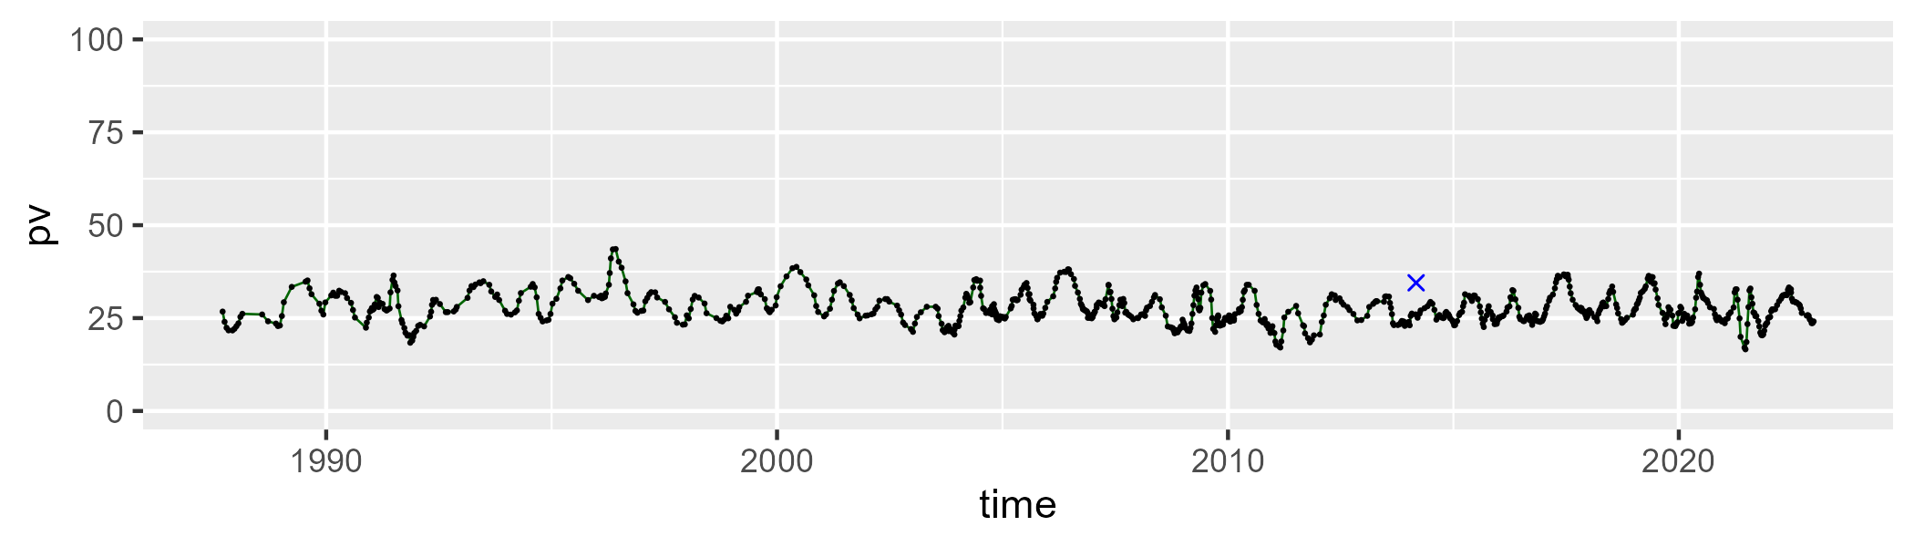

| Min. | 1st Qu. | Median | Mean | 3rd Qu. | Max. |
| --- | --- | --- | --- | --- | --- |
| 36.26518 | 47.72888 | 49.32176 | 49.30138 | 50.97452 | 63.05319 |

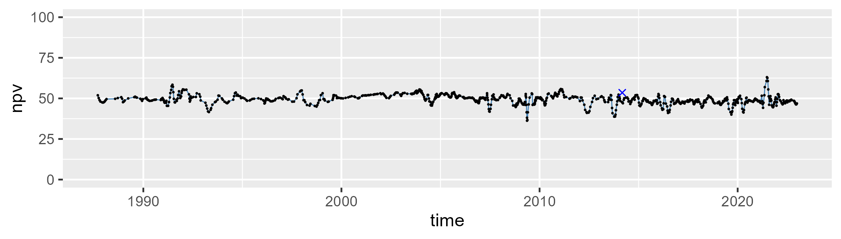

| Min. | 1st Qu. | Median | Mean | 3rd Qu. | Max. |
| --- | --- | --- | --- | --- | --- |
| 5.08982 | 18.91536 | 21.82015 | 21.81157 | 24.73641 | 36.39499 |

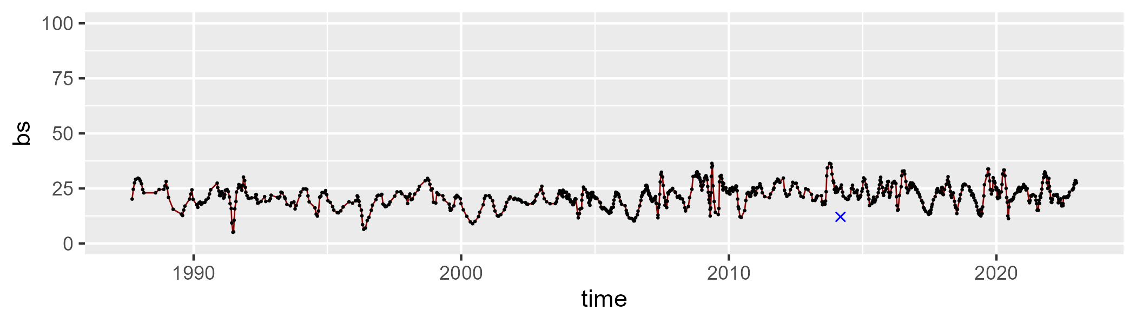

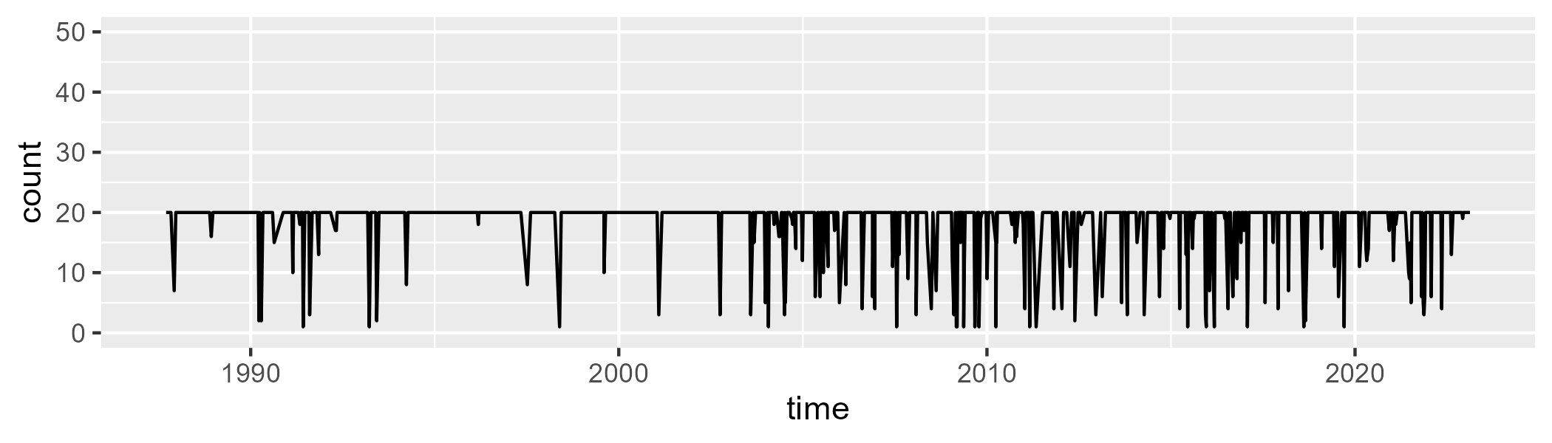

Min. : 1.00 1st Qu.:20.00 Median :20.00 Mean :18.17 3rd Qu.:20.00 Max. :20.00

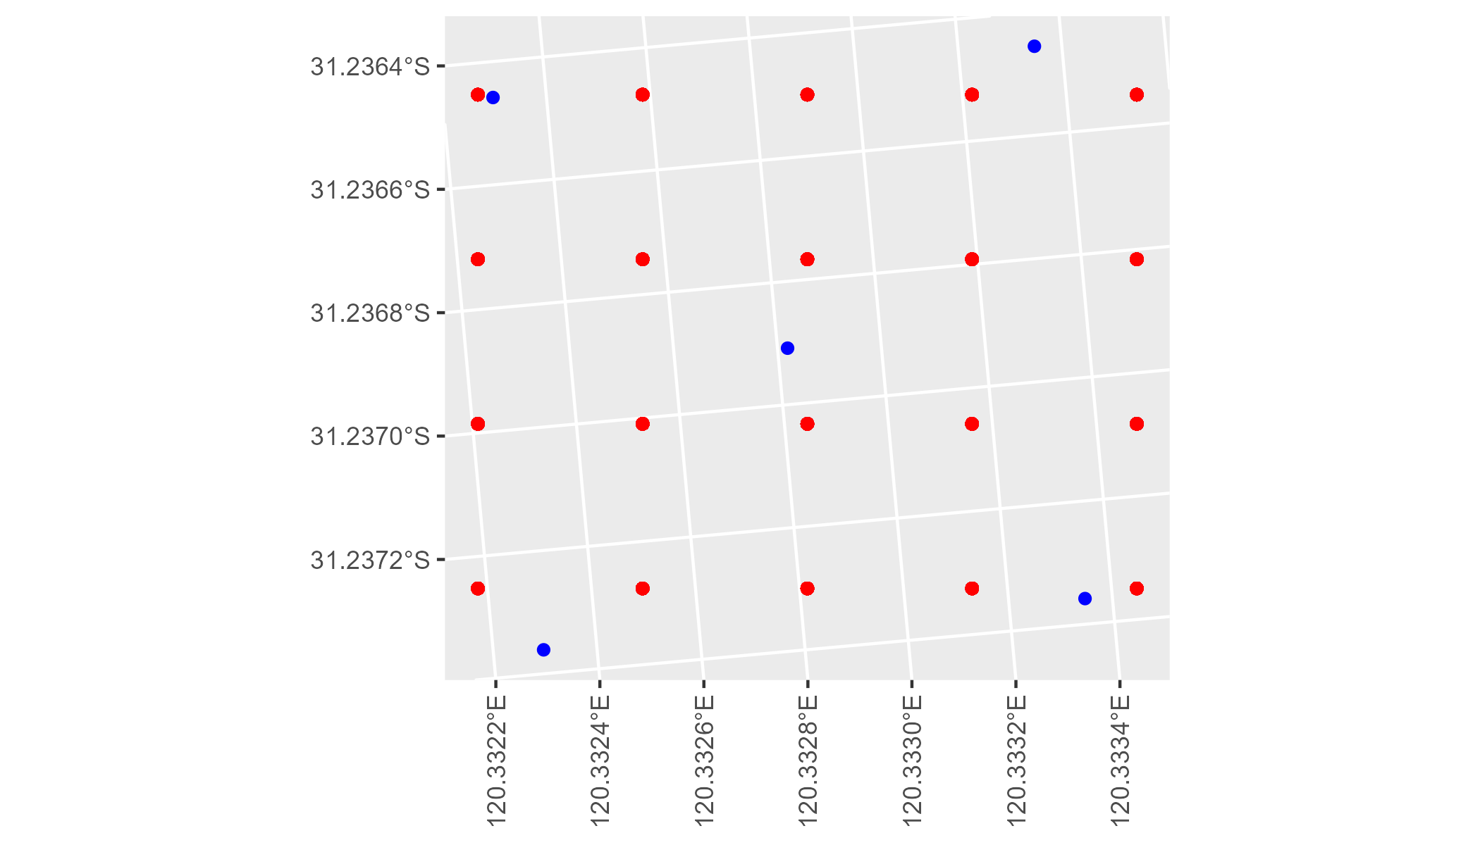

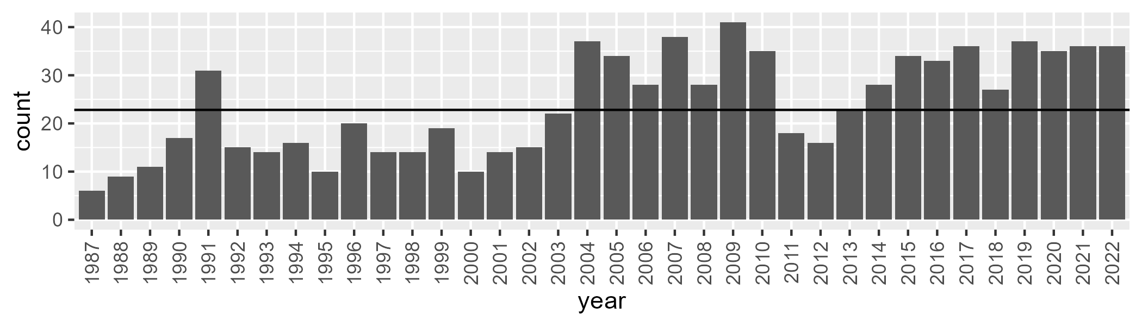

Number of samples: 857

# WAACOO0016

| Min. | 1st Qu. | Median | Mean | 3rd Qu. | Max. |
| --- | --- | --- | --- | --- | --- |
| 2.759601 | 7.679218 | 9.902044 | 10.21621 | 12.35937 | 21.01444 |

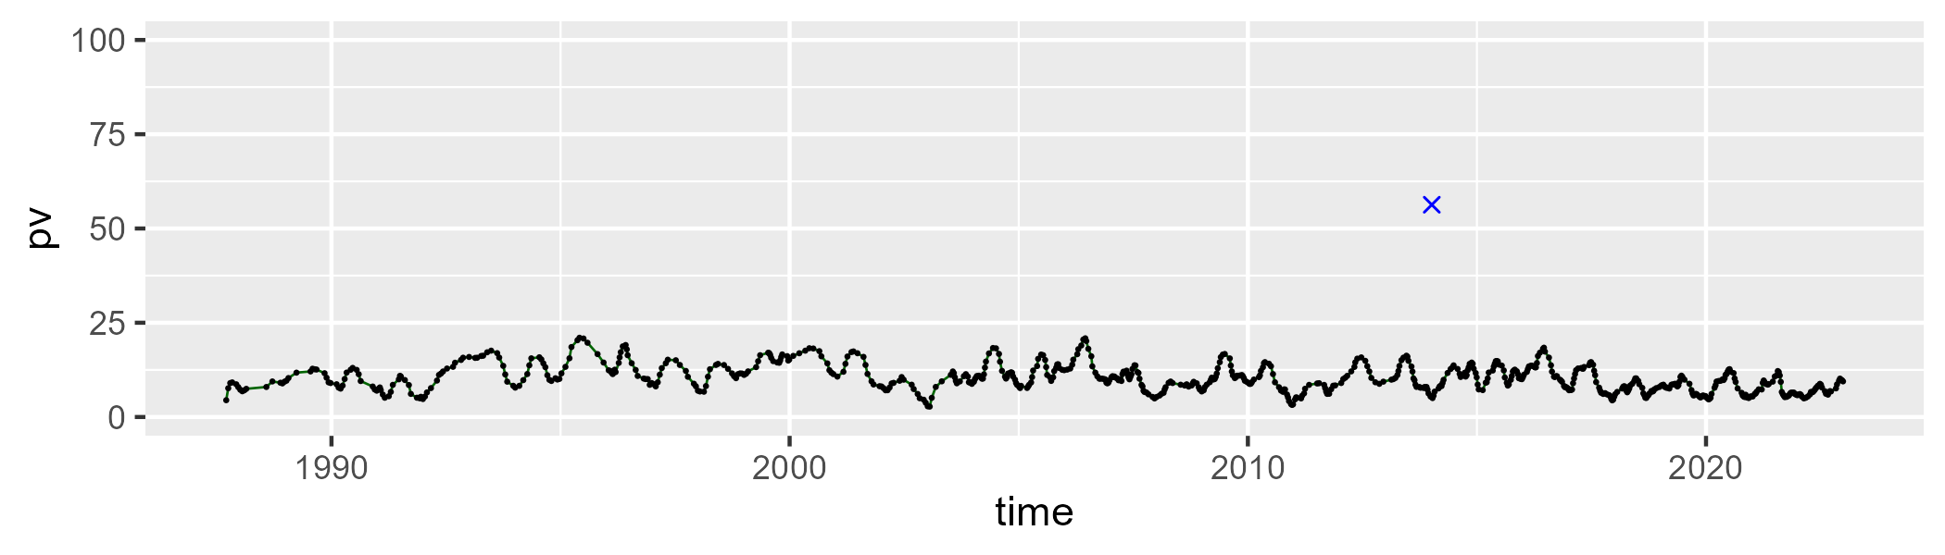

| Min. | 1st Qu. | Median | Mean | 3rd Qu. | Max. |
| --- | --- | --- | --- | --- | --- |
| 57.75615 | 68.73856 | 71.72297 | 71.76572 | 74.5128 | 84.99446 |

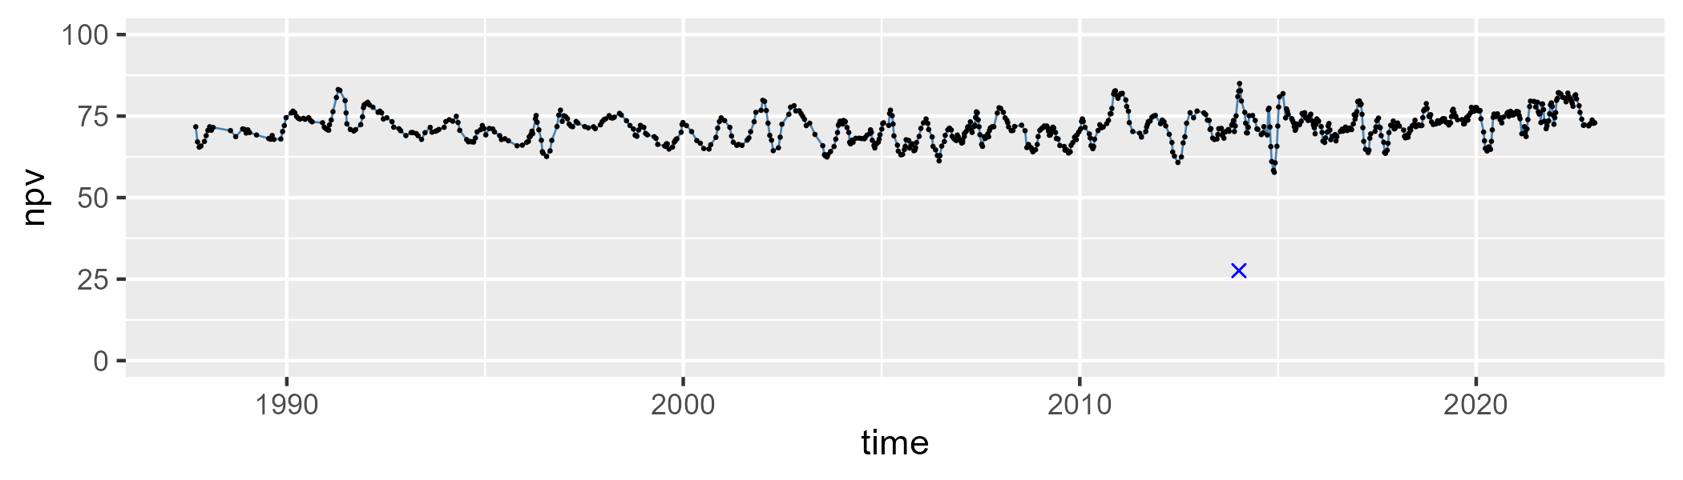

| Min. | 1st Qu. | Median | Mean | 3rd Qu. | Max. |
| --- | --- | --- | --- | --- | --- |
| 7.39923 | 14.0626 | 16.85122 | 16.79303 | 19.2108 | 28.68007 |

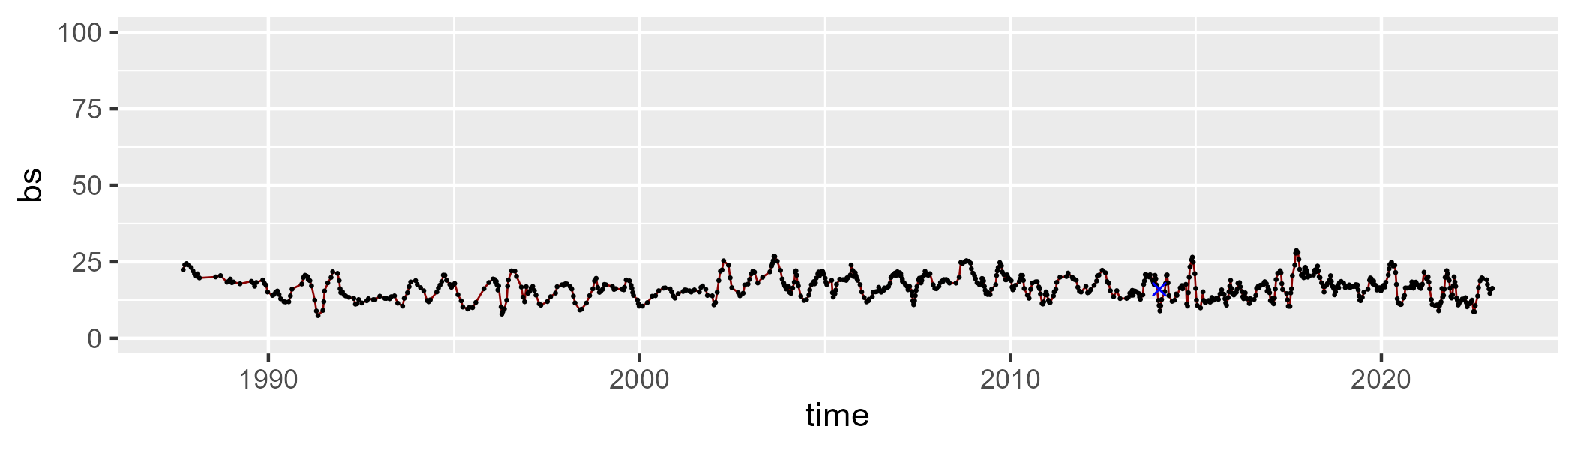

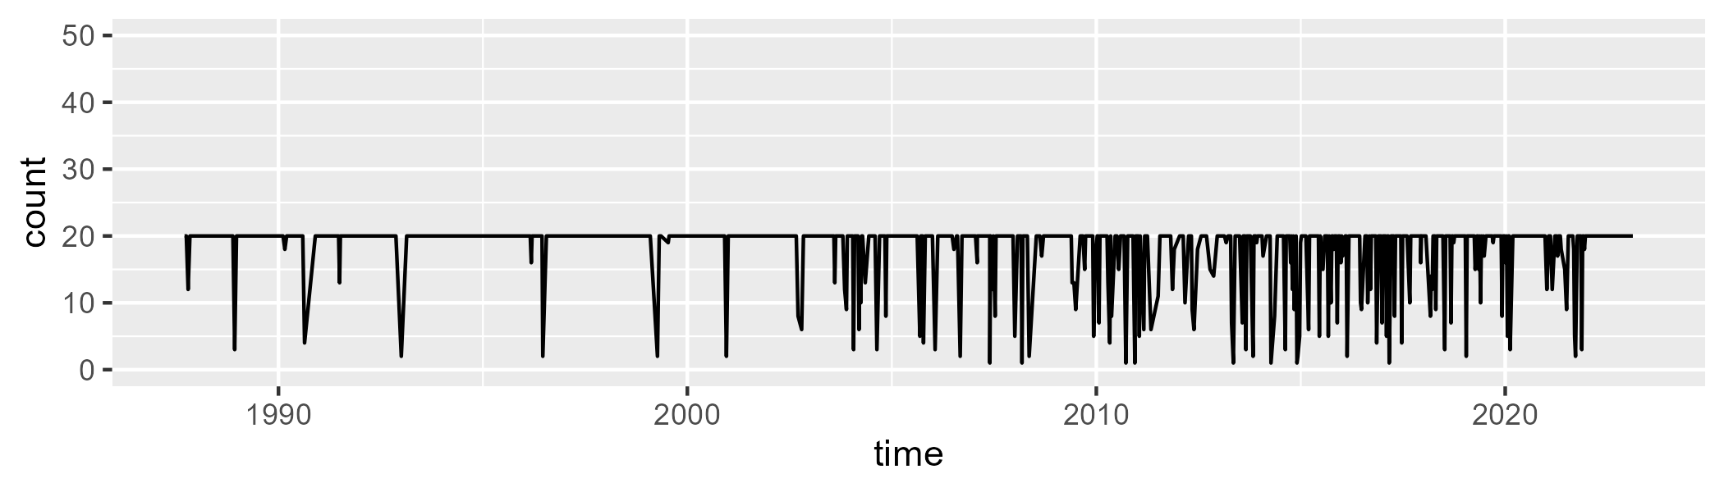

Min. : 1.00 1st Qu.:20.00 Median :20.00 Mean :18.23 3rd Qu.:20.00 Max. :20.00

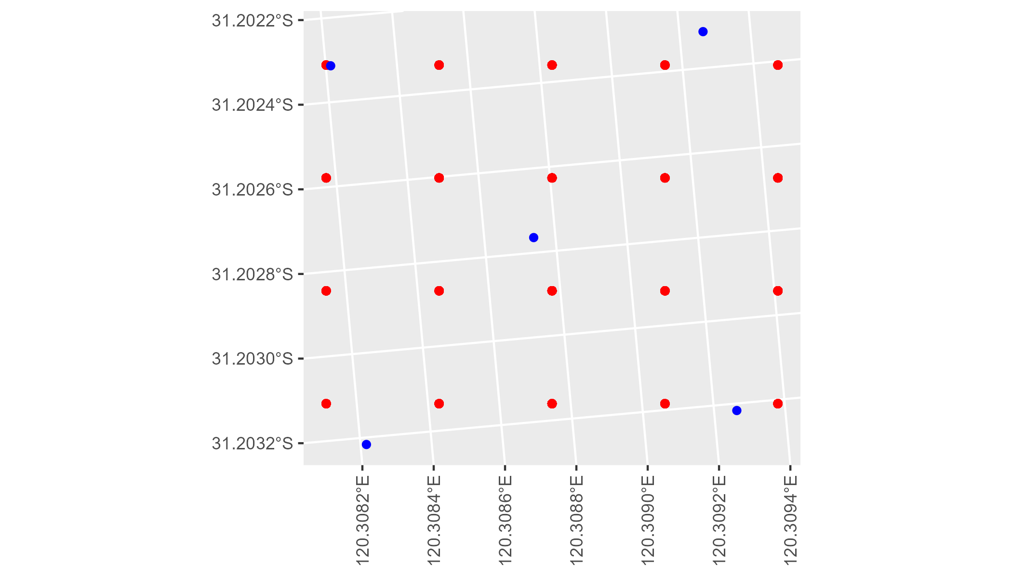

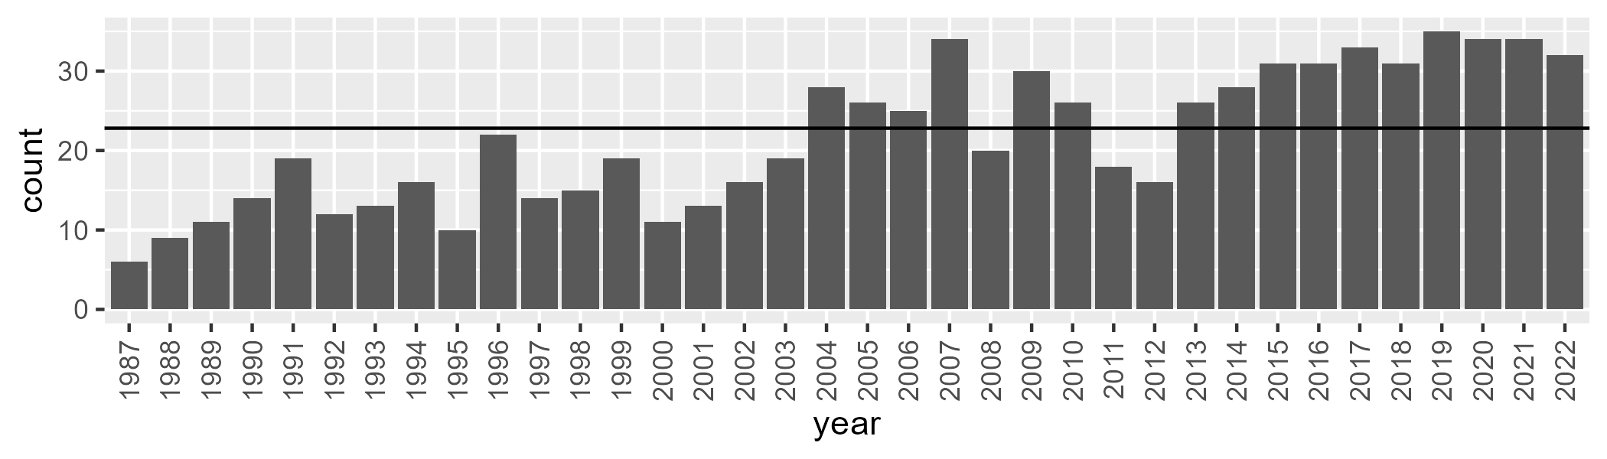

Number of samples: 777

# WAACOO0017

| Min. | 1st Qu. | Median | Mean | 3rd Qu. | Max. |
| --- | --- | --- | --- | --- | --- |
| 2.113213 | 8.136735 | 11.07557 | 11.52497 | 14.09998 | 25.97837 |

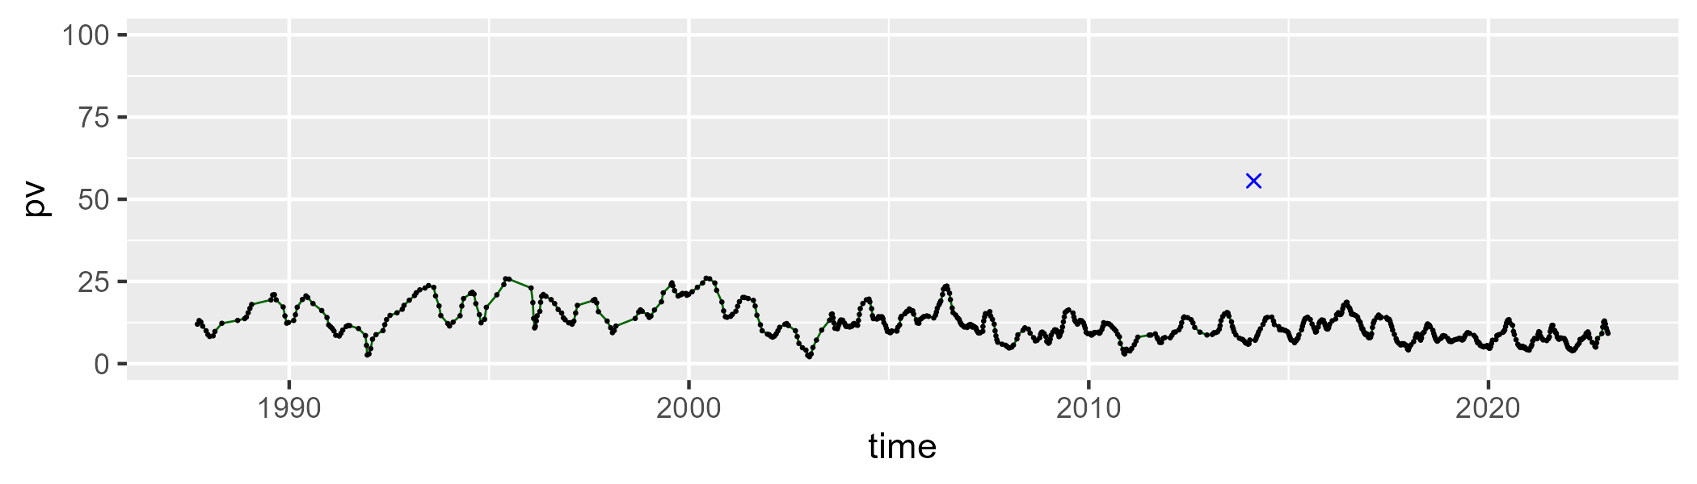

| Min. | 1st Qu. | Median | Mean | 3rd Qu. | Max. |
| --- | --- | --- | --- | --- | --- |
| 53.21078 | 65.49065 | 68.22561 | 68.2675 | 70.808 | 82.41702 |

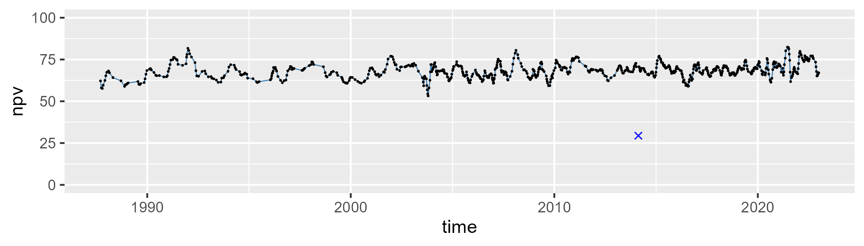

| Min. | 1st Qu. | Median | Mean | 3rd Qu. | Max. |
| --- | --- | --- | --- | --- | --- |
| 9.20067 | 15.84033 | 18.84892 | 19.0004 | 22.27133 | 32.37239 |

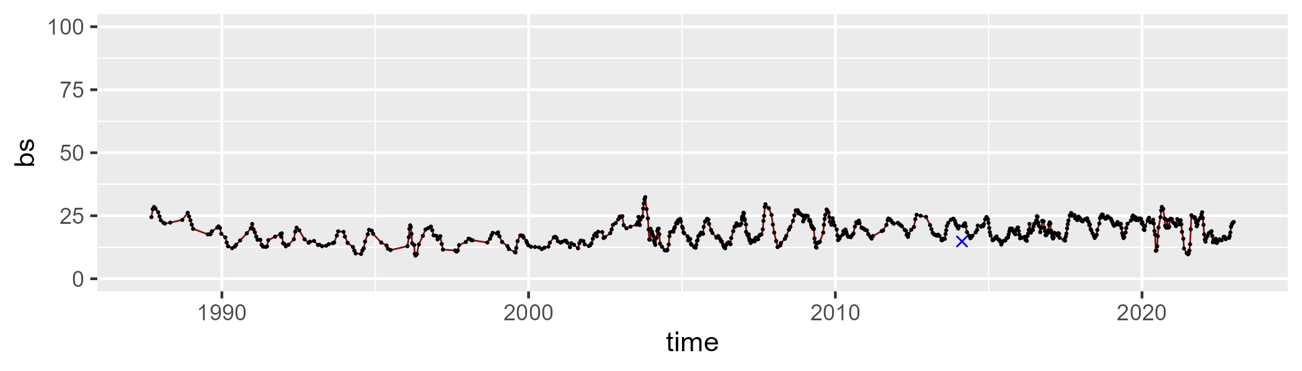

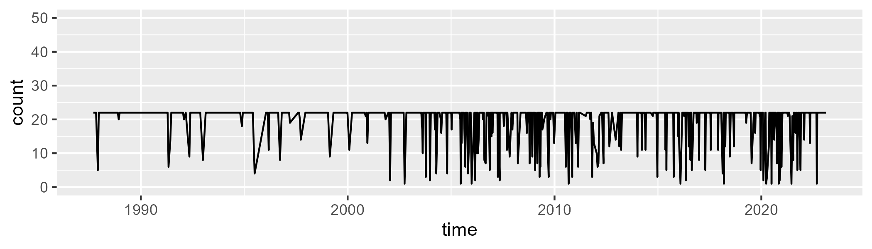

Min. : 1.00 1st Qu.:22.00 Median :22.00 Mean :19.68 3rd Qu.:22.00 Max. :22.00

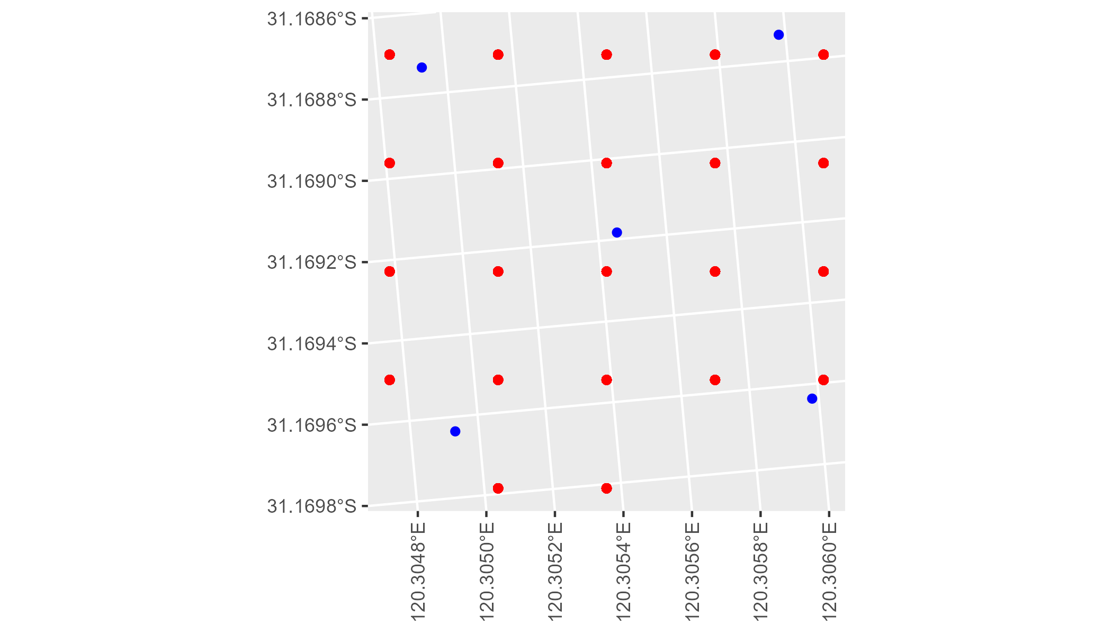

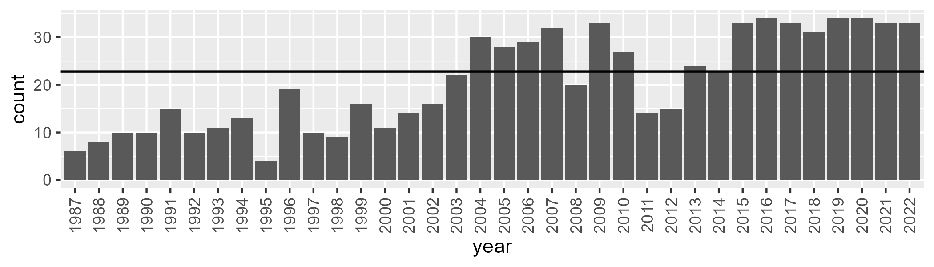

Number of samples: 744

# WAACOO0018

| Min. | 1st Qu. | Median | Mean | 3rd Qu. | Max. |
| --- | --- | --- | --- | --- | --- |
| 3.313267 | 12.26287 | 15.25752 | 16.16486 | 19.60549 | 35.89017 |

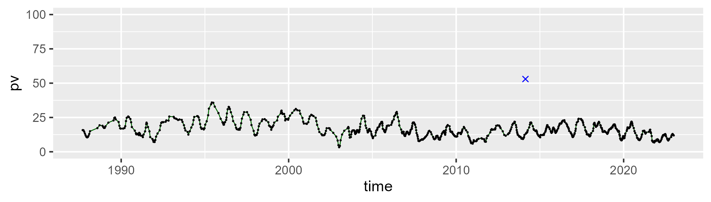

| Min. | 1st Qu. | Median | Mean | 3rd Qu. | Max. |
| --- | --- | --- | --- | --- | --- |
| 48.89763 | 62.57955 | 66.06794 | 65.78905 | 69.07693 | 78.10611 |

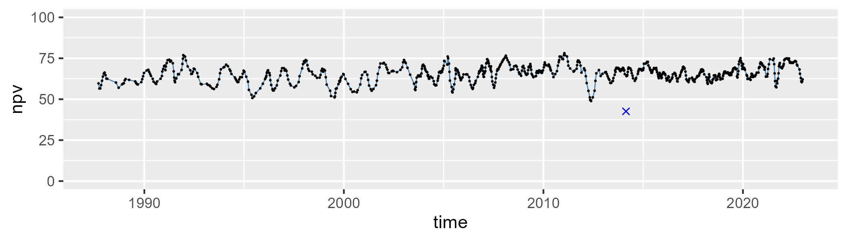

| Min. | 1st Qu. | Median | Mean | 3rd Qu. | Max. |
| --- | --- | --- | --- | --- | --- |
| 8.185306 | 14.29259 | 16.61213 | 16.89657 | 19.3497 | 32.17729 |

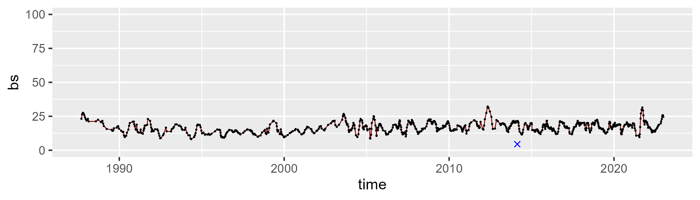

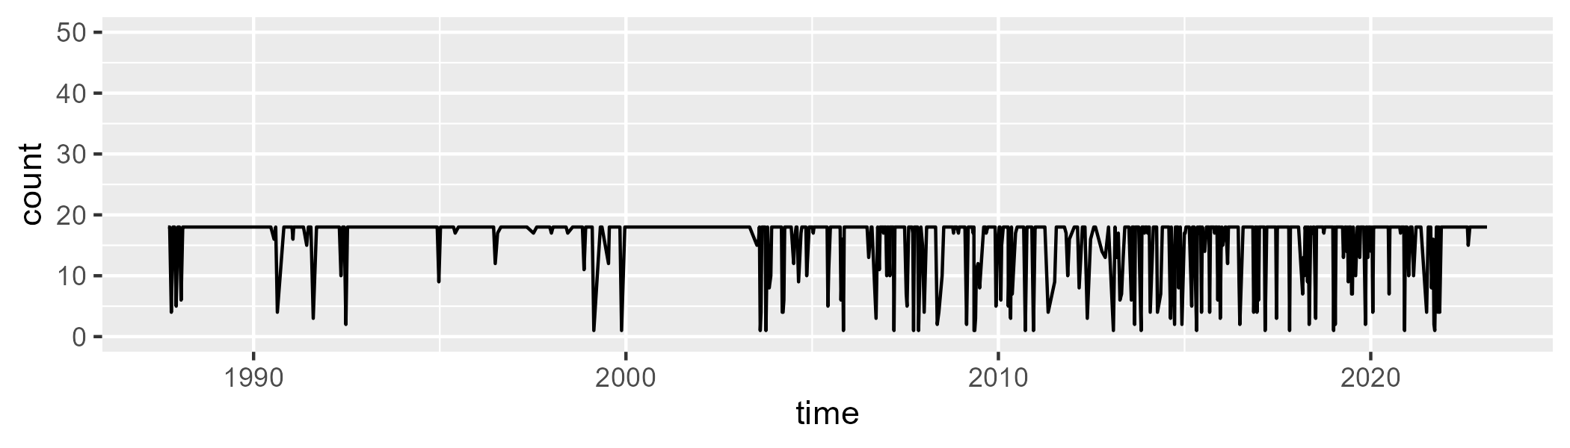

Min. : 1.00 1st Qu.:18.00 Median :18.00 Mean :15.99 3rd Qu.:18.00 Max. :18.00

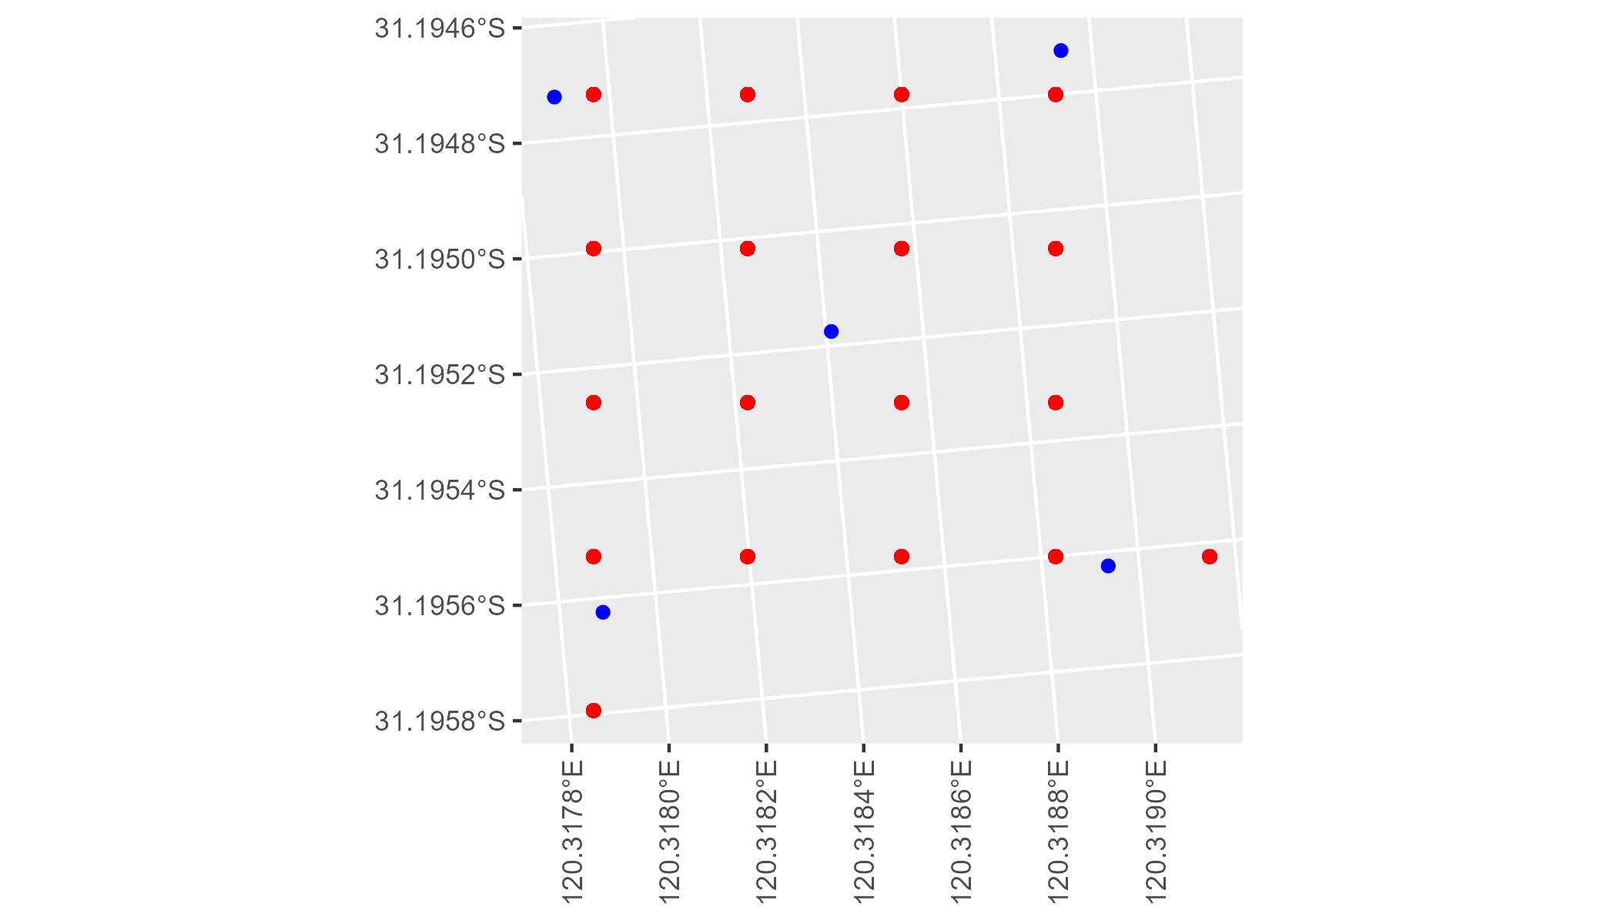

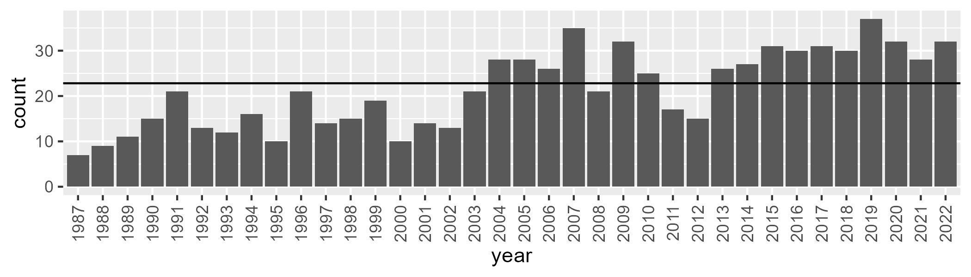

Number of samples: 772

# WAACOO0019

| Min. | 1st Qu. | Median | Mean | 3rd Qu. | Max. |
| --- | --- | --- | --- | --- | --- |
| 2.002845 | 7.736359 | 9.85836 | 10.39607 | 12.56477 | 24.11041 |

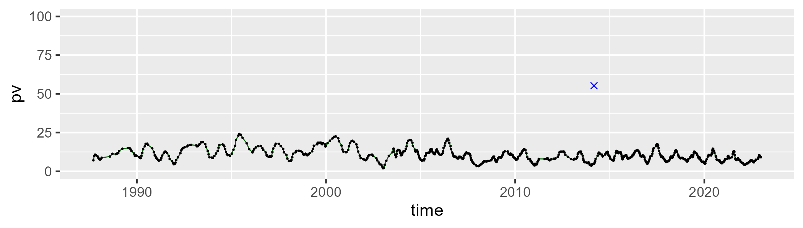

| Min. | 1st Qu. | Median | Mean | 3rd Qu. | Max. |
| --- | --- | --- | --- | --- | --- |
| 50.58512 | 66.69338 | 69.22616 | 69.29708 | 71.90363 | 82.34359 |

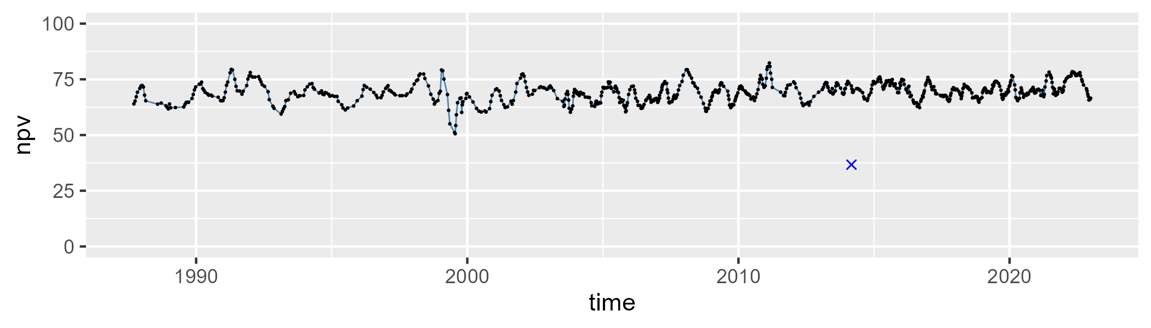

| Min. | 1st Qu. | Median | Mean | 3rd Qu. | Max. |
| --- | --- | --- | --- | --- | --- |
| 8.58262 | 16.34 | 19.16036 | 19.1126 | 21.99662 | 30.5841 |

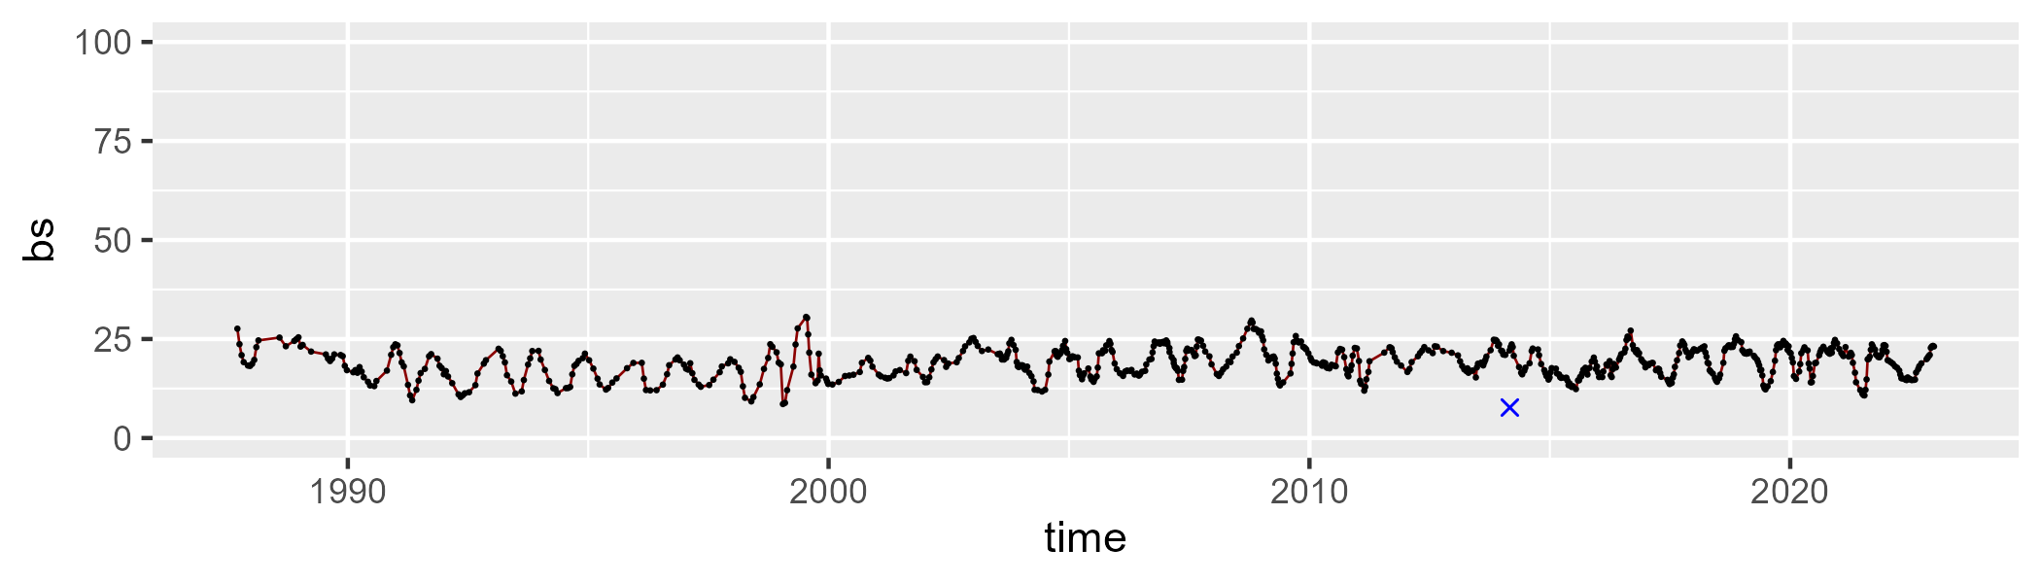

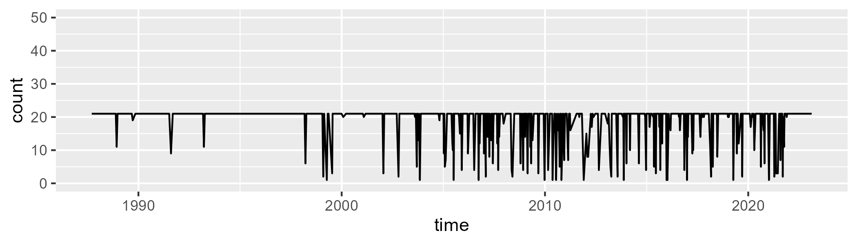

Min. : 1.00 1st Qu.:21.00 Median :21.00 Mean :19.01 3rd Qu.:21.00 Max. :21.00

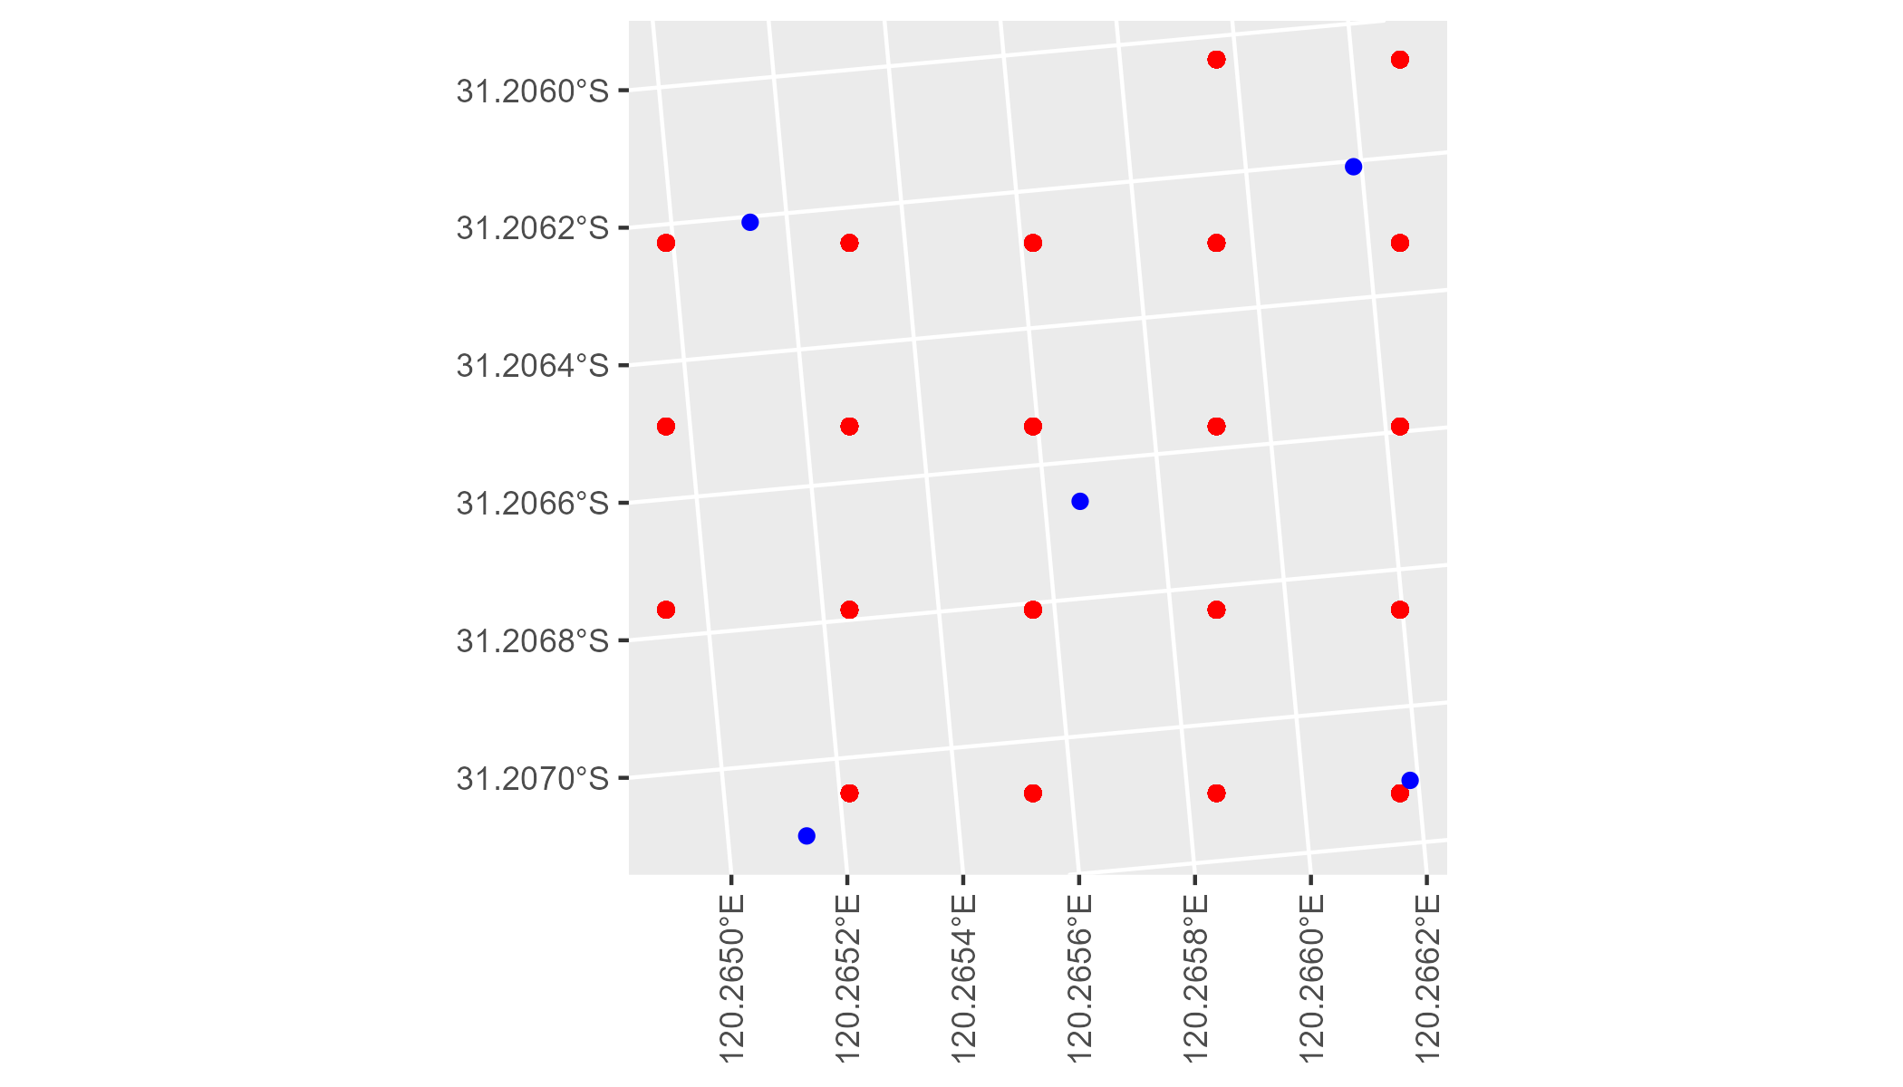

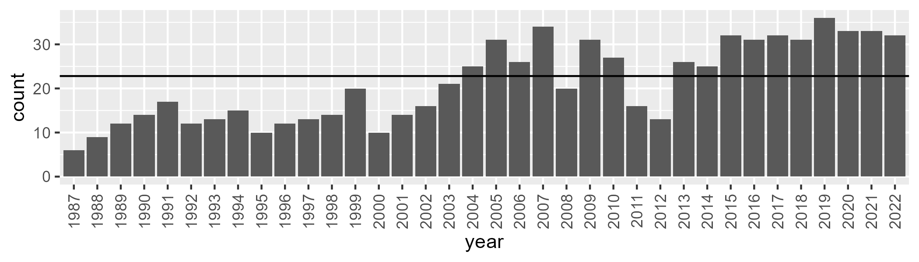

Number of samples: 762

# WAACOO0020

| Min. | 1st Qu. | Median | Mean | 3rd Qu. | Max. |
| --- | --- | --- | --- | --- | --- |
| 9.676024 | 14.65536 | 16.28589 | 16.44124 | 17.76641 | 31.84684 |

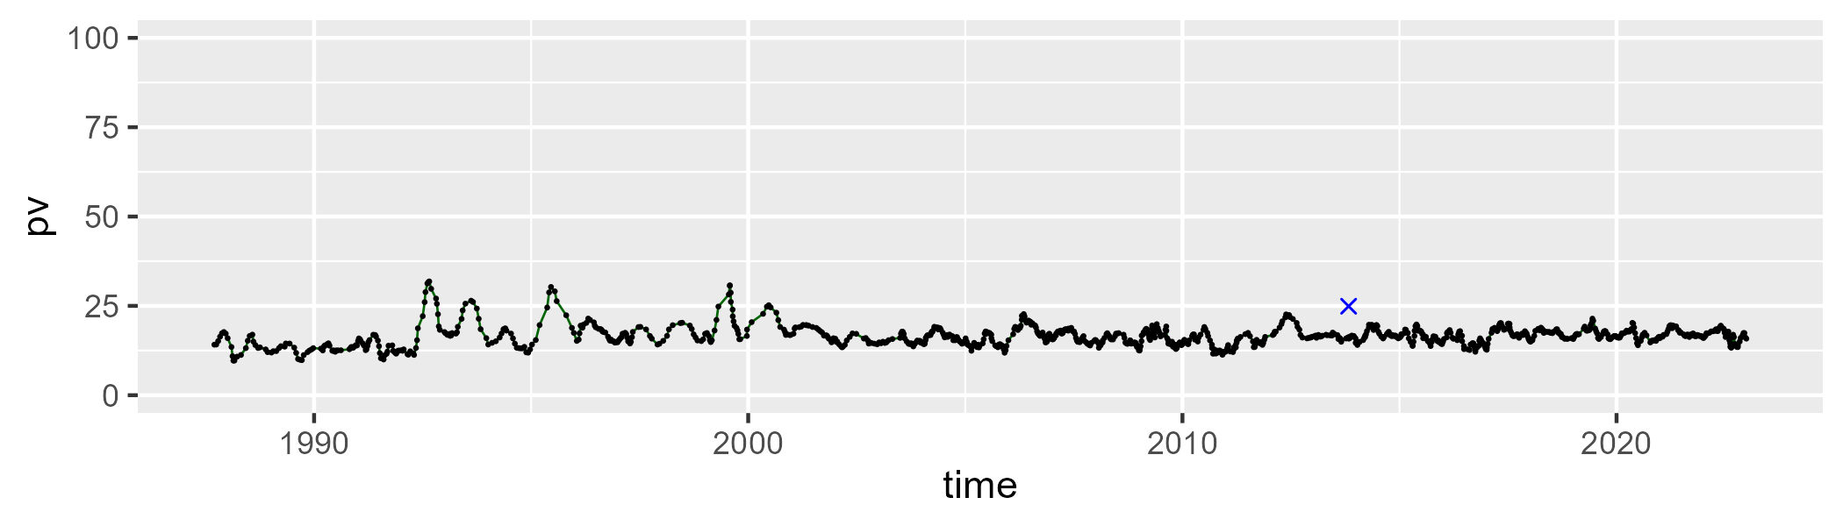

| Min. | 1st Qu. | Median | Mean | 3rd Qu. | Max. |
| --- | --- | --- | --- | --- | --- |
| 31.89572 | 38.60733 | 40.68173 | 40.84635 | 42.67608 | 54.79836 |

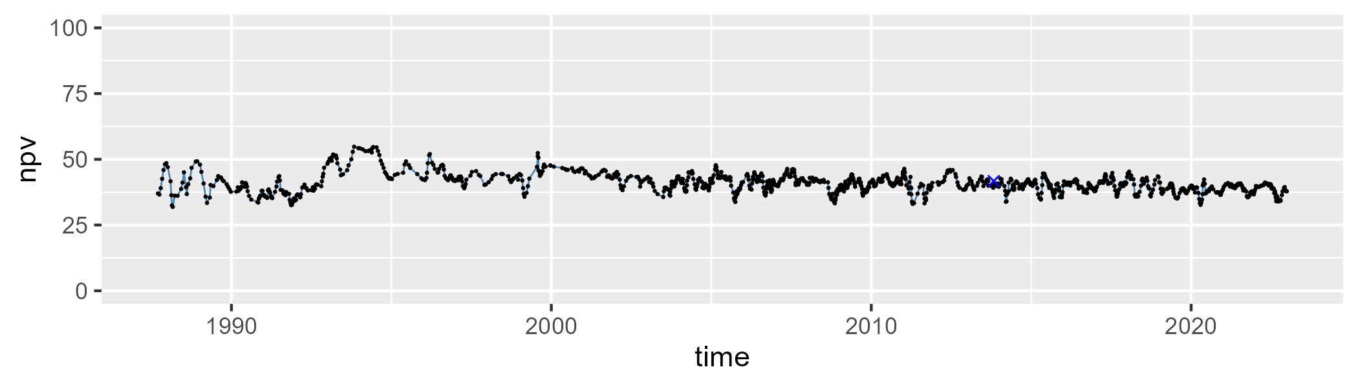

| Min. | 1st Qu. | Median | Mean | 3rd Qu. | Max. |
| --- | --- | --- | --- | --- | --- |
| 15.50417 | 38.78199 | 41.53177 | 41.20191 | 44.52262 | 56.63258 |

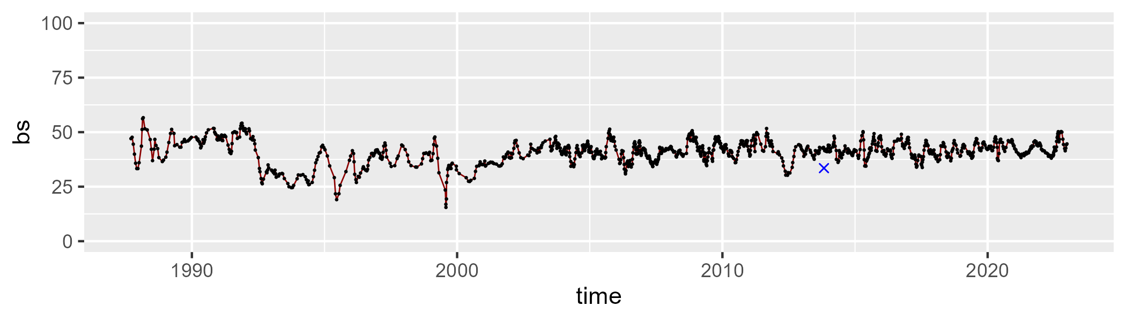

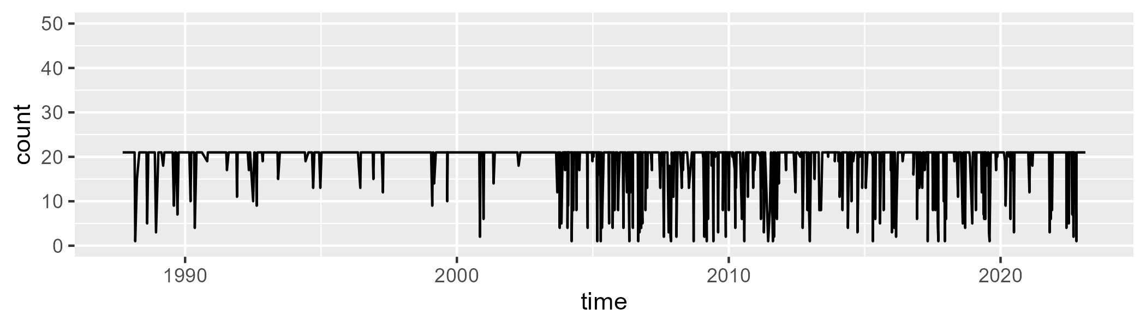

Min. : 1.00 1st Qu.:21.00 Median :21.00 Mean :19.02 3rd Qu.:21.00 Max. :21.00

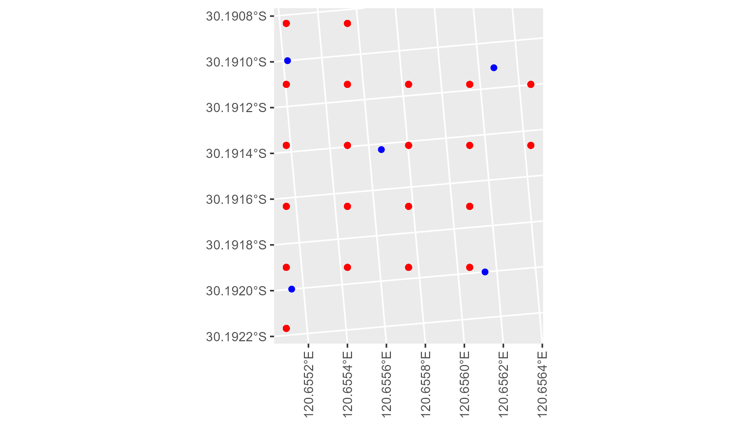

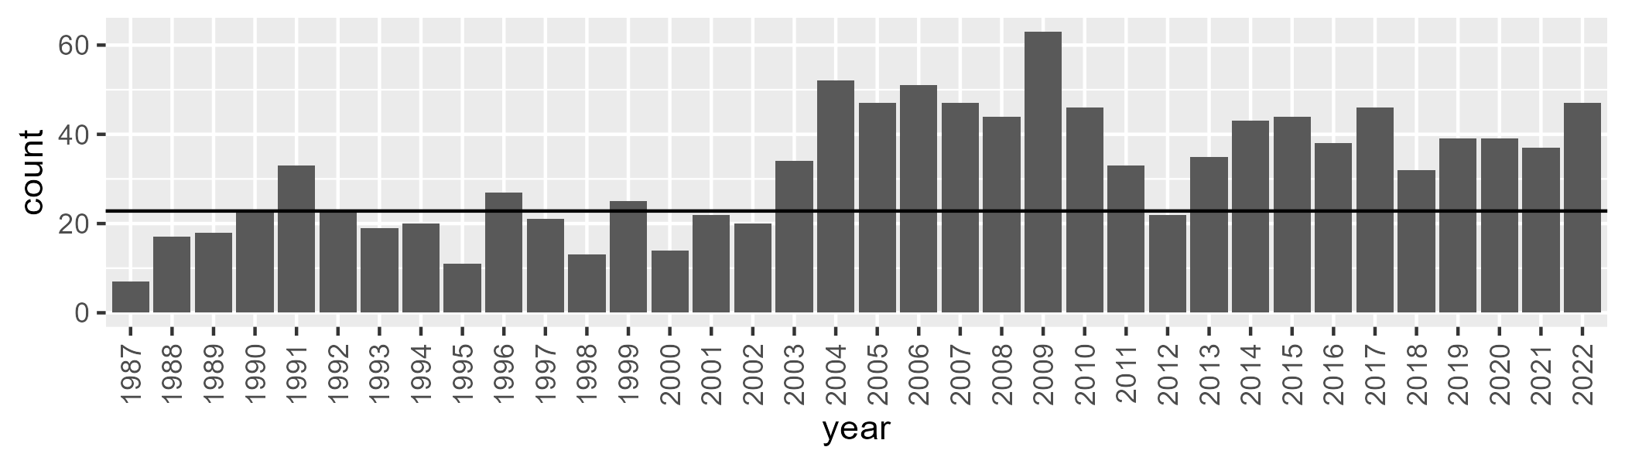

Number of samples: 1152

# WAACOO0021

| Min. | 1st Qu. | Median | Mean | 3rd Qu. | Max. |
| --- | --- | --- | --- | --- | --- |
| 11.16398 | 17.67887 | 19.4047 | 19.84072 | 21.44667 | 38.55279 |

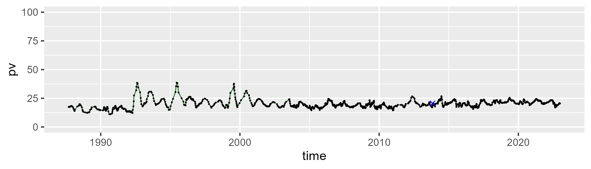

| Min. | 1st Qu. | Median | Mean | 3rd Qu. | Max. |
| --- | --- | --- | --- | --- | --- |
| 34.60318 | 41.71413 | 43.94392 | 44.0397 | 46.03153 | 61.24549 |

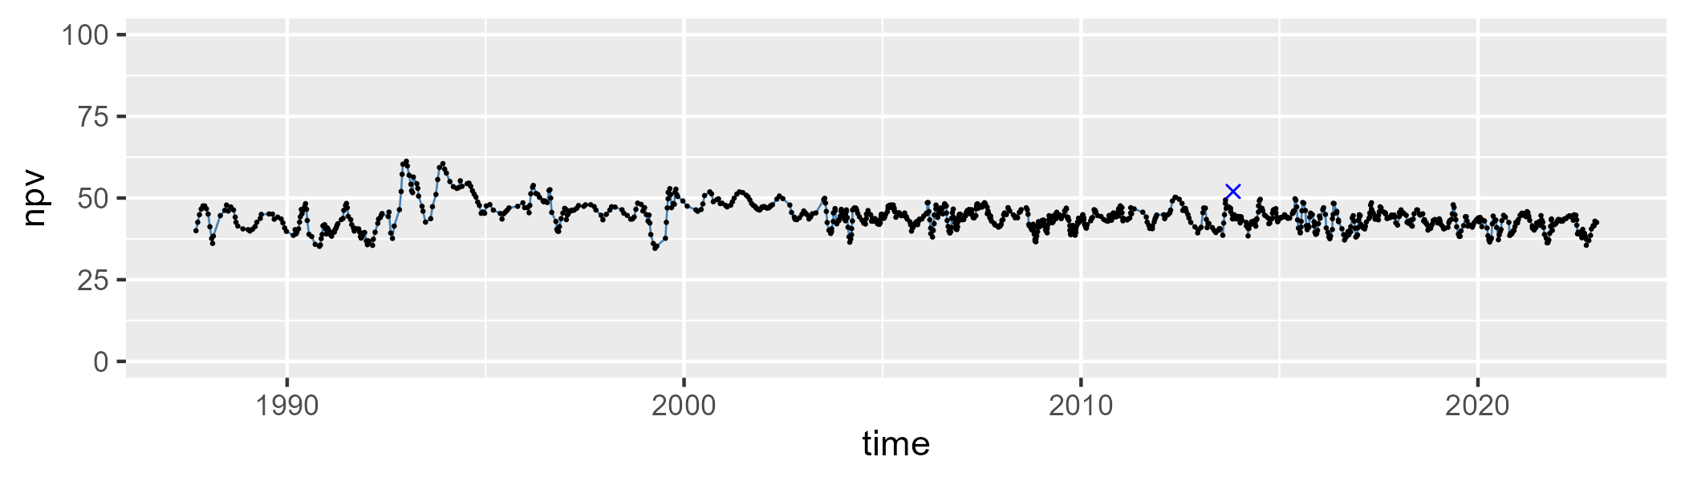

| Min. | 1st Qu. | Median | Mean | 3rd Qu. | Max. |
| --- | --- | --- | --- | --- | --- |
| 13.9718 | 31.99134 | 35.08743 | 34.69837 | 38.38545 | 51.60524 |

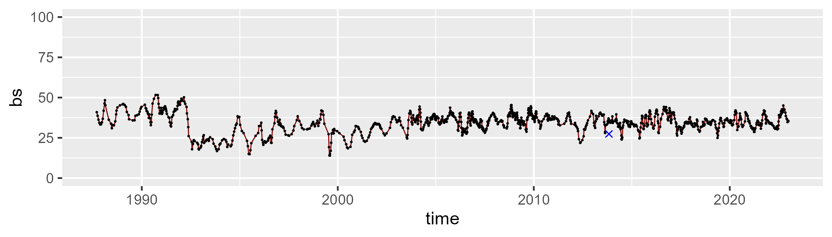

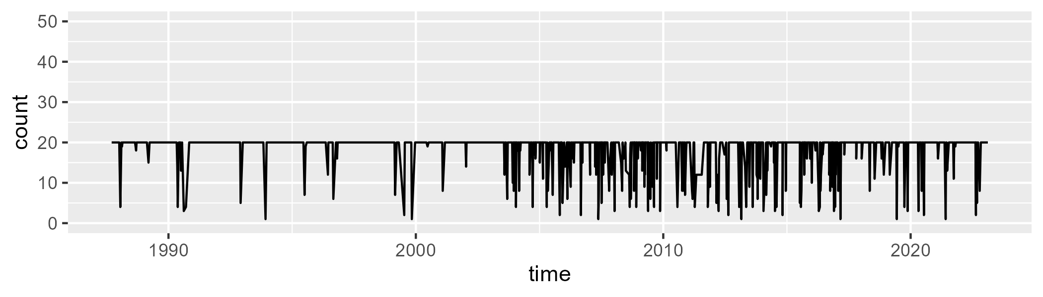

Min. : 1.00 1st Qu.:20.00 Median :20.00 Mean :18.29 3rd Qu.:20.00 Max. :20.00

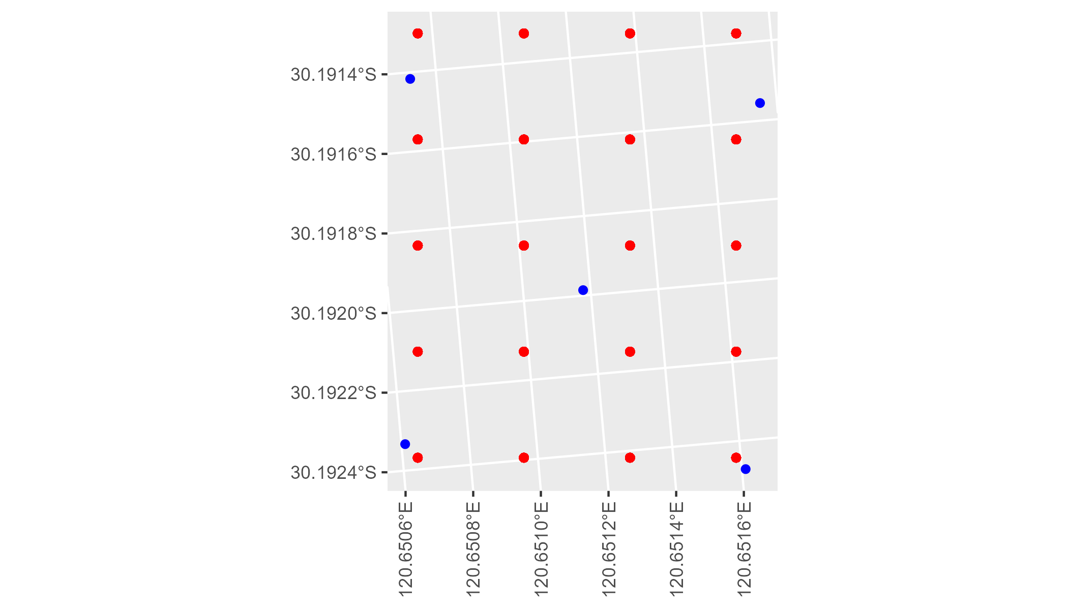

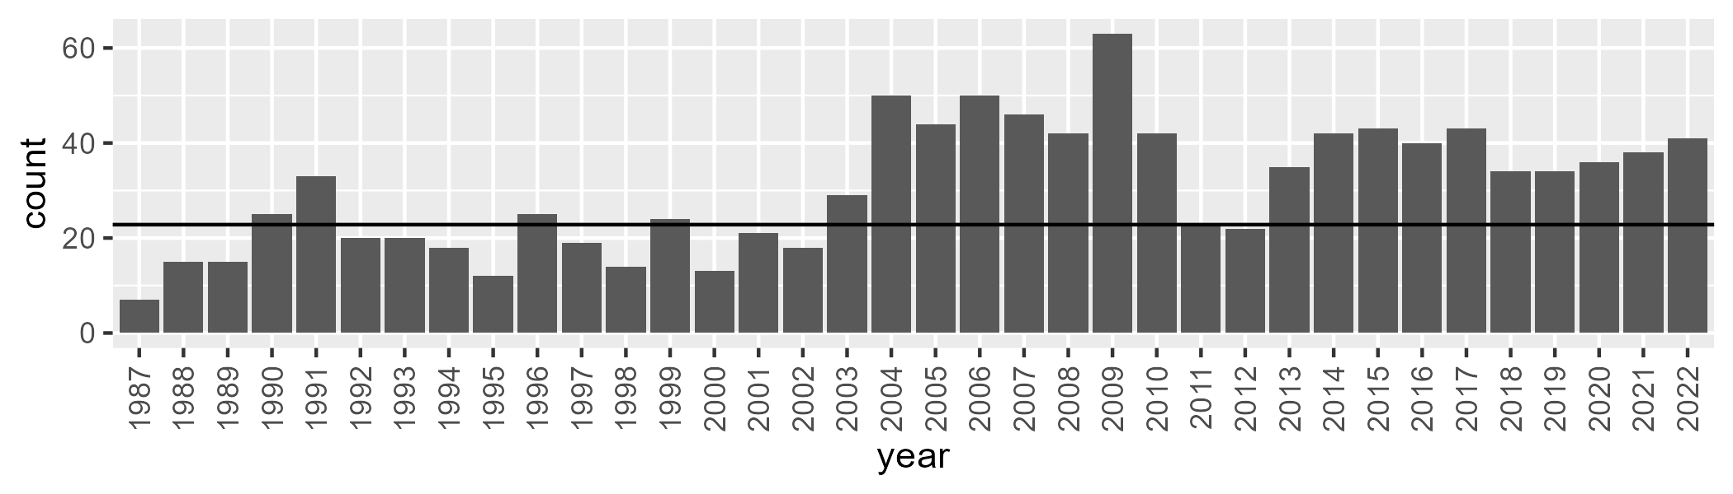

Number of samples: 1096

# WAACOO0022

| Min. | 1st Qu. | Median | Mean | 3rd Qu. | Max. |
| --- | --- | --- | --- | --- | --- |
| 16.58859 | 23.51081 | 26.25525 | 26.77797 | 29.5936 | 42.16598 |

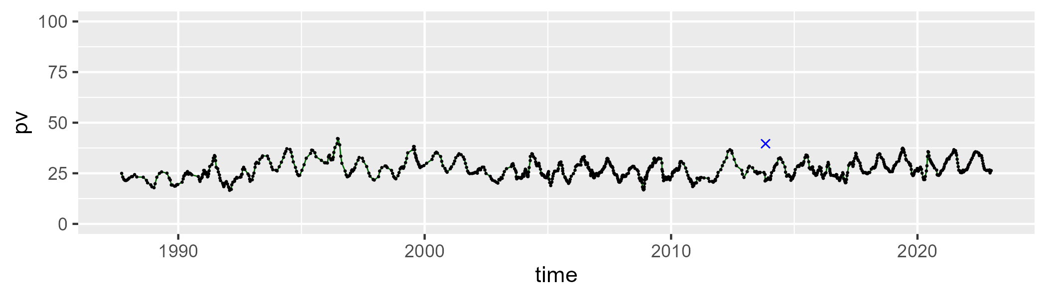

| Min. | 1st Qu. | Median | Mean | 3rd Qu. | Max. |
| --- | --- | --- | --- | --- | --- |
| 34.51051 | 43.97111 | 45.65085 | 45.56024 | 47.44292 | 57.27864 |

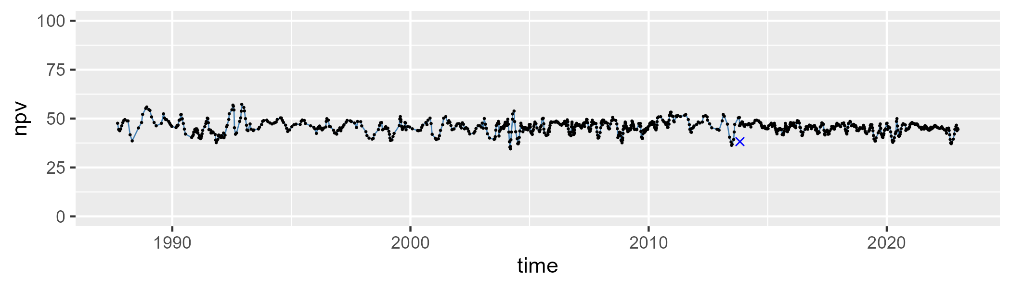

| Min. | 1st Qu. | Median | Mean | 3rd Qu. | Max. |
| --- | --- | --- | --- | --- | --- |
| 6.60059 | 22.64523 | 26.37437 | 26.23524 | 29.94054 | 44.46021 |

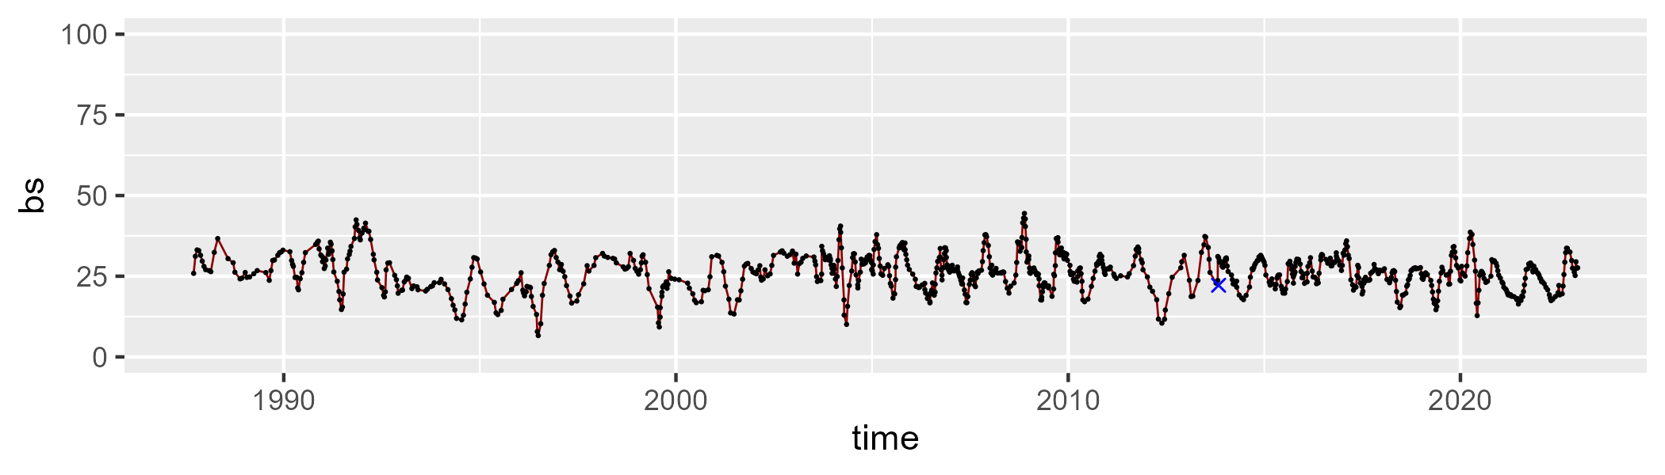

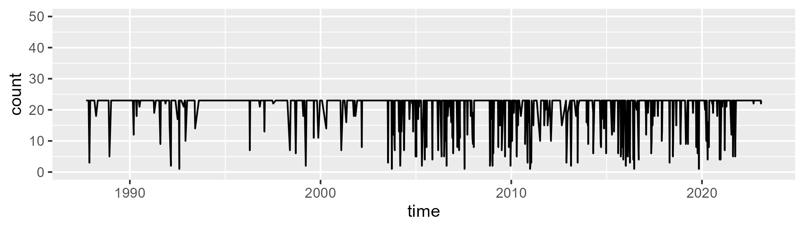

Min. : 1.00 1st Qu.:23.00 Median :23.00 Mean :20.67 3rd Qu.:23.00 Max. :23.00

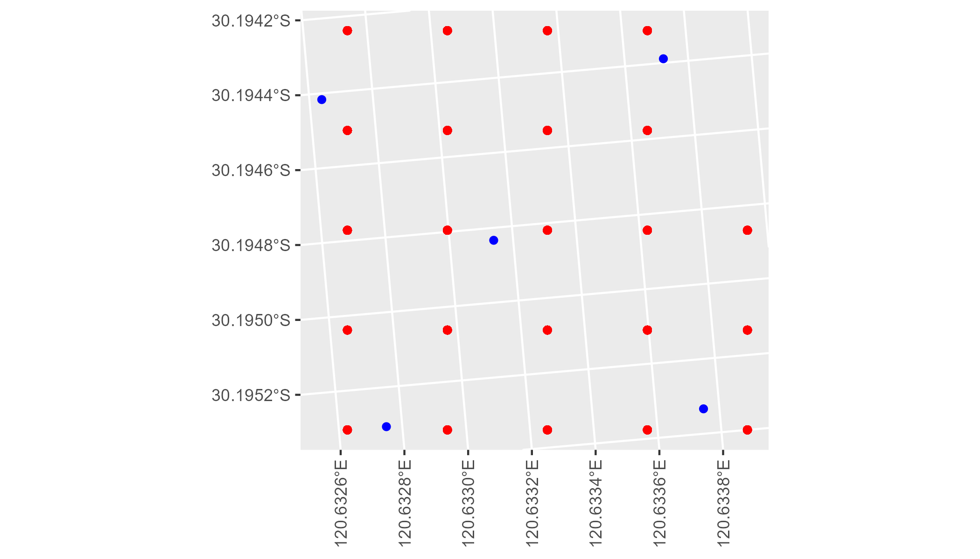

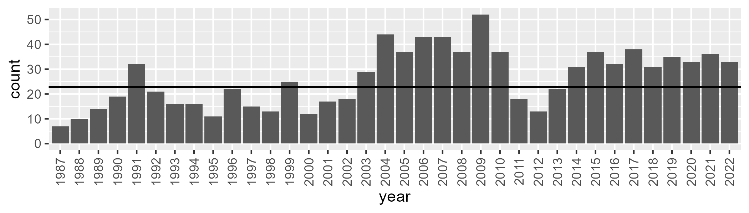

Number of samples: 949

# WAACOO0023

| Min. | 1st Qu. | Median | Mean | 3rd Qu. | Max. |
| --- | --- | --- | --- | --- | --- |
| 12.09655 | 17.18998 | 18.76995 | 19.25354 | 21.19735 | 30.11381 |

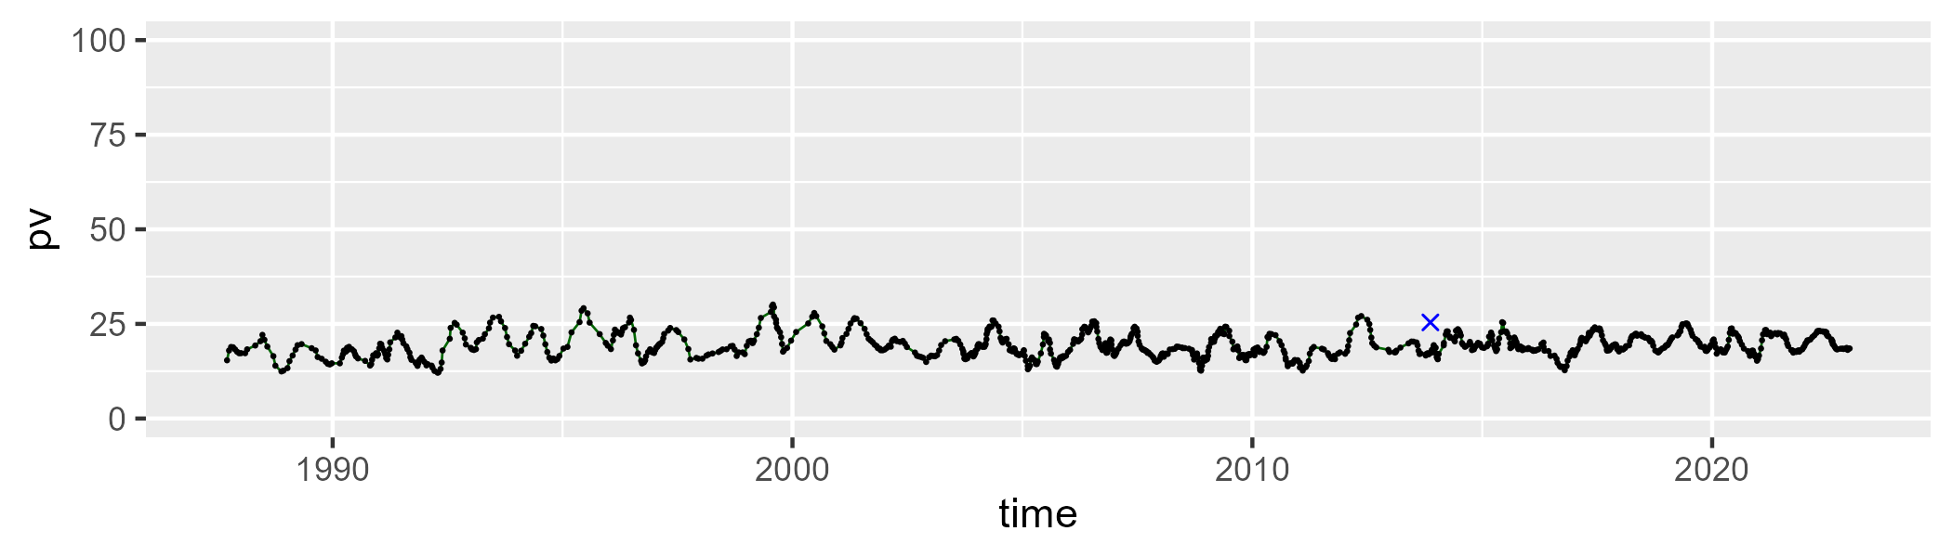

| Min. | 1st Qu. | Median | Mean | 3rd Qu. | Max. |
| --- | --- | --- | --- | --- | --- |
| 32.04793 | 42.55865 | 44.39301 | 44.33758 | 46.31755 | 53.634 |

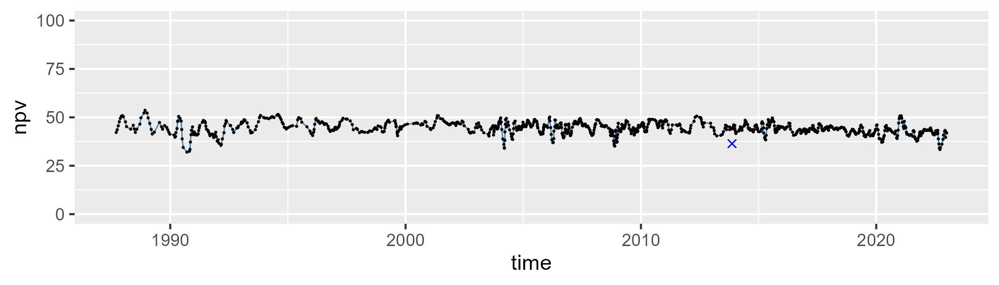

| Min. | 1st Qu. | Median | Mean | 3rd Qu. | Max. |
| --- | --- | --- | --- | --- | --- |
| 19.60821 | 32.00022 | 35.21388 | 35.00355 | 38.01317 | 52.29688 |

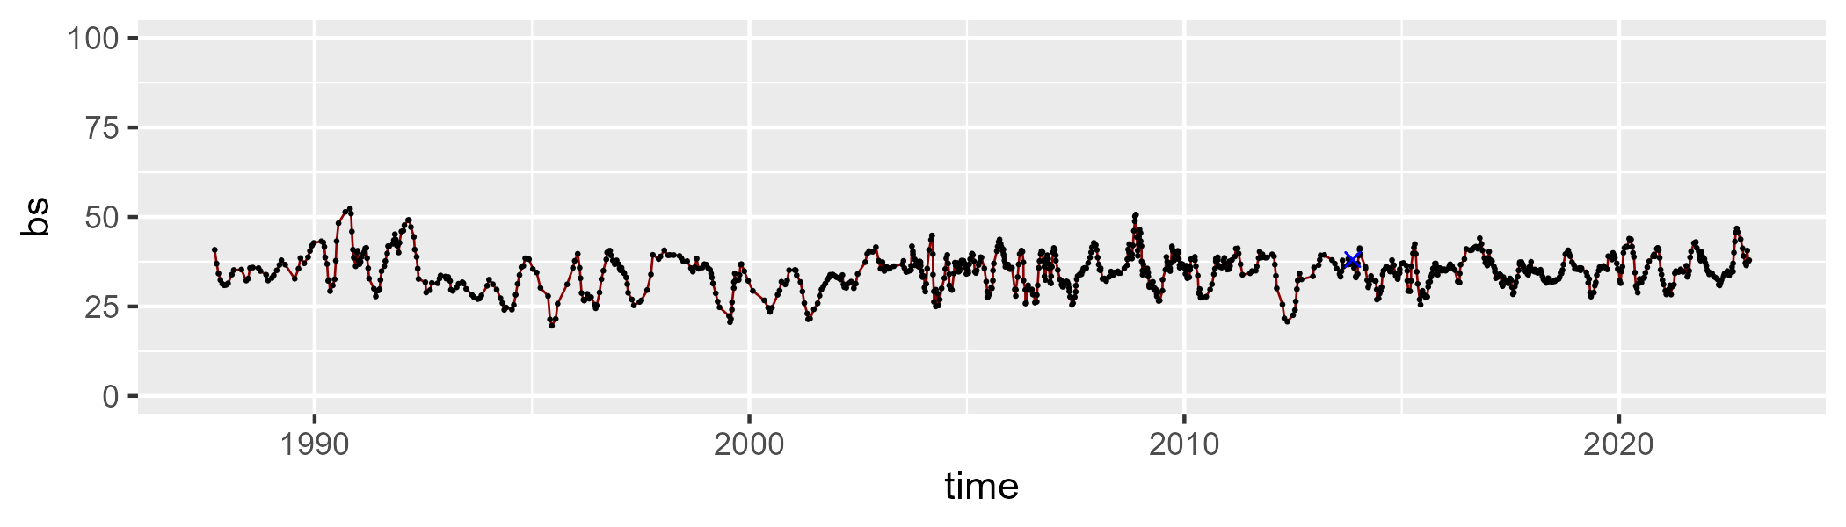

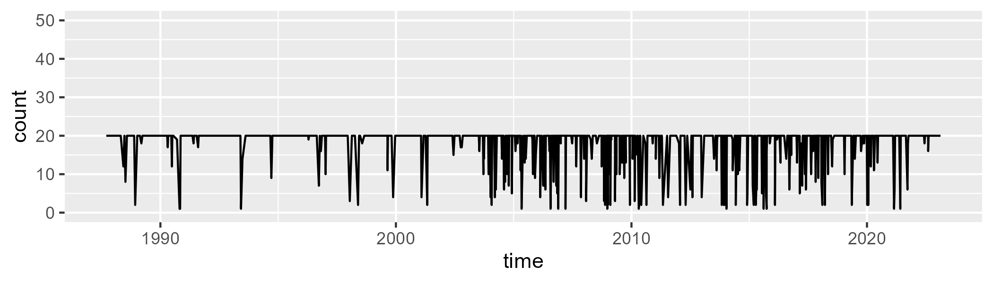

Min. : 1.00 1st Qu.:20.00 Median :20.00 Mean :18.05 3rd Qu.:20.00 Max. :20.00

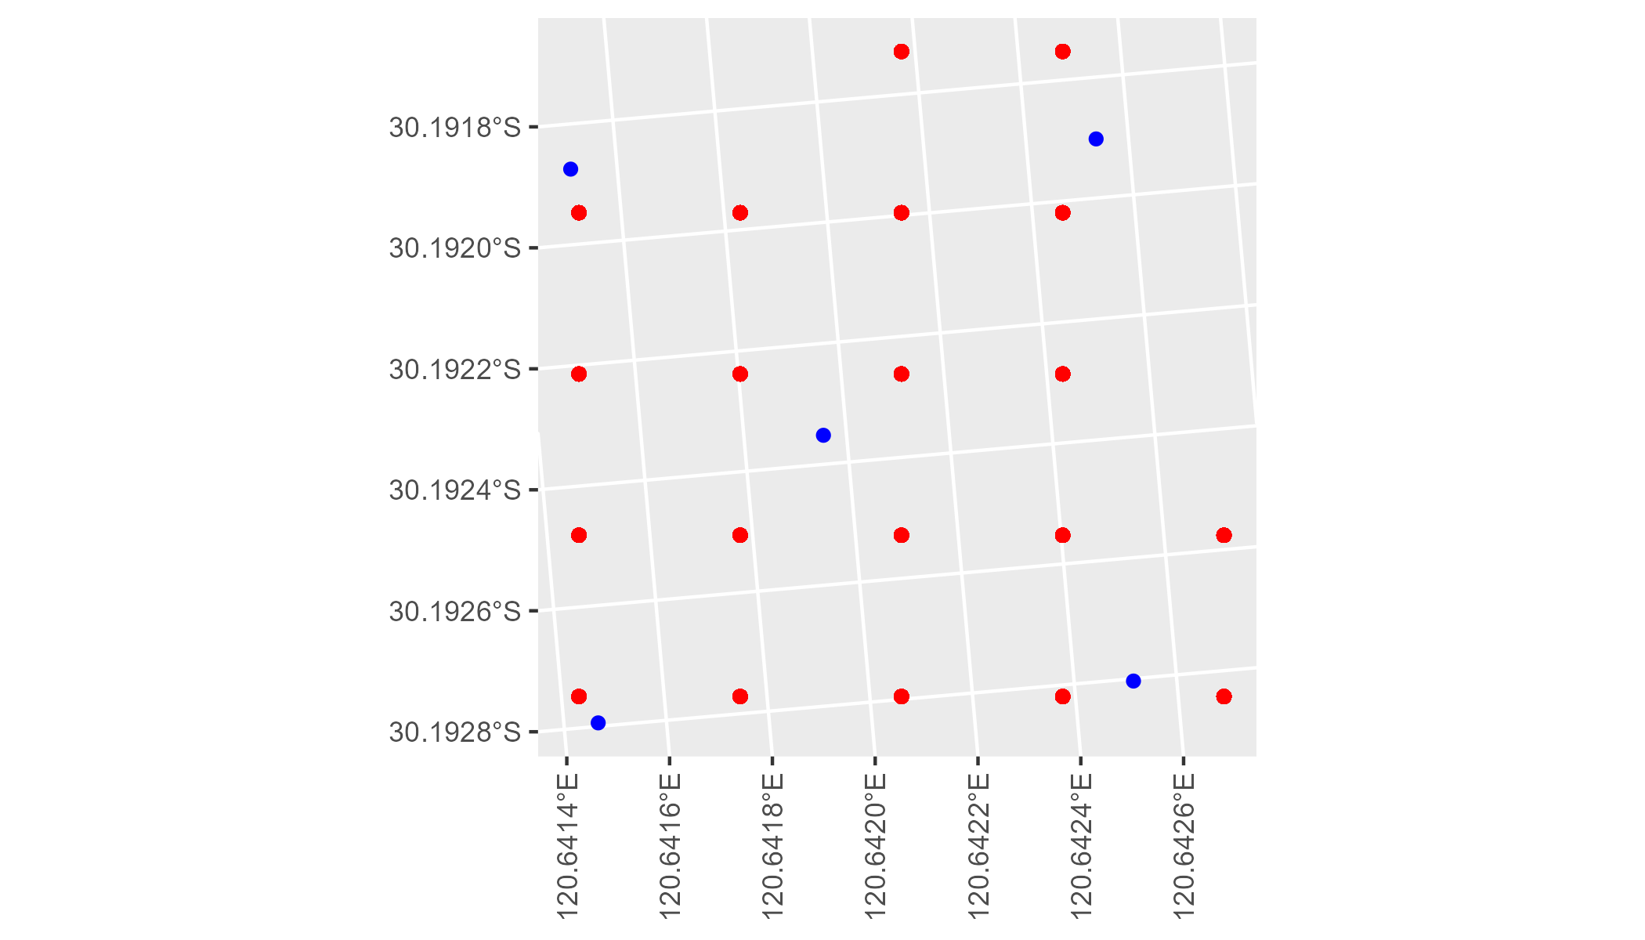

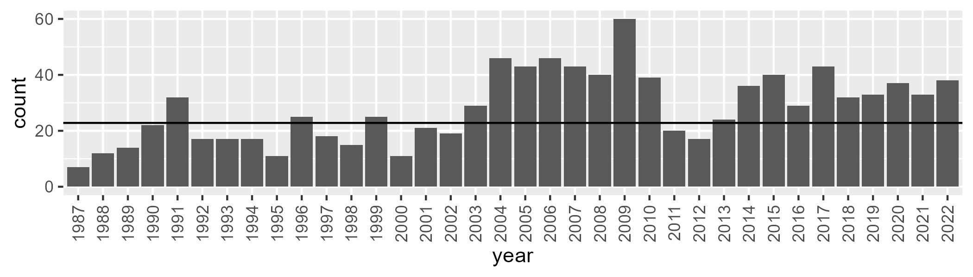

Number of samples: 1011

# WAACOO0024

| Min. | 1st Qu. | Median | Mean | 3rd Qu. | Max. |
| --- | --- | --- | --- | --- | --- |
| 3.040041 | 15.11194 | 19.18752 | 19.49163 | 23.61149 | 34.92365 |

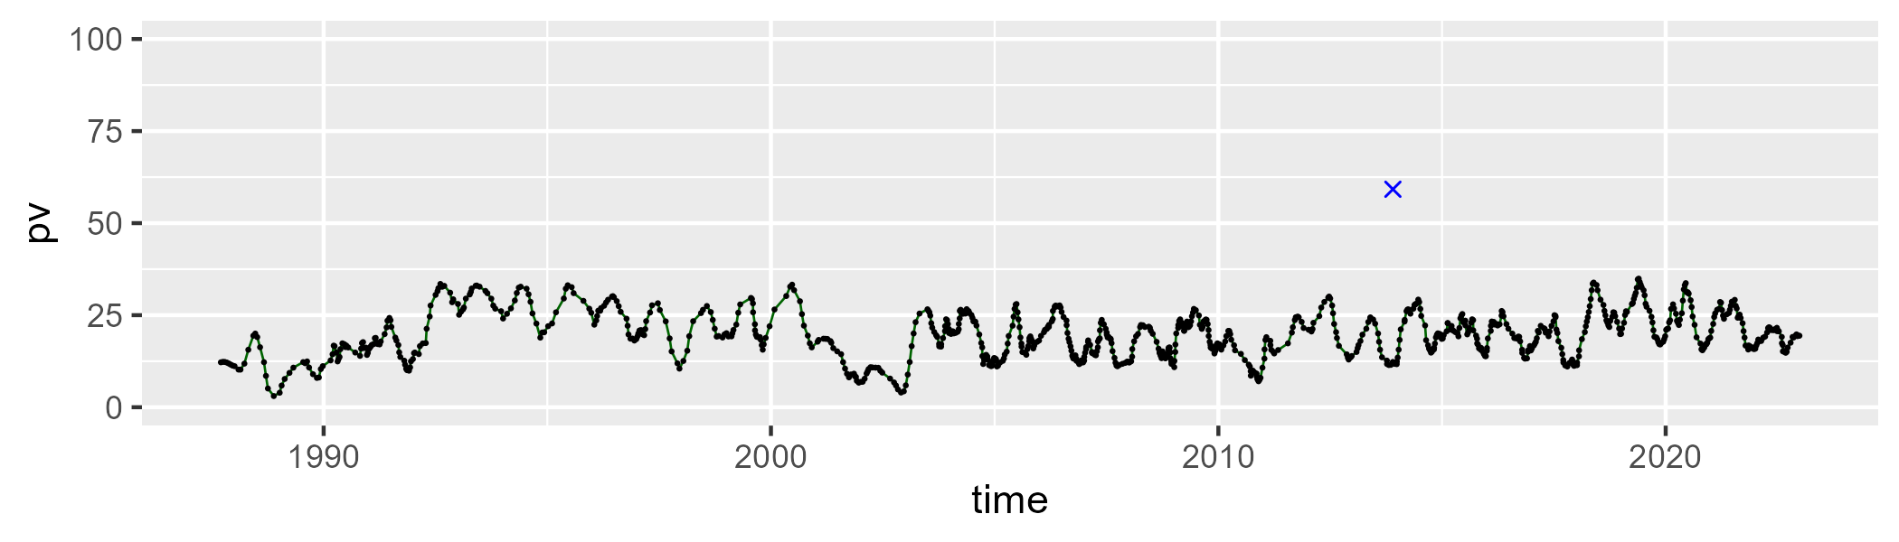

| Min. | 1st Qu. | Median | Mean | 3rd Qu. | Max. |
| --- | --- | --- | --- | --- | --- |
| 35.42767 | 53.42292 | 56.17002 | 55.57063 | 58.38327 | 66.21055 |

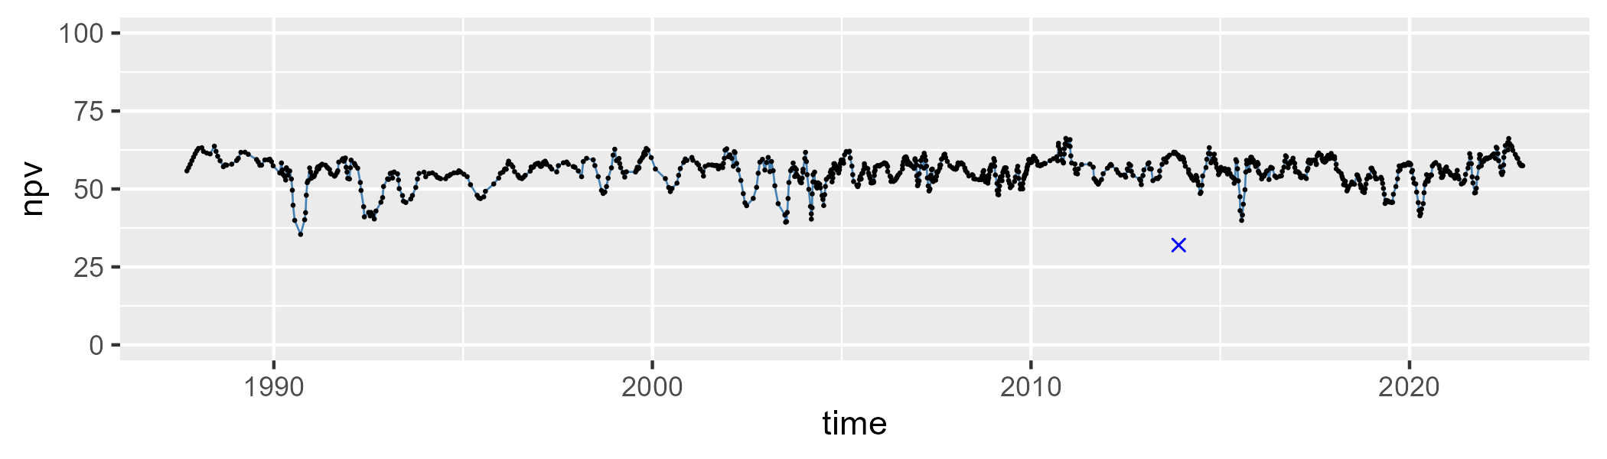

| Min. | 1st Qu. | Median | Mean | 3rd Qu. | Max. |
| --- | --- | --- | --- | --- | --- |
| 10.65121 | 20.13571 | 23.41992 | 23.81875 | 27.16844 | 48.33518 |

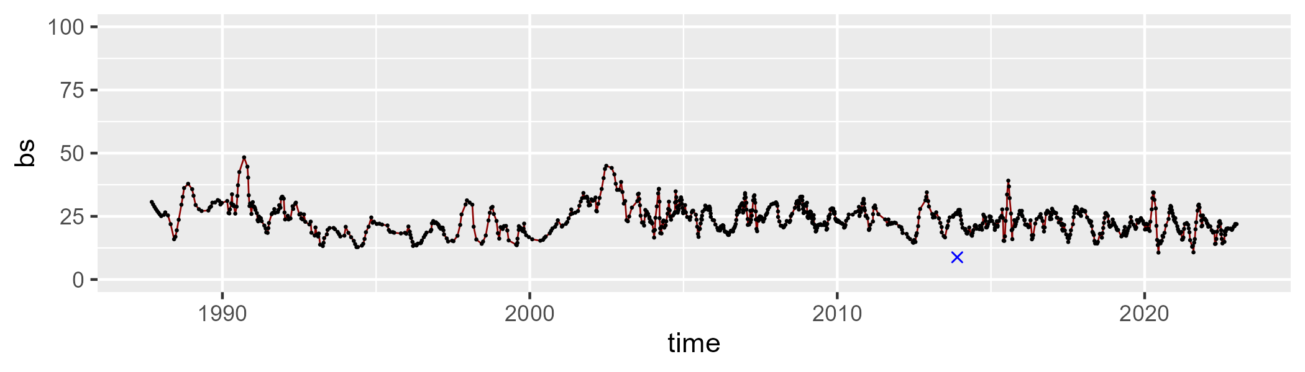

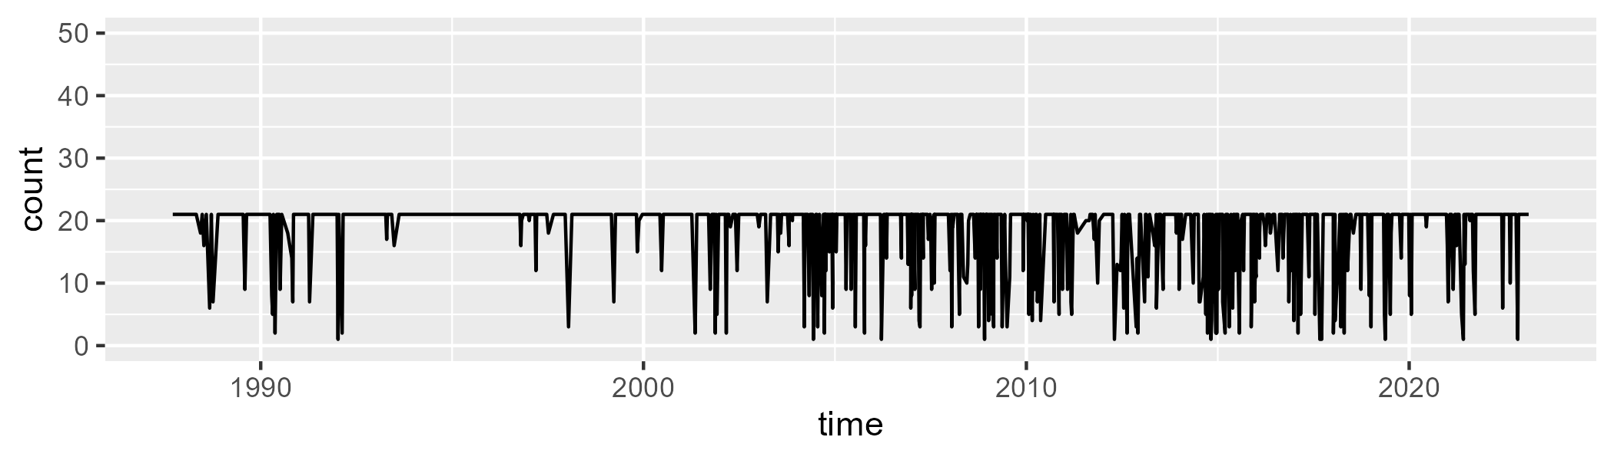

Min. : 1.0 1st Qu.:21.0 Median :21.0 Mean :18.5 3rd Qu.:21.0 Max. :21.0

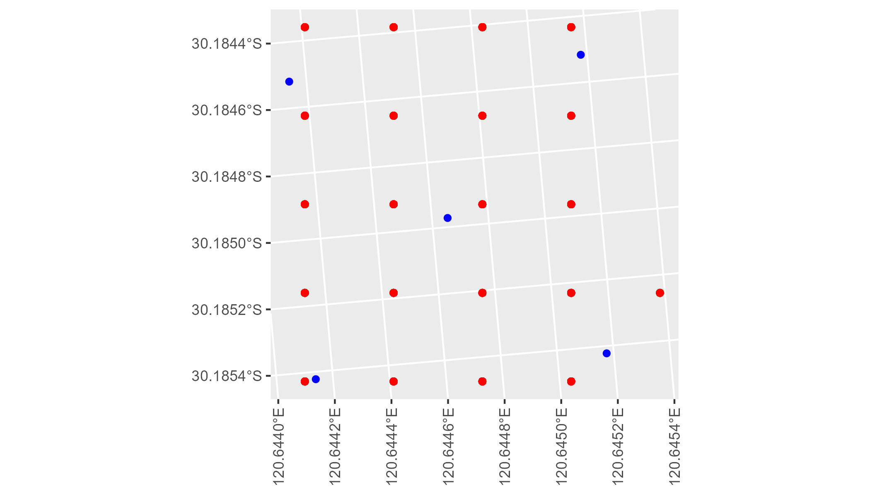

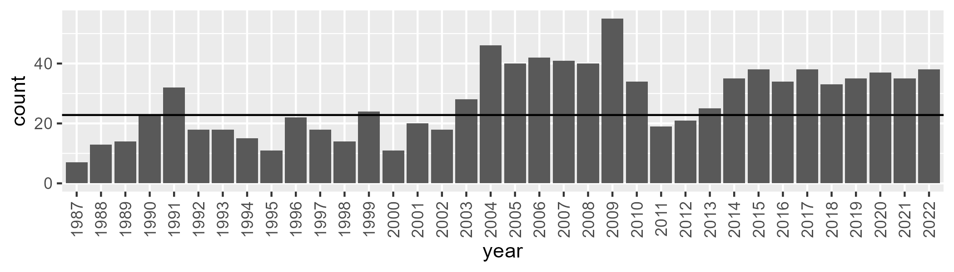

Number of samples: 992

# WAACOO0025

| Min. | 1st Qu. | Median | Mean | 3rd Qu. | Max. |
| --- | --- | --- | --- | --- | --- |
| 0 | 6.804365 | 9.293575 | 11.35983 | 13.422 | 56.24813 |

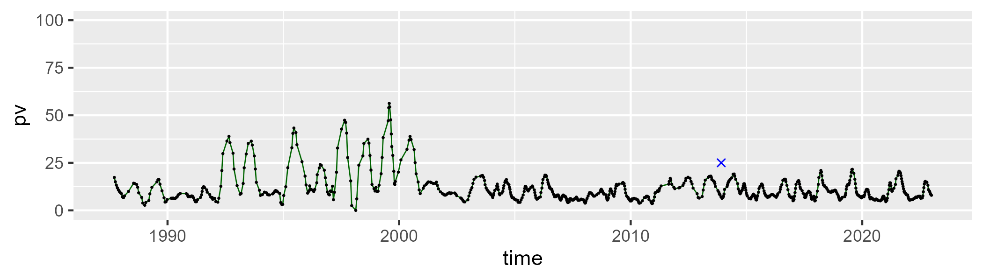

| Min. | 1st Qu. | Median | Mean | 3rd Qu. | Max. |
| --- | --- | --- | --- | --- | --- |
| 29.28238 | 38.15034 | 40.15187 | 41.4044 | 43.16552 | 61.81117 |

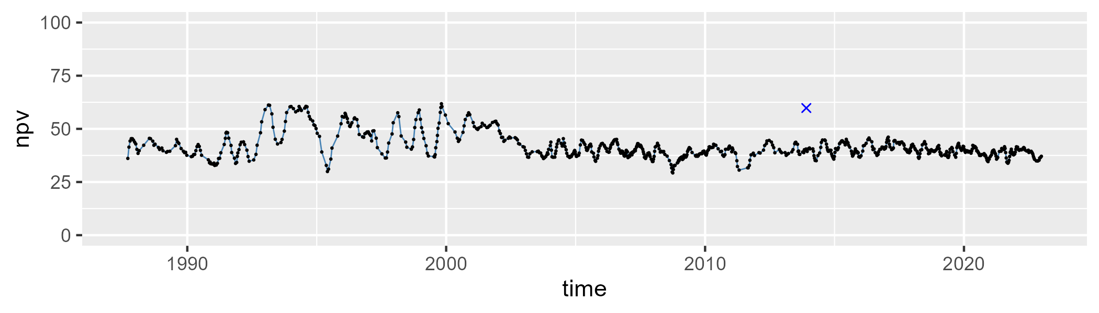

| Min. | 1st Qu. | Median | Mean | 3rd Qu. | Max. |
| --- | --- | --- | --- | --- | --- |
| 3.190685 | 42.36576 | 48.413 | 45.74244 | 52.0167 | 59.22065 |

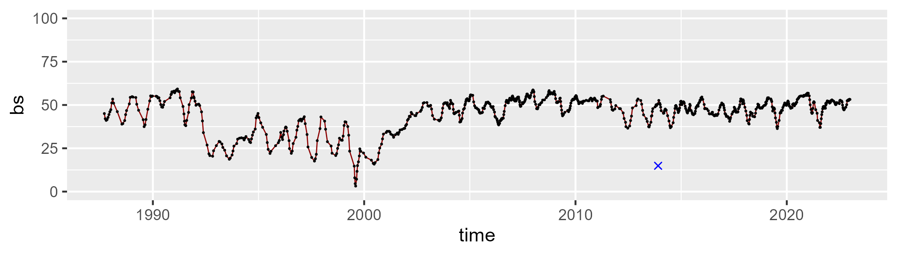

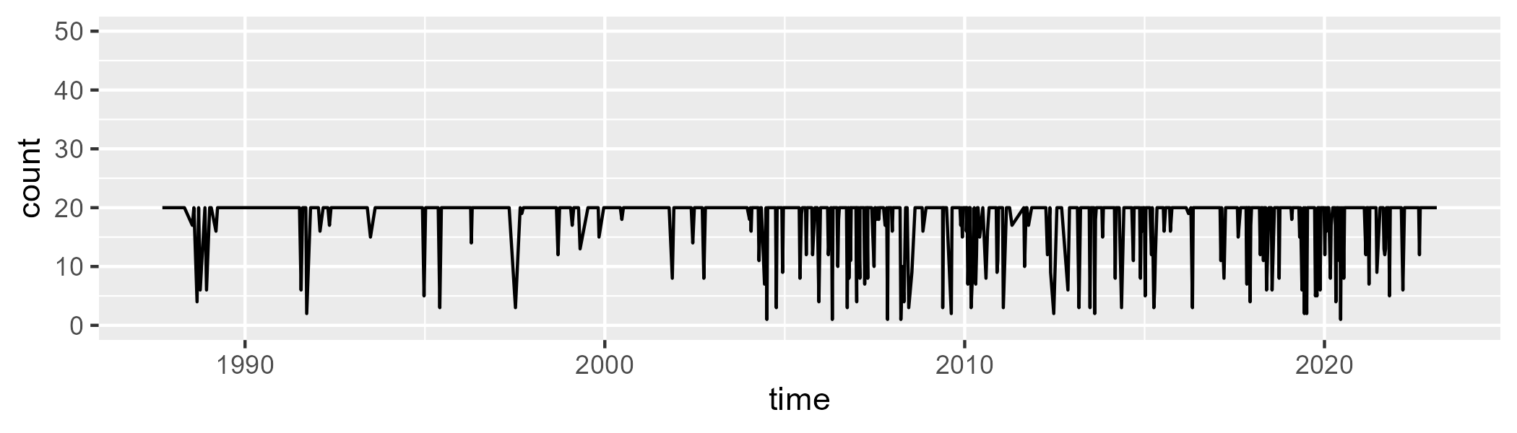

Min. : 1.00 1st Qu.:20.00 Median :20.00 Mean :18.26 3rd Qu.:20.00 Max. :20.00

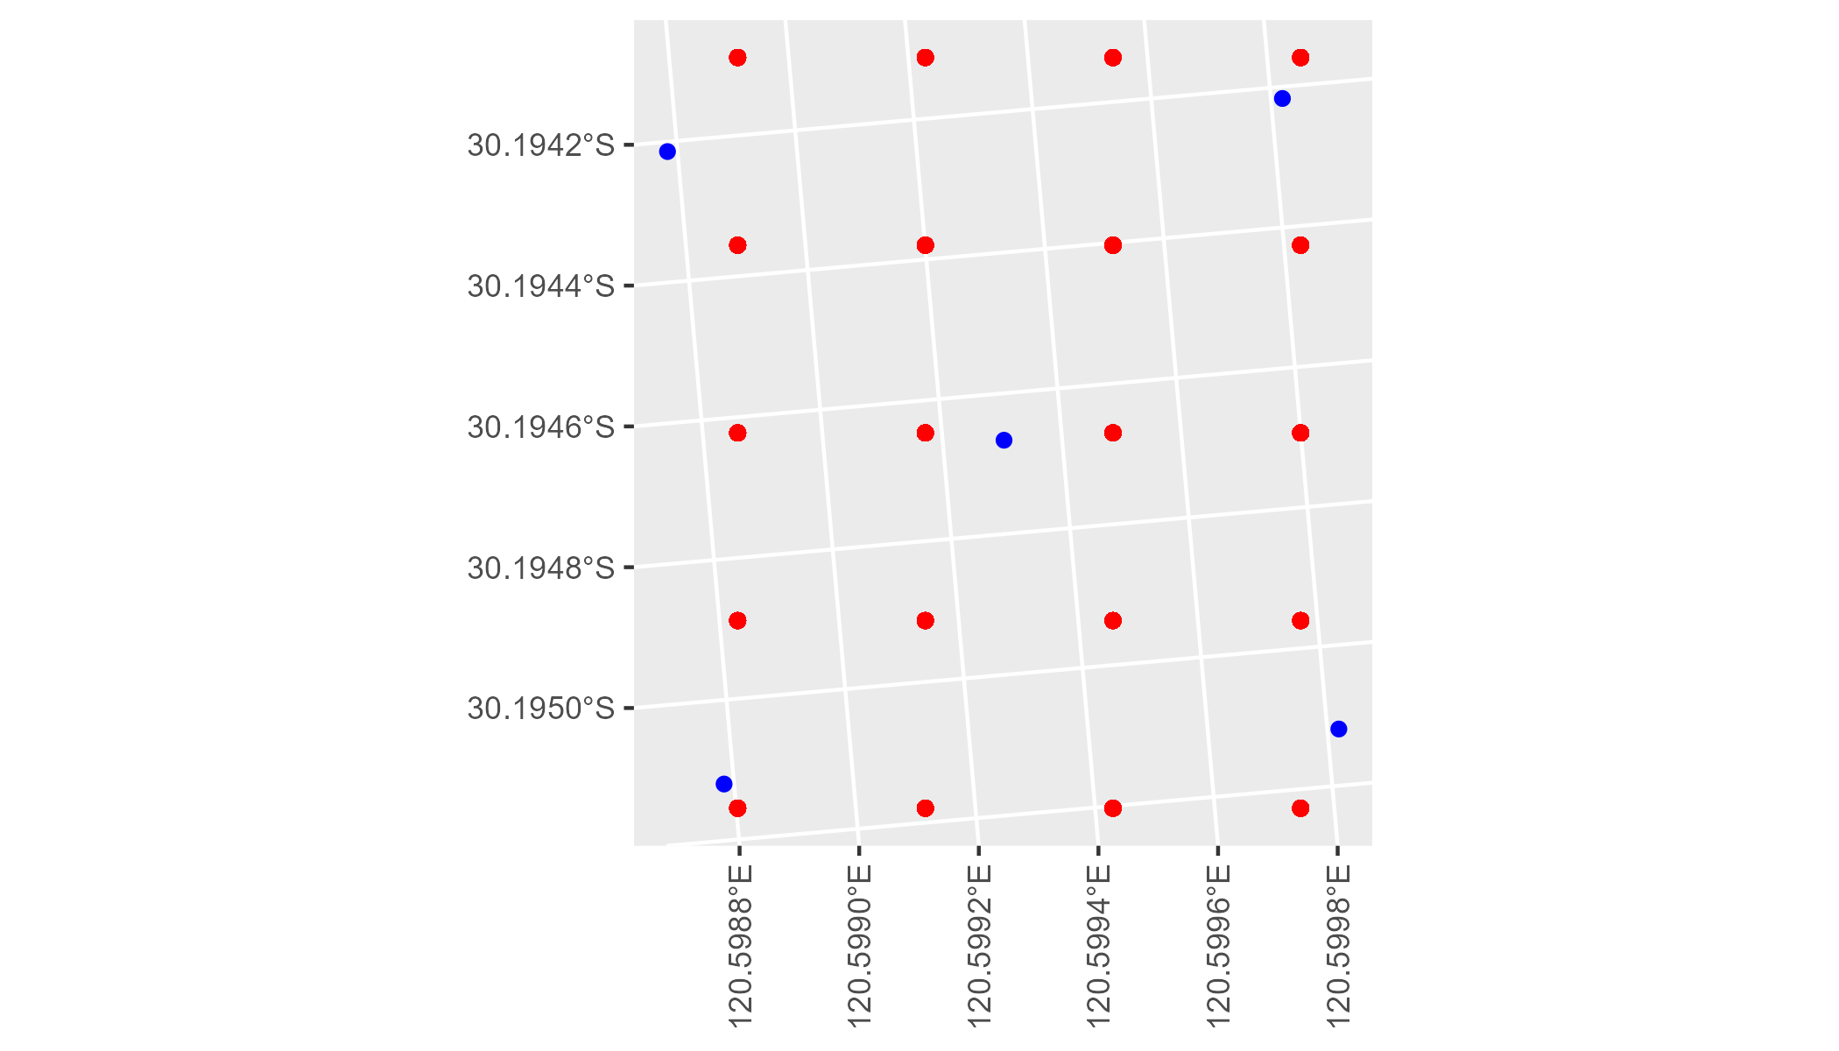

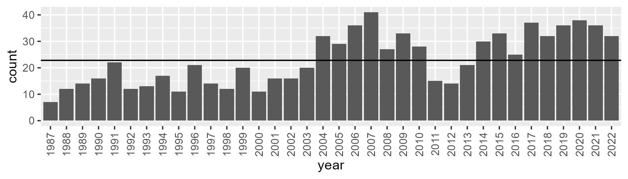

Number of samples: 829

# WAACOO0026

| Min. | 1st Qu. | Median | Mean | 3rd Qu. | Max. |
| --- | --- | --- | --- | --- | --- |
| 0 | 11.11805 | 15.14143 | 15.6693 | 19.7159 | 43.28184 |

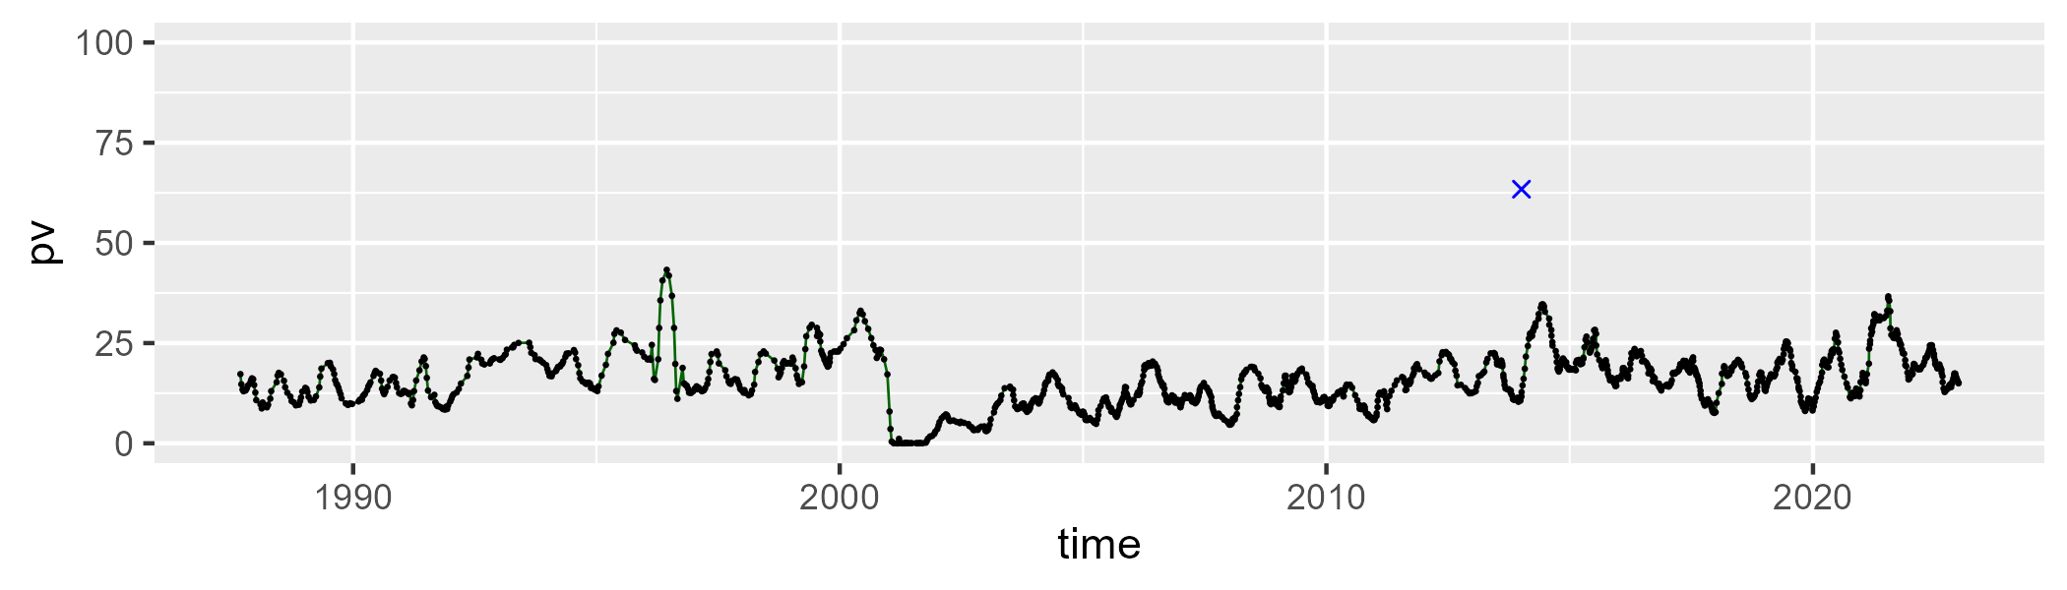

| Min. | 1st Qu. | Median | Mean | 3rd Qu. | Max. |
| --- | --- | --- | --- | --- | --- |
| 41.94658 | 52.63253 | 56.74033 | 56.65887 | 61.30401 | 69.7211 |

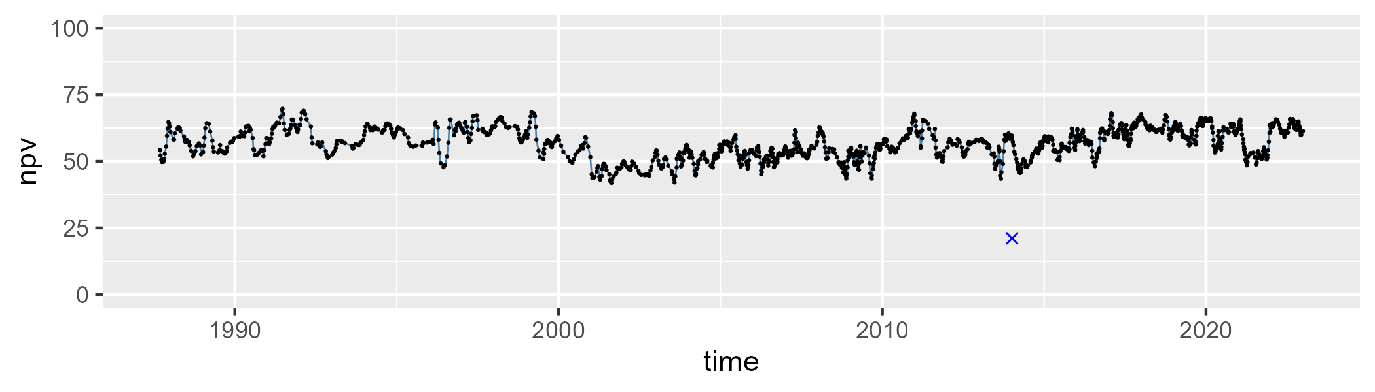

| Min. | 1st Qu. | Median | Mean | 3rd Qu. | Max. |
| --- | --- | --- | --- | --- | --- |
| 8.836018 | 19.84566 | 24.72828 | 26.41371 | 31.73366 | 57.19184 |

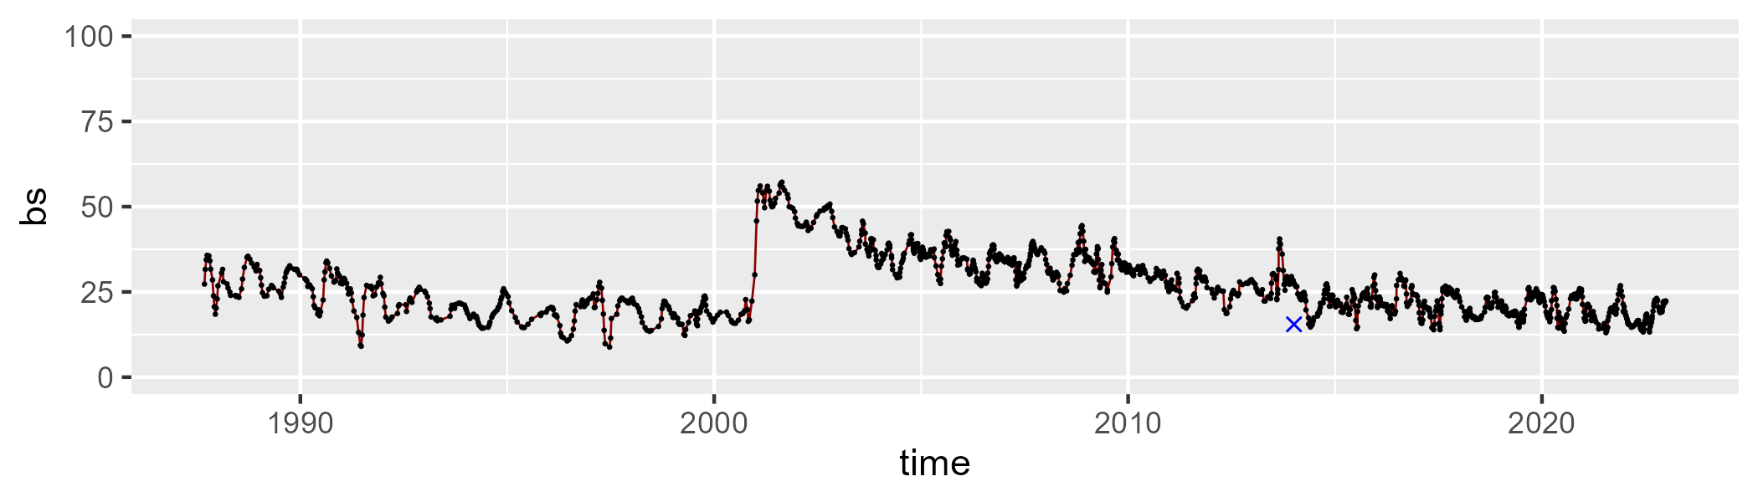

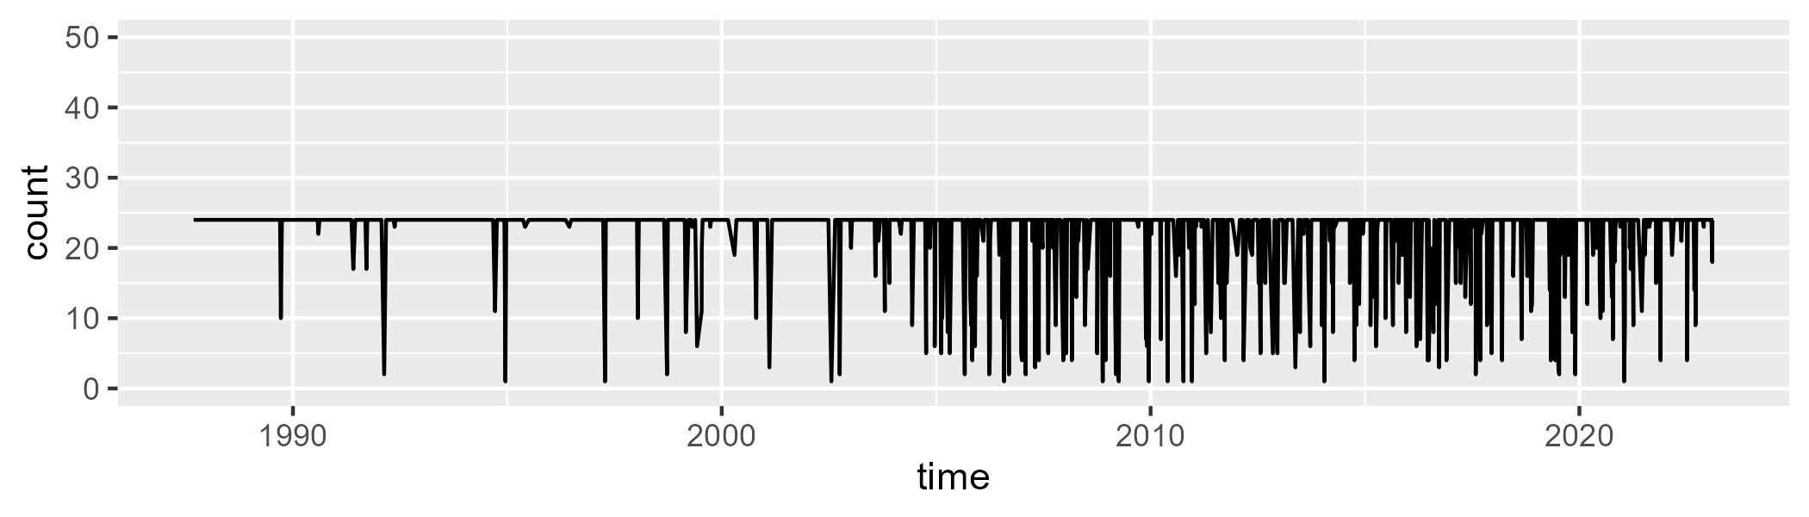

Min. : 1.00 1st Qu.:24.00 Median :24.00 Mean :22.13 3rd Qu.:24.00 Max. :24.00

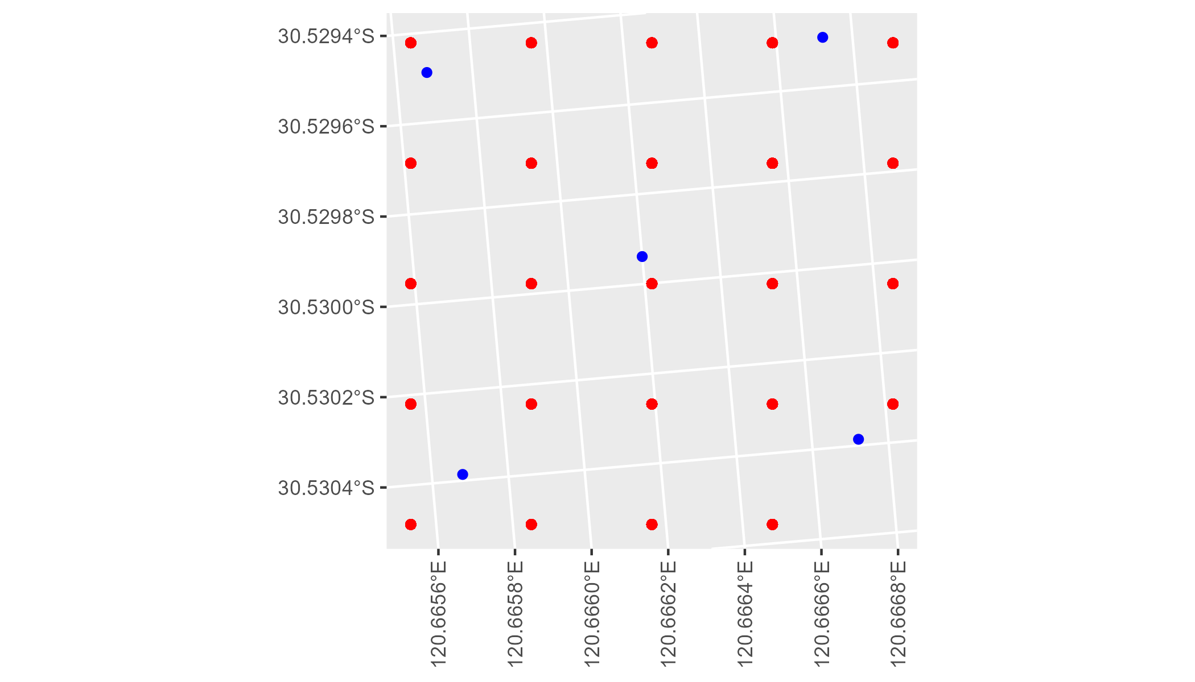

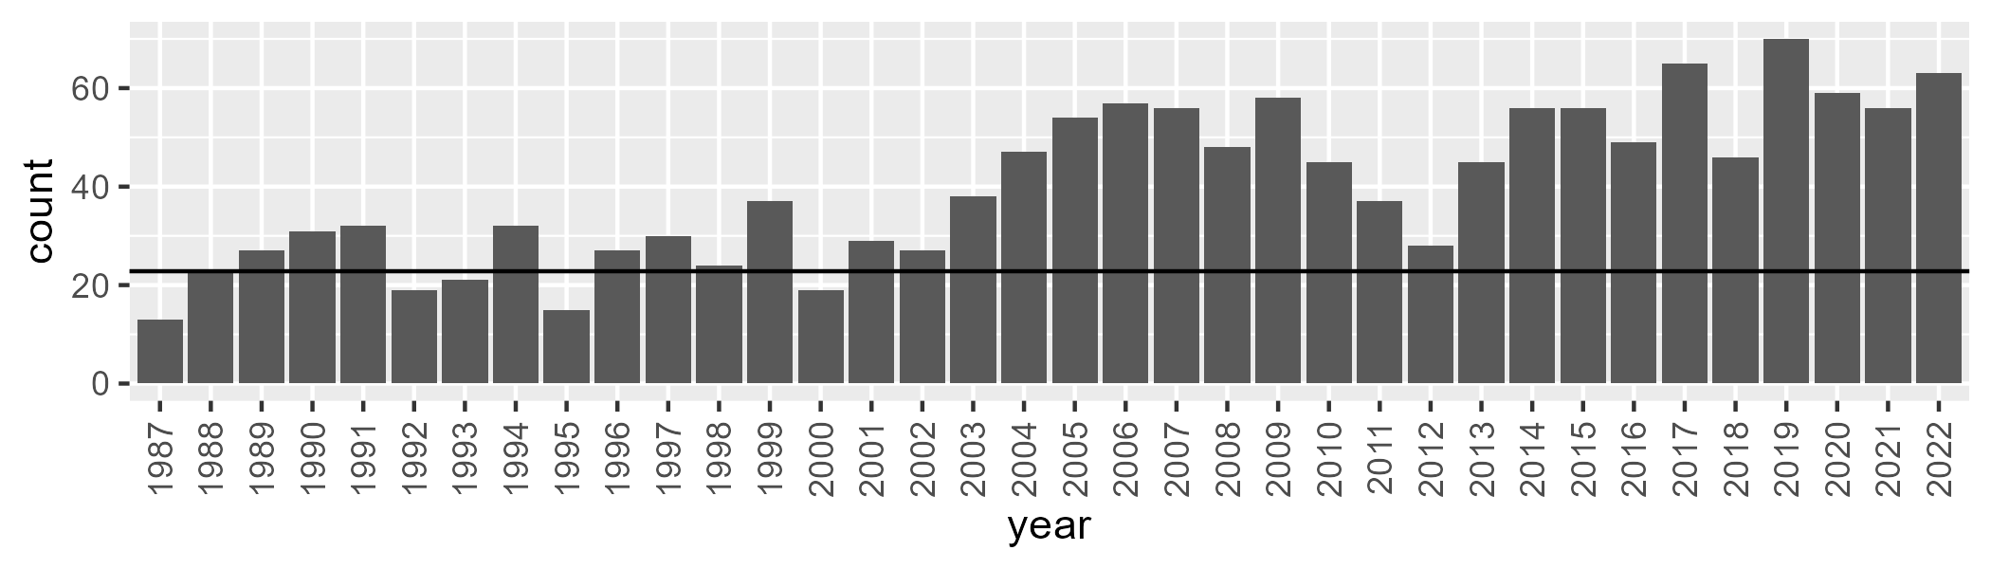

Number of samples: 1439

# WAACOO0027

| Min. | 1st Qu. | Median | Mean | 3rd Qu. | Max. |
| --- | --- | --- | --- | --- | --- |
| 0 | 10.46617 | 13.68744 | 14.25109 | 17.41966 | 38.82352 |

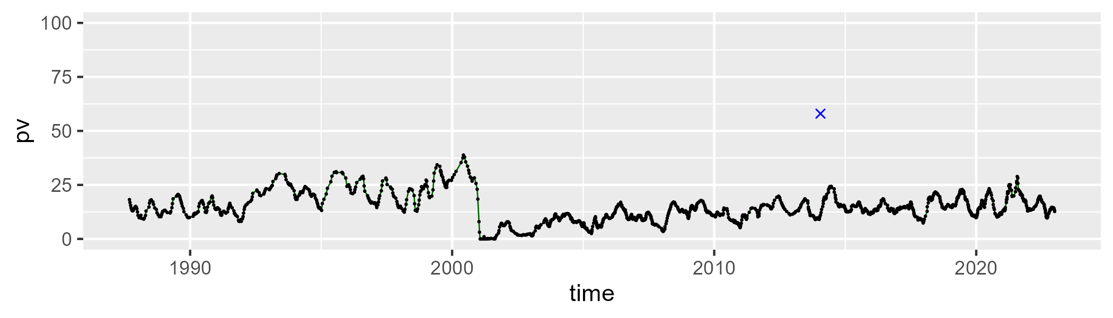

| Min. | 1st Qu. | Median | Mean | 3rd Qu. | Max. |
| --- | --- | --- | --- | --- | --- |
| 38.31975 | 50.81638 | 55.57288 | 55.1145 | 59.25316 | 73.51799 |

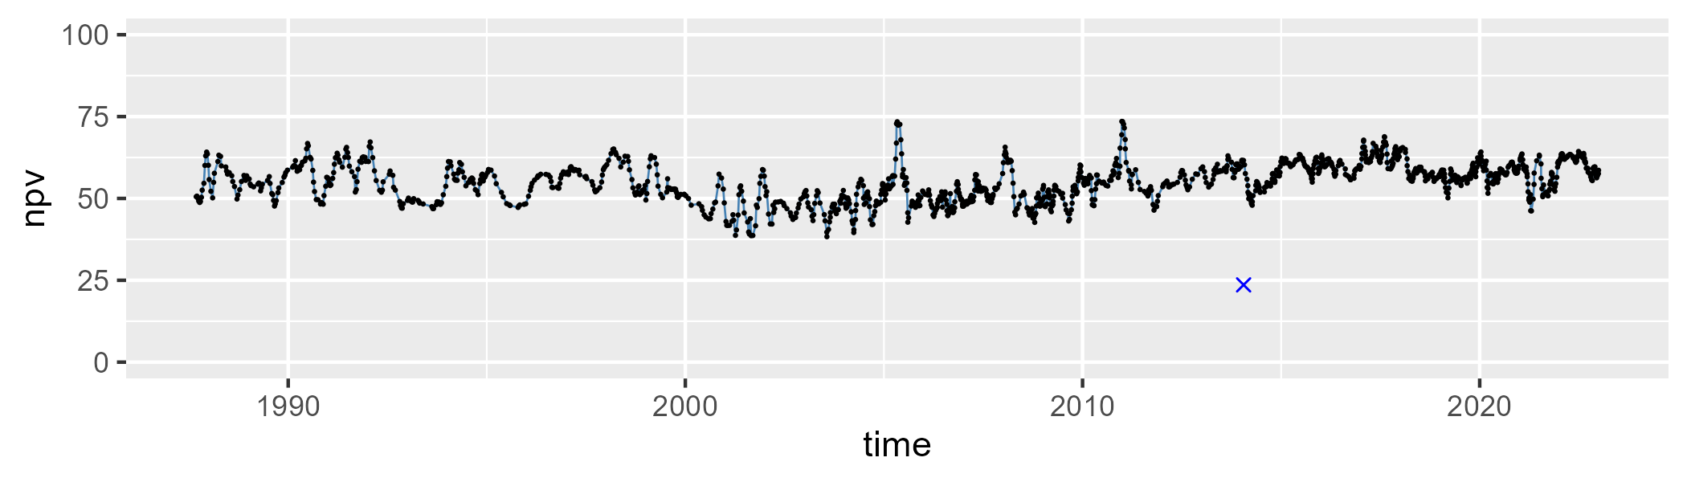

| Min. | 1st Qu. | Median | Mean | 3rd Qu. | Max. |
| --- | --- | --- | --- | --- | --- |
| 11.62949 | 23.13997 | 27.74299 | 29.31594 | 34.53503 | 60.41777 |

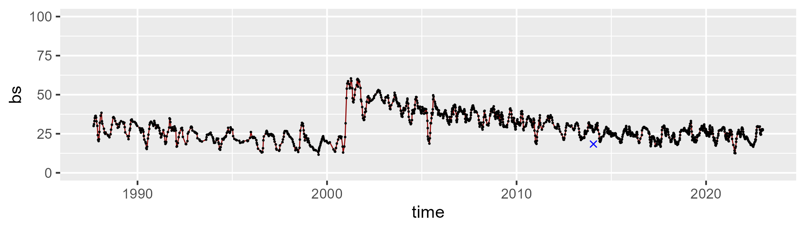

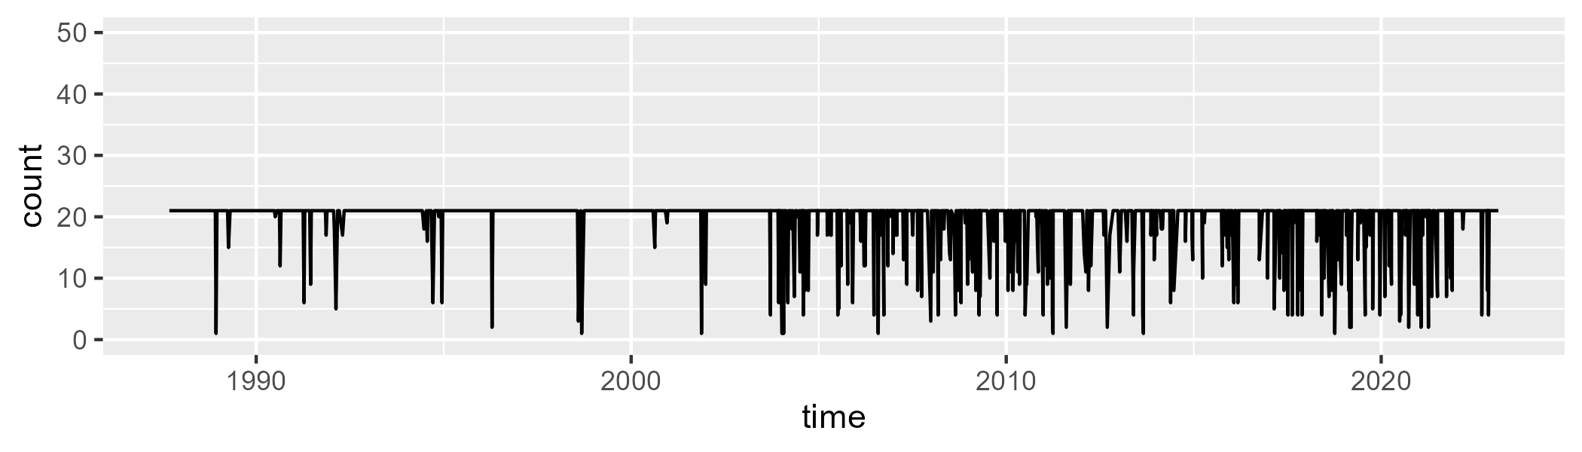

Min. : 1.00 1st Qu.:21.00 Median :21.00 Mean :19.44 3rd Qu.:21.00 Max. :21.00

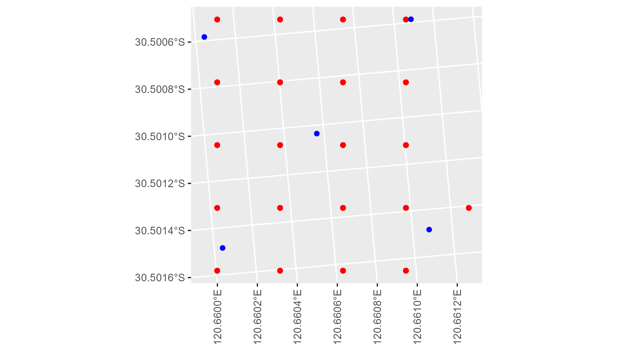

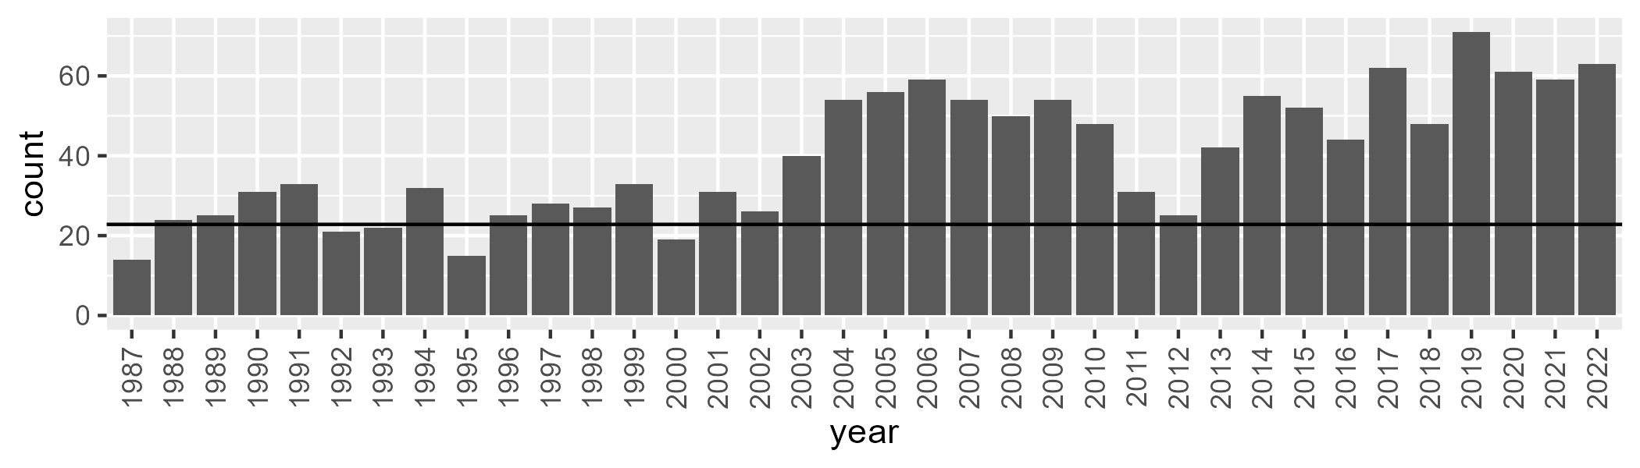

Number of samples: 1434

# WAACOO0028

| Min. | 1st Qu. | Median | Mean | 3rd Qu. | Max. |
| --- | --- | --- | --- | --- | --- |
| 0 | 9.60689 | 14.04573 | 14.34478 | 18.52476 | 36.43006 |

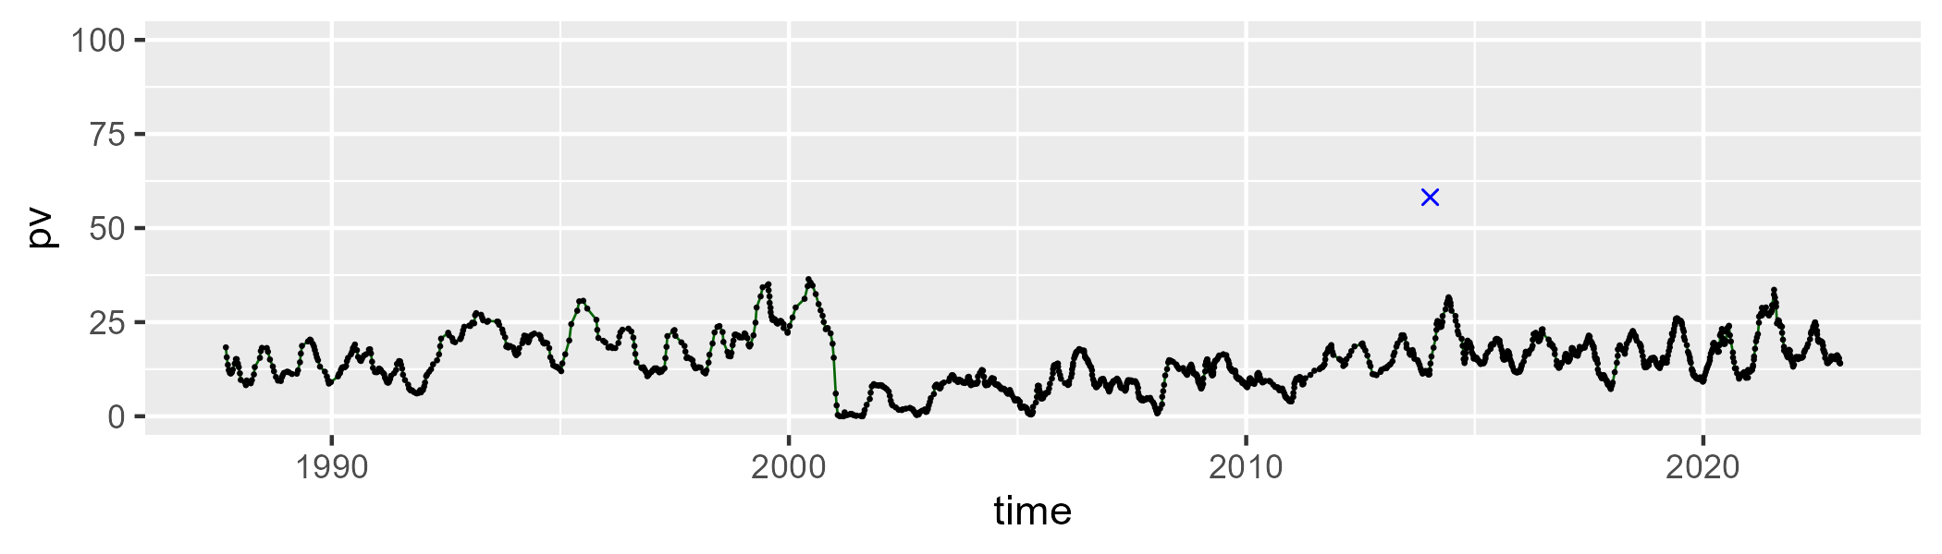

| Min. | 1st Qu. | Median | Mean | 3rd Qu. | Max. |
| --- | --- | --- | --- | --- | --- |
| 36.11979 | 50.62007 | 55.40732 | 54.59812 | 59.19752 | 72.41286 |

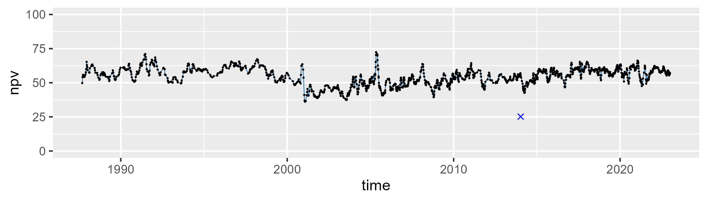

| Min. | 1st Qu. | Median | Mean | 3rd Qu. | Max. |
| --- | --- | --- | --- | --- | --- |
| 9.331235 | 22.56079 | 27.78184 | 29.75402 | 36.18915 | 63.65394 |

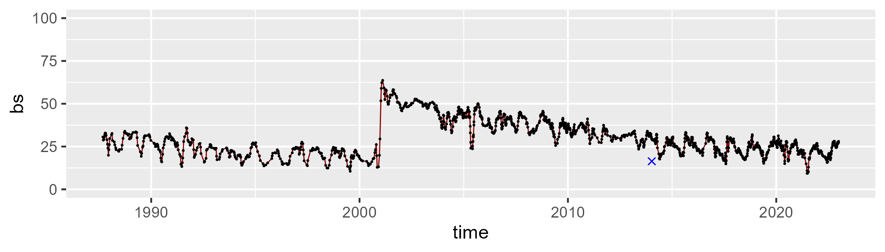

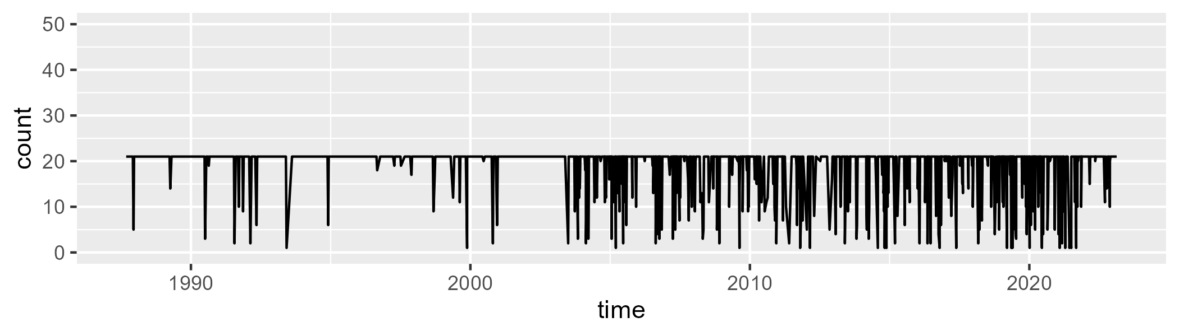

Min. : 1.00 1st Qu.:21.00 Median :21.00 Mean :19.14 3rd Qu.:21.00 Max. :21.00

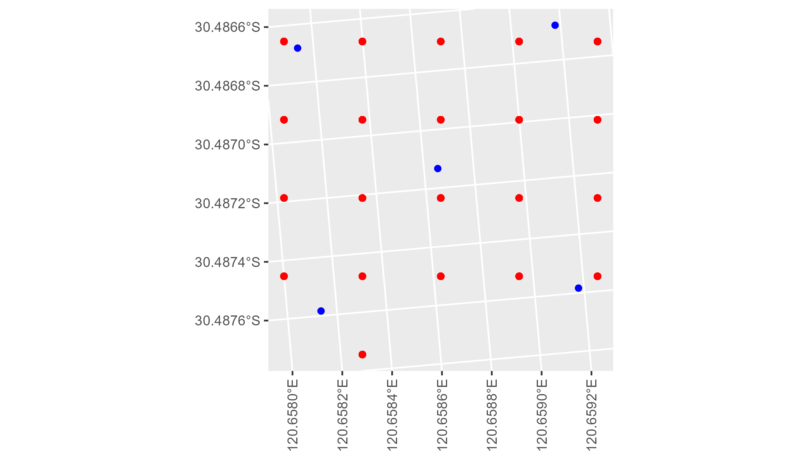

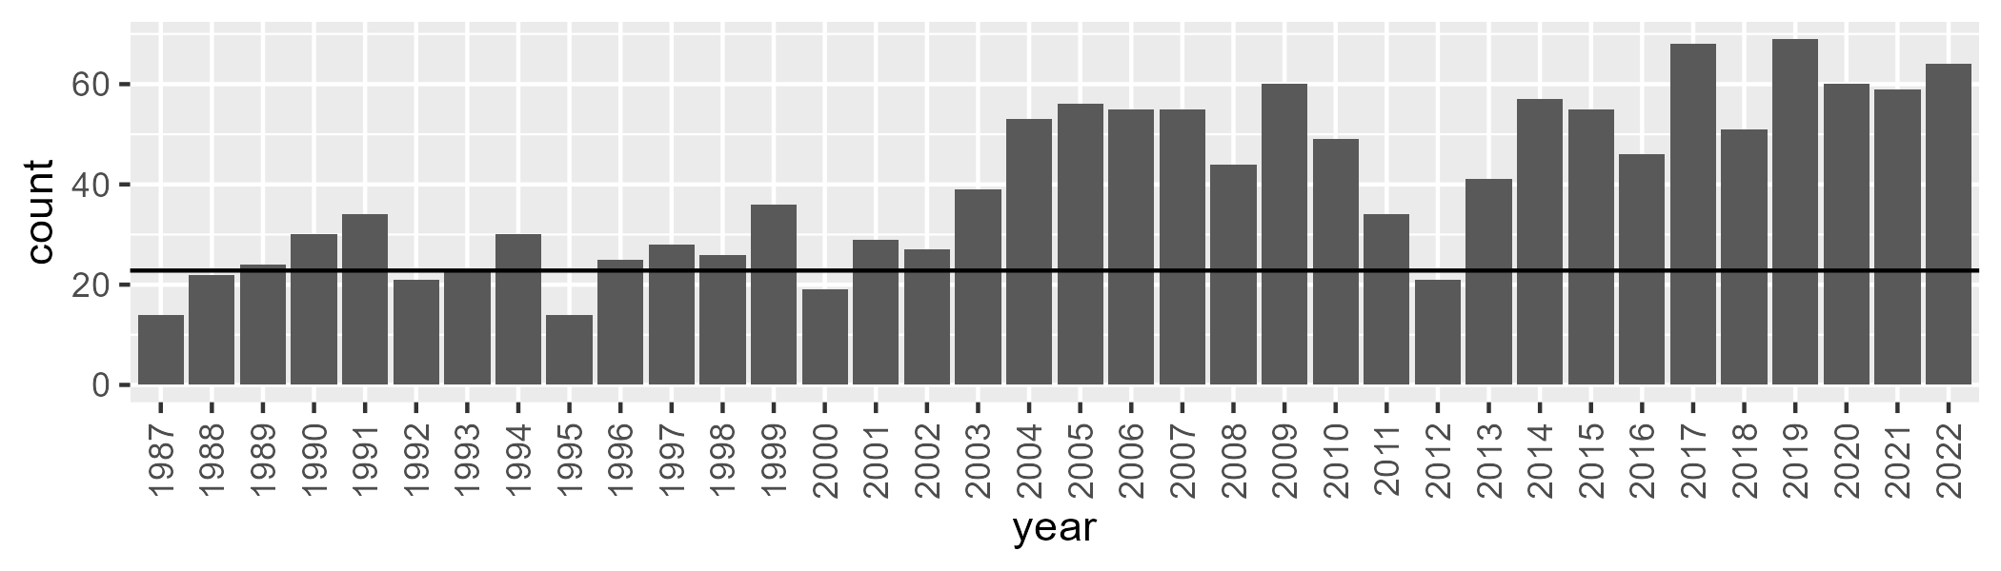

Number of samples: 1438

# WAACOO0029

| Min. | 1st Qu. | Median | Mean | 3rd Qu. | Max. |
| --- | --- | --- | --- | --- | --- |
| 0 | 12.30593 | 15.56842 | 16.29022 | 20.49901 | 34.09625 |

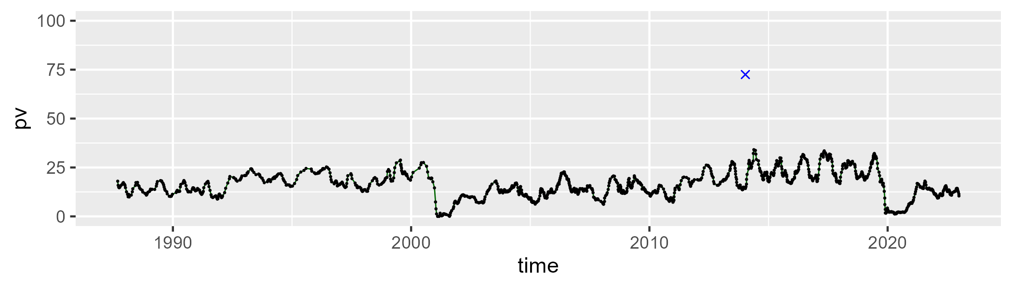

| Min. | 1st Qu. | Median | Mean | 3rd Qu. | Max. |
| --- | --- | --- | --- | --- | --- |
| 28.85617 | 48.60878 | 52.23927 | 52.61267 | 56.62189 | 68.83639 |

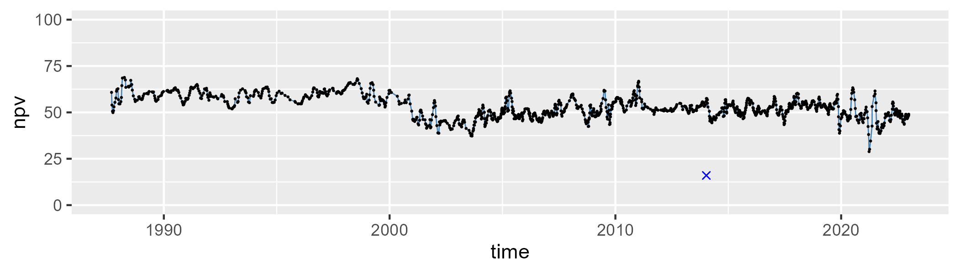

| Min. | 1st Qu. | Median | Mean | 3rd Qu. | Max. |
| --- | --- | --- | --- | --- | --- |
| 12.11148 | 22.52342 | 28.63305 | 29.75209 | 36.48895 | 57.6604 |

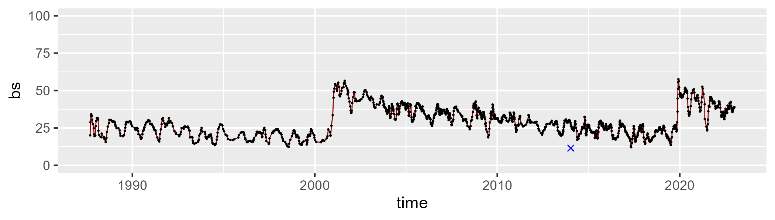

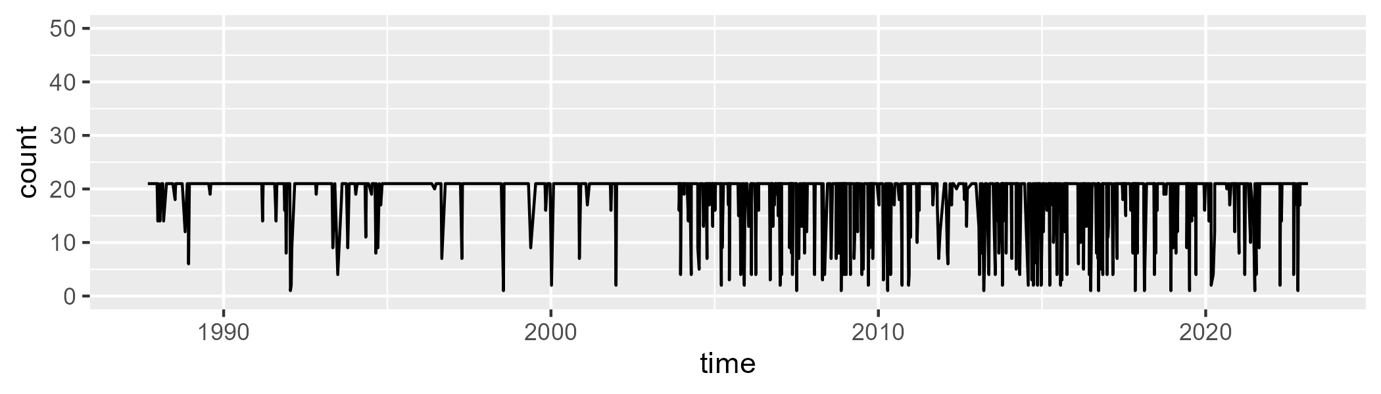

Min. : 1.00 1st Qu.:21.00 Median :21.00 Mean :18.98 3rd Qu.:21.00 Max. :21.00

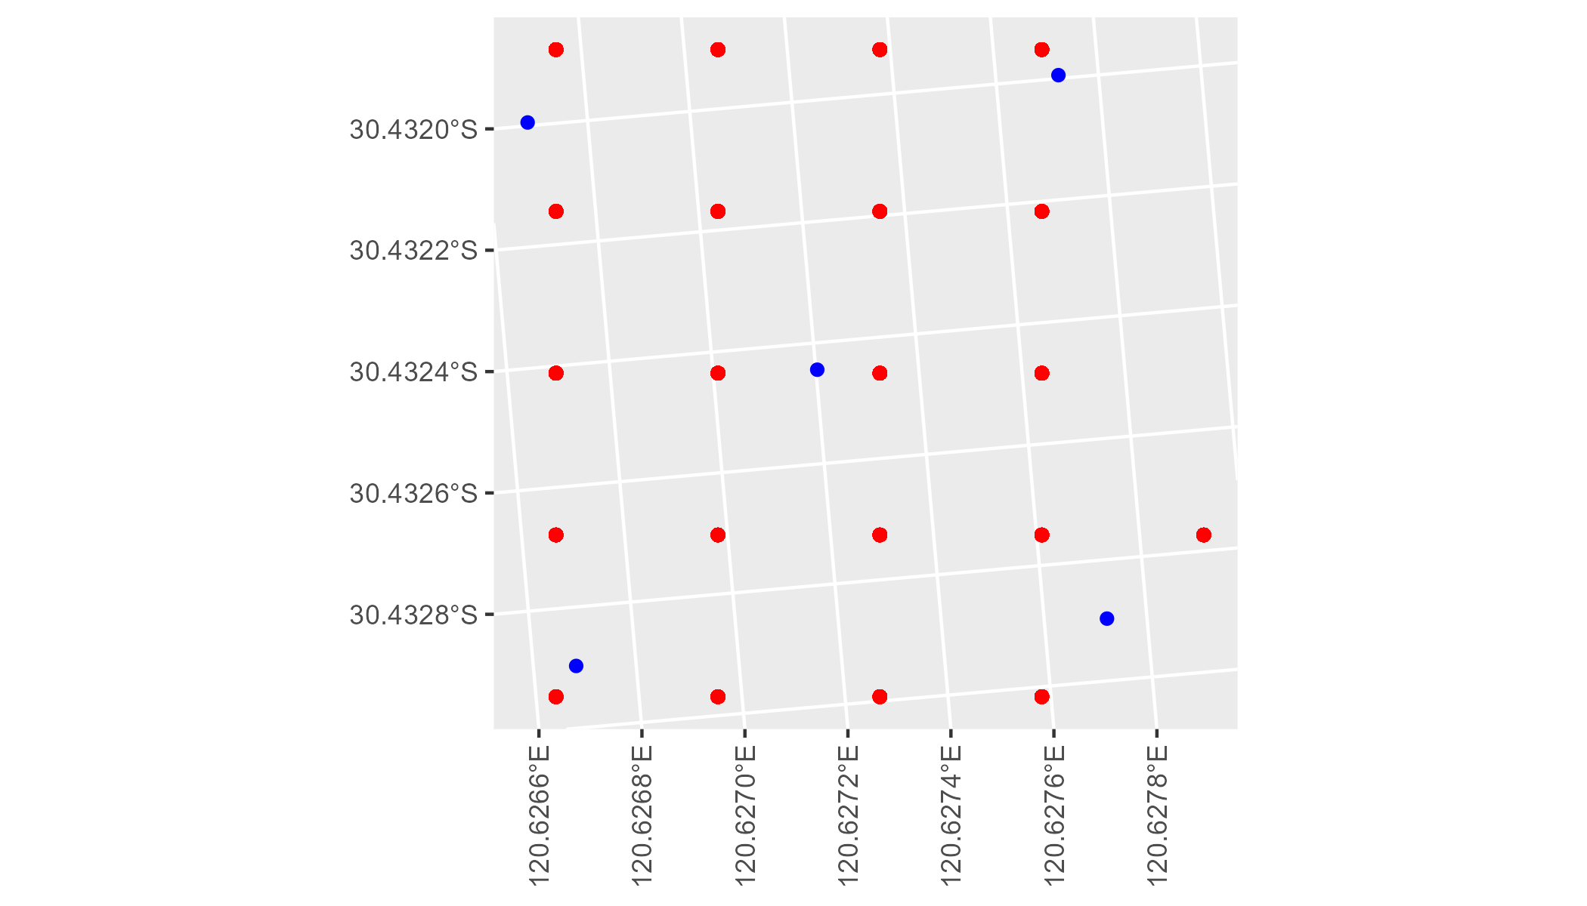

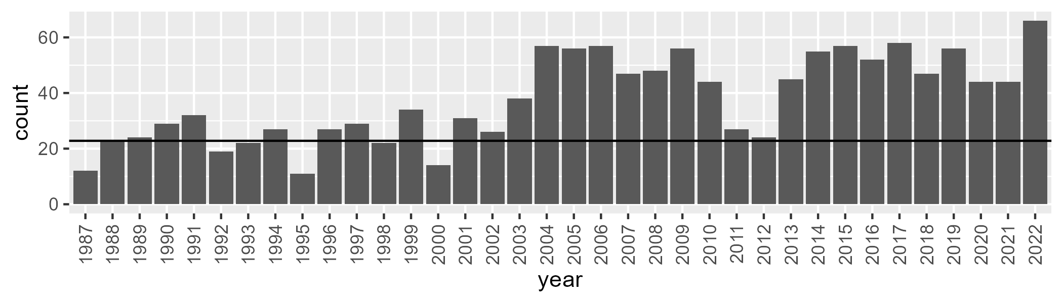

Number of samples: 1360

# WAACOO0030

| Min. | 1st Qu. | Median | Mean | 3rd Qu. | Max. |
| --- | --- | --- | --- | --- | --- |
| 0 | 7.710093 | 12.24611 | 13.88247 | 18.16498 | 50.78118 |

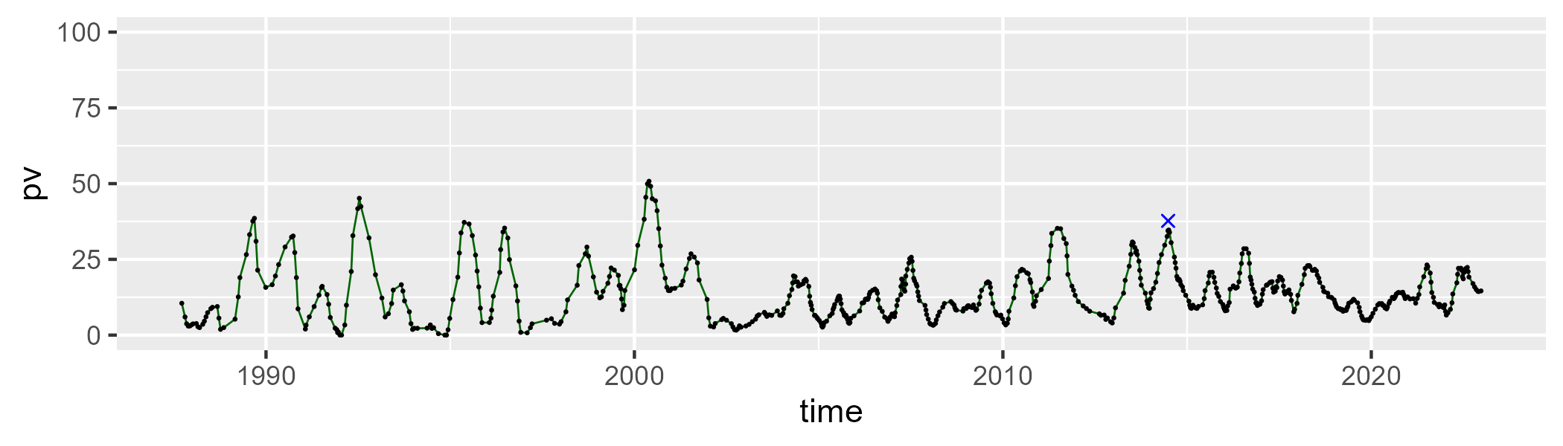

| Min. | 1st Qu. | Median | Mean | 3rd Qu. | Max. |
| --- | --- | --- | --- | --- | --- |
| 37.42065 | 47.4557 | 50.74986 | 52.99791 | 56.78307 | 80.34642 |

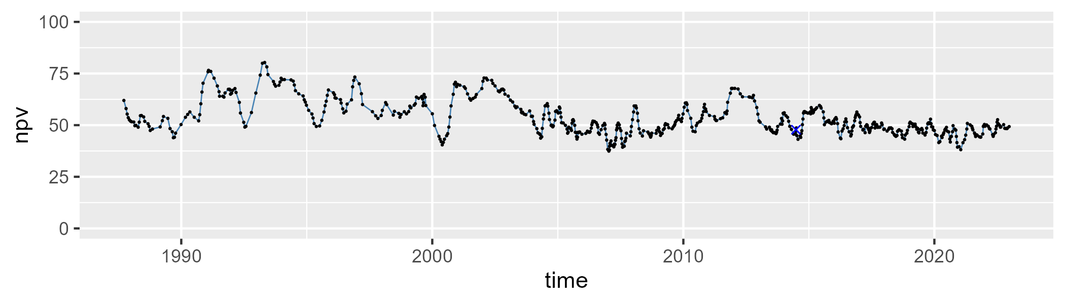

| Min. | 1st Qu. | Median | Mean | 3rd Qu. | Max. |
| --- | --- | --- | --- | --- | --- |
| 4.801028 | 25.61373 | 33.22502 | 31.7671 | 39.6501 | 54.37458 |

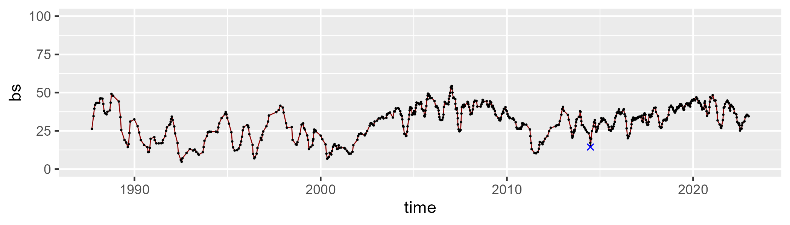

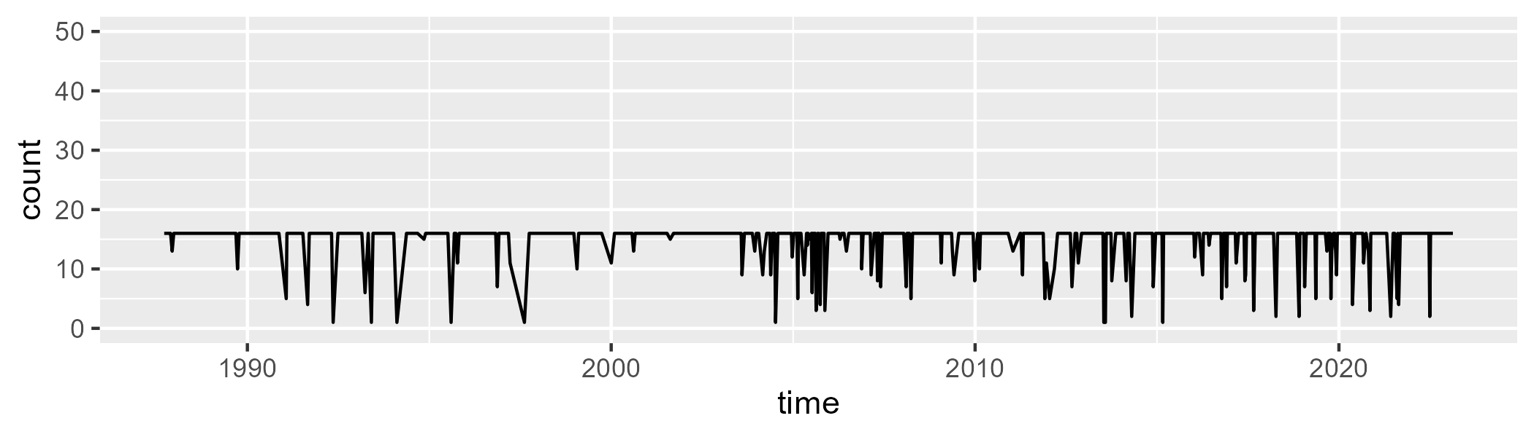

Min. : 1.00 1st Qu.:16.00 Median :16.00 Mean :14.88 3rd Qu.:16.00 Max. :16.00

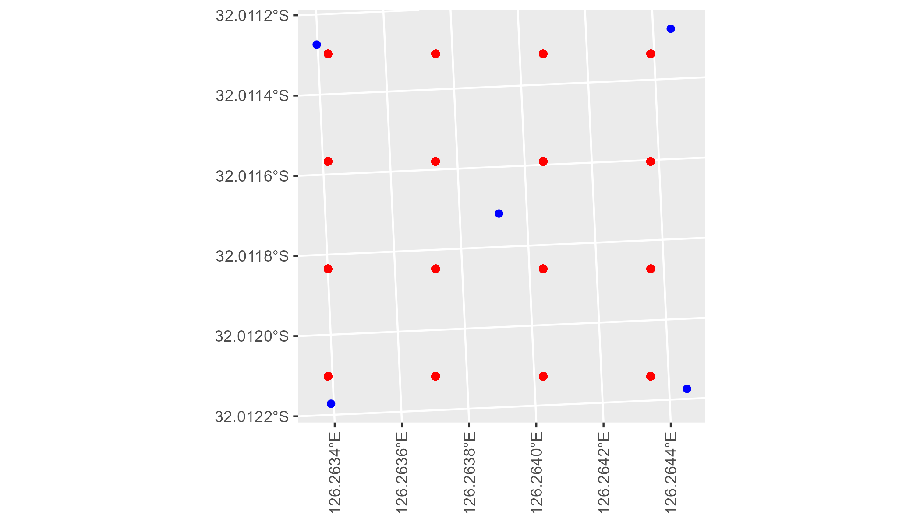

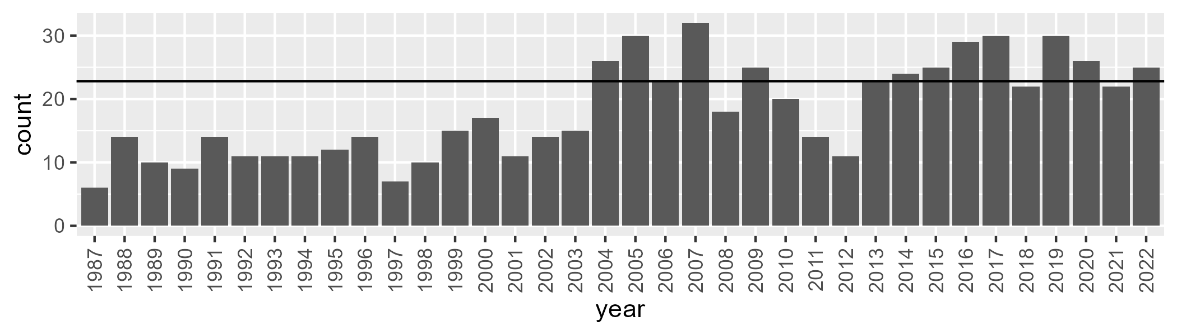

Number of samples: 656

# WAACOO0031

| Min. | 1st Qu. | Median | Mean | 3rd Qu. | Max. |
| --- | --- | --- | --- | --- | --- |
| 0 | 11.23831 | 13.89108 | 14.31442 | 17.25203 | 40.29026 |

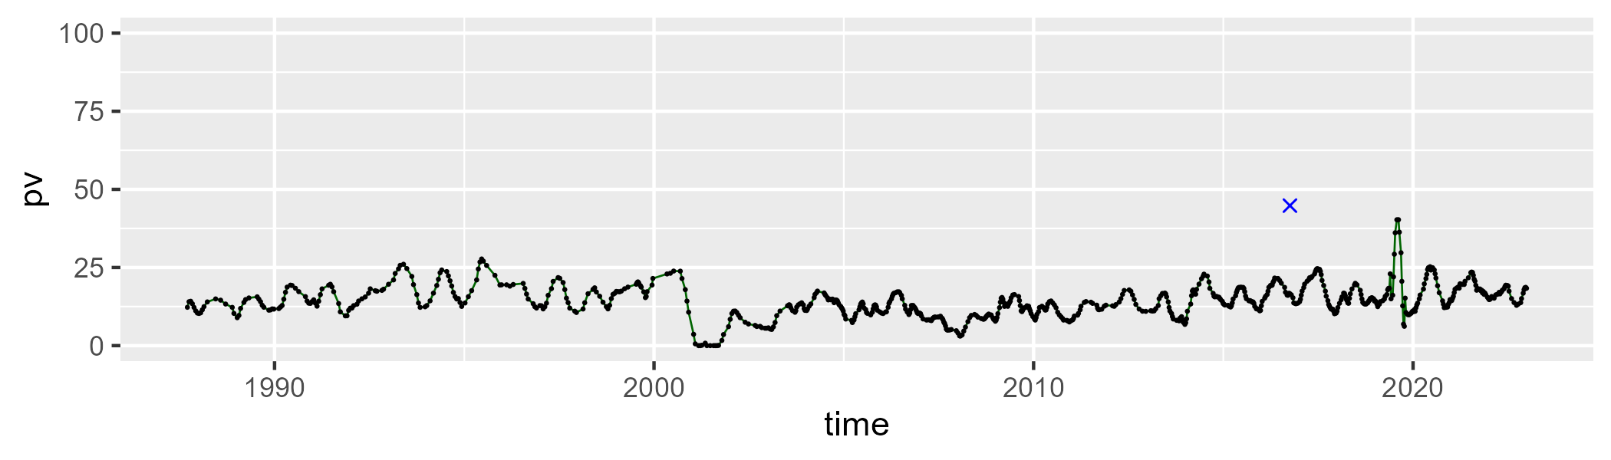

| Min. | 1st Qu. | Median | Mean | 3rd Qu. | Max. |
| --- | --- | --- | --- | --- | --- |
| 37.91654 | 52.86837 | 58.12937 | 57.39387 | 62.87763 | 72.98303 |

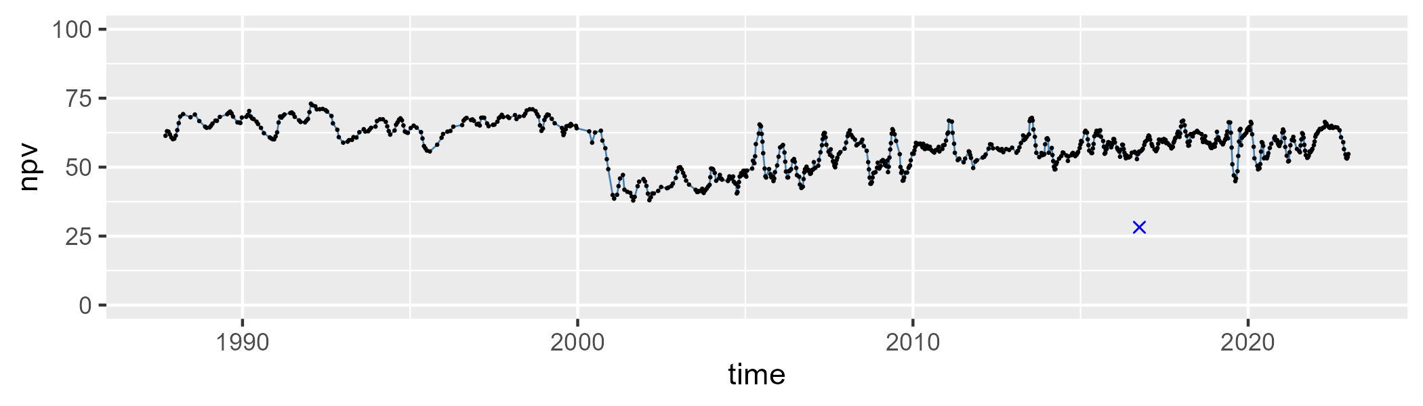

| Min. | 1st Qu. | Median | Mean | 3rd Qu. | Max. |
| --- | --- | --- | --- | --- | --- |
| 9.707533 | 19.17248 | 26.04276 | 27.05982 | 33.12708 | 61.45549 |

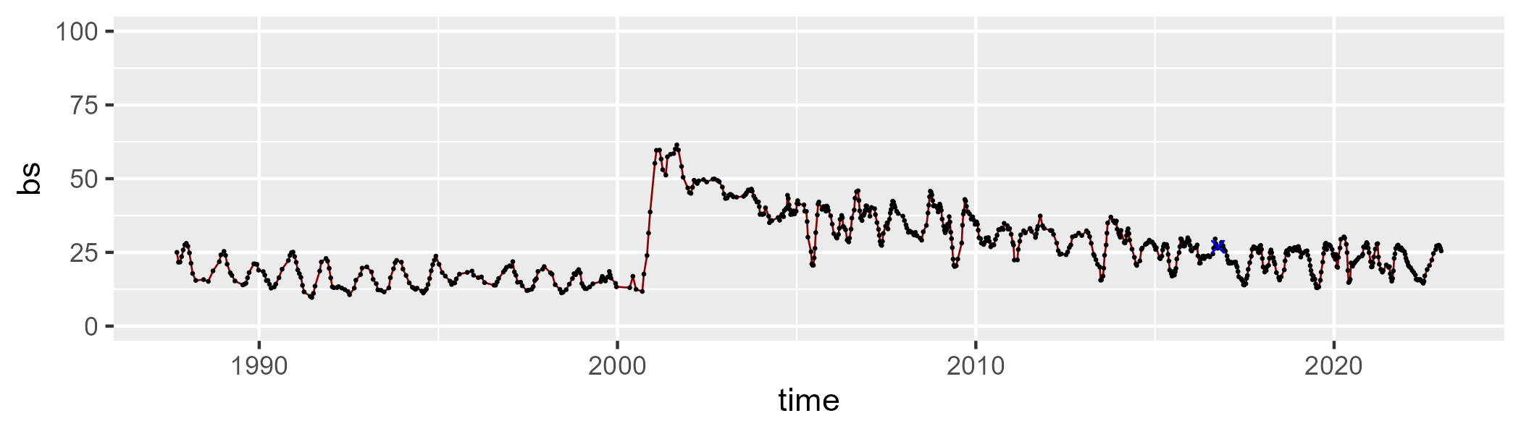

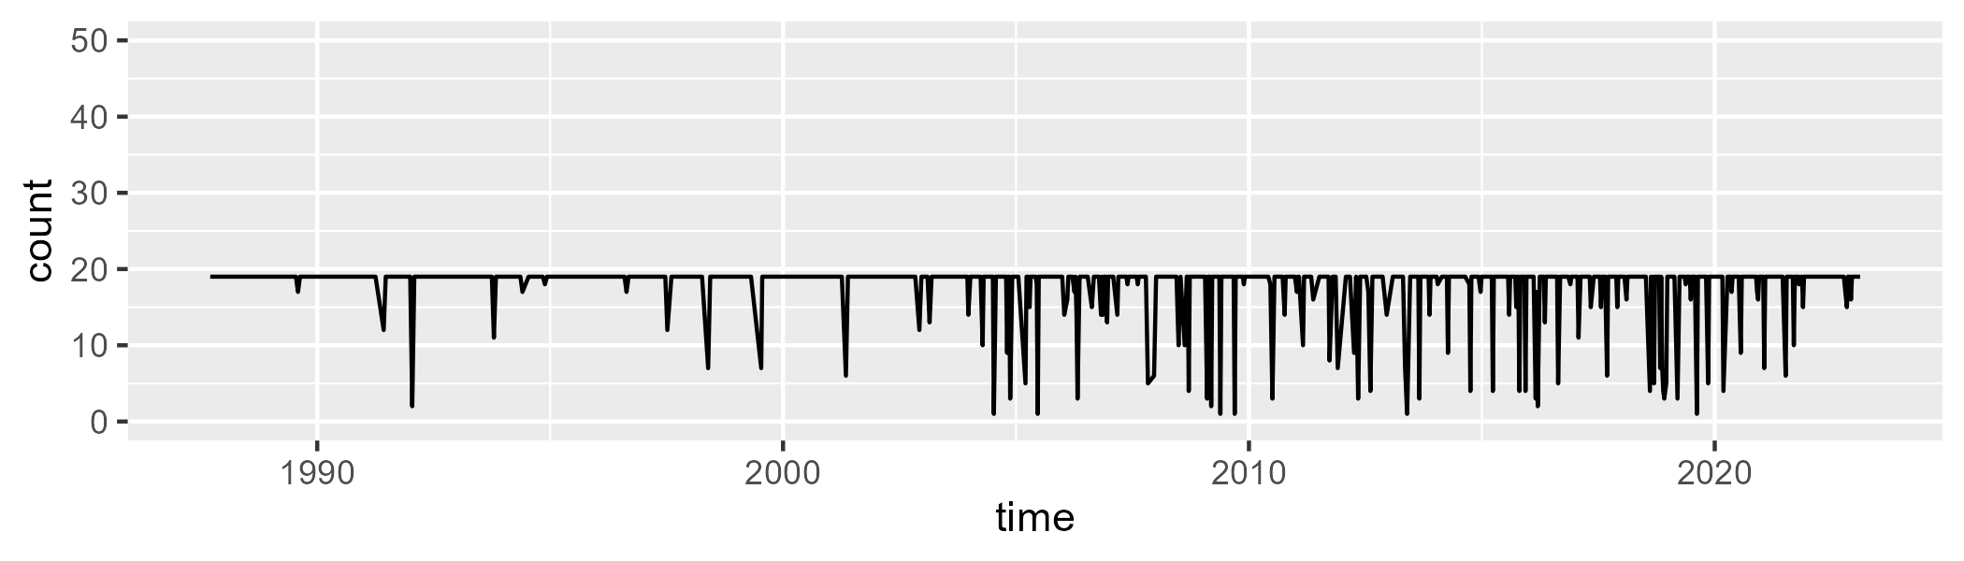

Min. : 1.00 1st Qu.:19.00 Median :19.00 Mean :17.79 3rd Qu.:19.00 Max. :19.00

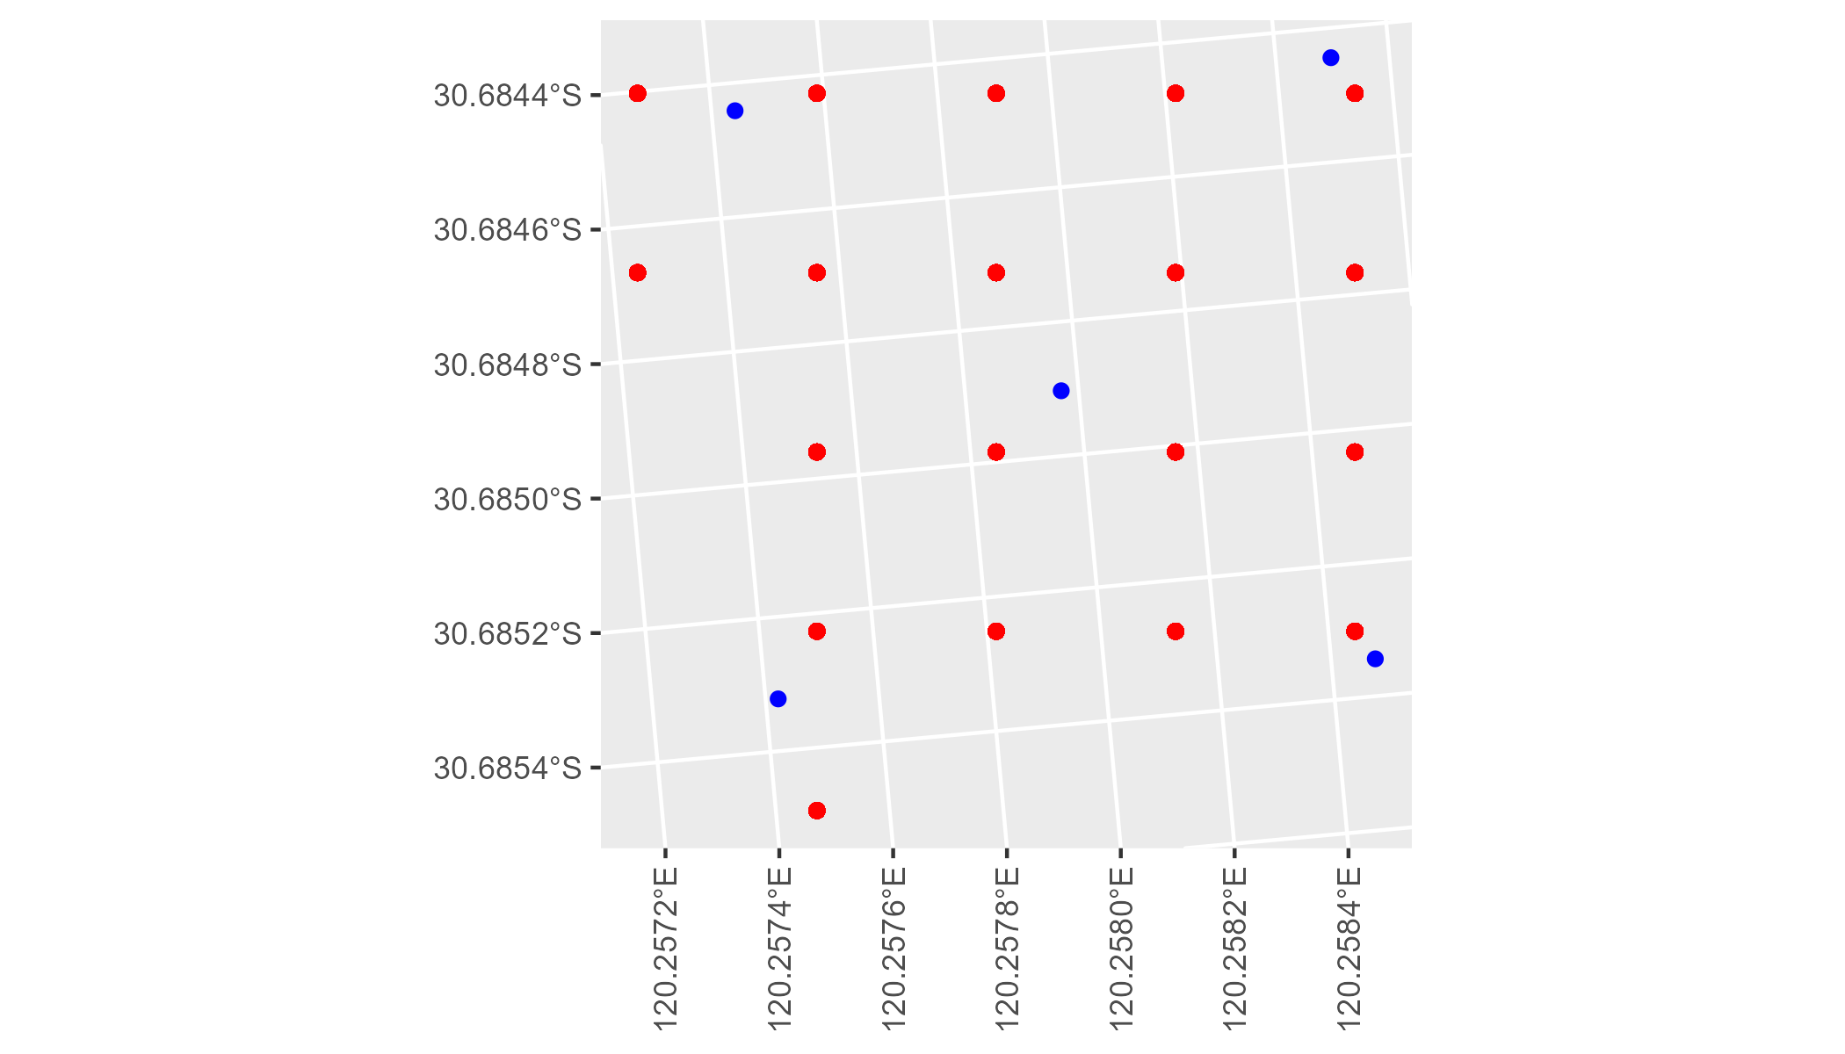

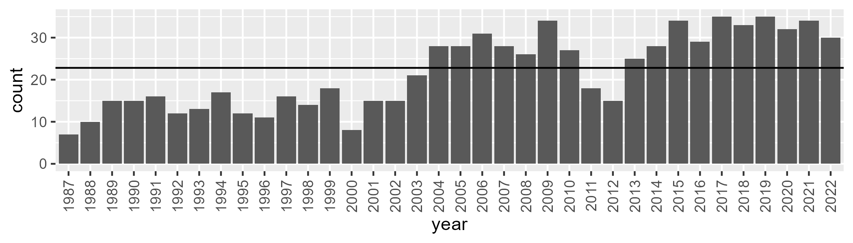

Number of samples: 785

# WAACOO0032

| Min. | 1st Qu. | Median | Mean | 3rd Qu. | Max. |
| --- | --- | --- | --- | --- | --- |
| 1.735712 | 7.660765 | 9.837282 | 9.950913 | 12.15662 | 18.25263 |

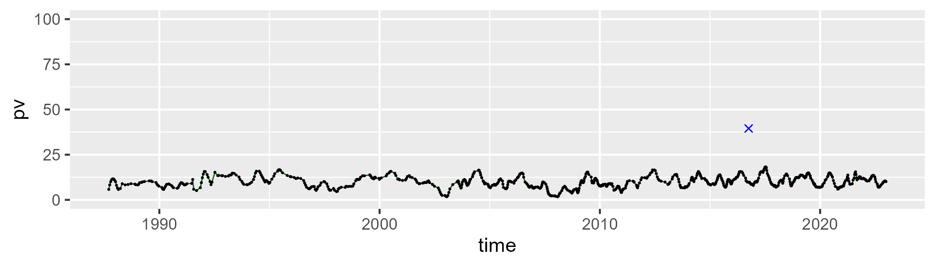

| Min. | 1st Qu. | Median | Mean | 3rd Qu. | Max. |
| --- | --- | --- | --- | --- | --- |
| 56.87867 | 64.77312 | 67.34007 | 67.5243 | 70.16608 | 80.16114 |

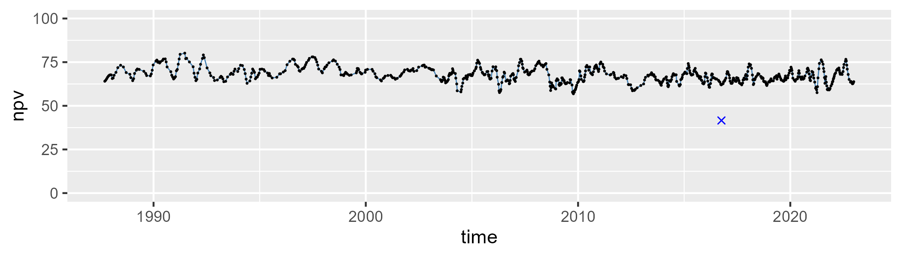

| Min. | 1st Qu. | Median | Mean | 3rd Qu. | Max. |
| --- | --- | --- | --- | --- | --- |
| 9.733127 | 18.18472 | 21.12548 | 21.29804 | 24.3875 | 35.79752 |

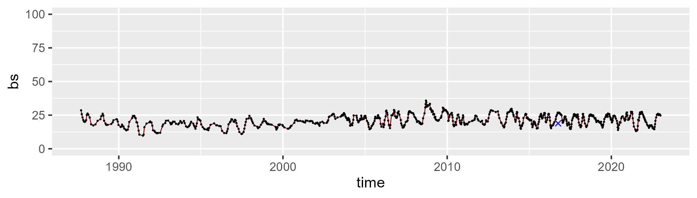

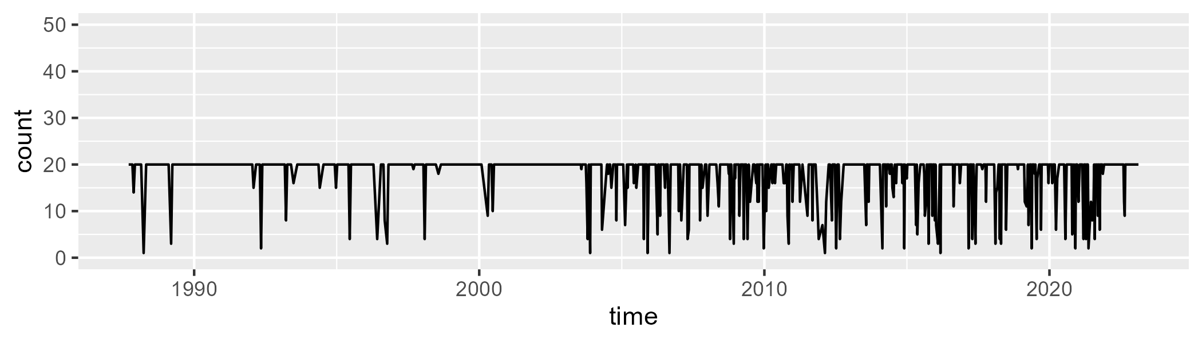

Min. : 1.00 1st Qu.:20.00 Median :20.00 Mean :18.01 3rd Qu.:20.00 Max. :20.00

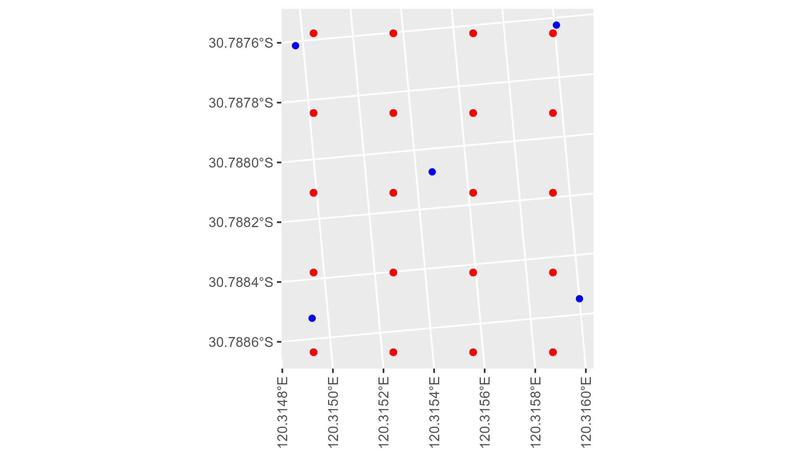

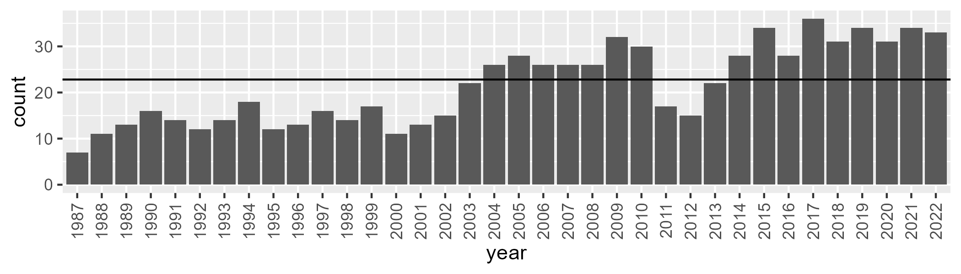

Number of samples: 775

# WAADAL0001

| Min. | 1st Qu. | Median | Mean | 3rd Qu. | Max. |
| --- | --- | --- | --- | --- | --- |
| 2.623791 | 15.54767 | 26.33144 | 31.05748 | 46.78607 | 75.1506 |

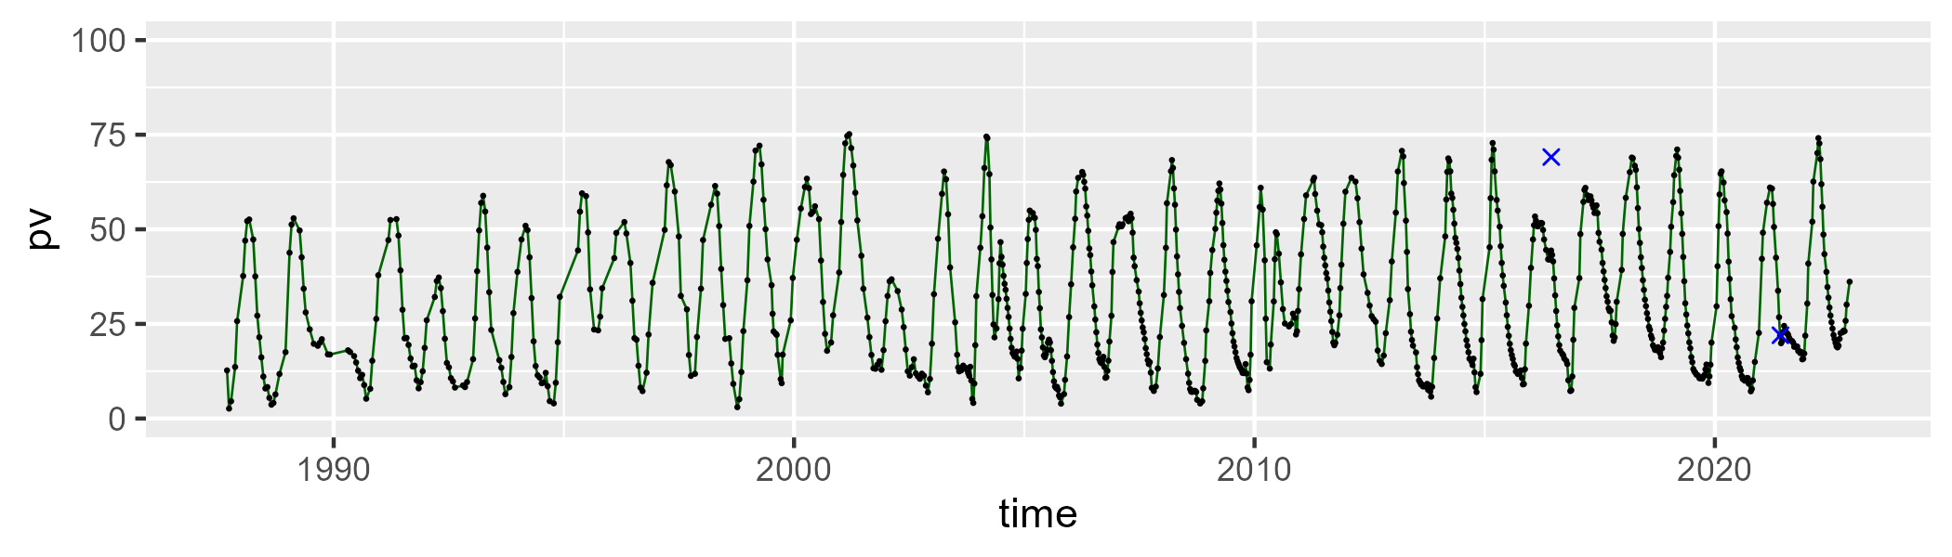

| Min. | 1st Qu. | Median | Mean | 3rd Qu. | Max. |
| --- | --- | --- | --- | --- | --- |
| 13.448 | 43.88856 | 57.21201 | 57.25105 | 71.73888 | 93.96069 |

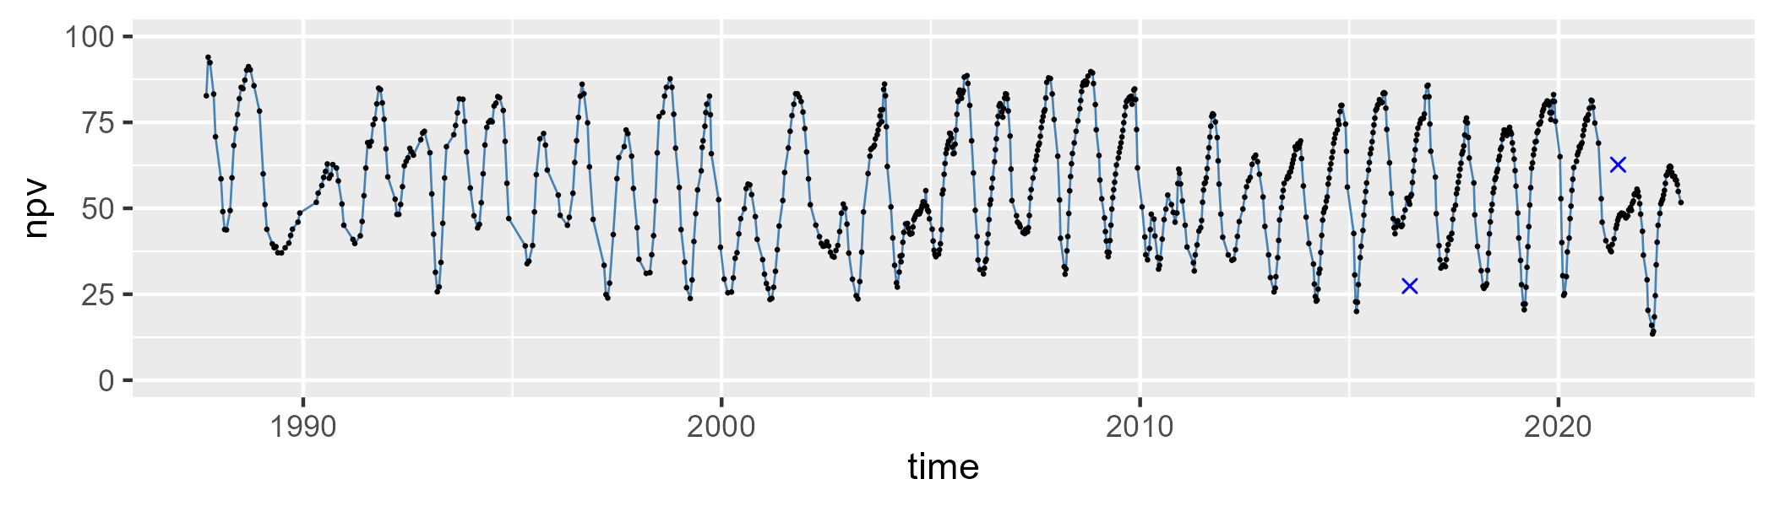

| Min. | 1st Qu. | Median | Mean | 3rd Qu. | Max. |
| --- | --- | --- | --- | --- | --- |
| 0 | 3.67628 | 7.153445 | 10.54273 | 14.30861 | 51.57617 |

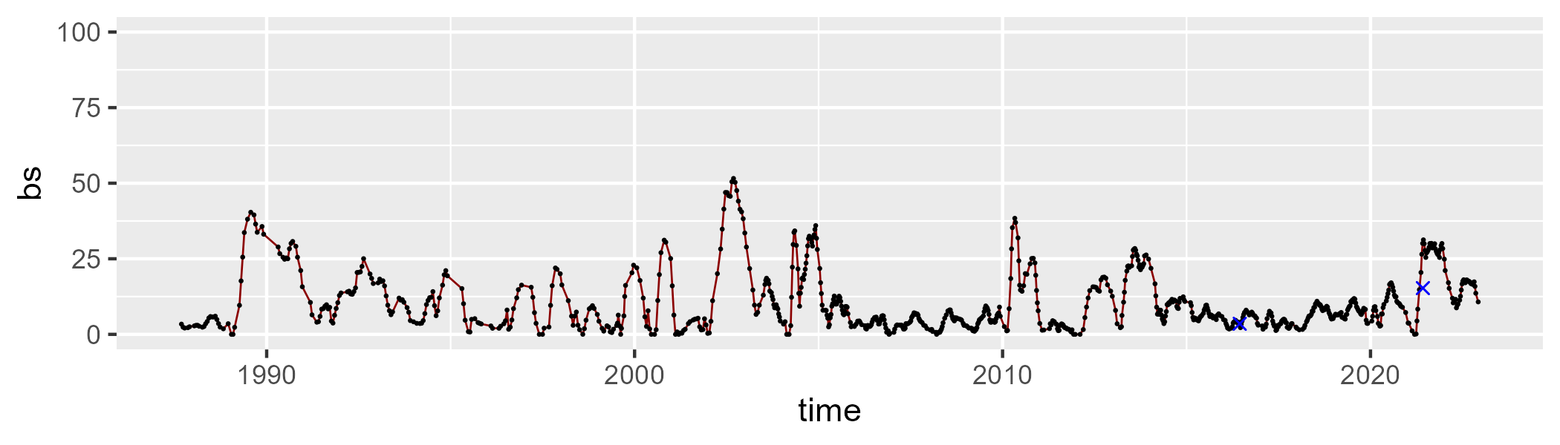

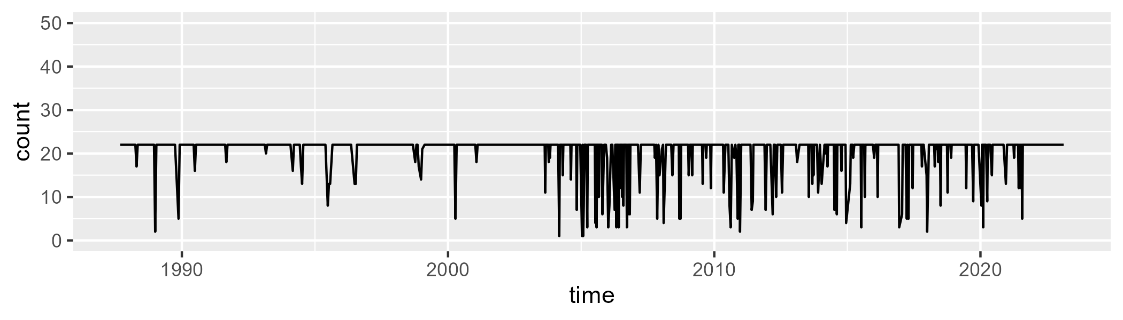

Min. : 1.00 1st Qu.:22.00 Median :22.00 Mean :20.55 3rd Qu.:22.00 Max. :22.00

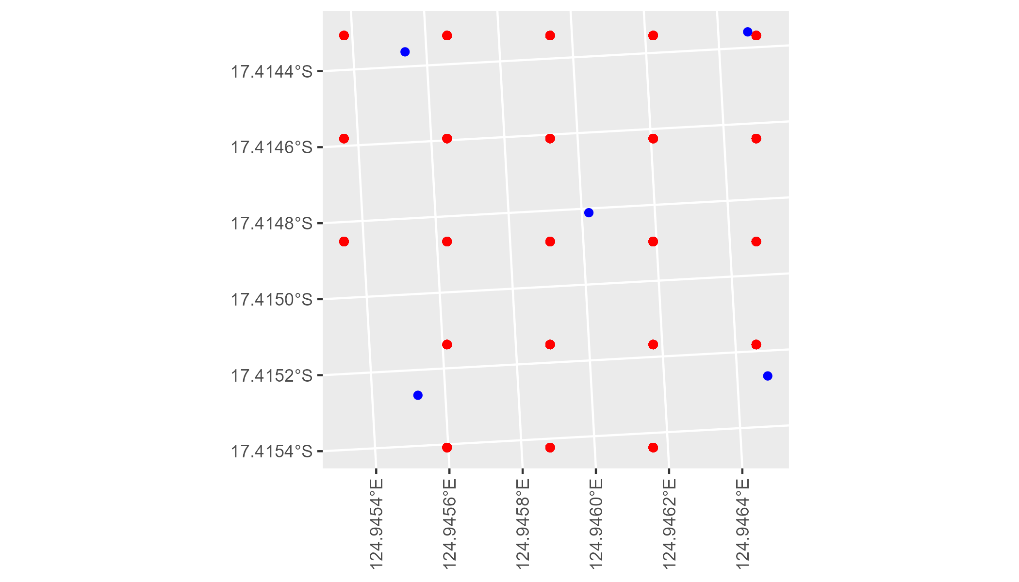

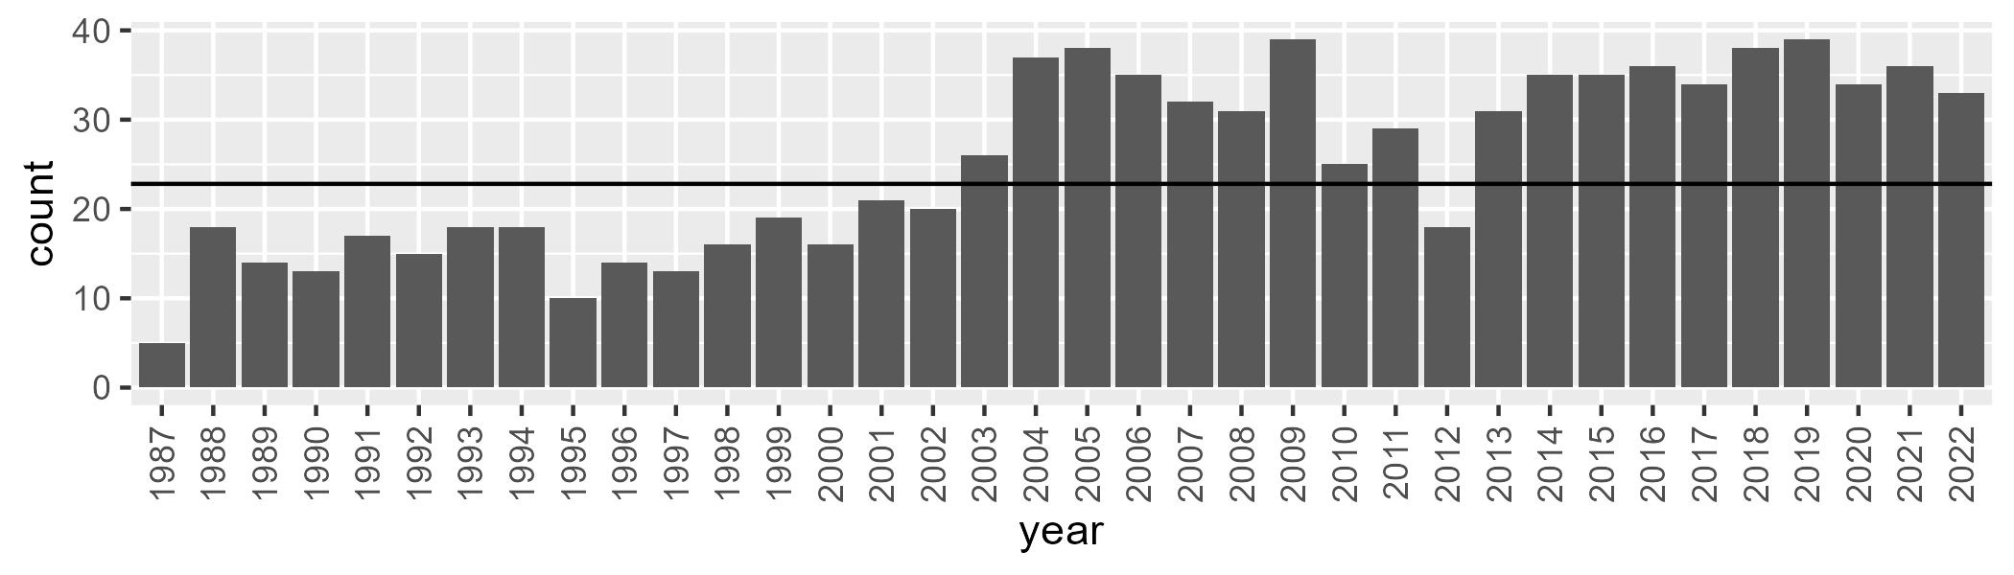

Number of samples: 908

# WAADAL0002

| Min. | 1st Qu. | Median | Mean | 3rd Qu. | Max. |
| --- | --- | --- | --- | --- | --- |
| 3.240624 | 19.95232 | 26.19861 | 27.42809 | 34.17895 | 58.02821 |

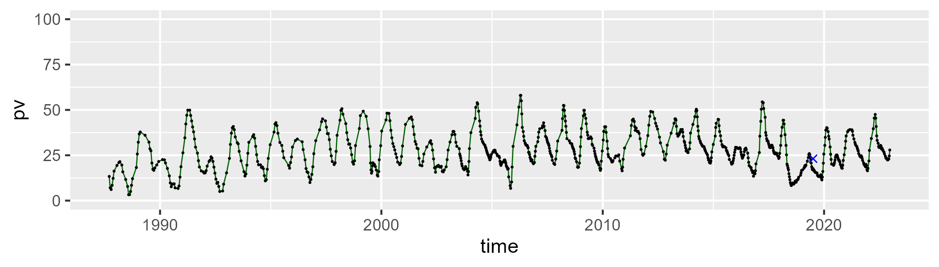

| Min. | 1st Qu. | Median | Mean | 3rd Qu. | Max. |
| --- | --- | --- | --- | --- | --- |
| 14.25727 | 37.78441 | 42.93473 | 44.84957 | 49.91102 | 87.41564 |

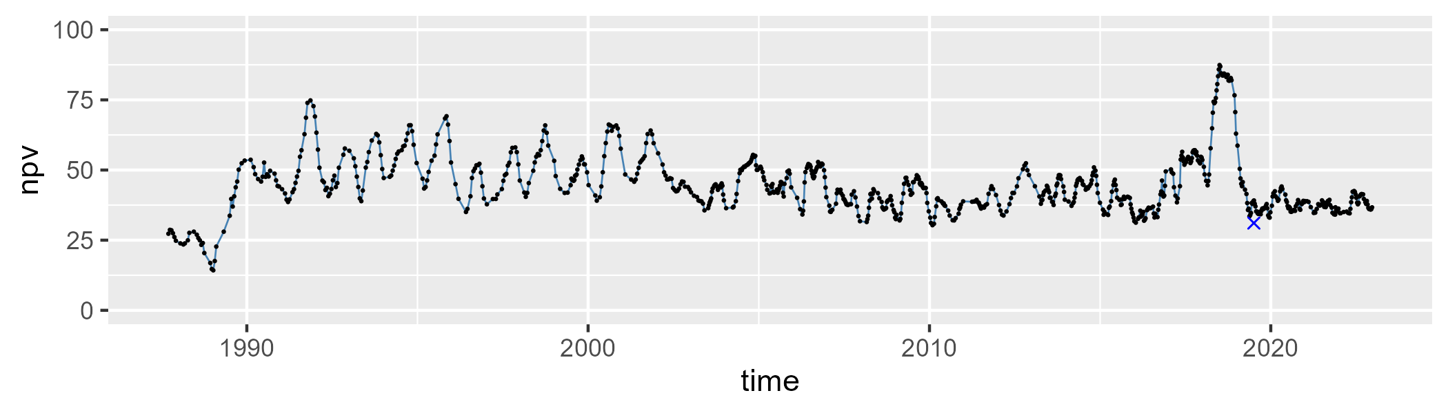

| Min. | 1st Qu. | Median | Mean | 3rd Qu. | Max. |
| --- | --- | --- | --- | --- | --- |
| 2.768509 | 16.00582 | 25.39625 | 26.37625 | 36.03118 | 70.00509 |

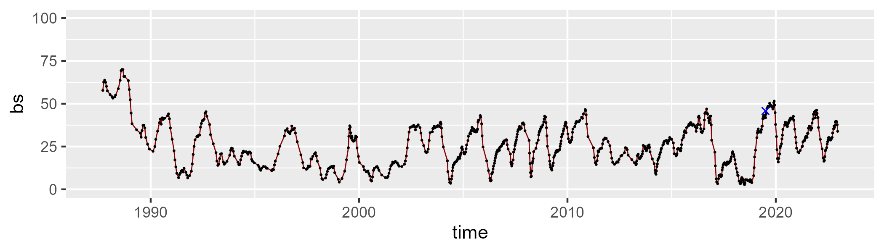

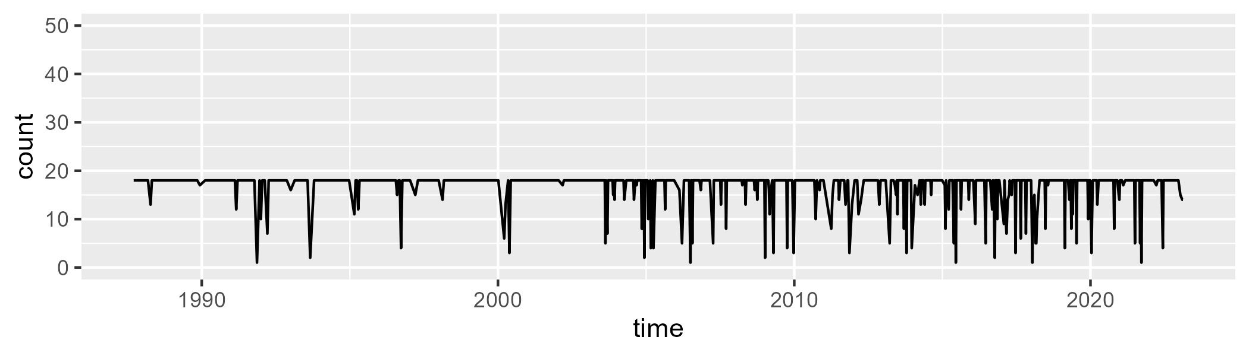

Min. : 1.00 1st Qu.:18.00 Median :18.00 Mean :16.82 3rd Qu.:18.00 Max. :18.00

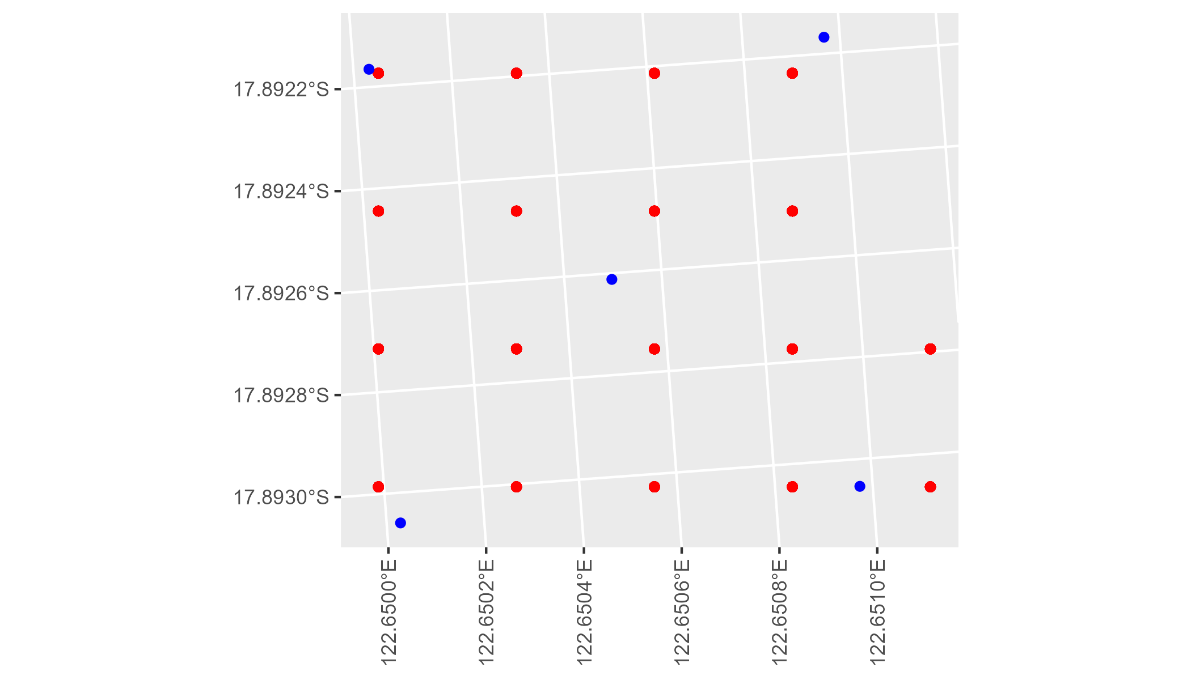

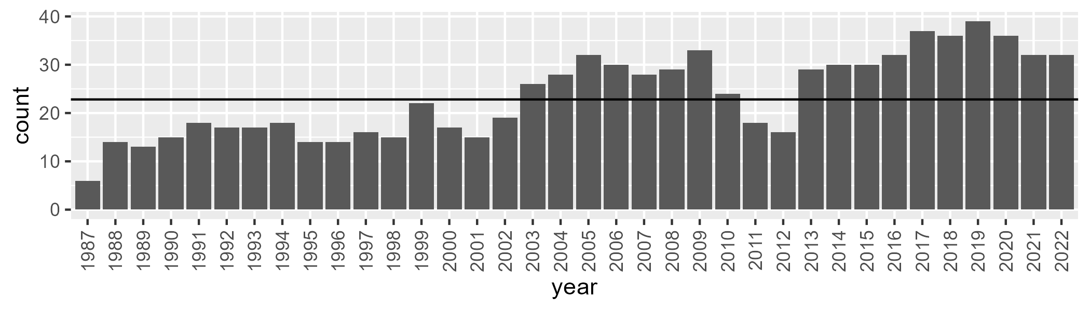

Number of samples: 847

# WAADAL0003

| Min. | 1st Qu. | Median | Mean | 3rd Qu. | Max. |
| --- | --- | --- | --- | --- | --- |
| 0 | 9.521606 | 13.71216 | 16.92358 | 22.23796 | 59.34299 |

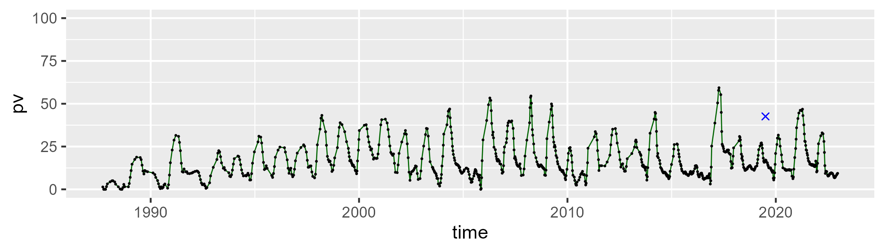

| Min. | 1st Qu. | Median | Mean | 3rd Qu. | Max. |
| --- | --- | --- | --- | --- | --- |
| 15.36866 | 48.96511 | 57.29758 | 55.94403 | 63.2808 | 83.39884 |

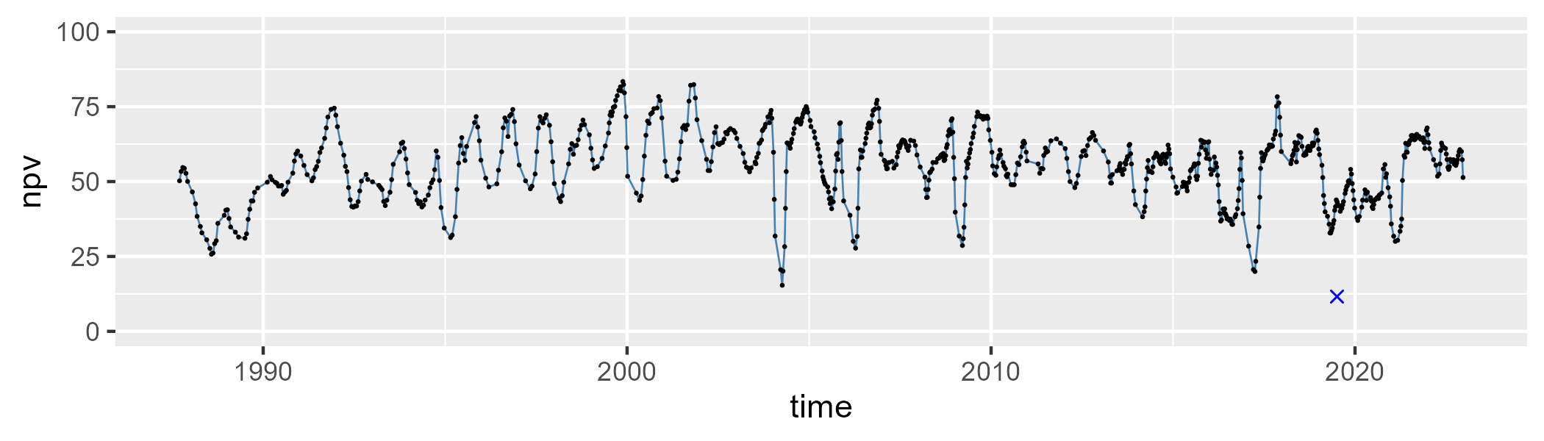

| Min. | 1st Qu. | Median | Mean | 3rd Qu. | Max. |
| --- | --- | --- | --- | --- | --- |
| 0 | 15.46793 | 24.05628 | 25.81185 | 33.67683 | 73.95658 |

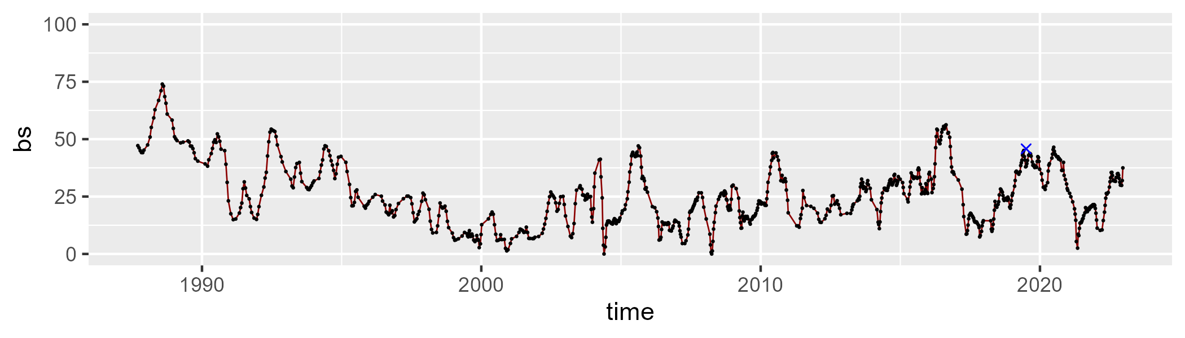

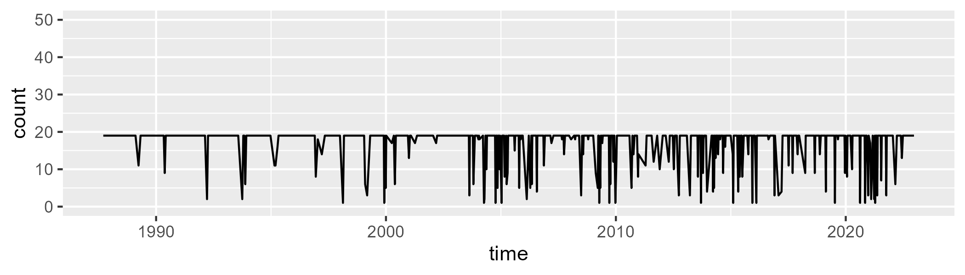

Min. : 1.00 1st Qu.:19.00 Median :19.00 Mean :17.47 3rd Qu.:19.00 Max. :19.00

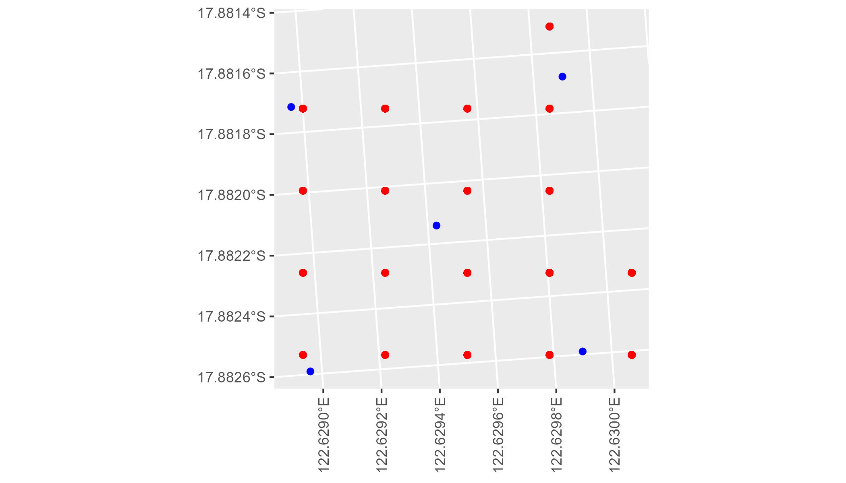

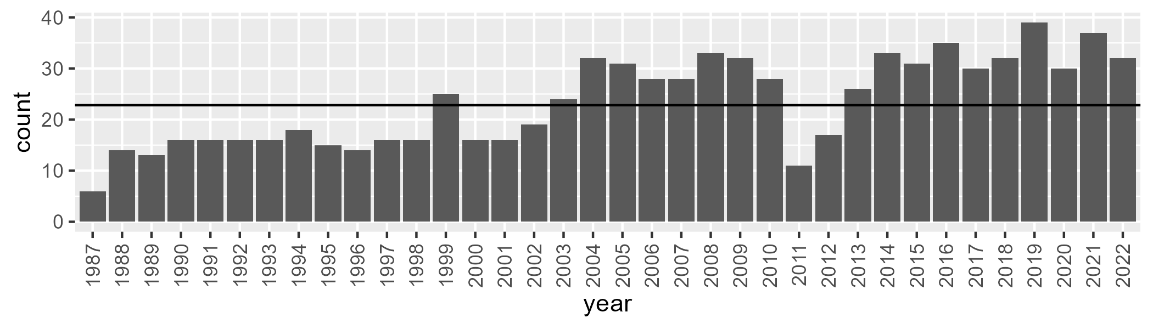

Number of samples: 841

# WAADAL0004

| Min. | 1st Qu. | Median | Mean | 3rd Qu. | Max. |
| --- | --- | --- | --- | --- | --- |
| 3.755092 | 23.78431 | 32.09113 | 32.02188 | 39.90487 | 59.03085 |

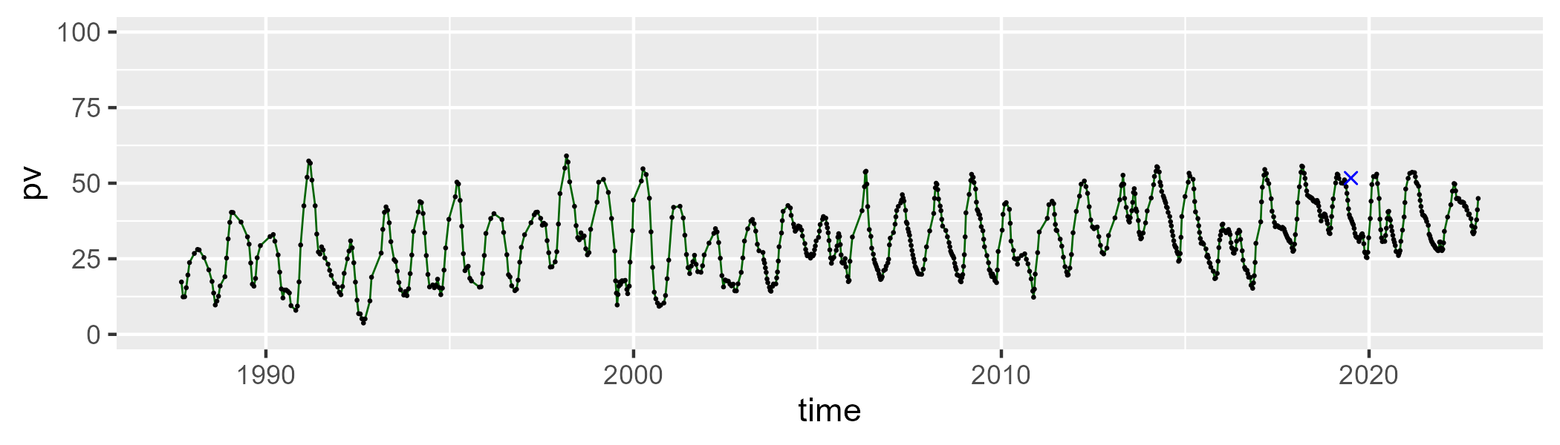

| Min. | 1st Qu. | Median | Mean | 3rd Qu. | Max. |
| --- | --- | --- | --- | --- | --- |
| 26.40442 | 44.44568 | 49.38894 | 49.44987 | 53.69981 | 76.93327 |

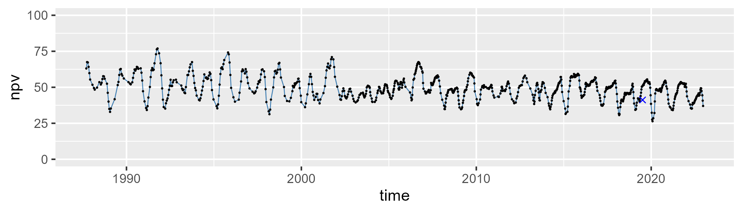

| Min. | 1st Qu. | Median | Mean | 3rd Qu. | Max. |
| --- | --- | --- | --- | --- | --- |
| 0.9003925 | 11.90735 | 15.84665 | 17.29462 | 21.2669 | 47.4981 |

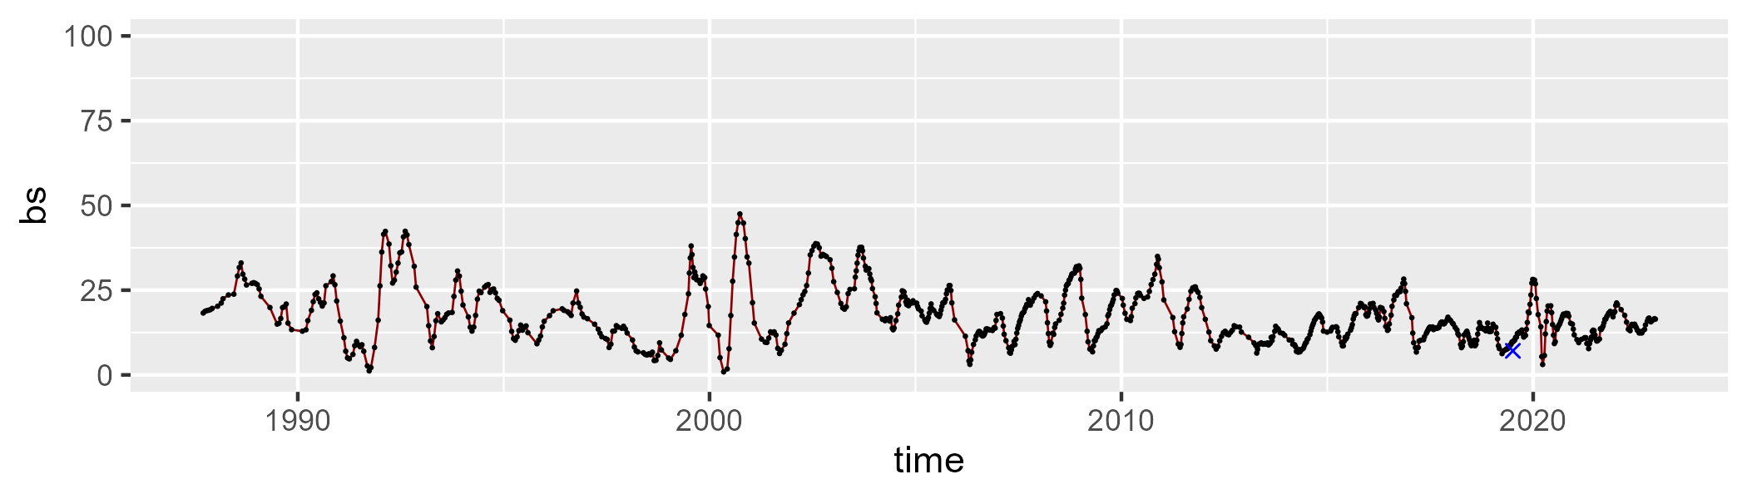

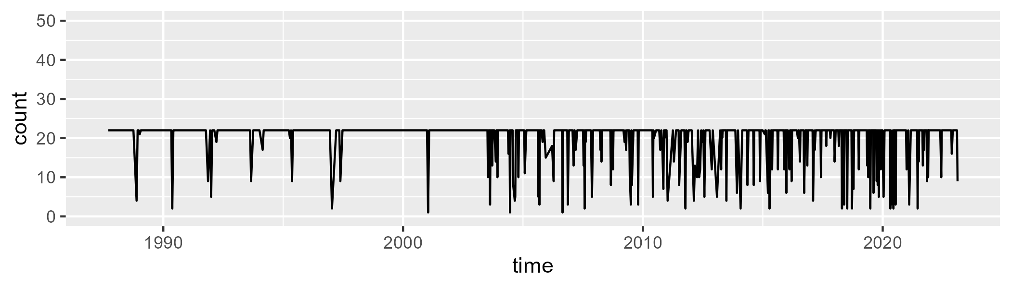

Min. : 1.00 1st Qu.:22.00 Median :22.00 Mean :20.22 3rd Qu.:22.00 Max. :22.00

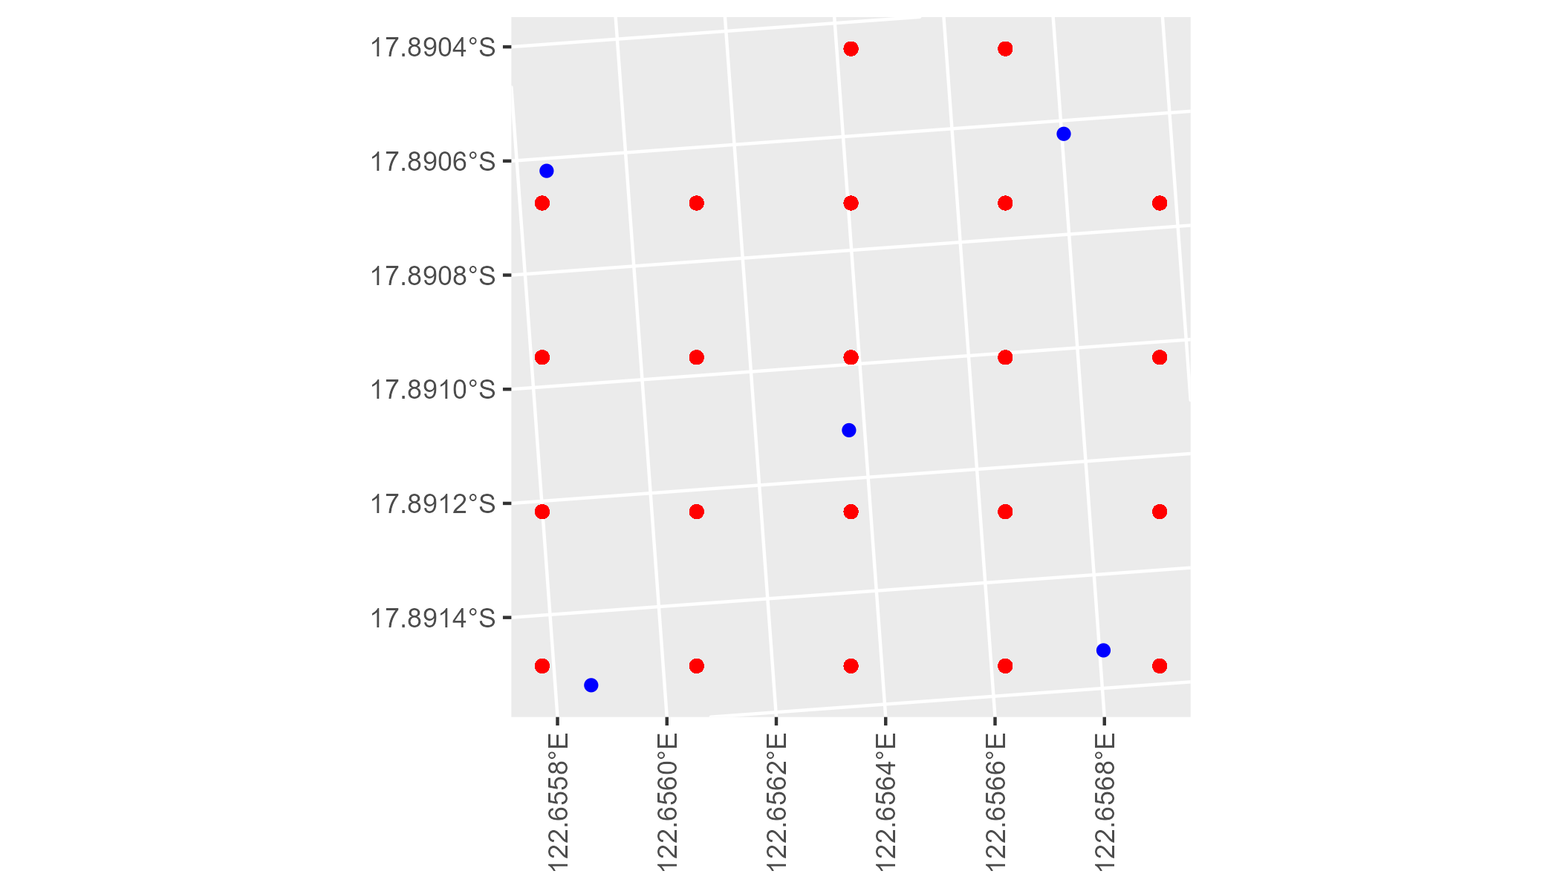

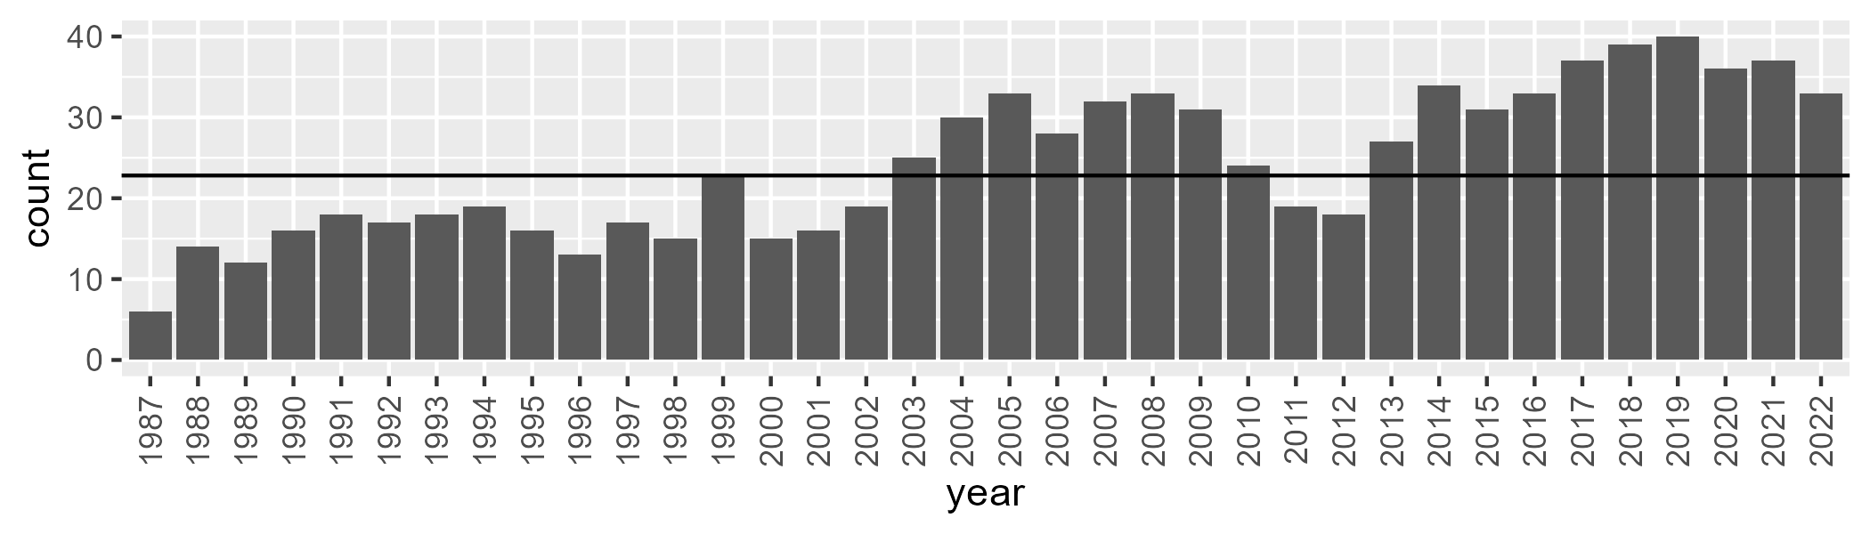

Number of samples: 874

# WAADAL0005

| Min. | 1st Qu. | Median | Mean | 3rd Qu. | Max. |
| --- | --- | --- | --- | --- | --- |
| 8.588082 | 26.7724 | 34.82084 | 35.21431 | 43.9386 | 65.63989 |

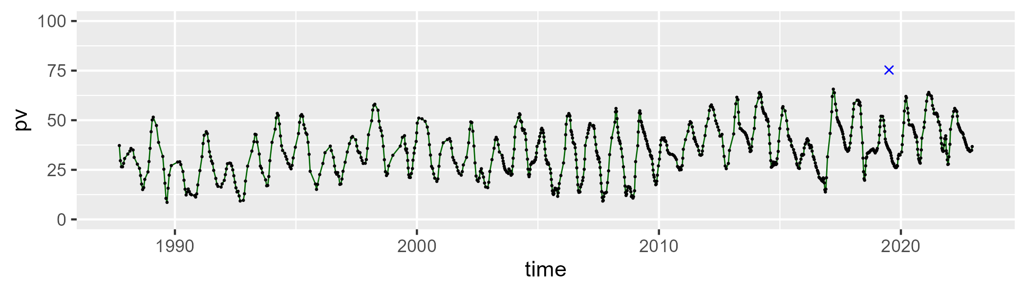

| Min. | 1st Qu. | Median | Mean | 3rd Qu. | Max. |
| --- | --- | --- | --- | --- | --- |
| 27.76911 | 42.99493 | 48.15428 | 48.15822 | 53.93822 | 68.9126 |

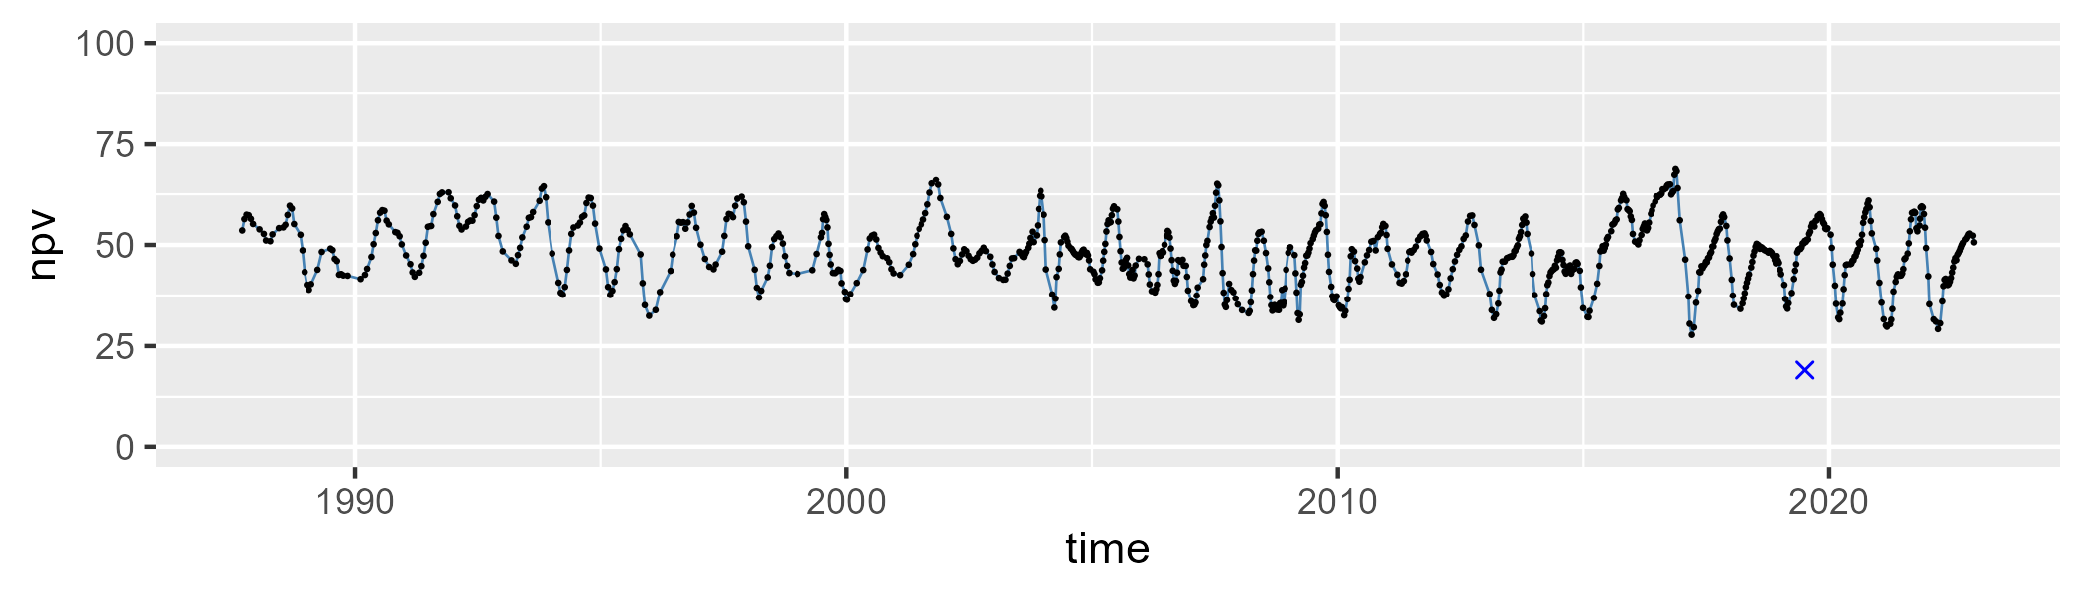

| Min. | 1st Qu. | Median | Mean | 3rd Qu. | Max. |
| --- | --- | --- | --- | --- | --- |
| 0.2718579 | 7.732678 | 12.08218 | 15.38438 | 20.51853 | 53.59252 |

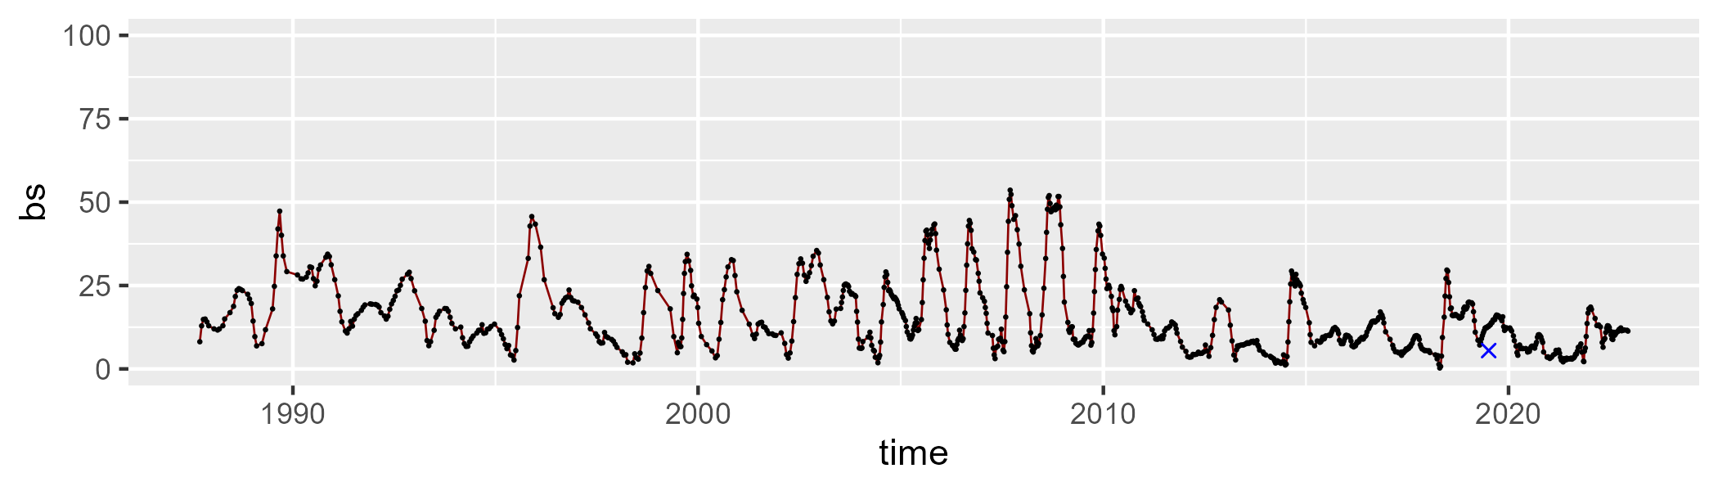

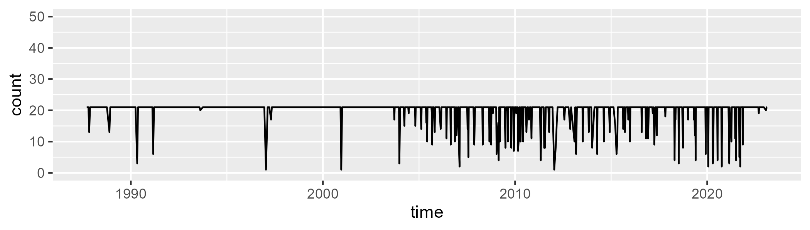

Min. : 1.00 1st Qu.:21.00 Median :21.00 Mean :19.76 3rd Qu.:21.00 Max. :21.00

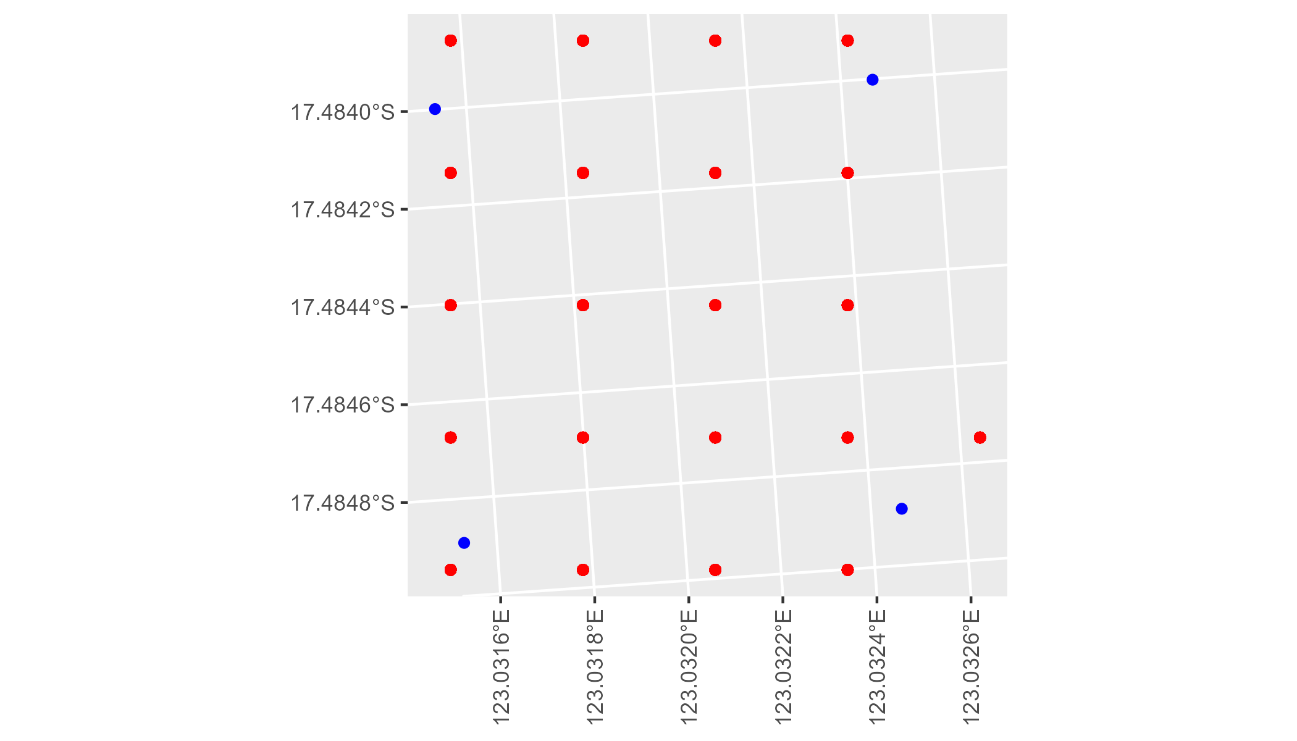

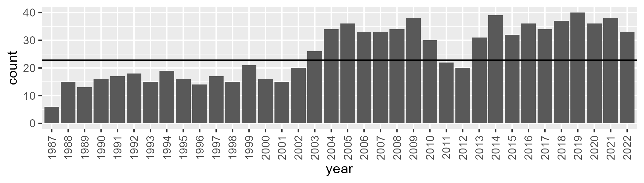

Number of samples: 915

# WAAESP0001

| Min. | 1st Qu. | Median | Mean | 3rd Qu. | Max. |
| --- | --- | --- | --- | --- | --- |
| 12.02886 | 34.23122 | 37.56312 | 37.2018 | 40.8005 | 56.05646 |

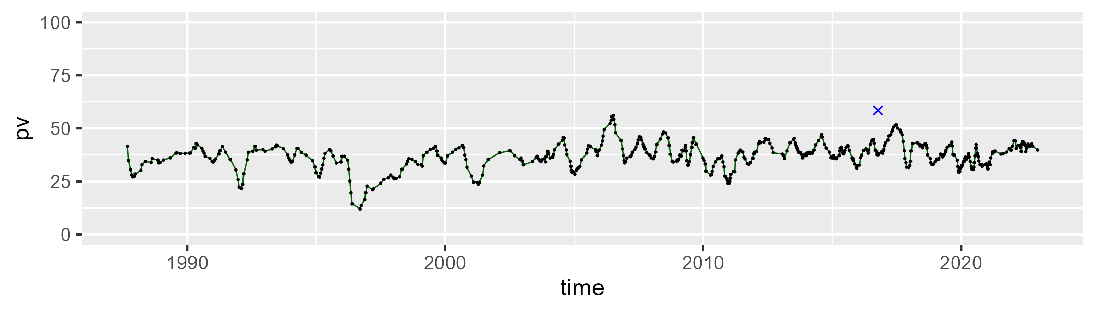

| Min. | 1st Qu. | Median | Mean | 3rd Qu. | Max. |
| --- | --- | --- | --- | --- | --- |
| 33.79697 | 47.69224 | 51.78091 | 51.97545 | 55.89755 | 69.68721 |

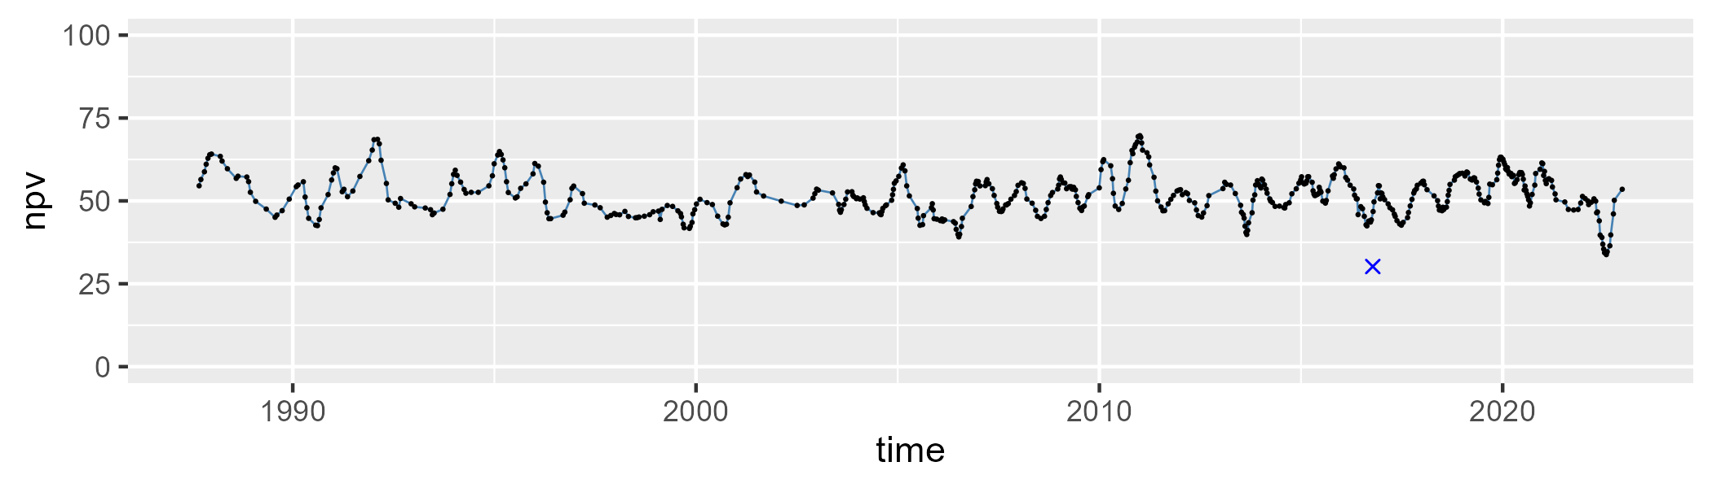

| Min. | 1st Qu. | Median | Mean | 3rd Qu. | Max. |
| --- | --- | --- | --- | --- | --- |
| 0.866936 | 6.015218 | 8.146939 | 9.665266 | 11.97435 | 41.00425 |

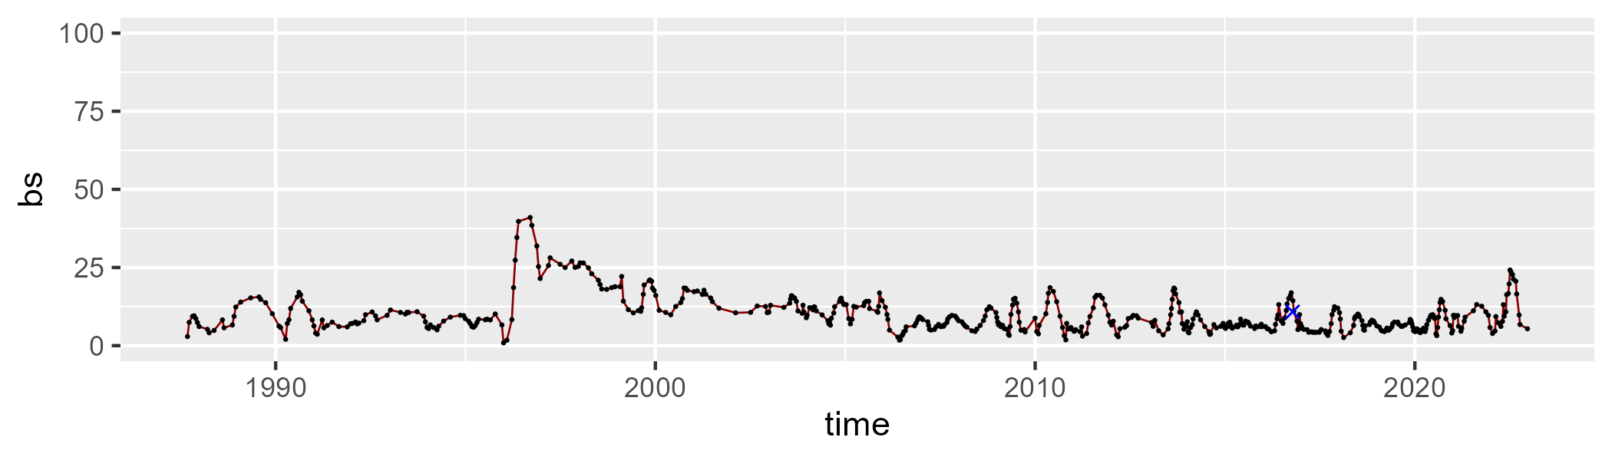

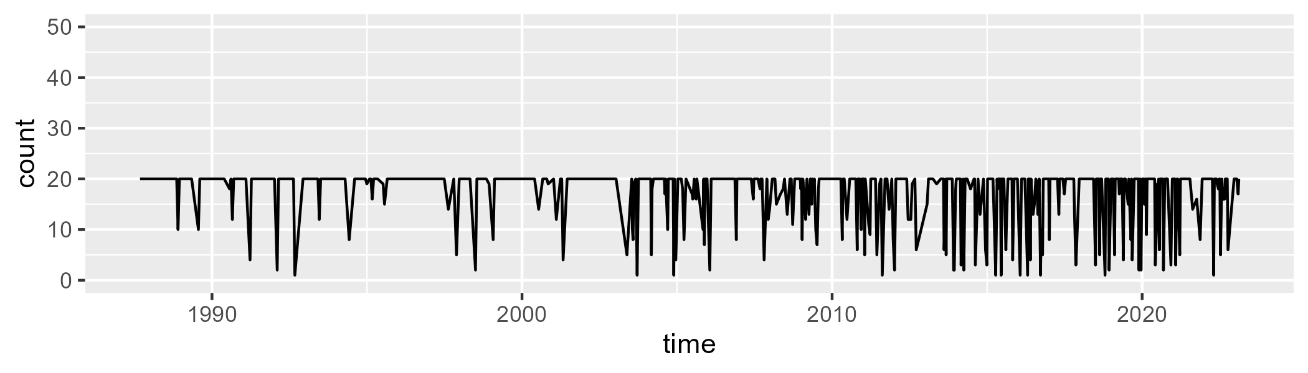

Min. : 1.00 1st Qu.:19.00 Median :20.00 Mean :17.25 3rd Qu.:20.00 Max. :20.00

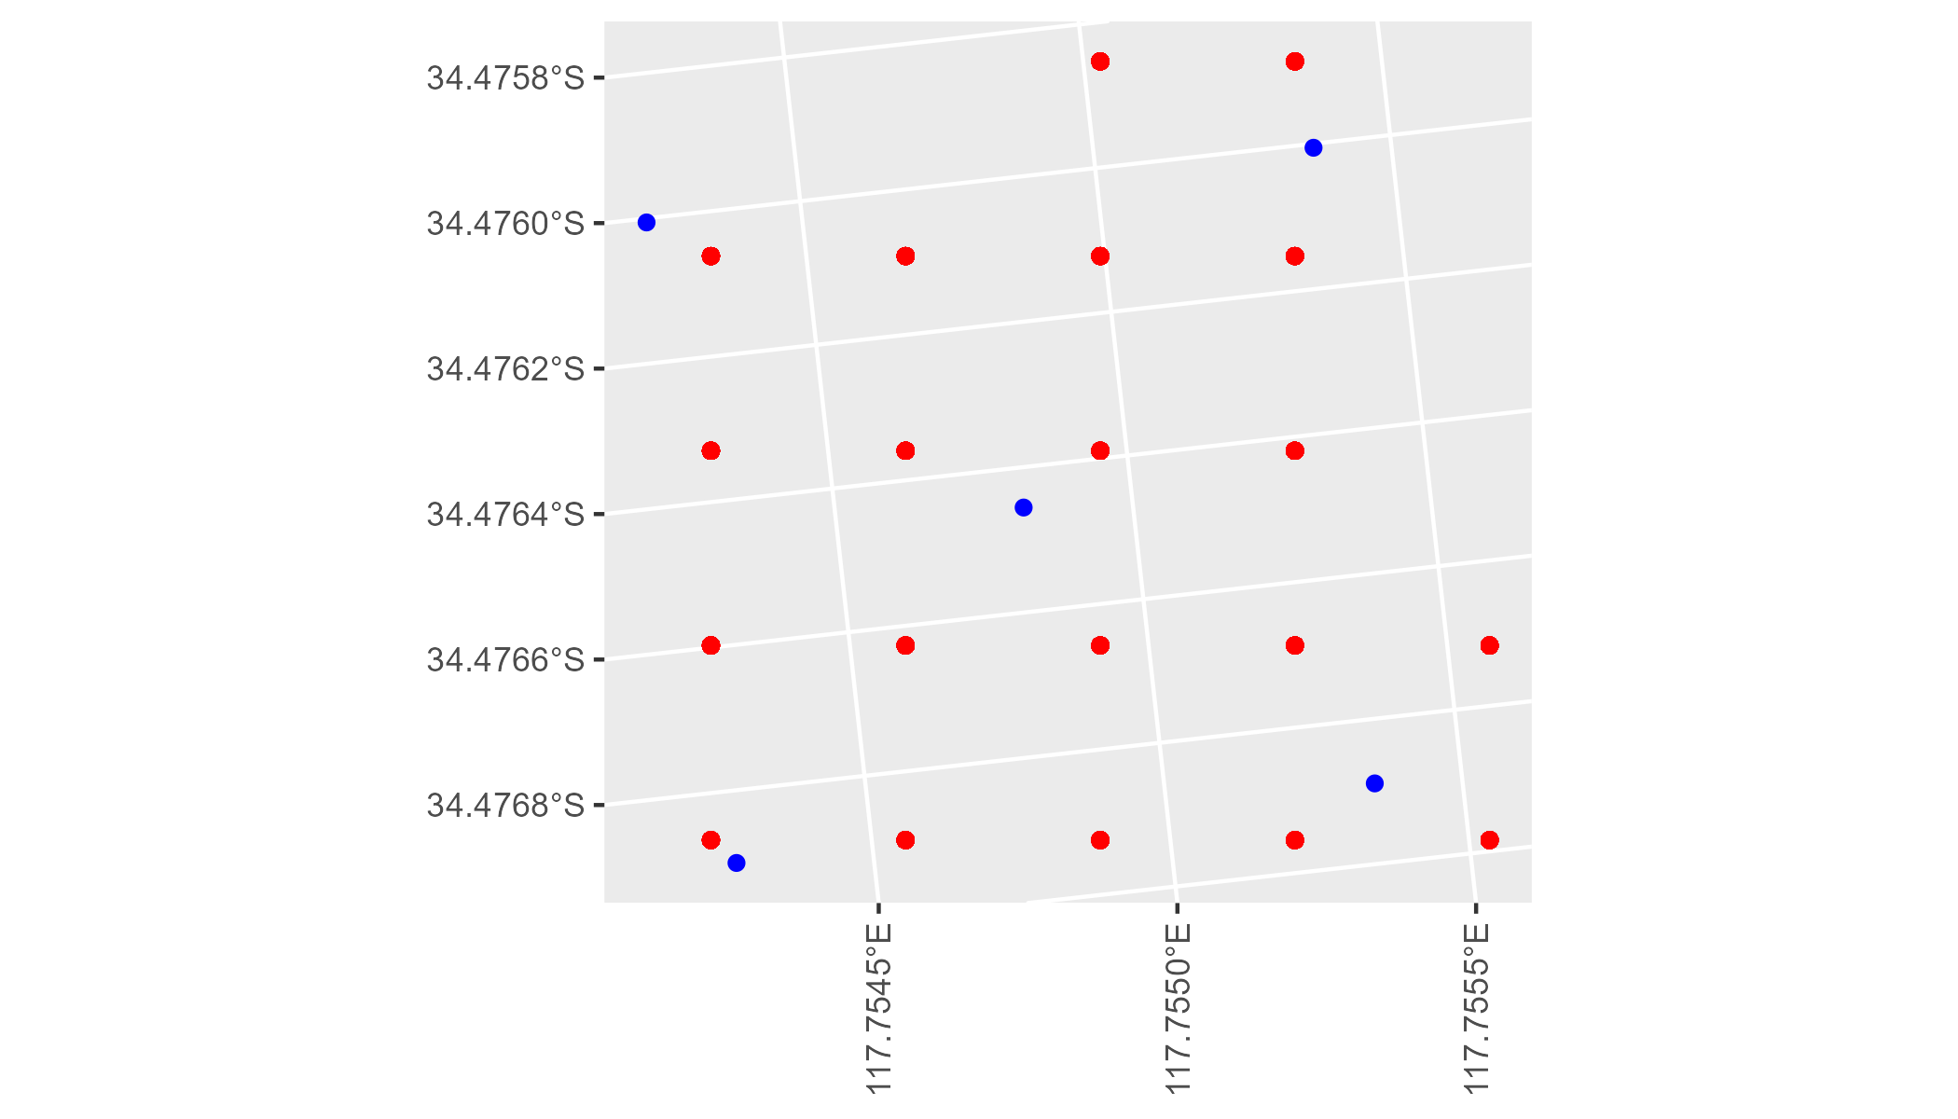

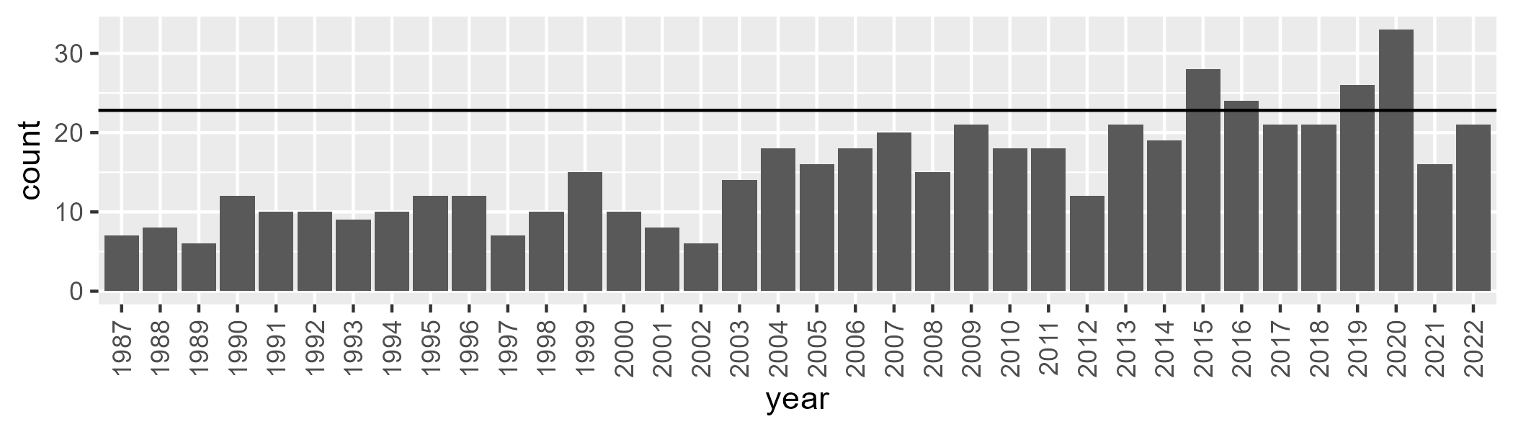

Number of samples: 552

# WAAGAS0001

| Min. | 1st Qu. | Median | Mean | 3rd Qu. | Max. |
| --- | --- | --- | --- | --- | --- |
| 0.1524501 | 2.603615 | 3.579907 | 4.136177 | 4.930921 | 20.12408 |

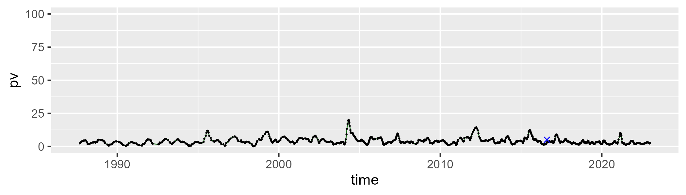

| Min. | 1st Qu. | Median | Mean | 3rd Qu. | Max. |
| --- | --- | --- | --- | --- | --- |
| 25.1274 | 32.84967 | 35.70153 | 35.79884 | 38.40685 | 48.52881 |

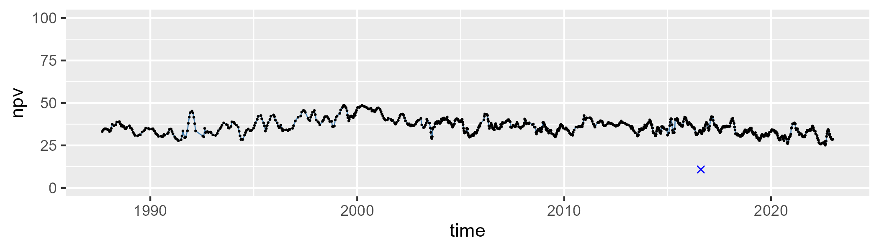

| Min. | 1st Qu. | Median | Mean | 3rd Qu. | Max. |
| --- | --- | --- | --- | --- | --- |
| 37.31911 | 55.32024 | 58.93411 | 58.53141 | 62.3837 | 70.70027 |

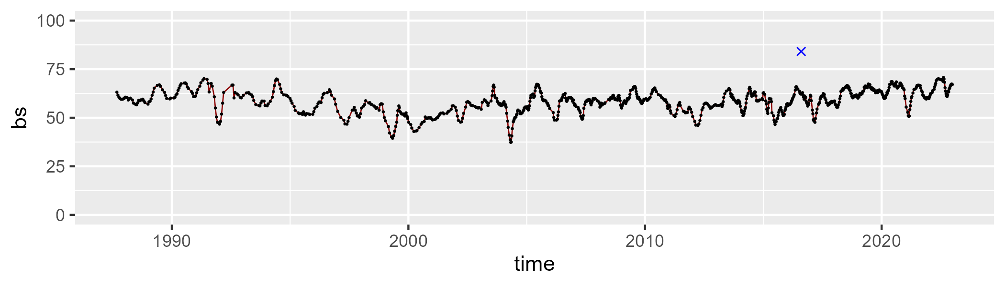

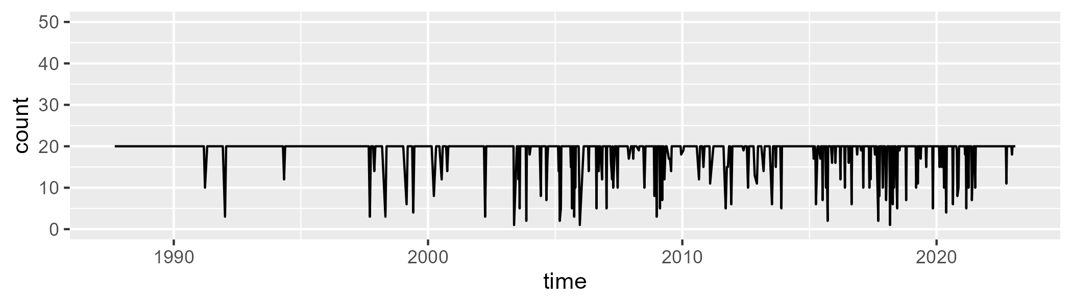

Min. : 1.00 1st Qu.:20.00 Median :20.00 Mean :18.78 3rd Qu.:20.00 Max. :20.00

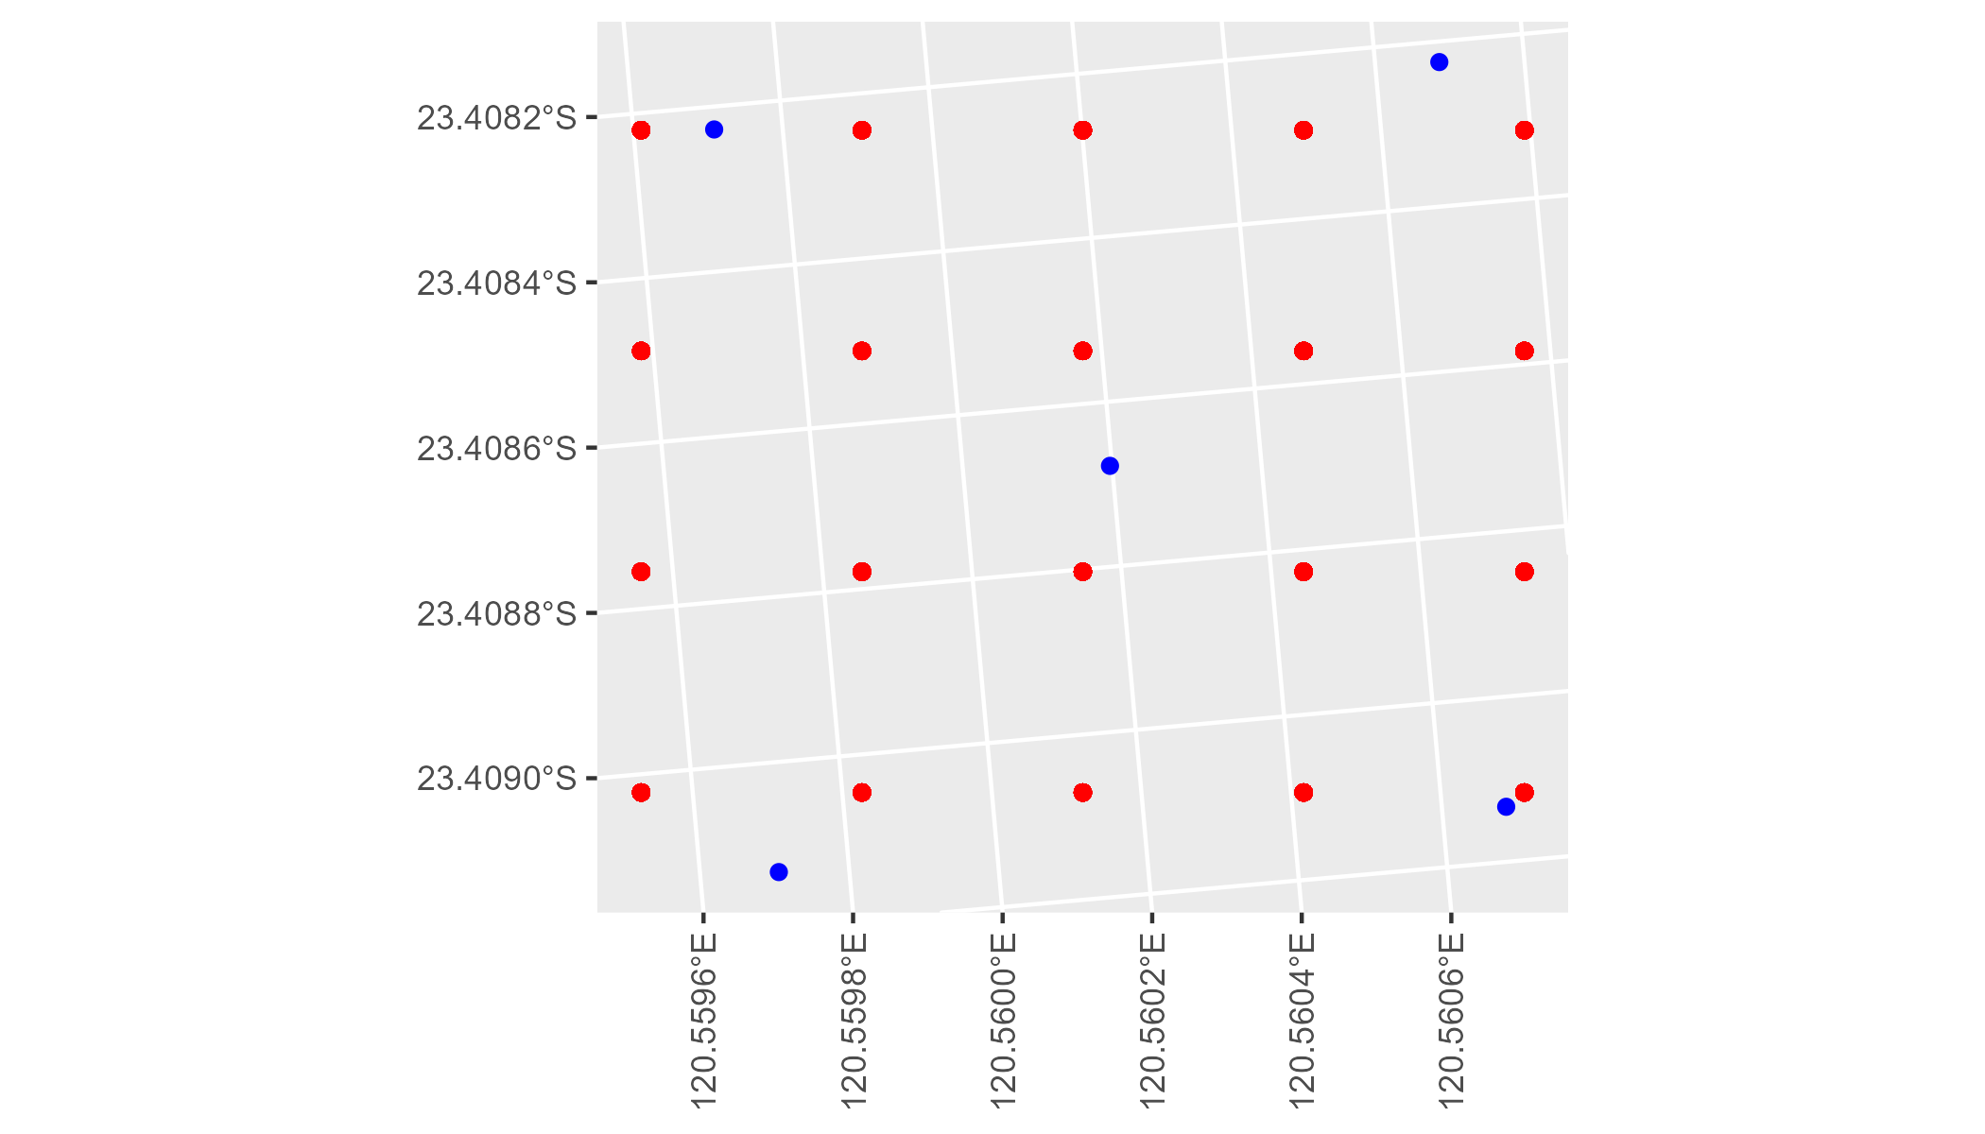

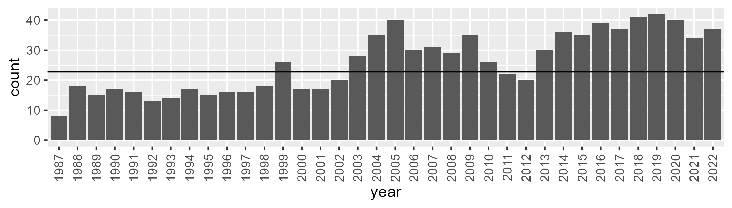

Number of samples: 930

# WAAGAS0002

| Min. | 1st Qu. | Median | Mean | 3rd Qu. | Max. |
| --- | --- | --- | --- | --- | --- |
| 0 | 7.786365 | 13.00094 | 17.26142 | 24.95864 | 56.93121 |

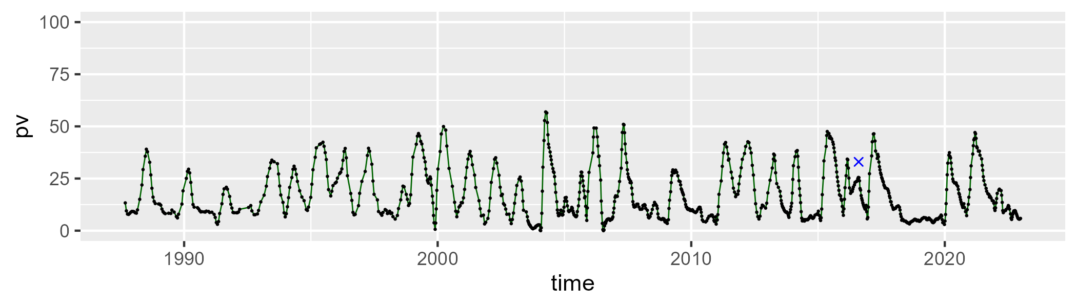

| Min. | 1st Qu. | Median | Mean | 3rd Qu. | Max. |
| --- | --- | --- | --- | --- | --- |
| 23.4279 | 40.90818 | 46.08709 | 45.70097 | 51.17448 | 71.8815 |

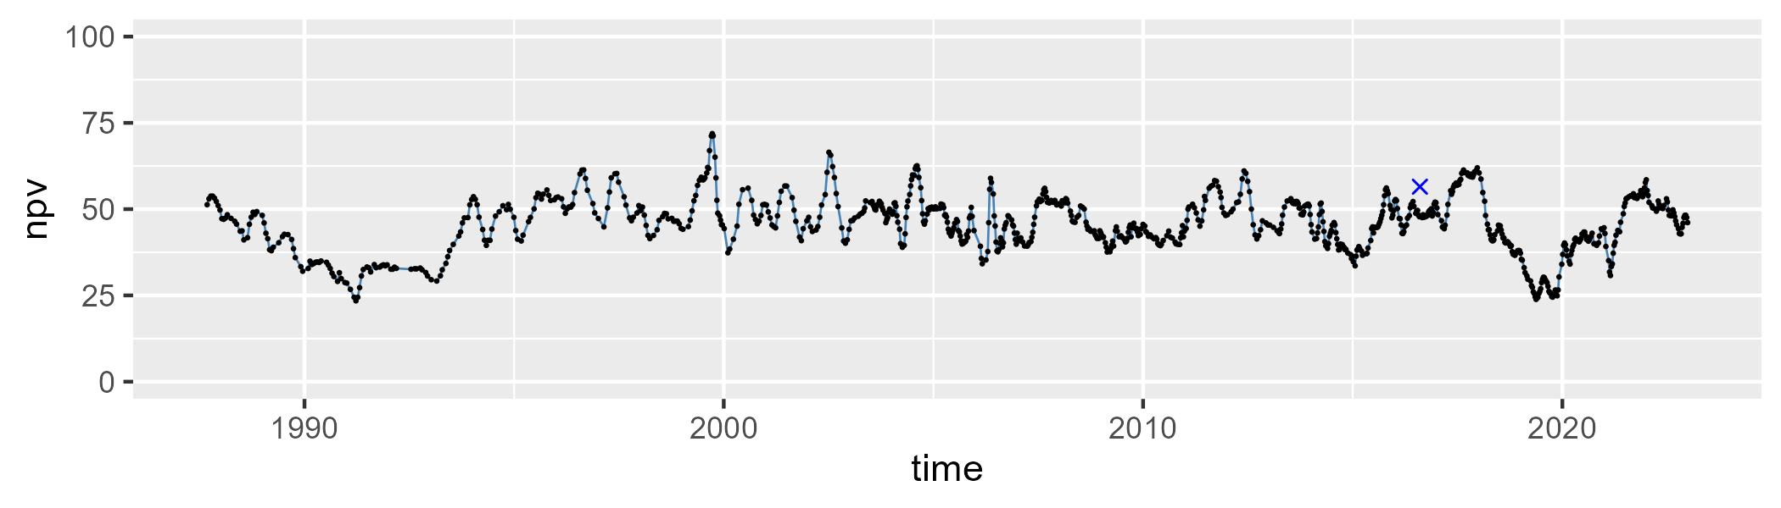

| Min. | 1st Qu. | Median | Mean | 3rd Qu. | Max. |
| --- | --- | --- | --- | --- | --- |
| 0.5488171 | 24.84505 | 36.6386 | 35.62923 | 47.05377 | 70.22319 |

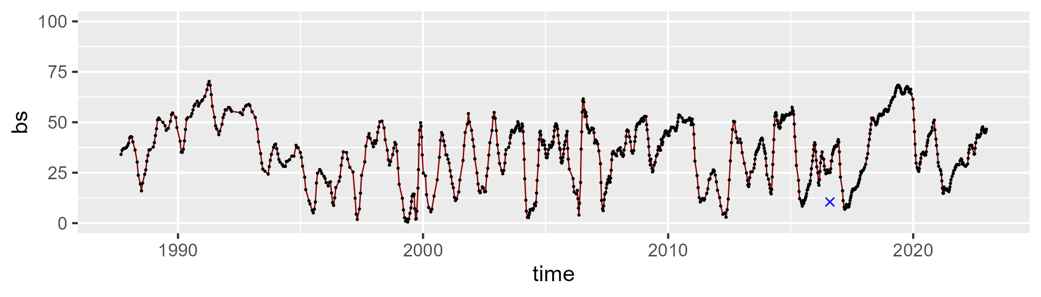

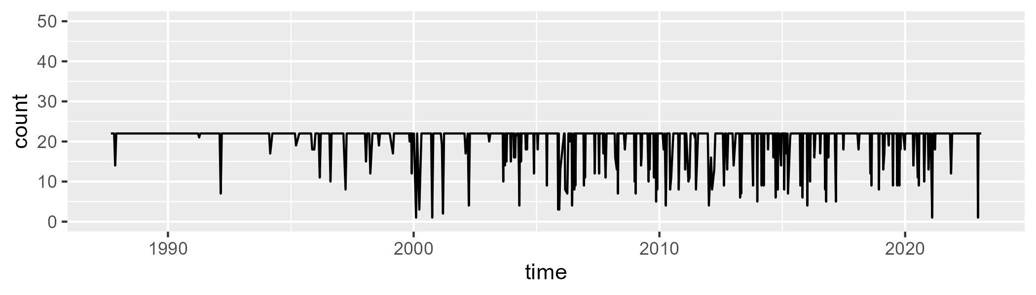

Min. : 1.00 1st Qu.:22.00 Median :22.00 Mean :20.56 3rd Qu.:22.00 Max. :22.00

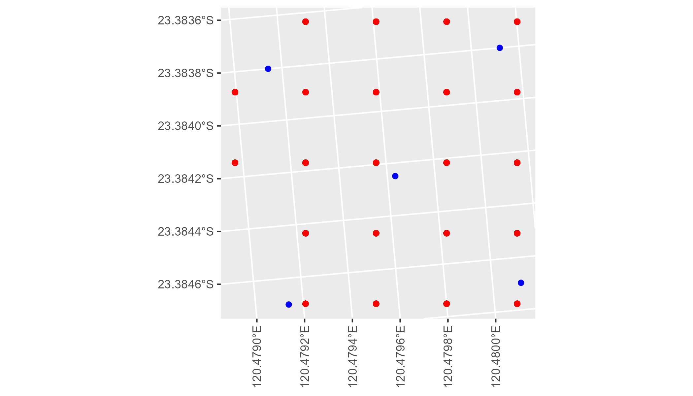

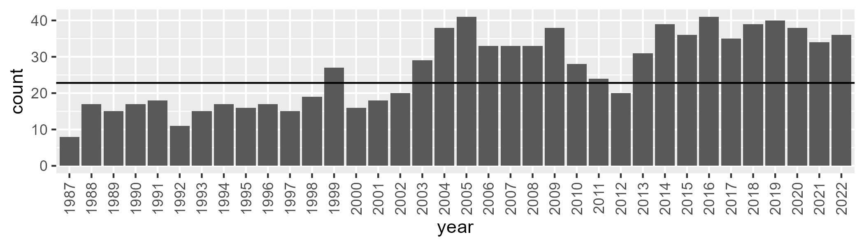

Number of samples: 952

# WAAGES0001

| Min. | 1st Qu. | Median | Mean | 3rd Qu. | Max. |
| --- | --- | --- | --- | --- | --- |
| 9.35413 | 16.12906 | 19.83846 | 19.90759 | 23.2098 | 36.17427 |

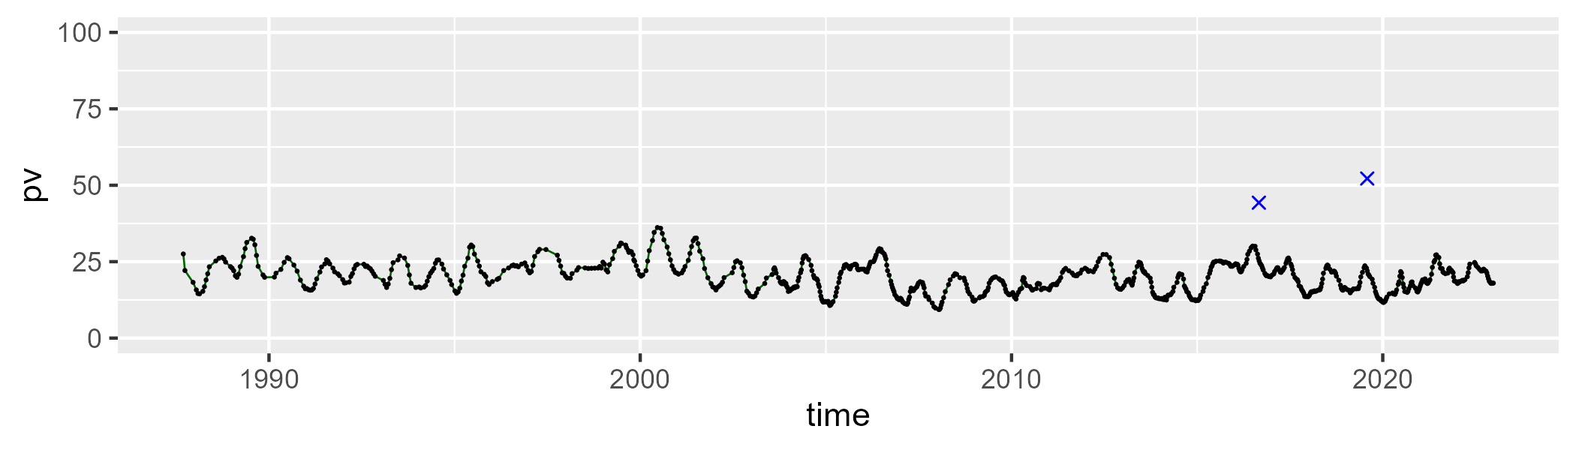

| Min. | 1st Qu. | Median | Mean | 3rd Qu. | Max. |
| --- | --- | --- | --- | --- | --- |
| 44.19278 | 53.74957 | 56.71938 | 56.86373 | 59.91635 | 69.8429 |

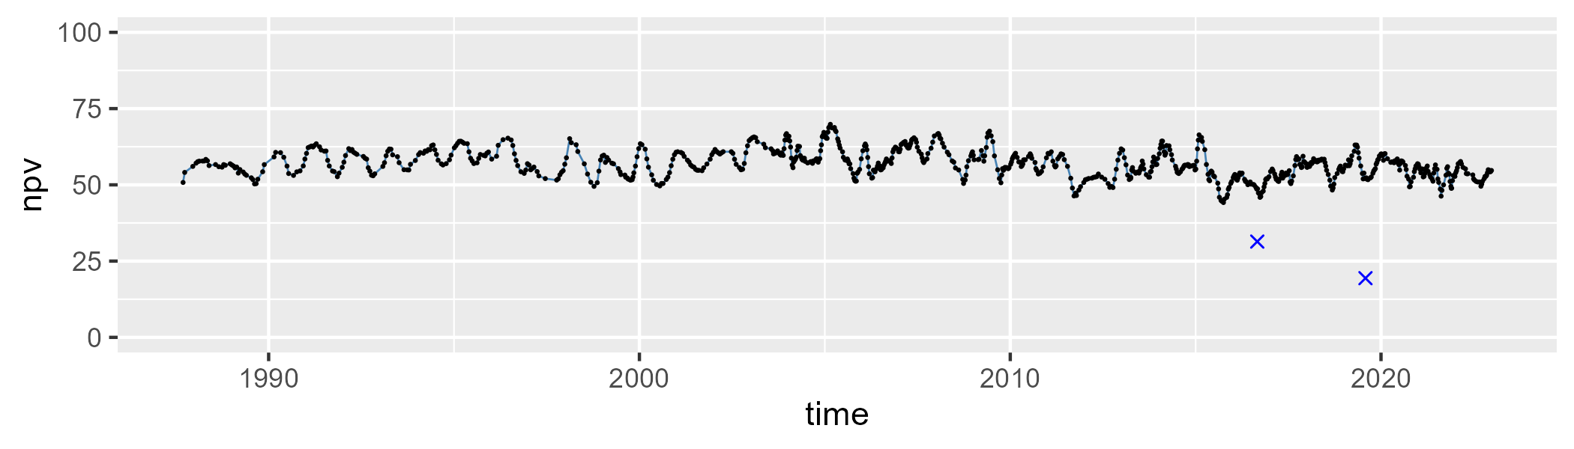

| Min. | 1st Qu. | Median | Mean | 3rd Qu. | Max. |
| --- | --- | --- | --- | --- | --- |
| 8.256041 | 18.69934 | 22.40656 | 21.95473 | 25.5716 | 31.91821 |

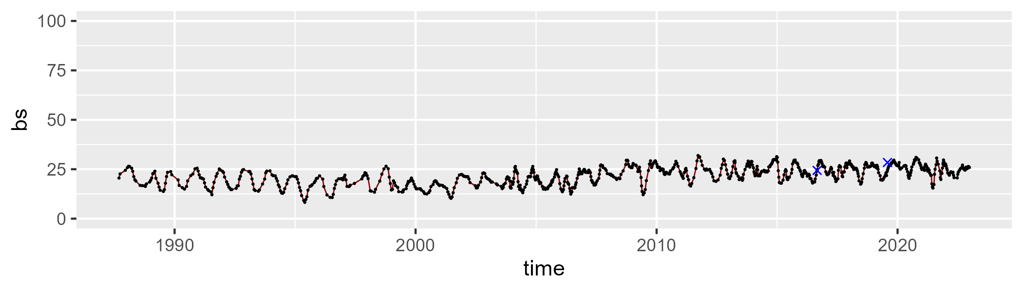

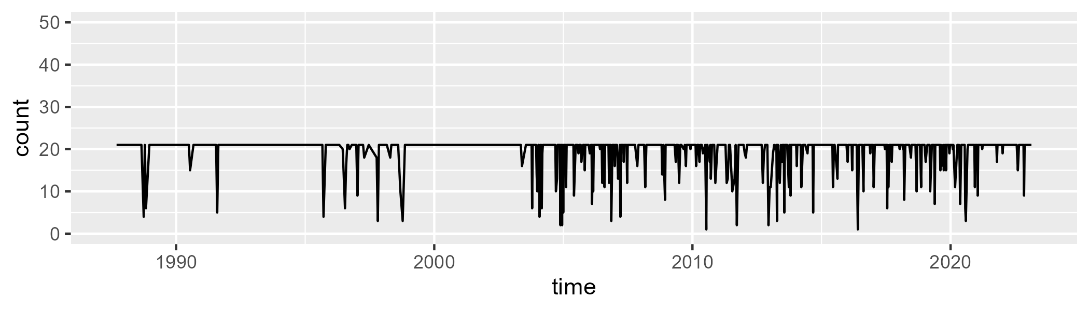

Min. : 1.00 1st Qu.:21.00 Median :21.00 Mean :19.72 3rd Qu.:21.00 Max. :21.00

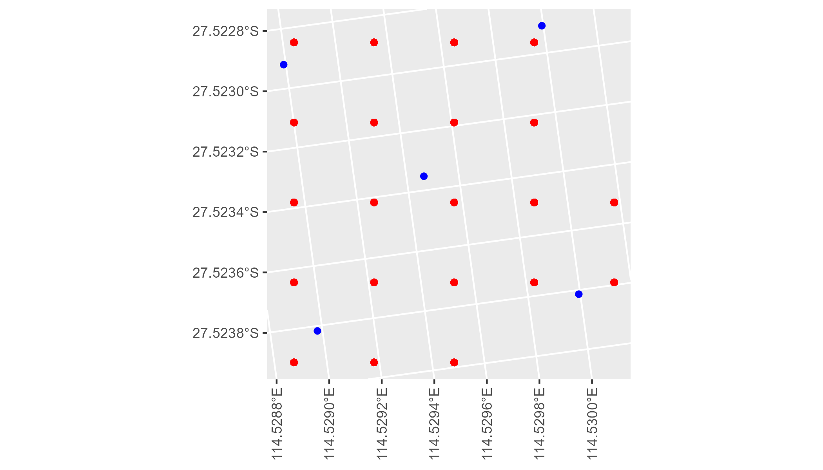

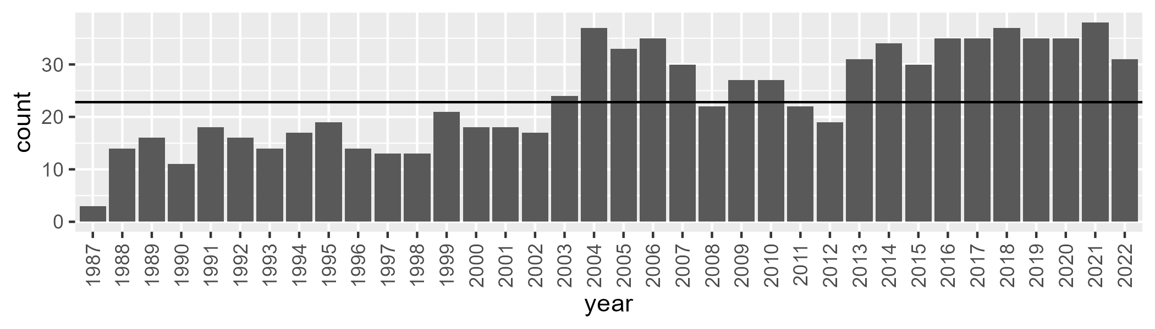

Number of samples: 859

# WAAGES0002

| Min. | 1st Qu. | Median | Mean | 3rd Qu. | Max. |
| --- | --- | --- | --- | --- | --- |
| 1.375719 | 14.23266 | 20.64104 | 20.50397 | 26.49185 | 41.24632 |

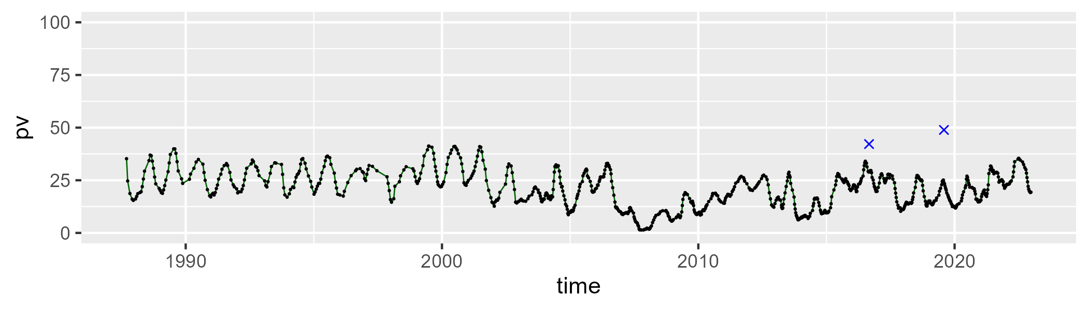

| Min. | 1st Qu. | Median | Mean | 3rd Qu. | Max. |
| --- | --- | --- | --- | --- | --- |
| 49.94029 | 60.73278 | 65.36727 | 65.1385 | 69.58096 | 83.05653 |

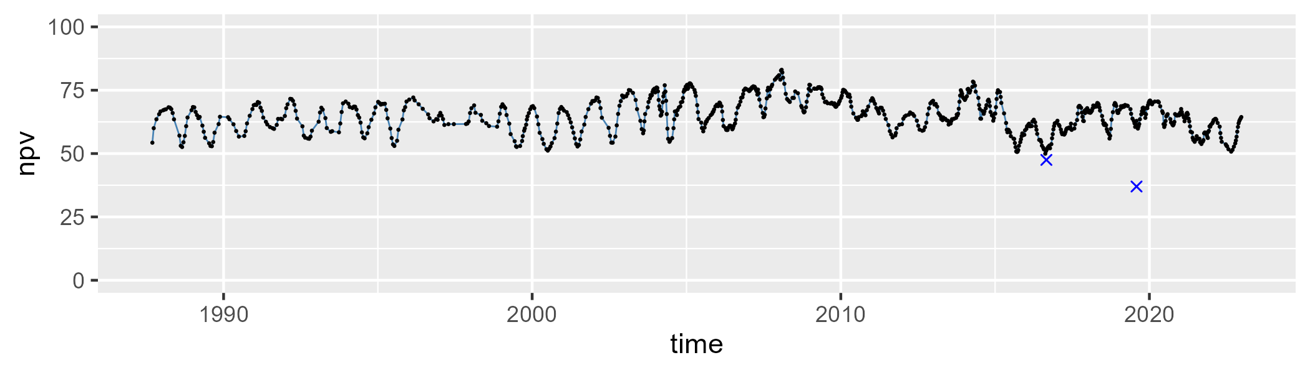

| Min. | 1st Qu. | Median | Mean | 3rd Qu. | Max. |
| --- | --- | --- | --- | --- | --- |
| 3.947413 | 9.792018 | 13.34066 | 13.20789 | 16.21316 | 28.17406 |

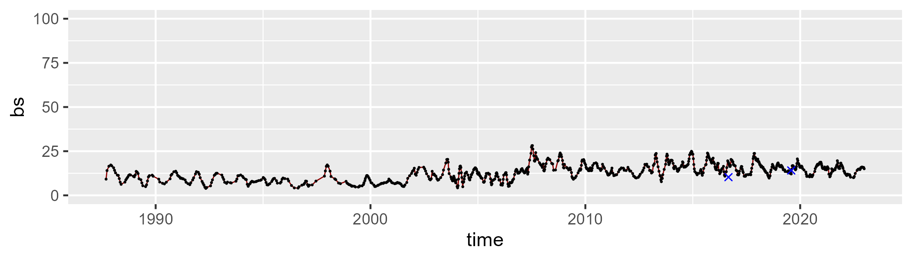

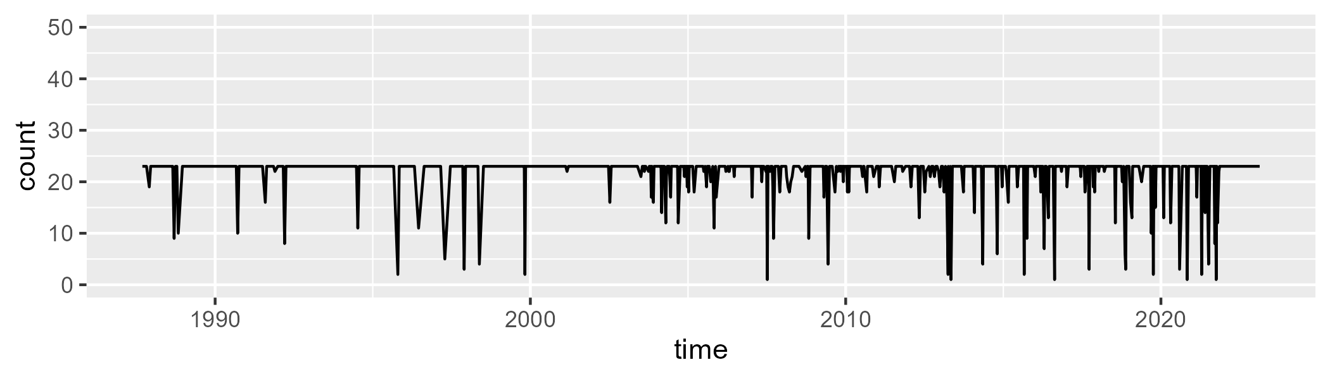

Min. : 1.00 1st Qu.:23.00 Median :23.00 Mean :21.76 3rd Qu.:23.00 Max. :23.00

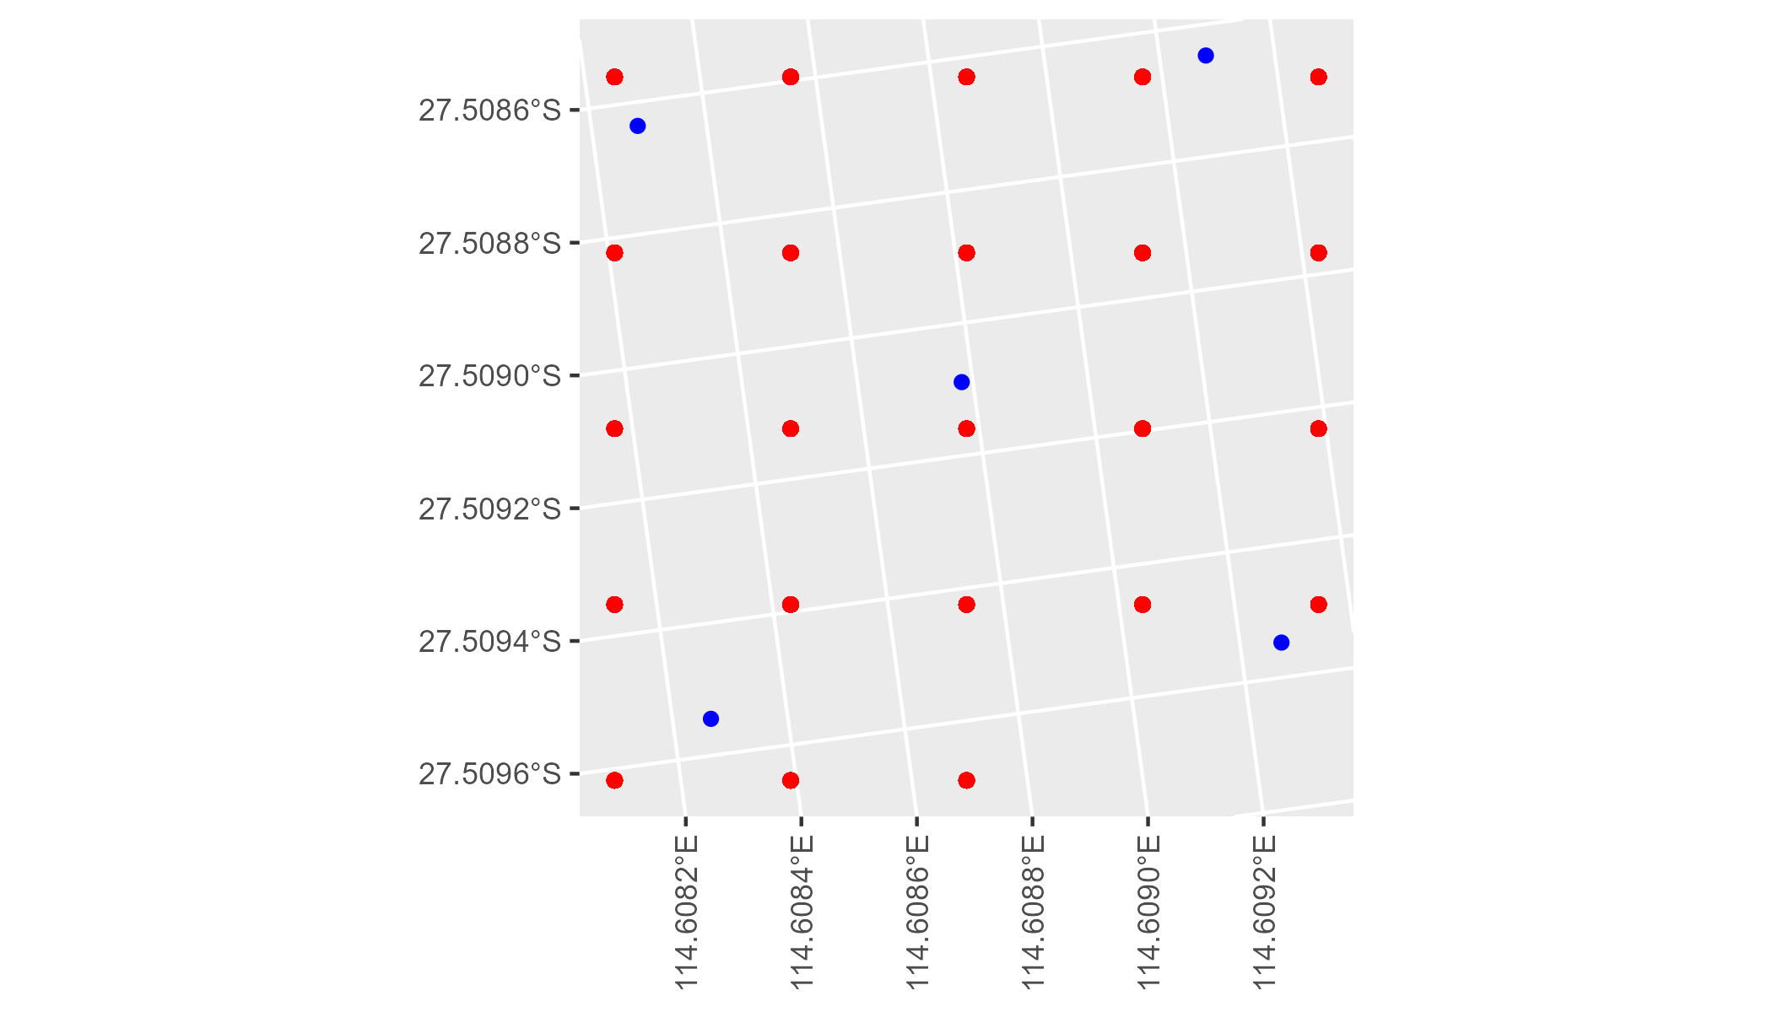

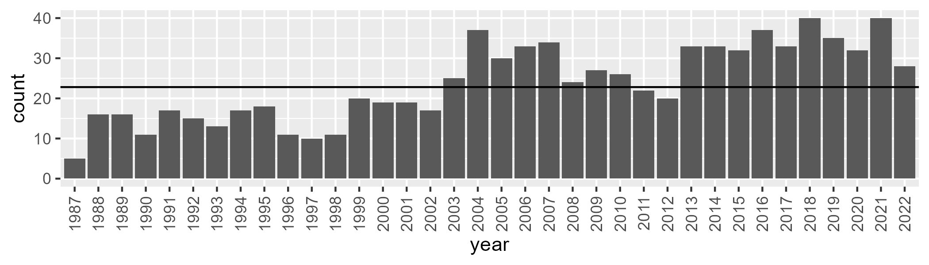

Number of samples: 856

# WAAGES0003

| Min. | 1st Qu. | Median | Mean | 3rd Qu. | Max. |
| --- | --- | --- | --- | --- | --- |
| 14.69003 | 20.20447 | 23.87082 | 24.16957 | 27.81802 | 37.42076 |

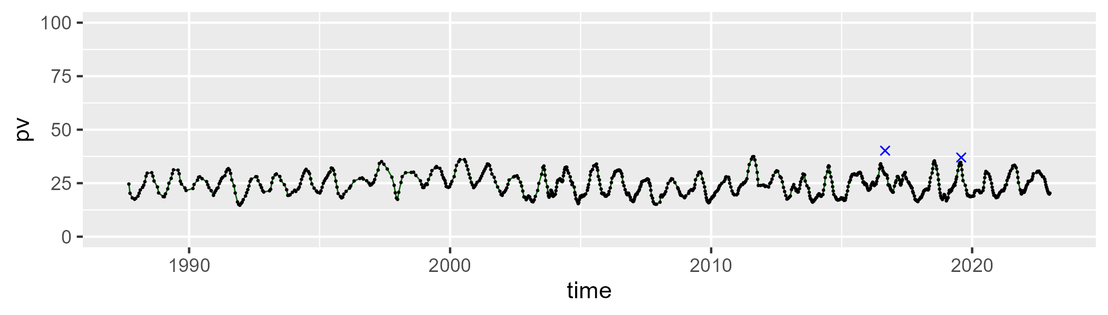

| Min. | 1st Qu. | Median | Mean | 3rd Qu. | Max. |
| --- | --- | --- | --- | --- | --- |
| 41.39109 | 50.84574 | 52.37921 | 52.30739 | 53.79153 | 59.28082 |

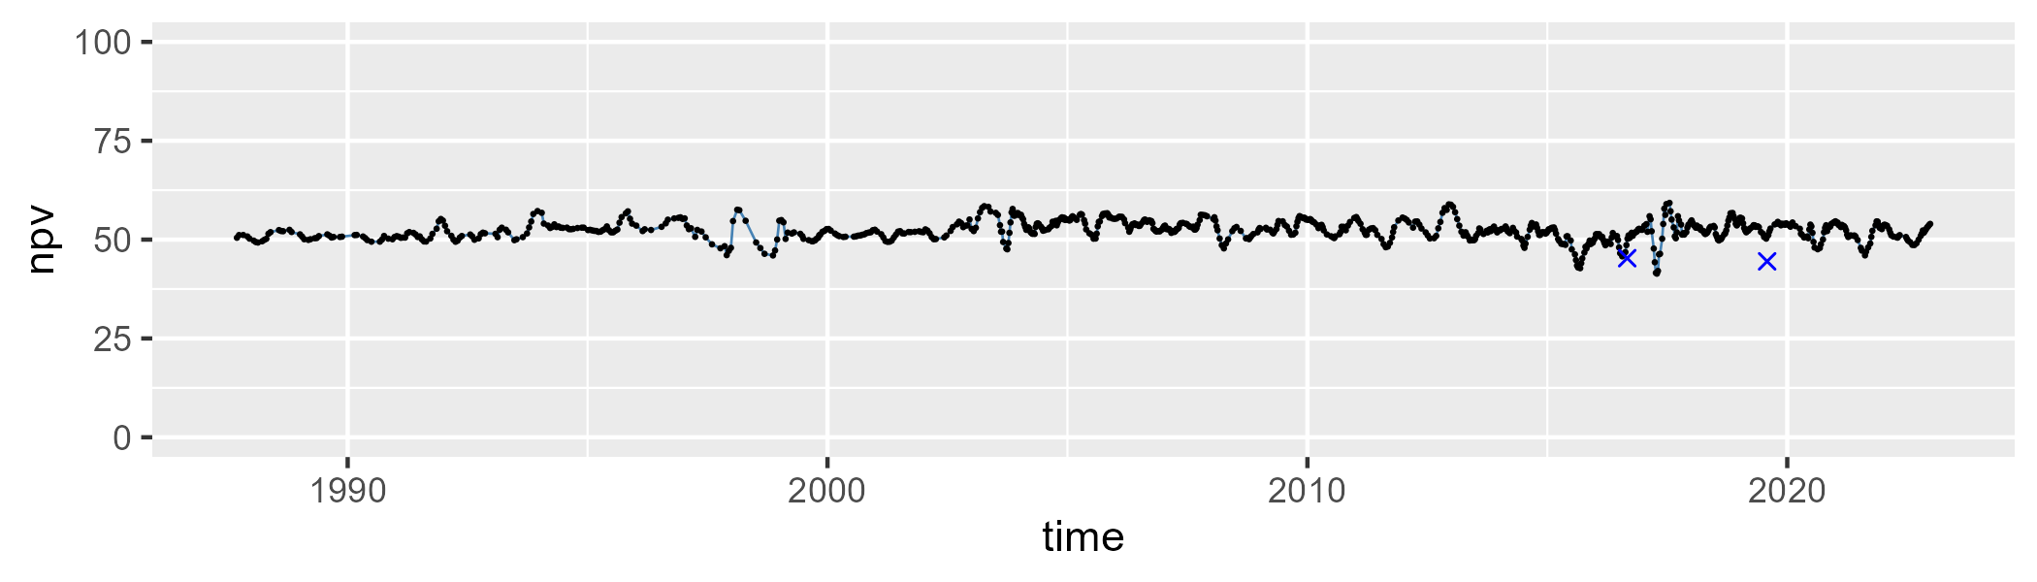

| Min. | 1st Qu. | Median | Mean | 3rd Qu. | Max. |
| --- | --- | --- | --- | --- | --- |
| 10.45474 | 19.37794 | 22.94937 | 22.35558 | 25.49963 | 33.4737 |

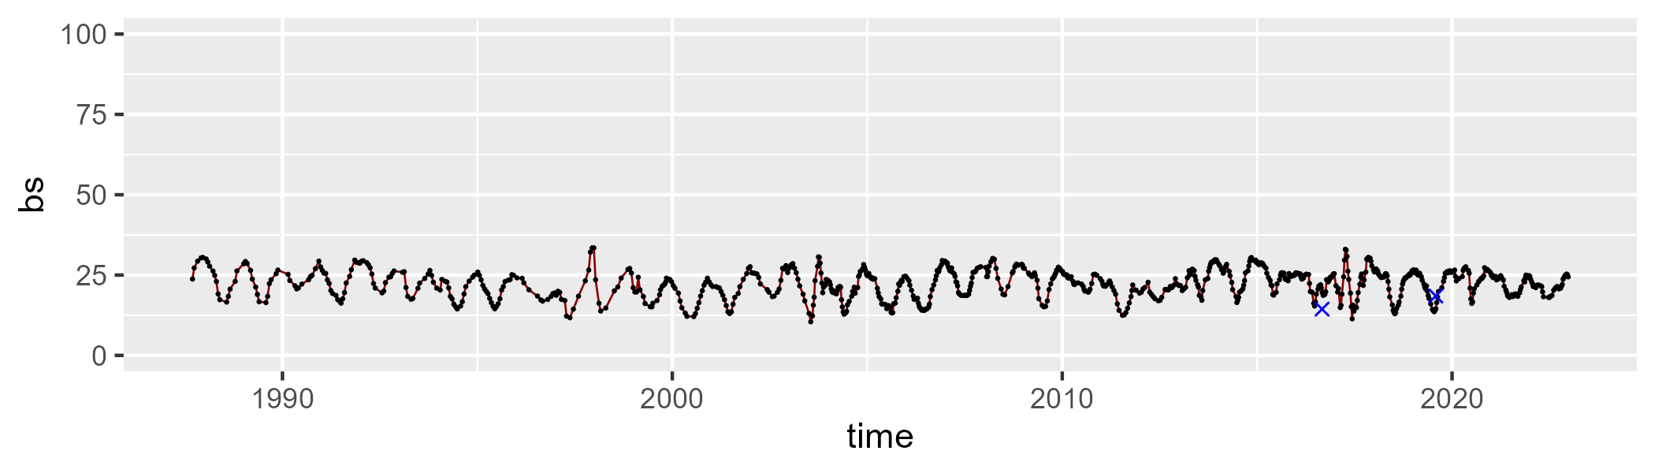

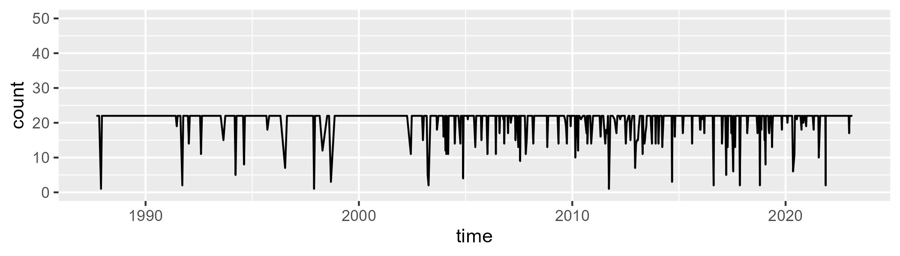

Min. : 1.00 1st Qu.:22.00 Median :22.00 Mean :20.83 3rd Qu.:22.00 Max. :22.00

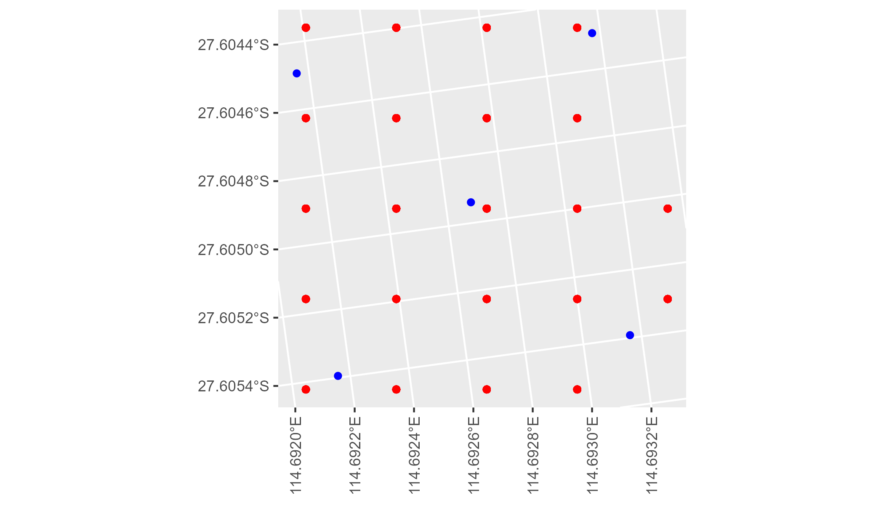

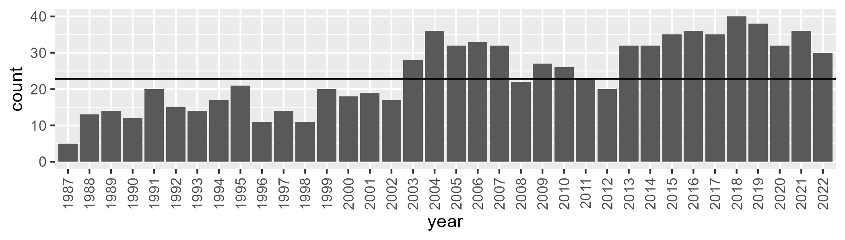

Number of samples: 866

# WAAGES0004

| Min. | 1st Qu. | Median | Mean | 3rd Qu. | Max. |
| --- | --- | --- | --- | --- | --- |
| 7.739478 | 13.15174 | 16.1155 | 16.3308 | 19.0692 | 27.49607 |

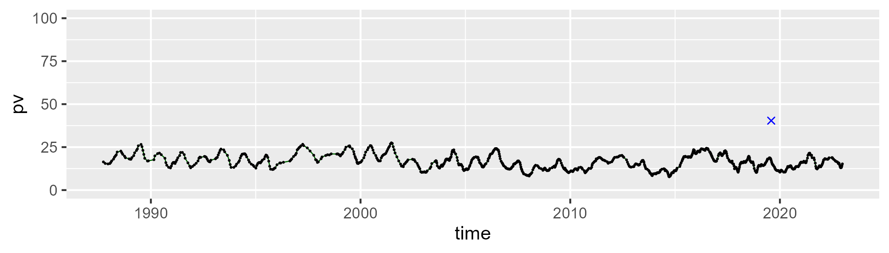

| Min. | 1st Qu. | Median | Mean | 3rd Qu. | Max. |
| --- | --- | --- | --- | --- | --- |
| 35.72036 | 46.02902 | 48.23667 | 48.28043 | 50.63542 | 59.7374 |

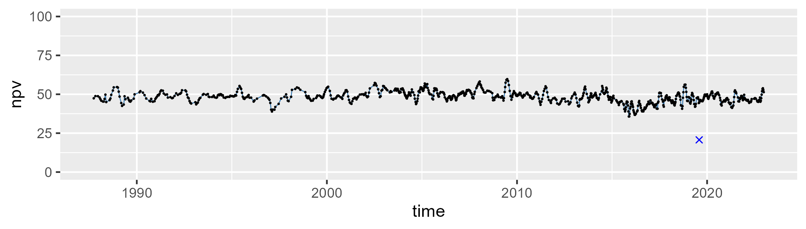

| Min. | 1st Qu. | Median | Mean | 3rd Qu. | Max. |
| --- | --- | --- | --- | --- | --- |
| 19.82869 | 30.97507 | 34.55808 | 33.97452 | 37.37589 | 42.66212 |

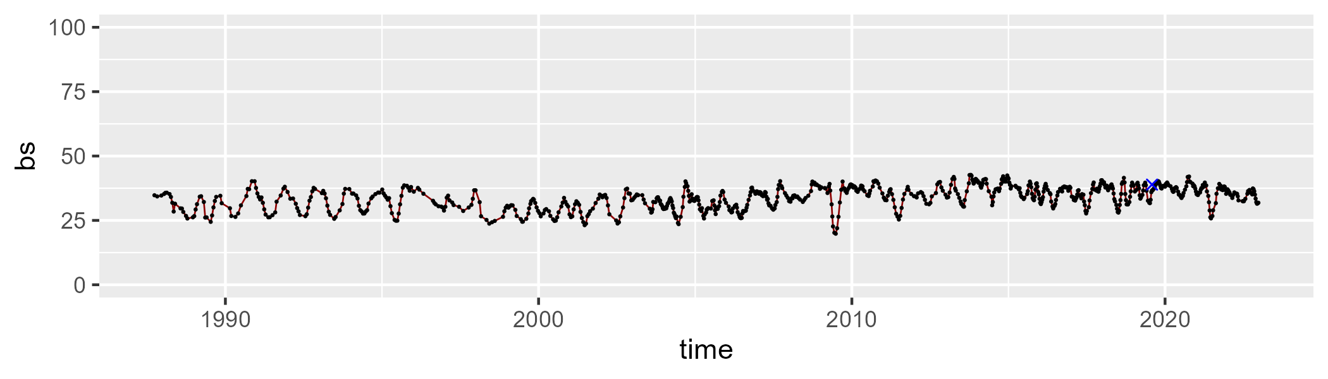

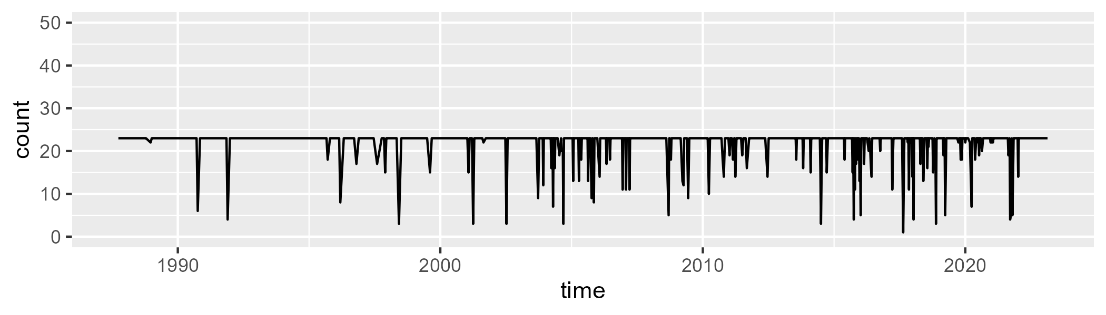

Min. : 1.00 1st Qu.:23.00 Median :23.00 Mean :21.92 3rd Qu.:23.00 Max. :23.00

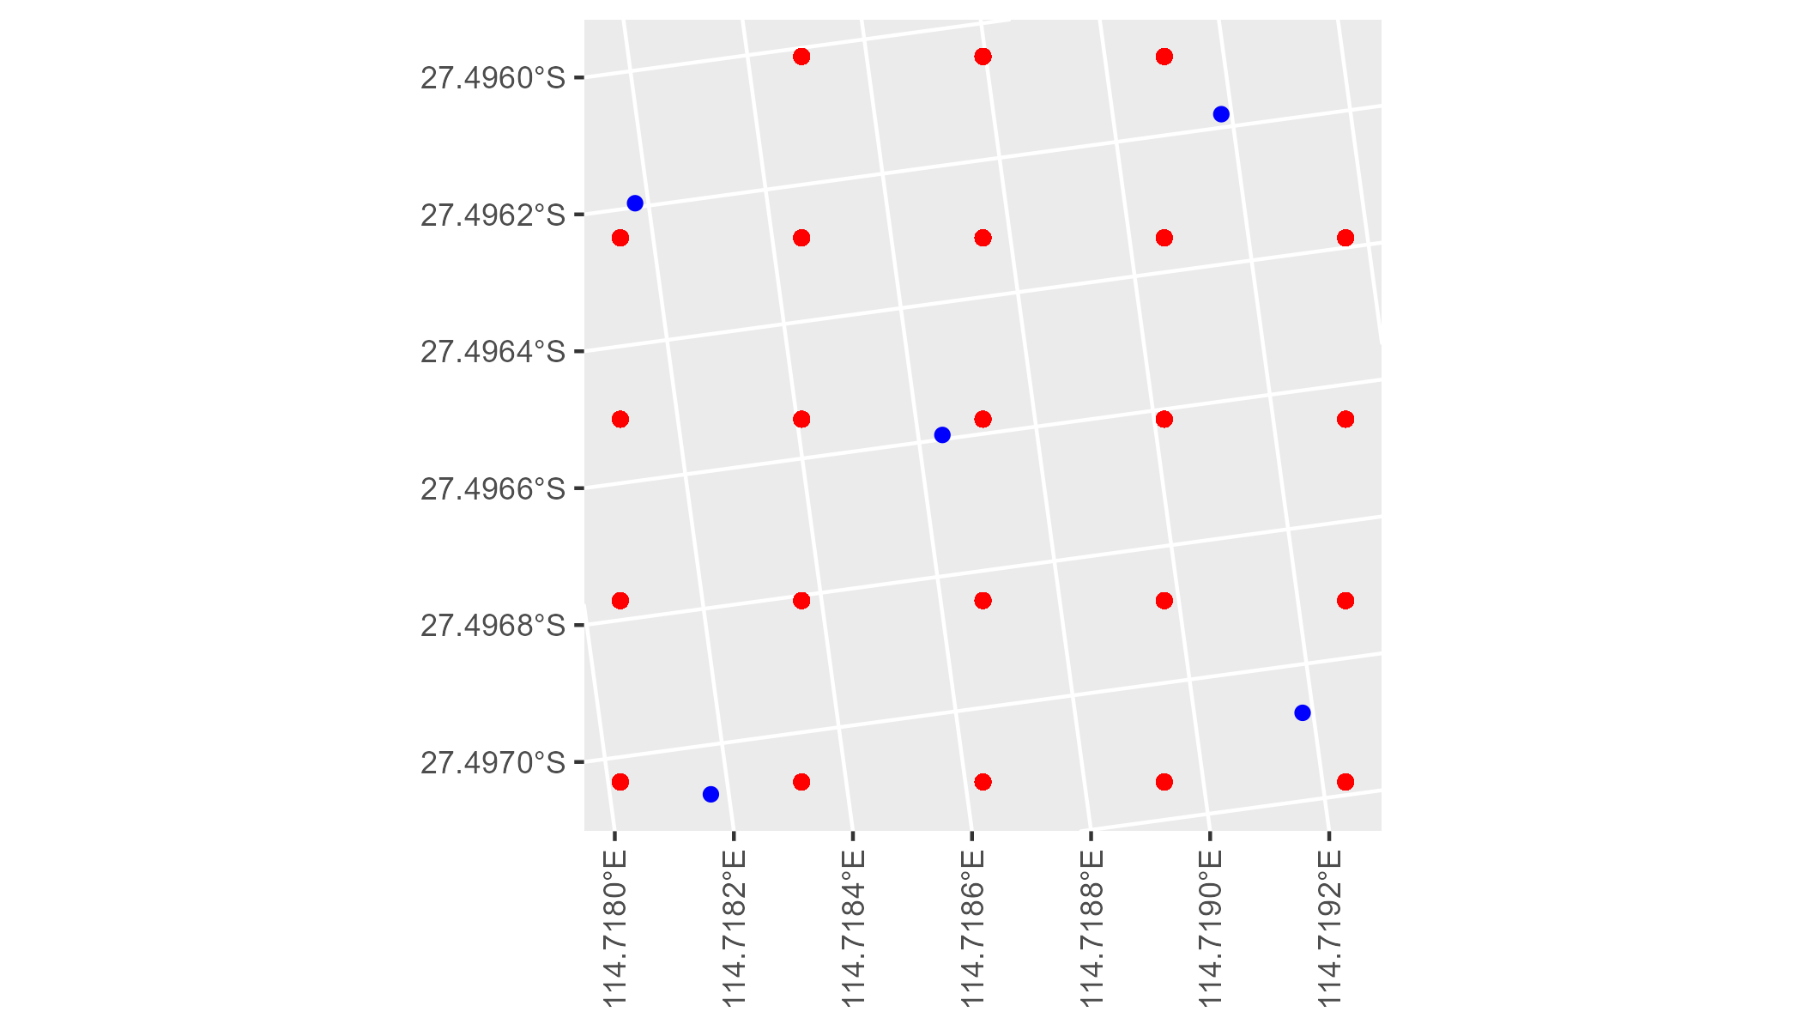

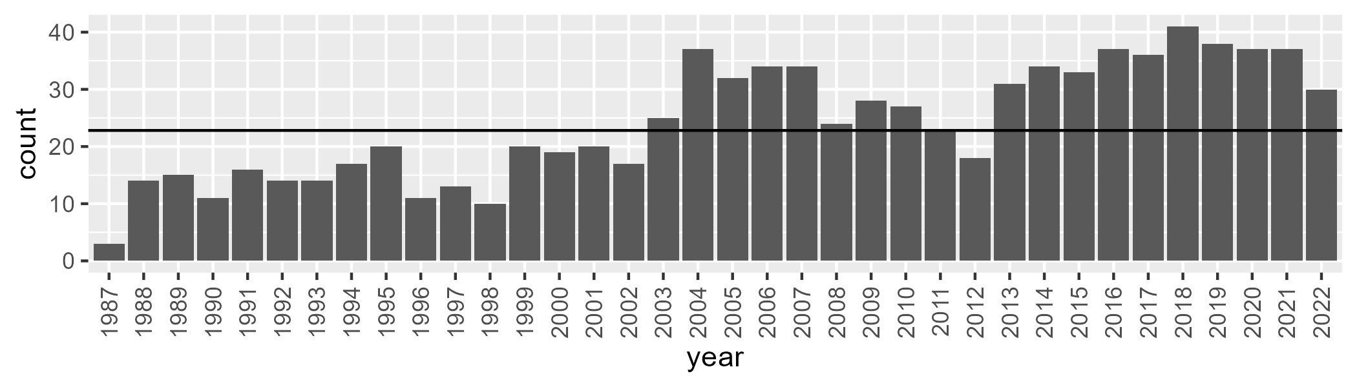

Number of samples: 870

# WAAGES0005

| Min. | 1st Qu. | Median | Mean | 3rd Qu. | Max. |
| --- | --- | --- | --- | --- | --- |
| 0.1380351 | 5.608693 | 9.530701 | 9.430986 | 12.81456 | 21.502 |

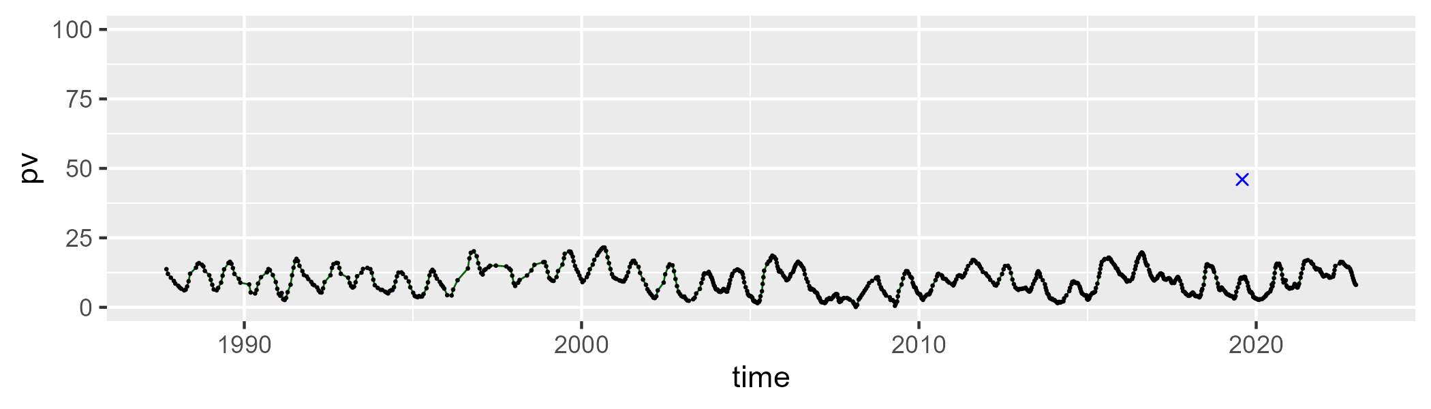

| Min. | 1st Qu. | Median | Mean | 3rd Qu. | Max. |
| --- | --- | --- | --- | --- | --- |
| 31.24929 | 51.97589 | 56.08859 | 55.66261 | 59.4241 | 69.2732 |

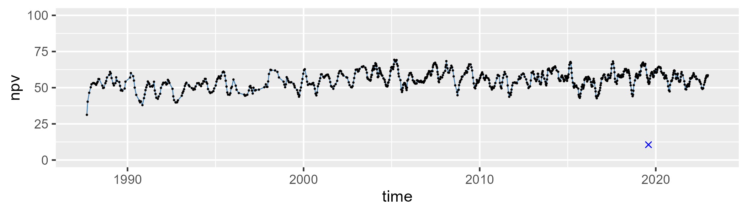

| Min. | 1st Qu. | Median | Mean | 3rd Qu. | Max. |
| --- | --- | --- | --- | --- | --- |
| 21.05481 | 30.37993 | 33.36286 | 33.5457 | 36.38946 | 53.9987 |

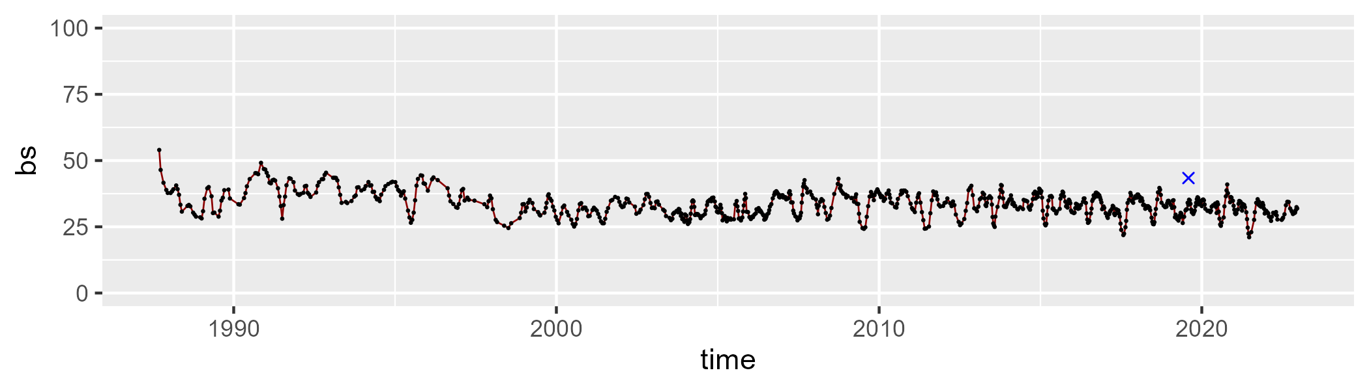

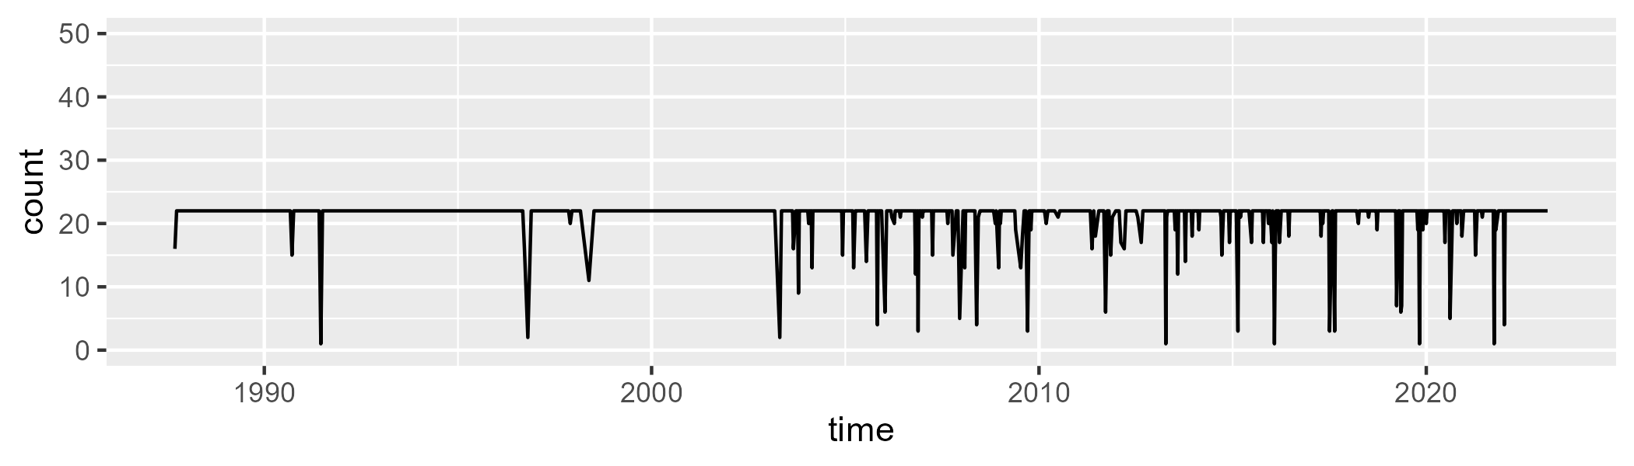

Min. : 1.00 1st Qu.:22.00 Median :22.00 Mean :21.16 3rd Qu.:22.00 Max. :22.00

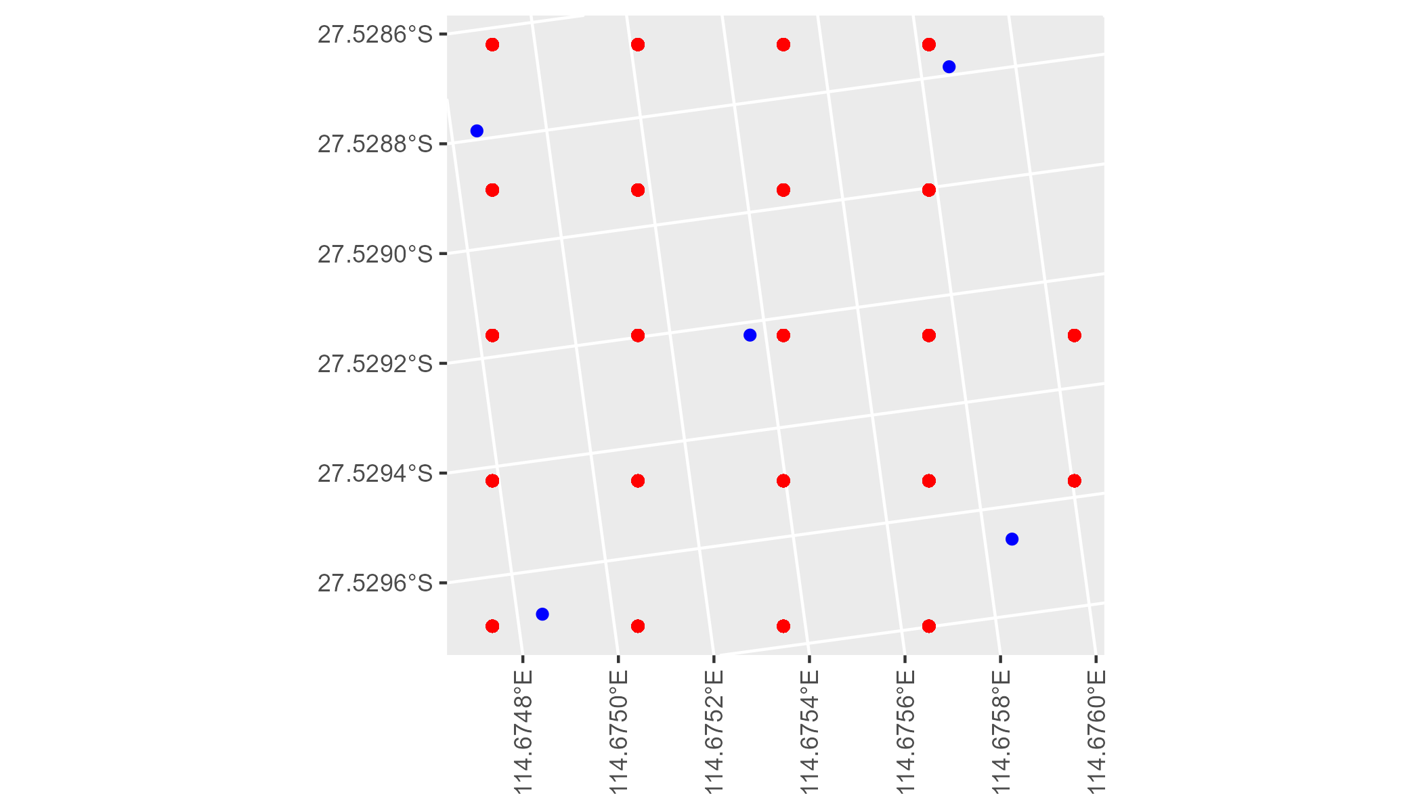

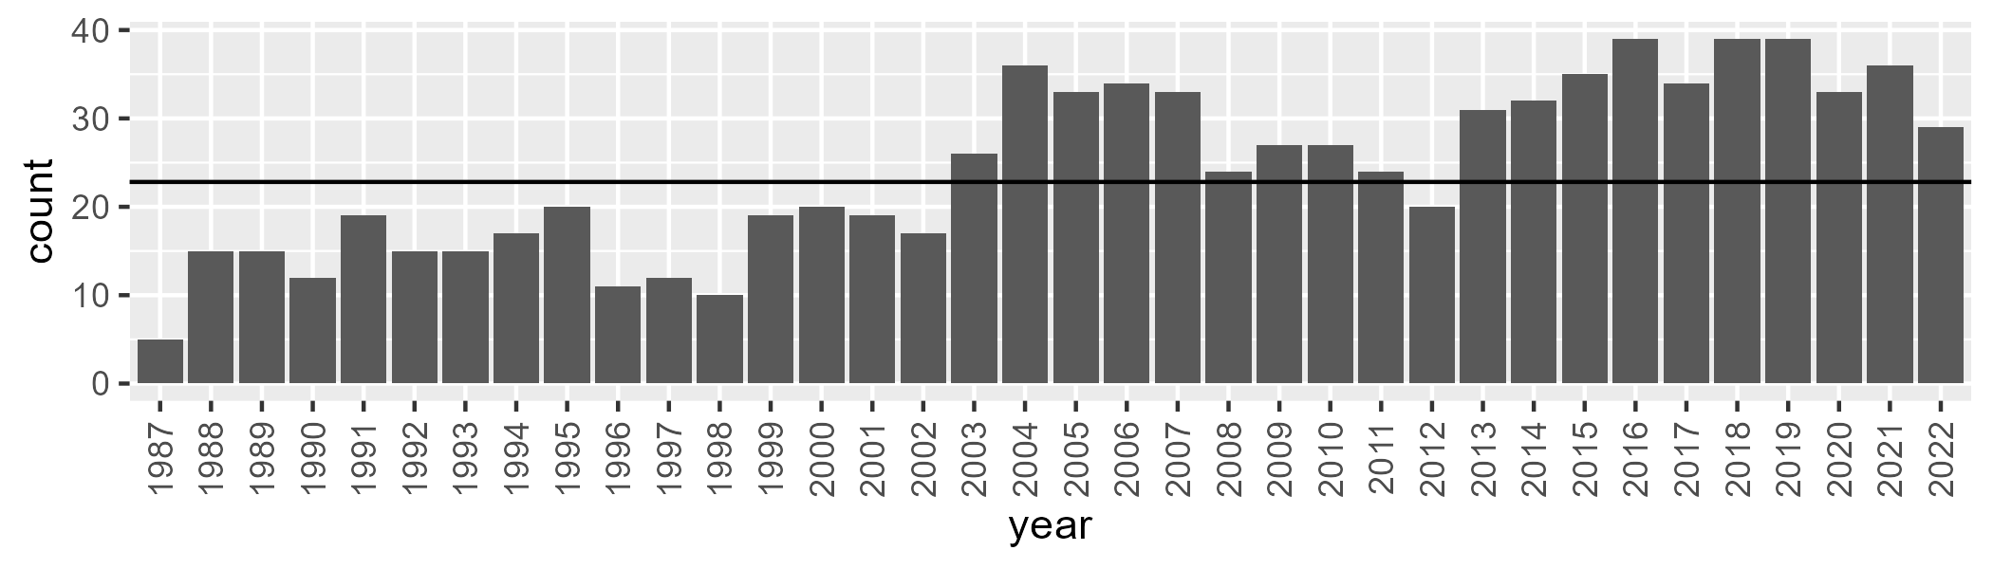

Number of samples: 872

# WAAGSD0001

| Min. | 1st Qu. | Median | Mean | 3rd Qu. | Max. |
| --- | --- | --- | --- | --- | --- |
| 3.310109 | 10.43924 | 13.35044 | 13.4909 | 16.44753 | 24.86296 |

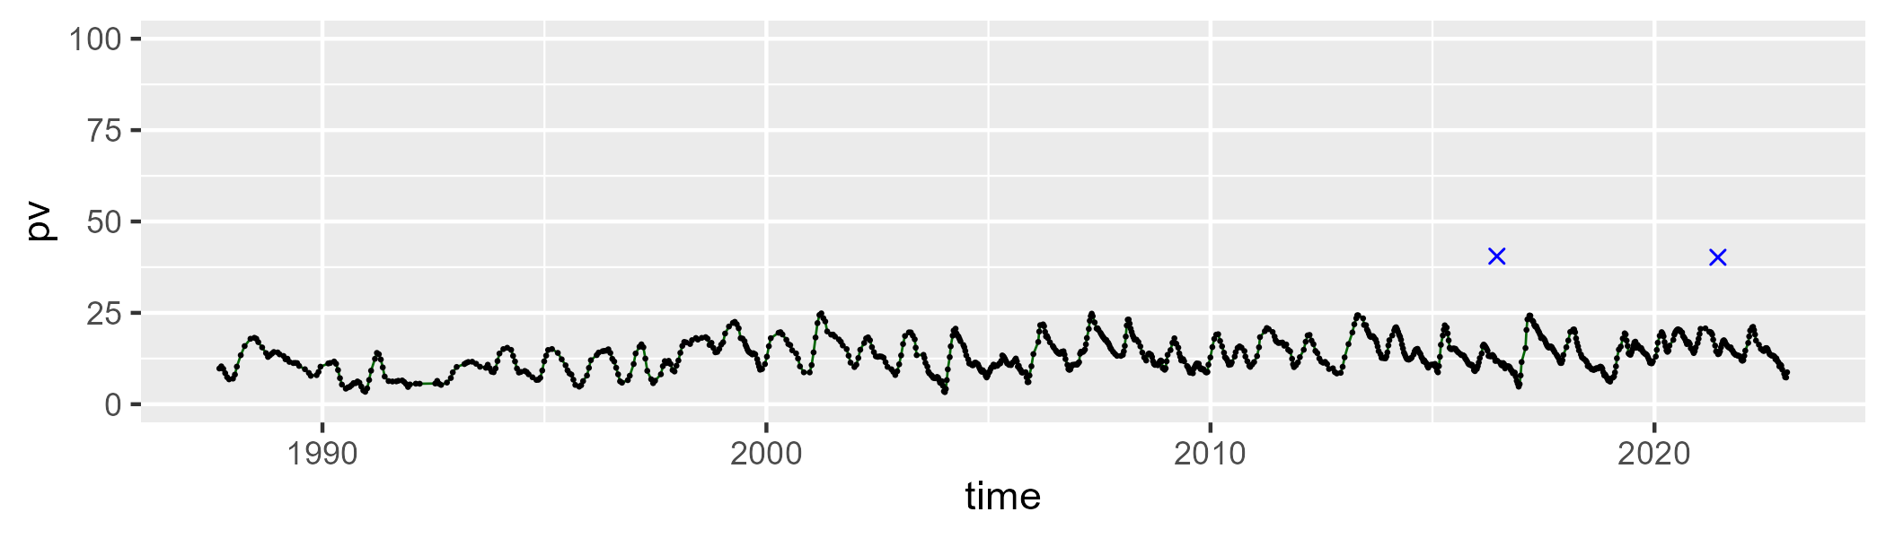

| Min. | 1st Qu. | Median | Mean | 3rd Qu. | Max. |
| --- | --- | --- | --- | --- | --- |
| 12.96606 | 30.12503 | 36.82413 | 37.06099 | 45.05413 | 66.9331 |

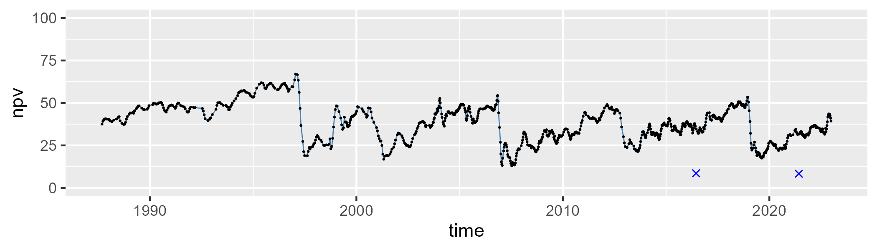

| Min. | 1st Qu. | Median | Mean | 3rd Qu. | Max. |
| --- | --- | --- | --- | --- | --- |
| 16.56507 | 41.33971 | 48.13962 | 47.94185 | 54.25198 | 73.0076 |

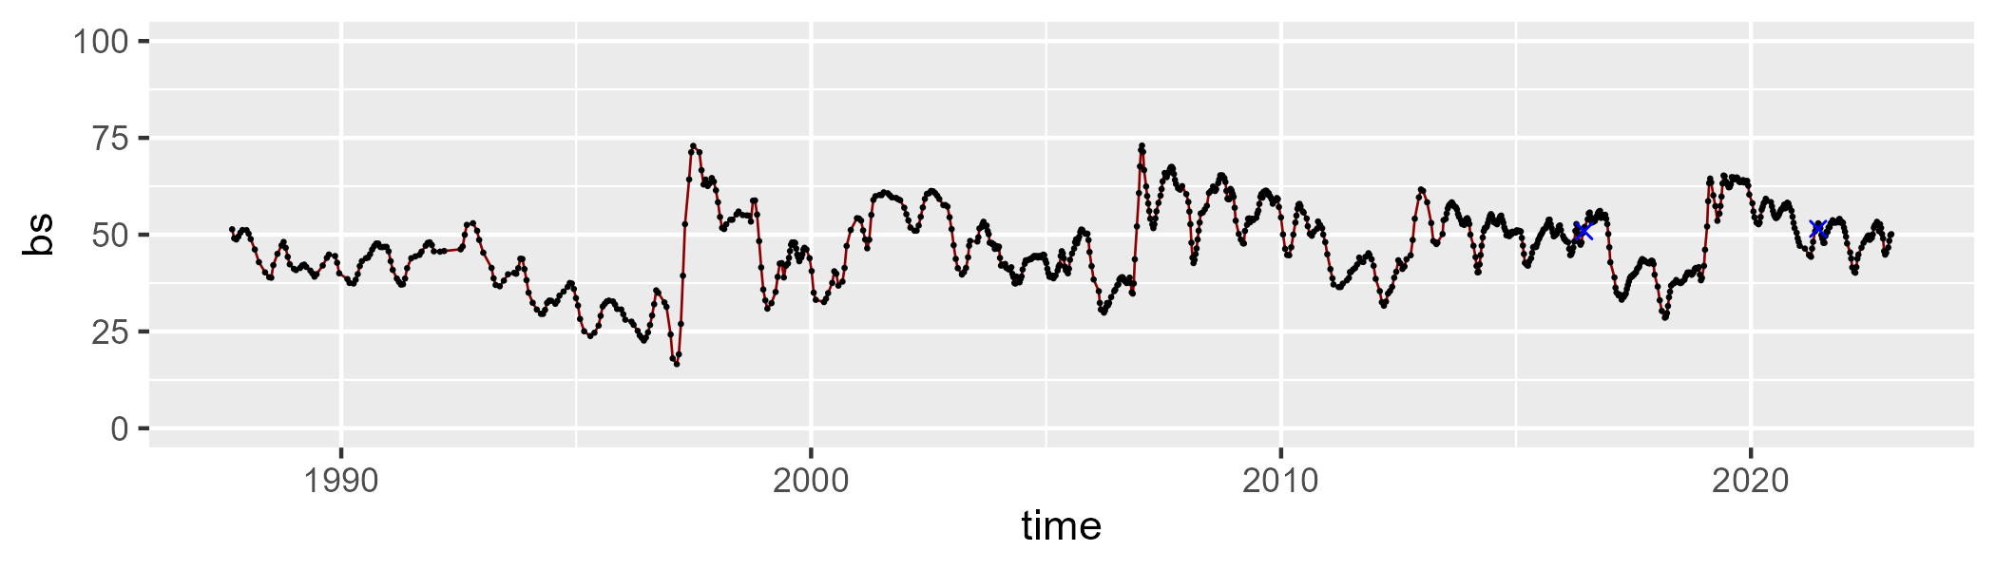

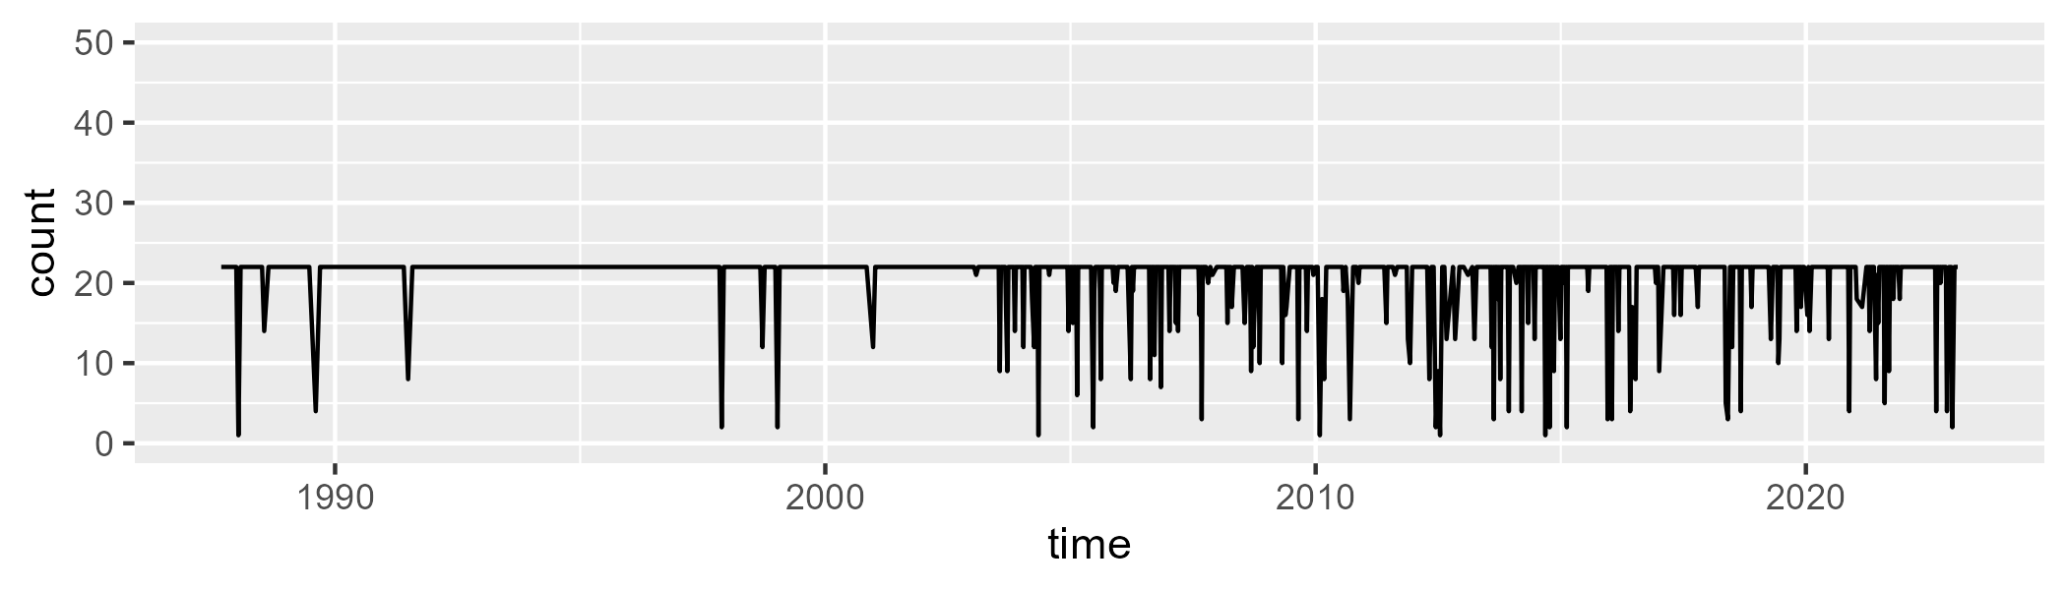

Min. : 1.00 1st Qu.:22.00 Median :22.00 Mean :20.66 3rd Qu.:22.00 Max. :22.00

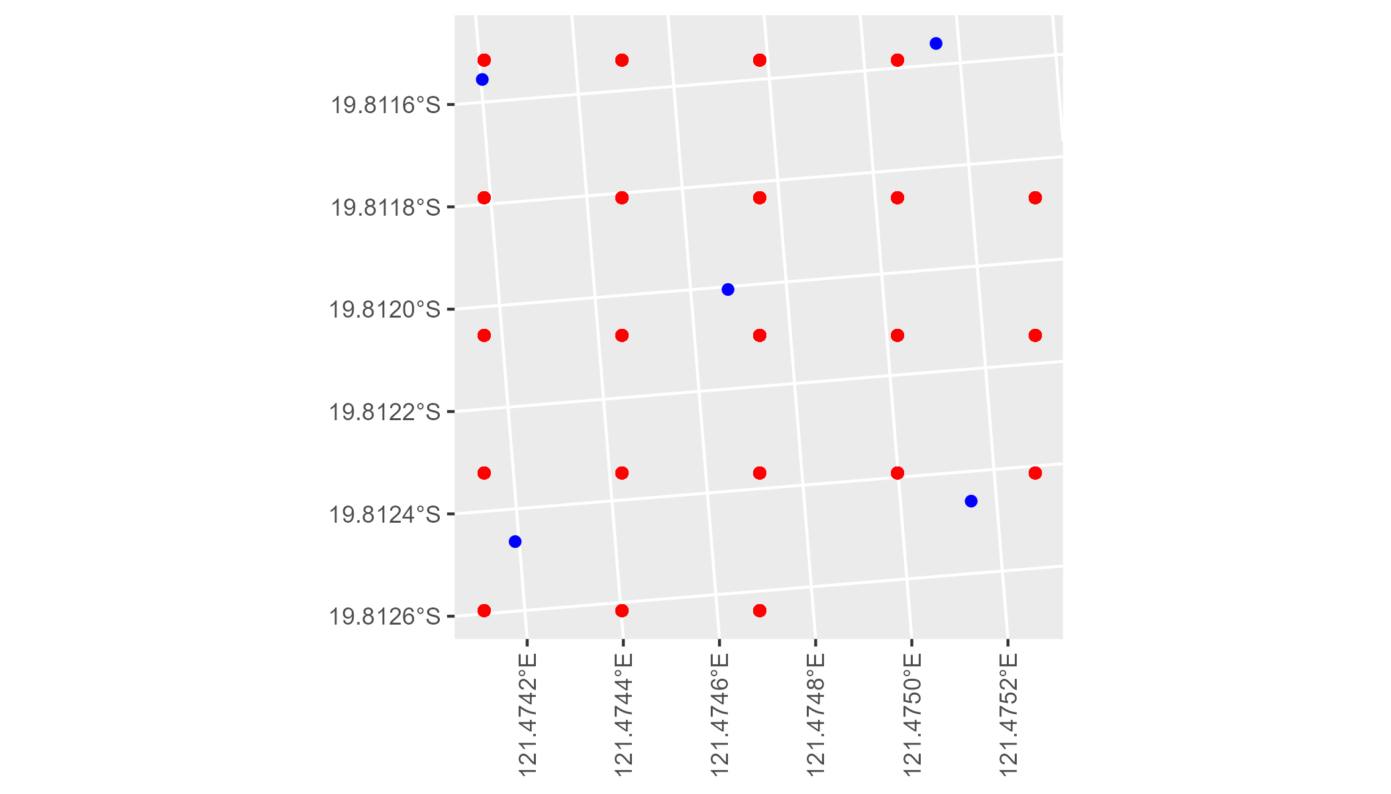

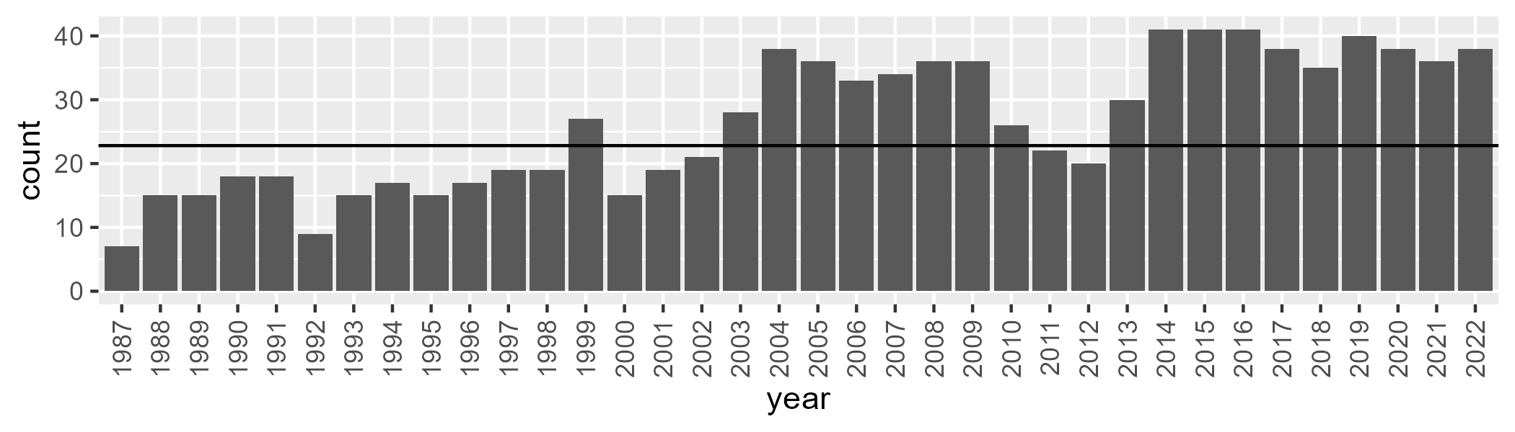

Number of samples: 953

# WAAGVD0001

| Min. | 1st Qu. | Median | Mean | 3rd Qu. | Max. |
| --- | --- | --- | --- | --- | --- |
| 5.075331 | 13.11334 | 15.56807 | 16.15737 | 18.50292 | 31.79714 |

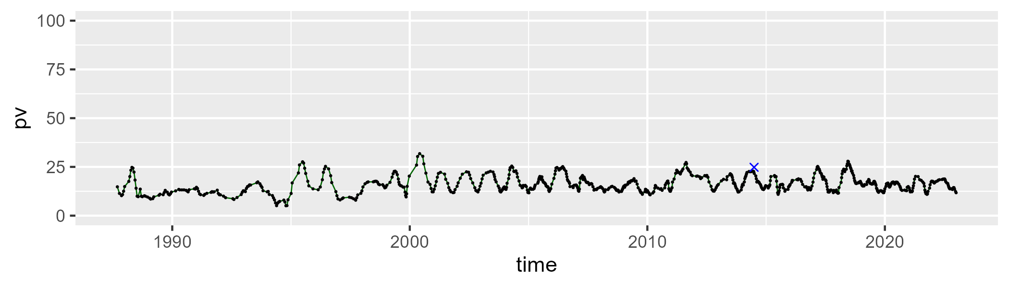

| Min. | 1st Qu. | Median | Mean | 3rd Qu. | Max. |
| --- | --- | --- | --- | --- | --- |
| 34.33327 | 46.6866 | 48.81082 | 48.53663 | 50.60981 | 59.21762 |

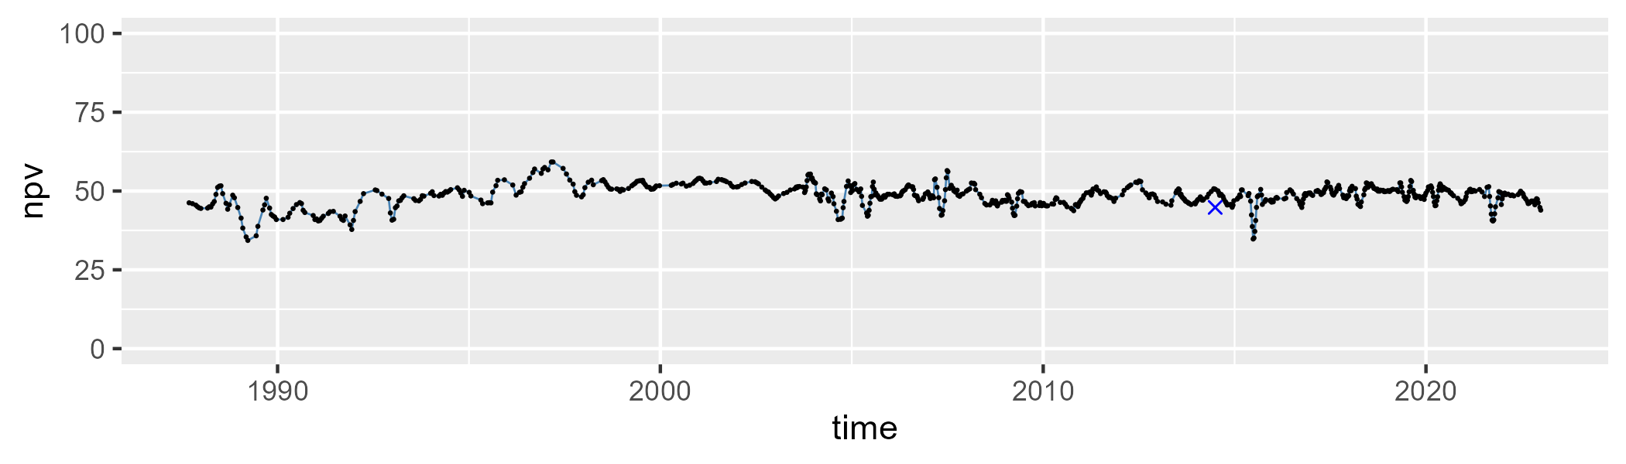

| Min. | 1st Qu. | Median | Mean | 3rd Qu. | Max. |
| --- | --- | --- | --- | --- | --- |
| 14.63422 | 30.26021 | 34.1455 | 34.03119 | 37.86624 | 54.4311 |

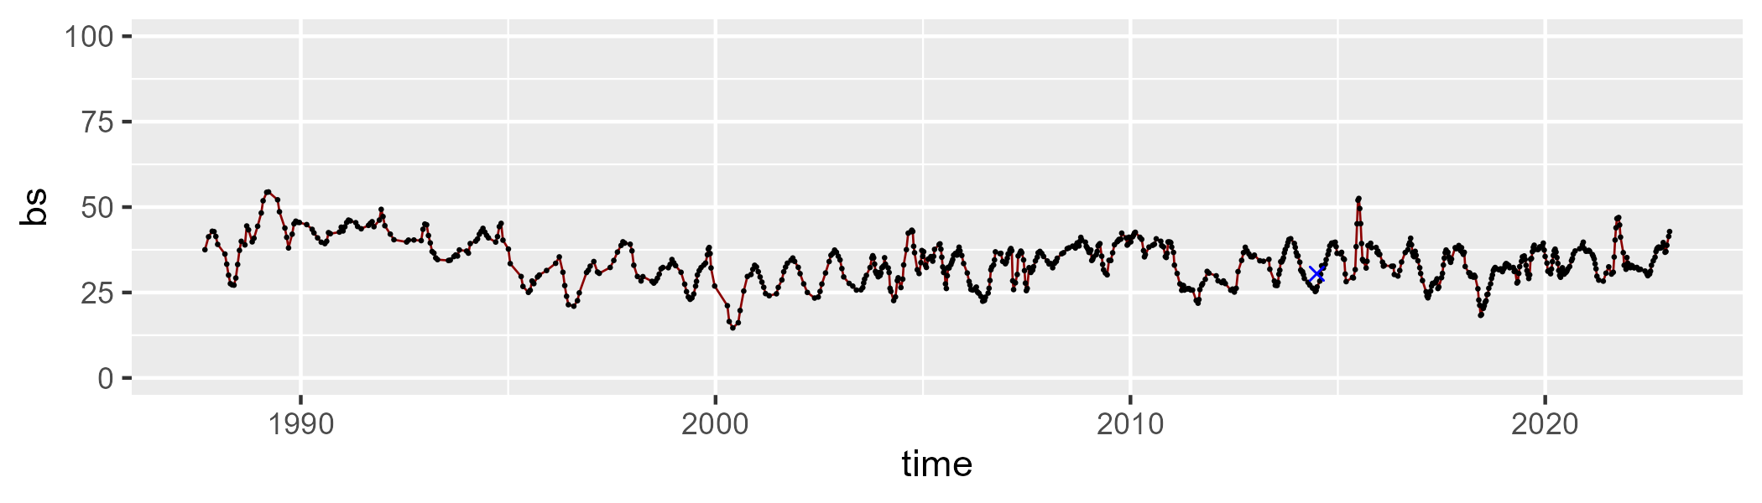

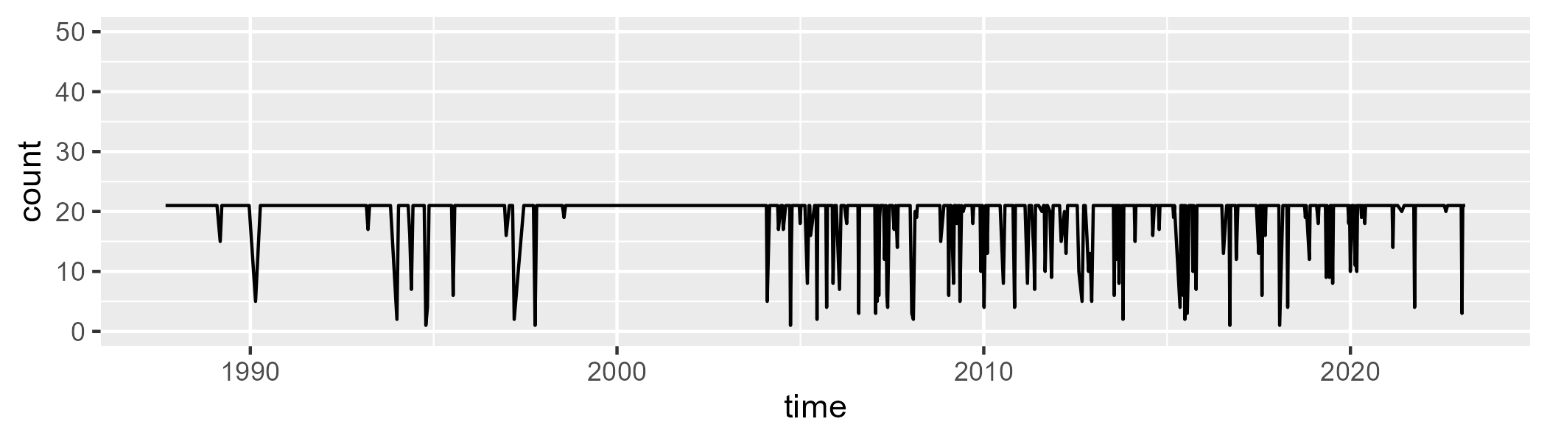

Min. : 1.00 1st Qu.:21.00 Median :21.00 Mean :19.48 3rd Qu.:21.00 Max. :21.00

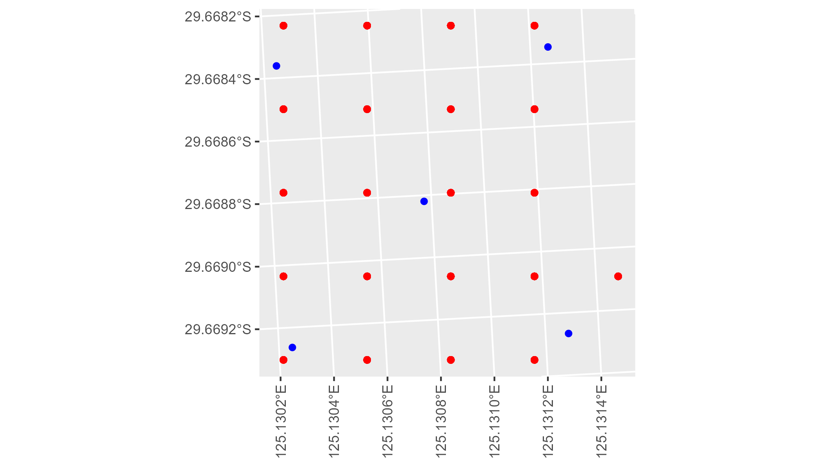

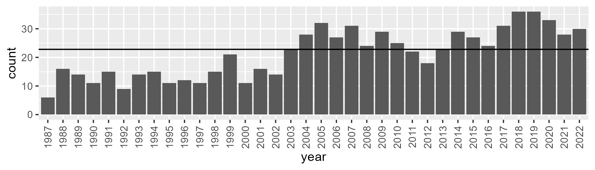

Number of samples: 767

# WAAHAM0001

| Min. | 1st Qu. | Median | Mean | 3rd Qu. | Max. |
| --- | --- | --- | --- | --- | --- |
| 7.915223 | 18.8603 | 23.48542 | 23.99936 | 28.74708 | 41.45952 |

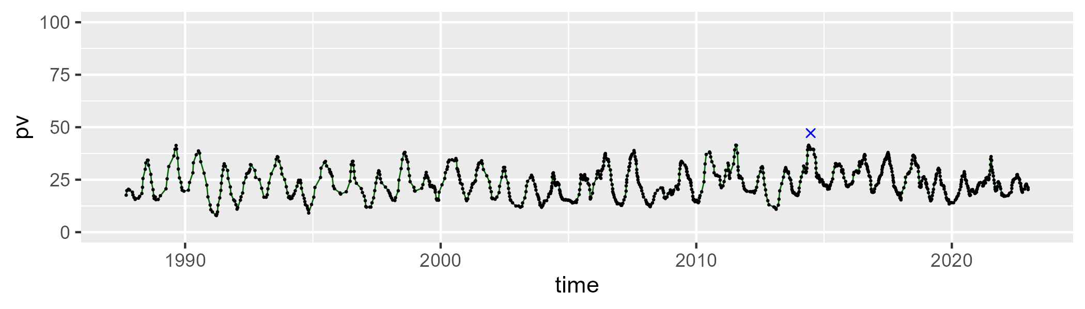

| Min. | 1st Qu. | Median | Mean | 3rd Qu. | Max. |
| --- | --- | --- | --- | --- | --- |
| 11.55903 | 31.45618 | 36.77371 | 37.15126 | 42.68154 | 56.79121 |

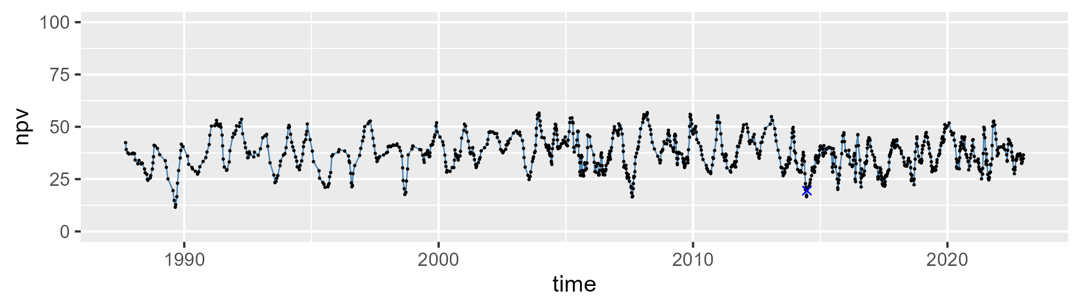

| Min. | 1st Qu. | Median | Mean | 3rd Qu. | Max. |
| --- | --- | --- | --- | --- | --- |
| 19.7664 | 34.61268 | 38.04181 | 37.63189 | 41.29632 | 50.36069 |

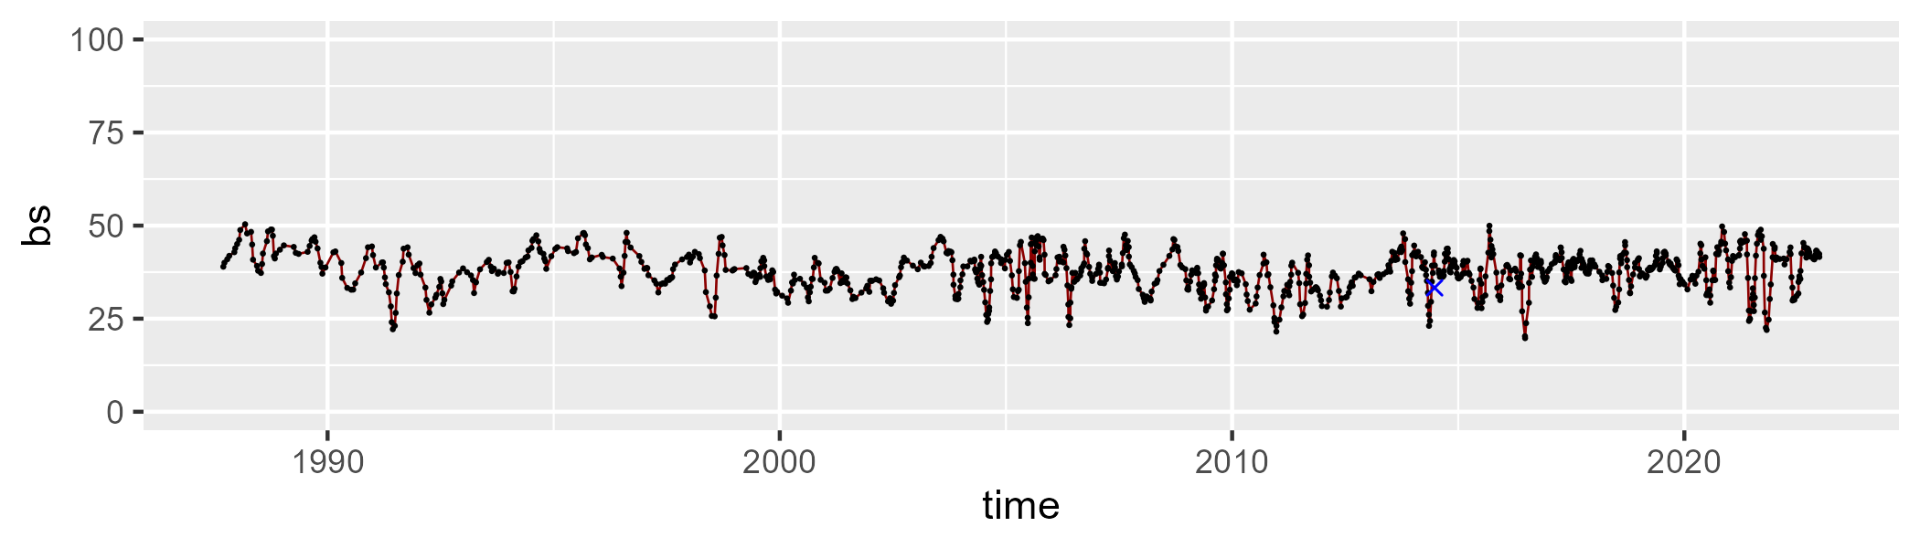

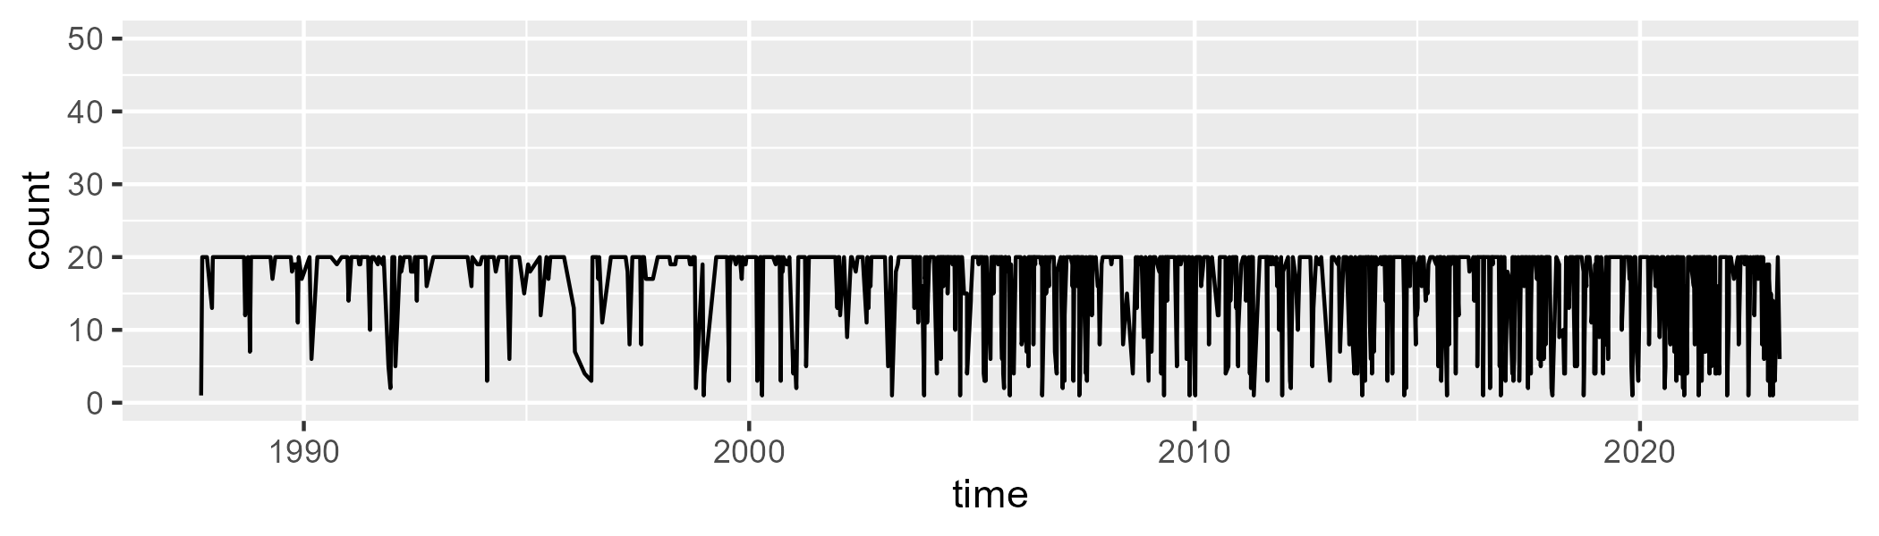

Min. : 1.00 1st Qu.:16.25 Median :20.00 Mean :16.75 3rd Qu.:20.00 Max. :20.00

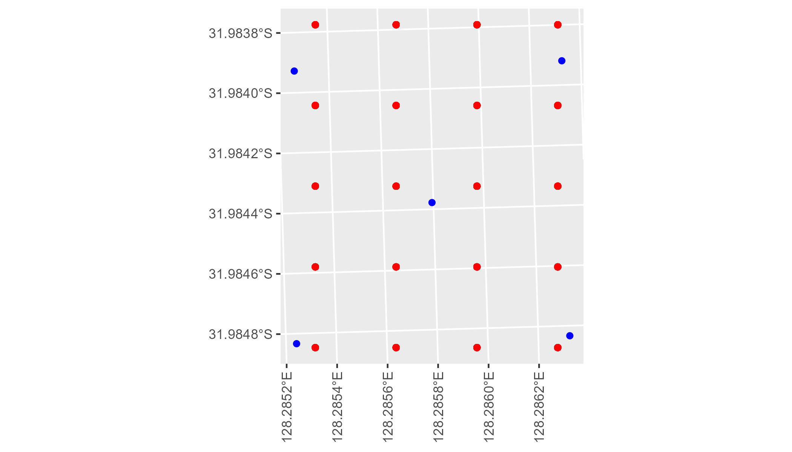

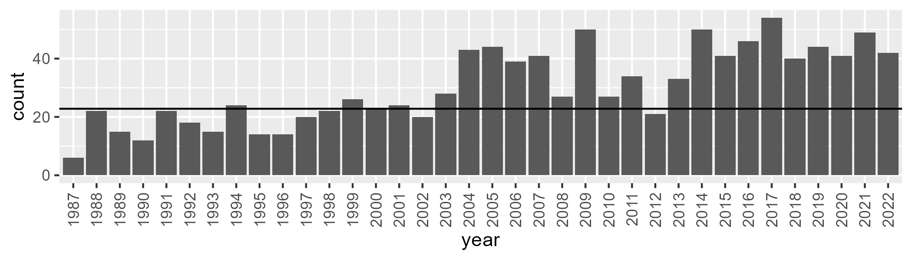

Number of samples: 1091

# WAAHAM0002

| Min. | 1st Qu. | Median | Mean | 3rd Qu. | Max. |
| --- | --- | --- | --- | --- | --- |
| 3.807888 | 10.18008 | 13.78545 | 14.80898 | 18.06584 | 38.5668 |

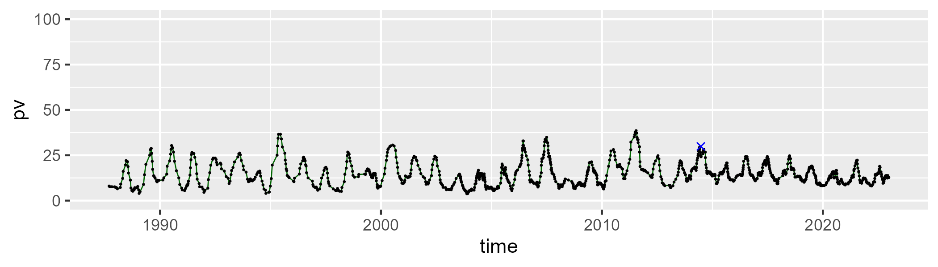

| Min. | 1st Qu. | Median | Mean | 3rd Qu. | Max. |
| --- | --- | --- | --- | --- | --- |
| 41.87437 | 50.37129 | 53.61066 | 53.68425 | 56.85435 | 67.97933 |

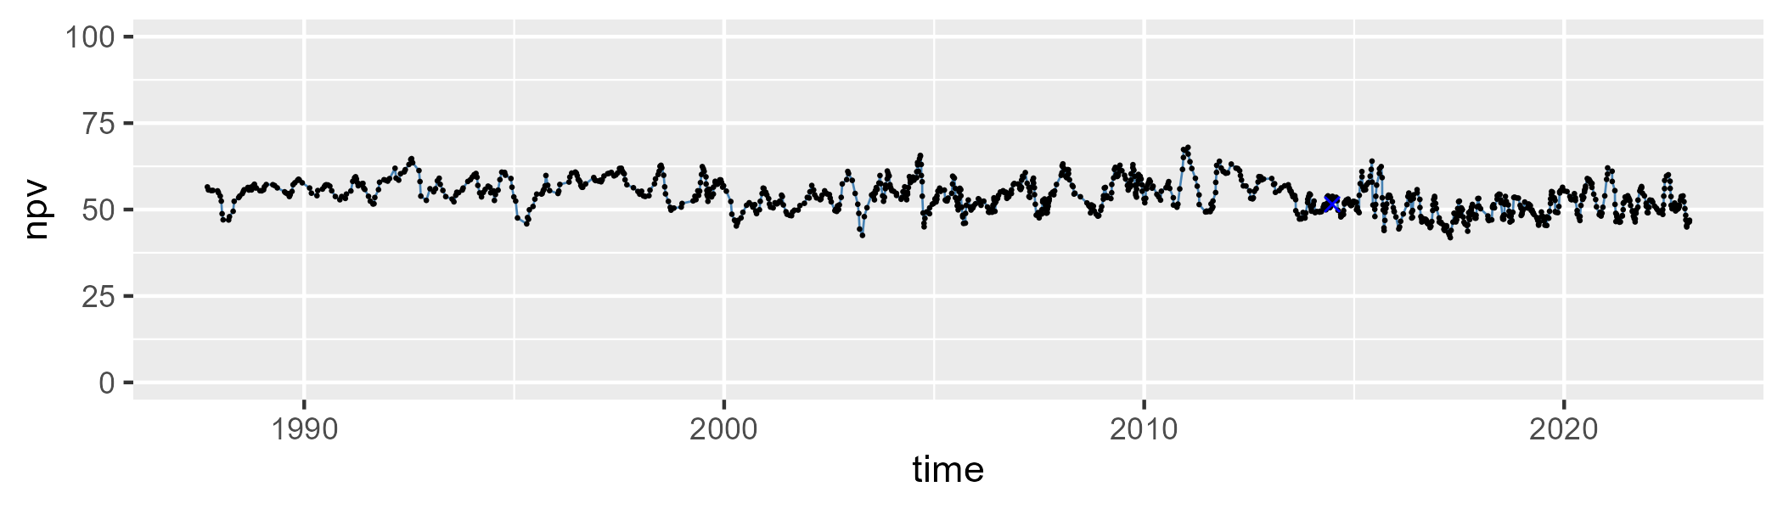

| Min. | 1st Qu. | Median | Mean | 3rd Qu. | Max. |
| --- | --- | --- | --- | --- | --- |
| 9.402989 | 25.37343 | 31.35039 | 30.14456 | 35.55101 | 47.31402 |

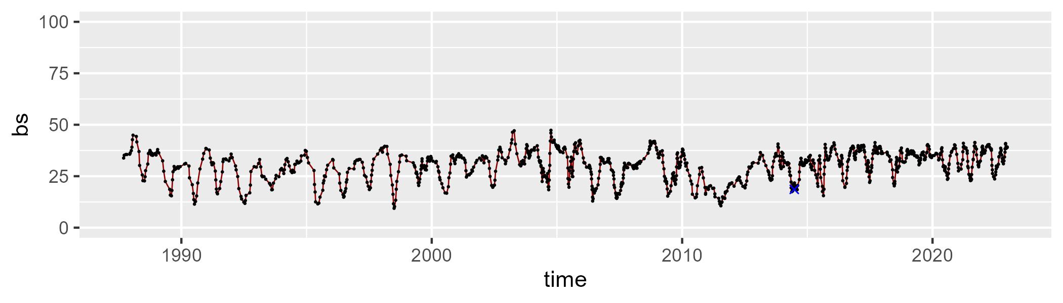

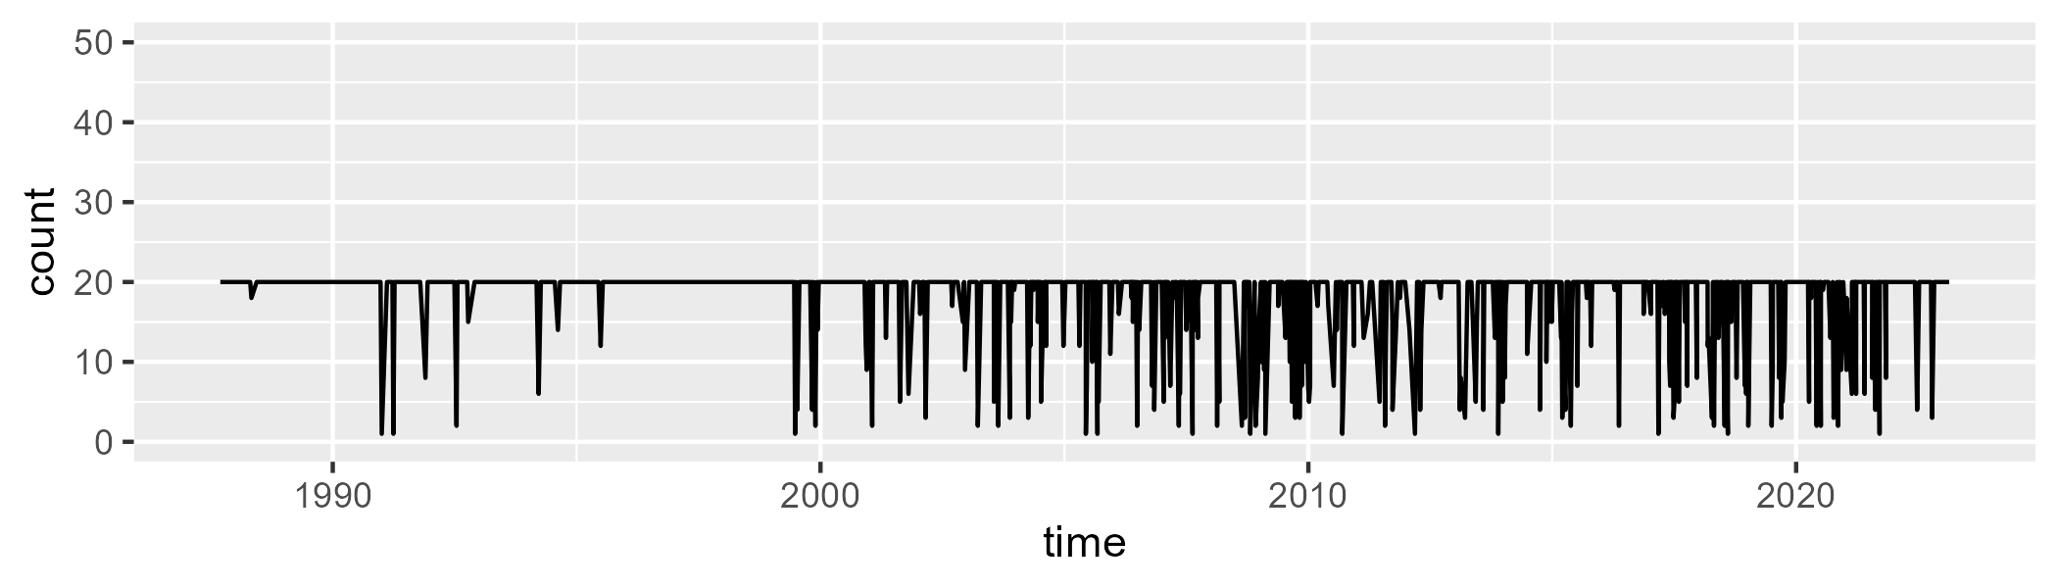

Min. : 1.00 1st Qu.:20.00 Median :20.00 Mean :18.06 3rd Qu.:20.00 Max. :20.00

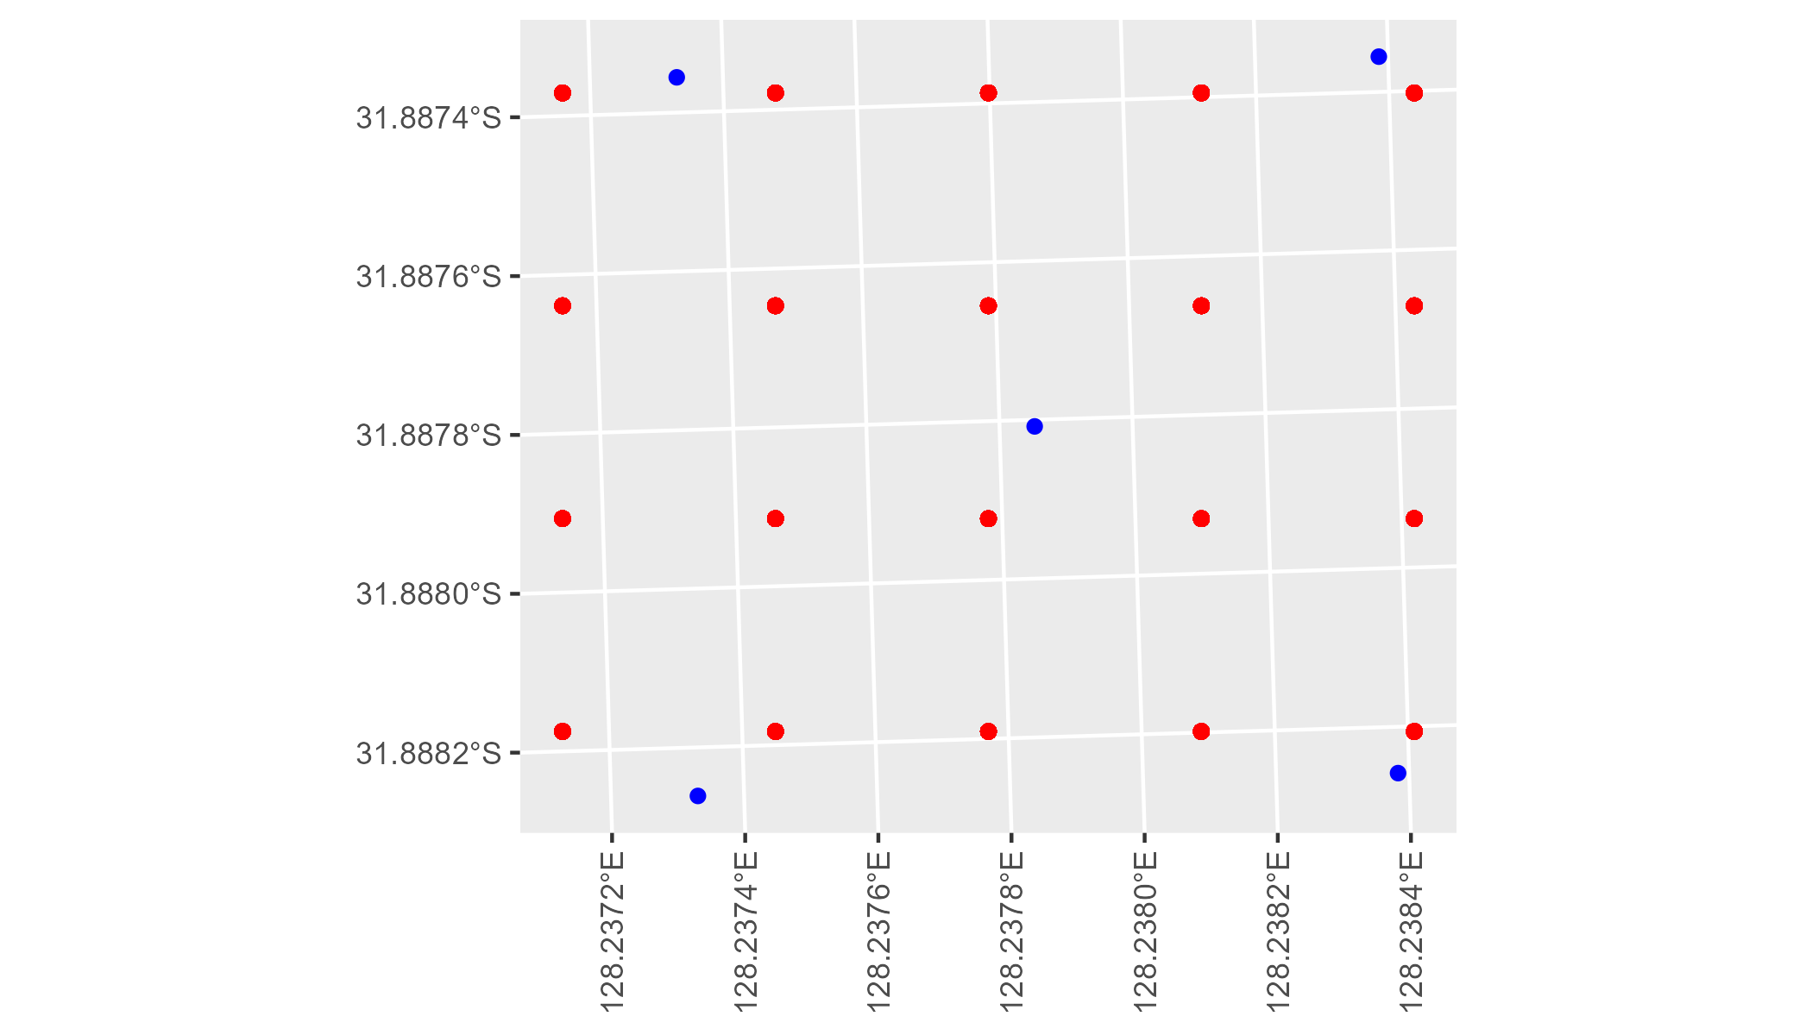

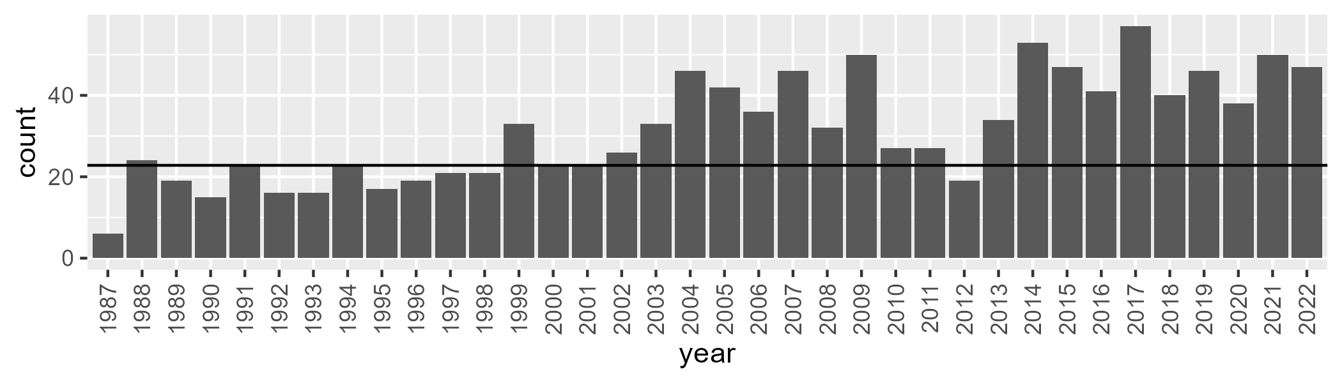

Number of samples: 1136

# WAAHAM0003

| Min. | 1st Qu. | Median | Mean | 3rd Qu. | Max. |
| --- | --- | --- | --- | --- | --- |
| 0 | 5.513019 | 10.84316 | 14.10626 | 19.24095 | 57.70687 |

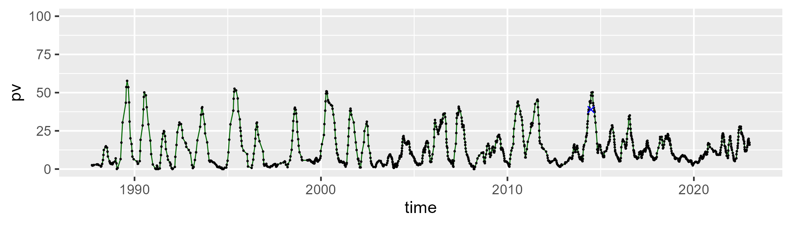

| Min. | 1st Qu. | Median | Mean | 3rd Qu. | Max. |
| --- | --- | --- | --- | --- | --- |
| 21.08181 | 40.82196 | 47.99071 | 49.17536 | 56.80329 | 76.47166 |

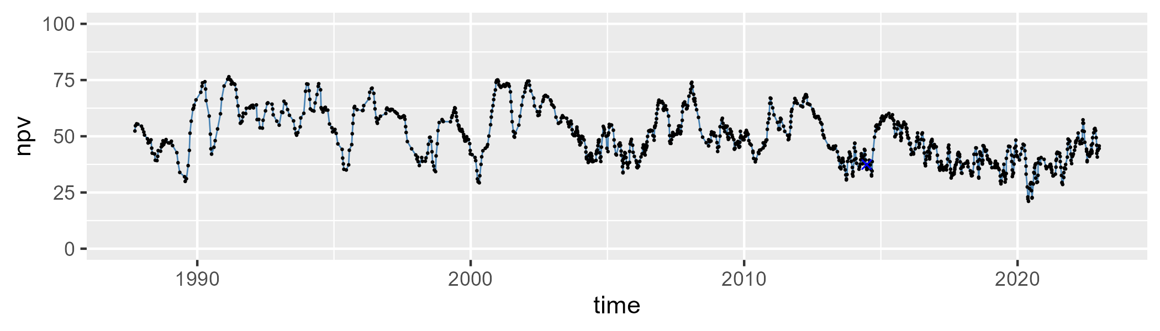

| Min. | 1st Qu. | Median | Mean | 3rd Qu. | Max. |
| --- | --- | --- | --- | --- | --- |
| 3.673464 | 24.86327 | 36.28361 | 35.32277 | 45.41763 | 69.57447 |

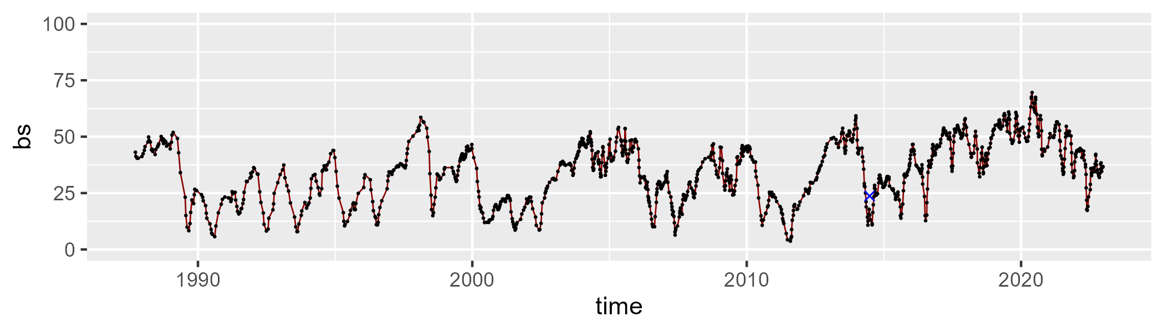

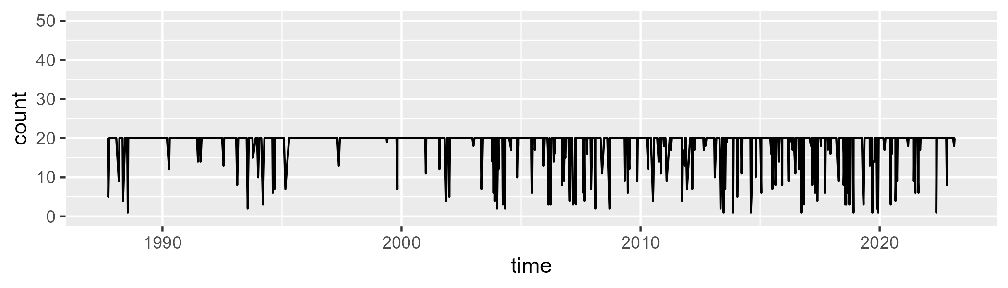

Min. : 1.00 1st Qu.:20.00 Median :20.00 Mean :18.61 3rd Qu.:20.00 Max. :20.00

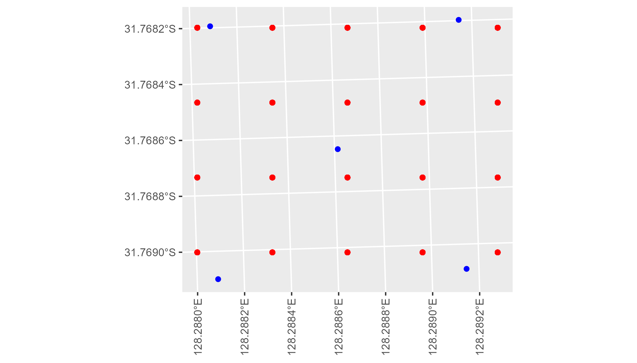

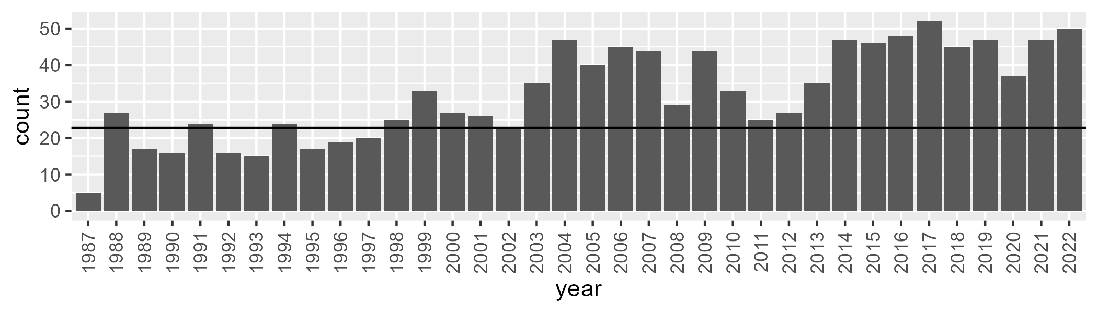

Number of samples: 1157

# WAAHAM0004

| Min. | 1st Qu. | Median | Mean | 3rd Qu. | Max. |
| --- | --- | --- | --- | --- | --- |
| 1.057197 | 8.946762 | 13.52251 | 15.00619 | 19.00128 | 47.7673 |

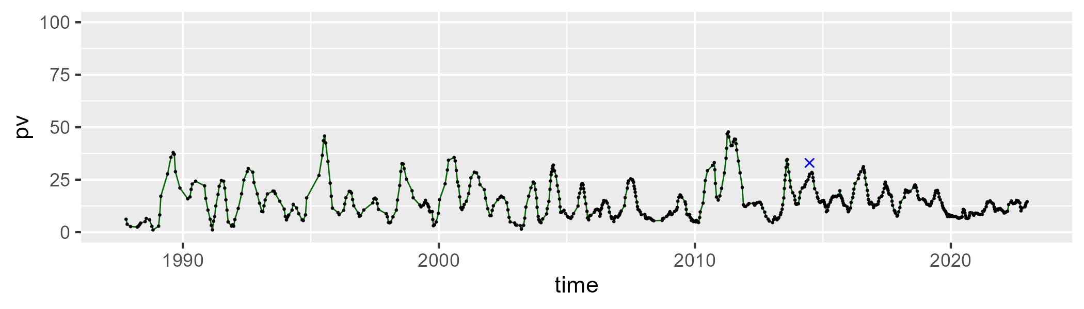

| Min. | 1st Qu. | Median | Mean | 3rd Qu. | Max. |
| --- | --- | --- | --- | --- | --- |
| 36.43028 | 48.23036 | 51.95718 | 52.75072 | 56.55851 | 78.33578 |

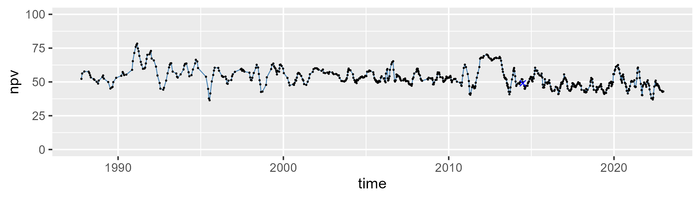

| Min. | 1st Qu. | Median | Mean | 3rd Qu. | Max. |
| --- | --- | --- | --- | --- | --- |
| 9.012413 | 25.04713 | 31.83751 | 30.86932 | 37.57772 | 47.81915 |

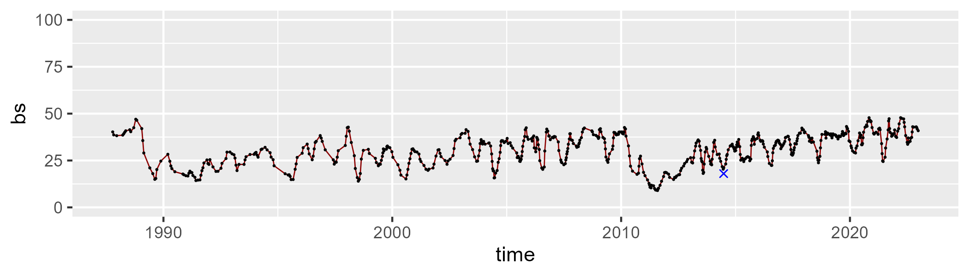

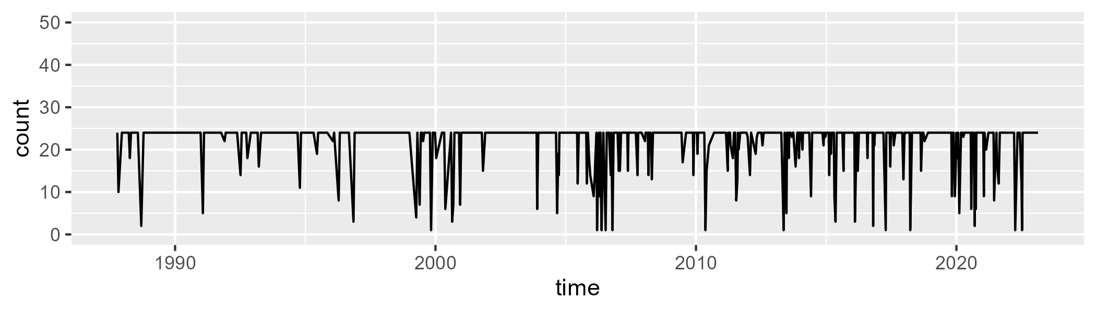

Min. : 1.00 1st Qu.:24.00 Median :24.00 Mean :22.02 3rd Qu.:24.00 Max. :24.00

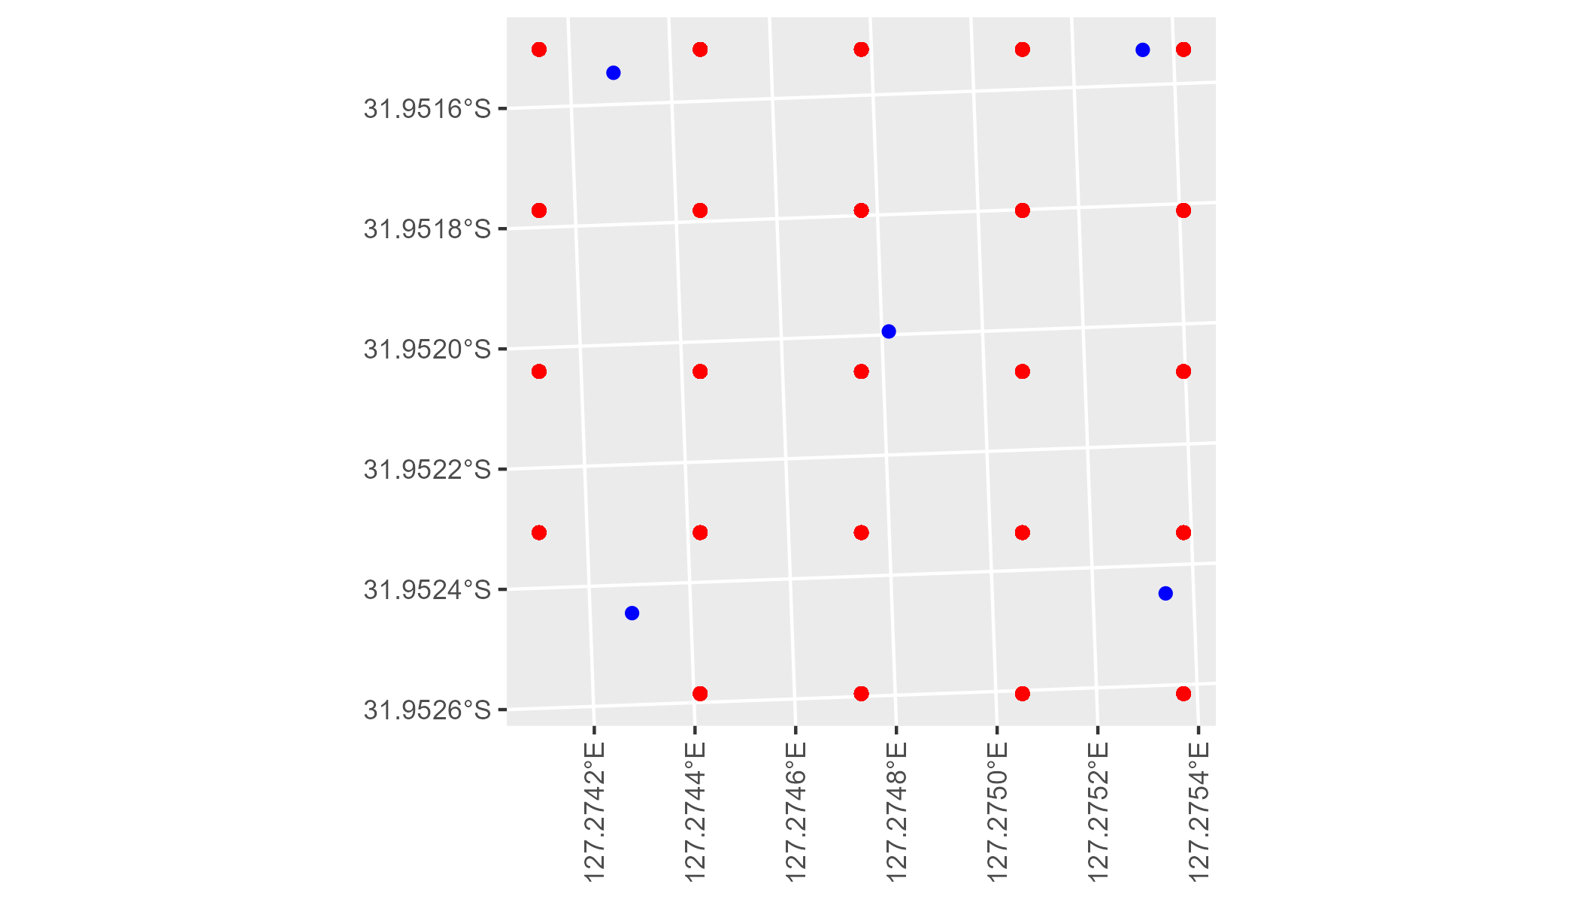

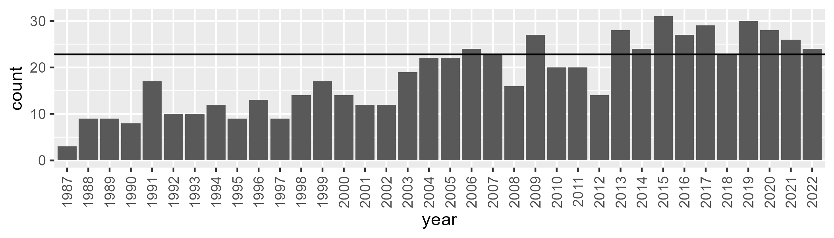

Number of samples: 655

# WAAHAM0005

| Min. | 1st Qu. | Median | Mean | 3rd Qu. | Max. |
| --- | --- | --- | --- | --- | --- |
| 13.98604 | 28.07233 | 33.48534 | 32.95435 | 37.28289 | 56.53032 |

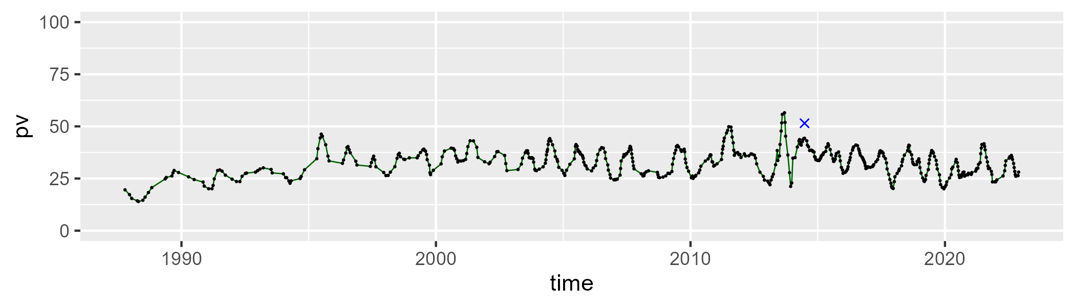

| Min. | 1st Qu. | Median | Mean | 3rd Qu. | Max. |
| --- | --- | --- | --- | --- | --- |
| 14.80109 | 30.34488 | 35.7818 | 36.06581 | 41.2557 | 56.12862 |

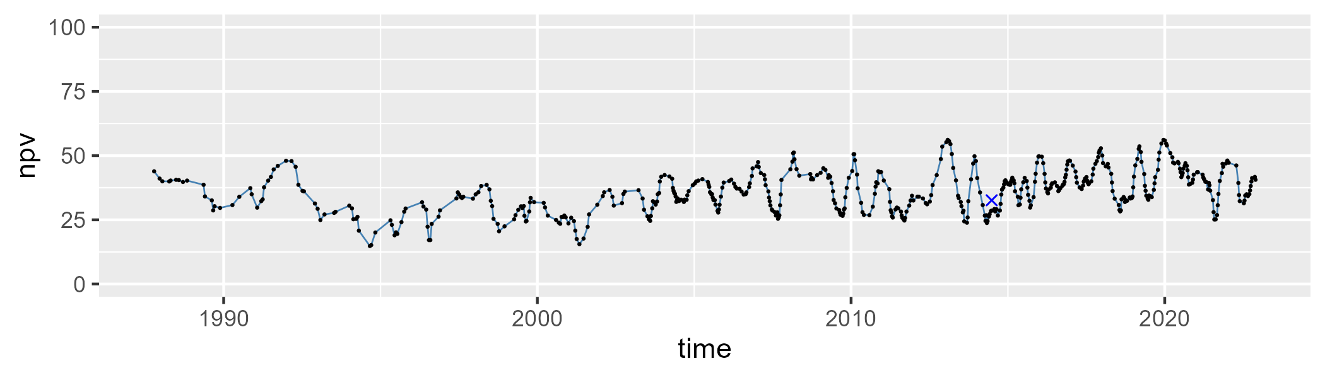

| Min. | 1st Qu. | Median | Mean | 3rd Qu. | Max. |
| --- | --- | --- | --- | --- | --- |
| 17.49313 | 24.97379 | 28.82162 | 29.75112 | 33.22325 | 59.45561 |

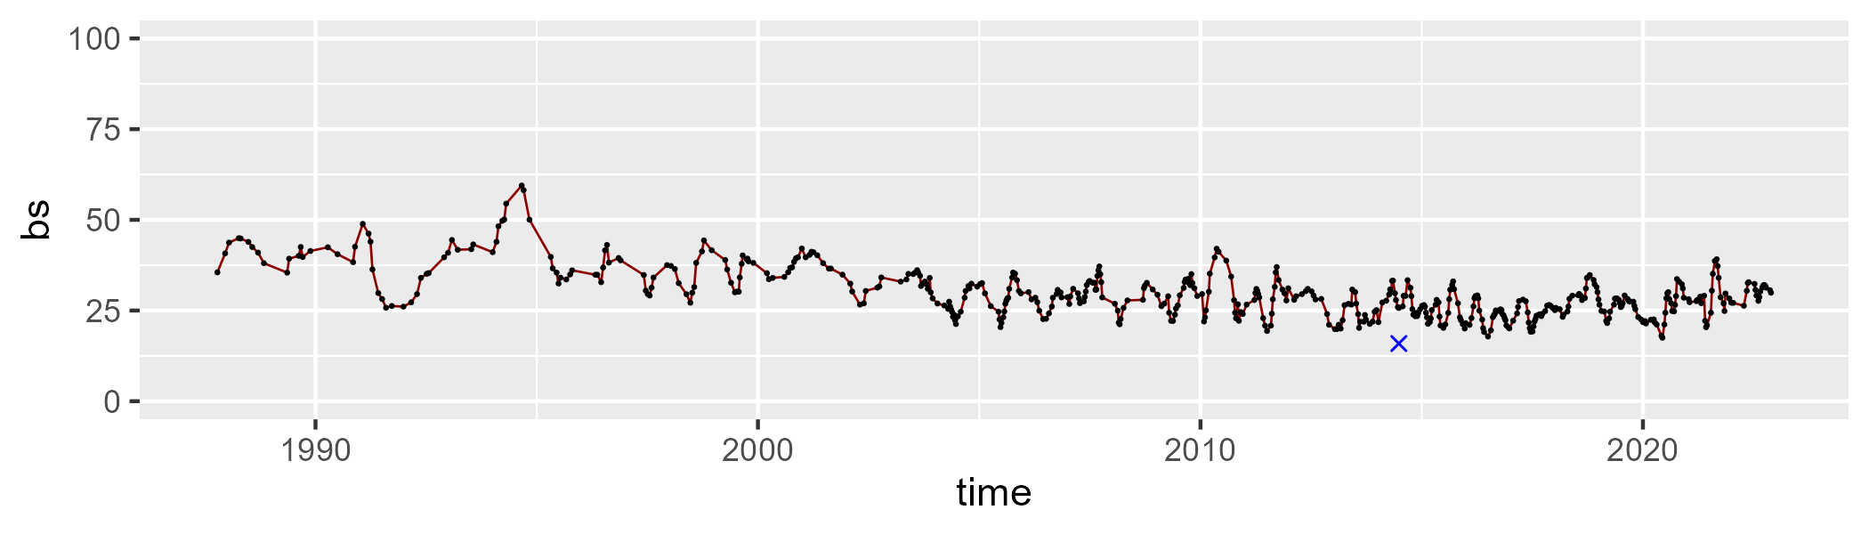

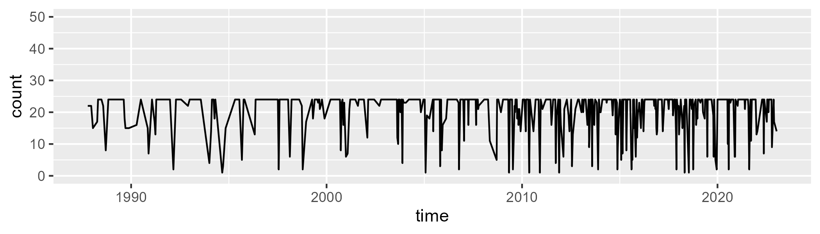

Min. : 1.00 1st Qu.:20.00 Median :24.00 Mean :20.64 3rd Qu.:24.00 Max. :24.00

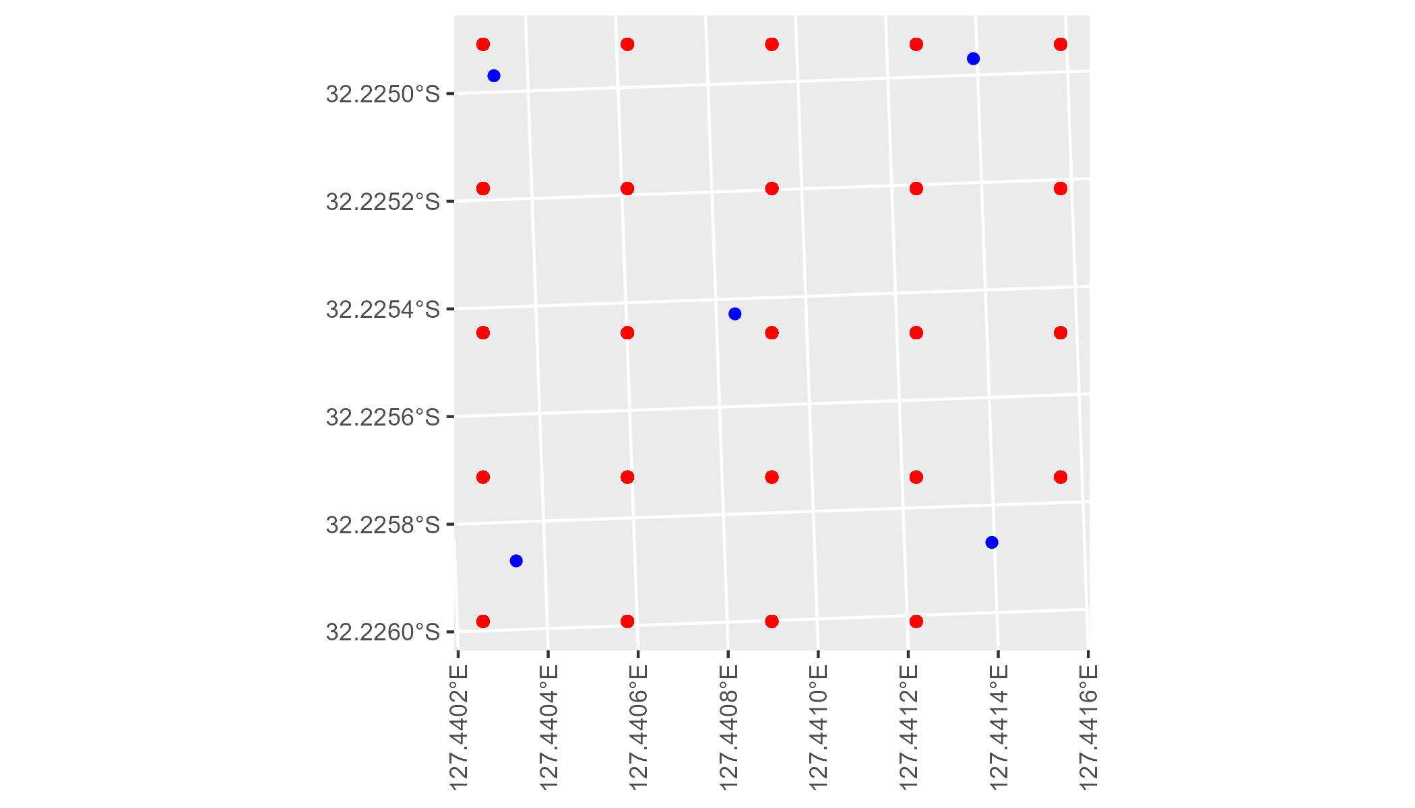

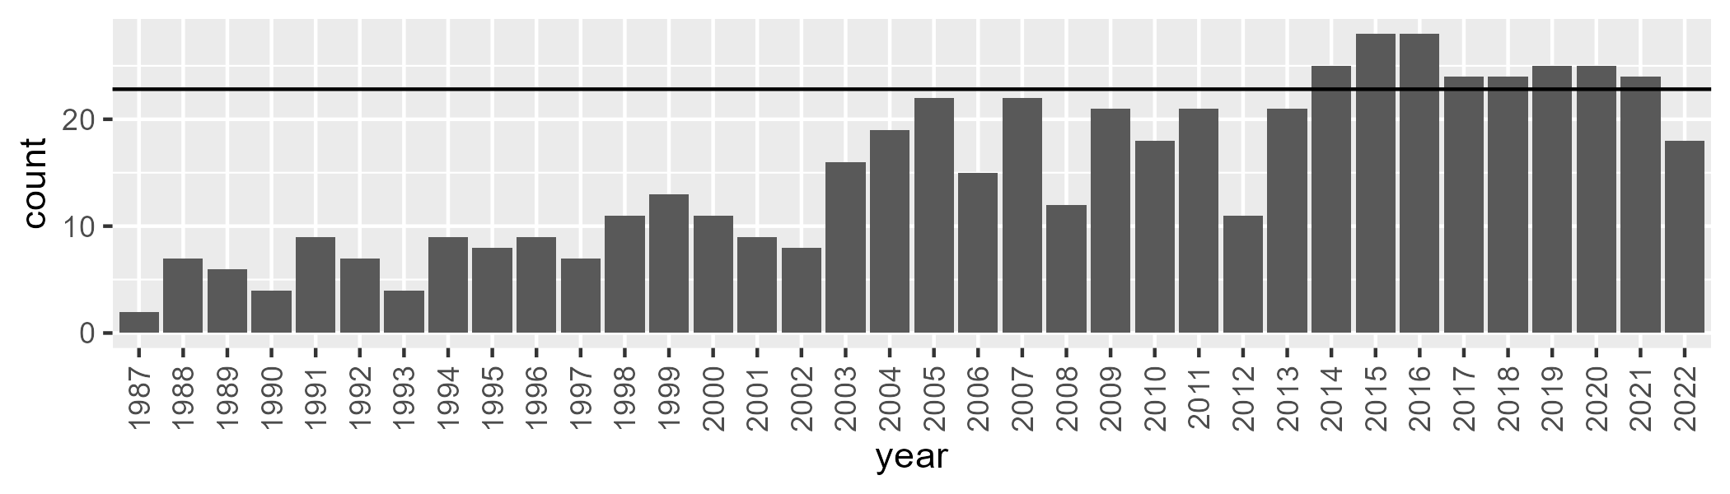

Number of samples: 543

# WAAHAM0006

| Min. | 1st Qu. | Median | Mean | 3rd Qu. | Max. |
| --- | --- | --- | --- | --- | --- |
| 9.105109 | 29.24728 | 34.50142 | 33.85179 | 39.15585 | 54.48102 |

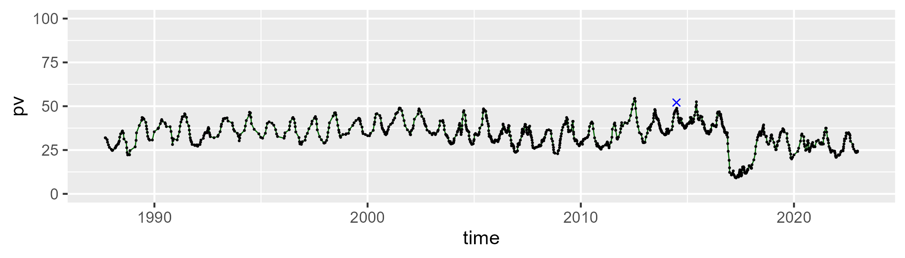

| Min. | 1st Qu. | Median | Mean | 3rd Qu. | Max. |
| --- | --- | --- | --- | --- | --- |
| 17.10499 | 34.57553 | 38.37283 | 38.27478 | 42.19302 | 55.86781 |

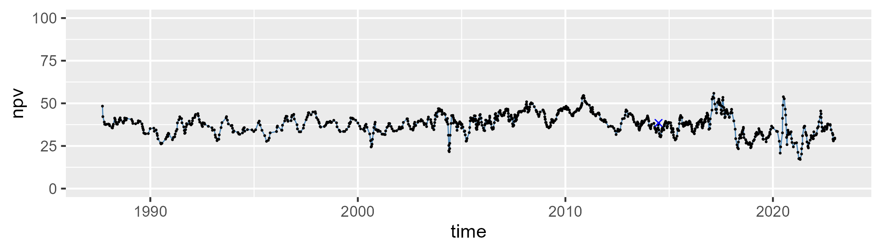

| Min. | 1st Qu. | Median | Mean | 3rd Qu. | Max. |
| --- | --- | --- | --- | --- | --- |
| 8.262802 | 21.17745 | 25.21064 | 26.55861 | 31.17495 | 53.4675 |

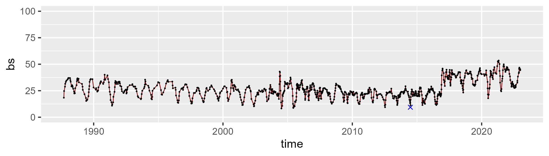

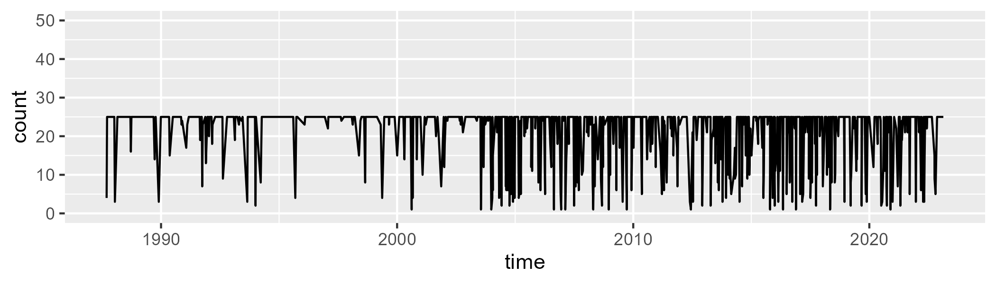

Min. : 1.00 1st Qu.:22.00 Median :25.00 Mean :21.38 3rd Qu.:25.00 Max. :25.00

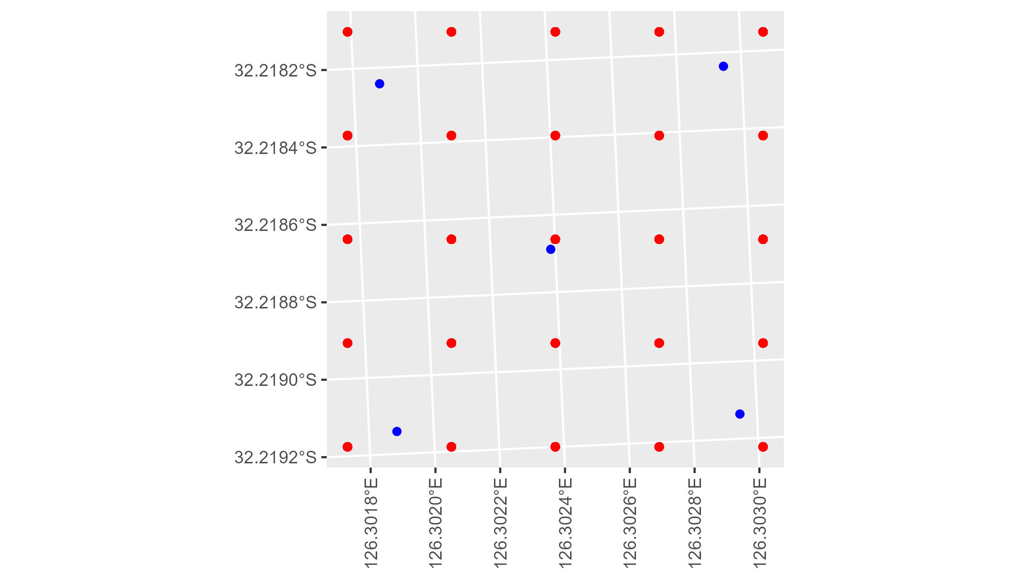

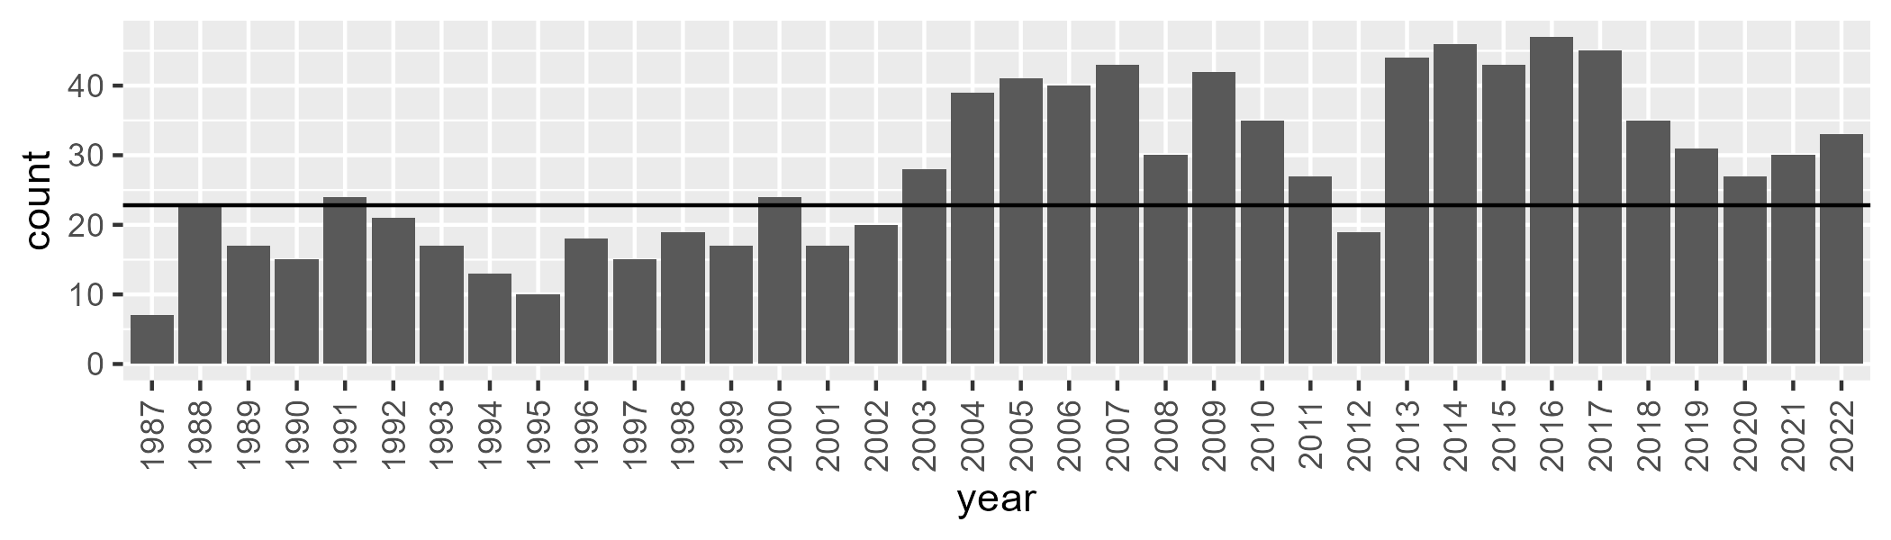

Number of samples: 1002

# WAAJAF0001

| Min. | 1st Qu. | Median | Mean | 3rd Qu. | Max. |
| --- | --- | --- | --- | --- | --- |
| 26.99546 | 50.85915 | 54.84799 | 54.25429 | 58.82374 | 67.62407 |

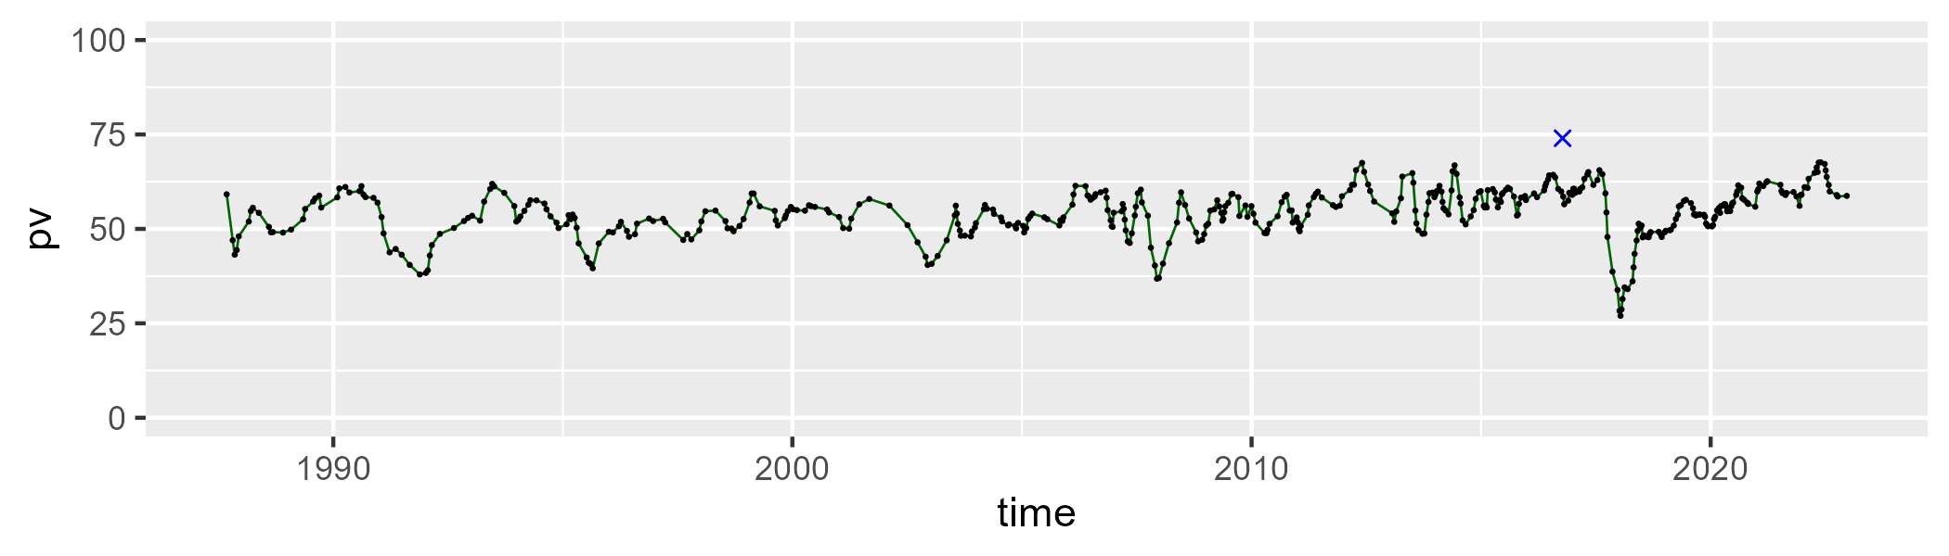

| Min. | 1st Qu. | Median | Mean | 3rd Qu. | Max. |
| --- | --- | --- | --- | --- | --- |
| 17.67349 | 29.50454 | 33.64543 | 33.18538 | 37.02969 | 53.59887 |

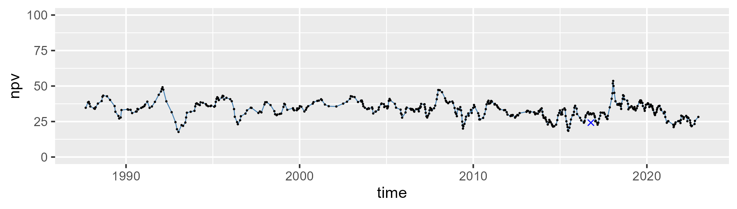

| Min. | 1st Qu. | Median | Mean | 3rd Qu. | Max. |
| --- | --- | --- | --- | --- | --- |
| 0.4824561 | 7.025923 | 10.58661 | 11.1917 | 14.40491 | 28.19238 |

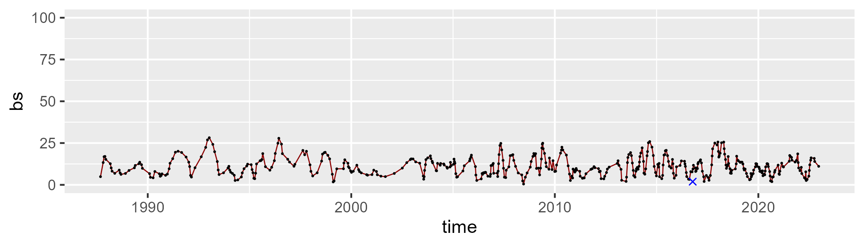

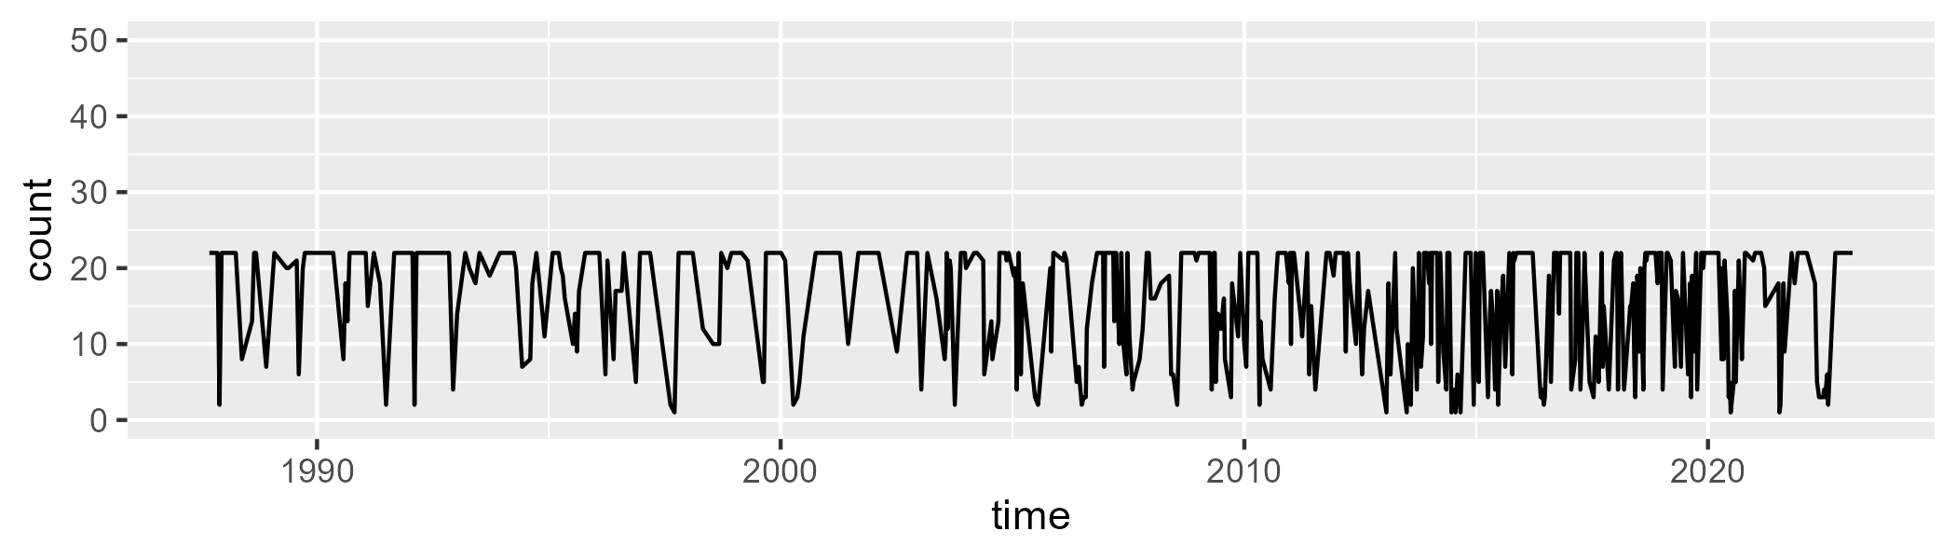

Min. : 1.00 1st Qu.: 9.00 Median :20.00 Mean :15.84 3rd Qu.:22.00 Max. :22.00

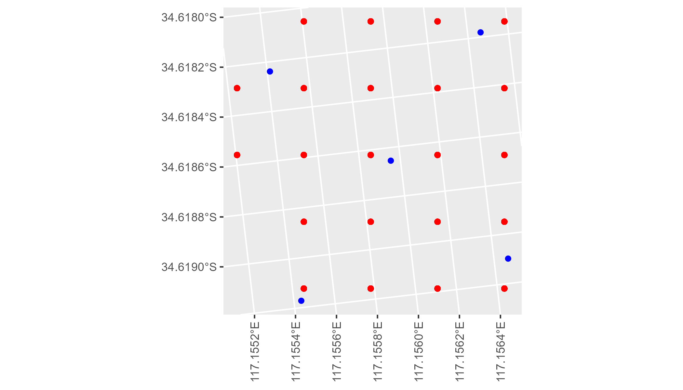

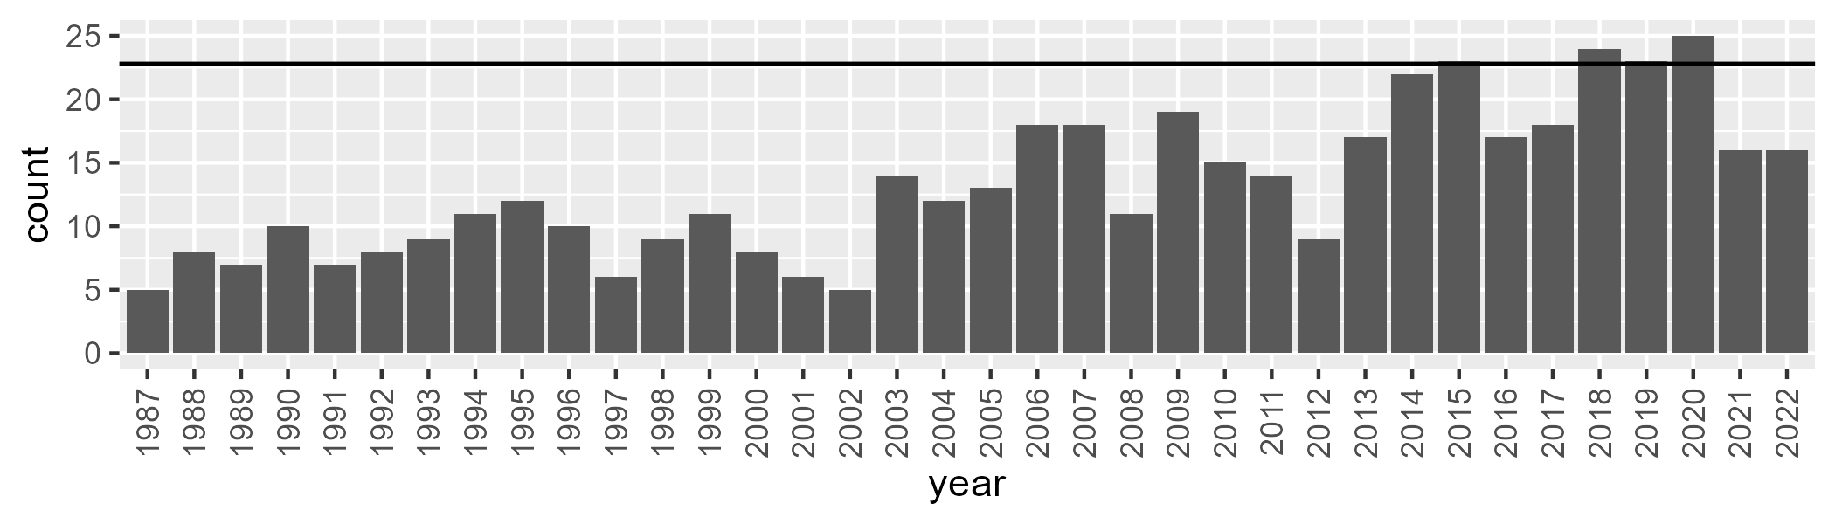

Number of samples: 476

# WAAJAF0002

| Min. | 1st Qu. | Median | Mean | 3rd Qu. | Max. |
| --- | --- | --- | --- | --- | --- |
| 25.94556 | 53.44864 | 56.89736 | 56.38427 | 60.24951 | 72.50796 |

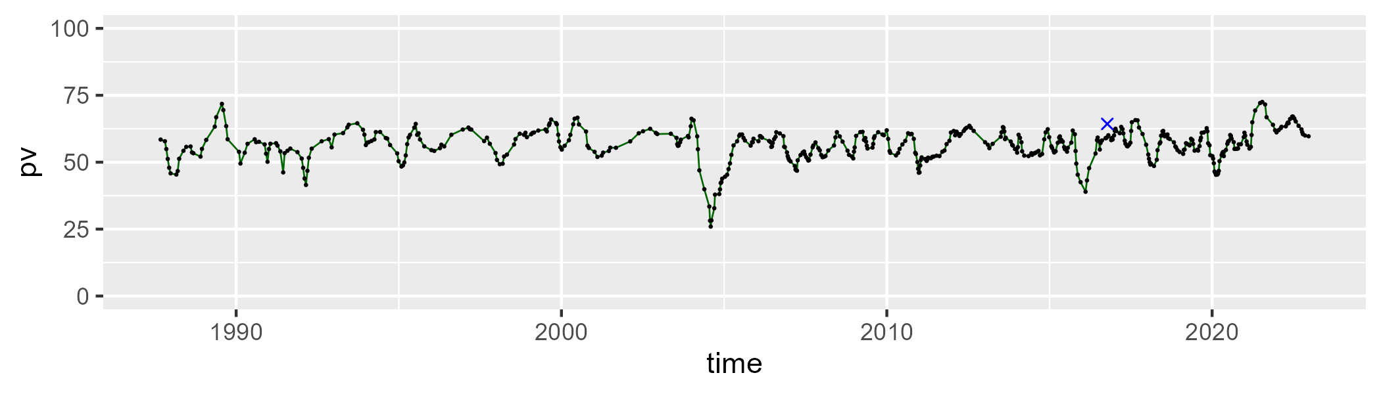

| Min. | 1st Qu. | Median | Mean | 3rd Qu. | Max. |
| --- | --- | --- | --- | --- | --- |
| 20.34534 | 30.54488 | 33.80018 | 34.39174 | 38.1301 | 51.43745 |

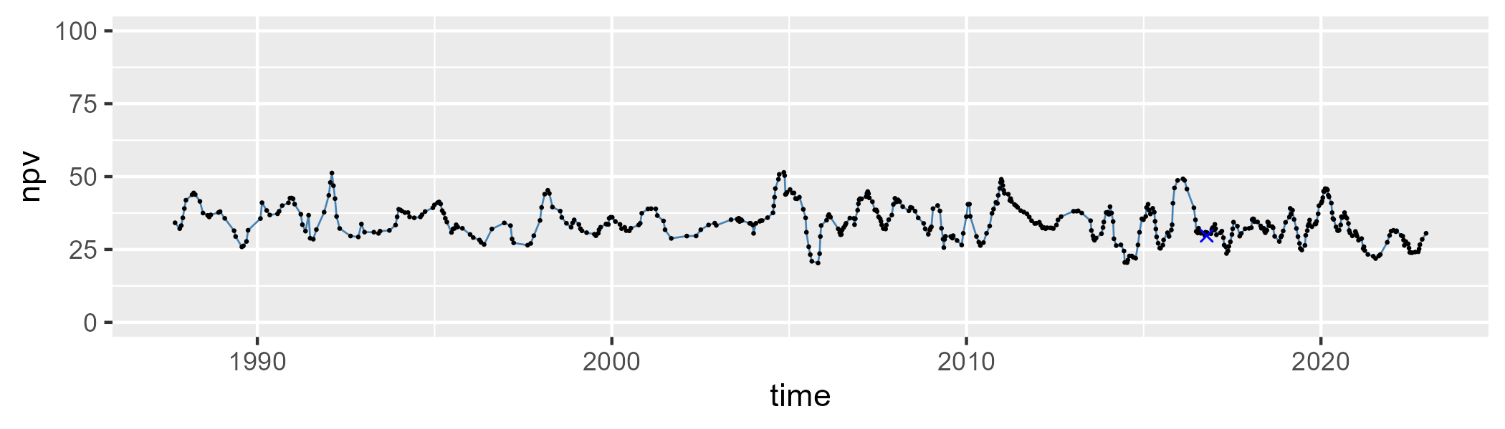

| Min. | 1st Qu. | Median | Mean | 3rd Qu. | Max. |
| --- | --- | --- | --- | --- | --- |
| 0 | 4.229563 | 6.89568 | 7.888994 | 10.3991 | 30.74855 |

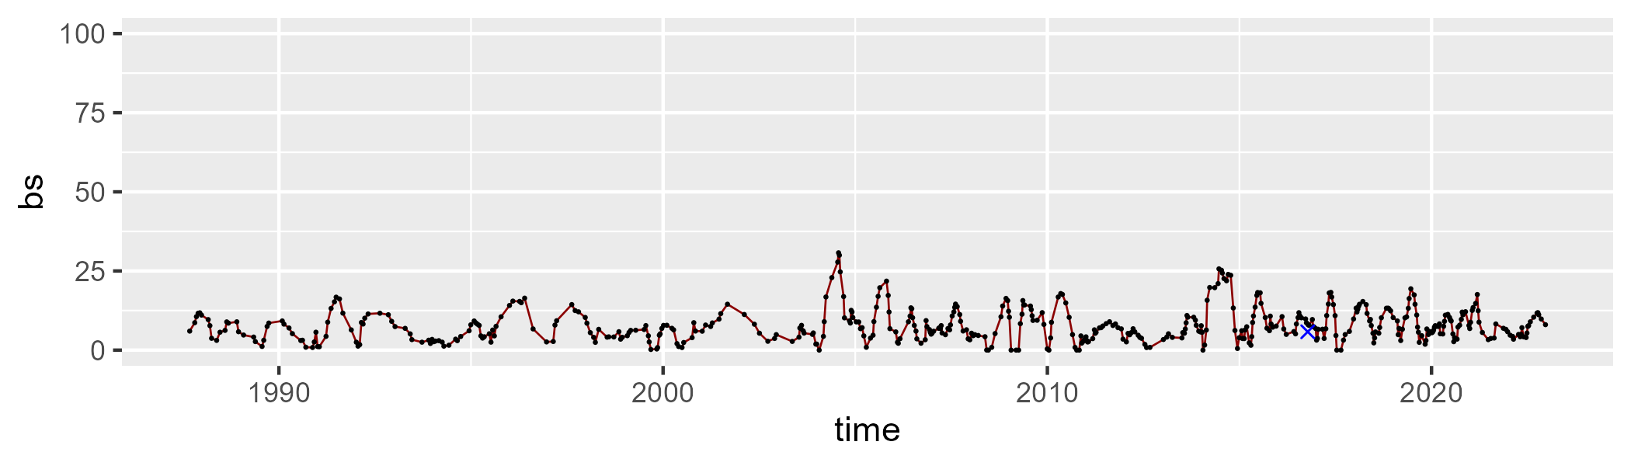

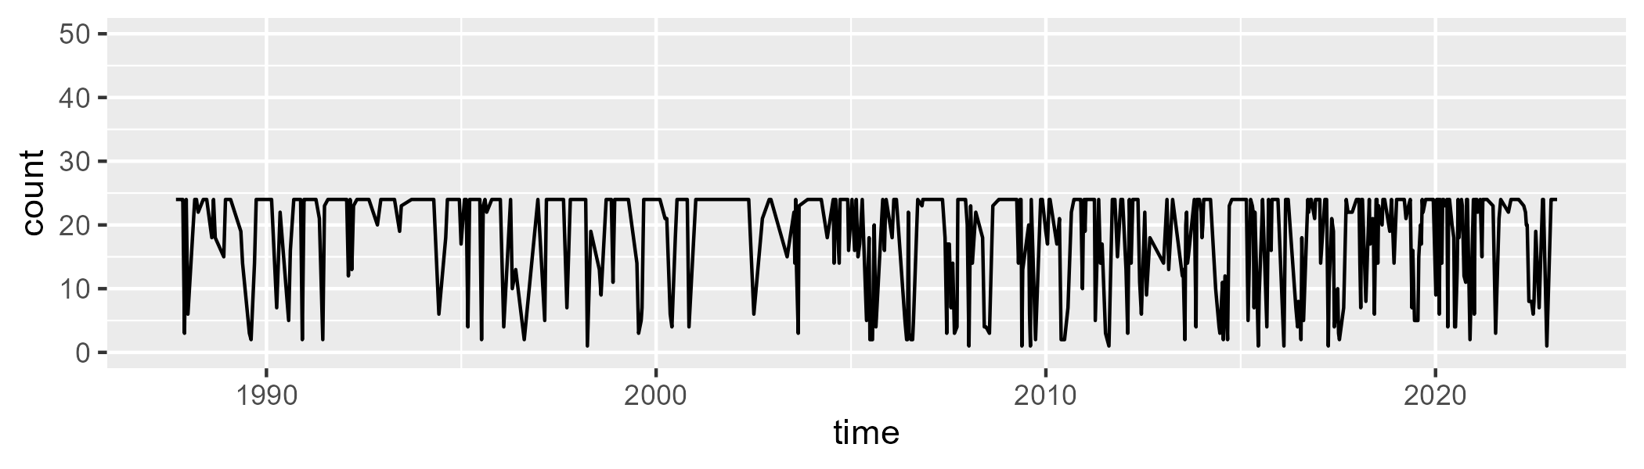

Min. : 1.00 1st Qu.:14.00 Median :24.00 Mean :18.32 3rd Qu.:24.00 Max. :24.00

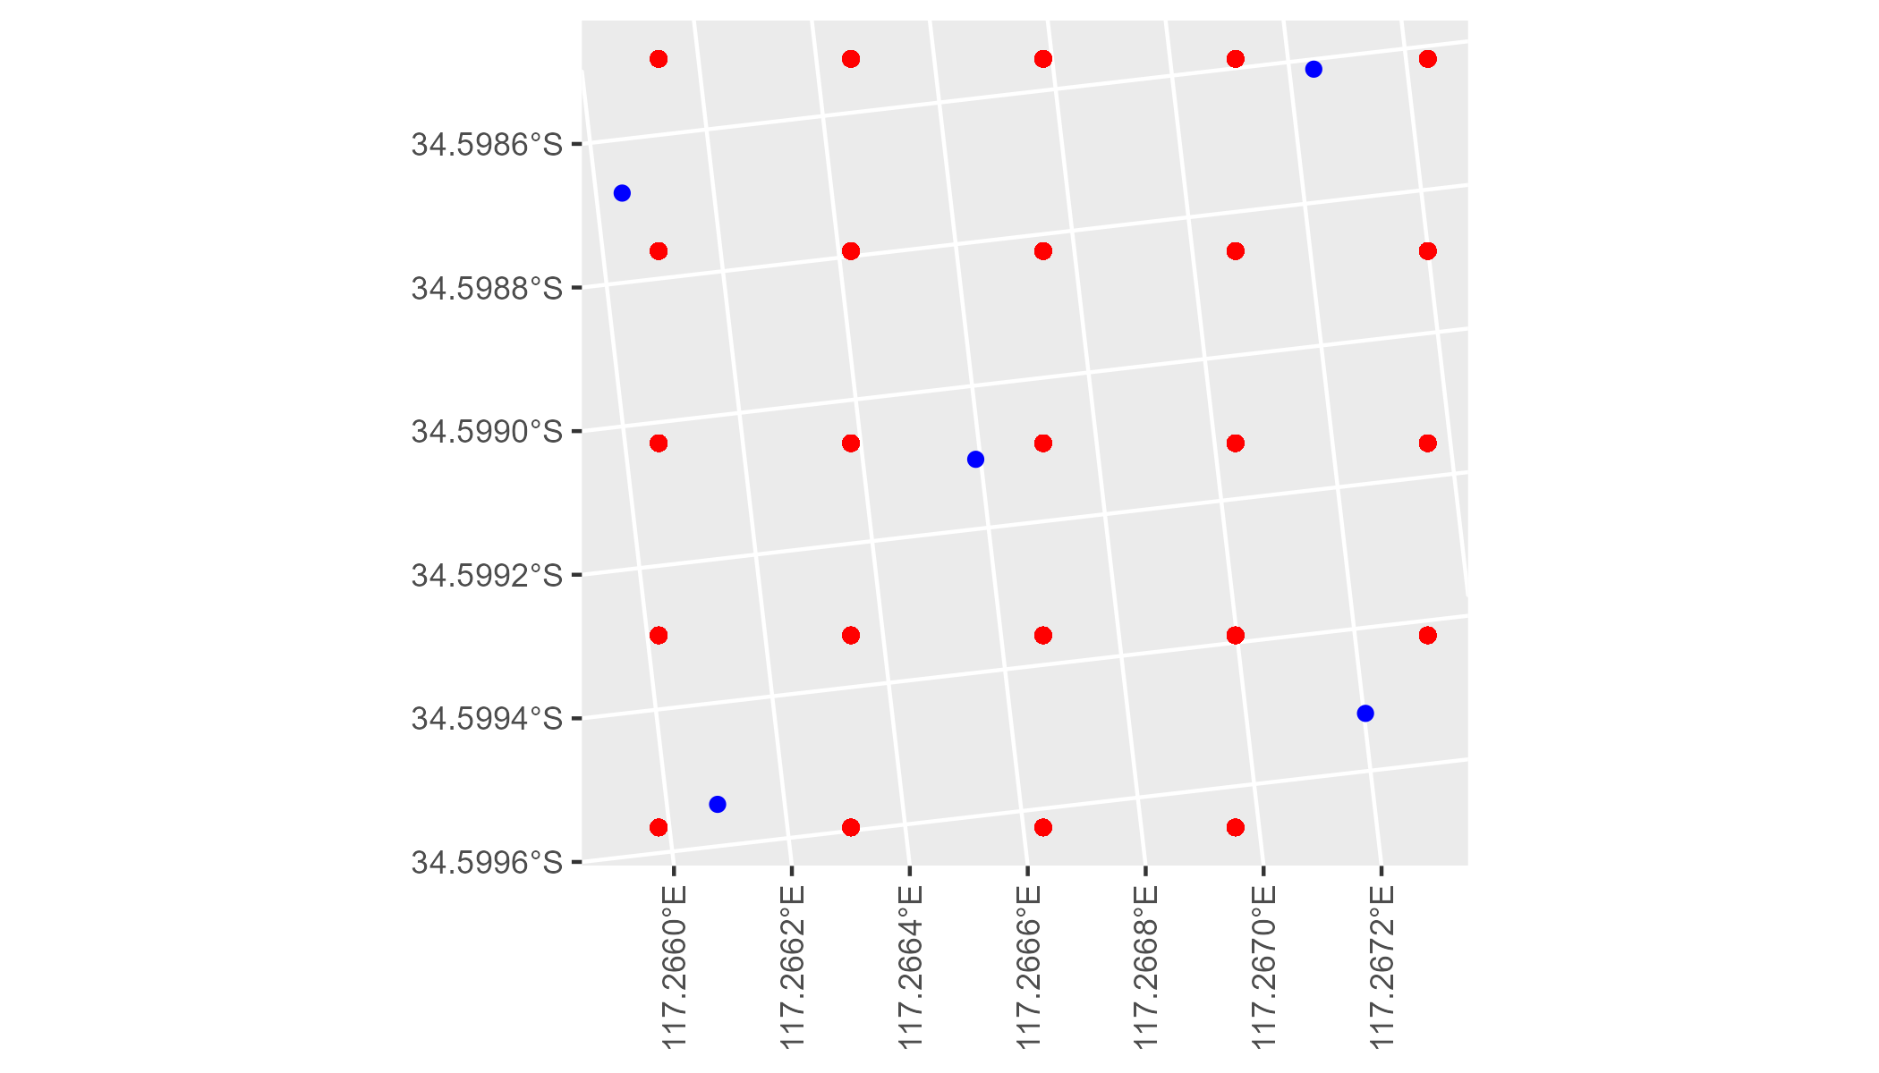

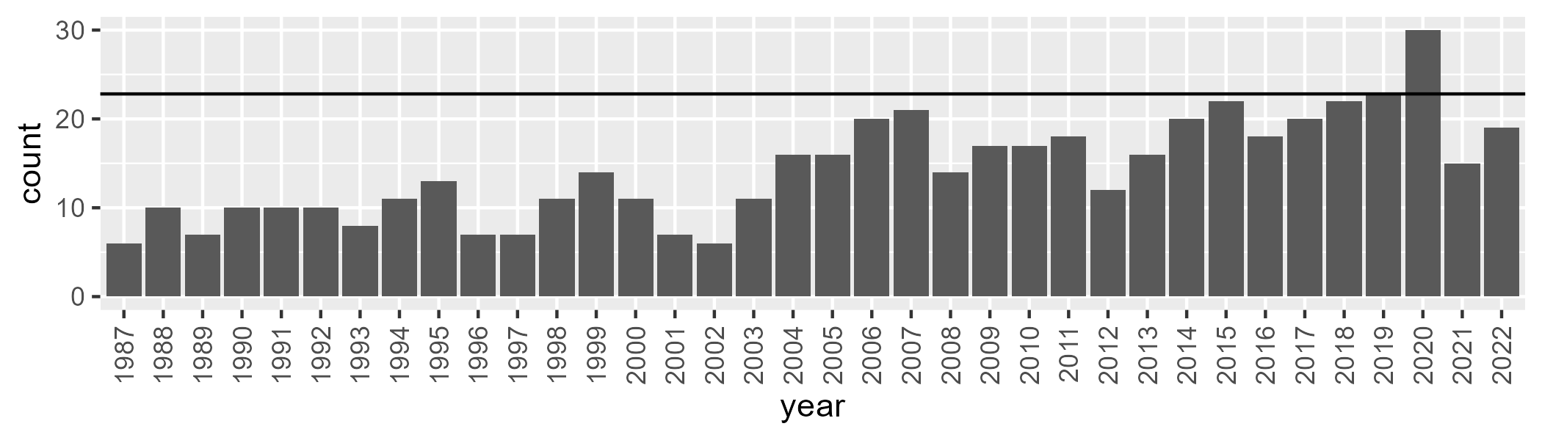

Number of samples: 515

# WAAJAF0003

| Min. | 1st Qu. | Median | Mean | 3rd Qu. | Max. |
| --- | --- | --- | --- | --- | --- |
| 0 | 33.46273 | 37.50742 | 36.7369 | 41.42576 | 51.7992 |

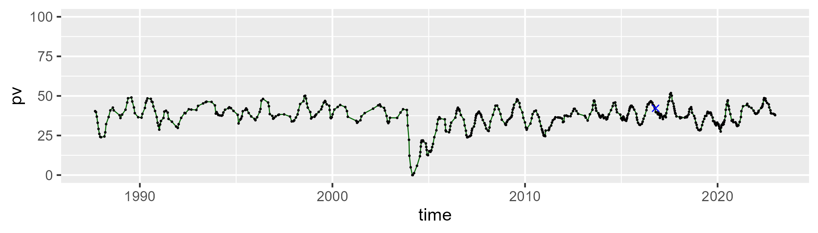

| Min. | 1st Qu. | Median | Mean | 3rd Qu. | Max. |
| --- | --- | --- | --- | --- | --- |
| 15.28453 | 40.41275 | 43.77113 | 44.12239 | 48.65429 | 60.82749 |

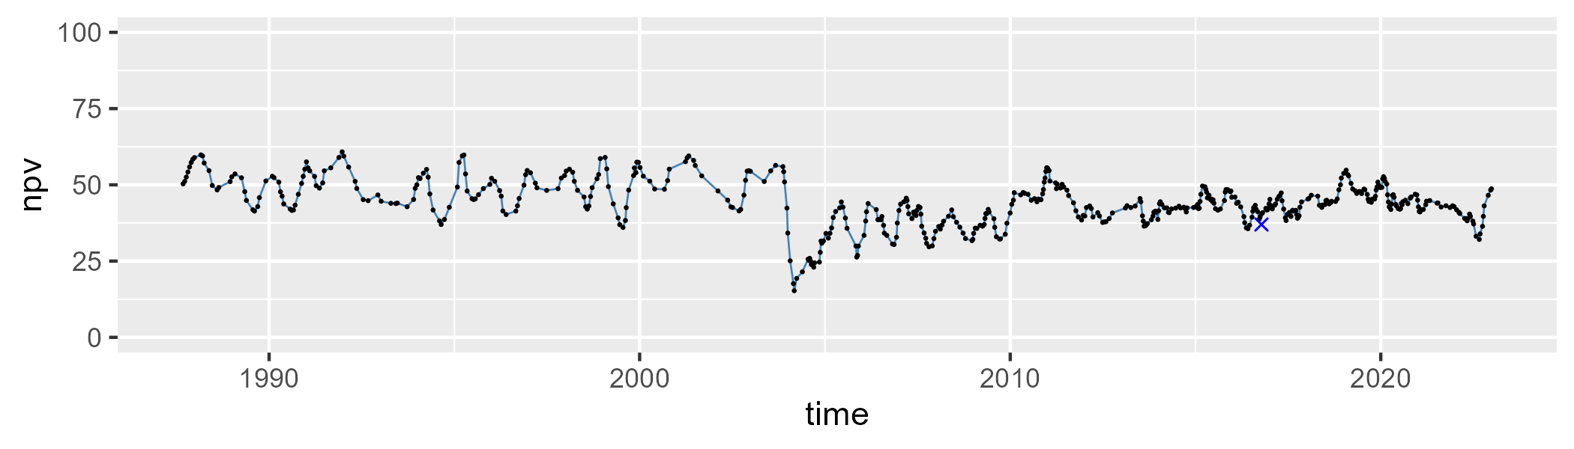

| Min. | 1st Qu. | Median | Mean | 3rd Qu. | Max. |
| --- | --- | --- | --- | --- | --- |
| 0.96804 | 11.21362 | 16.30158 | 17.86949 | 20.36727 | 85.28672 |

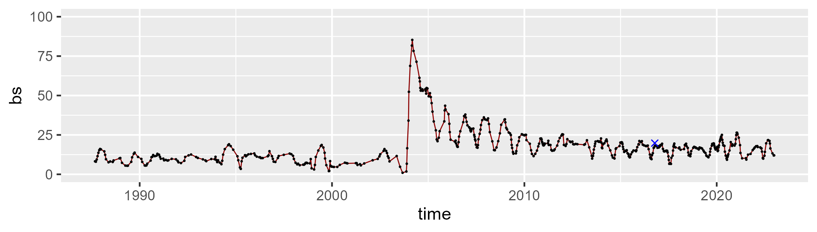

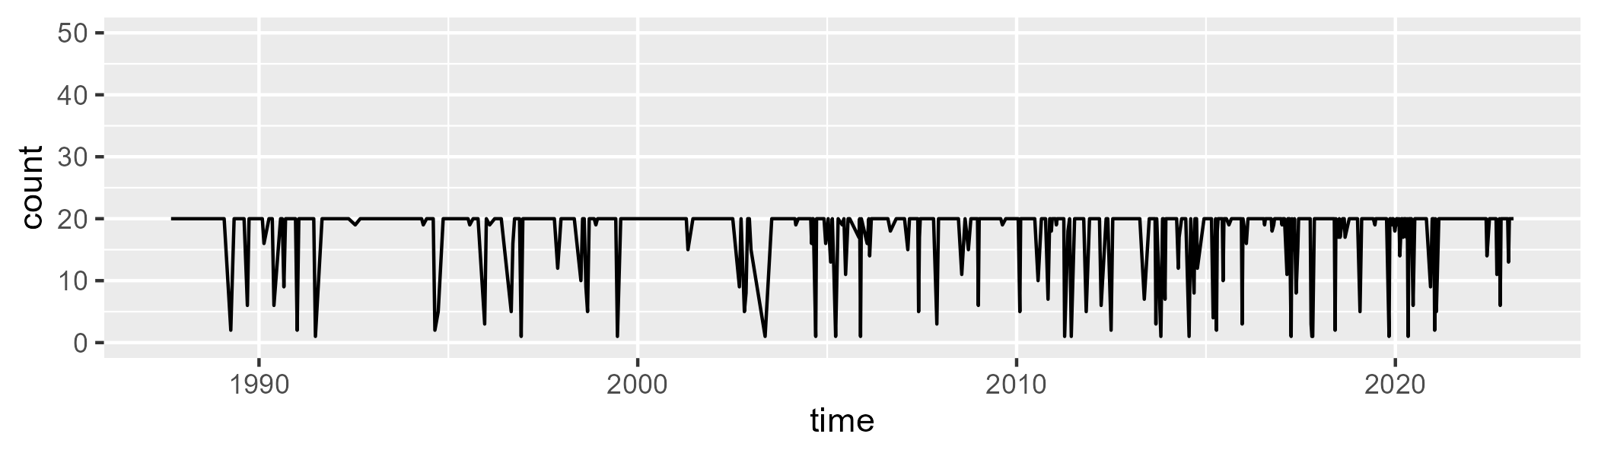

Min. : 1.00 1st Qu.:20.00 Median :20.00 Mean :17.99 3rd Qu.:20.00 Max. :20.00

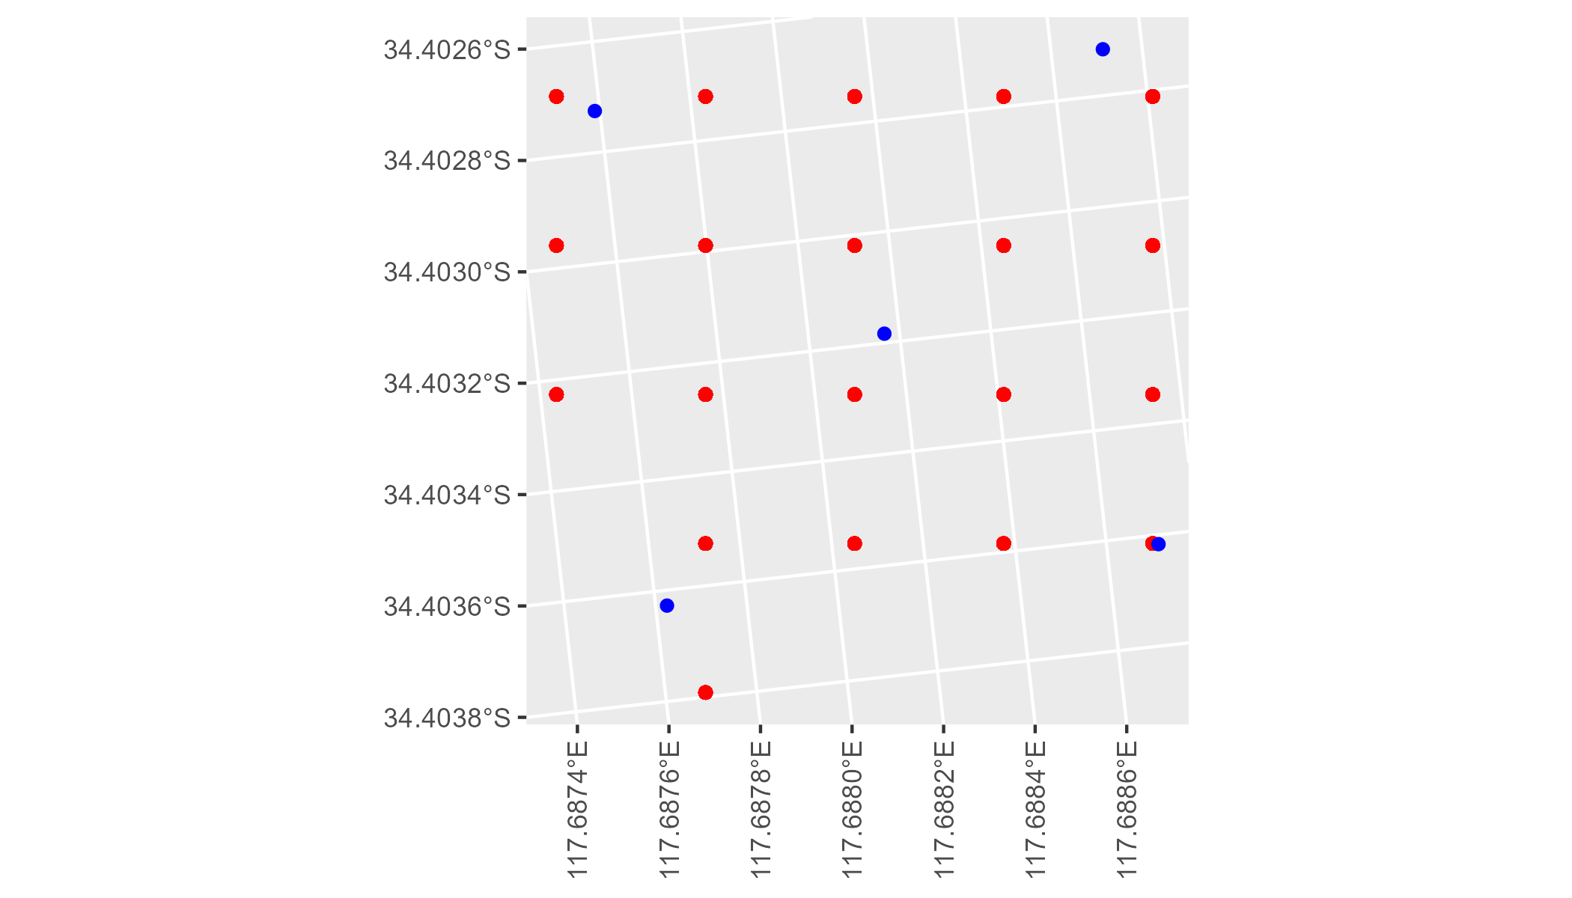

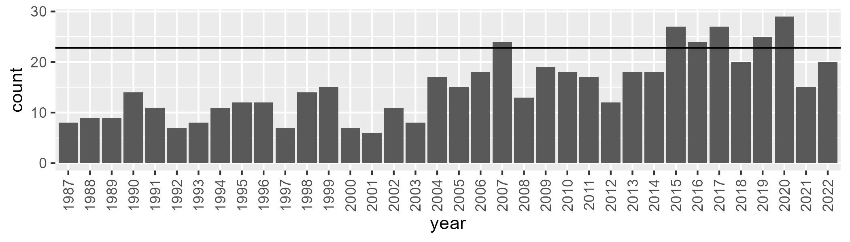

Number of samples: 545

# WAALSD0001

| Min. | 1st Qu. | Median | Mean | 3rd Qu. | Max. |
| --- | --- | --- | --- | --- | --- |
| 2.525405 | 7.74744 | 10.78055 | 11.51047 | 14.55213 | 35.4561 |

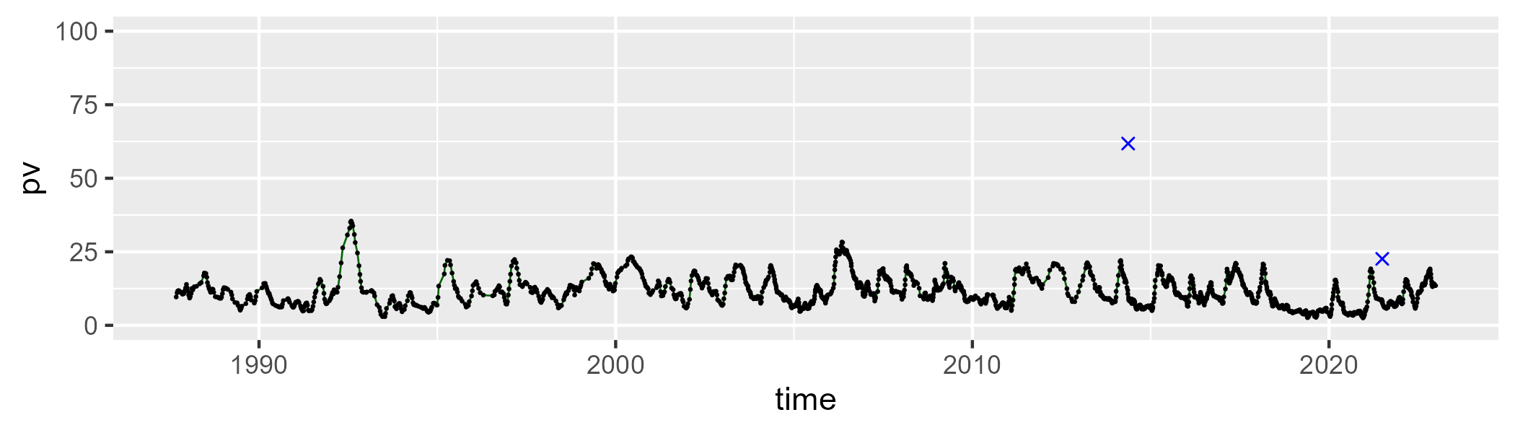

| Min. | 1st Qu. | Median | Mean | 3rd Qu. | Max. |
| --- | --- | --- | --- | --- | --- |
| 22.00173 | 39.54738 | 41.68199 | 41.1489 | 43.58542 | 53.71678 |

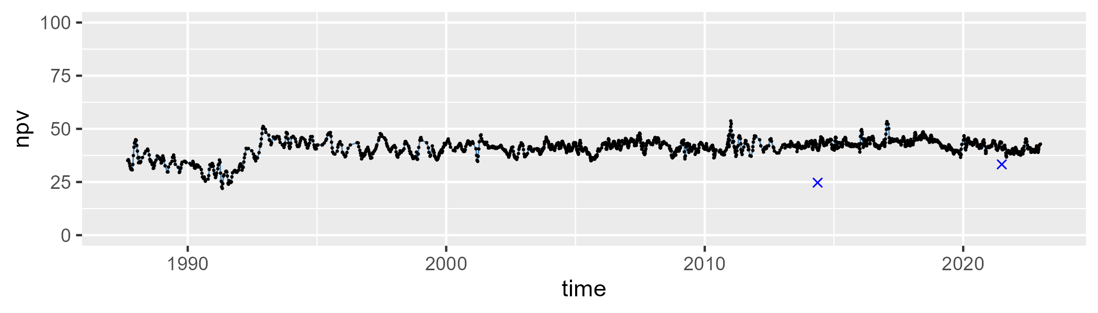

| Min. | 1st Qu. | Median | Mean | 3rd Qu. | Max. |
| --- | --- | --- | --- | --- | --- |
| 26.79071 | 41.40956 | 46.35577 | 45.87301 | 49.90423 | 68.90481 |

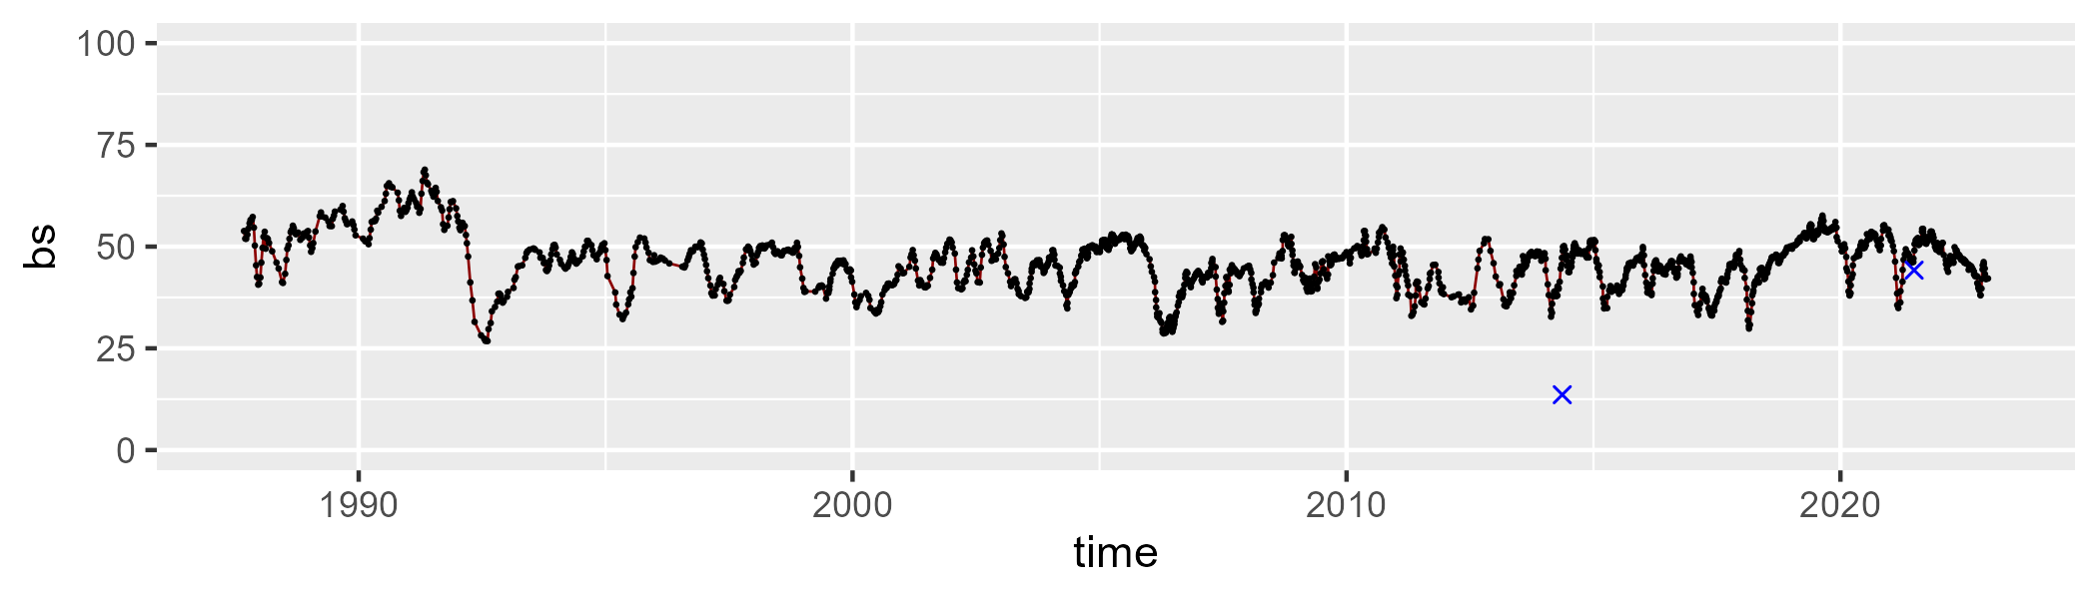

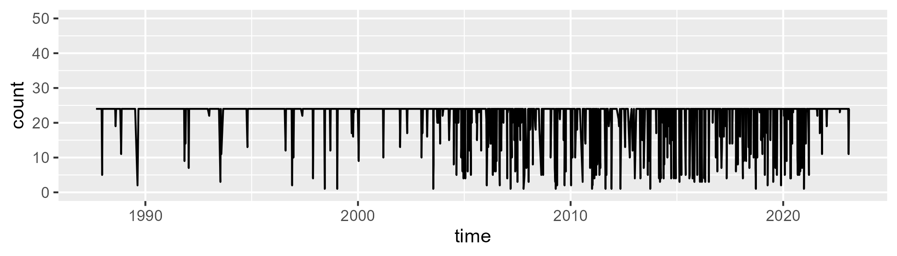

Min. : 1.00 1st Qu.:24.00 Median :24.00 Mean :22.07 3rd Qu.:24.00 Max. :24.00

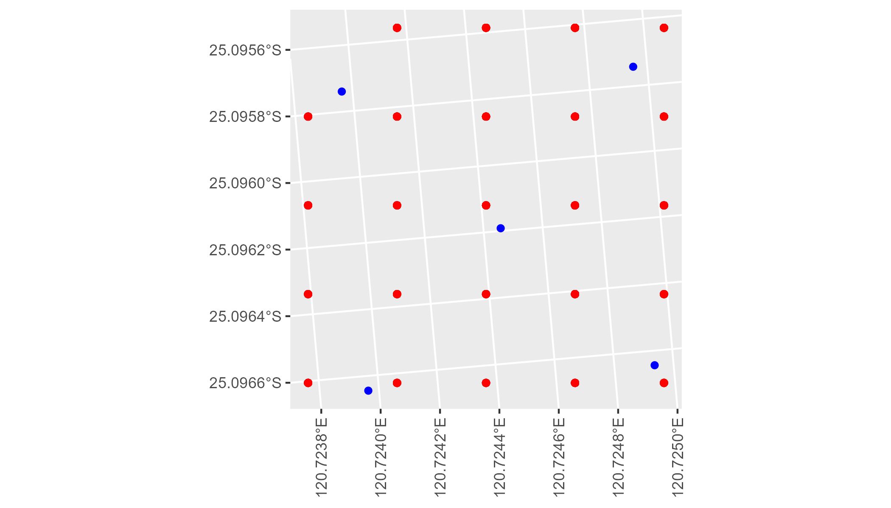

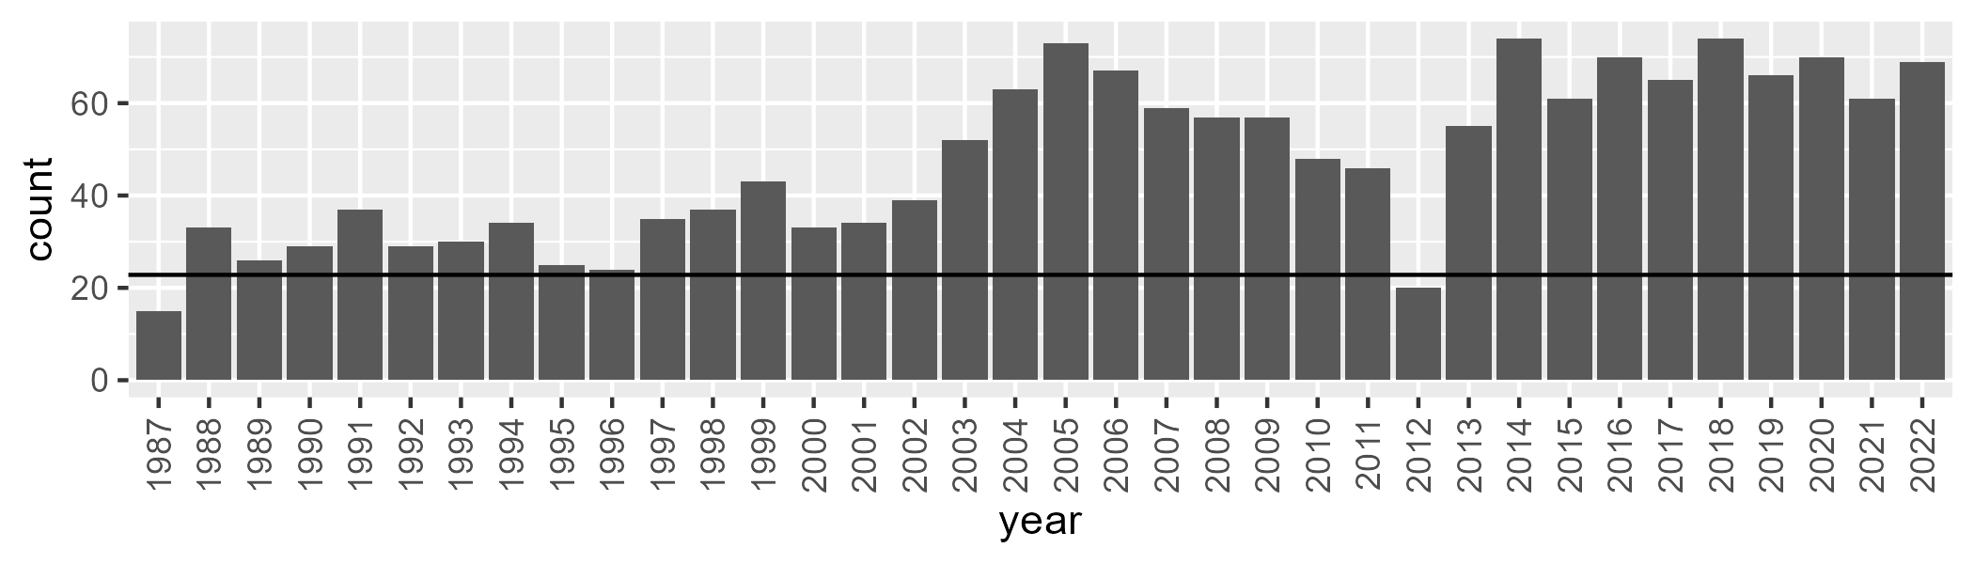

Number of samples: 1710

# WAALSD0002

| Min. | 1st Qu. | Median | Mean | 3rd Qu. | Max. |
| --- | --- | --- | --- | --- | --- |
| 2.466763 | 10.37926 | 13.51154 | 13.33138 | 16.43853 | 24.23426 |

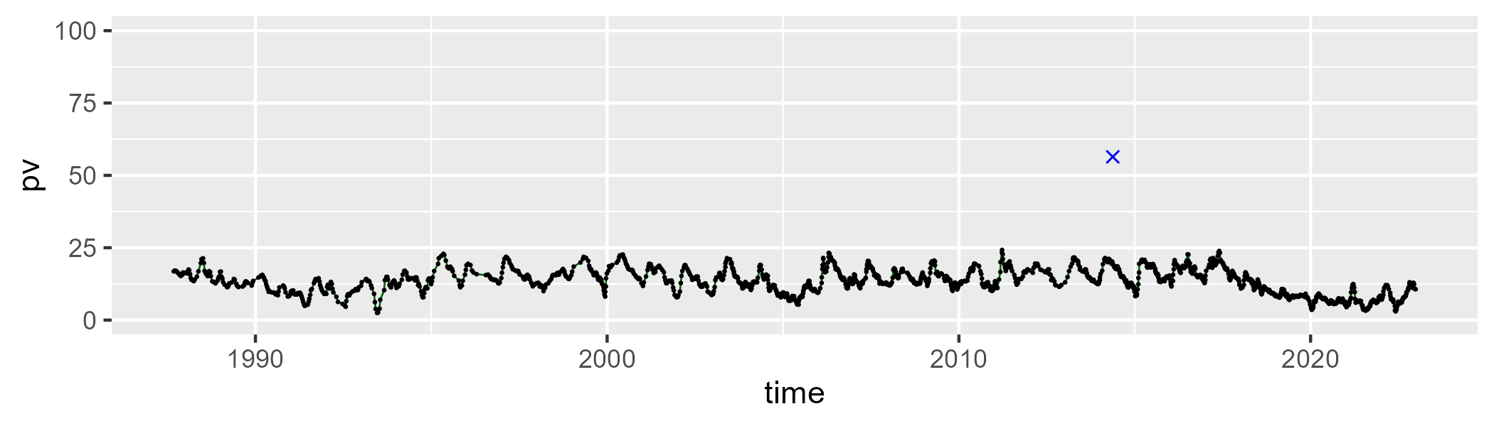

| Min. | 1st Qu. | Median | Mean | 3rd Qu. | Max. |
| --- | --- | --- | --- | --- | --- |
| 24.87072 | 38.43689 | 41.10468 | 40.56901 | 43.32897 | 55.0284 |

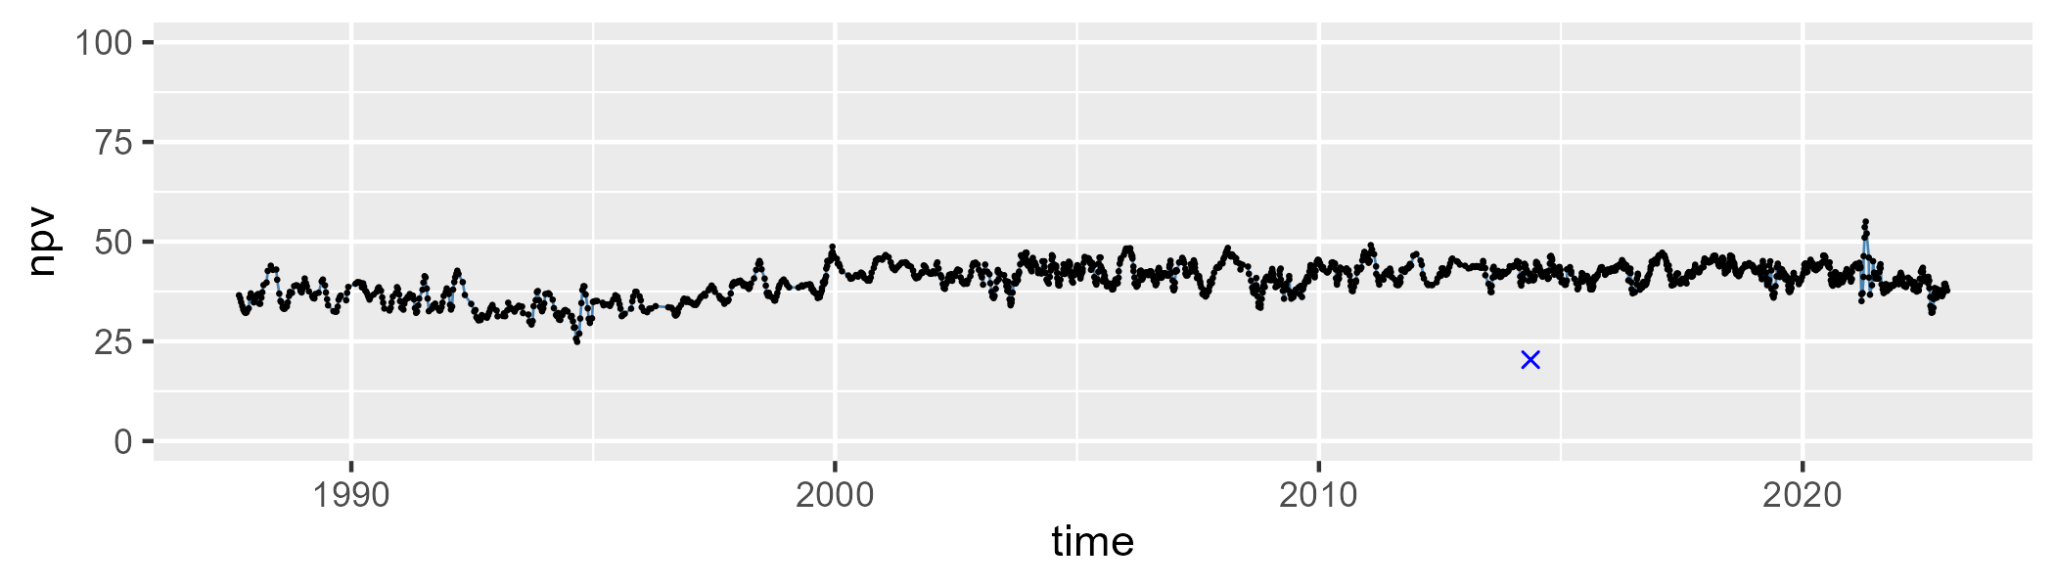

| Min. | 1st Qu. | Median | Mean | 3rd Qu. | Max. |
| --- | --- | --- | --- | --- | --- |
| 30.94011 | 40.49132 | 44.287 | 44.60986 | 48.6201 | 62.50887 |

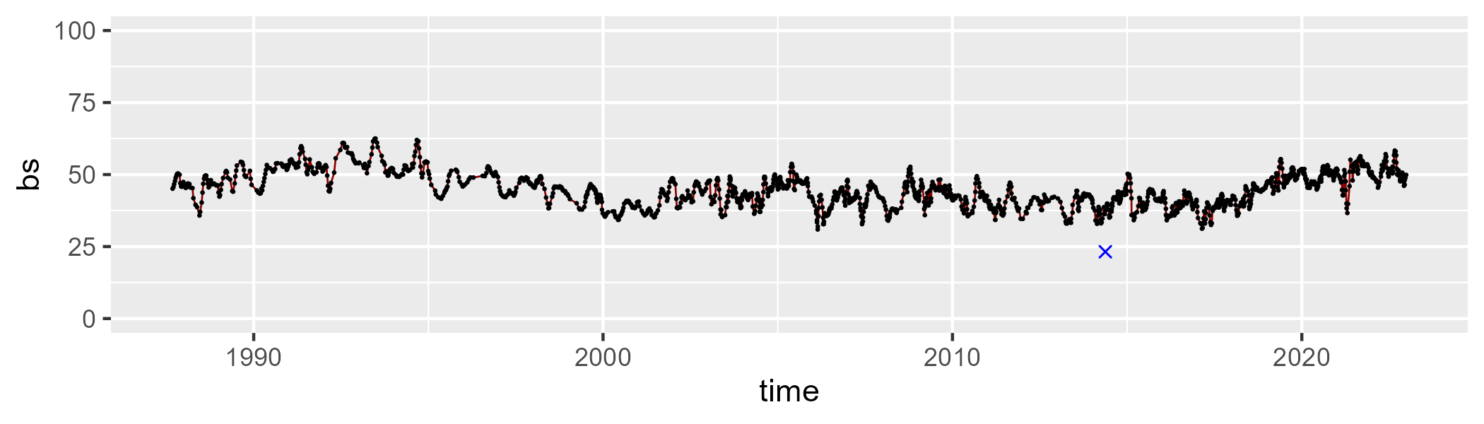

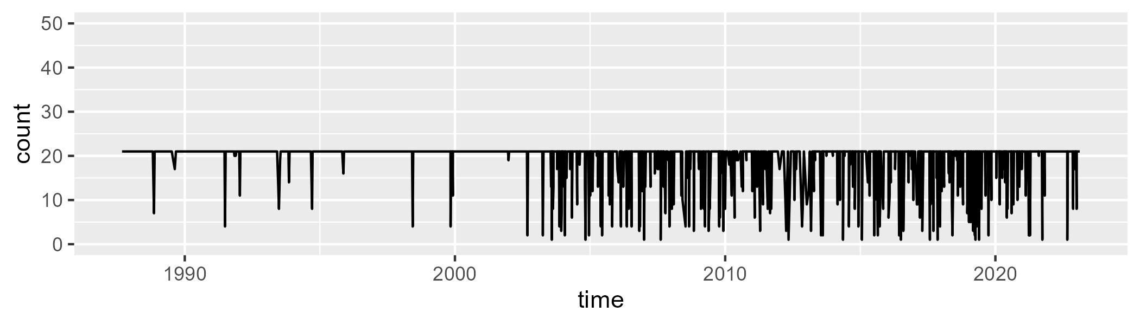

Min. : 1.00 1st Qu.:21.00 Median :21.00 Mean :19.47 3rd Qu.:21.00 Max. :21.00

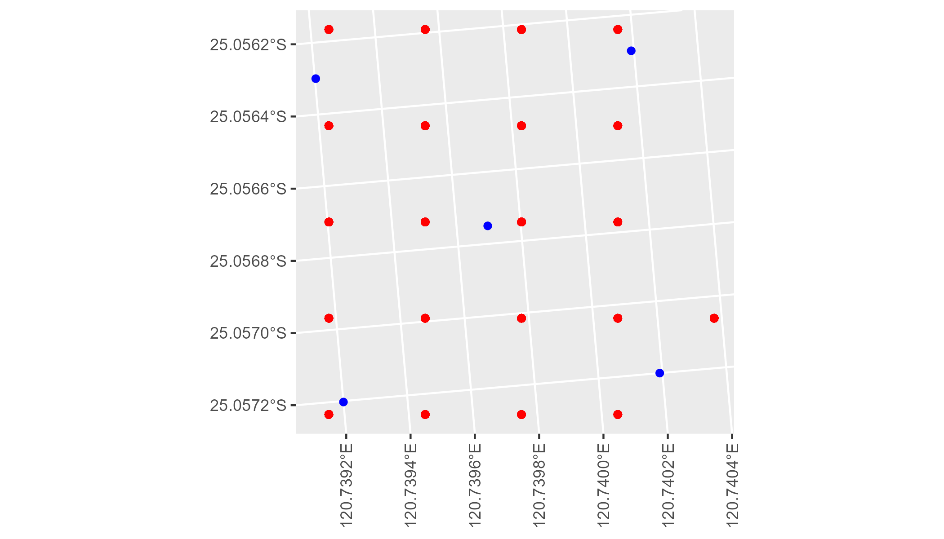

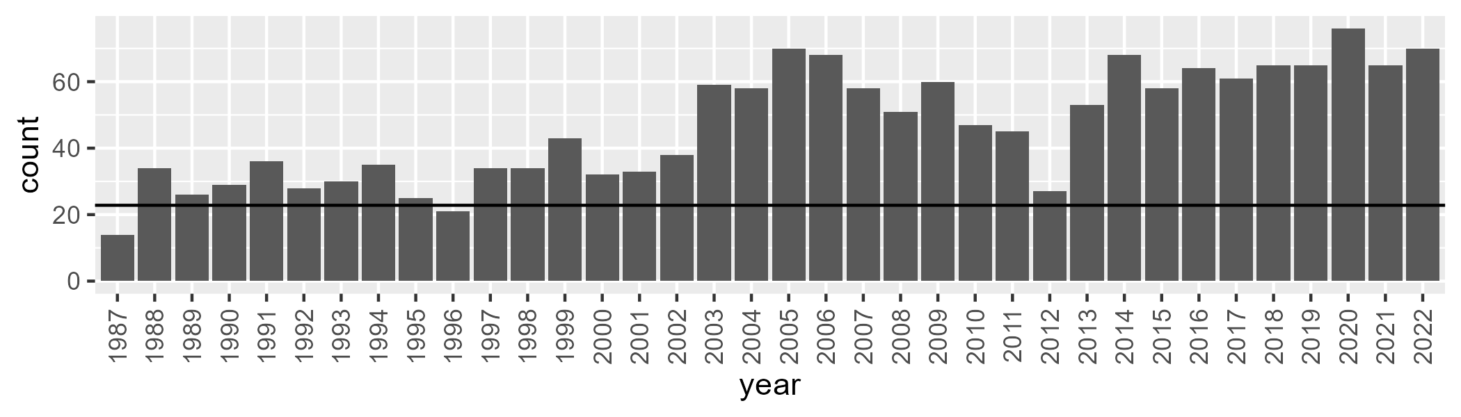

Number of samples: 1680

# WAALSD0003

| Min. | 1st Qu. | Median | Mean | 3rd Qu. | Max. |
| --- | --- | --- | --- | --- | --- |
| 3.395316 | 8.834145 | 11.90458 | 12.19969 | 14.76268 | 23.49821 |

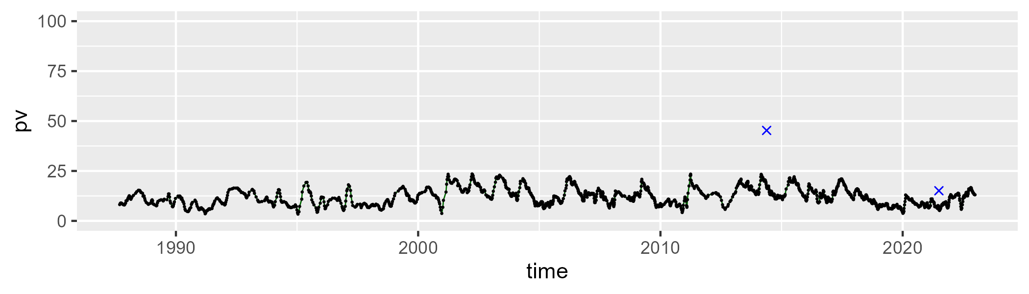

| Min. | 1st Qu. | Median | Mean | 3rd Qu. | Max. |
| --- | --- | --- | --- | --- | --- |
| 16.84616 | 29.72773 | 34.02602 | 34.57478 | 38.11184 | 56.05753 |

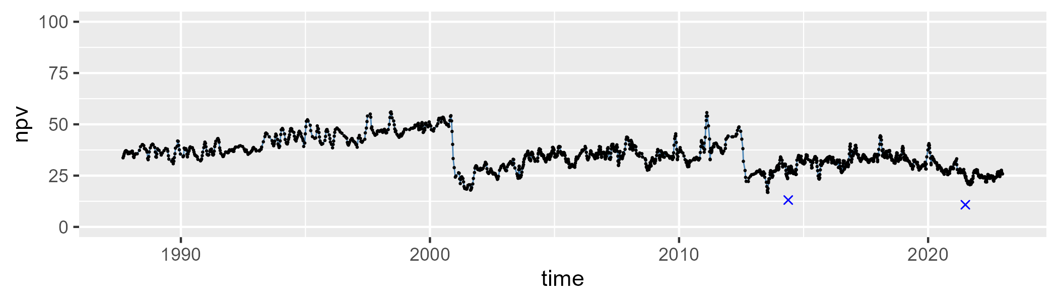

| Min. | 1st Qu. | Median | Mean | 3rd Qu. | Max. |
| --- | --- | --- | --- | --- | --- |
| 28.65868 | 46.97279 | 52.23857 | 51.60302 | 56.34343 | 69.87303 |

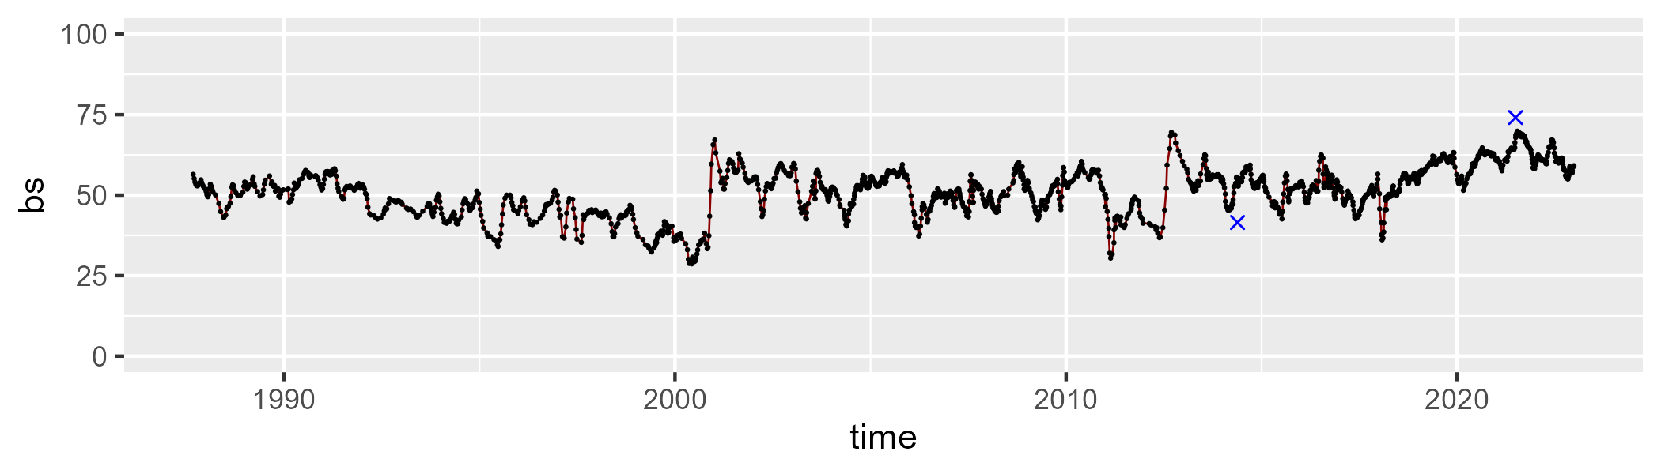

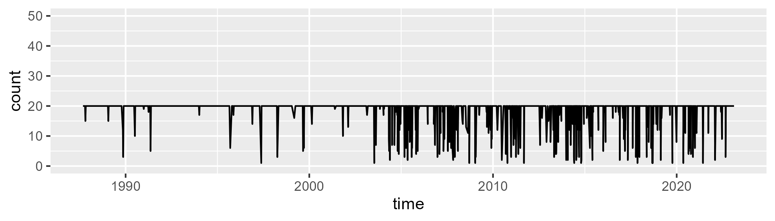

Min. : 1.00 1st Qu.:20.00 Median :20.00 Mean :18.73 3rd Qu.:20.00 Max. :20.00

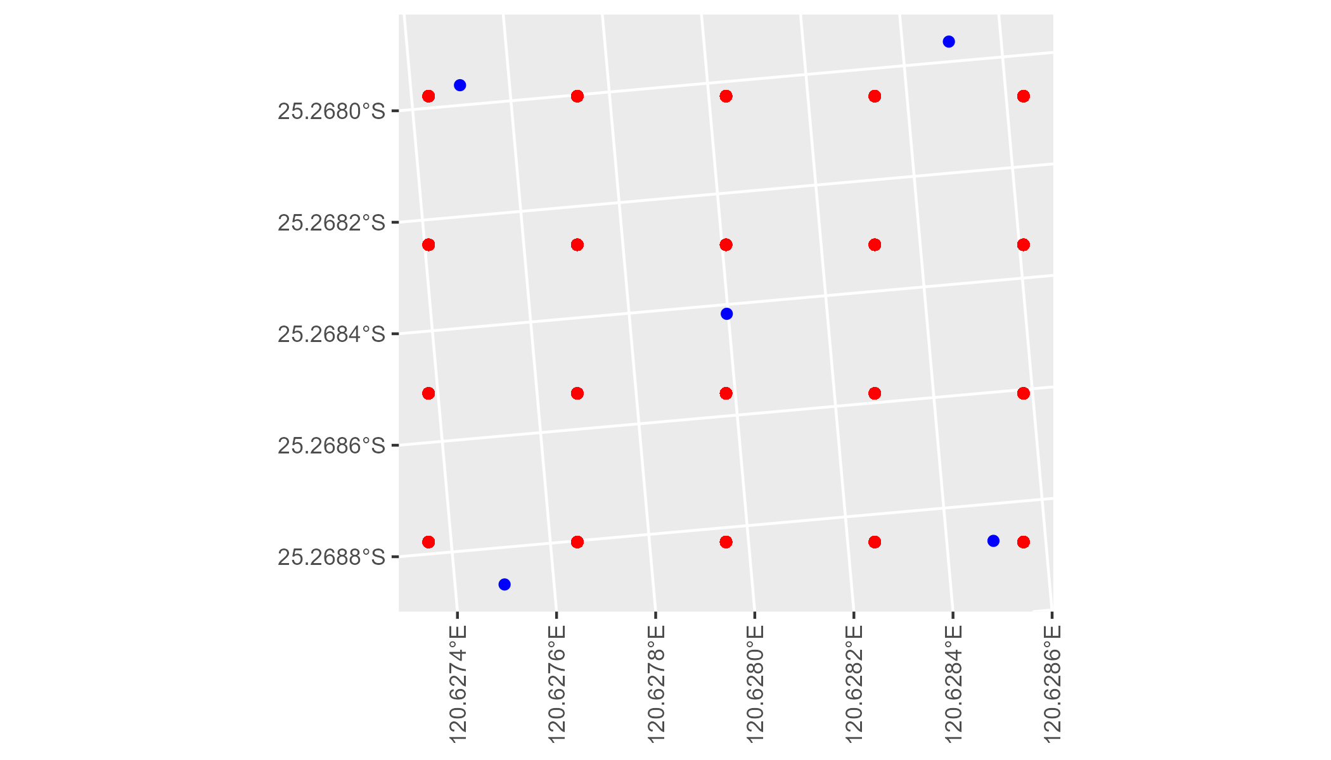

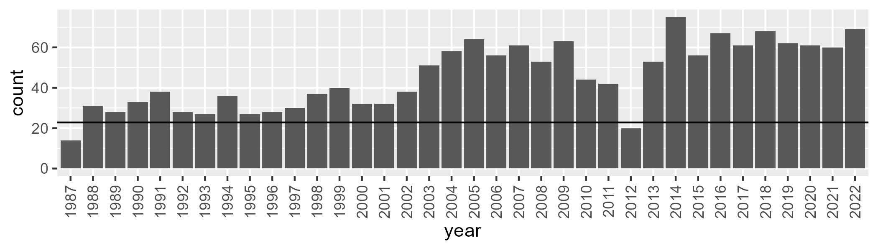

Number of samples: 1643

# WAAMAL0001

| Min. | 1st Qu. | Median | Mean | 3rd Qu. | Max. |
| --- | --- | --- | --- | --- | --- |
| 1.658999 | 20.81098 | 26.12477 | 25.38188 | 31.23239 | 40.72539 |

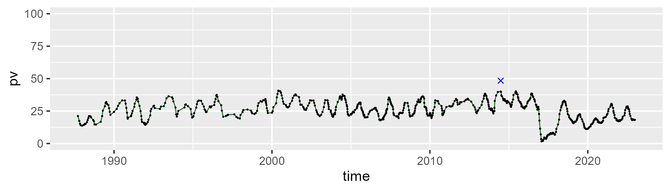

| Min. | 1st Qu. | Median | Mean | 3rd Qu. | Max. |
| --- | --- | --- | --- | --- | --- |
| 8.238147 | 41.83843 | 48.82186 | 43.65568 | 51.60647 | 58.92682 |

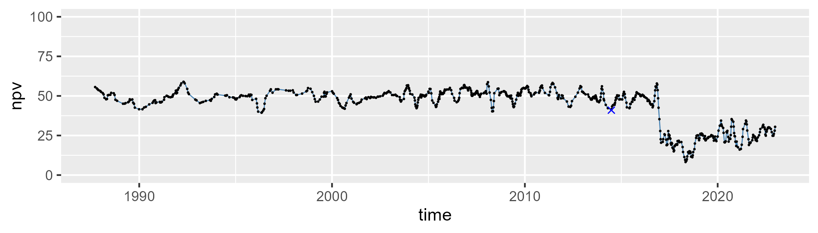

| Min. | 1st Qu. | Median | Mean | 3rd Qu. | Max. |
| --- | --- | --- | --- | --- | --- |
| 11.0213 | 18.48288 | 22.56725 | 29.64345 | 32.85264 | 75.93608 |

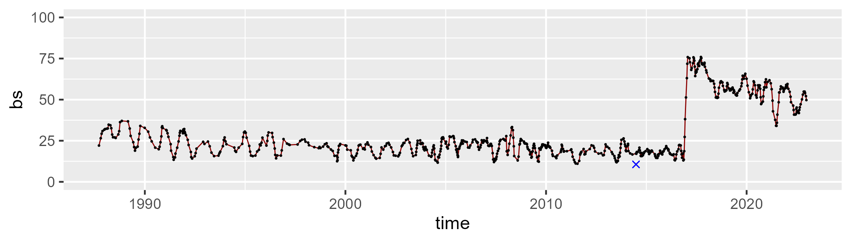

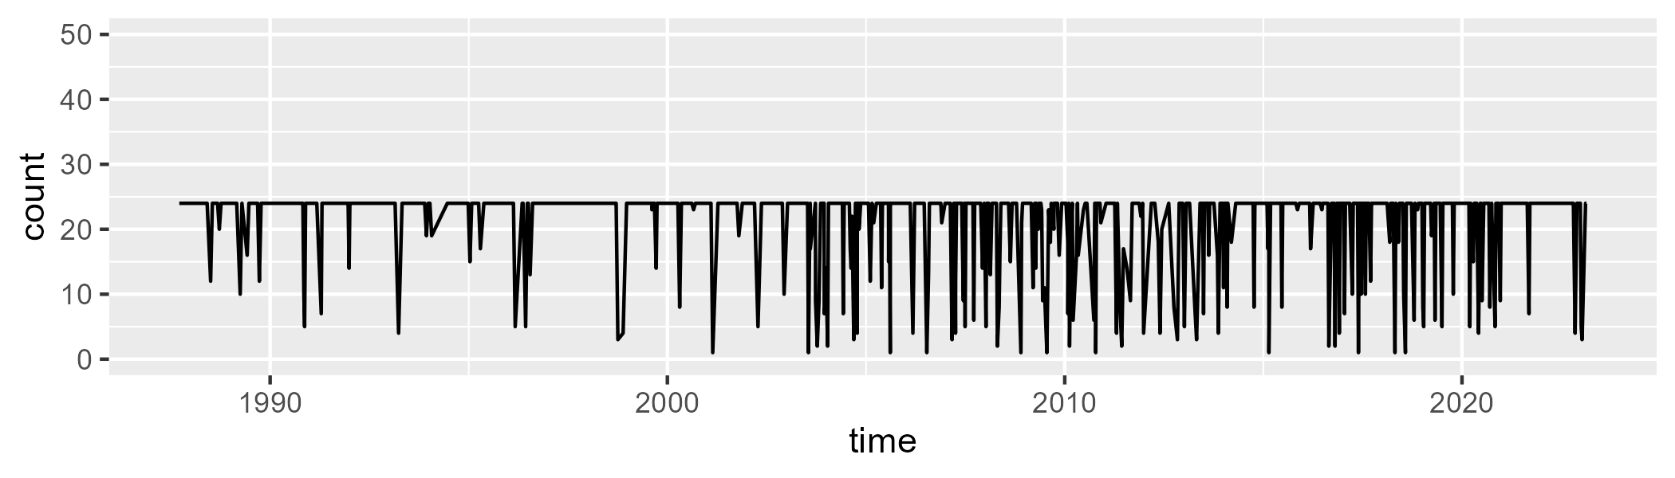

Min. : 1.00 1st Qu.:24.00 Median :24.00 Mean :21.06 3rd Qu.:24.00 Max. :24.00

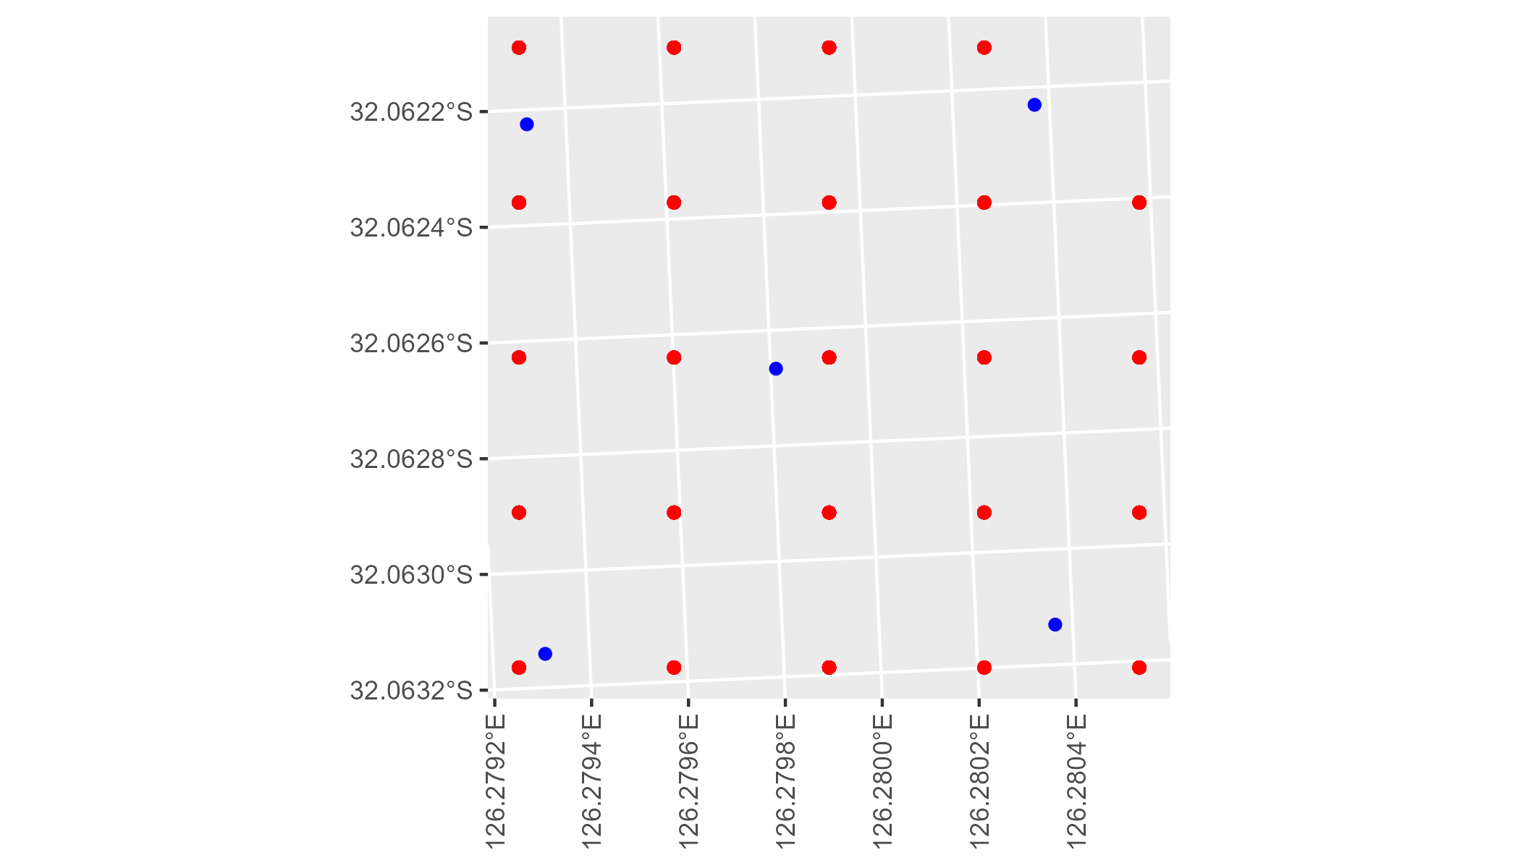

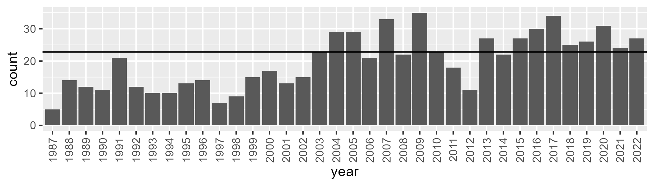

Number of samples: 715

# WAAMAL0002

| Min. | 1st Qu. | Median | Mean | 3rd Qu. | Max. |
| --- | --- | --- | --- | --- | --- |
| 7.191149 | 17.41505 | 20.8593 | 21.10178 | 24.96615 | 34.07981 |

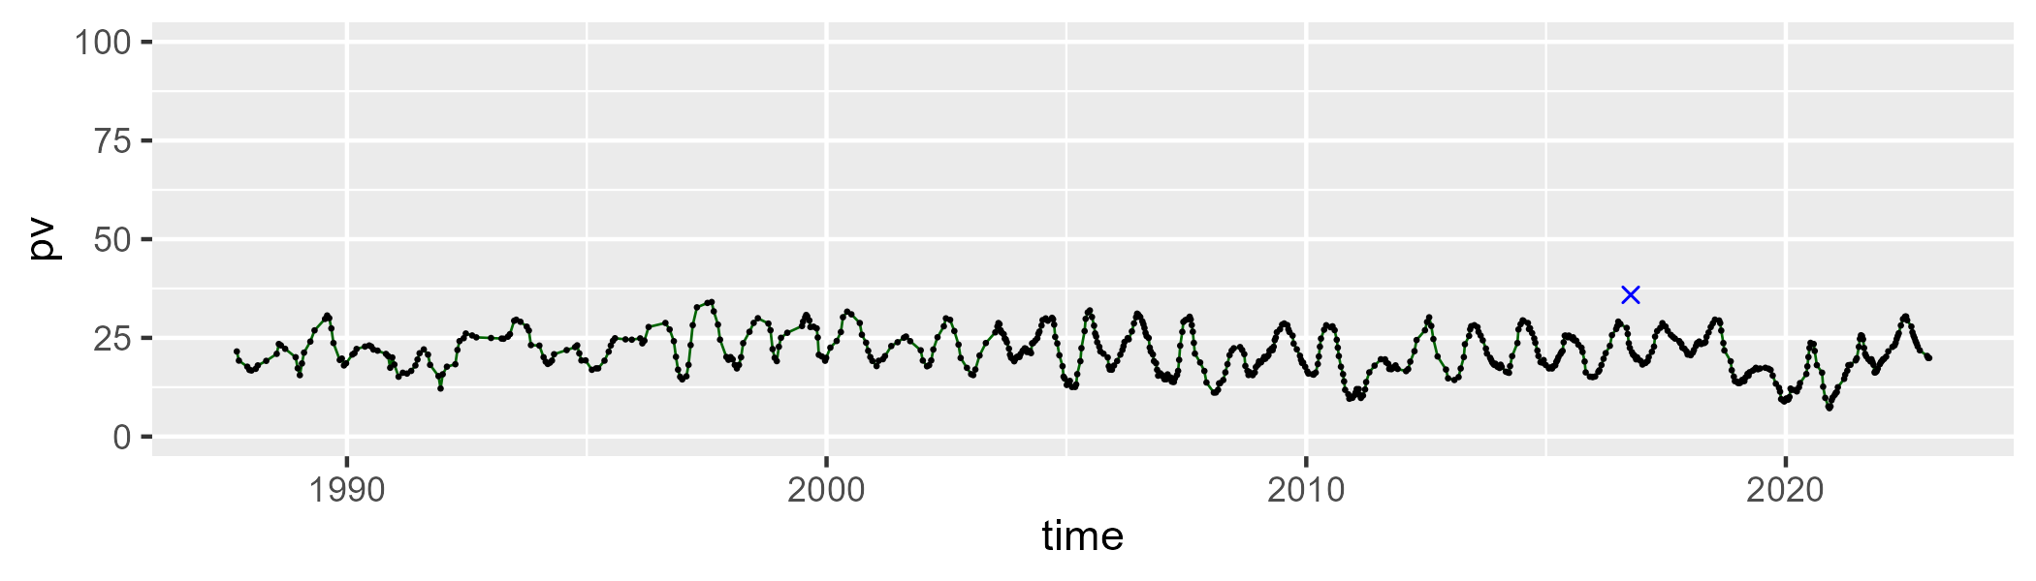

| Min. | 1st Qu. | Median | Mean | 3rd Qu. | Max. |
| --- | --- | --- | --- | --- | --- |
| 39.16885 | 60.20082 | 64.24126 | 64.3681 | 68.62542 | 79.67772 |

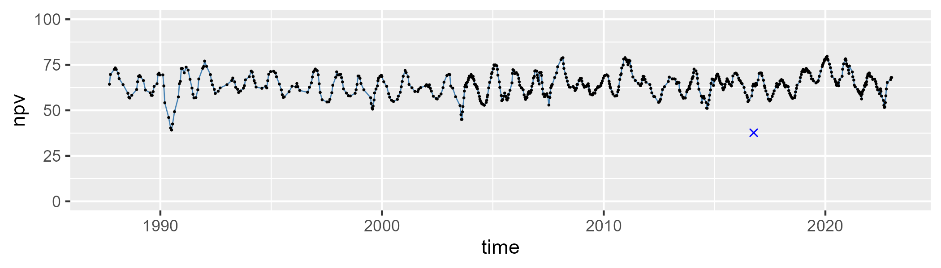

| Min. | 1st Qu. | Median | Mean | 3rd Qu. | Max. |
| --- | --- | --- | --- | --- | --- |
| 6.004539 | 11.09618 | 13.11795 | 13.41767 | 14.84191 | 37.0292 |

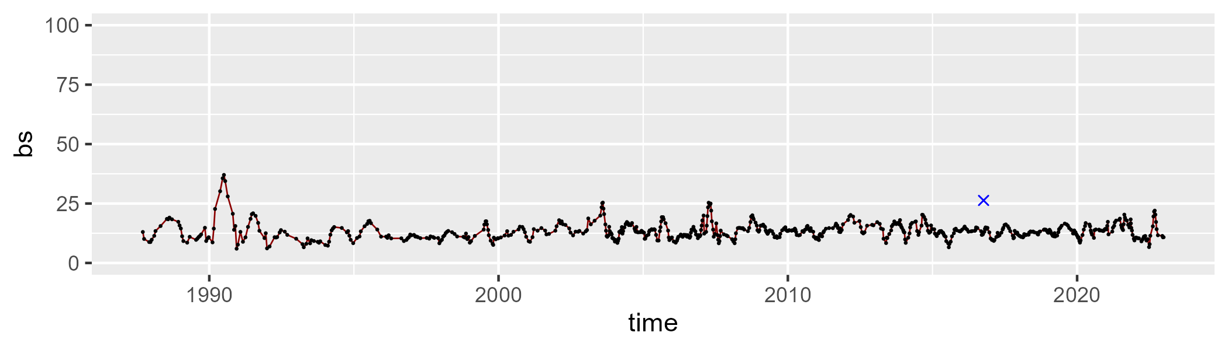

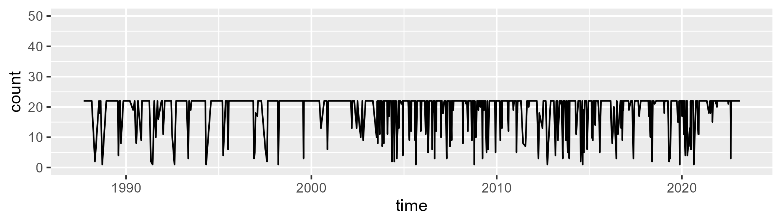

Min. : 1.00 1st Qu.:22.00 Median :22.00 Mean :19.26 3rd Qu.:22.00 Max. :22.00

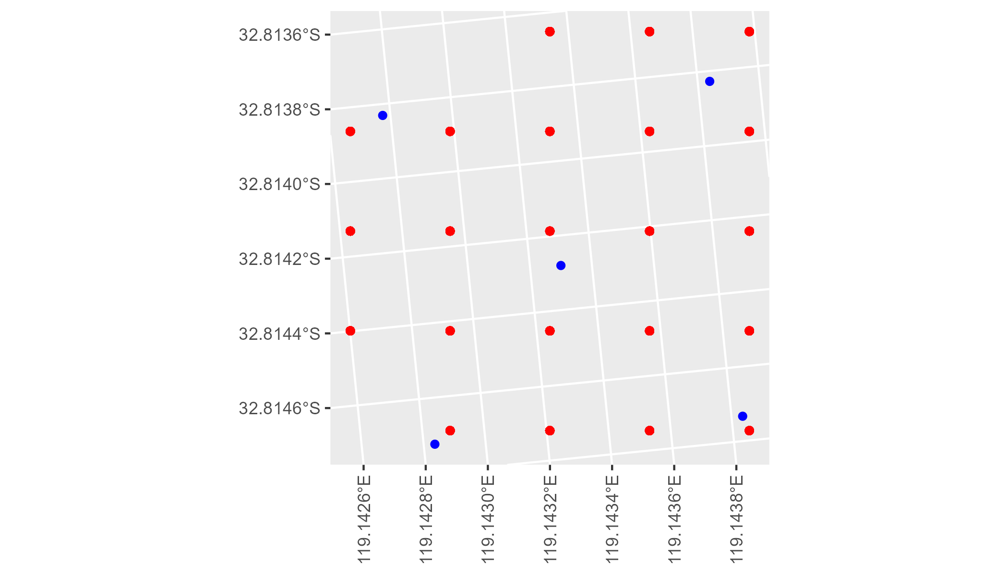

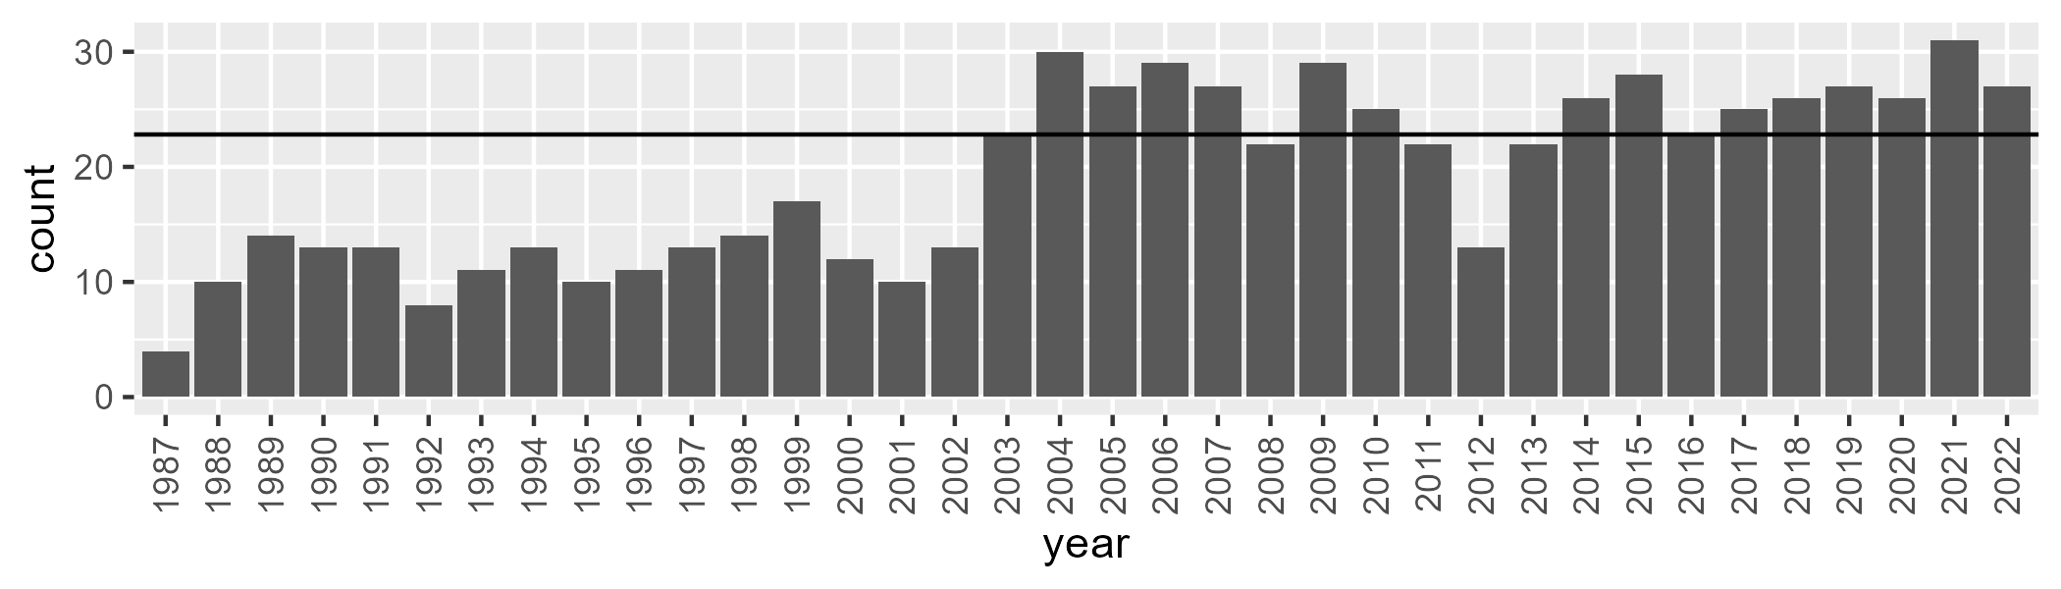

Number of samples: 694

# WAAMAL0003

| Min. | 1st Qu. | Median | Mean | 3rd Qu. | Max. |
| --- | --- | --- | --- | --- | --- |
| 10.87664 | 20.74281 | 24.34543 | 24.58037 | 29.08701 | 40.06377 |

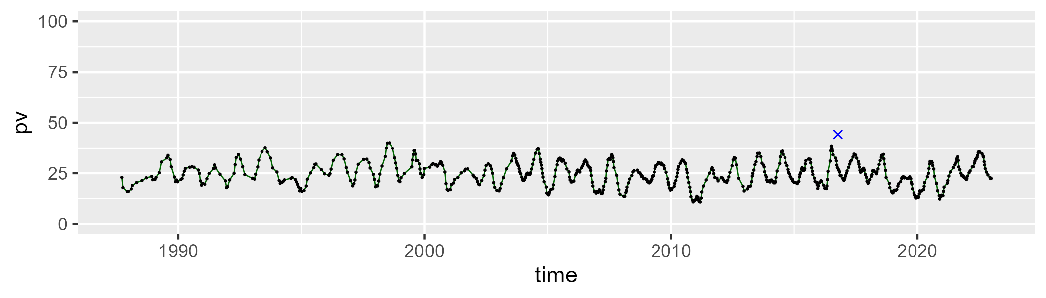

| Min. | 1st Qu. | Median | Mean | 3rd Qu. | Max. |
| --- | --- | --- | --- | --- | --- |
| 37.53437 | 53.16797 | 57.06318 | 57.31153 | 61.08627 | 74.99718 |

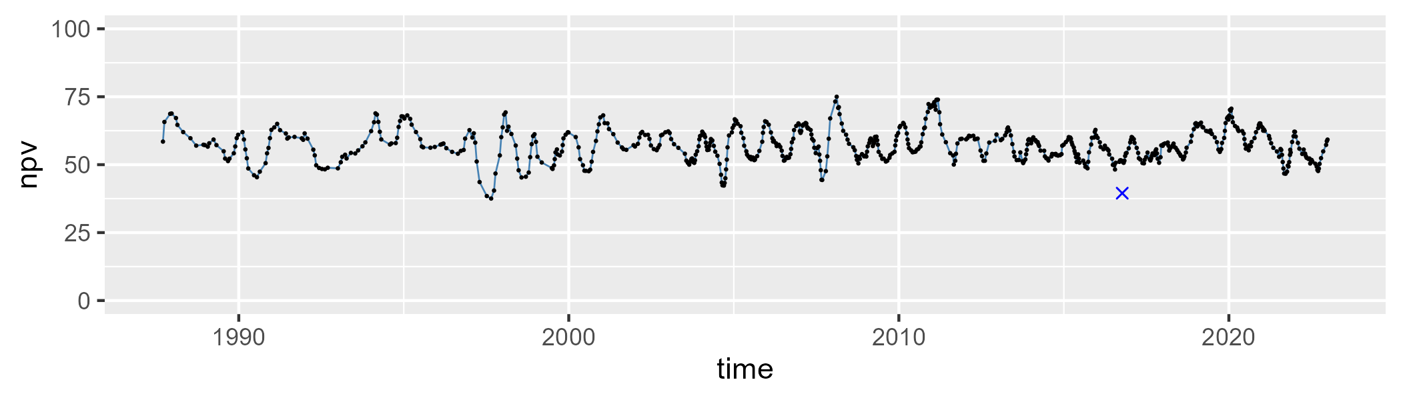

| Min. | 1st Qu. | Median | Mean | 3rd Qu. | Max. |
| --- | --- | --- | --- | --- | --- |
| 7.067474 | 14.24881 | 16.75781 | 16.89436 | 19.26055 | 29.36234 |

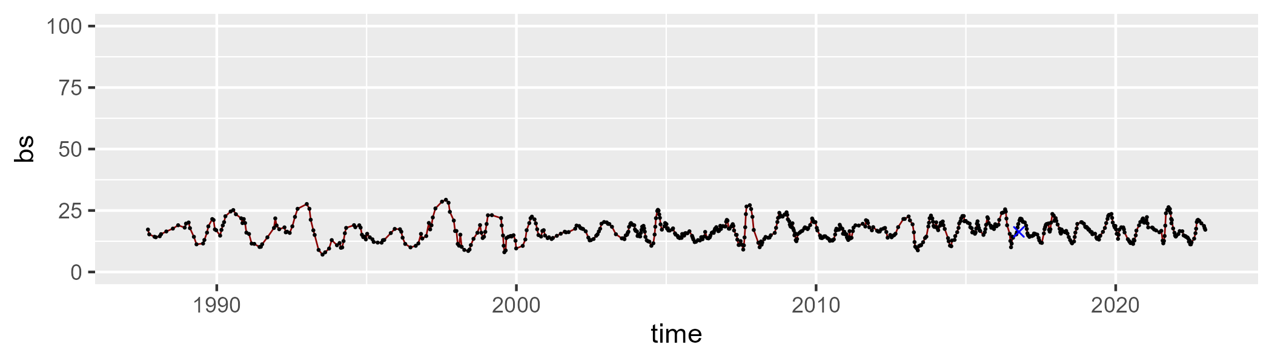

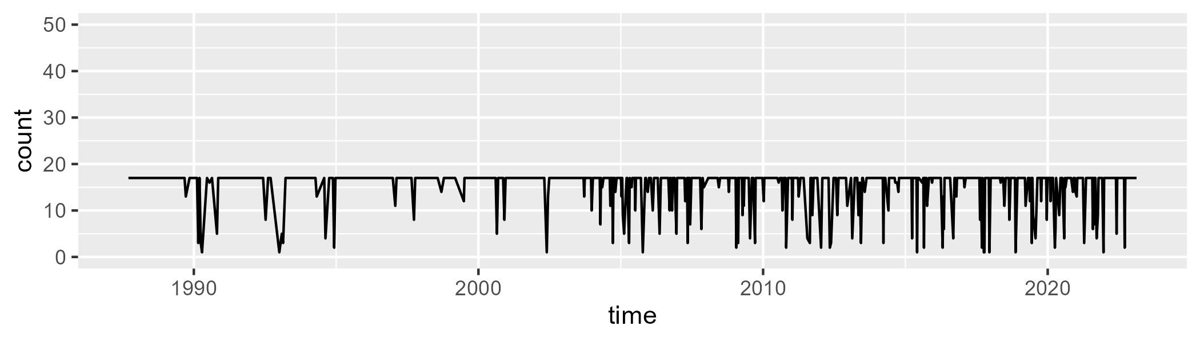

Min. : 1.0 1st Qu.:17.0 Median :17.0 Mean :15.4 3rd Qu.:17.0 Max. :17.0

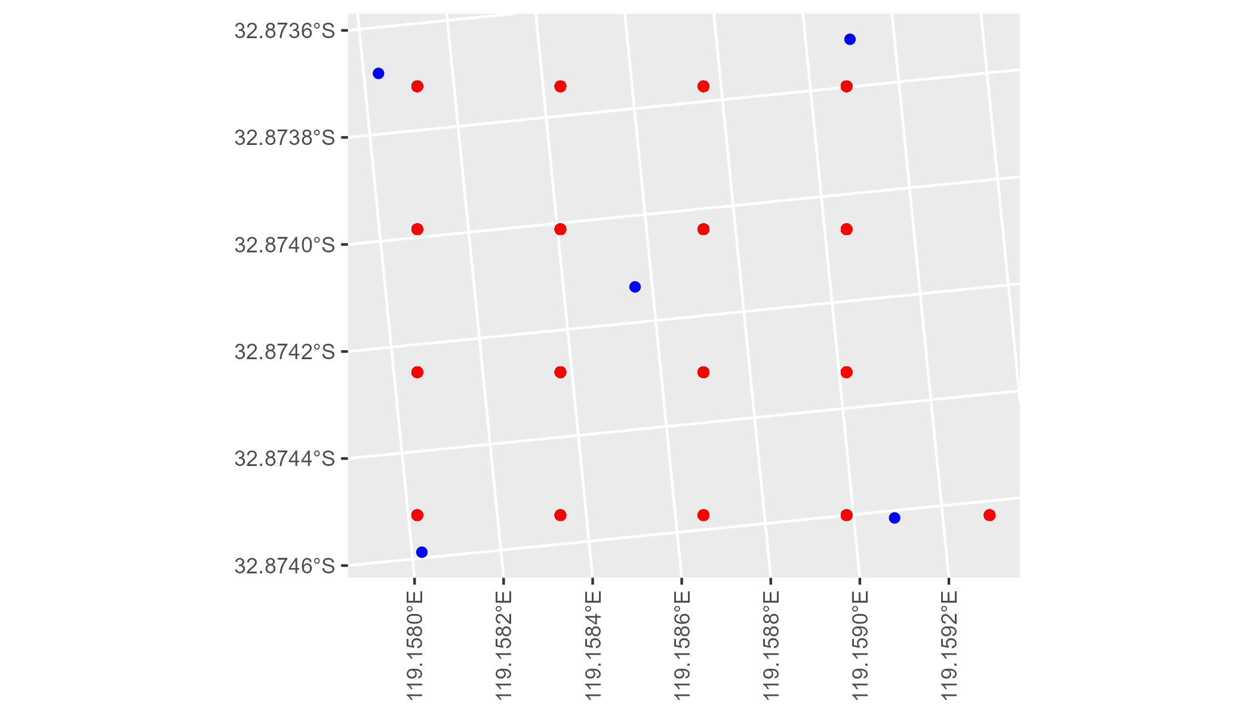

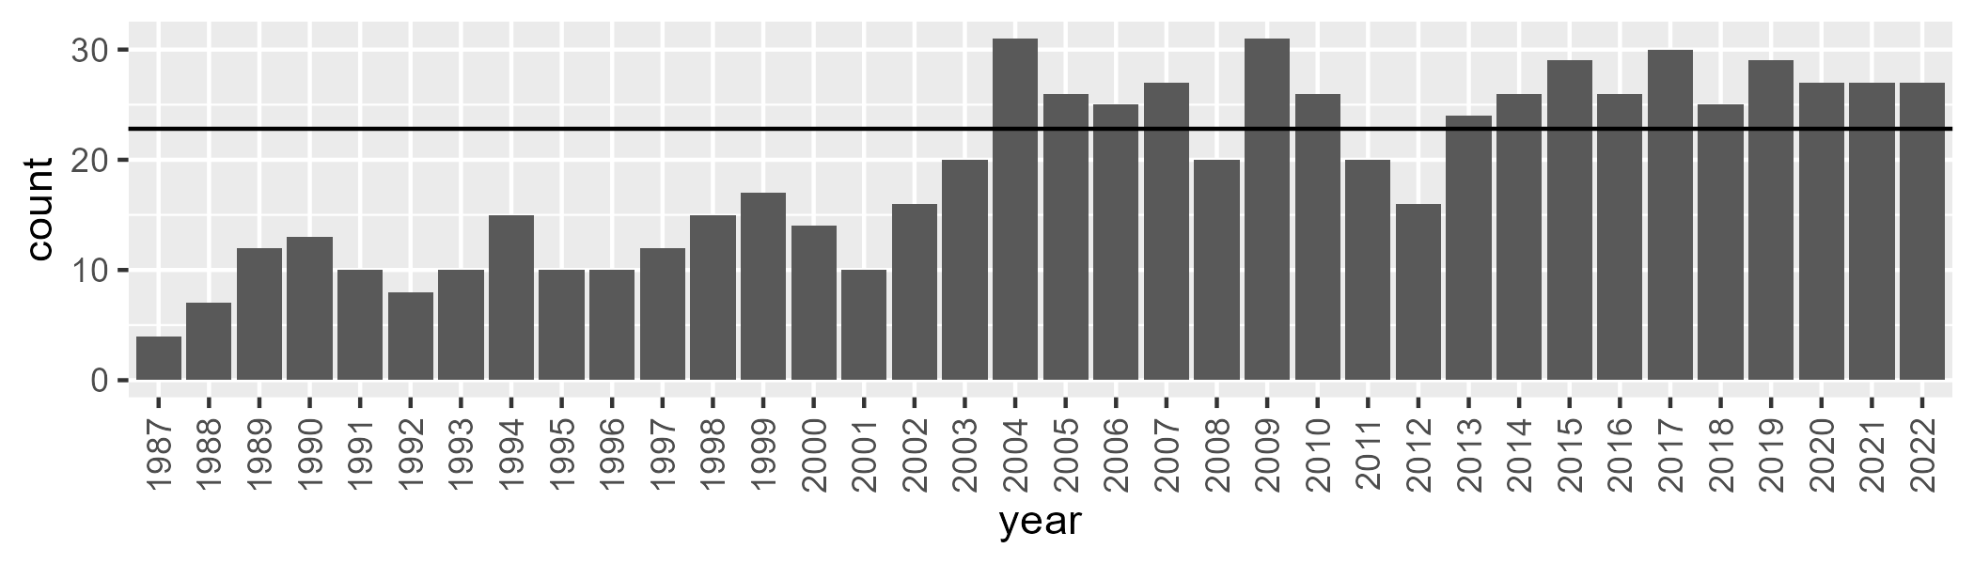

Number of samples: 695

# WAAMUR0001

| Min. | 1st Qu. | Median | Mean | 3rd Qu. | Max. |
| --- | --- | --- | --- | --- | --- |
| 3.813457 | 9.756226 | 12.47981 | 13.09967 | 16.08277 | 27.77942 |

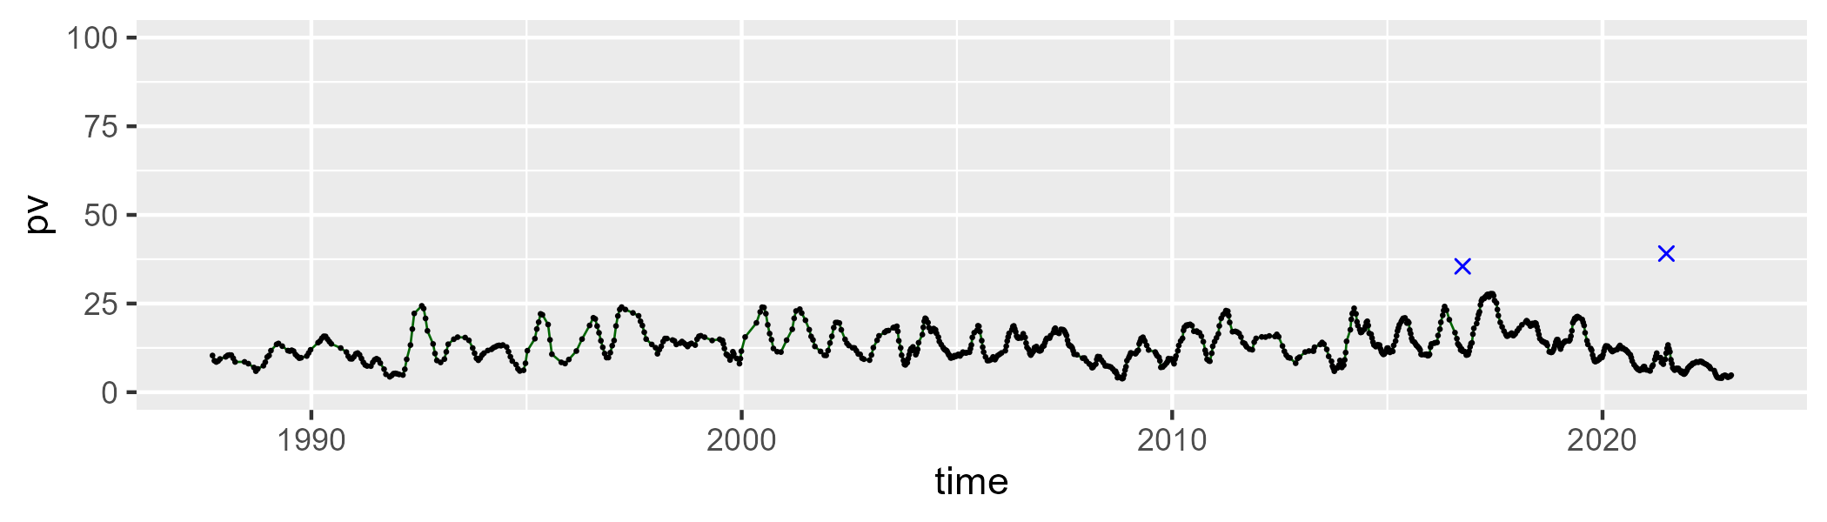

| Min. | 1st Qu. | Median | Mean | 3rd Qu. | Max. |
| --- | --- | --- | --- | --- | --- |
| 43.4669 | 50.08728 | 51.48832 | 51.56349 | 52.94756 | 60.83713 |

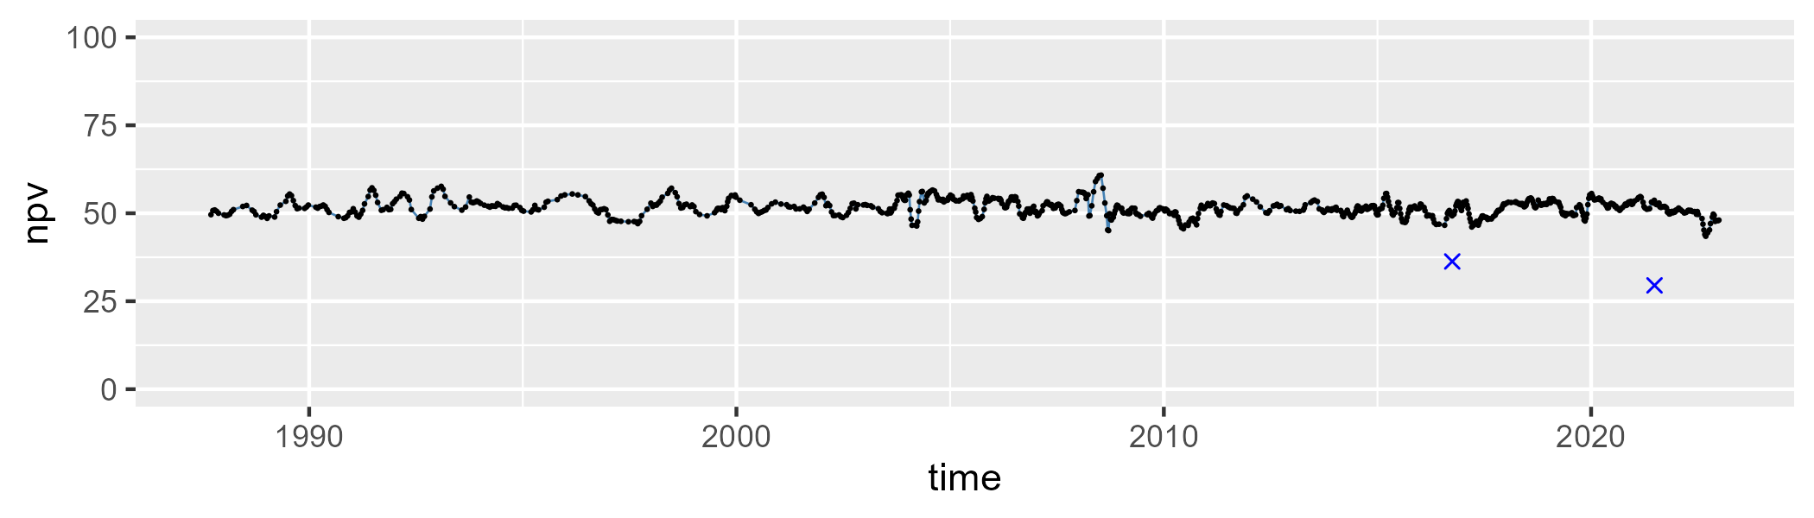

| Min. | 1st Qu. | Median | Mean | 3rd Qu. | Max. |
| --- | --- | --- | --- | --- | --- |
| 21.57345 | 30.73091 | 34.04308 | 34.04308 | 37.09235 | 50.93142 |

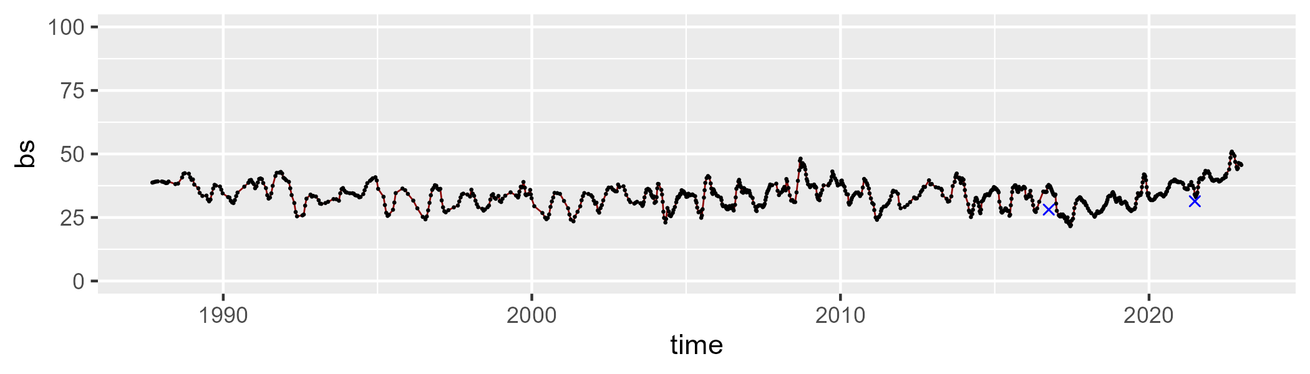

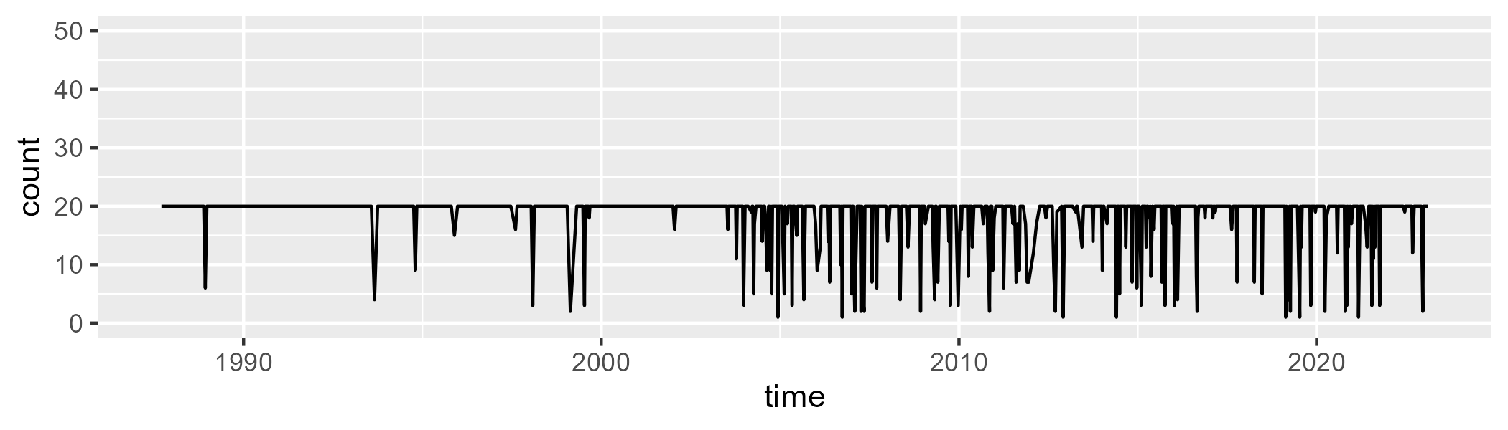

Min. : 1.00 1st Qu.:20.00 Median :20.00 Mean :18.41 3rd Qu.:20.00 Max. :20.00

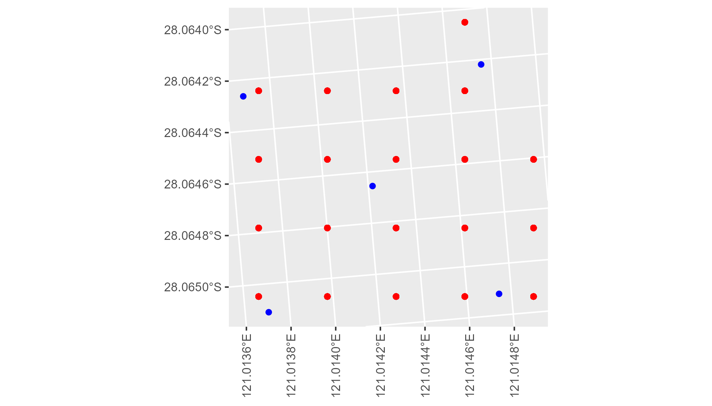

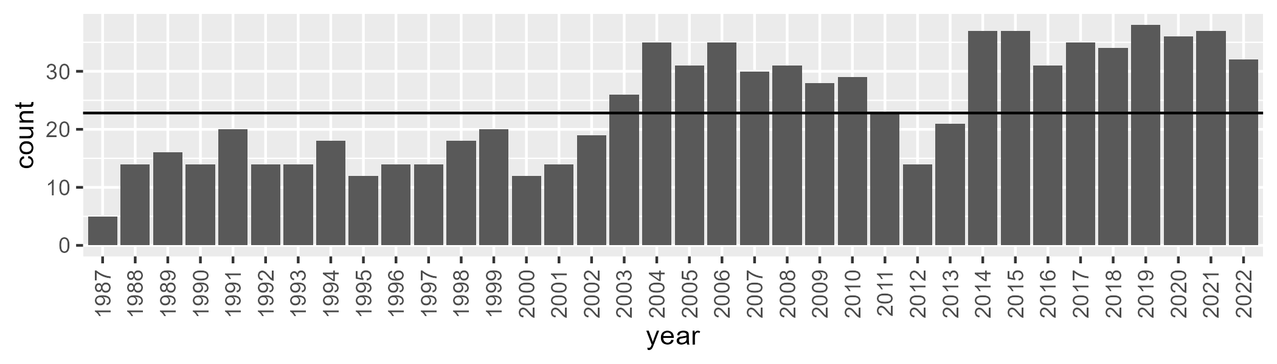

Number of samples: 858

# WAAMUR0002

| Min. | 1st Qu. | Median | Mean | 3rd Qu. | Max. |
| --- | --- | --- | --- | --- | --- |
| 0.3525839 | 7.463462 | 10.64213 | 11.30023 | 14.78605 | 26.49293 |

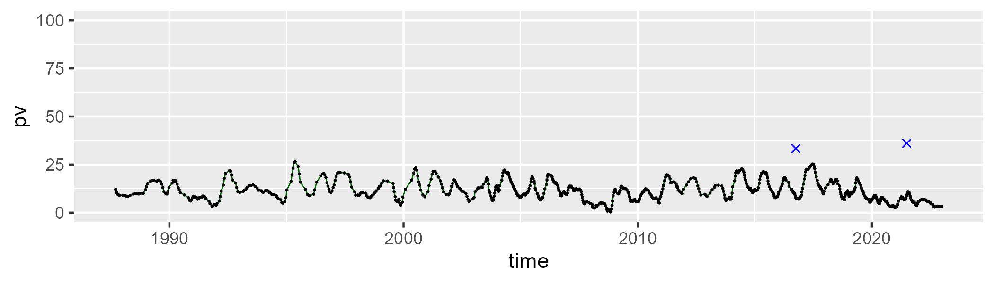

| Min. | 1st Qu. | Median | Mean | 3rd Qu. | Max. |
| --- | --- | --- | --- | --- | --- |
| 37.84831 | 48.28723 | 50.40739 | 50.51885 | 52.51525 | 62.69116 |

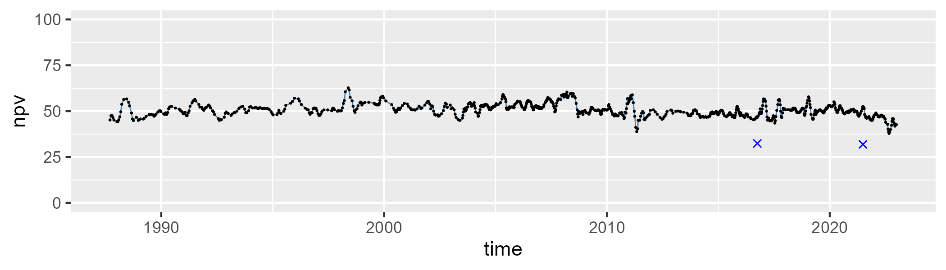

| Min. | 1st Qu. | Median | Mean | 3rd Qu. | Max. |
| --- | --- | --- | --- | --- | --- |
| 23.11466 | 32.50856 | 36.91787 | 36.78733 | 40.39648 | 57.43724 |

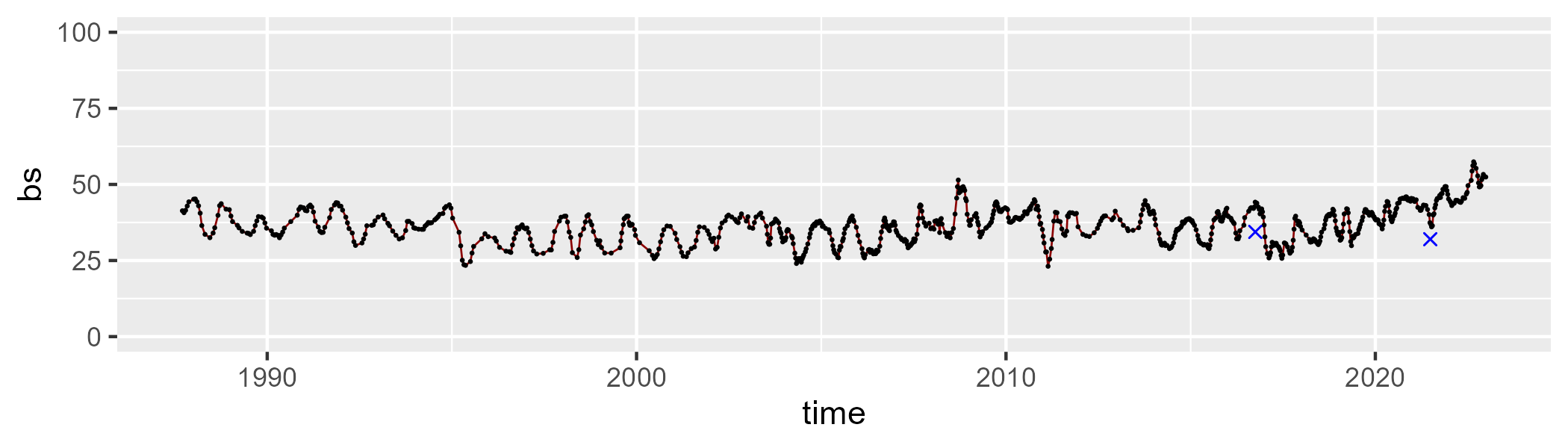

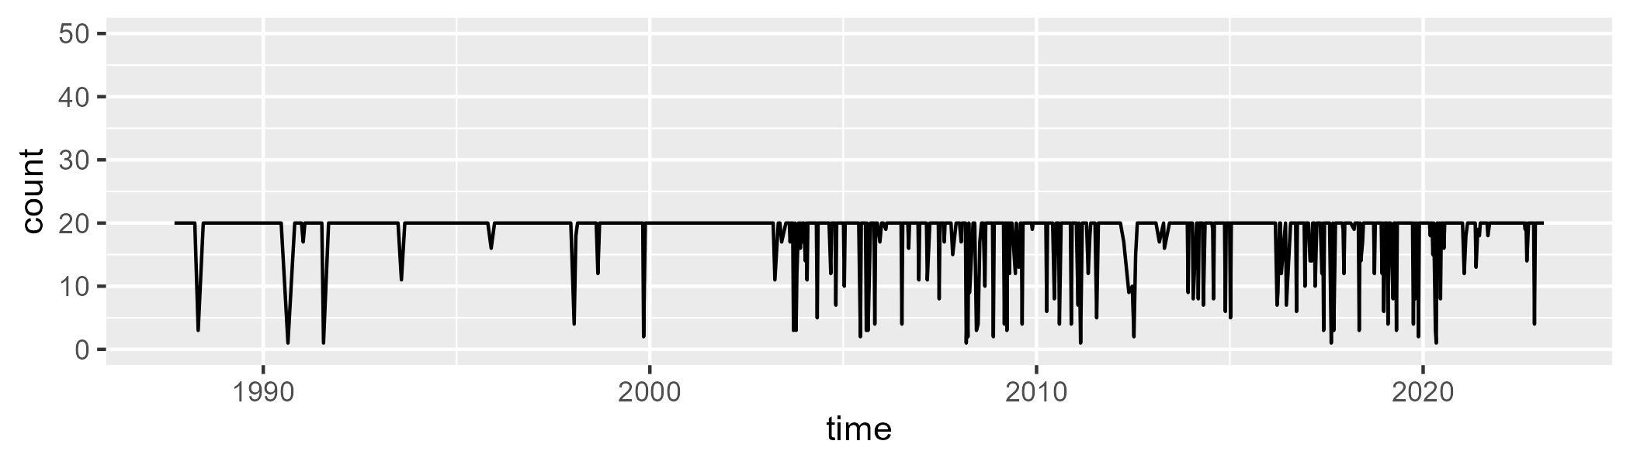

Min. : 1.00 1st Qu.:20.00 Median :20.00 Mean :18.55 3rd Qu.:20.00 Max. :20.00

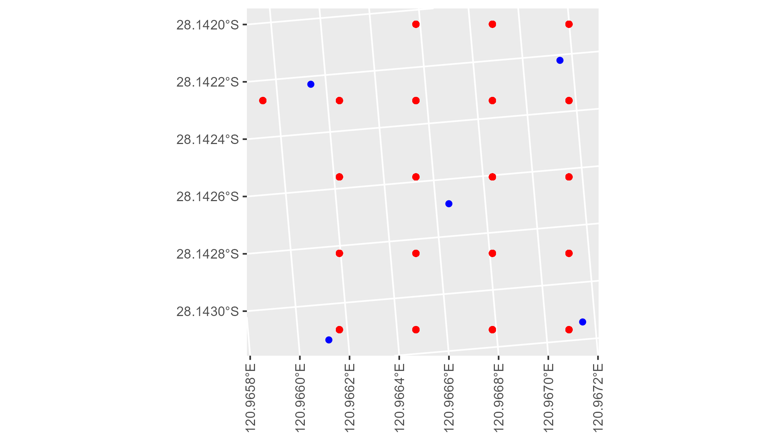

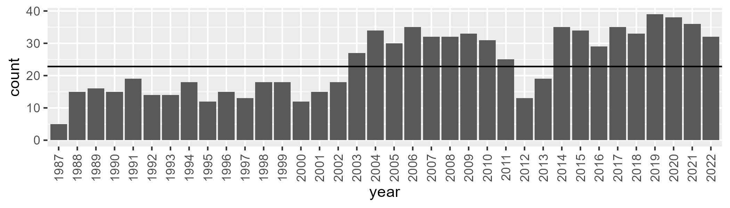

Number of samples: 859

# WAAMUR0003

| Min. | 1st Qu. | Median | Mean | 3rd Qu. | Max. |
| --- | --- | --- | --- | --- | --- |
| 0 | 5.763448 | 8.370443 | 11.55479 | 15.17863 | 43.48275 |

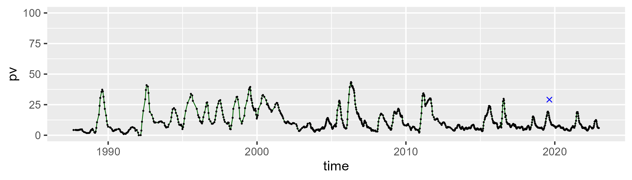

| Min. | 1st Qu. | Median | Mean | 3rd Qu. | Max. |
| --- | --- | --- | --- | --- | --- |
| 27.94013 | 41.69183 | 45.34654 | 46.26546 | 50.24071 | 68.55632 |

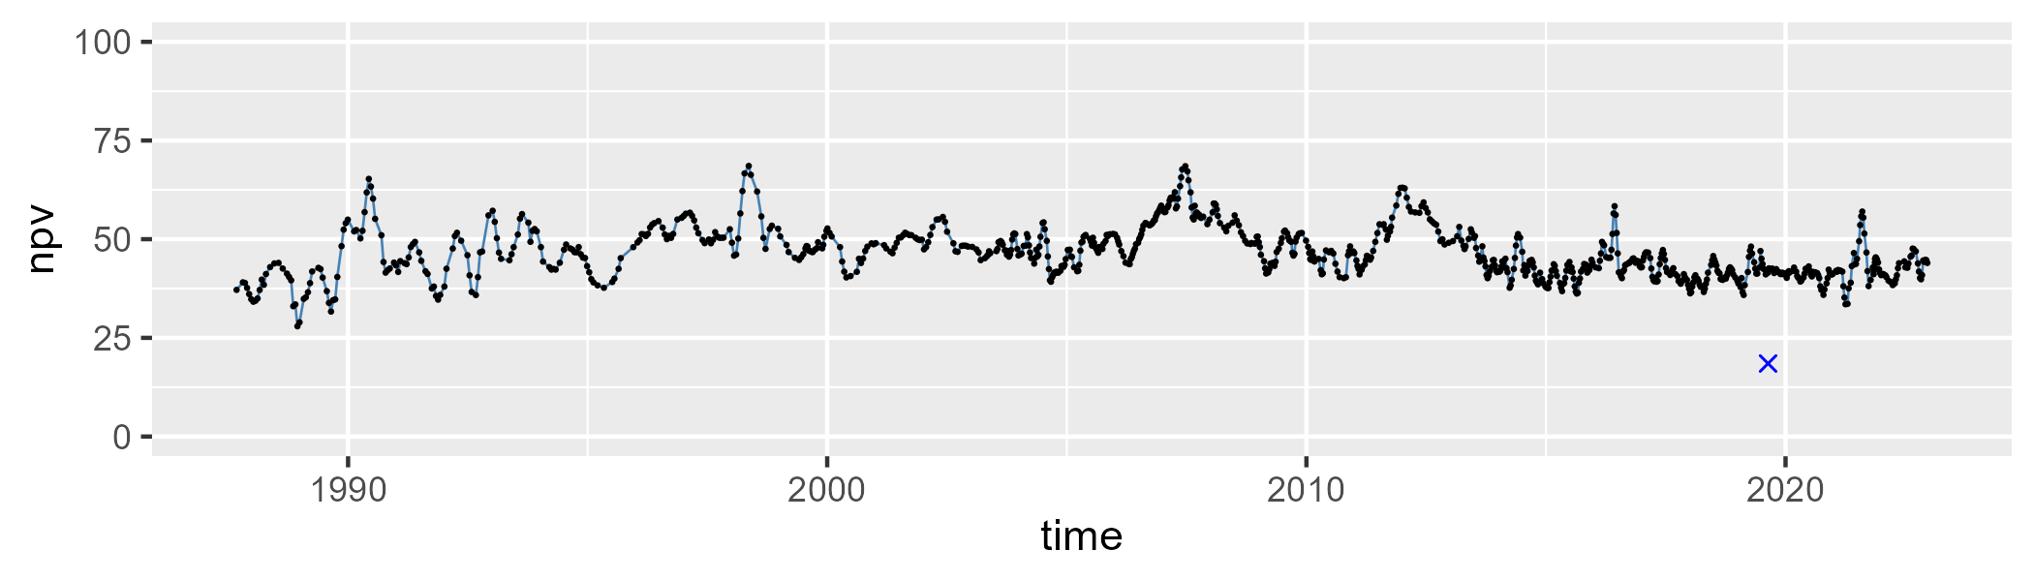

| Min. | 1st Qu. | Median | Mean | 3rd Qu. | Max. |
| --- | --- | --- | --- | --- | --- |
| 9.168738 | 32.61726 | 43.2226 | 40.80279 | 49.38069 | 65.35287 |

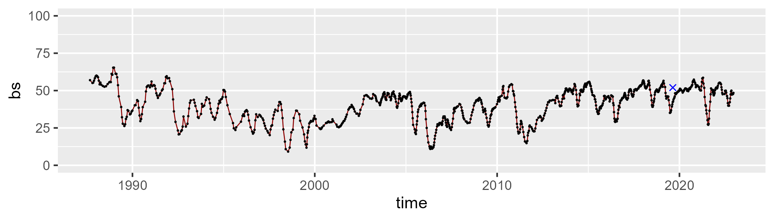

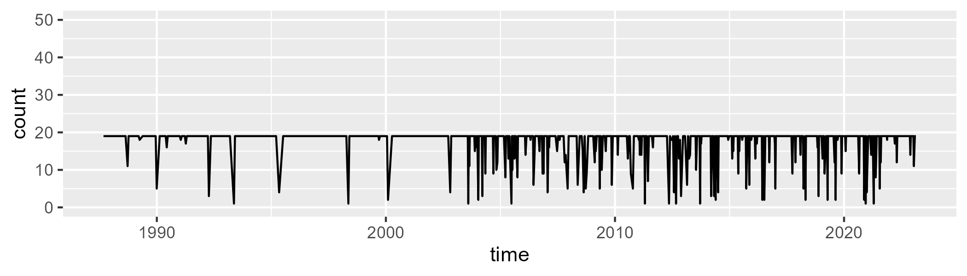

Min. : 1.00 1st Qu.:19.00 Median :19.00 Mean :17.72 3rd Qu.:19.00 Max. :19.00

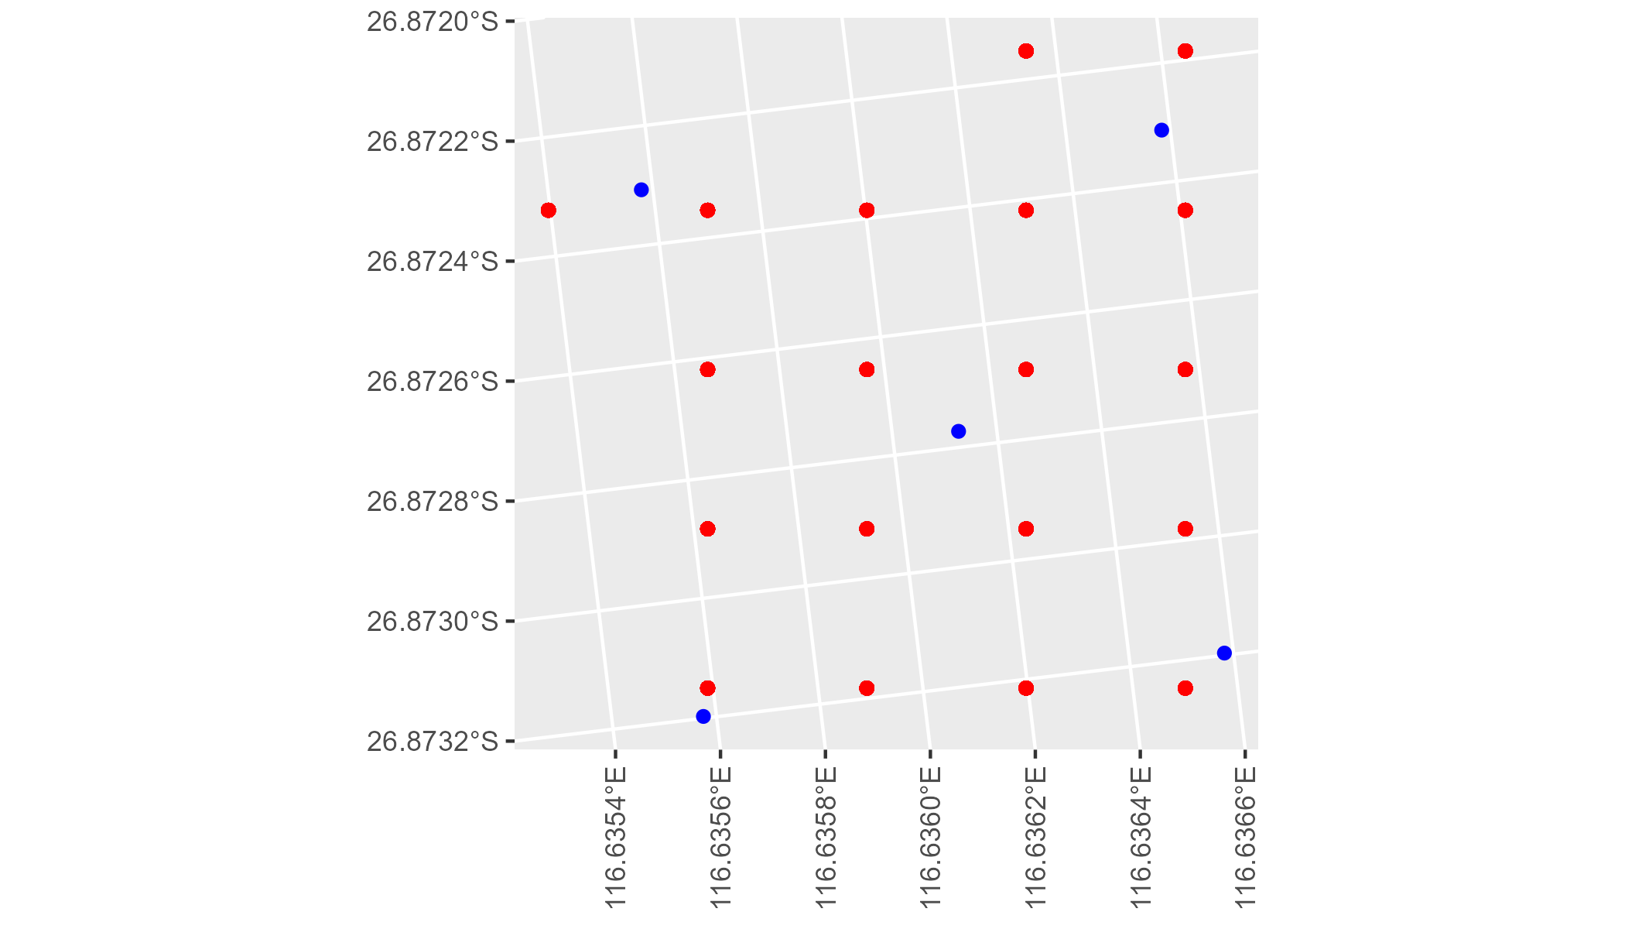

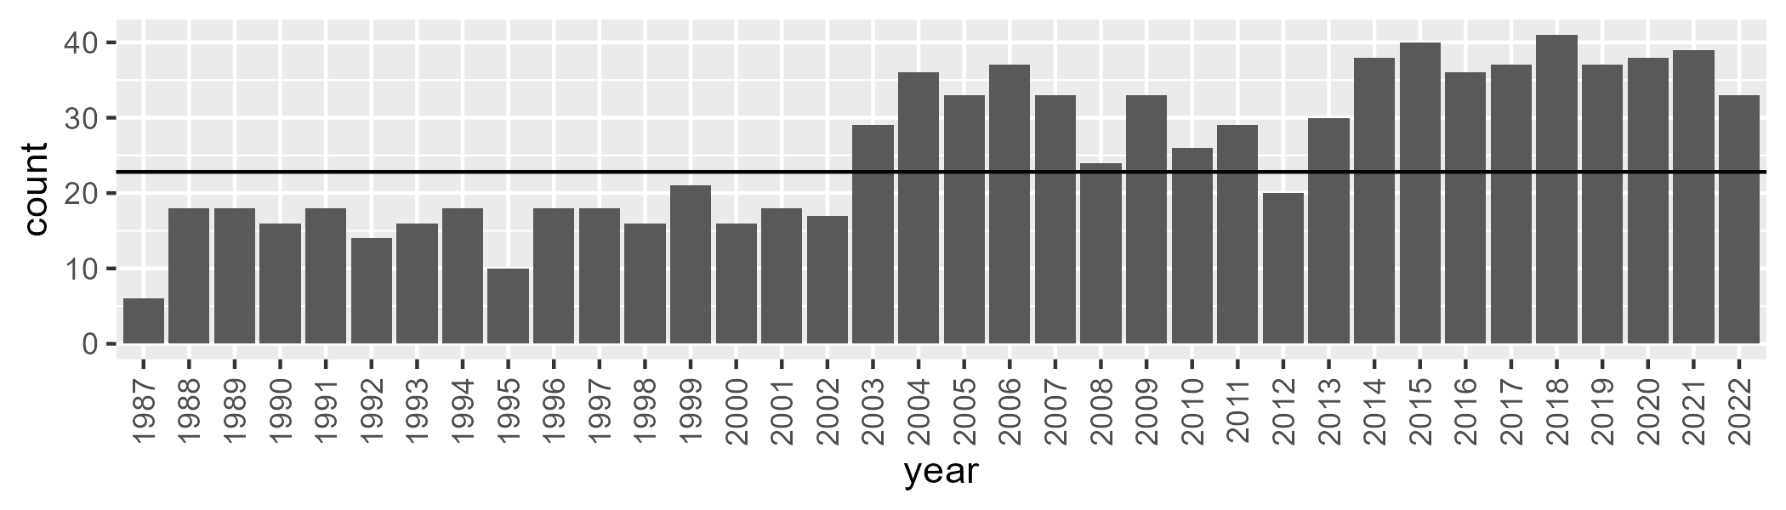

Number of samples: 927

# WAAMUR0004

| Min. | 1st Qu. | Median | Mean | 3rd Qu. | Max. |
| --- | --- | --- | --- | --- | --- |
| 0 | 4.350258 | 6.135411 | 8.268571 | 9.492625 | 41.30895 |

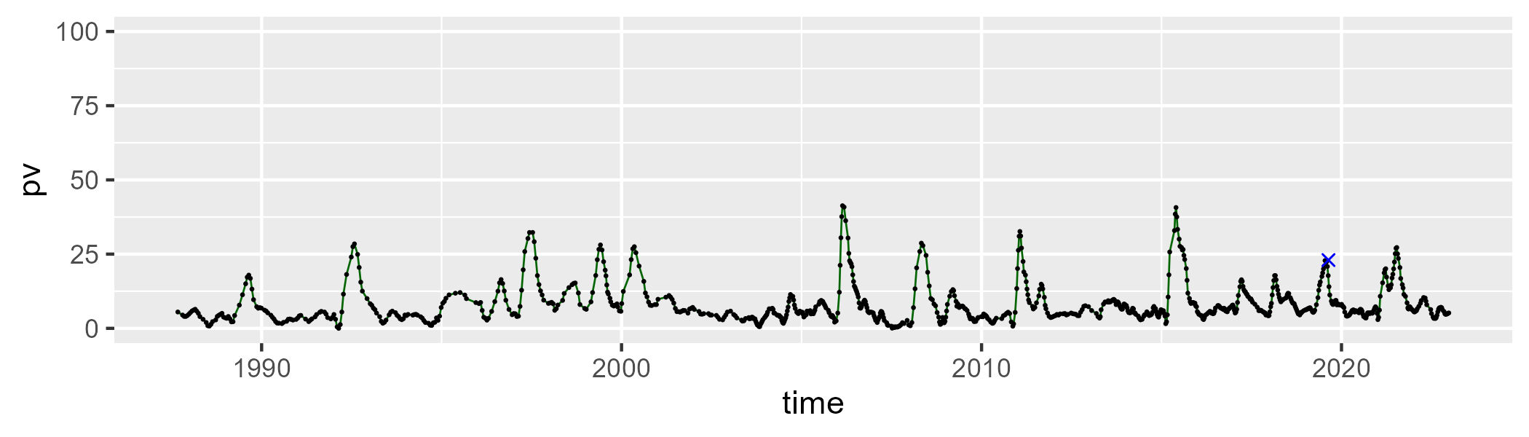

| Min. | 1st Qu. | Median | Mean | 3rd Qu. | Max. |
| --- | --- | --- | --- | --- | --- |
| 23.60171 | 36.09745 | 42.01023 | 43.4175 | 49.56097 | 70.68627 |

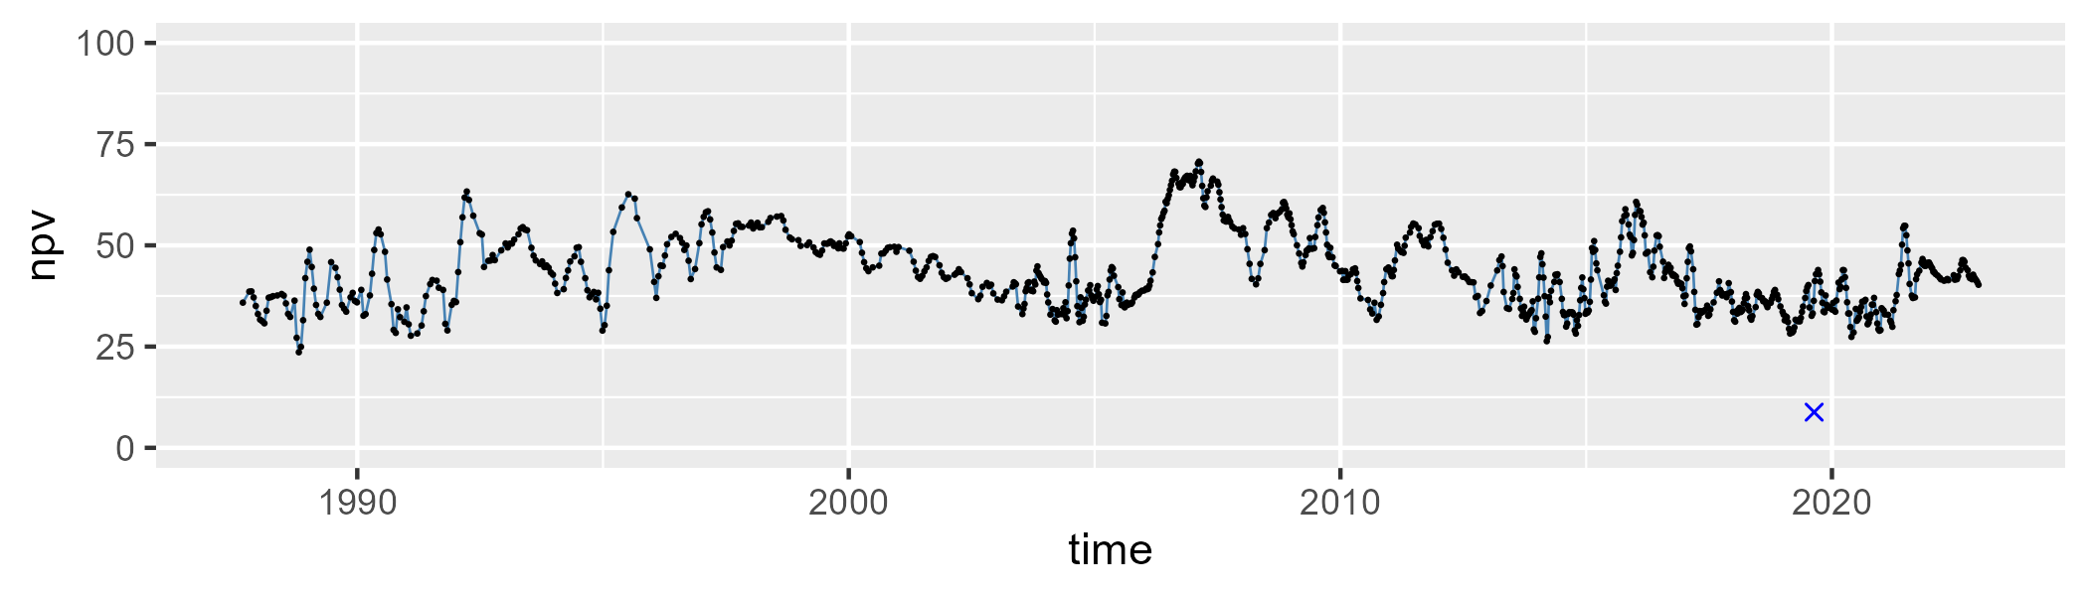

| Min. | 1st Qu. | Median | Mean | 3rd Qu. | Max. |
| --- | --- | --- | --- | --- | --- |
| 14.4671 | 39.56679 | 49.74984 | 46.99753 | 55.89031 | 70.50537 |

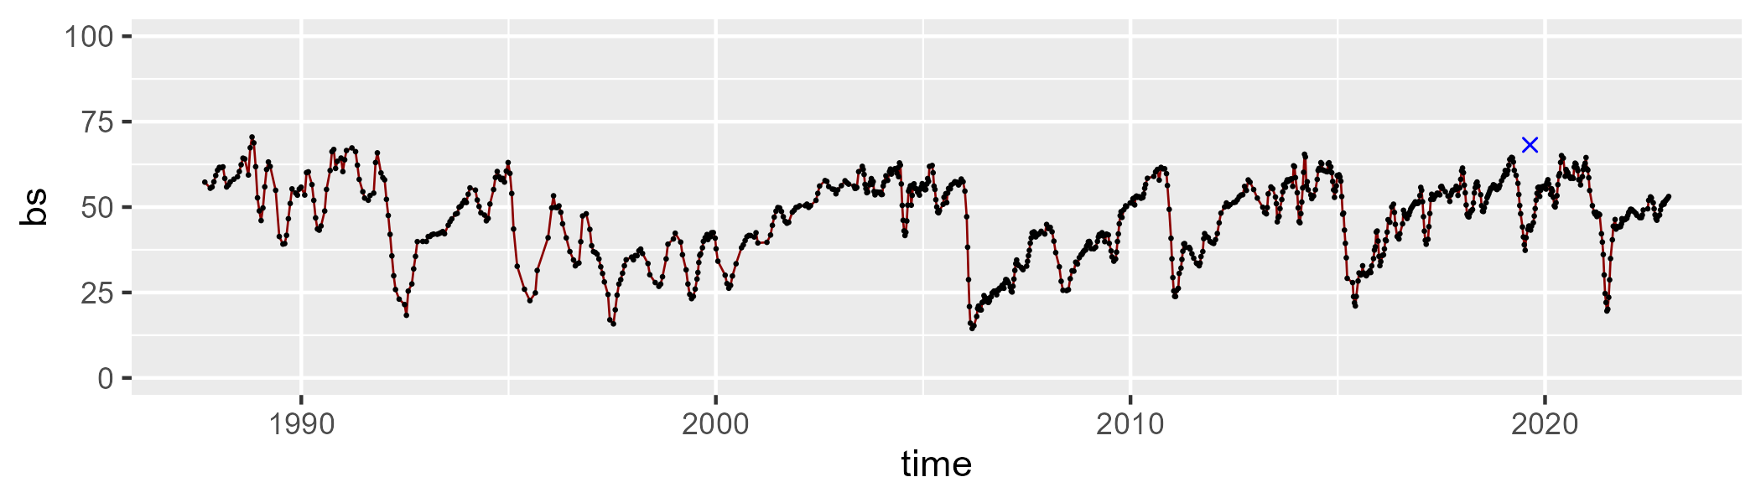

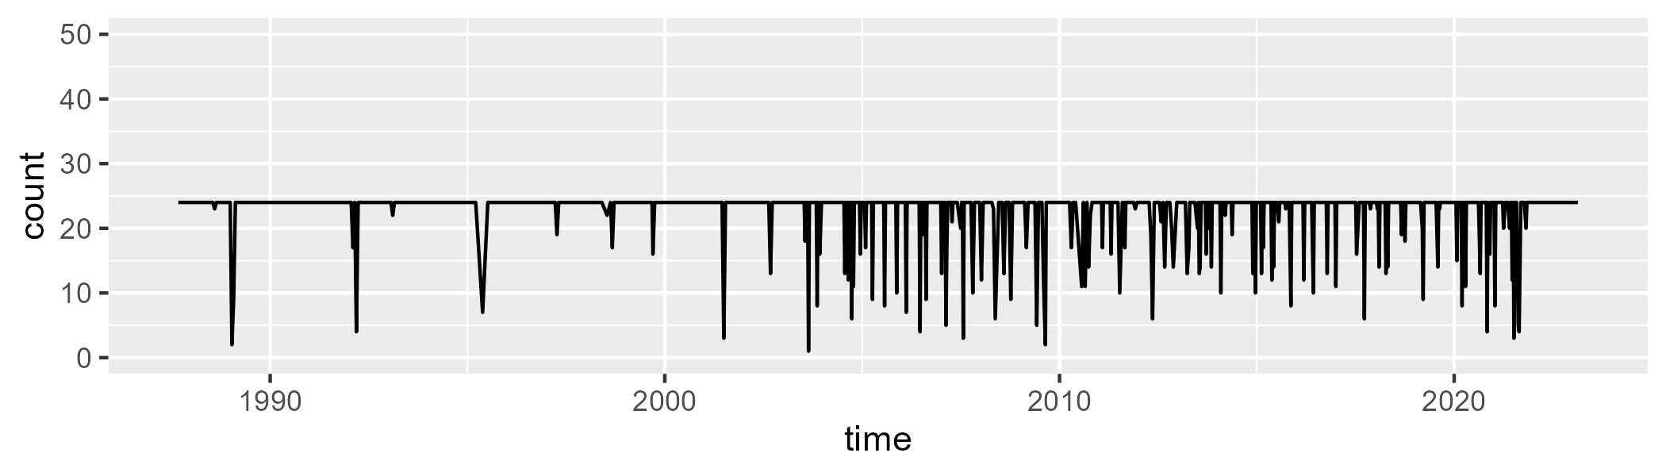

Min. : 1.00 1st Qu.:24.00 Median :24.00 Mean :22.73 3rd Qu.:24.00 Max. :24.00

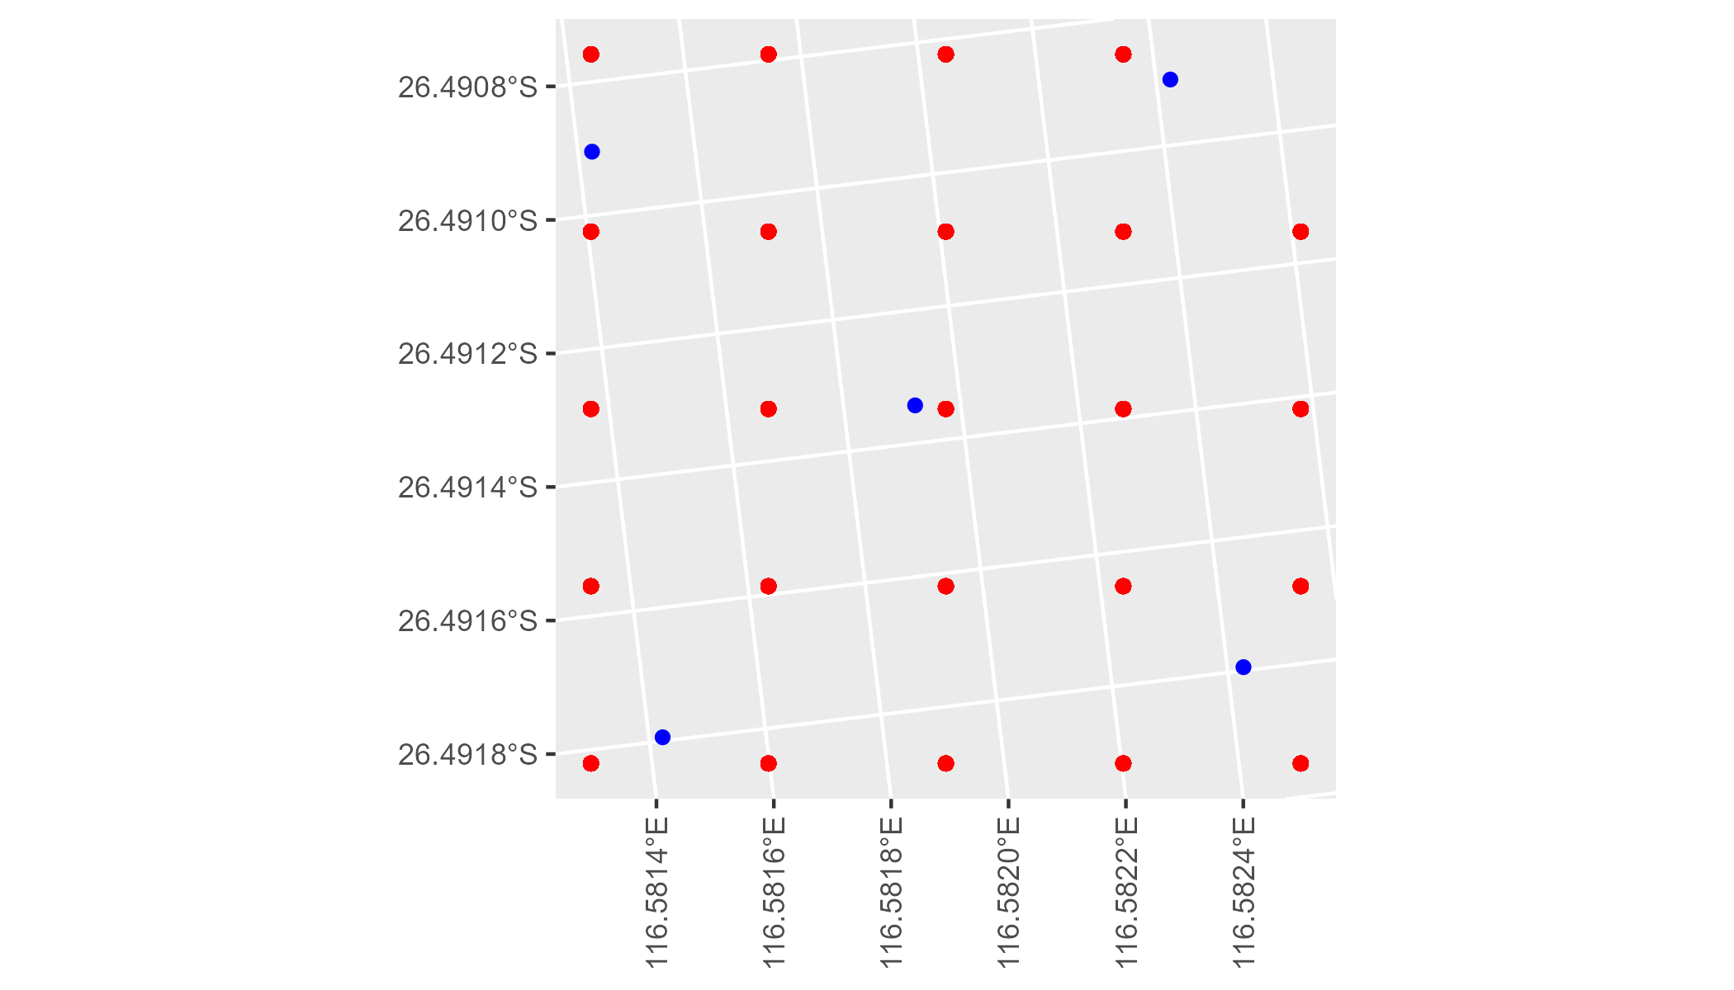

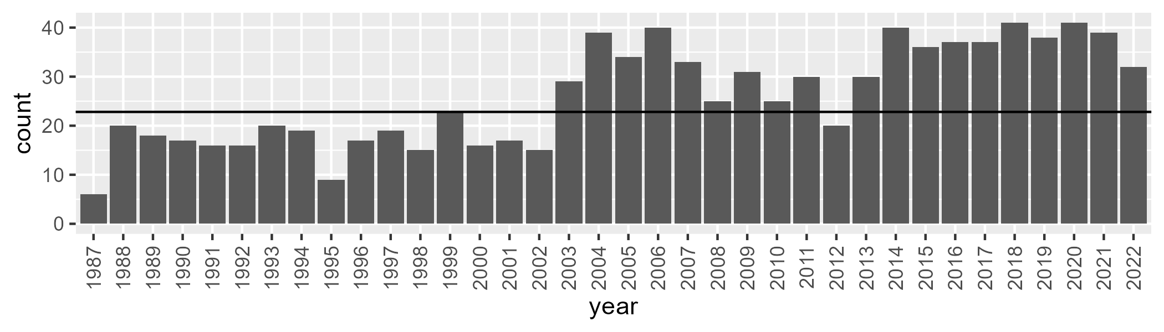

Number of samples: 940

# WAAMUR0005

| Min. | 1st Qu. | Median | Mean | 3rd Qu. | Max. |
| --- | --- | --- | --- | --- | --- |
| 0 | 3.888331 | 5.257051 | 7.322211 | 8.307317 | 32.82956 |

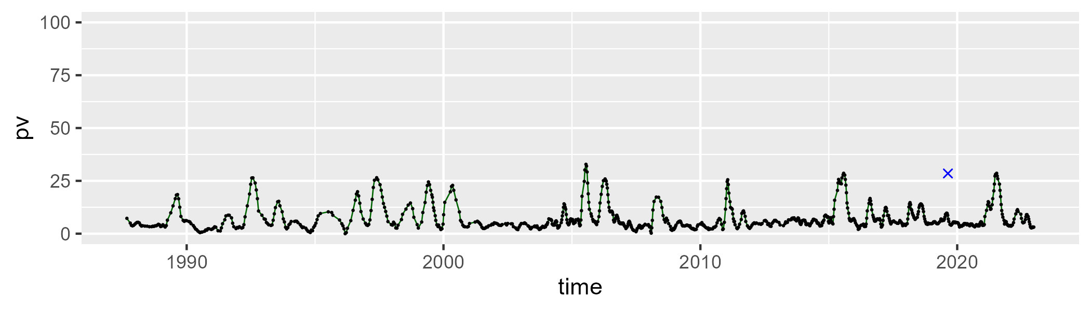

| Min. | 1st Qu. | Median | Mean | 3rd Qu. | Max. |
| --- | --- | --- | --- | --- | --- |
| 20.43861 | 33.90064 | 38.85908 | 39.74227 | 46.16478 | 60.36398 |

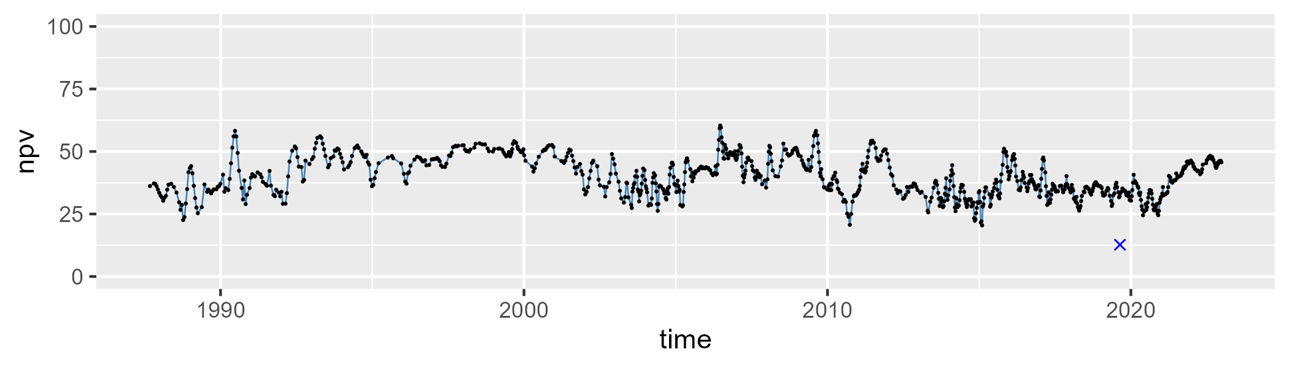

| Min. | 1st Qu. | Median | Mean | 3rd Qu. | Max. |
| --- | --- | --- | --- | --- | --- |
| 24.05746 | 45.04127 | 52.8812 | 51.66902 | 59.13706 | 72.4415 |

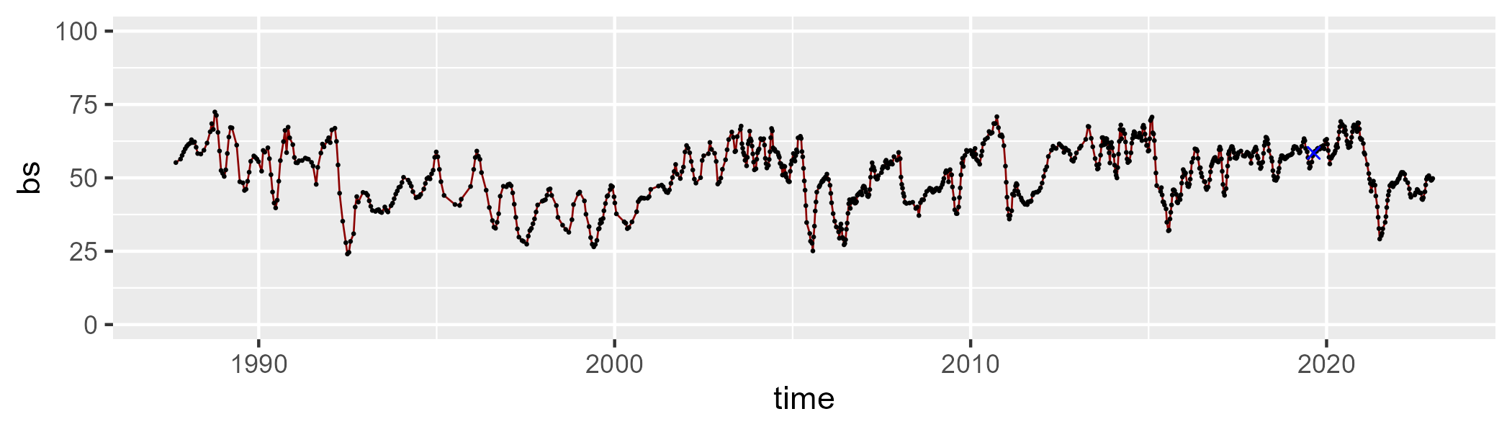

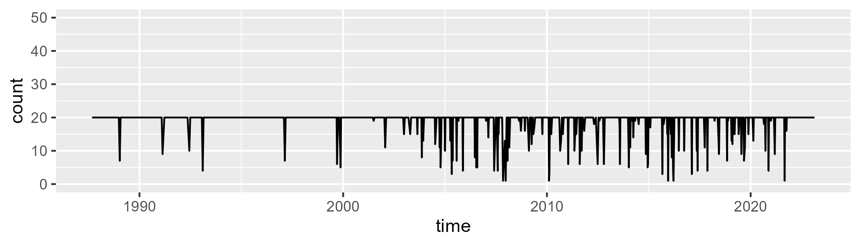

Min. : 1.0 1st Qu.:20.0 Median :20.0 Mean :18.9 3rd Qu.:20.0 Max. :20.0

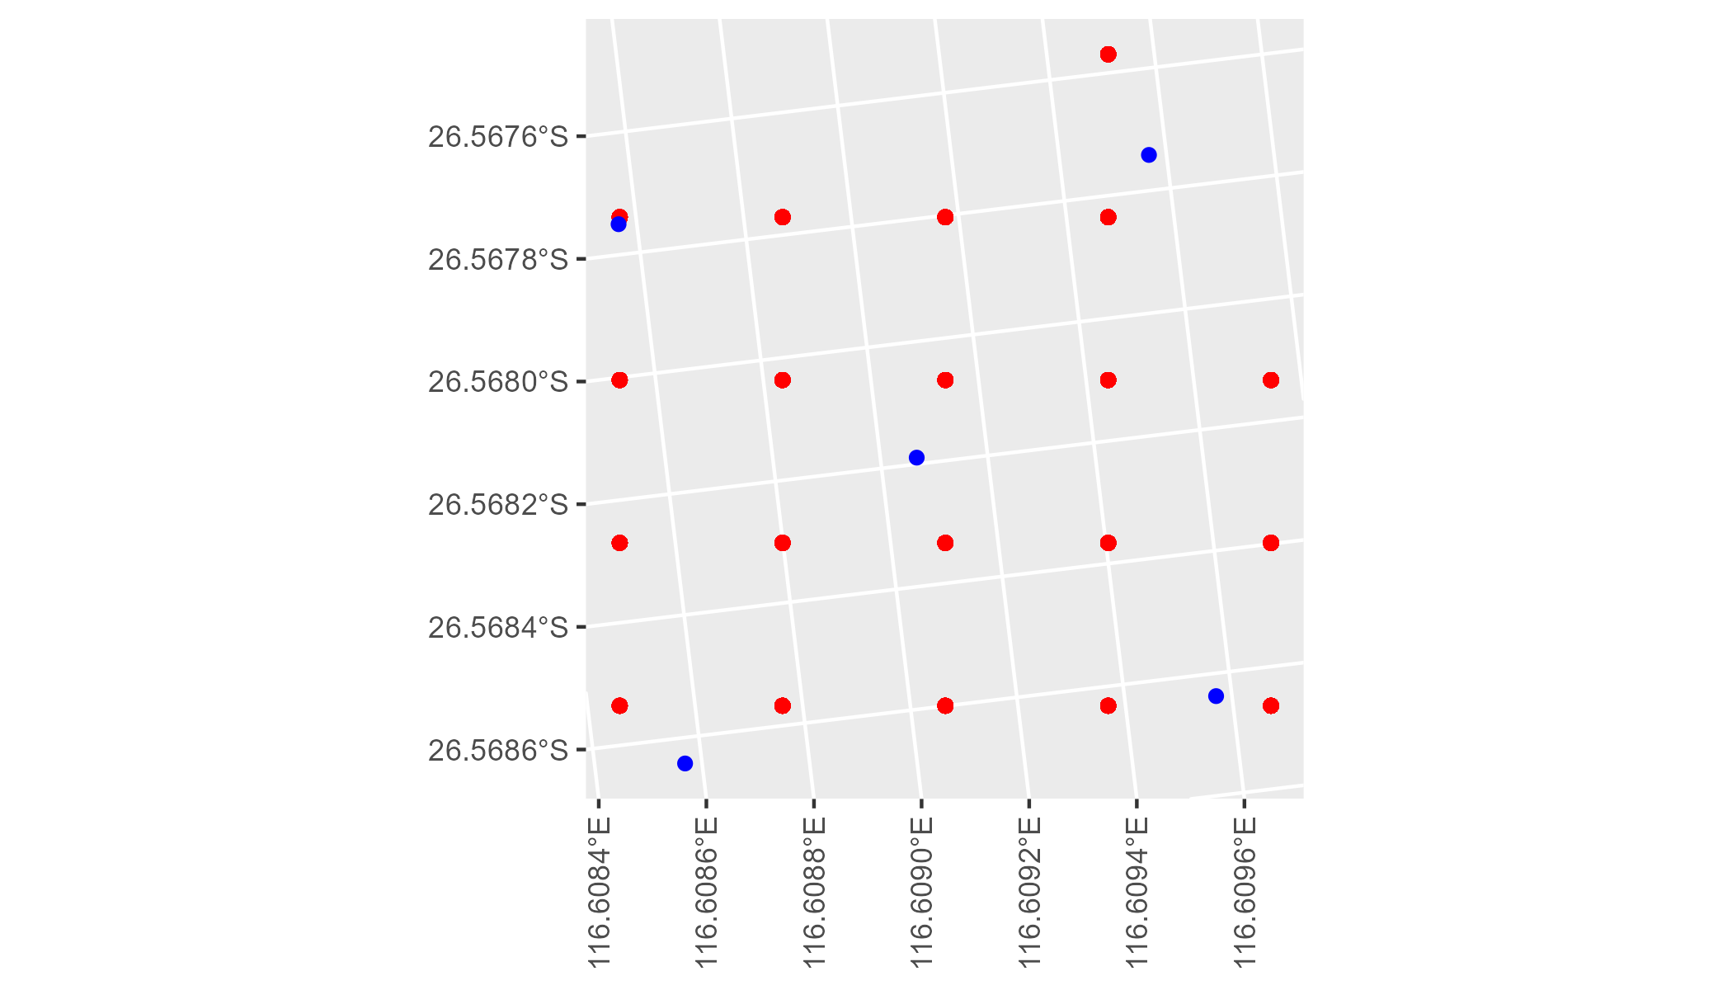

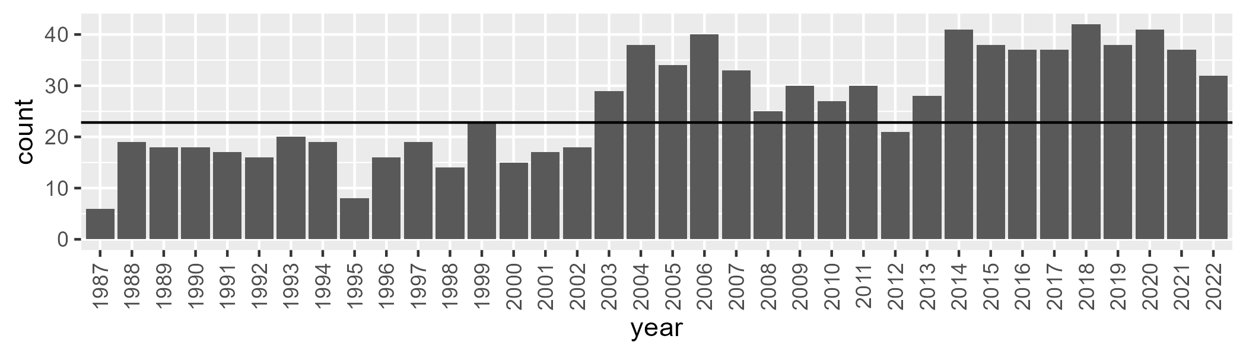

Number of samples: 941

# WAAMUR0006

| Min. | 1st Qu. | Median | Mean | 3rd Qu. | Max. |
| --- | --- | --- | --- | --- | --- |
| 0.5752461 | 4.686606 | 6.699198 | 8.743851 | 10.07838 | 40.56987 |

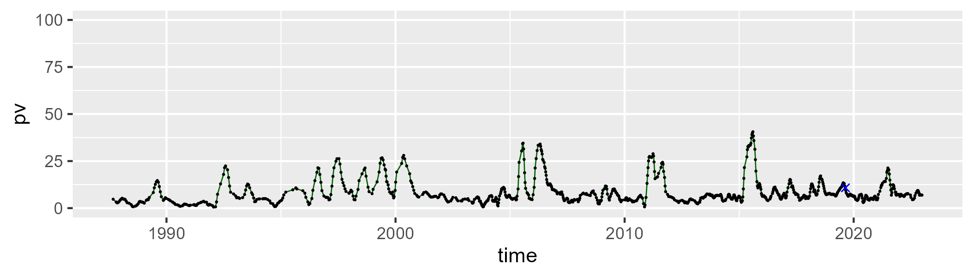

| Min. | 1st Qu. | Median | Mean | 3rd Qu. | Max. |
| --- | --- | --- | --- | --- | --- |
| 33.369 | 43.7939 | 48.60706 | 49.18914 | 54.26213 | 70.33454 |

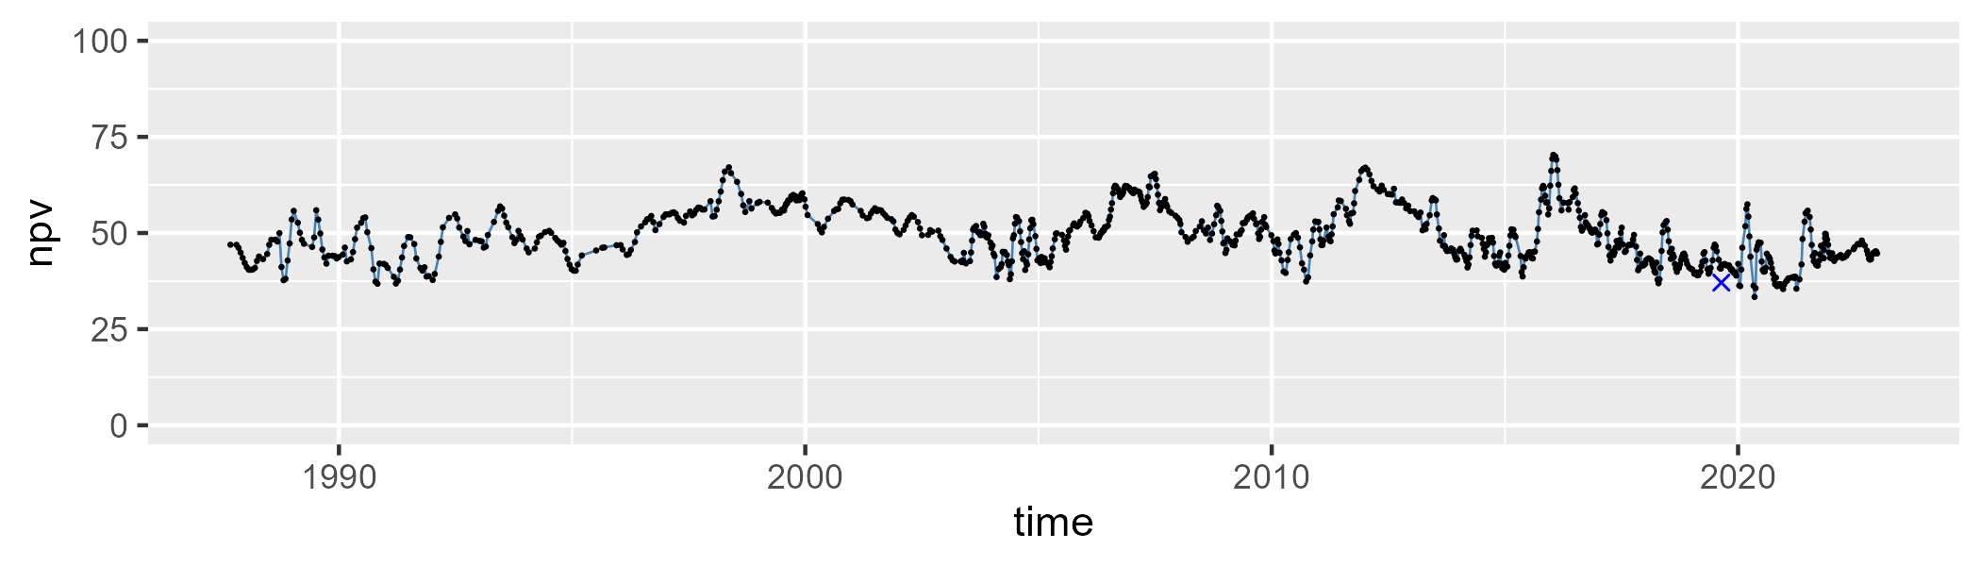

| Min. | 1st Qu. | Median | Mean | 3rd Qu. | Max. |
| --- | --- | --- | --- | --- | --- |
| 14.44251 | 34.19821 | 43.06113 | 40.8324 | 48.28785 | 60.01305 |

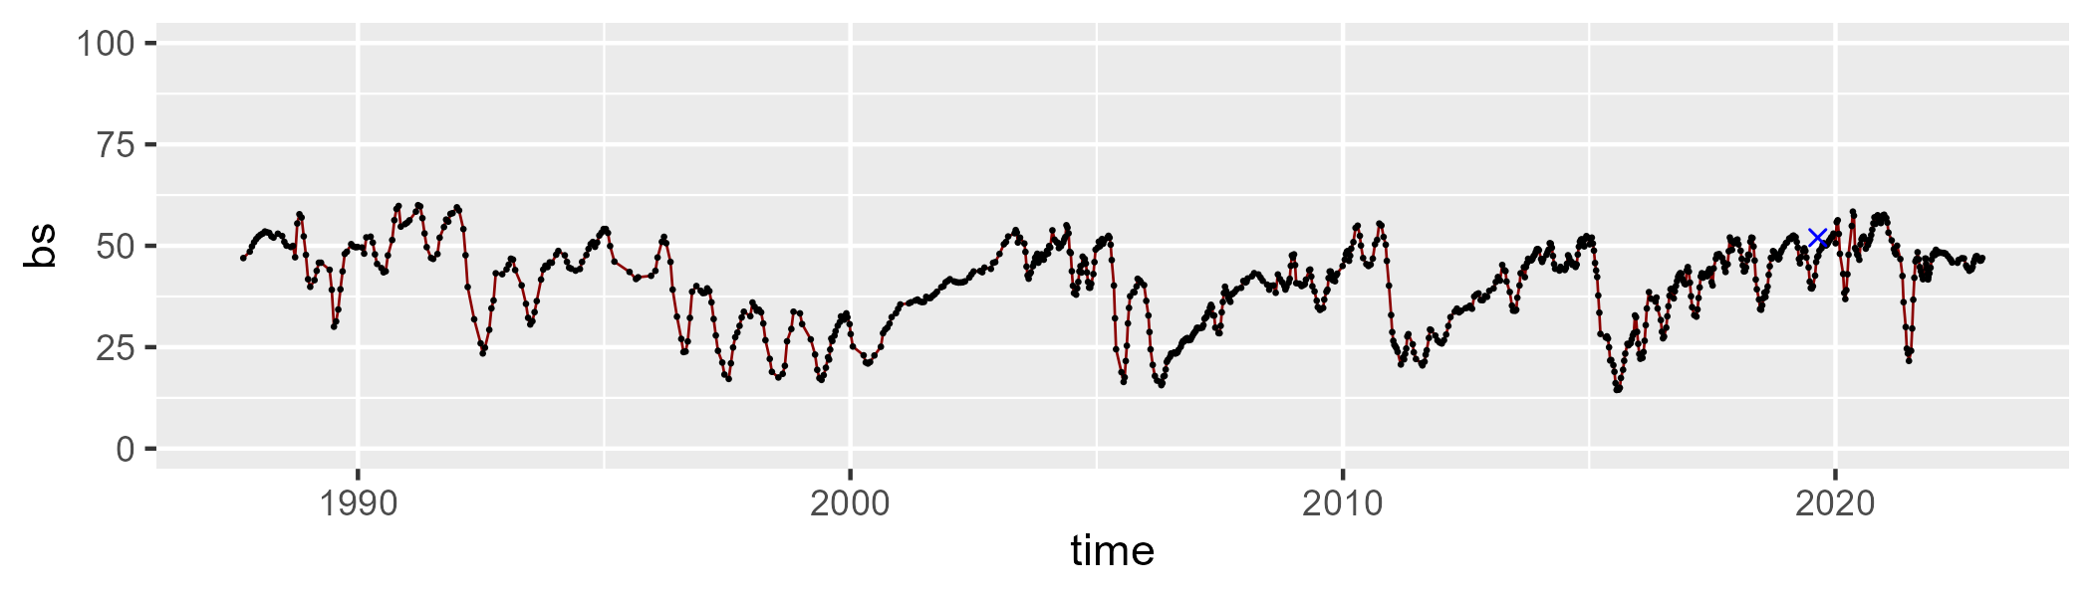

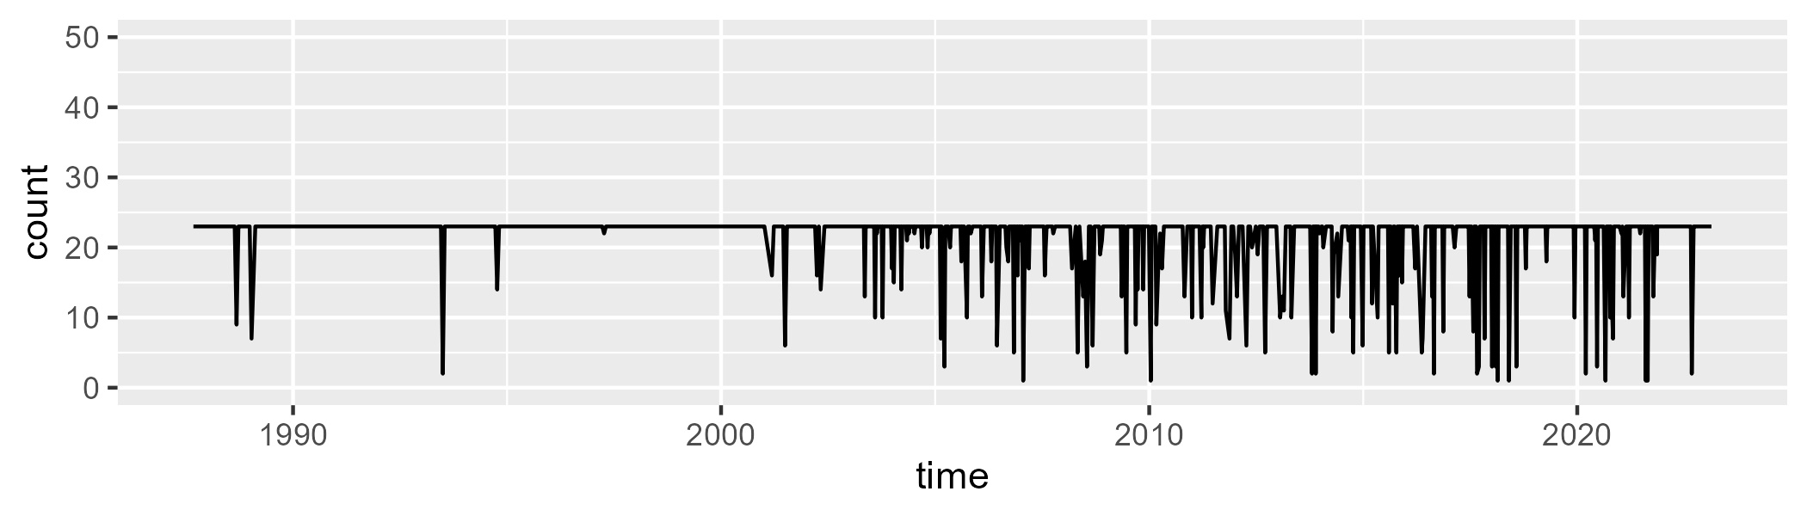

Min. : 1.00 1st Qu.:23.00 Median :23.00 Mean :21.44 3rd Qu.:23.00 Max. :23.00

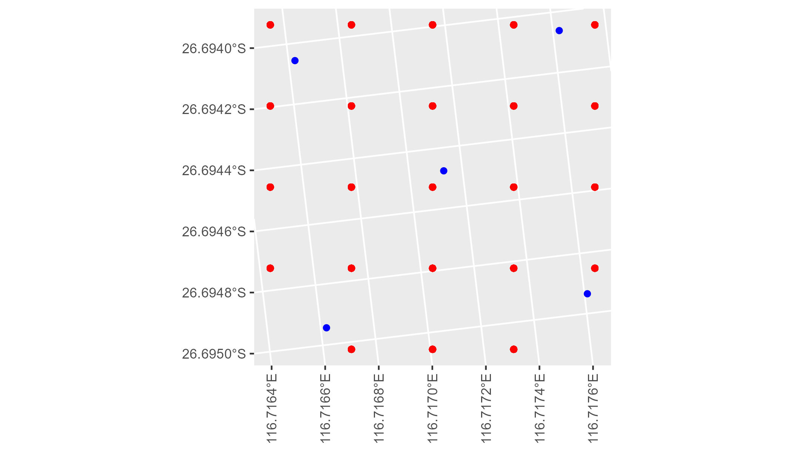

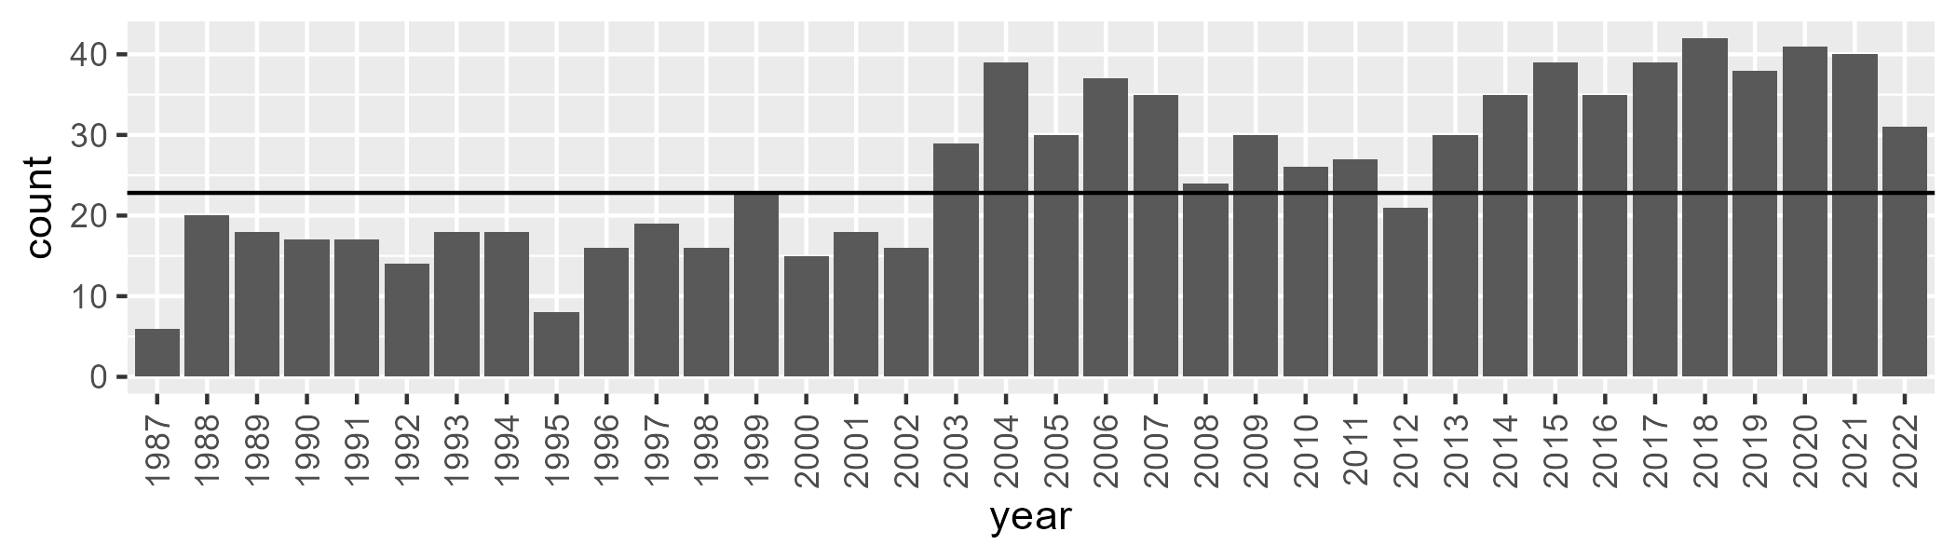

Number of samples: 927

# WAAMUR0007

| Min. | 1st Qu. | Median | Mean | 3rd Qu. | Max. |
| --- | --- | --- | --- | --- | --- |
| 0 | 4.70163 | 6.950072 | 10.89452 | 13.76592 | 47.56493 |

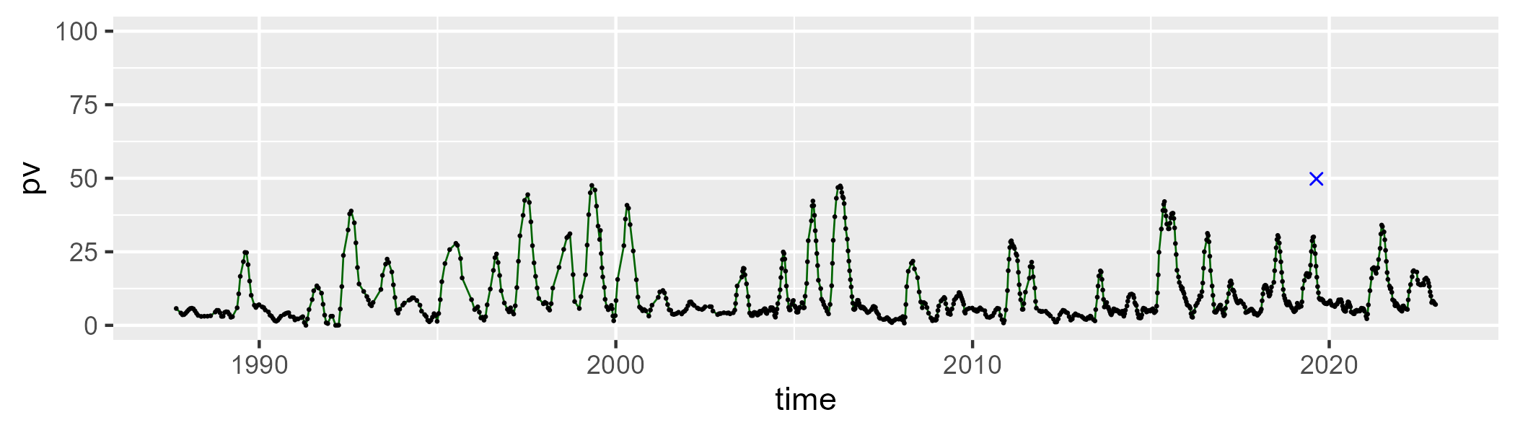

| Min. | 1st Qu. | Median | Mean | 3rd Qu. | Max. |
| --- | --- | --- | --- | --- | --- |
| 28.60275 | 44.12642 | 48.12884 | 49.32083 | 53.8104 | 72.09079 |

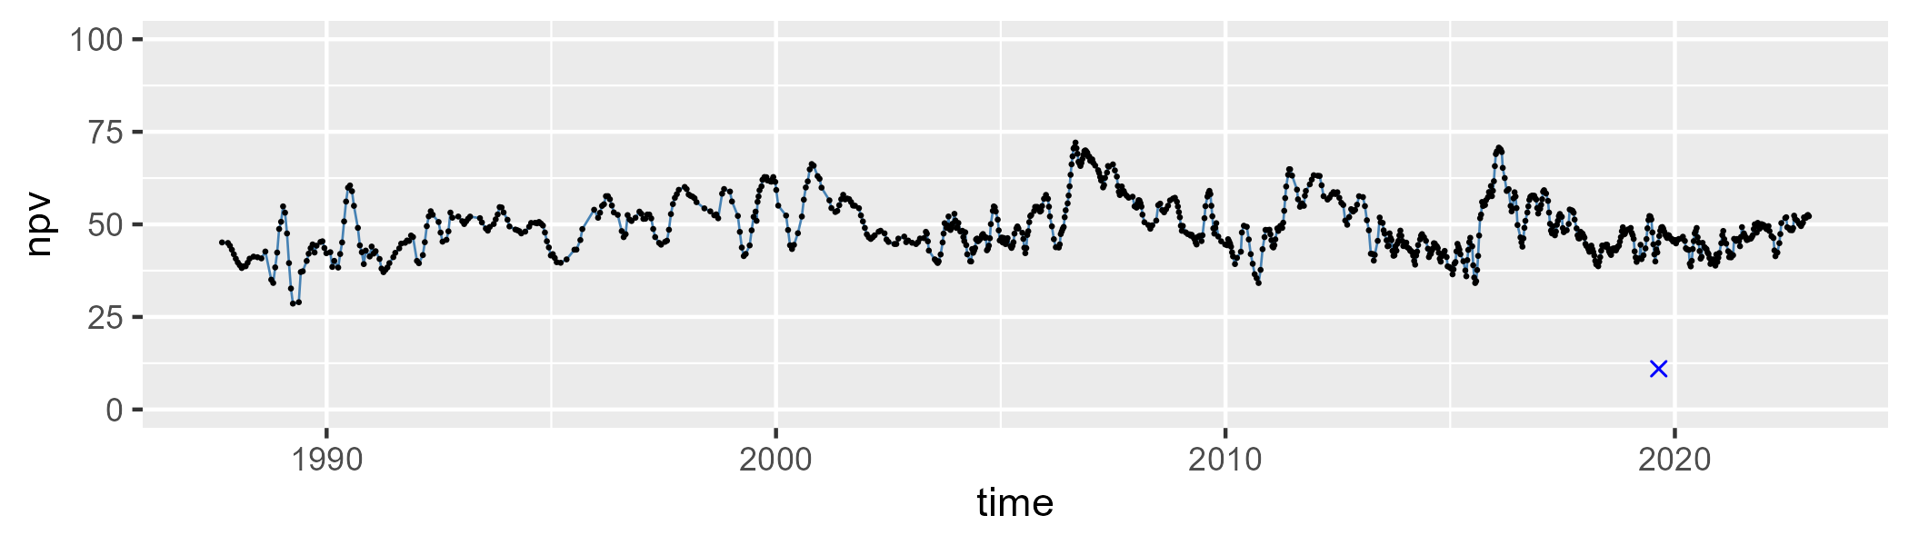

| Min. | 1st Qu. | Median | Mean | 3rd Qu. | Max. |
| --- | --- | --- | --- | --- | --- |
| 6.375574 | 31.28531 | 40.08516 | 38.63646 | 46.82664 | 67.37039 |

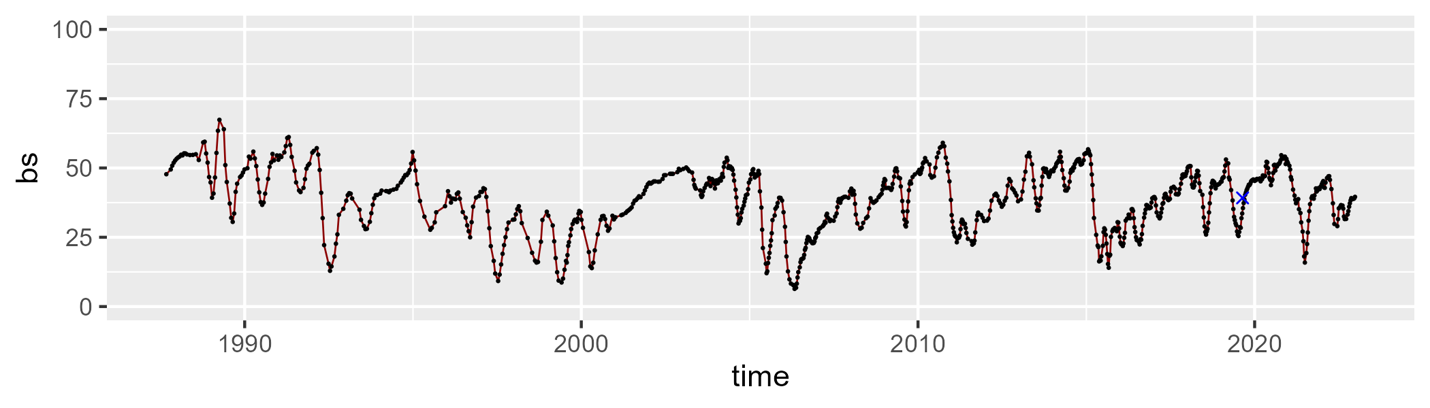

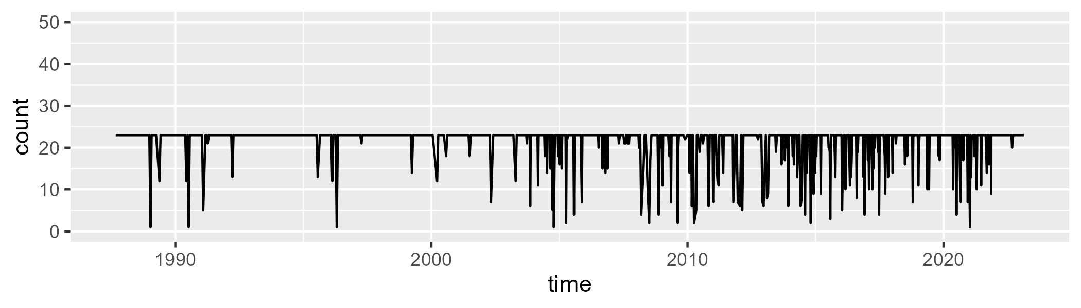

Min. : 1.00 1st Qu.:23.00 Median :23.00 Mean :21.38 3rd Qu.:23.00 Max. :23.00

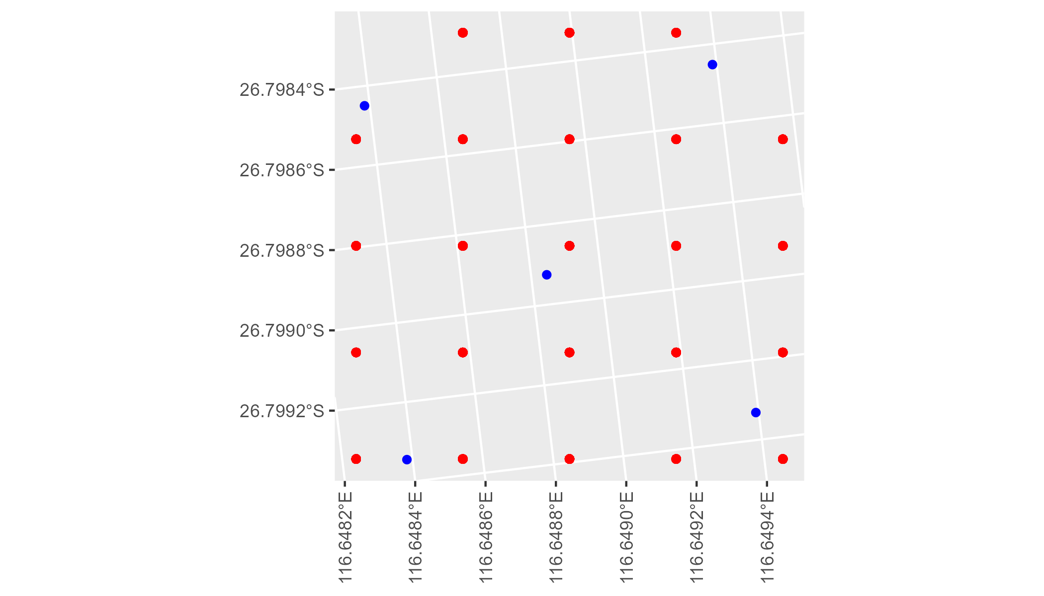

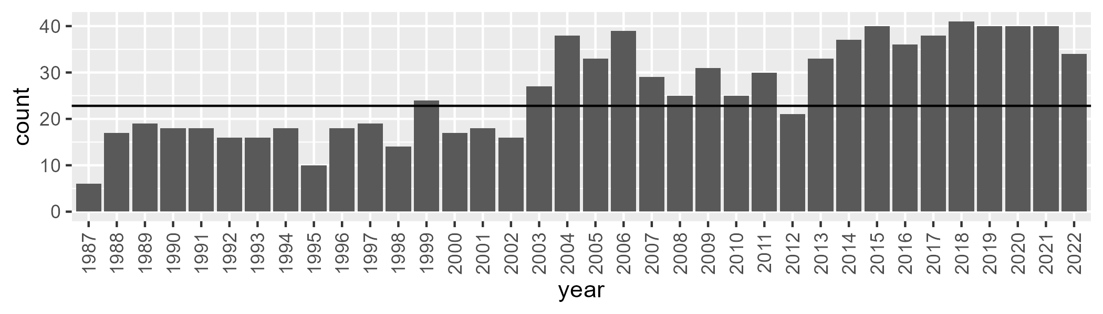

Number of samples: 941

# WAAMUR0008

| Min. | 1st Qu. | Median | Mean | 3rd Qu. | Max. |
| --- | --- | --- | --- | --- | --- |
| 0.0338038 | 4.319968 | 5.868001 | 7.653143 | 8.789467 | 38.72346 |

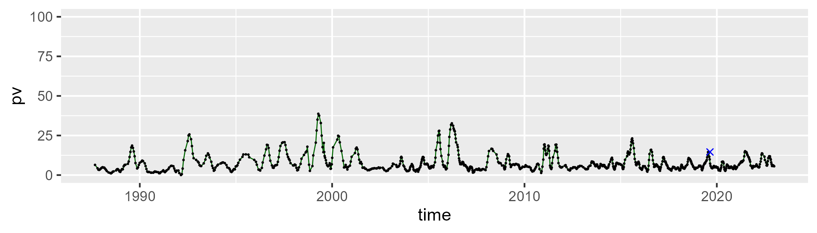

| Min. | 1st Qu. | Median | Mean | 3rd Qu. | Max. |
| --- | --- | --- | --- | --- | --- |
| 22.10855 | 35.66378 | 41.2307 | 41.92408 | 47.33531 | 63.5857 |

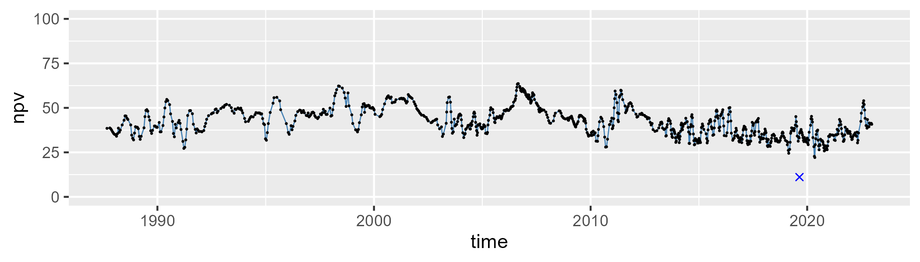

| Min. | 1st Qu. | Median | Mean | 3rd Qu. | Max. |
| --- | --- | --- | --- | --- | --- |
| 17.75156 | 42.09064 | 51.13681 | 49.09828 | 57.29618 | 68.82141 |

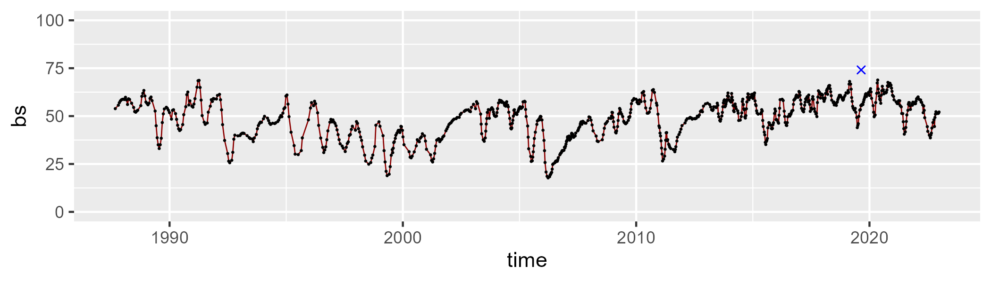

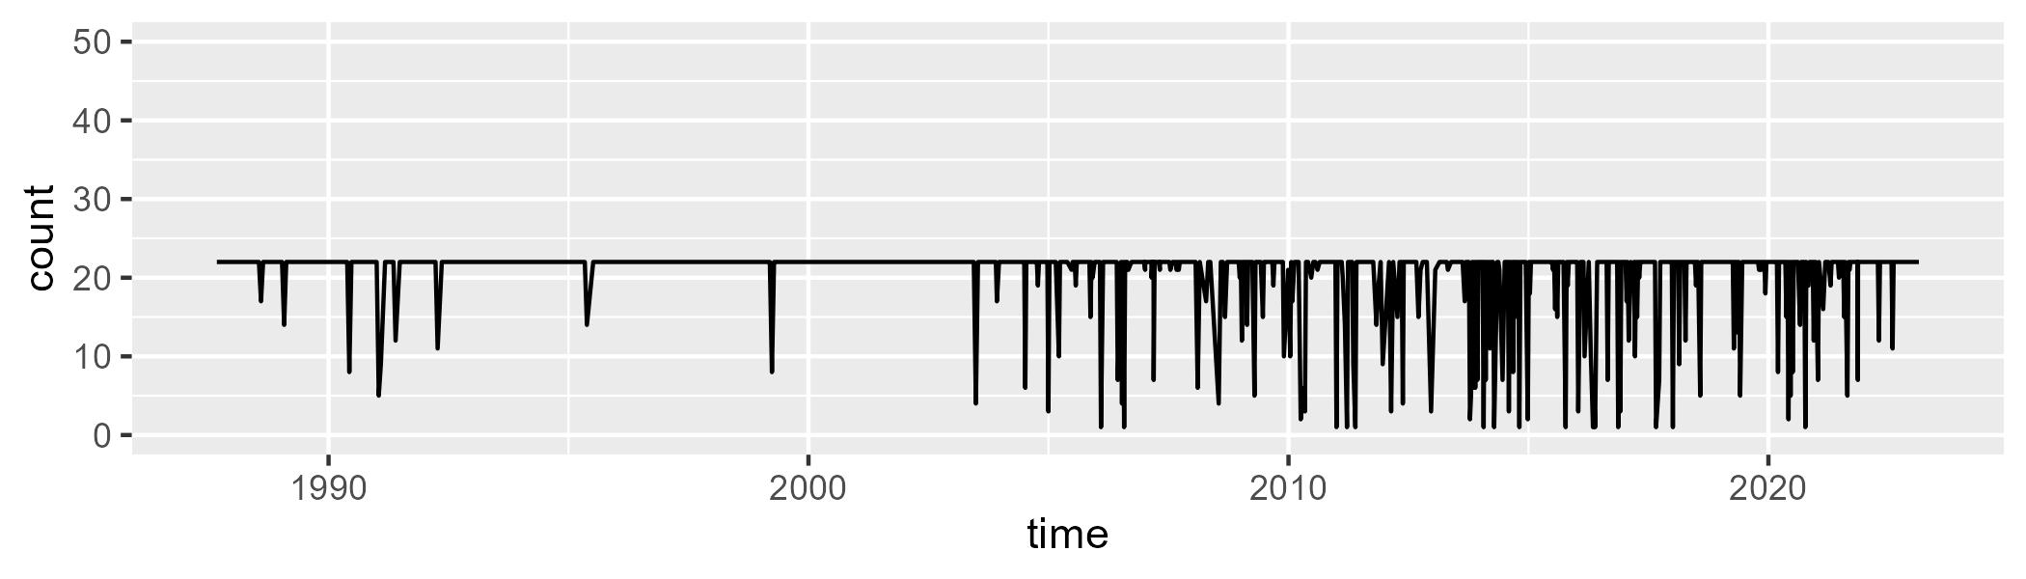

Min. : 1.00 1st Qu.:22.00 Median :22.00 Mean :20.38 3rd Qu.:22.00 Max. :22.00

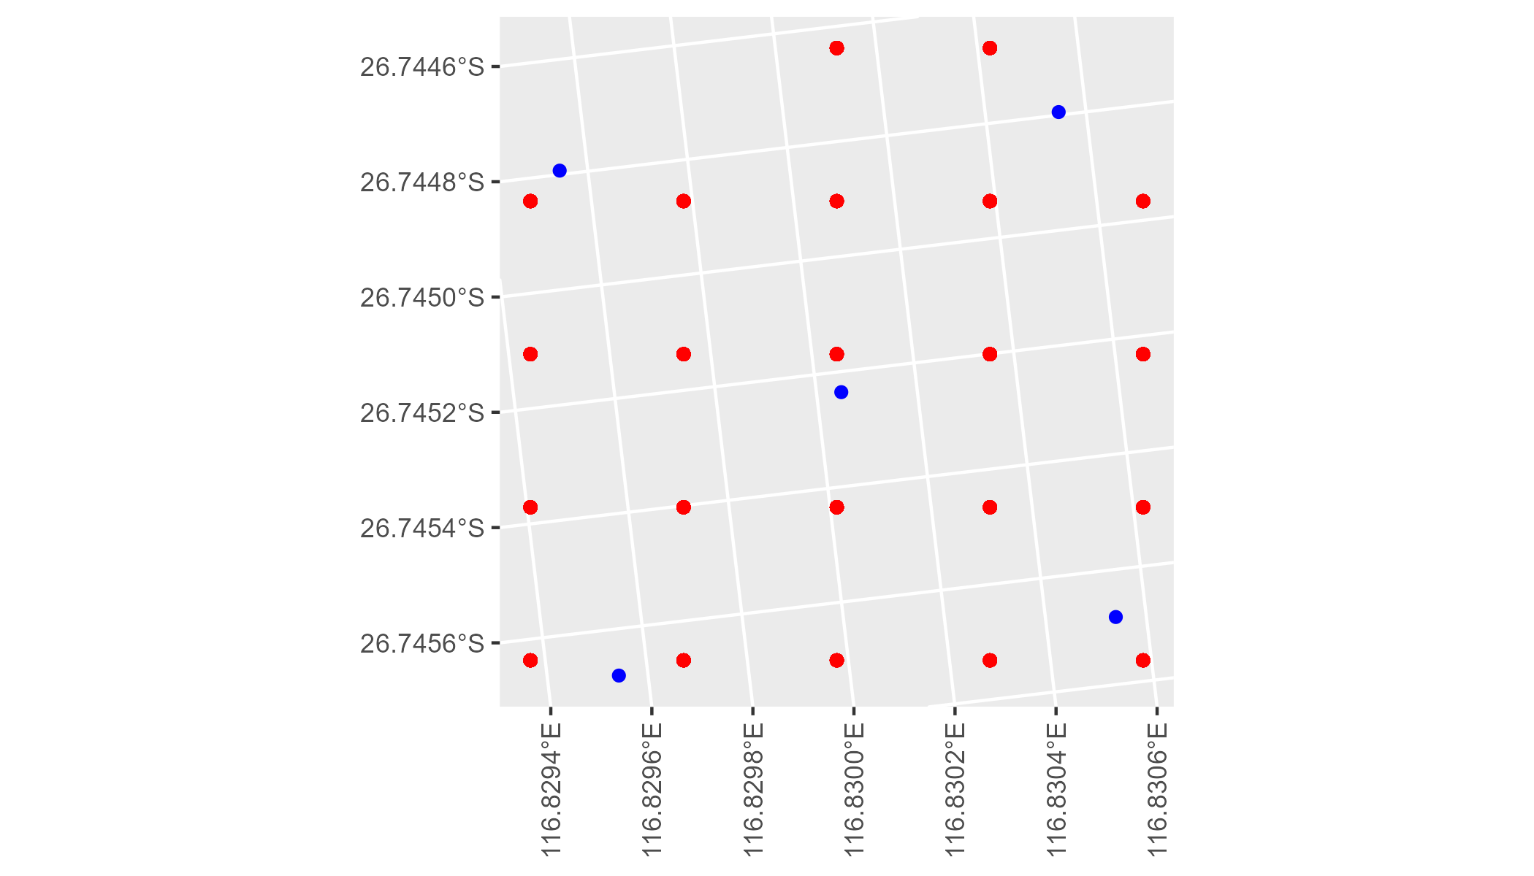

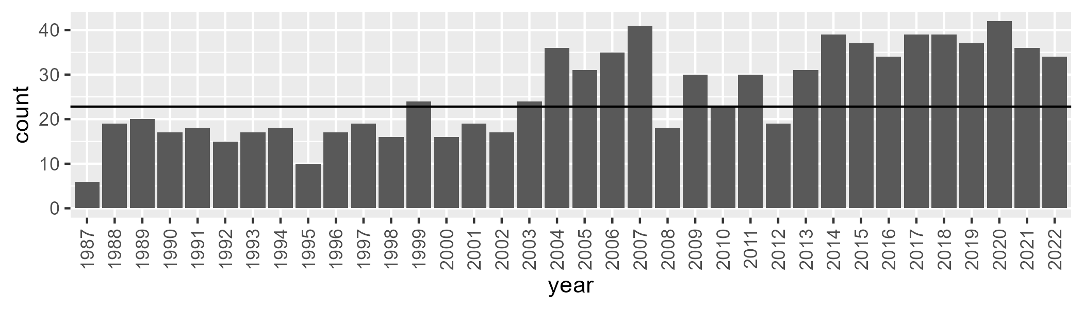

Number of samples: 923

# WAAMUR0028

| Min. | 1st Qu. | Median | Mean | 3rd Qu. | Max. |
| --- | --- | --- | --- | --- | --- |
| 2.056692 | 8.610822 | 10.79913 | 10.964 | 13.21543 | 25.39135 |

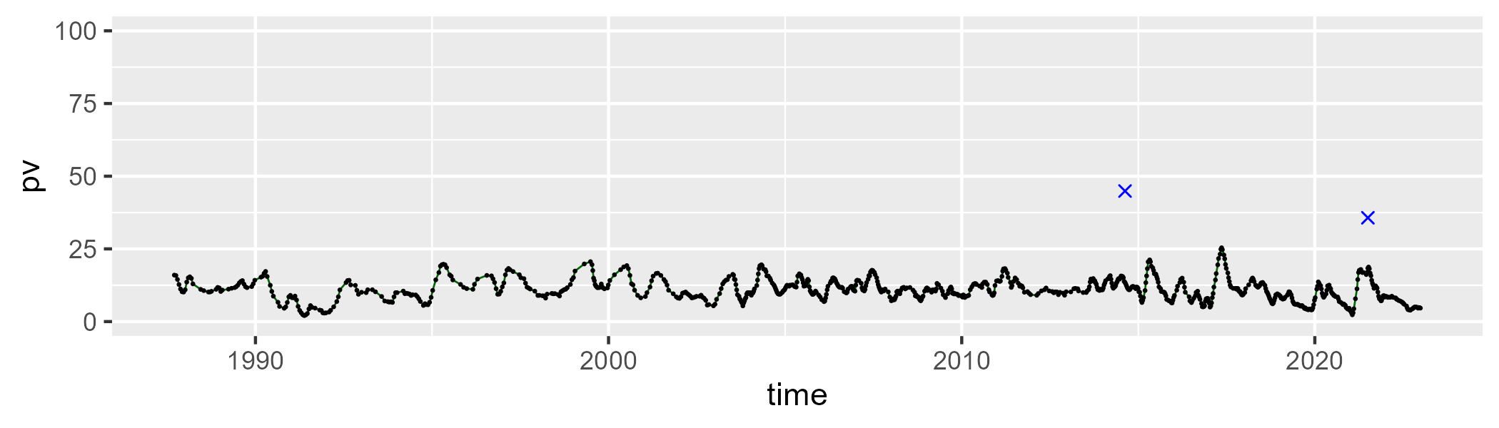

| Min. | 1st Qu. | Median | Mean | 3rd Qu. | Max. |
| --- | --- | --- | --- | --- | --- |
| 31.8139 | 40.39139 | 44.43561 | 44.12745 | 47.53589 | 57.96956 |

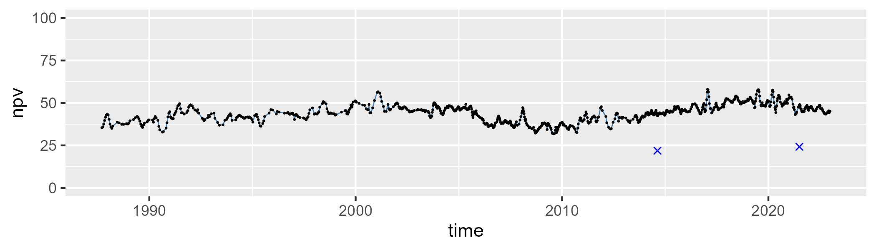

| Min. | 1st Qu. | Median | Mean | 3rd Qu. | Max. |
| --- | --- | --- | --- | --- | --- |
| 26.18327 | 39.63272 | 43.54701 | 43.45646 | 47.32083 | 60.42157 |

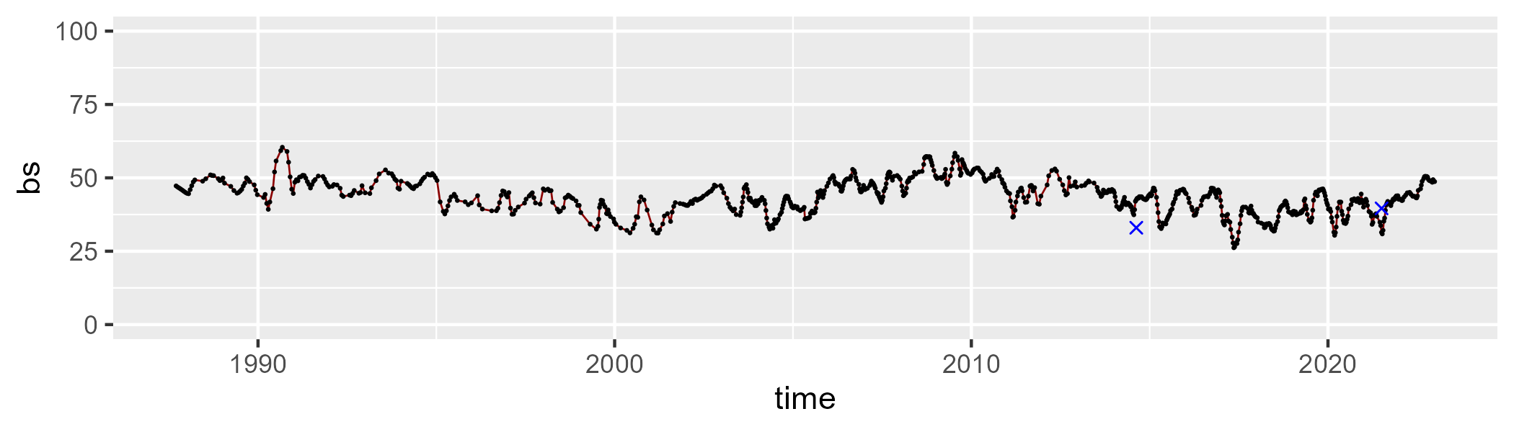

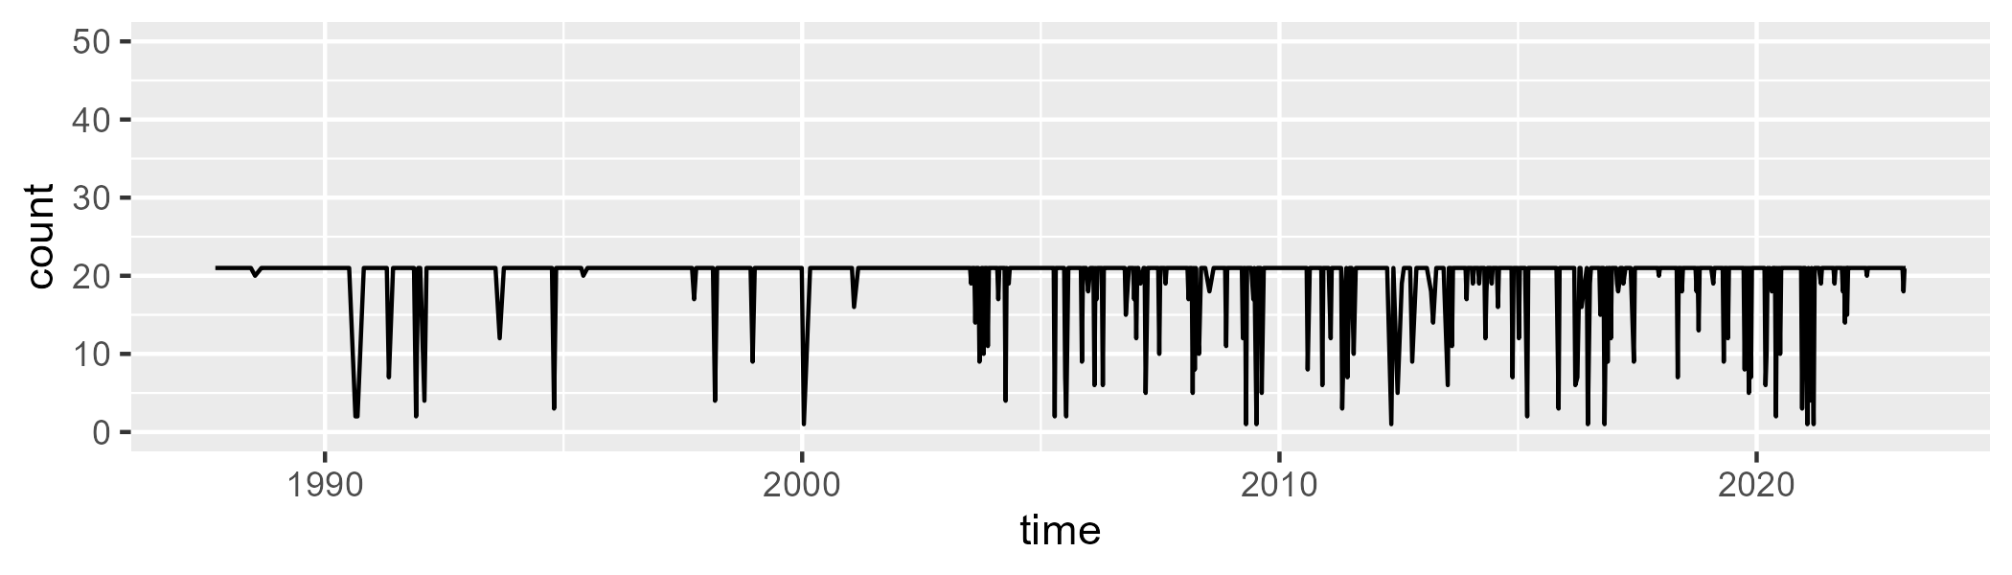

Min. : 1.00 1st Qu.:21.00 Median :21.00 Mean :19.68 3rd Qu.:21.00 Max. :21.00

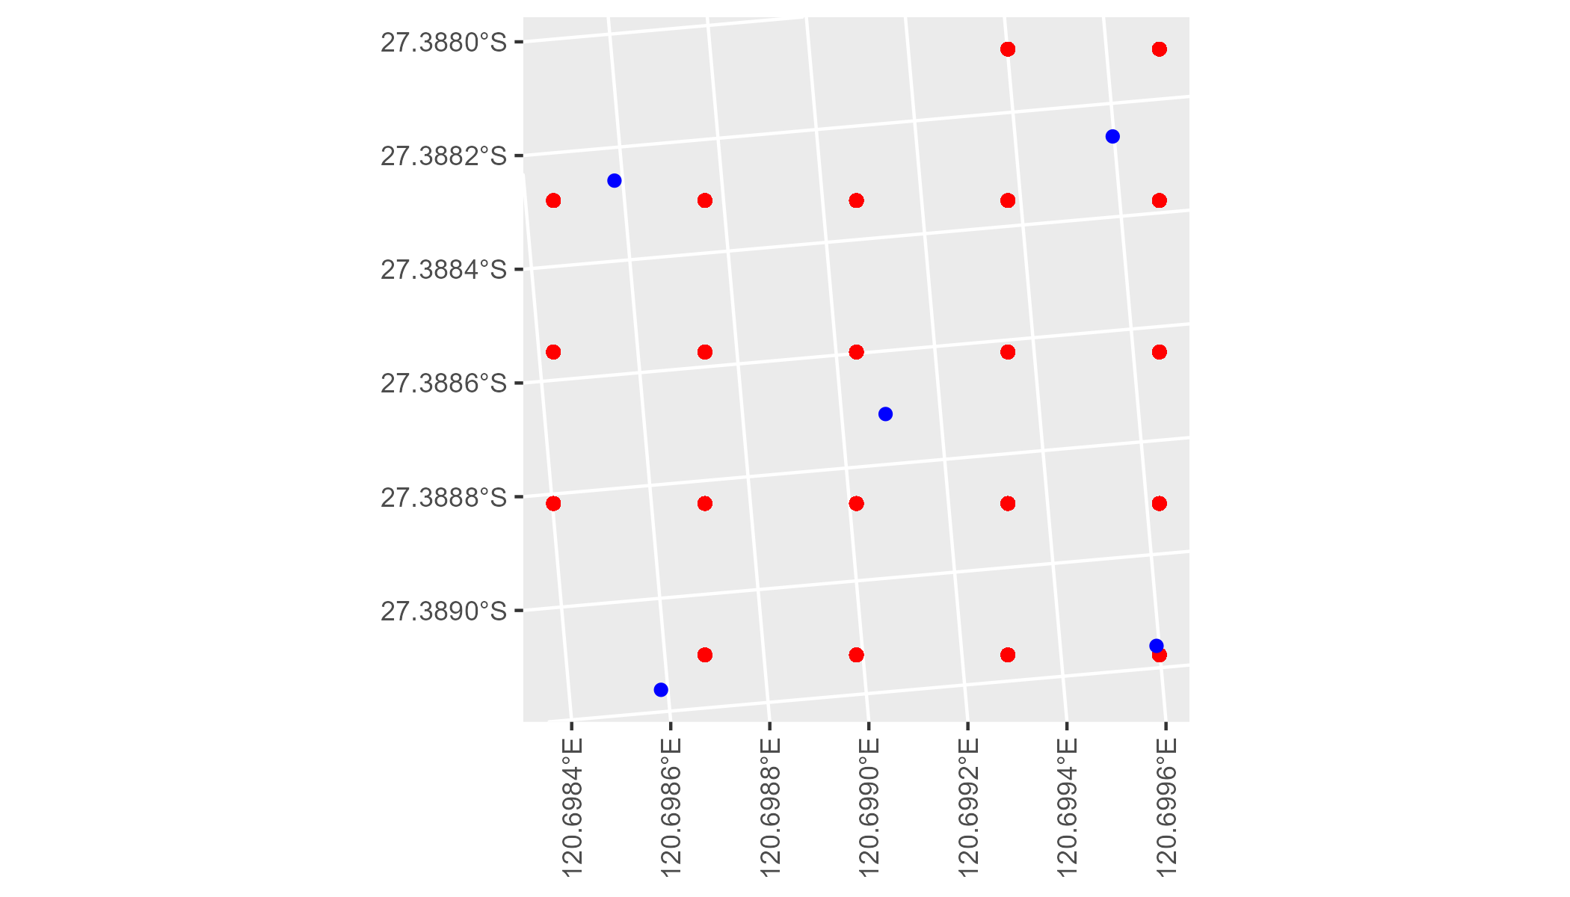

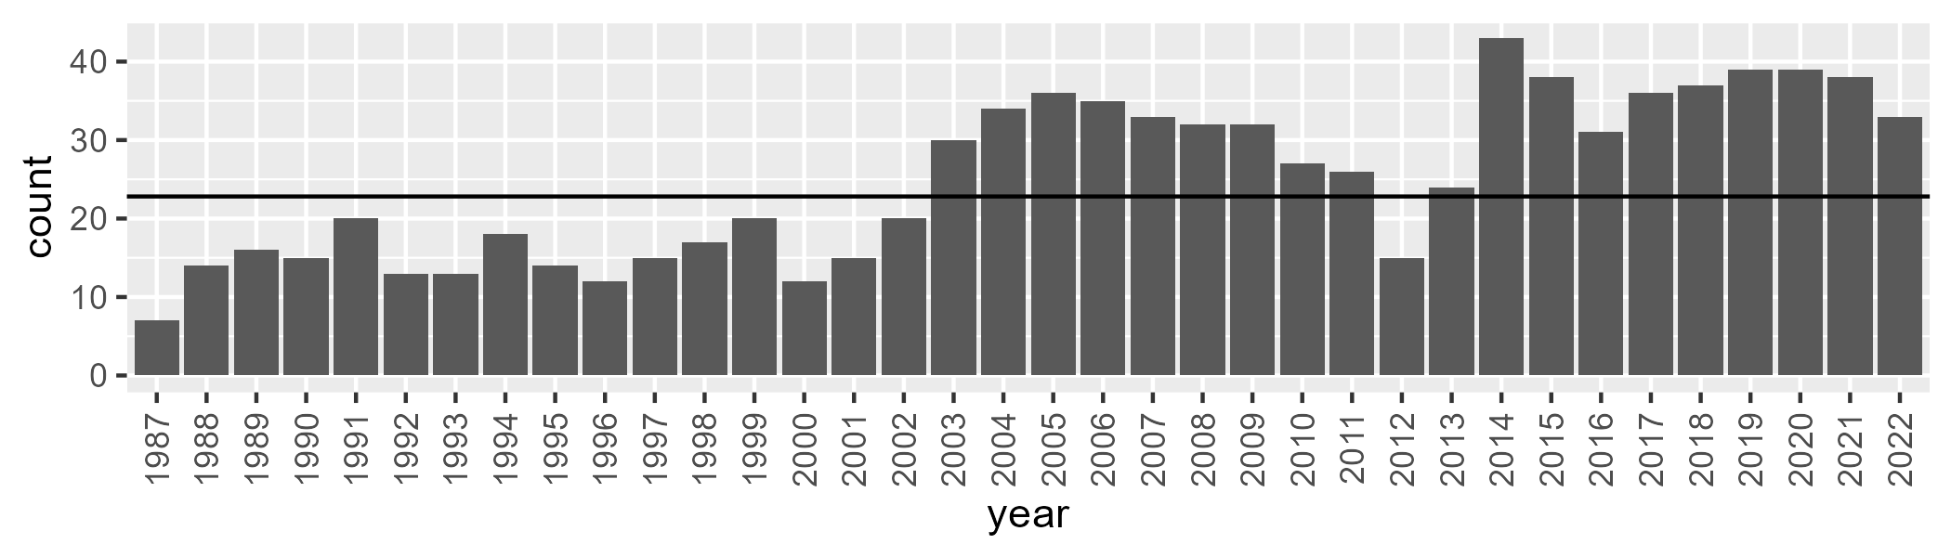

Number of samples: 899

# WAAMUR0029

| Min. | 1st Qu. | Median | Mean | 3rd Qu. | Max. |
| --- | --- | --- | --- | --- | --- |
| 0.4307671 | 5.856088 | 8.130474 | 8.561736 | 10.79614 | 22.99453 |

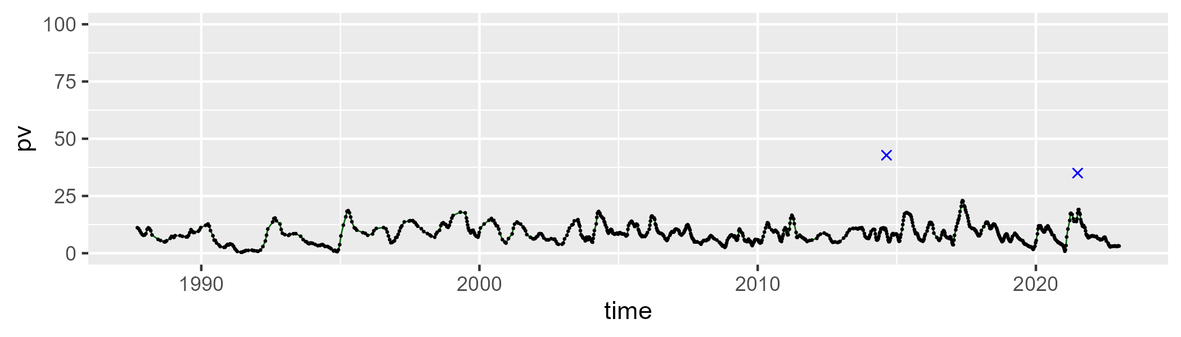

| Min. | 1st Qu. | Median | Mean | 3rd Qu. | Max. |
| --- | --- | --- | --- | --- | --- |
| 30.93389 | 45.27255 | 48.08465 | 47.69788 | 50.35743 | 61.88616 |

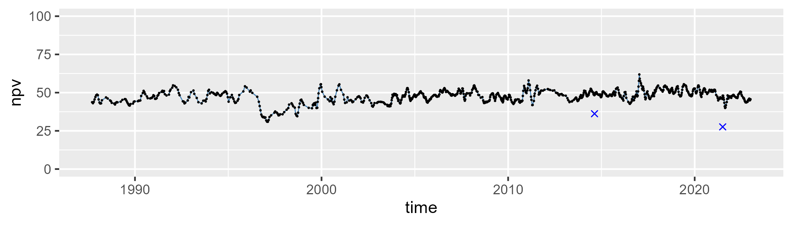

| Min. | 1st Qu. | Median | Mean | 3rd Qu. | Max. |
| --- | --- | --- | --- | --- | --- |
| 28.02052 | 39.27208 | 42.39051 | 42.3108 | 45.46804 | 59.67566 |

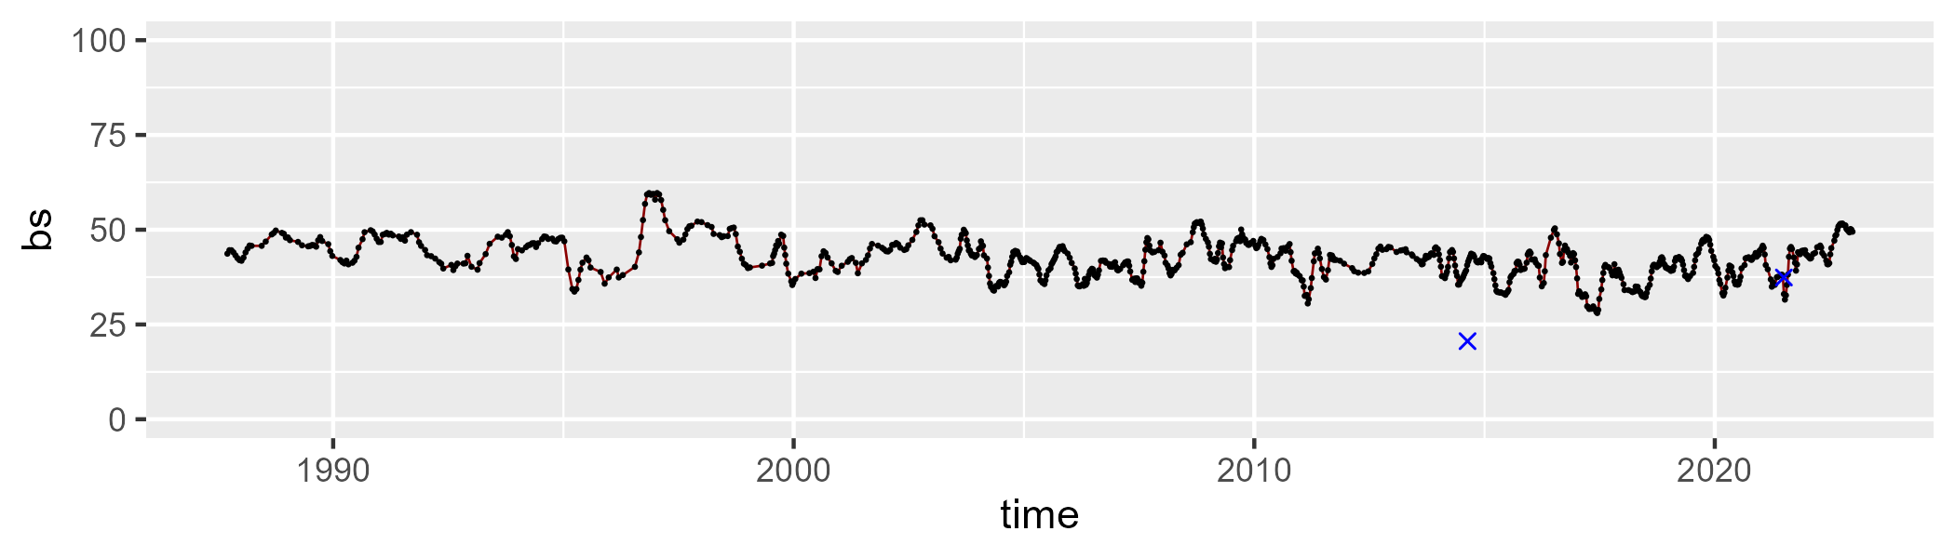

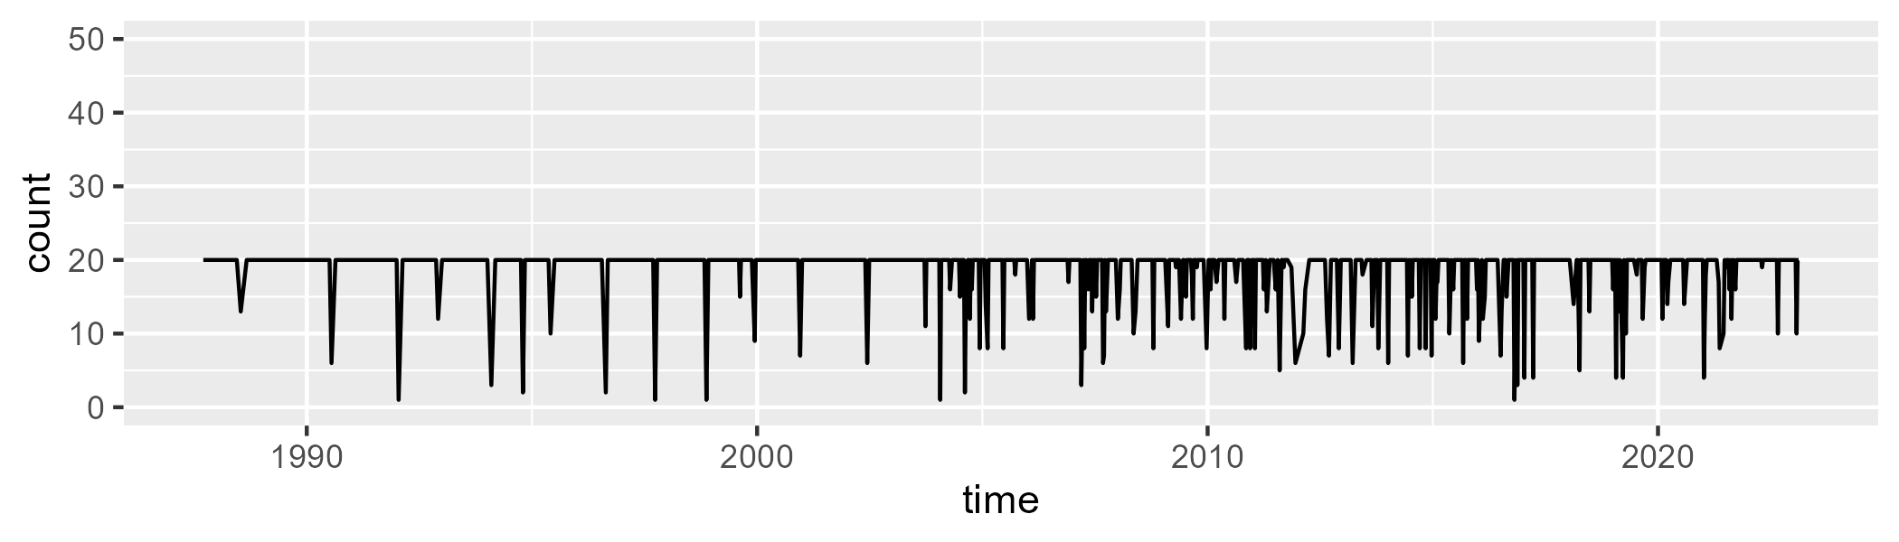

Min. : 1.00 1st Qu.:20.00 Median :20.00 Mean :18.76 3rd Qu.:20.00 Max. :20.00

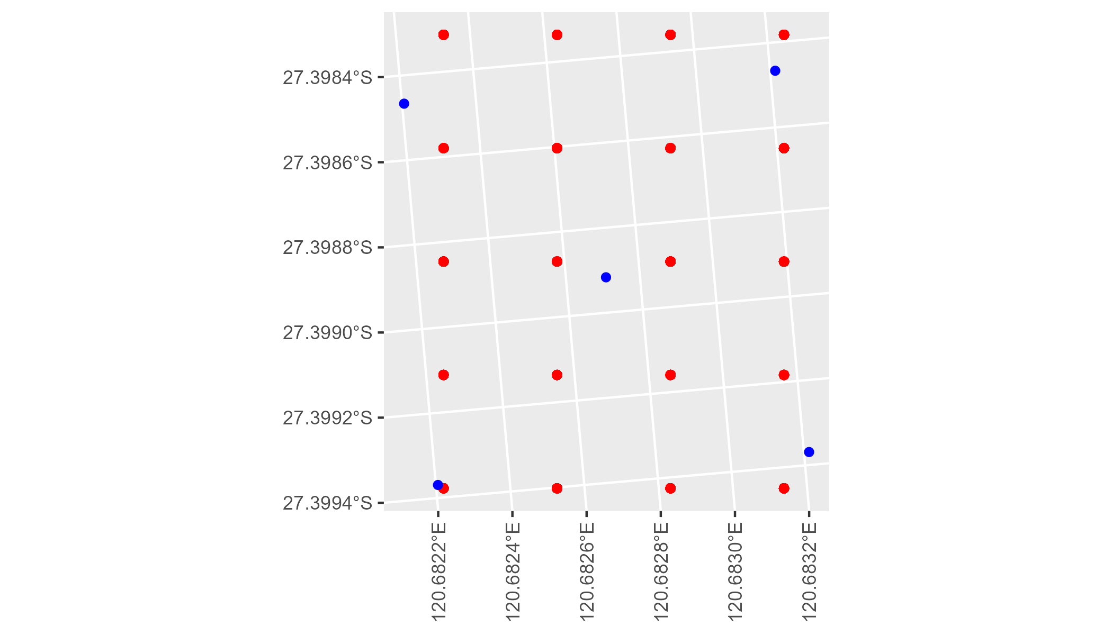

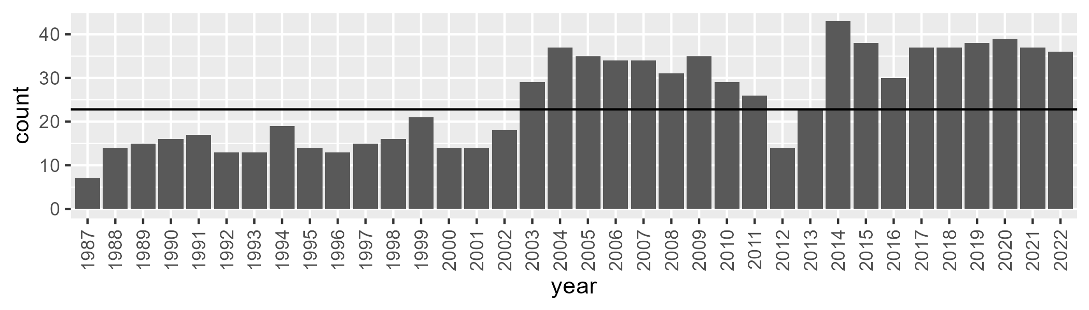

Number of samples: 901

# WAAMUR0030

| Min. | 1st Qu. | Median | Mean | 3rd Qu. | Max. |
| --- | --- | --- | --- | --- | --- |
| 2.290832 | 9.310619 | 11.34554 | 11.60821 | 13.68596 | 24.78047 |

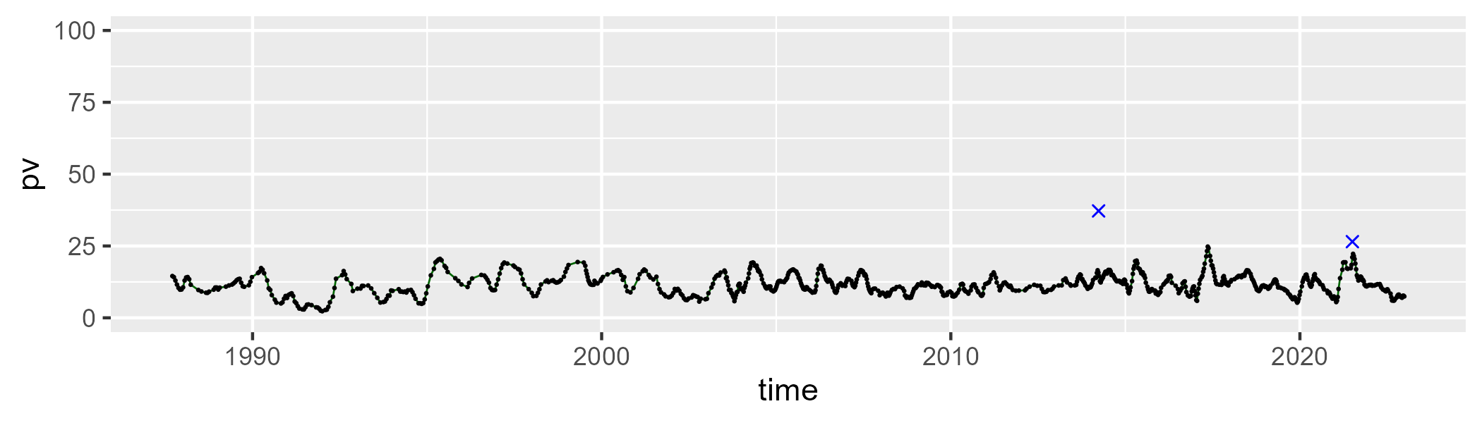

| Min. | 1st Qu. | Median | Mean | 3rd Qu. | Max. |
| --- | --- | --- | --- | --- | --- |
| 36.7027 | 41.49094 | 43.41472 | 43.47914 | 45.44912 | 54.88134 |

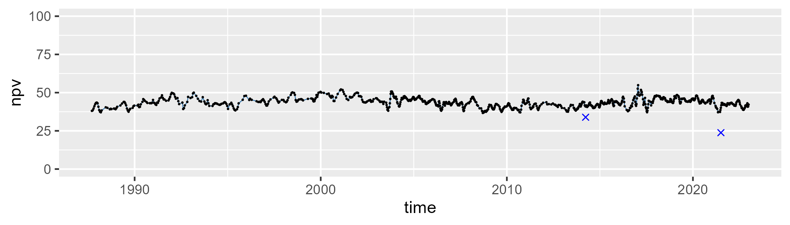

| Min. | 1st Qu. | Median | Mean | 3rd Qu. | Max. |
| --- | --- | --- | --- | --- | --- |
| 30.12254 | 40.60444 | 43.82296 | 43.44603 | 46.56294 | 54.42047 |

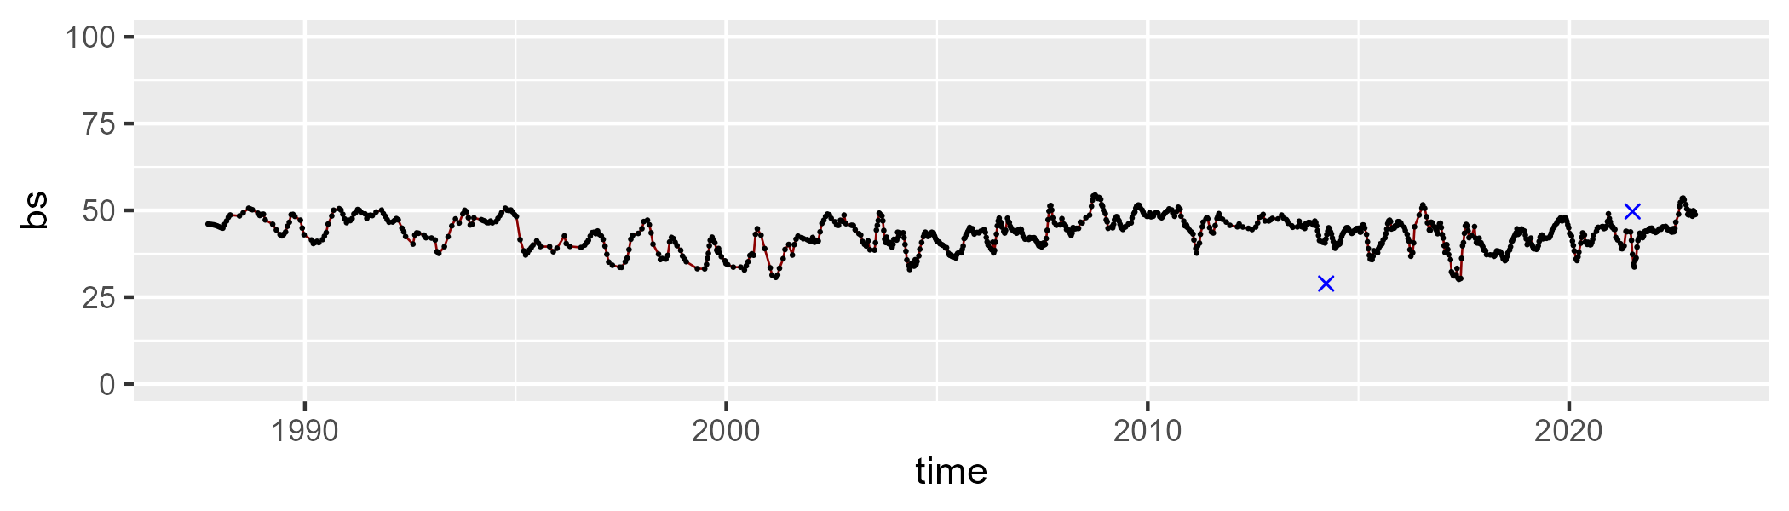

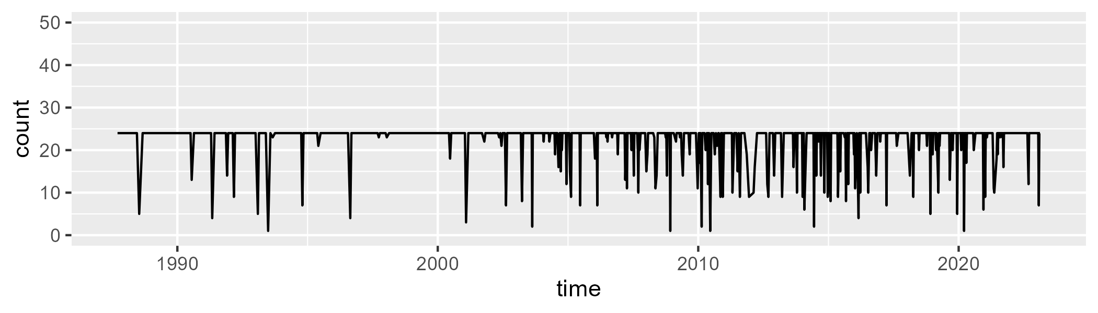

Min. : 1.00 1st Qu.:24.00 Median :24.00 Mean :22.51 3rd Qu.:24.00 Max. :24.00

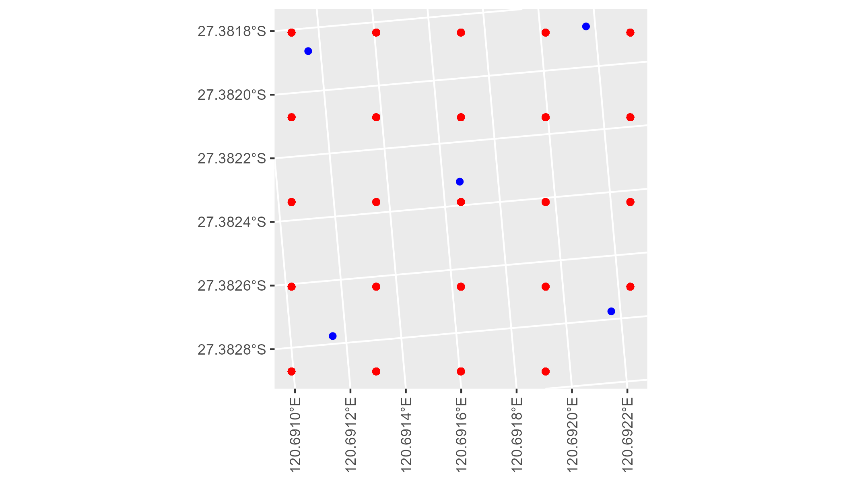

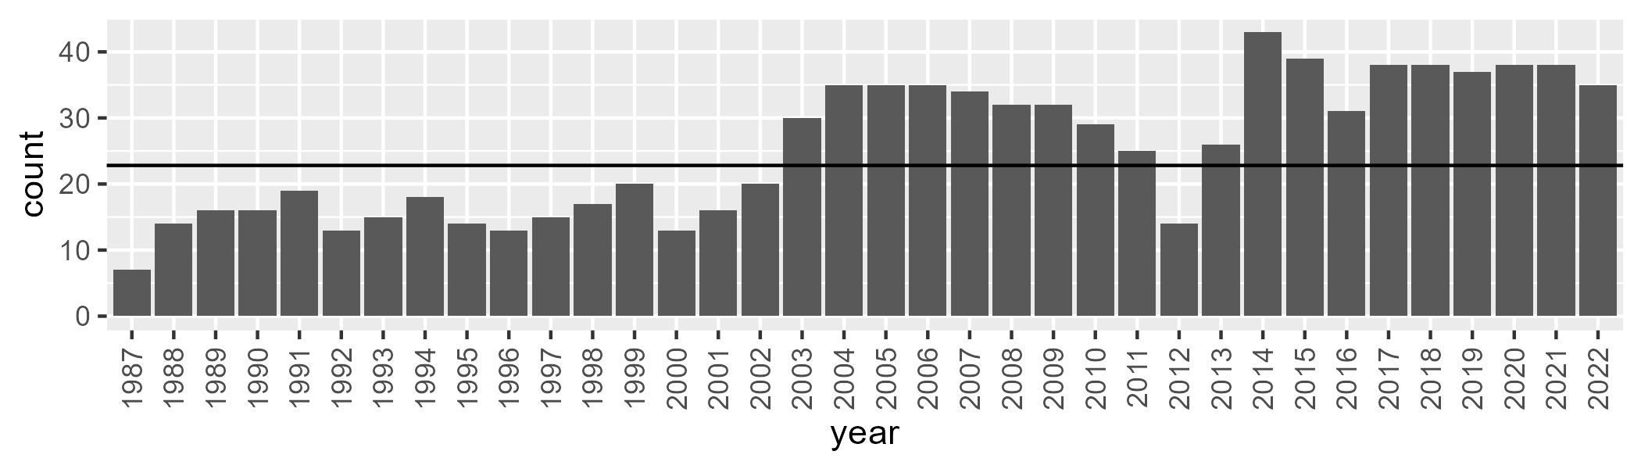

Number of samples: 910

# WAAMUR0031

| Min. | 1st Qu. | Median | Mean | 3rd Qu. | Max. |
| --- | --- | --- | --- | --- | --- |
| 0 | 6.151153 | 8.791421 | 9.04072 | 11.47728 | 22.9476 |

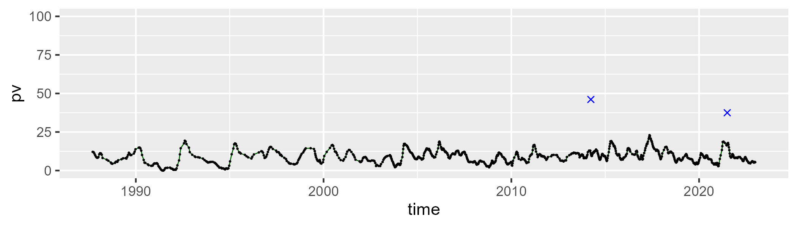

| Min. | 1st Qu. | Median | Mean | 3rd Qu. | Max. |
| --- | --- | --- | --- | --- | --- |
| 38.33996 | 45.08485 | 47.00303 | 47.3682 | 49.53804 | 57.29444 |

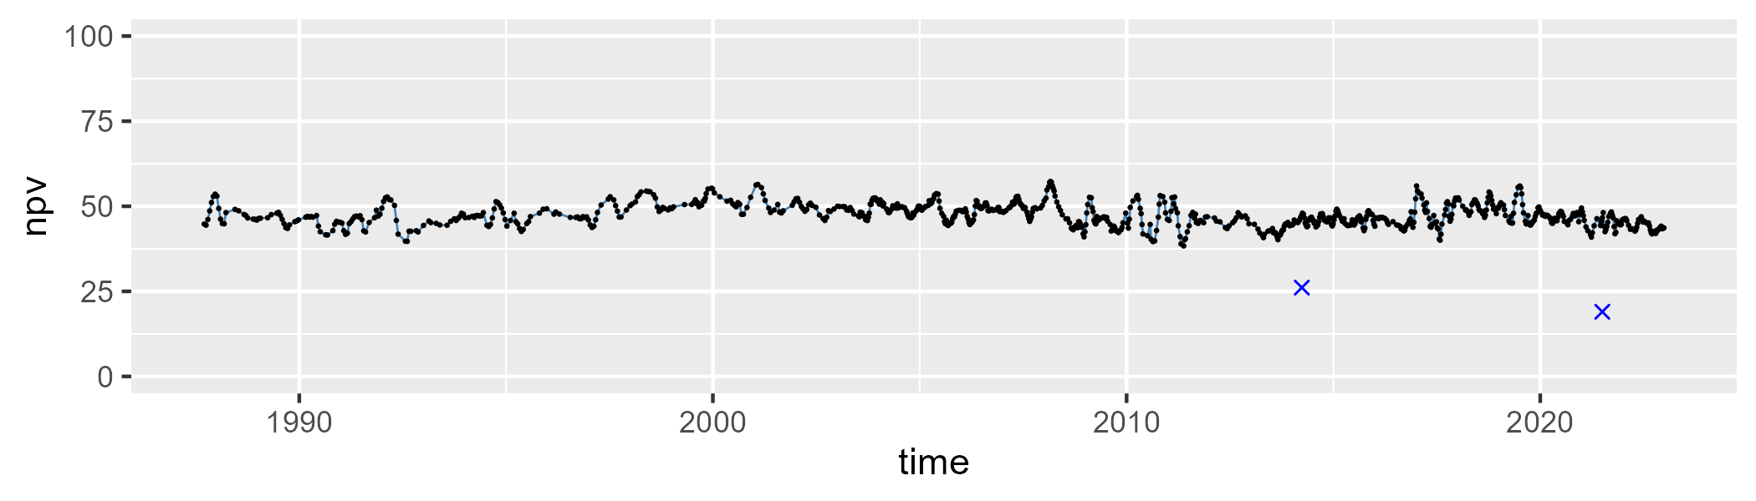

| Min. | 1st Qu. | Median | Mean | 3rd Qu. | Max. |
| --- | --- | --- | --- | --- | --- |
| 30.14376 | 39.13731 | 42.25546 | 42.1711 | 45.36901 | 54.61158 |

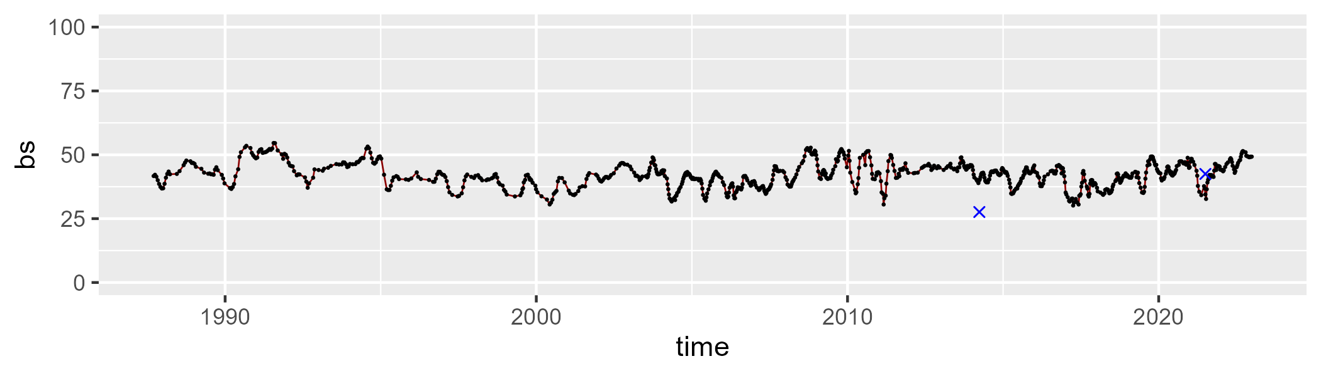

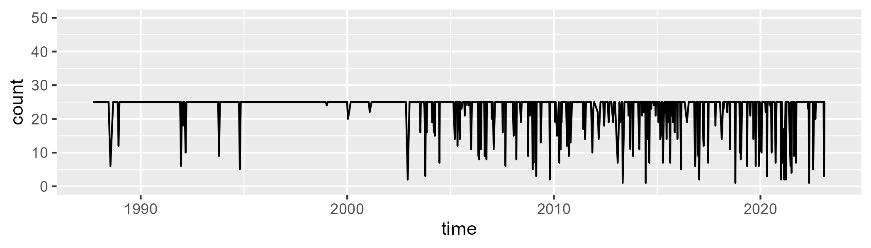

Min. : 1.00 1st Qu.:25.00 Median :25.00 Mean :23.15 3rd Qu.:25.00 Max. :25.00

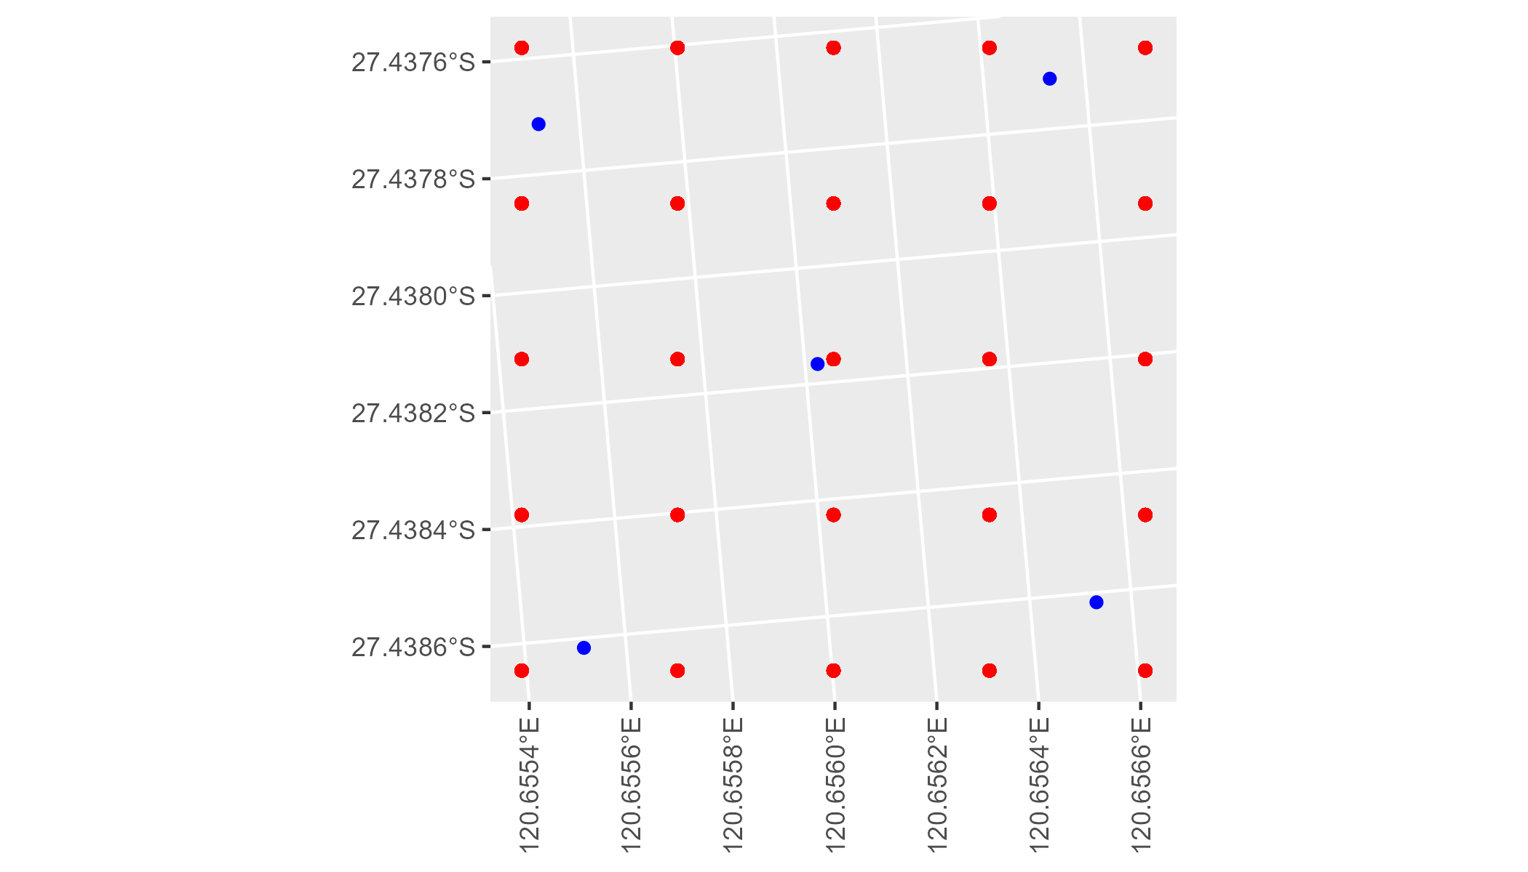

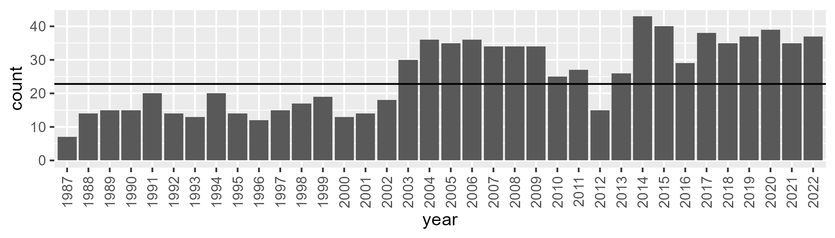

Number of samples: 905

# WAANOK0001

| Min. | 1st Qu. | Median | Mean | 3rd Qu. | Max. |
| --- | --- | --- | --- | --- | --- |
| 8.97847 | 20.75151 | 28.69528 | 31.03647 | 41.33935 | 56.62105 |

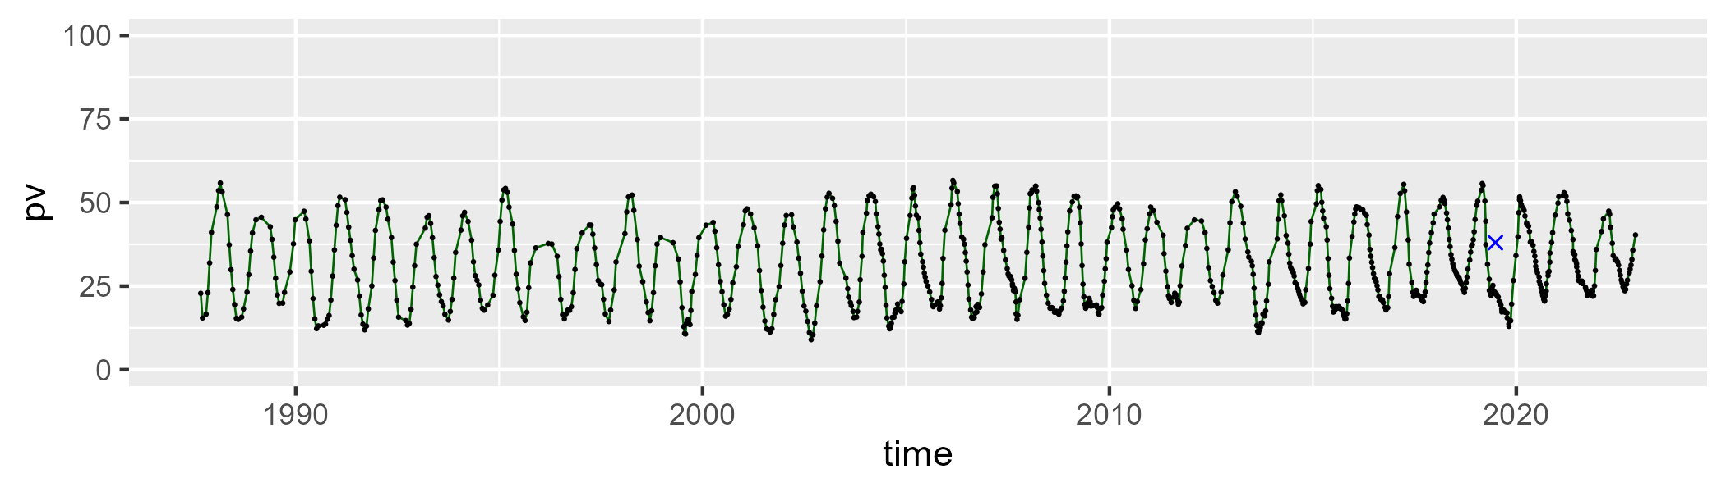

| Min. | 1st Qu. | Median | Mean | 3rd Qu. | Max. |
| --- | --- | --- | --- | --- | --- |
| 34.25563 | 50.13646 | 56.30457 | 55.17825 | 60.80818 | 75.03276 |

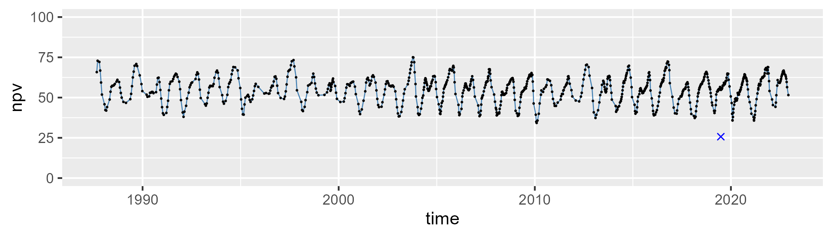

| Min. | 1st Qu. | Median | Mean | 3rd Qu. | Max. |
| --- | --- | --- | --- | --- | --- |
| 0 | 7.33602 | 10.70212 | 12.60981 | 17.77113 | 33.96505 |

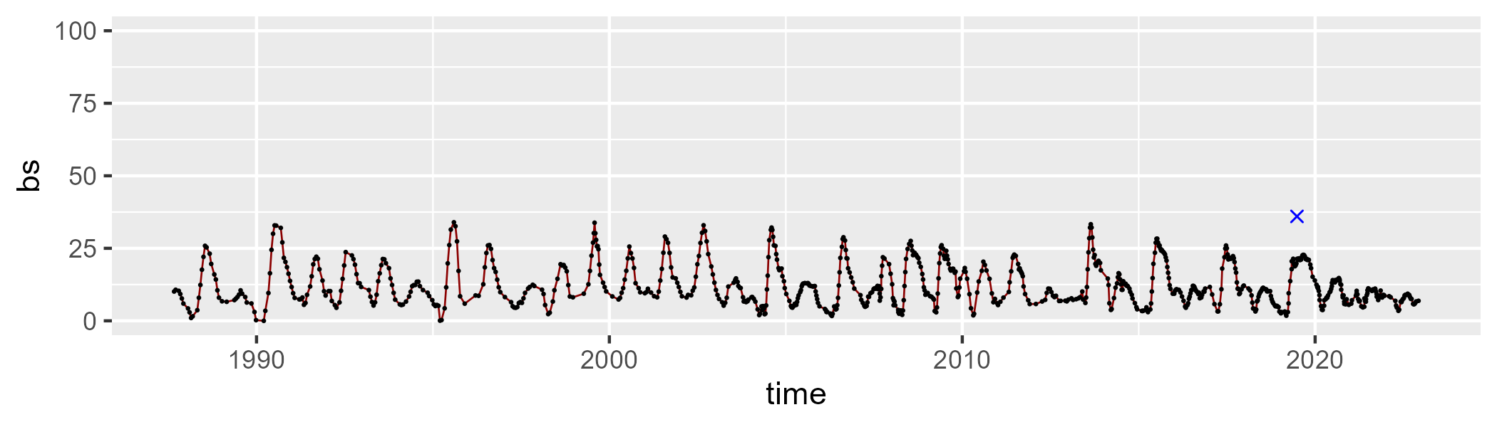

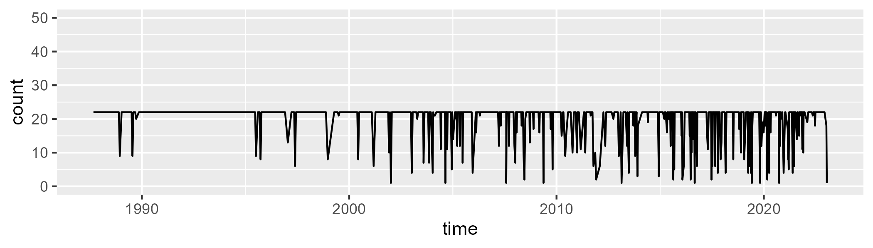

Min. : 1.00 1st Qu.:22.00 Median :22.00 Mean :20.16 3rd Qu.:22.00 Max. :22.00

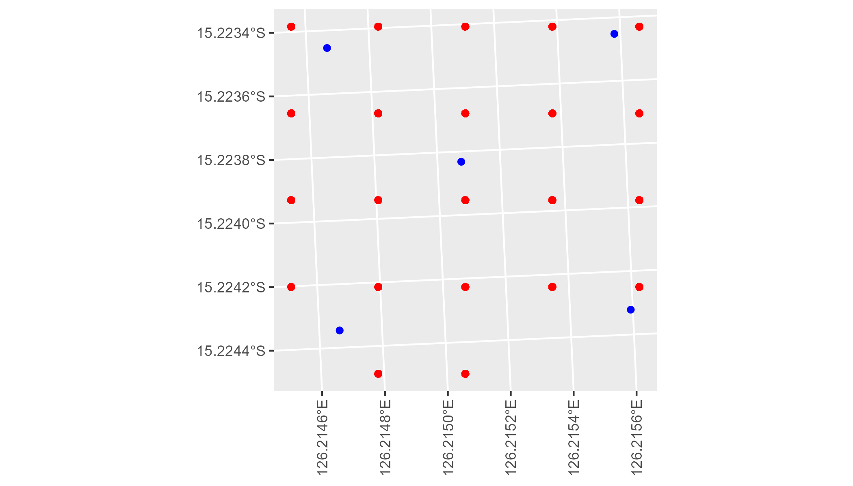

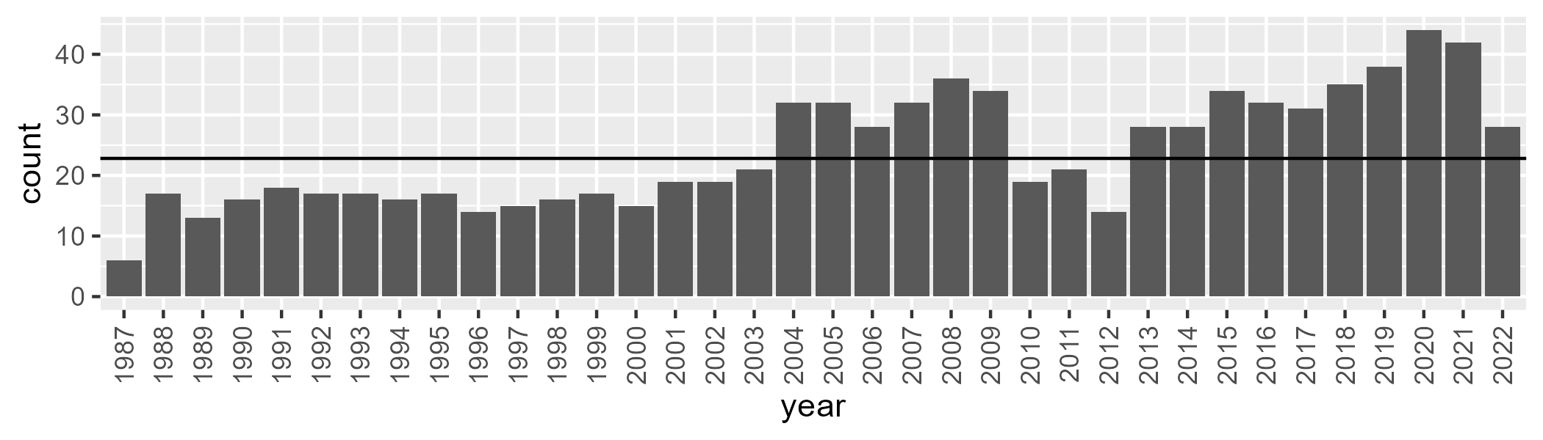

Number of samples: 861

# WAANOK0002

| Min. | 1st Qu. | Median | Mean | 3rd Qu. | Max. |
| --- | --- | --- | --- | --- | --- |
| 2.969788 | 19.61354 | 29.61152 | 31.15331 | 42.27794 | 61.34312 |

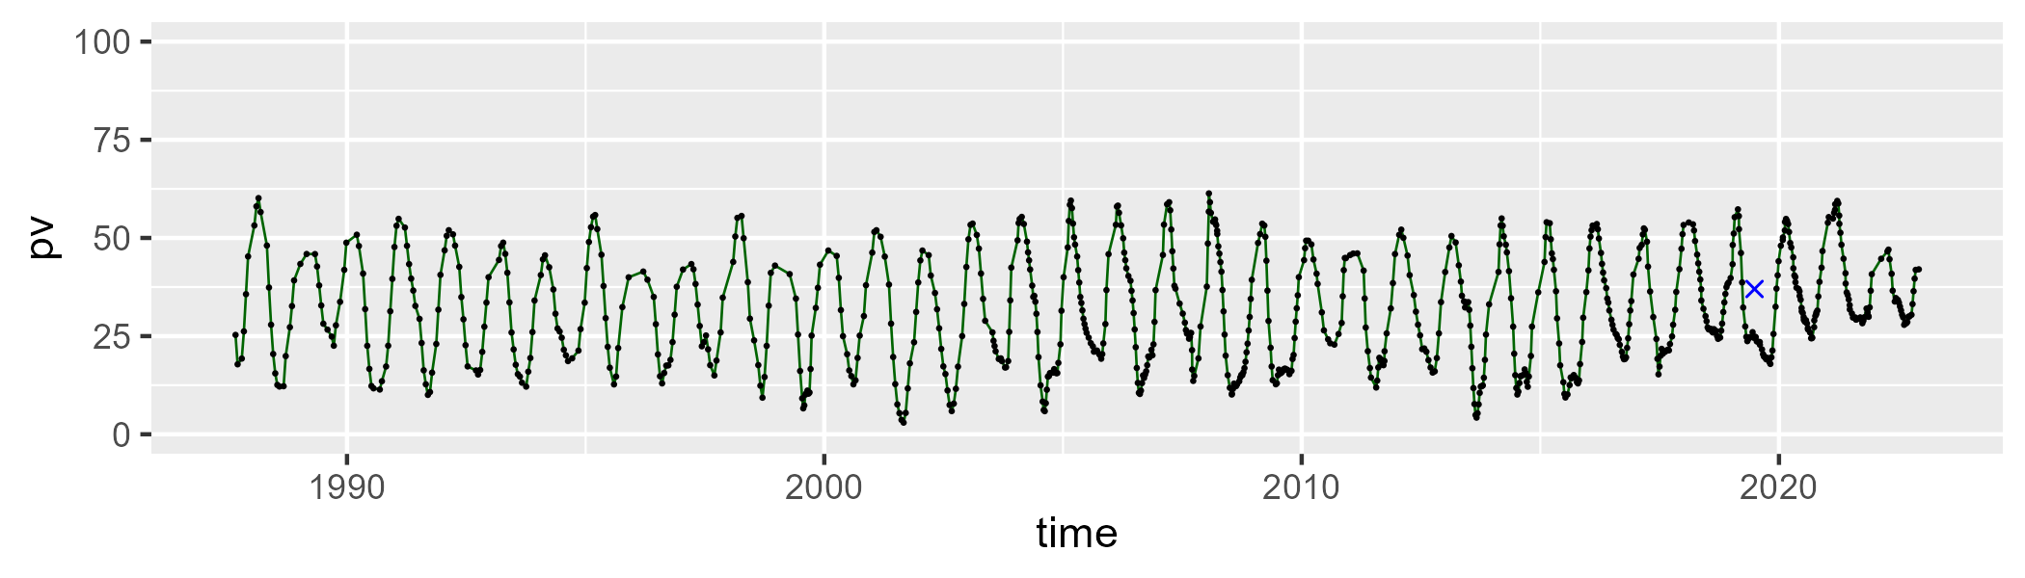

| Min. | 1st Qu. | Median | Mean | 3rd Qu. | Max. |
| --- | --- | --- | --- | --- | --- |
| 29.397 | 49.12325 | 55.04139 | 54.4211 | 60.75179 | 77.59108 |

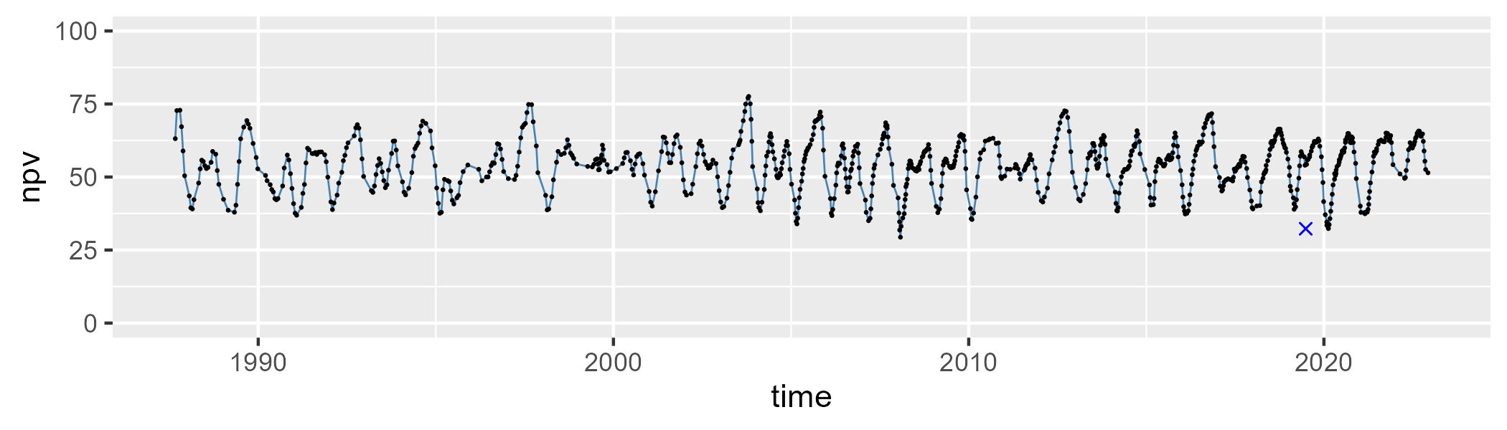

| Min. | 1st Qu. | Median | Mean | 3rd Qu. | Max. |
| --- | --- | --- | --- | --- | --- |
| 0 | 5.33935 | 9.96472 | 13.23489 | 19.10528 | 44.26915 |

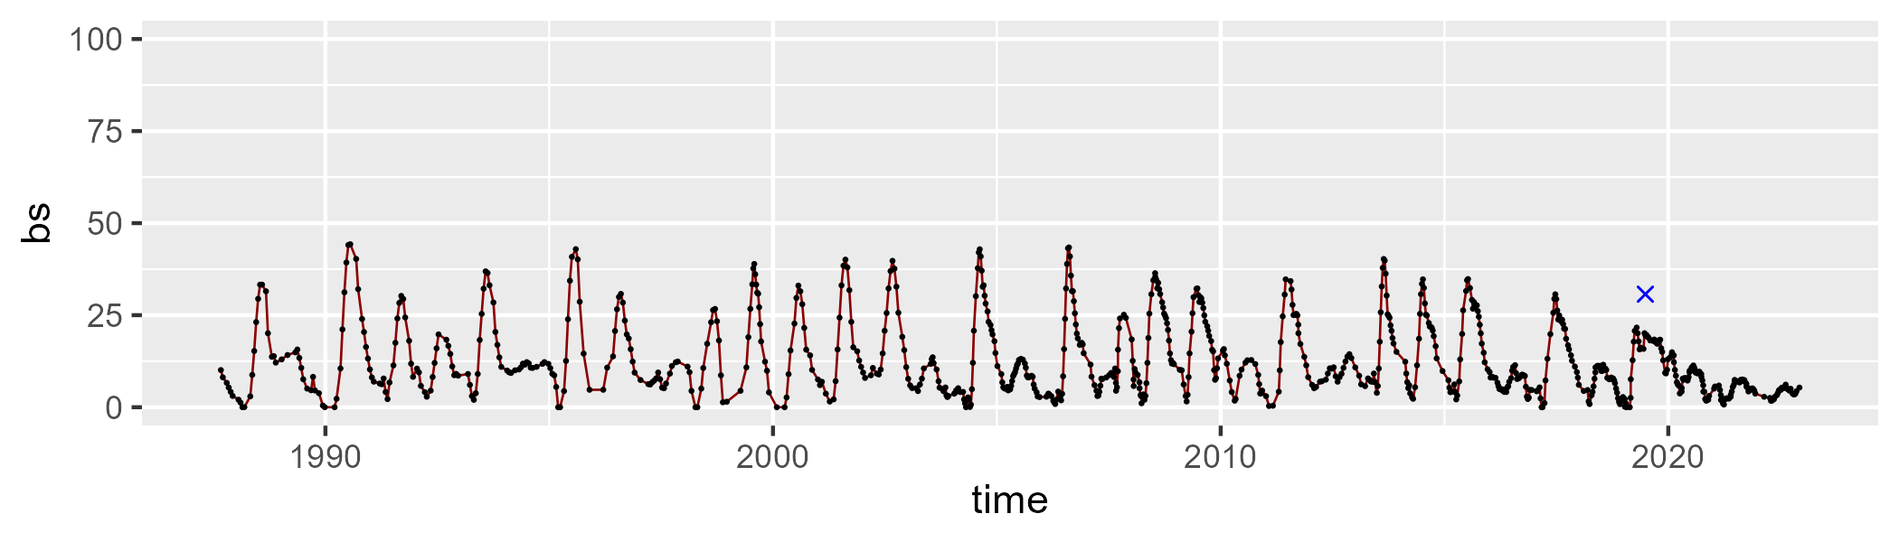

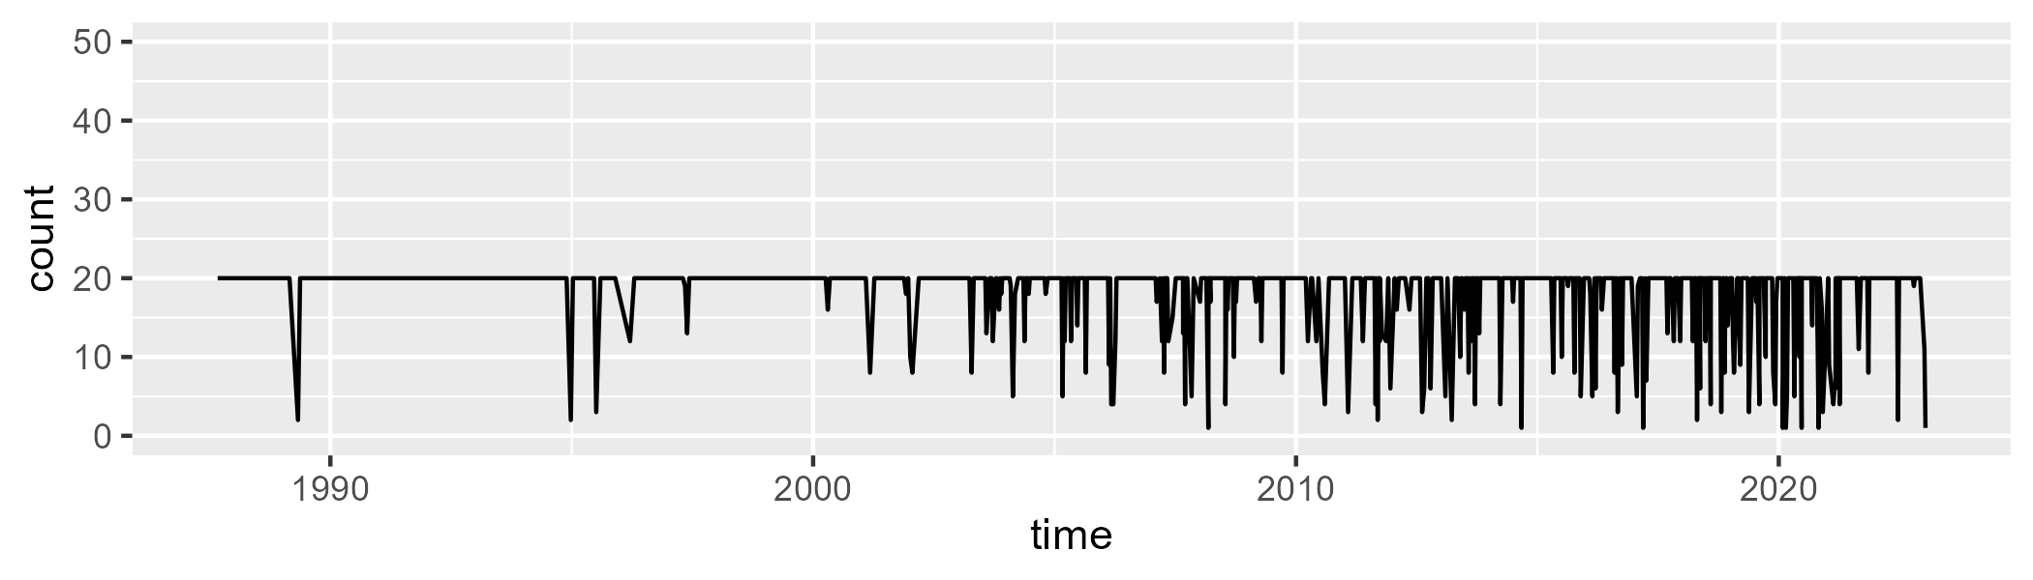

Min. : 1.00 1st Qu.:20.00 Median :20.00 Mean :18.34 3rd Qu.:20.00 Max. :20.00

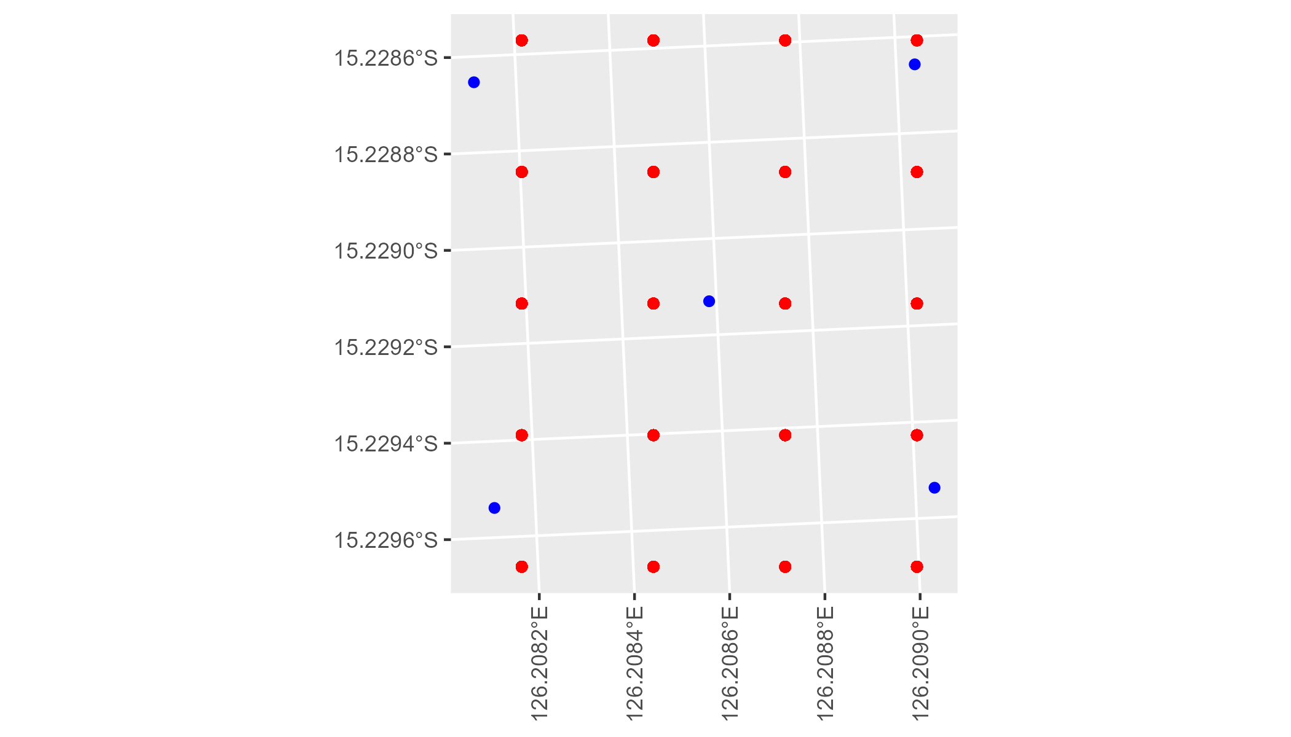

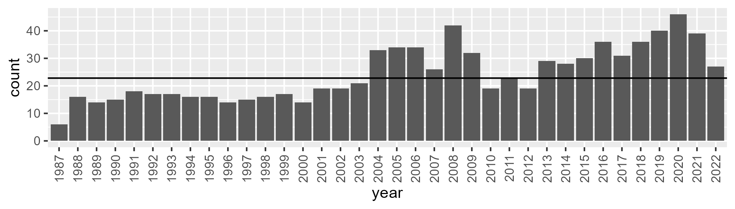

Number of samples: 874

# WAANOK0003

| Min. | 1st Qu. | Median | Mean | 3rd Qu. | Max. |
| --- | --- | --- | --- | --- | --- |
| 17.67792 | 34.30965 | 41.72823 | 41.47945 | 48.78077 | 65.54208 |

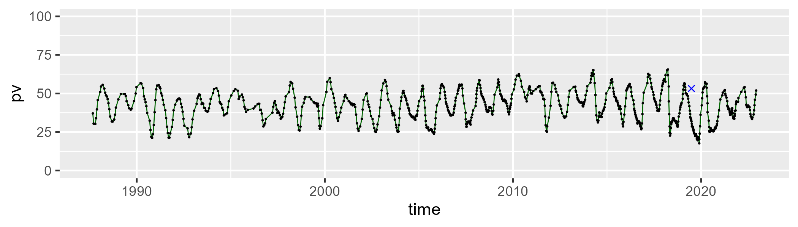

| Min. | 1st Qu. | Median | Mean | 3rd Qu. | Max. |
| --- | --- | --- | --- | --- | --- |
| 27.49083 | 42.46085 | 47.22397 | 47.01182 | 51.4381 | 71.68418 |

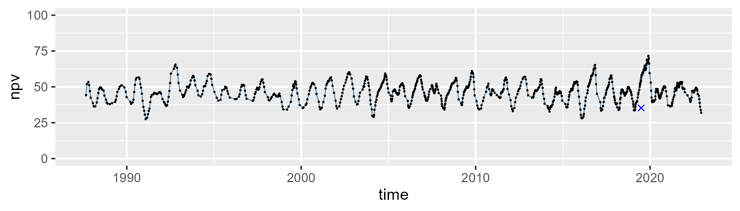

| Min. | 1st Qu. | Median | Mean | 3rd Qu. | Max. |
| --- | --- | --- | --- | --- | --- |
| 0 | 4.528548 | 8.897633 | 10.28512 | 14.32592 | 32.36918 |

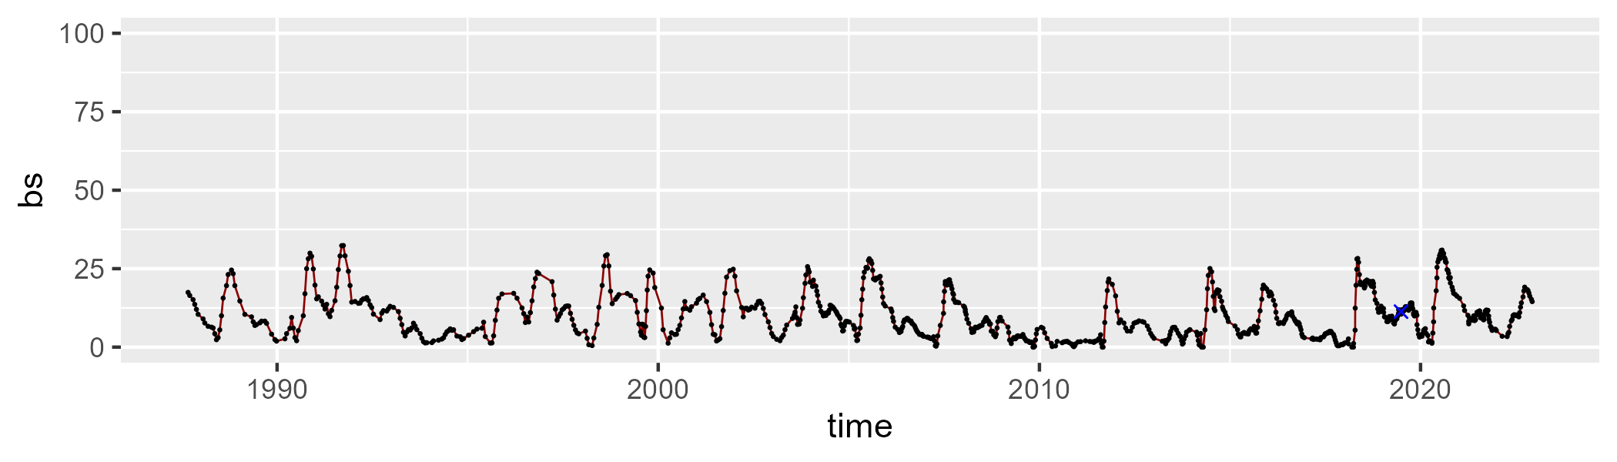

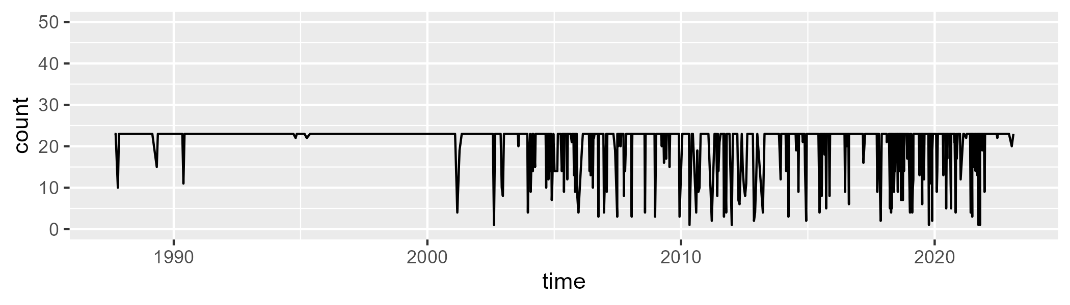

Min. : 1.00 1st Qu.:23.00 Median :23.00 Mean :20.94 3rd Qu.:23.00 Max. :23.00

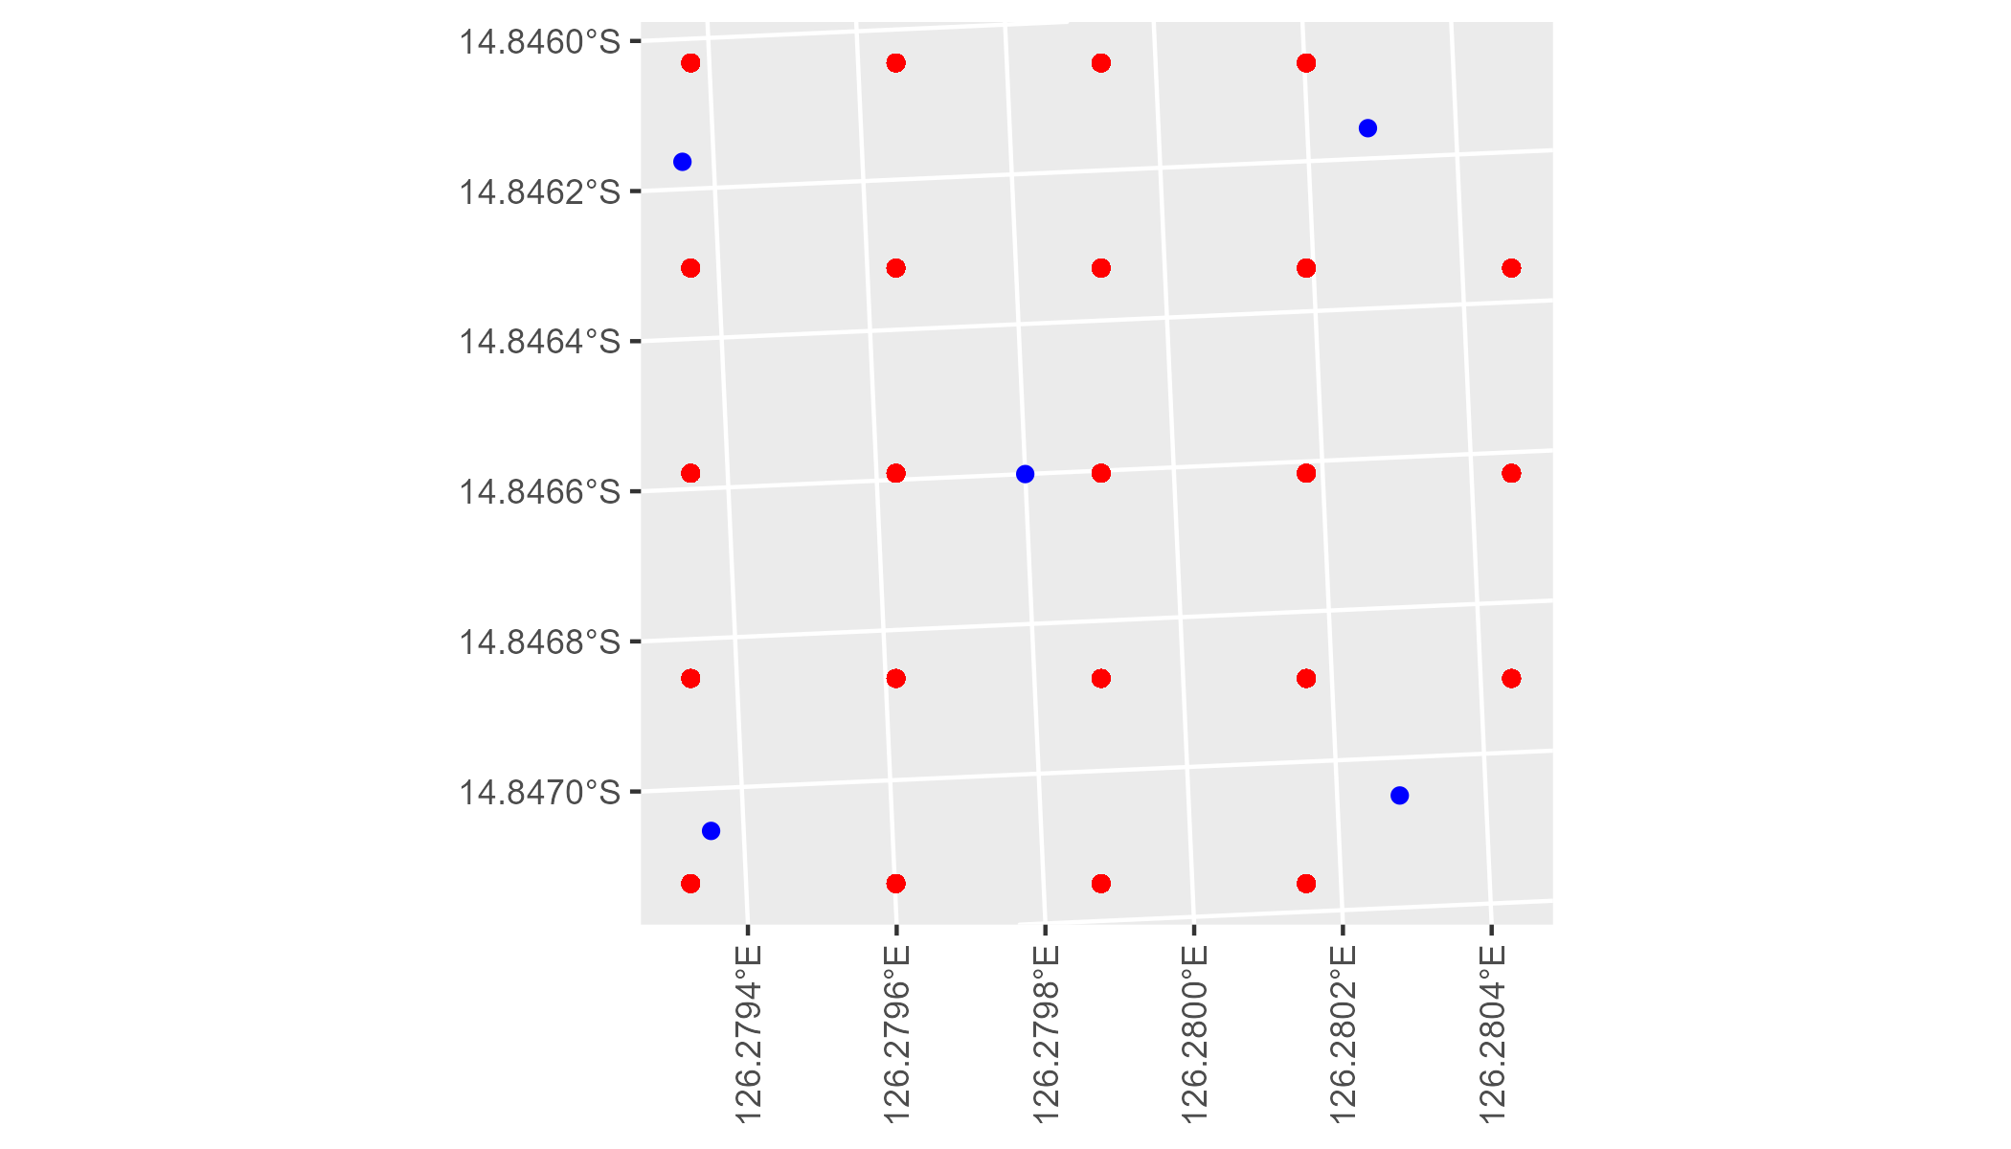

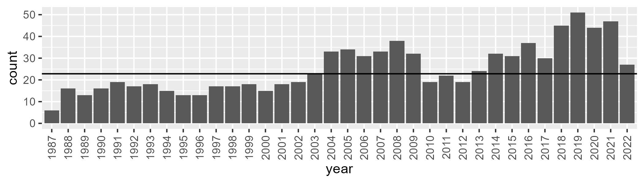

Number of samples: 902

# WAANOK0004

| Min. | 1st Qu. | Median | Mean | 3rd Qu. | Max. |
| --- | --- | --- | --- | --- | --- |
| 0 | 23.11239 | 35.64452 | 39.75979 | 56.16721 | 83.02449 |

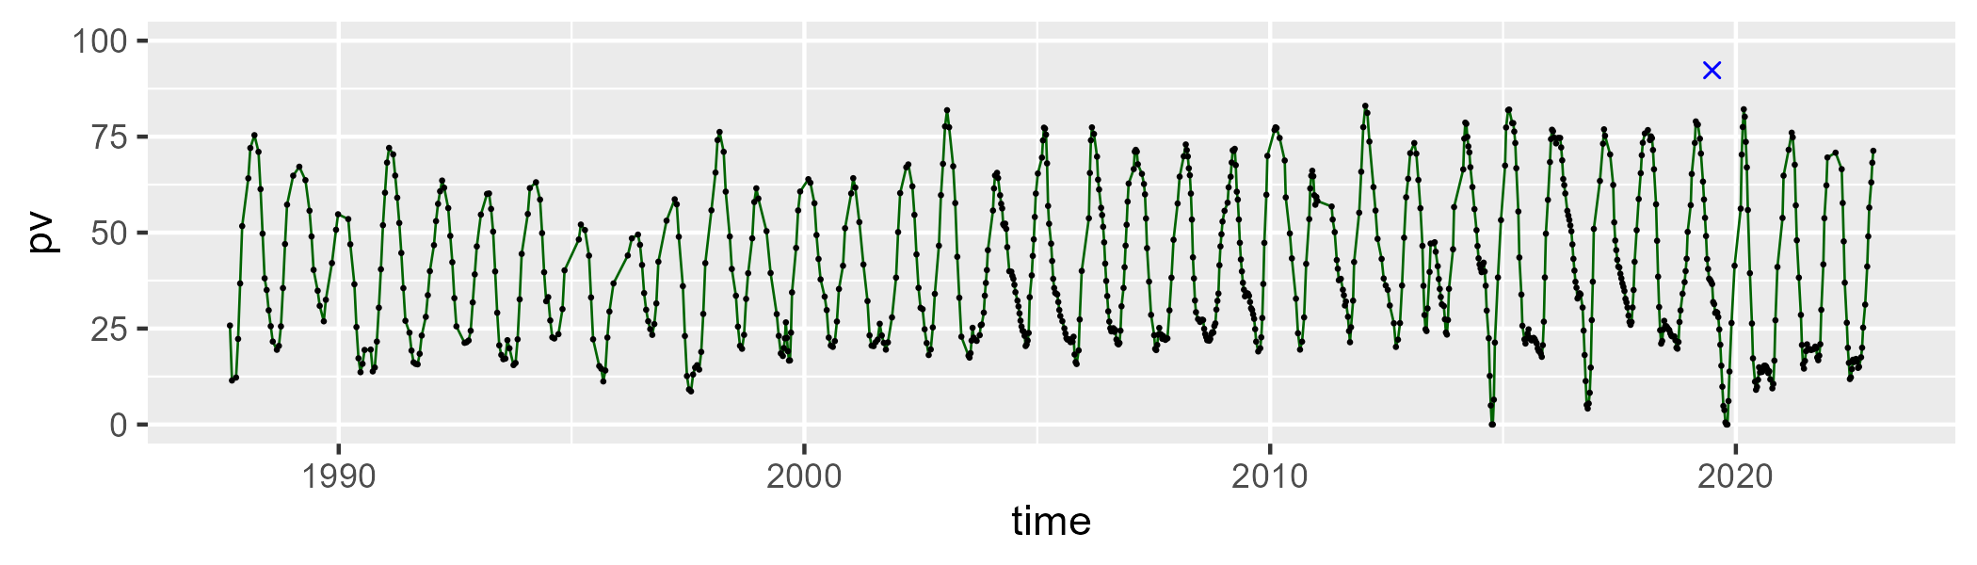

| Min. | 1st Qu. | Median | Mean | 3rd Qu. | Max. |
| --- | --- | --- | --- | --- | --- |
| 6.928803 | 35.53688 | 46.51319 | 44.44101 | 53.78784 | 76.56504 |

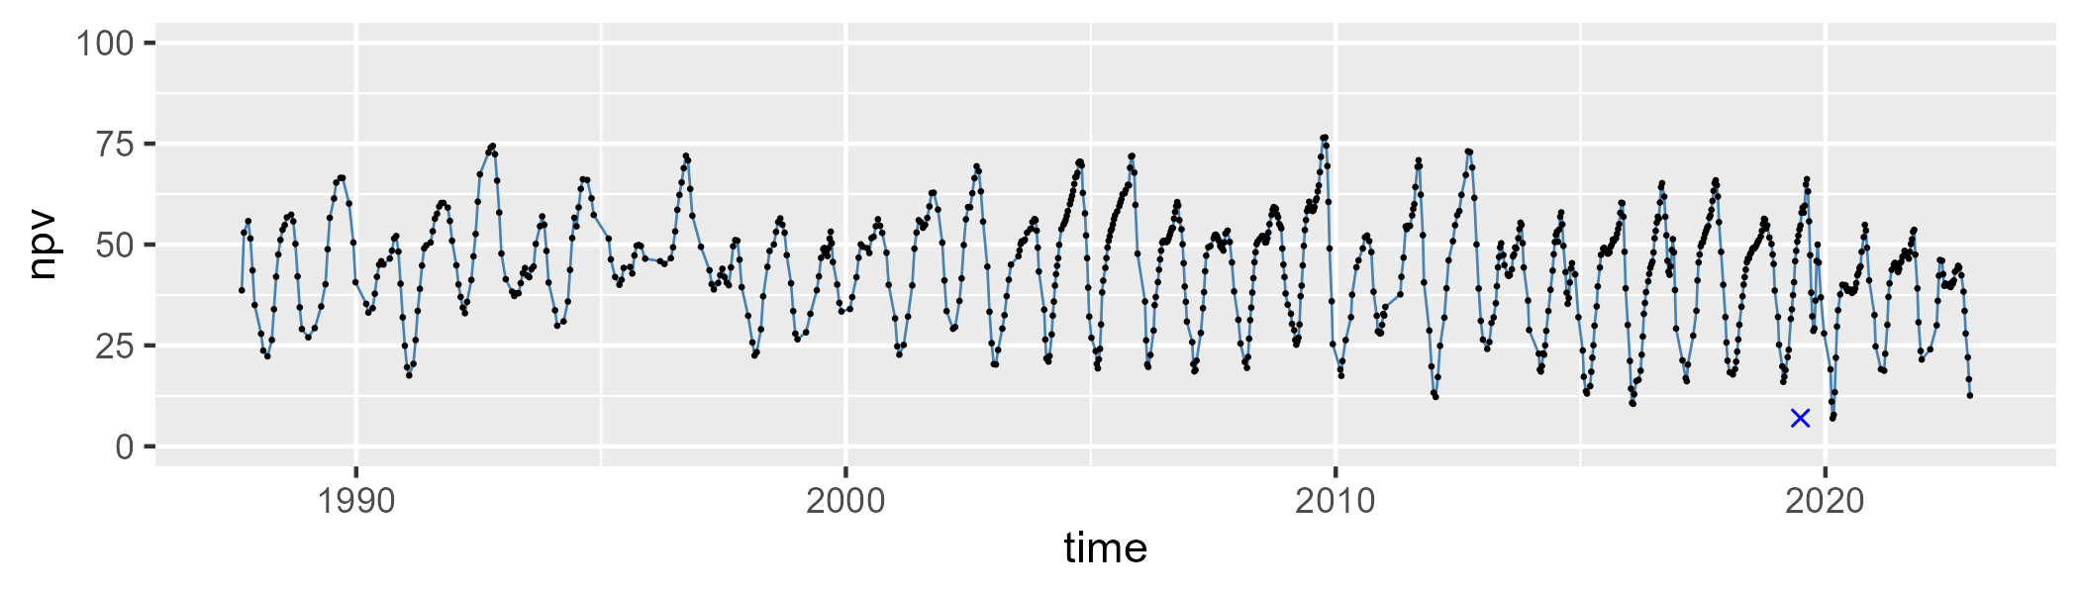

| Min. | 1st Qu. | Median | Mean | 3rd Qu. | Max. |
| --- | --- | --- | --- | --- | --- |
| 0 | 4.854418 | 10.06958 | 14.57448 | 22.71943 | 68.39177 |

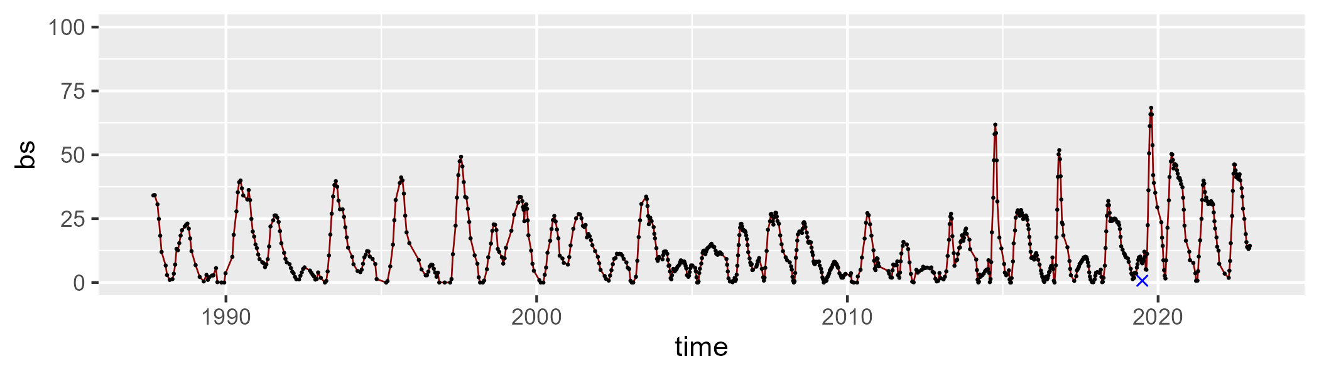

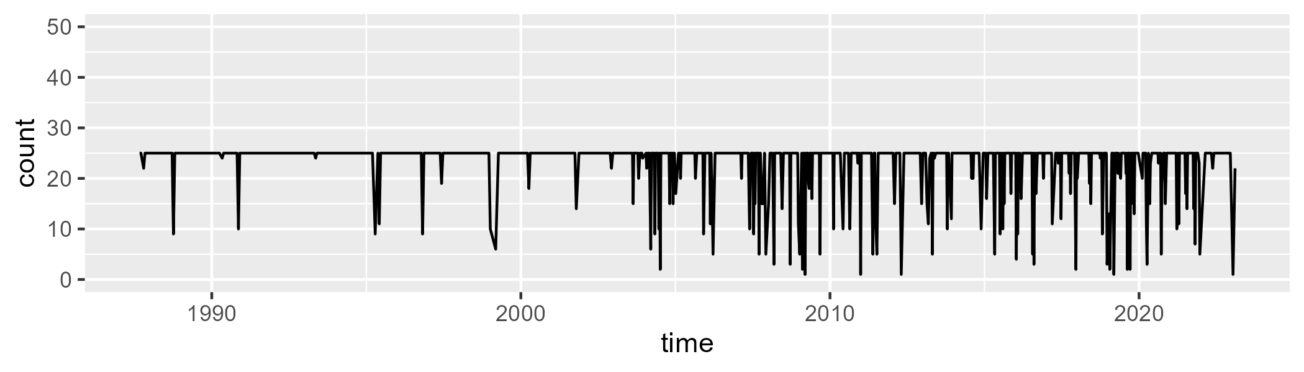

Min. : 1.00 1st Qu.:25.00 Median :25.00 Mean :23.22 3rd Qu.:25.00 Max. :25.00

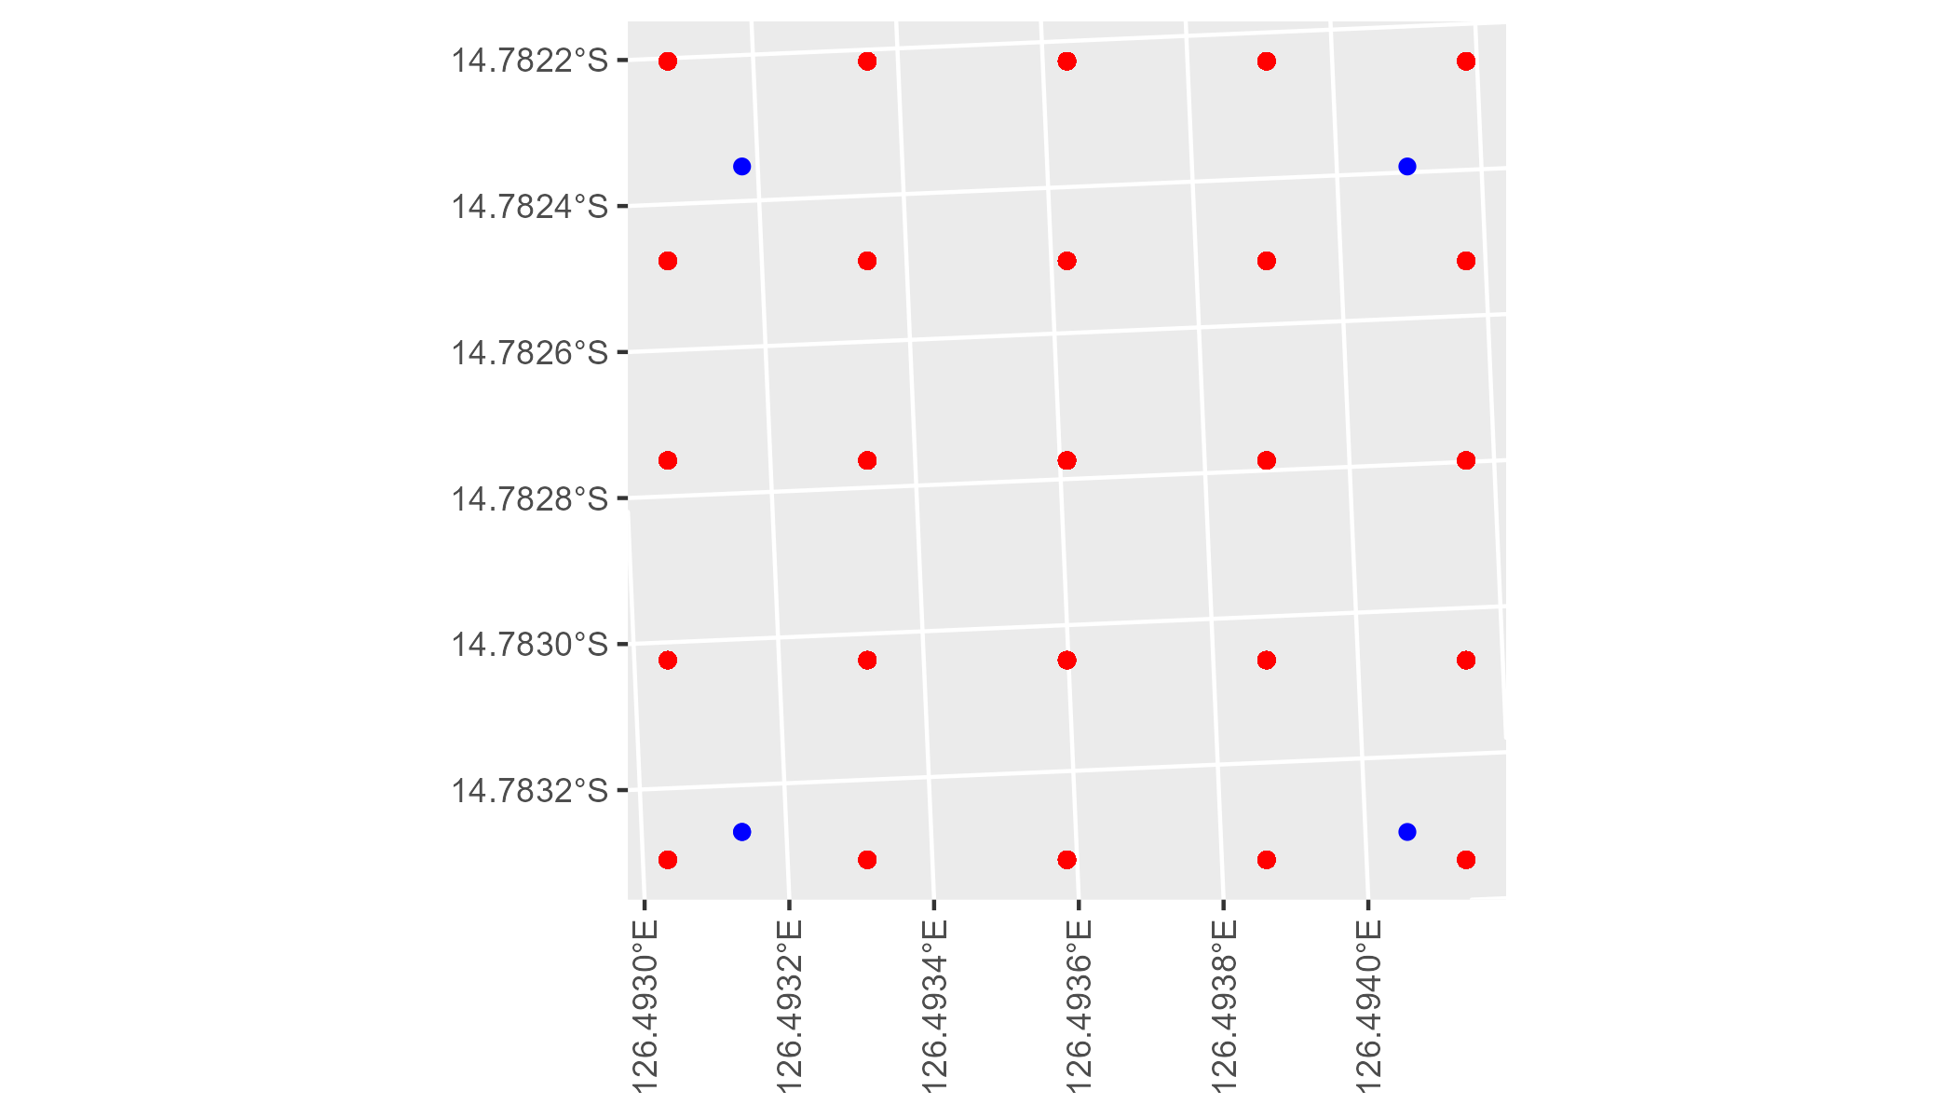

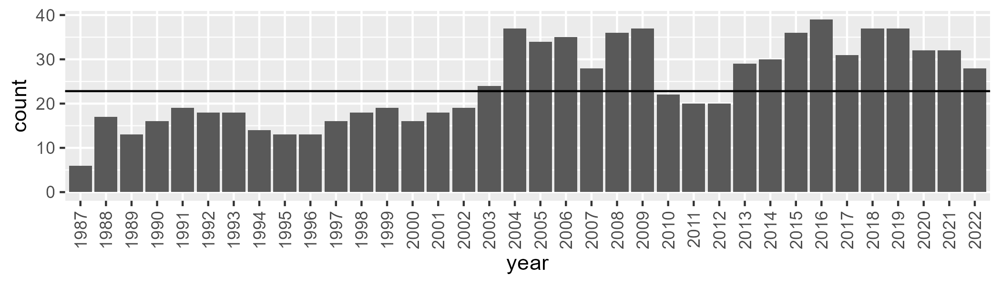

Number of samples: 877

# WAANOK0005

| Min. | 1st Qu. | Median | Mean | 3rd Qu. | Max. |
| --- | --- | --- | --- | --- | --- |
| 12.3137 | 22.74667 | 28.03431 | 29.12477 | 35.8542 | 49.04974 |

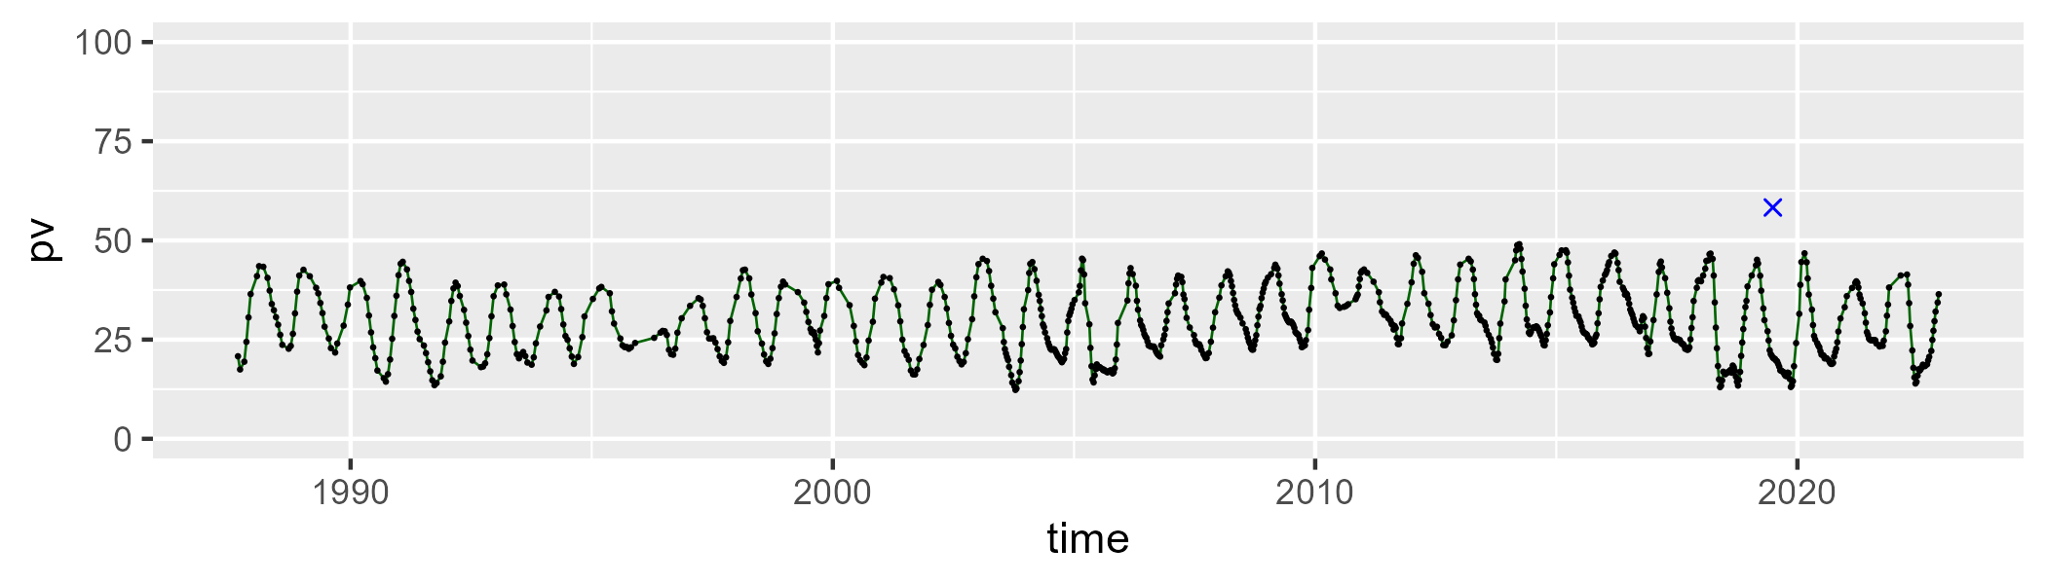

| Min. | 1st Qu. | Median | Mean | 3rd Qu. | Max. |
| --- | --- | --- | --- | --- | --- |
| 28.9923 | 45.04901 | 50.17795 | 50.04303 | 55.48991 | 70.19491 |

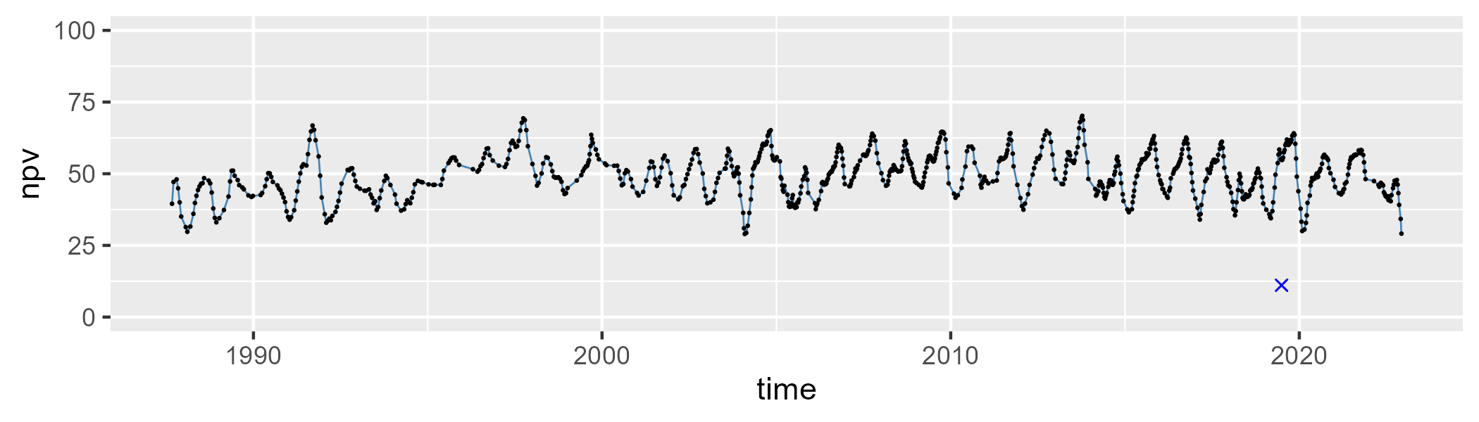

| Min. | 1st Qu. | Median | Mean | 3rd Qu. | Max. |
| --- | --- | --- | --- | --- | --- |
| 4.790955 | 13.39892 | 17.9841 | 19.55721 | 24.04951 | 45.80522 |

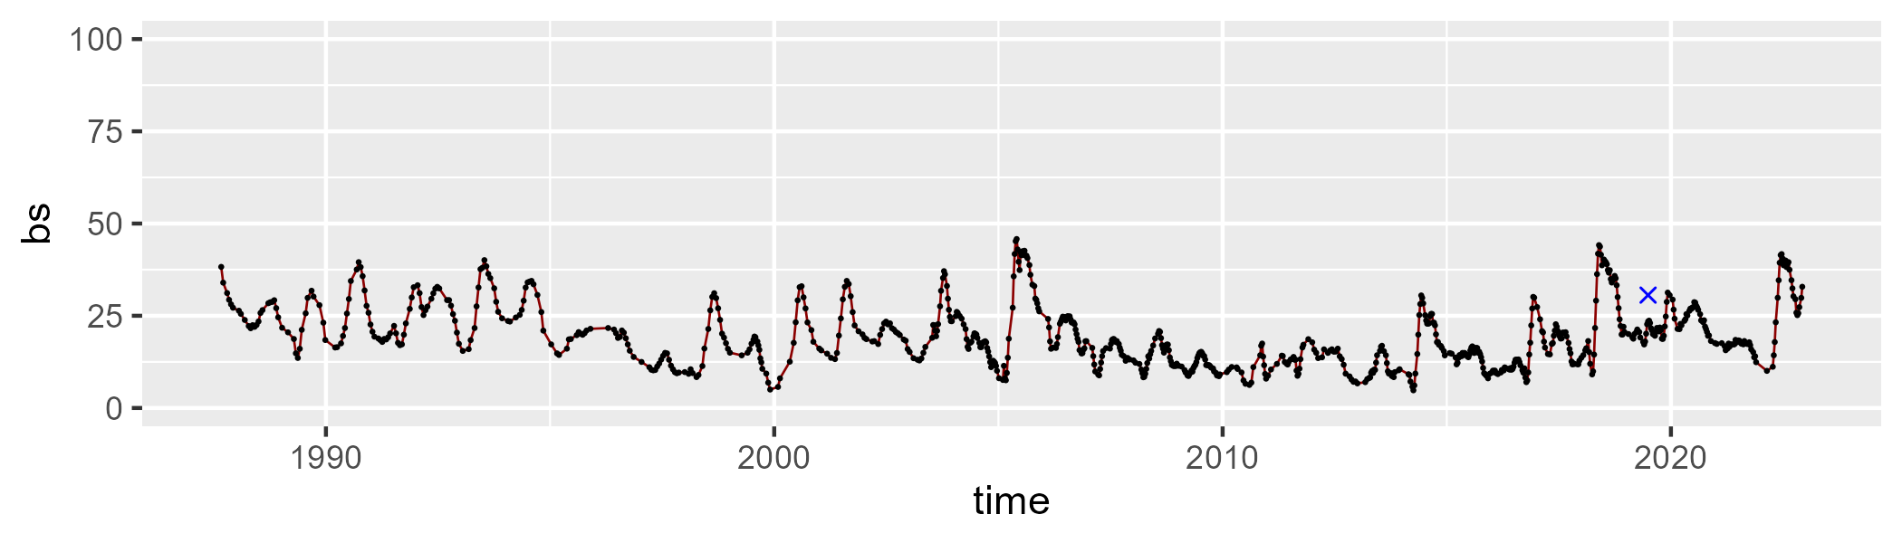

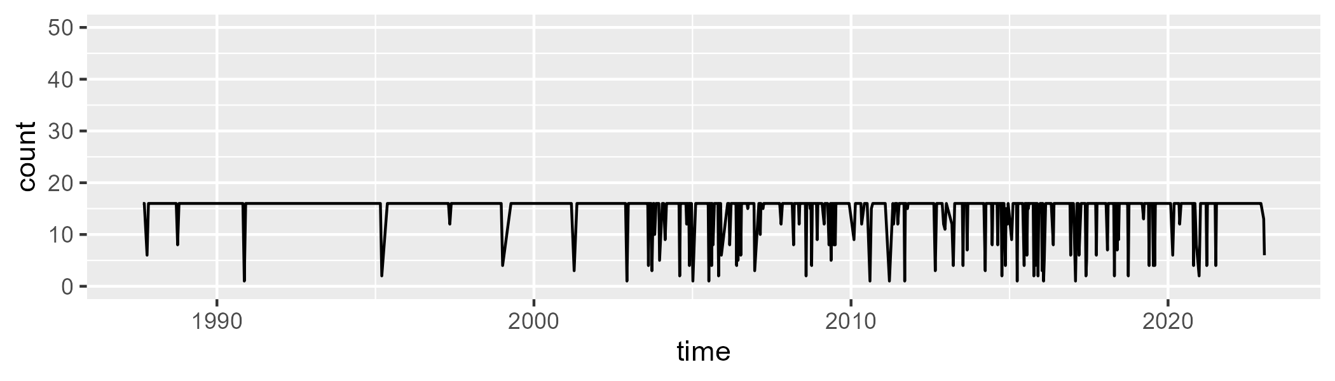

Min. : 1.00 1st Qu.:16.00 Median :16.00 Mean :14.88 3rd Qu.:16.00 Max. :16.00

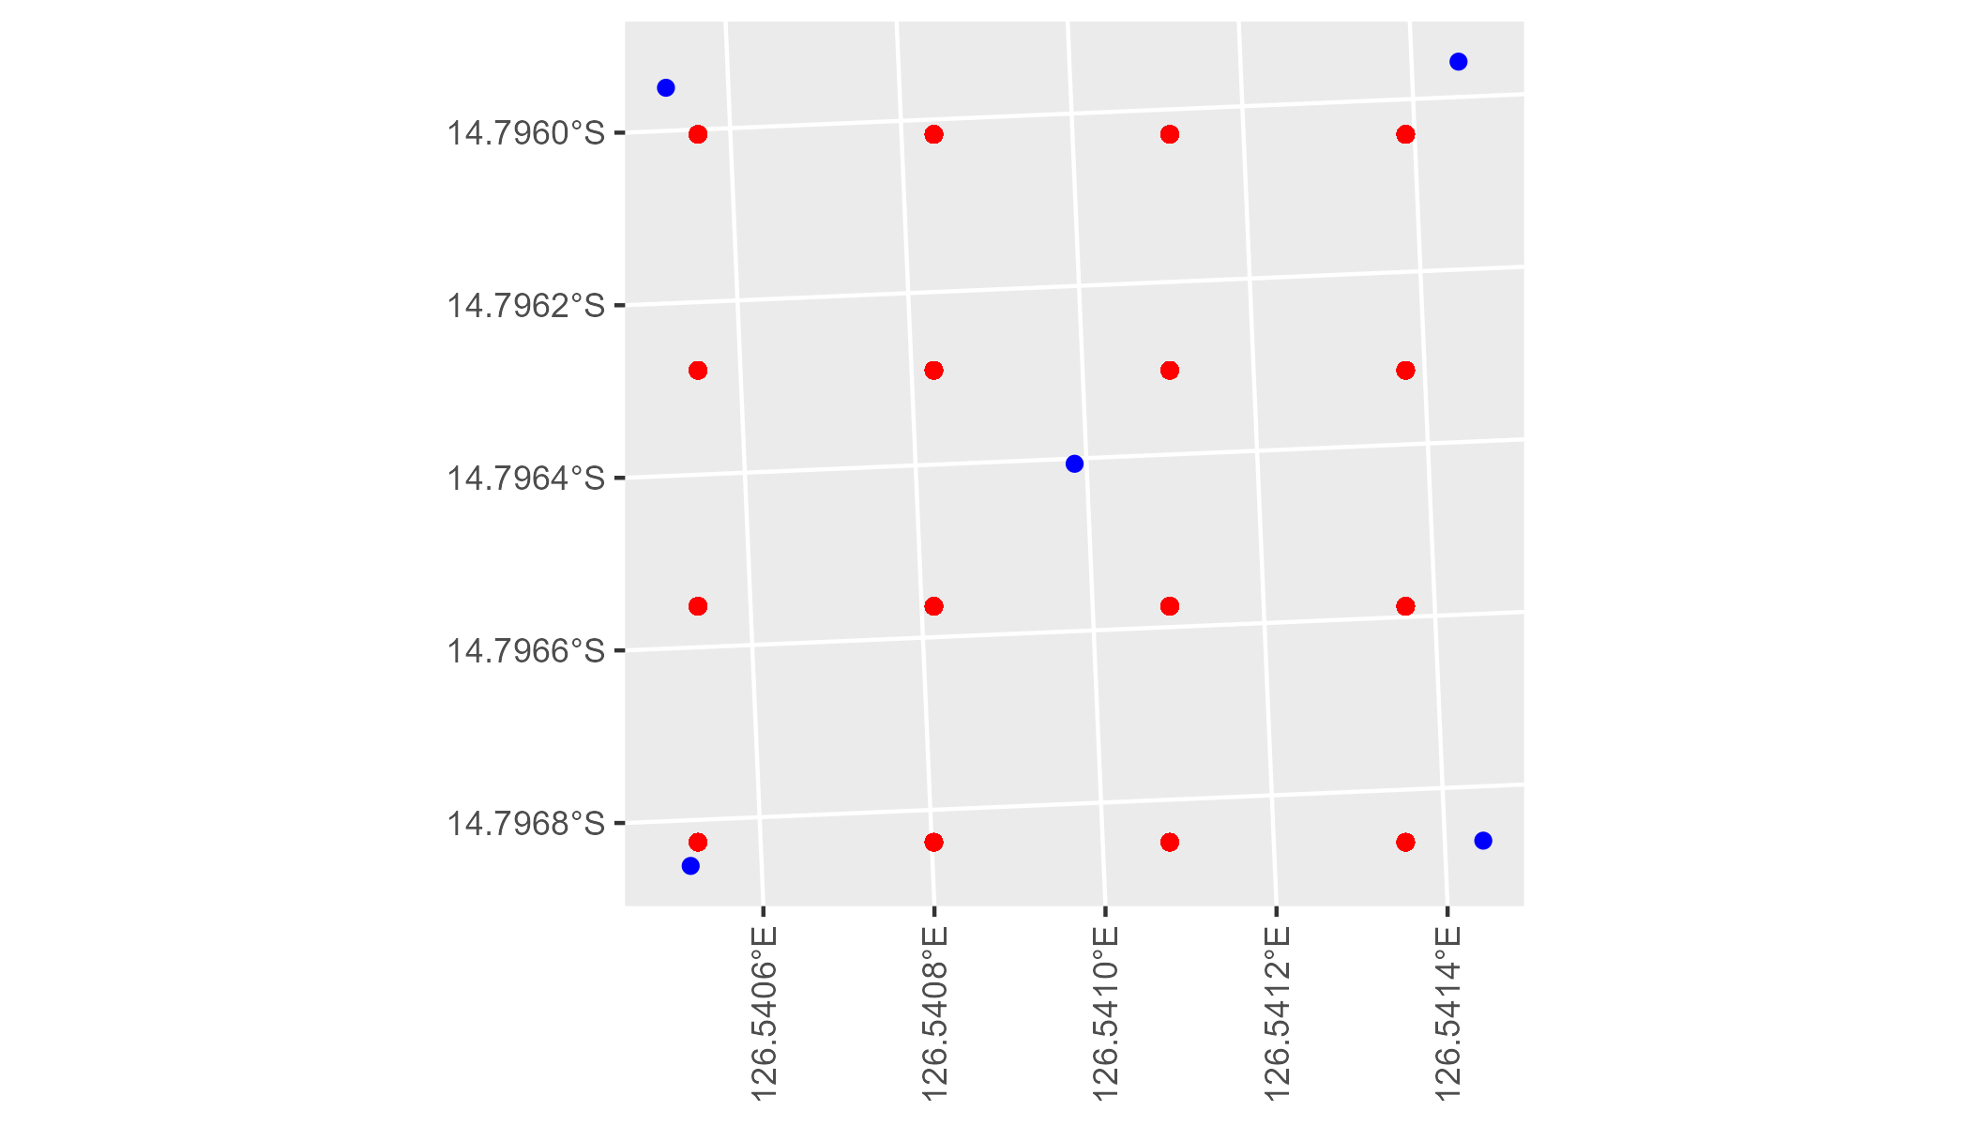

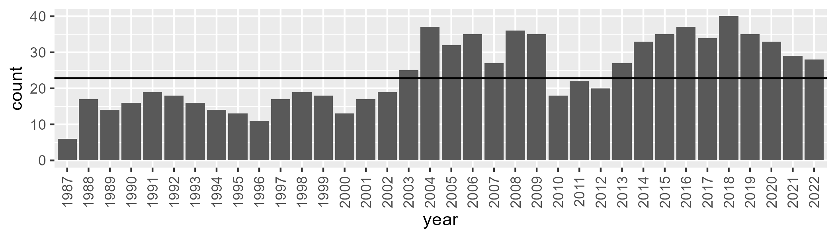

Number of samples: 865

# WAANOK0006

| Min. | 1st Qu. | Median | Mean | 3rd Qu. | Max. |
| --- | --- | --- | --- | --- | --- |
| 13.77864 | 33.50594 | 40.15231 | 40.12479 | 46.95509 | 64.98813 |

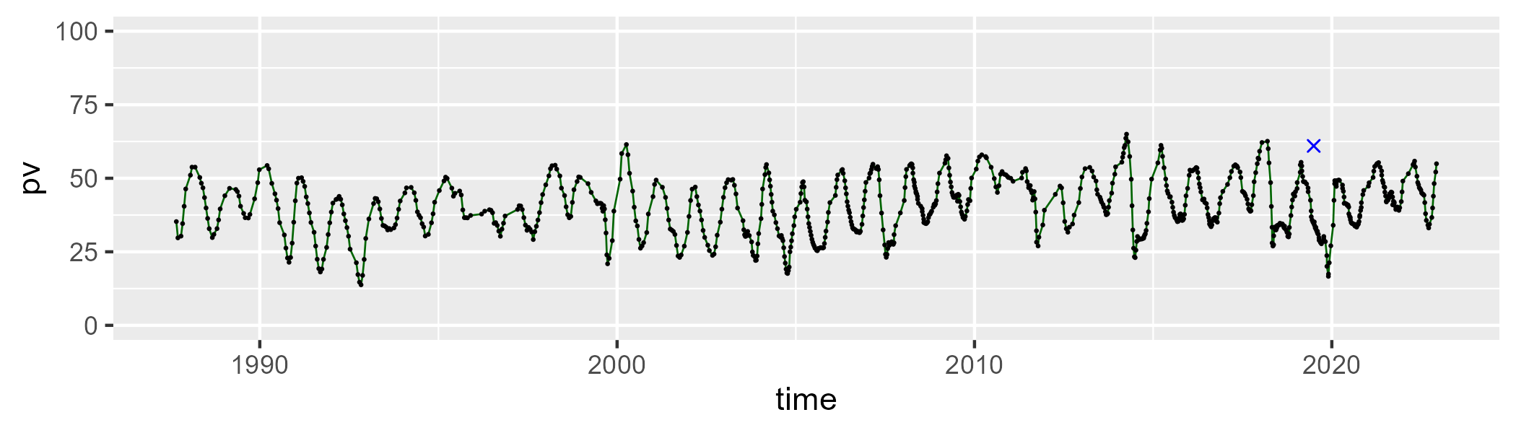

| Min. | 1st Qu. | Median | Mean | 3rd Qu. | Max. |
| --- | --- | --- | --- | --- | --- |
| 26.79726 | 43.36858 | 48.19861 | 48.00749 | 53.64269 | 65.40787 |

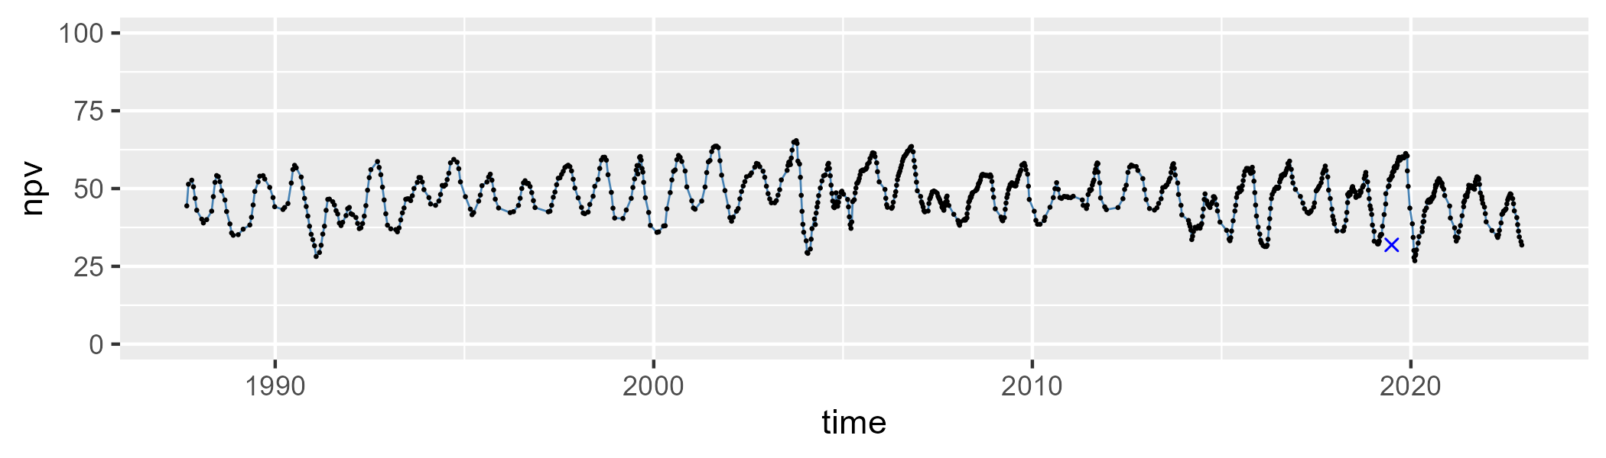

| Min. | 1st Qu. | Median | Mean | 3rd Qu. | Max. |
| --- | --- | --- | --- | --- | --- |
| 0 | 4.372032 | 9.218923 | 10.69807 | 15.27717 | 41.60122 |

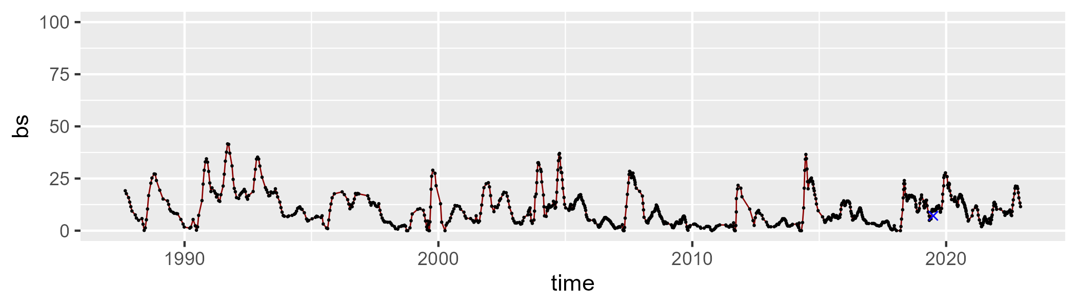

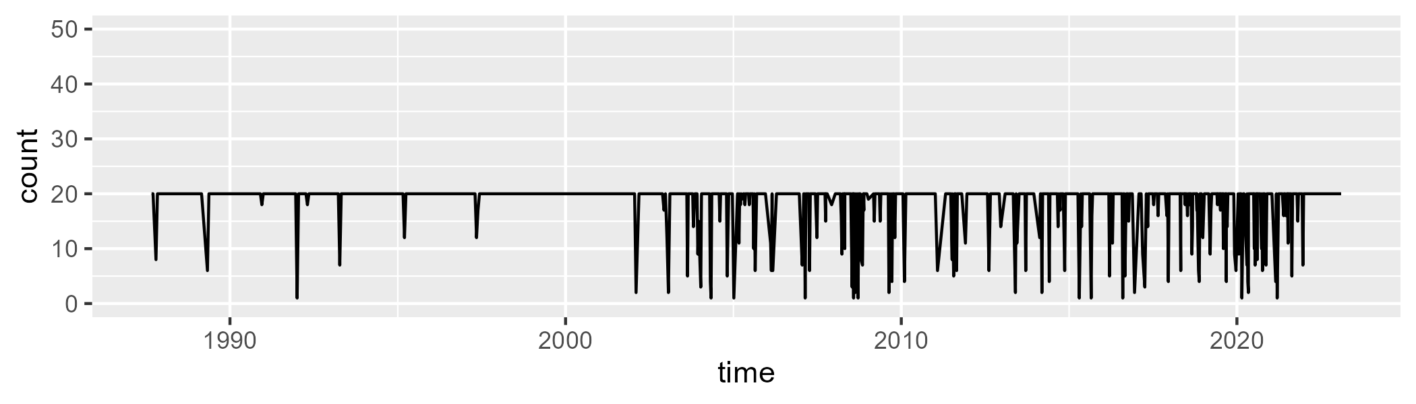

Min. : 1.00 1st Qu.:20.00 Median :20.00 Mean :18.41 3rd Qu.:20.00 Max. :20.00

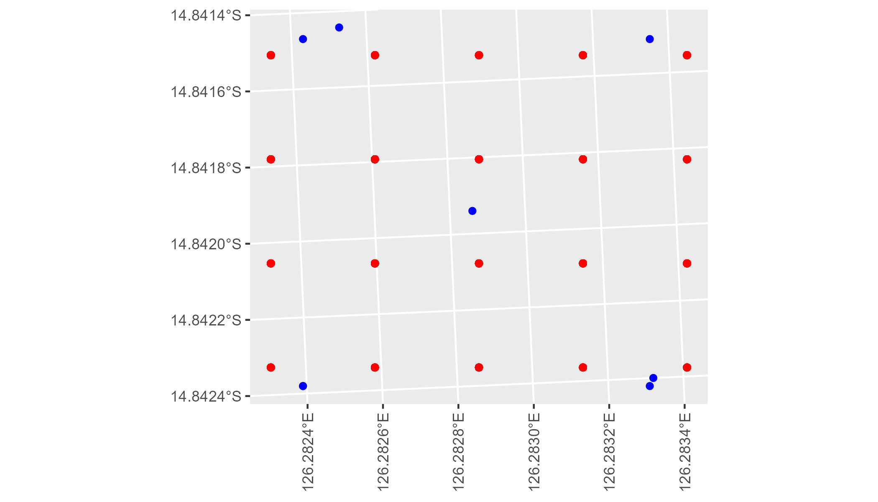

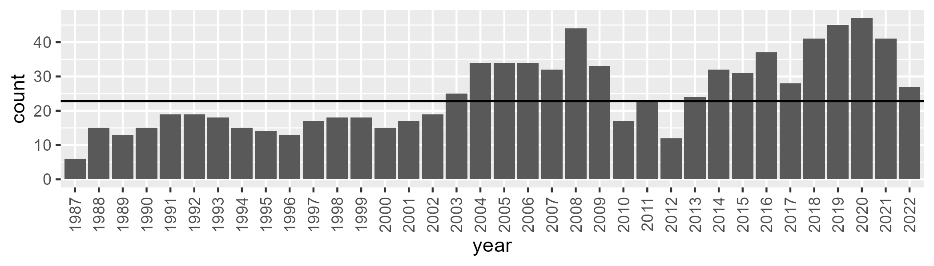

Number of samples: 892

# WAANOK0007

| Min. | 1st Qu. | Median | Mean | 3rd Qu. | Max. |
| --- | --- | --- | --- | --- | --- |
| 4.629952 | 23.93685 | 33.69578 | 38.33563 | 53.92145 | 83.04272 |

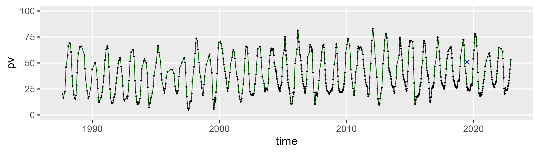

| Min. | 1st Qu. | Median | Mean | 3rd Qu. | Max. |
| --- | --- | --- | --- | --- | --- |
| 8.251498 | 37.90302 | 48.45852 | 46.23403 | 55.21131 | 74.26961 |

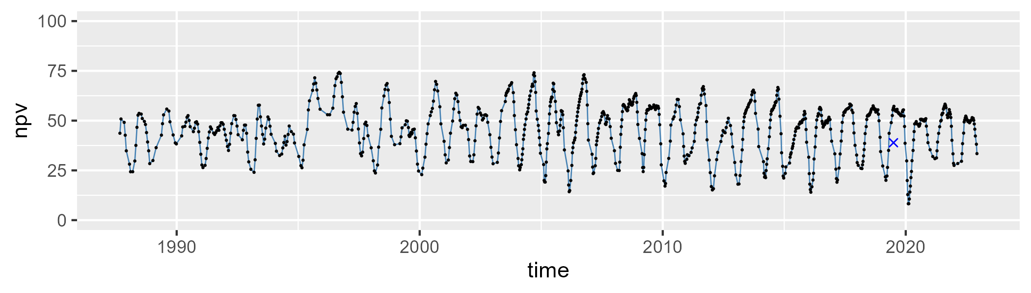

| Min. | 1st Qu. | Median | Mean | 3rd Qu. | Max. |
| --- | --- | --- | --- | --- | --- |
| 0 | 5.492895 | 10.95869 | 14.24531 | 19.79634 | 60.65016 |

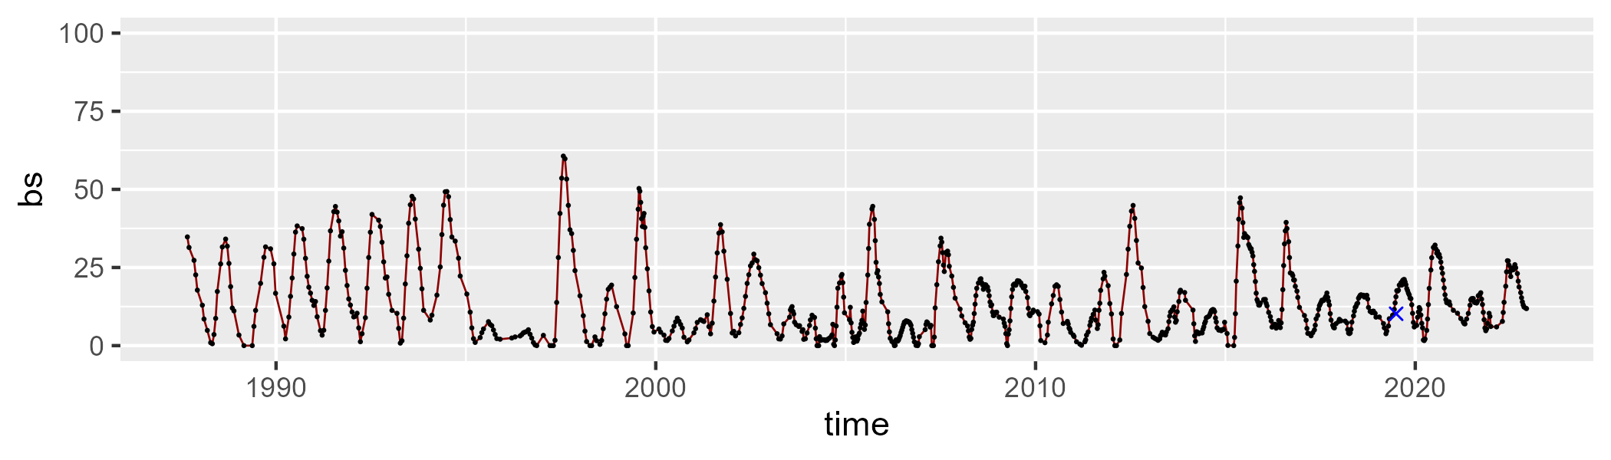

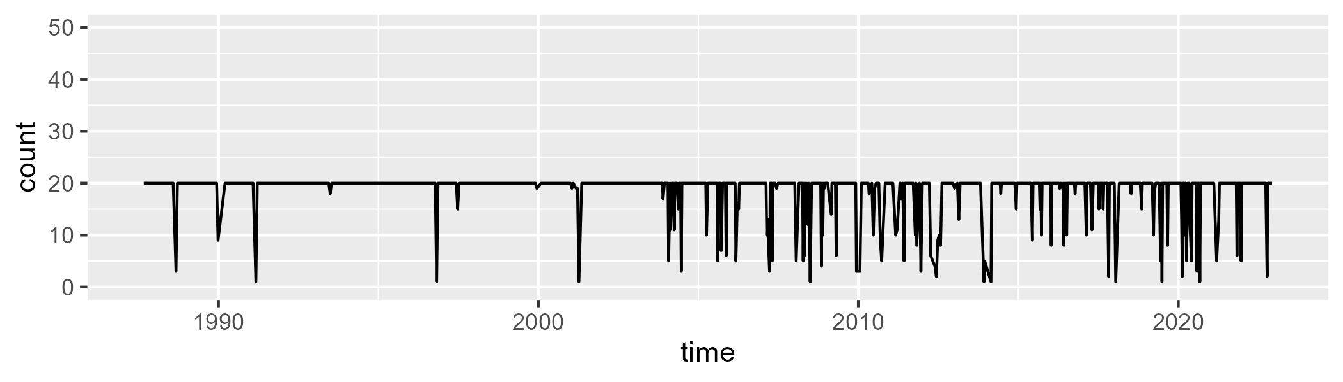

Min. : 1.00 1st Qu.:20.00 Median :20.00 Mean :18.75 3rd Qu.:20.00 Max. :20.00

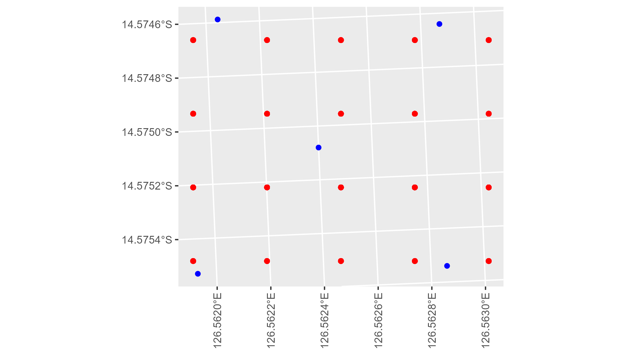

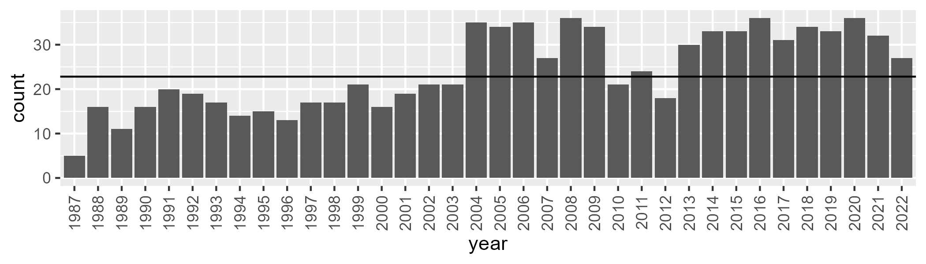

Number of samples: 867

# WAANOK0008

| Min. | 1st Qu. | Median | Mean | 3rd Qu. | Max. |
| --- | --- | --- | --- | --- | --- |
| 8.063417 | 27.10938 | 35.33149 | 39.53621 | 51.74879 | 77.57357 |

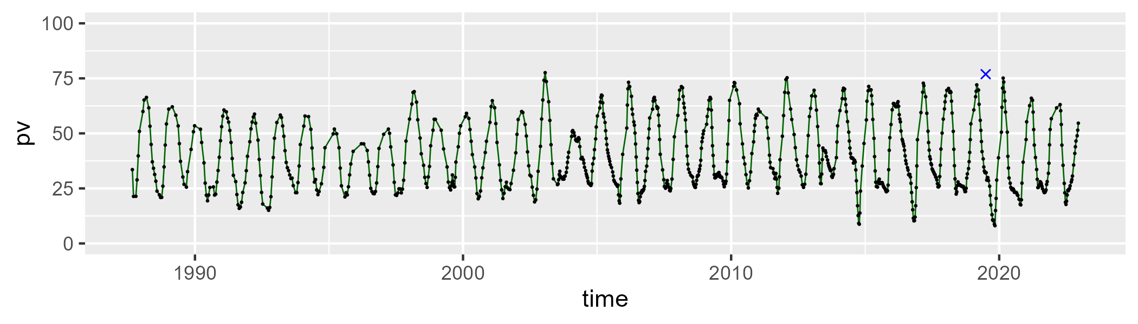

| Min. | 1st Qu. | Median | Mean | 3rd Qu. | Max. |
| --- | --- | --- | --- | --- | --- |
| 7.064745 | 39.15216 | 47.57524 | 45.8139 | 52.67478 | 75.73215 |

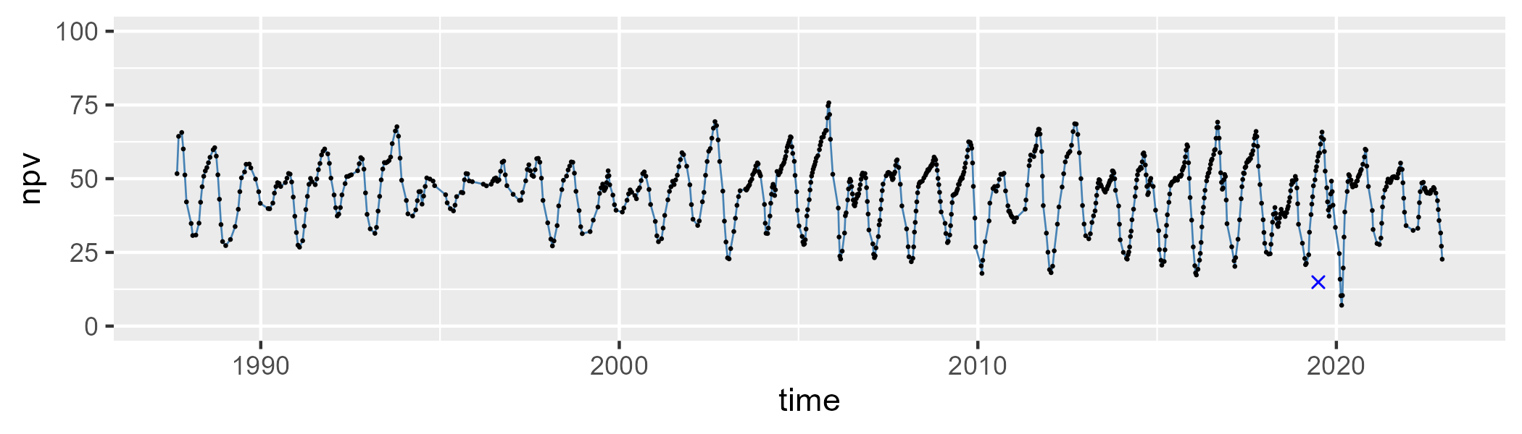

| Min. | 1st Qu. | Median | Mean | 3rd Qu. | Max. |
| --- | --- | --- | --- | --- | --- |
| 0 | 6.023302 | 10.73735 | 13.36254 | 19.81013 | 50.49781 |

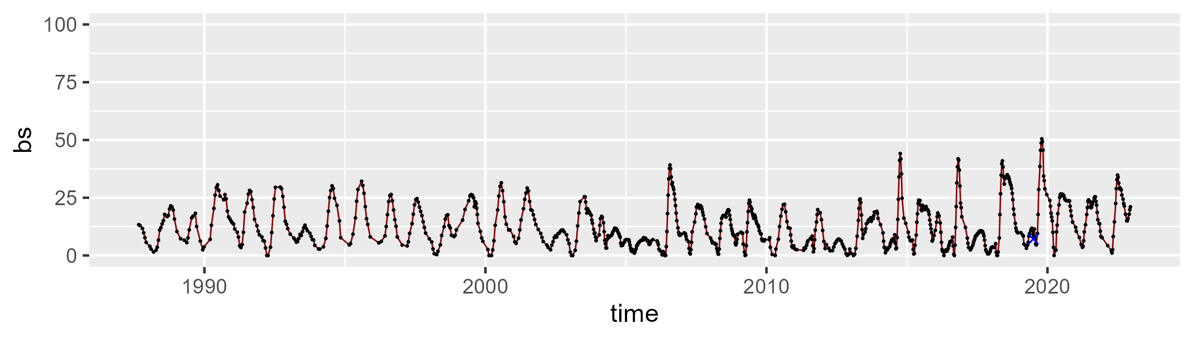

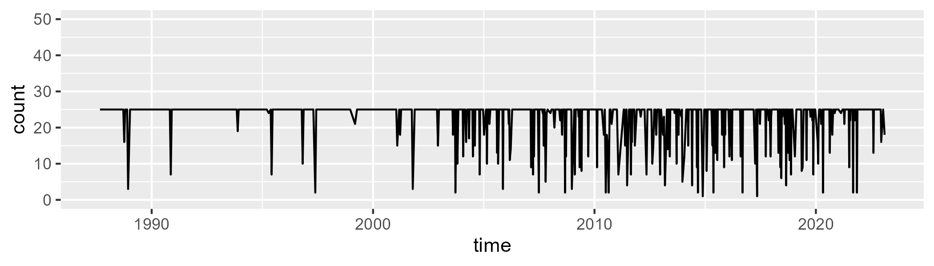

Min. : 1.00 1st Qu.:25.00 Median :25.00 Mean :23.03 3rd Qu.:25.00 Max. :25.00

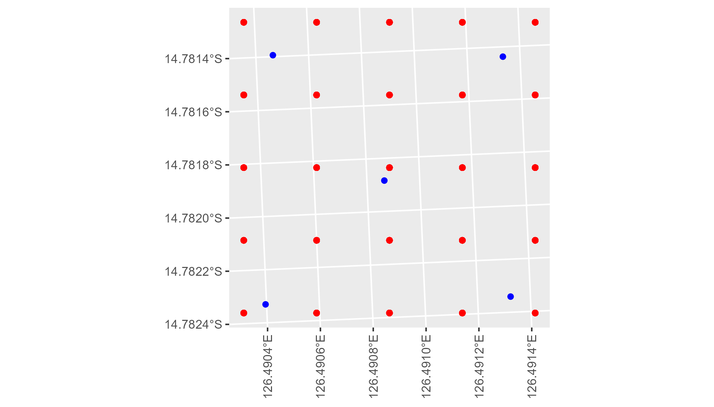

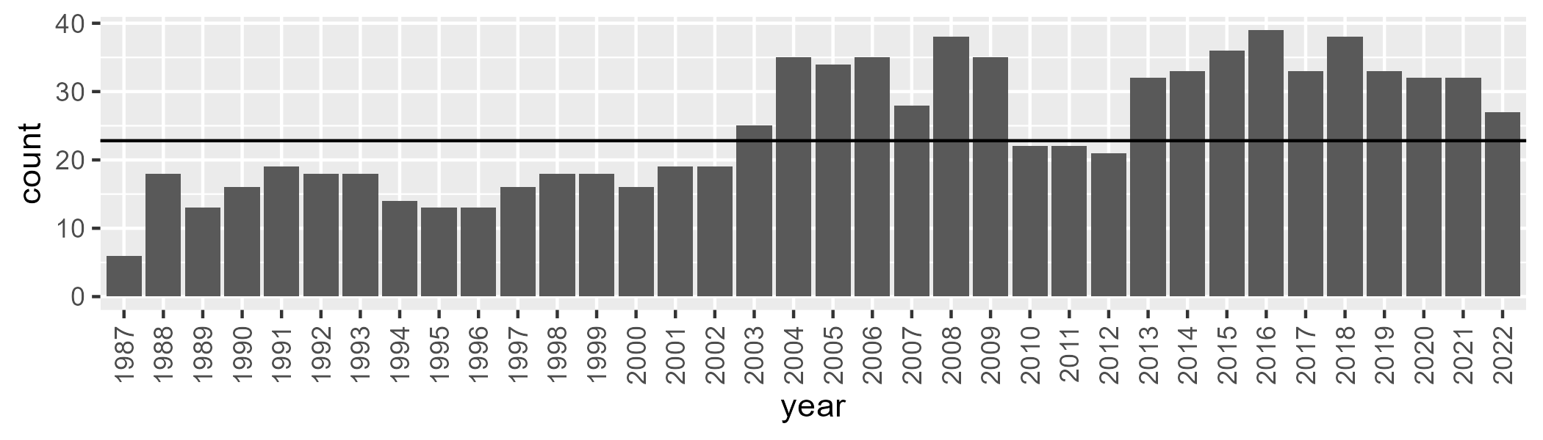

Number of samples: 884

# WAANUL0001

| Min. | 1st Qu. | Median | Mean | 3rd Qu. | Max. |
| --- | --- | --- | --- | --- | --- |
| 0.4075656 | 5.265519 | 7.942162 | 9.315488 | 12.83049 | 34.37714 |

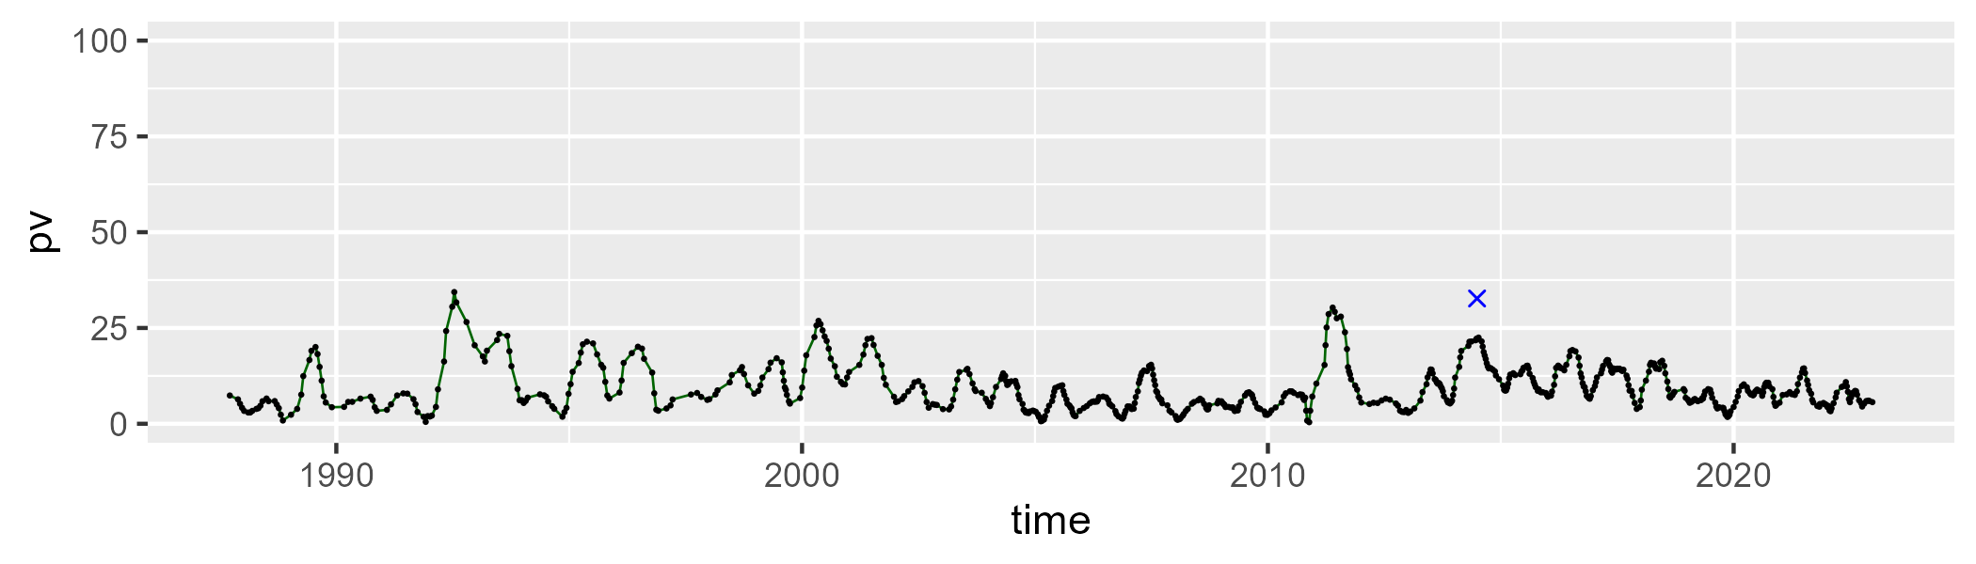

| Min. | 1st Qu. | Median | Mean | 3rd Qu. | Max. |
| --- | --- | --- | --- | --- | --- |
| 32.51759 | 41.1448 | 44.79339 | 45.36544 | 48.6922 | 66.9007 |

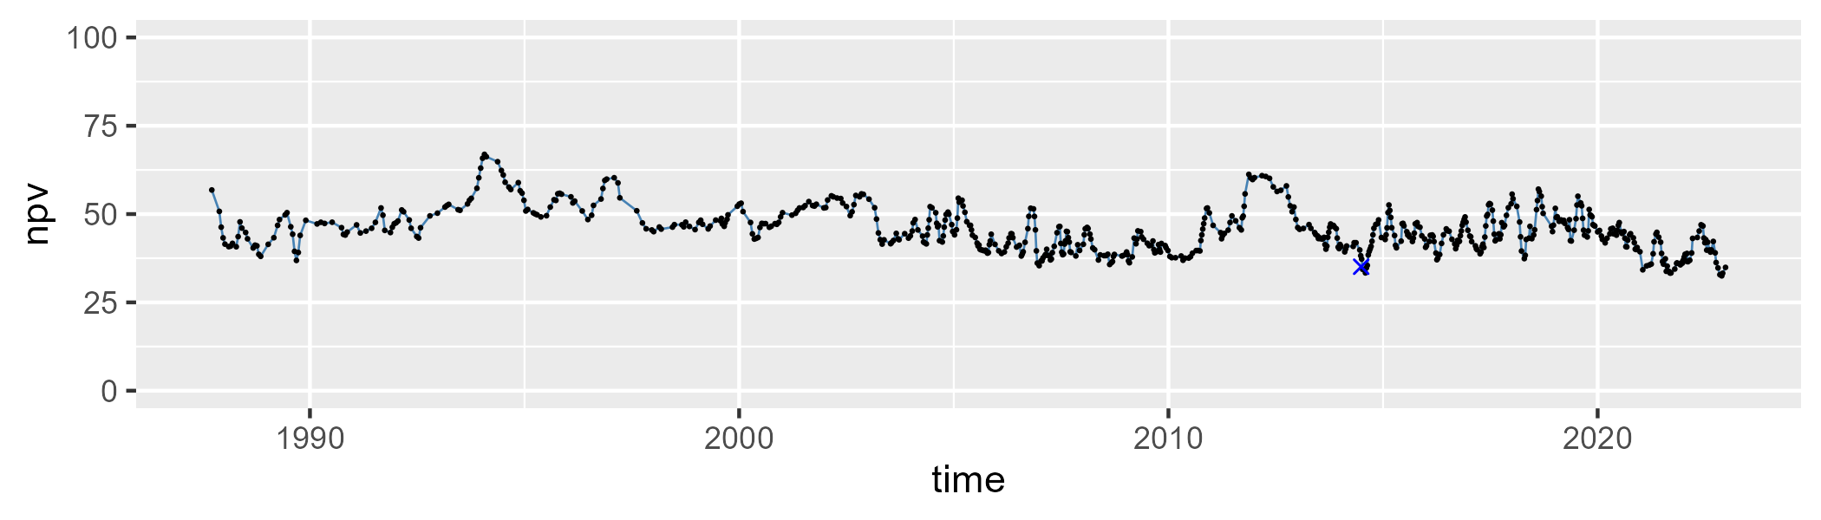

| Min. | 1st Qu. | Median | Mean | 3rd Qu. | Max. |
| --- | --- | --- | --- | --- | --- |
| 20.78284 | 38.5224 | 44.28867 | 43.84851 | 49.56844 | 59.65619 |

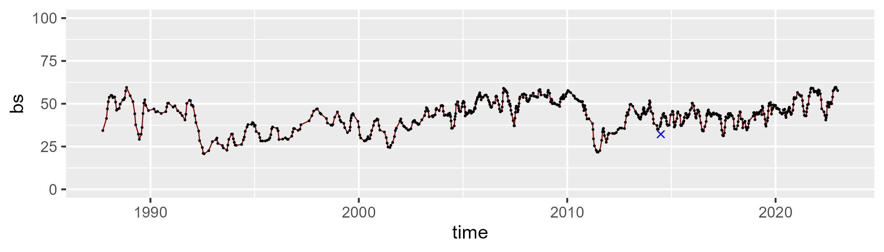

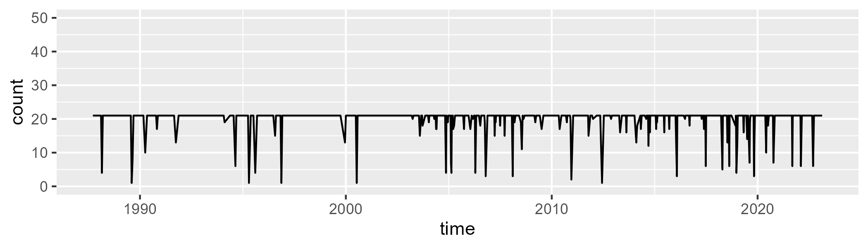

Min. : 1.00 1st Qu.:21.00 Median :21.00 Mean :19.97 3rd Qu.:21.00 Max. :21.00

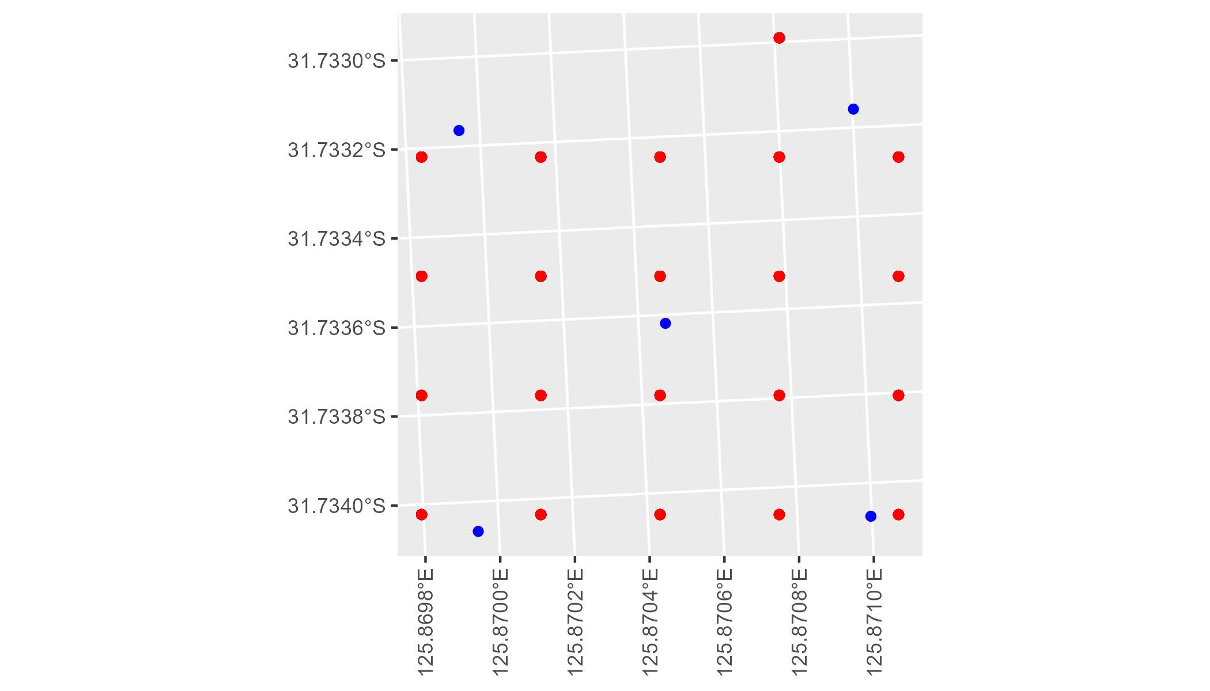

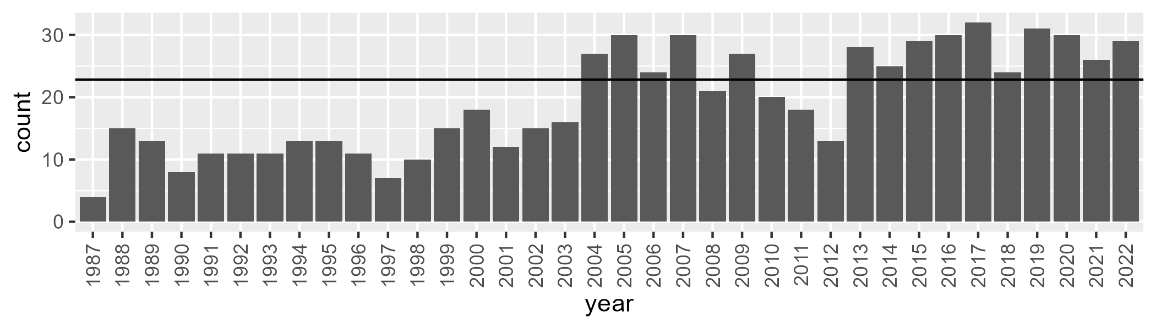

Number of samples: 697

# WAANUL0002

| Min. | 1st Qu. | Median | Mean | 3rd Qu. | Max. |
| --- | --- | --- | --- | --- | --- |
| 0 | 3.596585 | 6.046595 | 8.260598 | 10.0791 | 46.97315 |

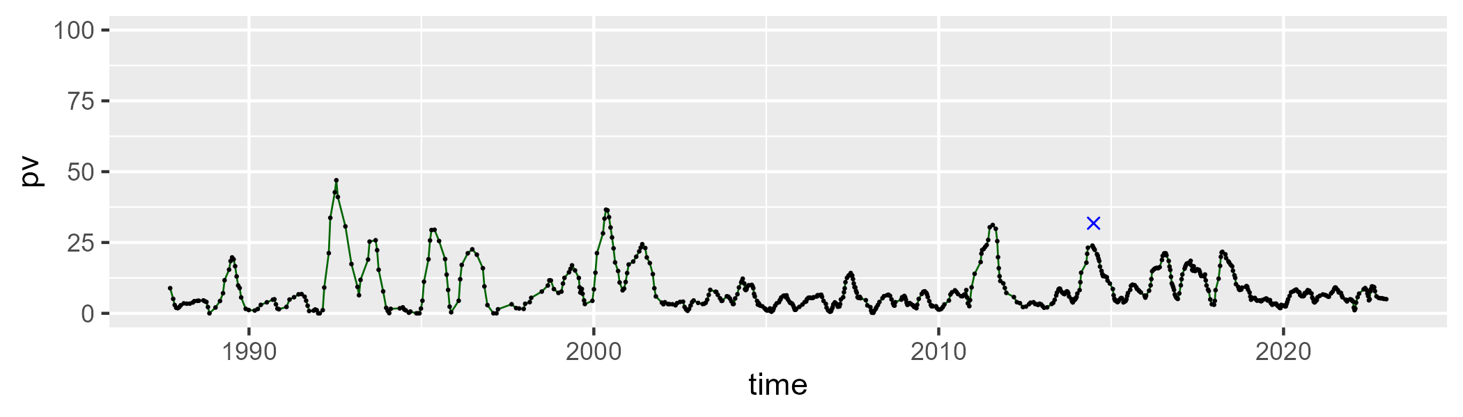

| Min. | 1st Qu. | Median | Mean | 3rd Qu. | Max. |
| --- | --- | --- | --- | --- | --- |
| 27.60772 | 44.94951 | 50.38919 | 50.68032 | 54.62372 | 87.99157 |

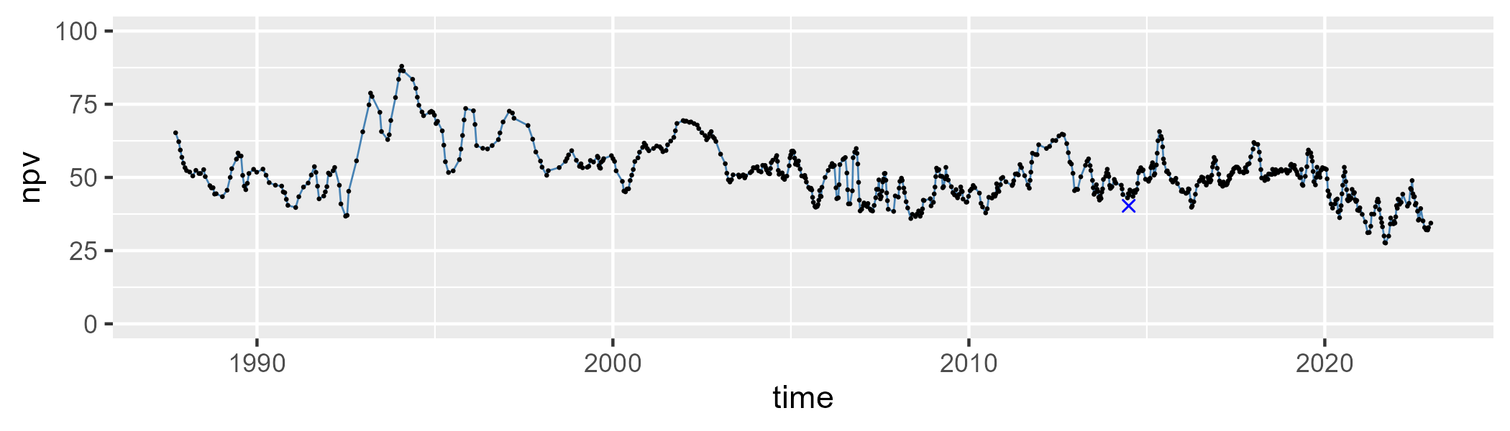

| Min. | 1st Qu. | Median | Mean | 3rd Qu. | Max. |
| --- | --- | --- | --- | --- | --- |
| 7.797657 | 32.52883 | 41.01015 | 39.66269 | 47.58329 | 65.02832 |

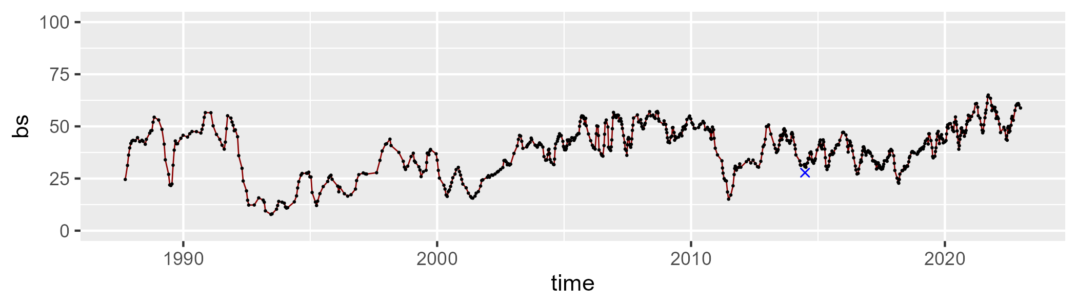

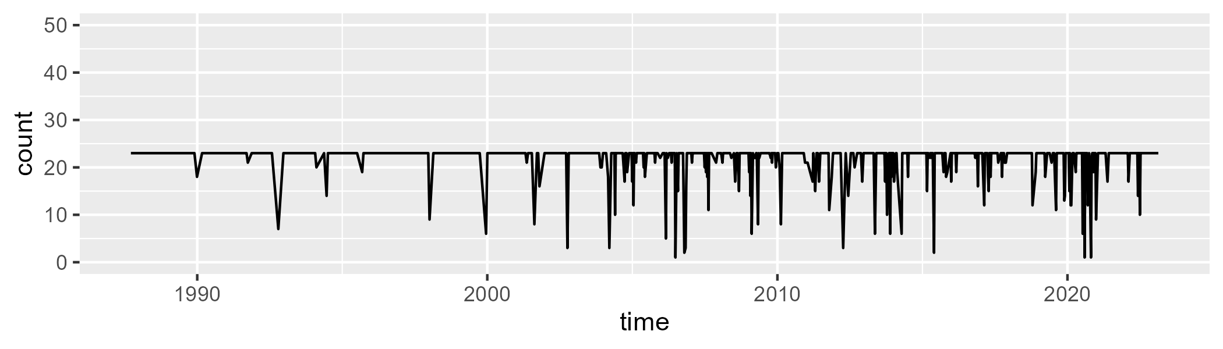

Min. : 1.00 1st Qu.:23.00 Median :23.00 Mean :21.74 3rd Qu.:23.00 Max. :23.00

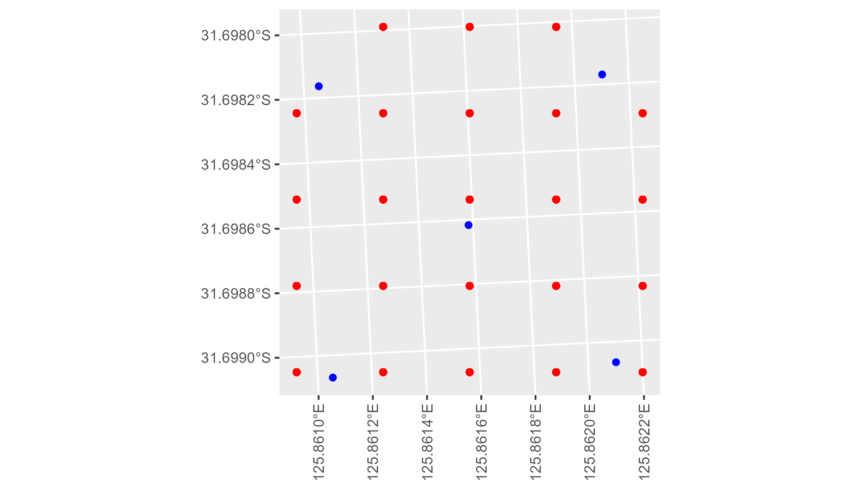

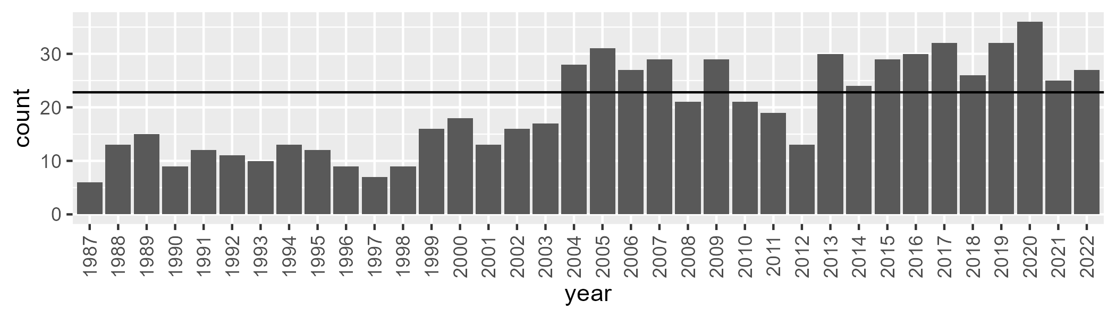

Number of samples: 715

# WAANUL0003

| Min. | 1st Qu. | Median | Mean | 3rd Qu. | Max. |
| --- | --- | --- | --- | --- | --- |
| 0.963782 | 8.981741 | 12.09671 | 12.59775 | 15.47219 | 33.33107 |

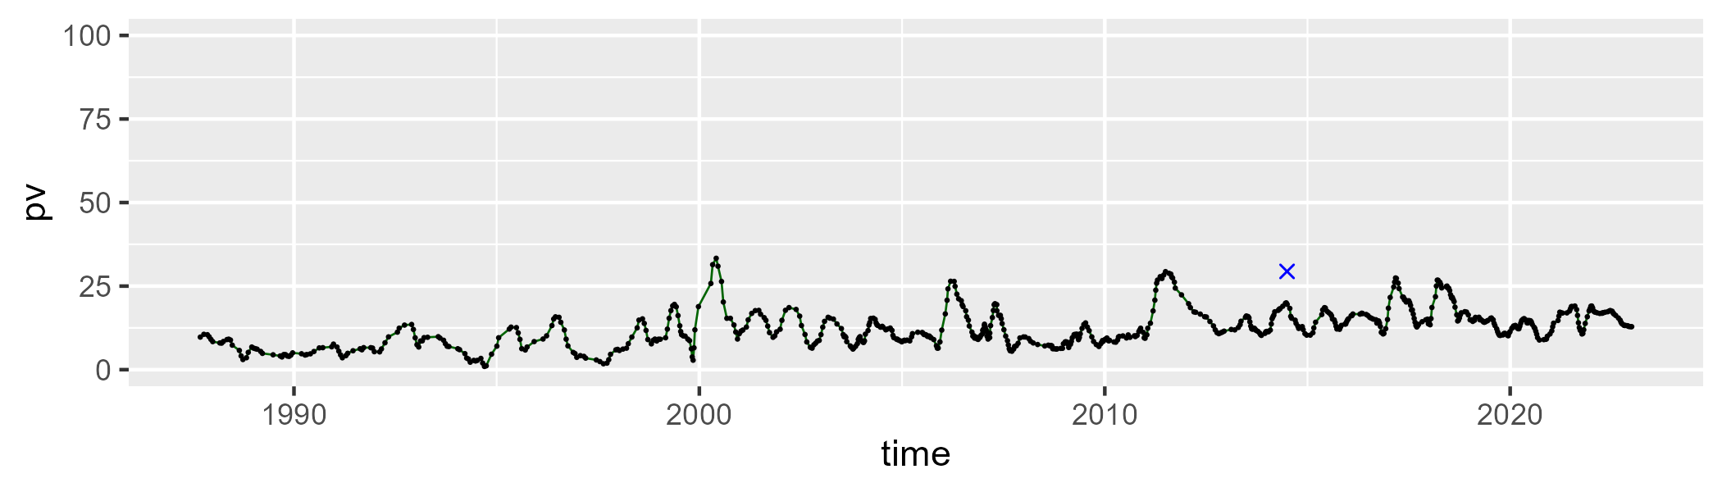

| Min. | 1st Qu. | Median | Mean | 3rd Qu. | Max. |
| --- | --- | --- | --- | --- | --- |
| 33.23594 | 43.08806 | 47.35493 | 47.29585 | 51.47775 | 64.69939 |

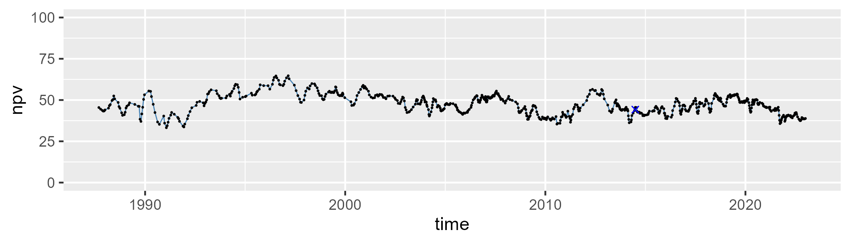

| Min. | 1st Qu. | Median | Mean | 3rd Qu. | Max. |
| --- | --- | --- | --- | --- | --- |
| 18.33996 | 33.72552 | 39.07189 | 38.68949 | 43.2354 | 58.44756 |

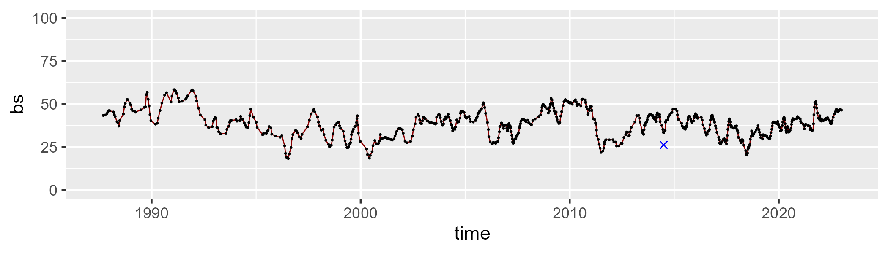

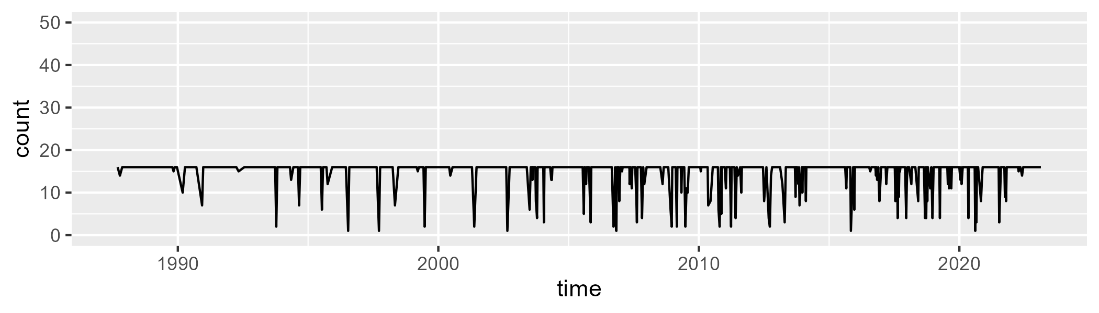

Min. : 1.00 1st Qu.:16.00 Median :16.00 Mean :14.83 3rd Qu.:16.00 Max. :16.00

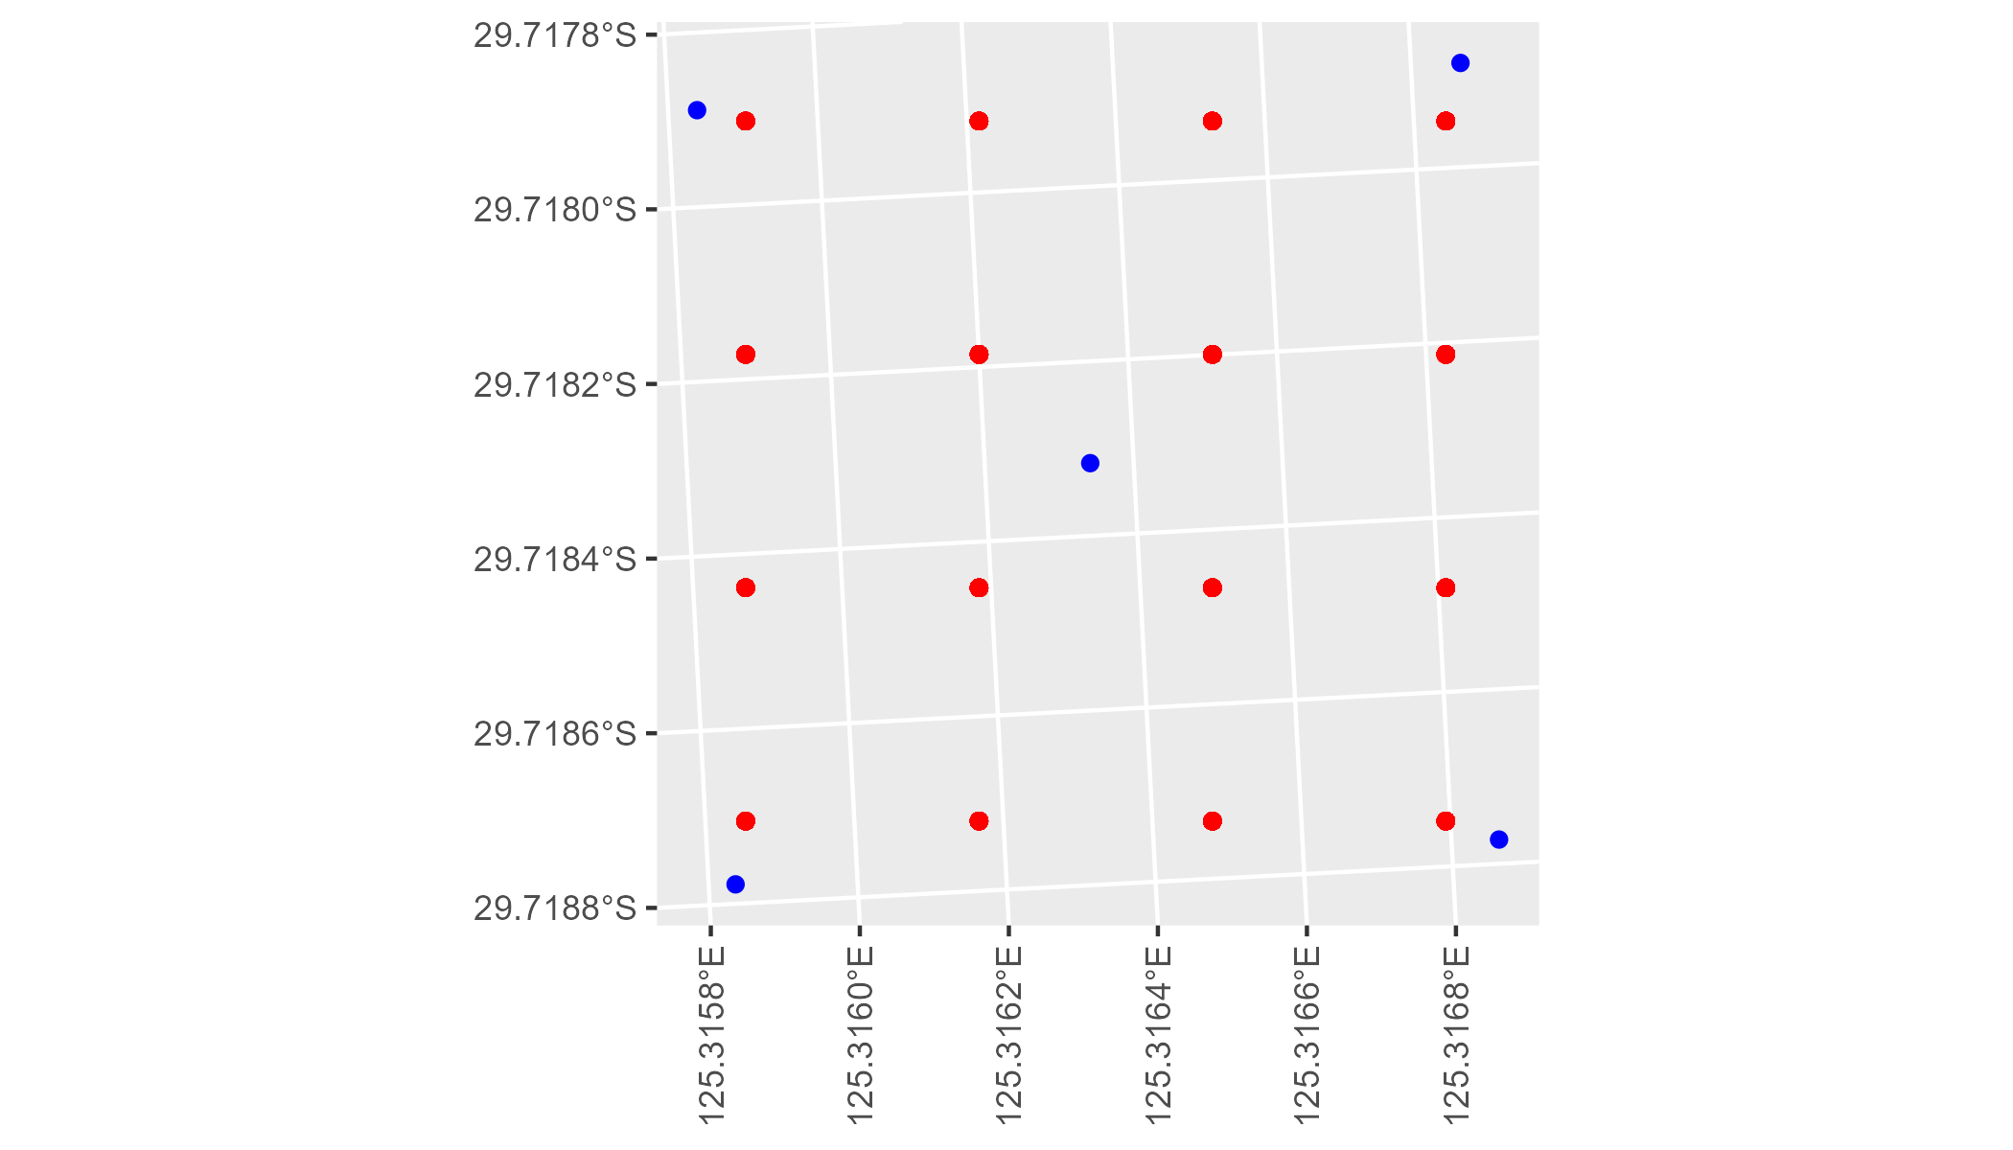

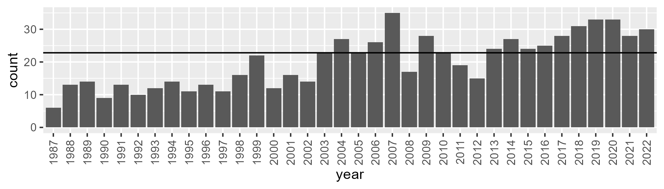

Number of samples: 725

# WAANUL0004

| Min. | 1st Qu. | Median | Mean | 3rd Qu. | Max. |
| --- | --- | --- | --- | --- | --- |
| 1.460924 | 7.21562 | 9.944153 | 10.59581 | 13.15924 | 27.30635 |

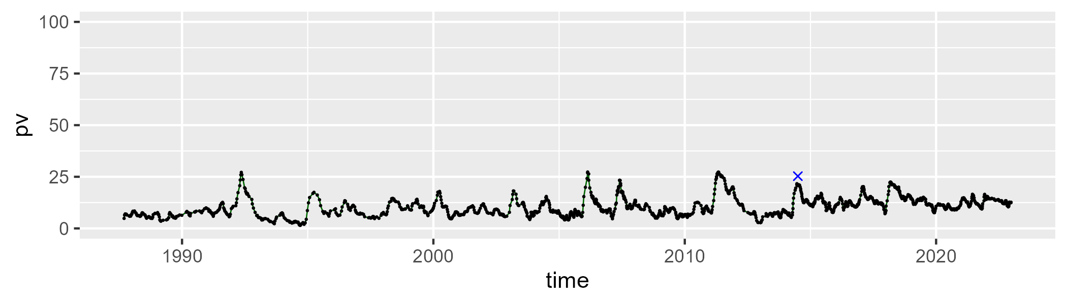

| Min. | 1st Qu. | Median | Mean | 3rd Qu. | Max. |
| --- | --- | --- | --- | --- | --- |
| 18.74381 | 37.98854 | 42.15243 | 41.9591 | 46.78056 | 60.57758 |

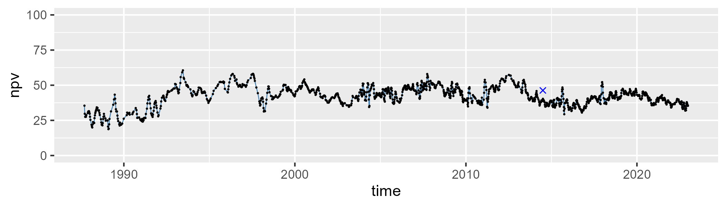

| Min. | 1st Qu. | Median | Mean | 3rd Qu. | Max. |
| --- | --- | --- | --- | --- | --- |
| 22.42435 | 40.75528 | 45.97581 | 45.96729 | 50.18991 | 75.21006 |

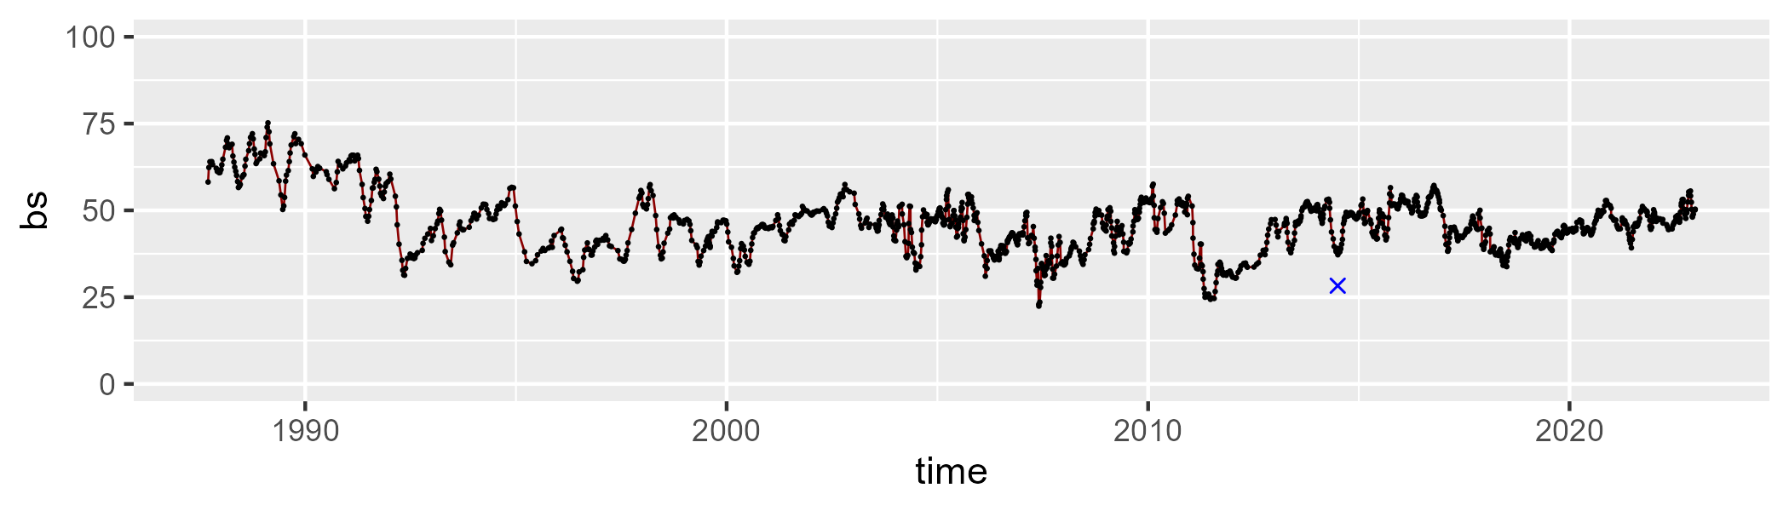

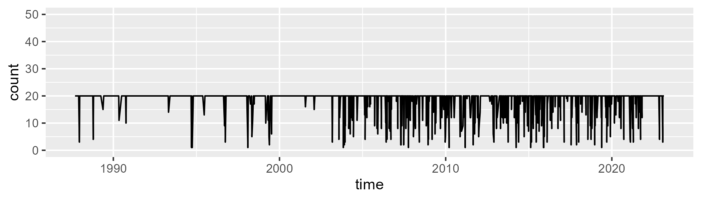

Min. : 1.00 1st Qu.:20.00 Median :20.00 Mean :18.43 3rd Qu.:20.00 Max. :20.00

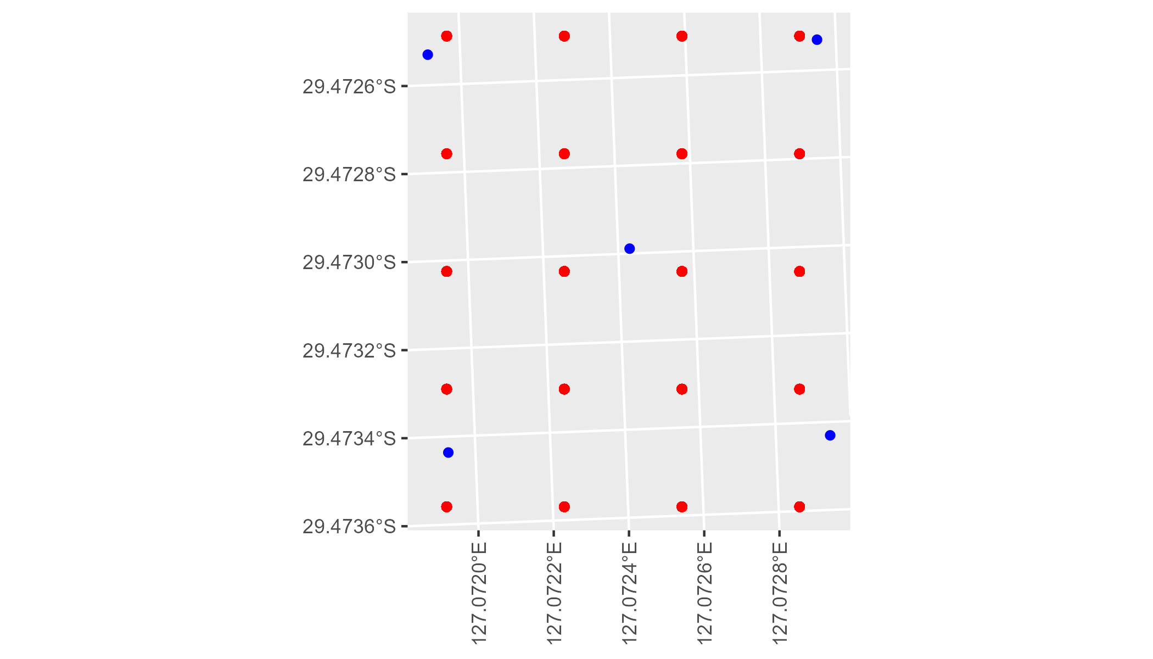

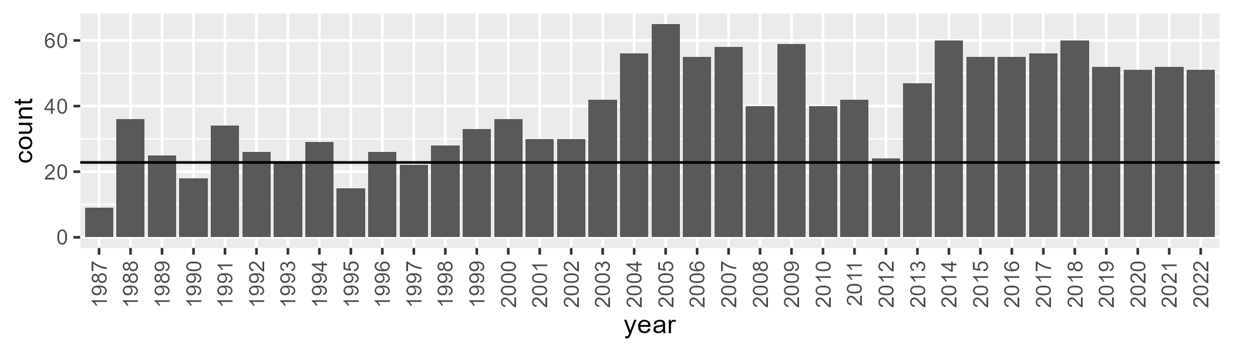

Number of samples: 1440

# WAANUL0005

| Min. | 1st Qu. | Median | Mean | 3rd Qu. | Max. |
| --- | --- | --- | --- | --- | --- |
| 0 | 2.562595 | 6.069021 | 10.86557 | 13.64264 | 78.13873 |

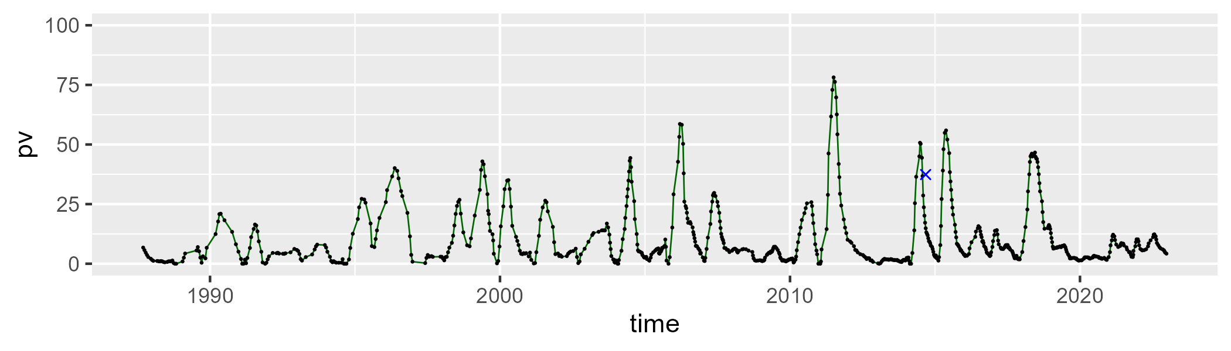

| Min. | 1st Qu. | Median | Mean | 3rd Qu. | Max. |
| --- | --- | --- | --- | --- | --- |
| 9.778336 | 42.41645 | 45.97716 | 46.96828 | 52.55822 | 66.98539 |

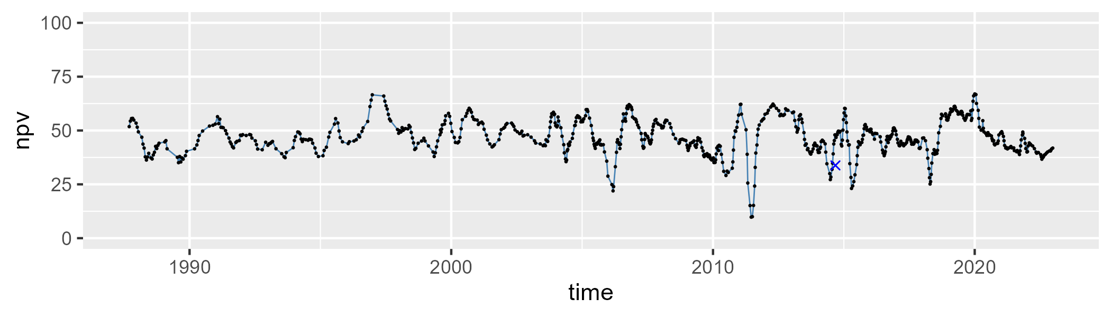

| Min. | 1st Qu. | Median | Mean | 3rd Qu. | Max. |
| --- | --- | --- | --- | --- | --- |
| 3.316214 | 33.79592 | 41.6451 | 40.77522 | 48.75094 | 61.51247 |

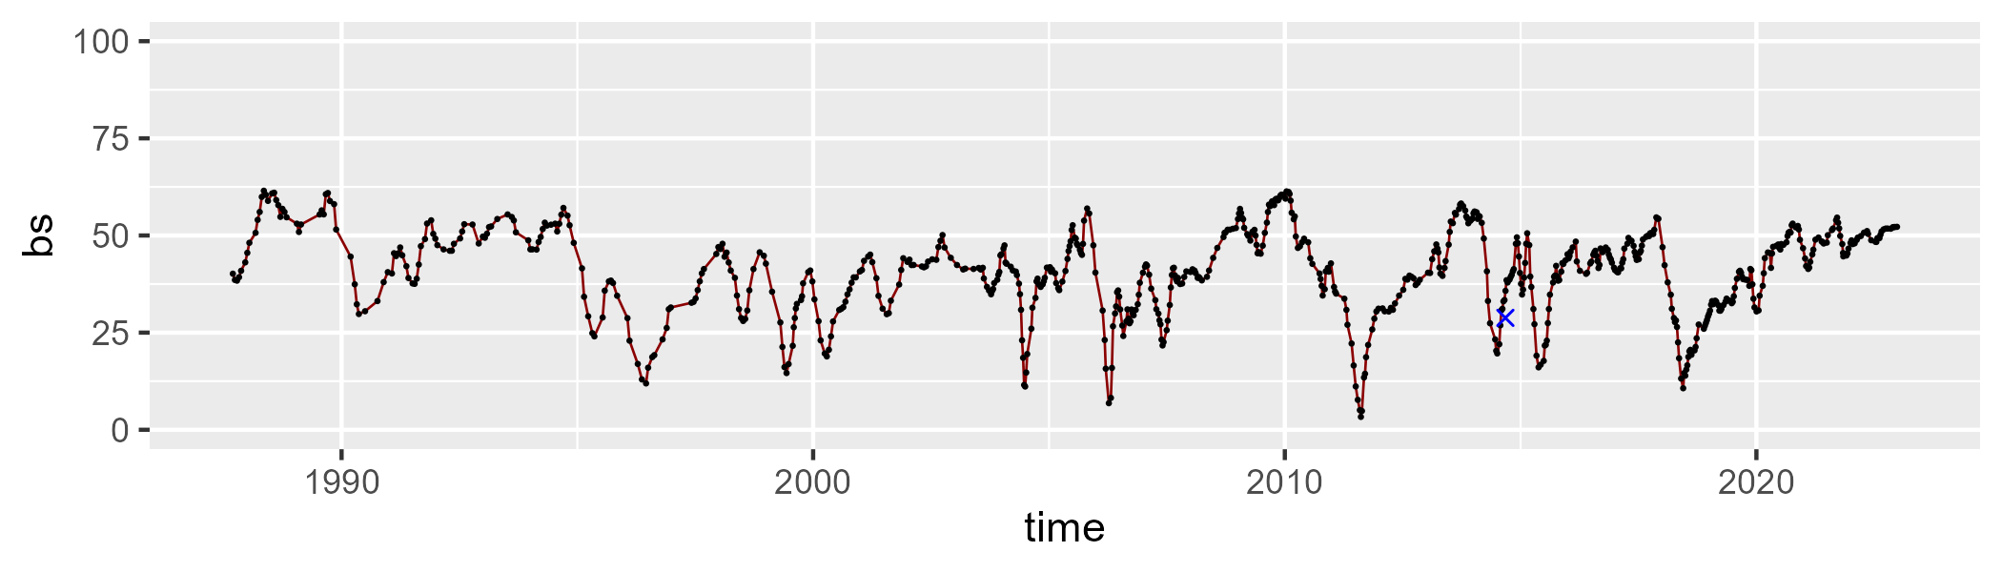

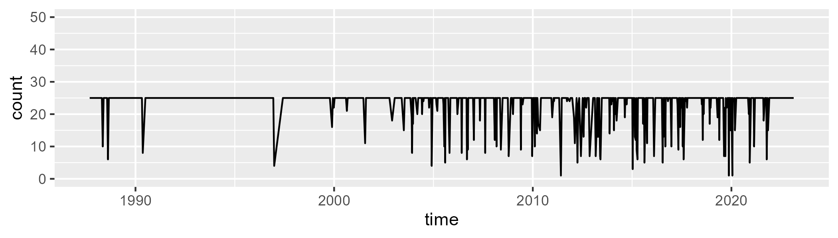

Min. : 1.00 1st Qu.:25.00 Median :25.00 Mean :23.31 3rd Qu.:25.00 Max. :25.00

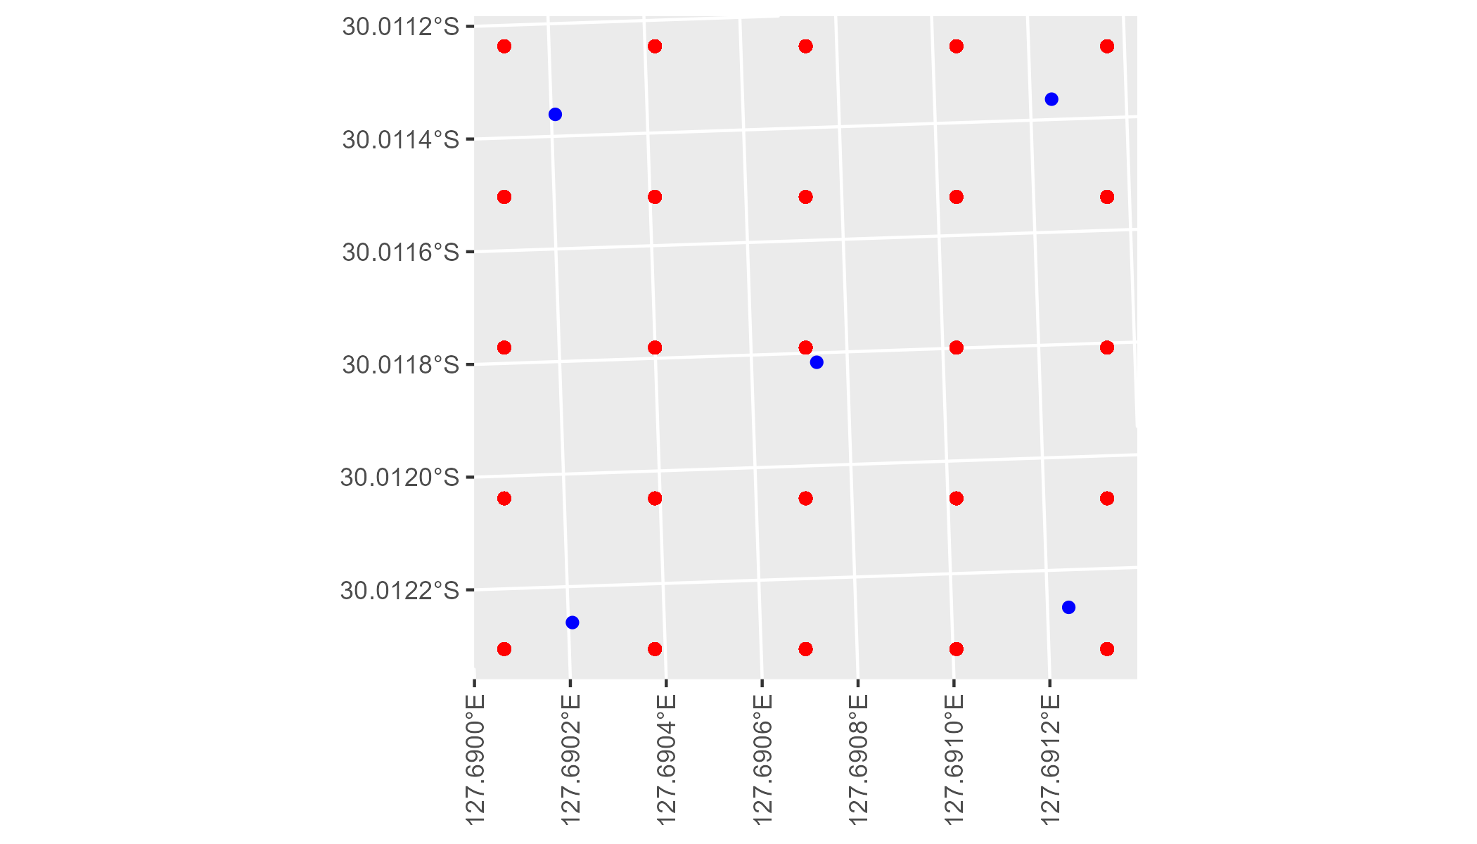

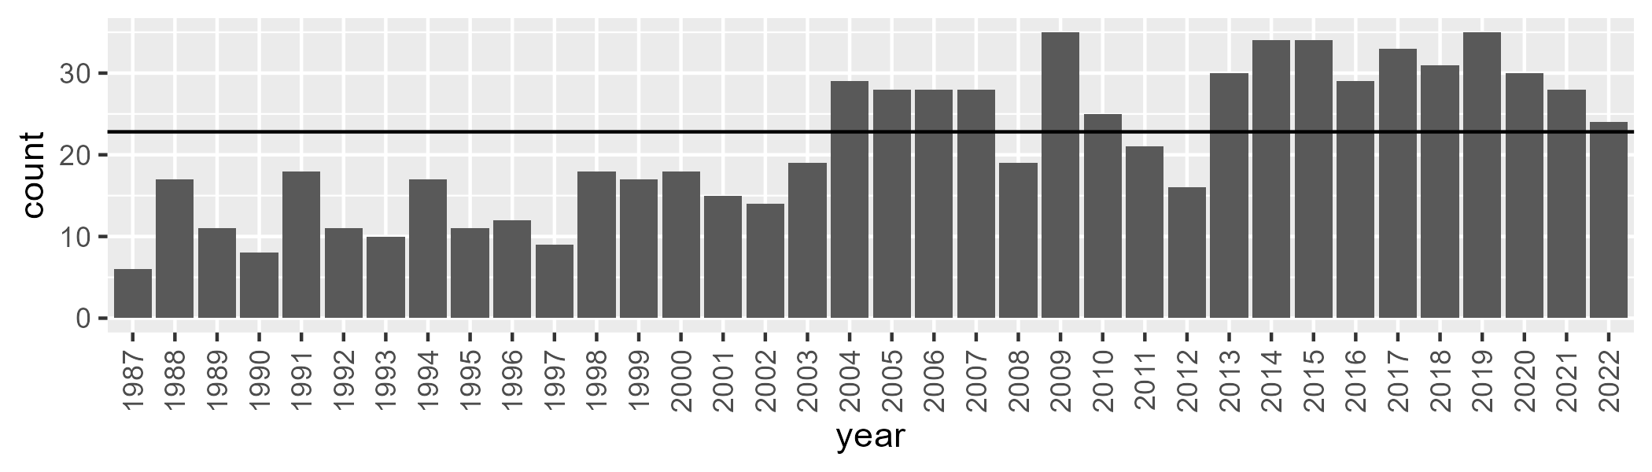

Number of samples: 768

# WAANUL0006

| Min. | 1st Qu. | Median | Mean | 3rd Qu. | Max. |
| --- | --- | --- | --- | --- | --- |
| 0 | 2.580685 | 5.988429 | 8.307768 | 11.70619 | 35.79278 |

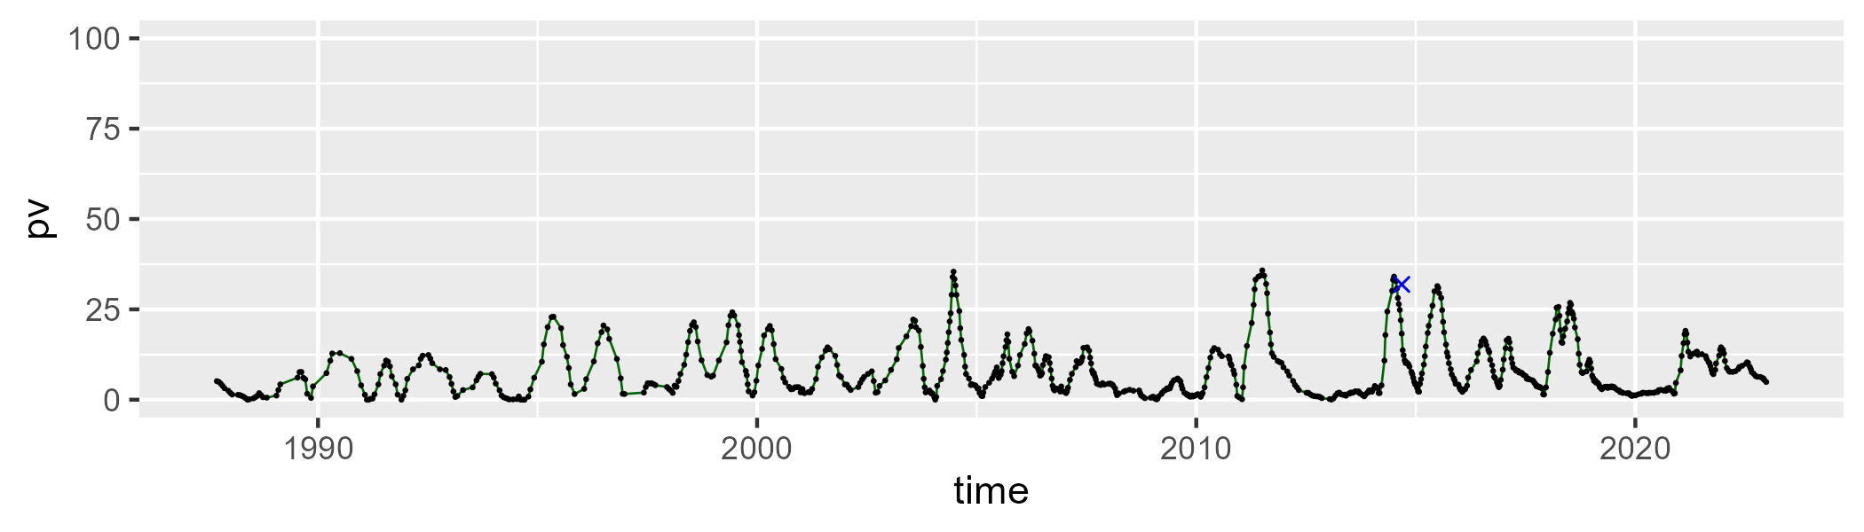

| Min. | 1st Qu. | Median | Mean | 3rd Qu. | Max. |
| --- | --- | --- | --- | --- | --- |
| 23.93455 | 38.60214 | 43.60003 | 43.7322 | 49.15731 | 59.22111 |

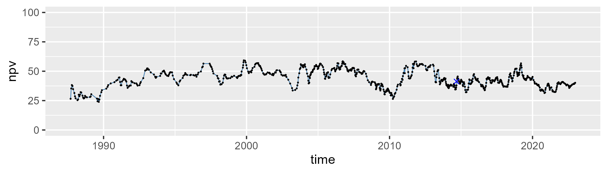

| Min. | 1st Qu. | Median | Mean | 3rd Qu. | Max. |
| --- | --- | --- | --- | --- | --- |
| 16.25542 | 39.71935 | 46.69781 | 46.52235 | 52.91887 | 71.72579 |

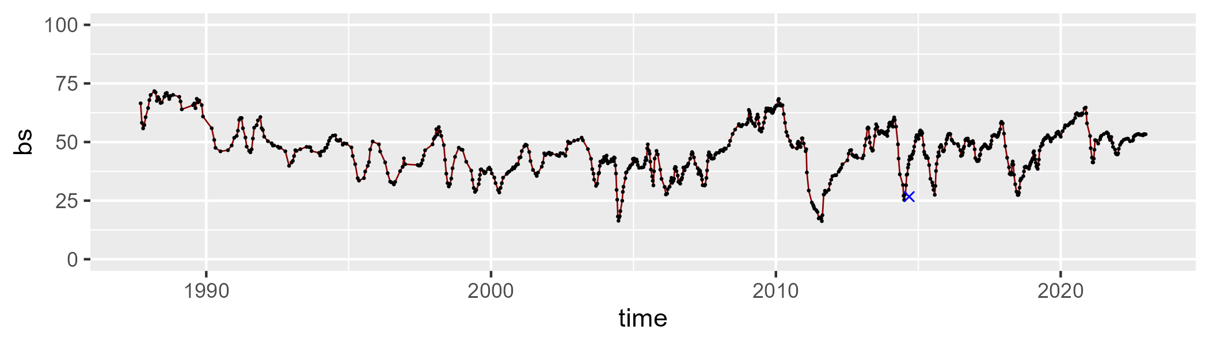

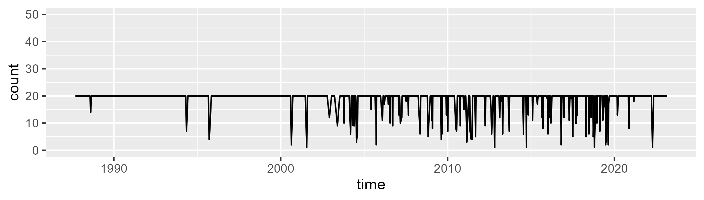

Min. : 1.00 1st Qu.:20.00 Median :20.00 Mean :18.69 3rd Qu.:20.00 Max. :20.00

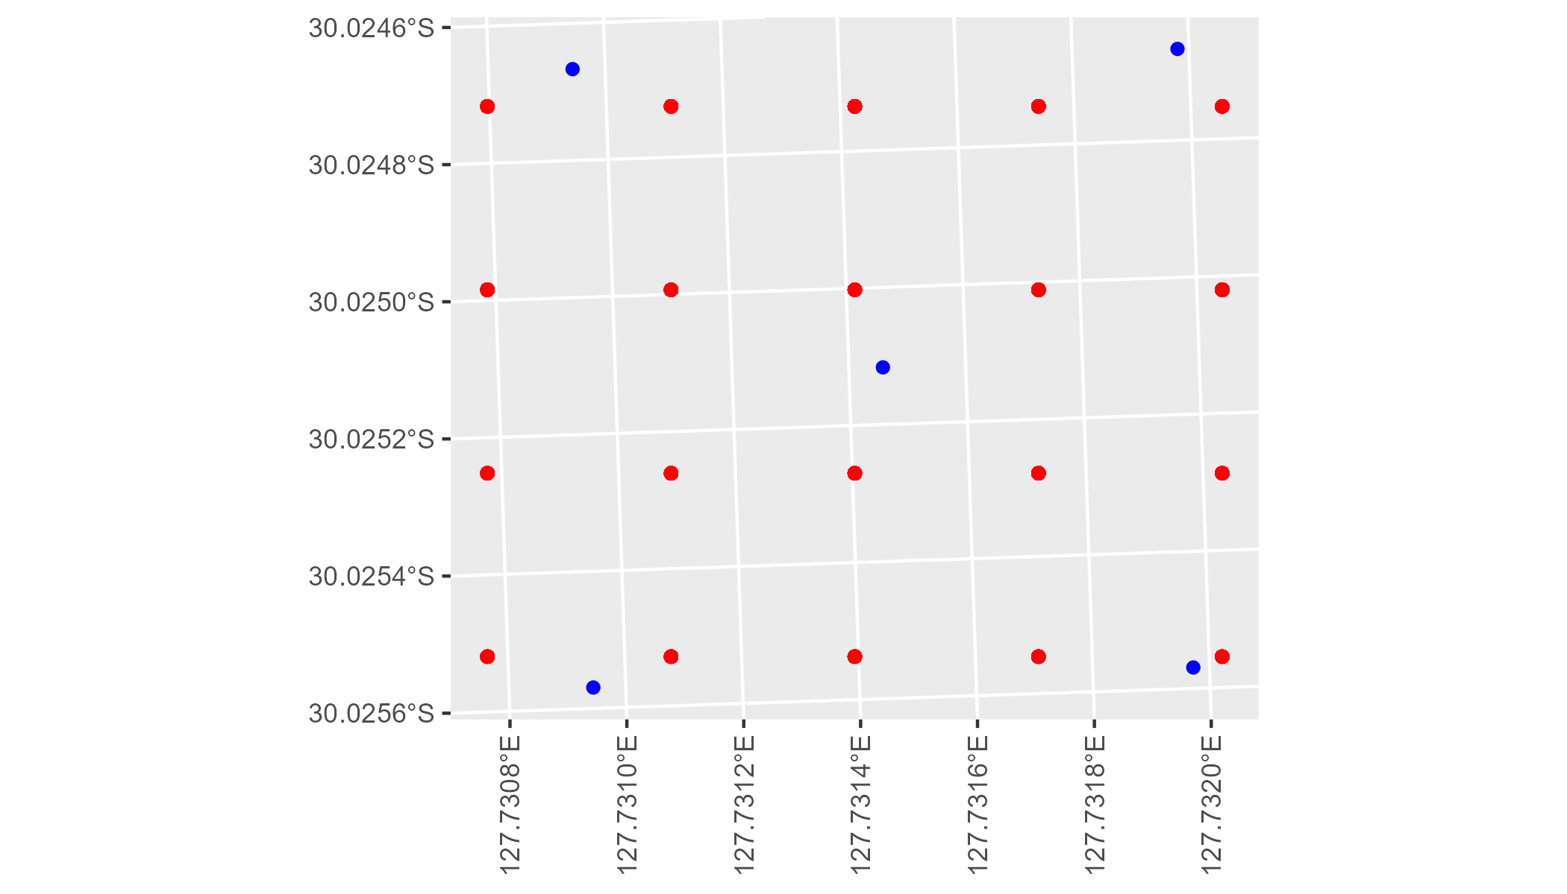

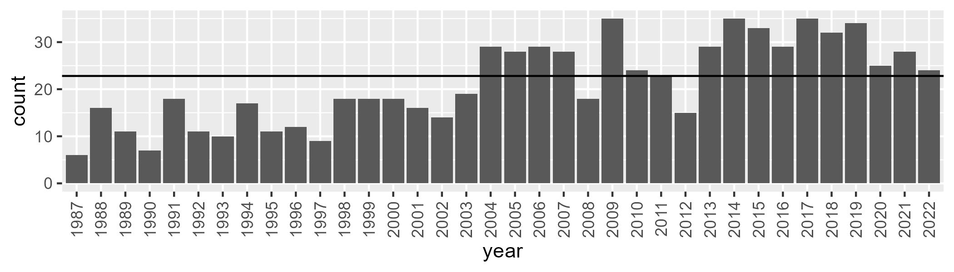

Number of samples: 764

# WAANUL0007

| Min. | 1st Qu. | Median | Mean | 3rd Qu. | Max. |
| --- | --- | --- | --- | --- | --- |
| 0 | 2.140027 | 5.746255 | 9.479862 | 13.23355 | 55.14834 |

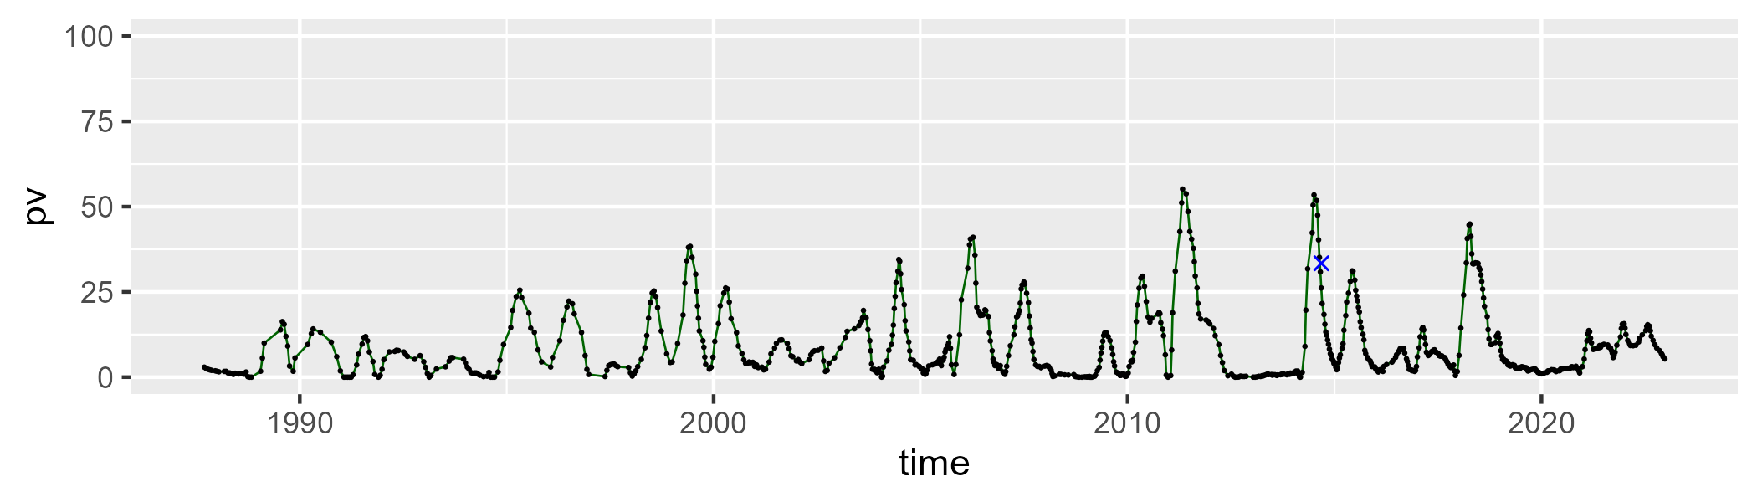

| Min. | 1st Qu. | Median | Mean | 3rd Qu. | Max. |
| --- | --- | --- | --- | --- | --- |
| 21.75541 | 39.55904 | 45.96381 | 46.21192 | 51.89961 | 83.44636 |

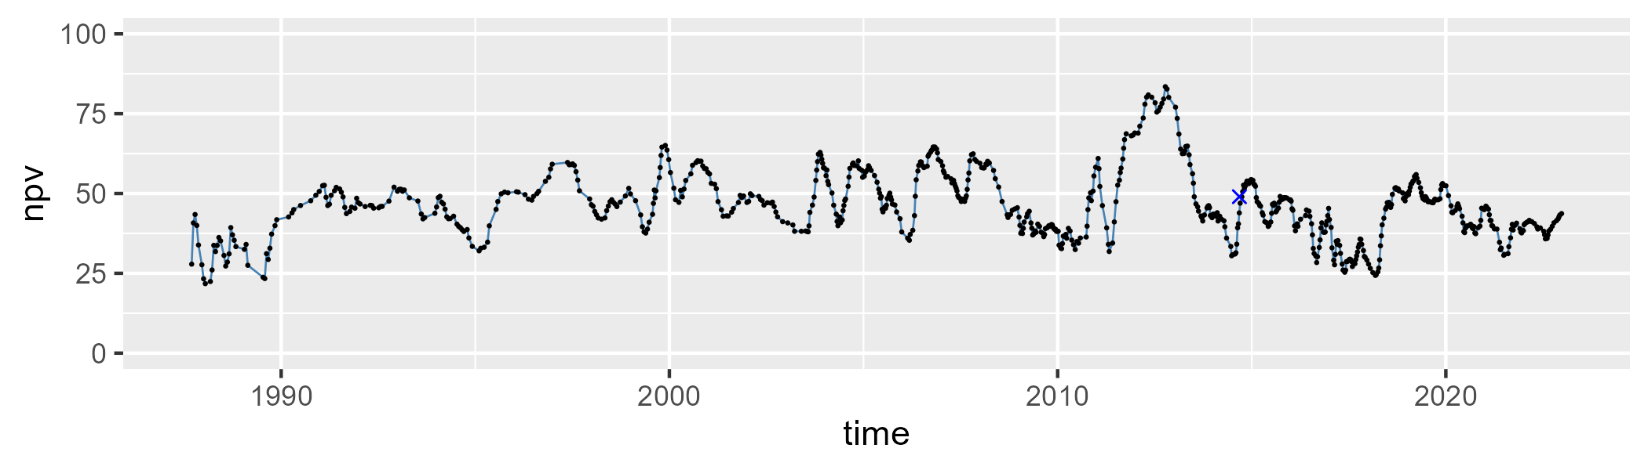

| Min. | 1st Qu. | Median | Mean | 3rd Qu. | Max. |
| --- | --- | --- | --- | --- | --- |
| 5.650719 | 34.68574 | 44.29288 | 42.93903 | 52.43997 | 75.18122 |

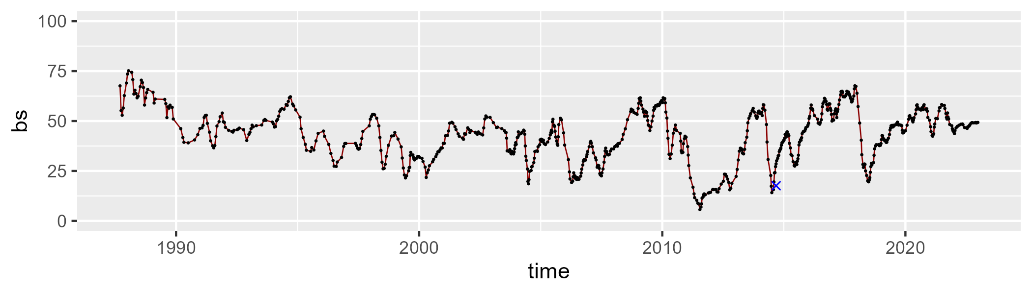

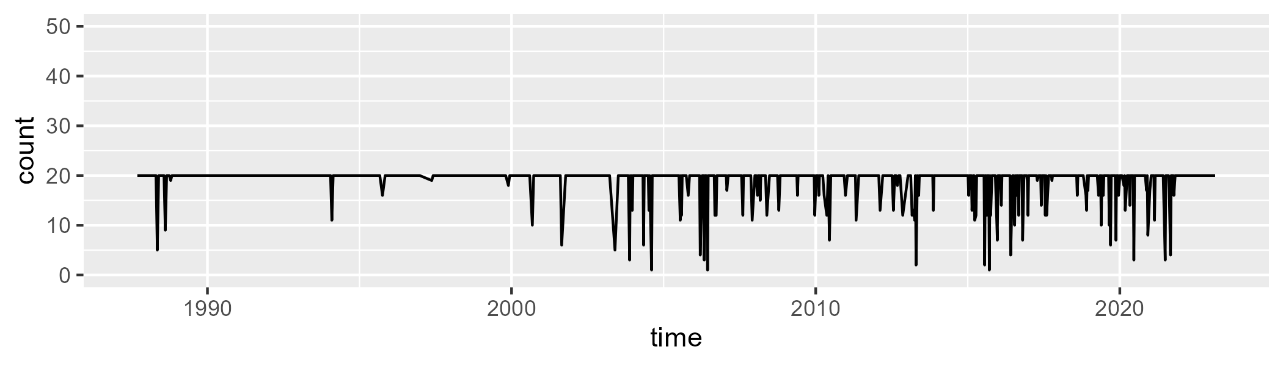

Min. : 1.00 1st Qu.:20.00 Median :20.00 Mean :18.98 3rd Qu.:20.00 Max. :20.00

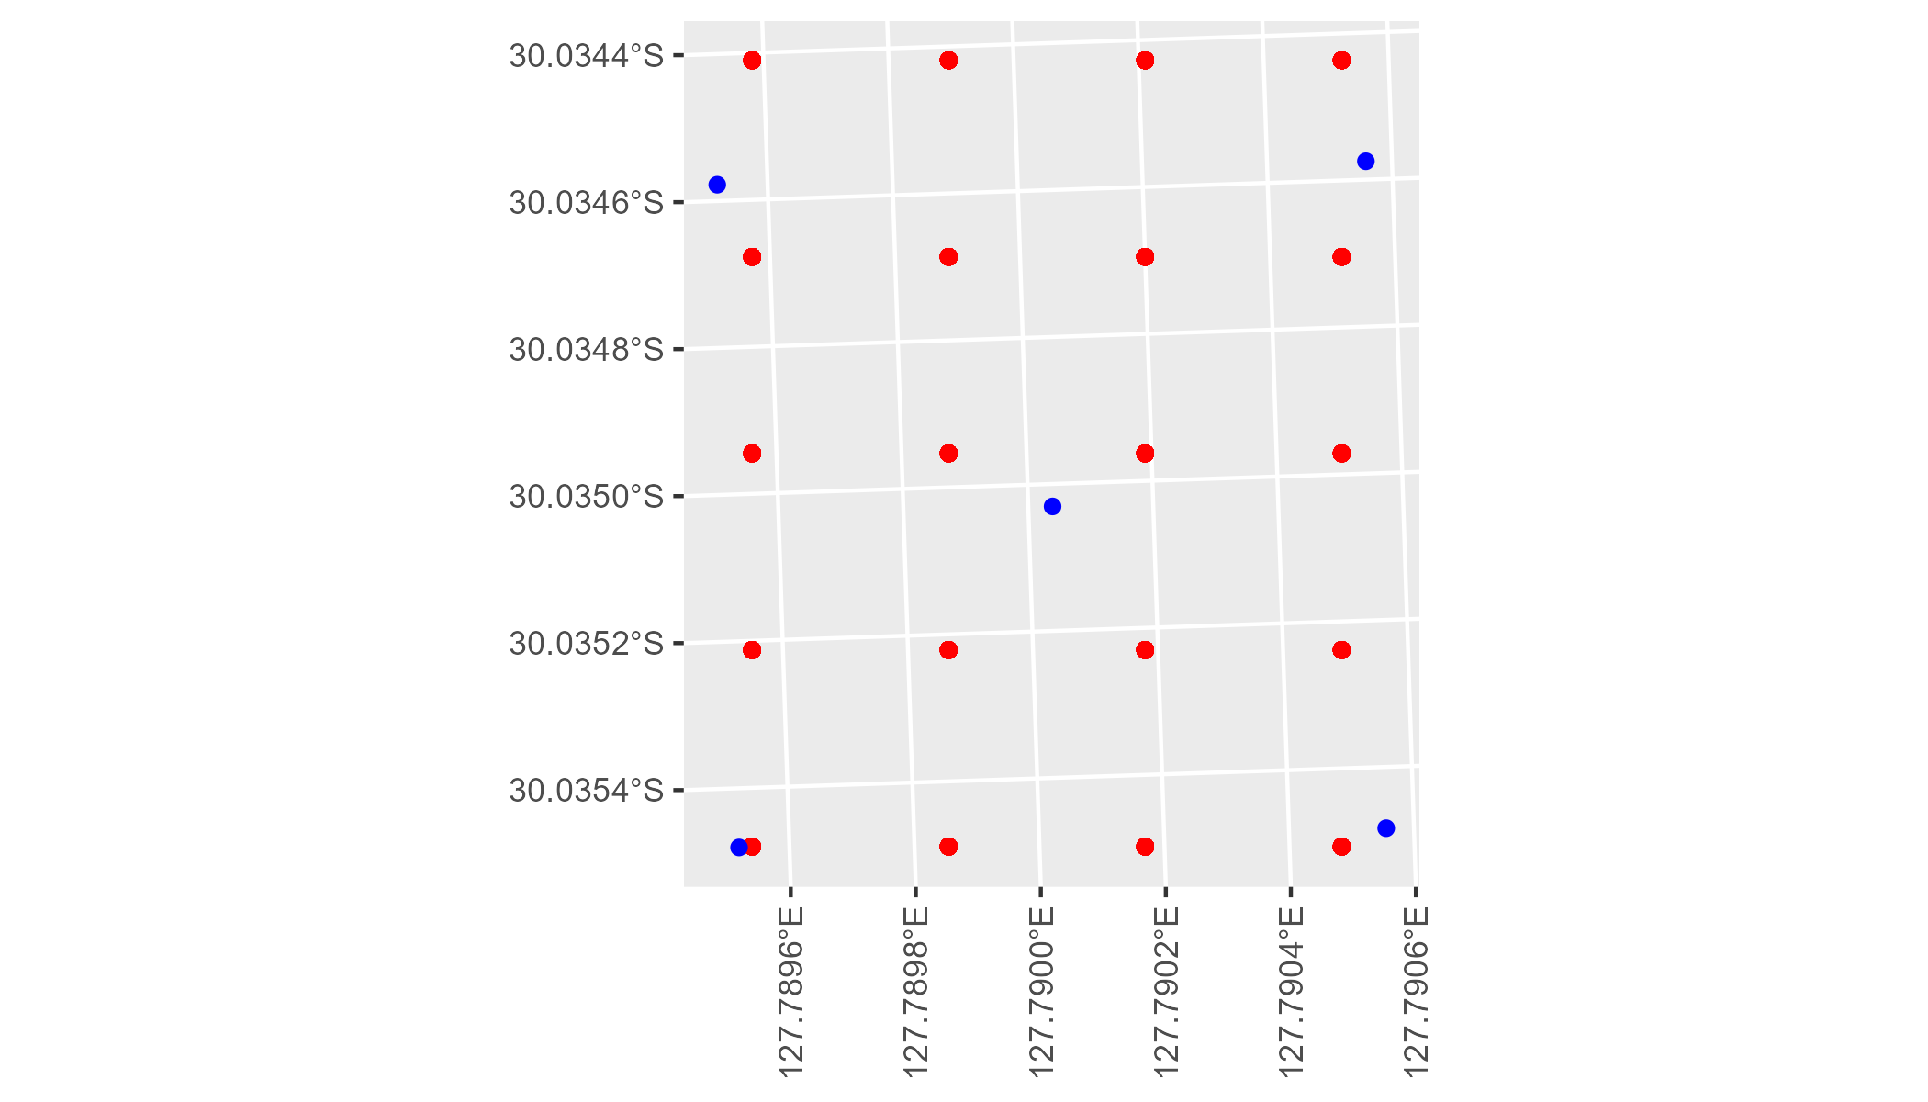

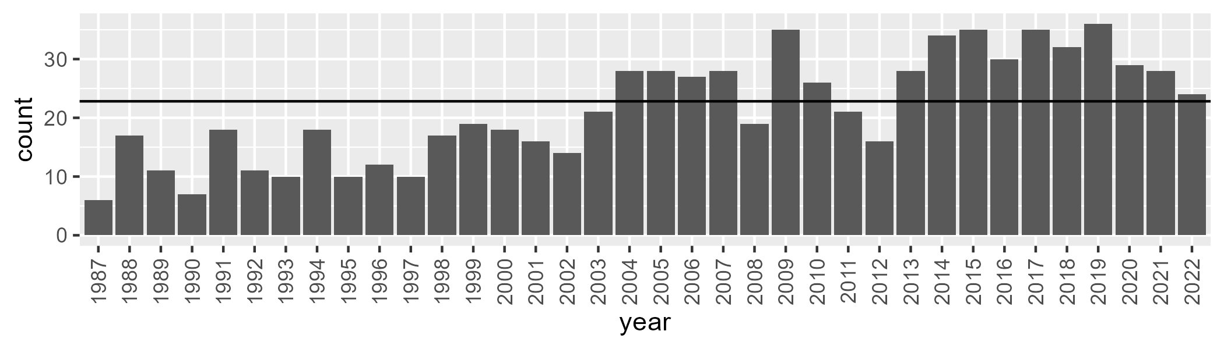

Number of samples: 774

# WAANUL0008

| Min. | 1st Qu. | Median | Mean | 3rd Qu. | Max. |
| --- | --- | --- | --- | --- | --- |
| 0 | 3.235967 | 6.644681 | 9.262901 | 13.73903 | 45.16876 |

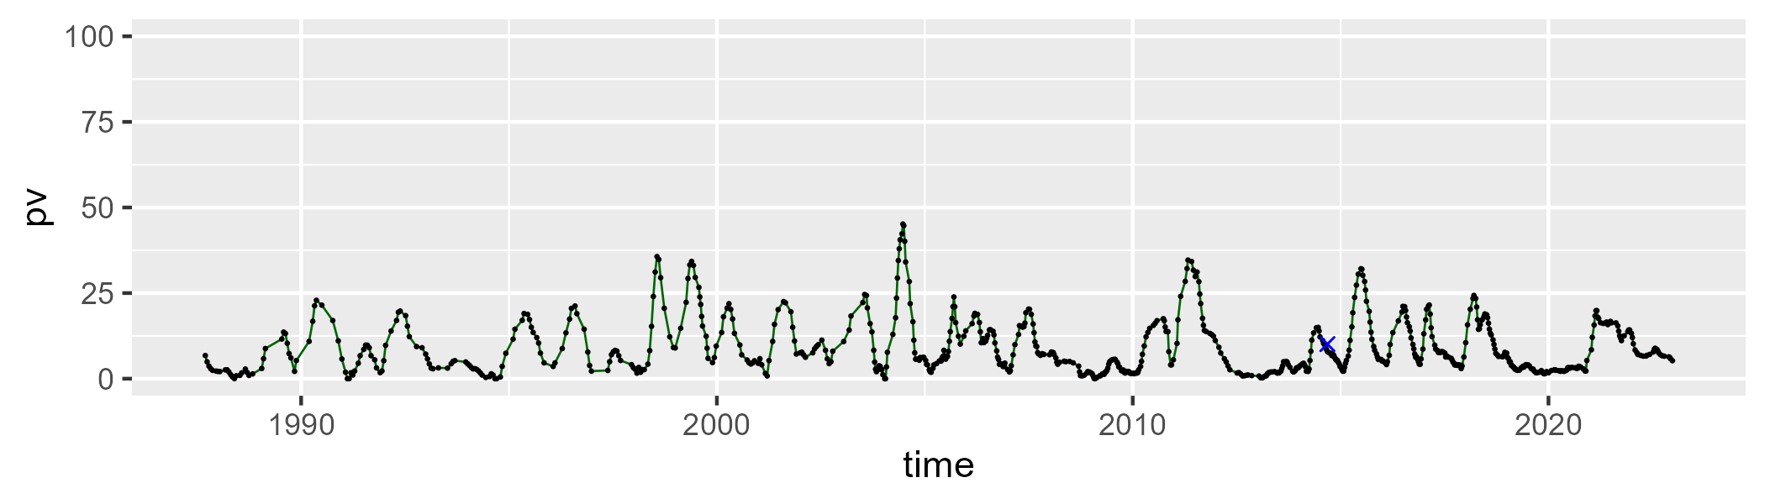

| Min. | 1st Qu. | Median | Mean | 3rd Qu. | Max. |
| --- | --- | --- | --- | --- | --- |
| 17.29582 | 37.85784 | 44.57458 | 44.49782 | 51.26266 | 62.38525 |

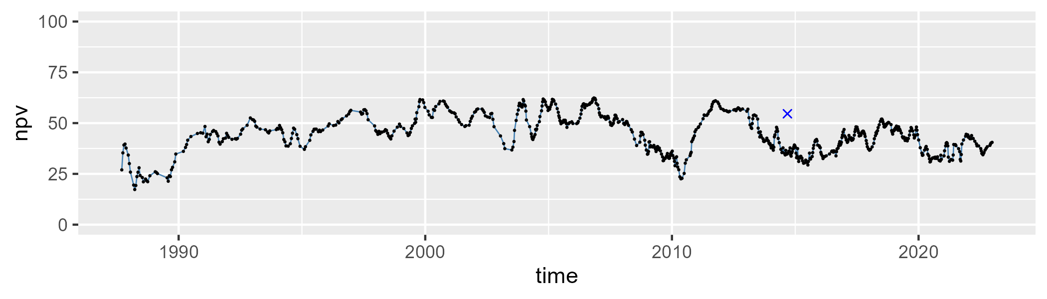

| Min. | 1st Qu. | Median | Mean | 3rd Qu. | Max. |
| --- | --- | --- | --- | --- | --- |
| 6.842182 | 36.26396 | 45.66752 | 44.81964 | 53.45585 | 78.59881 |

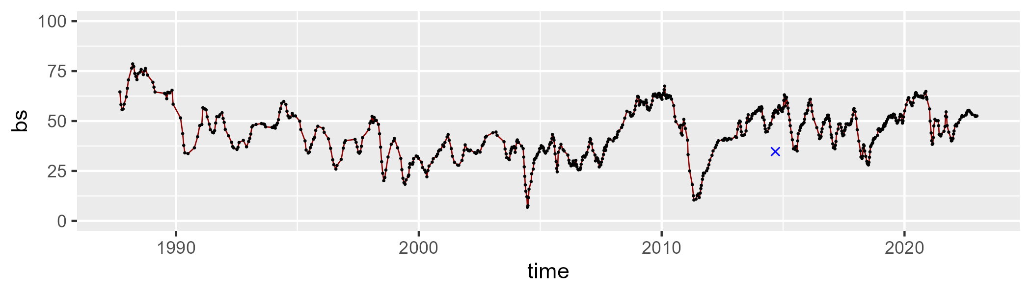

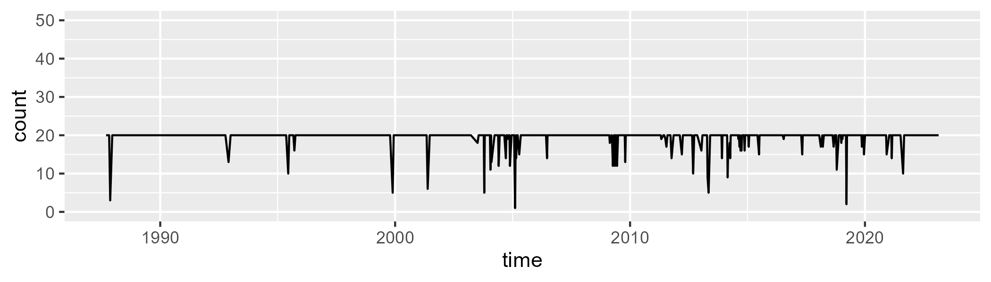

Min. : 1.0 1st Qu.:20.0 Median :20.0 Mean :19.5 3rd Qu.:20.0 Max. :20.0

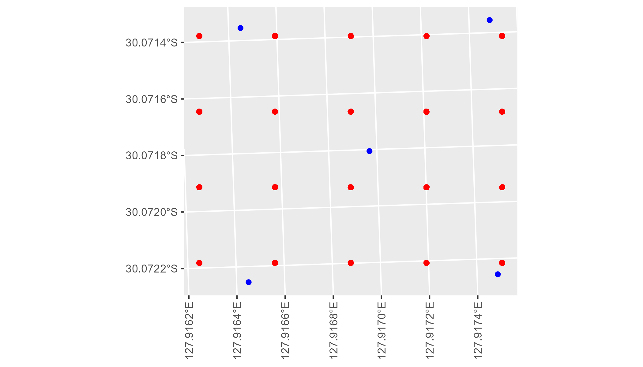

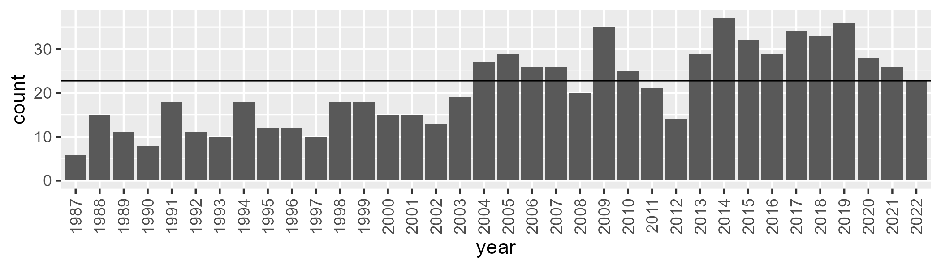

Number of samples: 759

# WAANUL0009

| Min. | 1st Qu. | Median | Mean | 3rd Qu. | Max. |
| --- | --- | --- | --- | --- | --- |
| 0.3349499 | 6.451445 | 9.066587 | 10.50433 | 13.0416 | 35.55593 |

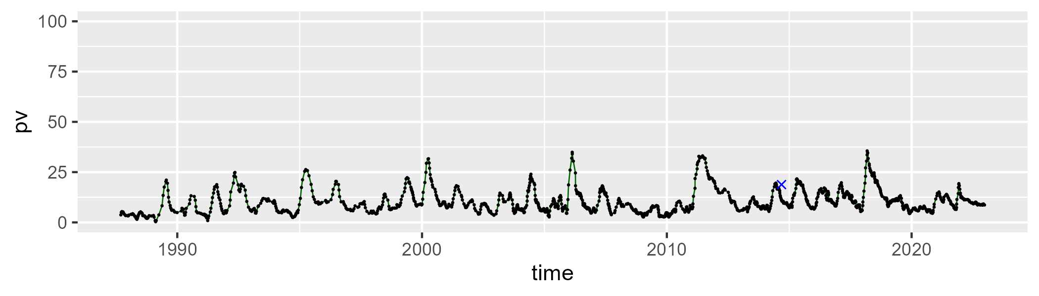

| Min. | 1st Qu. | Median | Mean | 3rd Qu. | Max. |
| --- | --- | --- | --- | --- | --- |
| 36.69454 | 49.42273 | 54.06101 | 53.99708 | 58.81358 | 70.68614 |

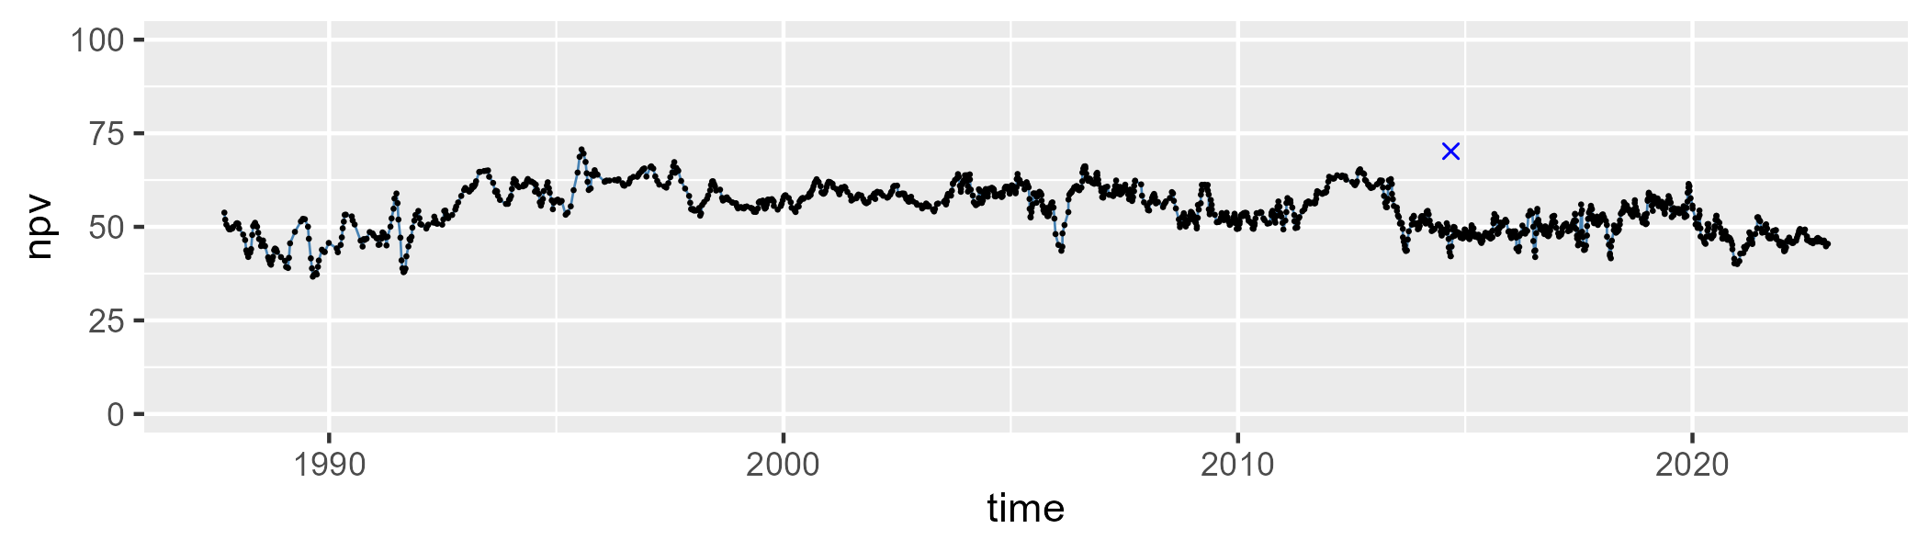

| Min. | 1st Qu. | Median | Mean | 3rd Qu. | Max. |
| --- | --- | --- | --- | --- | --- |
| 10.35481 | 29.19697 | 33.78974 | 34.14599 | 40.24705 | 58.74505 |

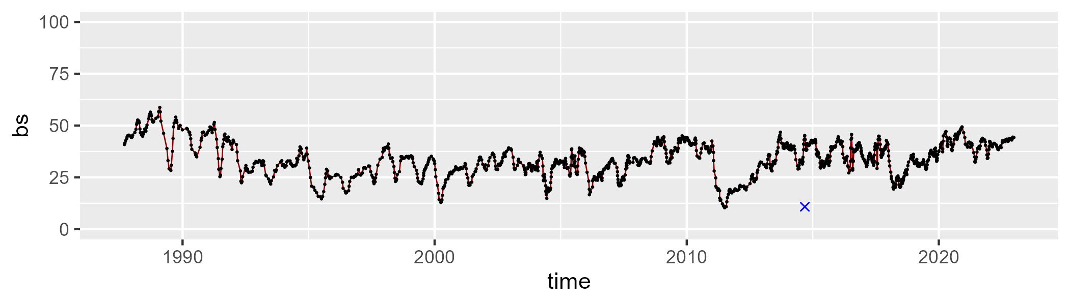

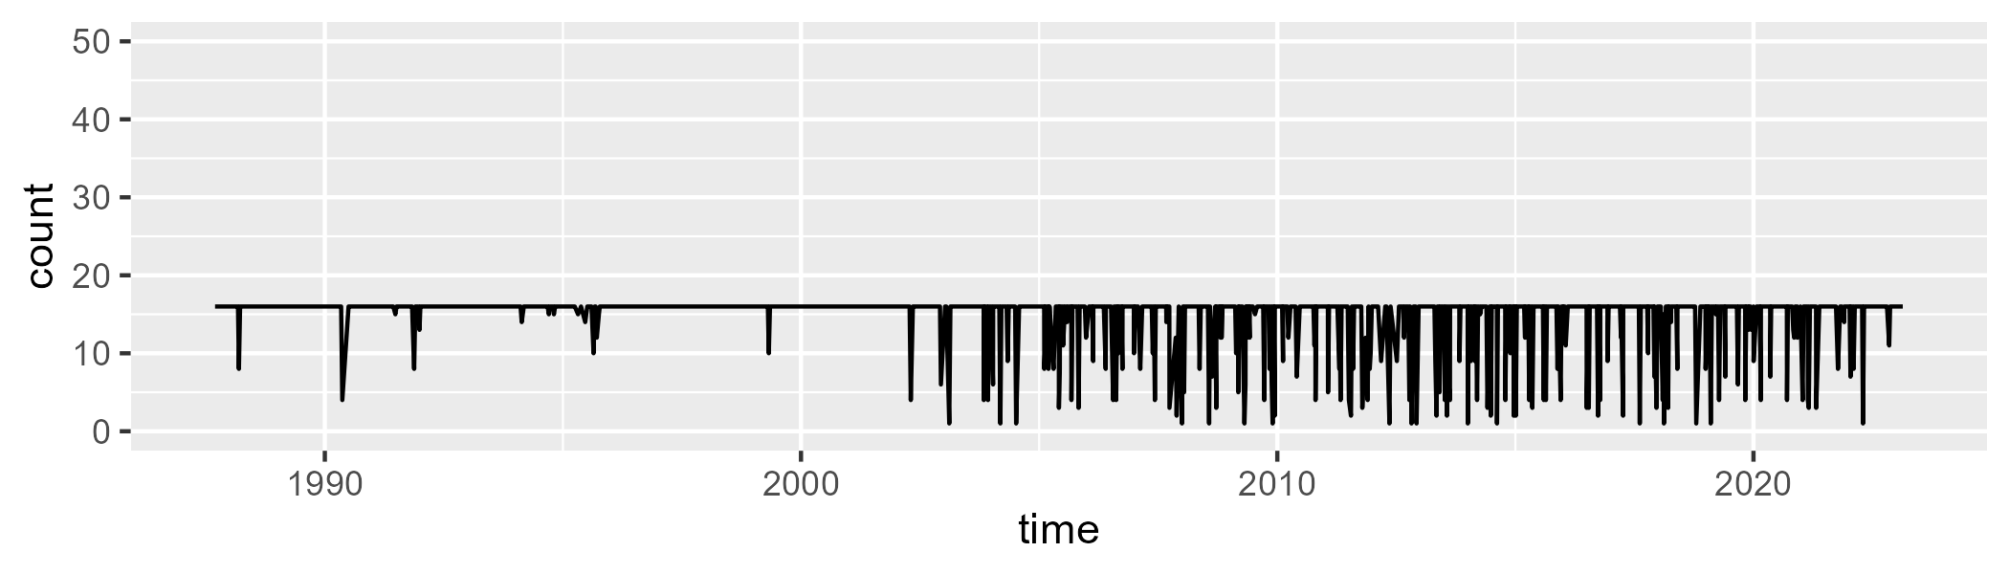

Min. : 1.00 1st Qu.:16.00 Median :16.00 Mean :14.94 3rd Qu.:16.00 Max. :16.00

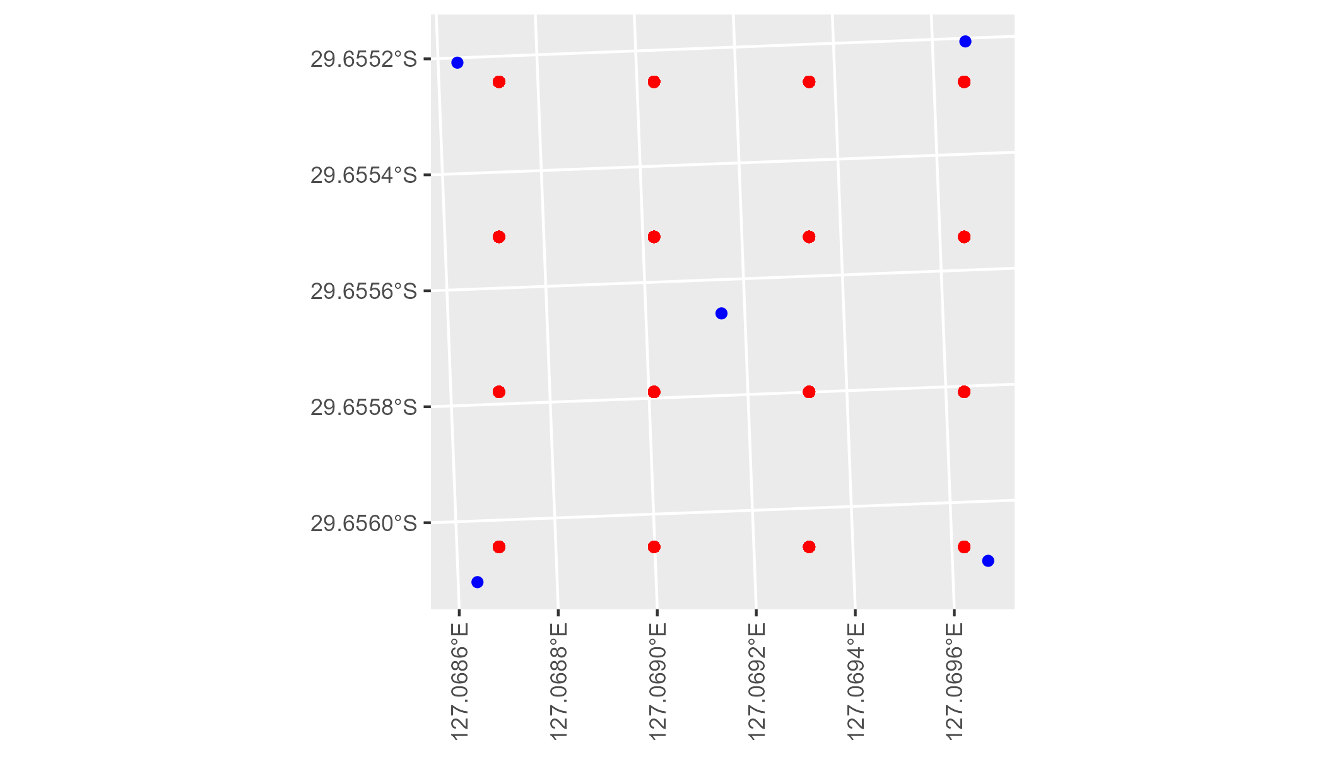

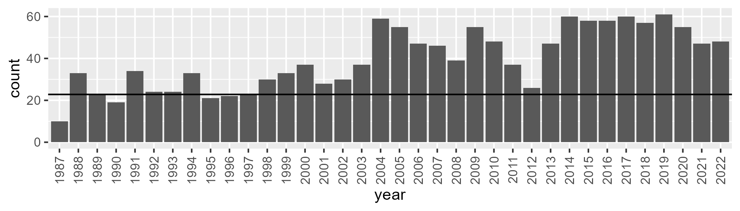

Number of samples: 1424

# WAAPIL0001

| Min. | 1st Qu. | Median | Mean | 3rd Qu. | Max. |
| --- | --- | --- | --- | --- | --- |
| 0 | 9.231416 | 13.62765 | 15.06905 | 20.35702 | 43.18006 |

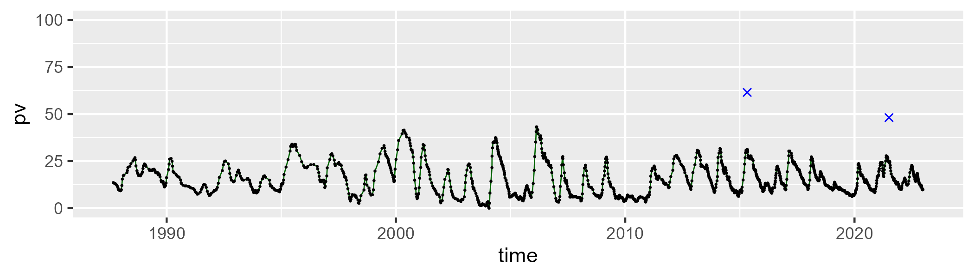

| Min. | 1st Qu. | Median | Mean | 3rd Qu. | Max. |
| --- | --- | --- | --- | --- | --- |
| 25.45565 | 38.23107 | 42.27569 | 42.07269 | 45.12172 | 59.15758 |

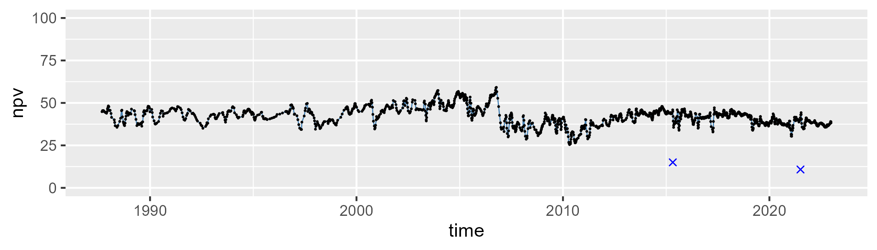

| Min. | 1st Qu. | Median | Mean | 3rd Qu. | Max. |
| --- | --- | --- | --- | --- | --- |
| 10.24061 | 35.51306 | 42.5045 | 41.35158 | 47.34838 | 67.40978 |

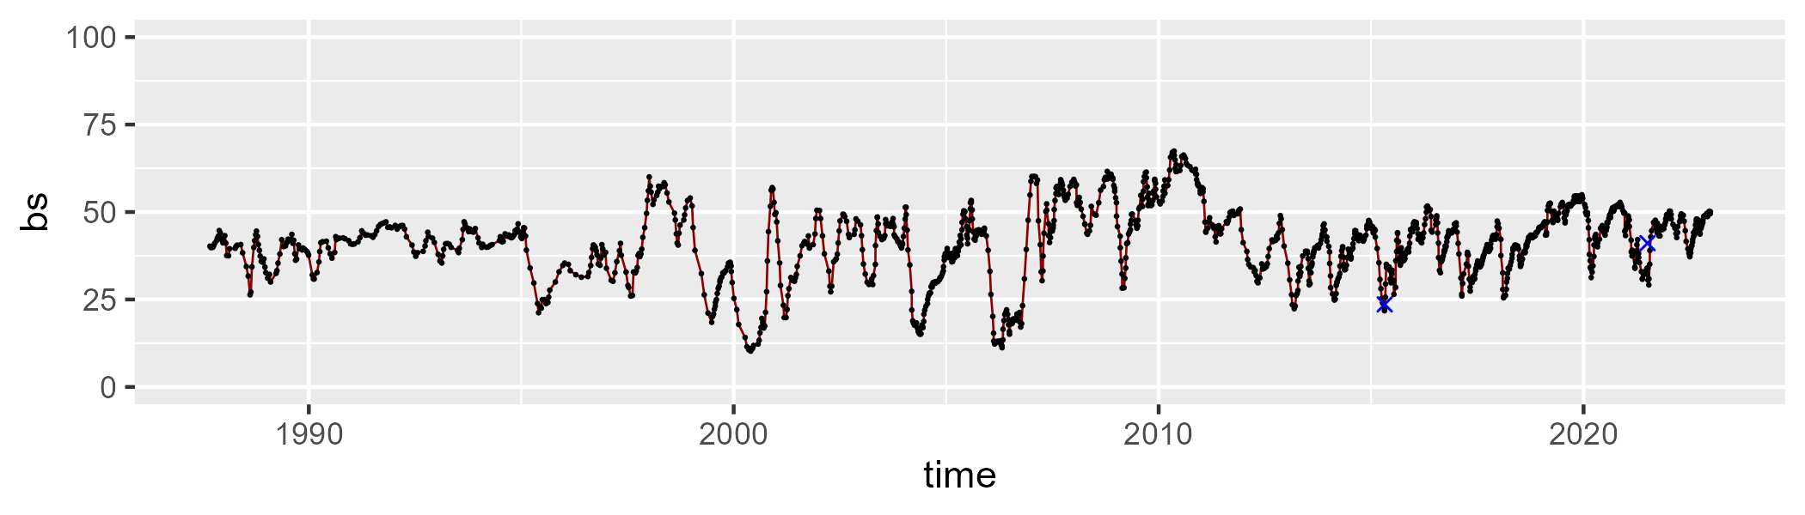

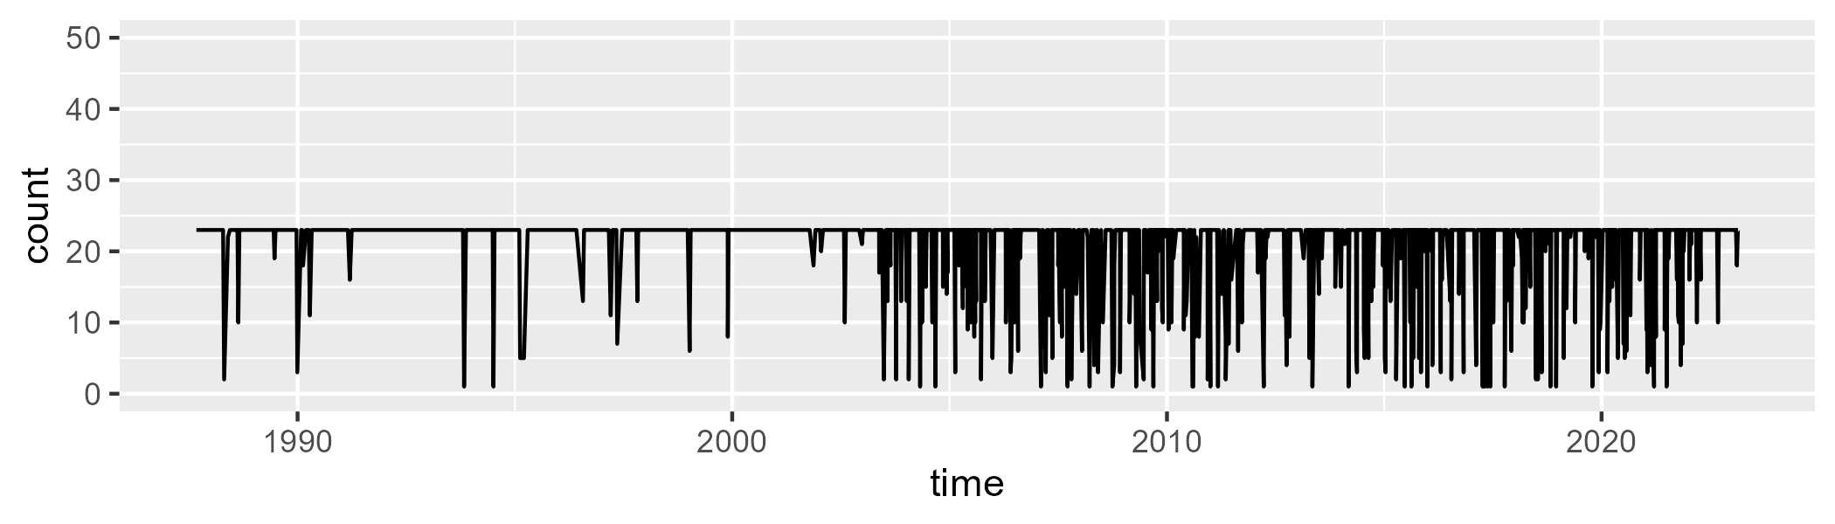

Min. : 1.00 1st Qu.:23.00 Median :23.00 Mean :20.95 3rd Qu.:23.00 Max. :23.00

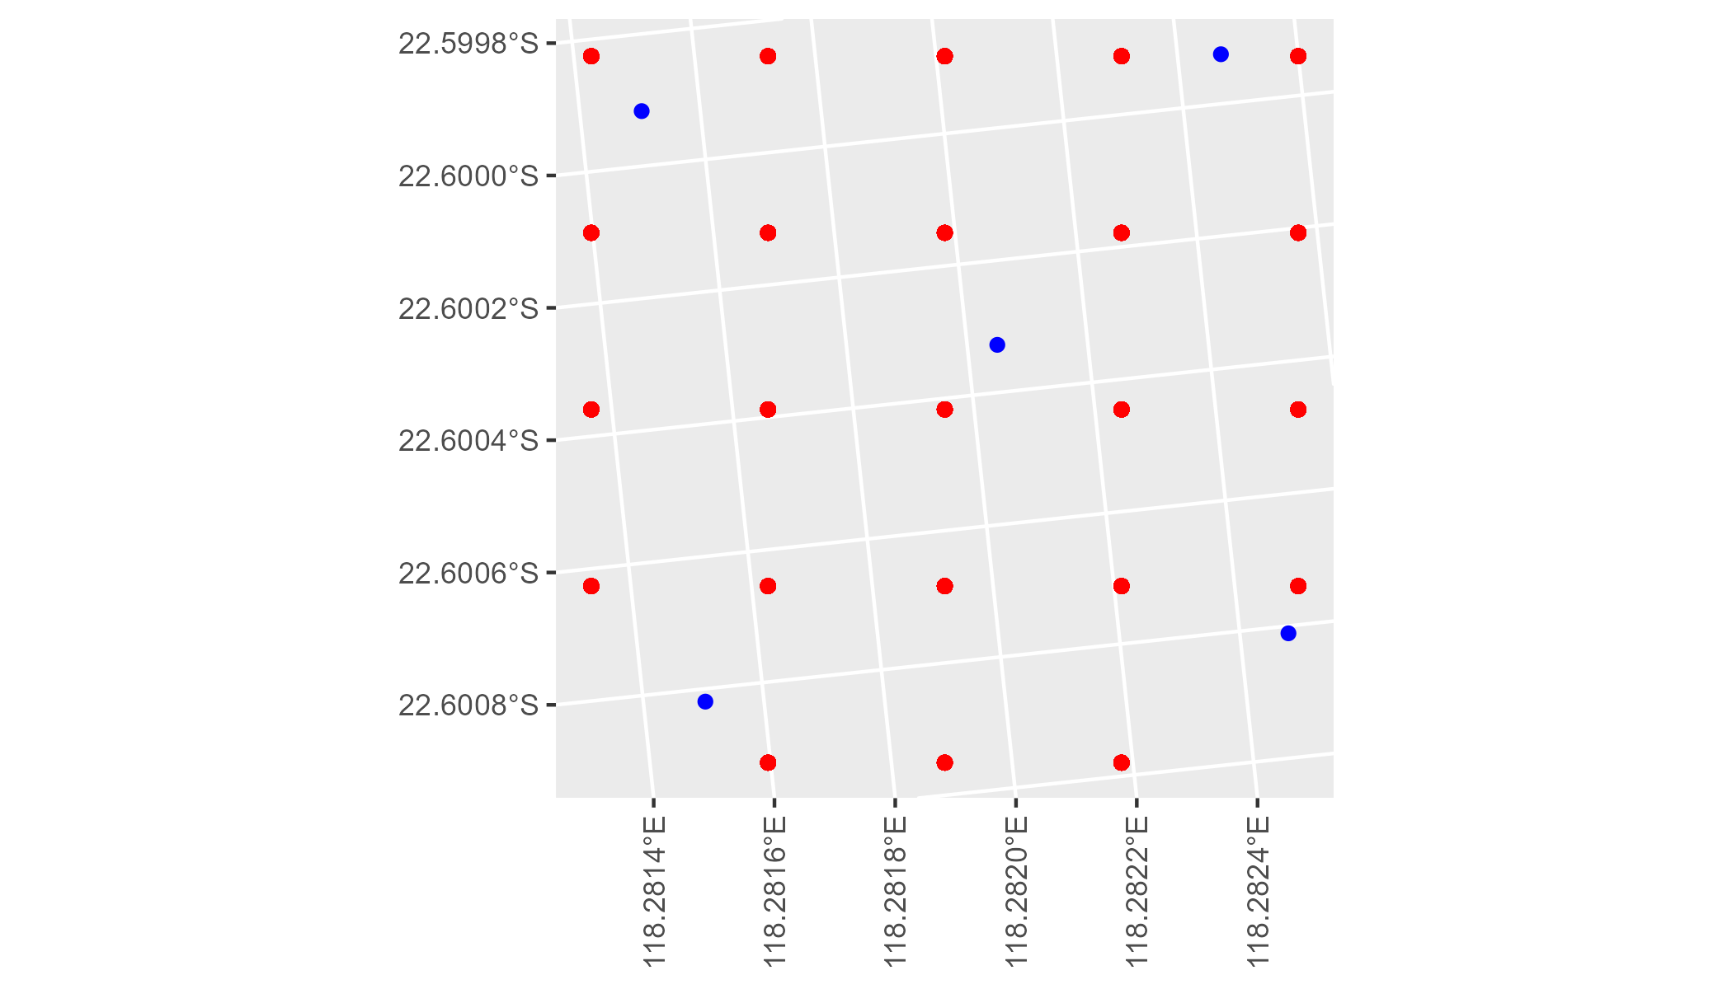

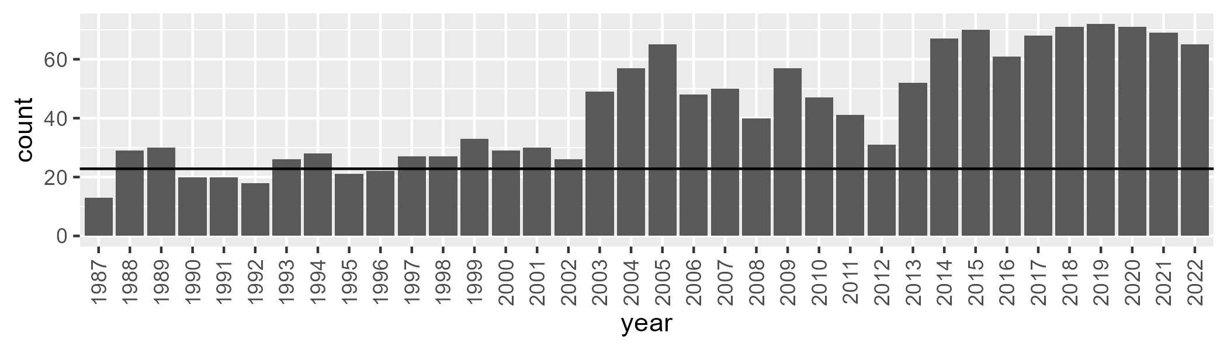

Number of samples: 1550

# WAAPIL0002

| Min. | 1st Qu. | Median | Mean | 3rd Qu. | Max. |
| --- | --- | --- | --- | --- | --- |
| 3.353999 | 12.5076 | 15.3283 | 16.04067 | 19.41604 | 32.84156 |

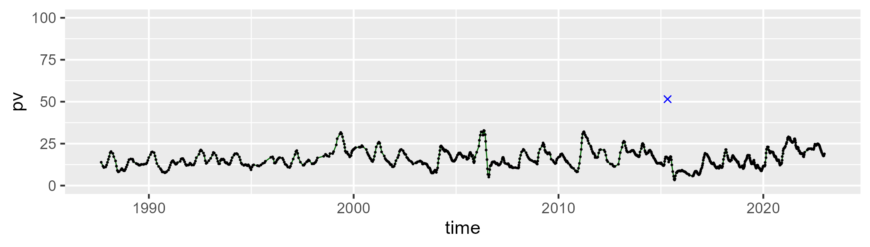

| Min. | 1st Qu. | Median | Mean | 3rd Qu. | Max. |
| --- | --- | --- | --- | --- | --- |
| 25.47953 | 39.43747 | 44.67763 | 44.80662 | 49.84949 | 65.2744 |

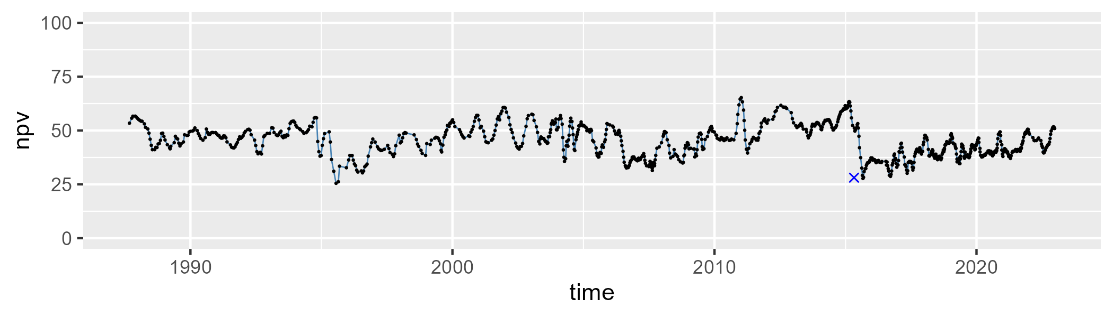

| Min. | 1st Qu. | Median | Mean | 3rd Qu. | Max. |
| --- | --- | --- | --- | --- | --- |
| 15.81604 | 30.71804 | 37.50585 | 37.76386 | 43.71569 | 67.11815 |

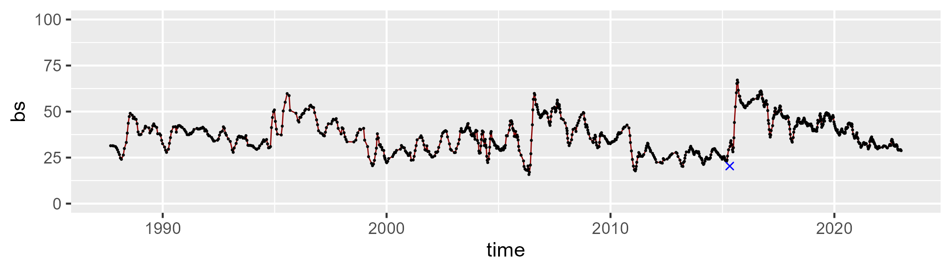

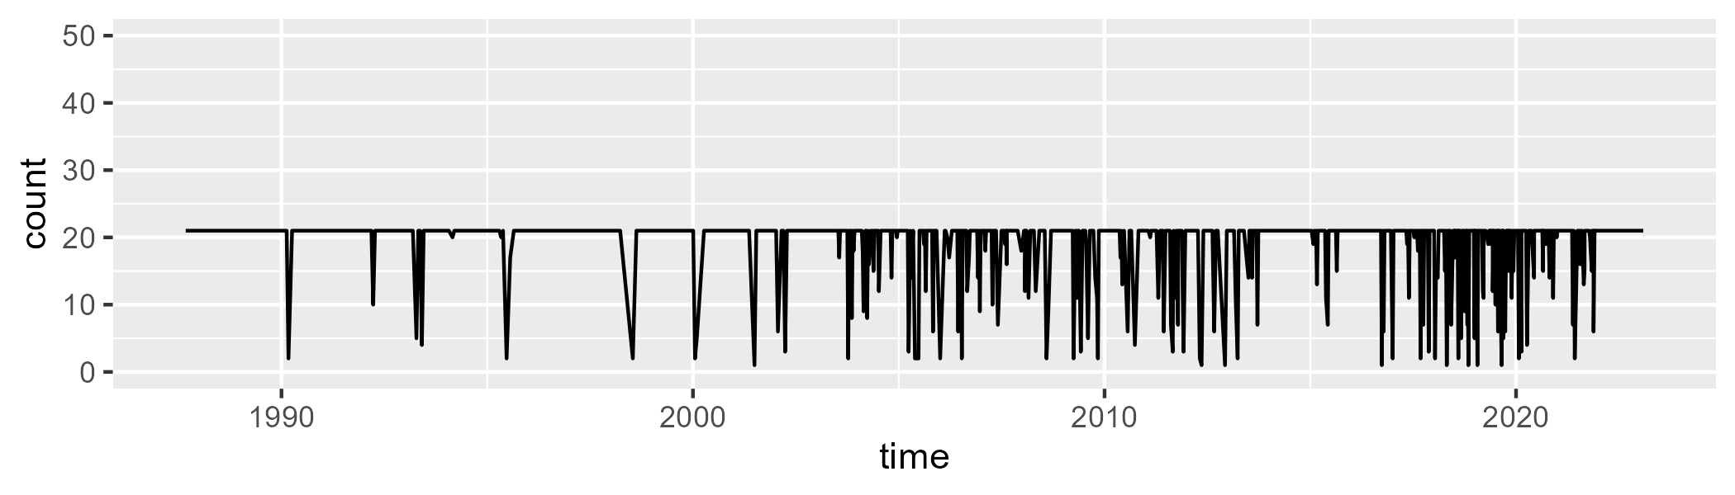

Min. : 1.00 1st Qu.:21.00 Median :21.00 Mean :19.31 3rd Qu.:21.00 Max. :21.00

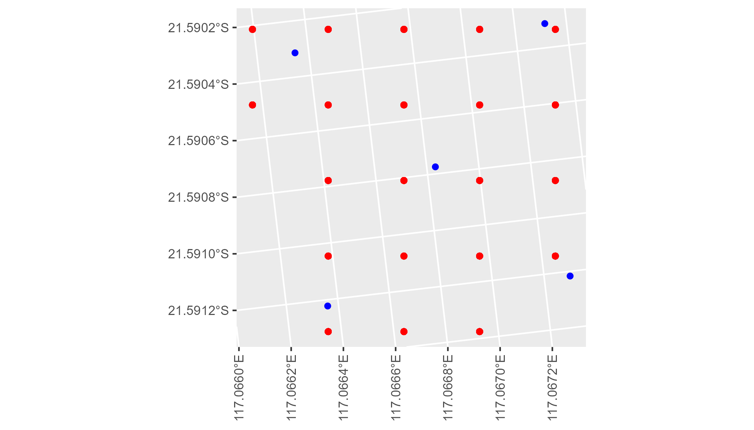

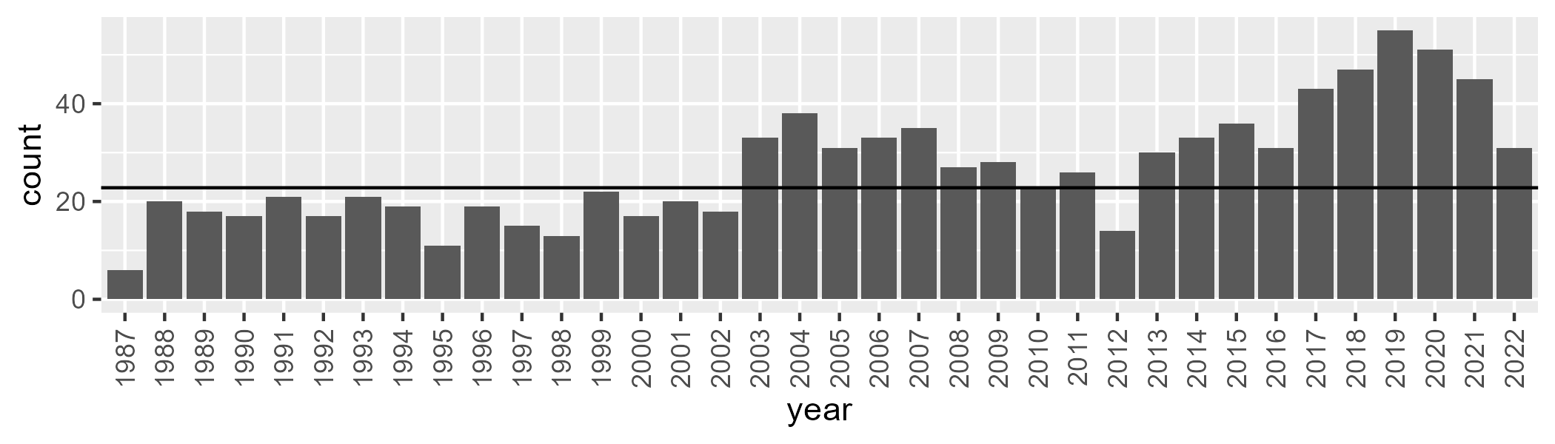

Number of samples: 964

# WAAPIL0003

| Min. | 1st Qu. | Median | Mean | 3rd Qu. | Max. |
| --- | --- | --- | --- | --- | --- |
| 0 | 2.687455 | 6.459453 | 7.306195 | 10.46297 | 22.40565 |

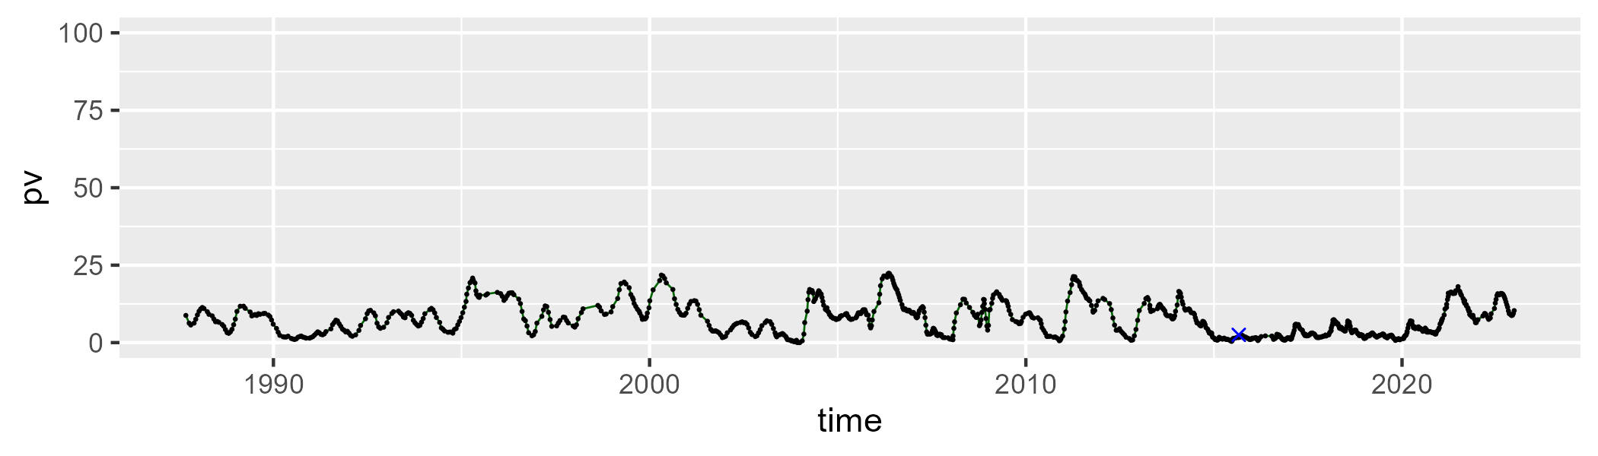

| Min. | 1st Qu. | Median | Mean | 3rd Qu. | Max. |
| --- | --- | --- | --- | --- | --- |
| 26.60163 | 43.53423 | 50.04254 | 49.36955 | 55.64822 | 72.08364 |

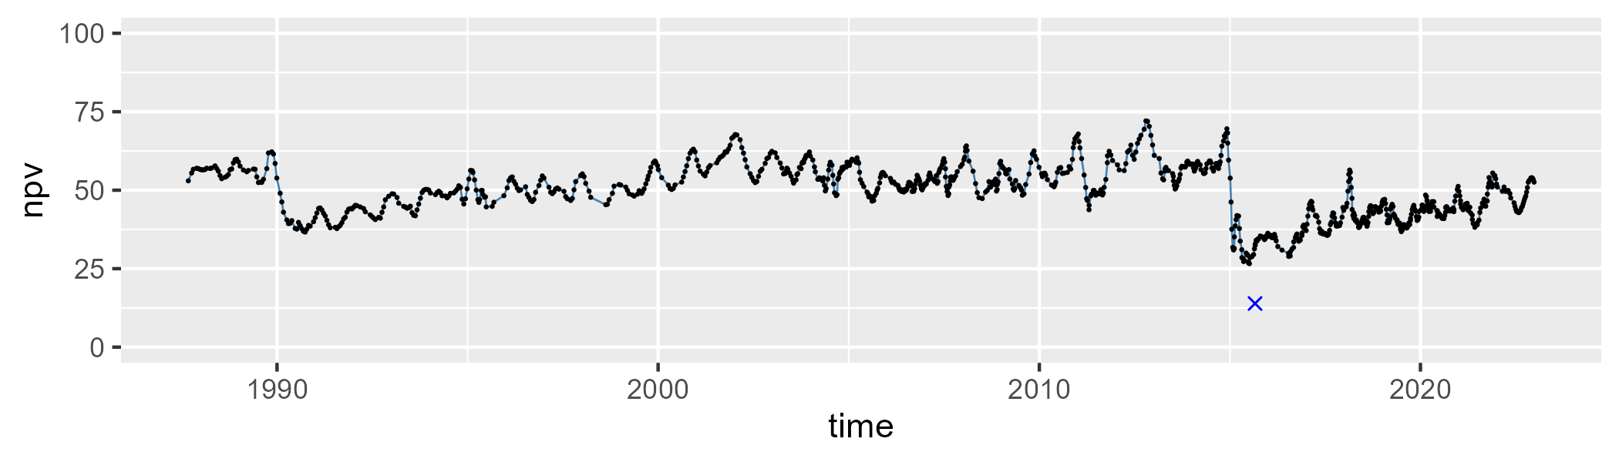

| Min. | 1st Qu. | Median | Mean | 3rd Qu. | Max. |
| --- | --- | --- | --- | --- | --- |
| 23.66299 | 33.23765 | 39.23842 | 41.81583 | 51.10606 | 70.82874 |

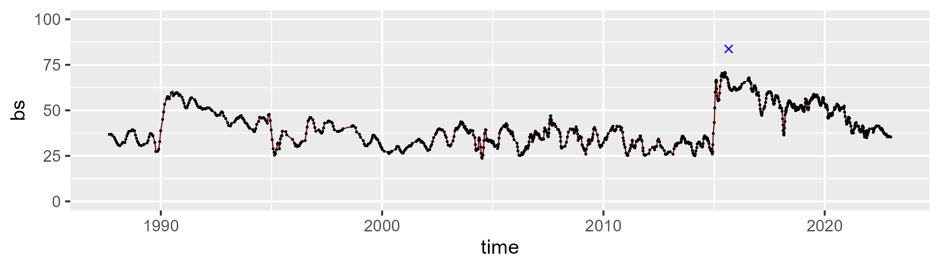

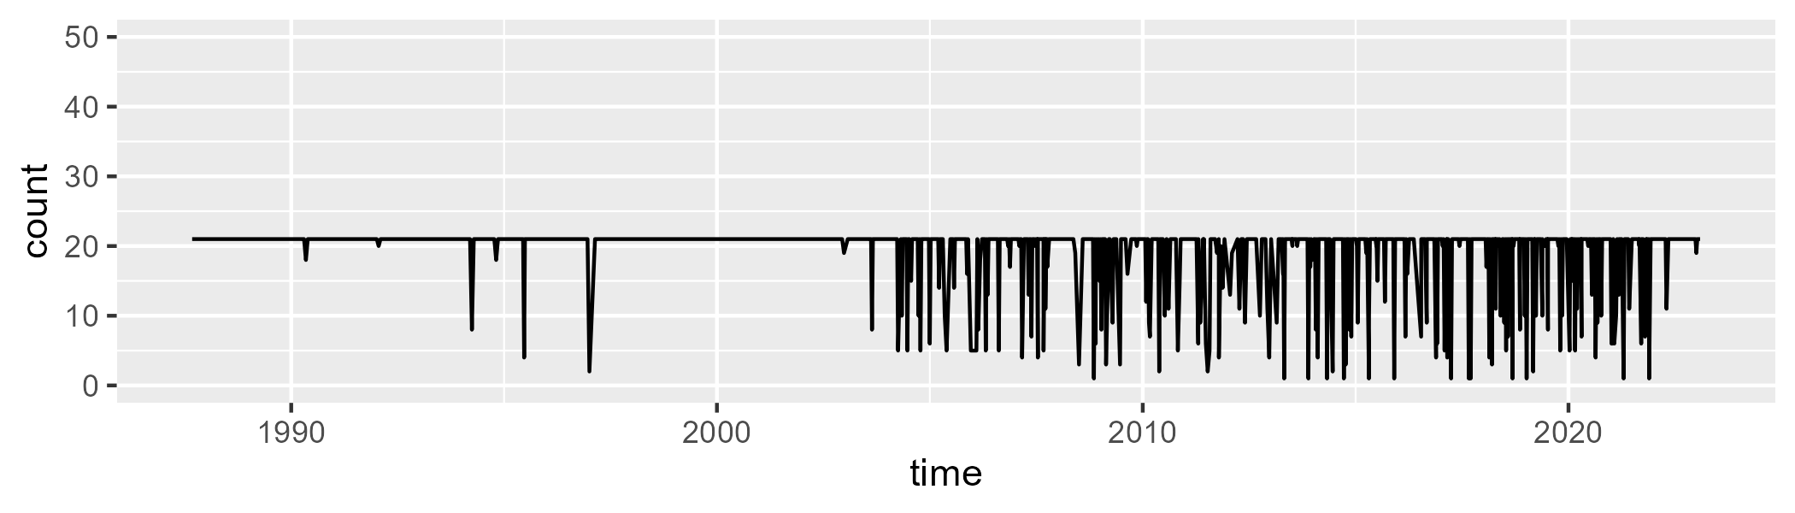

Min. : 1.00 1st Qu.:21.00 Median :21.00 Mean :19.17 3rd Qu.:21.00 Max. :21.00

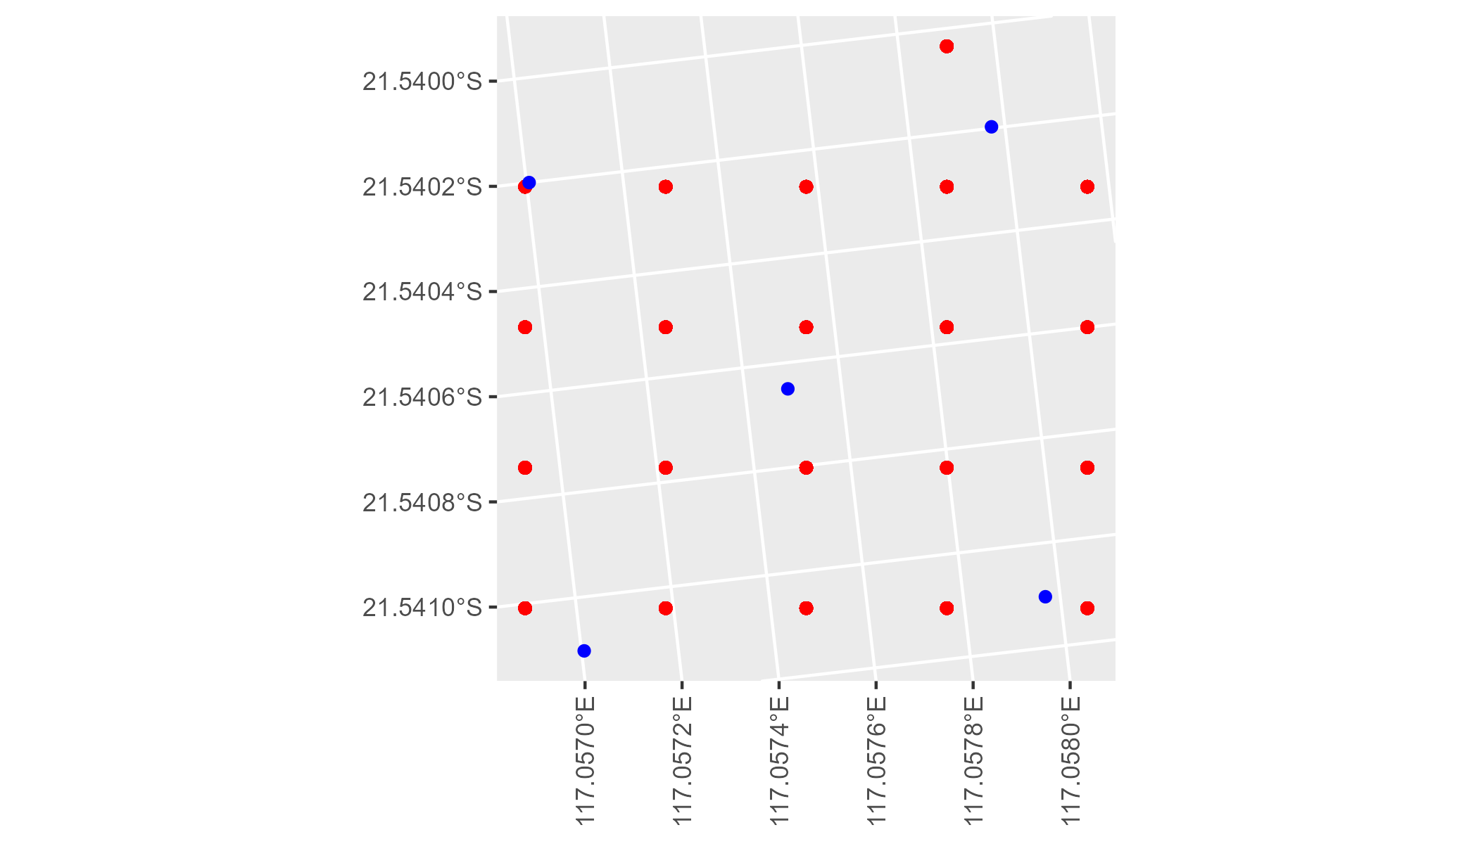

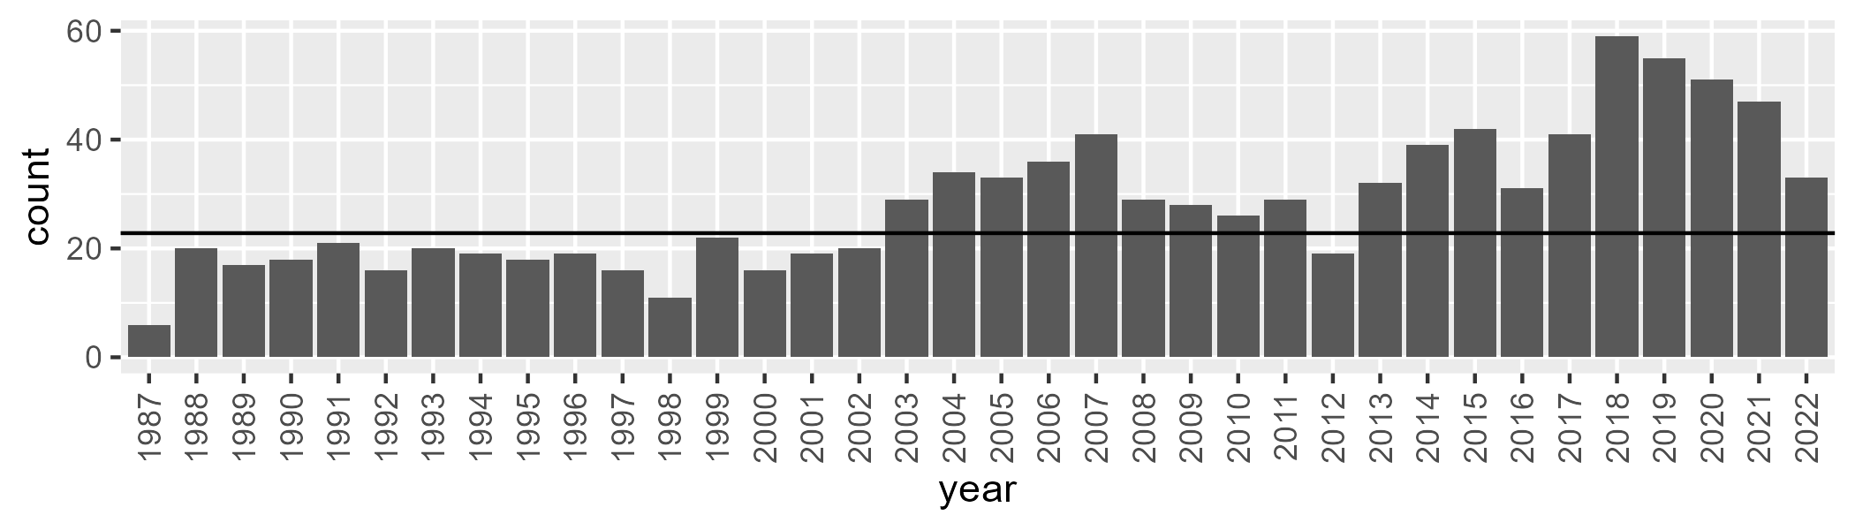

Number of samples: 1012

# WAAPIL0004

| Min. | 1st Qu. | Median | Mean | 3rd Qu. | Max. |
| --- | --- | --- | --- | --- | --- |
| 0 | 1.255499 | 4.259338 | 9.474093 | 12.871 | 64.58175 |

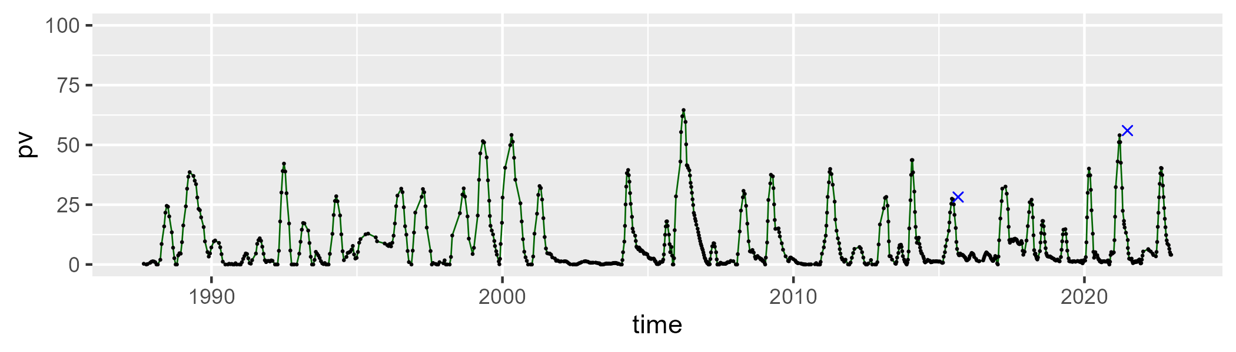

| Min. | 1st Qu. | Median | Mean | 3rd Qu. | Max. |
| --- | --- | --- | --- | --- | --- |
| 26.31029 | 47.18918 | 50.93013 | 51.62215 | 55.35468 | 77.10987 |

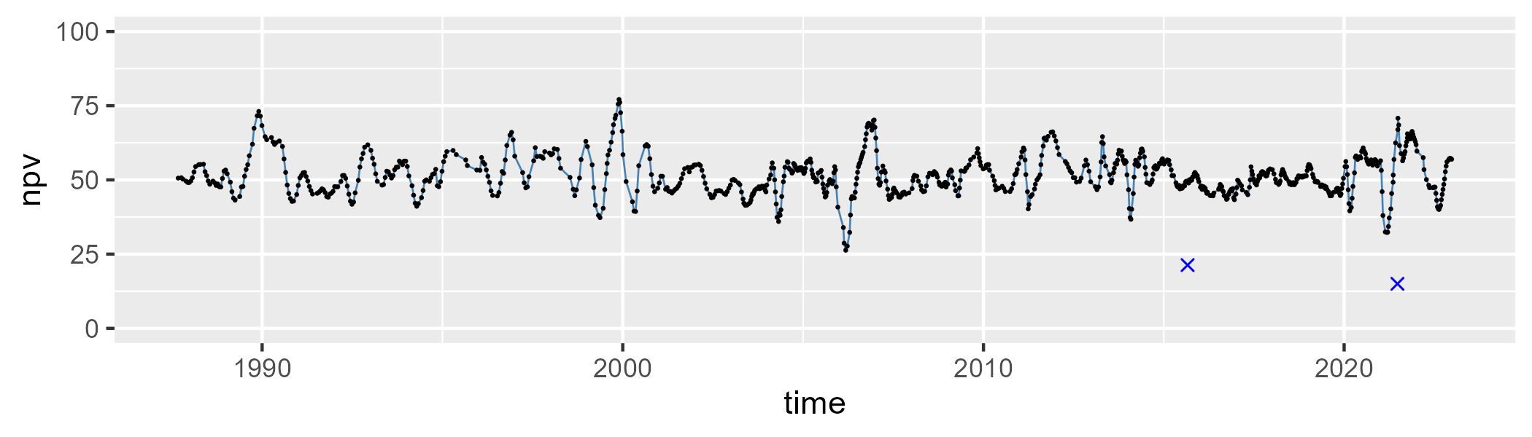

| Min. | 1st Qu. | Median | Mean | 3rd Qu. | Max. |
| --- | --- | --- | --- | --- | --- |
| 5.162596 | 30.70495 | 39.58717 | 37.67955 | 46.24348 | 57.86429 |

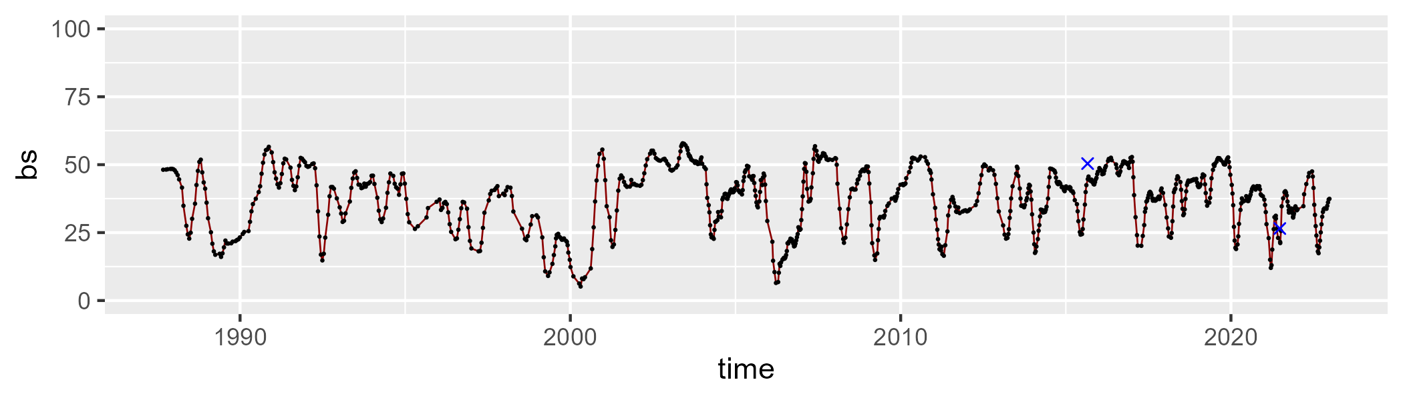

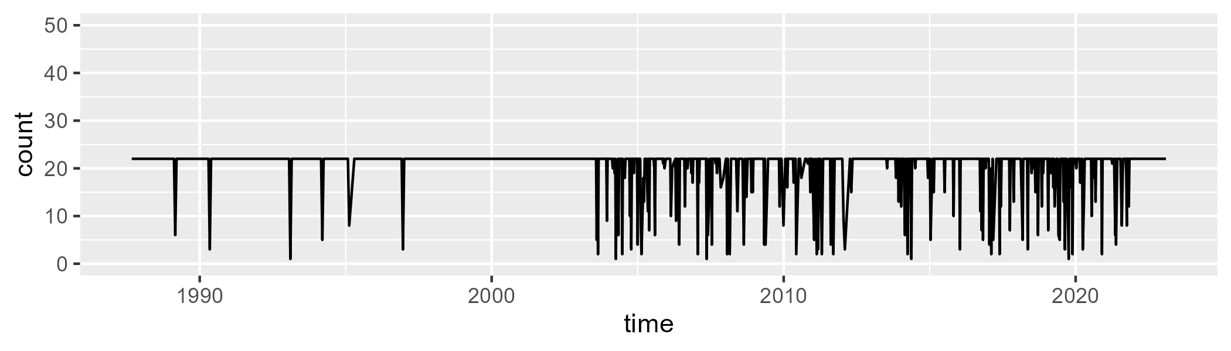

Min. : 1.00 1st Qu.:22.00 Median :22.00 Mean :20.28 3rd Qu.:22.00 Max. :22.00

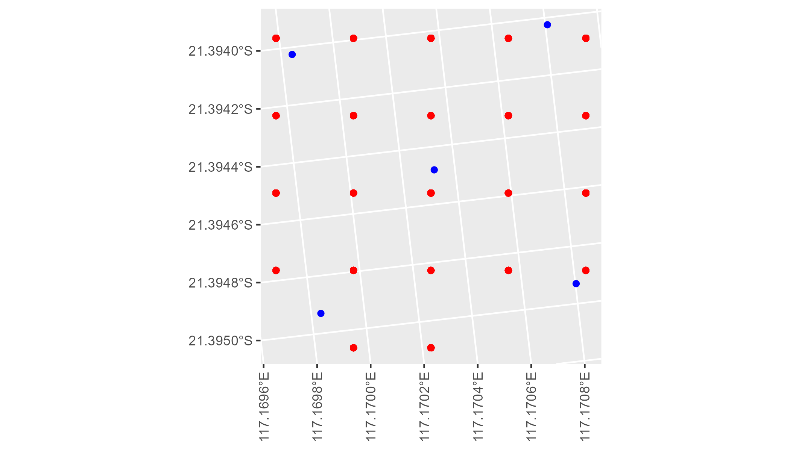

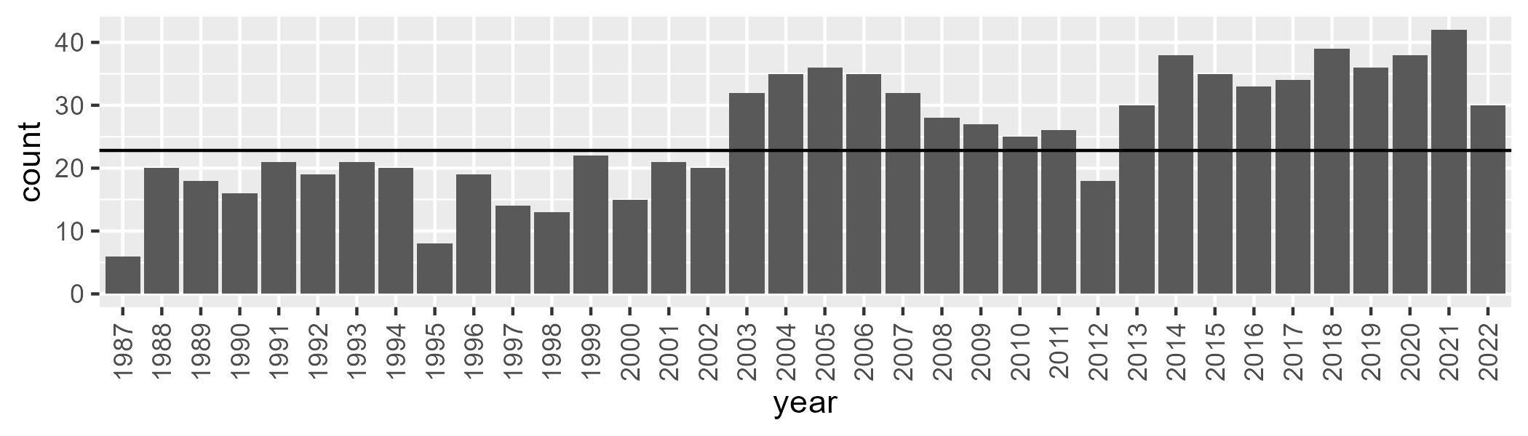

Number of samples: 922

# WAAPIL0005

| Min. | 1st Qu. | Median | Mean | 3rd Qu. | Max. |
| --- | --- | --- | --- | --- | --- |
| 18.53098 | 46.58147 | 51.08256 | 50.26271 | 54.22837 | 64.89053 |

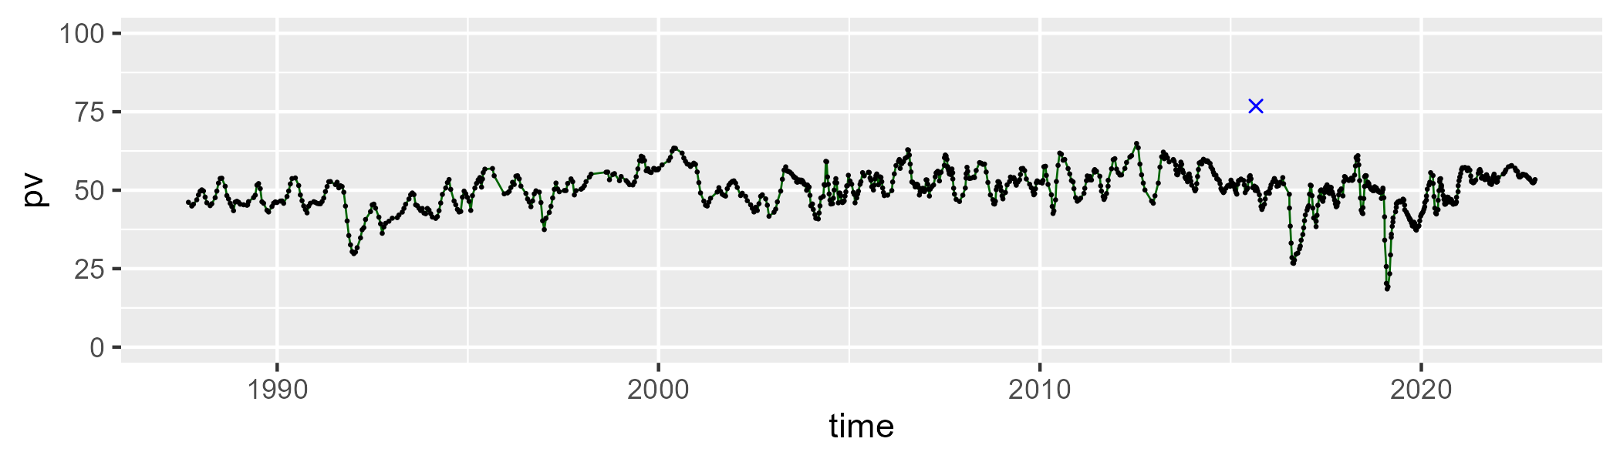

| Min. | 1st Qu. | Median | Mean | 3rd Qu. | Max. |
| --- | --- | --- | --- | --- | --- |
| 27.07013 | 33.58943 | 36.21342 | 36.43489 | 38.98058 | 49.69703 |

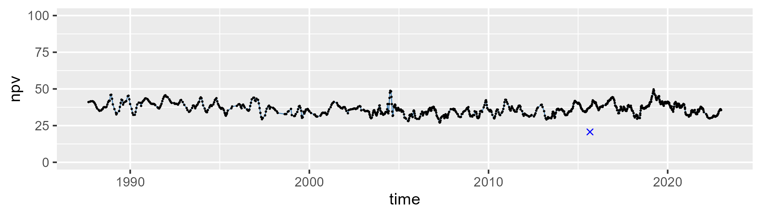

| Min. | 1st Qu. | Median | Mean | 3rd Qu. | Max. |
| --- | --- | --- | --- | --- | --- |
| 0.7261548 | 8.676716 | 11.10728 | 11.80865 | 14.04937 | 35.99927 |

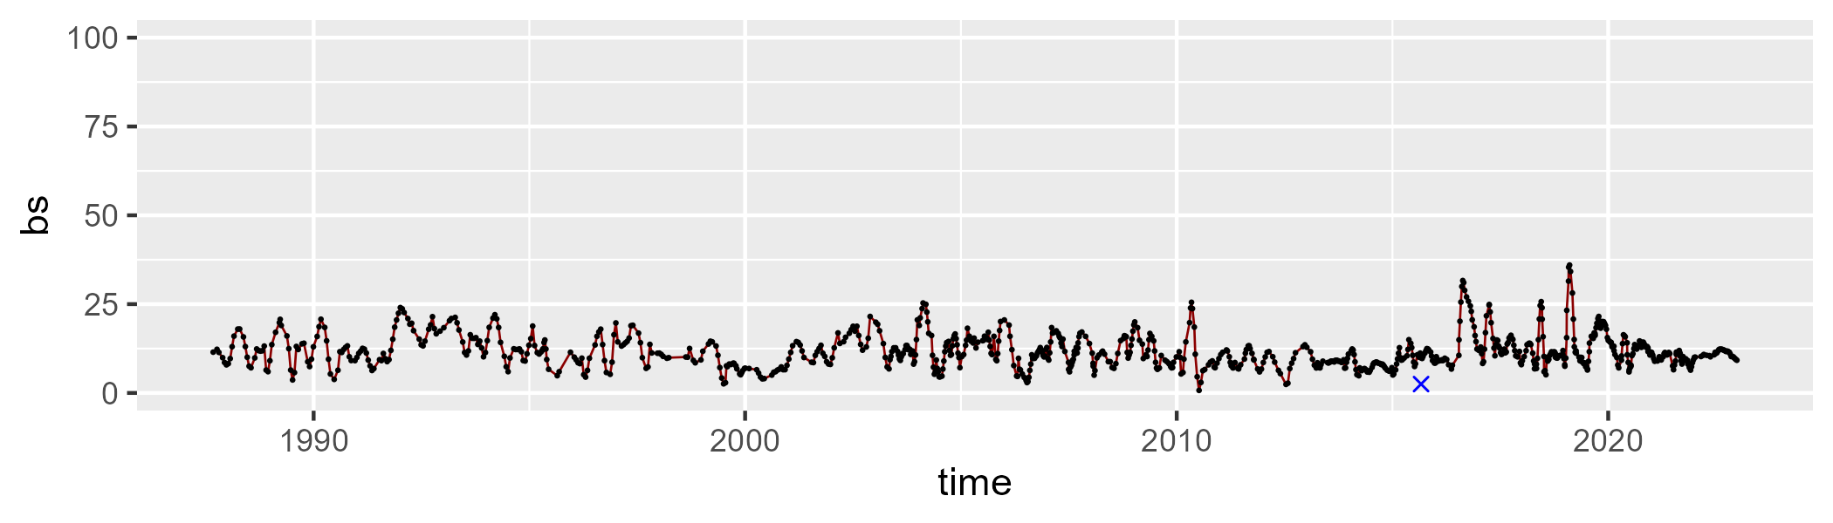

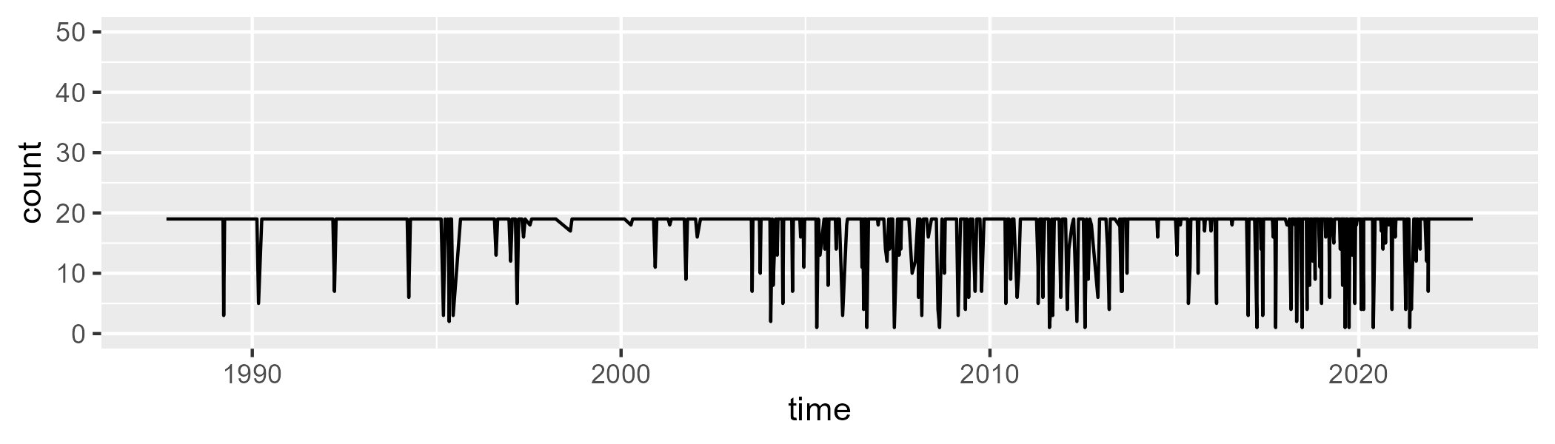

Min. : 1.00 1st Qu.:19.00 Median :19.00 Mean :17.53 3rd Qu.:19.00 Max. :19.00

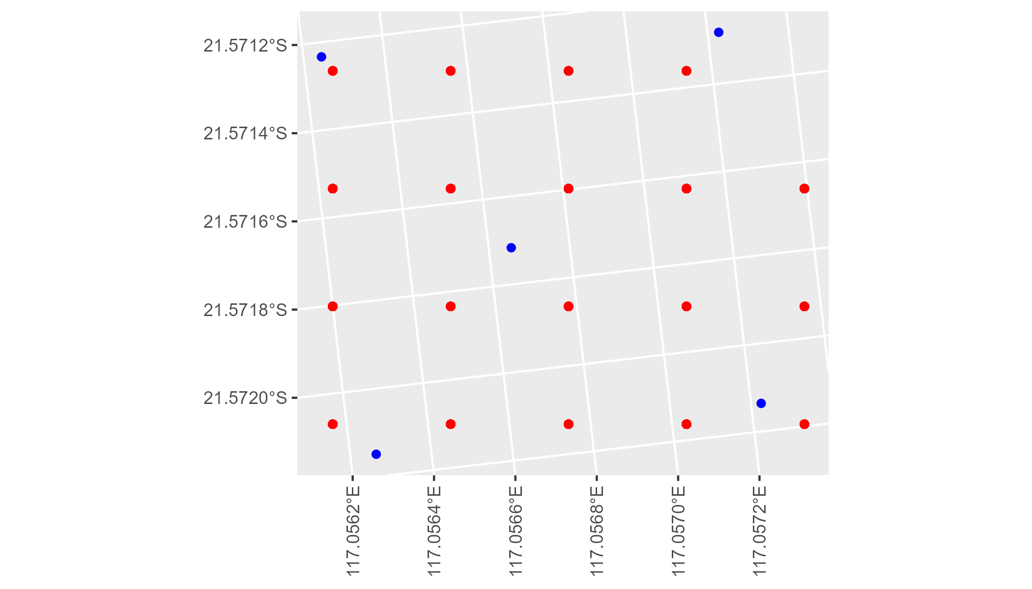

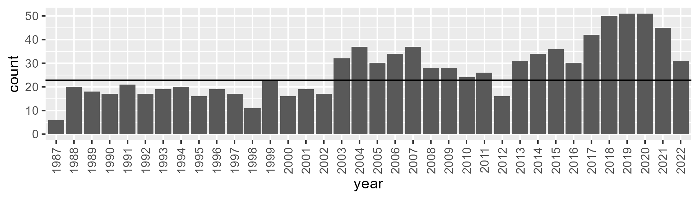

Number of samples: 969

# WAAPIL0006

| Min. | 1st Qu. | Median | Mean | 3rd Qu. | Max. |
| --- | --- | --- | --- | --- | --- |
| 0.7557453 | 6.387034 | 9.25835 | 9.38069 | 11.88223 | 21.86525 |

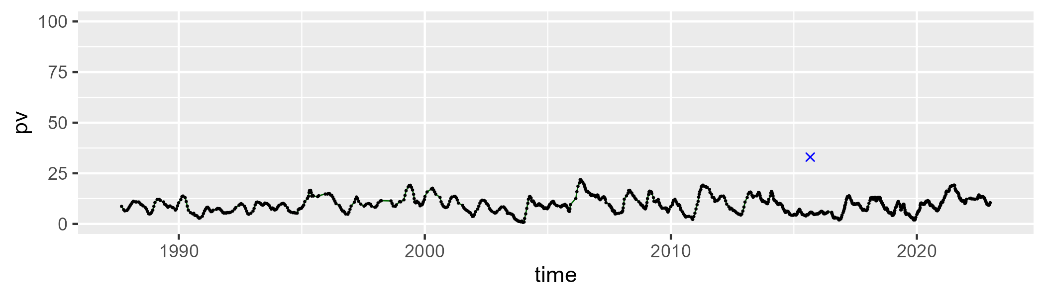

| Min. | 1st Qu. | Median | Mean | 3rd Qu. | Max. |
| --- | --- | --- | --- | --- | --- |
| 35.4557 | 45.82665 | 49.01381 | 49.37409 | 52.31639 | 65.70965 |

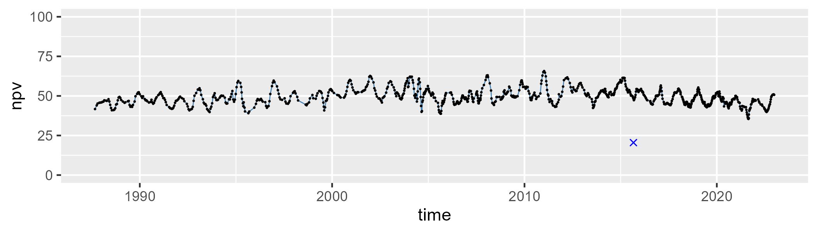

| Min. | 1st Qu. | Median | Mean | 3rd Qu. | Max. |
| --- | --- | --- | --- | --- | --- |
| 23.95167 | 36.64598 | 40.05565 | 39.81545 | 43.66977 | 50.99686 |

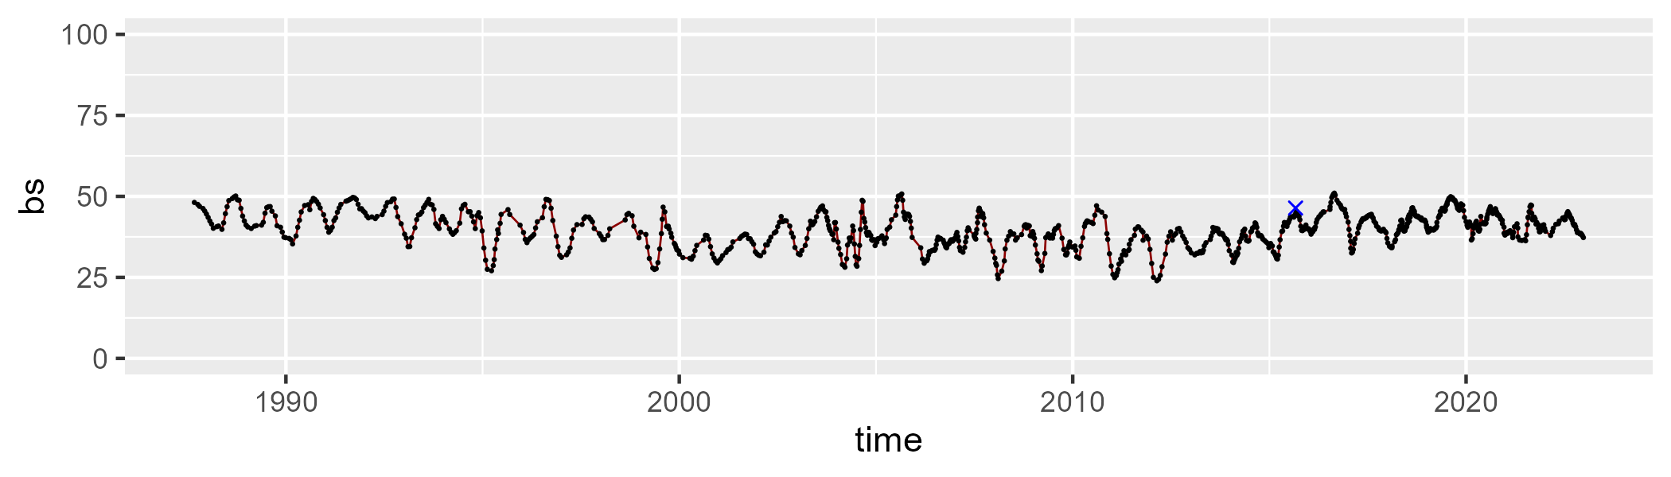

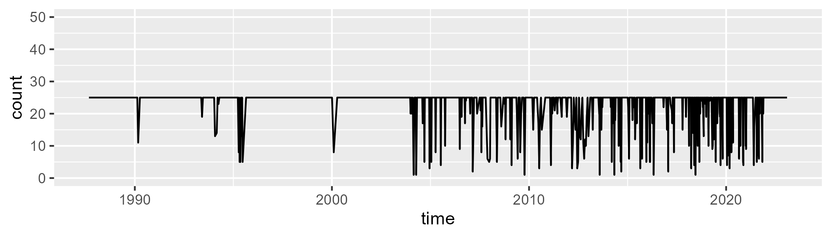

Min. : 1.00 1st Qu.:25.00 Median :25.00 Mean :22.85 3rd Qu.:25.00 Max. :25.00

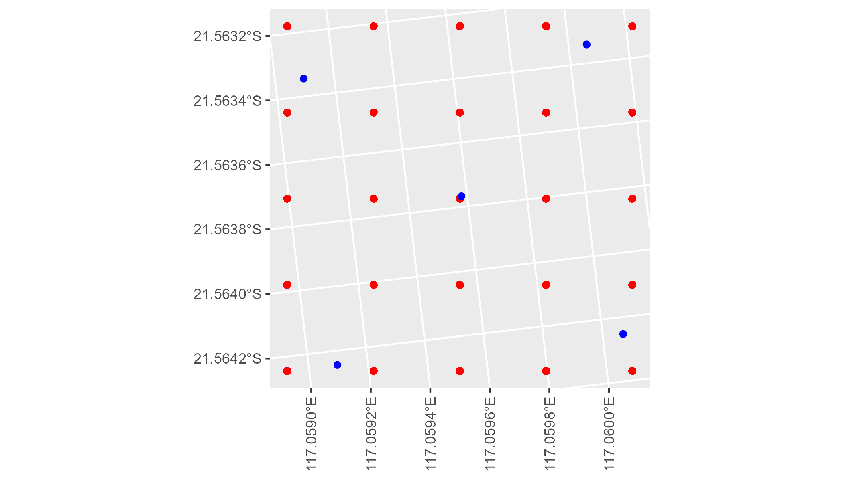

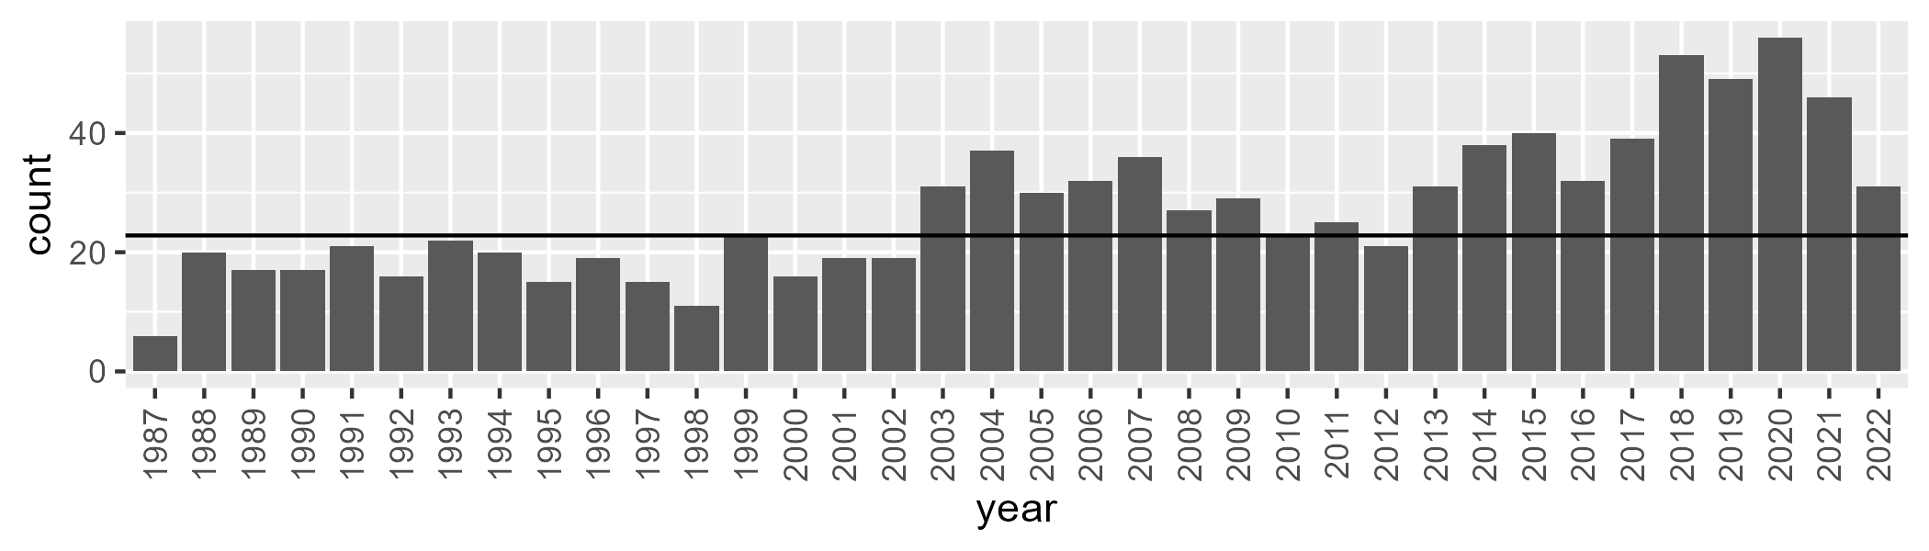

Number of samples: 982

# WAAPIL0007

| Min. | 1st Qu. | Median | Mean | 3rd Qu. | Max. |
| --- | --- | --- | --- | --- | --- |
| 0 | 9.917924 | 17.18074 | 17.22808 | 23.73777 | 38.80423 |

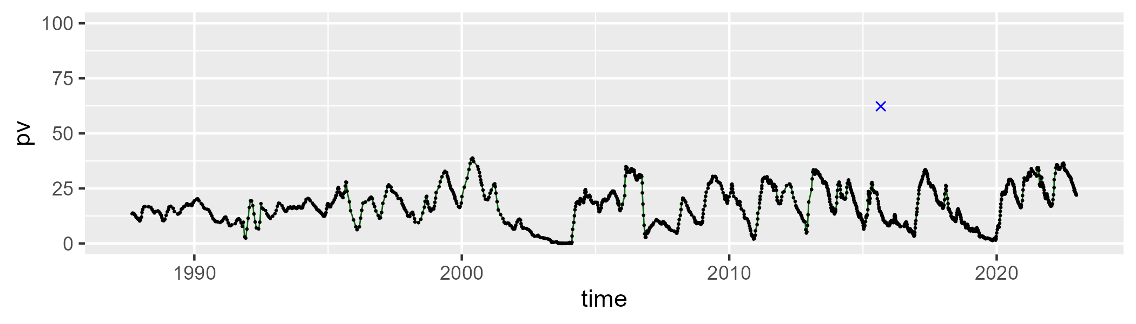

| Min. | 1st Qu. | Median | Mean | 3rd Qu. | Max. |
| --- | --- | --- | --- | --- | --- |
| 11.06591 | 34.38335 | 41.18497 | 39.65504 | 45.6195 | 57.52409 |

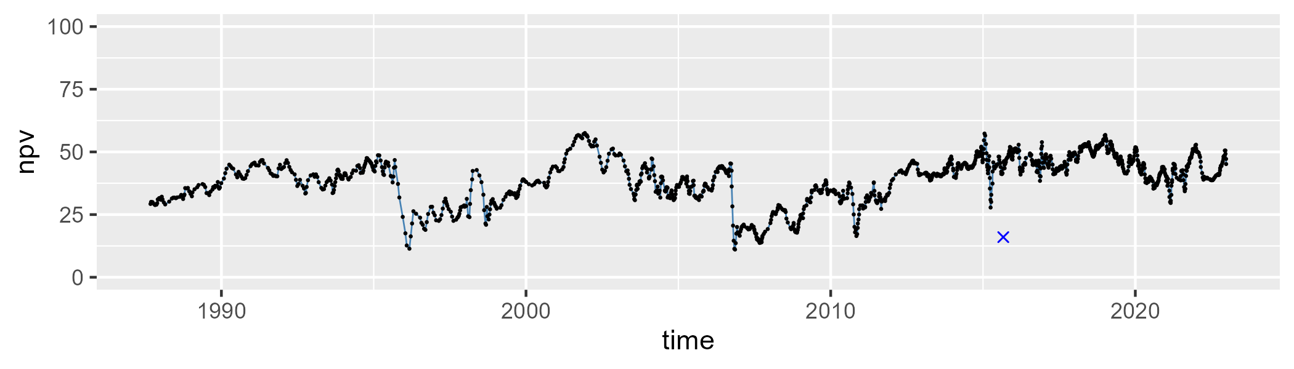

| Min. | 1st Qu. | Median | Mean | 3rd Qu. | Max. |
| --- | --- | --- | --- | --- | --- |
| 20.09393 | 32.7464 | 39.82473 | 41.56243 | 47.68099 | 84.19811 |

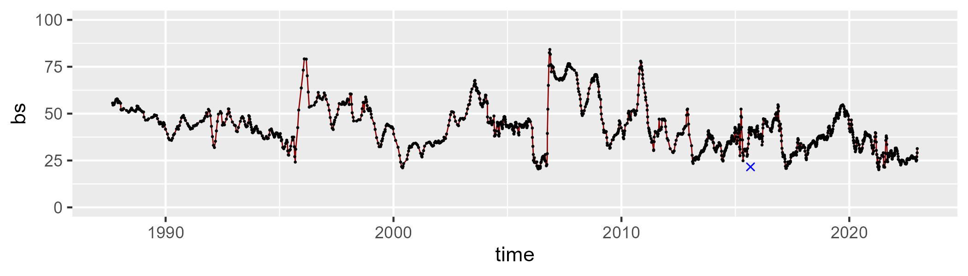

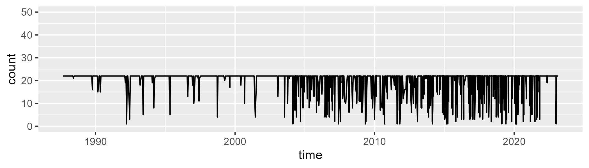

Min. : 1.00 1st Qu.:22.00 Median :22.00 Mean :19.75 3rd Qu.:22.00 Max. :22.00

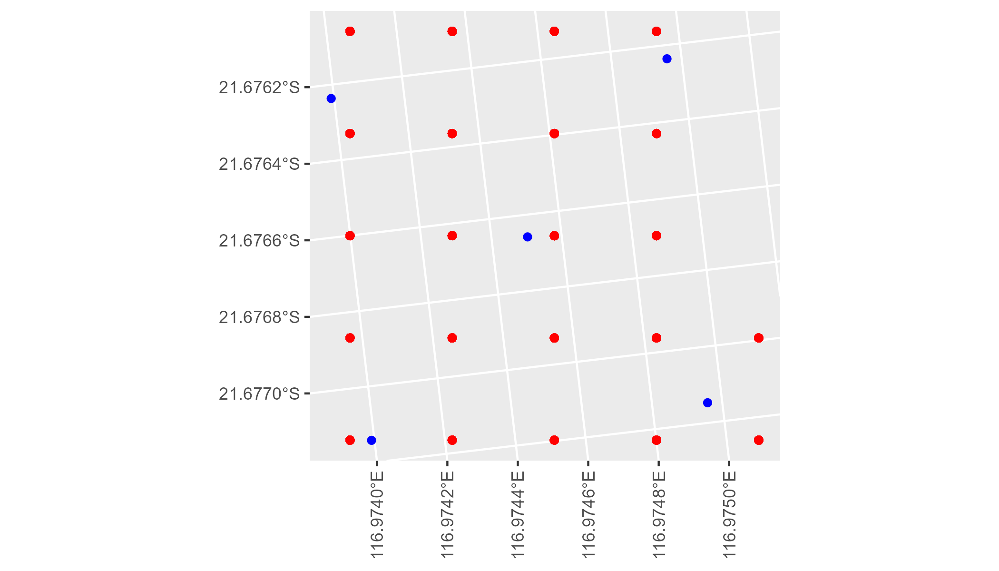

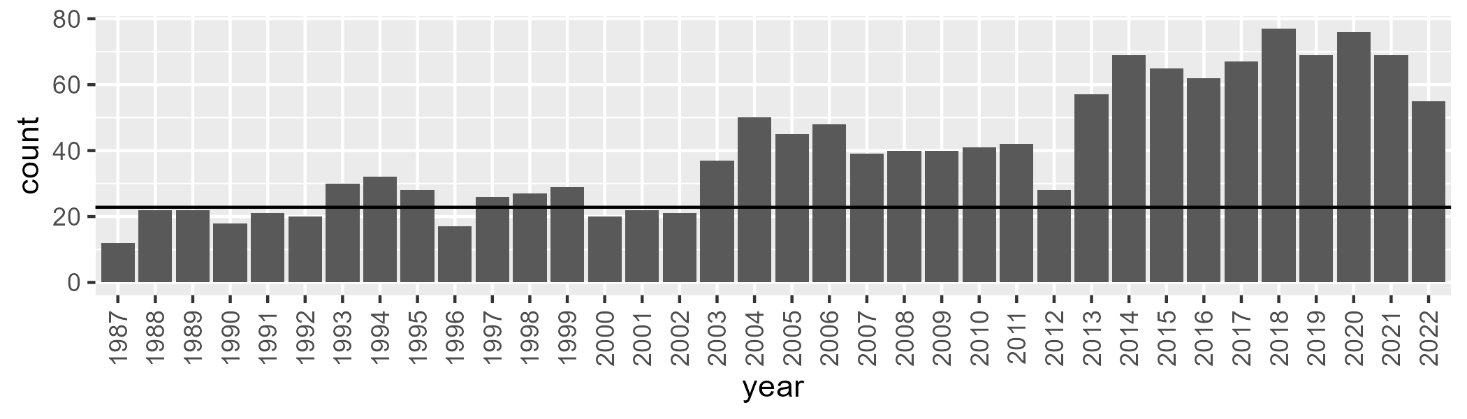

Number of samples: 1443

# WAAPIL0008

| Min. | 1st Qu. | Median | Mean | 3rd Qu. | Max. |
| --- | --- | --- | --- | --- | --- |
| 0 | 1.475782 | 3.856839 | 8.397235 | 12.8636 | 55.94185 |

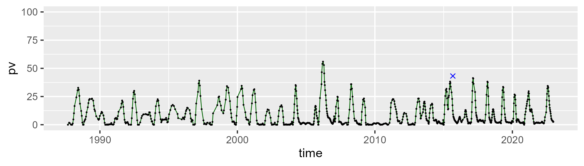

| Min. | 1st Qu. | Median | Mean | 3rd Qu. | Max. |
| --- | --- | --- | --- | --- | --- |
| 35.35051 | 46.14748 | 48.7672 | 50.15934 | 52.86189 | 77.80063 |

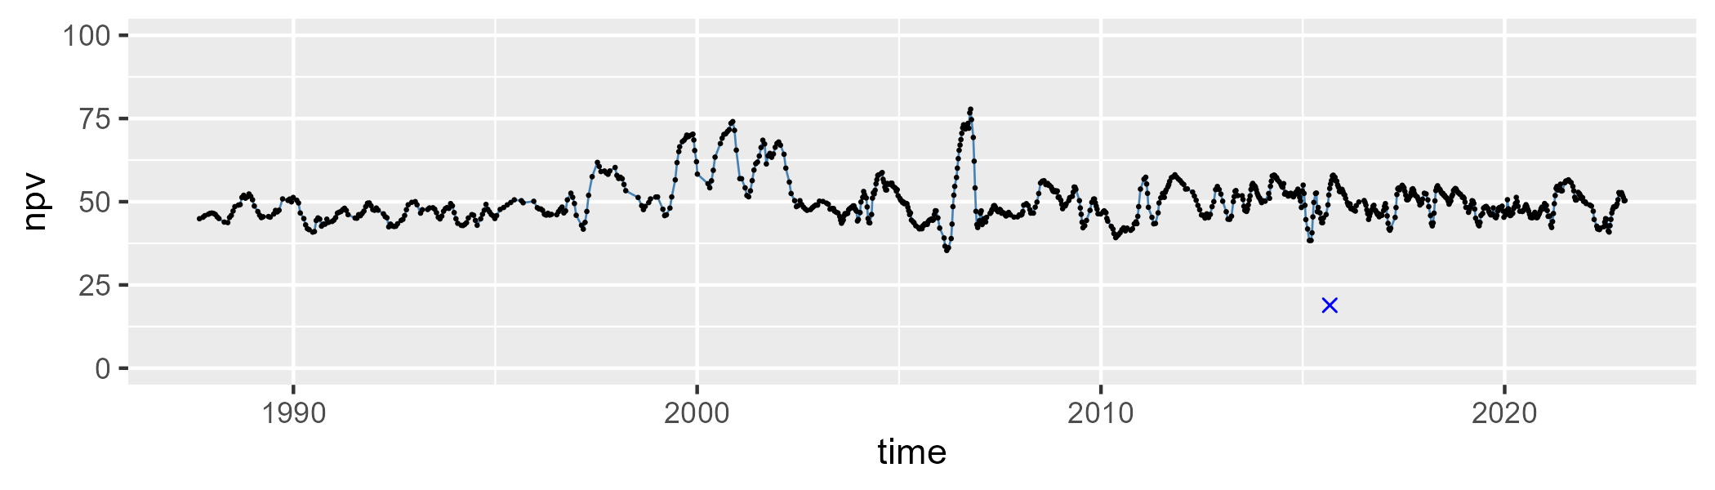

| Min. | 1st Qu. | Median | Mean | 3rd Qu. | Max. |
| --- | --- | --- | --- | --- | --- |
| 6.46839 | 33.34066 | 42.26419 | 40.19658 | 48.21791 | 59.53308 |

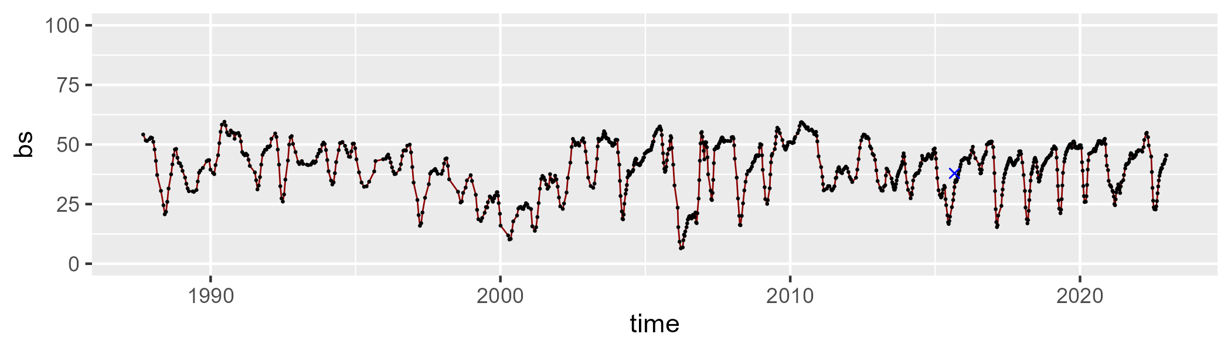

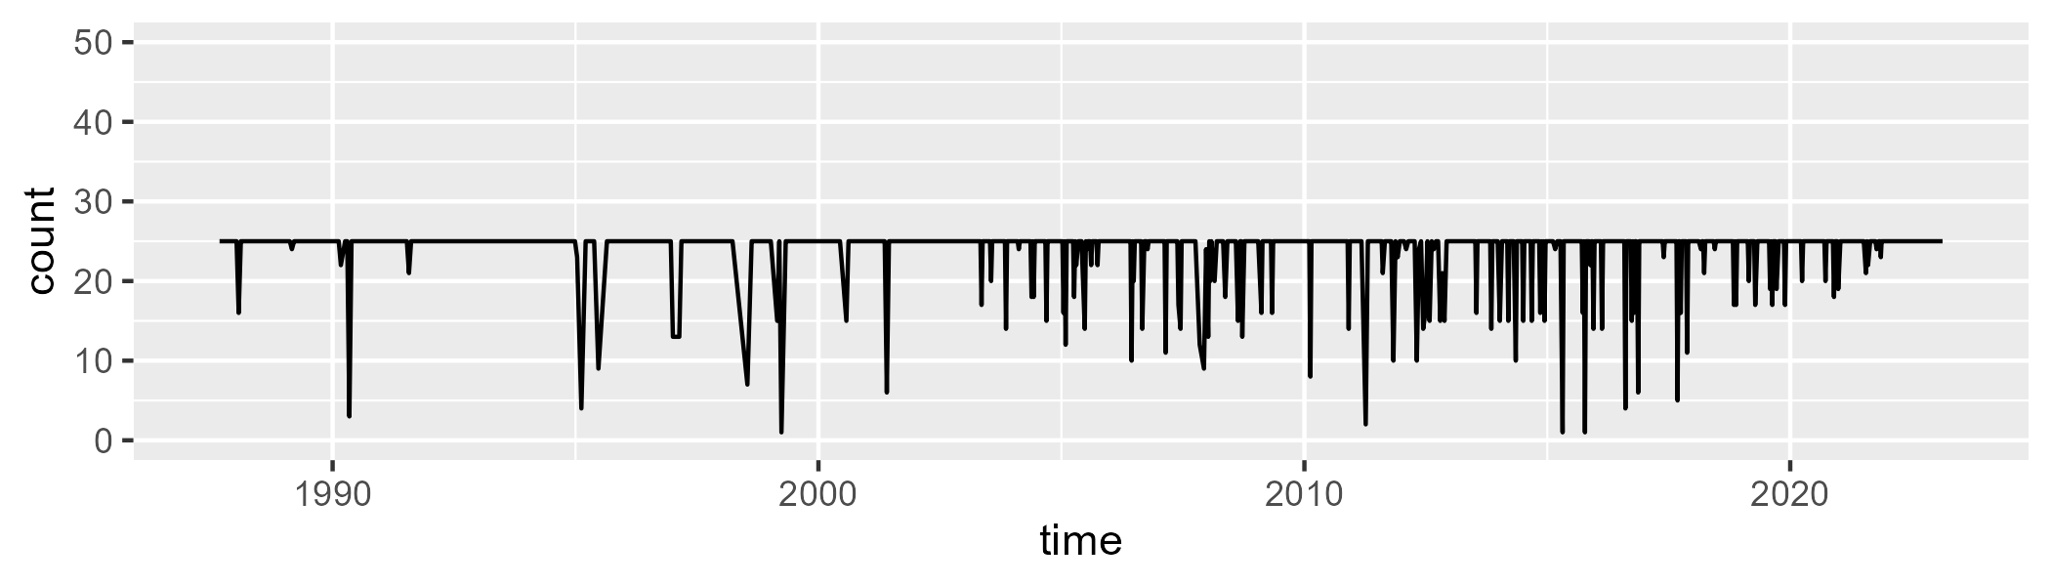

Min. : 1.00 1st Qu.:25.00 Median :25.00 Mean :23.97 3rd Qu.:25.00 Max. :25.00

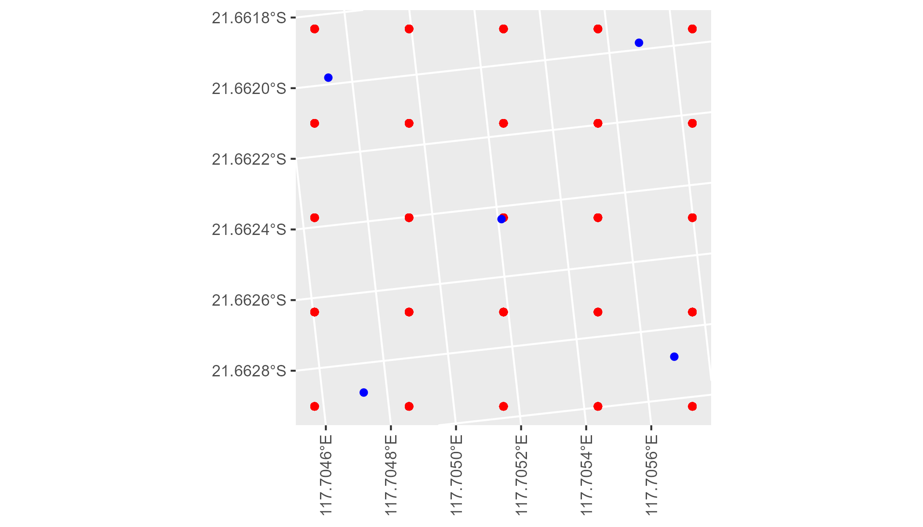

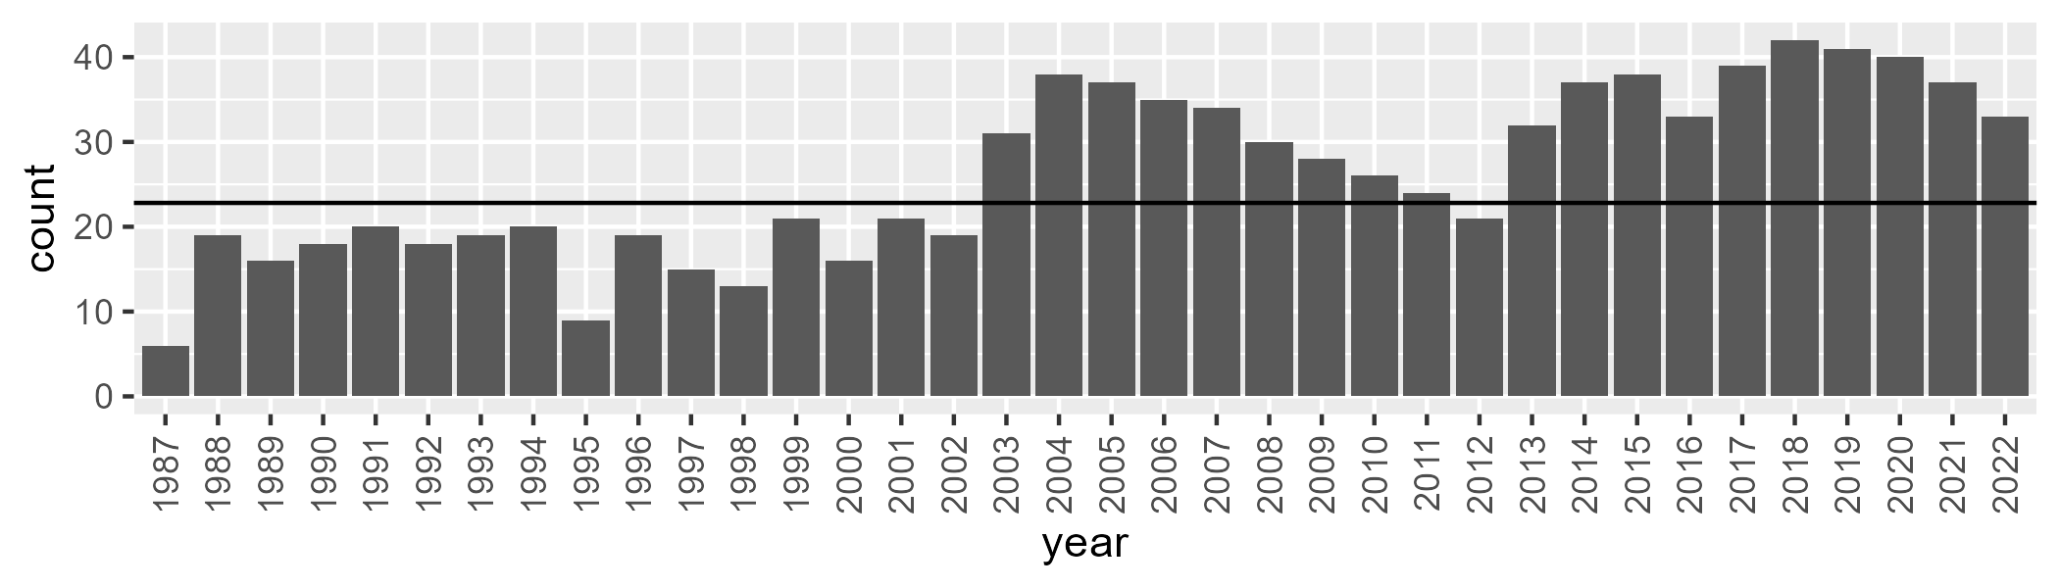

Number of samples: 945

# WAAPIL0009

| Min. | 1st Qu. | Median | Mean | 3rd Qu. | Max. |
| --- | --- | --- | --- | --- | --- |
| 2.961156 | 12.46405 | 16.35113 | 19.62324 | 24.97207 | 59.98523 |

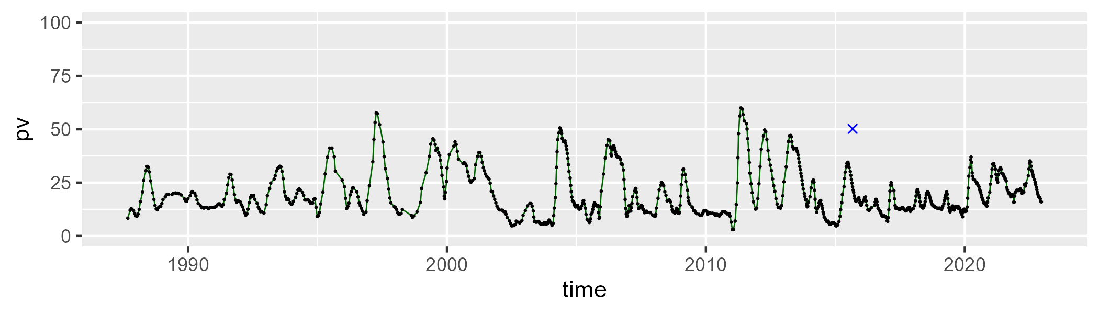

| Min. | 1st Qu. | Median | Mean | 3rd Qu. | Max. |
| --- | --- | --- | --- | --- | --- |
| 22.86579 | 35.02741 | 40.60015 | 40.9619 | 46.28348 | 64.60494 |

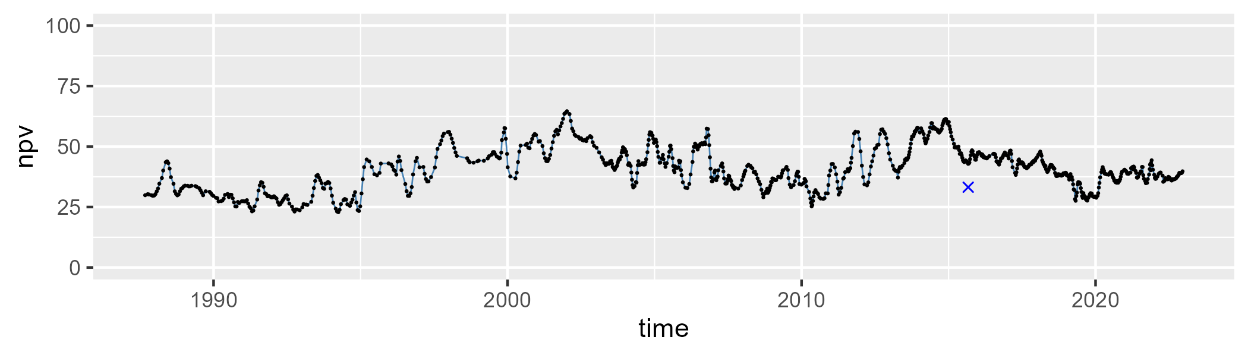

| Min. | 1st Qu. | Median | Mean | 3rd Qu. | Max. |
| --- | --- | --- | --- | --- | --- |
| 2.640895 | 28.74206 | 39.68975 | 37.91525 | 48.57859 | 63.9842 |

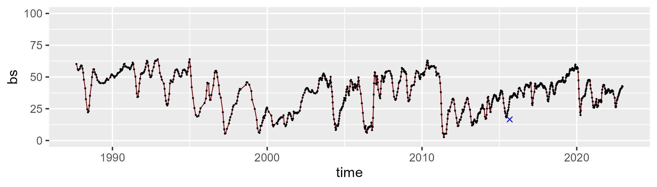

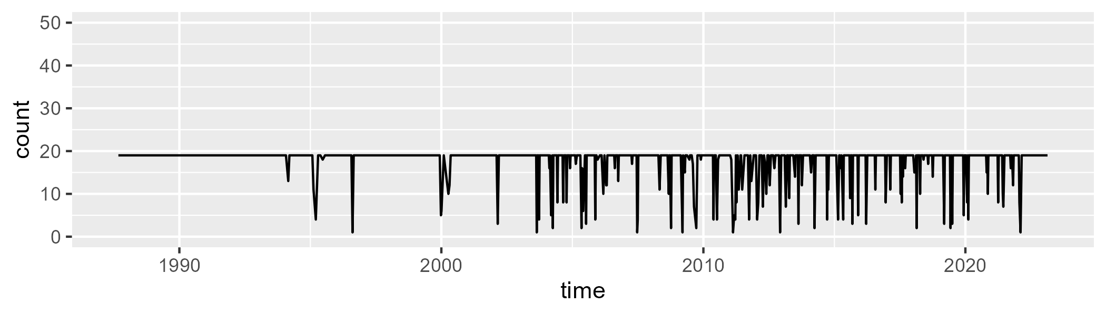

Min. : 1.00 1st Qu.:19.00 Median :19.00 Mean :17.84 3rd Qu.:19.00 Max. :19.00

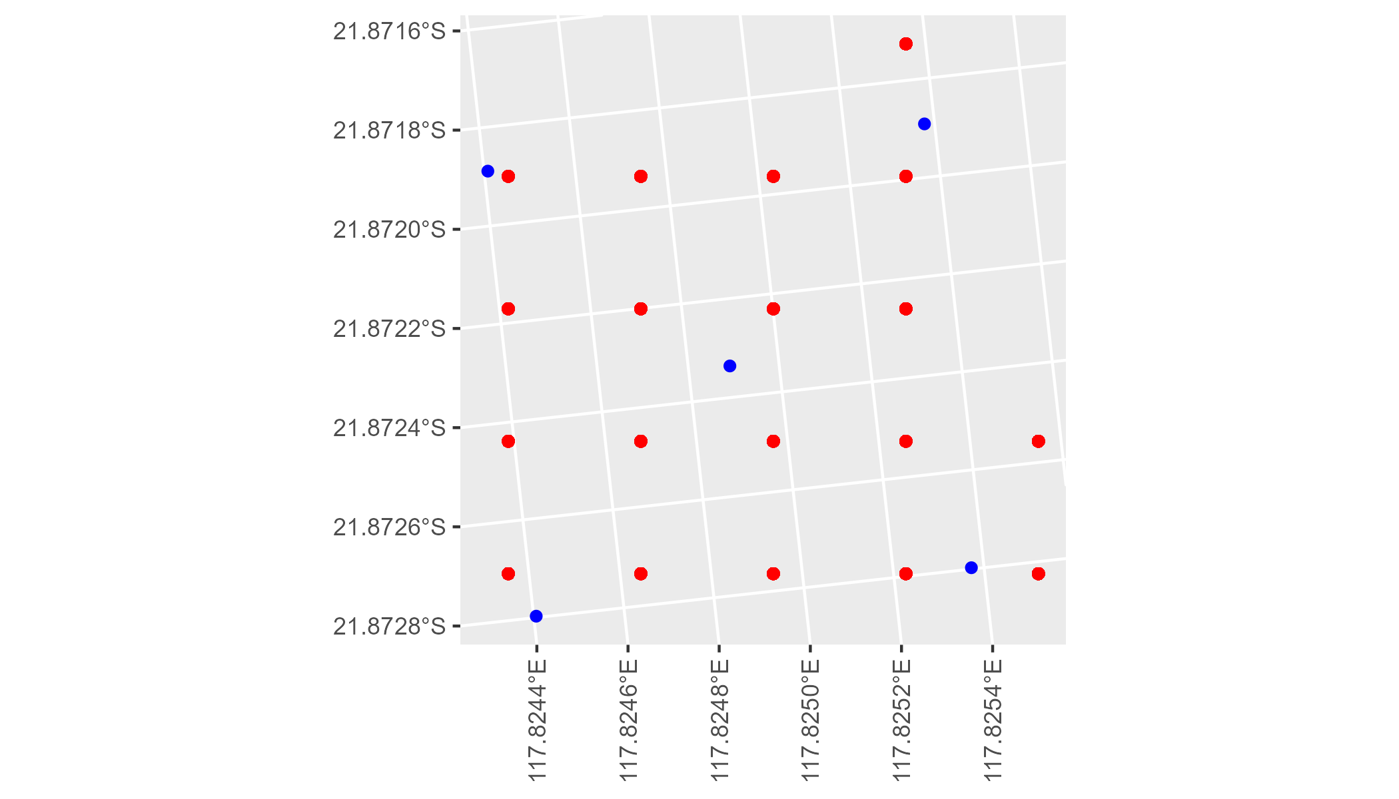

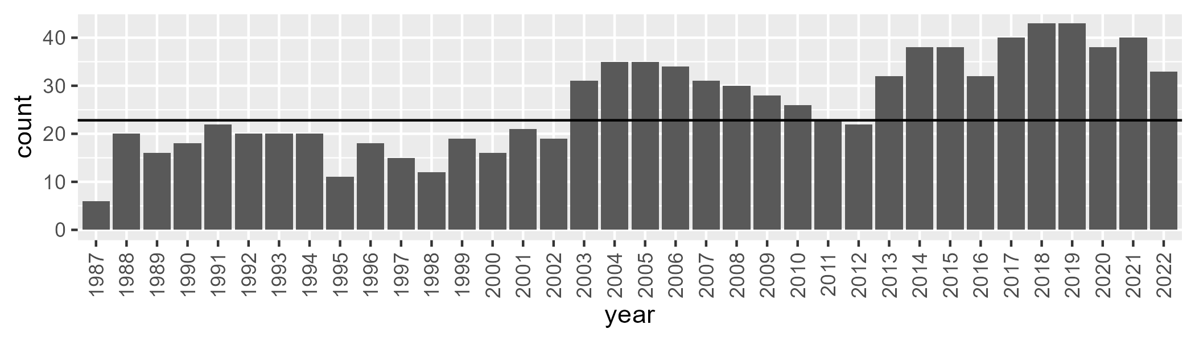

Number of samples: 945

# WAAPIL0010

| Min. | 1st Qu. | Median | Mean | 3rd Qu. | Max. |
| --- | --- | --- | --- | --- | --- |
| 0 | 9.117508 | 12.61446 | 13.01149 | 16.26268 | 29.83187 |

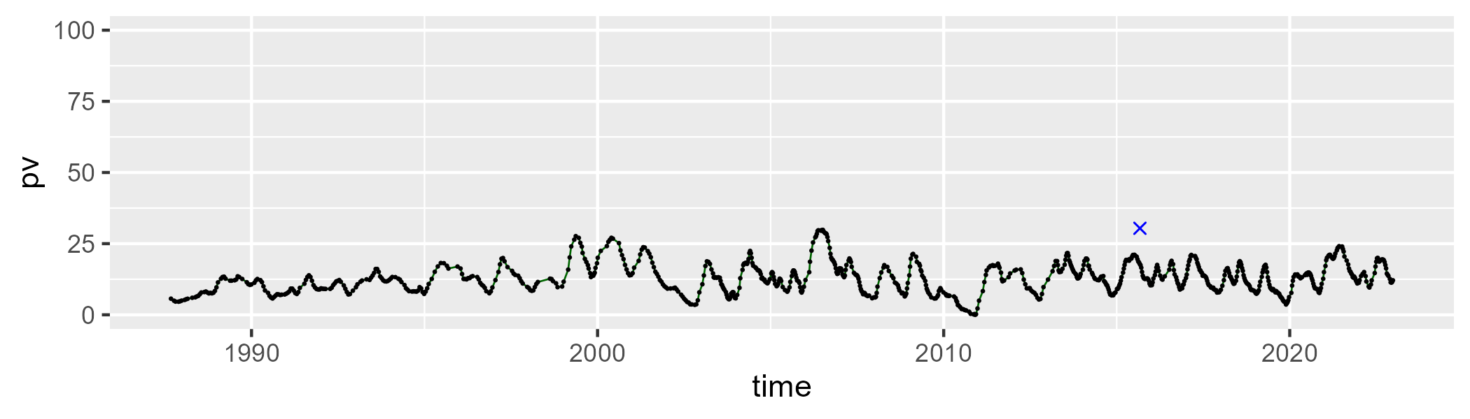

| Min. | 1st Qu. | Median | Mean | 3rd Qu. | Max. |
| --- | --- | --- | --- | --- | --- |
| 20.6433 | 33.82195 | 36.94963 | 36.23946 | 39.89643 | 51.64532 |

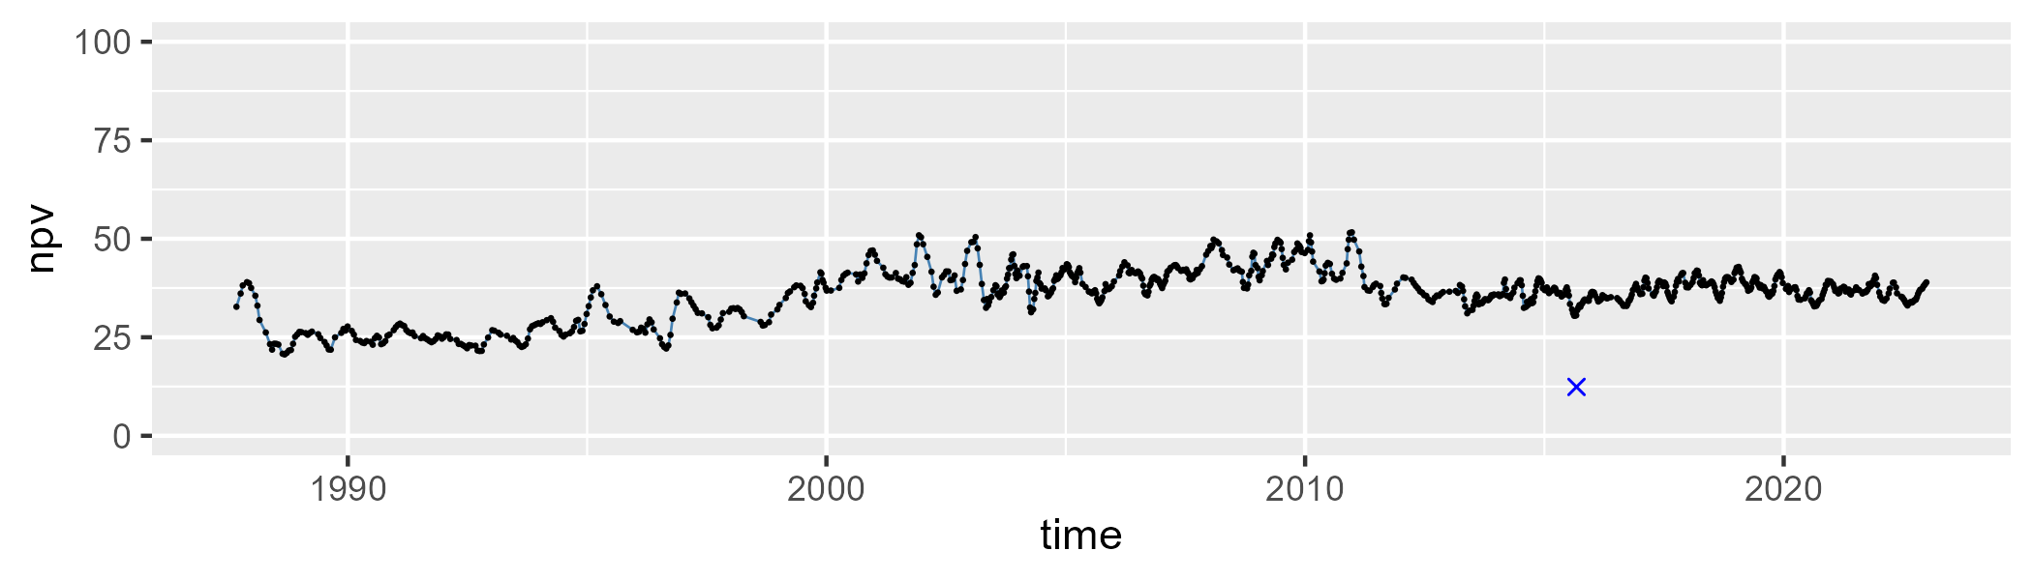

| Min. | 1st Qu. | Median | Mean | 3rd Qu. | Max. |
| --- | --- | --- | --- | --- | --- |
| 26.64309 | 43.97892 | 48.50952 | 49.06894 | 53.46242 | 69.8611 |

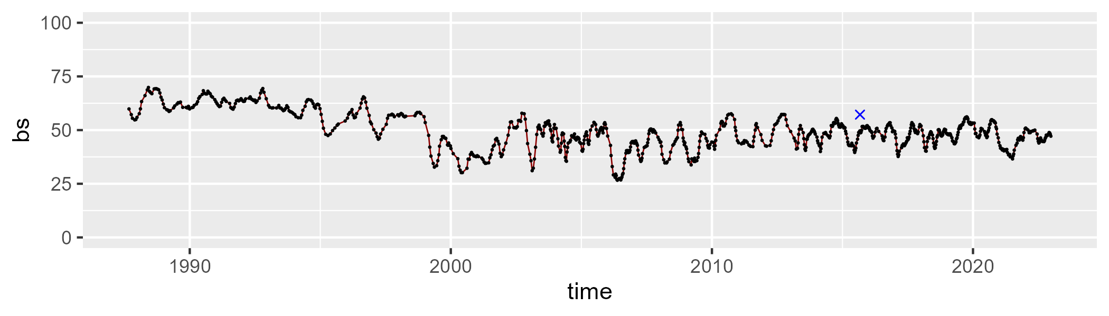

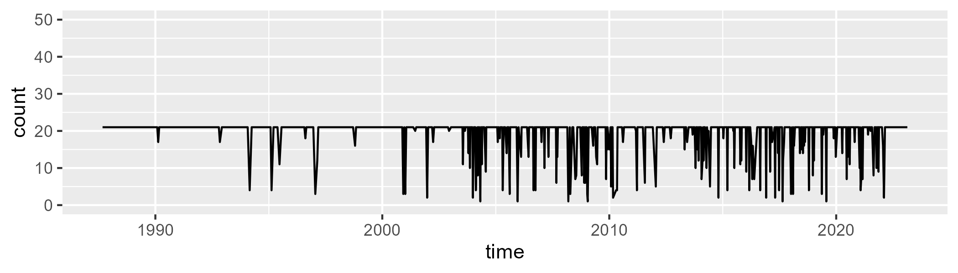

Min. : 1.00 1st Qu.:21.00 Median :21.00 Mean :19.45 3rd Qu.:21.00 Max. :21.00

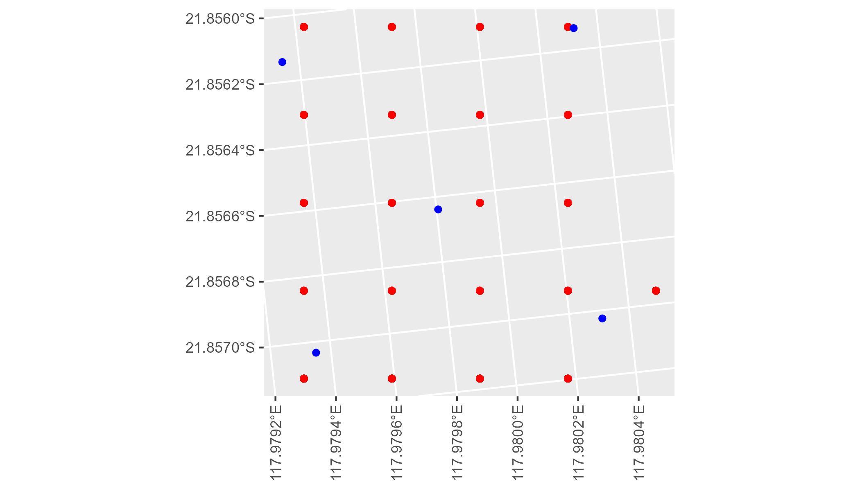

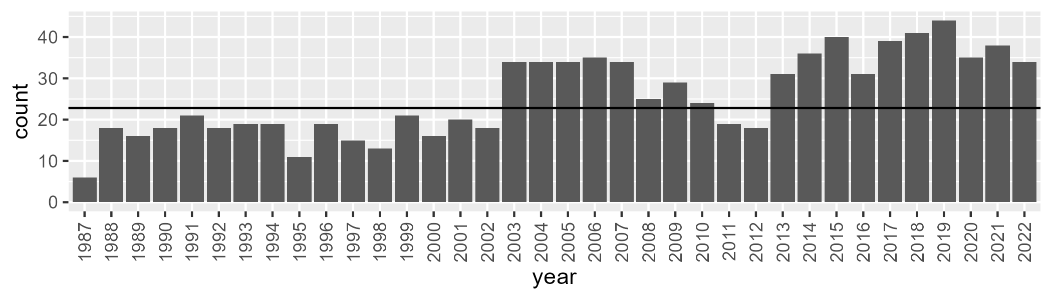

Number of samples: 923

# WAAPIL0011

| Min. | 1st Qu. | Median | Mean | 3rd Qu. | Max. |
| --- | --- | --- | --- | --- | --- |
| 2.60891 | 6.797886 | 8.744048 | 9.537101 | 11.34596 | 28.65804 |

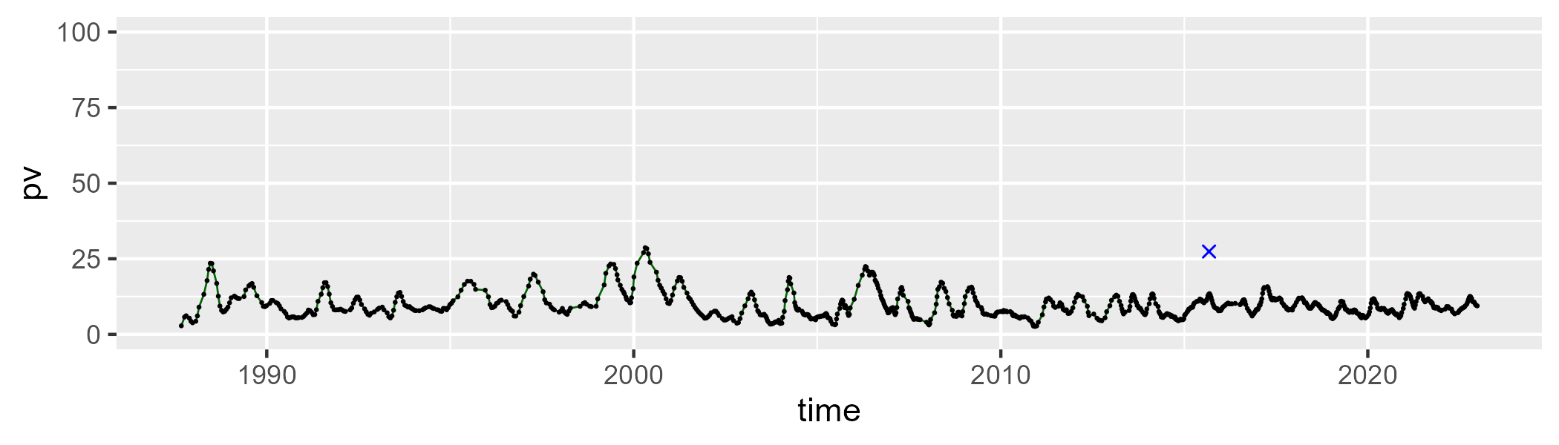

| Min. | 1st Qu. | Median | Mean | 3rd Qu. | Max. |
| --- | --- | --- | --- | --- | --- |
| 33.95247 | 41.29595 | 42.65977 | 42.78797 | 44.47878 | 54.93151 |

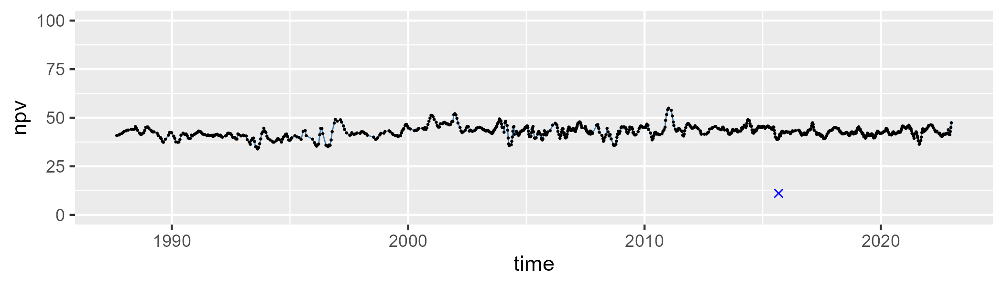

| Min. | 1st Qu. | Median | Mean | 3rd Qu. | Max. |
| --- | --- | --- | --- | --- | --- |
| 26.34136 | 43.97233 | 47.01505 | 46.16734 | 49.2422 | 56.71082 |

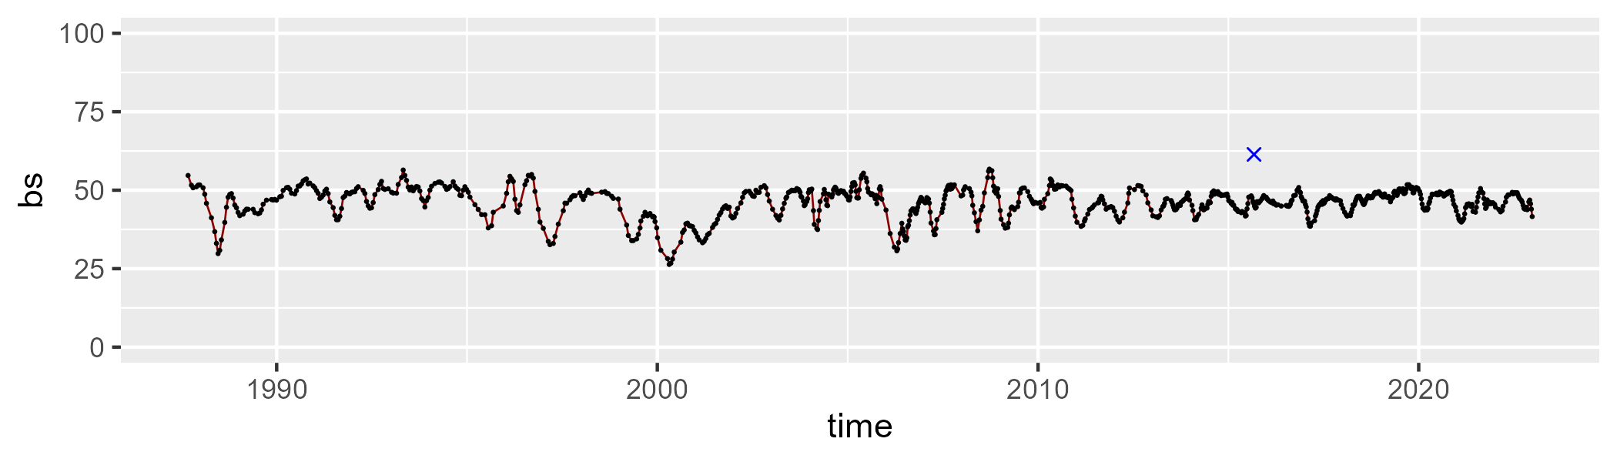

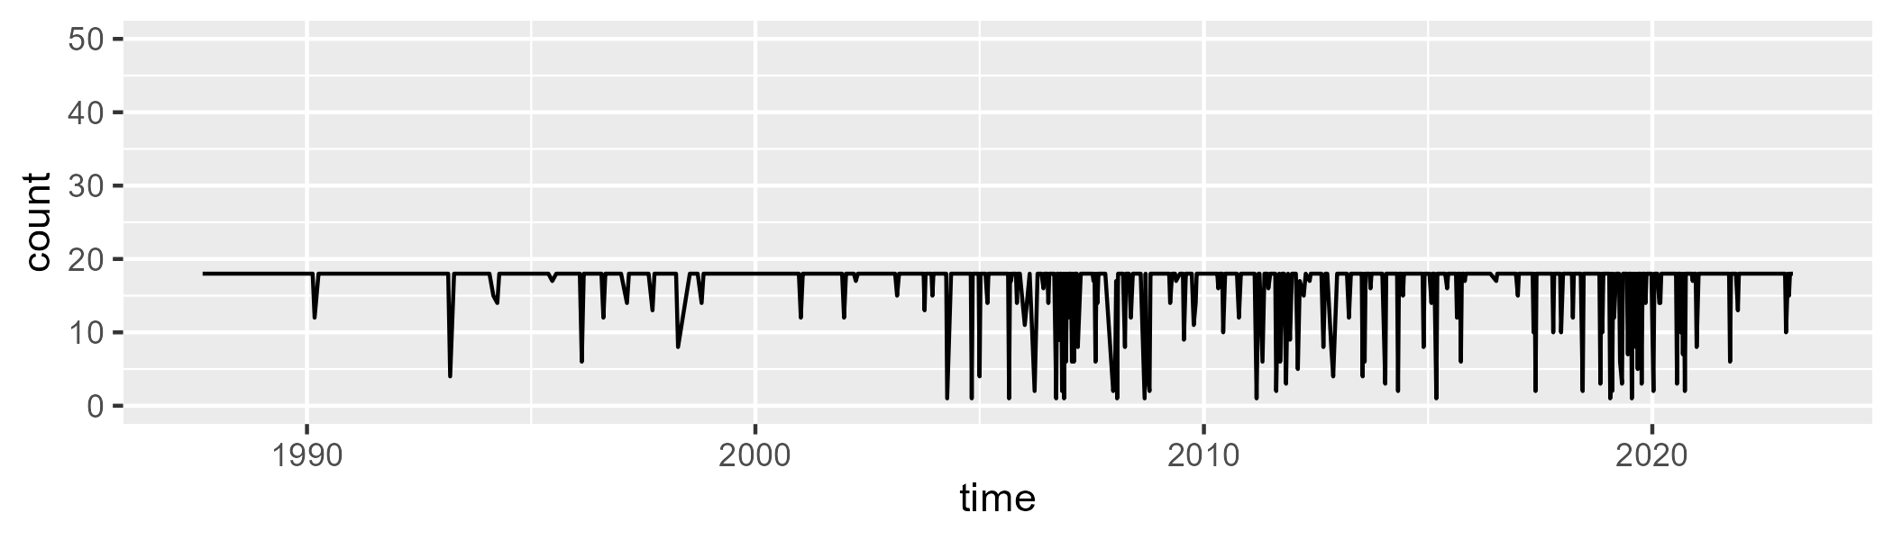

Min. : 1.00 1st Qu.:18.00 Median :18.00 Mean :16.83 3rd Qu.:18.00 Max. :18.00

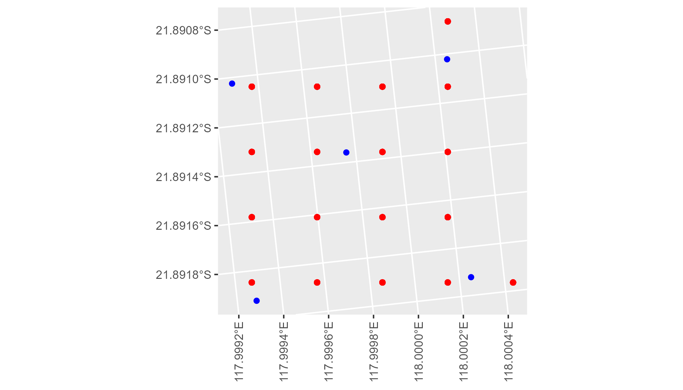

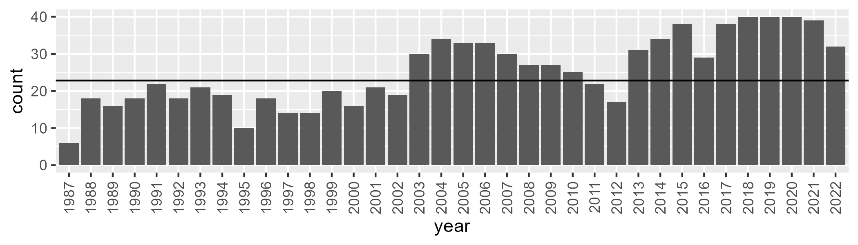

Number of samples: 909

# WAAPIL0012

| Min. | 1st Qu. | Median | Mean | 3rd Qu. | Max. |
| --- | --- | --- | --- | --- | --- |
| 0 | 8.553286 | 13.02129 | 13.4818 | 18.70714 | 38.82122 |

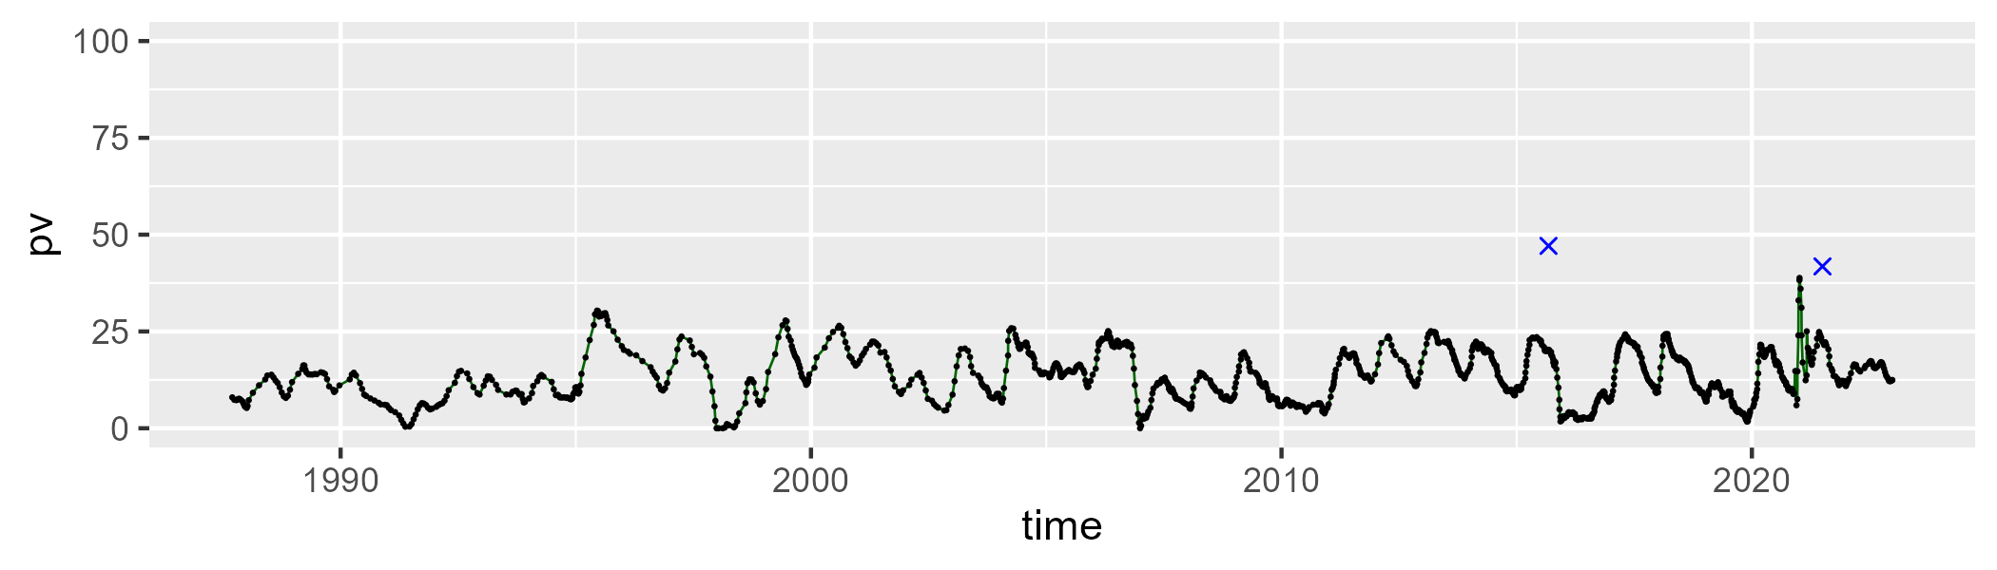

| Min. | 1st Qu. | Median | Mean | 3rd Qu. | Max. |
| --- | --- | --- | --- | --- | --- |
| 6.756661 | 25.49343 | 32.65859 | 32.11977 | 37.5337 | 50.92815 |

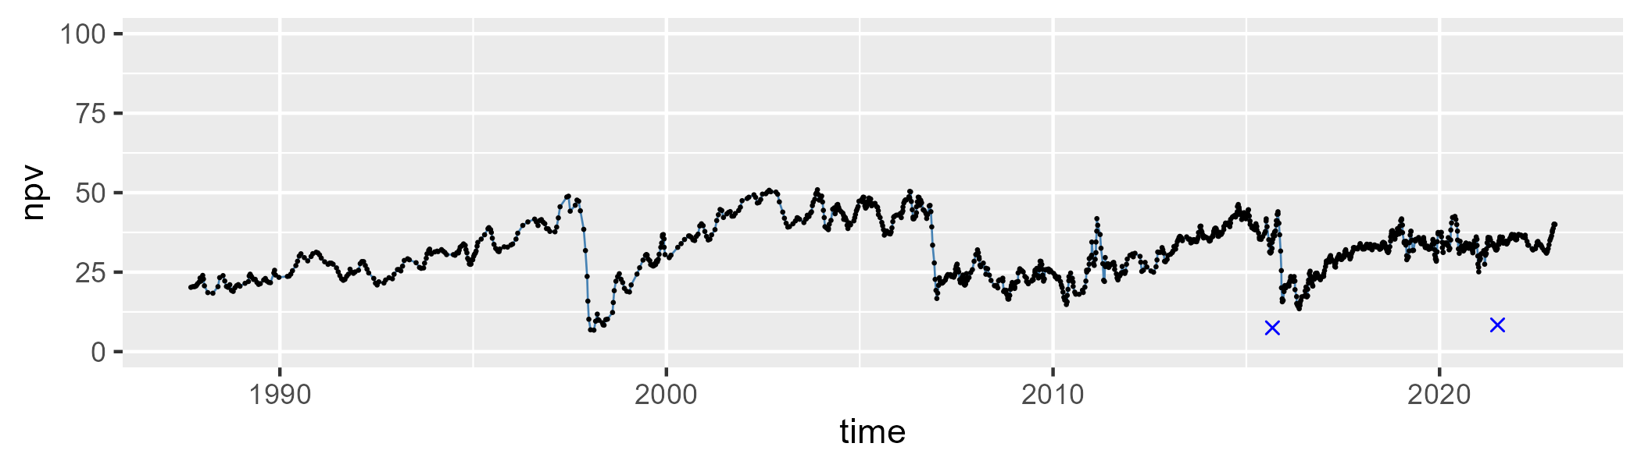

| Min. | 1st Qu. | Median | Mean | 3rd Qu. | Max. |
| --- | --- | --- | --- | --- | --- |
| 23.27369 | 43.31039 | 50.69189 | 52.67619 | 61.9163 | 92.49383 |

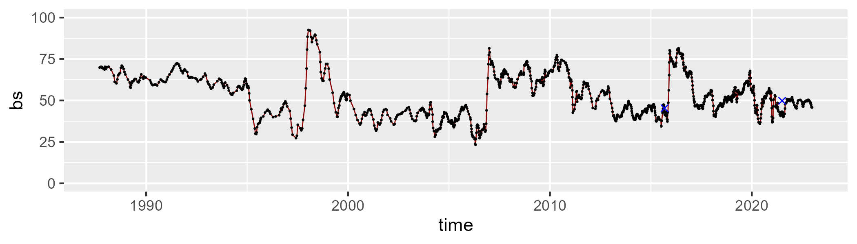

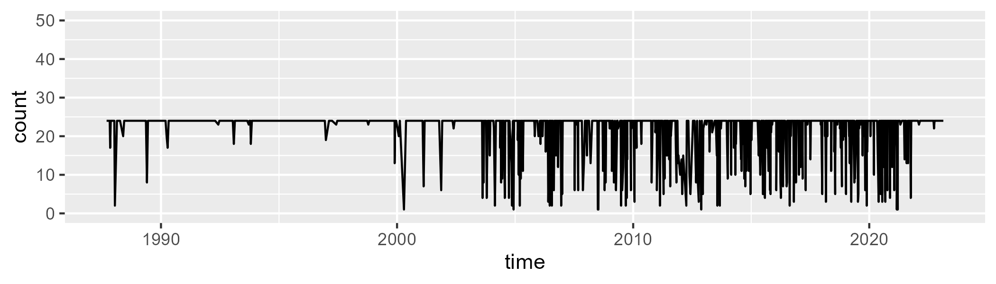

Min. : 1.00 1st Qu.:24.00 Median :24.00 Mean :21.76 3rd Qu.:24.00 Max. :24.00

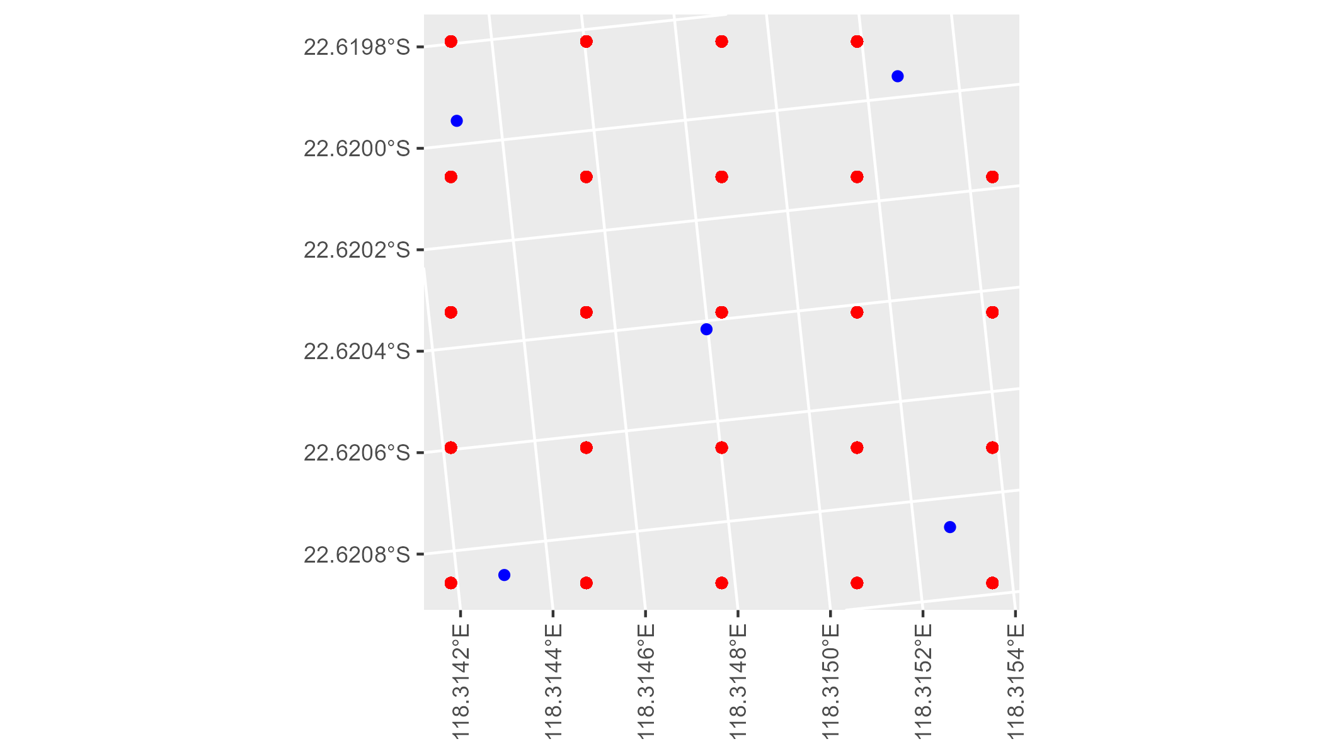

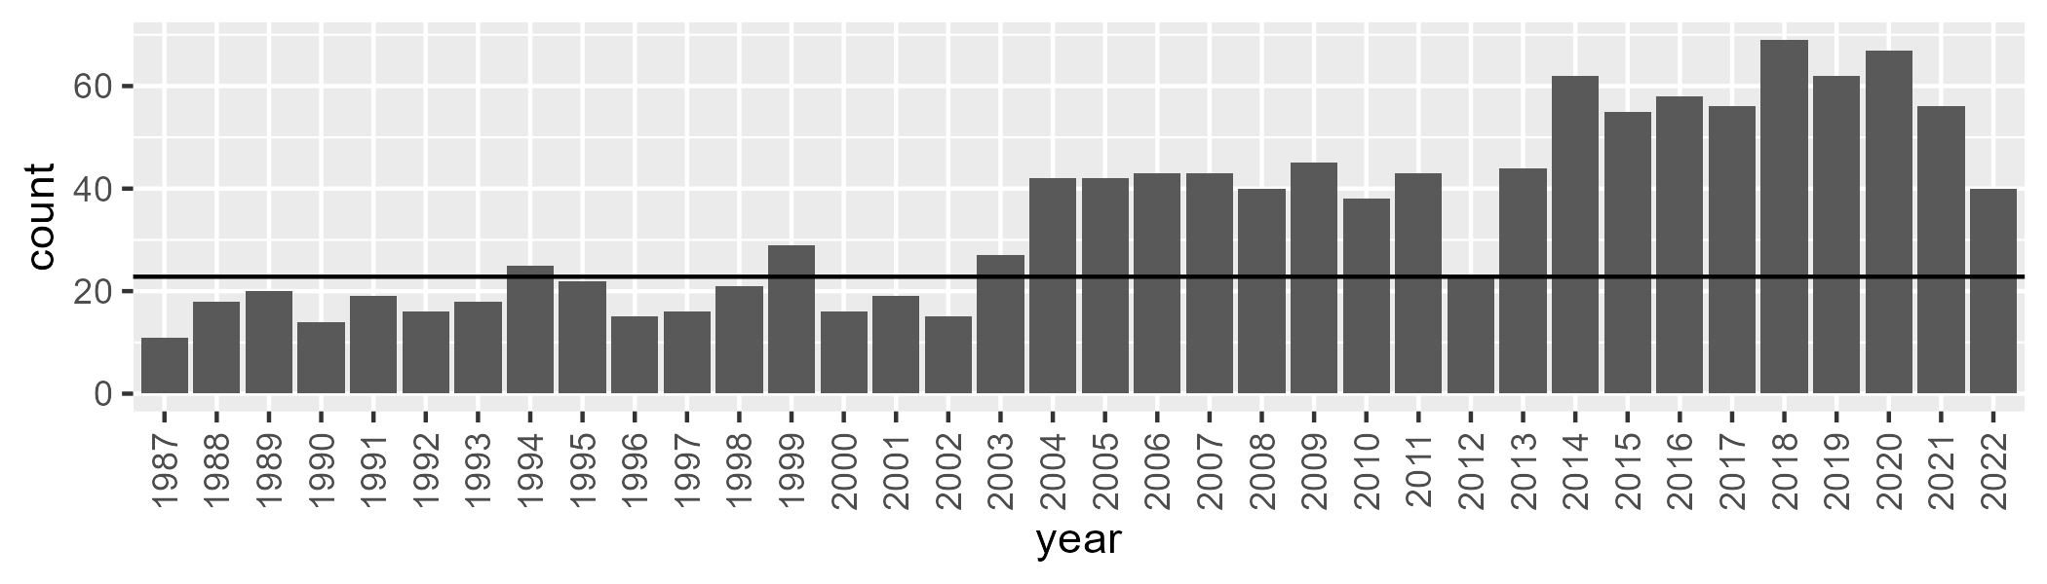

Number of samples: 1249

# WAAPIL0013

| Min. | 1st Qu. | Median | Mean | 3rd Qu. | Max. |
| --- | --- | --- | --- | --- | --- |
| 0 | 4.97382 | 11.77569 | 11.89405 | 17.62333 | 33.97716 |

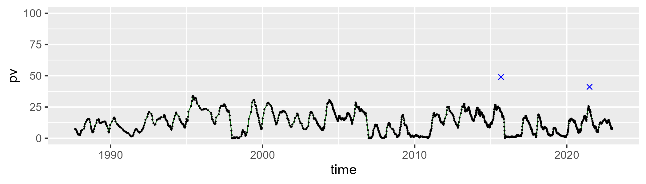

| Min. | 1st Qu. | Median | Mean | 3rd Qu. | Max. |
| --- | --- | --- | --- | --- | --- |
| 15.63829 | 38.13174 | 42.1106 | 41.7991 | 46.15784 | 63.08209 |

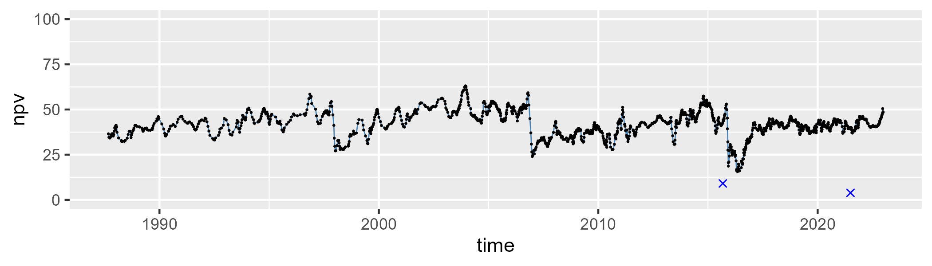

| Min. | 1st Qu. | Median | Mean | 3rd Qu. | Max. |
| --- | --- | --- | --- | --- | --- |
| 19.05049 | 34.30629 | 43.43139 | 44.75332 | 53.32391 | 81.47908 |

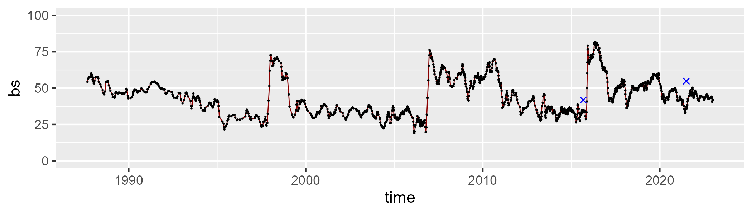

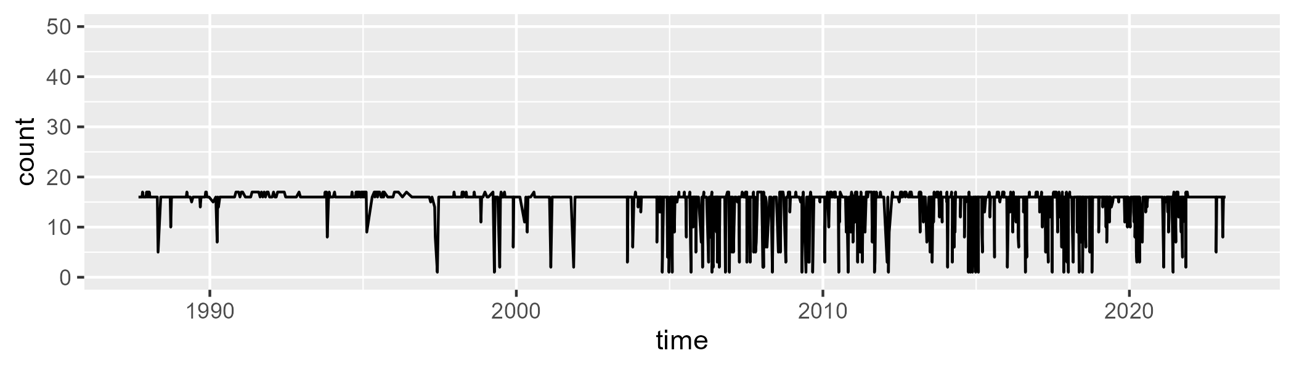

Min. : 1.00 1st Qu.:16.00 Median :16.00 Mean :14.82 3rd Qu.:16.00 Max. :17.00

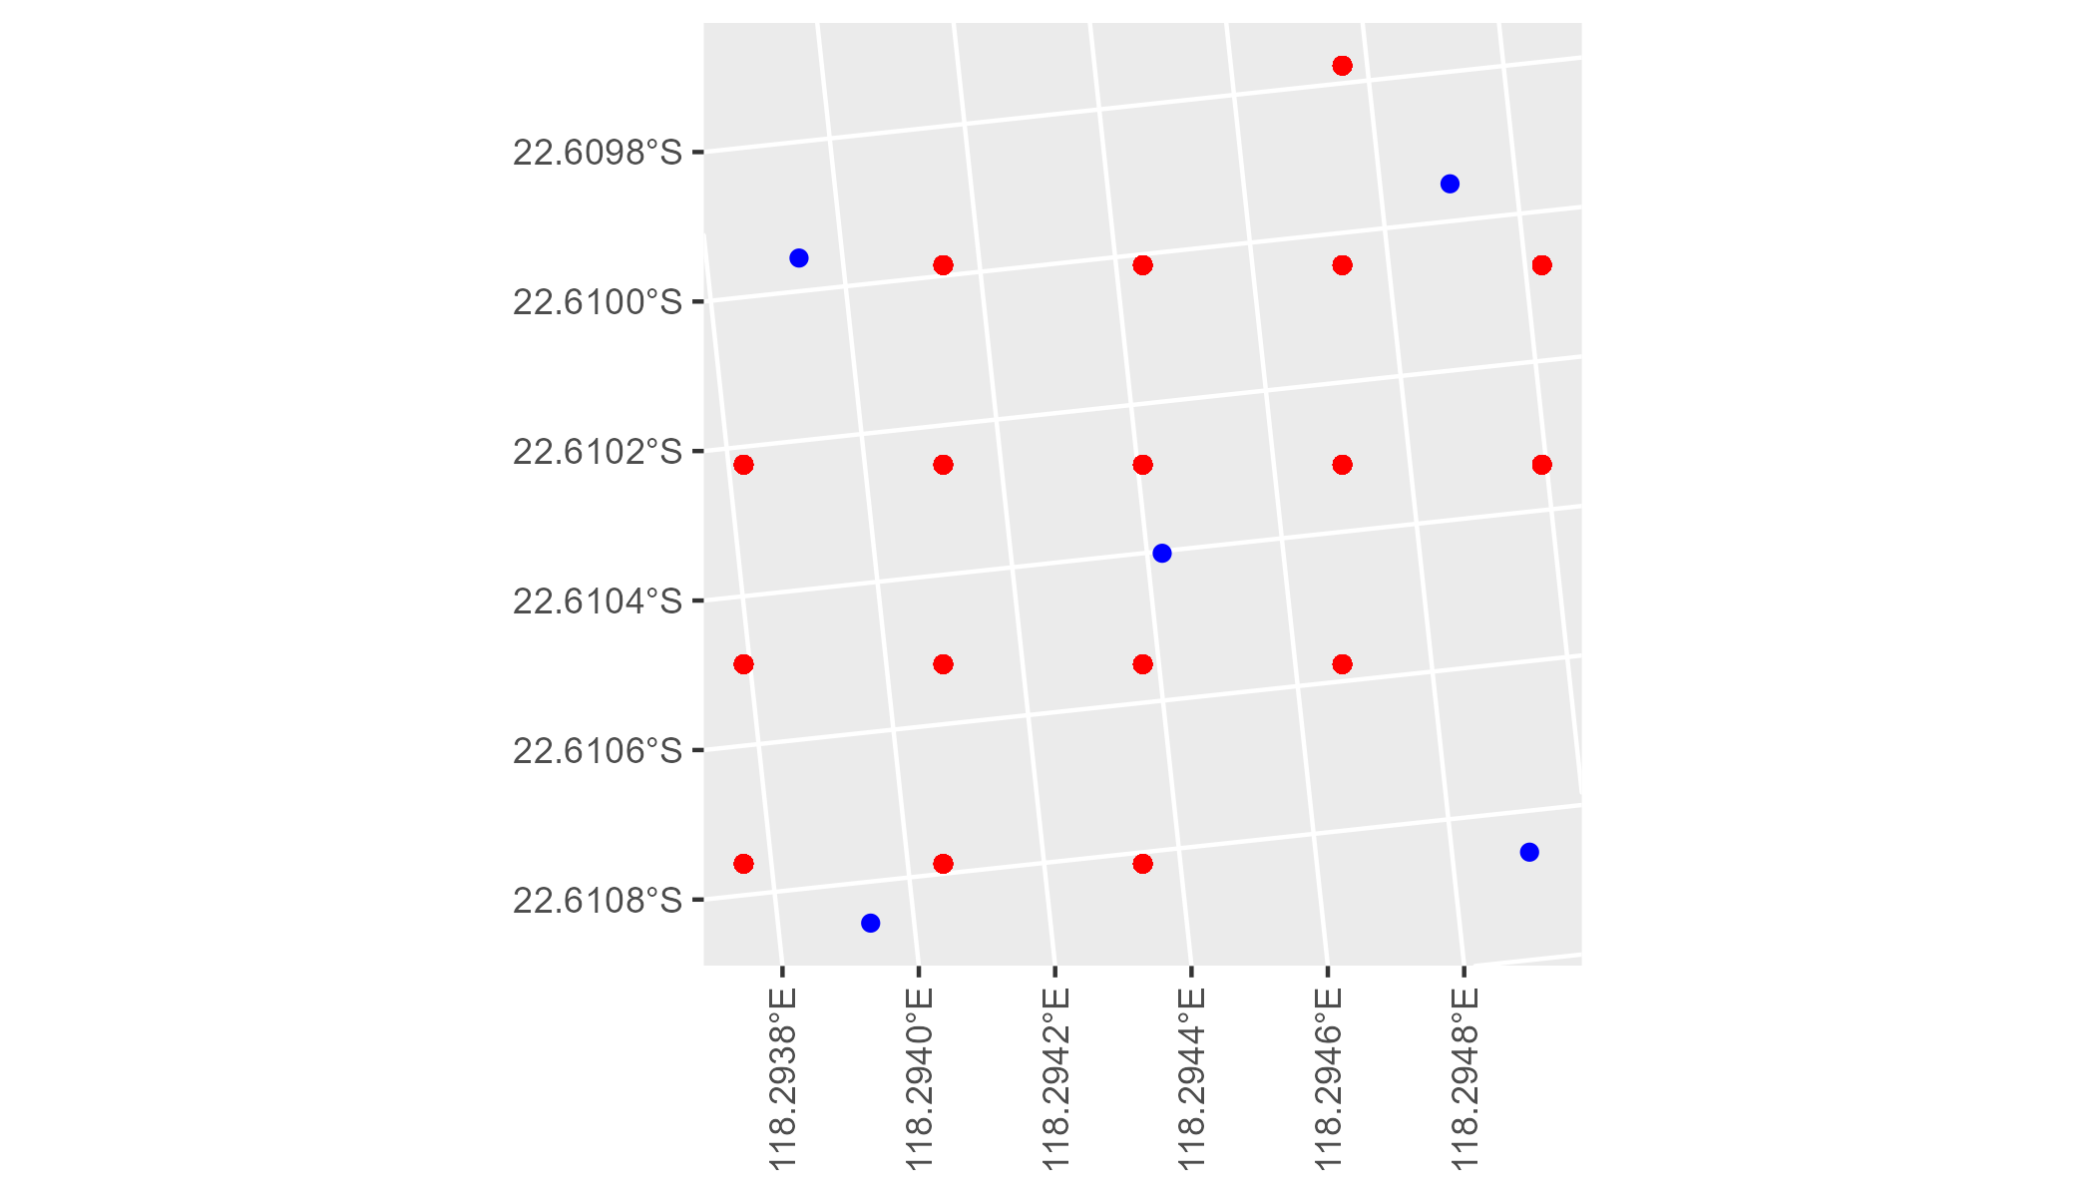

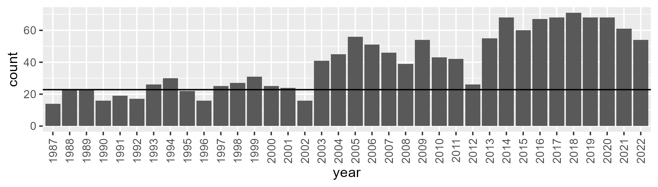

Number of samples: 1437

# WAAPIL0014

| Min. | 1st Qu. | Median | Mean | 3rd Qu. | Max. |
| --- | --- | --- | --- | --- | --- |
| 4.256627 | 10.24446 | 13.03869 | 14.65675 | 17.232 | 40.84683 |

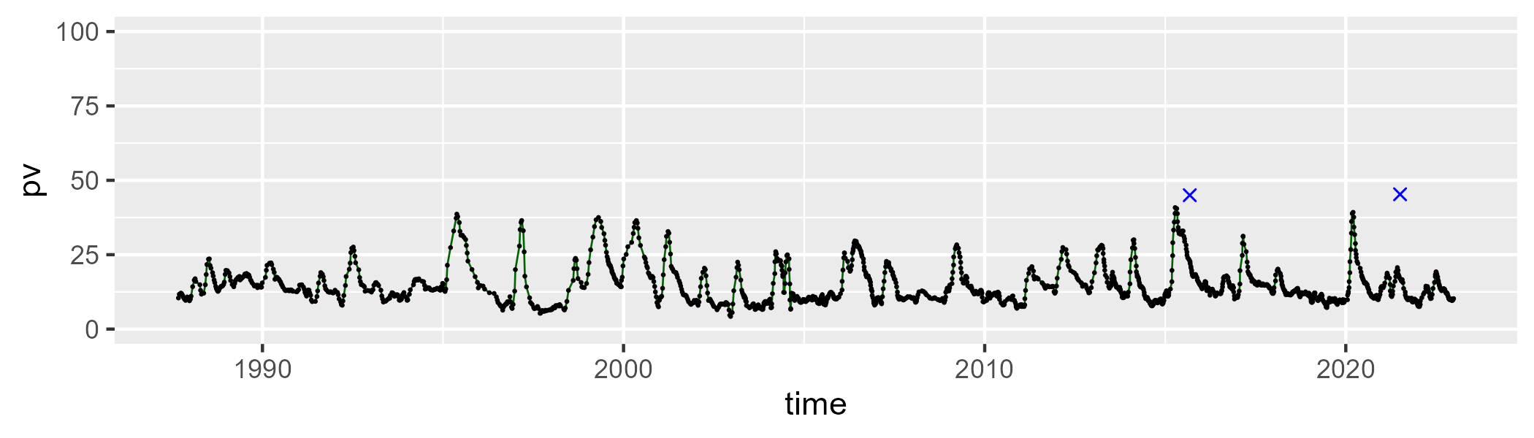

| Min. | 1st Qu. | Median | Mean | 3rd Qu. | Max. |
| --- | --- | --- | --- | --- | --- |
| 31.24517 | 43.5031 | 46.44604 | 46.32525 | 48.74041 | 64.56484 |

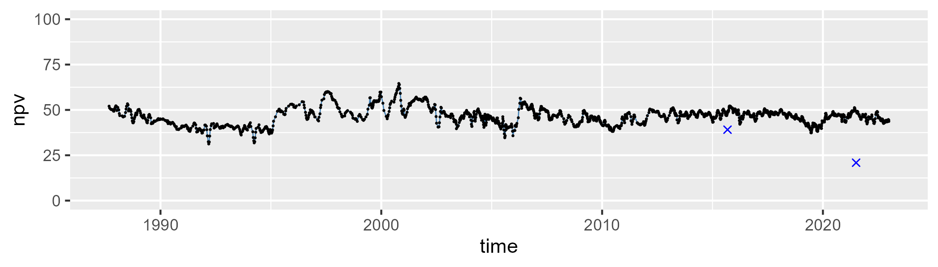

| Min. | 1st Qu. | Median | Mean | 3rd Qu. | Max. |
| --- | --- | --- | --- | --- | --- |
| 9.250602 | 32.91393 | 39.57135 | 37.6547 | 43.68691 | 58.95244 |

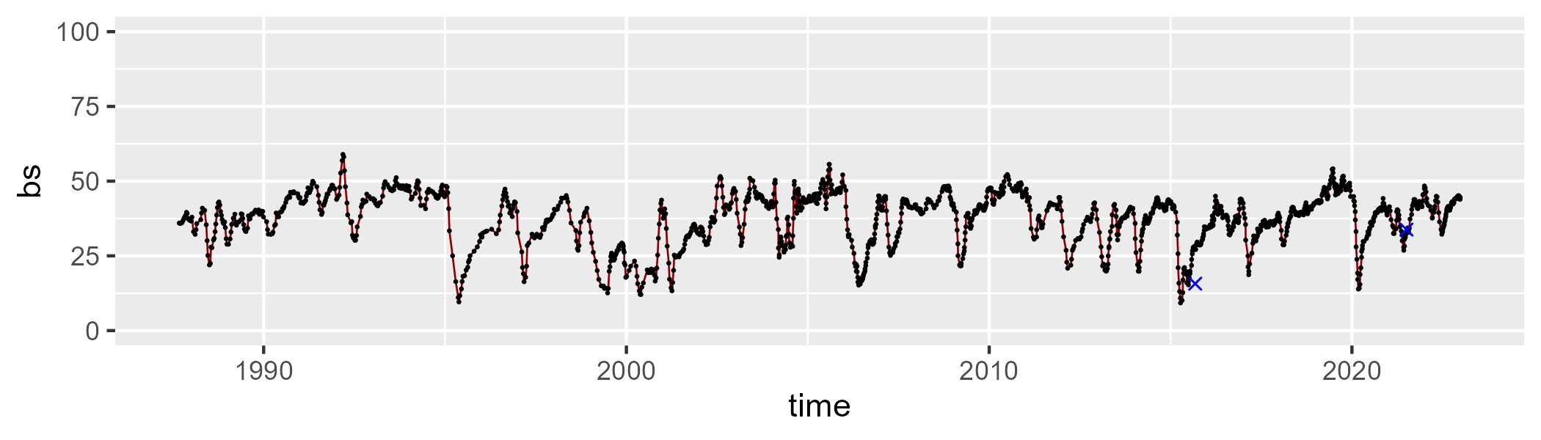

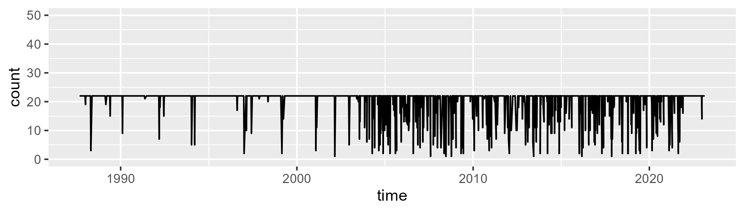

Min. : 1.0 1st Qu.:22.0 Median :22.0 Mean :20.4 3rd Qu.:22.0 Max. :22.0

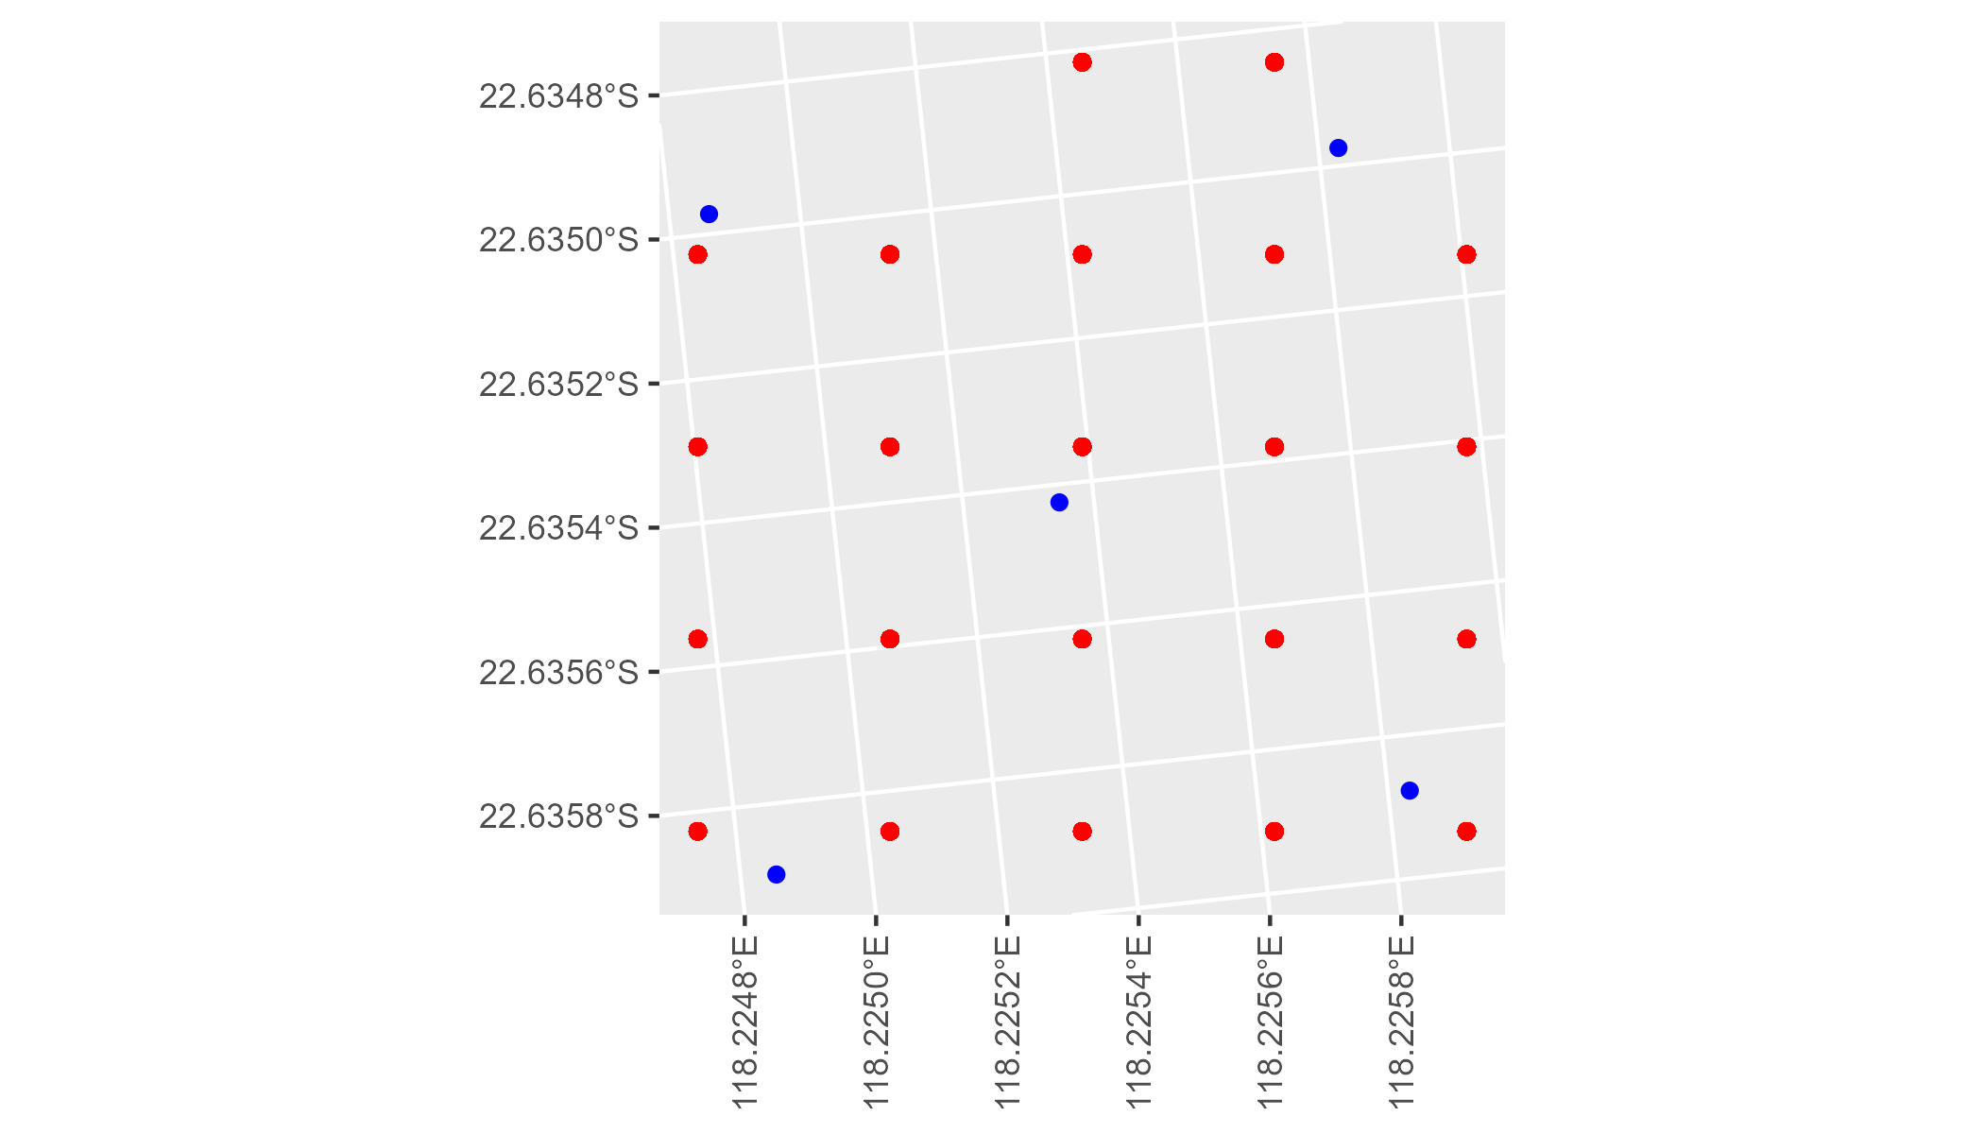

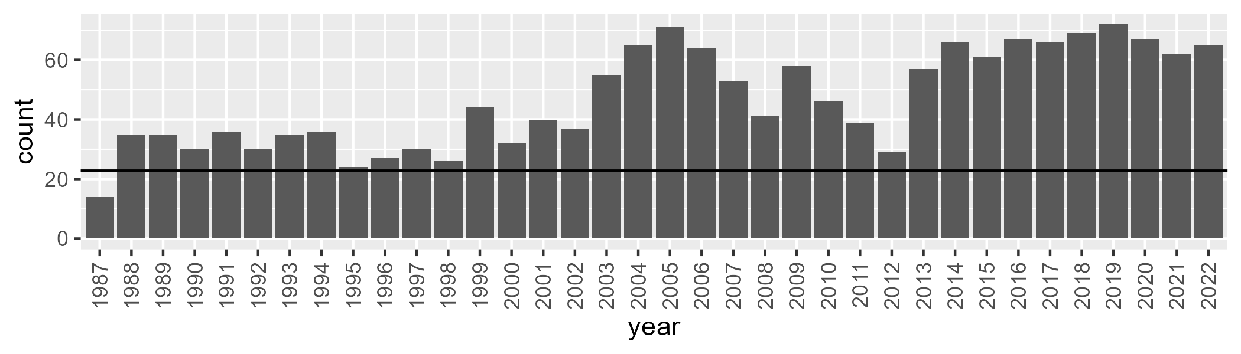

Number of samples: 1684

# WAAPIL0015

| Min. | 1st Qu. | Median | Mean | 3rd Qu. | Max. |
| --- | --- | --- | --- | --- | --- |
| 0 | 2.295375 | 4.756156 | 9.93315 | 13.83808 | 64.4649 |

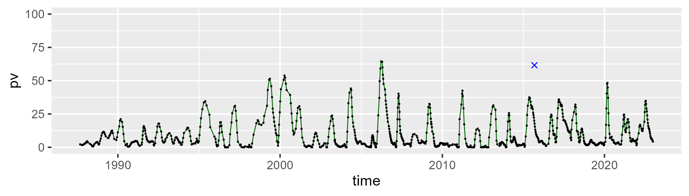

| Min. | 1st Qu. | Median | Mean | 3rd Qu. | Max. |
| --- | --- | --- | --- | --- | --- |
| 28.77721 | 43.55386 | 46.14976 | 46.69006 | 49.23569 | 70.98093 |

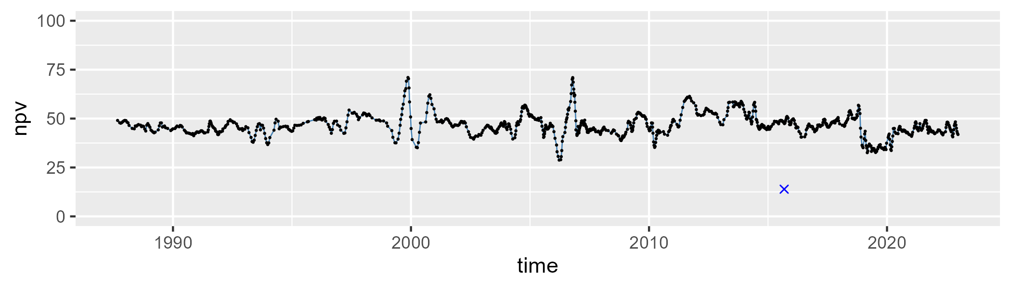

| Min. | 1st Qu. | Median | Mean | 3rd Qu. | Max. |
| --- | --- | --- | --- | --- | --- |
| 5.41011 | 35.62504 | 45.13119 | 42.04425 | 51.0957 | 64.26948 |

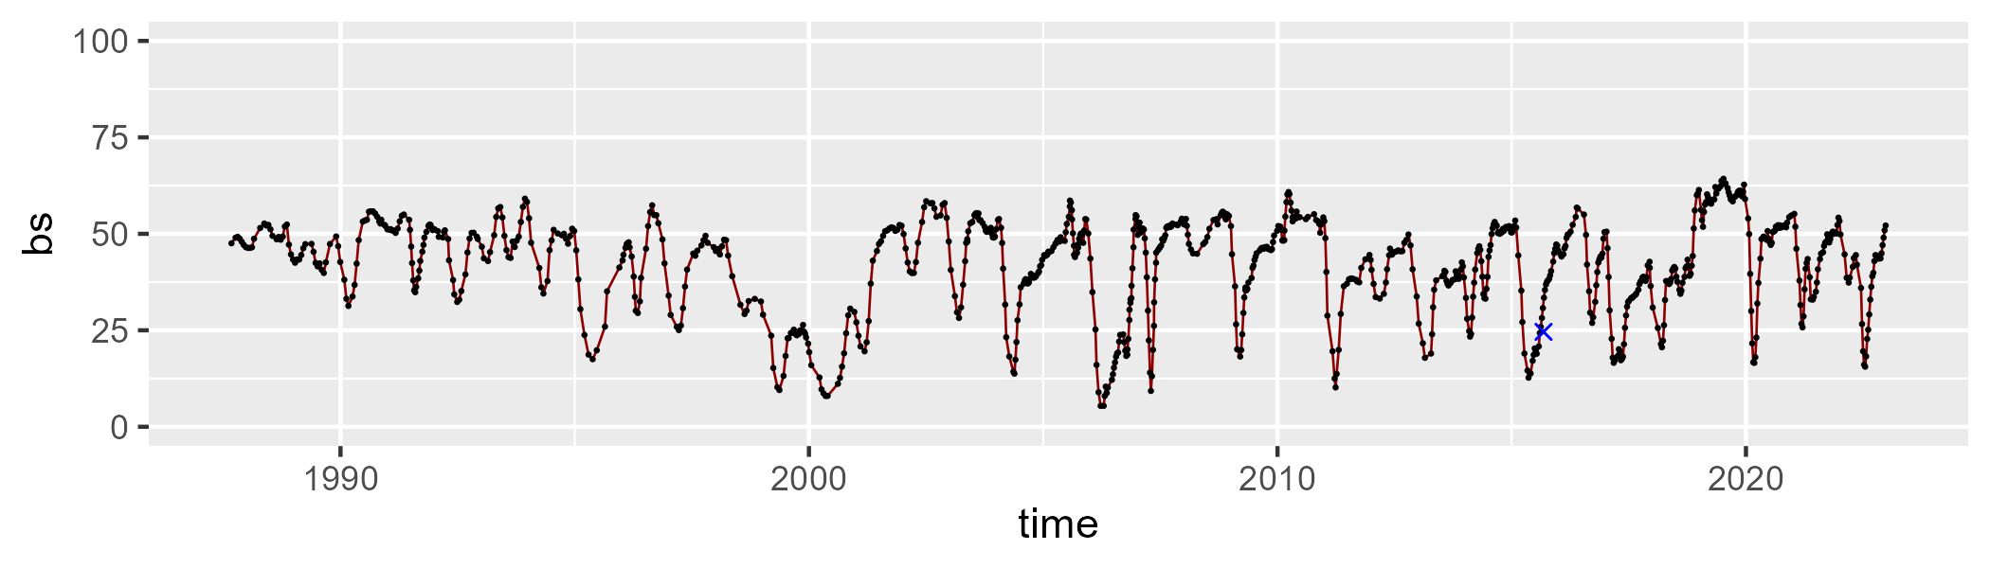

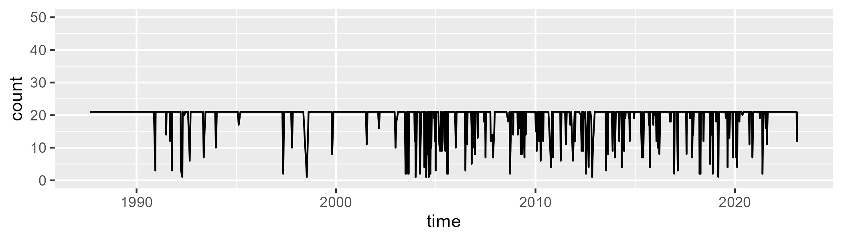

Min. : 1.00 1st Qu.:21.00 Median :21.00 Mean :19.28 3rd Qu.:21.00 Max. :21.00

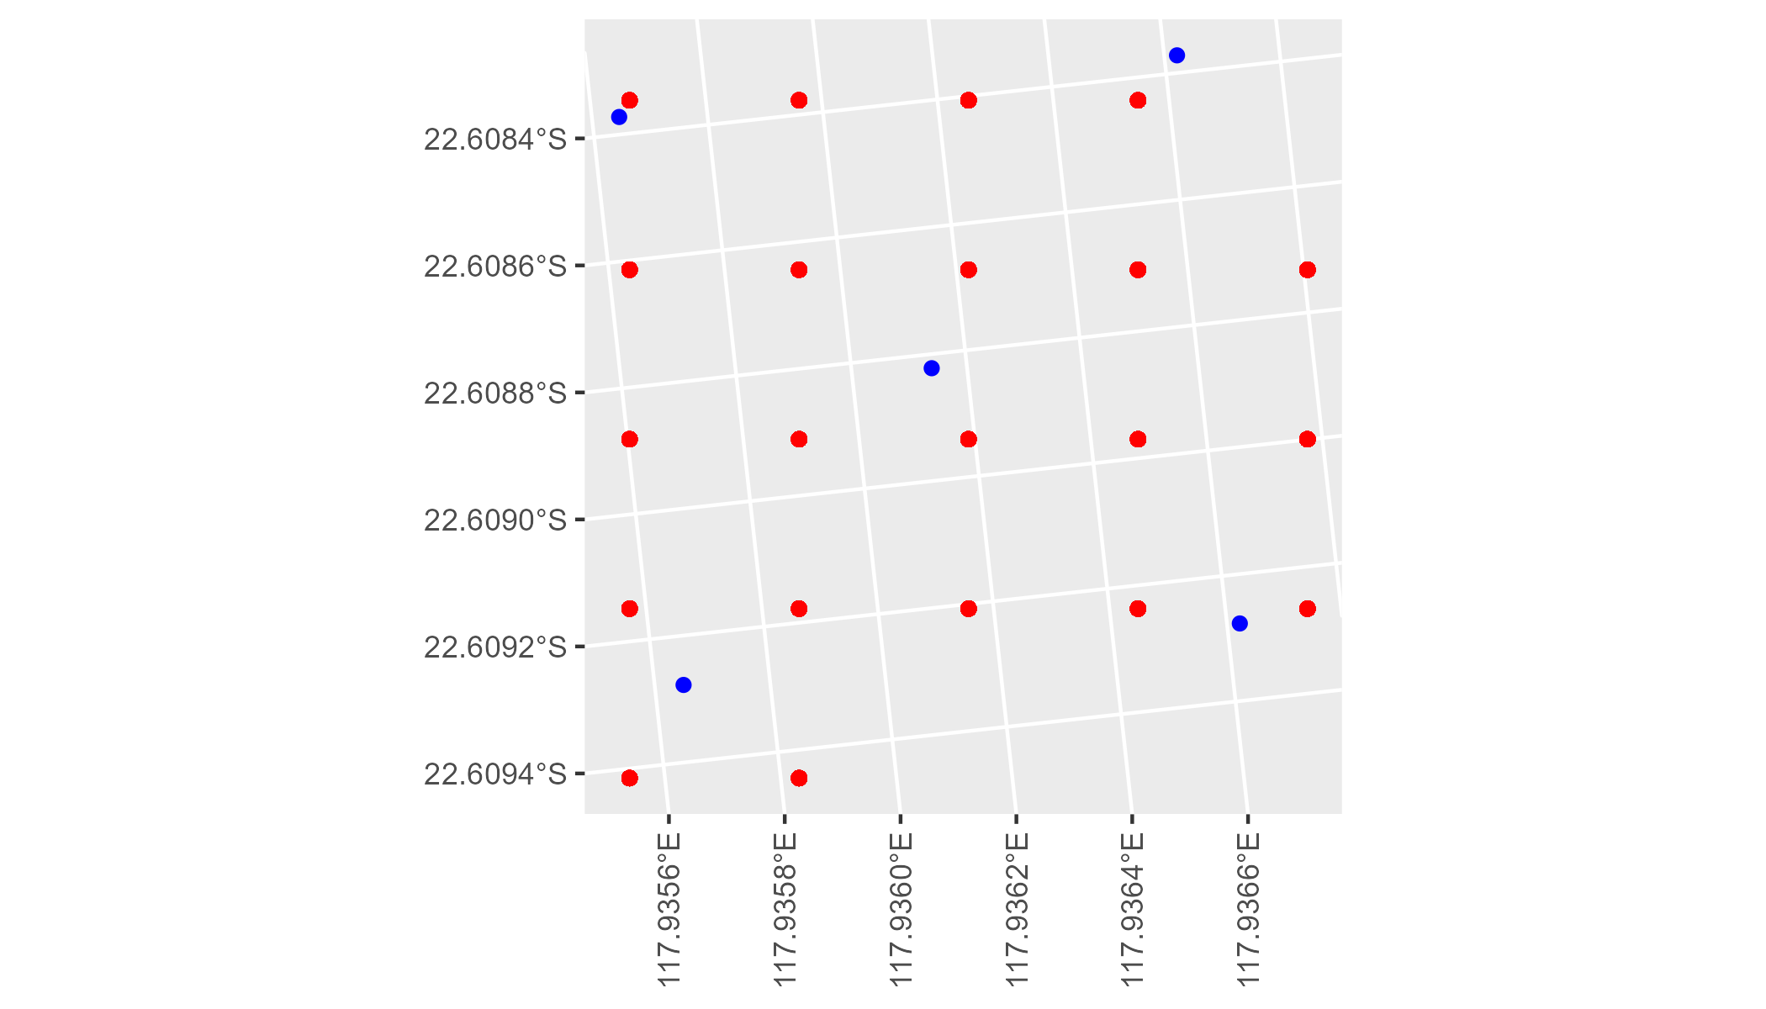

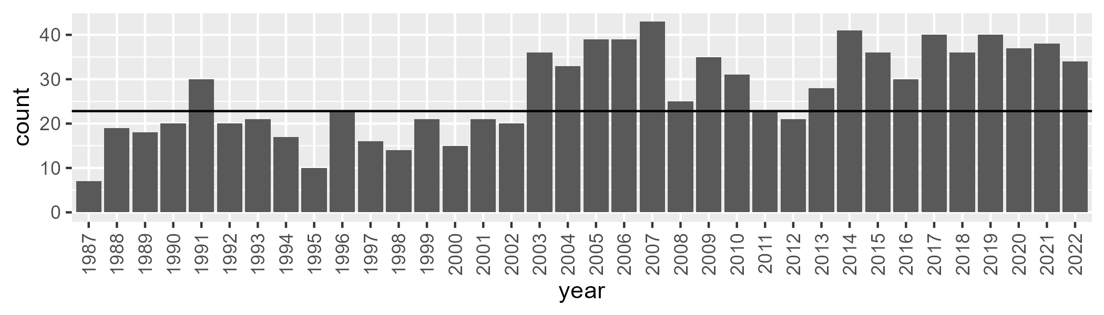

Number of samples: 977

# WAAPIL0016

| Min. | 1st Qu. | Median | Mean | 3rd Qu. | Max. |
| --- | --- | --- | --- | --- | --- |
| 14.92344 | 26.44033 | 31.3383 | 32.87901 | 40.19408 | 56.99783 |

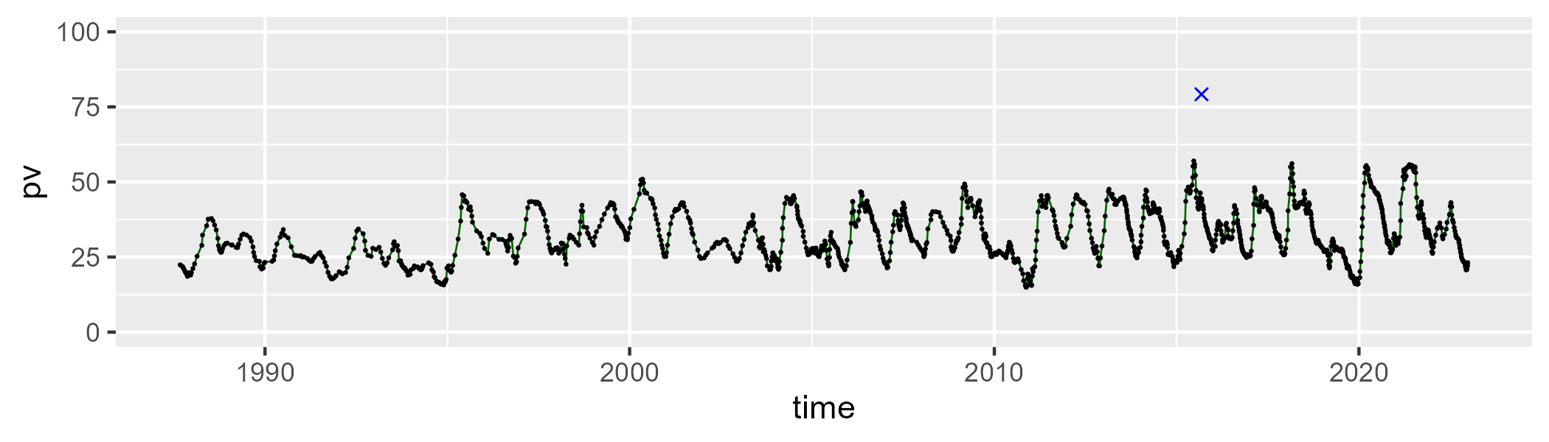

| Min. | 1st Qu. | Median | Mean | 3rd Qu. | Max. |
| --- | --- | --- | --- | --- | --- |
| 26.92406 | 40.4635 | 44.86755 | 45.13579 | 50.06342 | 62.98832 |

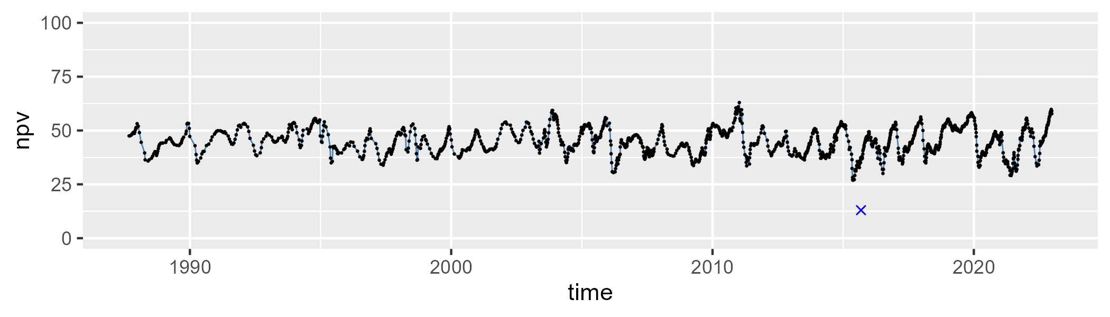

| Min. | 1st Qu. | Median | Mean | 3rd Qu. | Max. |
| --- | --- | --- | --- | --- | --- |
| 4.049014 | 16.94644 | 20.63236 | 20.5538 | 23.93976 | 37.08896 |

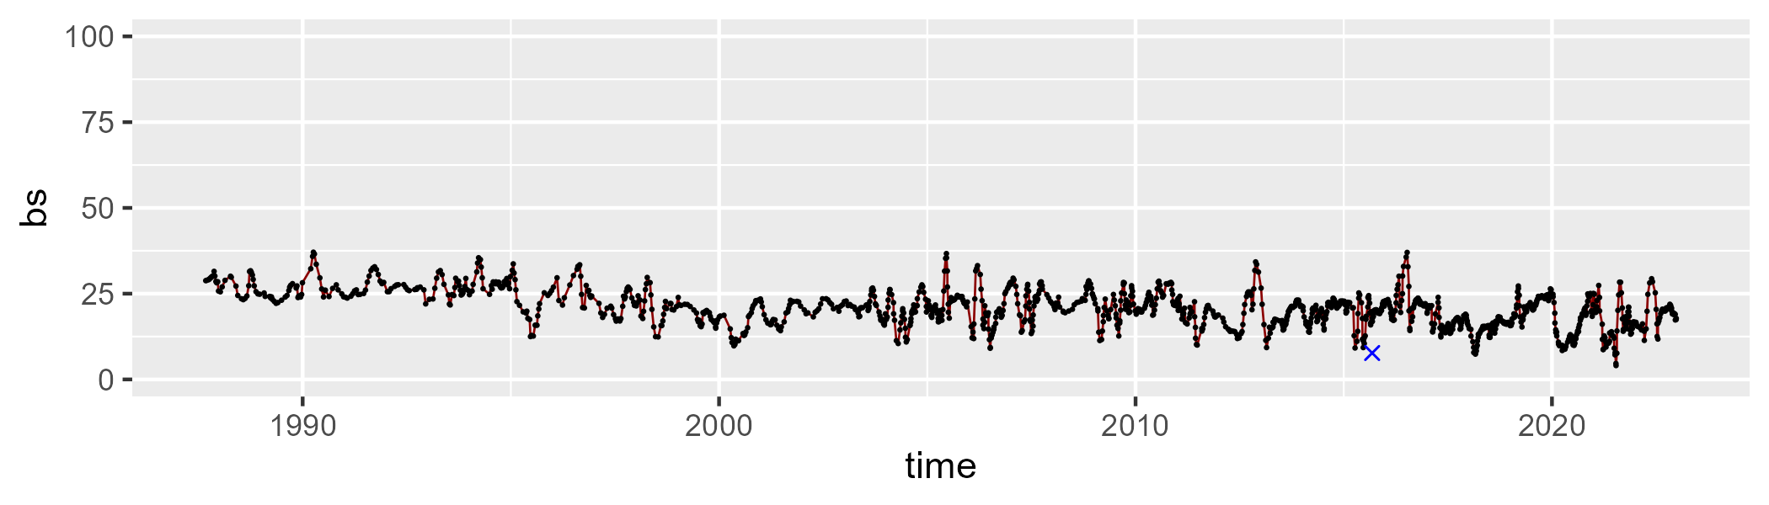

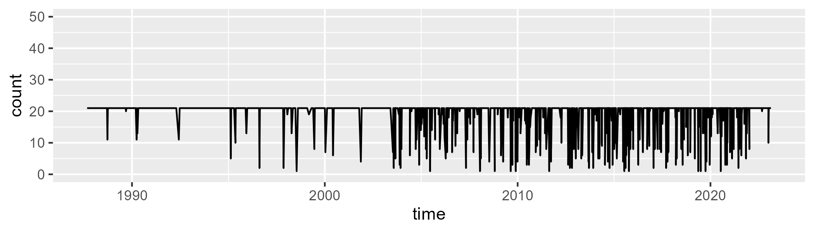

Min. : 1.00 1st Qu.:21.00 Median :21.00 Mean :19.26 3rd Qu.:21.00 Max. :21.00

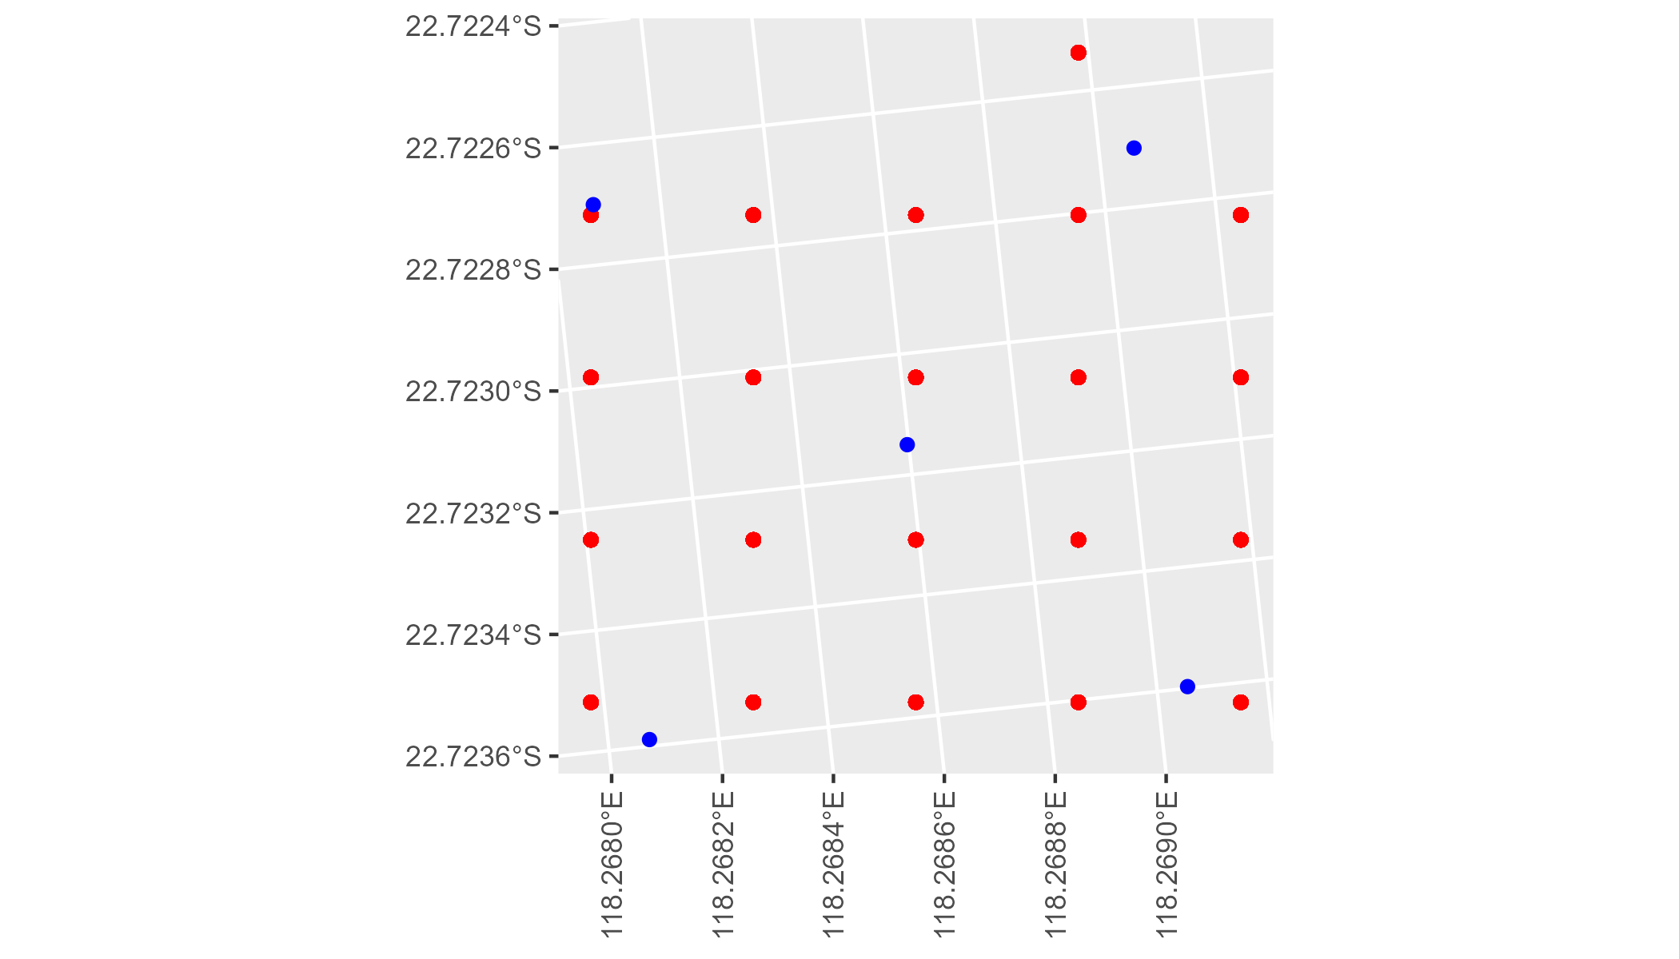

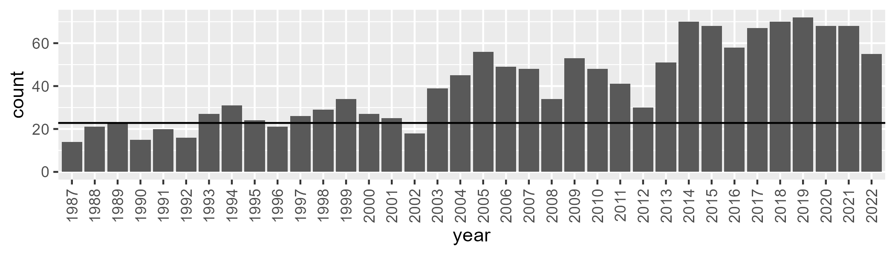

Number of samples: 1461

# WAAPIL0017

| Min. | 1st Qu. | Median | Mean | 3rd Qu. | Max. |
| --- | --- | --- | --- | --- | --- |
| 0.2728694 | 5.854576 | 10.18885 | 10.44312 | 14.54548 | 27.00422 |

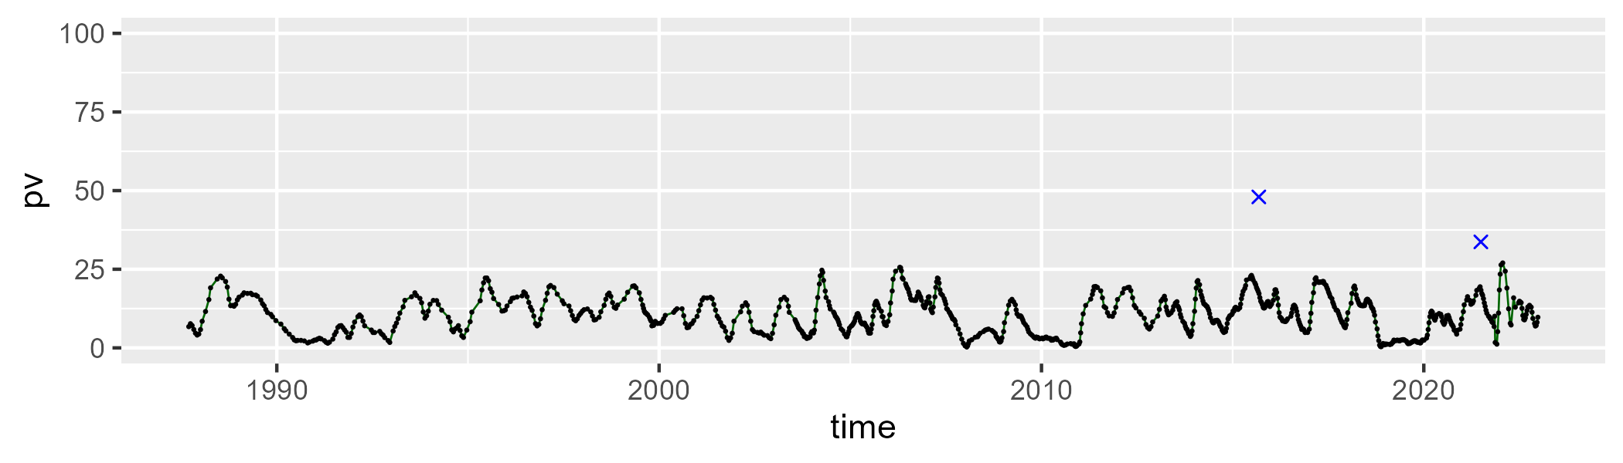

| Min. | 1st Qu. | Median | Mean | 3rd Qu. | Max. |
| --- | --- | --- | --- | --- | --- |
| 16.98425 | 38.0494 | 44.24711 | 43.61301 | 49.2523 | 61.75842 |

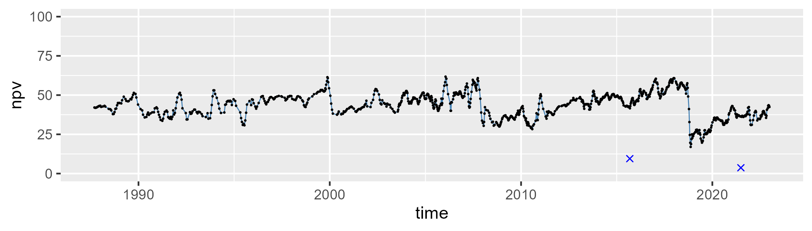

| Min. | 1st Qu. | Median | Mean | 3rd Qu. | Max. |
| --- | --- | --- | --- | --- | --- |
| 20.40145 | 36.4717 | 42.95781 | 44.38786 | 50.97915 | 80.78498 |

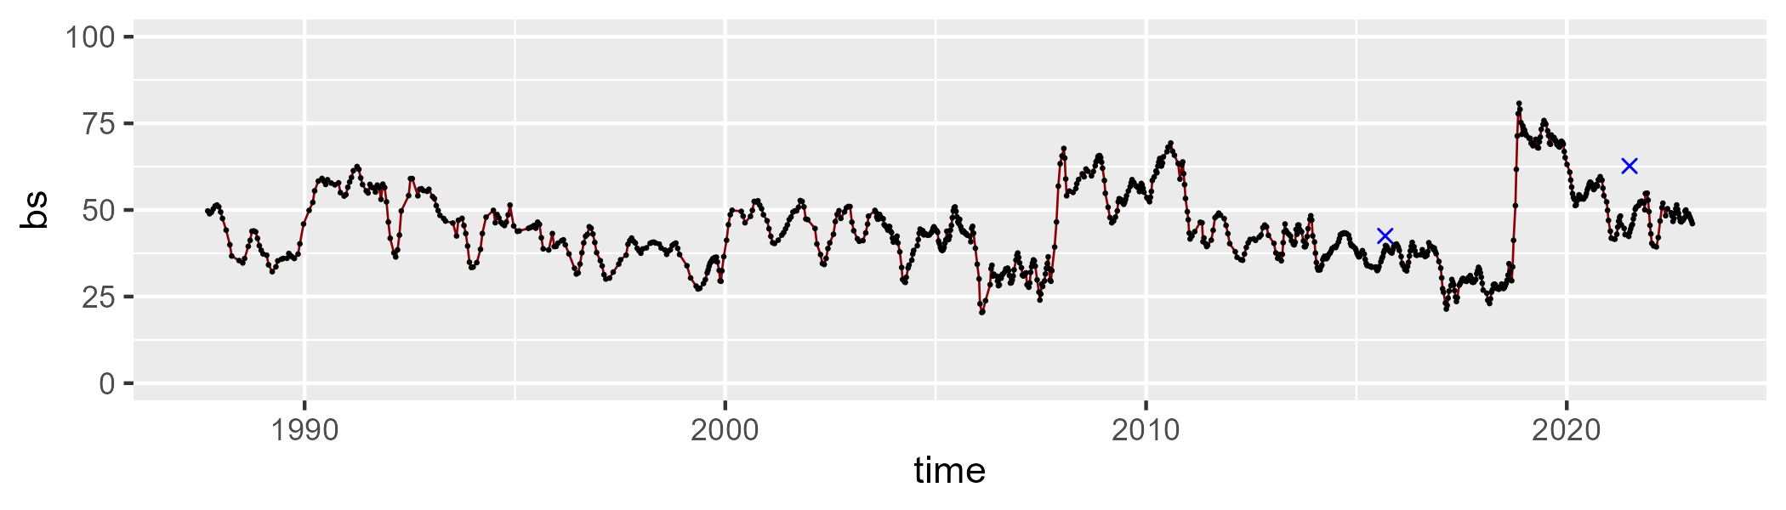

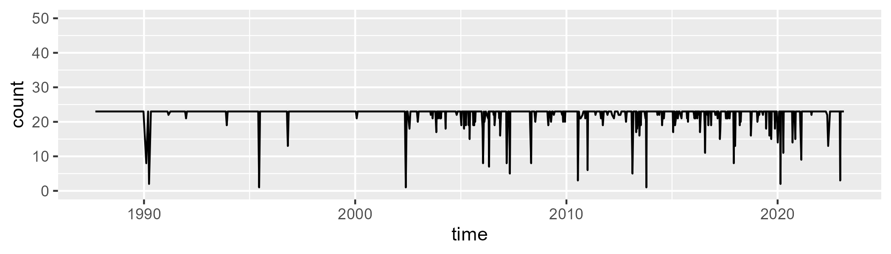

Min. : 1.00 1st Qu.:23.00 Median :23.00 Mean :22.26 3rd Qu.:23.00 Max. :23.00

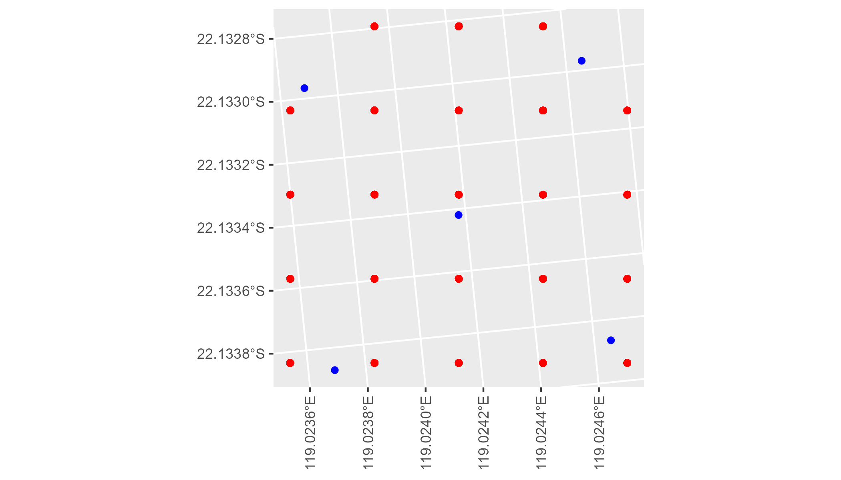

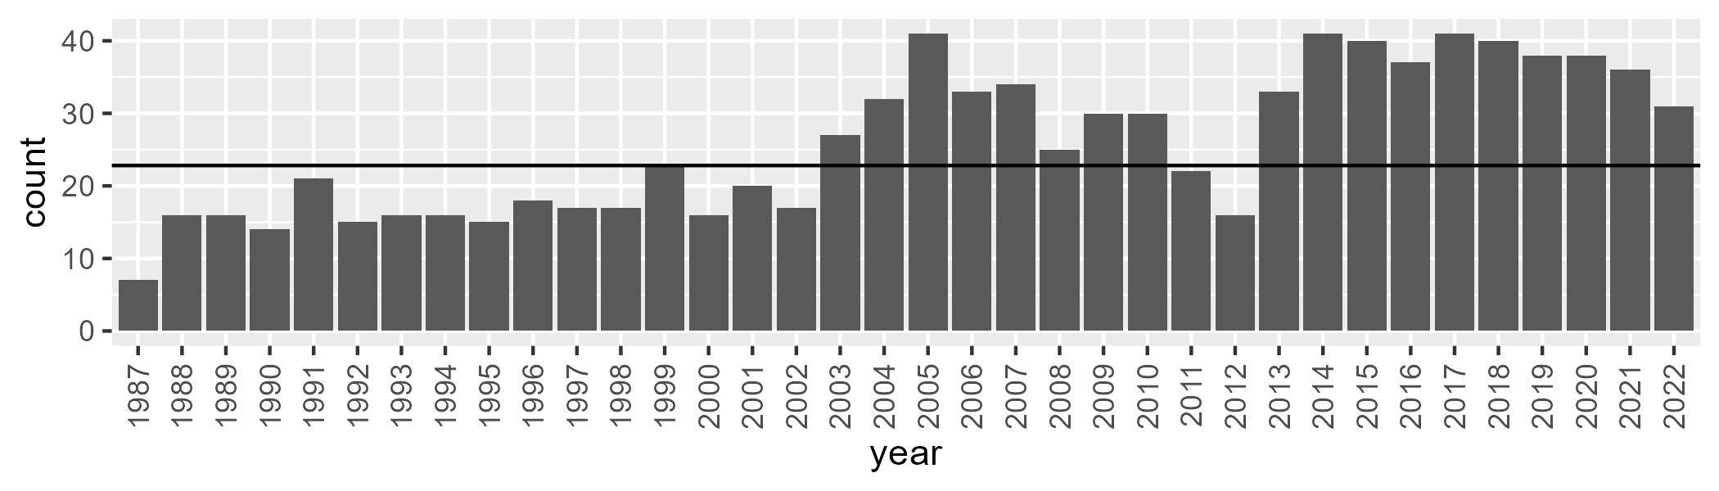

Number of samples: 929

# WAAPIL0018

| Min. | 1st Qu. | Median | Mean | 3rd Qu. | Max. |
| --- | --- | --- | --- | --- | --- |
| 0.9551926 | 15.16112 | 19.44322 | 22.48226 | 28.11008 | 53.84757 |

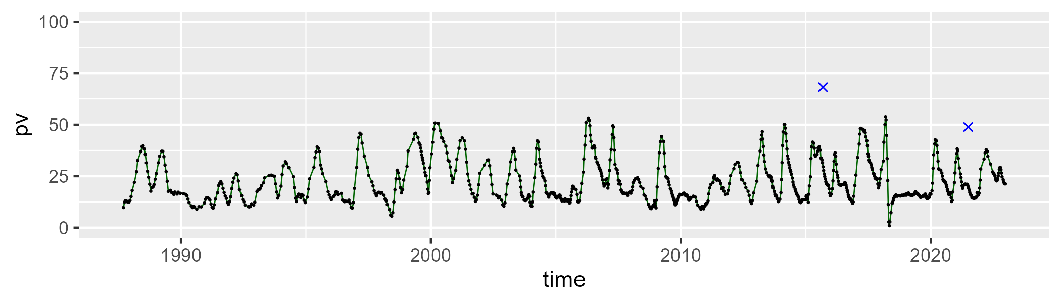

| Min. | 1st Qu. | Median | Mean | 3rd Qu. | Max. |
| --- | --- | --- | --- | --- | --- |
| 21.0871 | 44.60335 | 51.17756 | 51.30338 | 58.3951 | 71.31078 |

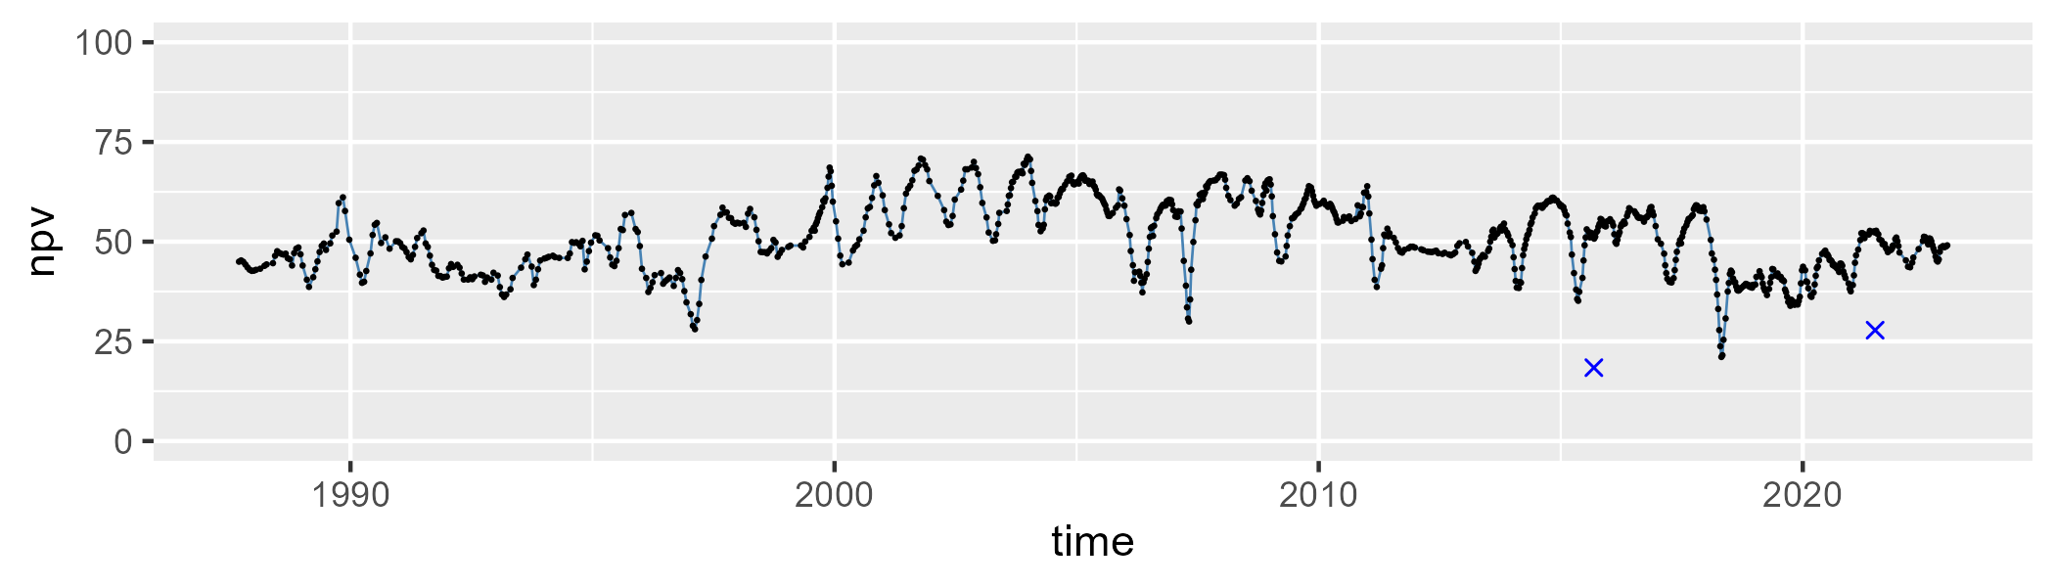

| Min. | 1st Qu. | Median | Mean | 3rd Qu. | Max. |
| --- | --- | --- | --- | --- | --- |
| 1.929141 | 16.8459 | 23.50677 | 24.91061 | 31.93665 | 75.51208 |

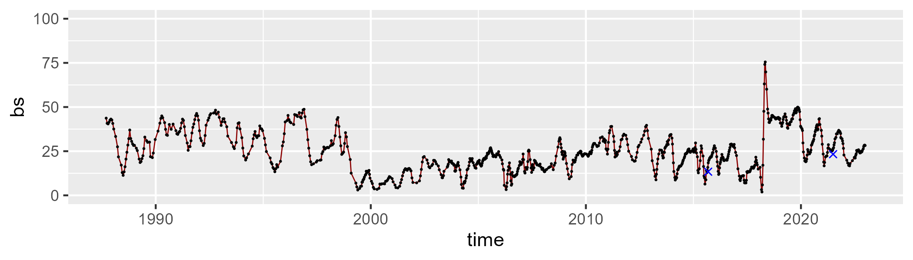

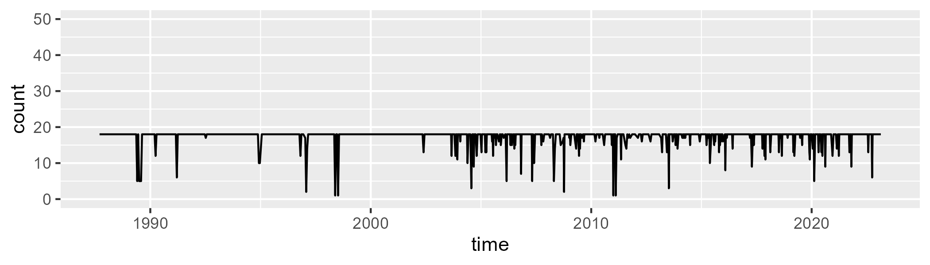

Min. : 1.00 1st Qu.:18.00 Median :18.00 Mean :17.27 3rd Qu.:18.00 Max. :18.00

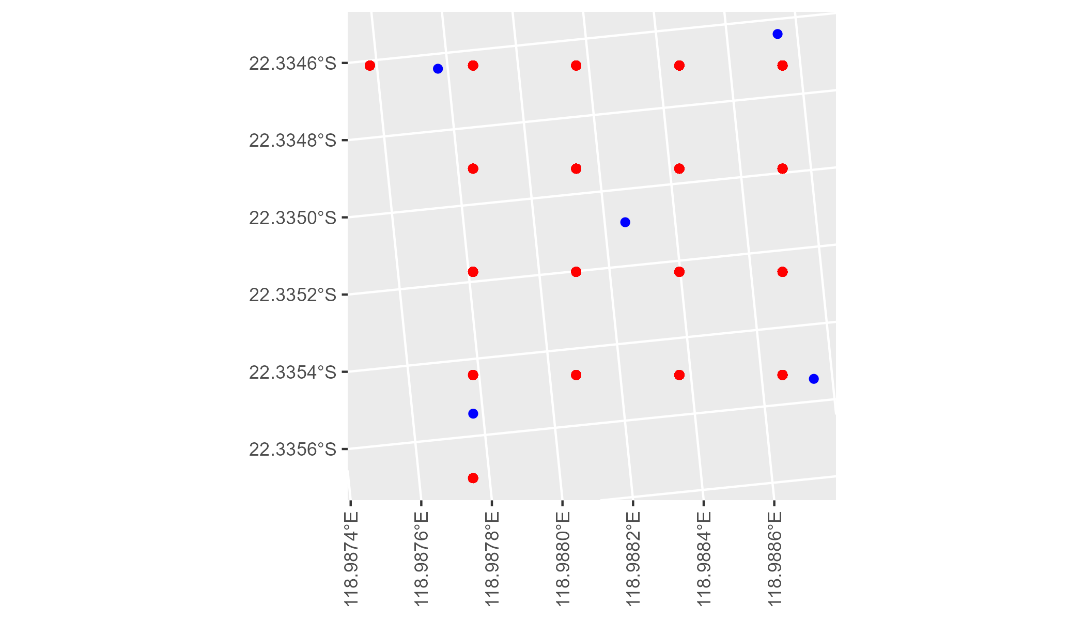

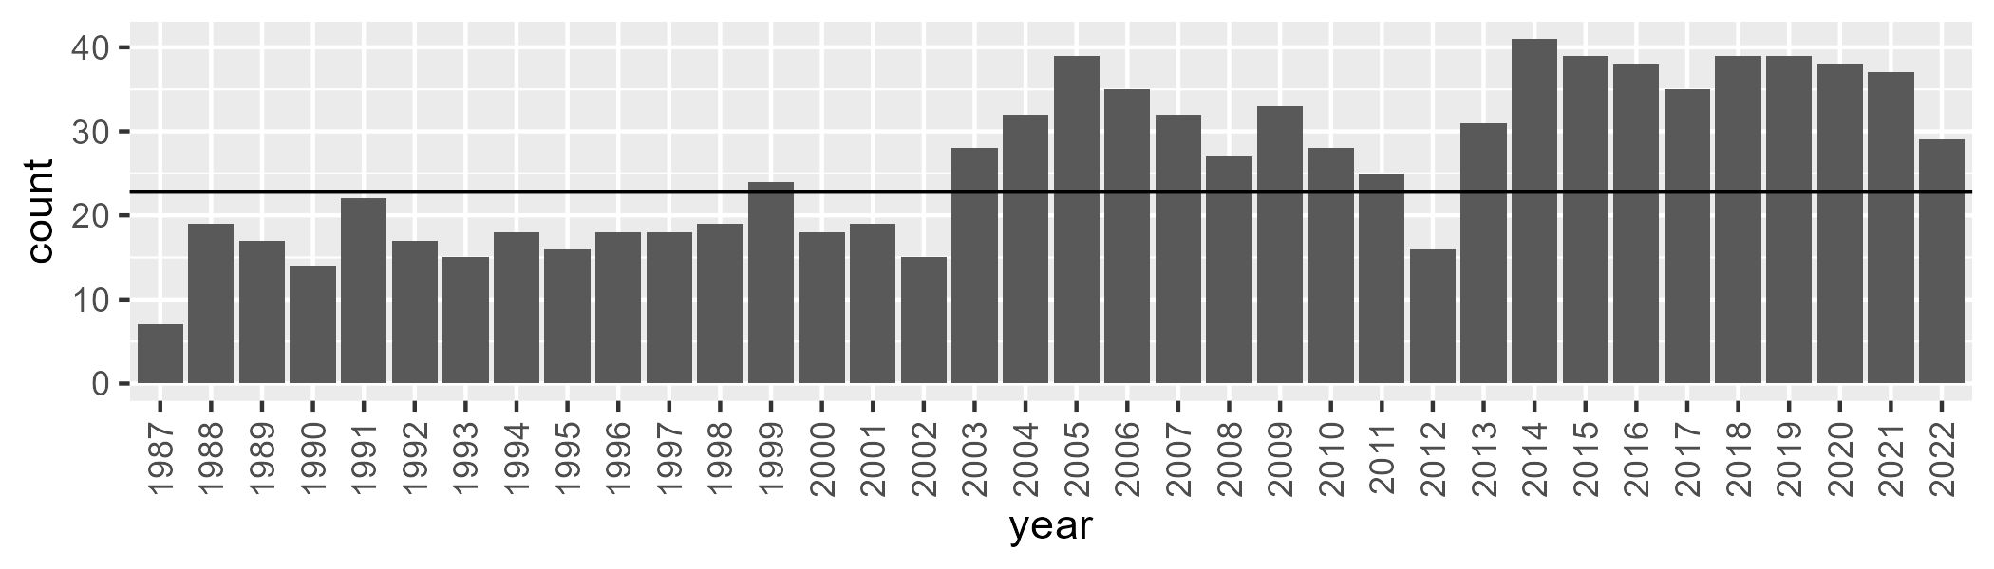

Number of samples: 937

# WAAPIL0019

| Min. | 1st Qu. | Median | Mean | 3rd Qu. | Max. |
| --- | --- | --- | --- | --- | --- |
| 3.573106 | 8.795526 | 11.02555 | 12.37459 | 14.60839 | 35.91324 |

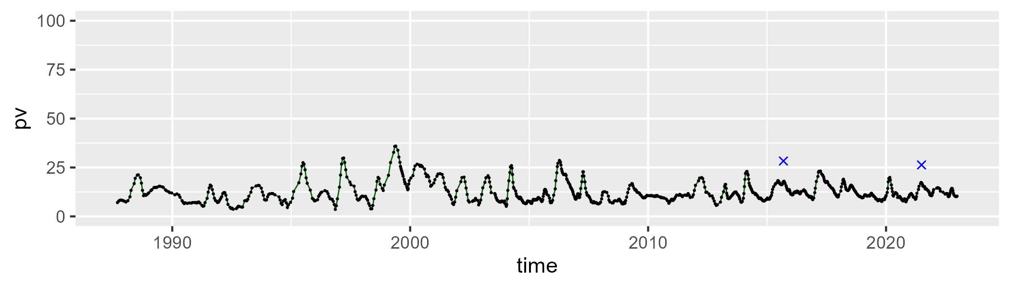

| Min. | 1st Qu. | Median | Mean | 3rd Qu. | Max. |
| --- | --- | --- | --- | --- | --- |
| 23.74396 | 33.39665 | 35.44305 | 36.06096 | 38.38125 | 53.98899 |

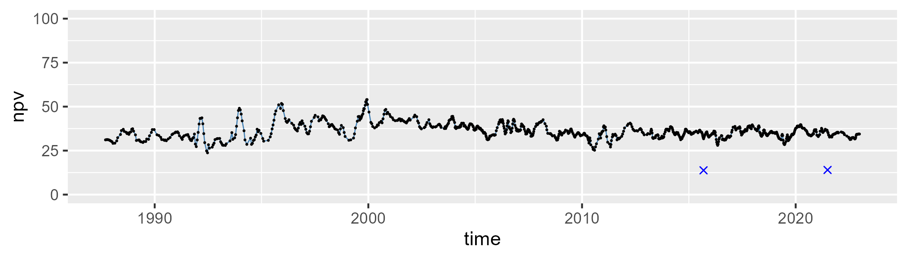

| Min. | 1st Qu. | Median | Mean | 3rd Qu. | Max. |
| --- | --- | --- | --- | --- | --- |
| 23.08552 | 46.19189 | 51.76855 | 49.91124 | 54.80057 | 70.67253 |

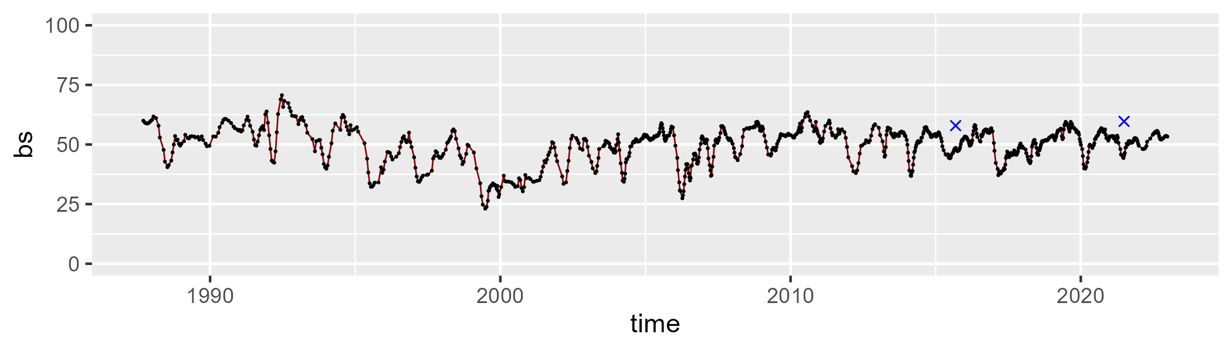

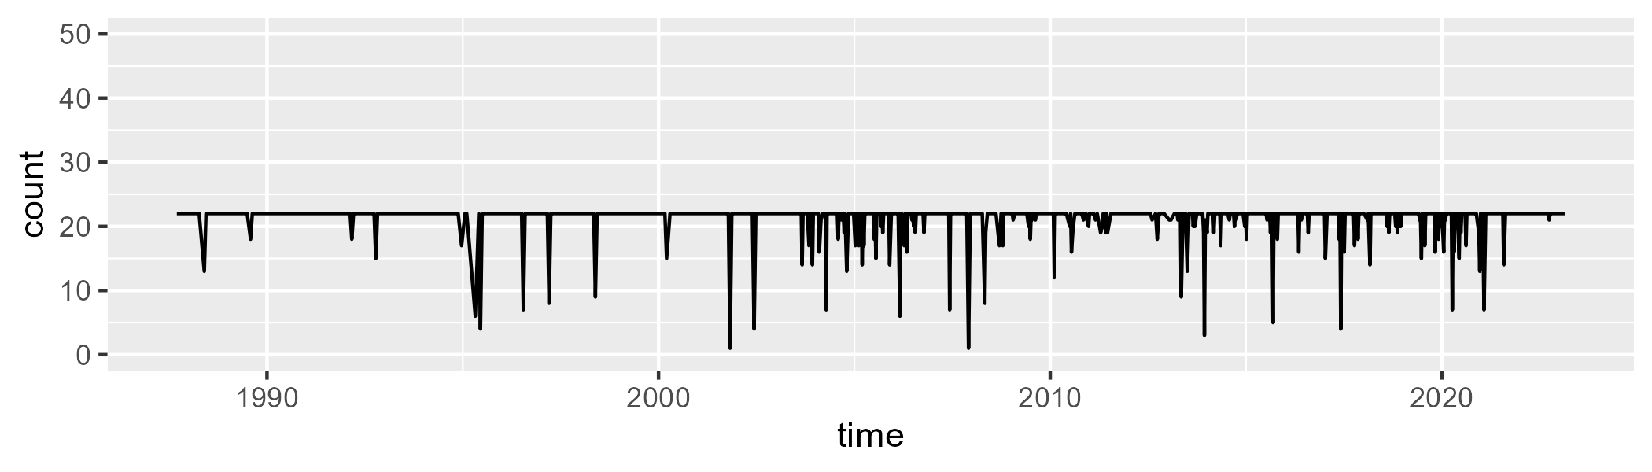

Min. : 1.00 1st Qu.:22.00 Median :22.00 Mean :21.27 3rd Qu.:22.00 Max. :22.00

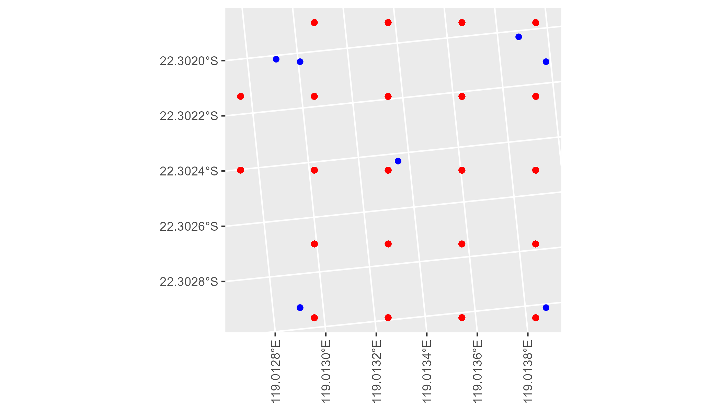

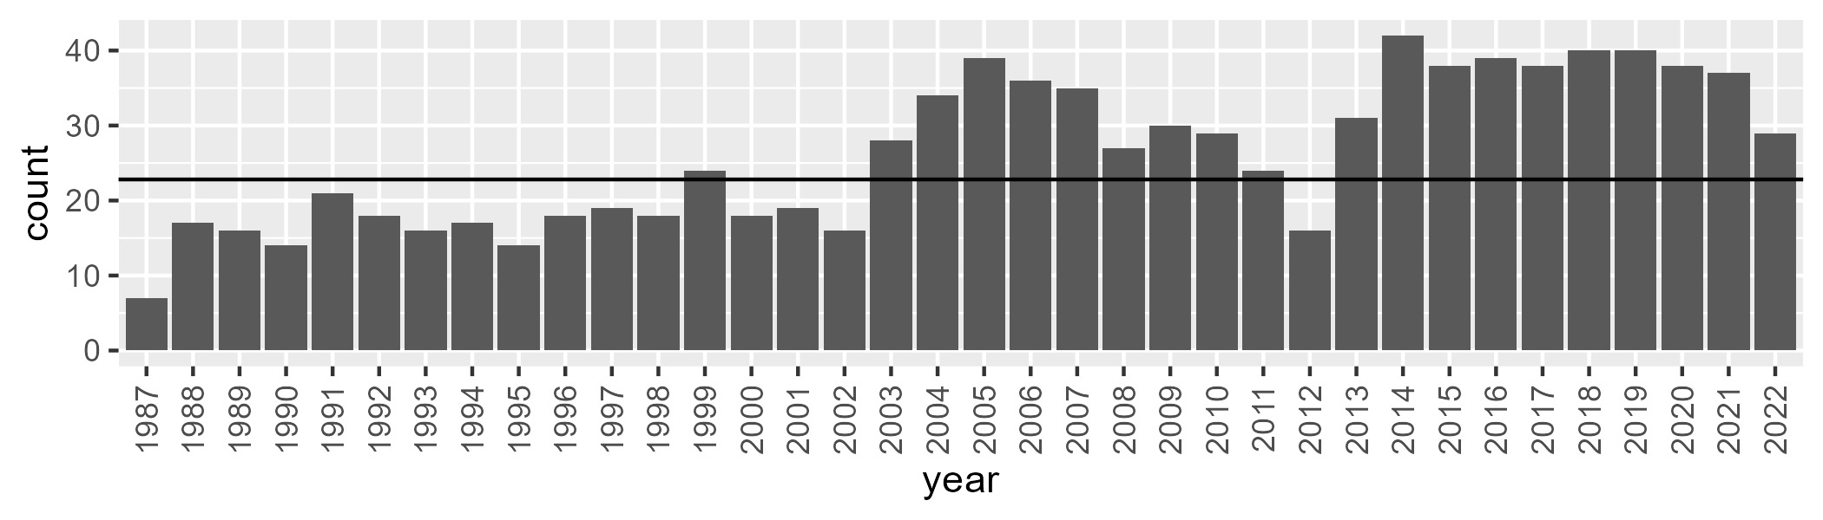

Number of samples: 942

# WAAPIL0020

| Min. | 1st Qu. | Median | Mean | 3rd Qu. | Max. |
| --- | --- | --- | --- | --- | --- |
| 0.6529394 | 6.500639 | 8.830561 | 9.957796 | 13.18185 | 26.67884 |

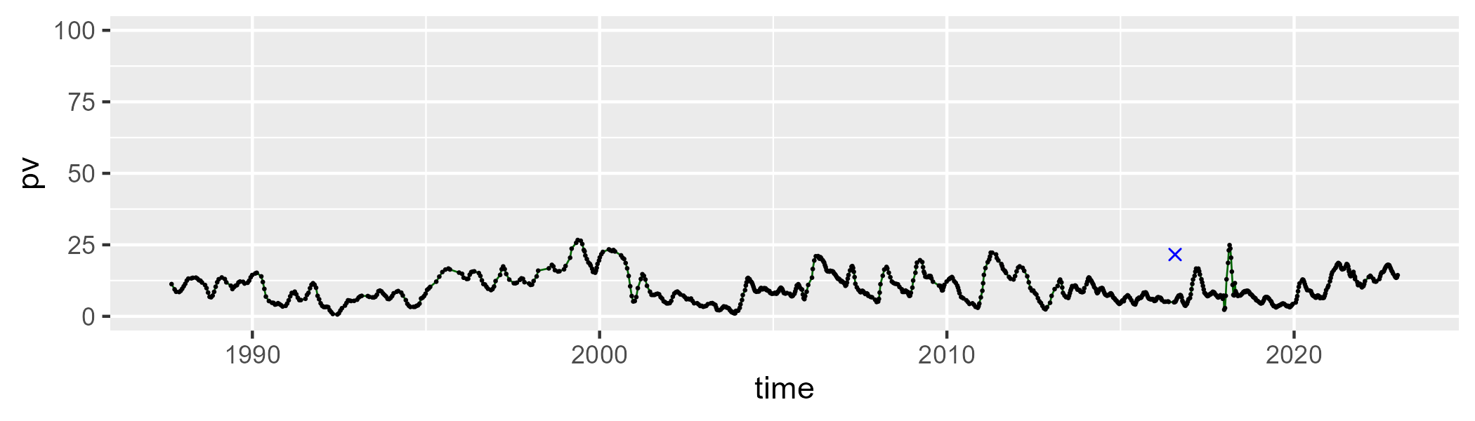

| Min. | 1st Qu. | Median | Mean | 3rd Qu. | Max. |
| --- | --- | --- | --- | --- | --- |
| 24.32936 | 38.88347 | 42.53924 | 43.42884 | 47.67775 | 63.49553 |

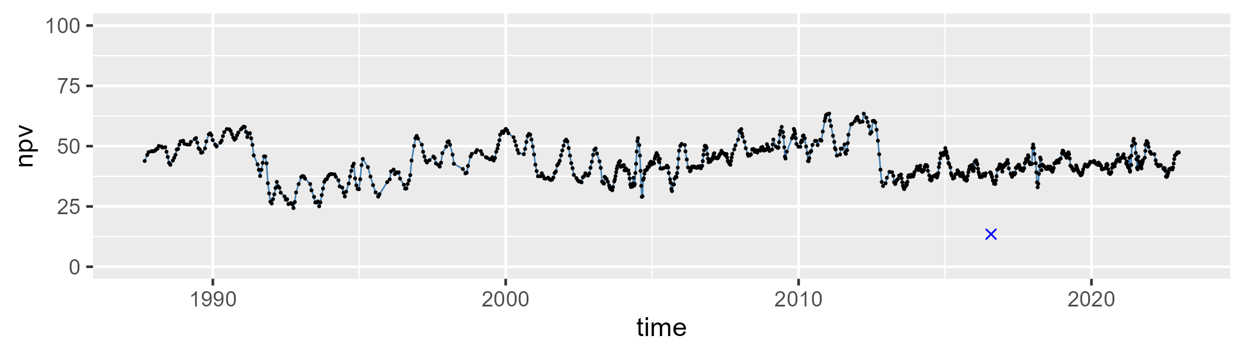

| Min. | 1st Qu. | Median | Mean | 3rd Qu. | Max. |
| --- | --- | --- | --- | --- | --- |
| 19.37845 | 38.76102 | 45.94863 | 45.1505 | 52.16346 | 69.7479 |

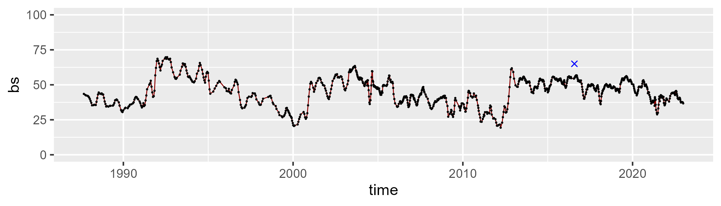

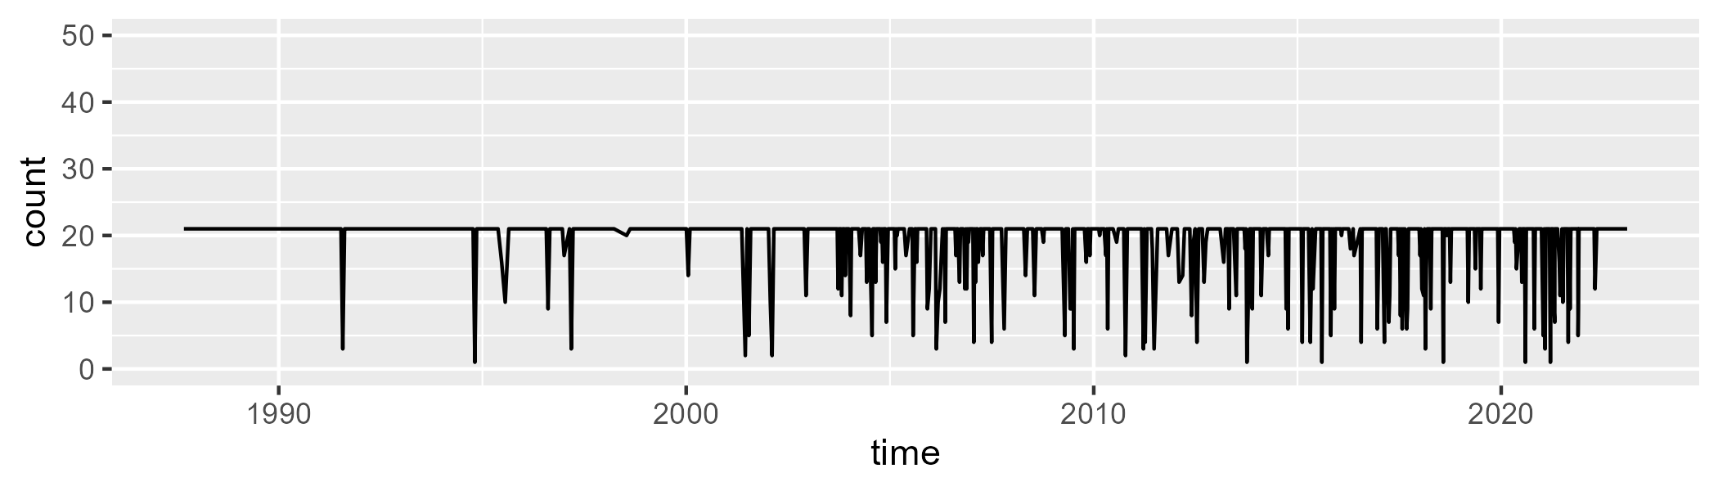

Min. : 1.00 1st Qu.:21.00 Median :21.00 Mean :19.47 3rd Qu.:21.00 Max. :21.00

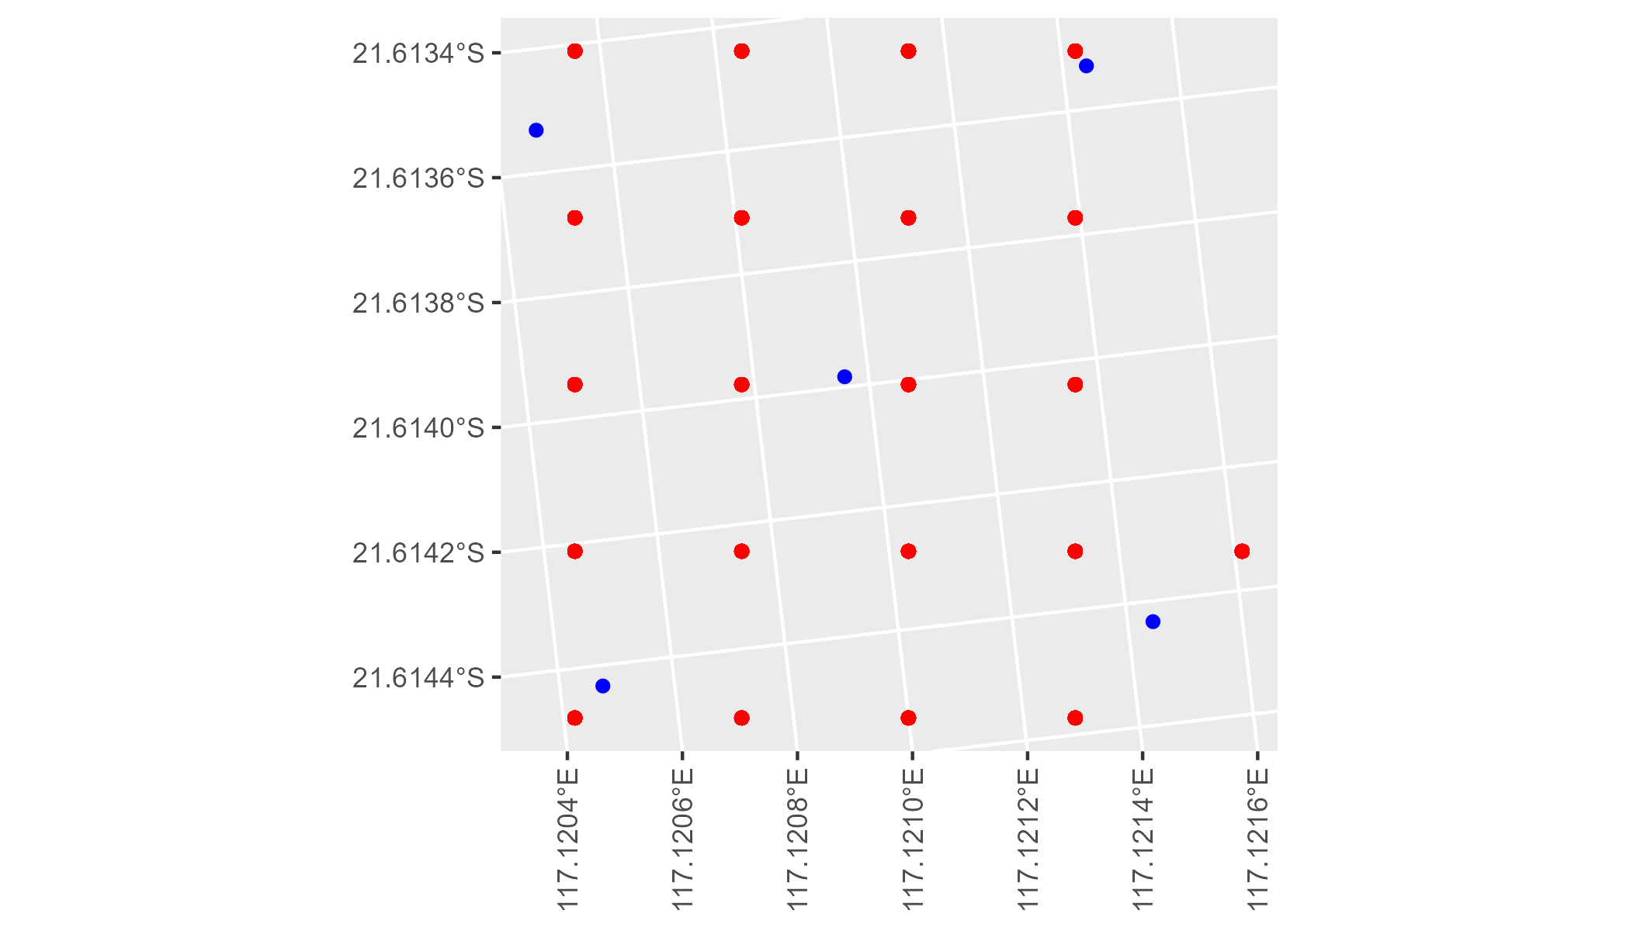

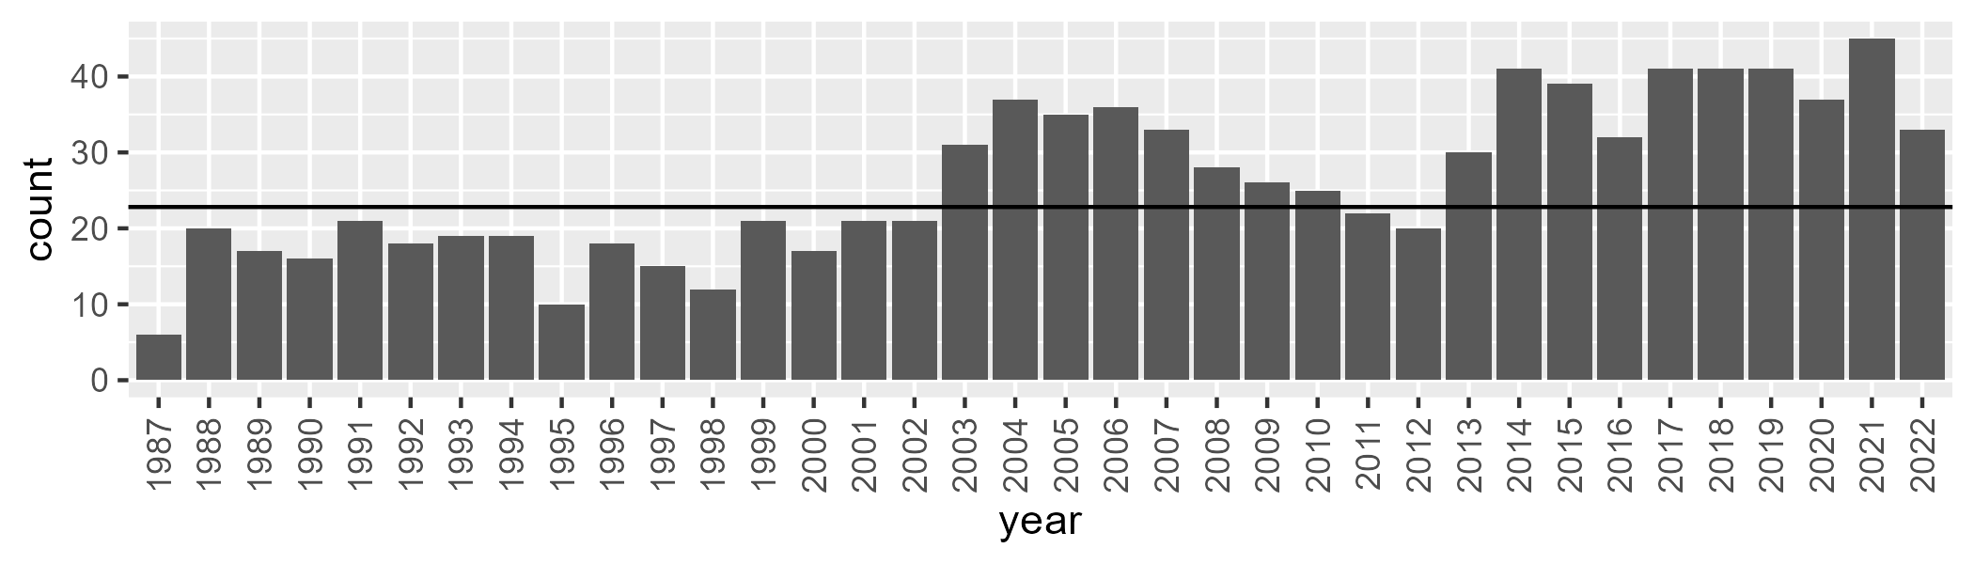

Number of samples: 944

# WAAPIL0021

| Min. | 1st Qu. | Median | Mean | 3rd Qu. | Max. |
| --- | --- | --- | --- | --- | --- |
| 1.931368 | 7.989276 | 11.3145 | 12.1165 | 14.96376 | 48.62409 |

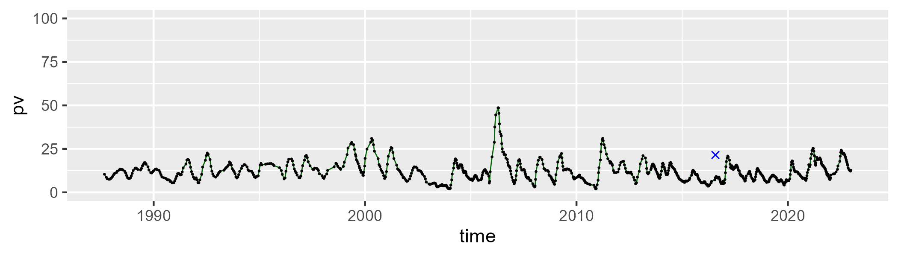

| Min. | 1st Qu. | Median | Mean | 3rd Qu. | Max. |
| --- | --- | --- | --- | --- | --- |
| 35.54064 | 42.94488 | 45.21545 | 45.69441 | 48.04089 | 61.35883 |

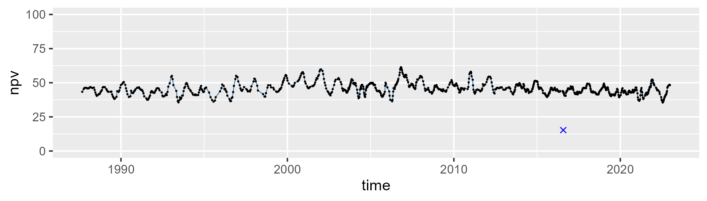

| Min. | 1st Qu. | Median | Mean | 3rd Qu. | Max. |
| --- | --- | --- | --- | --- | --- |
| 12.70216 | 37.60631 | 41.55541 | 40.71969 | 45.08492 | 52.01581 |

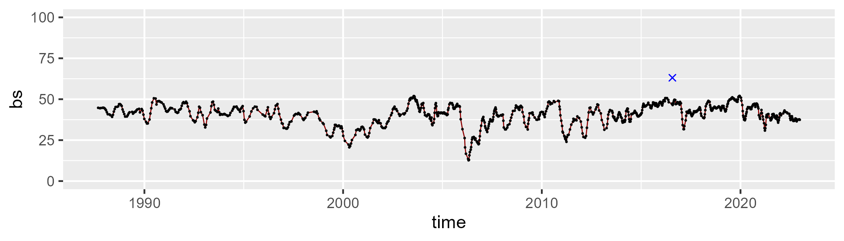

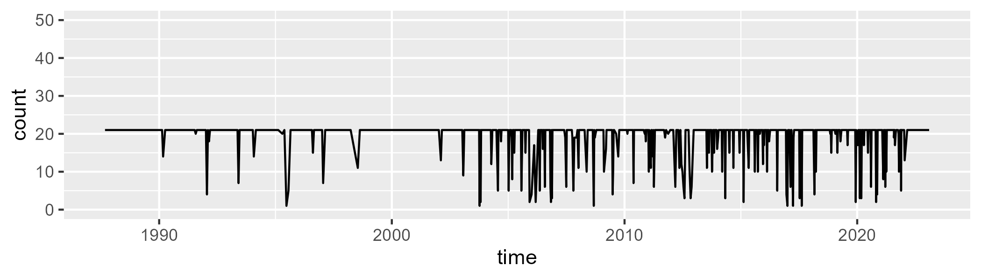

Min. : 1.00 1st Qu.:21.00 Median :21.00 Mean :19.57 3rd Qu.:21.00 Max. :21.00

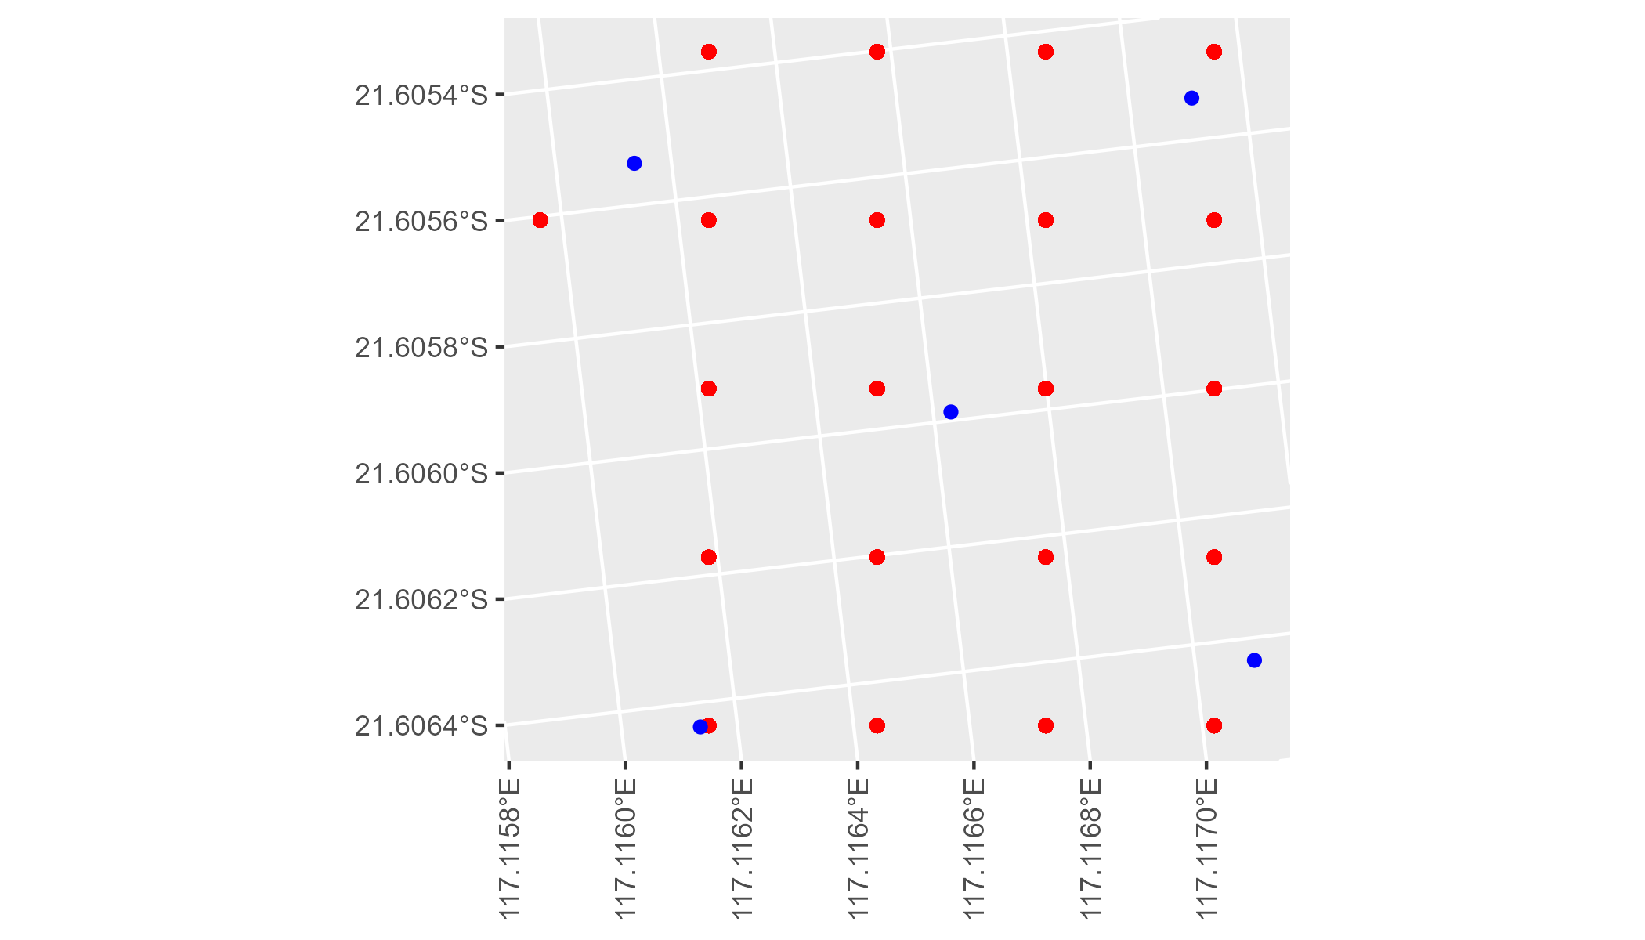

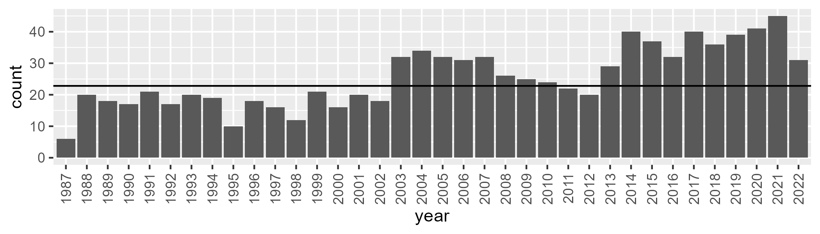

Number of samples: 917

# WAAPIL0022

| Min. | 1st Qu. | Median | Mean | 3rd Qu. | Max. |
| --- | --- | --- | --- | --- | --- |
| 10.02966 | 23.57517 | 27.70381 | 27.6624 | 31.3912 | 46.49209 |

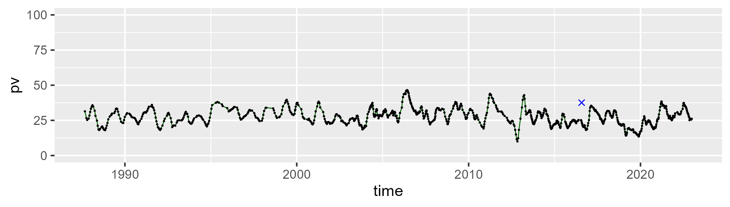

| Min. | 1st Qu. | Median | Mean | 3rd Qu. | Max. |
| --- | --- | --- | --- | --- | --- |
| 32.82385 | 40.9668 | 43.46047 | 44.13521 | 47.06032 | 62.39249 |

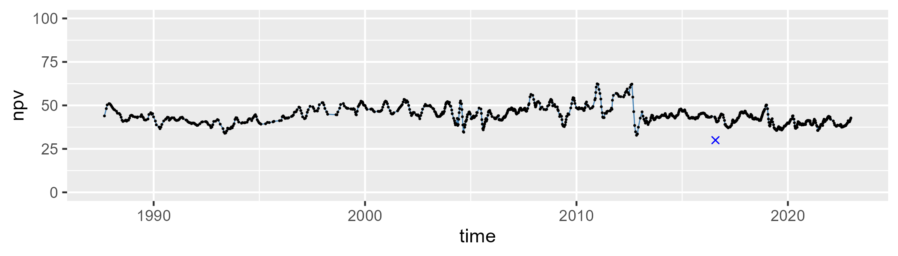

| Min. | 1st Qu. | Median | Mean | 3rd Qu. | Max. |
| --- | --- | --- | --- | --- | --- |
| 7.664333 | 21.89689 | 26.61608 | 26.73574 | 31.10574 | 55.64682 |

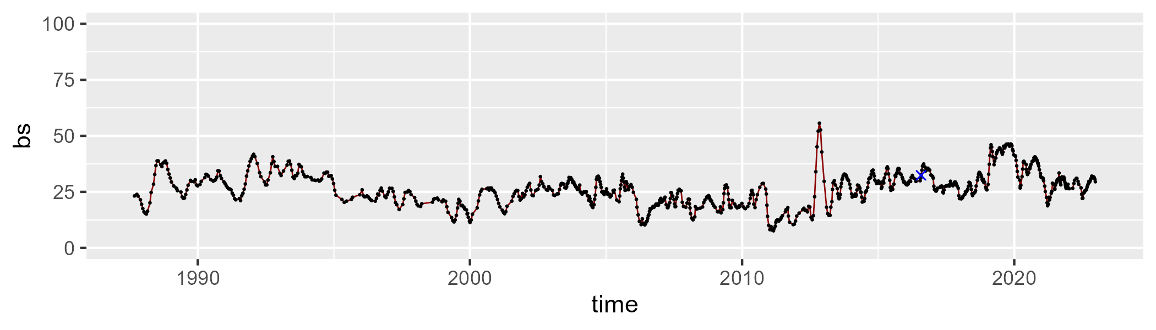

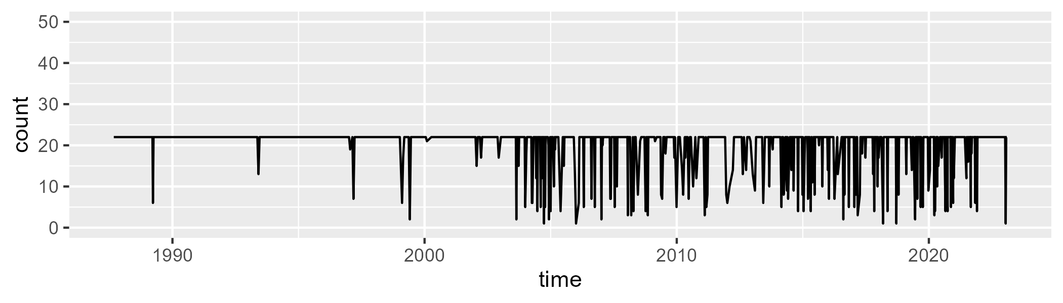

Min. : 1.00 1st Qu.:22.00 Median :22.00 Mean :20.02 3rd Qu.:22.00 Max. :22.00

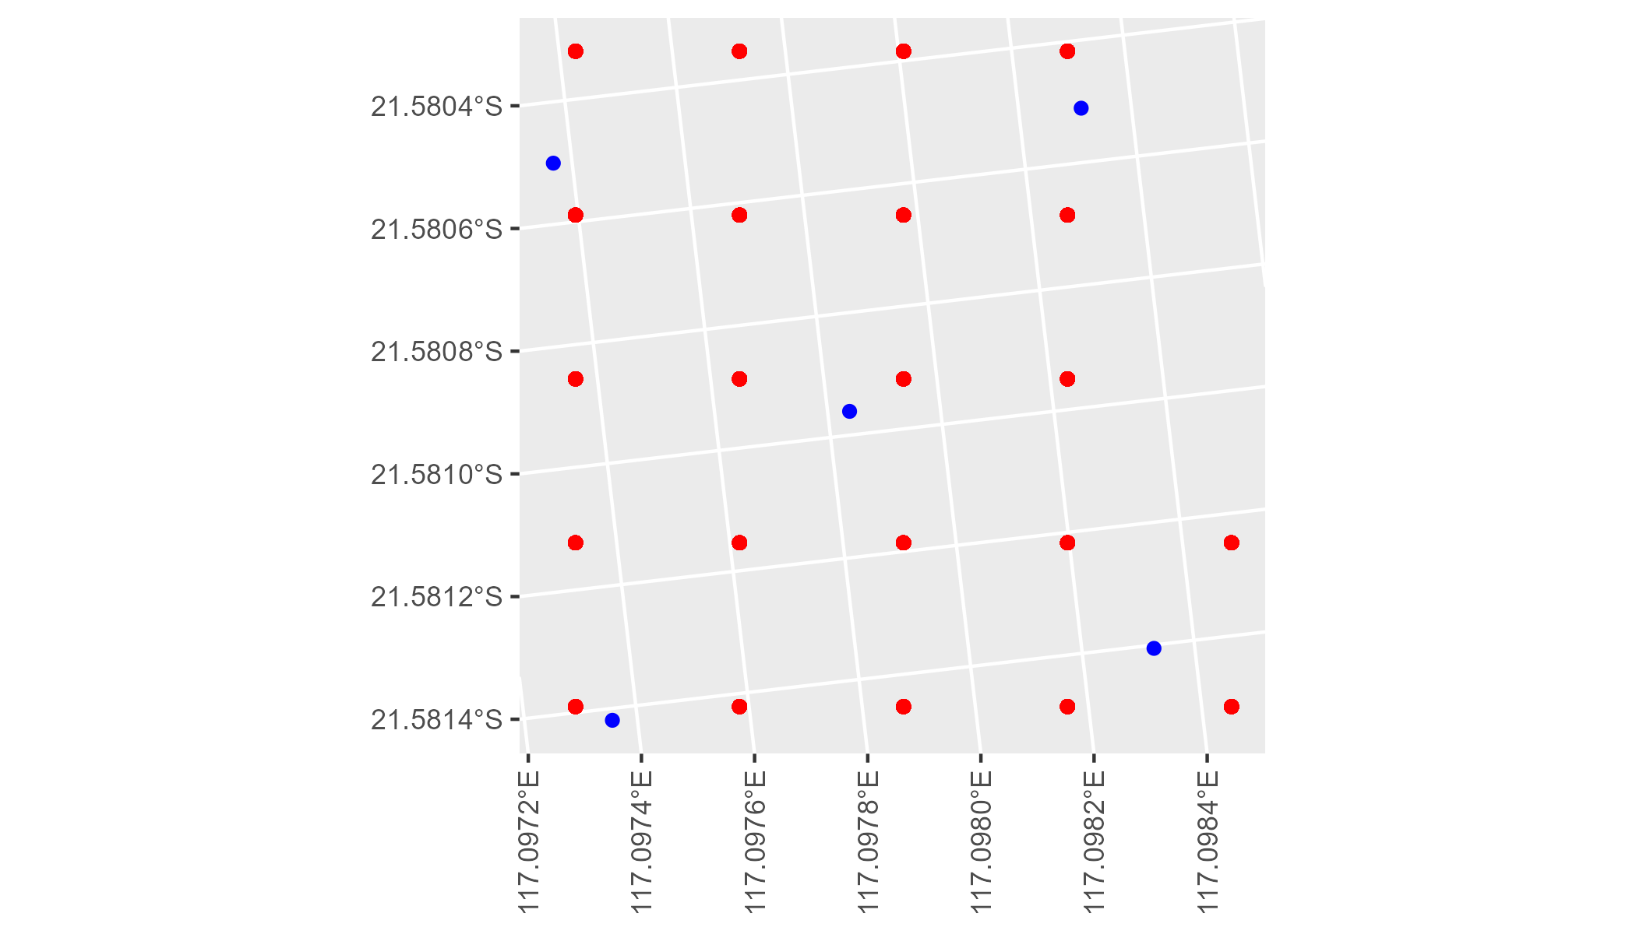

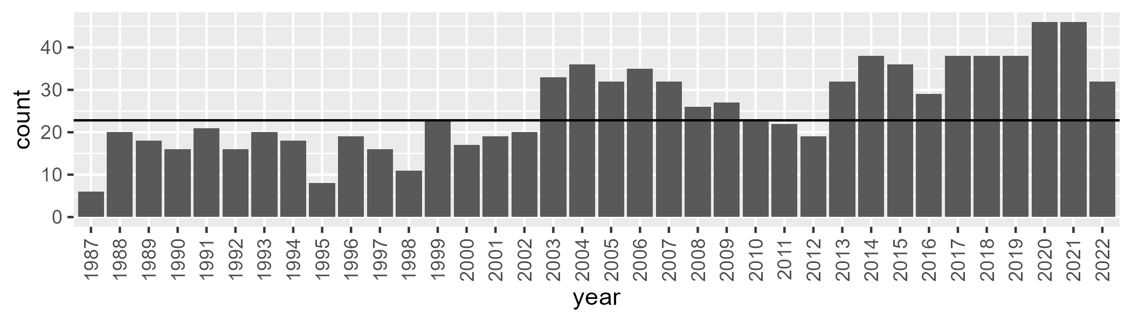

Number of samples: 926

# WAAPIL0023

| Min. | 1st Qu. | Median | Mean | 3rd Qu. | Max. |
| --- | --- | --- | --- | --- | --- |
| 6.311732 | 12.02941 | 15.47921 | 17.47504 | 21.72282 | 39.94283 |

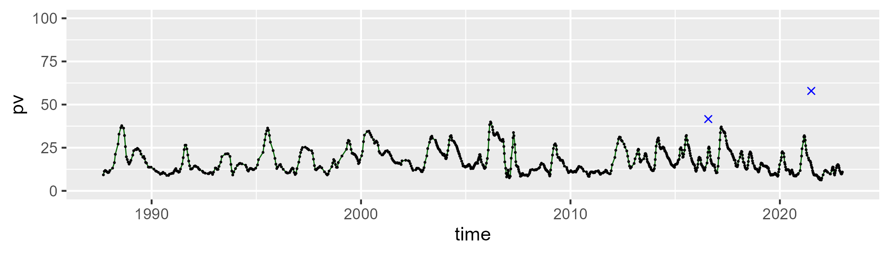

| Min. | 1st Qu. | Median | Mean | 3rd Qu. | Max. |
| --- | --- | --- | --- | --- | --- |
| 32.44445 | 42.46336 | 45.33033 | 45.02695 | 47.69819 | 53.94364 |

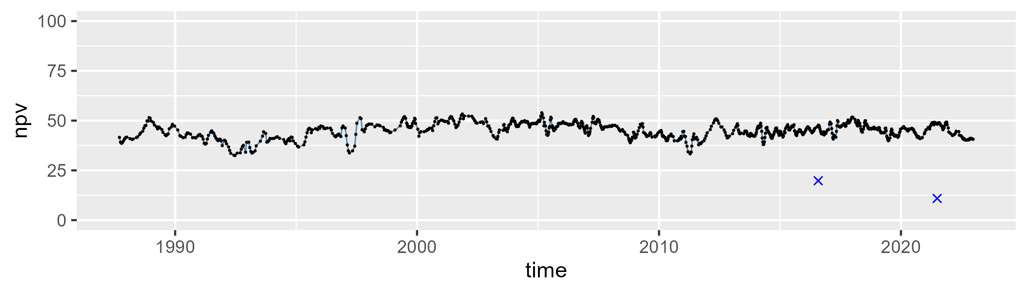

| Min. | 1st Qu. | Median | Mean | 3rd Qu. | Max. |
| --- | --- | --- | --- | --- | --- |
| 10.37615 | 29.88505 | 37.36182 | 36.08889 | 43.01781 | 55.26925 |

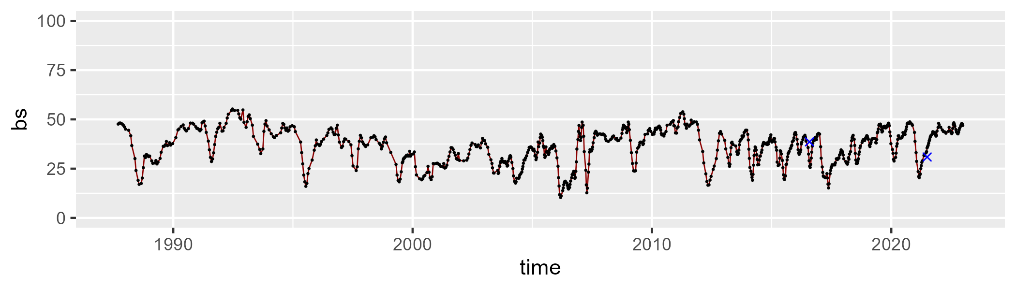

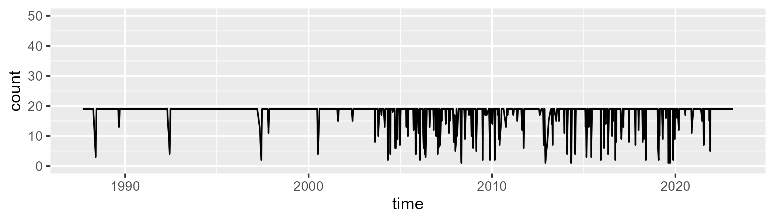

Min. : 1.00 1st Qu.:19.00 Median :19.00 Mean :17.67 3rd Qu.:19.00 Max. :19.00

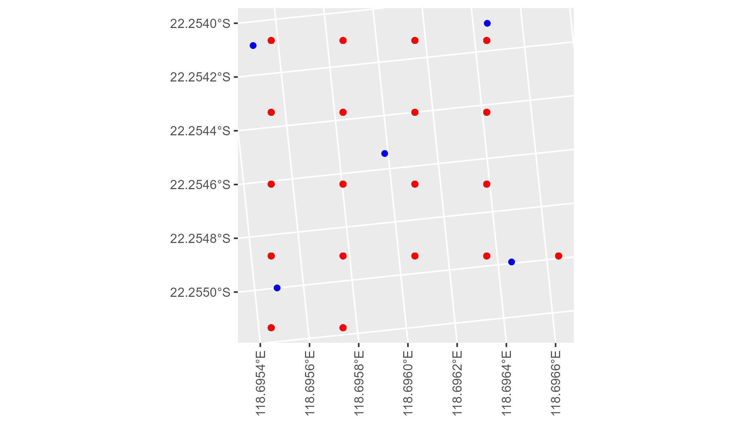

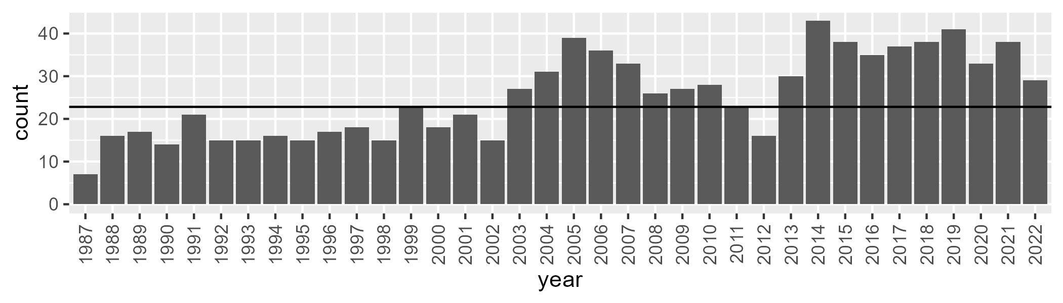

Number of samples: 911

# WAAPIL0024

| Min. | 1st Qu. | Median | Mean | 3rd Qu. | Max. |
| --- | --- | --- | --- | --- | --- |
| 1.735161 | 7.015715 | 9.094664 | 10.65324 | 12.87558 | 39.21777 |

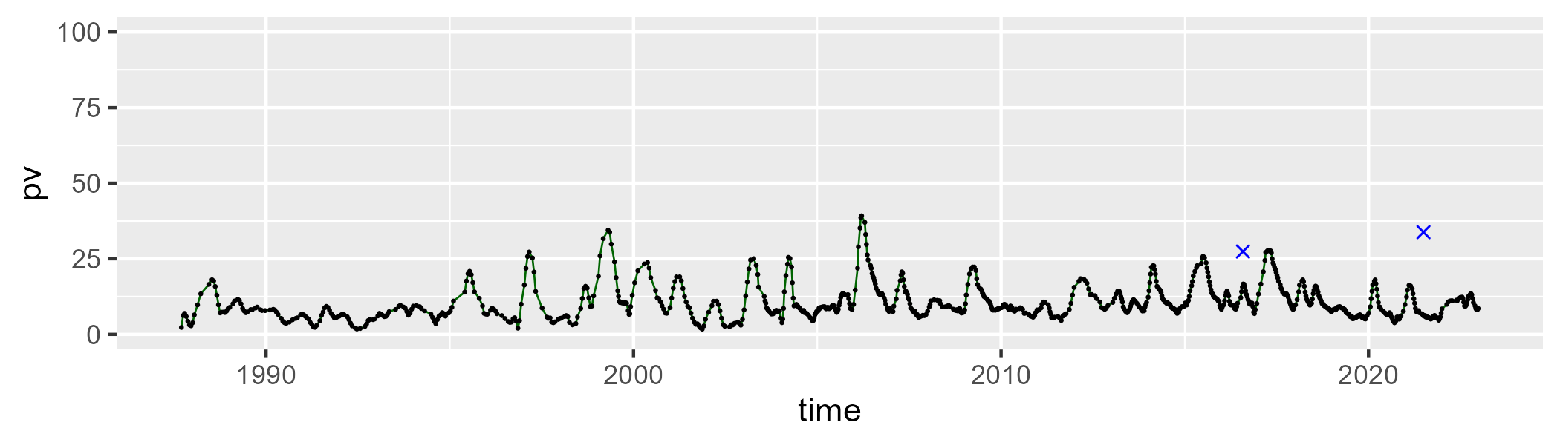

| Min. | 1st Qu. | Median | Mean | 3rd Qu. | Max. |
| --- | --- | --- | --- | --- | --- |
| 11.57173 | 28.55479 | 31.9627 | 32.27922 | 35.5604 | 53.43201 |

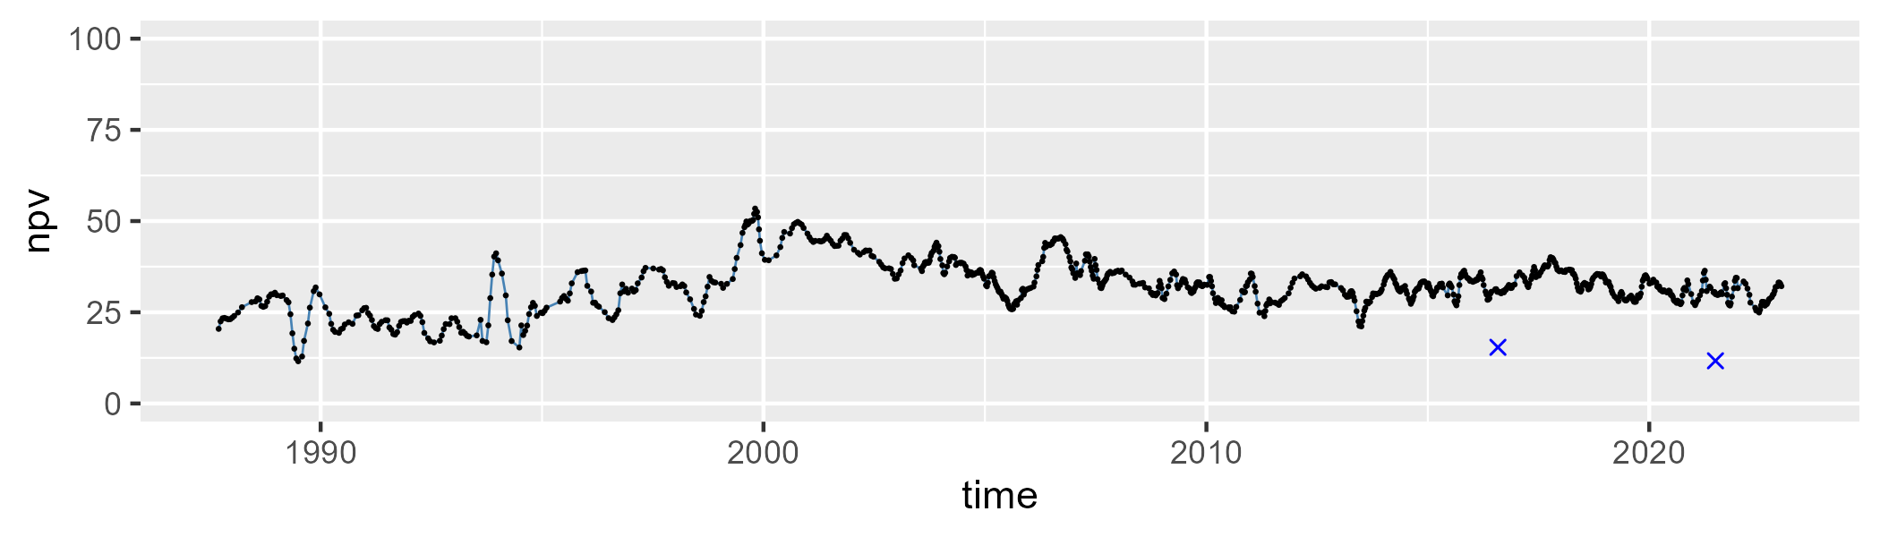

| Min. | 1st Qu. | Median | Mean | 3rd Qu. | Max. |
| --- | --- | --- | --- | --- | --- |
| 21.43721 | 50.37725 | 56.41786 | 55.31298 | 61.02276 | 79.56446 |

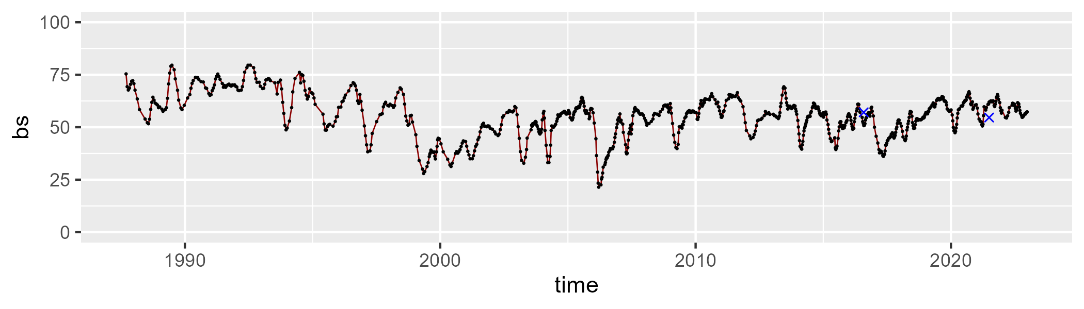

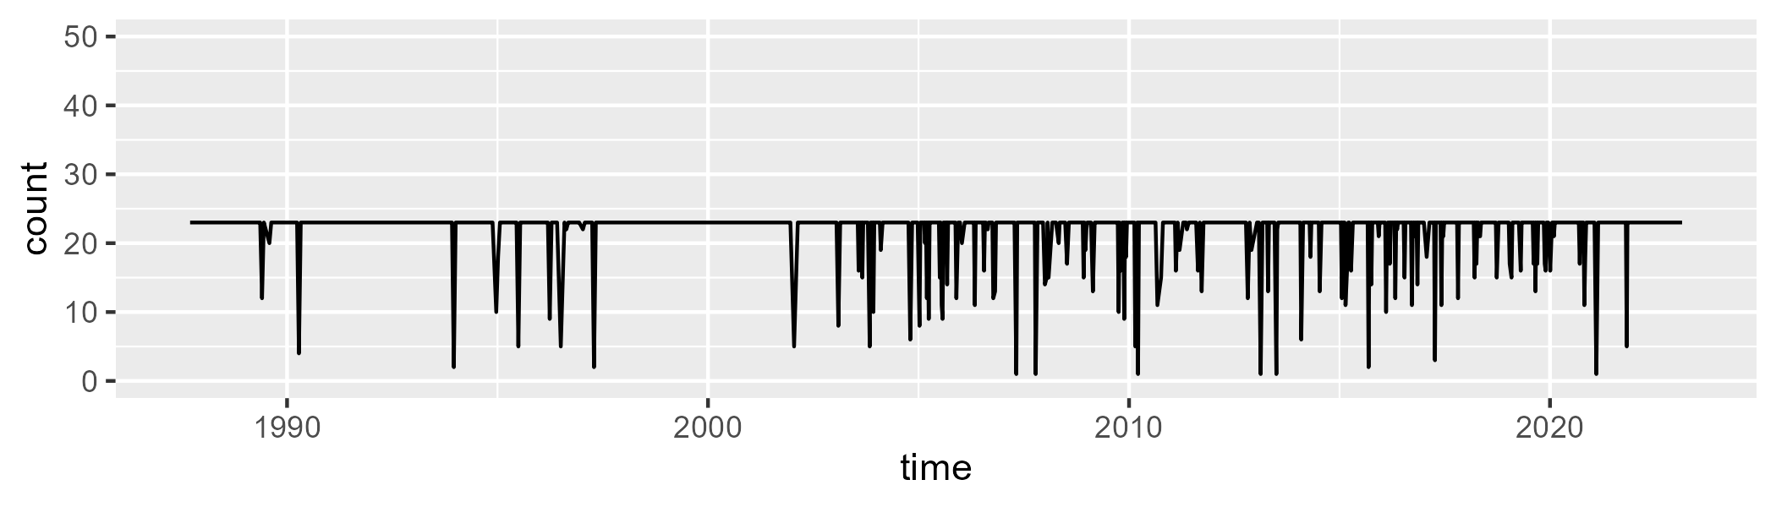

Min. : 1.00 1st Qu.:23.00 Median :23.00 Mean :21.86 3rd Qu.:23.00 Max. :23.00

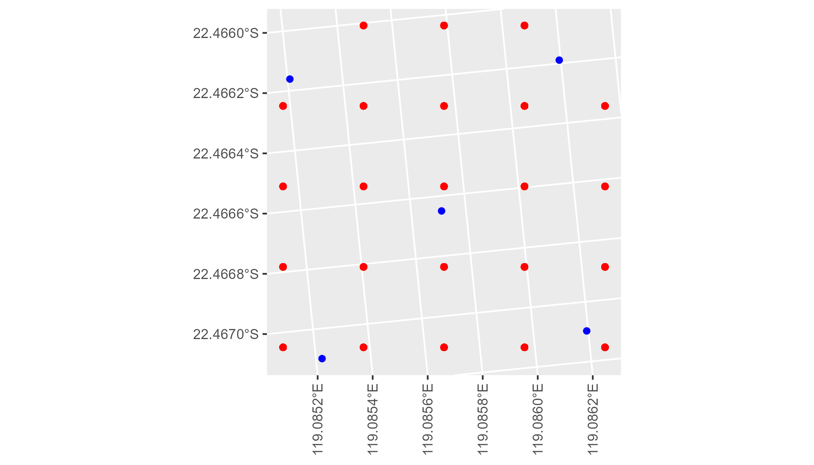

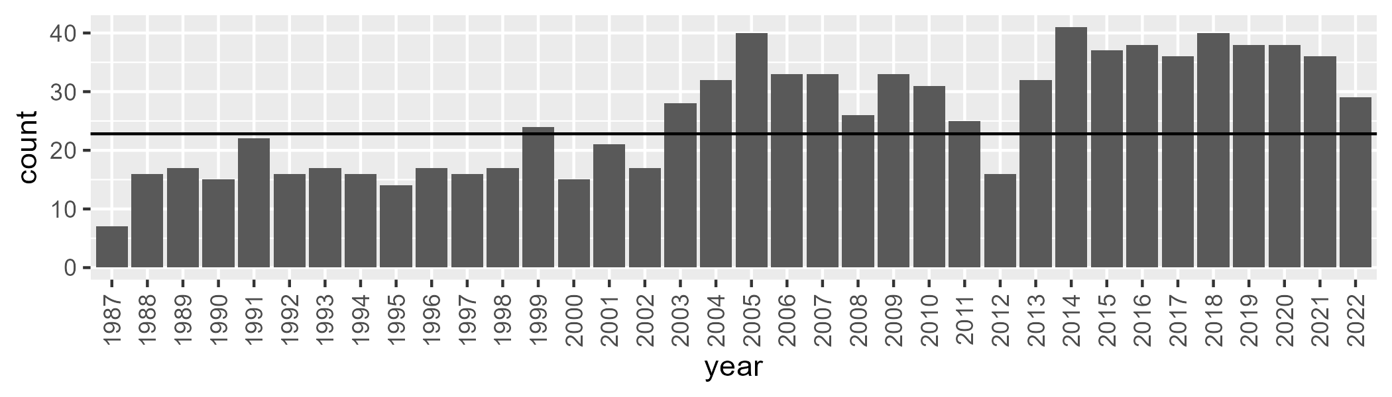

Number of samples: 929

# WAAPIL0025

| Min. | 1st Qu. | Median | Mean | 3rd Qu. | Max. |
| --- | --- | --- | --- | --- | --- |
| 5.856906 | 15.55332 | 19.51298 | 20.90432 | 25.89399 | 47.2125 |

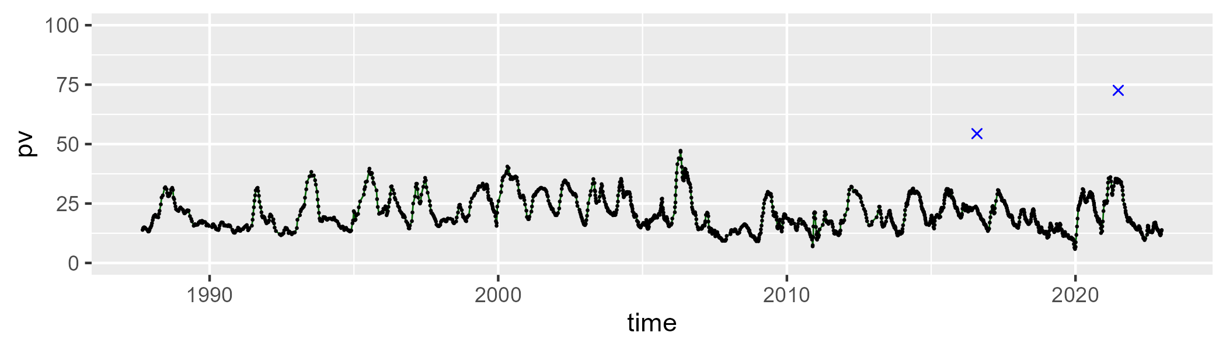

| Min. | 1st Qu. | Median | Mean | 3rd Qu. | Max. |
| --- | --- | --- | --- | --- | --- |
| 32.10743 | 45.25958 | 47.33991 | 47.12971 | 49.31417 | 57.5483 |

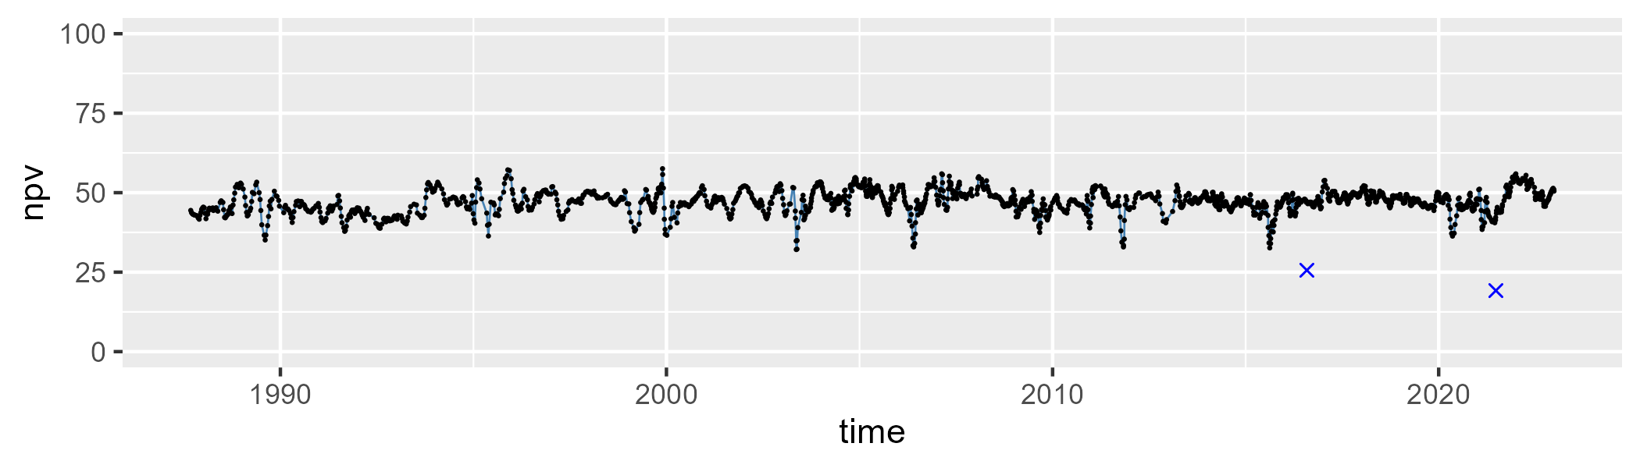

| Min. | 1st Qu. | Median | Mean | 3rd Qu. | Max. |
| --- | --- | --- | --- | --- | --- |
| 6.147234 | 25.91862 | 30.8953 | 30.62228 | 35.69693 | 53.26099 |

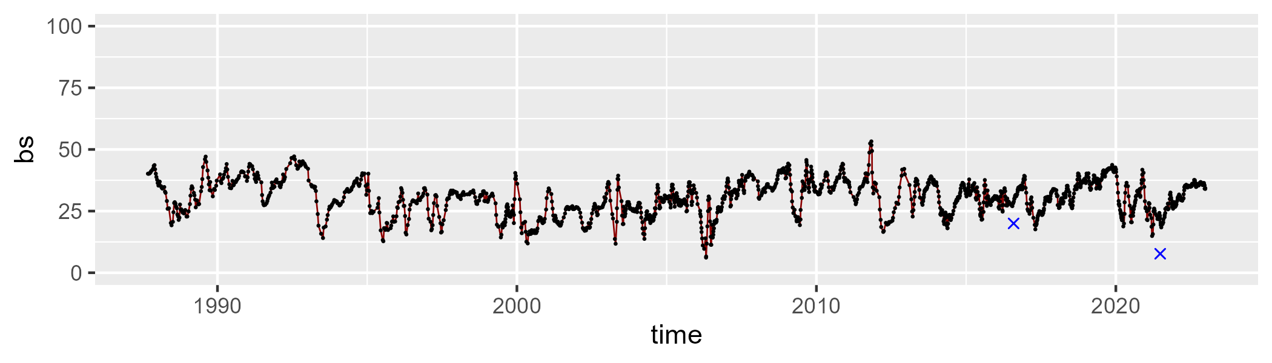

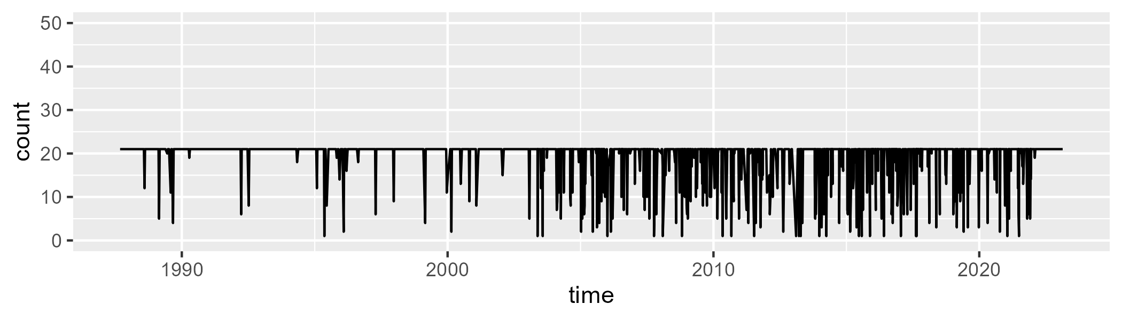

Min. : 1.00 1st Qu.:21.00 Median :21.00 Mean :19.42 3rd Qu.:21.00 Max. :21.00

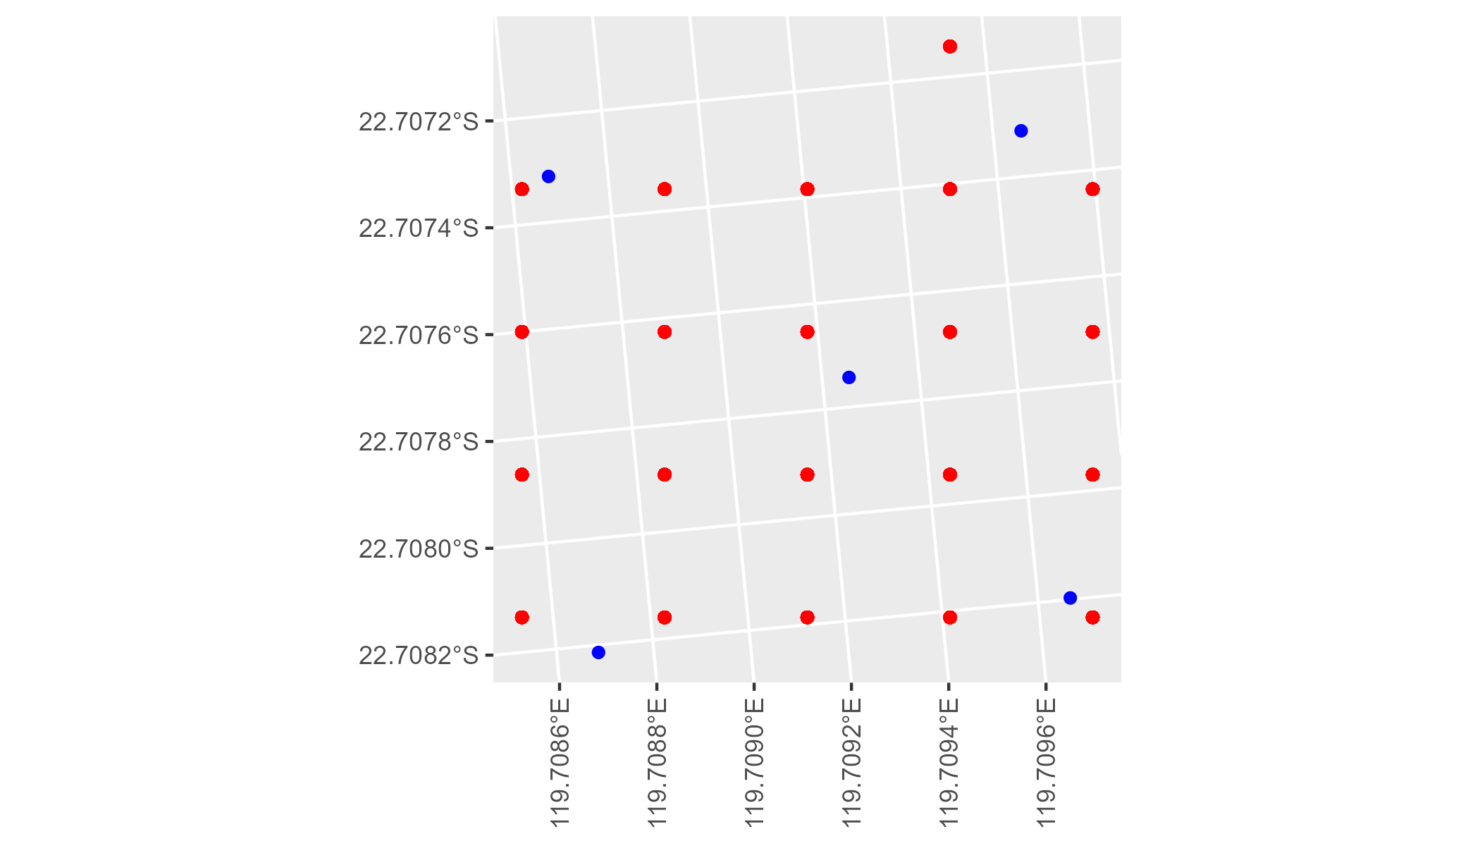

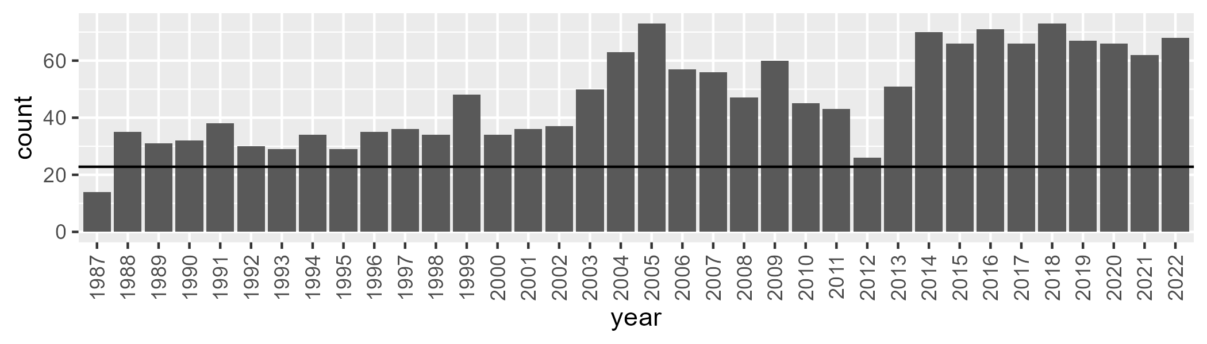

Number of samples: 1712

# WAAPIL0026

| Min. | 1st Qu. | Median | Mean | 3rd Qu. | Max. |
| --- | --- | --- | --- | --- | --- |
| 0.07951388 | 6.119109 | 7.801634 | 9.051203 | 10.69256 | 32.02144 |

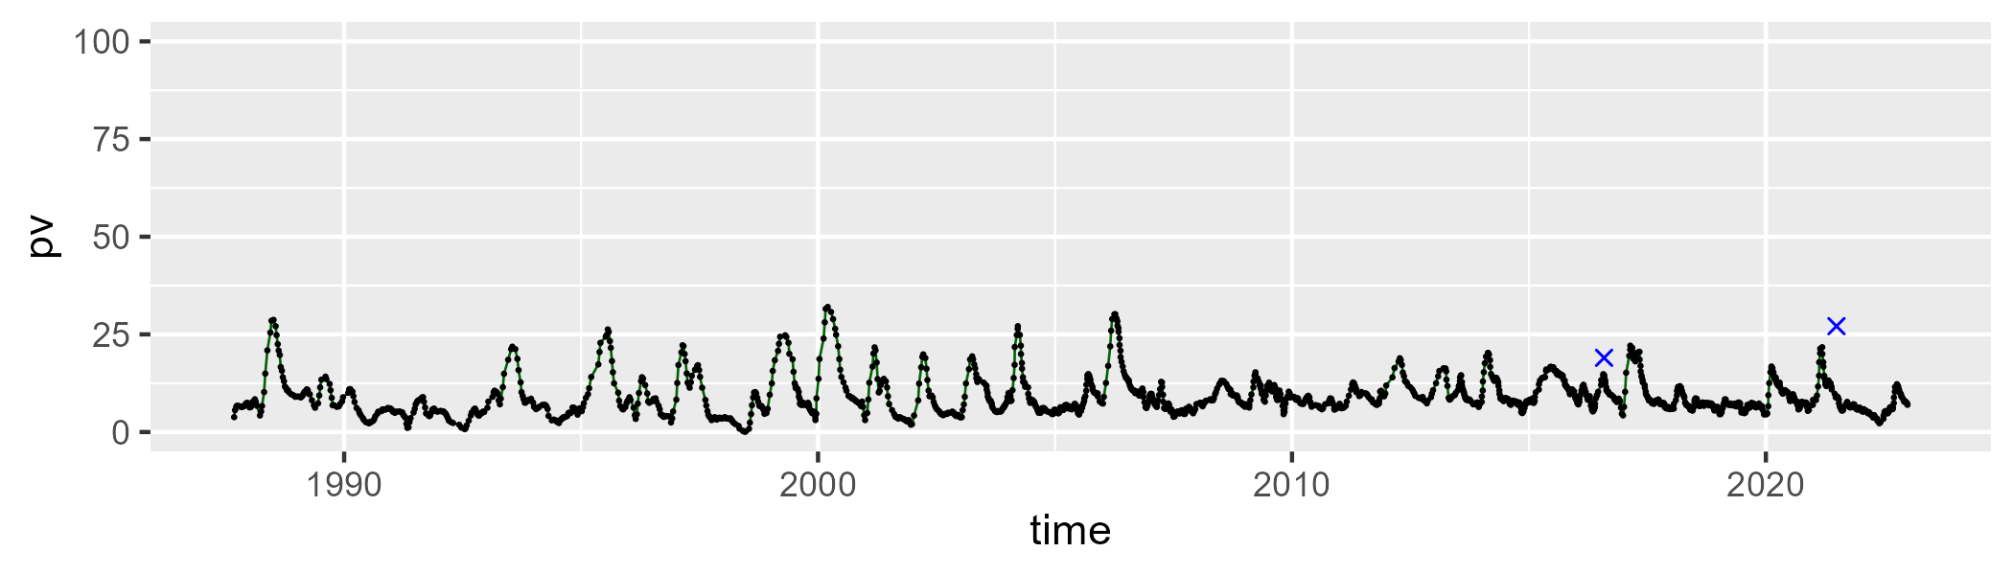

| Min. | 1st Qu. | Median | Mean | 3rd Qu. | Max. |
| --- | --- | --- | --- | --- | --- |
| 24.98197 | 33.91492 | 37.23886 | 37.95227 | 40.55217 | 64.49553 |

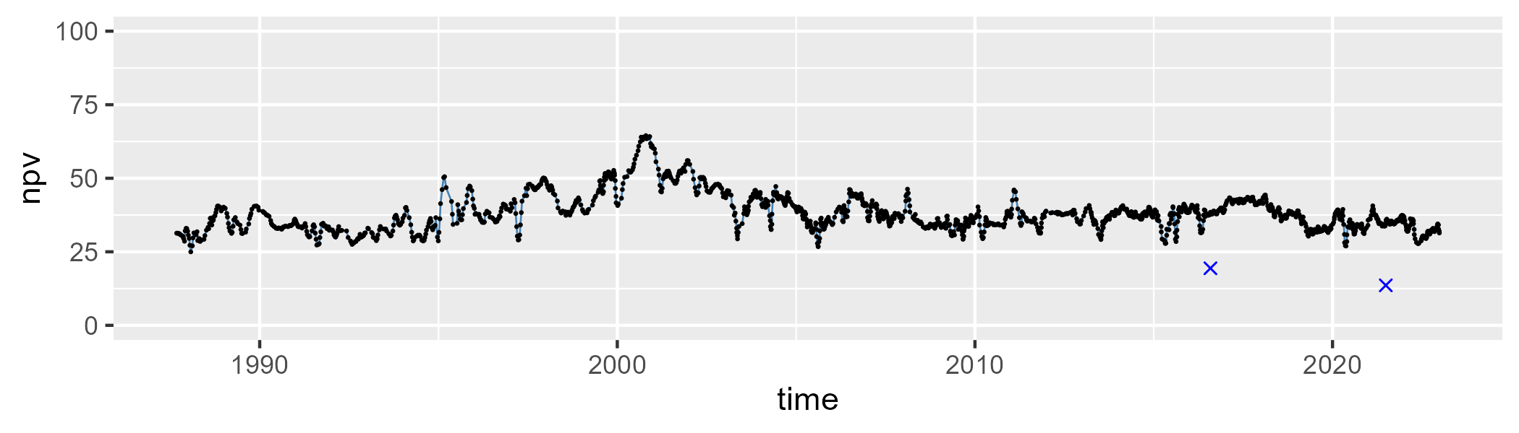

| Min. | 1st Qu. | Median | Mean | 3rd Qu. | Max. |
| --- | --- | --- | --- | --- | --- |
| 16.27483 | 47.52918 | 52.68466 | 51.37792 | 56.57951 | 69.34862 |

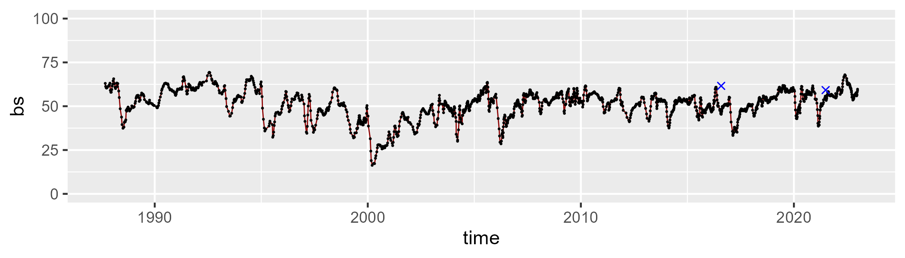

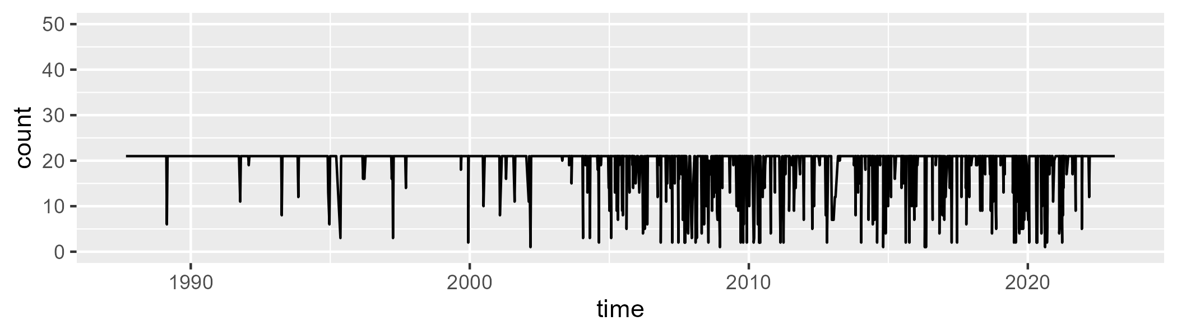

Min. : 1.00 1st Qu.:21.00 Median :21.00 Mean :19.51 3rd Qu.:21.00 Max. :21.00

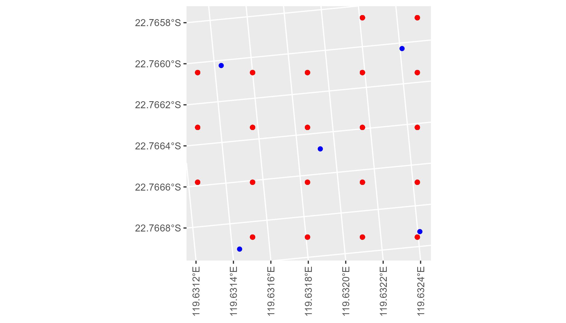

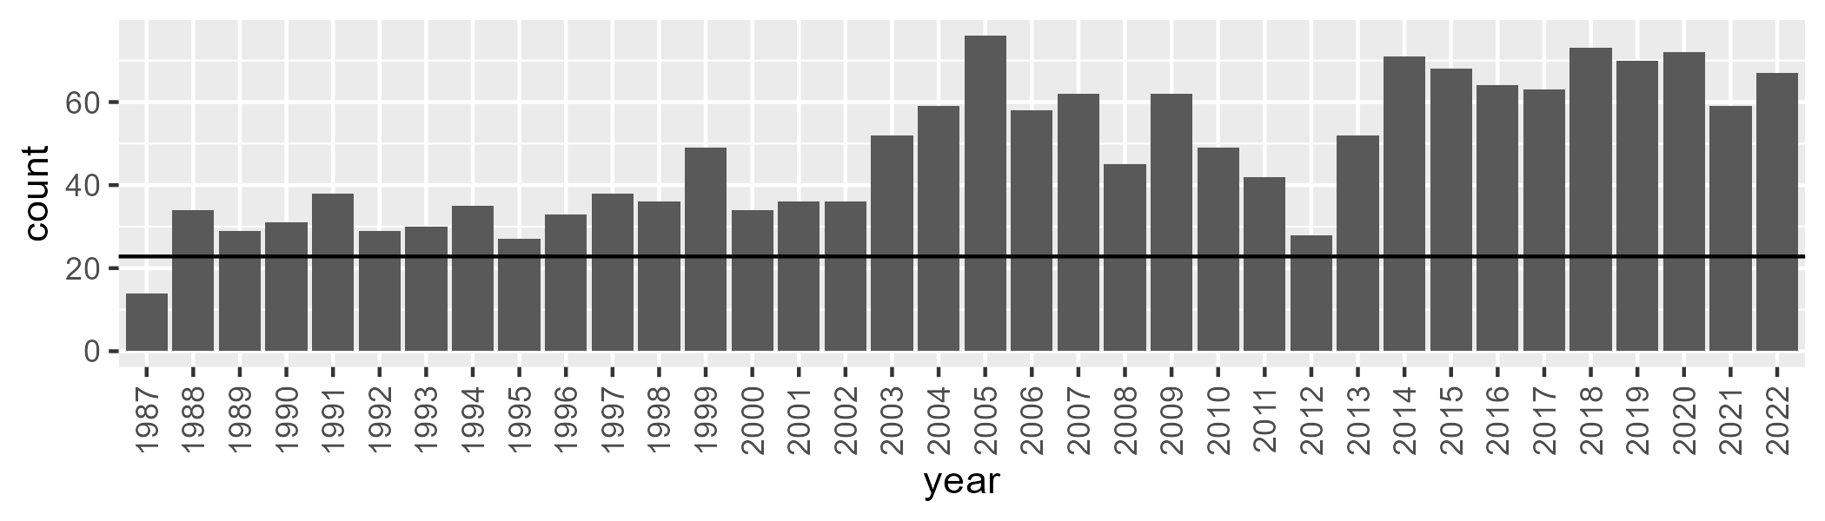

Number of samples: 1721

# WAAPIL0027

| Min. | 1st Qu. | Median | Mean | 3rd Qu. | Max. |
| --- | --- | --- | --- | --- | --- |
| 1.809982 | 8.218192 | 11.47267 | 11.76414 | 14.20555 | 27.52999 |

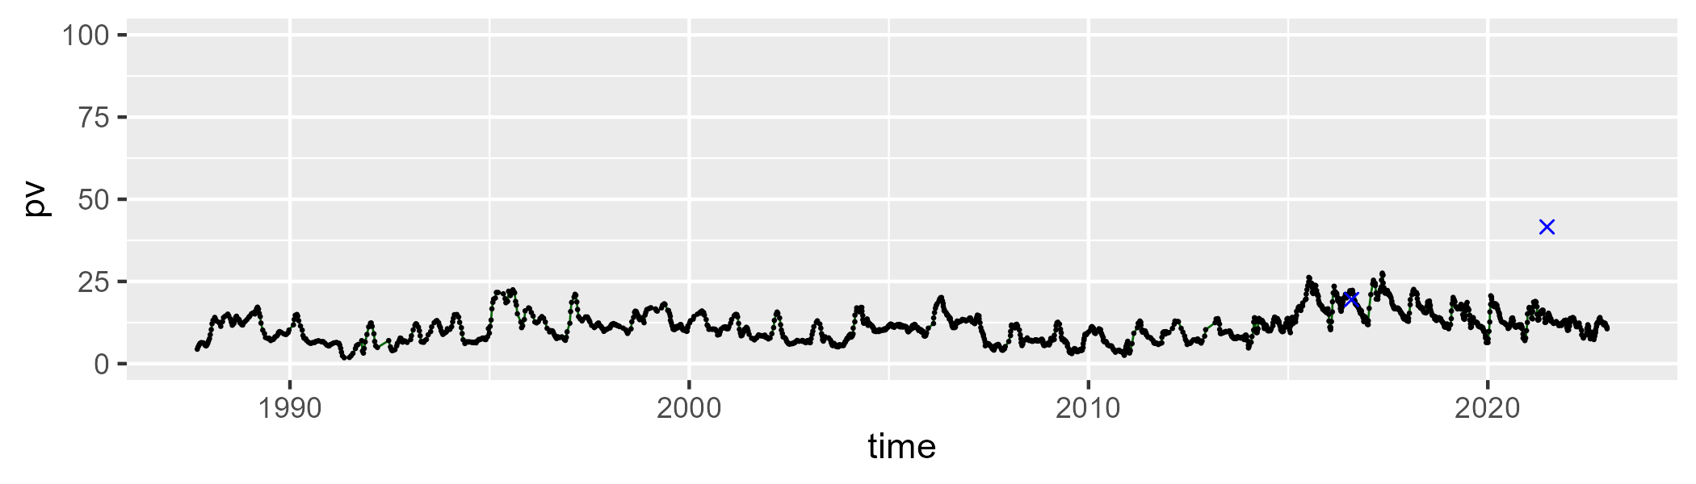

| Min. | 1st Qu. | Median | Mean | 3rd Qu. | Max. |
| --- | --- | --- | --- | --- | --- |
| 19.00888 | 35.7328 | 41.46495 | 41.77444 | 48.26826 | 61.47697 |

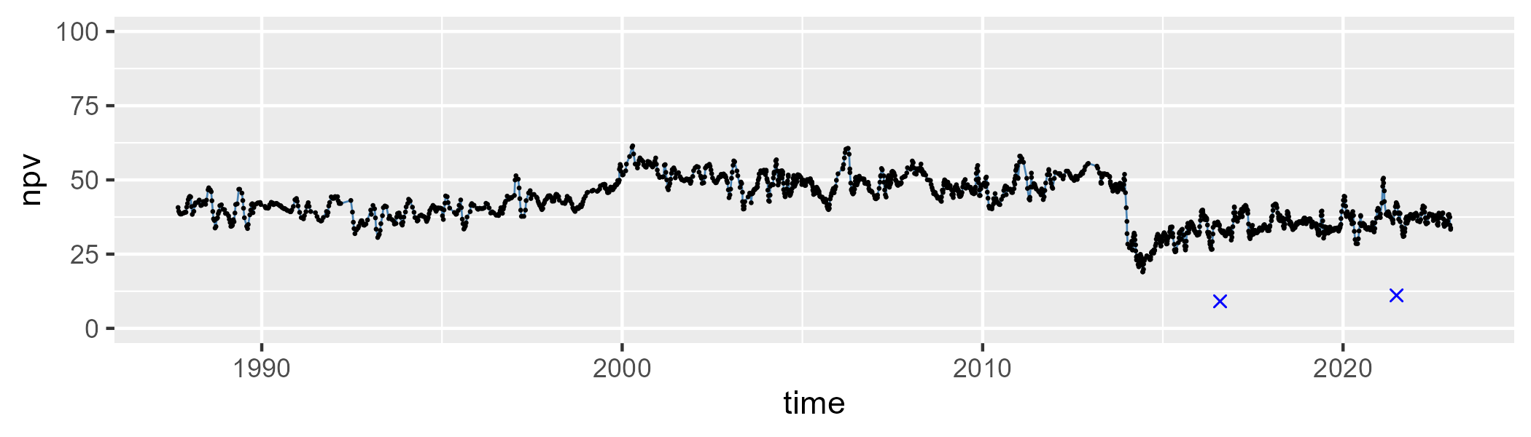

| Min. | 1st Qu. | Median | Mean | 3rd Qu. | Max. |
| --- | --- | --- | --- | --- | --- |
| 18.52011 | 40.25904 | 44.77594 | 44.93365 | 49.66277 | 67.36459 |

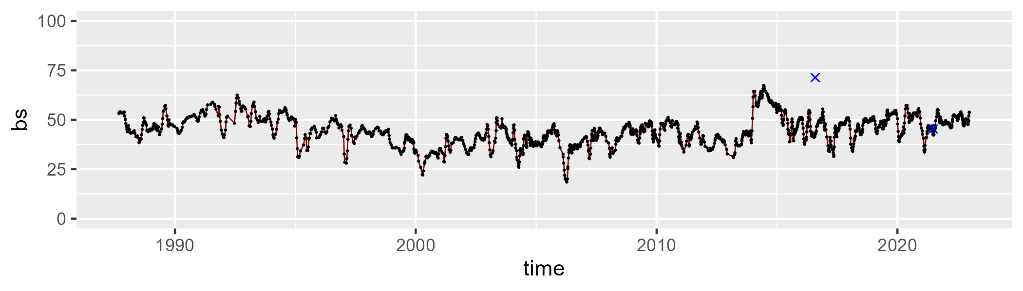

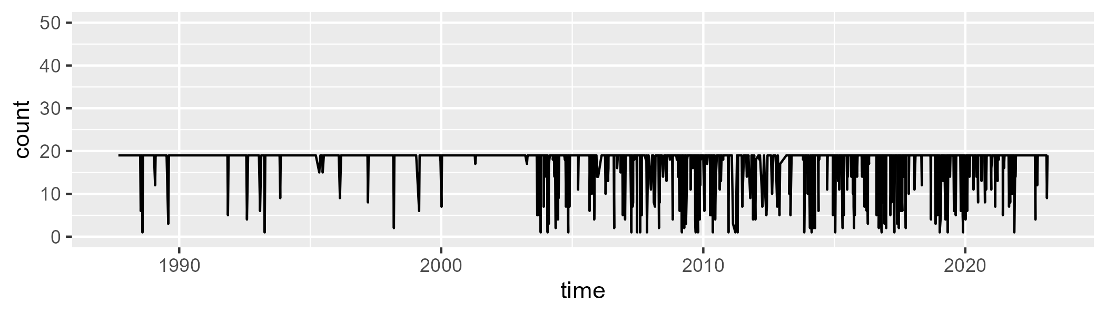

Min. : 1.00 1st Qu.:19.00 Median :19.00 Mean :17.54 3rd Qu.:19.00 Max. :19.00

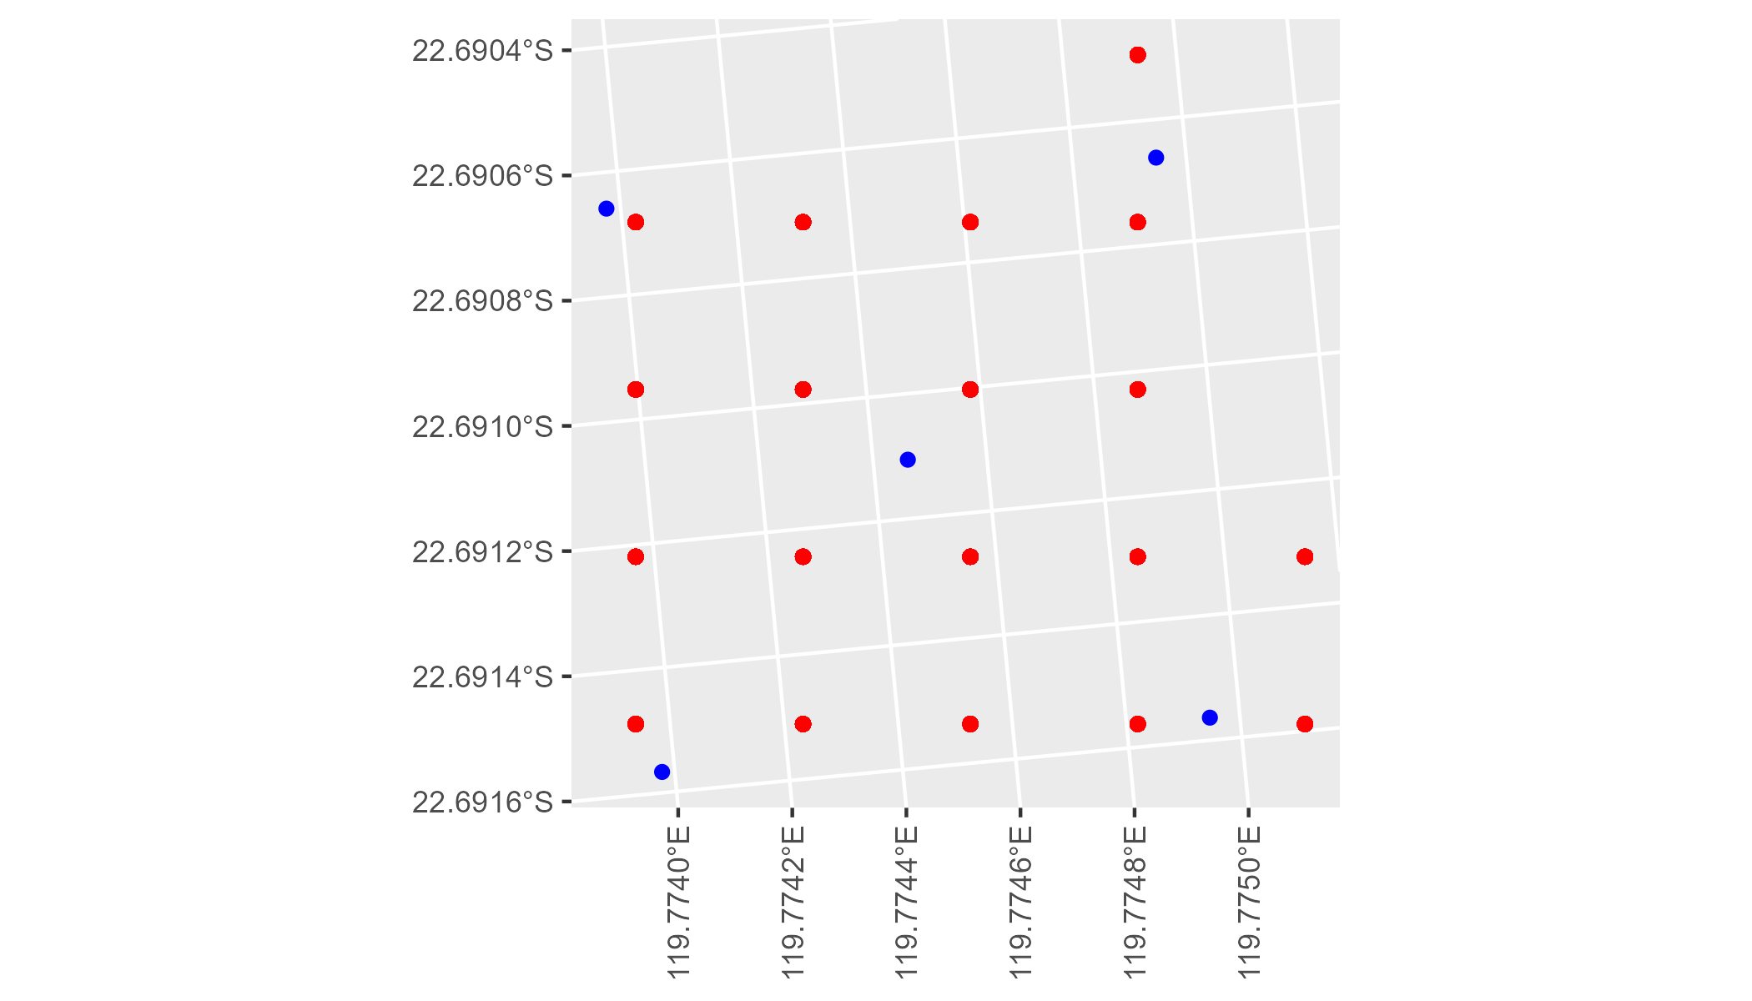

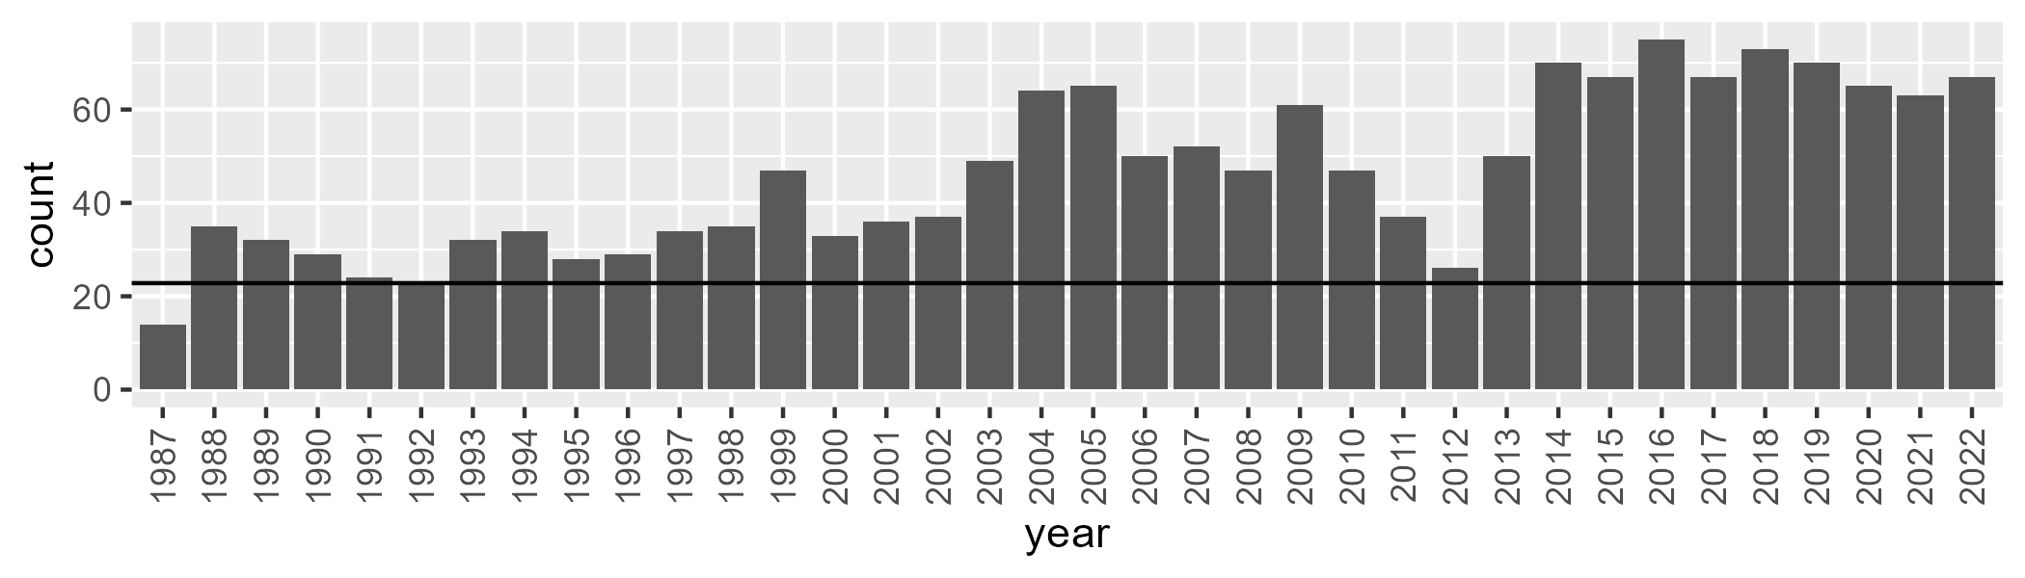

Number of samples: 1667

# WAAPIL0028

| Min. | 1st Qu. | Median | Mean | 3rd Qu. | Max. |
| --- | --- | --- | --- | --- | --- |
| 7.050625 | 12.1765 | 13.65849 | 13.62595 | 14.91035 | 19.92921 |

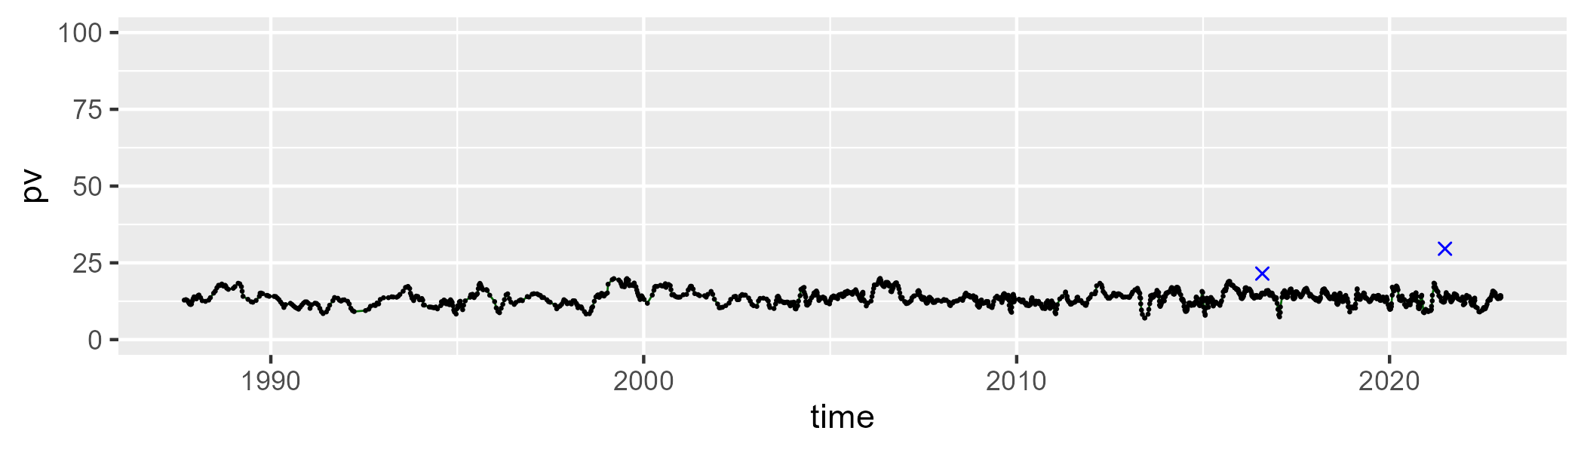

| Min. | 1st Qu. | Median | Mean | 3rd Qu. | Max. |
| --- | --- | --- | --- | --- | --- |
| 23.17754 | 29.86475 | 32.46427 | 32.73077 | 34.90147 | 54.58853 |

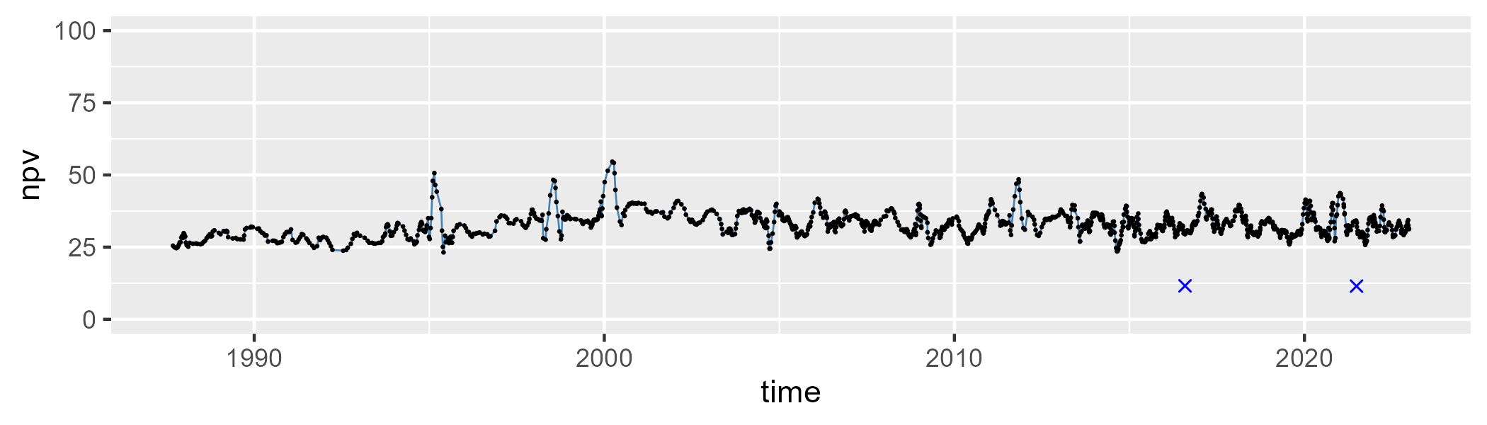

| Min. | 1st Qu. | Median | Mean | 3rd Qu. | Max. |
| --- | --- | --- | --- | --- | --- |
| 28.46647 | 49.17951 | 51.99413 | 52.05323 | 55.07682 | 65.11906 |

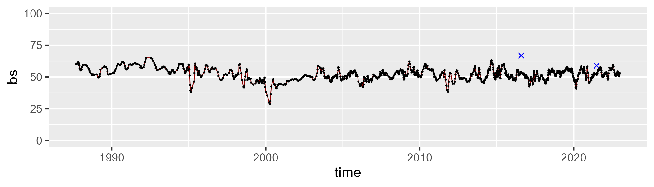

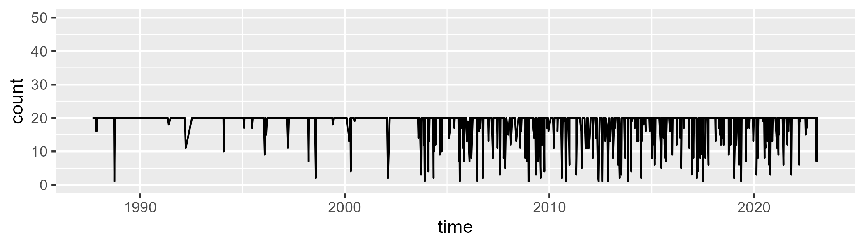

Min. : 1.00 1st Qu.:20.00 Median :20.00 Mean :18.56 3rd Qu.:20.00 Max. :20.00

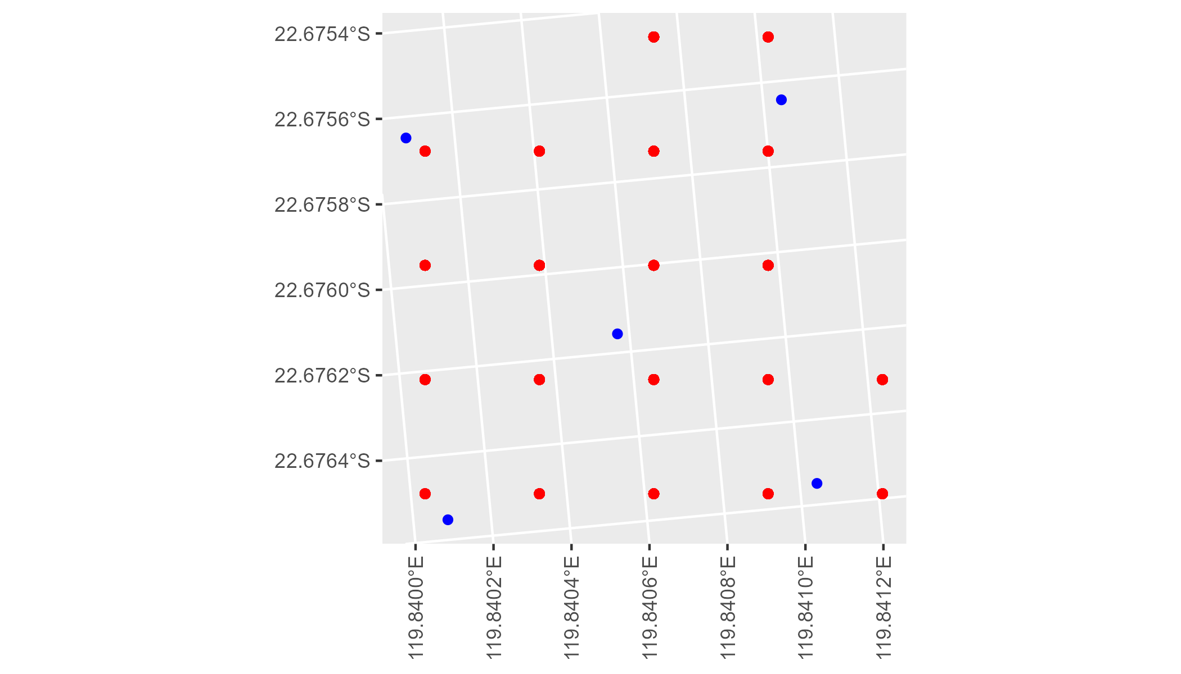

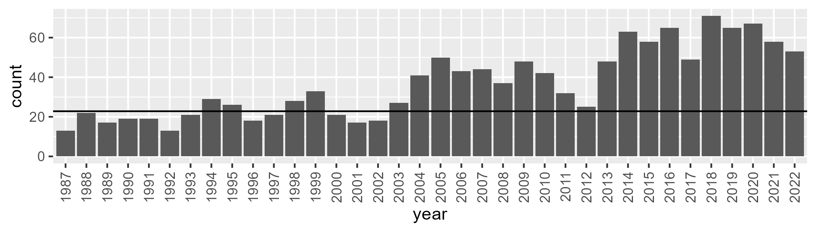

Number of samples: 1321

# WAAPIL0029

| Min. | 1st Qu. | Median | Mean | 3rd Qu. | Max. |
| --- | --- | --- | --- | --- | --- |
| 9.010308 | 18.13708 | 21.84962 | 23.21593 | 27.7179 | 48.11077 |

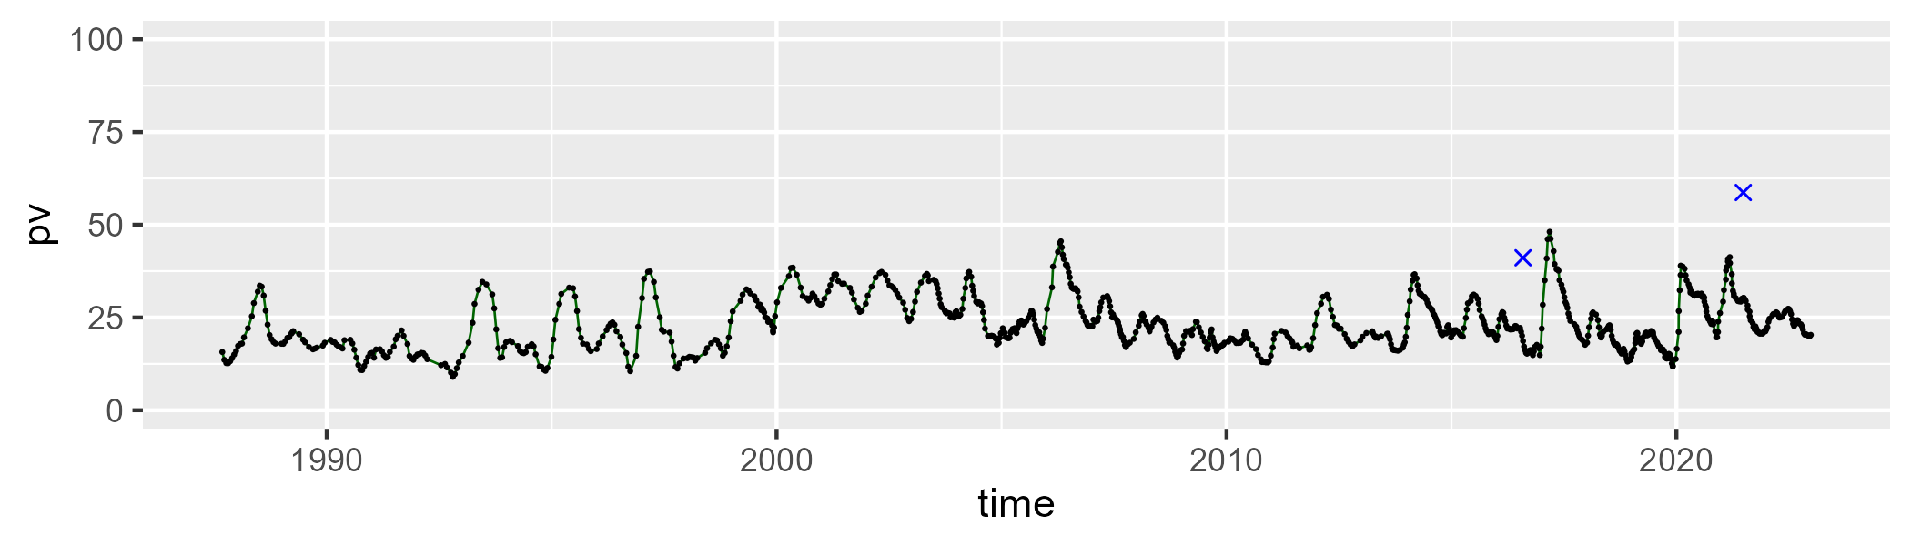

| Min. | 1st Qu. | Median | Mean | 3rd Qu. | Max. |
| --- | --- | --- | --- | --- | --- |
| 39.85277 | 45.93161 | 48.69208 | 48.7016 | 51.18669 | 58.57373 |

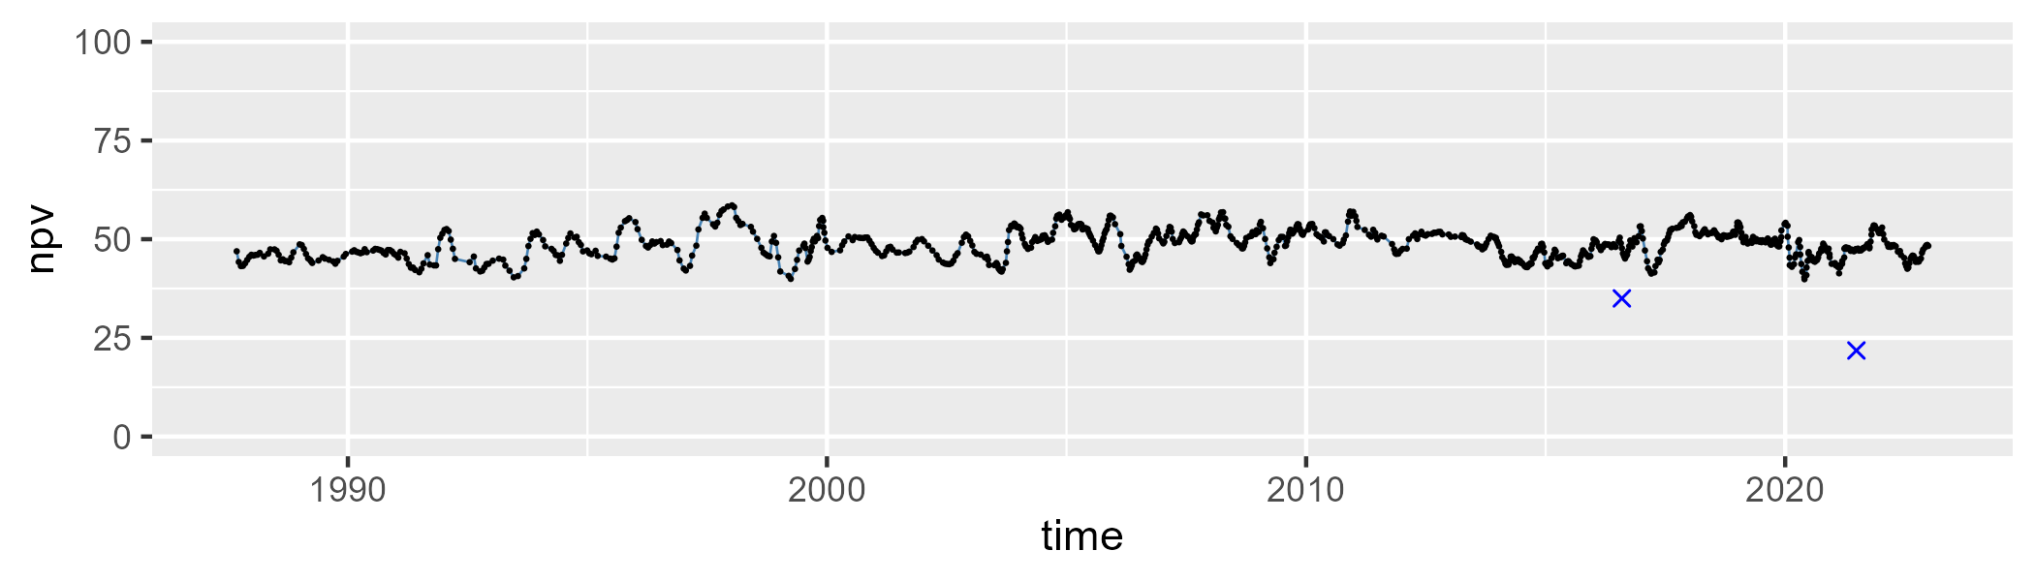

| Min. | 1st Qu. | Median | Mean | 3rd Qu. | Max. |
| --- | --- | --- | --- | --- | --- |
| 8.576977 | 22.25844 | 26.83861 | 26.72625 | 30.91141 | 47.48555 |

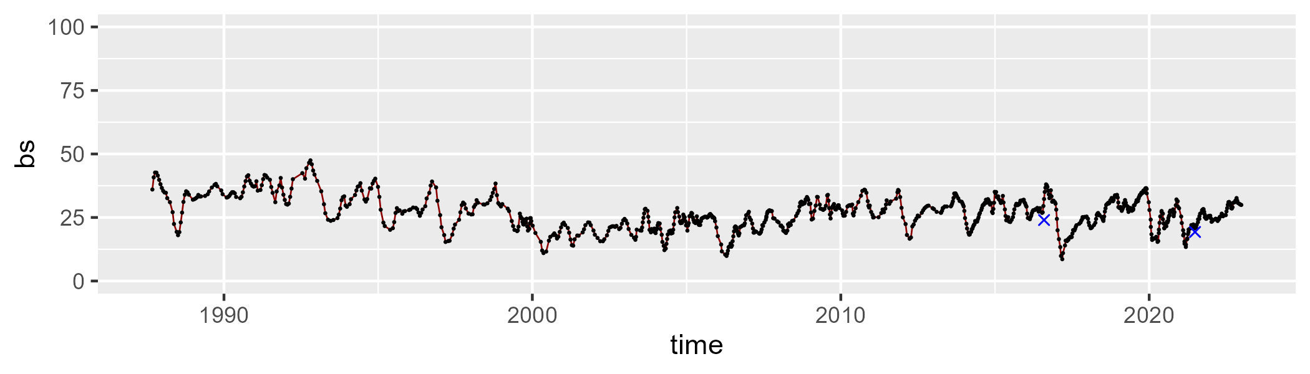

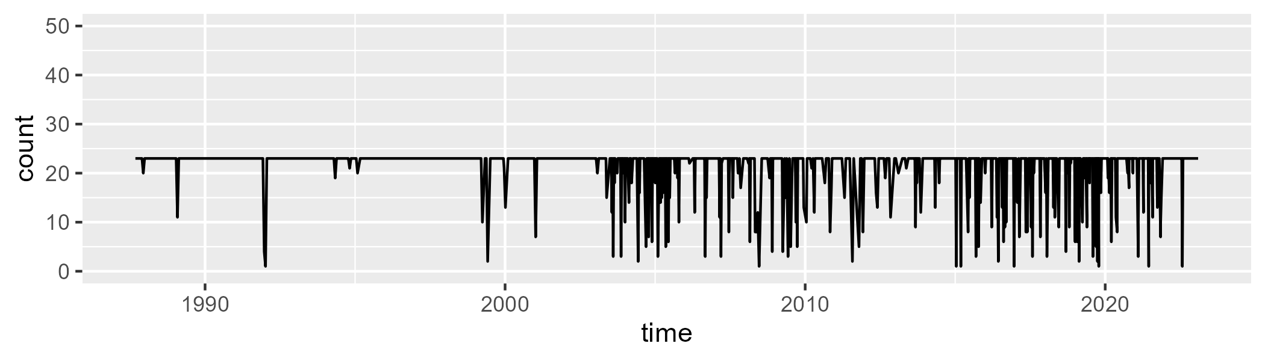

Min. : 1.00 1st Qu.:23.00 Median :23.00 Mean :21.08 3rd Qu.:23.00 Max. :23.00

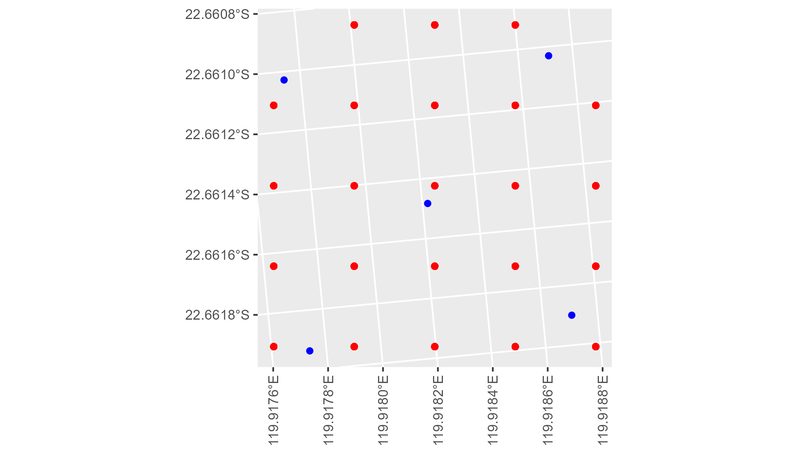

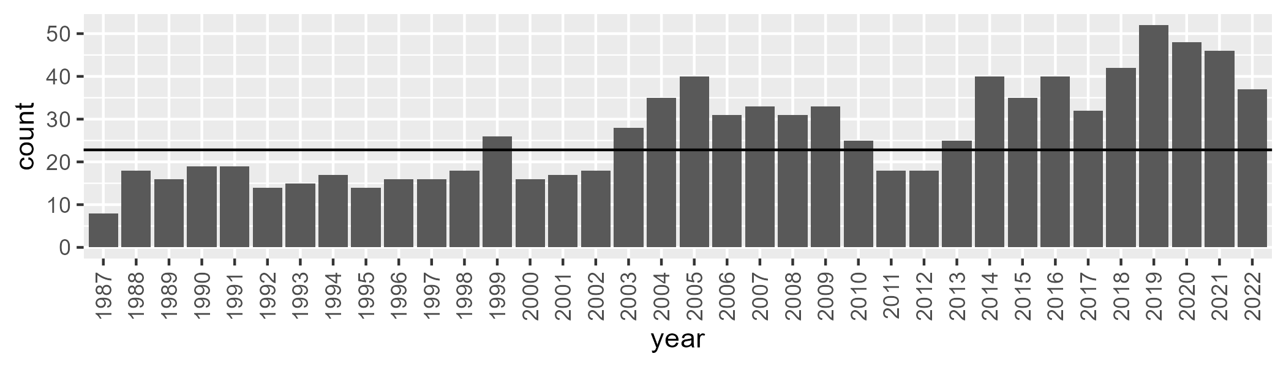

Number of samples: 956

# WAAPIL0030

| Min. | 1st Qu. | Median | Mean | 3rd Qu. | Max. |
| --- | --- | --- | --- | --- | --- |
| 0 | 3.098359 | 5.610826 | 9.150687 | 12.43248 | 45.73704 |

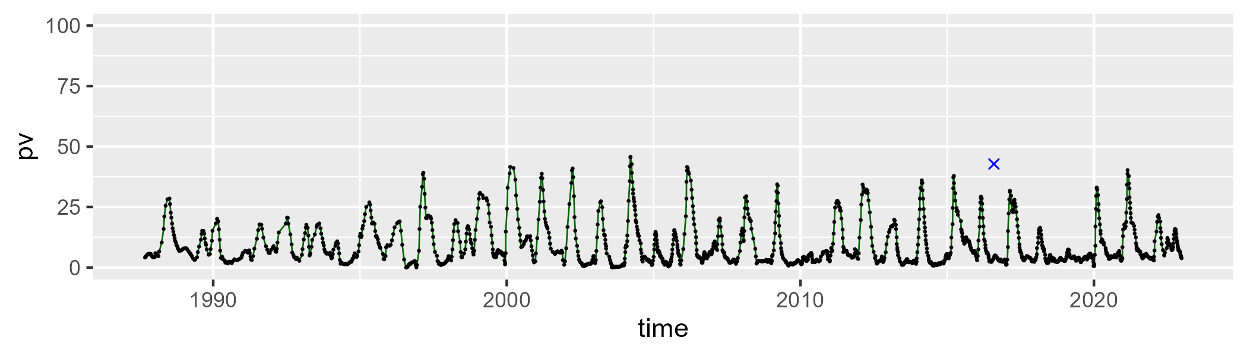

| Min. | 1st Qu. | Median | Mean | 3rd Qu. | Max. |
| --- | --- | --- | --- | --- | --- |
| 25.36628 | 39.18302 | 44.23313 | 45.08405 | 49.82054 | 78.3538 |

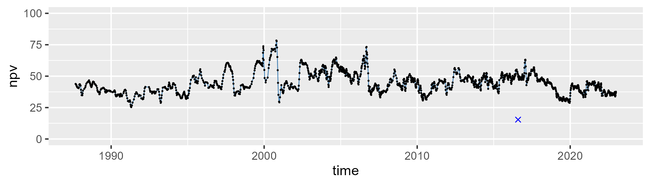

| Min. | 1st Qu. | Median | Mean | 3rd Qu. | Max. |
| --- | --- | --- | --- | --- | --- |
| 6.128524 | 37.15754 | 46.19804 | 44.31366 | 52.81139 | 70.11816 |

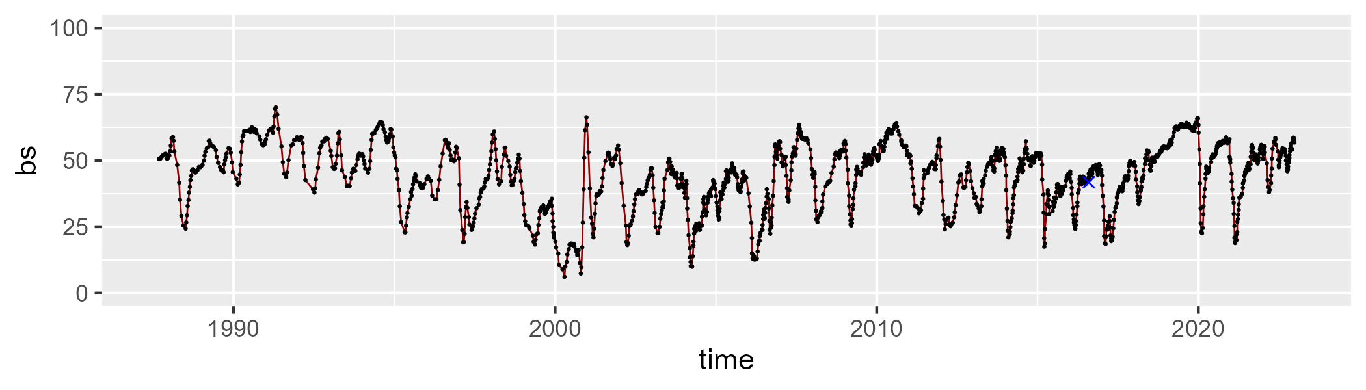

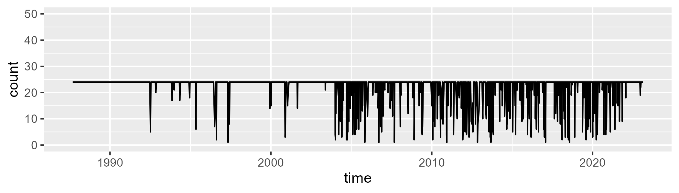

Min. : 1.00 1st Qu.:24.00 Median :24.00 Mean :22.28 3rd Qu.:24.00 Max. :24.00

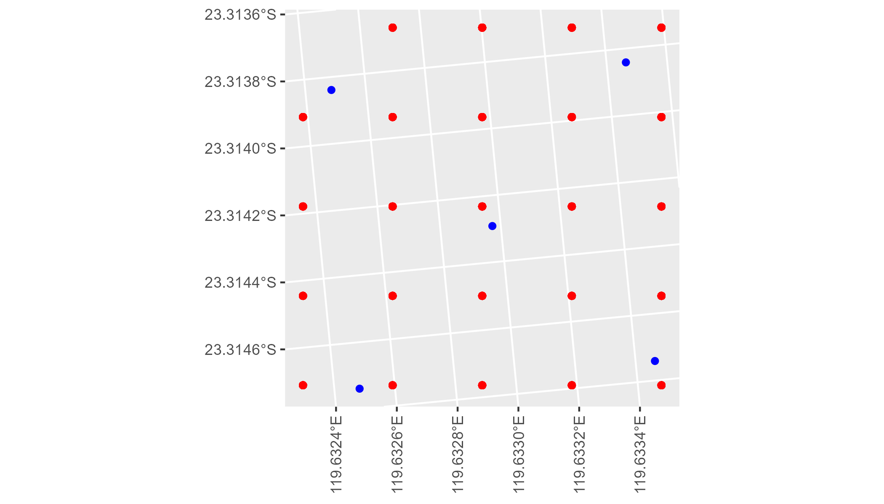

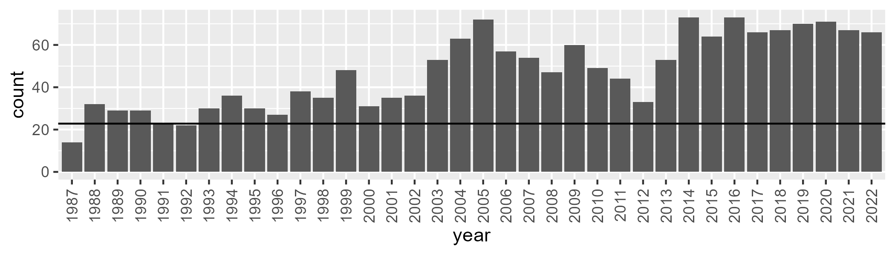

Number of samples: 1697

# WAAPIL0031

| Min. | 1st Qu. | Median | Mean | 3rd Qu. | Max. |
| --- | --- | --- | --- | --- | --- |
| 0 | 4.464861 | 12.09127 | 12.42537 | 18.30208 | 37.07088 |

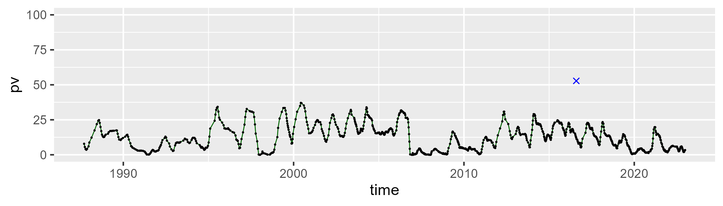

| Min. | 1st Qu. | Median | Mean | 3rd Qu. | Max. |
| --- | --- | --- | --- | --- | --- |
| 21.1576 | 47.91086 | 52.18985 | 52.28515 | 57.5406 | 65.61177 |

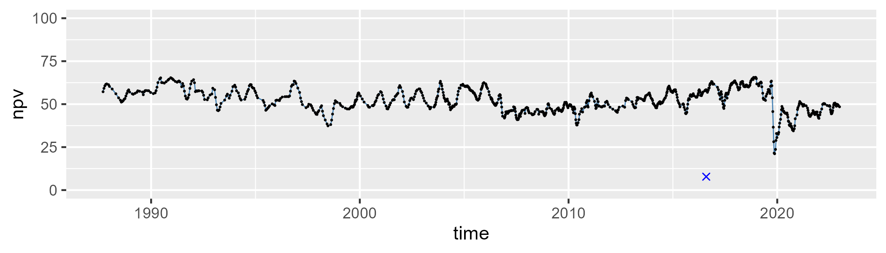

| Min. | 1st Qu. | Median | Mean | 3rd Qu. | Max. |
| --- | --- | --- | --- | --- | --- |
| 13.28549 | 25.48999 | 30.17195 | 34.01369 | 43.32864 | 77.21851 |

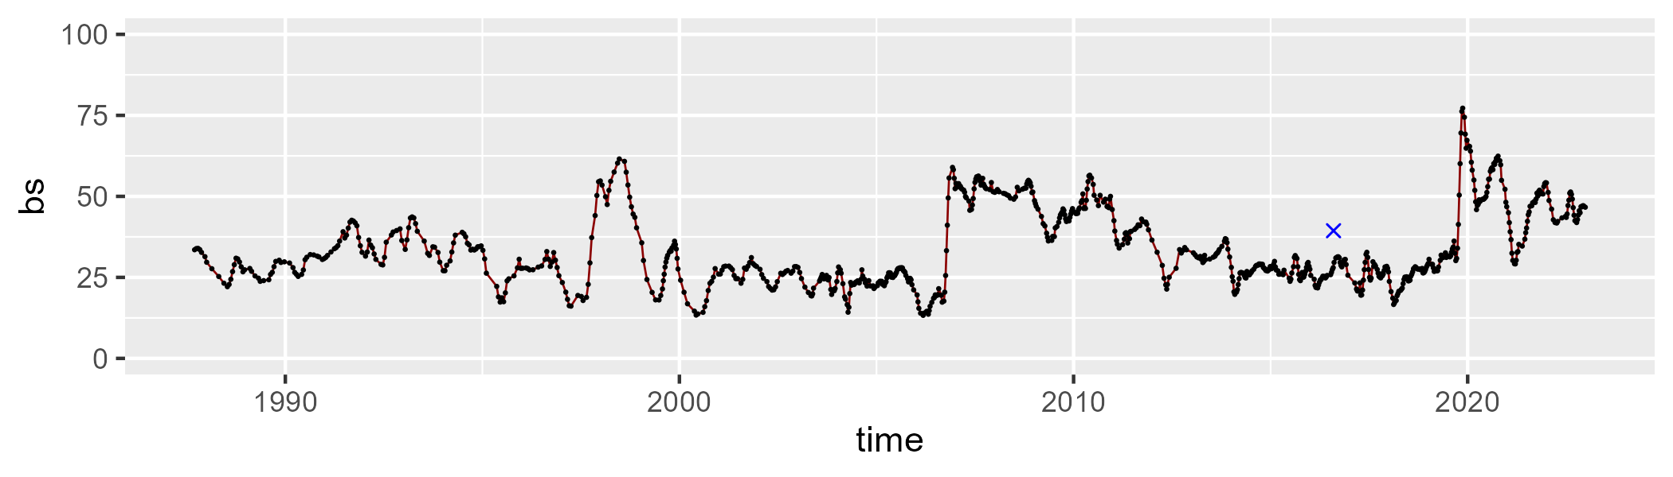

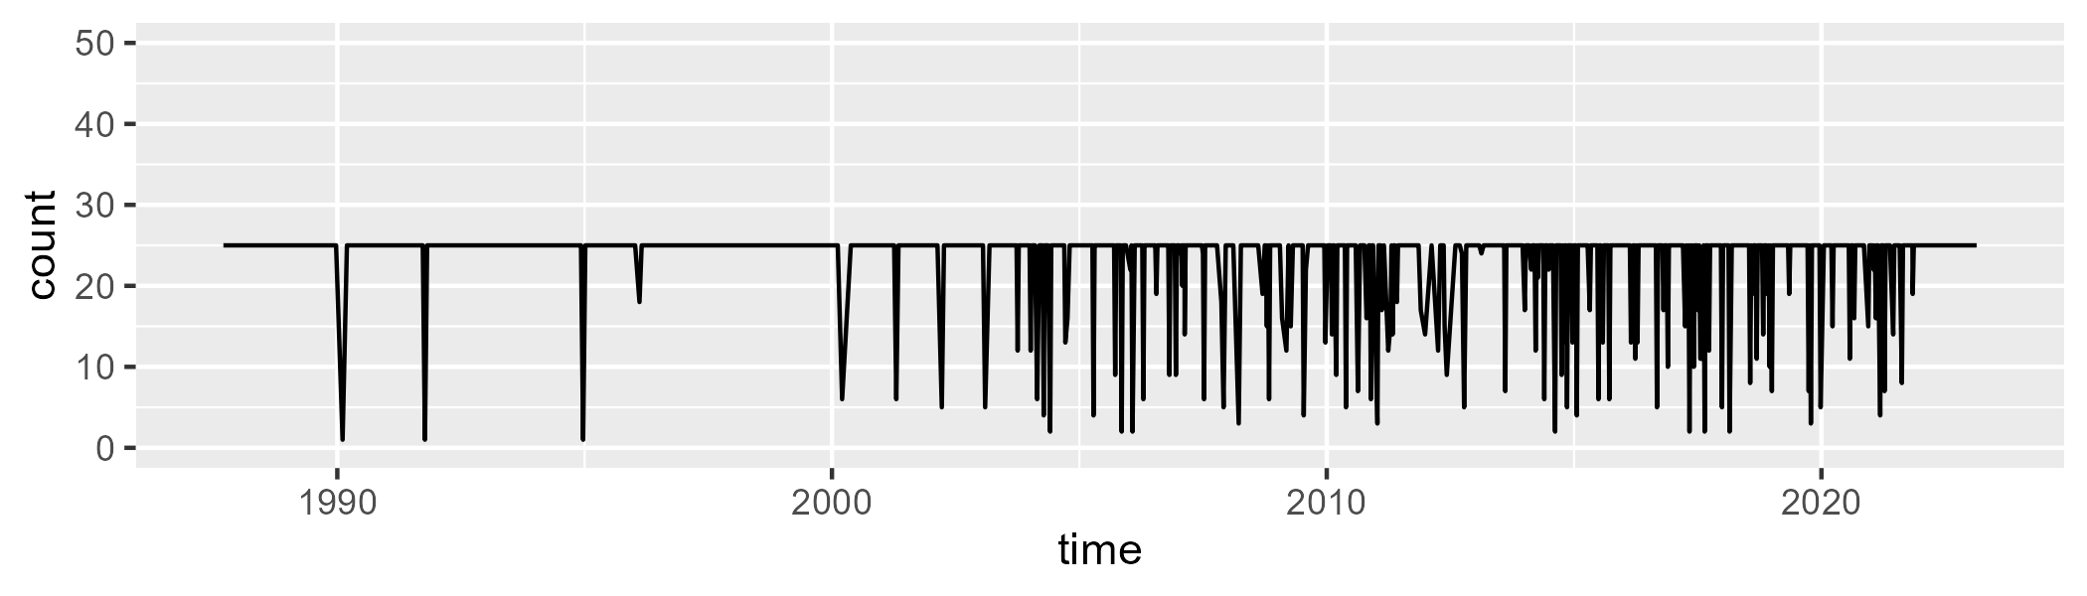

Min. : 1.00 1st Qu.:25.00 Median :25.00 Mean :23.22 3rd Qu.:25.00 Max. :25.00

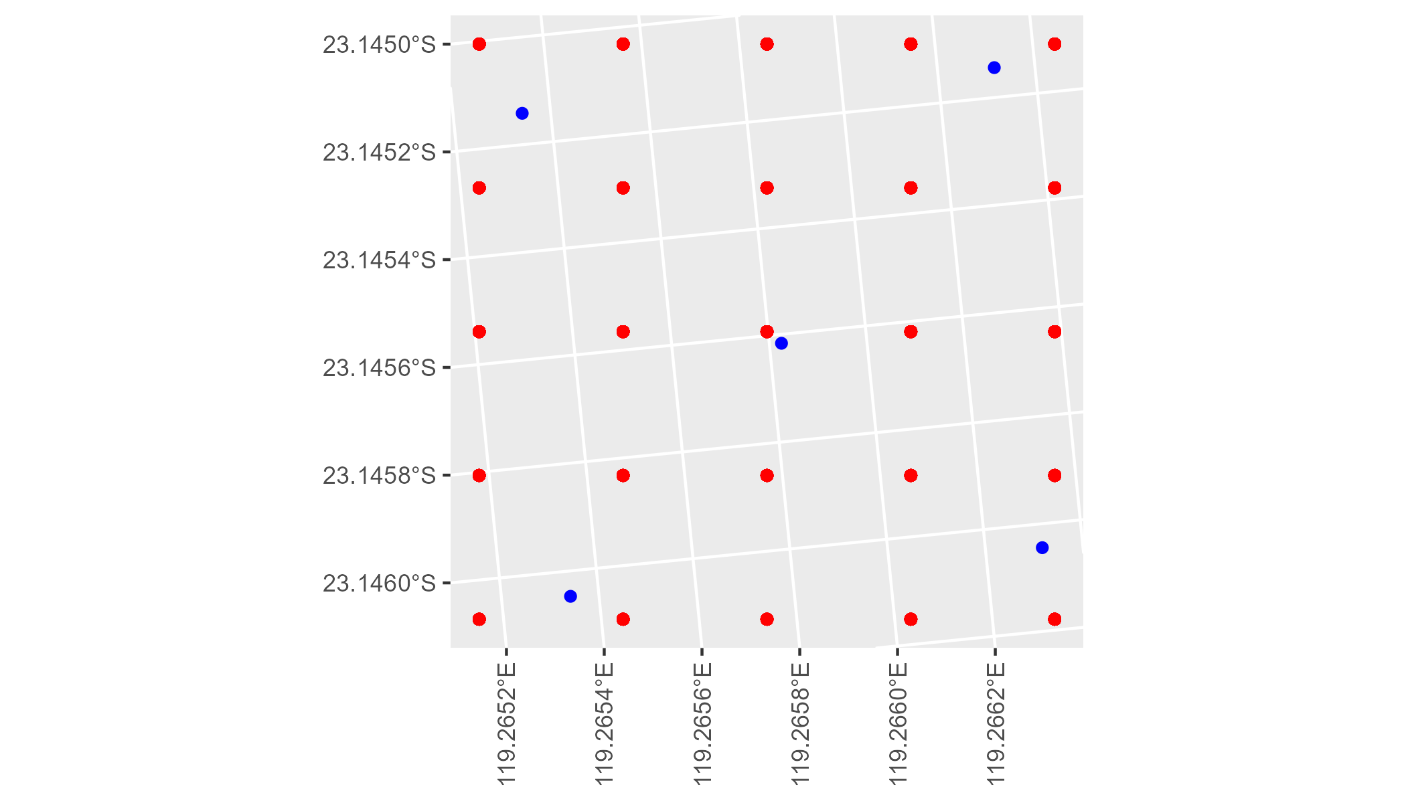

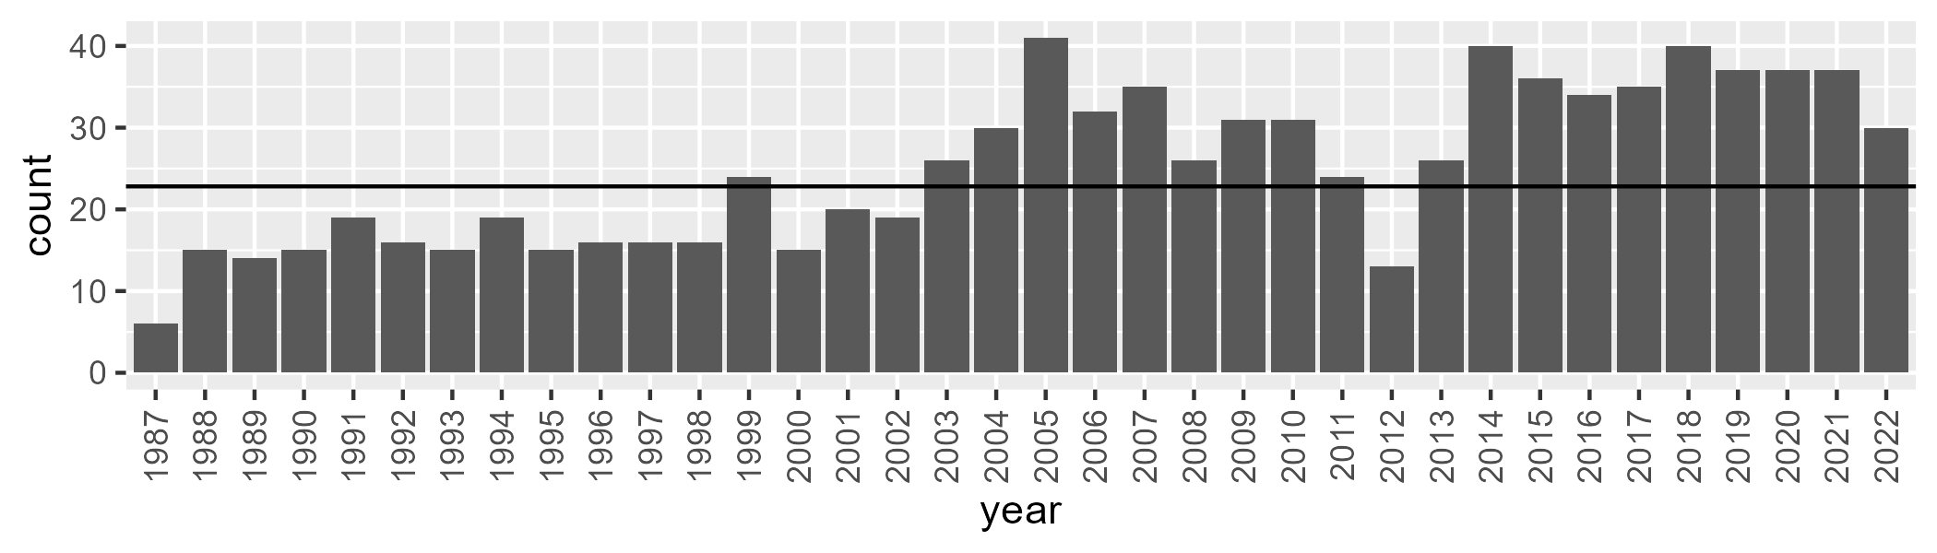

Number of samples: 901

# WAAPIL0032

| Min. | 1st Qu. | Median | Mean | 3rd Qu. | Max. |
| --- | --- | --- | --- | --- | --- |
| 0 | 1.11666 | 1.938743 | 2.625878 | 3.025969 | 16.44712 |

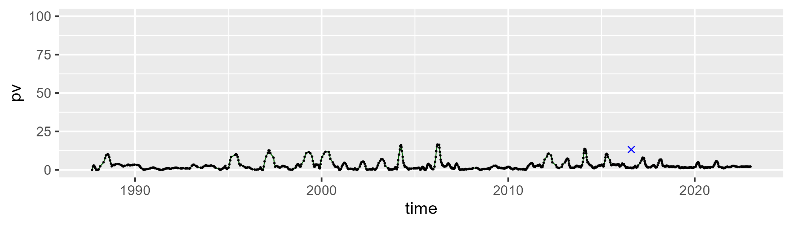

| Min. | 1st Qu. | Median | Mean | 3rd Qu. | Max. |
| --- | --- | --- | --- | --- | --- |
| 25.0529 | 41.0229 | 44.50974 | 44.1469 | 47.67563 | 60.00953 |

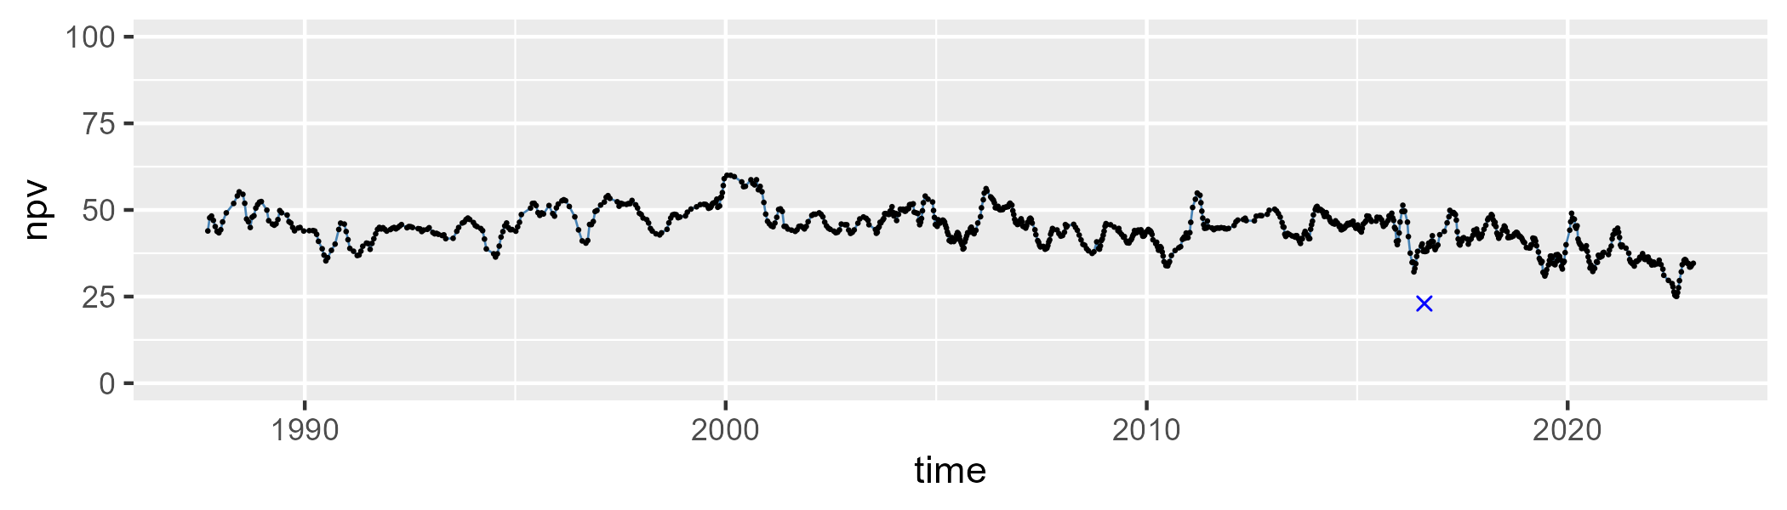

| Min. | 1st Qu. | Median | Mean | 3rd Qu. | Max. |
| --- | --- | --- | --- | --- | --- |
| 26.84398 | 47.72577 | 52.5617 | 51.95546 | 56.2661 | 71.34564 |

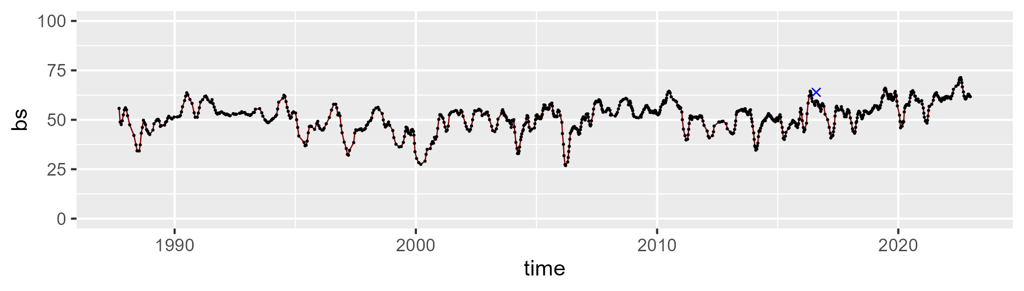

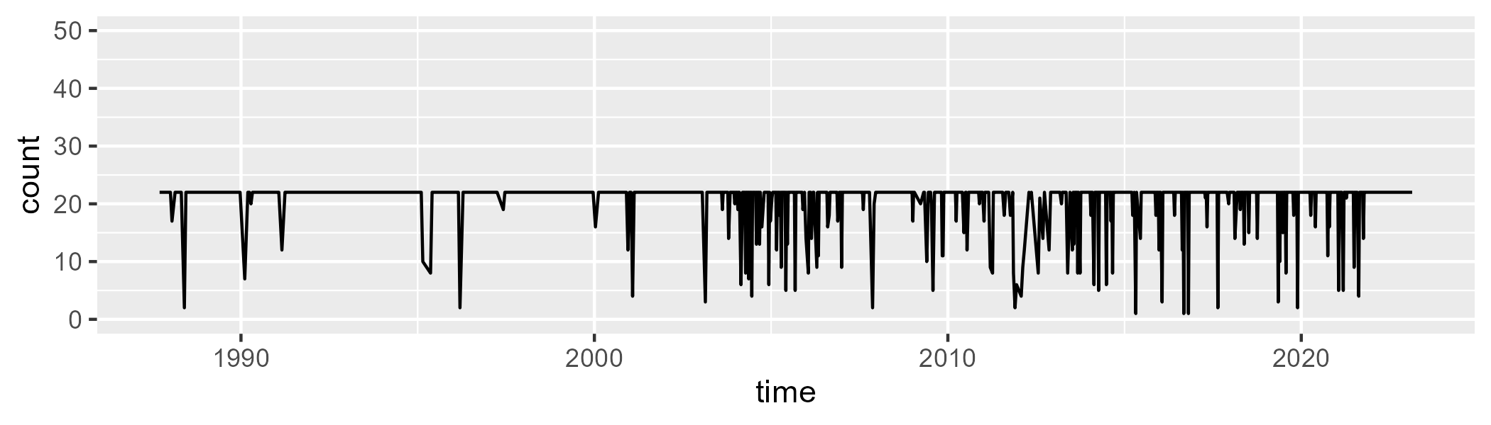

Min. : 1.00 1st Qu.:22.00 Median :22.00 Mean :20.66 3rd Qu.:22.00 Max. :22.00

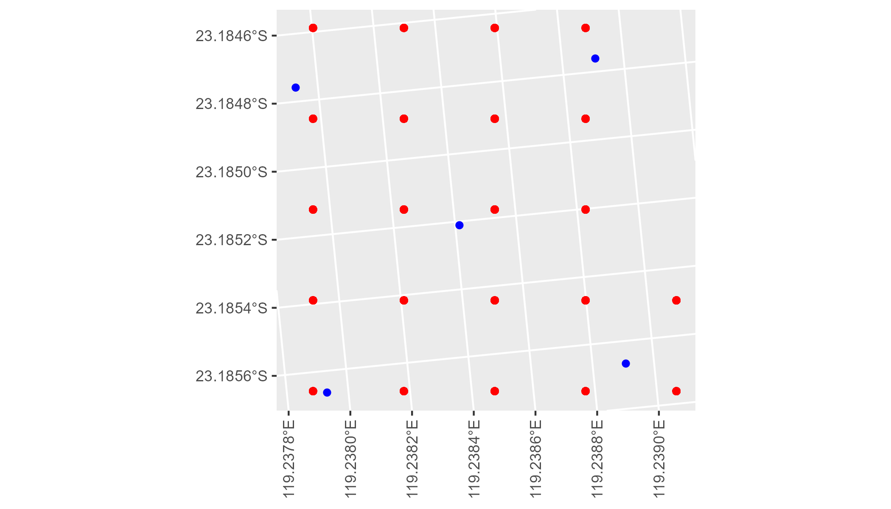

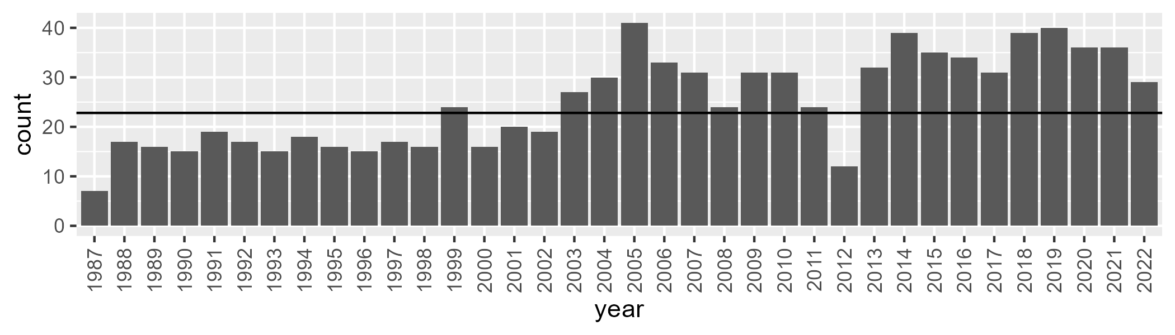

Number of samples: 902

# WAAPIL0033

| Min. | 1st Qu. | Median | Mean | 3rd Qu. | Max. |
| --- | --- | --- | --- | --- | --- |
| 0.885419 | 7.874766 | 11.34748 | 13.64466 | 18.05307 | 50.27733 |

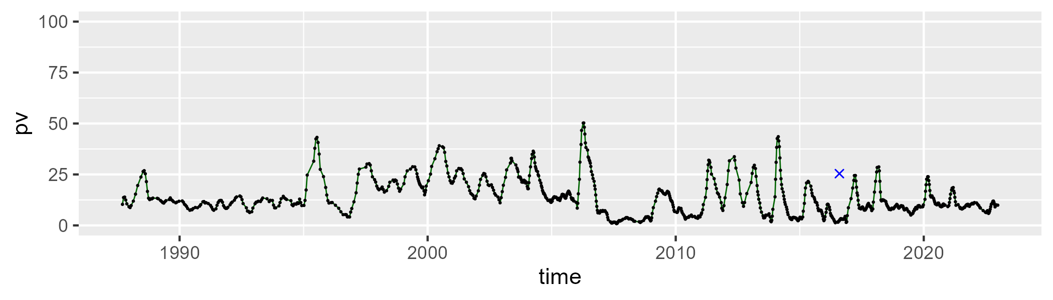

| Min. | 1st Qu. | Median | Mean | 3rd Qu. | Max. |
| --- | --- | --- | --- | --- | --- |
| 33.88352 | 45.94397 | 49.7339 | 49.44091 | 52.57401 | 63.21026 |

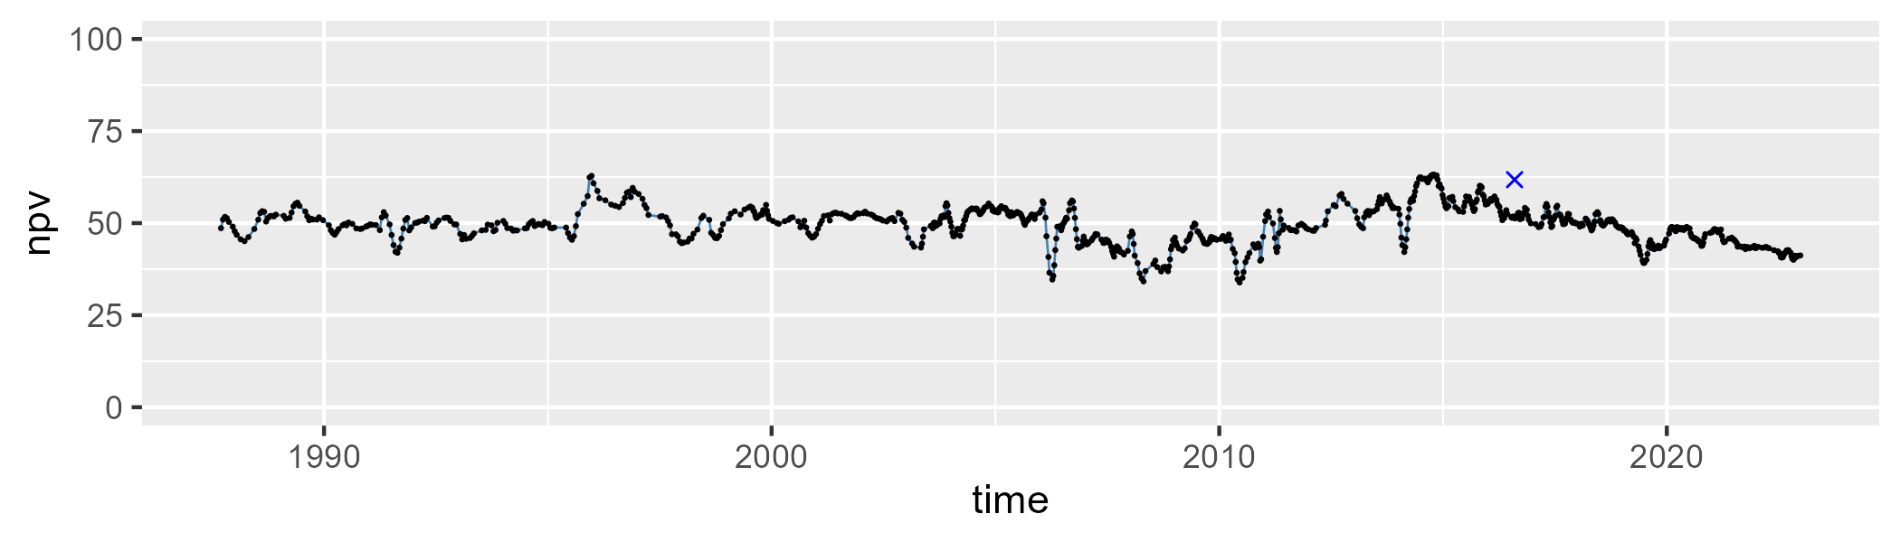

| Min. | 1st Qu. | Median | Mean | 3rd Qu. | Max. |
| --- | --- | --- | --- | --- | --- |
| 8.313341 | 29.26989 | 36.15859 | 35.61604 | 42.3196 | 62.38202 |

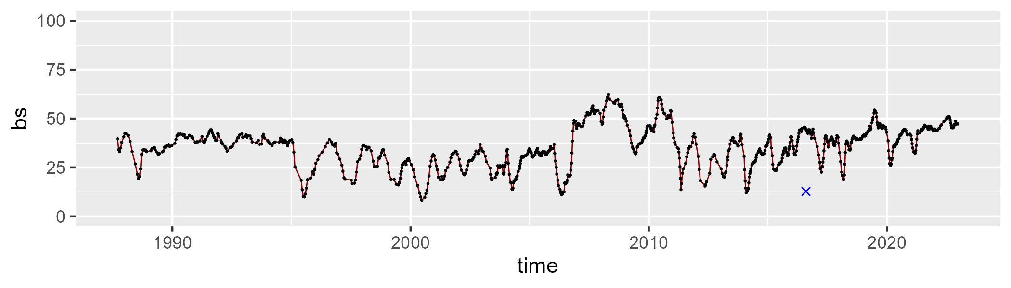

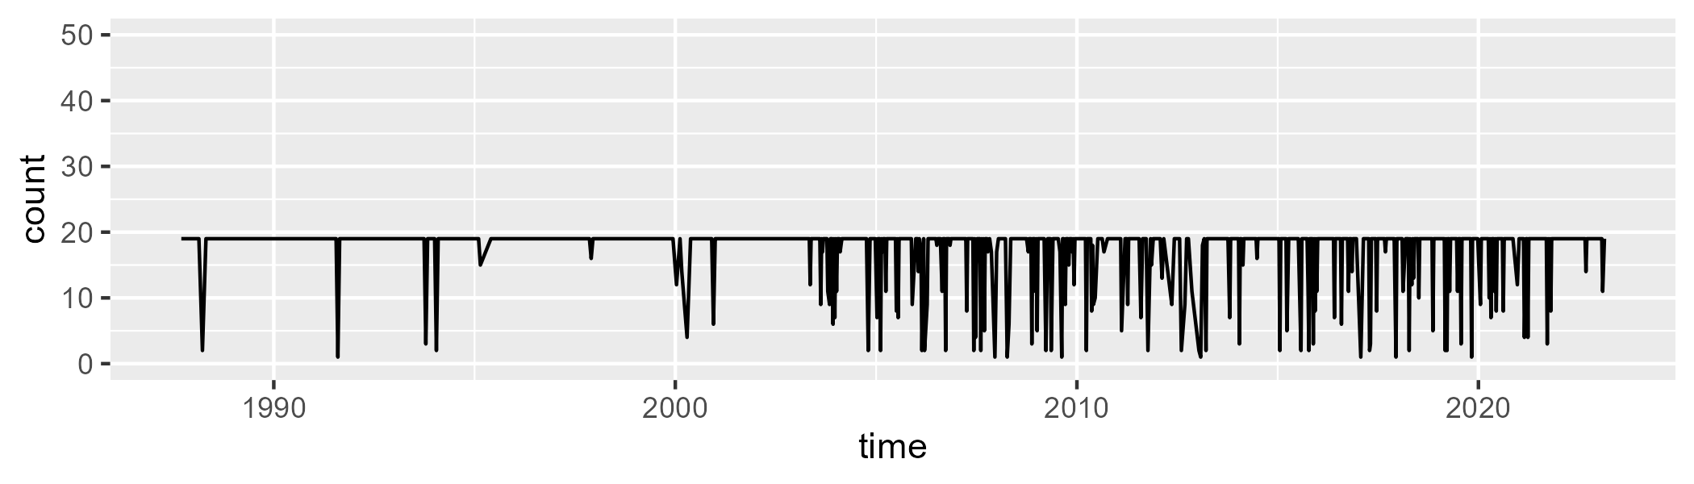

Min. : 1.00 1st Qu.:19.00 Median :19.00 Mean :17.48 3rd Qu.:19.00 Max. :19.00

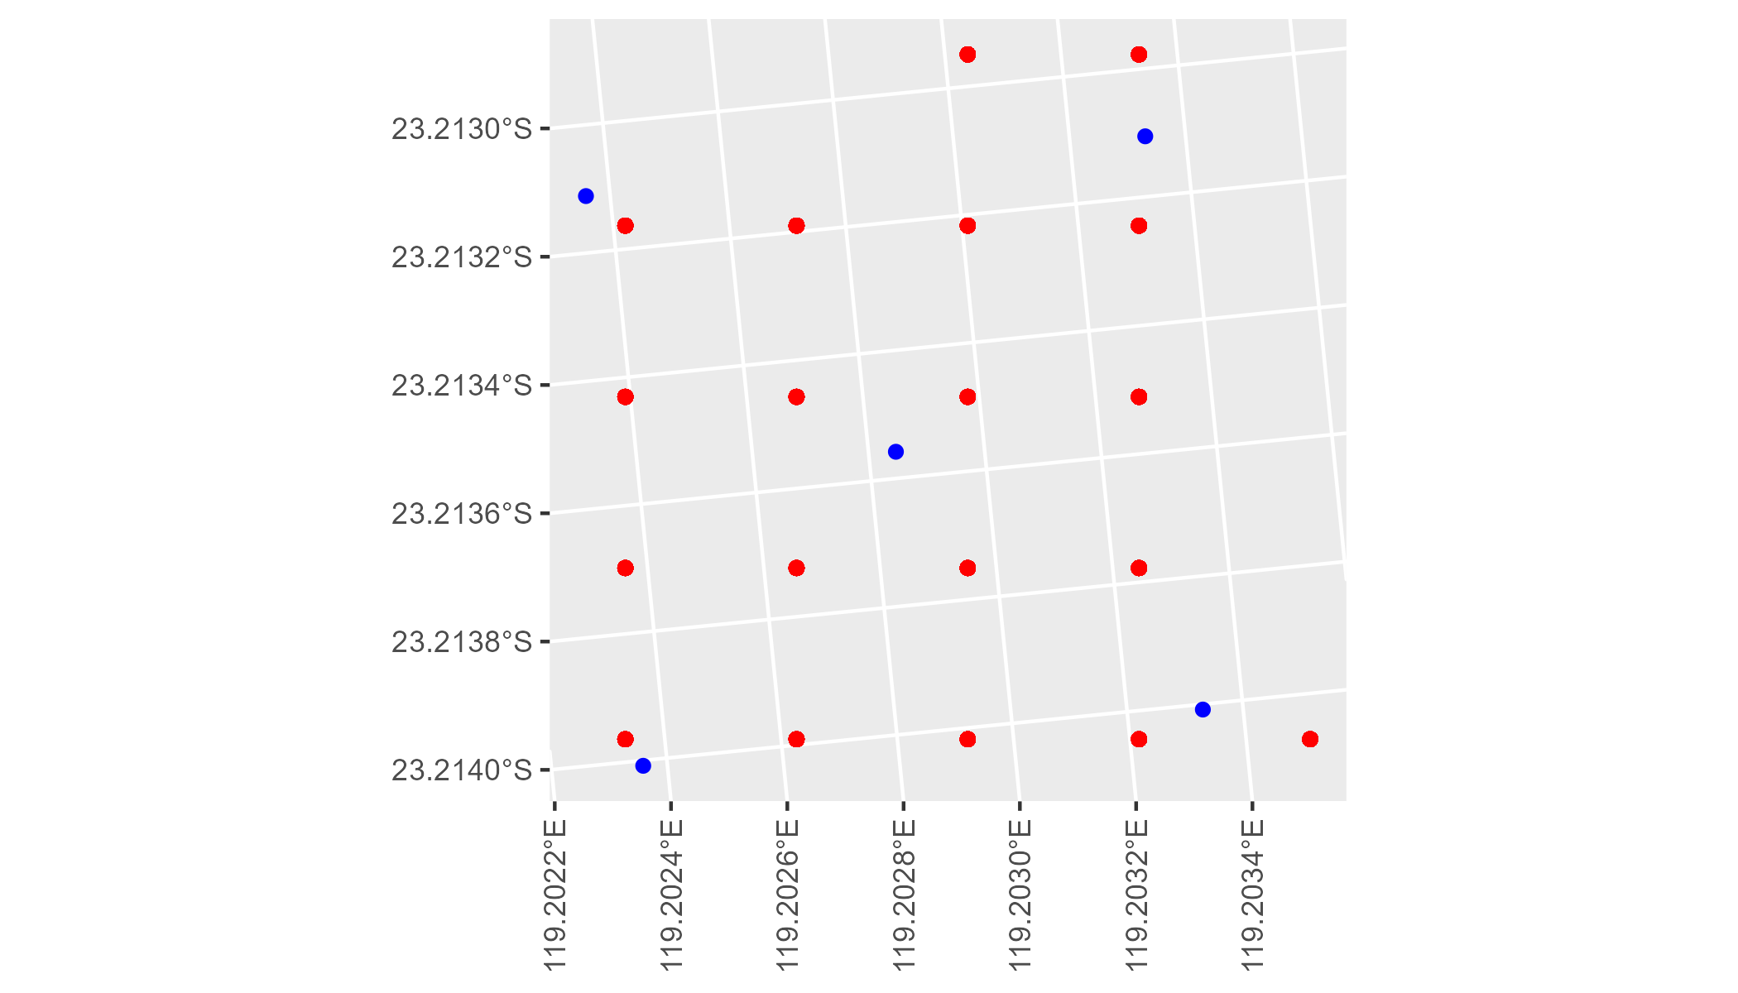

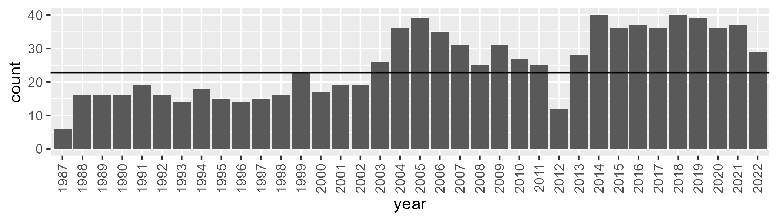

Number of samples: 904

# WAAPIL0034

| Min. | 1st Qu. | Median | Mean | 3rd Qu. | Max. |
| --- | --- | --- | --- | --- | --- |
| 1.657399 | 9.909829 | 12.48054 | 12.70447 | 15.29385 | 27.4229 |

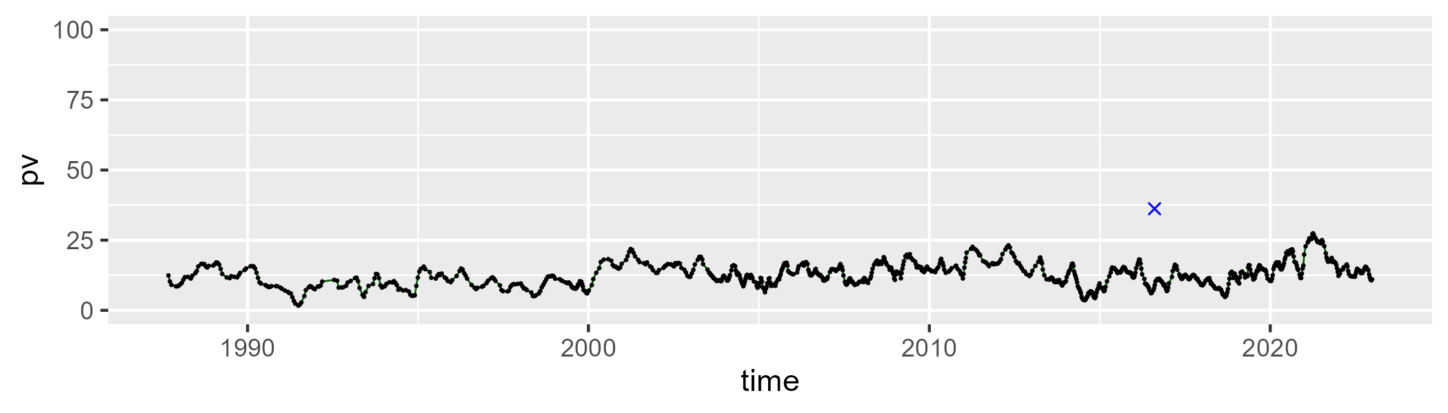

| Min. | 1st Qu. | Median | Mean | 3rd Qu. | Max. |
| --- | --- | --- | --- | --- | --- |
| 3.961991 | 28.80525 | 37.39876 | 35.17728 | 43.17275 | 52.47313 |

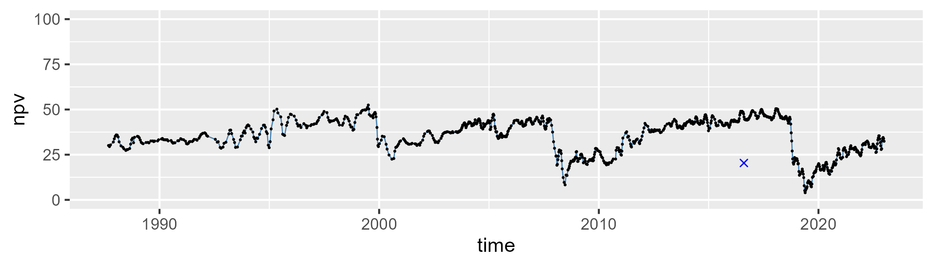

| Min. | 1st Qu. | Median | Mean | 3rd Qu. | Max. |
| --- | --- | --- | --- | --- | --- |
| 34.78355 | 43.73404 | 48.54975 | 50.61168 | 56.75893 | 79.05758 |

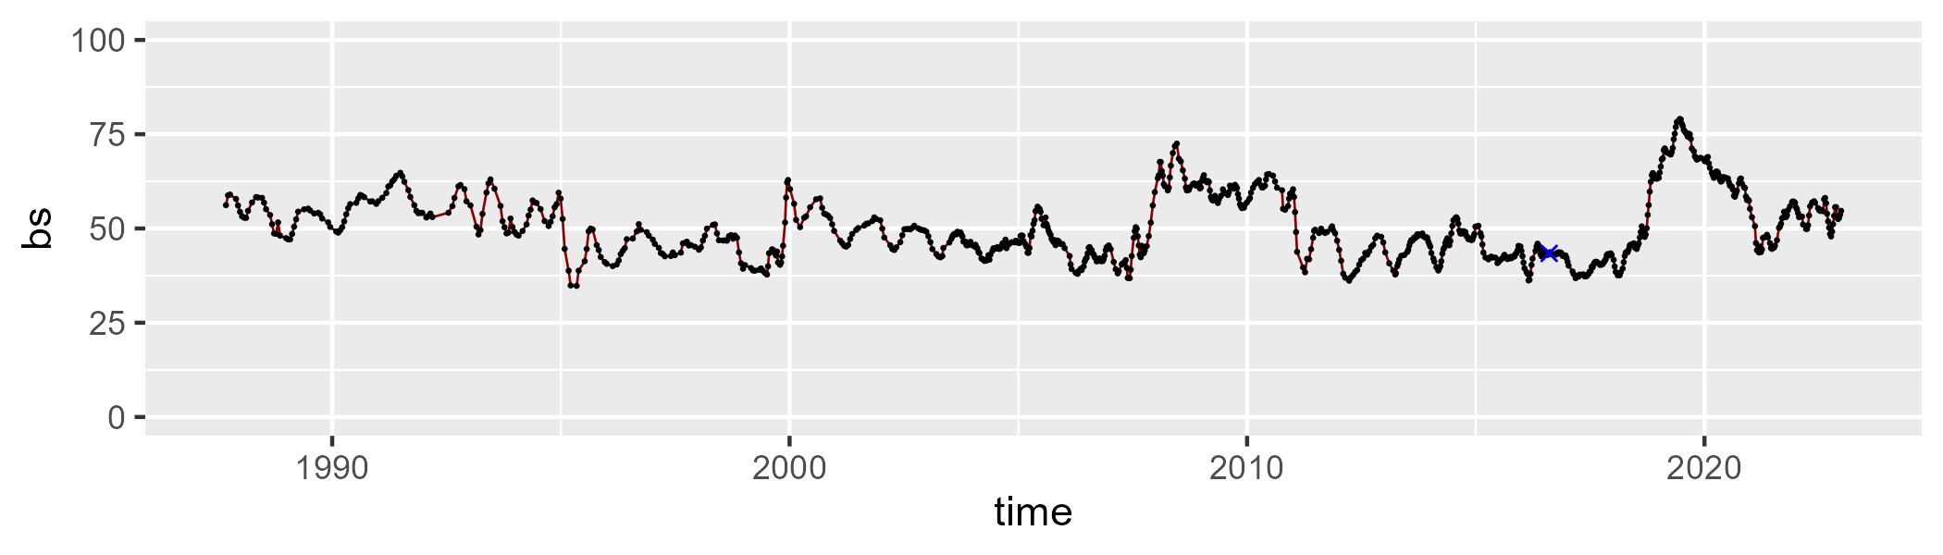

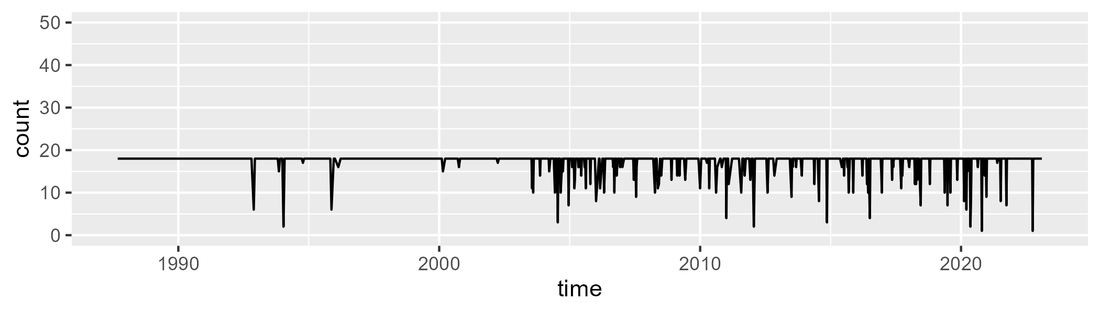

Min. : 1.00 1st Qu.:18.00 Median :18.00 Mean :17.28 3rd Qu.:18.00 Max. :18.00

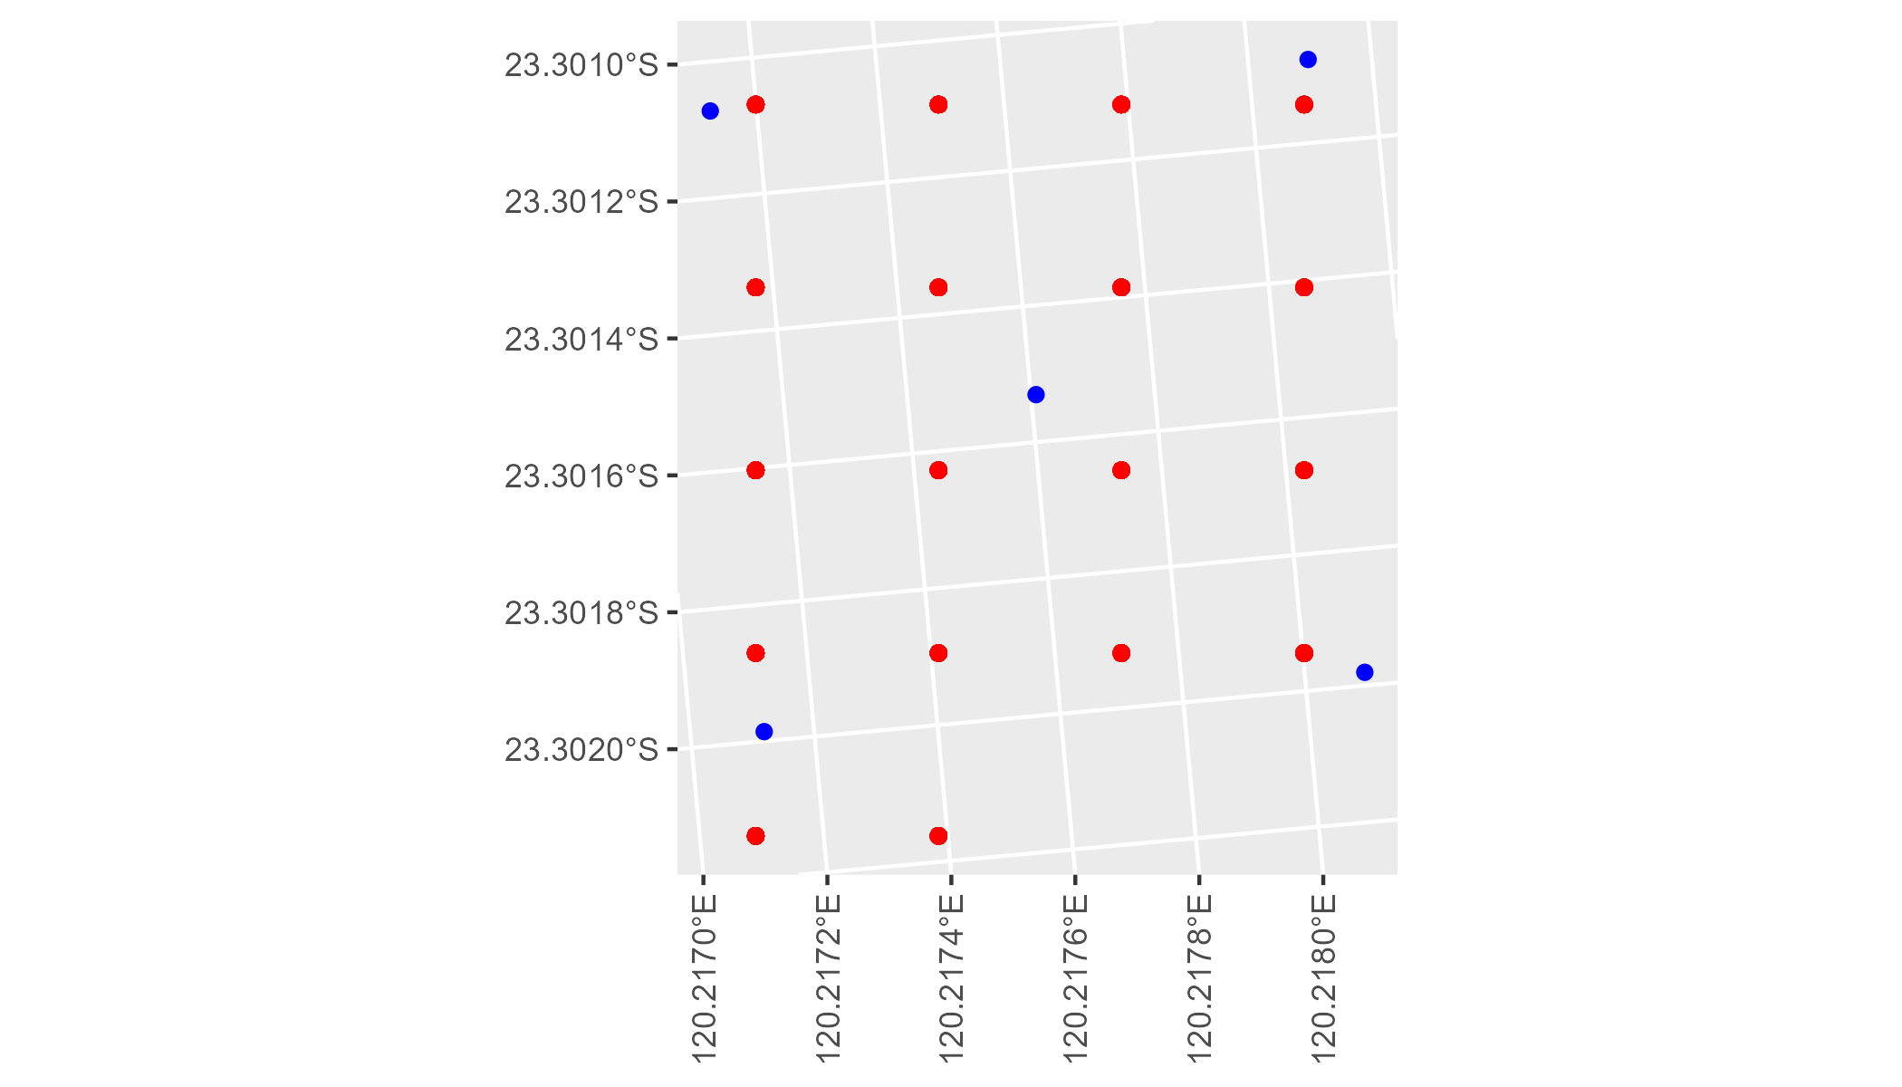

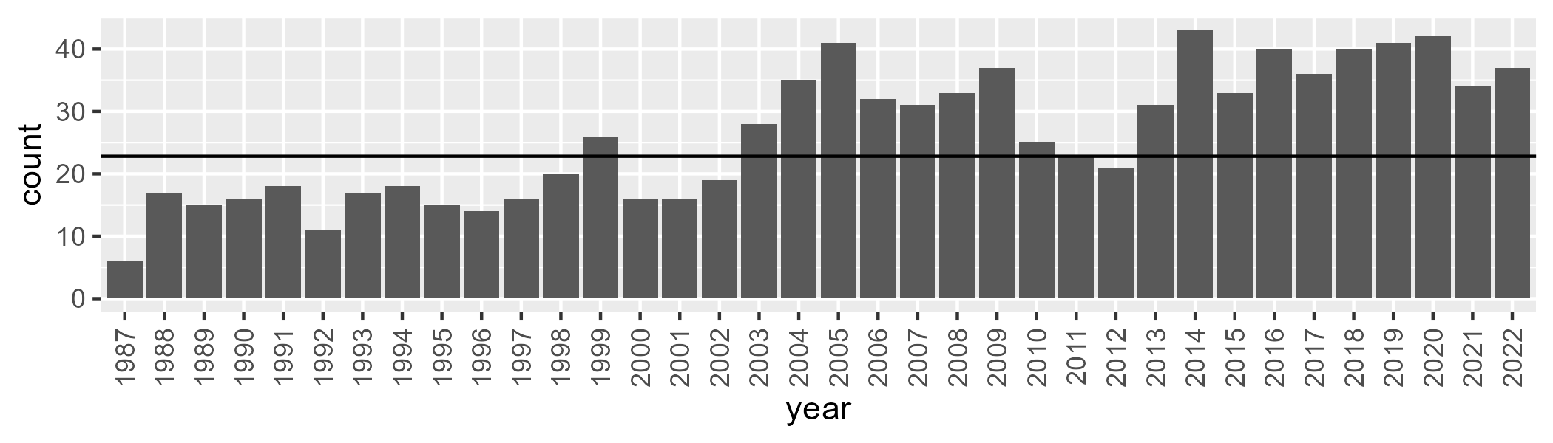

Number of samples: 943

# WAAPIL0035

| Min. | 1st Qu. | Median | Mean | 3rd Qu. | Max. |
| --- | --- | --- | --- | --- | --- |
| 1.120569 | 9.318985 | 12.09372 | 12.43122 | 15.24429 | 26.01643 |

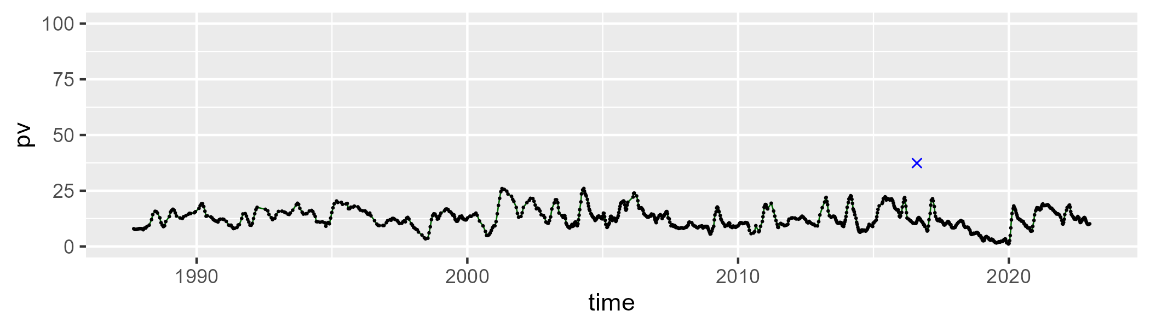

| Min. | 1st Qu. | Median | Mean | 3rd Qu. | Max. |
| --- | --- | --- | --- | --- | --- |
| 23.39892 | 37.66198 | 40.73094 | 40.47043 | 43.35043 | 63.69246 |

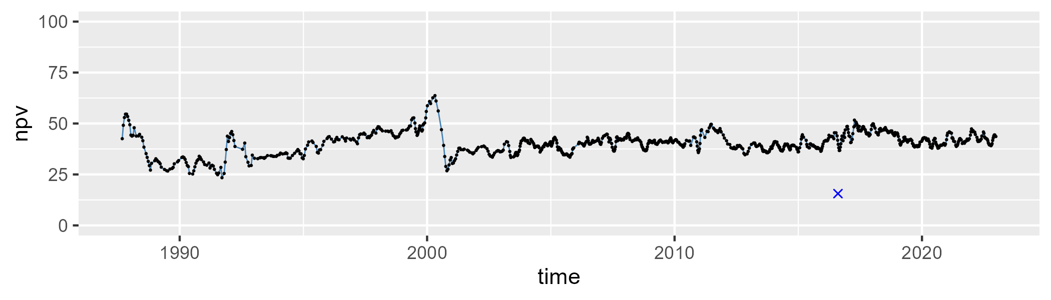

| Min. | 1st Qu. | Median | Mean | 3rd Qu. | Max. |
| --- | --- | --- | --- | --- | --- |
| 20.25139 | 41.30219 | 45.70279 | 45.58617 | 49.57278 | 66.29878 |

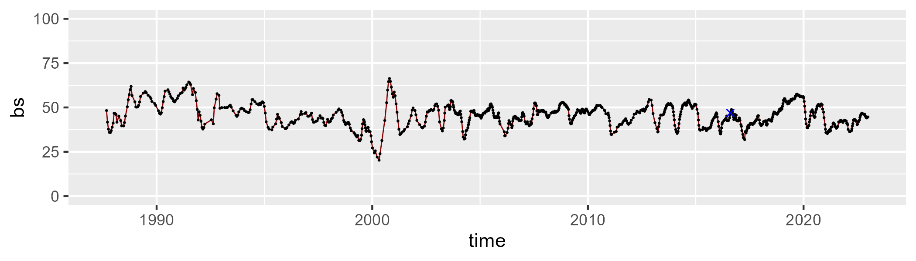

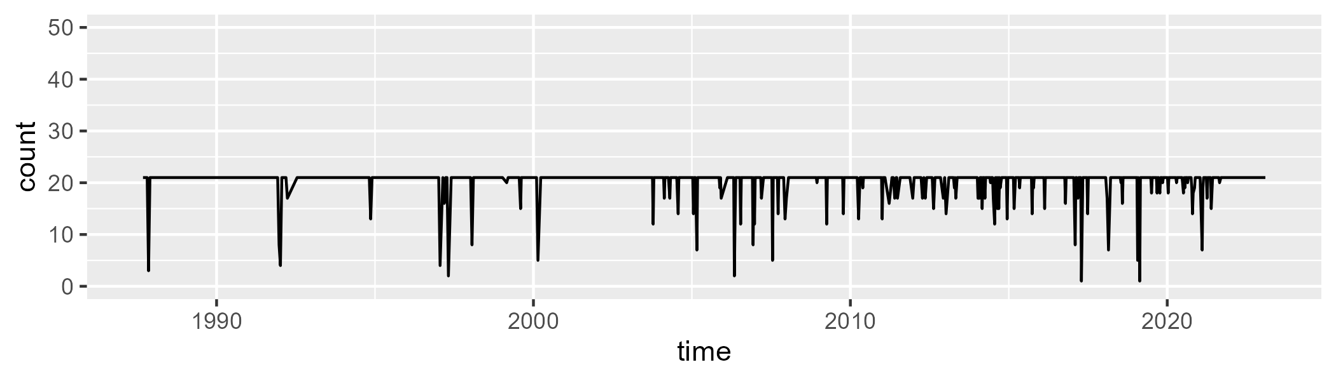

Min. : 1.00 1st Qu.:21.00 Median :21.00 Mean :20.34 3rd Qu.:21.00 Max. :21.00

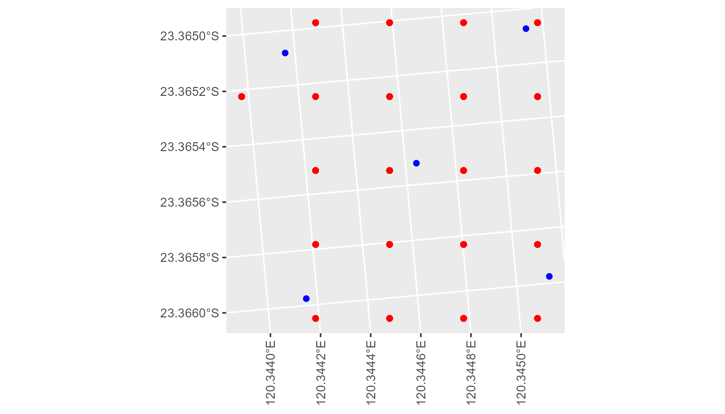

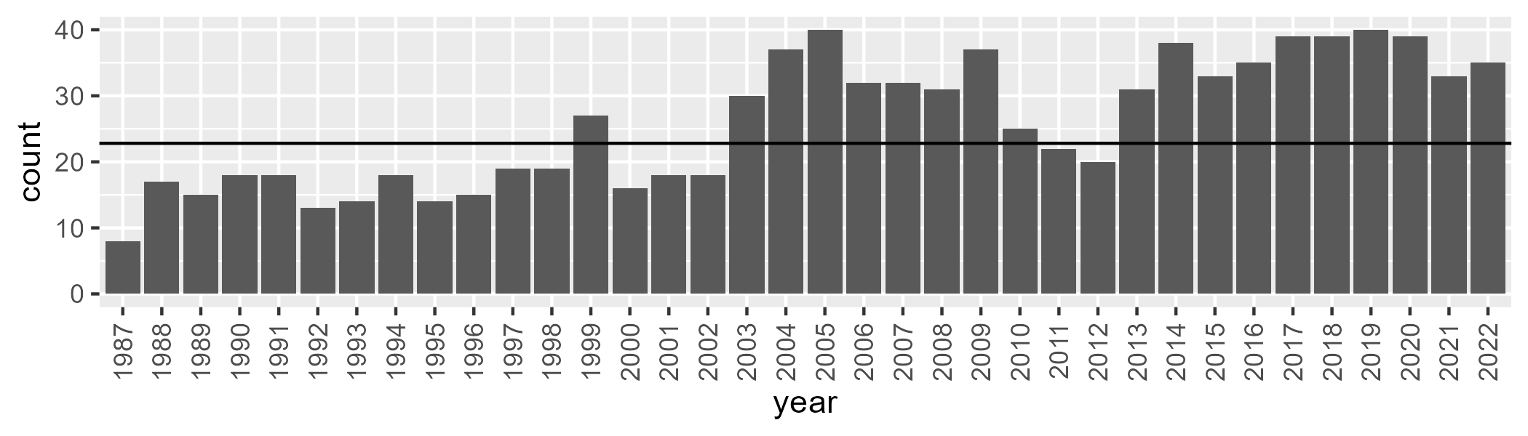

Number of samples: 935

# WAASWA0001

| Min. | 1st Qu. | Median | Mean | 3rd Qu. | Max. |
| --- | --- | --- | --- | --- | --- |
| 3.376191 | 44.41878 | 47.72774 | 46.74489 | 51.15015 | 61.05067 |

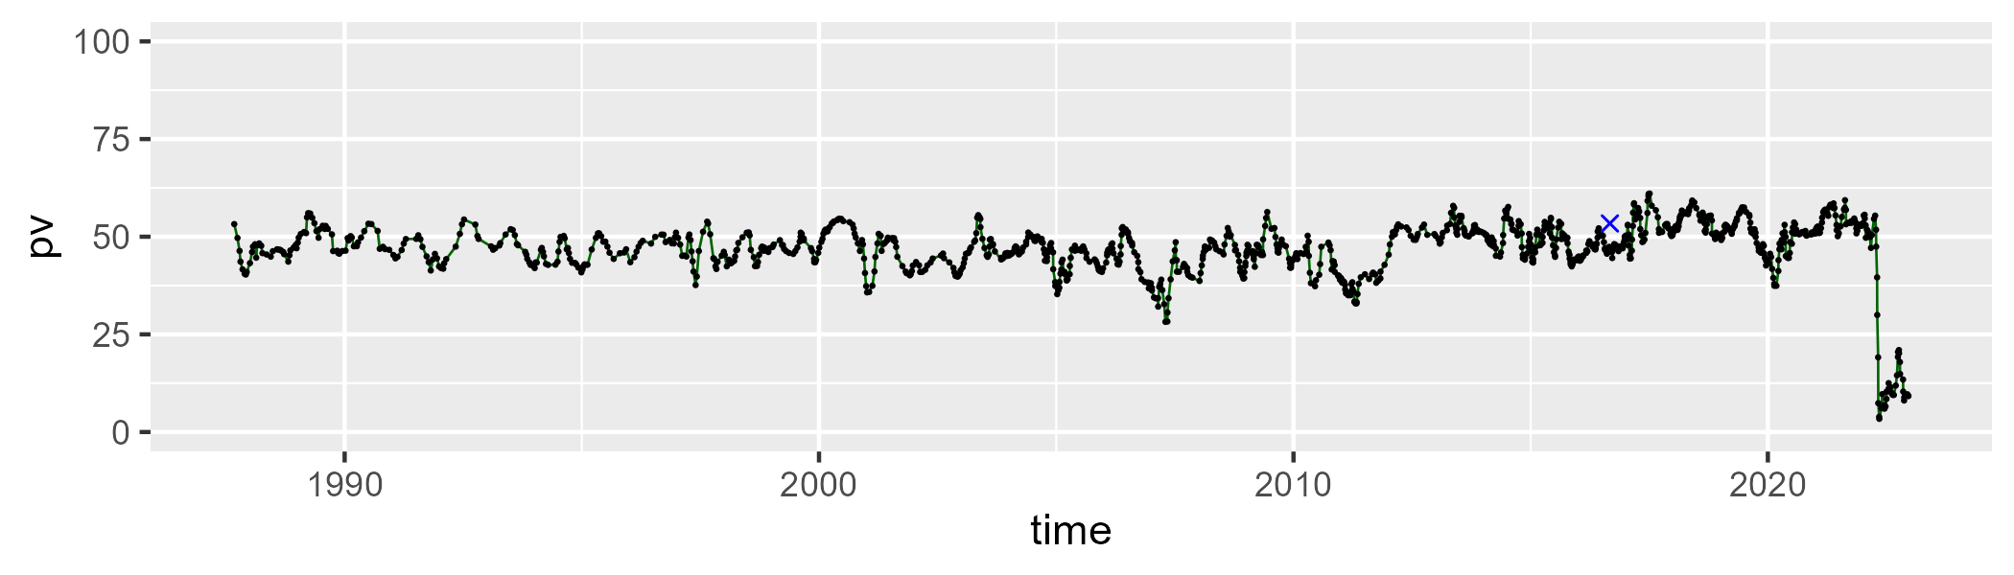

| Min. | 1st Qu. | Median | Mean | 3rd Qu. | Max. |
| --- | --- | --- | --- | --- | --- |
| 26.15165 | 40.29812 | 43.71738 | 44.24368 | 48.25084 | 65.87729 |

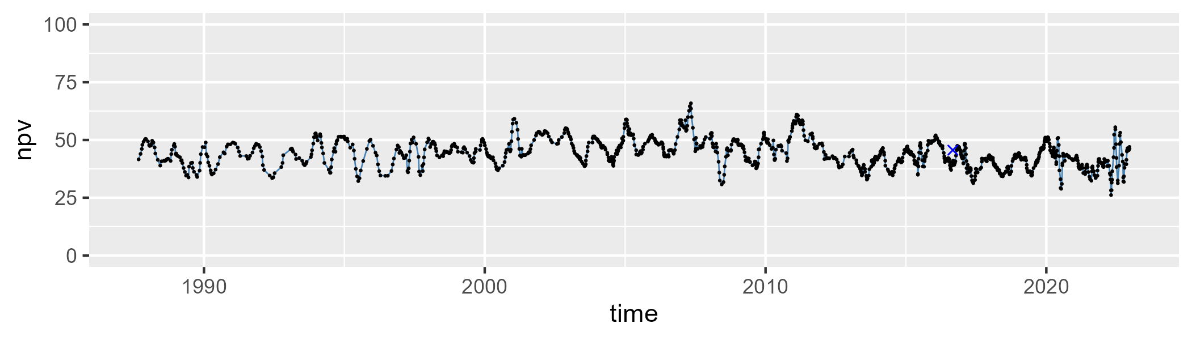

| Min. | 1st Qu. | Median | Mean | 3rd Qu. | Max. |
| --- | --- | --- | --- | --- | --- |
| 0 | 4.430107 | 5.772678 | 7.76393 | 8.237831 | 61.37566 |

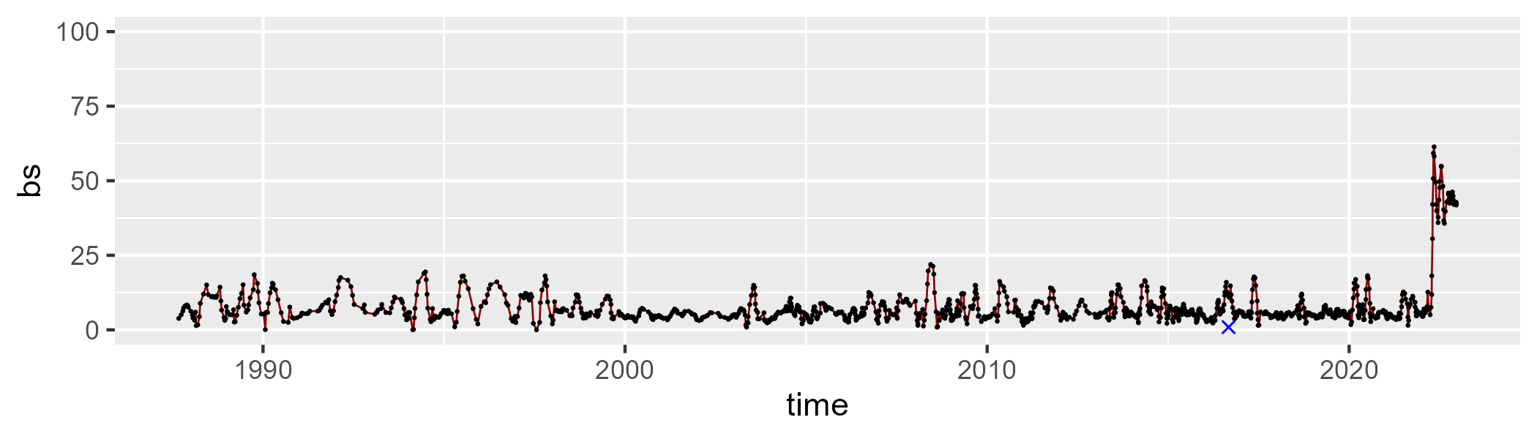

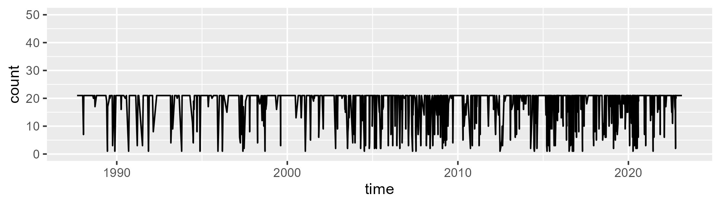

Min. : 1.00 1st Qu.:20.00 Median :21.00 Mean :18.24 3rd Qu.:21.00 Max. :21.00

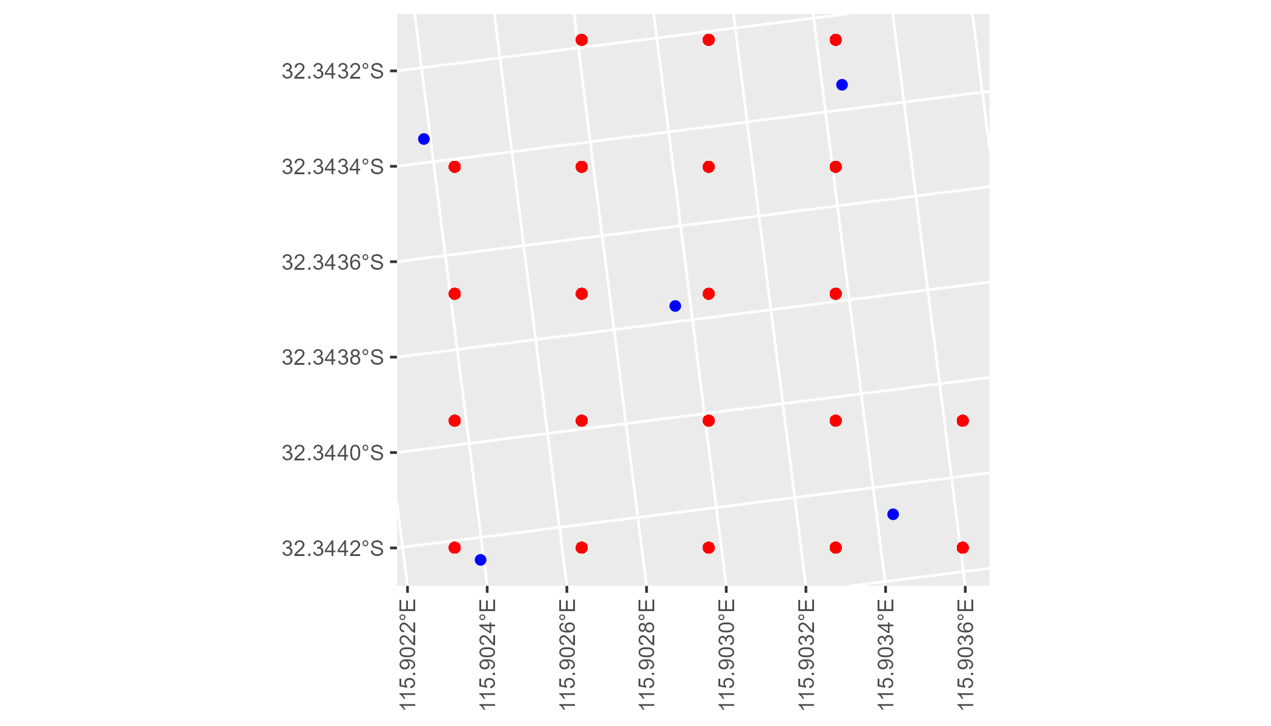

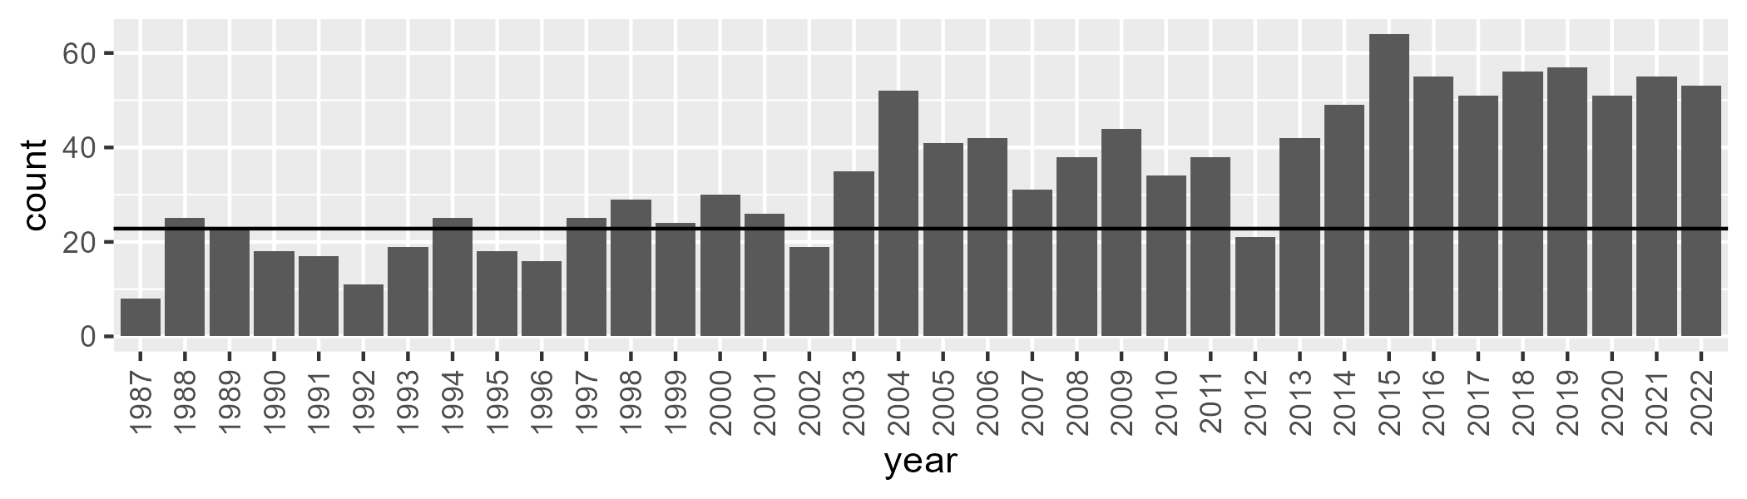

Number of samples: 1242

# WAASWA0002

| Min. | 1st Qu. | Median | Mean | 3rd Qu. | Max. |
| --- | --- | --- | --- | --- | --- |
| 37.44624 | 46.63069 | 49.42729 | 49.15969 | 51.78953 | 61.77989 |

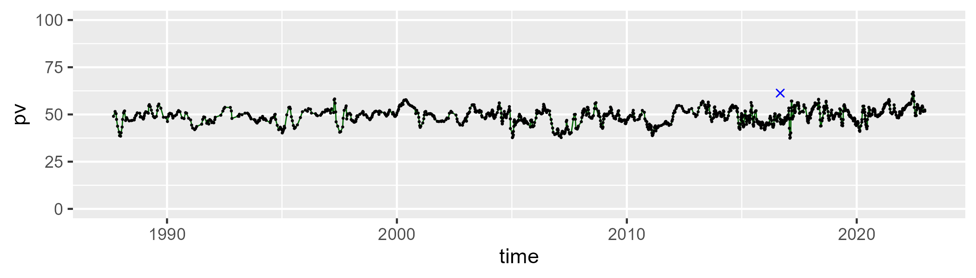

| Min. | 1st Qu. | Median | Mean | 3rd Qu. | Max. |
| --- | --- | --- | --- | --- | --- |
| 22.48166 | 38.89225 | 42.23355 | 41.83713 | 44.83409 | 56.88035 |

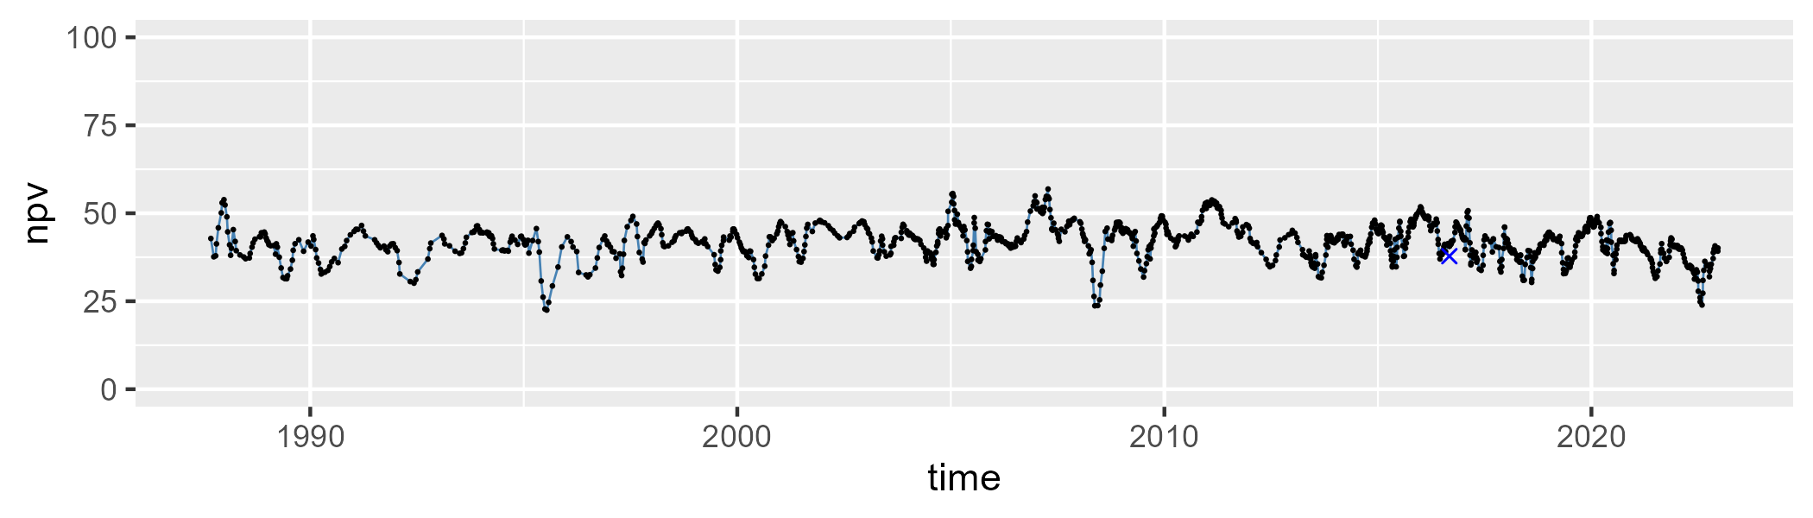

| Min. | 1st Qu. | Median | Mean | 3rd Qu. | Max. |
| --- | --- | --- | --- | --- | --- |
| 0 | 4.943718 | 6.62496 | 7.687599 | 9.202439 | 34.04266 |

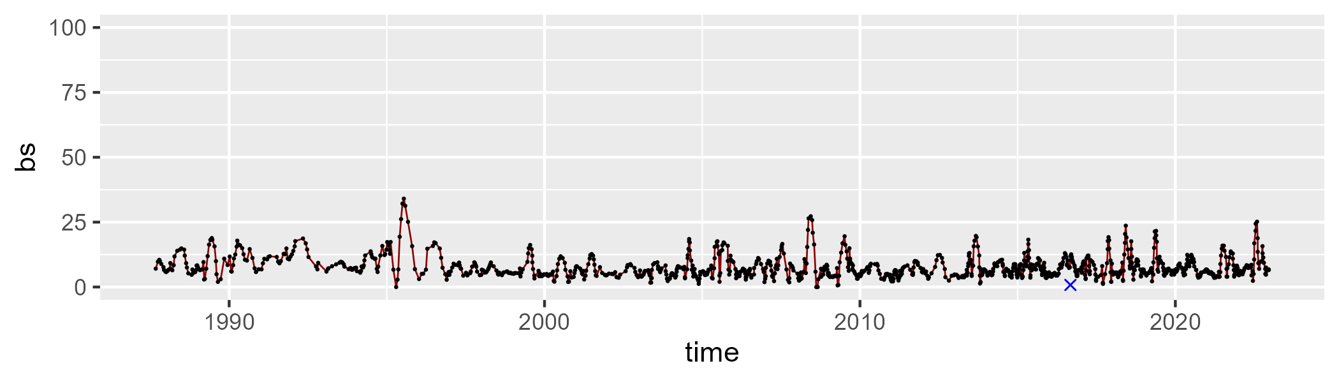

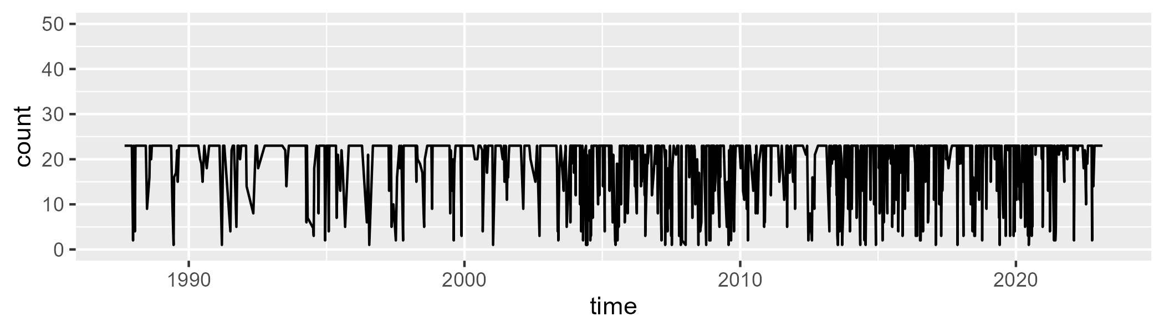

Min. : 1.00 1st Qu.:19.00 Median :23.00 Mean :19.36 3rd Qu.:23.00 Max. :23.00

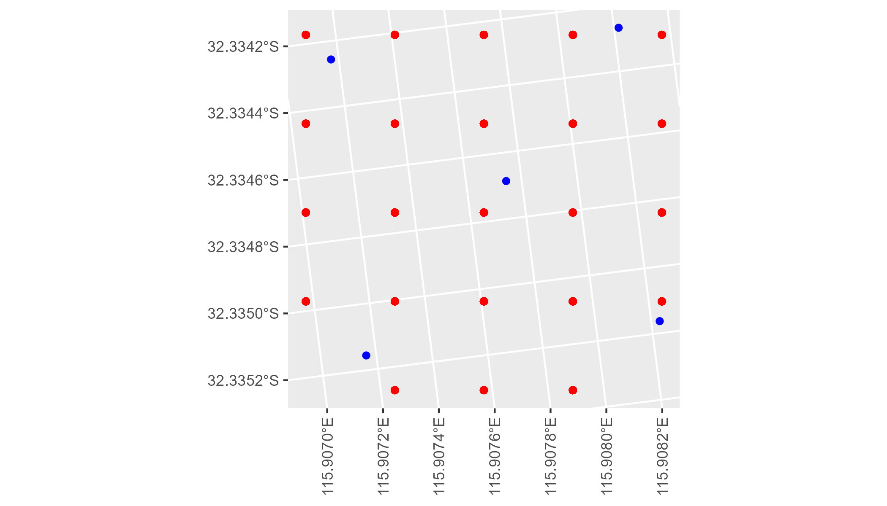

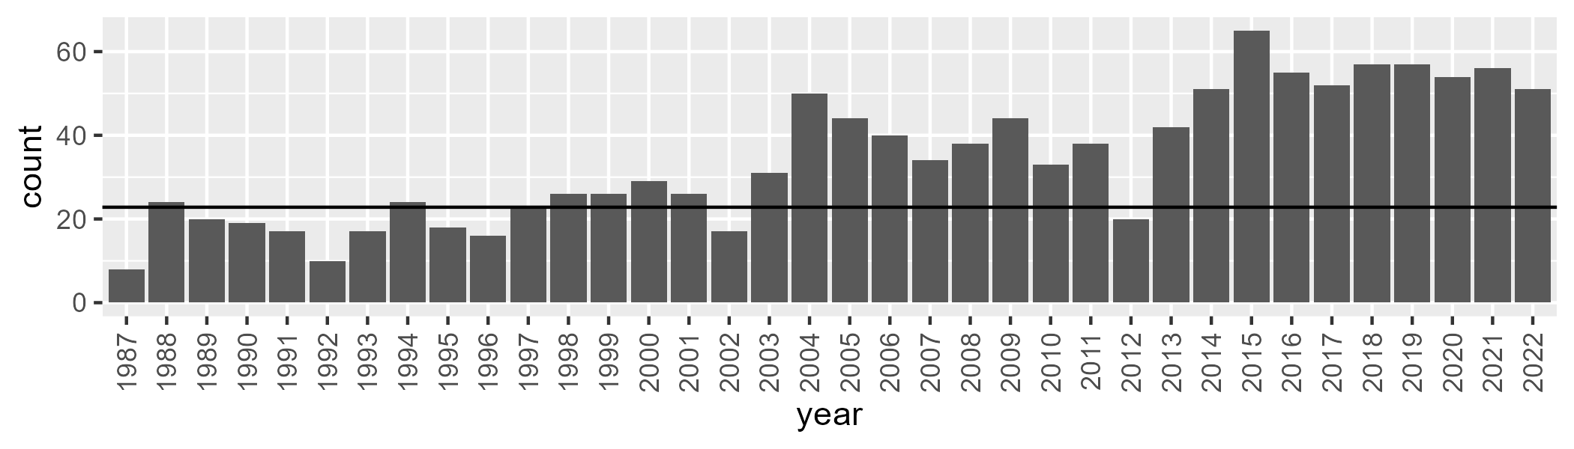

Number of samples: 1232

# WAASWA0003

| Min. | 1st Qu. | Median | Mean | 3rd Qu. | Max. |
| --- | --- | --- | --- | --- | --- |
| 43.5891 | 56.721 | 60.89679 | 60.44504 | 64.20771 | 75.49427 |

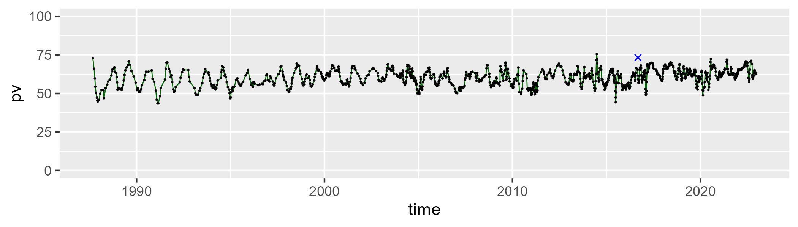

| Min. | 1st Qu. | Median | Mean | 3rd Qu. | Max. |
| --- | --- | --- | --- | --- | --- |
| 18.0368 | 29.62982 | 32.77795 | 33.20141 | 36.72867 | 50.11674 |

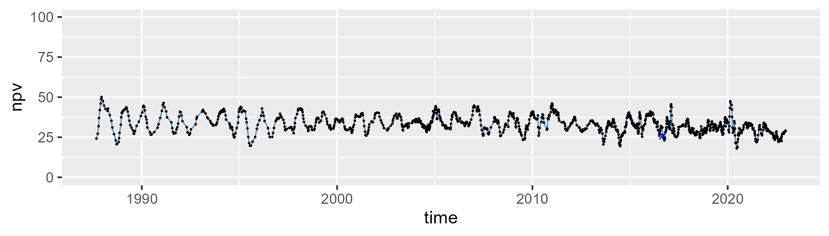

| Min. | 1st Qu. | Median | Mean | 3rd Qu. | Max. |
| --- | --- | --- | --- | --- | --- |
| 0 | 2.352407 | 3.872749 | 4.965236 | 6.397878 | 25.66374 |

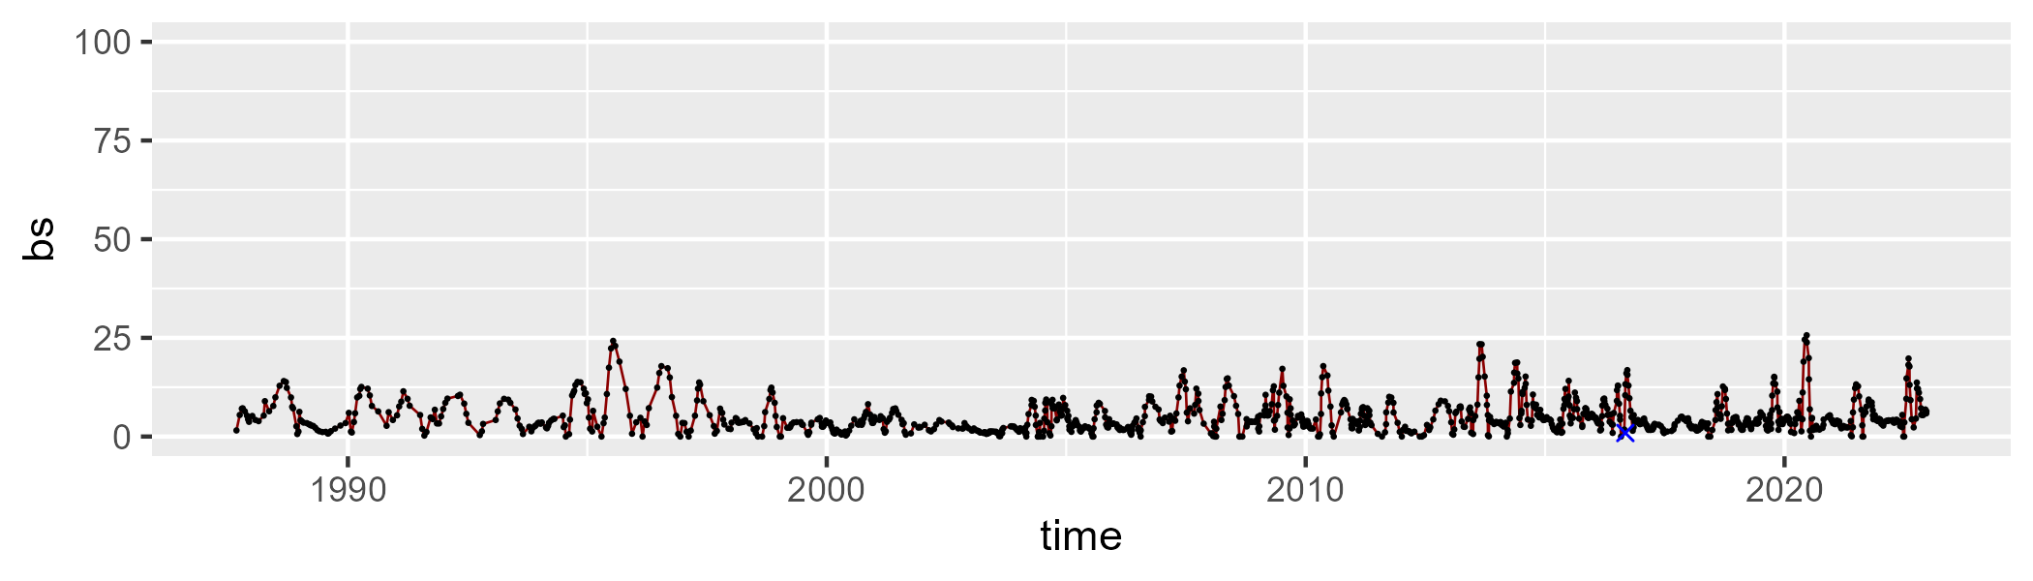

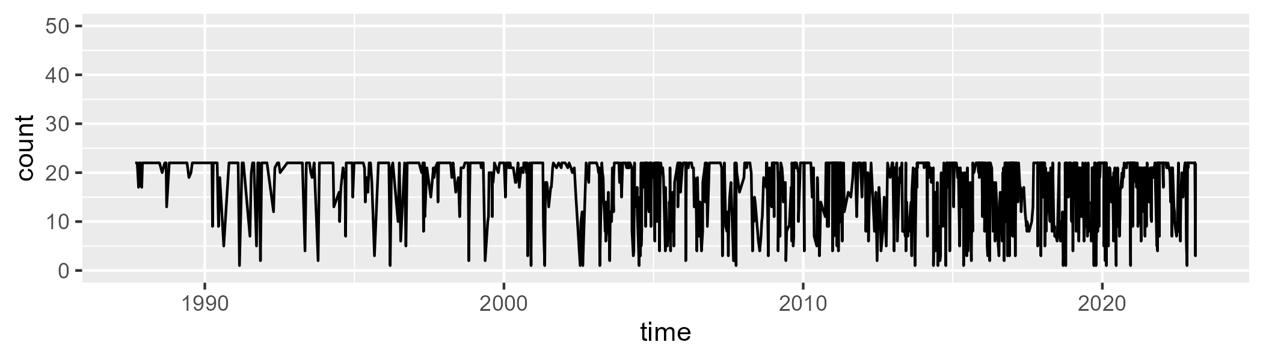

Min. : 1.00 1st Qu.:13.00 Median :21.00 Mean :17.15 3rd Qu.:22.00 Max. :22.00

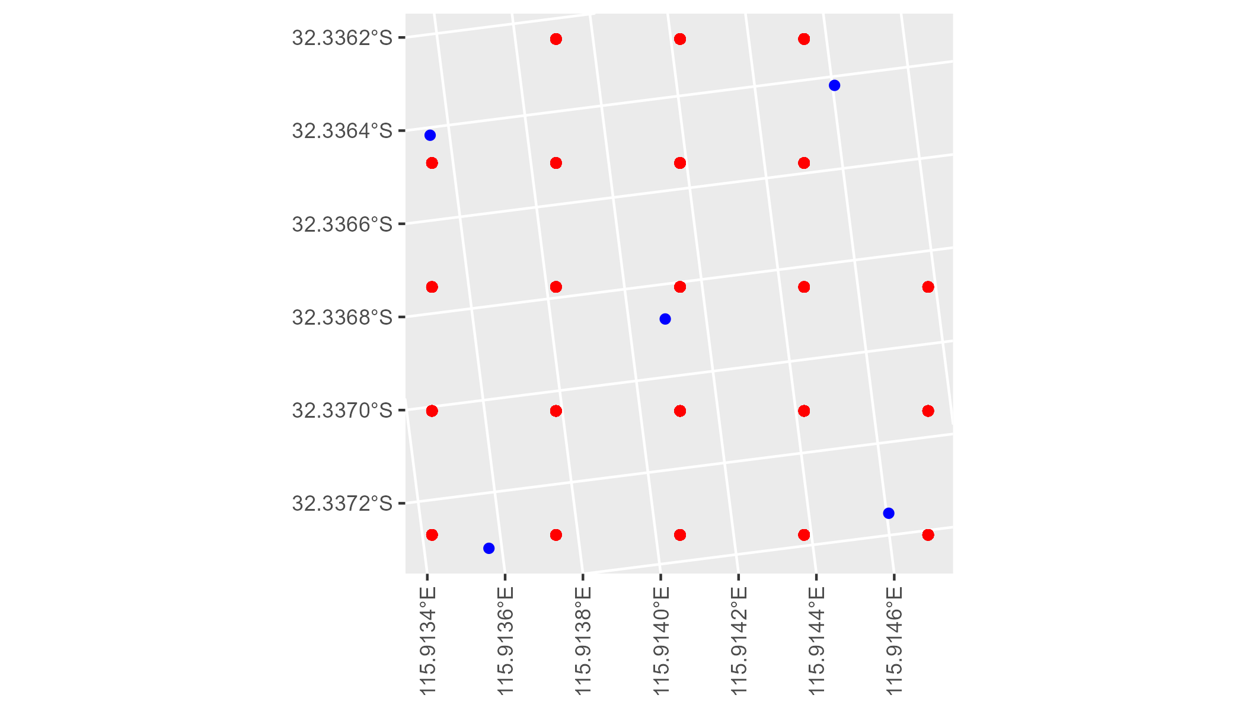

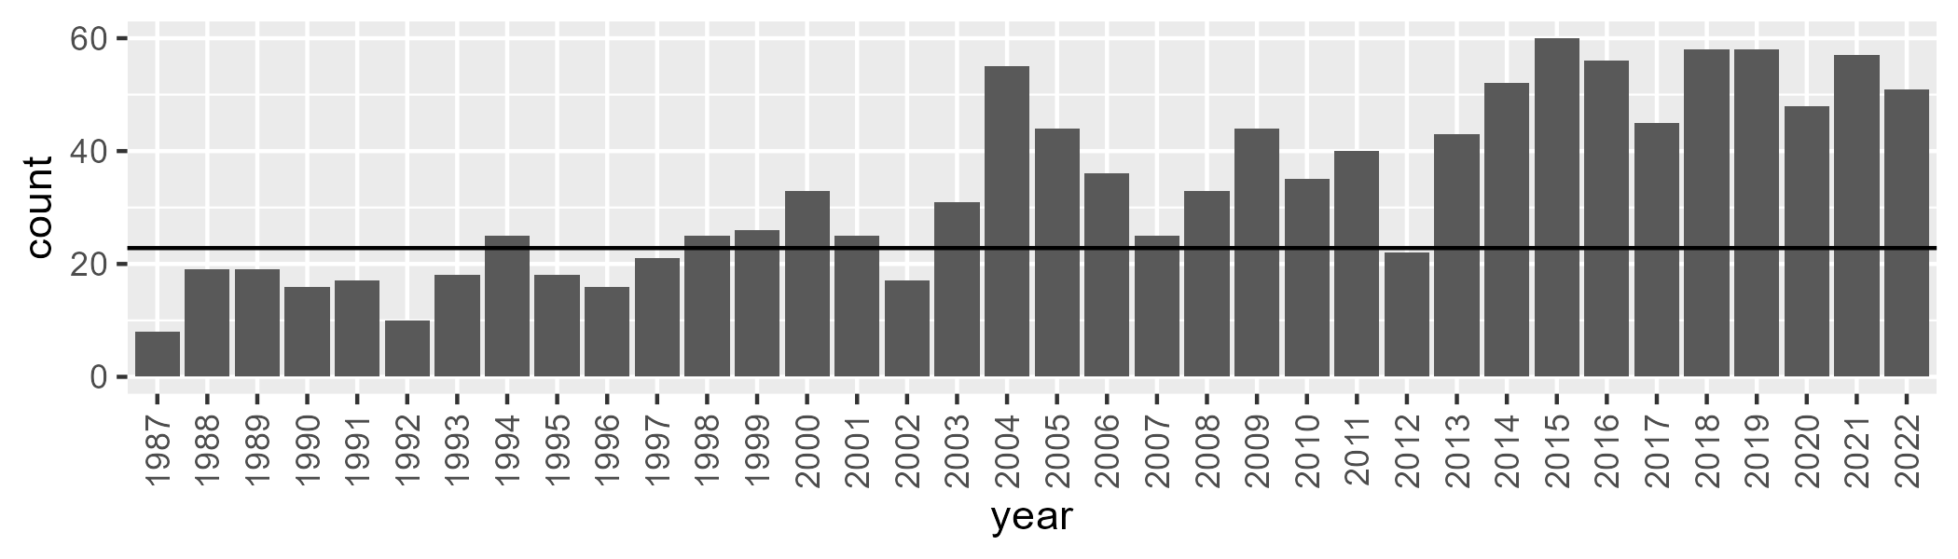

Number of samples: 1206

# WAASWA0004

| Min. | 1st Qu. | Median | Mean | 3rd Qu. | Max. |
| --- | --- | --- | --- | --- | --- |
| 22.18075 | 41.97984 | 44.95966 | 44.73054 | 47.94644 | 58.03237 |

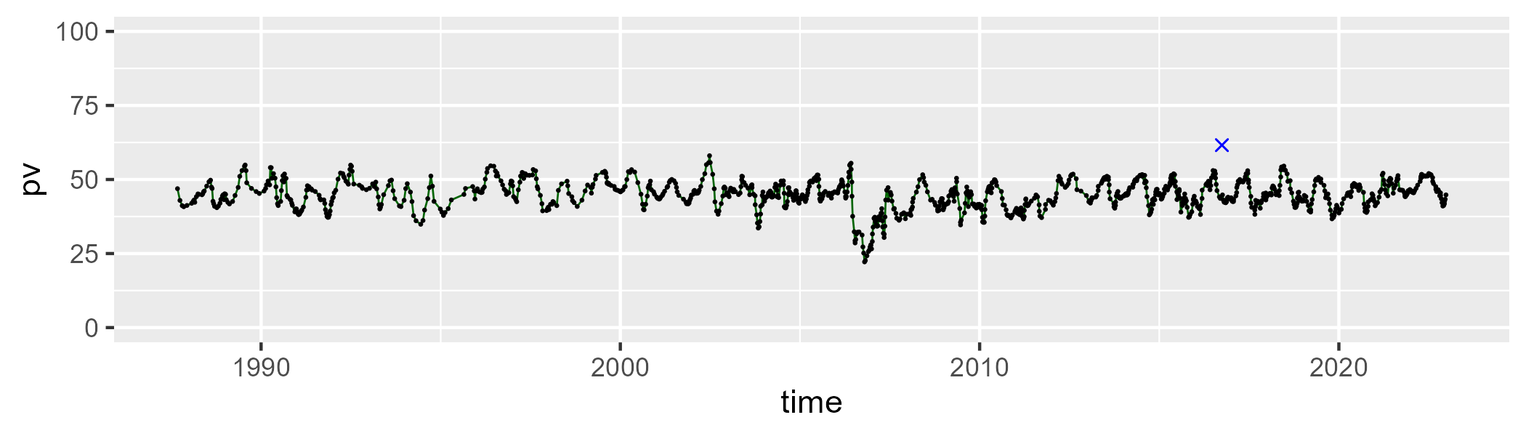

| Min. | 1st Qu. | Median | Mean | 3rd Qu. | Max. |
| --- | --- | --- | --- | --- | --- |
| 26.64467 | 40.879 | 43.86734 | 43.71683 | 47.19873 | 58.63207 |

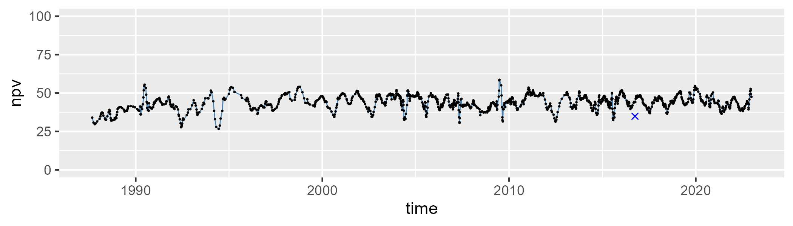

| Min. | 1st Qu. | Median | Mean | 3rd Qu. | Max. |
| --- | --- | --- | --- | --- | --- |
| 0 | 6.124427 | 8.297007 | 10.29166 | 13.17337 | 37.3405 |

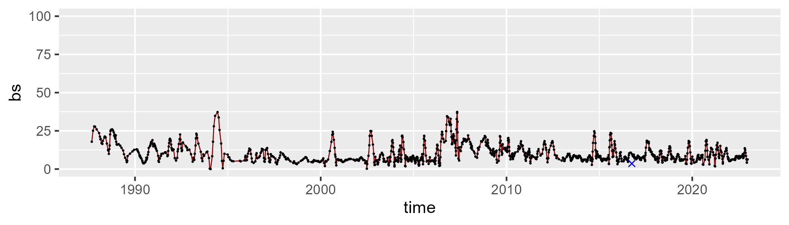

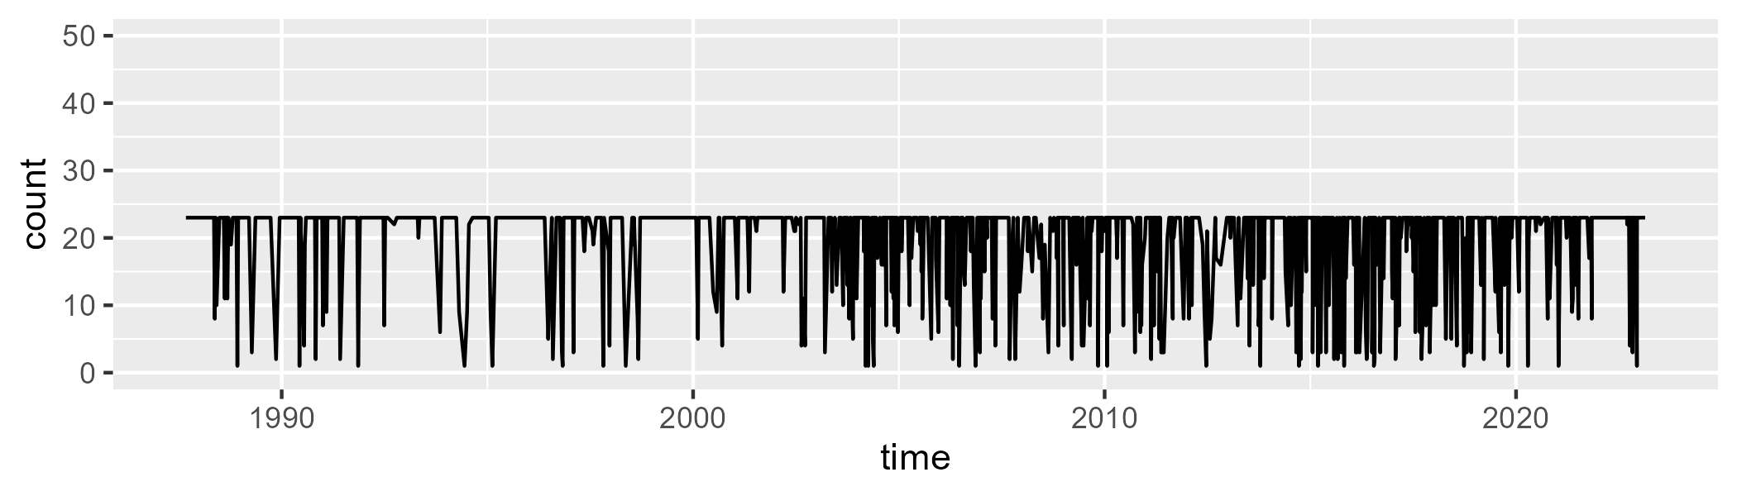

Min. : 1.00 1st Qu.:22.00 Median :23.00 Mean :19.92 3rd Qu.:23.00 Max. :23.00

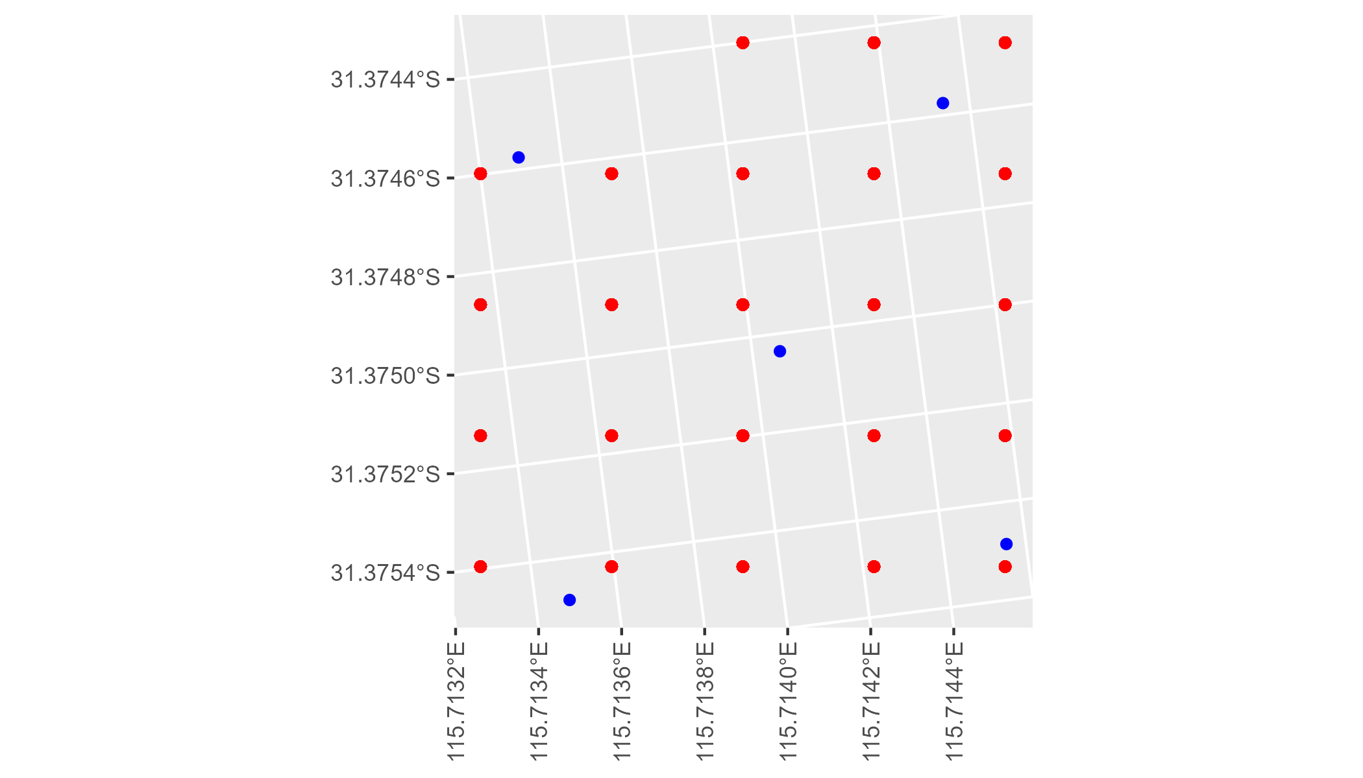

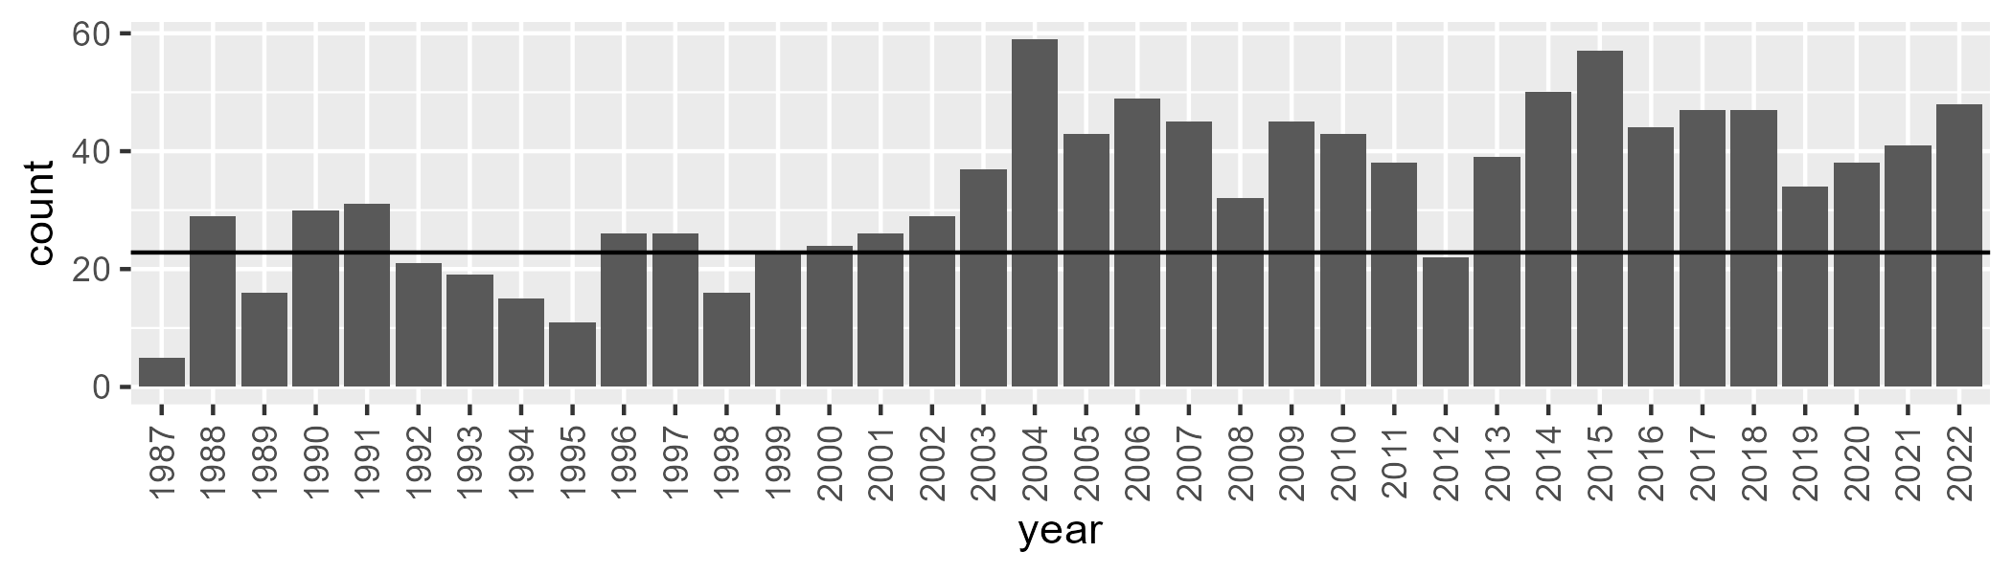

Number of samples: 1205

# WAAVIB0001

| Min. | 1st Qu. | Median | Mean | 3rd Qu. | Max. |
| --- | --- | --- | --- | --- | --- |
| 0 | 7.123667 | 12.25774 | 22.08821 | 35.2488 | 85.49842 |

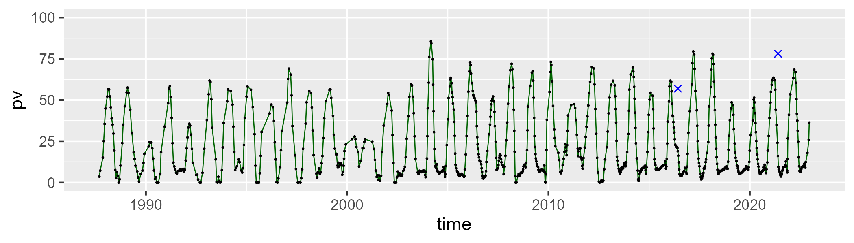

| Min. | 1st Qu. | Median | Mean | 3rd Qu. | Max. |
| --- | --- | --- | --- | --- | --- |
| 14.85878 | 32.09588 | 41.93707 | 45.38255 | 54.92988 | 91.55776 |

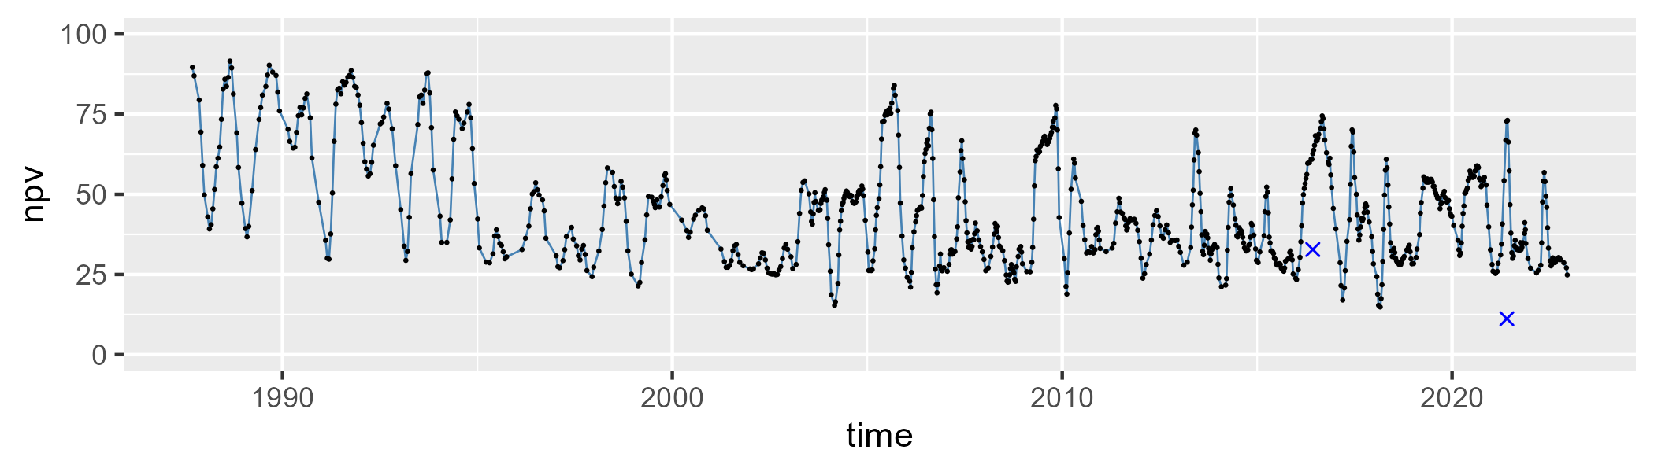

| Min. | 1st Qu. | Median | Mean | 3rd Qu. | Max. |
| --- | --- | --- | --- | --- | --- |
| 0 | 13.58283 | 29.38444 | 31.18503 | 47.68097 | 75.20495 |

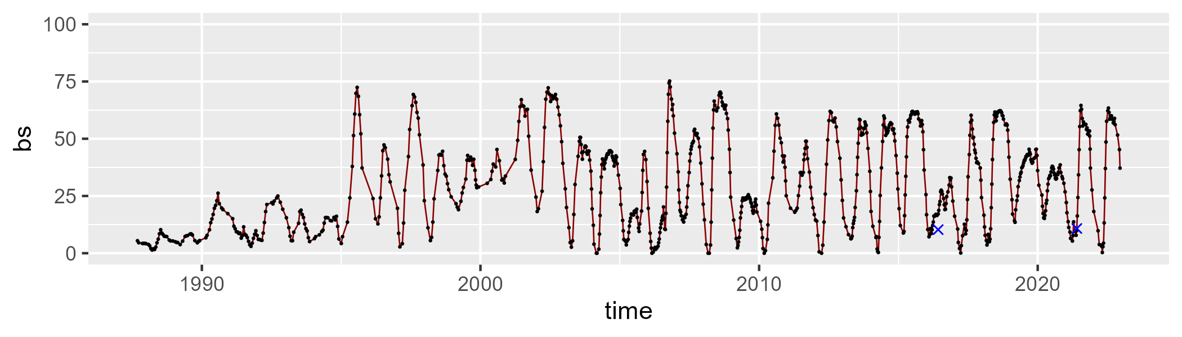

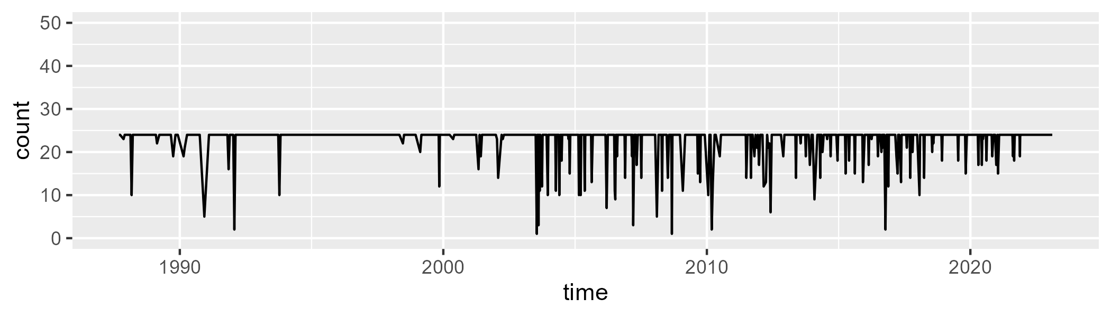

Min. : 1.00 1st Qu.:24.00 Median :24.00 Mean :22.93 3rd Qu.:24.00 Max. :24.00

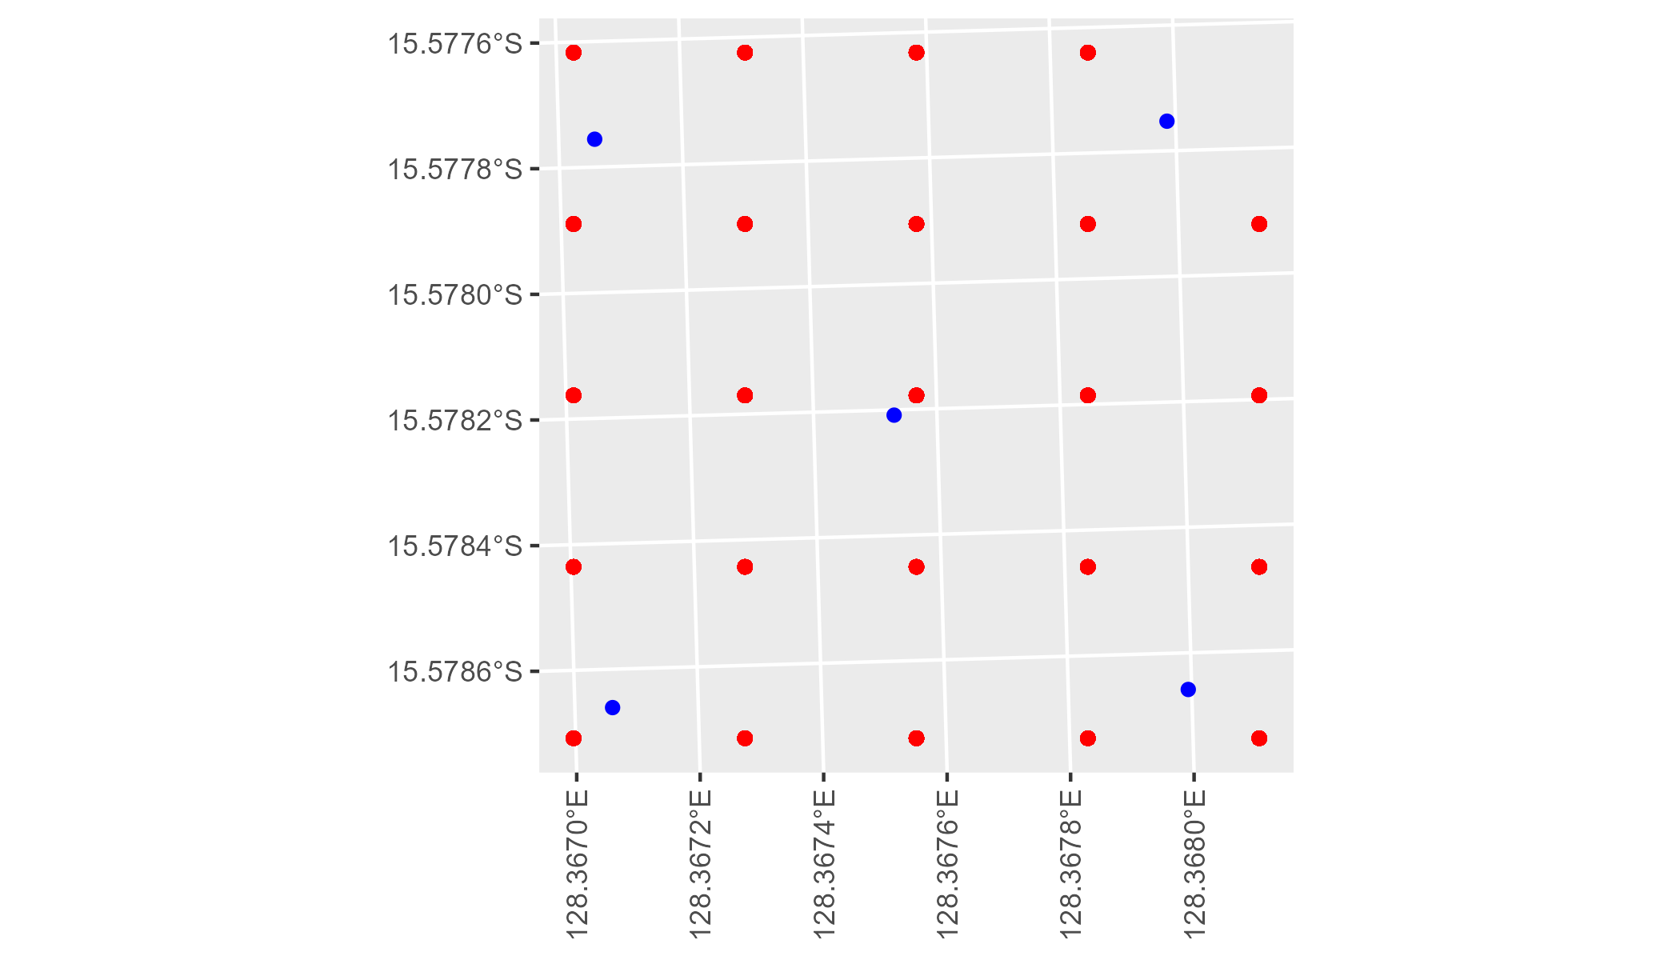

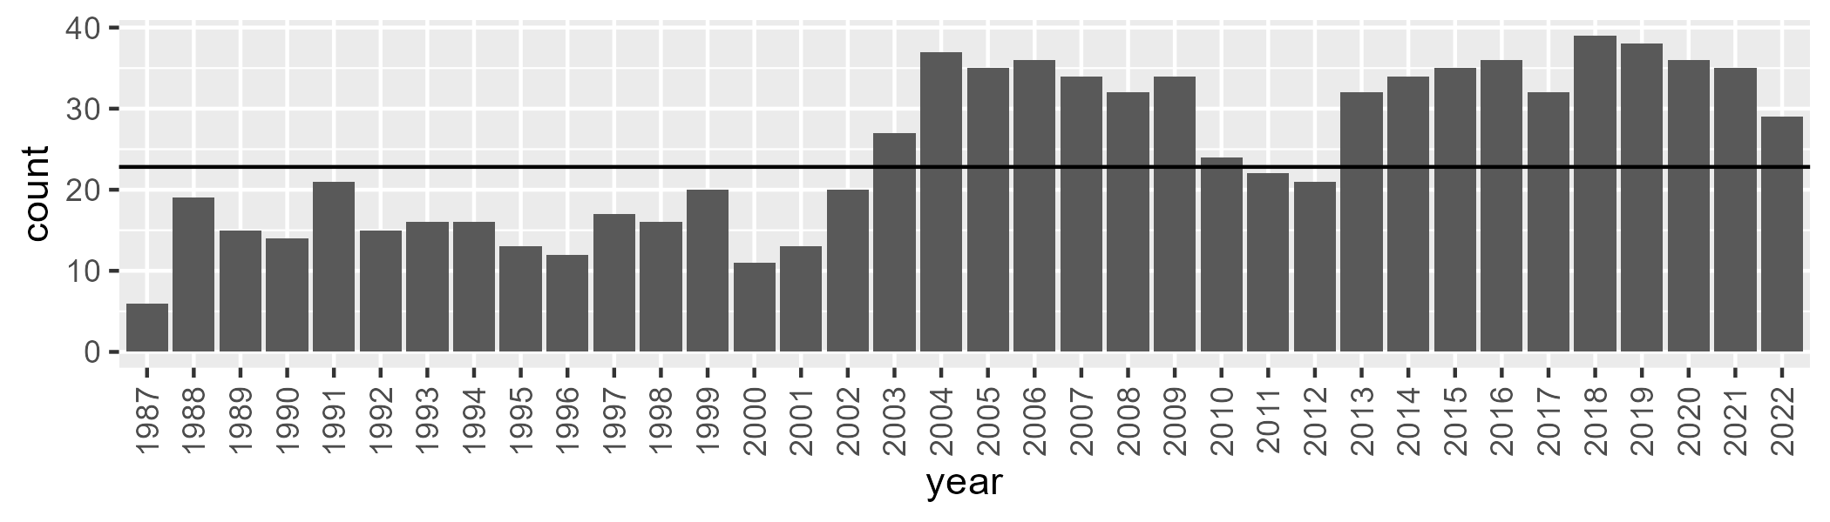

Number of samples: 892

# WAAVIB0002

| Min. | 1st Qu. | Median | Mean | 3rd Qu. | Max. |
| --- | --- | --- | --- | --- | --- |
| 0.4159467 | 11.91643 | 16.94589 | 18.51533 | 24.60904 | 39.00931 |

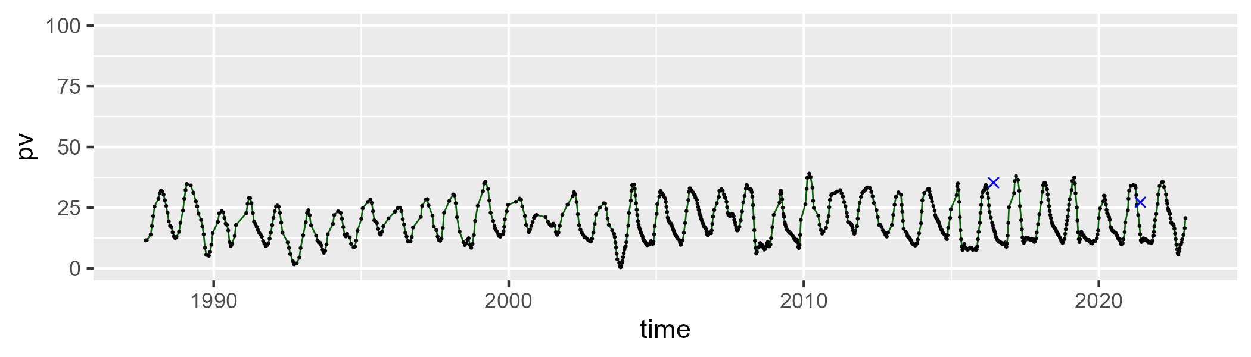

| Min. | 1st Qu. | Median | Mean | 3rd Qu. | Max. |
| --- | --- | --- | --- | --- | --- |
| 35.9885 | 49.80384 | 55.07263 | 55.46723 | 61.47966 | 77.16616 |

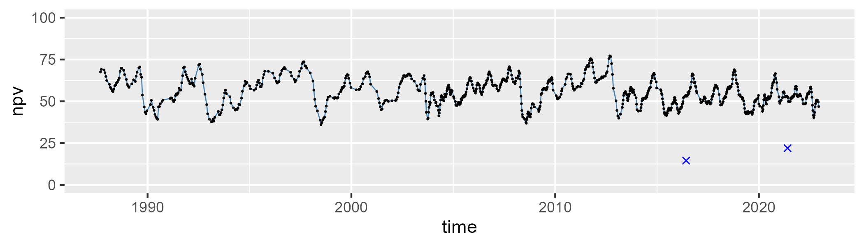

| Min. | 1st Qu. | Median | Mean | 3rd Qu. | Max. |
| --- | --- | --- | --- | --- | --- |
| 0 | 16.44254 | 23.80104 | 24.69178 | 31.6412 | 58.00616 |

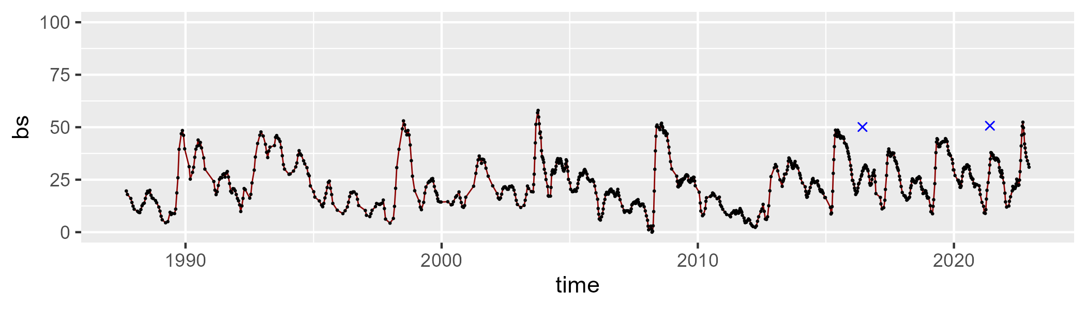

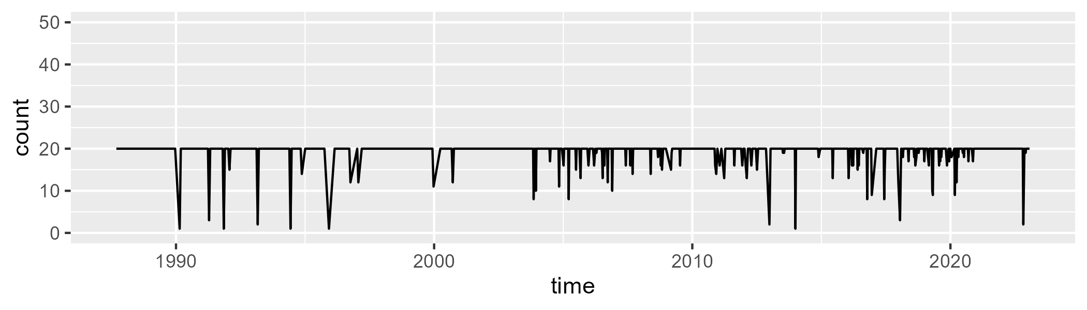

Min. : 1.00 1st Qu.:20.00 Median :20.00 Mean :19.33 3rd Qu.:20.00 Max. :20.00

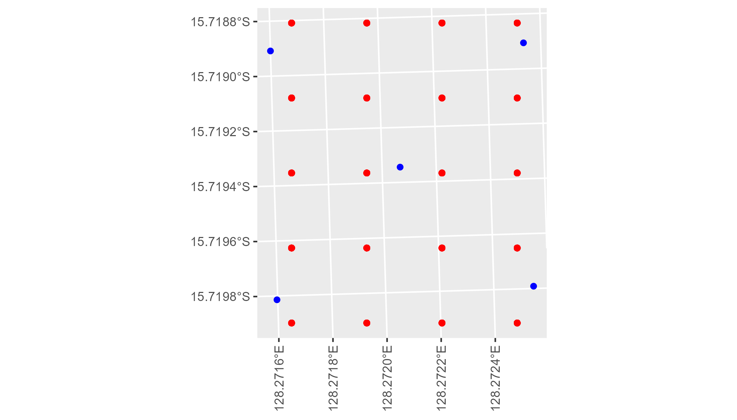

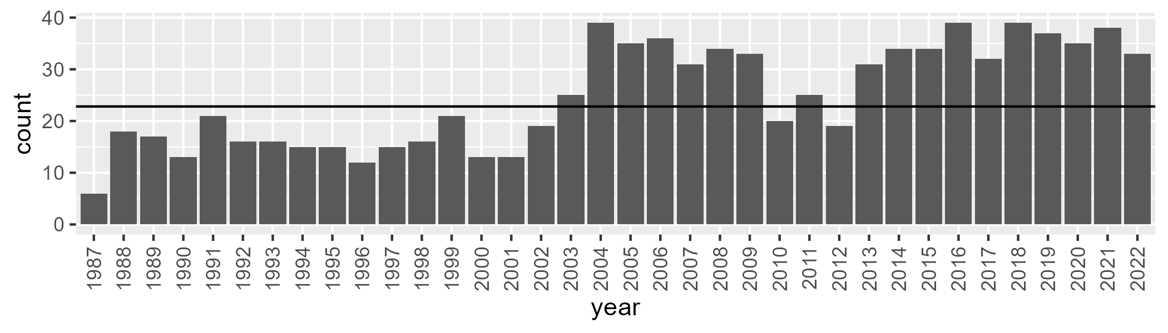

Number of samples: 895

# WAAVIB0003

| Min. | 1st Qu. | Median | Mean | 3rd Qu. | Max. |
| --- | --- | --- | --- | --- | --- |
| 17.66924 | 33.5353 | 38.17735 | 38.11066 | 43.62973 | 58.36409 |

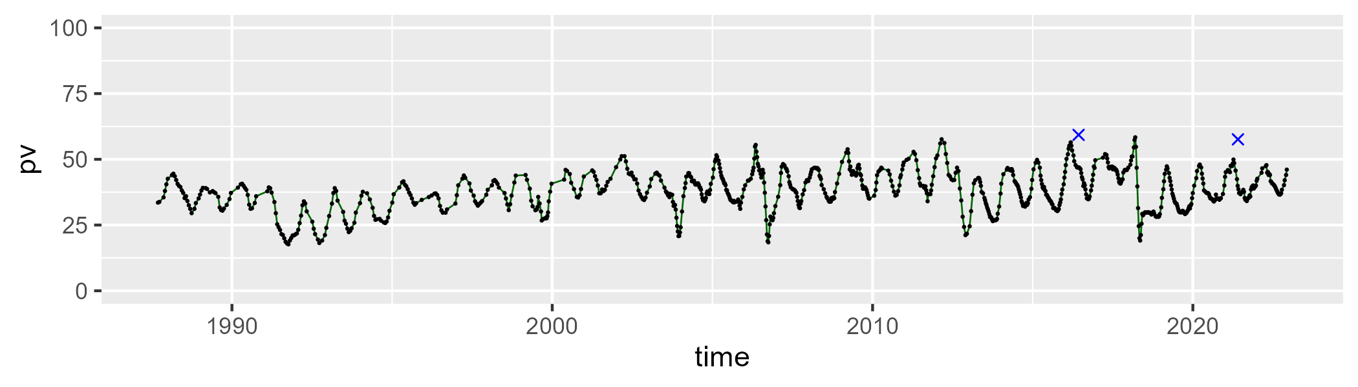

| Min. | 1st Qu. | Median | Mean | 3rd Qu. | Max. |
| --- | --- | --- | --- | --- | --- |
| 31.16886 | 42.29573 | 46.69404 | 46.78438 | 50.90782 | 65.54265 |

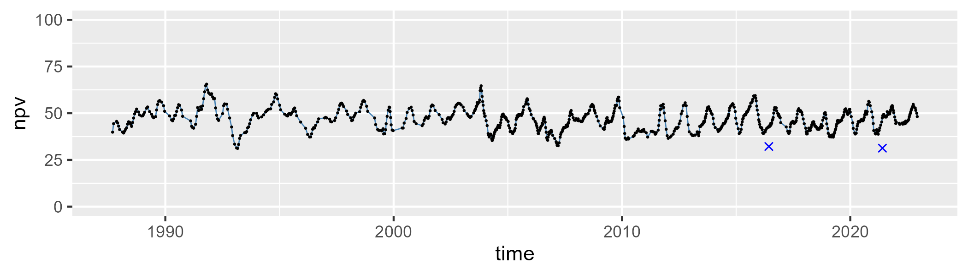

| Min. | 1st Qu. | Median | Mean | 3rd Qu. | Max. |
| --- | --- | --- | --- | --- | --- |
| 0 | 9.048741 | 12.24281 | 13.7774 | 17.47073 | 44.61062 |

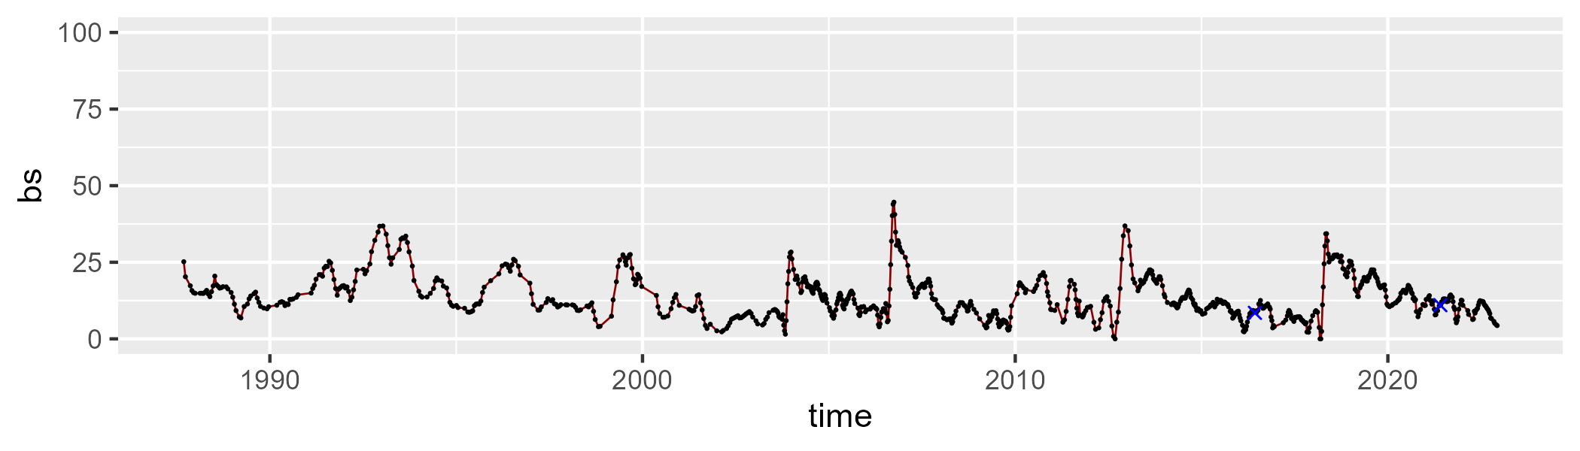

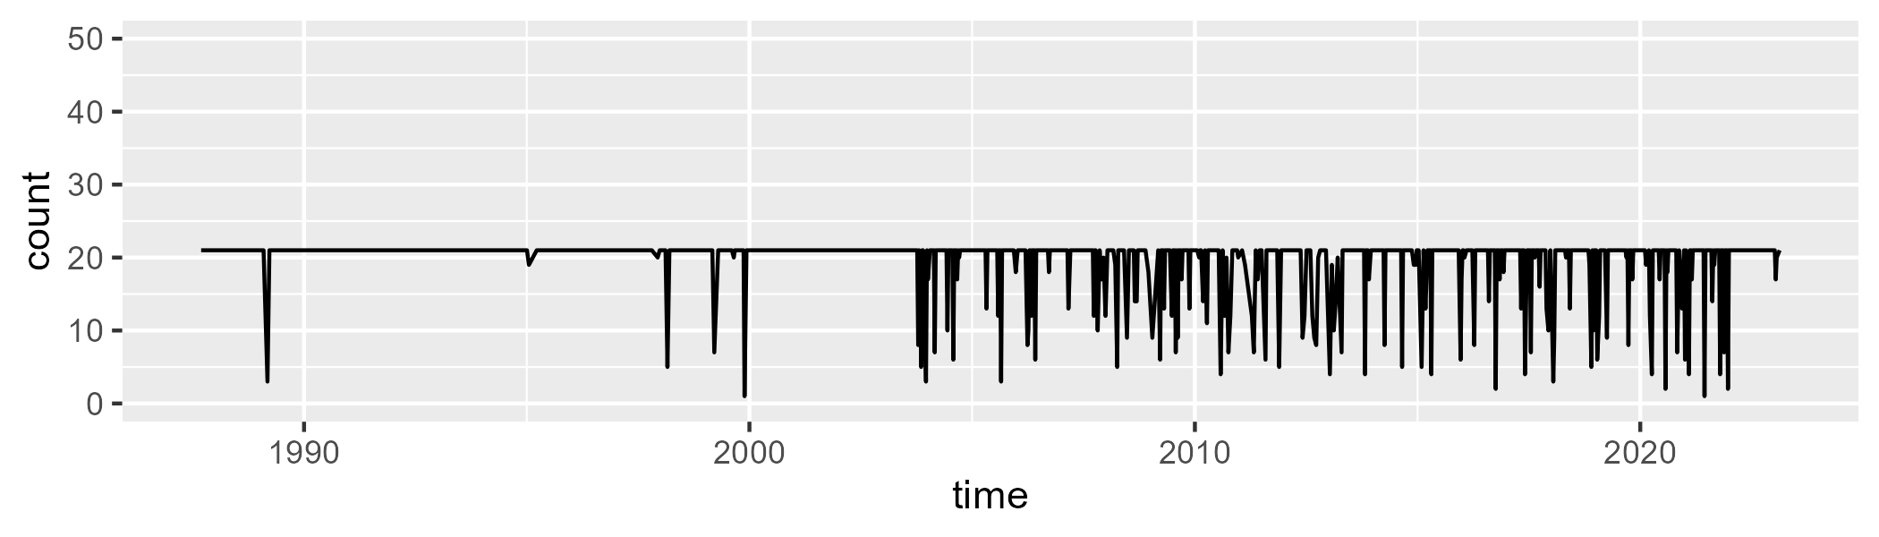

Min. : 1.00 1st Qu.:21.00 Median :21.00 Mean :19.64 3rd Qu.:21.00 Max. :21.00

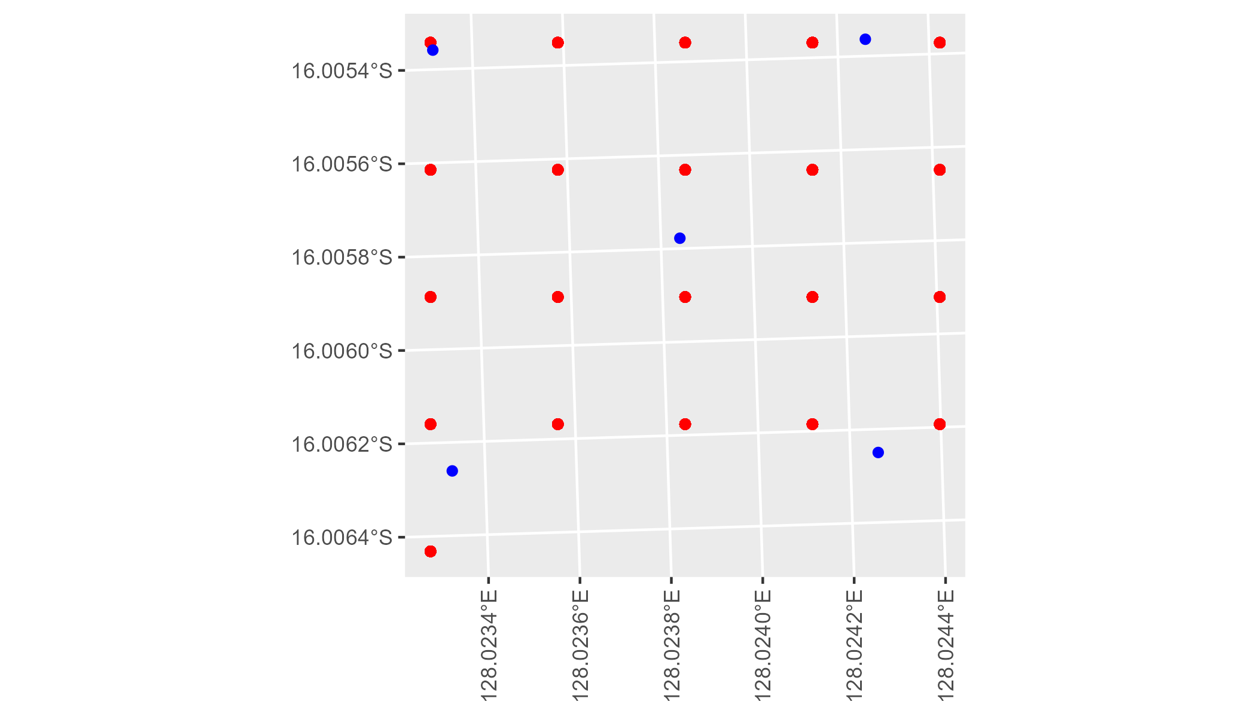

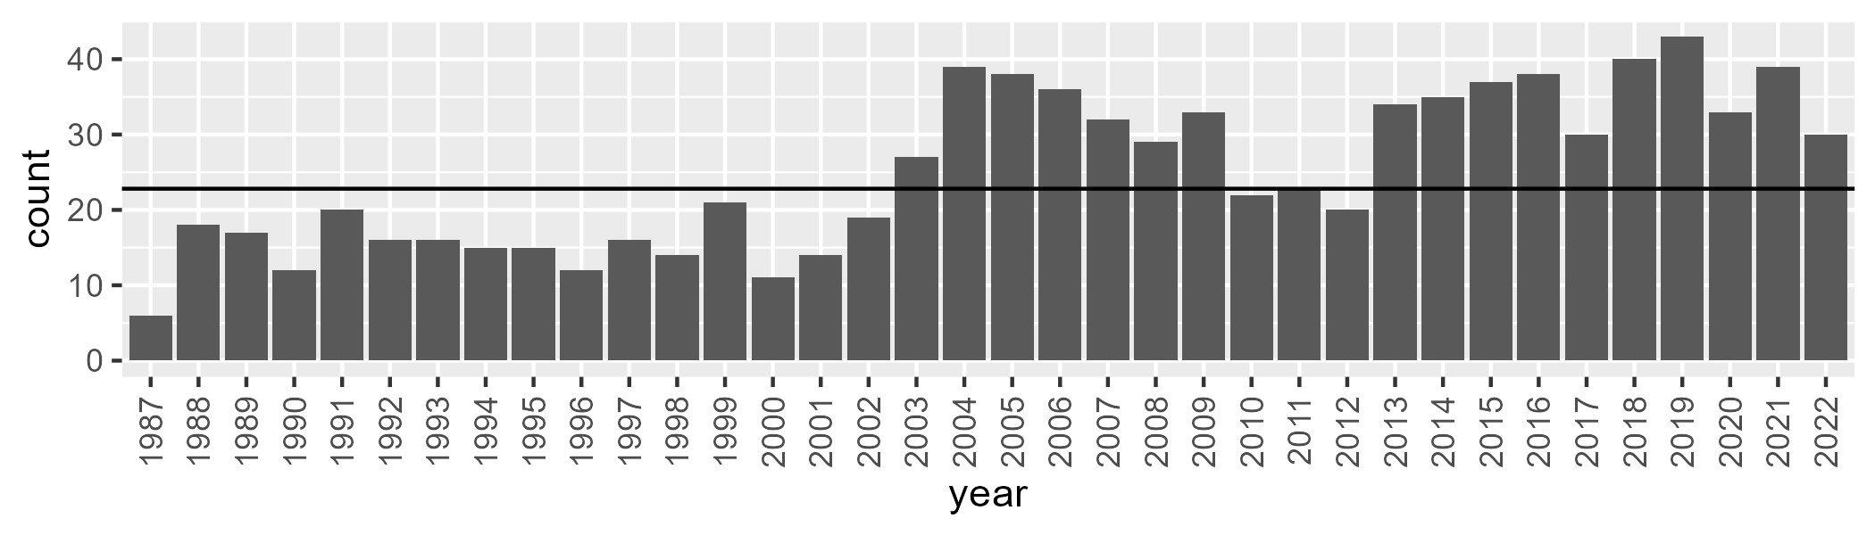

Number of samples: 900

# WAAVIB0004

| Min. | 1st Qu. | Median | Mean | 3rd Qu. | Max. |
| --- | --- | --- | --- | --- | --- |
| 15.67183 | 29.39018 | 35.13177 | 35.50179 | 41.28455 | 57.11129 |

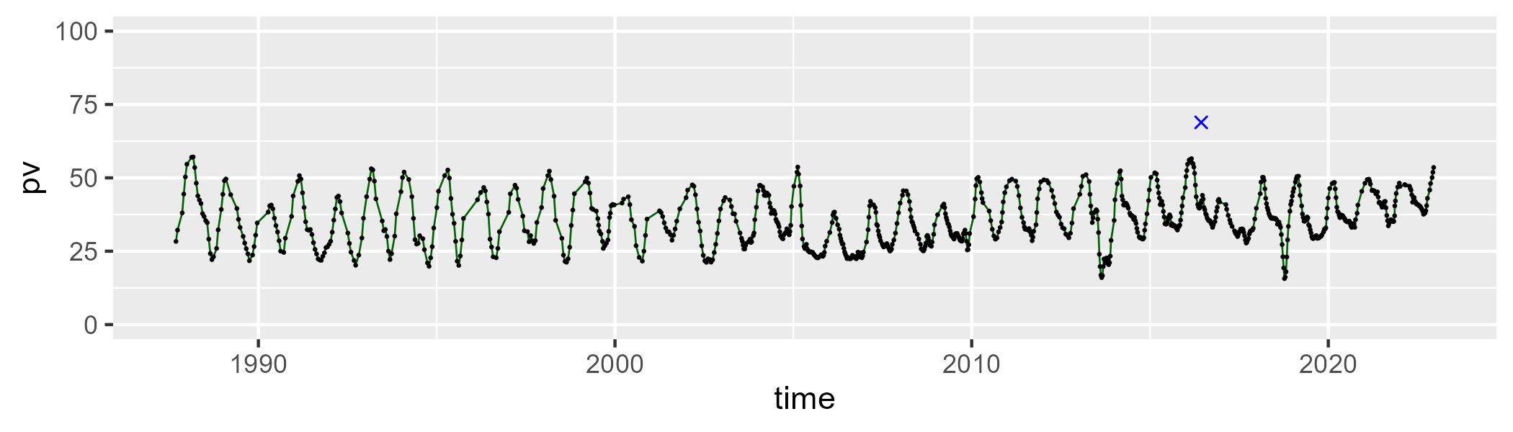

| Min. | 1st Qu. | Median | Mean | 3rd Qu. | Max. |
| --- | --- | --- | --- | --- | --- |
| 27.65534 | 43.44673 | 47.3167 | 47.48479 | 51.62339 | 69.48749 |

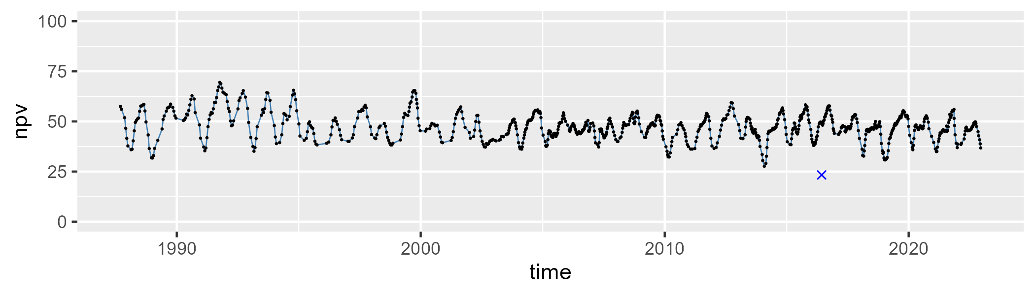

| Min. | 1st Qu. | Median | Mean | 3rd Qu. | Max. |
| --- | --- | --- | --- | --- | --- |
| 2.175631 | 10.57114 | 14.04541 | 15.73466 | 19.23311 | 39.08613 |

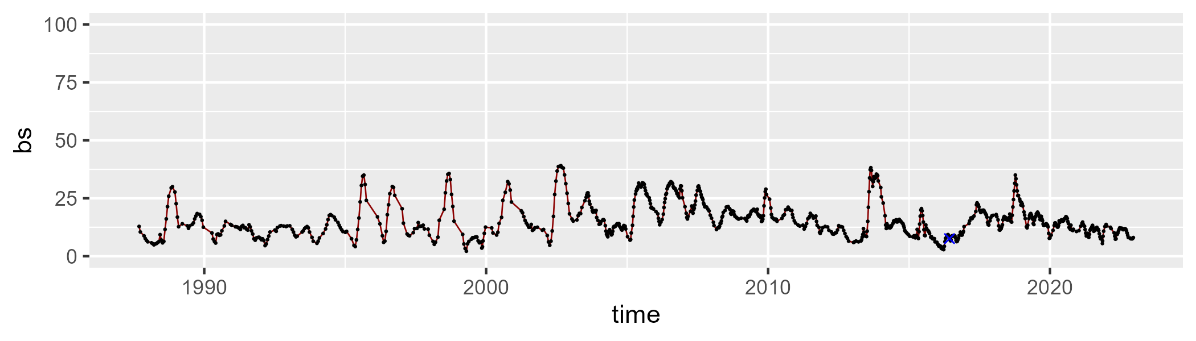

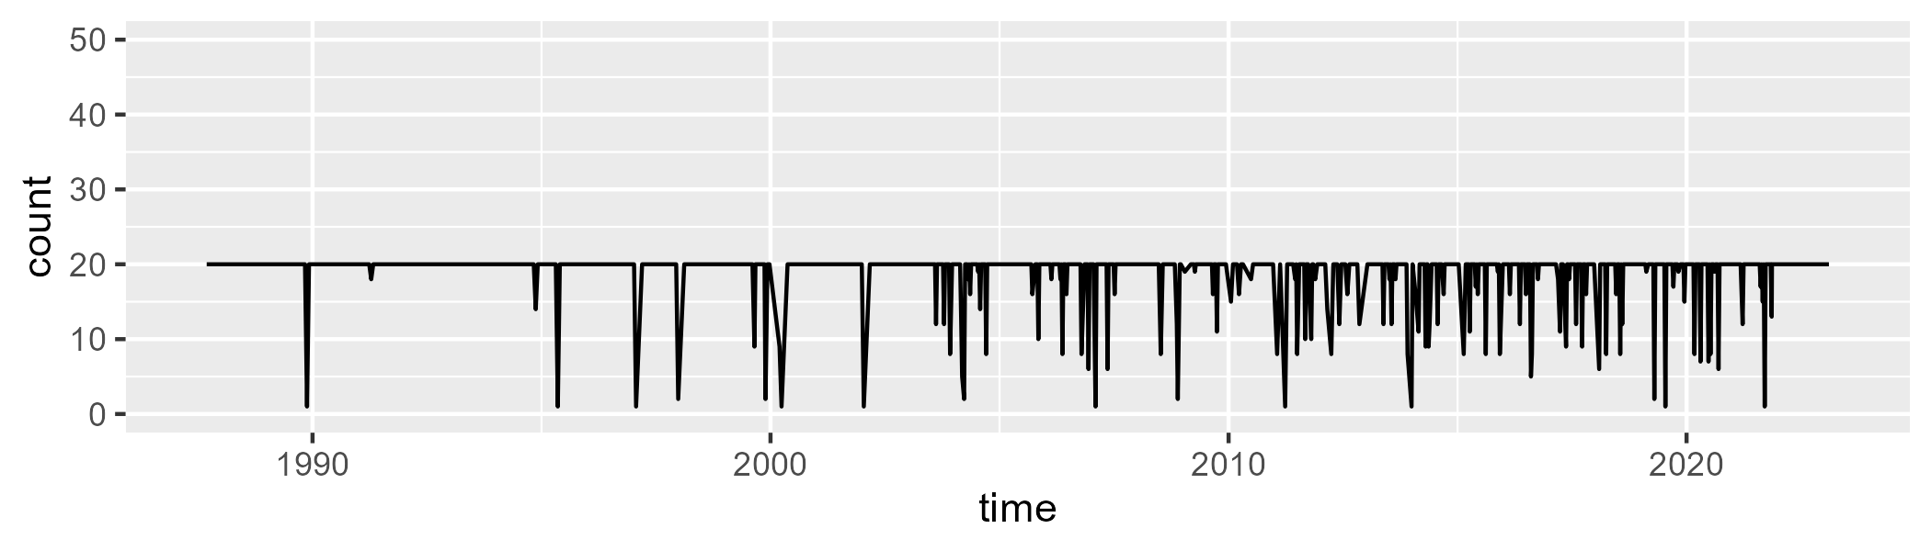

Min. : 1.00 1st Qu.:20.00 Median :20.00 Mean :18.92 3rd Qu.:20.00 Max. :20.00

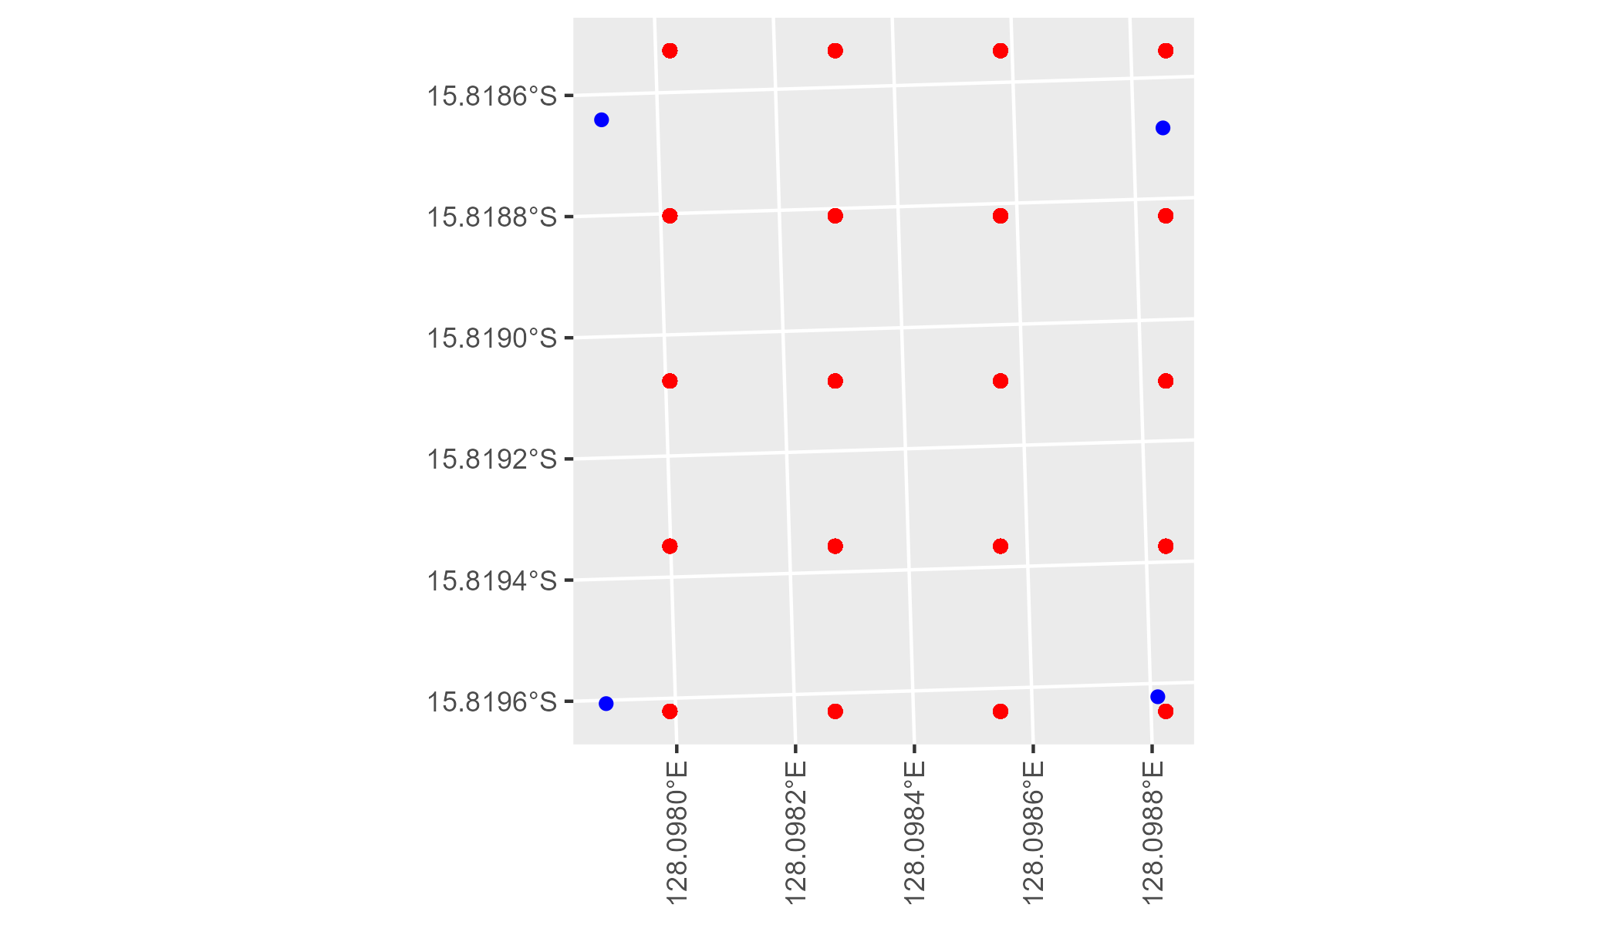

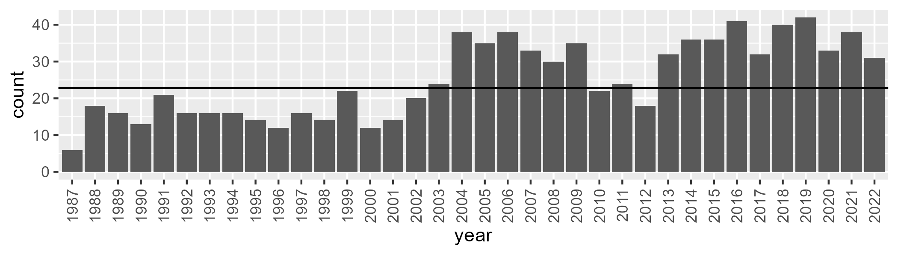

Number of samples: 904

# WAAYAL0002

| Min. | 1st Qu. | Median | Mean | 3rd Qu. | Max. |
| --- | --- | --- | --- | --- | --- |
| 6.145204 | 13.0884 | 16.58502 | 17.01688 | 20.22328 | 34.31116 |

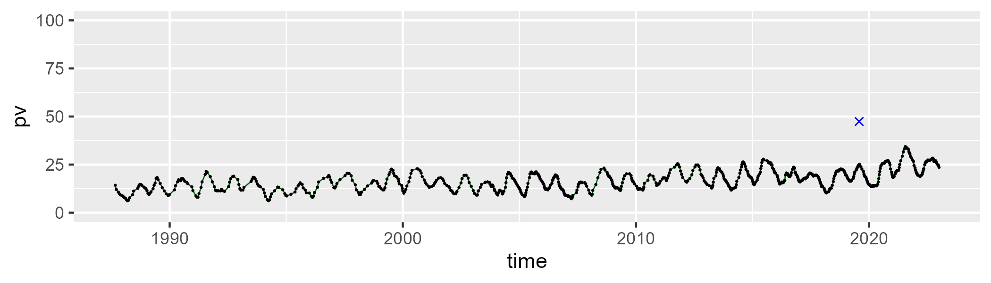

| Min. | 1st Qu. | Median | Mean | 3rd Qu. | Max. |
| --- | --- | --- | --- | --- | --- |
| 34.67462 | 51.09959 | 56.58682 | 56.26615 | 61.36689 | 77.81466 |

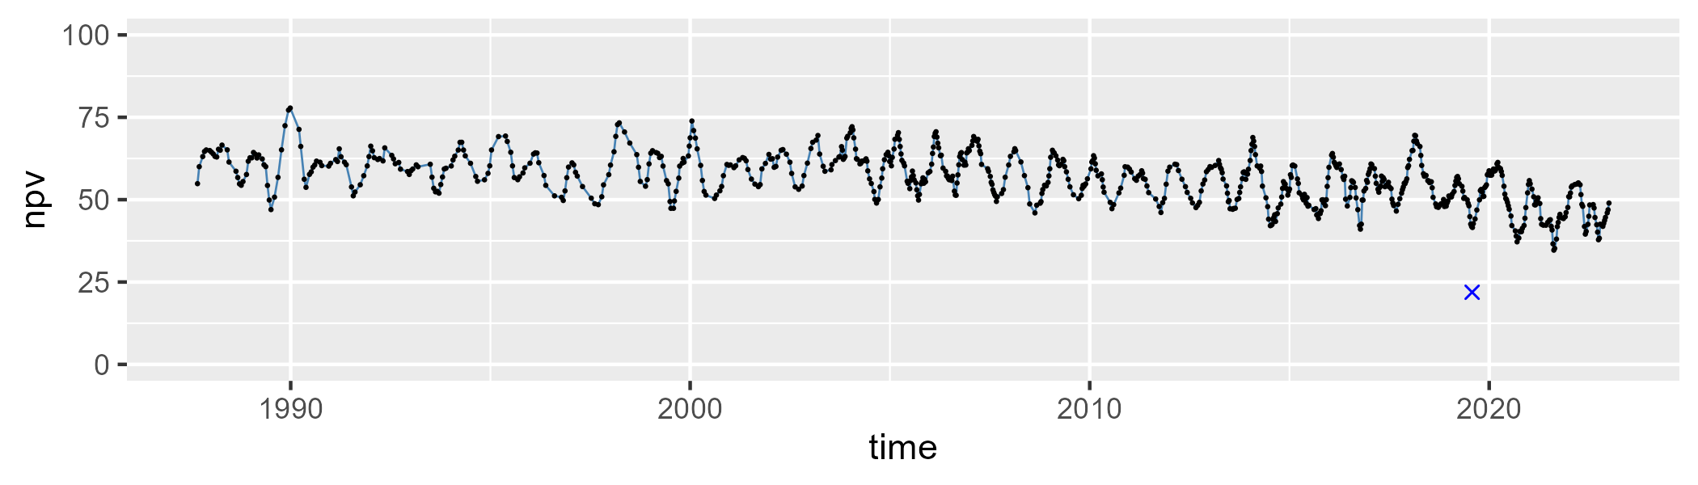

| Min. | 1st Qu. | Median | Mean | 3rd Qu. | Max. |
| --- | --- | --- | --- | --- | --- |
| 11.66196 | 23.46198 | 25.47699 | 25.44538 | 27.69267 | 34.87652 |

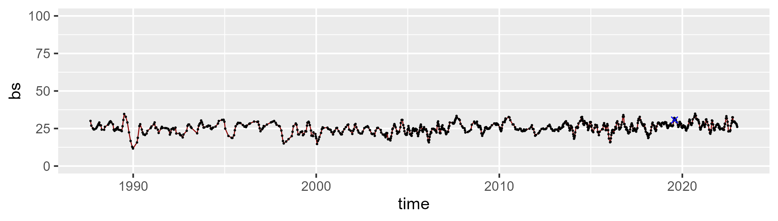

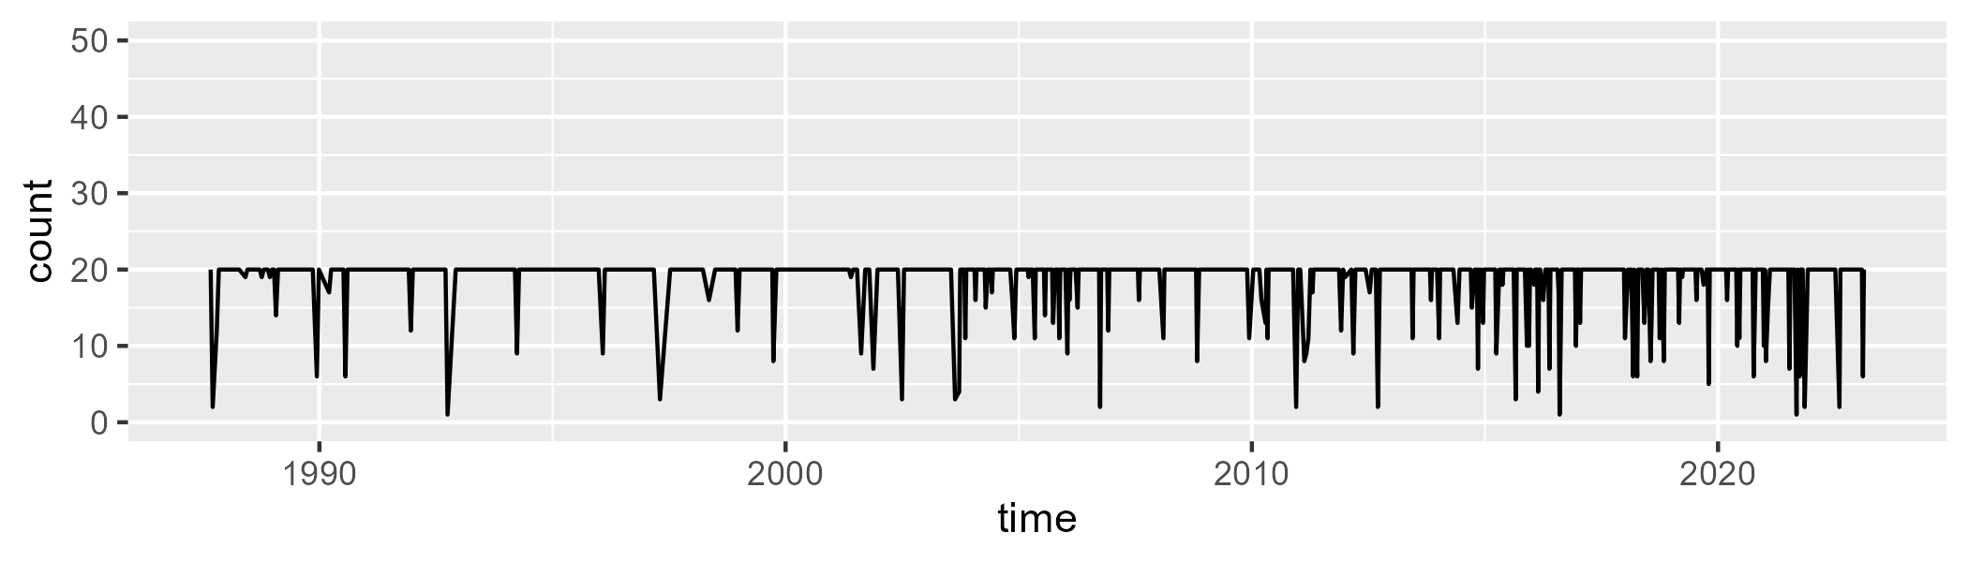

Min. : 1.00 1st Qu.:20.00 Median :20.00 Mean :18.81 3rd Qu.:20.00 Max. :20.00

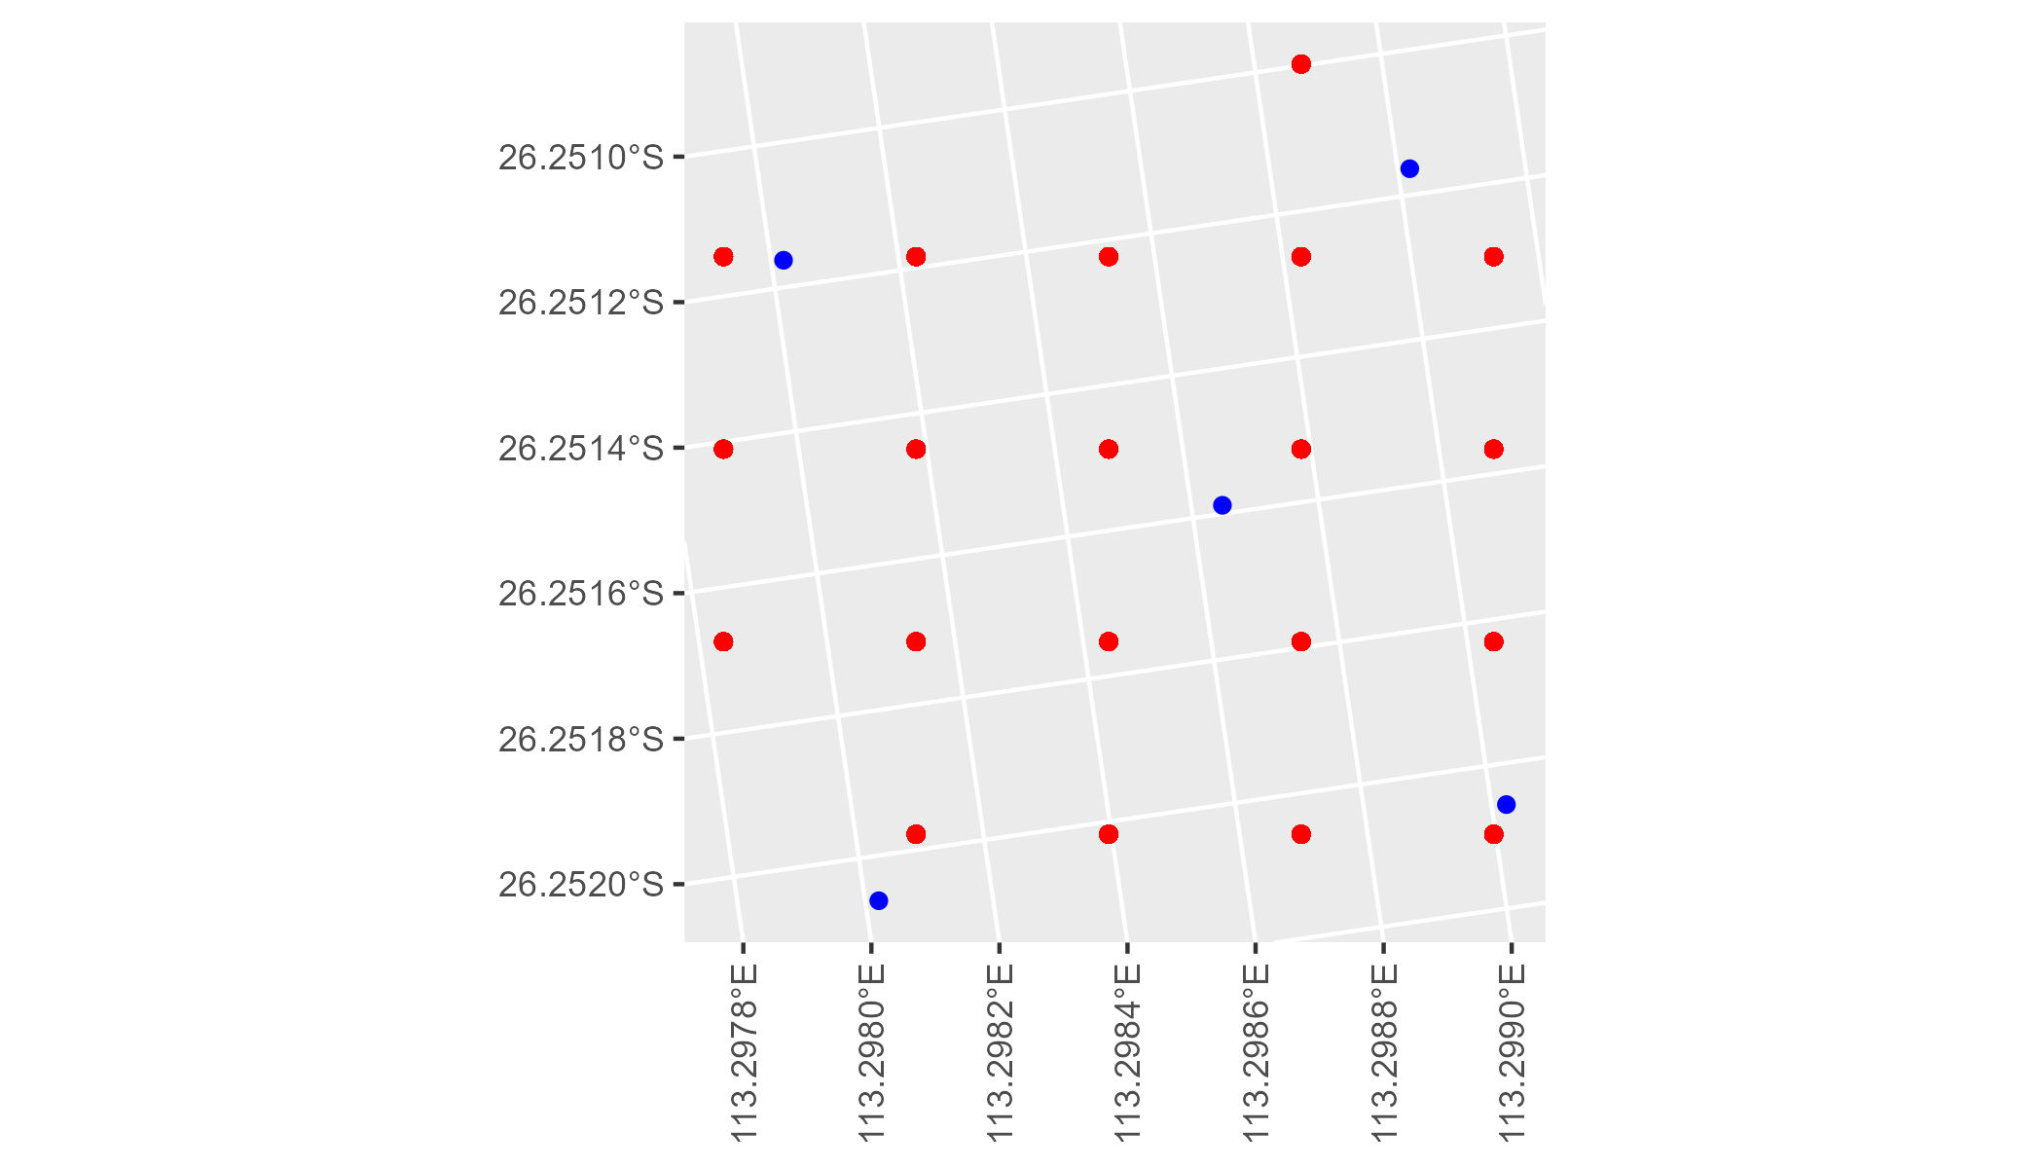

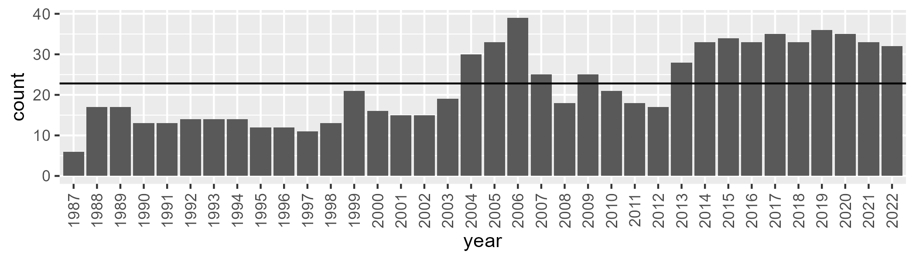

Number of samples: 800

# WAAYAL0004

| Min. | 1st Qu. | Median | Mean | 3rd Qu. | Max. |
| --- | --- | --- | --- | --- | --- |
| 14.13774 | 20.41326 | 22.96826 | 23.42593 | 26.42961 | 36.67814 |

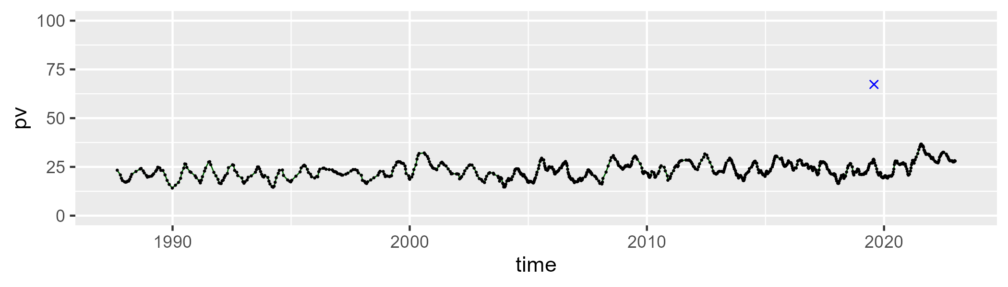

| Min. | 1st Qu. | Median | Mean | 3rd Qu. | Max. |
| --- | --- | --- | --- | --- | --- |
| 35.6939 | 51.76795 | 57.04474 | 56.54504 | 61.68244 | 73.88231 |

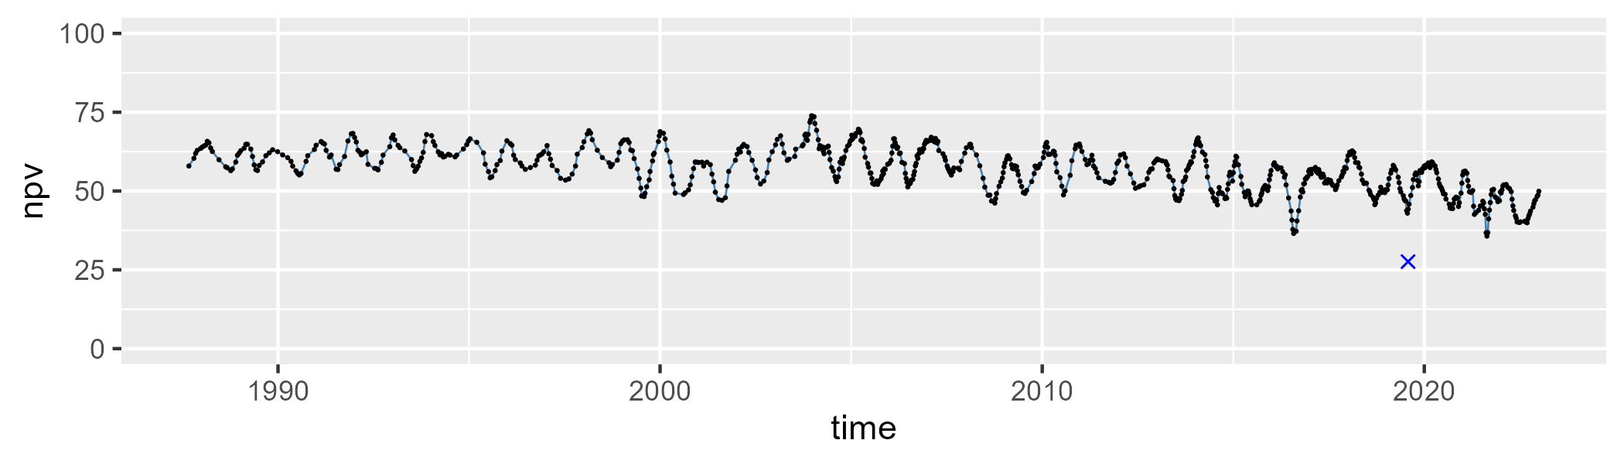

| Min. | 1st Qu. | Median | Mean | 3rd Qu. | Max. |
| --- | --- | --- | --- | --- | --- |
| 10.24759 | 15.51316 | 18.08974 | 18.76907 | 21.6489 | 36.27366 |

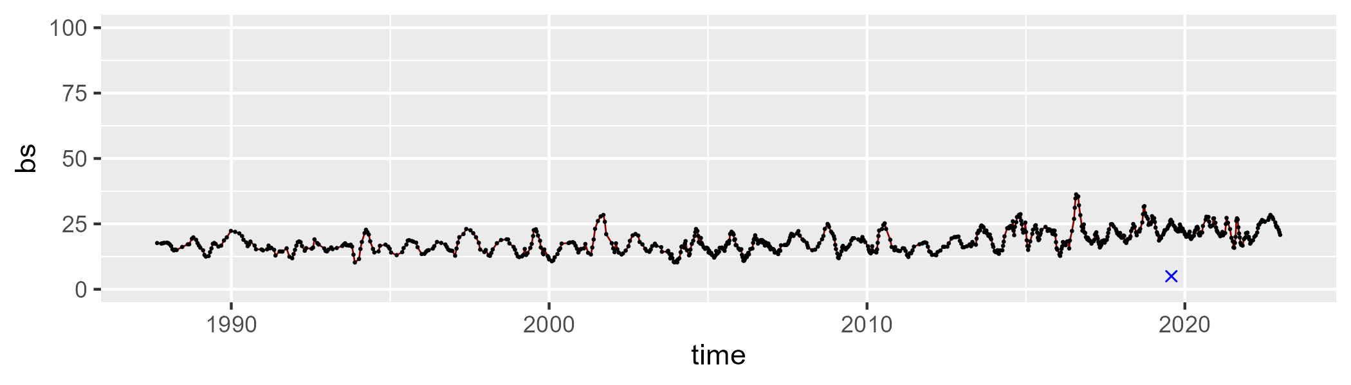

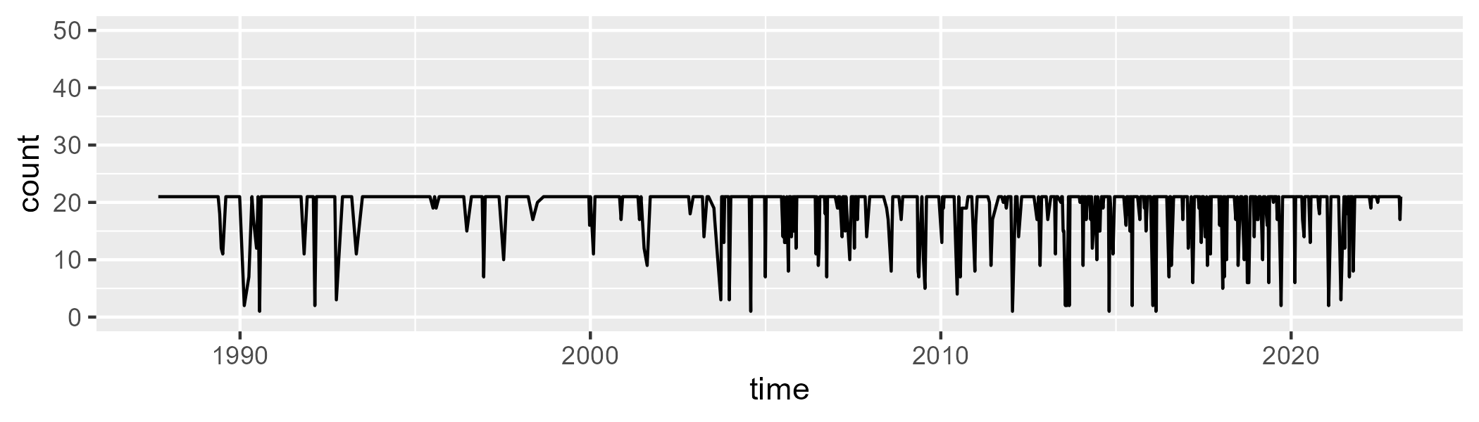

Min. : 1.00 1st Qu.:21.00 Median :21.00 Mean :19.25 3rd Qu.:21.00 Max. :21.00

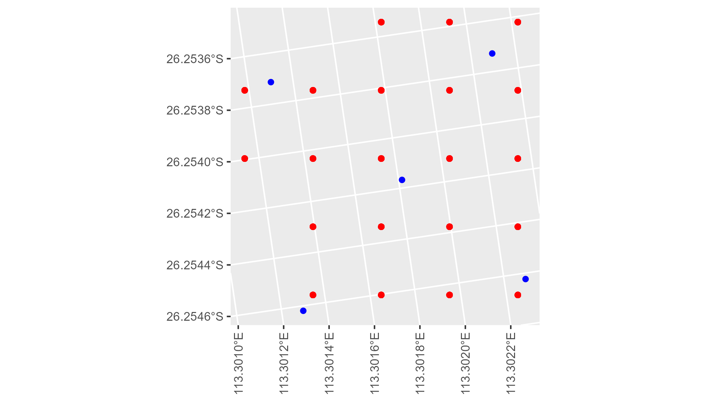

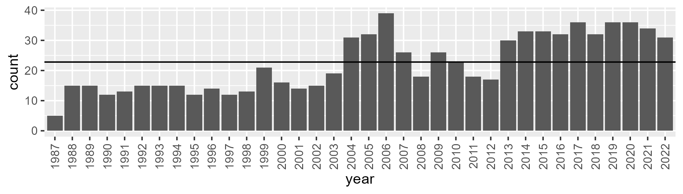

Number of samples: 804

# WAAYAL0005

| Min. | 1st Qu. | Median | Mean | 3rd Qu. | Max. |
| --- | --- | --- | --- | --- | --- |
| 8.740058 | 17.66257 | 22.64075 | 23.72905 | 29.61108 | 44.14995 |

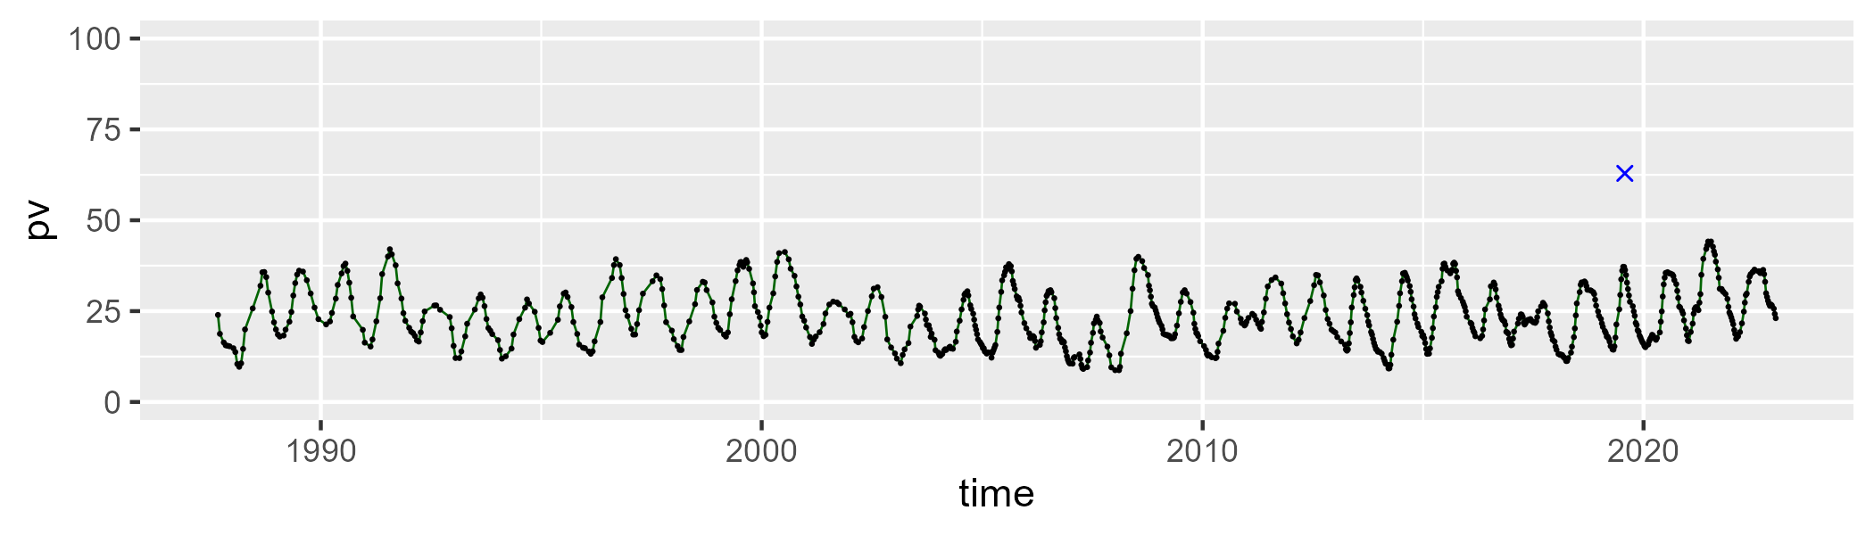

| Min. | 1st Qu. | Median | Mean | 3rd Qu. | Max. |
| --- | --- | --- | --- | --- | --- |
| 25.73626 | 43.07551 | 51.17996 | 50.32131 | 58.34181 | 71.62607 |

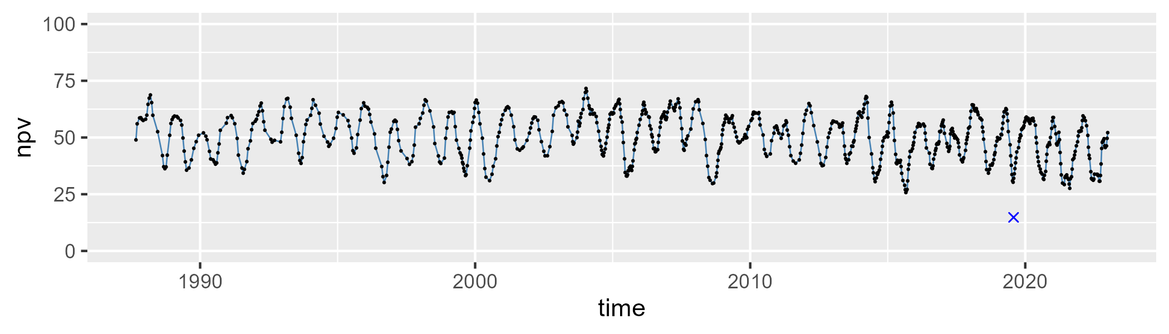

| Min. | 1st Qu. | Median | Mean | 3rd Qu. | Max. |
| --- | --- | --- | --- | --- | --- |
| 14.12139 | 22.25938 | 24.6188 | 24.68418 | 26.97294 | 36.51496 |

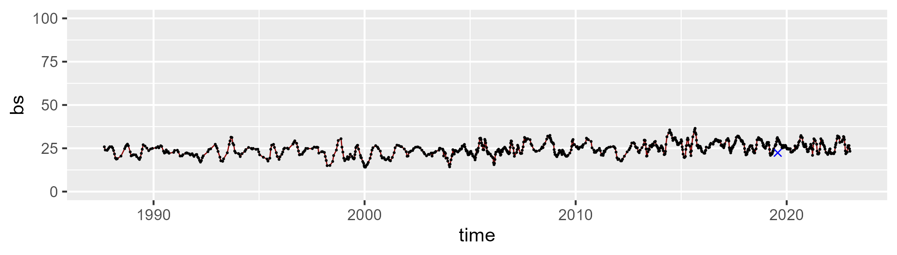

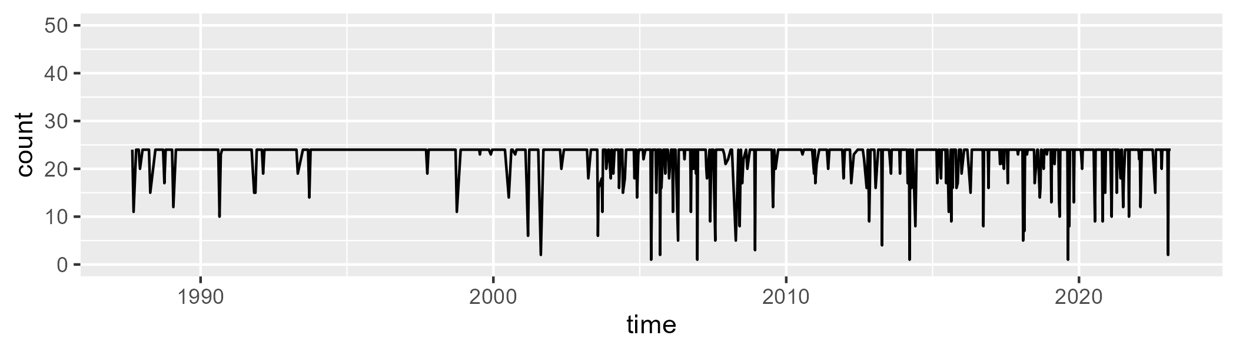

Min. : 1.00 1st Qu.:24.00 Median :24.00 Mean :22.58 3rd Qu.:24.00 Max. :24.00

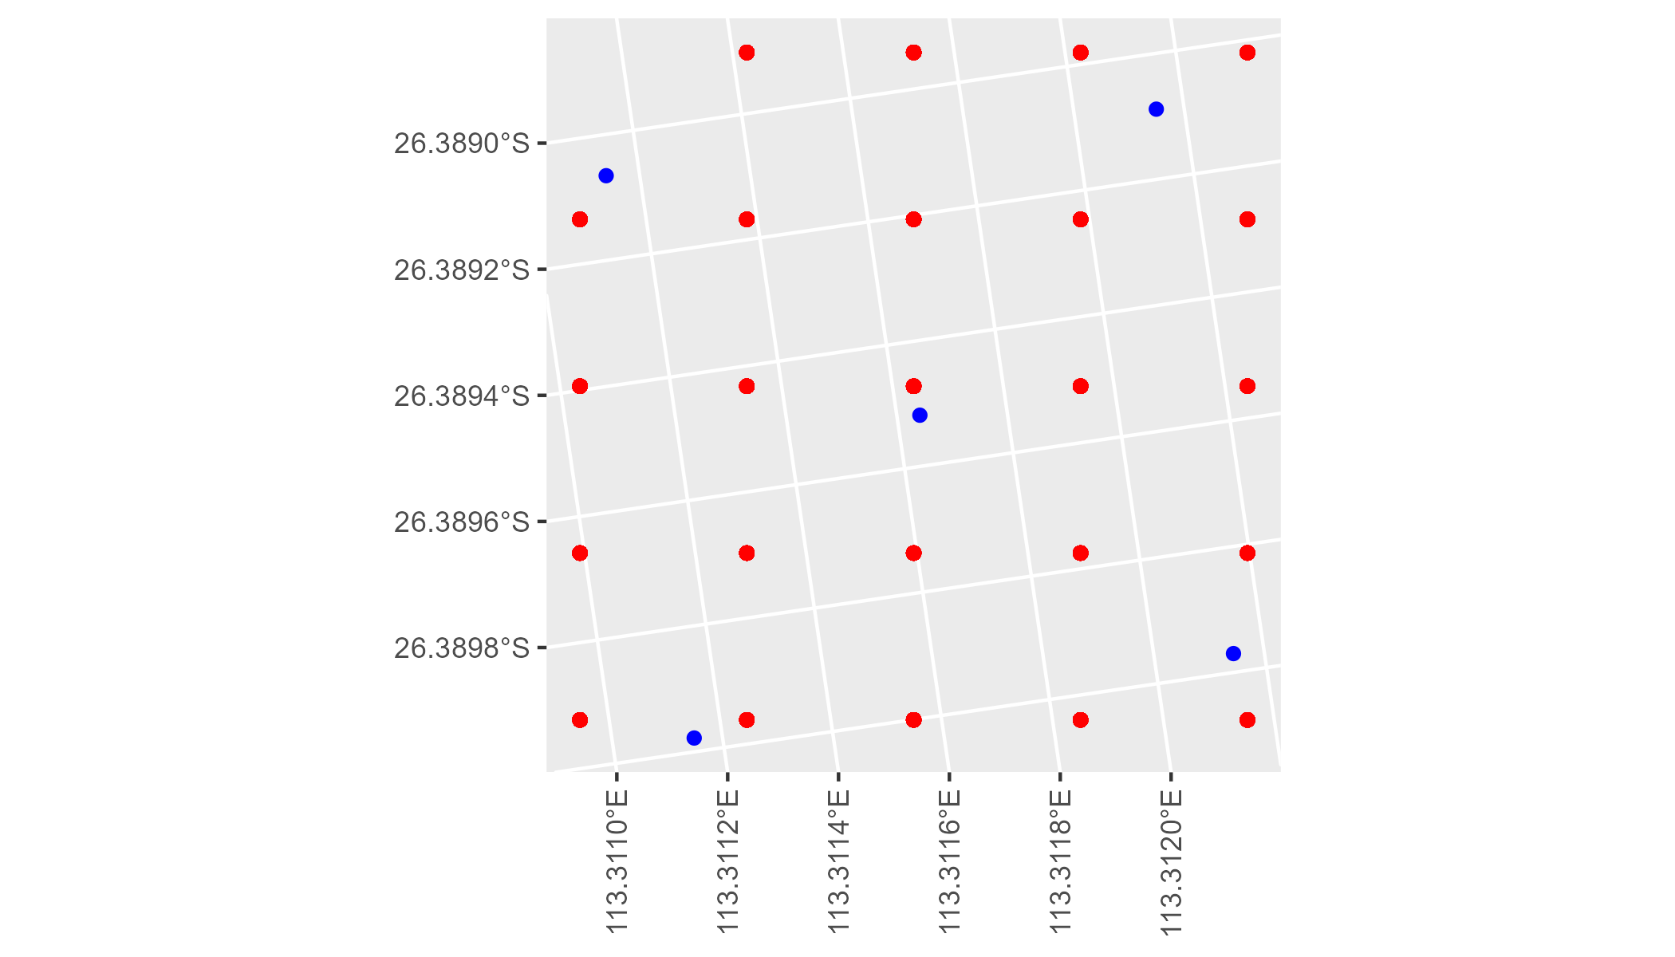

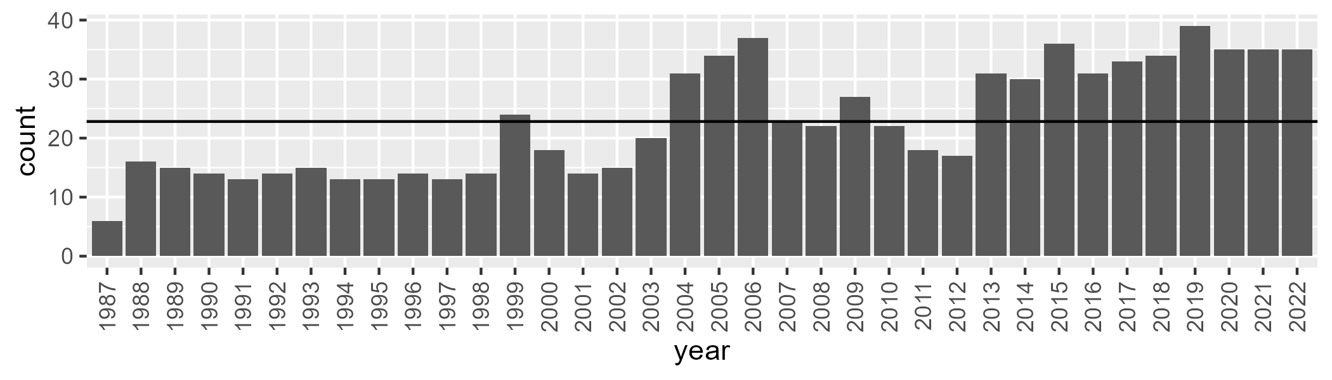

Number of samples: 821

# WAAYAL0006

| Min. | 1st Qu. | Median | Mean | 3rd Qu. | Max. |
| --- | --- | --- | --- | --- | --- |
| 0 | 2.134183 | 4.365556 | 6.412584 | 8.500177 | 30.5113 |

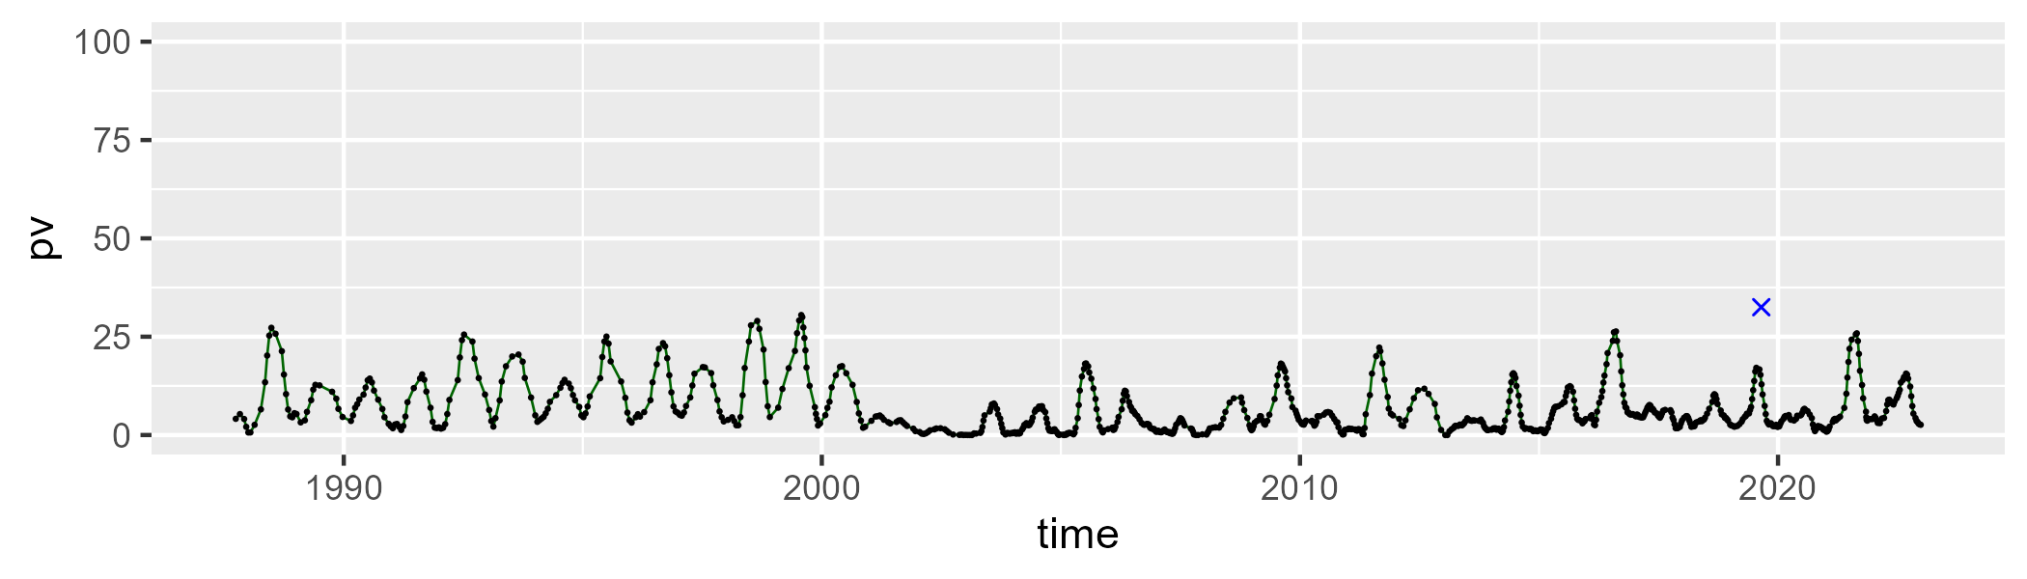

| Min. | 1st Qu. | Median | Mean | 3rd Qu. | Max. |
| --- | --- | --- | --- | --- | --- |
| 44.036 | 53.5506 | 55.90887 | 55.92677 | 58.29537 | 66.73479 |

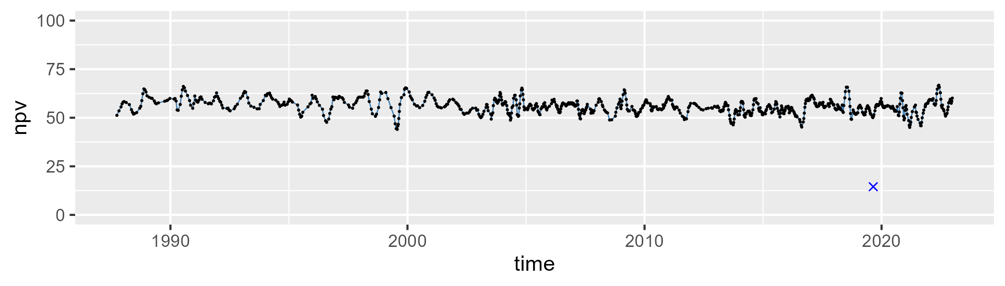

| Min. | 1st Qu. | Median | Mean | 3rd Qu. | Max. |
| --- | --- | --- | --- | --- | --- |
| 18.62134 | 32.67862 | 37.24877 | 36.45564 | 40.76277 | 49.62549 |

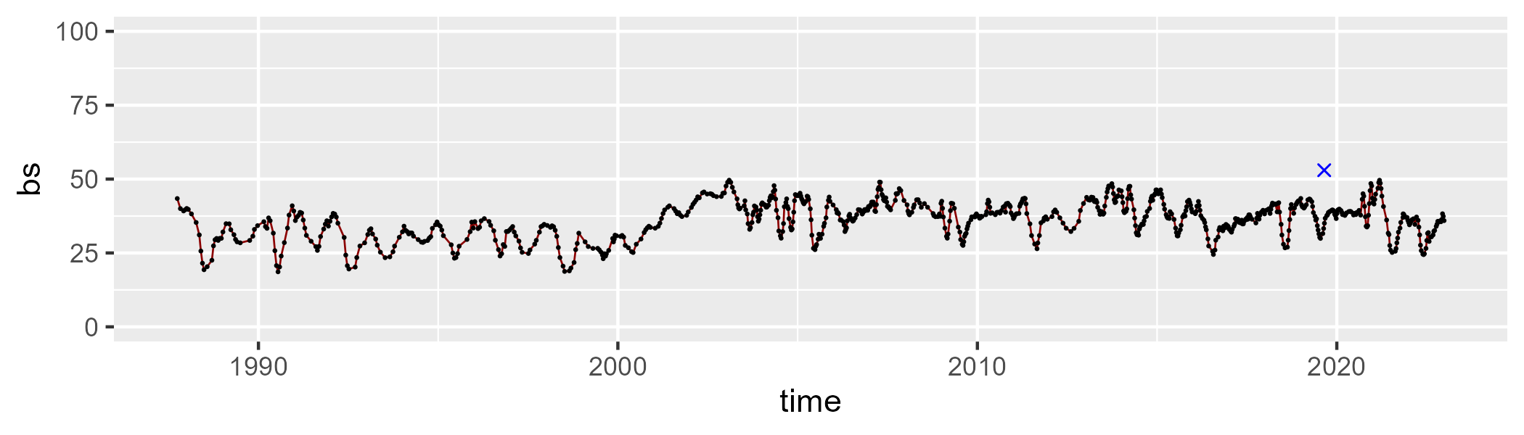

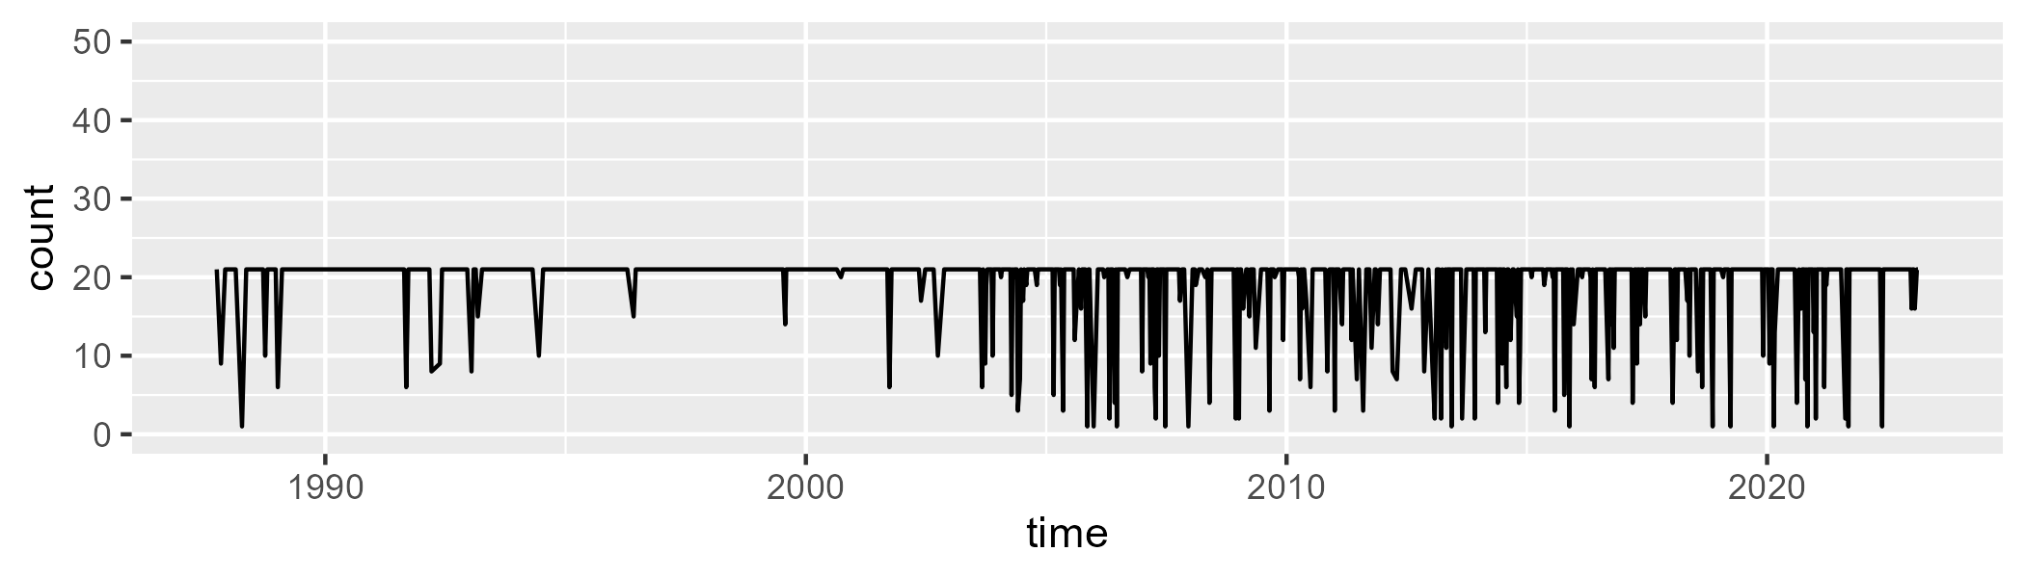

Min. : 1.00 1st Qu.:21.00 Median :21.00 Mean :19.19 3rd Qu.:21.00 Max. :21.00

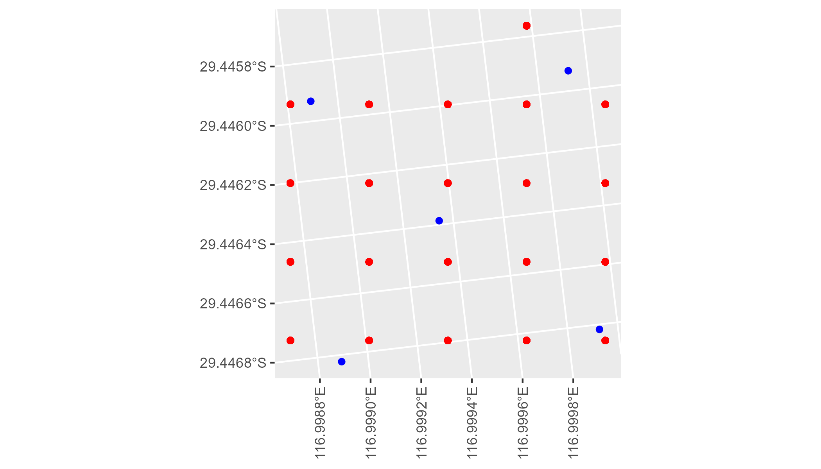

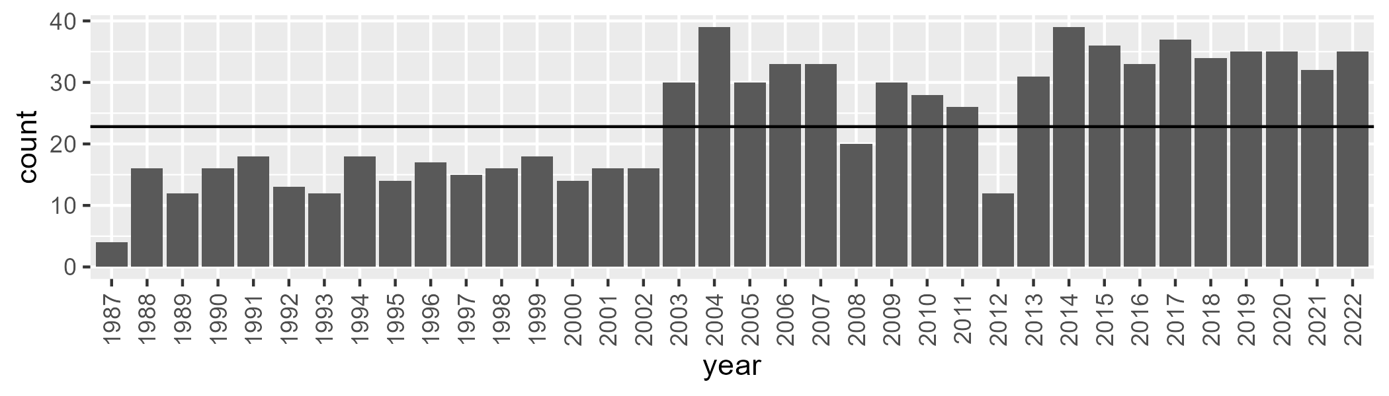

Number of samples: 863

# WAAYAL0007

| Min. | 1st Qu. | Median | Mean | 3rd Qu. | Max. |
| --- | --- | --- | --- | --- | --- |
| 1.4535 | 8.220947 | 10.46067 | 12.03391 | 14.52374 | 34.63695 |

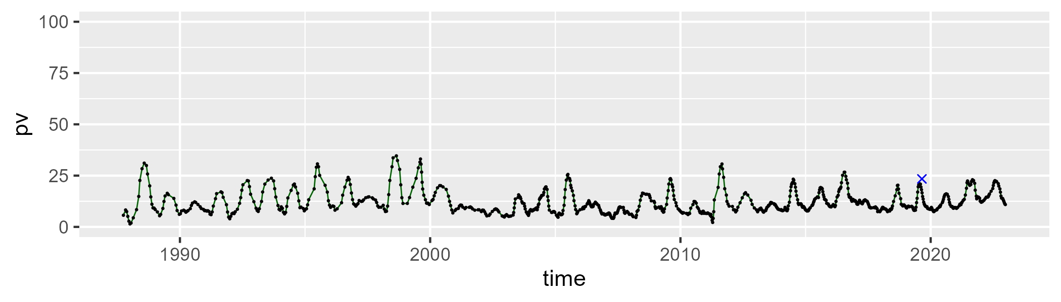

| Min. | 1st Qu. | Median | Mean | 3rd Qu. | Max. |
| --- | --- | --- | --- | --- | --- |
| 34.9855 | 44.08665 | 46.75867 | 47.19881 | 50.1206 | 67.43168 |

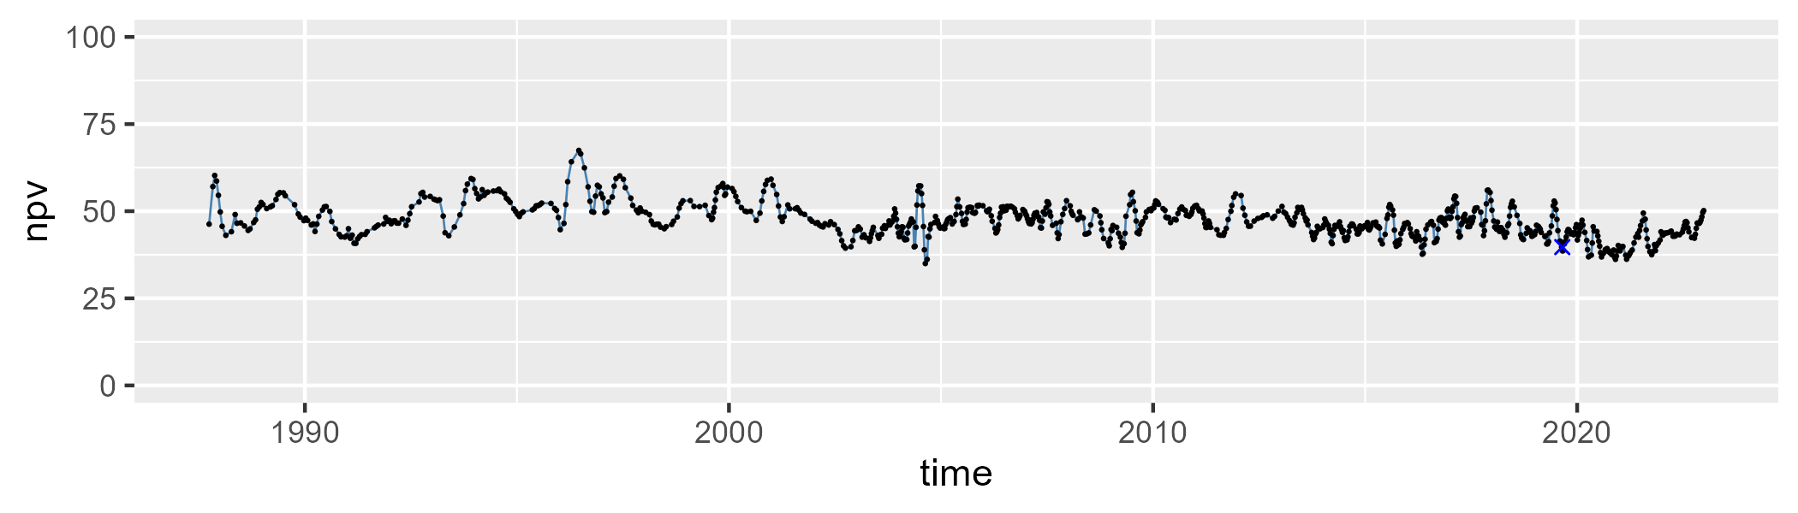

| Min. | 1st Qu. | Median | Mean | 3rd Qu. | Max. |
| --- | --- | --- | --- | --- | --- |
| 16.50488 | 35.72443 | 40.79336 | 39.37031 | 44.4519 | 53.42438 |

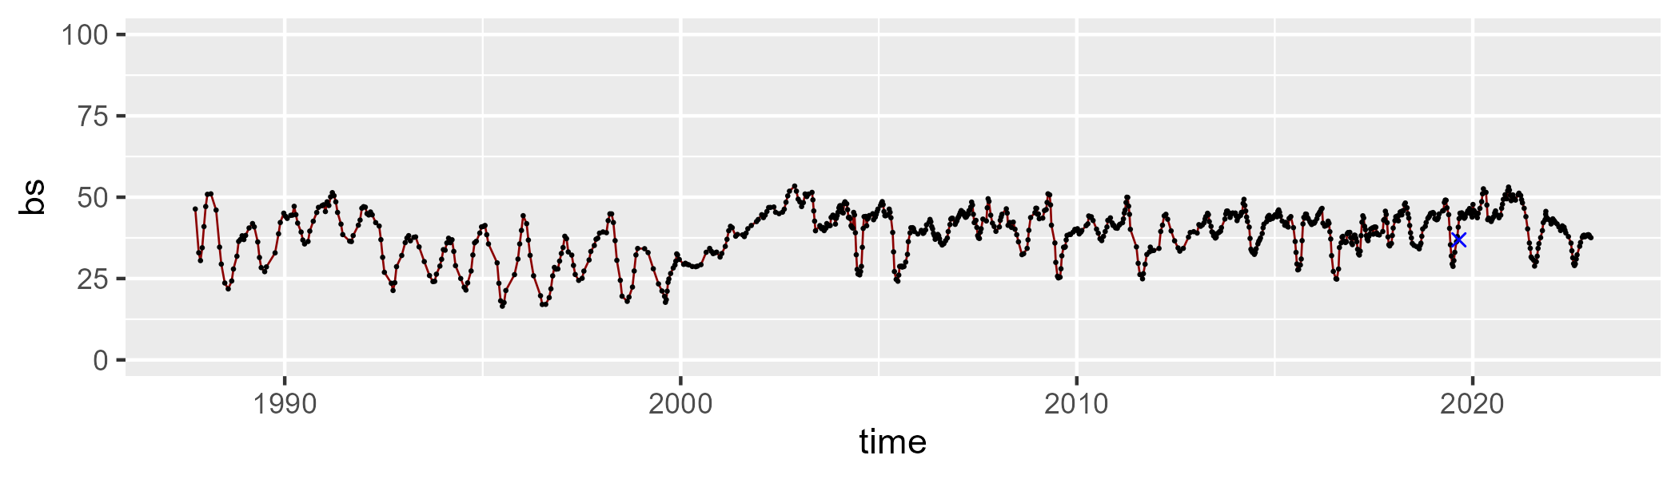

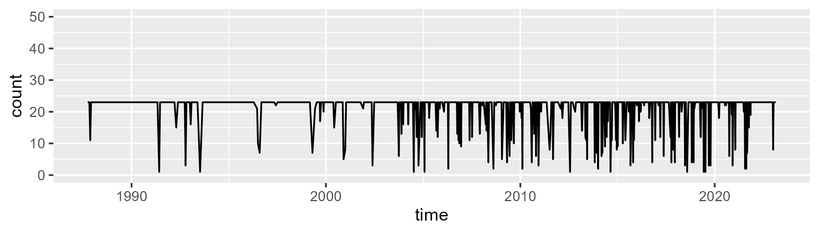

Min. : 1.00 1st Qu.:23.00 Median :23.00 Mean :21.14 3rd Qu.:23.00 Max. :23.00

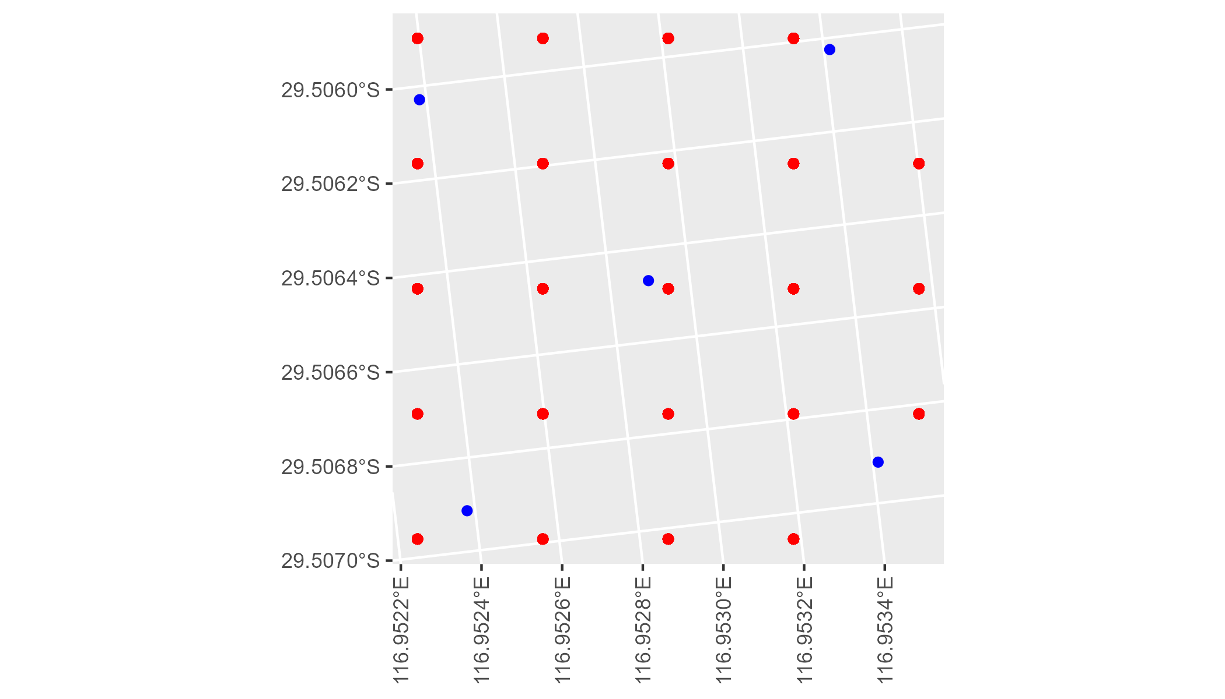

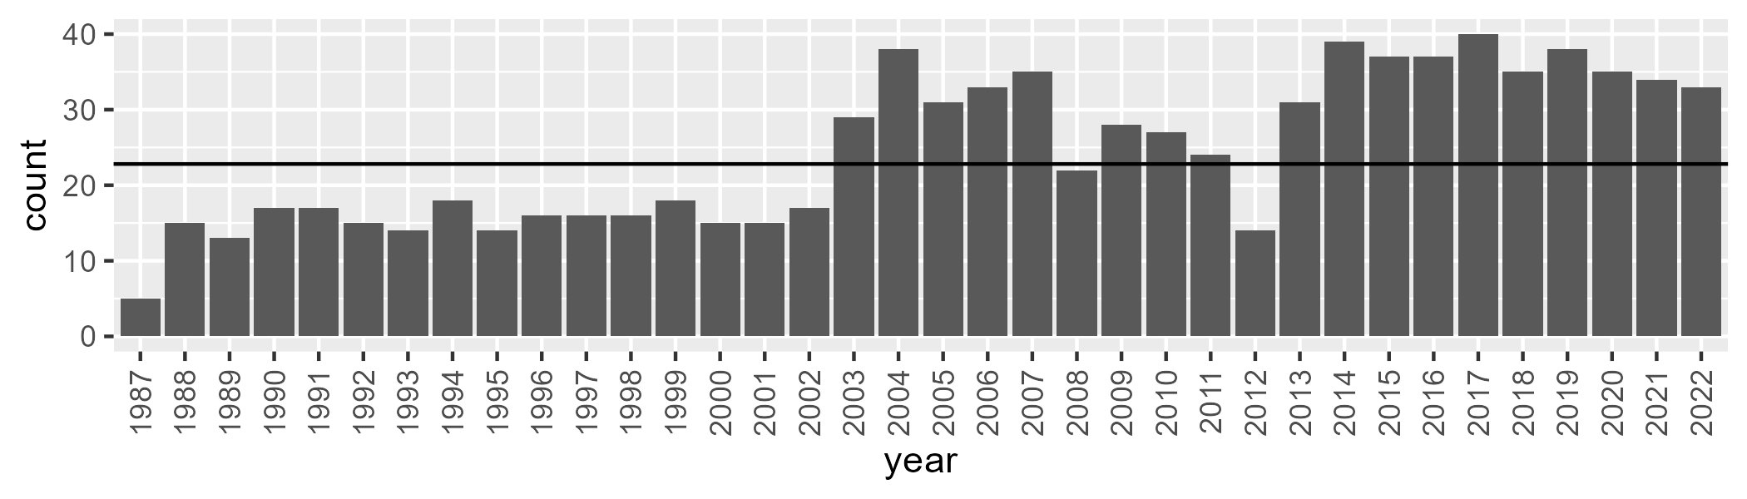

Number of samples: 881

# WAAYAL0008

| Min. | 1st Qu. | Median | Mean | 3rd Qu. | Max. |
| --- | --- | --- | --- | --- | --- |
| 2.098091 | 9.292336 | 11.86598 | 13.48715 | 15.97279 | 47.94072 |

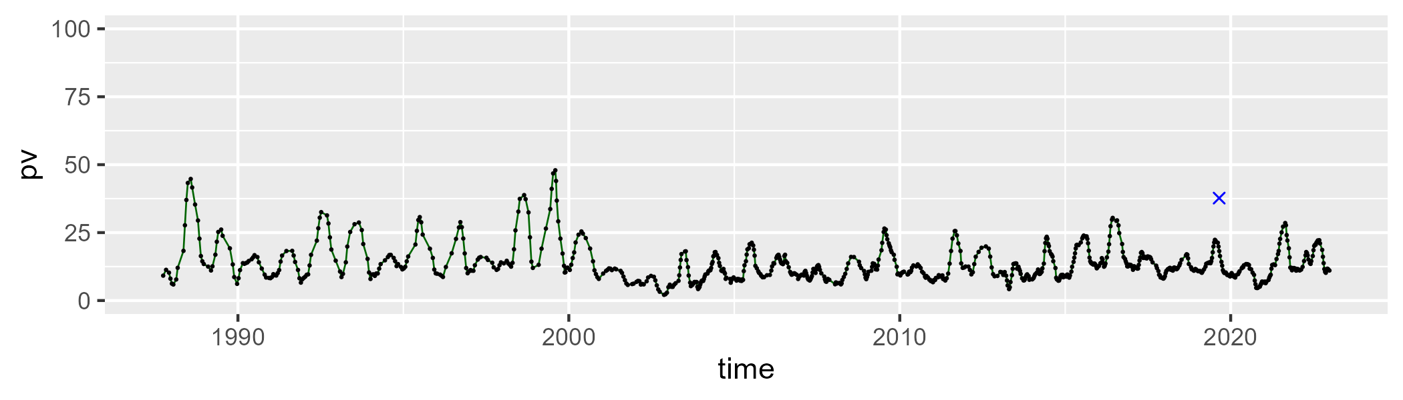

| Min. | 1st Qu. | Median | Mean | 3rd Qu. | Max. |
| --- | --- | --- | --- | --- | --- |
| 42.10258 | 50.95292 | 52.9169 | 53.26009 | 55.11683 | 68.00065 |

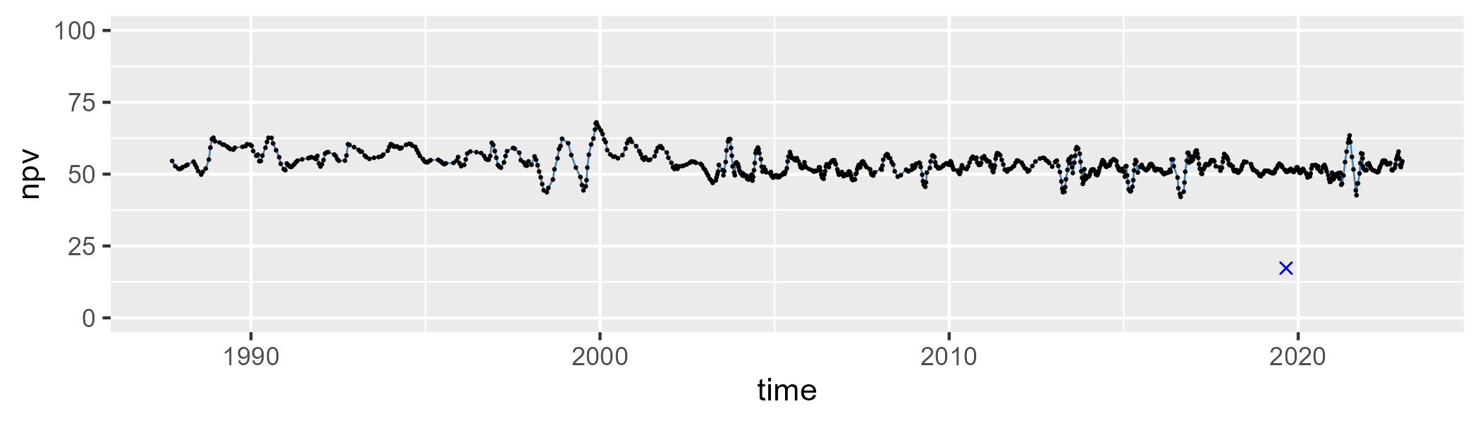

| Min. | 1st Qu. | Median | Mean | 3rd Qu. | Max. |
| --- | --- | --- | --- | --- | --- |
| 3.612471 | 28.26028 | 33.49159 | 32.11344 | 37.24856 | 50.82432 |

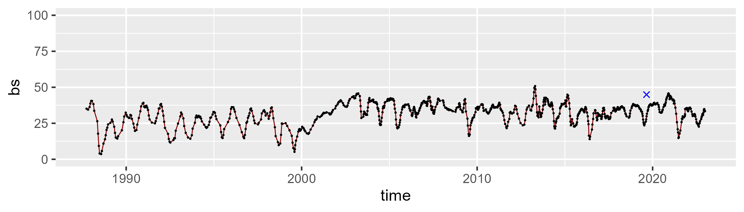

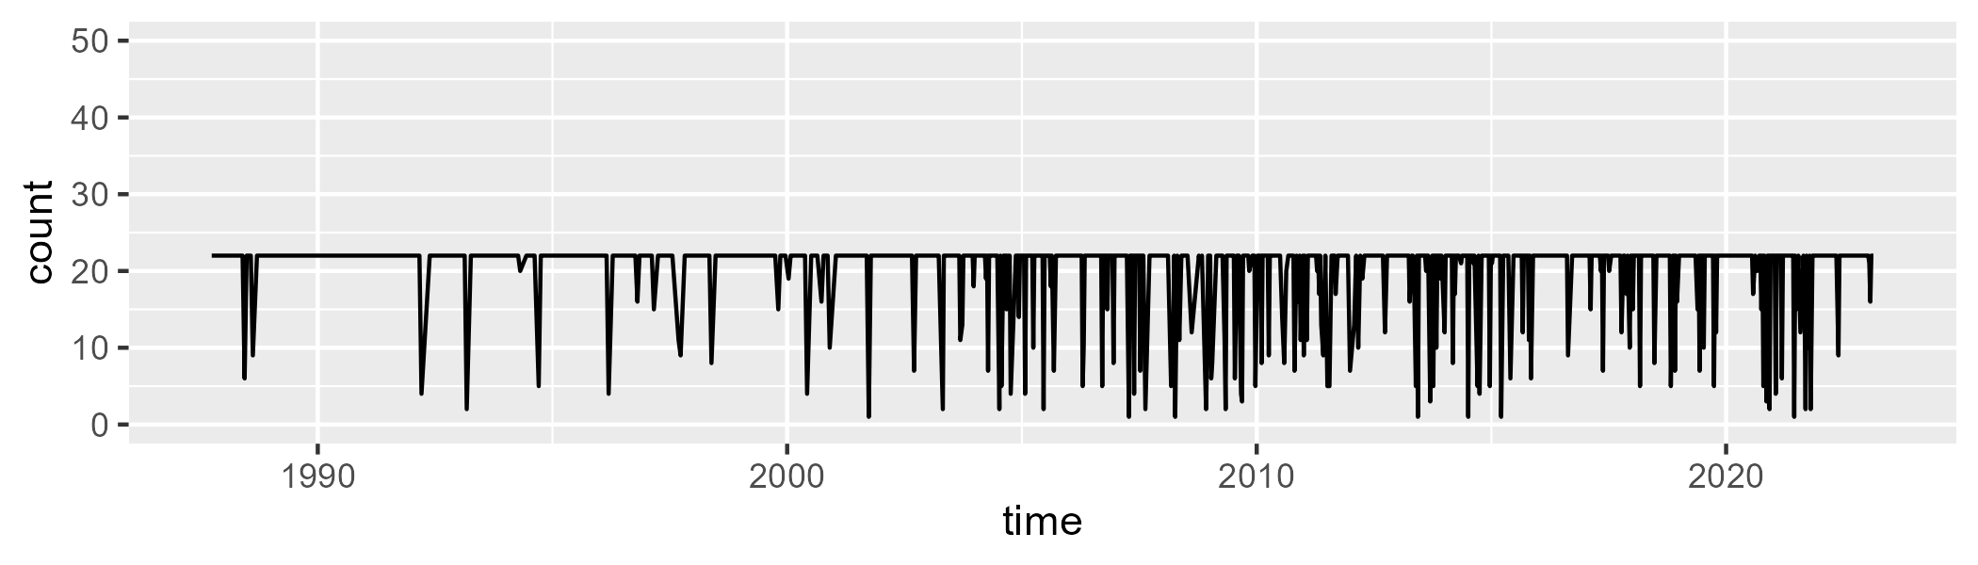

Min. : 1.00 1st Qu.:22.00 Median :22.00 Mean :20.01 3rd Qu.:22.00 Max. :22.00

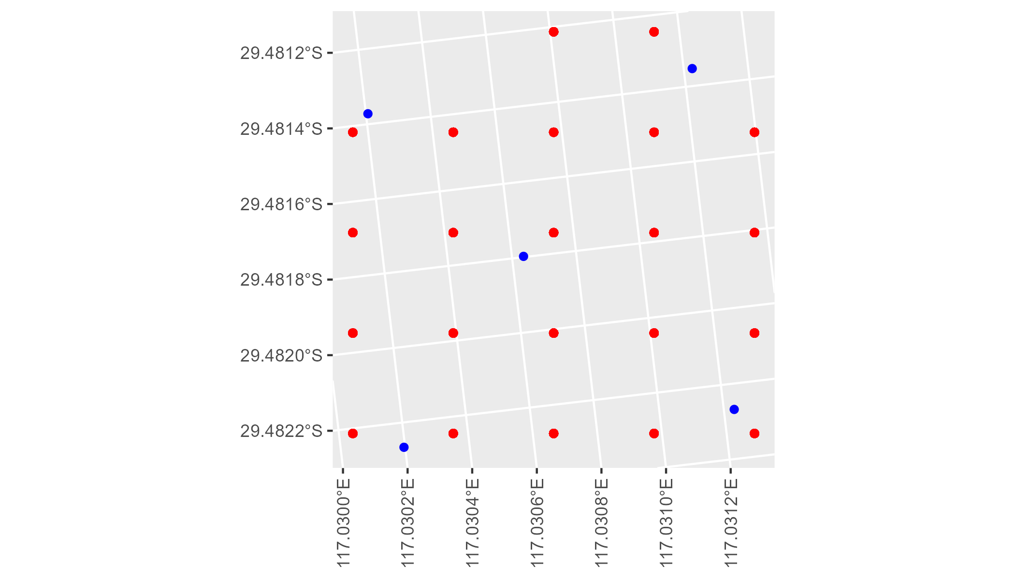

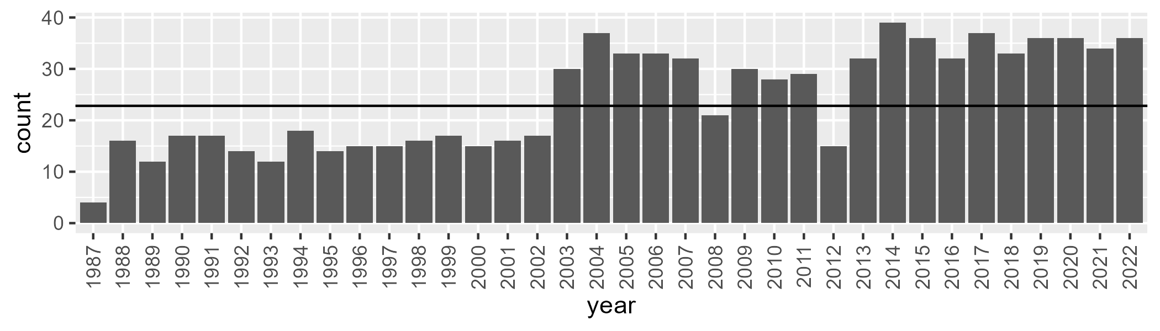

Number of samples: 874

# WAGCOO0001

| Min. | 1st Qu. | Median | Mean | 3rd Qu. | Max. |
| --- | --- | --- | --- | --- | --- |
| 13.81096 | 22.29031 | 24.27586 | 24.44463 | 26.71572 | 34.28377 |

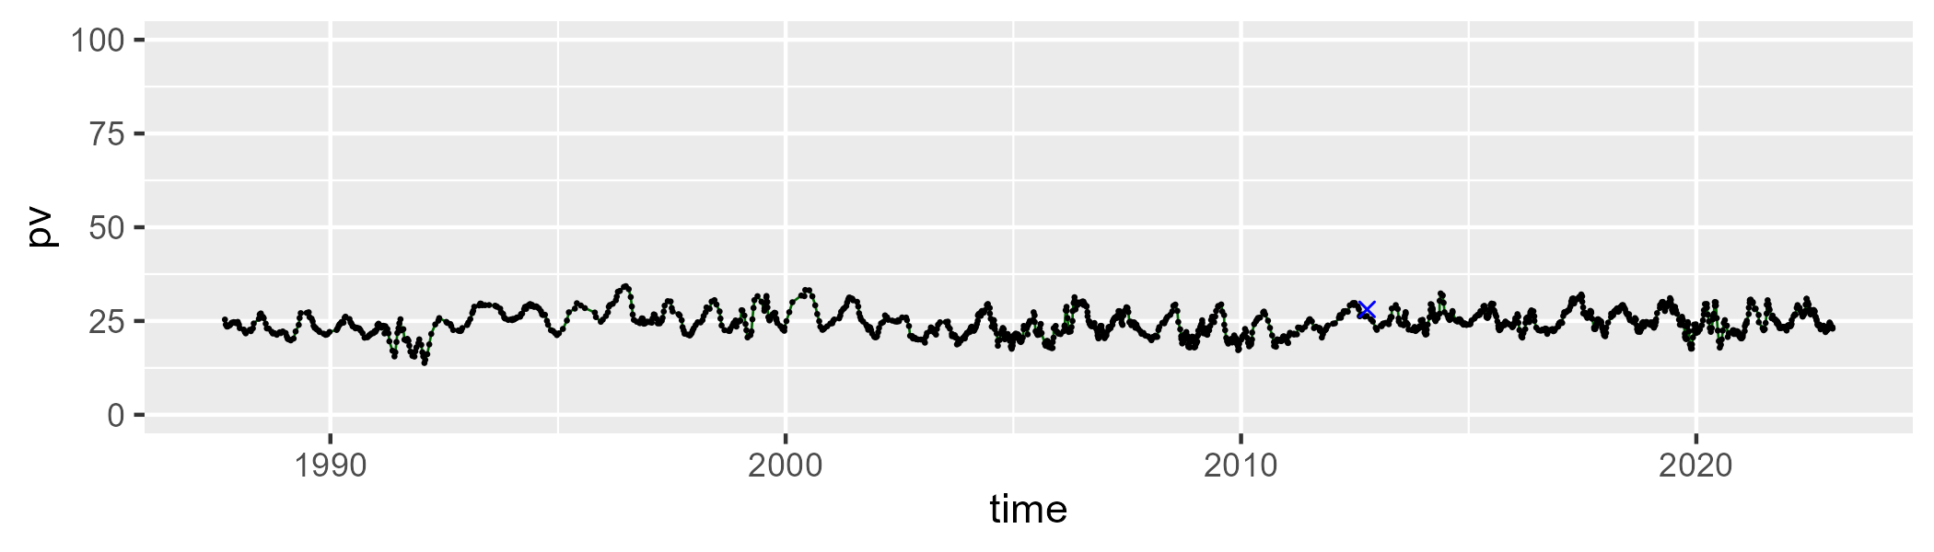

| Min. | 1st Qu. | Median | Mean | 3rd Qu. | Max. |
| --- | --- | --- | --- | --- | --- |
| 32.66554 | 42.39922 | 44.32364 | 44.2506 | 46.2817 | 55.35988 |

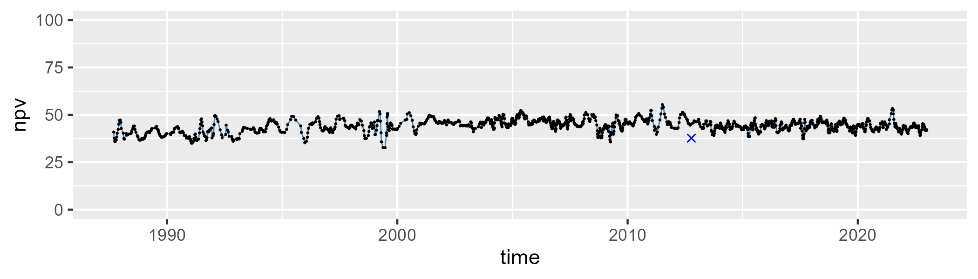

| Min. | 1st Qu. | Median | Mean | 3rd Qu. | Max. |
| --- | --- | --- | --- | --- | --- |
| 14.2989 | 26.79131 | 30.27159 | 29.91276 | 32.96097 | 44.30664 |

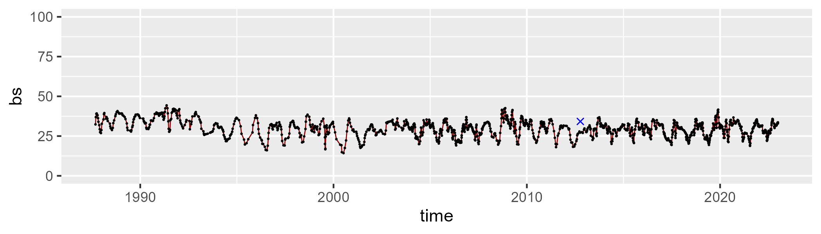

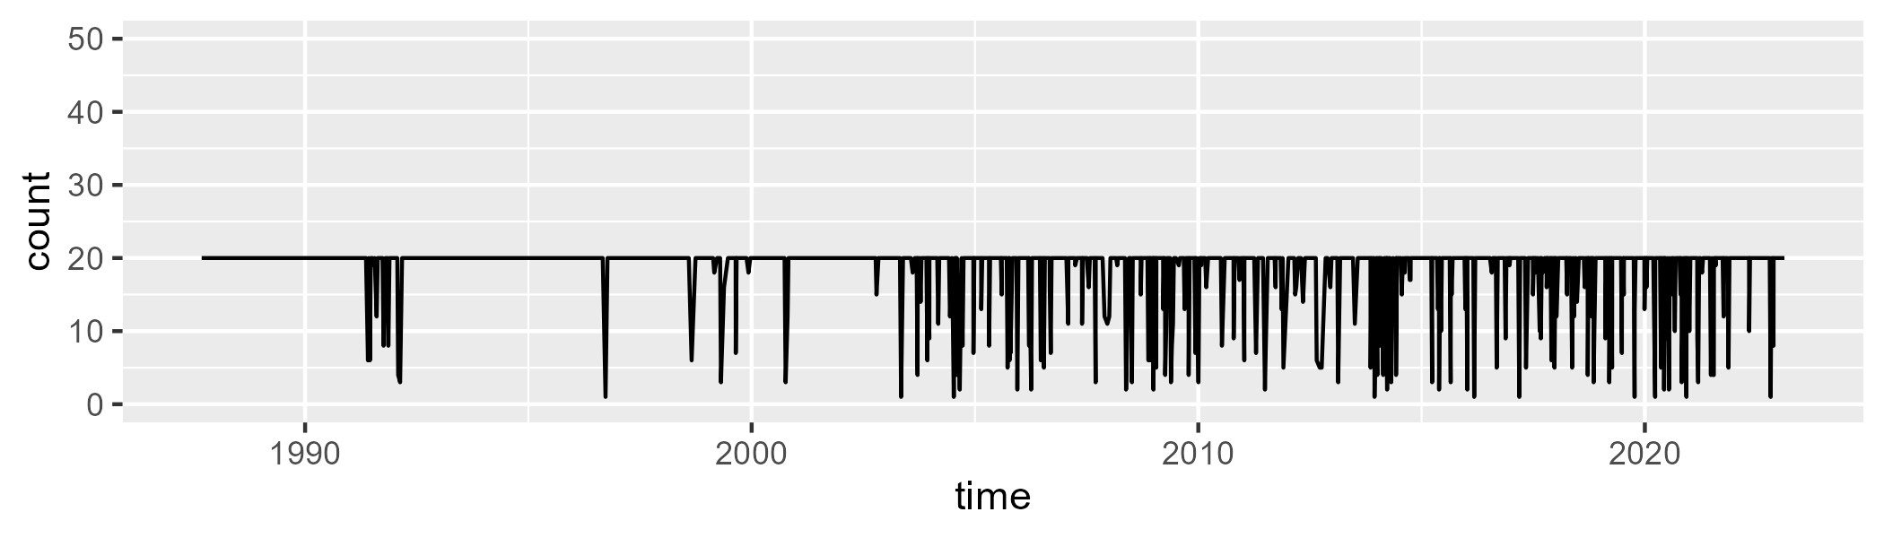

Min. : 1.00 1st Qu.:20.00 Median :20.00 Mean :18.61 3rd Qu.:20.00 Max. :20.00

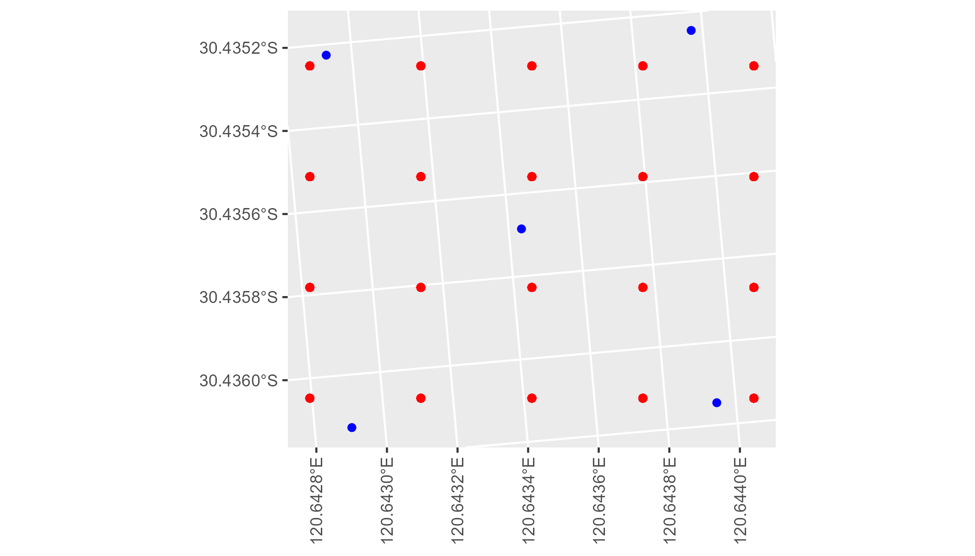

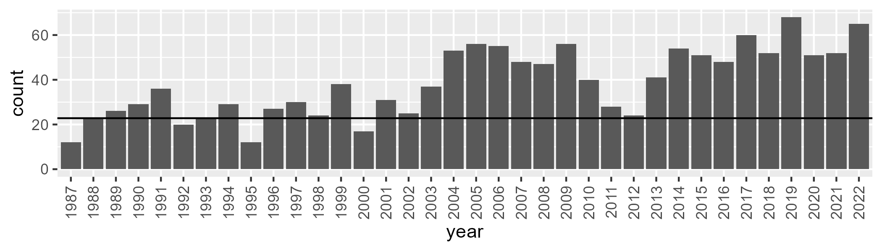

Number of samples: 1388

# WAGCOO0002

| Min. | 1st Qu. | Median | Mean | 3rd Qu. | Max. |
| --- | --- | --- | --- | --- | --- |
| 0 | 6.635041 | 10.27947 | 10.40778 | 14.16365 | 23.64894 |

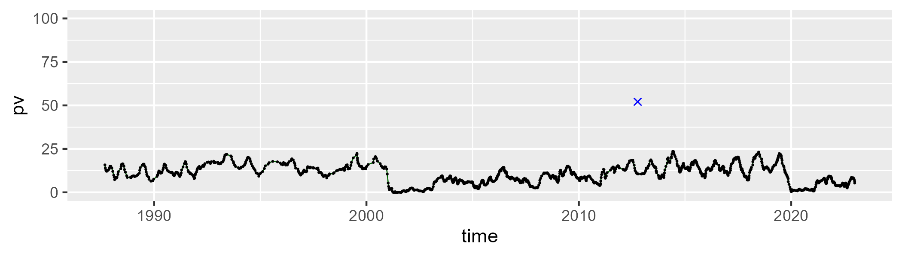

| Min. | 1st Qu. | Median | Mean | 3rd Qu. | Max. |
| --- | --- | --- | --- | --- | --- |
| 33.31061 | 53.00307 | 58.1799 | 57.43117 | 62.0591 | 76.41355 |

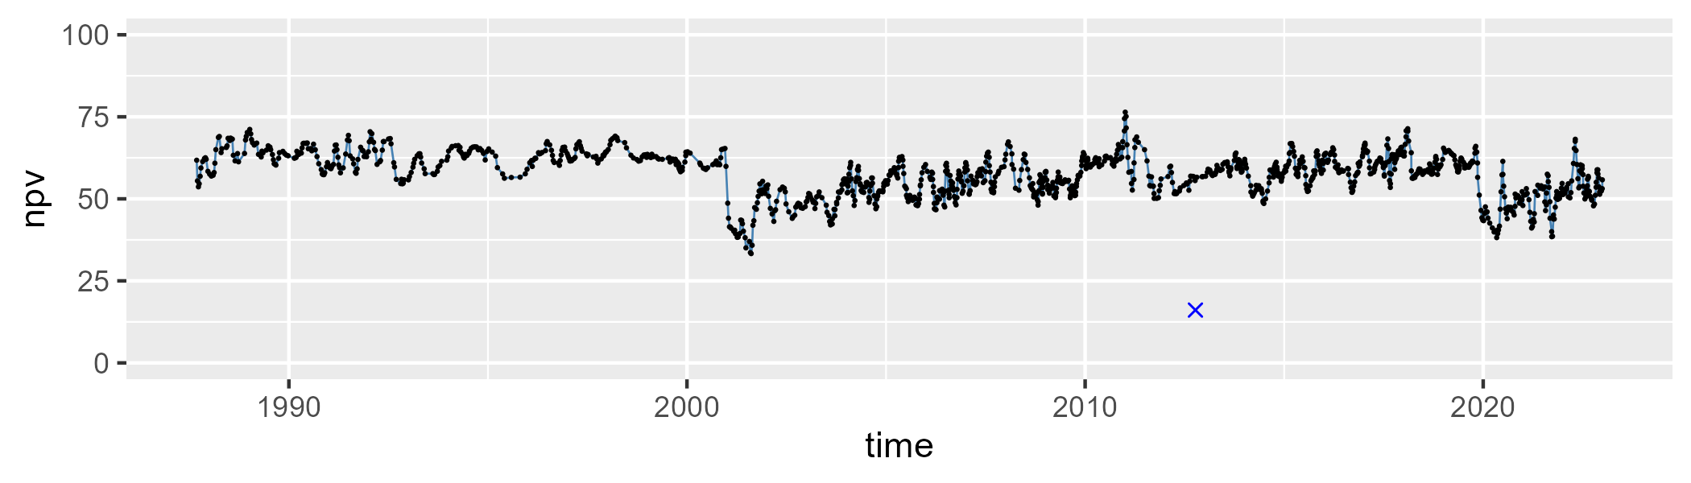

| Min. | 1st Qu. | Median | Mean | 3rd Qu. | Max. |
| --- | --- | --- | --- | --- | --- |
| 12.05243 | 23.30634 | 28.92801 | 30.81958 | 37.42075 | 66.03431 |

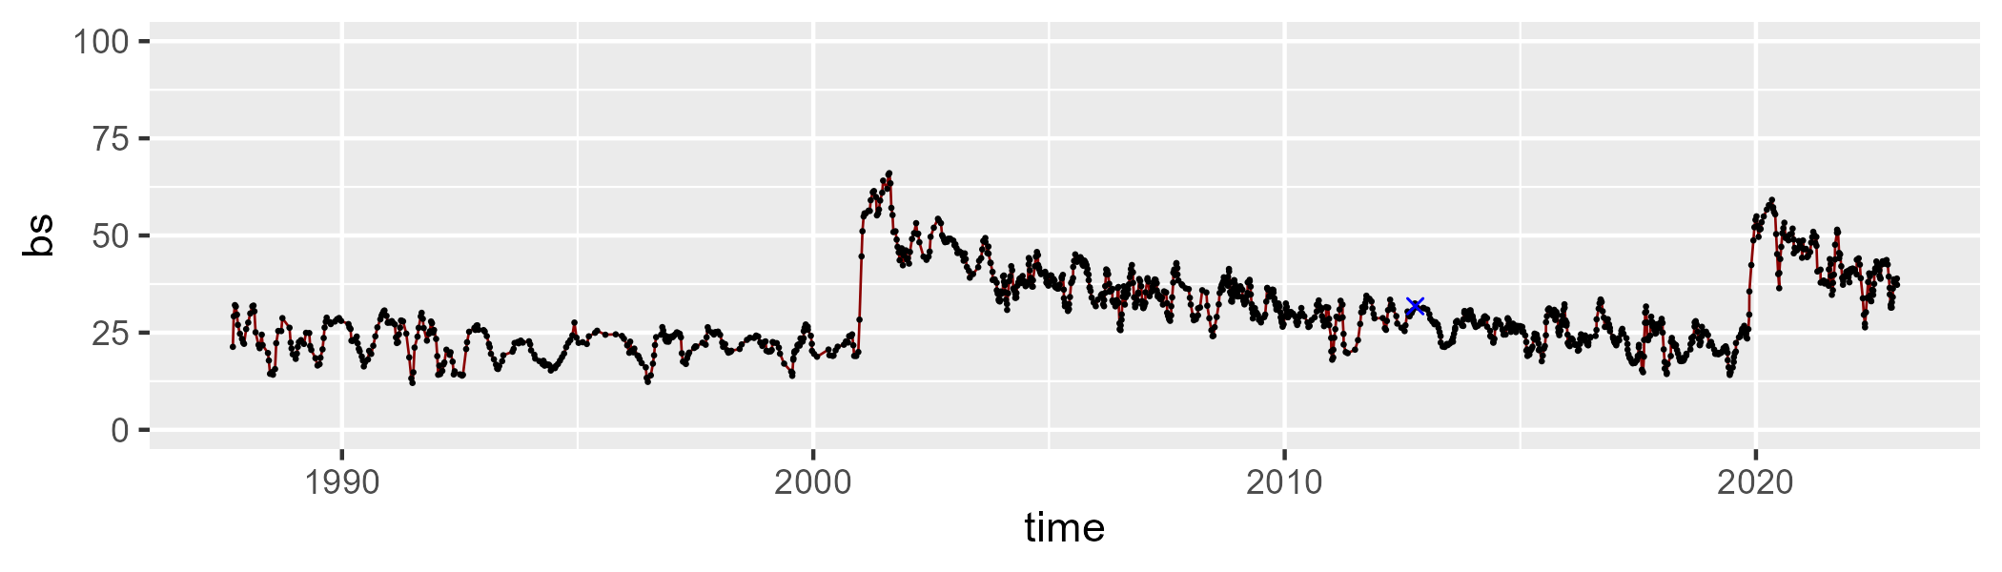

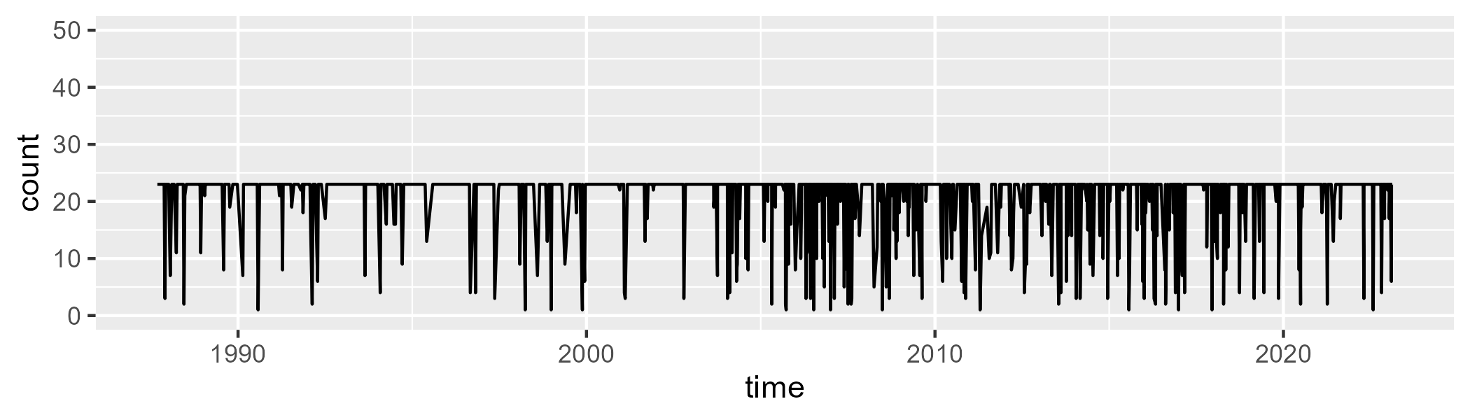

Min. : 1.00 1st Qu.:23.00 Median :23.00 Mean :20.96 3rd Qu.:23.00 Max. :23.00

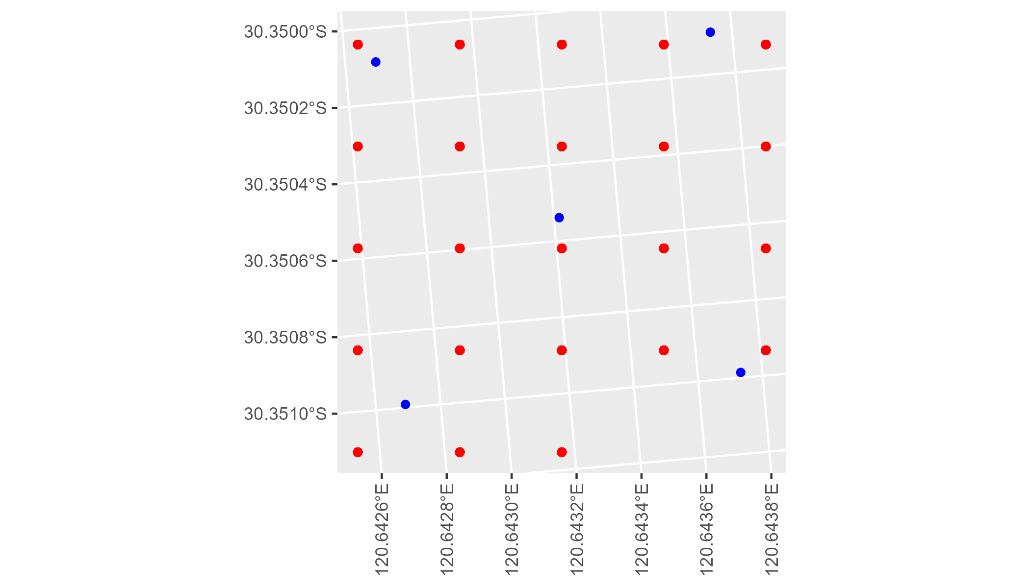

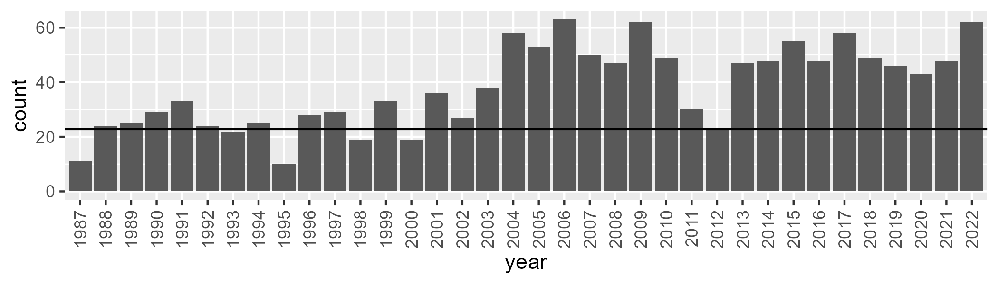

Number of samples: 1371

# WAGCOO0004

| Min. | 1st Qu. | Median | Mean | 3rd Qu. | Max. |
| --- | --- | --- | --- | --- | --- |
| 0.4263338 | 5.661649 | 8.003365 | 10.0877 | 12.68092 | 61.5152 |

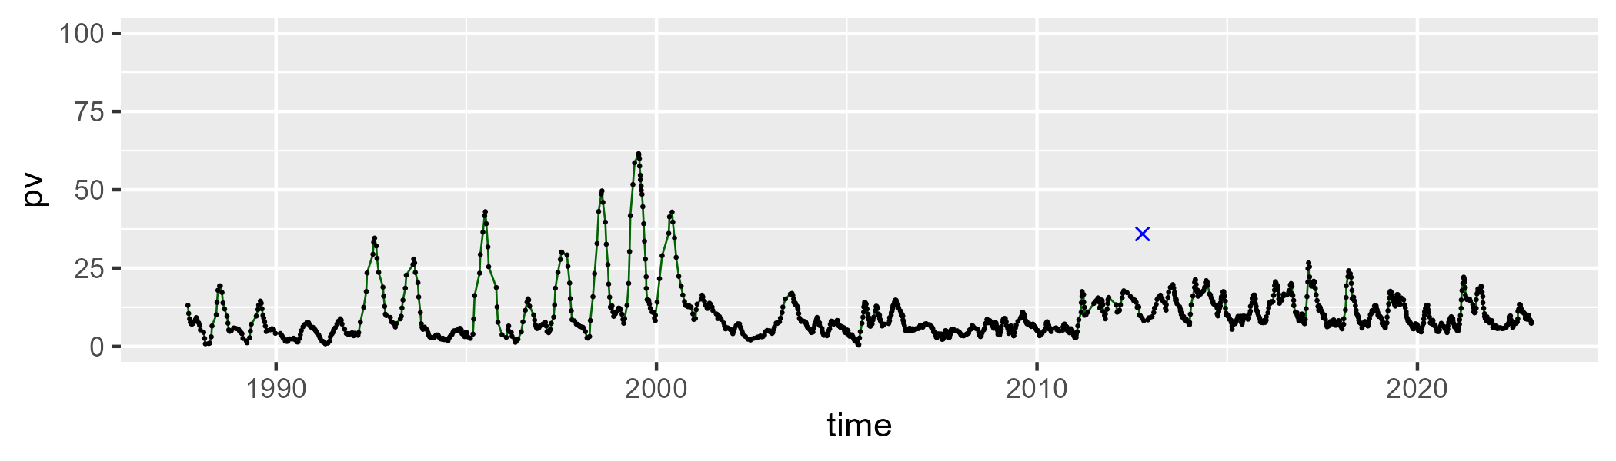

| Min. | 1st Qu. | Median | Mean | 3rd Qu. | Max. |
| --- | --- | --- | --- | --- | --- |
| 26.82274 | 42.05781 | 45.87385 | 46.39688 | 50.85031 | 74.03948 |

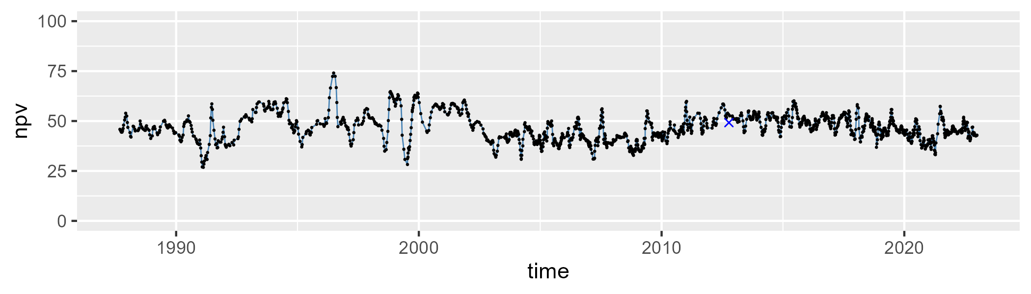

| Min. | 1st Qu. | Median | Mean | 3rd Qu. | Max. |
| --- | --- | --- | --- | --- | --- |
| 6.251465 | 35.95811 | 43.3427 | 42.14091 | 49.26508 | 67.91458 |

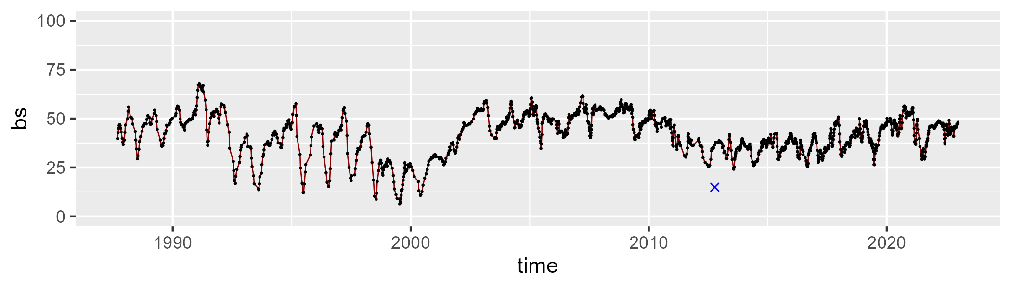

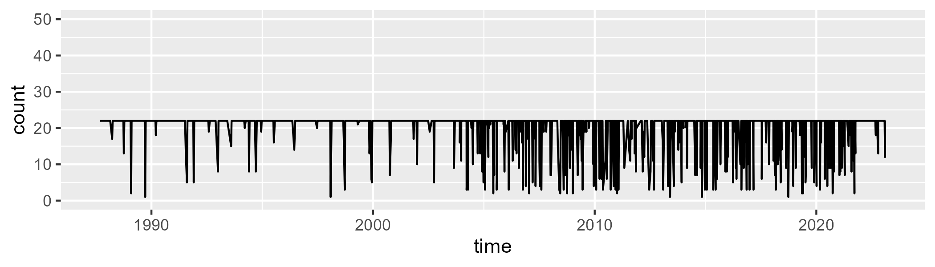

Min. : 1.00 1st Qu.:22.00 Median :22.00 Mean :20.12 3rd Qu.:22.00 Max. :22.00

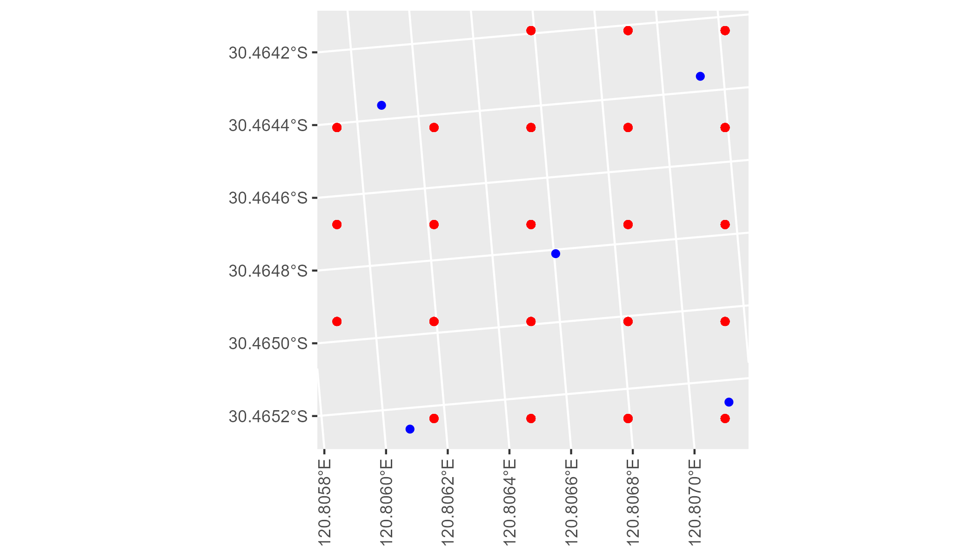

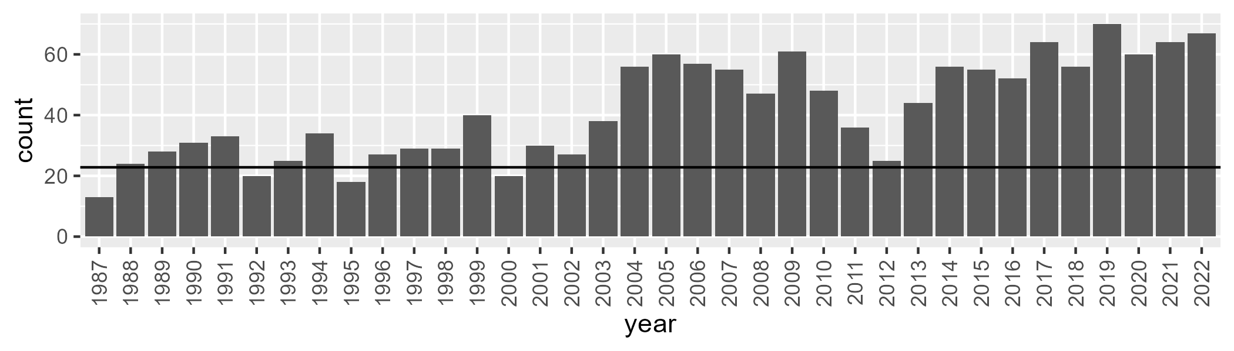

Number of samples: 1499